**Rune Caster**

**Sub-class house rule for Nemmyrl campaign world setting**

**V. 1.0**

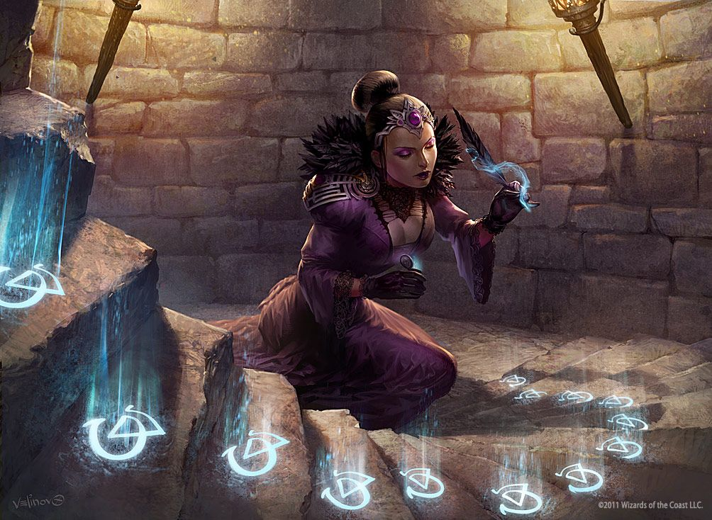

Rune casting is a special discipline that focuses on the study and inscription of ancient magical symbols dating back to the dawn of time. They are only found in Norgarde. They concentrate enormous primal power but are hard to control. It involves focusing on the mental image of the symbol and inscribing it. Different symbols use different materials to inscribe, which usually drawn but sometimes carved.

Rune casting is only available to clerics, sorcerers, and wizards from Norgarde. It is not available to casters from any other part of the world unless they master Norgardian as a language (2 ranks) and take at least 10 ranks in Knowledge: Runes.

This sub-class is only available if a rune caster is available and agrees to teach the character the discipline's secrets. In some instances, the gods may reveal the secrets to those deemed worthy. Both involve a special test called the **Revelation**.

**Rune Caster as a sub-class**

**Revelation** involves a strenuous rite of passage for the prospective learner.

* The character must spend one night naked in the wilderness beseeching the gods of Norgarde for divine knowledge. A wild beast will reveal itself to the character during the night of the ritual. The DM is free to choose the animal appropriate to the character’s current level in a standard class. The initiate must slay the beast armed only with a knife and wear the animal’s skin during the ritual.
* Passing the ritual is DC 15 and requires a check. Roll 1d20 and add the caster’s primary ability modifier plus the new level in their favored class.
* Revelation can only be sought as the character gains a new level in their favored class.
  + E.g. Geibera is a 2nd level cleric of Kord rising to 3rd level. She receives a vision to learn the runes. She engages in the ritual and must pass a DC 15 check. She has a Wisdom modifier of +2. So she rolls 1d20 and adds 3 + 2 = 5. She rolls a 10 and adds 5 to equal 15. She passes the ritual and now has rune caster as a sub-class beginning at level 1.

**Progression:** Each time a character with the rune caster sub-class goes up a level in their favored class (cleric, wizard, or sorcerer) they may attempt to progress a level in a rune caster. This is at no cost to XP. Simply roll 1d20 and add the character’s modifier for their primary ability. The DC equals 10 plus the new level in Rune Caster.

* For clerics, roll 1d20 and add their Wisdom modifier. For wizards, add their Intelligence modifier. For sorcerers roll their Charisma modifier.
  + e.g. Geibera is a 3rd level cleric of Kord with a Wisdom modifier of +2. She is already a 1st level rune caster. Upon reaching 4th level of cleric she attempts to learn more. Geirbera must pass a test of faith to achieve 2nd level rune casting. The DC is 10 + 2 or 12.
  + Geirbera rolls 1d20 and adds 2 from her Wisdom modifier. The result is 14 + 2 = 16, which beats the DC of 12. She is now a 2nd level rune caster.
  + If Geirbera pursues rune casting upon reaching 5th level cleric, the DC will be 13 (10 plus 3 for 3rd level rune casting), and so on.

**Learning Runes:** At each level of rune caster, the character learns one rune per level plus one extra per primary attribute modifier (WIS for clerics, CHA for sorcerers, INT for wizards). The runes are assigned randomly by the DM rolling on the Runes Table.

* + e.g. When Geirbera just achieved 1st level rune caster she learned 1 + 2 = 3 runes.
  + Geirbera continued studying and passed her test upon reaching 4th level cleric, becoming a 2nd level rune caster.
  + At 2nd level she can then learn 1 + 2 = 3 more runes for a total of six runes known.

**Inscribing Runes:** Inscribing is a standard action and elicits an Attack of Opportunity just like casting a spell. Inscribing requires the requisite materials and is normally specific to a person, creature, item, or event (see rune description). A rune caster can inscribe the same number of runes in a single day as the total number of those known. They can be in any combination of those known.

* + e.g. Geibera as a 2nd level rune caster knows 6 runes. So she can carve 6 runes each day.
  + Geirbera knows the wind, gift, sea, knowledge, thunder, and fire runes. She inscribes the fire rune three times in a single day and the wind rune three times. She has used up all her rune casting for the day.

**Rolling for Success**

* Runes are dangerous magic and may have disastrous consequences if they fail.
* Successfully inscribing a rune is determined by rolling d100 and adding the rune caster level.
* A result of 10-95 means the rune is inscribed successfully. Consult the **Rune Table** for the result.
* A result of 96-00 means the rune is inscribed with double its power! Consult the **Rune Table** and double the effects.
* A result of 01-09 means the inscription failed. Consult the **Rune Table** for potential side effects.

**Summary:**  
**Revelation**: 1d20 + Primary Ability Modifier + New Level in Favored Class VS DC 15

**Progression**: 1d20 + Primary Ability Modifier VS DC 10 + New Level in Rune Caster

**Runes Learned**: 1 rune per level of Rune Caster + number of runes equal to Primary Ability Modifier

