Palace of the Moon



Long ago Malina goddess of the moon, grew weary of her duties and sought to wander. The coyote god, always the trickster, offered to watch over the world for her. Foolish from her fatigue and wander lust, she agreed. Coyote was shown the stairs that led up to the moon, which touch the world in the Palace of the Moon located deep within the Horn Vale. While Malina was off traveling Coyote watched over the world, less interested in protecting mankind and more interested in spying on their activities and sowing mischief. He would whisper in the ears of men, informing of their neighbors’ deeds, sparking wars between tribes. At last Malina returned, shocked to find such chaos in her lands. She scolded Coyote and cast him out and shattered the staircase, but not before Coyote wrote down the location of the palace and made a copy of the key to the place.
Two hundred years ago Coyote crept back into the palace, which has been abandoned by Malina and locked tight. It still emanates powerful magic, but the broken staircase prevents ascension to the moon. Coyote has only recently managed to rebuild the staircase and sits upon the moon, watching mankind and making sport. Malina is asleep on the moon, tricked into drinking a potion to cause her to slumber.
The palace is currently overseen by a dark and twisted cult of Coyote, with seductive priestesses commanded by Osyka the high priestess. At her beck and call is an army of gnolls hiding in the forests outside the palace. They are fanatics of Coyote and stand ready to sow destruction in the wake of his schemes. The palace and grounds are covered in a field of enchantment and illusion, trickery and guile. All who wander into it are met with sweet smells, illusions of riches, and promises of luxurious excess.
Anyone who explores outside the palace will find a courtyard filled with stone statues of creatures depicted in agony. These are the victims of the cockatrice flocks that Osyka unleashes if anyone tries to escape.
A river flowing down from the mountain encircles the palace and flows southwest. Beyond the river is a ring of dense trees. This is where the gnoll army resides, taking warmth in hidden caves. To the north there is a place in the river where the crumbling hulks of old ships can be found, left here over the centuries by travelers lured to this place.
The palace can be reached only by a long narrow staircase made up in stones placed into the mountainside. It is a treacherous climb stretching over a quarter mile.

The palace was once a cathedral to Malina, with priests and priestesses caring for the grounds and studying magic. It was the repository for many reliquaries and artifacts of the heavens. Now it is the play ground for Osyka the dark priestess of chaos. She was given this place by Coyote to do with as she pleases. She has rendered the magical statues and ornaments powerless by robbing the temple of its trove of Moonstones, powerful gems that channel the power of the moon. Osyka lures sailors up the river to the top of the butte and enthralls them with drink and food and festivities. Those she finds distasteful she feeds to the Moonbeast which she has trapped in the catacombs. During the day the palace is filled with party goers and revelry. At night the palace is locked down, with traps activated and creatures wandering the grounds hunting any who wake from their enchantment and seek to escape.

Osyka, female human 10th level cleric of Coyote
Size M (5 ft., 6 in. tall);
HD 10d8+30; hp 89;
Init +2 (+2 Dex);
Spd 30 ft.;
AC 12 (+2 Dex);
Attack +8/+3 melee, or +9/+4 ranged;
SV Fort +10, Ref +5, Will +9;
Chaotic Evil
Str 13, Dex 15, Con 16, Int 8, Wis 14, Cha 13.
Languages Spoken: Common, Gnoll

Skills and feats: Perform (dance) +13, Hide +2, Knowledge (Arcana) +7, Knowledge (History) +6, Knowledge (The Planes) +7, Listen +2, Move Silently +2, Spot +2; Craft Rod, Empower Spell, Improved Counterspell, Leadership, Quick Draw.
Possessions:

Cleric Domains: War, Trickery.
Cleric Spells Per Day: 6/5+1/5+1/3+1/3+1
Orisons – detect magic, detect poison, guidance, light, mending, read magic, resistance, virtue
1st level spells – bane, cause fear, bless, obscuring mist, sanctuary / disguise self
2nd level spells – silence, darkness, death knell, enthrall, sound burst / invisibility
3rd level spells –bestow curse, blindness/deafness, contagion / nondetection
4th level spells – air walk, planar ally lesser, summon monster iv / confusion

Random seed: 715419192
wand
Invisibility (l2, cl3) (34 charges) (3,060 gp)
something provides a clue to the wand's function
-------------------
Total Value: 3,060 gp
Console total: 3,060 gp
----------------------

Treasure on Osyka
potion
potion of aid (300 gp)
potion of swimming (150 gp)
potion of swimming (150 gp)
potion of vision (150 gp)
ring
ring of Charm Resistance (13,100 gp)
ring of counterspells (4,000 gp)
- Ray of Flame
something hints at the ring's function
ring of counterspells (4,000 gp)
- Endurance
wand
Burning Hands (l1, cl1) (29 charges) (435 gp)
something provides a clue to the wand's function
Silence (l2, cl3) (33 charges) (2,970 gp)
wondrous item
headband of wisdom (+2) (4,000 gp)

Coyote’s Thrall: bright, royal blue powder is made from the pollen of blue flowers in the region. The target must make a DC 15 WIS saving throw or else enter a pleasant twilight state for 1d4 hours, during which the body is still fully functional, as if the mind wandered off somewhere and the body became a functional zombie. While in this state, the target is extremely open to suggestion, as if under the effects of a Charm Person spell. When the effect wears off, the target has no memory of anything that occurred during the episode. This only affects Humanoid types, regardless of immunity to Charm since the mechanisms of action are different from spells.

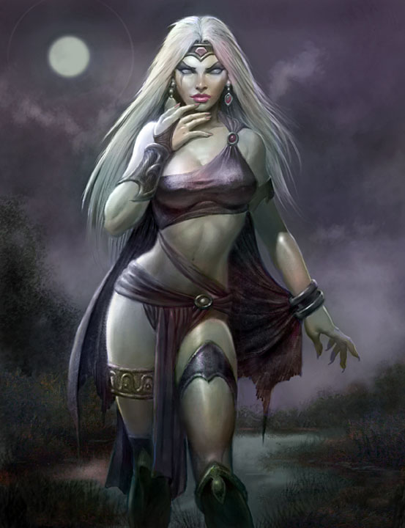
Gnoll soldiers
hp 11
Init +0
Spd 30 ft.
AC 15 touch 10, flat footed 15
Attack battlaxe +3 (1d8+2/x3) or short bow +1 ranged (1d6/x3)
SV Fort +4, Ref +0, Will +0
Str 15, Dex 10, Con 13, Int 8, Wis 11, Cha 8

Special : Dark vision

Skills : Listen +2, Spot +3

Feats: Power Attack (trade ATK bonus for DMG),
(Starting arms and armor) battleaxe, short bow, 20 arrows, leather armor, heavy steel shield
(Starting Equipment) backpack, rope (hemp), flint and steel, trail rations (10 days), water skin, bedroll, fishing net, fishhook, whetstone , winter blanket, pouch of hallucinogenic herbs, pipe
Notes: each bears the mark of the coyote god

1 – 11
2 – 12
3 – 13
4 – 12
5 – 11
6 – 10
7 – 9
8 – 10
9 – 11
10 – 12
11 – 13
12 – 14
13 – 15
14 – 14
15 – 13
16 – 12
17 – 11
18 – 10
19 – 9
20 – 10

Priests of Coyote
Waboyan, Chowilawu, Usti, Paytah, Matoskah : male human Clr3: CR 3; Size M (5 ft., 8 in. tall);
HD 3d8; hp 18
Init +2 (+2 Dex); Spd 30 ft.;
AC 14 (+2 Dex);
Attack +5 melee, or +4 ranged;
SV Fort +2, Ref +3, Will +7;
Str 17, Dex 15, Con 10, Int 15, Wis 18, Cha 15.

Languages Spoken: Common, Gnoll, Goblin.
Skills and feats: Diplomacy +11, Heal +9, Hide +2, Knowledge (Arcana) +6, Knowledge (History) +7, Knowledge (The Planes) +8, Listen +4, Move Silently +2, Spellcraft +6, Spot +4; Combat Casting, Extend Spell, Skill Focus (Diplomacy).
Possessions: 2,500 gp in gear.
Cleric Domains: War, Trickery
Cleric Spells Per Day: 4/3+1/2+1
Orisons – detect magic, detect poison, guidance, light, mending, read magic, resistance, virtue
1st level spells – bane, cause fear, bless, obscuring mist, sanctuary / disguise self
2nd level spells – silence, darkness, death knell, enthrall, sound burst / invisibility

Each carries 10 blood garnets worth 10 gp apiece
Each bears leather armor (mundane, decorated in orange coyote symbols and bright blue feathers), a masterwork greatclub, ceremonial dagger with poison reservoir, bag of hallucinogenic powder

Coyote’s Thrall: bright, royal blue powder is made from the pollen of blue flowers in the region. The target must make a DC 15 WIS saving throw or else enter a pleasant twilight state for 1d4 hours, during which the body is still fully functional, as if the mind wandered off somewhere and the body became a functional zombie. While in this state, the target is extremely open to suggestion, as if under the effects of a Charm Person spell. When the effect wears off, the target has no memory of anything that occurred during the episode. This only affects Humanoid types, regardless of immunity to Charm since the mechanisms of action are different from spells.

Loot on the priests (claimed by the party)
potions
potion of clairaudience/clairvoyance (300 gp)
potion of endurance (300 gp)
potion of enlarge (at 5th level) (250 gp)
scrolls
divine (175 gp)
Magic Stone (l1, cl1)
Chill Metal (l2, cl3)
arcane (175 gp)
Forceful Footfalls (l2, cl3)
Change Self (l1, cl1)
arcane (150 gp)
Cat's Grace (l2, cl3)
arcane (50 gp)
Grease (l1, cl1)
Charm Person (l1, cl1)
Wands
Burning Hands (l1, cl1) (1 charges) (15 gp)
Detect Secret Doors (l1, cl1) (26 charges) (390 gp)
Cure Moderate Wounds (l2, cl3) (18 charges) (1,620 gp)
Cure Moderate Wounds (l2, cl3) (36 charges) (3,240 gp)
Shatter (l2, cl3) (8 charges) (720 gp)
wondrous item
gloves of swimming and climbing (6,000 gp)
goggles of minute seeing (1,000 gp)
horn of goodness/evil (6,000 gp)
golembane scarab (iron) (1,600 gp)

GROUND LEVEL
1a – Foyer – six alcoves containing statues of Haka’Na deities. Each radiates a muted magical aura of neutral good but with no overt effects. The careful observer (Spot DC10) will note each one has their eyes concealed by a thick, dark muck.
- Corn Mother – fertility and harvest
- Tatanka Ska – the great white buffalo – god of the hunt
- Saqsakaew – the great heron – good luck
- Malina – goddess of the moon and warden of this palace
- Bear spirit -
- Beaver Spirit – industry, preparation
If a party member offers a prayer to one of the statues after they have been liberated of Osyka’s blight then the god will offer a boon (one per statue, no two to the same person).

1b – Throne Room – this is where the revelers gather each afternoon and feast until late at night. During this time Osyka can be seen seated on her throne at the top of the stairs in 1g with the entry doors thrown open. At night this area is deserted. Pale moonlight shining through the tall side windows faintly illuminates the room.

A large glass dome in the ceiling offers a stunning view of the nighttime sky. A mechanism hangs from the dome with sixteen arms radiating out from a central axis. The arms are of various lengths and are slowly rotating at different speeds. The light of the moon is caught in the gems at the ends of these arms and casts a brilliant pattern of orbs traveling the floor of the throne room.

A careful search of the place will note many ancient markings have been concealed by newer markings that have a sinister feel to them. (If the moonstones are returned to their proper positions in the Moon Phase Chamber the original markings will glow a bright blue light, burning away the ones placed over them.)

Written over the archway on the west are the words in Haka’Na script:

By the stones of the moon
we honor Malina

“By the stones of the moon we honor Malina”

At night this area is warded against intruders. Pressure pads between each pair of columns will activate a trap. Each column has metal blades that will flare up from tiny vertical grooves. Tension springs within the columns cause the blades to spin quickly, cutting everything within five feet at a height of two feet and five feet from the ground.

TRAP: Whirling blades: CR2; mechanical; proximity trigger; automatic reset; hidden lock bypass (Search DC 20, Open Lock DC 20); ATK +10 melee (1d8, scythe); Search DC 15; Disable Device DC 15

1c – Meditation Cell – door is locked – heavy wooden door is magically sealed with a riddle

To enter
walk as if into your past

“To enter walk as if into your past”

A luxurious cushion is laid out on the floor for worshippers to kneel and reflect on the universe. A shaft of light emanates from overhead. A special prism in the ceiling catches the moon’s rays even in daylight and bathes the chamber in the light.
A large rectangular niche features a mural of Malina holding the moon. The moon softly glows and is a trigger to open the secret door behind the niche. All those passing a Wisdom check of 15 will accept the peace that comes over them, enjoying a +4 to Wisdom rolls and +2 to Will saves for one week. They will also heal 2d8 hit points of damage magically. This only applies to non-evil characters.
- Secret door – this leads to a reliquary of Malina, a short sword that glows bright blue and emanates moon beams as a ray on command three times per day. Functions as a +1 short sword that causes an extra 1d8 damage against lycanthropes and undead. Ray operates as searing light spell.
- Scrolls
- divine (150 gp)
- Summon Swarm (l2, cl3)
- divine (75 gp)
- Detect Chaos (l1, cl1)
- Detect Law (l1, cl1)
- Magic Weapon (l1, cl1)



1d – Cleansing Cell – This is a plain square cell with a drain in the floor and holes in the ceiling above. A large rectangular niche features a mural of Malina holding the moon. The moon softly glows and is a trigger to open the secret door behind the niche. three elaborately decorated levers are mounted on the wall, each with a carved figurehead. Pulling each of the levers will operate one of three magical effects:
- Fish – a heavy torrent of water will erupt from overhead, flooding the chamber but without drowning the occupant; the occupant will notice the floor opens up with only the space beneath their feet remaining intact. The water disappears into the depths before the floor closes back up moments later.
- Sparrow – a heavy gust of wind fills the chamber, drying all moisture including any from the magical shower triggered by the fish. There is a 10% chance of the character losing an item held in their hand. The item is swept below and lost forever.
- Flower – the occupant is doused in a heady blend of aromatic oils, which will cause them to smell very pleasant for many days. It is also very noticeable to any animals that can detect creatures by scent.

- Secret door – this leads to

  - a reliquary of Malina: a sliver of moonbeam that was left over during one of her visits to this world centuries ago. It has many magical properties, including light on command, greater daylight spell, command over lycanthropes, and the searing light spell. While it cannot harm the undead that are sensitive to the sun, it can cause a fear effect in them with a Save DC of 20 or they must flee.
  - Scrolls
    - divine (50 gp)
      - Faerie Fire (l1, cl1)
      - Invisibility to Animals (l1, cl1)
    - divine (200 gp)
      - Detect Law (l1, cl1)
      - Invisibility to Animals (l1, cl1)
      - Summon Monster II (l2, cl3)

1e – UPPER STAIRWELL - locked heavy wooden door – magic DC 35 – can only be opened when moonlight is shined upon it; the shard of moonbeam will work to open; script on the door reads

MALINAS LIGHT UPON ME

“MALINA’S LIGHT UPON ME”

This area is guarded by a pair of dread guards standing stationary against opposite walls. This is the
upper stairwell to level 2 or down to catacombs.

1f – LOWER STAIRWELL - locked heavy wooden door – magic DC 35 – can only be opened when moonlight is shined upon it; the shard of moonbeam will work to open

MOLINAS LIGHT UPON ME

“MALINA’S LIGHT UPON ME”

This area is guarded by a pair of dread guards standing stationary against opposite walls. This is the lower stairwell to level 2 or down to catacombs.

1g – Main Entrance – double doors: heavy wooden doors, mechanical lock
TRAP Poison Dart TrapCR 1; mechanical; location trigger; manual reset; Atk +8 ranged (1d4 plus poison, dart); poison (bloodroot, DC 12 Fortitude save resists, 0/1d4 Con plus 1d3 Wis); Search DC 20; Disable Device DC 18. Poison: Bloodroot Injury DC 12 1d4 Con + 1d3 Wis
Twin statues of Malina goddess of the moon stand here, arms outstretched; those who take note of the statues will notice (Spot Check DC10) that Malina’s eyes have been covered by a strange dark material.
If the moonstones are placed back in their rightful homes then the eyes will activate and burn away the ooze. Once this happens the statues of Malina will emanate powerful rays of light from the eyes and hands, destroying any evil creature in this area extending all the way to the throne room doors.

1h – Inner Foyer – this leads to a hallway extending 45’ to the west. A silver archway stands 15’ from the door. Beyond the archway, running the length of the hallways, an inky blackness hangs about the floor. If one waits long enough their eyes will adjust to the darkness to see a slender beam of light along the floor. This moonbeam will sustain the weight of anyone walking across it.

Any spell dismissing or removing magic will cause it to wink out for the length of the spell, after which it will return again. Anyone standing on the moonbeam when it goes out is cast into a deep void of darkness below. Only one who knows how to operate the Moon Phase Chamber has a chance of retrieving them from the void.

Gorgeous pictures hang on the walls depicting the stars and the gods and goddesses walking among them. Sculptures set into the walls glow a soft blue light in the darkness. Tiny pendants of crescent moons hang from the ceiling. Disturbing the pendants in any way has a 20% chance of disrupting the moonbeam walkway along this hall.

1i – Horn of Plenty – Opening this door reveals a yawning portal from which blinding warm light emanates. The smells of delicious foods pour out of the portal. Any passing a WISDOM check of DC 15 will be able to see into a realm of plenty: bright green grass stretches out as far as the eye can see, with stacked platters containing every sort of delicious food. Fountains overflow with wine, mead, ale, and every sort of refreshment. Special silver plates and pitchers are stored on shelves inside the door, which can be commanded to fetch the foods seen beyond the portal. But none may enter the portal for fear of being lost within. Anyone setting foot on the grass beyond the portal will be lost forever within this realm. Only one who knows how to operate the Moon Phase Chamber has any chance of retrieving them.

1j – Dread Guard Storage -

1k – Dread Guard Generator -

1l – Vargouille Storage -

1m – Portal to Abyss that generates Vargouilles

1n – outer ring corridor – an arcane eye floats here, moving from one end of the corridor to the other; if it sees an intruder it will sound a magical alarm that can be heard throughout the first level

1o – transverse corridor – this is a dark corridor with large paintings of Malina and the moon, but defaced to show a feral humanoid creature resembling a gnoll menacing the goddess and groping her. Tiny moonbeams project across the floor every ten feet from a height of six inches from the floor. These do nothing, but appear to have once been a magical tripwire of some kind.

1p – Servants Quarters – a half dozen men and women are sleeping here on shabby cots. They are dressed in rags, with their day wear of fancy green ceremonial robes hanging from hooks. They appear starved and will cower in the face of intruders. There are bowls of a strange herb here and incense burners creating a strange smoke. The herbs have dulled their senses even further than this place’s enchantments have. Anyone entering the room must pass a Fortitude Save DC 10 or have their Wisdom and Intelligence reduced by 2 for the next 1d20 hours.

A message scrawled on the wall reads:
“It’s the light of hope that I shine in the dark,
for the shaking ground has left red marks.
And I sway in the wind shaking away the pain,
the petrichor is my companion after the rain.”
- Clod the Unburning – A large, roughly hewn table with “CLOD WUZ HERE” carved into one corner. The table is absolutely and utterly fireproof; even on the elemental plane of fire, it feels cool and firm. It’s also a heavy table.

1q – master bath – this is Osyka’s personal lavatory. A giant claw-foot tub sits here, with warm water bubbling from an overhead spigot. A large full-length mirror stands on the wall opposite of the doorway. The mirror will display whoever stands in its frame as naked and in the most favorable light, even augmenting certain features. The mirror is itself detached from the wall and concealing a secret doorway.
- Secret door leads to: (repository for moonstones) – if the moonstones have already been found, roll for treasure

1r – master bedroom – this is the personal quarters of Osyka the evil priestess. The room, once decorated in silvers and blues, is now festooned in cloth of dark green. A large luxurious bed and other furniture are here. A man is sleeping here, bound by manacles hanging from the headboard. Reclining in either of the far corners are large tigers, Osyka’s pets. They will awake if they hear anything coming through the door and attack if it is not Osyka.

Tiger
Size/Type: | Large Animal
Hit Dice: | 6d8+18 (45 hp)
Initiative: | +2
Speed: | 40 ft. (8 squares)
Armor Class: | 14 (-1 size, +2 Dex, +3 natural), touch 11, flat-footed 12
Base Attack/Grapple: | +4/+14
Attack: | Claw +9 melee (1d8+6)
Full Attack: | 2 claws +9 melee (1d8+6) and bite +4 melee (2d6+3)
Space/Reach: | 10 ft./5 ft.
Special Attacks: | Improved grab, pounce, rake 1d8+3
Special Qualities: | Low-light vision, scent
Saves: | Fort +8, Ref +7, Will +3
Abilities: | Str 23, Dex 15, Con 17, Int 2, Wis 12, Cha 6
Skills: | Balance +6, Hide +3*, Listen +3, Move Silently +9, Spot +3, Swim +11
Feats: | Alertness, Improved Natural Attack (bite), and Improved Natural Attack (claw).
Environment: | Warm forests
Organization: | Solitary
Challenge Rating: | 4
Advancement: | 7-12 HD (Large); 13-18 HD (Huge)
Level Adjustment: | —
These great cats stand more than 3 feet tall at the shoulder and are about 9 feet long. They weigh from 400 to 600 pounds.

Combat

Improved Grab (Ex)
To use this ability, a tiger must hit with a claw or bite attack. It can then attempt to start a grapple as a free action without provoking an attack of opportunity. If it wins the grapple check, it establishes a hold and can rake.

Pounce (Ex)
If a tiger charges a foe, it can make a full attack, including two rake attacks.

Rake (Ex)
Attack bonus +9 melee, damage 1d8+3.

Skills
Tigers have a +4 racial bonus on Balance, Hide, and Move Silently checks. *In areas of tall grass or heavy undergrowth, the Hide bonus improves to +8.

1s – master closet – Osyka’s extensive wardrobe, filled with gowns and raunchy garments. Everything is of the highest quality and decorated in bizarre geometric patterns. Across from the door is a large full-length mirror. The mirror is enchanted. A soft feminine voice will coo with admiration over whoever stands before it. It will answer commands to fetch any item in the closet but becomes annoying as it offers one piece of fashion advice after another. The mirror is itself detached from the wall and conceals a secret door.
- Secret door leads to: (repository for moonstones) – if the moonstones have already been found, roll for treasure
- A six-pack of potions tied together. A note on one of the potions reads “This One Isn’t Poisoned!” The note magically moves between bottles when unexamined. The potions refill every evening at dusk.
- A wand that can give a wish at whoever is targeted but it got mixed up with 20 other wands some possibly deadly.
- Illegal alcoholic beverages spiked with Illithid blood. It is said to have a strong hallucinogen effect when consumed.

1t – priestess’ quarters – the three female acolytes of Osyka are asleep here. A large mirror hangs on the wall opposite the door and is tilted at an angle.

Each is armed with an amulet of greater charm person. Casting is a free action and must be done while locking eyes or within earshot. Anyone failing a Will save DC 17 is completely charmed, meaning they will do anything including turning on friends or even harming themselves. This is stronger than the standard spell, but comes at a cost. Each time the amulet is used there is a 1% cumulative chance that the user will be rendered permanently charmed themselves and open to suggestion from anyone around them.

Items within the room:
- Seventeen Key Ring- Each key has a 5% chance of opening a lock you find. Once a key has opened something, it will not fit any other lock.
- The Loud Coin- This grimy copper coin, when thrown on the ground, loudly comments on everything within 60 feet of it in Common, giving an accurate (if unflattering) description of the room and all its occupants.

- Secret door leads to: (repository for moonstones) – if the moonstones have already been found then ignore
- Sack of gold – 120 gp
- Potions
- potion of speak with animals (300 gp)
- potion of spider climb (50 gp)
- Ring of Forgetfulness – CURSED ITEM – anyone who puts on this ring must pass a Will Save DC 12 or be struck with permanent amnesia, forgetting who they are and anything of their lives but maintaining their skills and alignment
- Scrolls
- divine (50 gp)
- Faerie Fire (l1, cl1)
- Invisibility to Animals (l1, cl1)
- divine (150 gp)
- Summon Monster II (l2, cl3)

1u – priests’ quarters – the three male acolytes of Osyka are asleep here. It reeks of incense here, which covers the order of horrible body odor. Each looks unhealthy and in truth they have a strange skin affliction which may be contagious. They will rouse and beg for their lives, but not before throwing themselves on the party and clinging to them uncomfortably while lisping their pleas in ridiculous fashion. Anyone touched by them must pass a Fortitude Save DC 10 versus permanent stench.
- Potions
- potion of spider climb (50 gp)
- potion of vision (150 gp)
- Scrolls
- divine (300 gp)
- Hold Person (l2, cl3)
- Chill Metal (l2, cl3)
- divine (150 gp)
- Flaming Sphere (l2, cl3)
- A book full of strange markings said to have been taken from the dead head of a cult. In reality, it was a book scribbled in by a toddler.
- The Left Hand of Maaug – A large gauntlet covered in blades. It weighs a good 25 lbs., and as such is all but impossible to wear.

1v – holy instruments storage – this was once the storage place for the holy instruments of the Temple of Malina. It is now ransacked, with all of the items destroyed and desecrated and littering the floor. A recessed niche stands on the wall opposite of the door leading into this room. The niche features a mural of Malina standing on the moon, her light shining down on the people and animals of the world. The moon glows a soft blue light. It is in fact a trigger to open a secret door behind the niche.
- Secret door leads to:
  - ancient codex that illustrates how to operate the Moon Phase Chamber
  - ring of protection +1 (2,000 gp)
  - ring of protection +2 (8,000 gp)
  - potion of blur (300 gp)
  - potion of charisma (300 gp)
  - potion of cure light wounds (50 gp)
  - potion of cure moderate wounds (300 gp)

1w – Library – this was once a library housing writings from all over the Haka’Na lands. The shelves are in ruins now, with tatters of pages littering the floor. A tiny figure huddles in a dark corner, chewing on paper. It is an Alpha Quasit, a tiny demon that has found the ability to eat magical writings and actually grow from their power. He has now grown to the size of a halfling and is able to cast spells like a 1st level sorcerer. Within its guts is a magic ring of forgetfulness.

Quariust - Sorcerer Spells Known (5/4): 0th -- Acid Splash, Arcane Mark, Daze, Ray of Frost. 1st -- Shocking Grasp, Summon Monster I. Fear spell, invisibility

Items that can be found here in a DC 20 search:
- Scrolls:
- arcane (150 gp)
- Darkvision (l2, cl3)
- arcane (150 gp)
- Summon Monster II (l2, cl3)
- arcane (175 gp)
- Charm Person (l1, cl1)
- Summon Swarm (l2, cl3)

- The rear stairwell stands here and leads up to 2nd level

SECOND LEVEL

2a – Party Room – this used to be a lovely study with a balcony overlooking the Horn Valley. It has now been turned into a place of dark revelry. Dark green sashes hang from the ceiling, paintings and statuettes of lewd figures decorate the walls. Crystals in the ceiling pulse and flicker with eerie green light, making it difficult to see. Large mattresses are scattered on the floor next to overturned flagons of wine. Six naked men and women lie sleeping on the mattresses, denizens of this place.

The four columns here are caryatid constructs guarding this room. Any attempt to move to the eastern side of the room will activate them.

With its feet planted firmly together, this marble statue of a female warrior holding a stone sword rises up to support the ceiling.

Caryatid Column CR 3

XP 800
N Medium construct
Init -1; Senses darkvision 60 ft., low-light vision; Perception +0

AC 14, touch 9, flat-footed 14 (-1 Dex, +5 natural)
hp 36 (3d10+20)
Fort +1, Ref +0, Will +1
DR 5/—; Immune construct traits, magic
Defensive Abilities shatter weapons

Speed 20 ft.
ATK Melee mwk longsword +8 (1d8+4/19-20)

Str 18, Dex 9, Con —, Int —, Wis 11, Cha 1
Base Atk +3; CMB +7; CMD 16 (cannot be disarmed)
SPECIAL ABILITIES

Immunity to Magic (Ex)
A caryatid column is immune to any spell or spell-like ability that allows spell resistance. In addition, certain spells and effects function differently against the creature, as noted below.

A transmute rock to mud spell deals 1d6 points of damage per caster level to a caryatid column, with no saving throw. Transmute mud to rock immediately heals any and all damage currently suffered by a caryatid column. A stone to flesh spell does not actually change the column’s structure but negates its damage reduction and immunity to magic for 1 round.
Shatter Weapons (Ex)
Whenever a character strikes a caryatid column with a weapon (magical or nonmagical), the weapon takes 3d6 points of damage. Apply the weapon’s hardness normally. Weapons that take any amount of damage in excess of their hardness gain the broken condition.

Statue (Ex)
A caryatid column can stand perfectly still, emulating a statue (usually one that is holding up the ceiling, like a carved column). An observer must succeed at a DC 20 Perception check to notice the caryatid column is alive. If a caryatid column initiates combat from this pose, it gains a +6 bonus on its initiative check.

Caryatid columns are the lesser cousins of true golems, constructs created by spellcasters to guard objects or areas. Unlike true golems, caryatid columns cannot be made into shield guardians, but they are often used in greater numbers because of their relatively inexpensive creation cost. Each caryatid column is programmed to guard an object or area when created, and once set, this command cannot be changed. Caryatid columns are often given specific parameters concerning whom to ignore and whom to attack, but since they have no special form of detection, such restrictions can be overcome with disguises if the parameters are known.

A caryatid column stands 7 feet tall and weighs 1,500 pounds. Caryatid columns are always equipped with a masterwork weapon that appears to be made out of stone as long as the construct remains in statue form. The weapon can be recovered after a caryatid column has been defeated. Arming a caryatid column with magical weapons is expensive but feasible—even the most powerful of magic weapons appear as nothing more than stone when held by a caryatid column. Since a weapon held in this manner does not radiate magic, many use this trait as a method to hide potent or powerful weapons from both casual observation and study via detect magic. True seeing reveals such disguised weapons for what they really are. Often, only particularly powerful caryatid columns (typically those with advanced Hit Dice, but rarely those made much larger than Medium size) are entrusted with the care and protection of such weapons. Of course, the constructs themselves make full use of any magic weapons they are given to guard.

stairwell – (leading down to library and up to the Chamber of the Moon Phases)
The stairwell has a heavy wooden door barring entry into the 2nd level. The door is locked with a magic puzzle. An inscription reads:

A TOKEN OF LOVE WILL PASS

“A TOKEN OF LOVE WILL PASS”

From low to high will bring you nigh

From low to high will bring thee nigh

From tall to short will take thee forth

From tall to short will take the forth

This room around the stairwell is guarded by two boneclaw creatures that have been petrified.

2b – balcony – a host of quasits hang here, disguised as bats. They will attack anyone who enters the balcony.

2c – Treasury –
The hallway outside the treasury is trapped. A pressure pad just in front of the door will trigger the floor on either side of the pad to tilt, inclining towards the entrances. Grease will shoot out from tiny pipets in the walls to render the floor slick. Characters failing to make a successful Reflex save DC 20 will tumble downward to waiting pits.

The actual entrance into the treasury is barred by a heavy wooden door locked with a magic puzzle. An inscription reads:

ONLY THEY WHO ARE NAMED
MAY ENTER

“ONLY THEY WHO ARE NAMED MAY ENTER” (only allows passage to anyone given a Haka’Na name)

- 10 sacks with 100 gp each
- 22 sacks with 100 sp each
- 5 sacks of 20 platinum pieces each
- Chest with 21 gems worth 50 gp each
- Chest with 14 gems worth 100 gp each
- Chest with 6 gems worth 250 gp each
- armor
- buckler +1 (1,165 gp)
- full plate +1 (2,650 gp)
- full plate +1 (2,650 gp)
- half-plate +1 (1,750 gp)
- hide armor +1 (1,165 gp)
- large steel shield +1 (1,170 gp)
- large steel shield +1 (arrow deflection) (9,170 gp)
- large steel shield +2 (4,170 gp)
- potion
- potion of darkvision (300 gp)
- potion of darkvision (300 gp)
- potion of delay poison (300 gp)
- potion of hiding (150 gp)
- potion of hiding (150 gp)
- potion of jump (50 gp)
- potion of jump (50 gp)
- potion of sneaking (150 gp)
- potion of sneaking (150 gp)
- potion of spider climb (50 gp)
- potion of vision (150 gp)
- rings
- ring of climbing (2,000 gp)
- ring of feather falling (2,200 gp)
- ring of minor elemental resistance (acid) (16,000 gp)
- ring of protection +1 (2,000 gp)
- ring of sustenance (2,500 gp)
- scrolls
- arcane (150 gp)
  - Web (l2, cl3)
- arcane (150 gp)
  - Blur (l2, cl3)
- arcane (150 gp)
  - Levitate (l2, cl3)
- arcane (450 gp)
  - Darkvision (l2, cl3)
  - Misdirection (l2, cl3)
  - Invisibility (l2, cl3)
- arcane (150 gp)
  - Blur (l2, cl3)
- arcane (25 gp)
  - Detect Undead (l1, cl1)
- arcane (50 gp)
  - Grease (l1, cl1)
  - Unseen Servant (l1, cl1)
- arcane (525 gp)
  - Arcane Lock (l2, cl3)
  - Spectral Hand (l3, cl5)
- arcane (175 gp)
  - Mirror Image (l2, cl3)
  - Spider Climb (l1, cl1)
- arcane (325 gp)
  - Misdirection (l2, cl3)
  - Spectral Hand (l2, cl3)
  - Silent Image (l1, cl1)
- divine (150 gp)
  - Undetectable Alignment (l2, cl3)
- divine (25 gp)
  - Detect Law (l1, cl1)
- divine (300 gp)
  - Barkskin (l2, cl3)
  - Silence (l2, cl3)
- divine (325 gp)
- Silence (l2, cl3)
- Spiritual Weapon (l2, cl3)
- Magic Weapon (l1, cl1)

- wands
- Burning Hands (l1, cl1) (30 charges) (450 gp)
- Charm Person (l1, cl1) (44 charges) (660 gp)
- Color Spray (l1, cl1) (13 charges) (195 gp)
- Cure Moderate Wounds (l2, cl3) (16 charges) (1,440 gp)
- Hold Person (l2, cl3) (14 charges) (1,260 gp)
- Invisibility (l2, cl3) (2 charges) (180 gp)
- Levitate (l2, cl3) (50 charges) (4,500 gp)
- Magic Missile (l1, cl1) (37 charges) (555 gp)
- Mirror Image (l2, cl3) (13 charges) (1,170 gp)
- Silence (l2, cl3) (13 charges) (1,170 gp)
- Silence (l2, cl3) (24 charges) (2,160 gp)
- weapons
- bastard sword +1 (2,335 gp)
- bastard sword +2 (23,335 gp)
  - Int: 15 (2)
  - Wis: 10 (0)
  - Cha: 13 (1)
  - Ego: 7
  - Communication: empathy
  - Alignment: lawful neutral
  - 'locate object' in 120-ft. radius
  - 'cure light wounds' (1d8+5) on self (1 per day)
- composite longbow +1 (17,400 gp)
  - Int: 9 (-1)
  - Wis: 9 (-1)
  - Cha: 15 (2)
  - Ego: 6
  - Communication: empathy
  - Alignment: chaotic neutral
  - detect opposing alignment at will
  - 'telepathy' (100 ft. range) (2 per day)
- 33 crossbow bolt +1 (2,333 gp)
- gnome hooked hammer +1 (2,620 gp)
- greataxe +2 (8,320 gp)
- greatsword +1 (2,350 gp)
- heavy mace +1 (throwing) (defending) (18,312 gp)
- mighty composite longbow (+1 Str bonus) +1 (2,500 gp)
- mighty composite longbow (+3 Str bonus) +1 (2,700 gp)
- shortspear +1 (2,302 gp)
- sheds light in a 20-foot radius (as a torch)
- sickle +2 (8,302 gp)
- wondrous items
- bead of force (2,000 gp)
- bracers of armor (+1) (1,000 gp)
- cloak of elvenkind (2,000 gp)
- glove of storing (2,200 gp)
- golembane scarab (iron) (1,600 gp)
- golembane scarab (stone) (1,200 gp)
- hand of the mage (1,000 gp)
- helm of comprehending languages and reading magic (2,600 gp)
- horseshoes of speed (1,900 gp)
- Quaal's feather token (anchor) (50 gp)
- Quaal's feather token (fan) (200 gp)
- stone of alarm (1,000 gp)
- universal solvent (2,000 gp)
- Sundry Items
- The Bell of Beloved Fortune- Said to bring true love- to your best friends- when rung. Does not actually provide any romantic benefit to the owner.
- Periapt of Porcine Attraction – This amulet makes the wearer adorable to pigs, boars, and similar beasts. The animals will not harm the wearer, nor are they romantically interested; instead, they simply cuddle up to the wearer and stare at them lovingly.

2d – hallway connecting to the upper stairwell
Door locked DC25 to open
Hallway is filled with strange mists. Tiny points of light float in the air. Anyone passing through here will attract the points of light, which will attach themselves harmlessly until removed. The lights will keep returning to cling to the person until they exit back into the main circular area to the west.

2e – hallway connecting to the lower stairwell
Door locked DC25 to open
Hallway is filled with strange mists, flickering lights, and a mournful sound that may be the wind. Tiny points of light float in the air. Anyone passing through here will attract the points of light, which will attach themselves and burn the skin, causing 1d4 points of damage. There are 4d20 of these points of light here. Characters will each attract an equal number of the lights, so divide the total by the number in the party to determine how many attack. These lights are normally harmless, but this hallway leads to the ruptured stairwell and is malfunctioning.

2f – upper stairwell – guarded by three dread guards who stand motionless here
Doorway is trapped: Extended Bane Trap
CR 3; magic device; proximity trigger (detect good); automatic reset; spell effect (extended bane, 3rd-level cleric, DC 13 Will save negates); Search DC 27; Disable Device DC 27. Cost: 3,500 gp, 280 XP.

WHERE does truth lie

Where does truth lie

The person must press their chest to the door for their heartbeat to be felt/heard.

2g – lower stairwell – guarded by three dread guards who stand motionless here
Doorway is trapped: Ghoul Touch Trap
CR 3; magic device; touch trigger; automatic reset; spell effect (ghoul touch, 3rd-level wizard, DC 13 Fortitude save negates); Search DC 27; Disable Device DC 27. Cost: 3,000 gp, 240 XP.

What instrument can be heard but not seen?

What instrument can be heard but not seen?

Your voice

THIRD LEVEL

3a – Moon Phase Chamber –

The entry from the stairwell is a locked, impassable door that, when touched, chimes and says, "Password, please." On the wall is a large, onyx pyramid that, when touched, steals the spirit of the person who touched it and randomly injects the spirit of one of its other captives into the vacant body. One of these souls knows the password, and a number of them are violent, insane, or previous adventurers with their own agendas who won't be too keen on giving up the body they're in.

List of Souls in the Obelisk (roll d20 each time someone touches the obelisk:
(note to send the player:

(you have now been possessed by another person. Below is a brief description of the person.
The primary motivation of the person is to stay in the body now that they're free, so they will pretend to be who you were.
They may be good or evil but they will make up any story to stay in the body.
Use a crazy accent based on where they are and color their story with biases from their background
that would offer a clue as to who they really are.

1 - crazy, homicidal escaped criminal named Gourd from Plenia (french accent): all he wants is to draw blood then he'll return to the obelisk
2 - a deranged drow named Drizzt: all he wants is a hug, then he'll return to the obelisk
3 - a horny halfling named Berfin: all he wants is a kiss, then he'll return to the obelisk
4 - a peace loving orc name Klogol: all he wants is a taste of marrow, then he'll return to the obelisk
5 - a drunken sailor from Lost Anchor (sailor accent): all he wants is a drink, then he'll return to the obelisk
6 - a shifty merchant from Darmidia (arabian accent): all he wants is a gold coin, then he'll return to the obelisk
7 - a young noble from Mahabar named Ghidyan (indian accent): all he wants is a whif of perfume, then he'll return to the obelisk
8 - a thief from Hyderis named Hasken (russian accent): all he wants is a token of affection, then he'll return to the obelisk
9 - an anti-paladin from Ongolk named Sir Raegul (deep voice): all he wants is a sniff of something potent, then he'll return to the obelisk
10 - a druid from Adhanar named Mellowood (normal accent): all he wants is a flower, then he'll return to the obelisk
11 - a grizzled war veteran from Tirudor named Captain Serian (spanish accent): all he wants is a friendly duel with a sword in hand, then he'll return to the obelisk
12 - a water bearer from Tengaibo. Kaduru named Nkami (african accent): all he wants is a foot rub, then he'll return to the obelisk
13 - a courtesan from Kazeldun named Valena (sleezy accent): all she wants is a pretty dress, then she'll return to the obelisk
14 - an alchemist from Treviland named Sordus (british accent): all he wants is a potion of any kind, then he'll return to the obelisk
15 - a necromancer from Celedon named Evrus (italian accent) - has the password "Illuminate": all he wants is someone to lance his boil, then he'll return to the obelisk
16 - a Haka'Na hunter named Na'Oma (native american accent): all she wants is something shiny, then she'll return to the obelisk
17 - a Haka'Na shaman named Kawaithem (native american accent): all he wants is any mild spell cast upon him, then he'll return to the obelisk
18 - a Haka'Na ranger named Hachupu (native american accent): all he wants is a tribal mark made upon him, then he'll return to the obelisk
19 - a demon named Alaxres intent on corrupting others: all he wants is a taste of blood, then he'll return to the obelisk
20 - yourself!

The chamber is a round room 80’ in diameter, with sixteen stone pillars made of the purest white marble standing 10’ inset from the outer wall. There is a soft blue light within the room and a domed ceiling that begins 15’ above the floor and rises to 30’ overhead at its pinnacle. At the center of the room there is a thick silver column that extends up from the floor about 10’, where sixteen smaller rods radiate outward from the column. Each rod is parallel with the ground and of a different length. Each rod ends in a translucent glass sphere, each of a different colored glass but all of them the size of a fist. The mechanism slowly rotates the spheres around the room at different speeds. Ancient markings along the ceiling appear as simple stick diagrams showing people, animals, monsters, symbols.

There are two hidden compartments, one at the base of the central column and another on the east wall. The base compartment contains the set of levers. The compartment to the east holds items used to place the Mooonstones into the colored glass spheres on top of the radial arms.

writing on the items in the eastern compartment:
gloves:
to hold that which cannot be held
to hold that which cannot be held

vials:
to reach what cannot be reached
to reach what cannot be reached

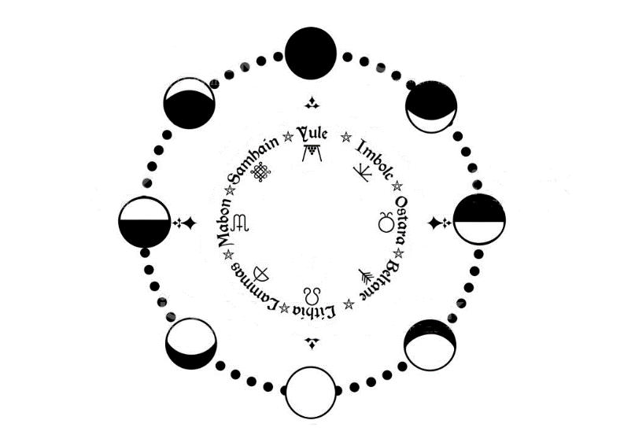
- Stairwell leads down to 2a

3b - upper stairwell – this is a magical stairwell, with steps leading skyward to a star-filled void. This is the only stairwell repaired since the temple’s destruction. Any character who succeeds in a Wisdom check DC 20 has shown the faith to see the divine stairway to the moon. If Osyka is allowed to complete her ritual and the palace is transported to the moon, this stairwell leads back down to Nemmyrl.

3c – lower stairwell – this was the second of two magic staircases that led to the moon. It is now in a state of utter destruction. Light from an unknown source fills the room and flickers on and off. Ten dread guards are stationed here, motionless until someone emerges from the stairwell.

Catacombs
0a – guard room
- lower stairwell leading up

0b – pit of despair

0c – torture chamber

0d – prisoners – denizens of Osyka’s dungeon are imprisoned here, sailors and travelers from all over the world. If the adventurers arrived here by boat, then any surviving crew members can be found here chained up with everyone else. All of the prisoners here are in the full throes of the enchanted song, unable to communicate except for singing the ditty over and over again.

0e – prisoners – same as Od

0f – prisoners – same as Od

0g – trapped area leading to prisoners

0h – guard room
- Upper stairwell leading up

0i – hallway leading to monster’s lair

0j – trapped Moonbeast – the Moonbeast, a creature of old and terrible power, is magically restrained within this room. It is Osyka’s plan to sacrifice the Moonbeast upon reaching the moon, using the power of the stones to overwhelm the beast and cut out its heart. This will occur only if she transports the palace to the moon, aligns the Phase Chamber to the proper position, and places the Moonstones within the eight glass spheres atop the radial fins.

0k – treasury

0l – secret door leads to powerful magic items

0m - treasury

0n – secret door leads to powerful magic items

Appendix : Codex of the Esbats and the Moon Phase Chamber

Esbats are special holidays marked by the position of the moon and observed by Wiccans. In the Moon Phase Chamber the eight phases of the moon are laid out in a circle, as well as the symbols of the eight esbats. A large clockwork mechanism in the room has eight spokes, each of a different length. The purpose of the room is to align the spokes of the wheel in the right configuration befitting the current season to unlock the power of the moon.
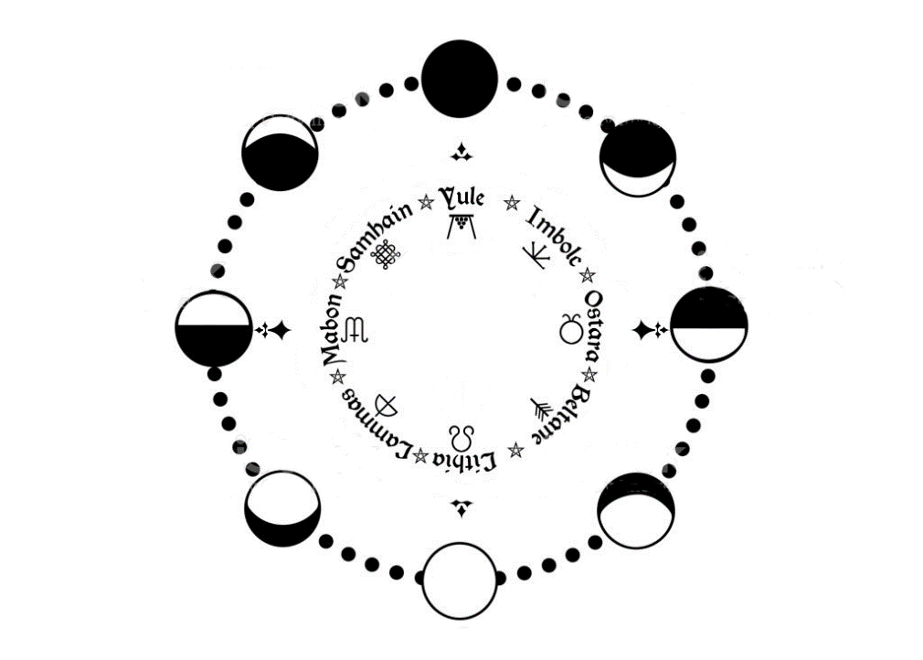
For this encounter, the characters are to align the spokes of the wheel to fit the configuration prescribed for the current. Osyka is attempting to align the spokes in a different, corrupted way, to unlock the power of the Stellar Staircase.

The puzzle works in this way: the Codex Esbats has entries for every day of the year. Under each entry is an incantation in the Haka’Na language that will reveal the arrangement of the spokes to make the room work. The incantation lists the order of the esbats. The clue will tell how the lengths of the spokes relate to the incantation.

The incantation calls for the esbats in this order:

Samhain – Imbolc – Lithia – Mabon – Beltane – Lammas – Ostara – Yule

The clue will dictate which spokes align to these positions.
“the least shall be the first and greatest will be the last”

These clues working together indicate the shortest spoke should point to the first esbat (Samhain), then the next longest (Imbolc), and so on.
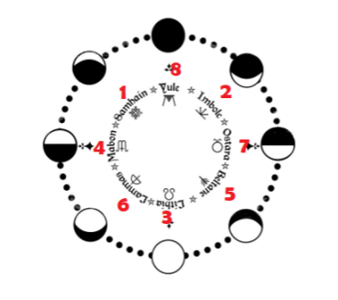

When completed, the spokes will be aligned like the figure below:



Simply put, the spokes should point to the following symbols in this order (shortest spoke to longest spoke):
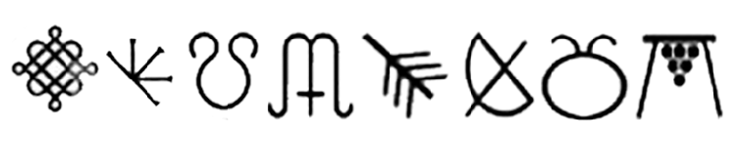

The room itself will only have the symbols to go by. So players must divine the words, then the arrangement of the spokes, then match the symbols to words to decide how to move the spokes.

Lastly, the players must find and learn how to use the control mechanism for the Moon Phase Chamber. Osyka is using her magic to move the spokes. The party will have to use the control panel: eight levers, each of which controls the movement of a spoke. The levers begin at the mid-point of eight horizontal slides. Moving a lever to the left moves a spoke clockwise, moving a lever to the right moves a spoke counter-clockwise. The levers are arranged top-to-bottom from shortest spoke (red lever) to the longest (black lever).

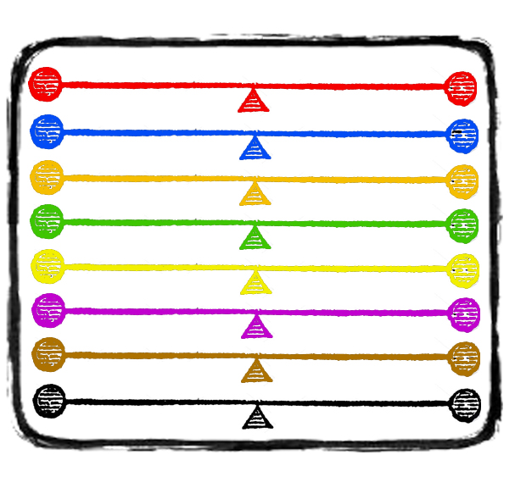

Esbat Codex
The book is divided up into cycles of the year, each with an incantation listed below it. Under the current day’s page is the following recitation:

Oh Samhain you start our journey,

Moving through Imbolc, Lithia, and Mabon.

We transform and fly to Beltane,

We struggle through Lammas and Ostara.

Only in Yule do we find our destination.

For the least shall be first, and the greatest shall be last.

Translated:
Oh Samhain you start our journey,
Moving through Imbolc, Lithia, and Mabon.
We transform and fly to Beltane,
We struggle through Lammas and Ostara.
Only in Yule do we find our destination.
For the least shall be first, and the greatest shall be last.

Haka’Na Alphabet:
A B C D E F
A B C D E F

G H I J K L
G H I J K L

M N O P Q R
M N O P Q R

S T U V W X
S T U V W X

Y Z
Y Z

Appendix 2: More riddles to use when needed

what does truth lie

Where does truth lie: in the heart, the character is to place their chest against the door to let their heart be heard

what can you keep after giving it to someone else

what can you keep after giving it to someone else: a promise

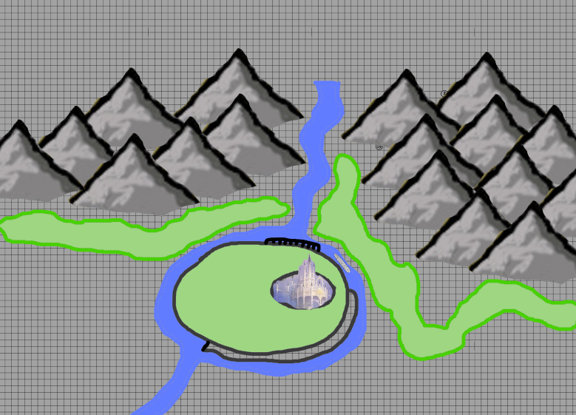
Map of the butte where sits the Palace of the Moon, along with the river flowing out of the mountains and around it. The river flows south through the Horn Vale.

Moon Phase Chamber – as the characters find it (colored dots for reference to keep the battle map clear)
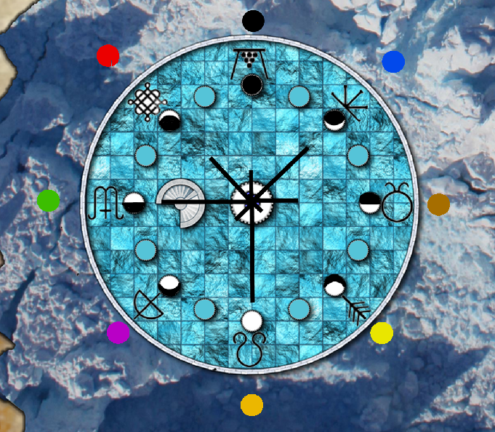

Moon Phase Chamber – in solved position (colored dots for reference to keep the battle map clear)

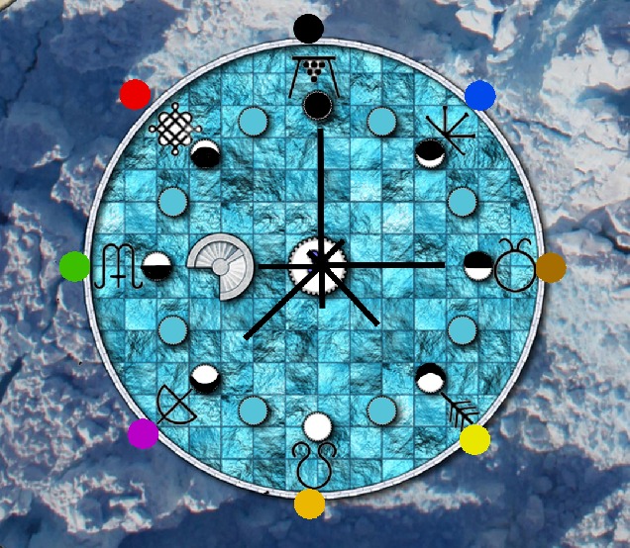

Levels
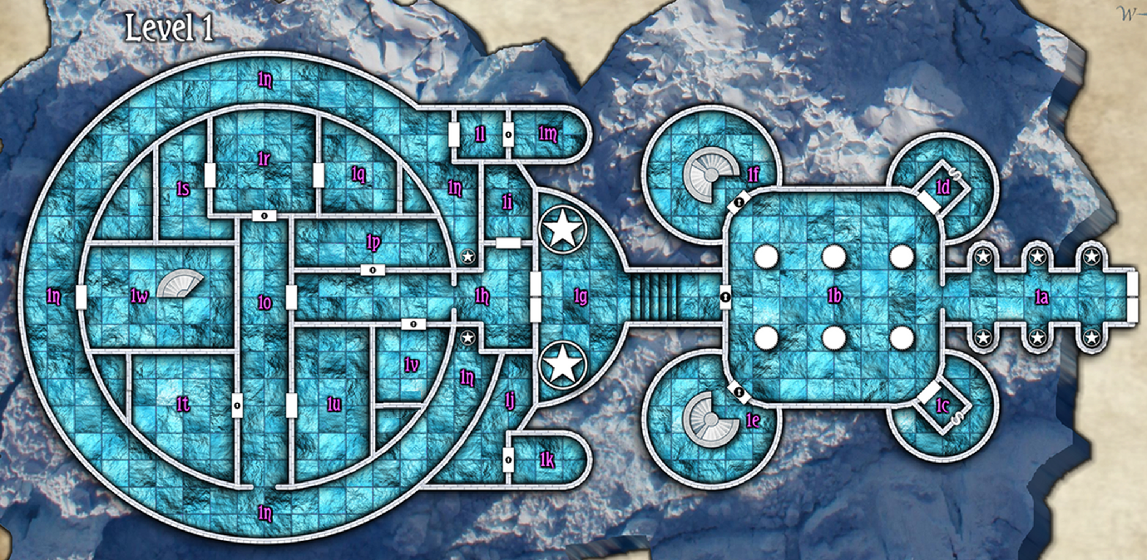
Level 1

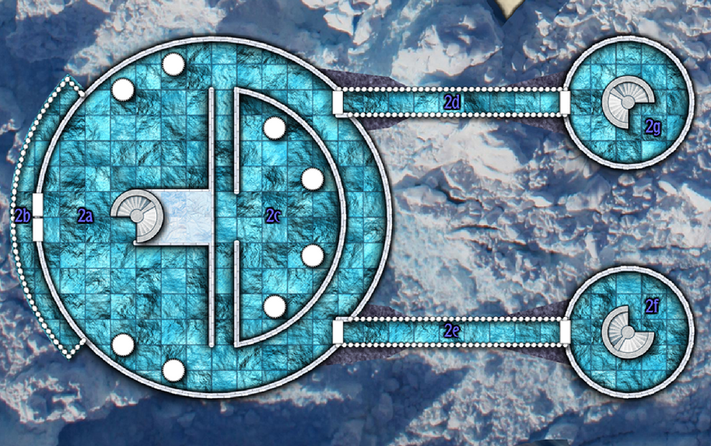
Level 2

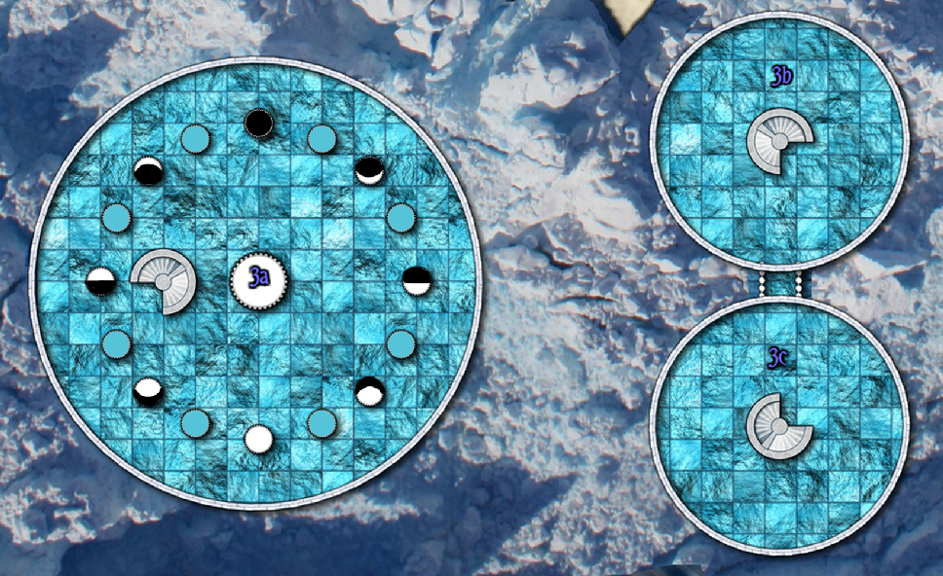
Level 3

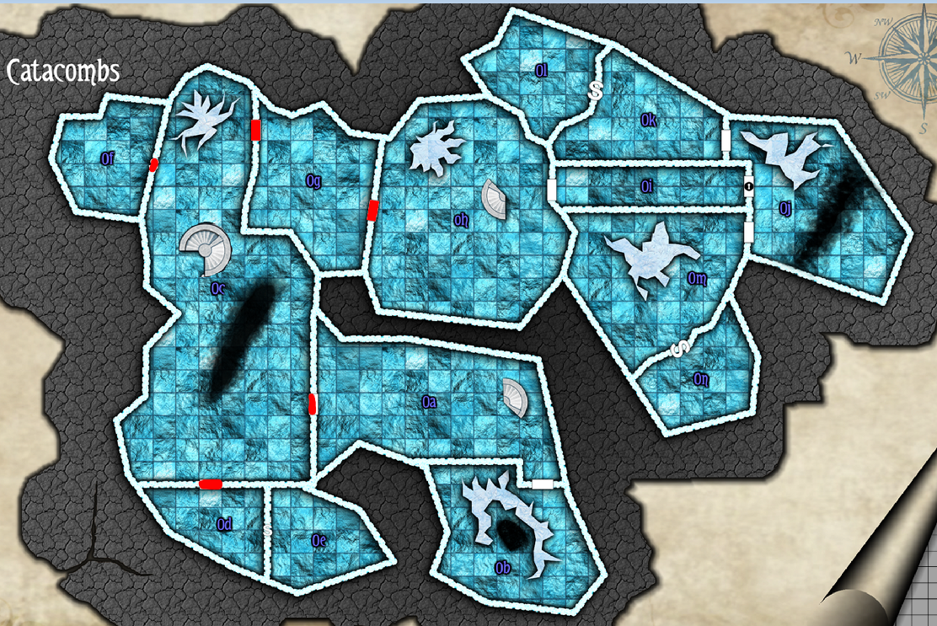
Level 0 – Catacombs

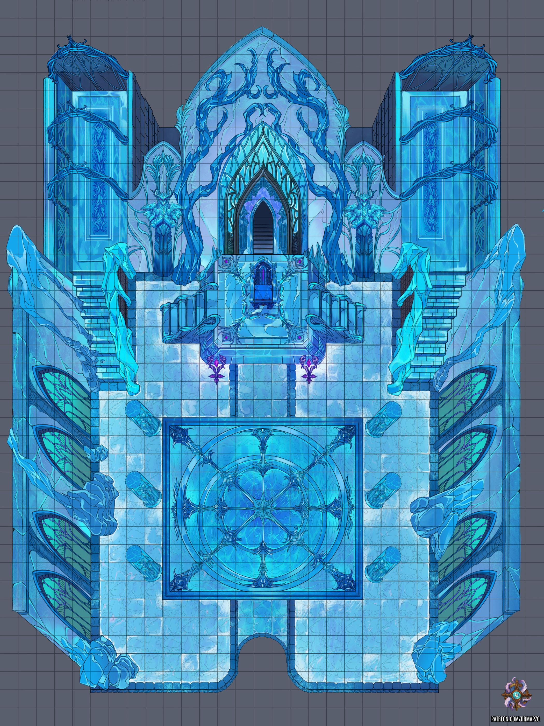
Throne Room of the Moon Palace

Verse to be read complete and in order to break the enchantment of the Coyote Song

