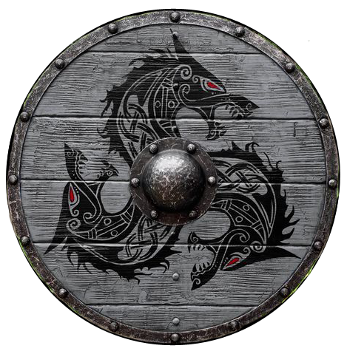

It is the fiftieth year of the Fourth Written Age. Our story begins in Kolheim, a fishing village in Norgarde nestled in the Geirodur Fiords. It is a poor village, barely making a living from the few farms nestled in warm valleys amidst the hills, as well as what the fishing boats bring in. It is wild country, beset by wolves who seem to plague Kolheim like angry spirits. But the people here are proud and hard working.

Upriver from Kolheim is the much larger town of Jotunn. In recent years Jotunn’s jarl, **Hrolf Guthrum**, has made trouble for the poor village, as he seeks to consolidate power in the region. Spring raids have cost the Kolheim harvests, fighting men, and boats.

Last autumn **Arnfinn Vikarsson**, Kolheim’s chieftain, sent envoys to Jotunn. Jarl Hrolf sent the messengers back with their breeches torn, exposing their backsides. It was a clear message that Hrolf found Kolheim weak and unworthy of Kord’s protection. Arnfinn fumed at the insult but took the charge of weakness personally. He spent all winter scheming how to restore Kolheim’s honor.

In the darkest night of winter the village seer, **Arnora**, came to Arnfinn’s hall with a vision. In her dreams Arnora had seen an old fish swim up a stream and speak to her. It told her it was a lucky fish, and that she could stand on its back and it would hold her. If she were to hold her courage through the many things it showed her, it would bring luck and fortune to her and her people. The next day, a Norgardian longboat washed up on the shore outside Kolheim, half encased in an ice floe. It was a proud vessel, but very old. Onboard the crew was all dead and there were signs of battle all over.

Arnfinn was confident it was a sign of the gods. He christened the ship the **Herlighet**, naming it Fortune. He has called on every able bodied man and woman to take part in a journey to seek out danger and fortune and save the village through acts of valor. A bull was sacrificed and Arnora prayed to the gods. As she prayed, the season’s first rain fell…and it was blood.

Now the fate of Kolheim is set in motion. The Herlighet and its crew are their best hope for winning the favor of the gods and proving their worth.

Notes: Kolheim has a long history in spite of its small size. Four hundred years ago (665 WA3) Bolverk Steeleyes, a warrior from Kolheim, won renown in the war against the forces of Mortavay in the Second Dark Crusade. He returned a hero and brought back the Horn of Ragneid, enchanted by the war priests he met in the campaign in Amadar. It was used as a clarion call both in the war and back at home during Kolheim’s greatest perils.