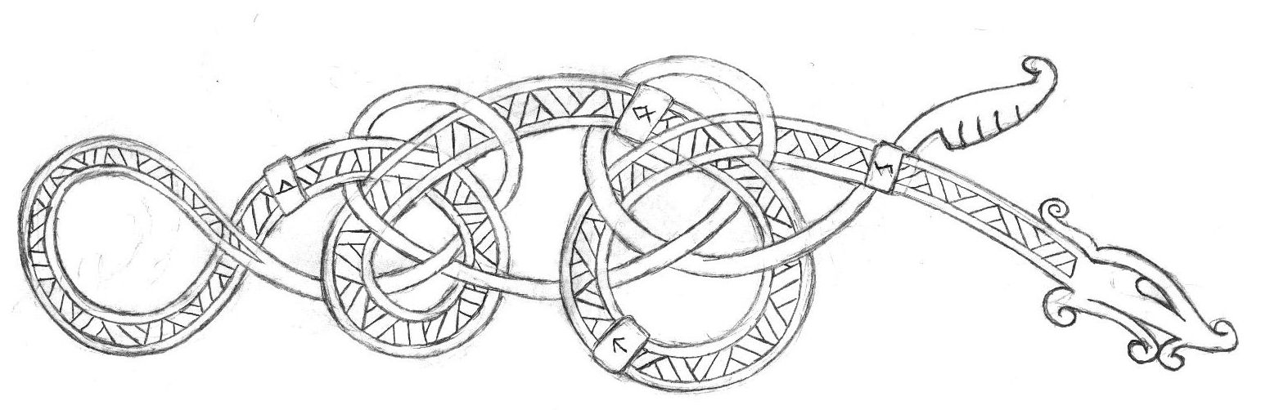

The Journeys of the Herlighet

Introduction
Sullen was the sky the day the boat was boarded. A cold wind blew in from the sea under a pearlescent sky of gray. The villagers gathered at the shore, their brows furrowed and prayers on their lips. They watched as eight and twenty souls took to their oars. It had been a brutal winter for Kolheim. Upriver the town of Jotunn had made its growing power known, raids on the fishing boats and the grain stores. And before that the soil had spurned last year’s seed and left the village clinging to life.

So was it proclaimed by Arnora, reader of bones and Alva of the village, that the gods had spoken. A saga was called for. The people of Kolheim were found wanting in the eyes of Wodan and his host. How could they suffer such indignities from Jotunn without responding in kind? Were these people worthy children of the Aesir? What feats would they recount when they one day stand before the eternal hall?
Thus was an aging longship laden with salted fish, fresh water, and gear enough for thirty. The ship was old, found ten summers ago with a dead crew and abandoned after an unknown sea battle. It would be the vessel to fortune or doom. Arnora lashed its hull with the branches of hemlock, spat the sacred mead on its prow, and uttered the word “Herlighet” to name it “glory.”

The crew was young, save for the captain and the navigator, and green as new wood. But they were stout. They’d been fed well at their mother’s breasts as well as the mead horn, and taught to a man and woman to fight. Now they took up their swords and axes and put behind farming and the raising of sheep. Mothers held forth tokens of Kord for their sons and daughters. Fathers, grim faced and bent with age, solemnly wished them fortune or good deaths.
Thus sailed the Herlighet into the unknown…

Click on the chapters below to go directly to them:
Chapter One : Halslaf’s Keep
Chapter Two : Raid on Sakura
Chapter Three : Raid on Xiandai
Chapter Four : Lair of the Wendigo
Chapter Five : Fellowship with the Haka’Na
Chapter Six : On to Horn Vale
Chapter Seven : Palace of the Moon
Character Accounts

Chapter One : Halslaf’s Keep
Start with max storage of food and water provisions:
14 x 30 = 420 units (1 unit serves one person for one day)
14 x 30 = 420 units (1 unit serves one person for one day)

Rumors of dire things promising fortune:
- An angry ghost of a raider chief Halslaf haunts Bone Bay, guarding his treasure.
- A dreaded sea monster looms in Kapinga Bay, guarding a long lost temple to Kord.
- A sea hag Gereon terrorizes Roskilde Bay to the south and hides a trove of weapons of legend.
- A horde of goblins laden with treasure in Haunted Bay
- An abandoned monastery on the Isle of Algron
The ship sets off for Bone Bay, gets blown off course, then returns to the proper course. During the voyage a mighty storm blows in, dragging crew members overboard and requiring rescue.
X4 scimitars +1
+1 flaming great axe
+1 shield
+1 bastard sword – defender
1280 gp
1660 sp
5 gems worth 100 gp ea
12 arm bands – bronze chased with silver – 50 gp ea
7 days total journey

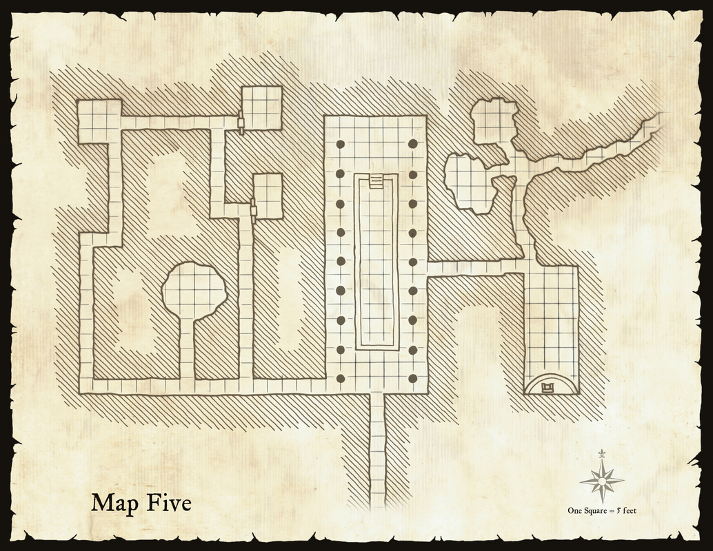

Chapter Two : Raid on Sakura
Meets the Sea Witch Rana – the captain spurned the demand for an offering of gold, thus the witch sent a magical tempest that took them to the far east, where they came upon the lands of Sakura

Village 1
- 48 gold
- 91 silver
- 70 copper
Halmhallur the navigator hears tell of the word “Sakura” uttered by the villagers and correctly guesses the boat has landed in Sakura. He schemes a return home that offers three options. The Captain and crew vote on avoiding the Noreast Jaunt or the Straits of Immolas and instead make for Red Horn, travel up river, portage the boat over to Lone Wolf Lake, then travel by way of Tirawa Sea back to the northern waters.
After five days, the boat finds the lands of Sakura receding to the south and make for the tip of the continent for one last stop to provision. They follow trails of smoke to a village near the coast.

Village 2
- 10 daikyu bows (long bows); 1 bow is +1
- 11 katanas (equiv longsword) ; 2 are +1
- 3 suits of armor (equiv of studded leather)
- 6 suits of armor (equiv of leather armor)
- 5 frog crotch arrows
- 10 whistling arrows
- 5 flaming arrows
- 74 arrows
- 84 copper
- 17 silver
- 93 gold
- 17 gems - 4 green (100 gp), 3 red (50 gp), 10 yellow (10 gp)

After taking on rice and fish, the crew now has provisions of 352 food and plenty of water.
7 days total journey

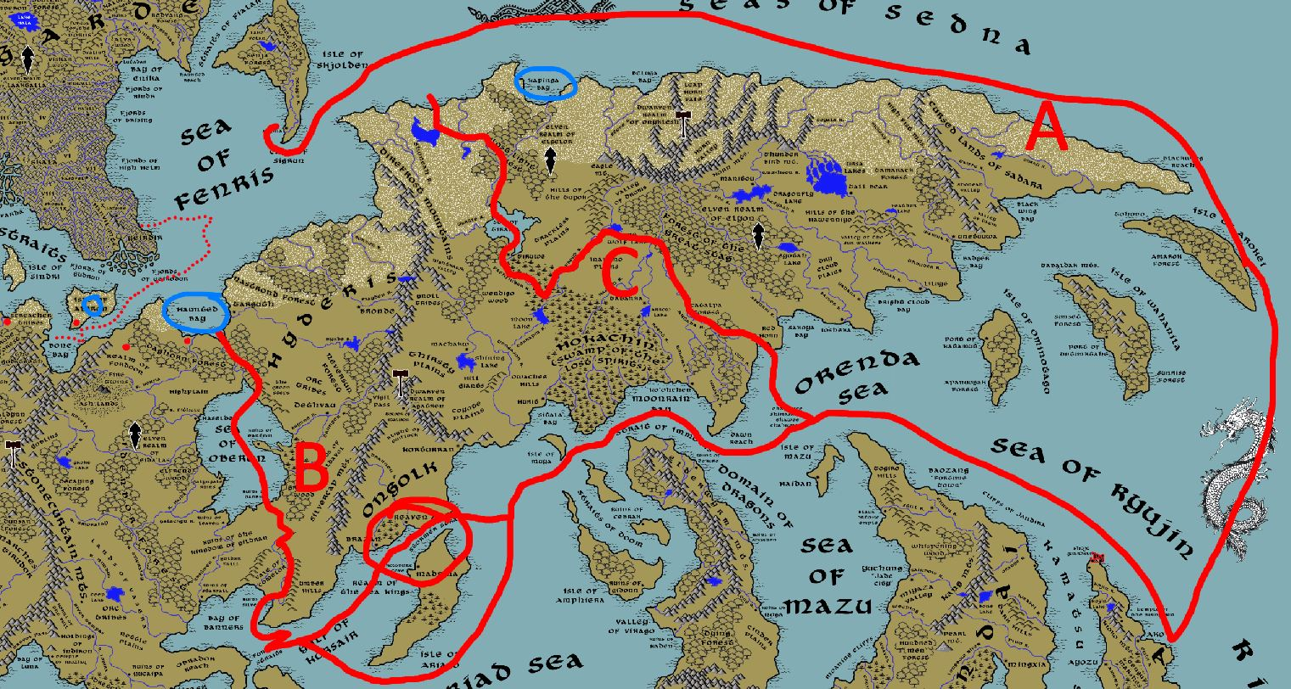

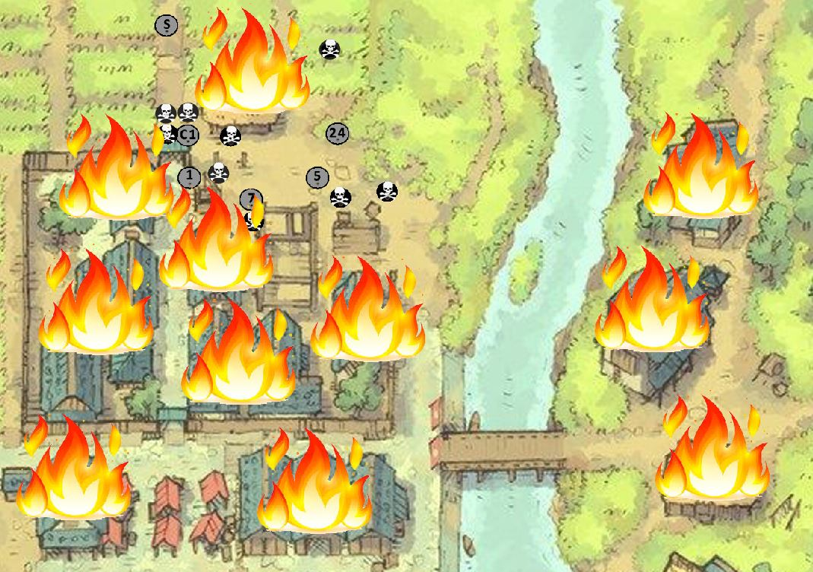
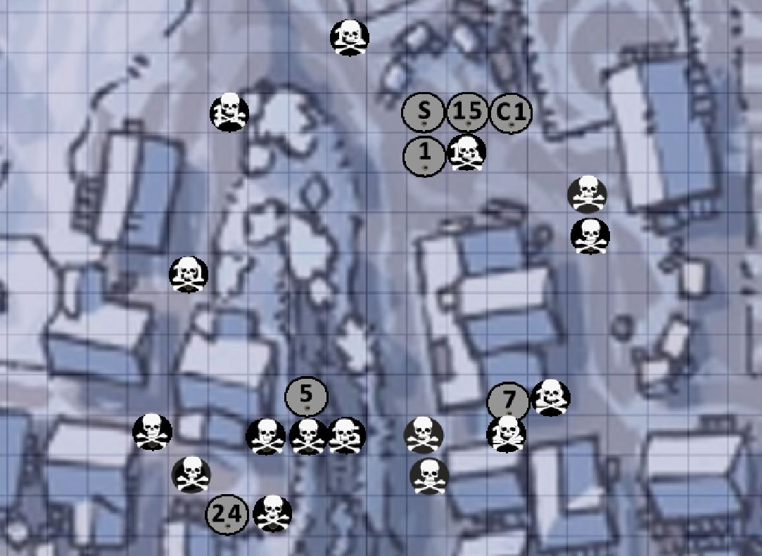

Chapter Three
Soft was the sunrise on the morn of the crew's last day in Sakuran lands. Fresh from the conquest of the sleepy village, they uttered prayers to the unforgiving gods of valor and set sail. Long was the path before them to return to northern waters. But strong were their hearts and songs of battle kept their minds to the oars as they sailed onward.

Two days on a storm of calamitous scale set on them. The hull and mast were lashed like a stubborn thrall. Finnthor, their captain, called out to make for land. Their way was made past the mouth of the Sumatra Straits, nary a merchant nor armed escort in view. Lo they came to the shores of the lands of Xiandai, another far-off eastern realm, and by luck made purchase well past the large settlement some called Fortune Town. For their courage be sound, the Herlighet would not fare well against such numbers.

To work they went on the ribs and planks of the steely ship. Holmhallur the navigator laid out the plan to the chief members of the crew, that their way was well on to Red Horn and the western lands of the Amadar. If only their provisions held and the winds were sweet they would make pass over the Orenda Sea ere the week was out. Geirbera uttered another prayer. From her purse she drew forth two golden Fate Stones, and of their number Finnthor and herself were chosen. At this all marveled, and of them it was Asgrim who seemed to stand taller than the others: for in that moment he was god-touched. So they all gave thanks and set to work.

But the winds were not kind. A storm rolled in the next day at sea, such as only the sagas speak of: planks cracked, oars snapped, and large sums of provender were lost to the depths. Here again they made land, but well on past Xiandai and on the island of Mazu. A small realm to itself, storied for its fishermen and the honors it paid to the gods of the sea.

And so Finnthor drew up and gathered his finest warriors to go forth, for provisions and the taste of victory were in short supply. Into the jungles they drove, marveling at the broad-leafed trees that grew there and the dampness of its heat. Unrelenting, they hunted as the Norgardians do: for blood, for fortune, and for mayhem.

At last they came upon a clearing, and to their ears came the sounds of toil and idle speech. Here were none that knew of war but only the tilling of soil. Such sweet music, like the sound of sheep to hungry wolves or of yielding metal to a smith's heavy hammer. Their eyes grew keen and they drew their axes.
Finnthor was first, drawing close to a homely house near the edge of the tree line. Then came Hjorleif and Herkatla, stealing to a smaller house beside it. Asgrim and Sighvat, eager at their first raid, hurried after the holy woman Geribera who had drawn up to the nearby groves and made ready.

Into that strange place Finnthor crept, noting the polished wooden floors and drapes of silk that likened the place to a palace. Geirbera too spied these things, and with them a strange idol of a mother goddess with arms lifted to heaven. Strange bowls sat all about, filled with twigs that gave off a queer scented smoke. A distance away, Hjorlief and Herkatla crept into their house and found themselves surrounded by children uttering speech not their own.

But lo, of a sudden came a chanting, far off and otherworldly. It drifted from the far reaches of the village, then filled the room where Finnthor and now Geirbera stood. Bound their minds became, ensorcelled by those voices that muttered rhythmically like the beating of a drum. Asgrim and Sighvat came anon and found them, wondering at their state. But into their midst appeared two holy men, chanting louder and clapping their hands together. A mighty boom erupted, splitting the air and casting them all aback.

In a flash the company moved, falling upon the house on all sides and setting to work on the mad priests. Axes swung, splintering the polished floors. Swords clove, rending the strange reeds that bound the house and all therein. Geirbera and Kolorun uttered prayers to Kord, pressing back at this strange host. Kolgauta drew up and called forth her strange magicks.

At last the priests fell, their robes stained and their mouths falling silent. Geibera, remembering her charge, drove her dagger into their flesh and made sacred the bone revealed to her by the gods but two nights hence. Her face she painted in their blood and commissioned her fellows to hearken to this ritual.

But the voices were not all silent. On the air was heard the chant summoned up again, this time in force and all around. Finnthor looked and beheld all around that place stood a company of priests, all of steel eyes and calling on their foul gods. Off a sudden a great light came down and all therein were consumed in a mighty cataclysm. The Norgarde host was cast to the floor, overcome with a blast that drew all but the last of their strength from them.

Asgrim stood and called out, yelling for vengeance against the mother god. Sighvat leapt forth and assailed the idol, bringing his axe down in mighty blows. Hjorleif and Herkatla charged, felling the priests at the door of the dwelling, while Salhelga and Thorgeir rushed the flanks of the foe and turned their chants to gurgling screams.

In a swift measure the battle was over, the Norgardians breathing heavy and standing over the tattered limbs of the fallen acolytes. Geirbera collected herself and made for the center of the village. Before her red-stained visage the people fled screaming with eyes wide in bewilderment.

"See what we have wrought, O Kord," the woman shouted in a hoarse voice. "See us and our deeds, our show of your strength and that of the north! Hear our battle cry and know this land is marked with your name!" What that Gerbeira fashioned the sign of Kord in the dirt and spat an offering of salt.

Then the sky darkened. From every corner of the sky clouds rolled inward and swirled overhead. Lightning flashed and thunder came in a wave that shook the ground the very buildings. A low rumble sounded, building slowly into a growling, booming voice so terrible it moved the north men to quake in fear.

"We have seen what you have wrought and it has been found worthy. Go forth and be mighty."
And so it was that the company of Norgardians lay claim to the Mazu soil for Kord. And mightier were they after they went forth from that place.

Chapter 4 : Lair of the Wendigo

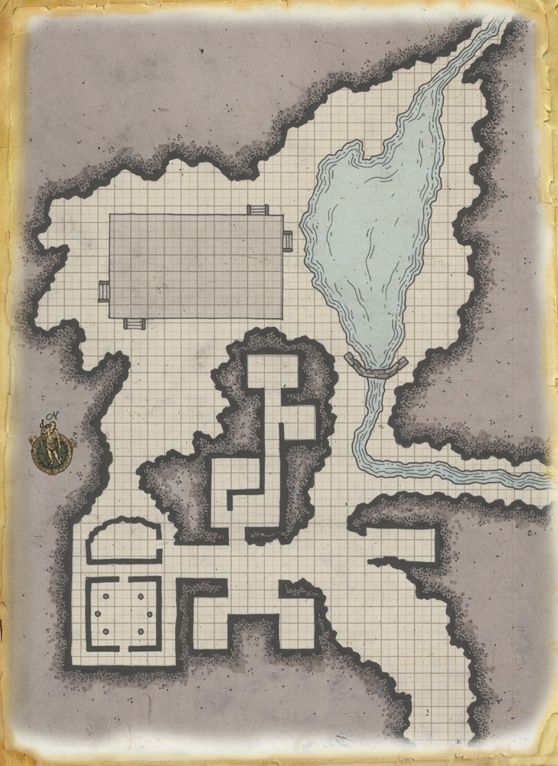

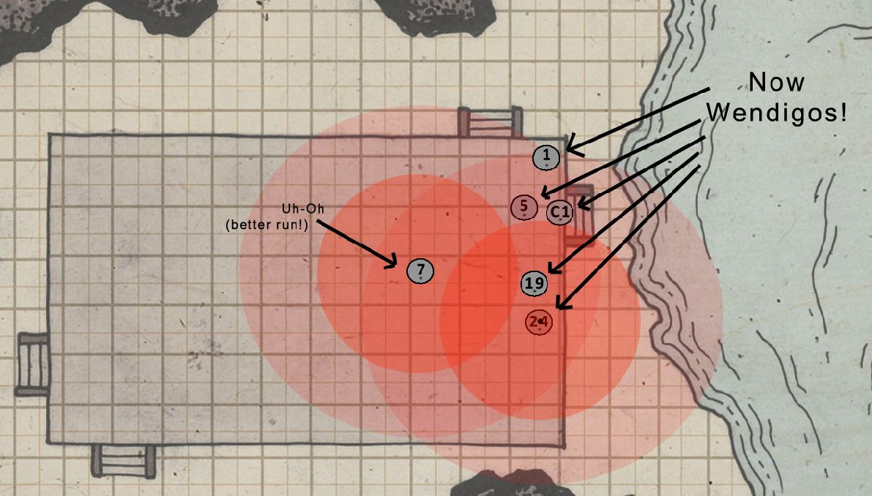

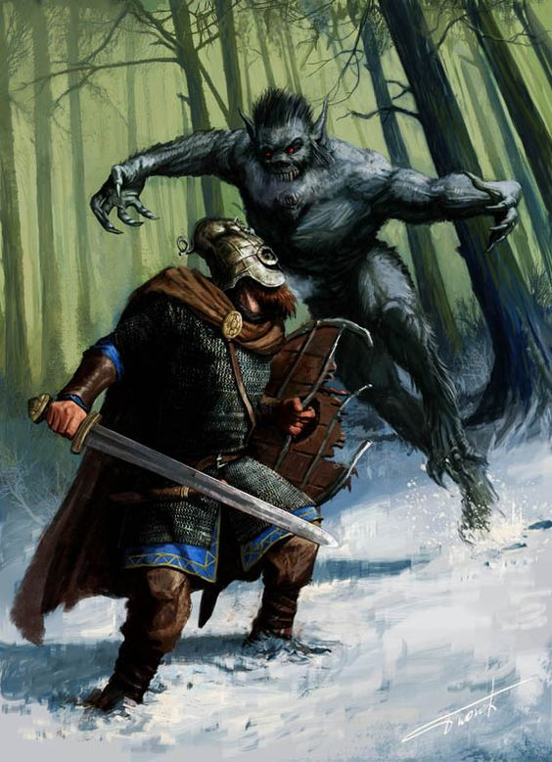

Chapter 5 : Fellowship with the Haka’Na

Attacked by Haka’Na party during the night while moving downriver

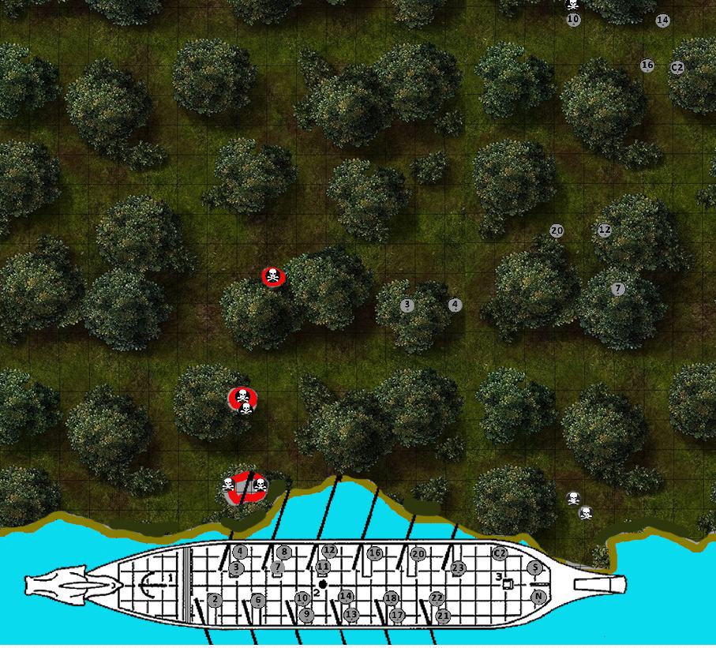

that night during his sleep, Ulfarr is visited by the figure of an old man
he seems to be translucent
he appears in the garb of another people, similar to that of the warriors you fell
his hair is braided and he wears bones and beads intricately arranged
he seems to have a passive expression, he holds up a hand in greeting
DymuxToday at 5:14 PM
more like a chieftain or a shaman?
fairhandToday at 5:14 PM
yes, indeed
he has dark lines carved by time in his face with kind eyes
he speaks, "I am Inuake. It was my son who fell to your blade."
DymuxToday at 5:15 PM
can i speak back in this dream?
fairhandToday at 5:15 PM
yes. he offers you a handsome blade, fashioned in a strange decorative pattern, a buffalo on the hilt
DymuxToday at 5:16 PM
i can i take it? if so i do
fairhandToday at 5:16 PM
"you are a worthy warrior. you gave him a good ending."
you take the blade and feel a sense of strength surge within you, there are the sounds of drums in your mind and chanting
you feel the calling of ages past and the thrill of running over open plains
the old man continues, "You are now Nightriver. You are known among my people."
You now have Knowledge : Haka'Na peoples +5
DymuxToday at 5:19 PM
WOW. i add the blade to my belongings. and I am honored and thank the spirit.
fairhandToday at 5:19 PM
You also have +1 to attack/damage with the knife on normal attacks plus +2 to Will saves versus fear while it is on your person
Once per day you get an automatic hit when throwing the blade and it automatically returns to you the next turn.
Please feel fee to share your experience with the group. Makes for a good story! :slight_smile:
DymuxToday at 5:20 PM
Yes

Stopped at a temporary encampment called Buffalo Horn
War clubs of Manitou (Thunder Bird) – forged in the Great Horn Mountains in a volcano, imbued with the properties of fire and ice, used by Haka’Na paladins to combat great evil
+2 war clubs - +2 to ATK and DMG
protection from evil
additional +1 vs evil creatures
resistance to energy (hot/cold) of 5
(one each given to Finnthor, Villatha, Freyotta, Kolorun, Ulfarr, Dagfrith, Sighvat, and Athelkarl )

Captain Finnthor, feeling regret for leaving behind five of his warriors in the lair of the wendigo, orders the crew to turn back. Perhaps they can be saved from the curse? So they set to oars and row upriver.

The natives of the Haka'Na lands attack the boat at night, but the Norgardians stand strong. One warrior, Ulfarr, chases down the last of the braves and cuts him down, ending the threat of news getting to the enemy. That night he is visited by a shaman's ghost in his dreams: he gifts Ulfarr with the knife of his son, whom Ulfarr slew in battle. Ulfarr is named Night River and granted a bond with the Haka'Na few would understand.

The Norgardians set aside their warlike ways and treat with the Haka'Na at the camp of Buffalo Horn some miles away. Osuma the holy man tells the visitors that the land has grown darker now with this army of wendigo slaughtering villages. Osuma hears the tales of the crew and advises them: lower the lake in the lair of the wendigo, for a weapon is there that can end this curse. That night the Haka'Na hold a spirit walk. Three of the crew ask to join them: Sighvat, Kolorun, and Dagfrith. They emerge, troubled by what the spirits tell them: "the darkness ahead is full of deceit: flush out the deceiver by slaying the first creature to utter the words 'Kord give me strength!"

At last the company forms up and marches to the lair, accompanied by a pack of braves. Battle ensues instantly and is furious, with blood and brains strewn everywhere in a flurry of carnage. To everyone's surprise, it is Ulfarr who utters the fateful words warned of in prophecy. To everyone's surprise Sighvat, Kolorun, and Dagfrith cut down Ulfarr and leave him utterly dead on the ground.

"It was in the spirit walk," Sighvat exclaims in frustration, "the spirits told me to cut down the first creature to utter the words 'Kord give me strength' to reveal a spirit of deception! What have we done?!" But there is little time for anyone to grasp this tragedy.

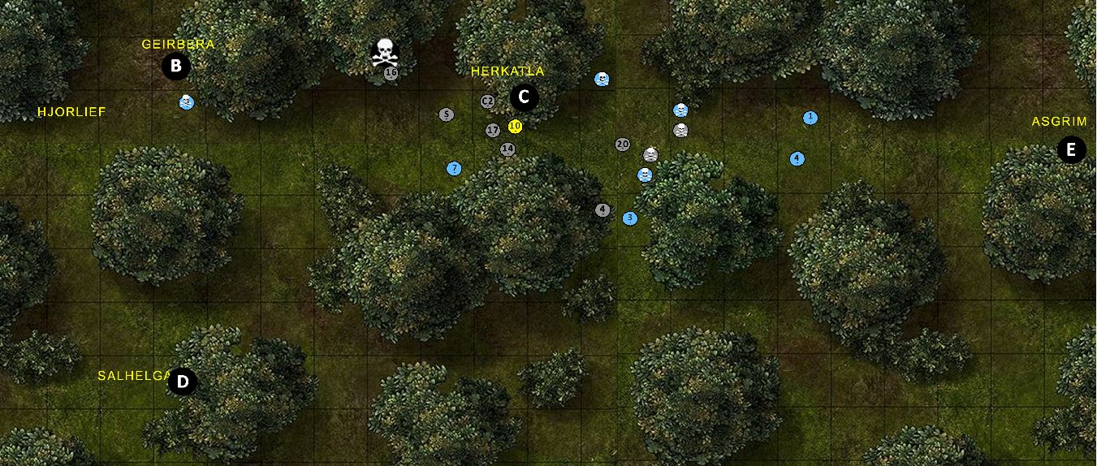

The battle turns against the Norgardians, with six wendigo carving a path through their ranks: half the braves are ripped apart and battle lines scattered. Brandishing enchanted war clubs gifted to them by Osuma, the crew fights back with ferocity. It is only when Sighvat is threatened with certain death that Ulfarr appears again, glowing with the magic of the Haka'Na. His time in the spirit world was brief, and he loudly announces his three comrades had indeed past the test! A surge of energy bolsters the company and they find their strength returning.

Remembering the words of the holy man, Ulfarr leads a group to the wendigo lair to finish the work their companions had begun: lower the lake and retrieve the bane of the wendigo! If only the rest of them could buy them time.

But the Norgardians prevail! Sighvat, Dagfrith, and Athelkarl mount a mighty defense, holding the creatures in spite of terrible losses. With many blows the last of the entire demons are slain. Ulfarr returns and thrusts the spear found in the lair into the heart of the chief wendigo. Five figures rise, their friends freed from the curse! But alas, Captain Finnthor is found dead on the battlefield, having faced the largest of the creatures head-on. He has saved his crew mates and has died a hero.

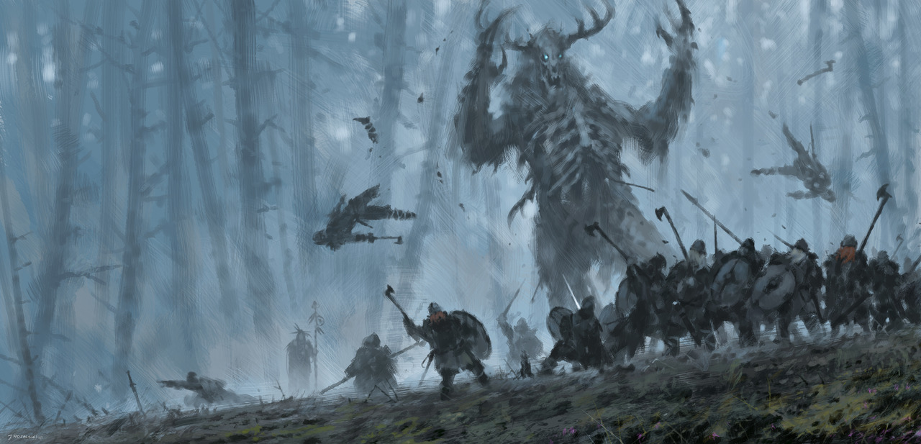

Food stores: fully restocked by the Haka’Na
XP:
1 alpha wendigo CR9 7200 400 400 (div by 18 characters)
5x sub wendigo CR 6 2700 150 750 (div by 18)
8x 1st lvl ftr 300 37.5 300 (div by 8)
Story XP 250 each
1700 total
(for anyone in the battle but not visiting the Haka’Na camp they do not receive the 250 XP: Kolgauta and Bjorn)

Treasure:
6 of the Manitou war clubs (already described above)
10 potions of cure light wounds (given before the battle)
8x longbows, battleaxes, suits of studded leather armor, wooden shields, daggers, and 128 arrows (taken from the battle at the river)

Loot from the Lair of the Wendigo:
- Tapestry of the Buffalo People symbolSignet
- Ring of the priest showing a blood red star (not magical)
- An old map with ancient writings indicating what the Haka'Na braves tell you is somewhere deep in the Horn Mountains. It appears to be a valley, but the Haka'Na say there is nothing there but ice.
1,641 gold coins
2,737 silver coins
17 blue sapphires worth 120 gp each
23 small rubies worth 60 gp each
2 large diamonds worth 1000 gp each

weapons
heavy flail +1 (2,315 gp)
light crossbow +1 (2,335 gp)
something provides a clue to the item's function(s)
mighty composite longbow (+1 Str bonus) +2 (8,500 gp)
kama +1 (2,302 gp)
light mace +1 (2,305 gp)
shortspear +1 (flaming) (8,302 gp)
siangham +1 (2,303 gp)
siangham +1 (ghost touch) (8,303 gp)
throwing axe +1 (keen) (8,308 gp)

armor
large wooden shield +1 (1,157 gp)
half-plate +1 (1,750 gp)
large steel shield +1 (1,170 gp)
large steel shield +1 (1,170 gp)
large steel shield +1 (1,170 gp)
large steel shield +1 (1,170 gp)
small wooden shield +1 (1,153 gp)

potions
potion of cure moderate wounds (300 gp)
potion of intelligence (300 gp)
potion of invisibility (300 gp)
potion of speak with animals (300 gp)
potion of cure light wounds (50 gp)
potion of delay poison (300 gp)
potion of enlarge (at 5th level) (250 gp)
potion of enlarge (at 5th level) (250 gp)
potion of enlarge (at 5th level) (250 gp)
potion of glibness (500 gp)
potion of hiding (150 gp)
potion of reduce (at 5th level) (250 gp)

scrolls
arcane (425 gp)
Charm Person (l1, cl1)
Clairaudience/Clairvoyance (l3, cl5)
Color Spray (l1, cl1)
arcane (325 gp)
Change Self (l1, cl1)
Detect Thoughts (l2, cl3)
Invisibility (l2, cl3)
divine (300 gp)
Lesser Restoration (l2, cl3)
Barkskin (l2, cl3)
divine (50 gp)
Detect Chaos (l1, cl1)
Cure Light Wounds (l1, cl1)
arcane (525 gp)
Flaming Sphere (l2, cl3)
Vampiric Touch (l3, cl5)
arcane (25 gp)
Mage Armor (l1, cl1)
arcane (25 gp)
Silent Image (l1, cl1)
arcane (300 gp)
Mirror Image (l2, cl3) (scribed 2 times)
arcane (150 gp)
Locate Object (l2, cl3)

wondrous items
bag of holding (bag 2) (5,000 gp)
brooch of shielding (1,500 gp)
chime of opening (3,000 gp)
dust of tracelessness (250 gp)
Nolzur's marvelous pigments (5,500 gp)
robe of useful items (7,000 gp)
amulet of health (+2) (4,000 gp)
boots of the winterlands (2,500 gp)
horn of goodness/evil (6,000 gp)
pipes of haunting (6,500 gp)
Quaal's feather token (fan) (200 gp)
vest of escape (2,000 gp)

rings
ring of animal friendship (9,500 gp)
ring of animal friendship (9,500 gp)
ring of protection +1 (2,000 gp)
ring of protection +2 (8,000 gp)
ring of swimming (2,300 gp)
ring of water walking (15,000 gp)

wands
Detect Secret Doors (l1, cl1) (42 charges) (630 gp)
Shatter (l2, cl3) (11 charges) (990 gp)

Chapter Six : On to Horn Vale
The morning after the battle against the Wendigo the crew gathered for a funeral for their fallen, particularly Captain Finnthor. Geirbera spoke holy words commending his spirit and many trinkets were placed upon him and upon Villatha as well as a pyre for Thorgeir whose body was never recovered. Large funeral fires were lit and for an instant the group thought they could even see their fallen comrades' spirits rising to the sky.

The group then convened to elect a new Captain. At last, Sighvat put up his hand and reluctantly agreed to lead the group and try to do honor by Finnthor's example.

The party pondered the strange map found in the cave and decided to follow the surviving Haka'Na braves back to their village to consult their elders about the map. There the party was feasted like heroes. In the elder council they group noticed a young Haka'Na woman speaking wisdom beyond her years. Kolgauta and the two clerics took a walk with her and she burst into light and dropped some heavy knowledge on them about the Coyote God. It seems the map leads to Horn Valley up in the Horn Mountains. Legend has it that it is the location of the Temple of the Moon where the Moon herself lives. But one day the Moon grew tired of her duties and asked the Coyote to mind her post. The Coyote delighted in watching mortals from on high and spread mischief by telling people what their neighbors were doing, just to stir up trouble. It is said that the Moon returned to find the land in disarray, and was so busy restoring her order that she did not notice that the Coyote made a copy of the key to her Temple. It is said that the Temple has fallen into chaos now and the valley with it. There are tales of great dangers there but also great fortune. It is also said that one must guard one's mind and passions, for the Coyote may make sport with humans and bend them to his games.

After the party departed the village they rowed the boat upriver for many days. Hunting was good and the food stores replenished. Along the way there were no signs of other Haka'Na villagers or encounters with any fell creatures. At last they came within view of the Great Stag Forest where the river enters it. Captain Sighvat ordered the crew make camp one last night under the open sky.

But around the third watch a band of goblins attacked. They fired sleeping arrows into the camp, which rendered 2/3 of the party helpless. But the rest fought on bravely and eventually overcame the goblins. At the end the party noticed the goblins looked like goblins, but were vastly different in appearance and clothing than the ones Norgardians are accustomed to seeing: more brown in color, more feral looking, very shabby hides worn as clothing. They also found a note adorned with strange markings. And at one point Geirbera and Herkatla looked up and just for an instant imagined seeing a startling face staring down on the group from the moon itself, then it disappeared!

Chapter Seven : Palace of the Moon

After the goblin attack the party continues upriver to find Horn Valley, cautious as they pass into the Great Stag Forest. A few of the crew begin humming a strange melody. At each humming, more crew members begin to find it difficult to get the melody out of their heads. Some even report knowing the lyrics to the song, but each person reports a different set of words.

At the head of the river the crew anchors the boat in a mere at the foot of the Horn Mountains, seeking a way through to the valley beyond. A search party find two magical runes are found carved in the rocks. Kolgauta discerns the first says 'enter' addressed to an individual, another says 'enter' addressed to a large group. Hjorleif touches the latter rune, causing the ground to shake and minutes later a whirlpool in the lake swallows the Herlighet! Within minutes a smaller boat surfaces from the lake. The party investigates the boat, while Hjorleif touches the second rune and disappears.

The party assumes Hjorleif has been disintegrated and decides to push the second rune again and jump into the boat. The party is whisked away via underground river to the far end of Horn Valley and greeted by strangely garbed humans, all of whom appear to hail from a wide variety of lands. The boat eventually travels upriver to the foot of a giant mesa rising up from the valley floor and flanked by water falls from the mountains beyond. Stone steps ringing the outside of the mesa lead upward. The party ascends and finds a large area covered in lush grass and trees with a sparkling palace at the eastern end.

The party is ushered into the palace where a high priestess named Osyka lounges on a throne in seductive clothing. She bids them welcome and invites them to join a never ending feast of delights.
The rest of the crew is found outside, partaking in food, drink, games, entertainment, and canoodling with the hot servants. It is a party of dark and entrancing delights!

As time progresses, more and more crew members fall victim to the strange melody that started before the ship entered the Great Stag Forest. Four of the crew identify four different passages that accompany the melody and decide the warning they received could be true.

The party is shocked to learn that their single night of pleasure in the palace has actually been an entire month! They also find their wits are dimming. The party decides the palace is too dangerous and requests Osyka return their boat. She agrees and tells them at noon the boat will be at the northern landing. At noon the party meets up to leave. They find nine of the crew have not reported to depart, so they are left behind as deserters.

On their way to the northern end of the top of the mesa, the party stumbles across a garden of statues depicting people with horrified looks and poses. The party is attacked by a flock of cockatrice, which they slay but not before four of the crew and one of Herkatla's dogs are turned to stone.

Fresh from surviving the ambush, the party arrives at the northern end of the mesa and the stairs down to the northern landing, but no ship is to be found. To everyone's surprise, they spy a ravine on the north bank of the river and concealed by forest. There lie dozens of shipwrecks, discarded over the centuries. And the Herlighet is seen being moved towards it by priests! Also to everyone's surprise, the priests have mostly been slain and the strange pack animals moving the ship scattered by Hjorleif, who managed to trek on foot the entire length of the valley and attack the enemy from a hiding place. Party slays the remaining priests, saving the Herlighet, and loots the priests to find several items.

Character Accounts

Hjorleif’s Prologue:
Down by the river they built a house. Away from the noise away from the town. There, where the water was ale to their souls, and Fenrir would dance through fire that burns. Down by the fjord couples live in sin. Where there’s a cold of the night and a warm of the skin. Away from the lights, they dream in colors. Away from the nightmares, away from Jotunn’s gaze. There’s a war; it sat on the soul and ends up in their arms. Deep in the forest they built a dream. Leading and dancing the nature within. Hiding away from the material world, of gold and silver and laws and words. Deep in the forest they built a house, up on the tree near the clouds. Deep in the forest, they would sing through the night, with seers and shamans and shadows and stars. And Hjorleif, would force himself to this Earl, and he, 24 hours of working, would force himself to be nothing, but an empty shell. They will take his bones.
Hjorleif was working on empty, facing the burning heat. He thought of his baby, so full of love he could barely eat. But his love found him, he was three days on a drunken sin. He awoke with her arms around him, with nothing in her room but an empty crib. Burning up a fever, he didn’t care much how long he lived, but there he dreamed of her, and she never asked once about the wrong he did. His love never fret none, about what the hands and the body done. If Kord didn’t forgive him; he’d still have his baby and his babe would have he.
And so, Hjorleif abandons his life for Jotunn. He will build their ships and supply their wares. He will give his body and soul. And abandon his family for fear. Jotunn will destroy his friends and family’s ancient ways, for lumber and material and riches. To destroy the town of Kolheim. They will destroy his family; the seers, the magicians and the couples living near. But it’s worth it, it’s divine. The Earls words are icy. Like Ale on a fire, hard and fast and angry is he.
He’ll return to Kolheim.
And it’s a crime, that they’re not around most of the time…

Hjorleif’s Aside:
The axe impacts with a satisfying thud, and bloody pink-mist of the priest launches high, reaching to the Gods. The priest lets out an agonizing scream as he pleads with his Gods for mercy. “Kord smiles upon me this day” Hjorleif says to himself. Hjorleif stands, ready to launch another volley, but spots his crew members running and shouting and screaming with arrows and blades as they fire upon the fleeing priests. He jumps down from his rocky position with a thunderous roar, axes in hand, excited to be reunited and joined in battle once again with his brothers and sisters. Picking up speed, he rips the axes implanted in the bodies of the fallen, flinging them once more towards the cowardly priests.

As the party mops up the rest of their enemies and loot their corpses, Hjorleif gathers his axes and walks towards the dying priest who tried to kill him and destroy their ship. The Norgardians giant stature towers over the man whose blood now weeps into the earth. Their eyes meet, but only hatred can be found in Hjorleif’s gaze. Never breaking eye contact, Hjorleif grabs the dying man’s feet and drags him to the nearest tree, stringing him upside down over a branch placing an eating bowl below the priest’s head. Uttering some strange Norgardian words, which only the name “Kord” can be understood as Hjorleif slices clean into the priest’s throat. “Your false gods will not avail thee. I grant this for you, my father, Kord. I deliver this slave eternally to you. May he never know peace. May his blood bathe us in your strength and guide us on your path.” The bowl now overflowing in beautiful crimson, Hjorleif wipes it onto his hair, face and neck, and spatters it onto his axes. He walks from the drained priest towards his Captain, his crew, his family. Blood-filled bowl in hand

Hjorleif’s Journey Alone through Horn Vale

The rune ignited. And all the worlds and 9 dimensions Hjorleif saw collide into one another as he was transported through time and space. His body torn to shreads instantly before reforming. He swore he saw the eyes of his forbearers gazing through as he bridged back into reality, now in a dark space that smells of water and rock. It is pure darkness, he can see nor feel anything except a chill breeze from the north against his skin. He waits, and listens. And dares not ignite a flame. Surely his crew will follow soon, when they do he will be here to reassure them. He waits longer, and longer but no none ever shows. Fearing they must all have been transported elsewhere. He begins to push forward, towards the chilling breeze that soothes his worn face. As he walks, there is a light that begins to show. What he’d assume the gates of Valhalla would be. Surely this couldn’t be it? He does not feel dead. He presses onwards through the dark, before waiting one last time. Nearing the light, it appears to be the exit to a lush green valley. He ignites his Bullseye lantern and points it backwards, looking for his crew or any creature, but only spots a similar rune to the one he touched when he entered. He could go back... He could return to his crew if they’re still there. But why did they not follow? Are they elsewhere instead? Have the Gods played a trick and separated us? He decides to continue on his path, “If this is what the Gods will.” He draws his axe and peers into the valley, moving quietly and finding a vantage point. The land is beautiful and cold. He listens and searches for signs of life, but seeing none, cautiously creeps onwards.
Hjorleif must find his crew. He searches his mind for the image of the map. If this is the valley, then the point of interest must be... here, close, unless... he is on the other end the valley… This cannot be, maybe he should go back. Night will be upon him soon, he eats what little rations he has left, and tries to conserve water. He’s survived the harsh winters of Norgard alone, he can do it again.
Wolf Encounters:
Throughout his trek through the valley, Hjorleif will be approached and hounded by many wolves. They are tracking him, or are they leading him, protecting him? He decides again to trust the gods. He not only prays and acknowledges Kord, but for the first time in his life feels the need to speak to Fenrir. His bedding is harsh. It will be a long voyage alone, but he knows in his heart the Gods will provide. The stars wheel overhead, the constellation of Fenrir is bright and the howls of the wolves at first do not let him sleep. He becomes highly aware they have surrounded him, far off, but their howls forming a perfect circle. He is at their mercy and awaits death. He stomps out the fire. The howling continues, they’re talking to him, communicating, he feels as though he understands their voice. The air grows cold and darker. He will not sleep this night. He sits up against a tree, covered in his cloak, axe in hand and waits.
Morning comes, and Hjorleif set’s off towards the other end of the valley. He presses onwards, collecting water and killing raccoons and rabbits. He swears he’s embodied the wolf this day. He skins his kills and cooks their meat, and adorns himself with his small victories. He leaves portions of the kills for the wolves, to pay them respect and honor their presence. The next several days however will not be as bountiful. He’ll suffer several days of no real food. Throughout the day a wolf howl will cry out and he follows, he chooses to follow the pack to become one with their hunt. As dusk and night approaches each night, the howling of the wolves grow ever closer. Their words become ever clearer. He prays to Fenrir again, asking for strength and a successful hunt. The howls are his answer. “Onwards. Do not tire. Fear none.” He finally sleeps fitfully. His dreams are troubled. He sees flashes of the wolves, as they stalk and hunt. As they kill. They are a wise and tireless unit. He feels they’re acceptance, but there is one that lurks outside, alone, like him. A fallen member. He is a large black wolf. His eyes are red as coal and he snickers at Hjorleif, taunting him. The lone wolf finally corners Hjorleif, and pounces ripping and tearing and shredding. His jowls are massive and his teeth are sharp as an axe. Hjorleif awakes in a cold sweat, his heart racing. Is Fenrir taunting me? Have I forseen my death?
The following days and nights are the same. Hjorleif imagines he is 2 days away from the end of the valley, where hopefully his pack will be. He finds mushrooms this day, the food of the Gods. Fearing not, he consumes a handful and saves the rest. Their magic takes him. He once again flutters through space and time. His senses are heightened. He is outside of his body, watching himself hunt and kill, climbing rocks and trees and crossing streams. The howling of the wolves are ever closer. They are close. They walk among him. He is a part of them and they are a part of him. They are one with each other. The world is all smeared and strobed together. He can hear the throaty music and chants of his people playing all around. The world spins and moves so fast. He sees the wolves sitting among him, watching from the rocks and the hills. Walking alongside him. Howling to his presence as a skald would their King. Hjorleif finds and consumes more of the mushrooms. A perpetual alter of consciousness. The wolves flash all around. Hjorleif kills more, skins and eats, and feeds his brothers and sisters their bounty in celebration. They all howl together. He finally sits, and closes his eyes. Visions of the gods and wolves, music and blood dance all around. But the Black wolf is there also. Watching, smiling, pacing to and fro, always stalking and laughing. Its howl is dark and cold like the night.
Hjorleif opens his eyes. It is dark. The fire is out and his pack no longer sing to him. He stands to look for them, but stands alone. There are no night noises. No insects or frogs. Only a cold breeze blows towards him. On it he catches a strange scent, unlike any he’s ever witnessed. He raises his nose to the sky hunting, feeling, and tasting it. He is not alone. Crouching low, the world still spinning. He prays to Fenrir, but not to Kord this time. Taking the axe, Hjorleif slices his palm and paints his face with the blood and squeezes it onto his axe. He removes his cloak and shirt, revealing his chest and its many scars to the Gods. He now hears the music in his head. It is the song of the wolf, of death. Hjorleif stands, and out of the darkness those glowing red eyes appear, pacing around him…
[Hjorleif will battle and defeat the wolf. He will skin the pelt and atune to it. Honoring his combatant from here on. He will eat of the meat, drink and bathe in its blood, and pray to the God Fenrir and Kord.]
Hjorleif finishes his ceremony. Out of the darkness his wolf pack appears, circled around him. They all sit, and in unison howl together. They howl to the Moon, to the stars, to the gods. They all sleep peacefully.
The final day Hjorleif makes it to the Bute where his crew is. He turns to his new found family. They gaze at him from the tops of hills, and rocks. The former alpha is there close to him, sitting at the edge of the tree line. They all wait patiently for his next decision, and Hjorleif for the first time thinks of abandoning Kolheim’s mission. He speaks to his family and says “Thank you, my friends, but there is a hunt I must still finish. I must now guide my pack, as you have guided me.” And one by one they all begin to howl. Hjorleif turns towards the Bute, forever changed, sniffing the air and perceiving his next hunt.

