**Adventures of the Norgarde Ship Herlighet “Glory”**

One thousand years ago (323 WA3) a band of hardy warriors set off on an expedition to explore the world and seek their fortune. The crew was made up of men and women from the fishing village Kolheim near city of Geirdir. Most were farmers and fishermen-turned warriors. Their leader was a famed warrior, joined by his trusted navigator and a handful of village seers. Together they hearkened to the call of the sea in the tradition of their people. This is their story…

**Ship**

150’ Drakkar

12 rowing benches, 24 rowers

Single mast, square sail

Medium Ballista – 50 ballista bolts

Water: barrels containing 1 portion per person for two weeks: 14x30= 420

Food: salted provisions 1 portion per person for two weeks: 14x30= 420

Hull HP 150, Hardness 5

Rigging HP 60, Hardness 0

Water Taken Before Sinking: 70 units (70’ x 20’ x 5’ = 7000 cubic feet)

**The Crew**

~~Finnvir – captain – Ftr 5~~ - KIA

Holmhallur – navigator, first mate - Rgr 5

**Geirbera – priestess of Kord – Clr 3 - Sarah**

**Kolorun – priest of Kord –Clr 2 - Sarah**

Kolgauta – sorceress – Sor 2

The Warriors

1. **Herkatla – Ftr 2 - Beau**
2. Svanerna - Ftr 2
3. ~~Villatha - Ftr 2~~ - KIA
4. **Freyotta - Ftr 2 - Jarred**
5. Salhelga - Ftr 2
6. Aldbeinn – Ftr 2
7. ~~Finnthor - Ftr 2~~ – KIA
8. Ingemundur – Ftr 2
9. Gudarinn – Ftr 2
10. **Ulfarr – Ftr 2 - Dave**
11. Harthingur – Ftr 2
12. Bergstyrr – Ftr 2
13. Farrun – Ftr 2
14. **Dagfrith – Ftr 2 - Alan**
15. ~~Thorgeir - Ftr 2~~ - KIA
16. **Sighvat – Ftr 2 - Tim**
17. Bjorn – Ftr 2
18. Hermarr – Ftr 2
19. **Asgrim – Ftr 2 - Tim**
20. Athalkarl – Ftr 2
21. Kolbardur – Ftr 2
22. Ulfrikur – Ftr 2
23. Arinbjorn – Ftr 2
24. **Hjorleif - Ftr 2 - Jarred**

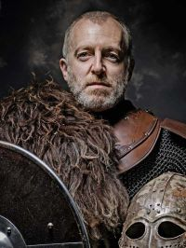

Captain - Finnvir – FTR 5 **(KIA)**

male human (5 ft., 3 in. tall)

HD 5d10+20; hp 53

Init +1 (+1 Dex)

Spd 30 ft.

AC 11 (+1 Dex)

Attack +9 melee, or +6 ranged

SV Fort +8, Ref +2, Will -1

Str 19, Dex 12, Con 18, Int 15, Wis 7, Cha 11

Skills (skill points: ): Sailing +10, Craft (Sculpting) +8, Diplomacy +2, Handle Animal +7, Hide +1, Listen +0, Move Silently +1, Perform (Sing) +2, Ride +9, Spot -2, Swim +12

Feats: Cleave, Combat Expertise (trade ATK bonus for AC),, Endurance, Persuasive, Power Attack (trade ATK bonus for DMG), Weapon Focus (+1 with longsword).

Possessions: 4,300 gp in gear.

(Starting arms and armor) Chain shirt, light wooden shield, dagger, throwing axe, longsword, masterwork battleaxe, longbow, arrows (40) (734 gp)

(Starting Equipment) Spellbook, Explorer’s outfit, backpack, small chest, rope (hemp), flint and steel, trail rations (10 days), water skin, bedroll, fishing net, fishhook, bullseye lantern, pouch, everburning torch, whetstone , winter blanket (140 gp)

-----------------------------

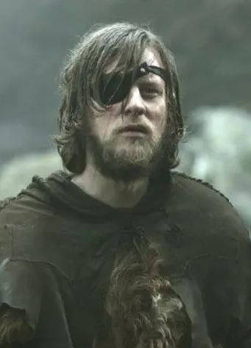

**The Navigator –** Holmhallur – RGR 5

male human (5 ft., 3 in. tall)

HD 5d8; hp 29

Init +8 (+4 Dex, +4 Improved Initiative)

Spd 30 ft.

AC 19 (+4 Dex)

Attack +9 melee, or +9 ranged

SV Fort +4, Ref +5, Will +3

Str 18, Dex 19, Con 11, Int 12, Wis 15, Cha 7

Skills (skill points: ): Sailing +10, Concentration +7, Craft (Armorsmithing) +3, Decipher Script +2, Heal +10, Hide +4, Jump +12, Knowledge (Dungeoneering) +8, Knowledge (Geography) +5, Knowledge (Nature) +7, Listen +9, Move Silently +4, Spot +2, Survival +8, Use Rope (hemp) +11

Feats: Deceitful, Dodge, Improved Initiative, [Rapid Shot], [Track].

Possessions: 4,300 gp in gear.

+1 Studded leather armor, light wooden shield, dagger, Composite longbow (+4), +1 battleaxe, throwing axe, backpack, small chest, rope (hemp), flint and steel, trail rations (10 days), small steel mirror, water skin, bedroll, map case, fishing net, fishhook, bullseye lantern, pouch, everburning torch, whetstone,

Ranger Spells Per Day: 1.

-----------------------------

Explorer’s outfit, backpack, small chest, rope (hemp), flint and steel, trail rations (10 days), water skin, bedroll, map case, fishing net, fishhook, bullseye lantern, pouch, everburning torch, whetstone,

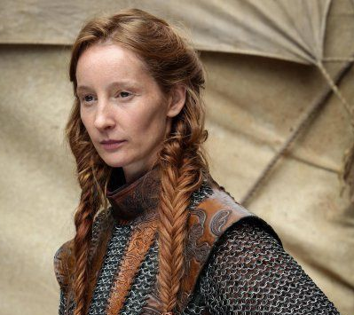

Priestess - Geirbera – CLR 3 **[RUN BY PC – STATS NEED TO BE UPDATED]**

female human (5 ft., 4 in. tall)

HD 1d8-1; hp 21

Init +0

Spd 30 ft.

AC 15

Attack +1 melee, or +0 ranged

SV Fort +1, Ref +0, Will +4

Str 12, Dex 10, Con 8, Int 10, Wis 14, Cha 11.

Skills (skill points: ): Knowledge: Religion +10, Heal +6, Hide +0, Listen +2, Move Silently +0, Spot +2

Feats: Persuasive, Spell Focus (divination).

Possessions: 245 gp

(Starting arms and armor) Chain shirt, light wooden shield, dagger, throwing axe, longsword, masterwork battleaxe, longbow, arrows (40) (734 gp)

(Starting Equipment) Holy symbol, explorer’s outfit, backpack, small chest, rope (hemp), flint and steel, trail rations (10 days), water skin, bedroll, fishing net, fishhook, bullseye lantern, pouch, everburning torch, whetstone , winter blanket (140 gp)

-----------------------------

Cleric Domains: Knowledge, Fire

Cleric Spells Per Day: 3/2+1

-----------------------------



Priest - Kolorun – CLR 2 **[RUN BY PC – STATS NEED TO BE UPDATED]**

male human (5 ft., 3 in. tall)

HD 1d8+1; hp 27

Init +0

Spd 30 ft.

AC 15

Attack +4 melee, or +0 ranged

SV Fort +3, Ref +0, Will +6

Str 18, Dex 11, Con 12, Int 7, Wis 18, Cha 15

Skills (skill points: ): Knowledge: Religion +10, Craft (Bowmaking) +2, Craft (Trapmaking) +2, Hide +0, Listen +4, Move Silently +0, Spot +4

Feats: Combat Reflexes, Still Spell

Possessions: 245 gp

(Starting arms and armor) Chain shirt, light wooden shield, dagger, throwing axe, longsword, masterwork battleaxe, longbow, arrows (40) (734 gp)

(Starting Equipment) Holy symbol, Explorer’s outfit, backpack, small chest, rope (hemp), flint and steel, trail rations (10 days), water skin, bedroll, fishing net, fishhook, bullseye lantern, pouch, everburning torch, whetstone , winter blanket (140 gp)

-----------------------------

Cleric Domains: Death, Travel

Cleric Spells Per Day: 3/2+1

-----------------------------



**Sorceress -** Kolgauta – SOR 3 **[RUN BY PC – STATS NEED TO BE UPDATED]**

female human (4 ft., 10 in. tall)

HD 1d4+4; hp 21

Init +1 (+1 Dex)

Spd 30 ft.

AC 11 (+1 Dex)

Attack -1 melee, or +2 ranged

SV Fort +5, Ref +2, Will +3

Str 7, Dex 12, Con 18, Int 15, Wis 11, Cha 18

Skills (skill points: ): Knowledge: Knowledge (Arcana) +14, Climb +0, Disguise +6, Hide +1, Knowledge (The Planes) +3, Use Magic Device +4, Listen +0, Move Silently +1, Sense Motive +2, Spot +0

Feats: Improved Unarmed Strike, Investigator

Possessions: 245 gp

(Starting arms and armor) Chain shirt, light wooden shield, dagger, throwing axe, longsword, masterwork battleaxe, longbow, arrows (40) (734 gp)

(Starting Equipment) Spellbook, Explorer’s outfit, backpack, small chest, rope (hemp), flint and steel, trail rations (10 days), water skin, bedroll, fishing net, fishhook, bullseye lantern, pouch, everburning torch, whetstone , winter blanket (140 gp)

-----------------------------

Spells per day: (0-level) 4, (1st-level) 2, (2nd-level) 1

Sorcerer Spells Known (5/4/1):

Bonus spells for 1st, 2nd, 3rd, and 4th level spells (+4 on her CHA ability mod)

0-level: Message, Prestidigitation, Mage Hand, Touch of Fatigue, Light, Read Magic (free)

1st-level: Hold Portal, Magic Missile, Sleep, Silent Image

2nd-level: Flaming Sphere

Summon Familiar – Raven

Scribe Scroll

-----------------------------

**The Warriors**

-----------------------------

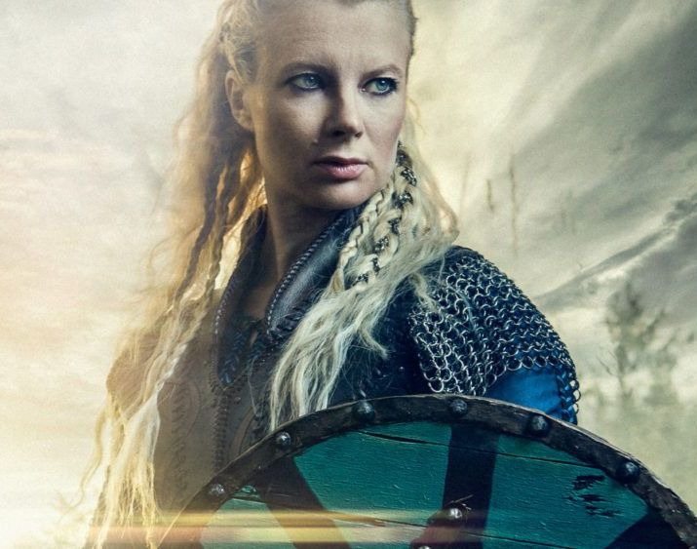

1 – Herkatla – FTR 3 **[RUN BY PC – STATS NEED TO BE UPDATED]**

female human (5 ft., 9 in. tall)

HD 1d10+1; hp 11

Init +3 (+3 Dex)

Spd 30 ft.

AC 18 (+3 Dex)

Attack +5 melee, or +4 ranged

SV Fort +3, Ref +3, Will +0

Str 18, Dex 17, Con 12, Int 7, Wis 10, Cha 5

Skills (skill points: ): Sailing +10, Climb +8, Hide +3, Listen +0, Move Silently +3, Ride +7, Spot +0

Feats: Blind-Fight (re-roll miss chance for concealment), Point Blank Shot, Weapon Focus (+1 to ATK with longsword)

Possessions: 245 gp

(Starting arms and armor) Chain shirt, light wooden shield, dagger, throwing axe, longsword, masterwork battleaxe, longbow, arrows (40) (734 gp)

(Starting Equipment) Explorer’s outfit, backpack, small chest, rope (hemp), flint and steel, trail rations (10 days), water skin, bedroll, fishing net, fishhook, bullseye lantern, pouch, everburning torch, whetstone , winter blanket (140 gp)

-----------------------------



2 – Svanerna – Barbarian level 2

female human (6 ft., 2 in. tall)

HD 1d12; hp 24

Init +5 (+1 Dex, +4 Improved Initiative)

Spd 40 ft.

AC 16 (+1 Dex)

Attack +3 melee, or +3 ranged

SV Fort +3, Ref +1, Will +0; AL N

Str 12, Dex 13, Con 11, Int 10, Wis 10, Cha 7

Skills (skill points: 20): Sailing +10, Forgery +2, Handle Animal +2, Hide +1, Listen +0, Move Silently +1, Perform (Wind Instruments) +0, Spot +0 (skill points: 20)

Feats: Improved Initiative (+4), Mobility (+4 AC vs Attacks of Opportunity)

Possessions: 245 gp

(Starting arms and armor) Chain shirt, light wooden shield, dagger, throwing axe, longsword, masterwork battleaxe, longbow, arrows (40) , longbow, arrows (40) (511 gp)

(Starting Equipment) Explorer’s outfit, backpack, small chest, rope (hemp), flint and steel, trail rations (10 days), water skin, bedroll, fishing net, fishhook, bullseye lantern, pouch, everburning torch, whetstone , winter blanket (140 gp)

Special: Fast movement (40’), illiteracy, rage (1/day), uncanny dodge, trap sense +1

-----------------------------

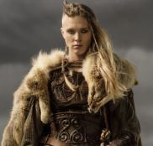

3 – Villatha – Barbarian level 2 **[KIA]**

female human (5 ft., 7 in. tall)

HD 1d12+3; hp 30

Init +1 (+1 Dex)

Spd 40 ft.

AC 16 (+1 Dex)

Attack +4 melee, or +2 ranged

SV Fort +5, Ref +1, Will +1

Str 16, Dex 12, Con 16, Int 15, Wis 12, Cha 15

Skills (skill points: ): Sailing +10, Appraise +4, Handle Animal +6, Hide +1, Intimidate +6, Jump +7, Listen +3, Move Silently +1, Sense Motive +3, Spot +3

Feats: Alertness (+2 to listen and spot checks), Blind-Fight (re-roll miss chance for concealment)ing

Possessions: 245 gp

(Starting arms and armor) Chain shirt, light wooden shield, dagger, throwing axe, longsword, masterwork battleaxe, longbow, arrows (40) (734 gp)

(Starting Equipment) Explorer’s outfit, backpack, small chest, rope (hemp), flint and steel, trail rations (10 days), water skin, bedroll, fishing net, fishhook, bullseye lantern, pouch, everburning torch, whetstone , winter blanket (140 gp)

Special: Fast movement (40’), illiteracy, rage (1/day), uncanny dodge, trap sense +1

-----------------------------

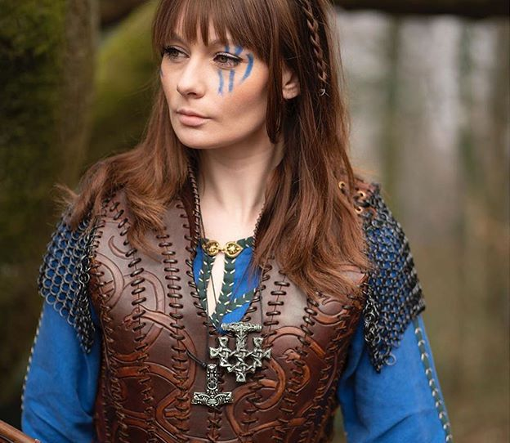

4 - Freyotta – Barbarian level 3

female human (6 ft., 1 in. tall)

HD 1d12+1; hp 39

Init +0

Spd 40 ft.

AC 15

Attack +4 melee, or +3 ranged

SV Fort +3, Ref +0, Will +1

Str 13, Dex 11, Con 13, Int 13, Wis 13, Cha 8

Skills (skill points: 25): Sailing +10, Climb +3, Handle Animal +3, Heal +2, Hide +0, Jump +3, Listen +1, Move Silently +0, Spot +1, Swim +5, Tumble +1

Feats: Persuasive (+2 bluff and intimidate), Power Attack (trade ATK bonus for DMG), Weapon Focus (+1 ATK with battle axe)

Possessions: 245 gp

(Starting arms and armor) Chain shirt, light wooden shield, dagger, throwing axe, longsword, masterwork battleaxe, longbow, arrows (40) (734 gp)

(Starting Equipment) Explorer’s outfit, backpack, small chest, rope (hemp), flint and steel, trail rations (10 days), water skin, bedroll, fishing net, fishhook, bullseye lantern, pouch, everburning torch, whetstone , winter blanket (140 gp)

Special: Fast movement (40’), illiteracy, rage (1/day), uncanny dodge, trap sense +1

-----------------------------



5 – Salhelga – Barbarian level 3

female human (6 ft., 2 in. tall)

HD 1d12+2; hp 42

Init +2 (+2 Dex)

Spd 40 ft.

AC 17 (+2 Dex)

Attack +6 melee, or +5 ranged

SV Fort +4, Ref +2, Will +2

Str 16, Dex 15, Con 15, Int 15, Wis 14, Cha 9

Skills (skill points: 30): Sailing +10, Climb +7, Craft (Leatherworking) +6, Decipher Script +4, Hide +2, Jump +7, Listen +2, Move Silently +2, Ride +6, Spot +2

Feats: Combat Expertise (trade ATK bonus for AC), Power Attack (trade ATK bonus for DMG), Weapon Focus (+1 to ATK with battle axe).

Possessions: 245 gp

(Starting arms and armor) Chain shirt, light wooden shield, dagger, throwing axe, longsword, masterwork battleaxe, longbow, arrows (40) (734 gp)

(Starting Equipment) Explorer’s outfit, backpack, small chest, rope (hemp), flint and steel, trail rations (10 days), water skin, bedroll, fishing net, fishhook, bullseye lantern, pouch, everburning torch, whetstone , winter blanket (140 gp)

Special: Fast movement (40’), illiteracy, rage (1/day), uncanny dodge, trap sense +1

-----------------------------

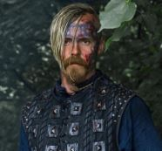

6 – Aldbeinn – Barbarian level 2

male human (5 ft., 3 in. tall)

HD 1d12+4; hp 32

Init +1 (+1 Dex)

Spd 40 ft.

AC 16 (+1 Dex)

Attack +6 melee, or +3 ranged

SV Fort +7, Ref +1, Will -2; AL N

Str 18, Dex 12, Con 18, Int 15, Wis 7, Cha 11

Skills (skill points: 30): Sailing +10, Diplomacy +2, Handle Animal +2, Hide +1, Listen +0, Move Silently +1, Perform (Sing) +1, Ride +5, Spot -2, Swim +8

Feats: Power Attack (trade ATK bonus for DMG), Weapon Focus (+1 to ATK with battle axe)

Possessions: 245 gp

(Starting arms and armor) Chain shirt, light wooden shield, dagger, throwing axe, longsword, masterwork battle axe, longbow, arrows (40) (734 gp)

(Starting Equipment) Explorer’s outfit, backpack, small chest, rope (hemp), flint and steel, trail rations (10 days), water skin, bedroll, fishing net, fishhook, bullseye lantern, pouch, everburning torch, whetstone , winter blanket (140 gp)

Special: Fast movement (40’), illiteracy, rage (1/day), uncanny dodge, trap sense +1

-----------------------------



7 – Finnthor – FTR 2 **[KIA]**

male human (5 ft., 9 in. tall)

HD 1d10+2; hp 24

Init +3 (-1 Dex, +4 Improved Initiative)

Spd 30 ft.

AC 14 (-1 Dex)

Attack +4 melee, or +0 ranged

SV Fort +4, Ref -1, Will -1

Str 16, Dex 9, Con 15, Int 14, Wis 8, Cha 7

Skills (skill points: ): Sailing +10, Climb +7, Hide -1, Intimidate +0, Jump +5, Listen +1, Move Silently -1, Ride +3, Spot -1, Swim +7

Feats: Blind-Fight (re-roll miss chance for concealment), Endurance, Improved Initiative

Possessions: 245 gp

(Starting arms and armor) Chain shirt, light wooden shield, dagger, throwing axe, longsword, masterwork battleaxe, longbow, arrows (40) (734 gp)

(Starting Equipment) Explorer’s outfit, backpack, small chest, rope (hemp), flint and steel, trail rations (10 days), water skin, bedroll, fishing net, fishhook, bullseye lantern, pouch, everburning torch, whetstone , winter blanket (140 gp)

-----------------------------

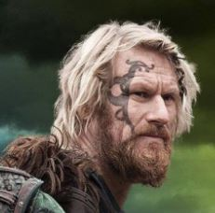

8 – Ingemundur – Barbarian level 2

male human (5 ft., 6 in. tall)

HD 1d12; hp 24

Init +0

Spd 40 ft.

AC 15

Attack +5 melee, or +2 ranged

SV Fort +3, Ref +0, Will +3

Str 16, Dex 11, Con 11, Int 10, Wis 16, Cha 10

Skills (skill points: 20): Sailing +10, Decipher Script +1, Hide +0, Listen +3, Move Silently +0, Perform (Wind Instruments) +1, Ride +4, Spot +3, Use Rope (hemp) +2

Feats: Blind-Fight (re-roll miss chance for concealment), Negotiator (+2 diplomacy, sense motive)

Possessions: 245 gp

(Starting arms and armor) Chain shirt, light wooden shield, dagger, throwing axe, longsword, masterwork battleaxe, longbow, arrows (40) (734 gp)

(Starting Equipment) Explorer’s outfit, backpack, small chest, rope (hemp), flint and steel, trail rations (10 days), water skin, bedroll, fishing net, fishhook, bullseye lantern, pouch, everburning torch, whetstone , winter blanket (140 gp)

Special: Fast movement (40’), illiteracy, rage (1/day), uncanny dodge, trap sense +1

-----------------------------



9 – Gudarinn – Barbarian level 2

male human (5 ft., 10 in. tall)

HD 1d12+3; hp 30

Init +1 (+1 Dex)

Spd 40 ft.

AC 16 (+1 Dex)

Attack +5 melee, or +3 ranged

SV Fort +6, Ref +1, Will +0

Str 17, Dex 12, Con 16, Int 14, Wis 11, Cha 11

Skills (skill points: 30): Sailing +10, Climb +5, Handle Animal +2, Hide +1, Intimidate +4, Knowledge (Nature) +4, Listen +1, Move Silently +1, Spot +1, Swim +7, Use Magic Device +2

Feats: Blind-Fight (re-roll miss chance for concealment), Combat Reflexes

Possessions: 245 gp

(Starting arms and armor) Chain shirt, light wooden shield, dagger, throwing axe, longsword, masterwork battleaxe, longbow, arrows (40) (734 gp)

(Starting Equipment) Explorer’s outfit, backpack, small chest, rope (hemp), flint and steel, trail rations (10 days), water skin, bedroll, fishing net, fishhook, bullseye lantern, pouch, everburning torch, whetstone , winter blanket (140 gp)

Special: Fast movement (40’), illiteracy, rage (1/day), uncanny dodge, trap sense +1

-----------------------------



10 – Ulfarr – FTR 3 **[RUN BY PC – STATS NEED TO BE UPDATED]**

male human (5 ft., 8 in. tall)

HD 1d10+1; hp 11

Init +2 (+2 Dex)

Spd 30 ft.

AC 17 (+2 Dex)

Attack +3 melee, or +3 ranged

SV Fort +3, Ref +2, Will -2

Str 15, Dex 14, Con 13, Int 14, Wis 6, Cha 13

Skills (skill points: ): Sailing +10, Climb +6, Handle Animal +5, Hide +2, Intimidate +5, Knowledge (History) +4, Listen -2, Move Silently +2, Spot -2, Swim +6

Feats: Cleave, Combat Reflexes, Power Attack (trade ATK bonus for DMG)

Possessions: 245 gp

(Starting arms and armor) Chain shirt, light wooden shield, dagger, throwing axe, longsword, masterwork battleaxe, longbow, arrows (40) (734 gp)

(Starting Equipment) Explorer’s outfit, backpack, small chest, rope (hemp), flint and steel, trail rations (10 days), water skin, bedroll, fishing net, fishhook, bullseye lantern, pouch, everburning torch, whetstone , winter blanket (140 gp)

-----------------------------

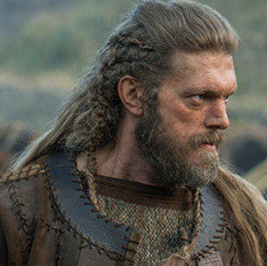

11 – Harthingur – Barbarian level 2

male human (5 ft., 11 in. tall)

HD 1d12+2; hp 28

Init -1 (-1 Dex)

Spd 40 ft.

AC 14 (-1 Dex)

Attack +5 melee, or +1 ranged

SV Fort +5, Ref -1, Will -3

Str 17, Dex 9, Con 15, Int 7, Wis 5, Cha 7

Skills (skill points: 6): Sailing +10, Hide -1, Intimidate +2, Jump +7, Listen -3, Move Silently -1, Spot -3

Feats: Blind-Fight (re-roll miss chance for concealment), Power Attack (trade ATK bonus for DMG)

Possessions: 245 gp

(Starting arms and armor) Chain shirt, light wooden shield, dagger, throwing axe, longsword, masterwork battleaxe, longbow, arrows (40) (734 gp)

(Starting Equipment) Explorer’s outfit, backpack, small chest, rope (hemp), flint and steel, trail rations (10 days), water skin, bedroll, fishing net, fishhook, bullseye lantern, pouch, everburning torch, whetstone , winter blanket (140 gp)

Special: Fast movement (40’), illiteracy, rage (1/day), uncanny dodge, trap sense +1

-----------------------------

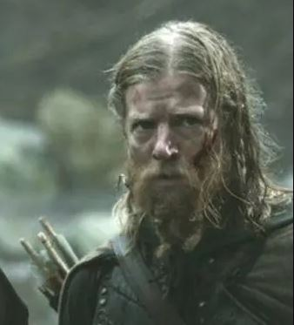

12 – Bergstyrr – Barbarian level 2

male human (5 ft., 9 in. tall)

HD 1d12+1; hp 26

Init +0

Spd 40 ft.

AC 15

Attack +4 melee, or +2 ranged

SV Fort +6, Ref +0, Will -2

Str 15, Dex 11, Con 12, Int 8, Wis 7, Cha 10

Skills (skill points: 7): Sailing +10, Climb +6, Hide +0, Intimidate +4, Listen -2, Move Silently +0, Spot -2

Feats: Great Fortitude (+2 to FORT saves), Power Attack (trade ATK bonus for DMG)

Possessions: 245 gp

(Starting arms and armor) Chain shirt, light wooden shield, dagger, throwing axe, longsword, masterwork battleaxe, longbow, arrows (40) (734 gp)

(Starting Equipment) Explorer’s outfit, backpack, small chest, rope (hemp), flint and steel, trail rations (10 days), water skin, bedroll, fishing net, fishhook, bullseye lantern, pouch, everburning torch, whetstone , winter blanket (140 gp)

Special: Fast movement (40’), illiteracy, rage (1/day), uncanny dodge, trap sense +1

-----------------------------



13 - Farrun – Barbarian level 2

male human (5 ft., 6 in. tall)

HD 1d12; hp 24

Init +2 (+2 Dex)

Spd 40 ft.

AC 17 (+2 Dex)

Attack +3 melee, or +4 ranged

SV Fort +2, Ref +2, Will -2

Str 13, Dex 15, Con 11, Int 14, Wis 7, Cha 14

Skills (skill points: 30): Sailing +10, Climb +3, Hide +2, Intimidate +2, Jump +5, Listen -2, Move Silently +4, Ride +4, Spot +2, Swim +5

Feats: Combat Expertise (trade ATK bonus for AC), Combat Reflexes

Possessions: 245 gp

(Starting arms and armor) Chain shirt, light wooden shield, dagger, throwing axe, longsword, masterwork battleaxe, longbow, arrows (40) (734 gp)

(Starting Equipment) Explorer’s outfit, backpack, small chest, rope (hemp), flint and steel, trail rations (10 days), water skin, bedroll, fishing net, fishhook, bullseye lantern, pouch, everburning torch, whetstone , winter blanket (140 gp)

Special: Fast movement (40’), illiteracy, rage (1/day), uncanny dodge, trap sense +1

-----------------------------



14 – Dagfrith – FTR 3 **[RUN BY PC – STATS NEED TO BE UPDATED]**

male human (5 ft., 9 in. tall)

HD 1d10+2; hp 12

Init +0

Spd 30 ft.

AC 15

Attack +6 melee, or +3 ranged

SV Fort +4, Ref +0, Will -1

Str 17, Dex 11, Con 14, Int 10, Wis 8, Cha 15

Skills (skill points: ): Sailing +10, Hide +1, Jump +7, Listen -1, Move Silently +1, Perform (Wind Instruments) +4, Ride +4, Spot +1

Feats: Point Blank Shot, Power Attack (trade ATK bonus for DMG), Precise Shot

Possessions: 245 gp

(Starting arms and armor) Chain shirt, light wooden shield, dagger, throwing axe, longsword, masterwork battleaxe, longbow, arrows (40) (734 gp)

(Starting Equipment) Explorer’s outfit, backpack, small chest, rope (hemp), flint and steel, trail rations (10 days), water skin, bedroll, fishing net, fishhook, bullseye lantern, pouch, everburning torch, whetstone , winter blanket (140 gp)

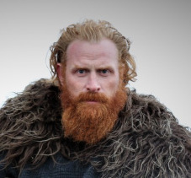

15 – Thorgeir – FTR 3 **[KIA]**

male human (5 ft., 10 in. tall)

HD 1d10+1; hp 33

Init +1 (+1 Dex)

Spd 30 ft.

AC 16 (+1 Dex)

Attack +2 melee, or +2 ranged

SV Fort +3, Ref +3, Will -1

Str 12, Dex 12, Con 12, Int 11, Wis 9, Cha 8

Skills (skill points: ): Sailing +10, Craft (Bowmaking) +4, Handle Animal +3, Hide +1, Listen +1, Move Silently +1, Ride +5, Spot +1

Feats: Lightning Reflexes, Persuasive, Quick Draw

Possessions: 245 gp

(Starting arms and armor) Chain shirt, light wooden shield, dagger, throwing axe, longsword, masterwork battleaxe, longbow, arrows (40) (734 gp)

(Starting Equipment) Explorer’s outfit, backpack, small chest, rope (hemp), flint and steel, trail rations (10 days), water skin, bedroll, fishing net, fishhook, bullseye lantern, pouch, everburning torch, whetstone , winter blanket (140 gp)

-----------------------------

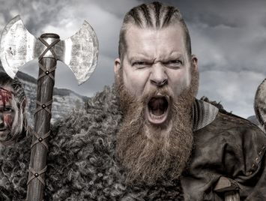

16 – Sighvat – FTR 3 **[RUN BY PC – STATS NEED TO BE UPDATED]**

male human (5 ft., 10 in. tall)

HD 1d10+2; hp 36

Init +2 (+2 Dex)

Spd 30 ft.

AC 17 (+2 Dex)

Attack +4 melee, or +3 ranged

SV Fort +4, Ref +2, Will +2

Str 16, Dex 15, Con 15, Int 13, Wis 11, Cha 11

Skills (skill points: ): Sailing +10, Climb +5, Handle Animal +2, Hide +2, Intimidate +4, Jump +7, Listen +1, Move Silently +2, Spot +1, Swim +7

Feats: Combat Expertise (trade ATK bonus for AC), Combat Reflexes, Iron Will

Possessions: 245 gp

(Starting arms and armor) Chain shirt, light wooden shield, dagger, throwing axe, longsword, masterwork battleaxe, longbow, arrows (40) (734 gp)

(Starting Equipment) Explorer’s outfit, backpack, small chest, rope (hemp), flint and steel, trail rations (10 days), water skin, bedroll, fishing net, fishhook, bullseye lantern, pouch, everburning torch, whetstone , winter blanket (140 gp)

-----------------------------



17 – Bjorn – Barbarian level 2

male human (6 ft., 0 in. tall)

HD 1d12+1; hp 26

Init +1 (+1 Dex)

Spd 40 ft.

AC 16 (+1 Dex)

Attack +3 melee, or +3 ranged

SV Fort +4, Ref +1, Will +3

Str 13, Dex 13, Con 13, Int 15, Wis 17, Cha 13

Skills (skill points: 30): Sailing +10, Craft (Shipmaking) +6, Craft (Woodworking) +4, Hide +1, Knowledge (Dungeoneering) +4, Listen +3, Move Silently +1, Ride +5, Sense Motive +5, Sleight of Hand +2, Spot +3

Feats: Combat Reflexes, Self Sufficient (+2 to heal and survival checks)

Possessions: 245 gp

(Starting arms and armor) Chain shirt, light wooden shield, dagger, throwing axe, longsword, masterwork battleaxe, longbow, arrows (40) (734 gp)

(Starting Equipment) Explorer’s outfit, backpack, small chest, rope (hemp), flint and steel, trail rations (10 days), water skin, bedroll, fishing net, fishhook, bullseye lantern, pouch, everburning torch, whetstone , winter blanket (140 gp)

Special: Fast movement (40’), illiteracy, rage (1/day), uncanny dodge, trap sense +1

-----------------------------



18 – Hermarr – Barbarian level 2

male human (6 ft., 0 in. tall)

HD 1d12+1; hp 26

Init +0

Spd 40 ft.

AC 15

Attack +5 melee, or +2 ranged

SV Fort +4, Ref +0, Will -1

Str 17, Dex 11, Con 13, Int 13, Wis 9, Cha 10

Skills (skill points: 25): Sailing +10, Climb +5, Concentration +3, Hide +1, Intimidate +2, Jump +7, Listen +1, Move Silently +1, Ride +4, Spot +1

Feats: Alertness (+2 to listen and spot checks), Track

Possessions: 245 gp

(Starting arms and armor) Chain shirt, light wooden shield, dagger, throwing axe, longsword, masterwork battleaxe, longbow, arrows (40) (734 gp)

(Starting Equipment) Explorer’s outfit, backpack, small chest, rope (hemp), flint and steel, trail rations (10 days), water skin, bedroll, fishing net, fishhook, bullseye lantern, pouch, everburning torch, whetstone , winter blanket (140 gp)

Special: Fast movement (40’), illiteracy, rage (1/day), uncanny dodge, trap sense +1

-----------------------------

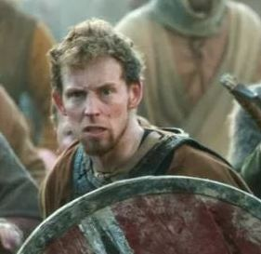

19 – Asgrim – Barbarian level 2

male human (5 ft., 7 in. tall)

HD 1d12+2; hp 28

Init +3 (+3 Dex)

Spd 40 ft.

AC 18 (+3 Dex)

Attack +4 melee, or +5 ranged

SV Fort +4, Ref +3, Will +0

Str 14, Dex 17, Con 15, Int 11, Wis 10, Cha 14

Skills (skill points: 20): Sailing +10, Climb +4, Hide +3, Jump +4, Listen +1, Move Silently +3, Spot +1, Swim +6, Use Magic Device +4

Feats: Combat Reflexes, Investigator, Point Blank Shot

Possessions: 245 gp

(Starting arms and armor) Chain shirt, light wooden shield, dagger, throwing axe, longsword, masterwork battleaxe, longbow, arrows (40) (734 gp)

(Starting Equipment) Explorer’s outfit, backpack, small chest, rope (hemp), flint and steel, trail rations (10 days), water skin, bedroll, fishing net, fishhook, bullseye lantern, pouch, everburning torch, whetstone , winter blanket (140 gp)

Special: Fast movement (40’), illiteracy, rage (1/day), uncanny dodge, trap sense +1

-----------------------------

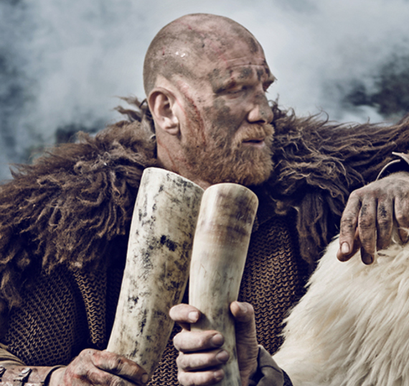

20 – Athalkarl – Barbarian level 2

male human (6 ft., 0 in. tall)

HD 1d12+2; hp 28

Init +0

Spd 40 ft.

AC 15

Attack +5 melee, or +2 ranged

SV Fort +5, Ref +0, Will -3

Str 16, Dex 11, Con 15, Int 14, Wis 5, Cha 13

Skills (skill points: 30): Sailing +10, Climb +7, Handle Animal +5, Heal -1, Hide +1, Intimidate +7, Jump +7, Listen -3, Move Silently +1, Spot -3

Feats: Combat Reflexes, Persuasive

Possessions: 245 gp

(Starting arms and armor) Chain shirt, light wooden shield, dagger, throwing axe, longsword, masterwork battleaxe, longbow, arrows (40) (734 gp)

(Starting Equipment) Explorer’s outfit, backpack, small chest, rope (hemp), flint and steel, trail rations (10 days), water skin, bedroll, fishing net, fishhook, bullseye lantern, pouch, everburning torch, whetstone , winter blanket (140 gp)

Special: Fast movement (40’), illiteracy, rage (1/day), uncanny dodge, trap sense +1

-----------------------------



21 – Kolbardur – Barbarian level 2

male human (5 ft., 10 in. tall)

HD 1d12+3; hp 30

Init +2 (+2 Dex)

Spd 40 ft.

AC 17 (+2 Dex)

Attack +5 melee, or +4 ranged

SV Fort +6, Ref +2, Will -1

Str 16, Dex 15, Con 16, Int 13, Wis 9, Cha 12

Skills (skill points: 25): Sailing +10, Handle Animal +5, Hide +2, Intimidate +5, Listen -1, Move Silently +3, Perform (String Instruments) +3, Ride +4, Spot -1

Feats: Weapon Focus (+1 to attack with longsword), Cleave

Possessions: 245 gp

(Starting arms and armor) Chain shirt, light wooden shield, dagger, throwing axe, longsword, masterwork battleaxe, longbow, arrows (40) (734 gp)

(Starting Equipment) Explorer’s outfit, backpack, small chest, rope (hemp), flint and steel, trail rations (10 days), water skin, bedroll, fishing net, fishhook, bullseye lantern, pouch, everburning torch, whetstone , winter blanket (140 gp)

Special: Fast movement (40’), illiteracy, rage (1/day), uncanny dodge, trap sense +1

-----------------------------

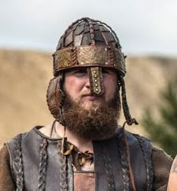

22 – Ulfrikur – Barbarian level 2

male human (5 ft., 6 in. tall)

HD 1d12+2; hp 28

Init +1 (+1 Dex)

Spd 40 ft.

AC 16 (+1 Dex)

Attack +4 melee, or +3 ranged

SV Fort +5, Ref +1, Will -1

Str 14, Dex 12, Con 15, Int 13, Wis 8, Cha 11

Skills (skill points: 25): Sailing +10, Bluff +1, Climb +6, Craft (Painting) +5, Hide +1, Intimidate +4, Listen -1, Move Silently +1, Spot -1, Swim +4

Feats: Power Attack (trade ATK bonus for DMG), Quick Draw

Possessions: 245 gp

(Starting arms and armor) Chain shirt, light wooden shield, dagger, throwing axe, longsword, masterwork battleaxe, longbow, arrows (40) (734 gp)

(Starting Equipment) Explorer’s outfit, backpack, small chest, rope (hemp), flint and steel, trail rations (10 days), water skin, bedroll, fishing net, fishhook, bullseye lantern, pouch, everburning torch, whetstone , winter blanket (140 gp)

Special: Fast movement (40’), illiteracy, rage (1/day), uncanny dodge, trap sense +1

-----------------------------

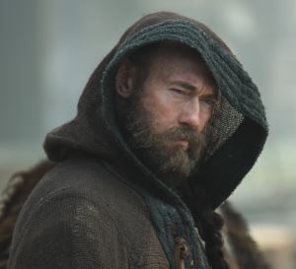

23 – Arinbjorn – Barbarian level 2

male human (6 ft., 2 in. tall)

HD 1d12+1; hp 26

Init +4 (+4 Improved Initiative)

Spd 40 ft.

AC 15

Attack +3 melee, or +2 ranged

SV Fort +4, Ref +0, Will +0; AL N

Str 13, Dex 11, Con 12, Int 10, Wis 11, Cha 8

Skills (skill points: 20): Sailing +10, Handle Animal +3, Hide +1, Intimidate +1, Listen +2, Move Silently +1, Perform (poetry, recitation) +1, Spellcraft +1, Spot +2

Feats: Alertness (+2 to listen and spot checks), Improved Initiative

Possessions: 245 gp

(Starting arms and armor) Chain shirt, light wooden shield, dagger, throwing axe, longsword, masterwork battleaxe, longbow, arrows (40) (734 gp)

(Starting Equipment) Explorer’s outfit, backpack, small chest, rope (hemp), flint and steel, trail rations (10 days), water skin, bedroll, fishing net, fishhook, bullseye lantern, pouch, everburning torch, whetstone , winter blanket (140 gp)

Special: Fast movement (40’), illiteracy, rage (1/day), uncanny dodge, trap sense +1

-----------------------------

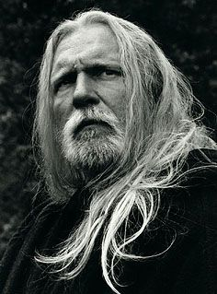

24 – Hjorleif – FTR 2 **[KIA]**

male human (6 ft., 2 in. tall)

HD 1d10+2; hp 12

Init +2 (+2 Dex)

Spd 30 ft.

AC 17 (+2 Dex)

Attack +4 melee, or +3 ranged

SV Fort +4, Ref +4, Will -3

Str 16, Dex 15, Con 14, Int 12, Wis 4, Cha 11

Skills (skill points: ): Sailing +10, Climb +7, Handle Animal +4, Heal +1, Hide +2, Jump +7, Listen +1, Move Silently +2, Spot +1

Feats: Alertness (+2 to listen and spot checks), Lightning Reflexes, Quick Draw

Possessions: 245 gp

(Starting arms and armor) Chain shirt, light wooden shield, dagger, throwing axe, longsword, masterwork battleaxe, longbow, arrows (40) (734 gp)

(Starting Equipment) Explorer’s outfit, backpack, small chest, rope (hemp), flint and steel, trail rations (10 days), water skin, bedroll, fishing net, fishhook, bullseye lantern, pouch, everburning torch, whetstone , winter blanket (140 gp)

-----------------------------