Castle Fairhand Staff
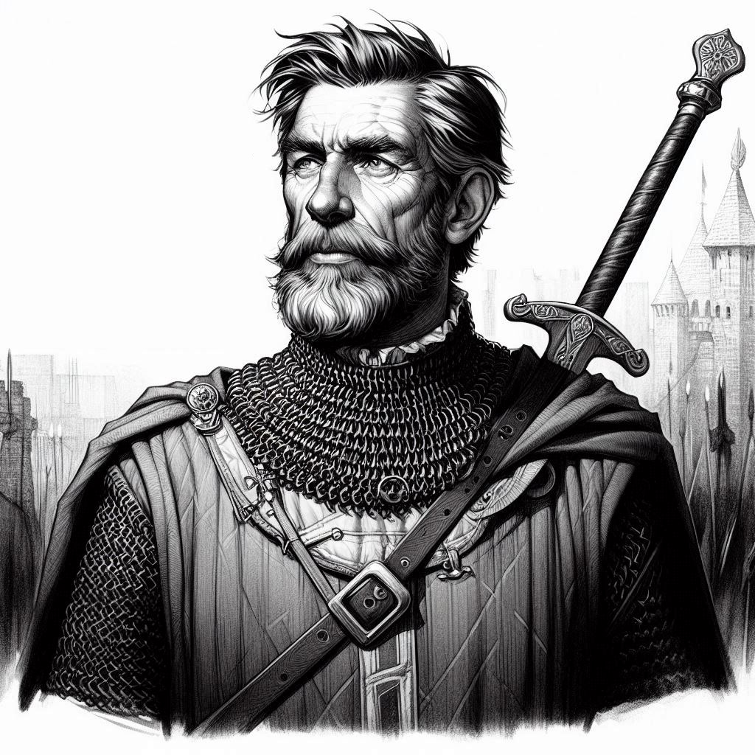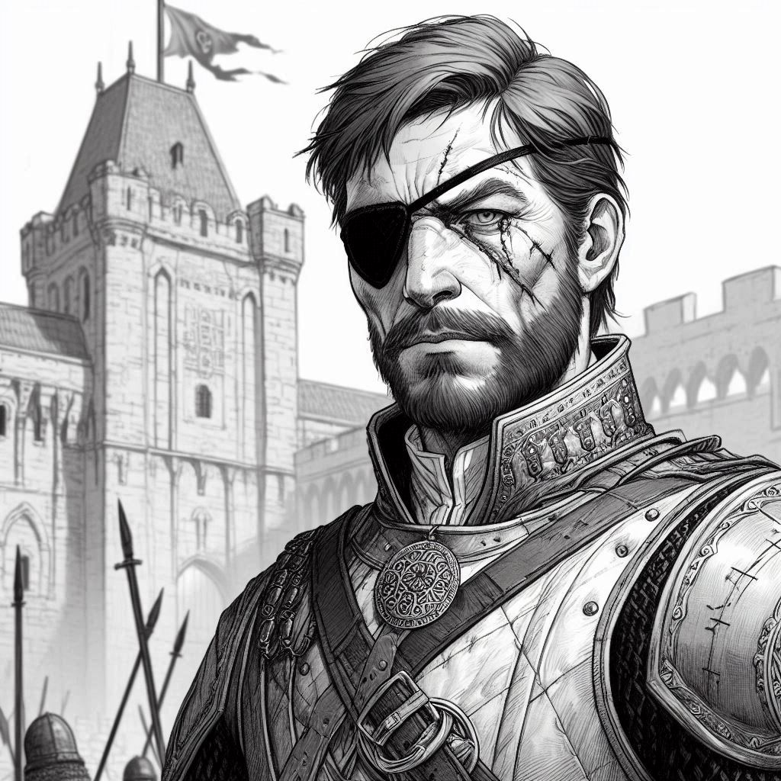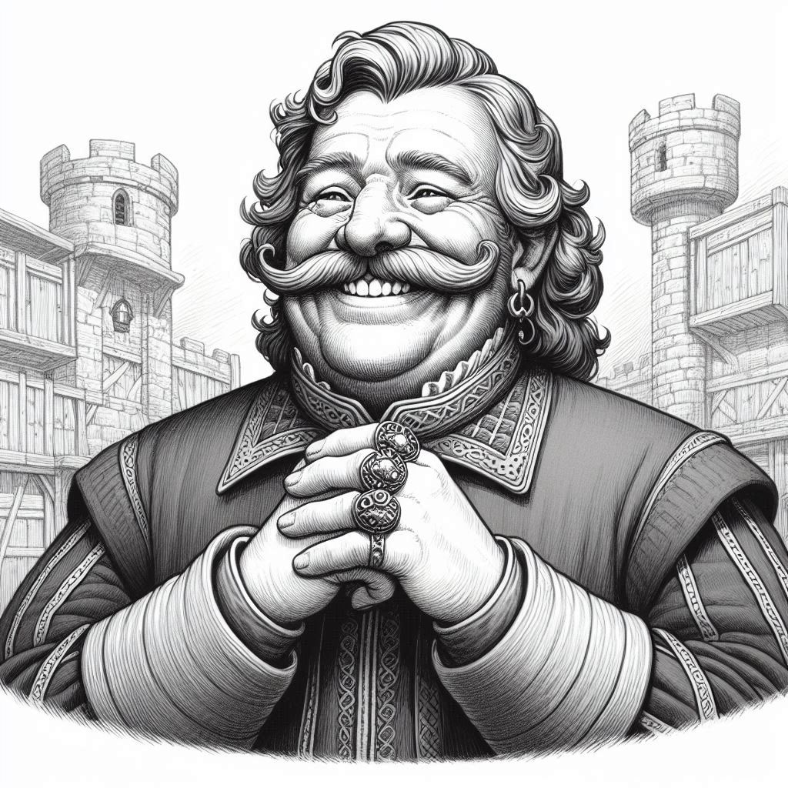
Cuthbert Wrayton, Steward Osric Delacy, Marshal Baldwin Kerrif, Chamberlain

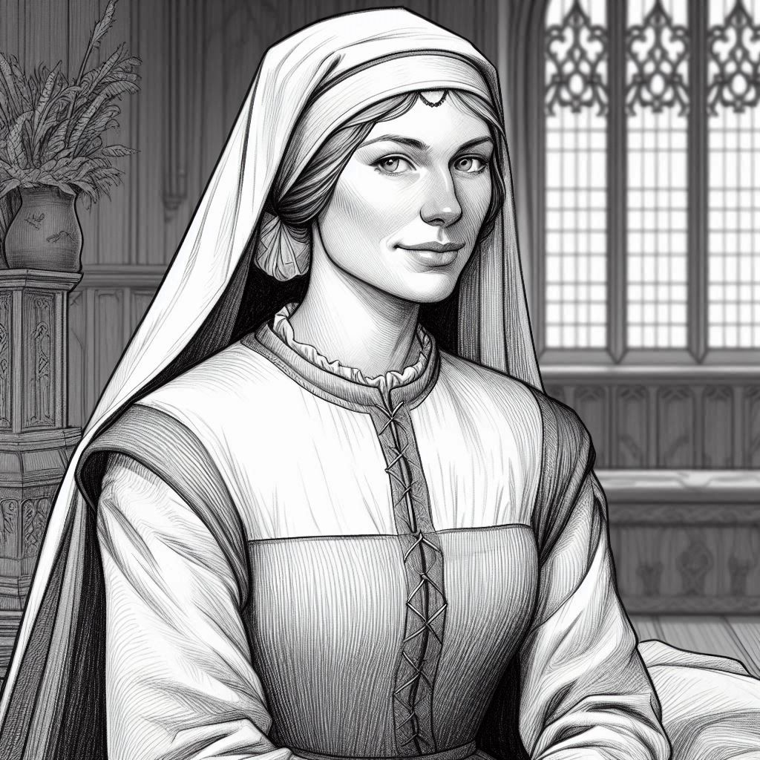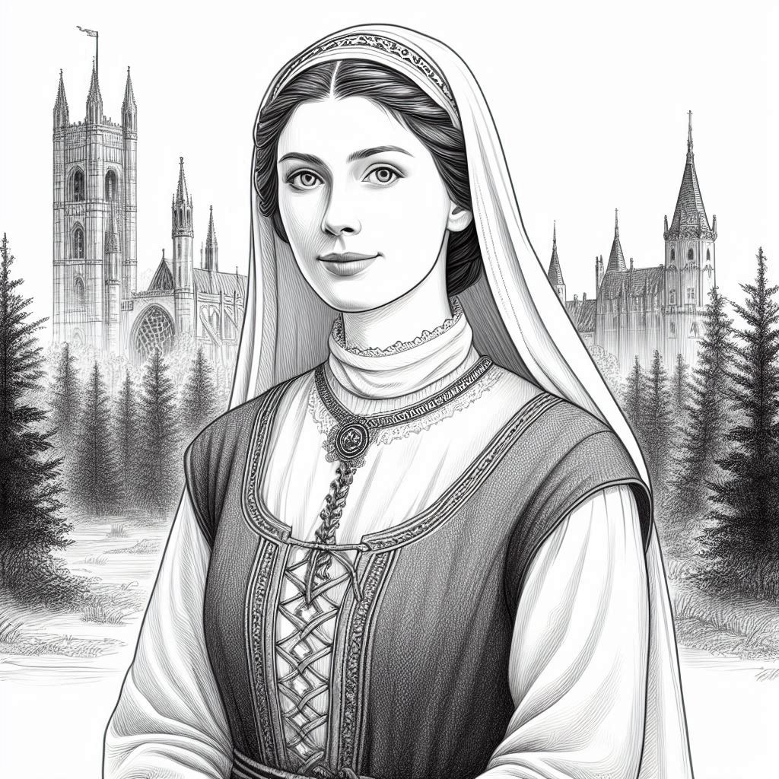
Edwyna Cullum, handmaiden Winifred Beller, handmaiden
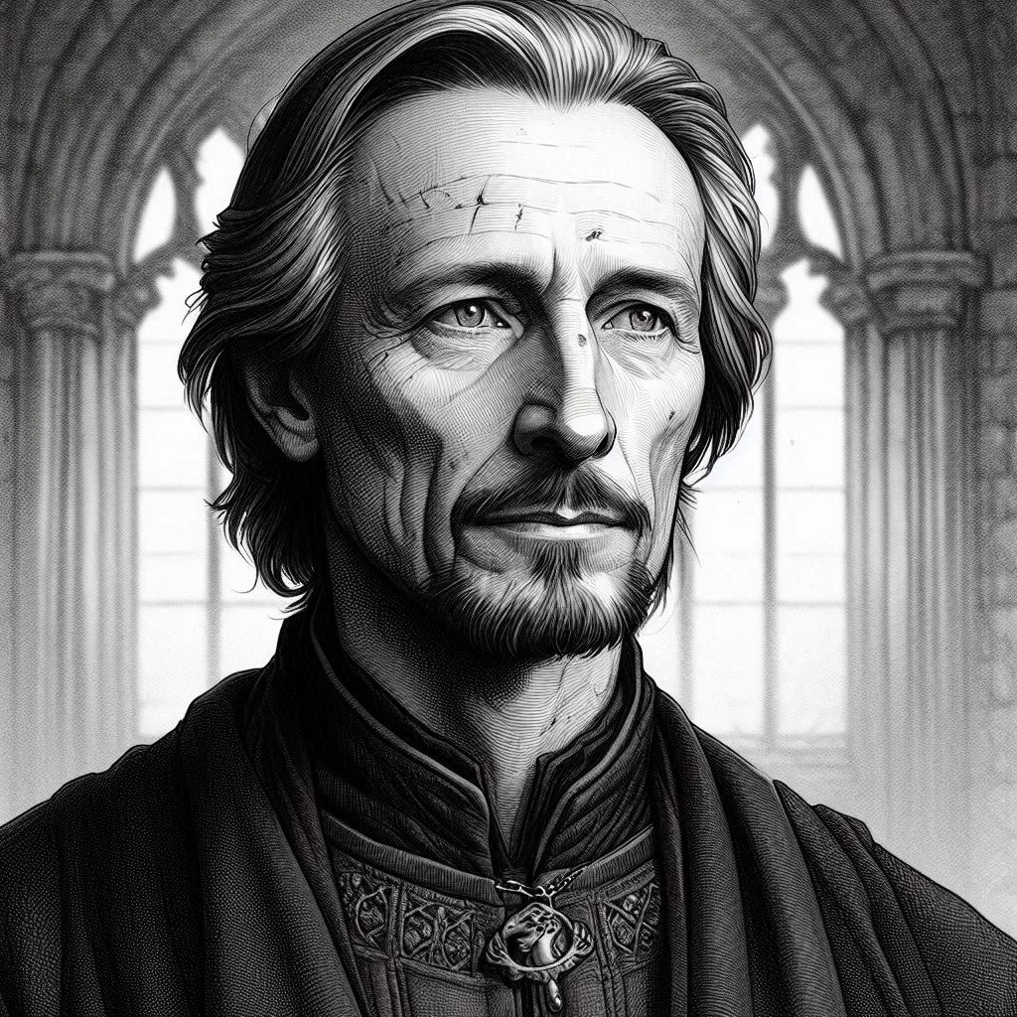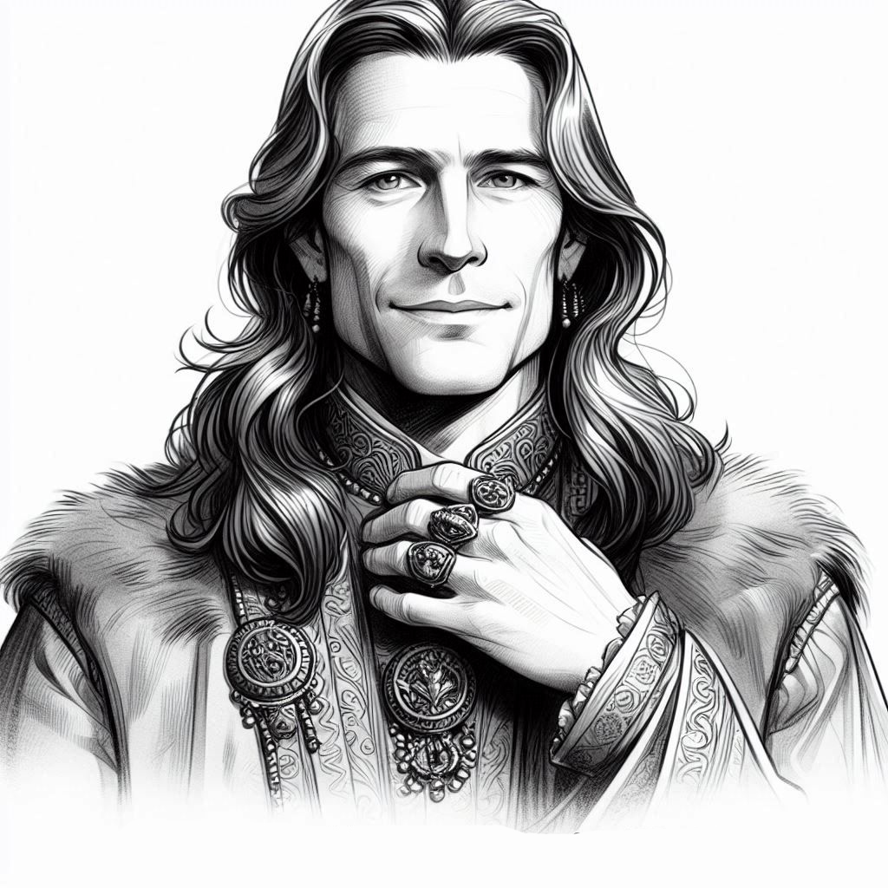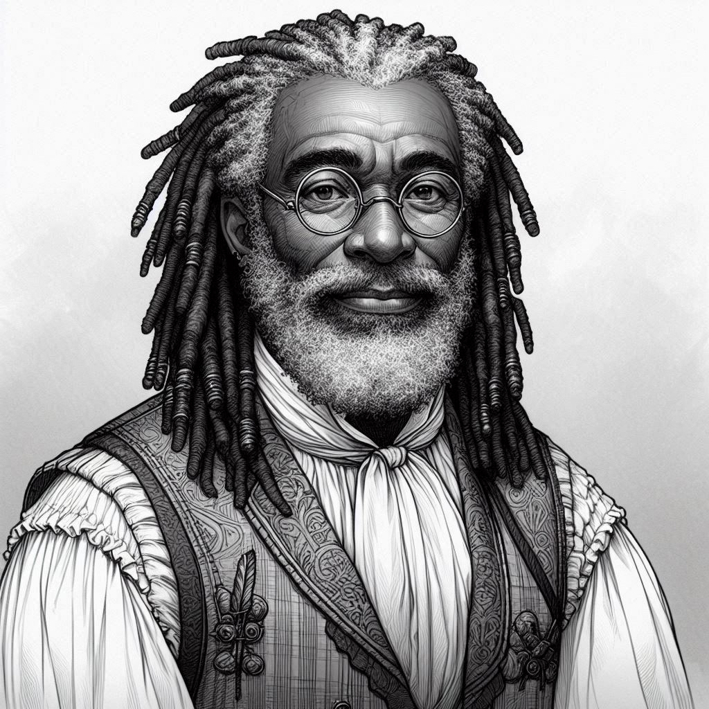
Alcuin Leech, Physician Geoffrey FitzAlan, Herald Hubert de Warenne, Tailor

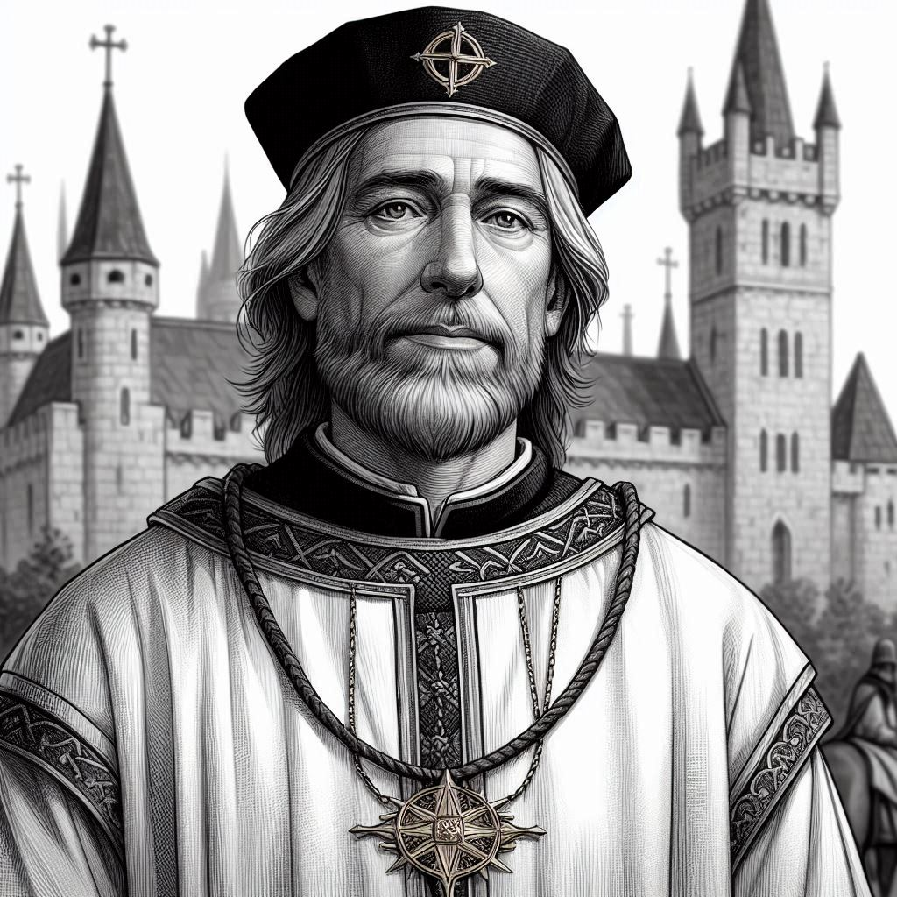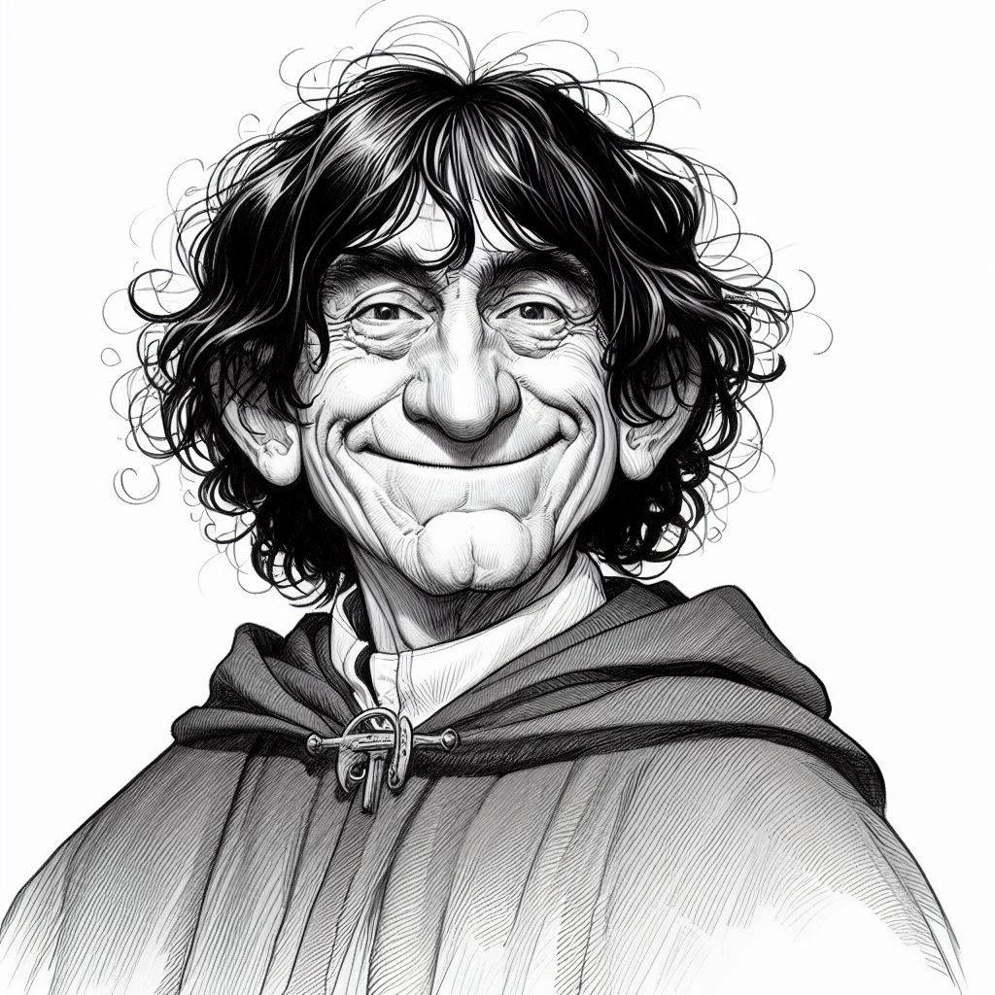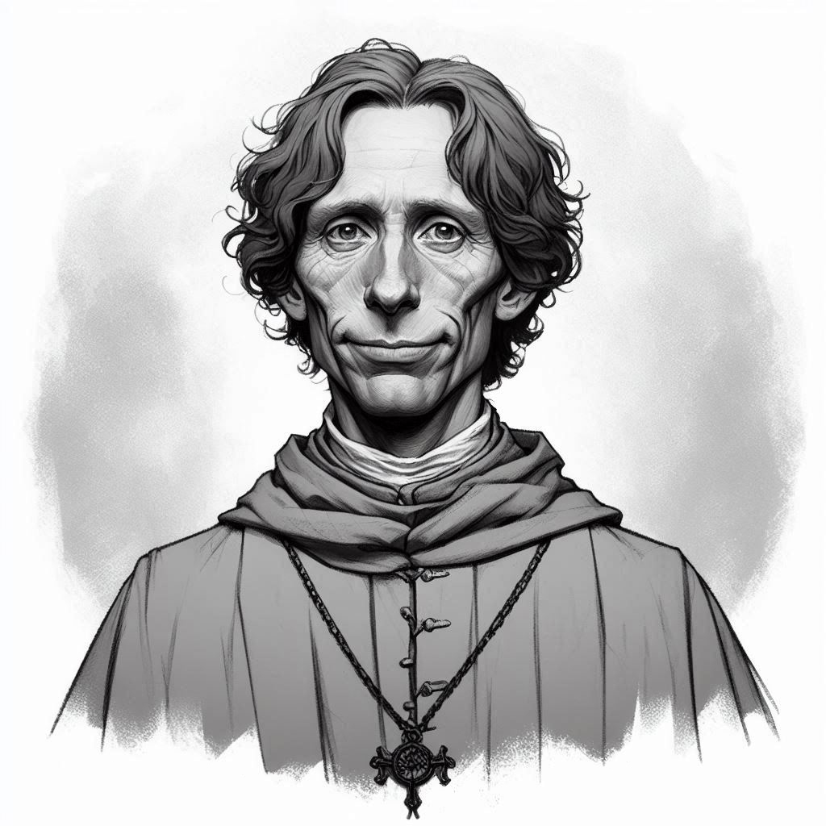
Anselm Sentery, Chaplain Simon Scrivener, Clerk Walter Redmayne, Clerk

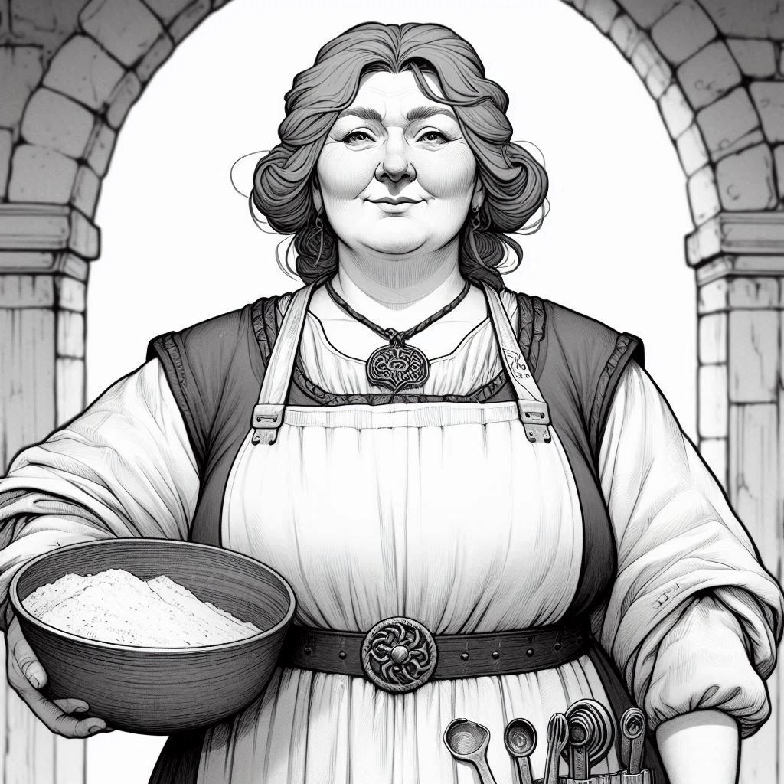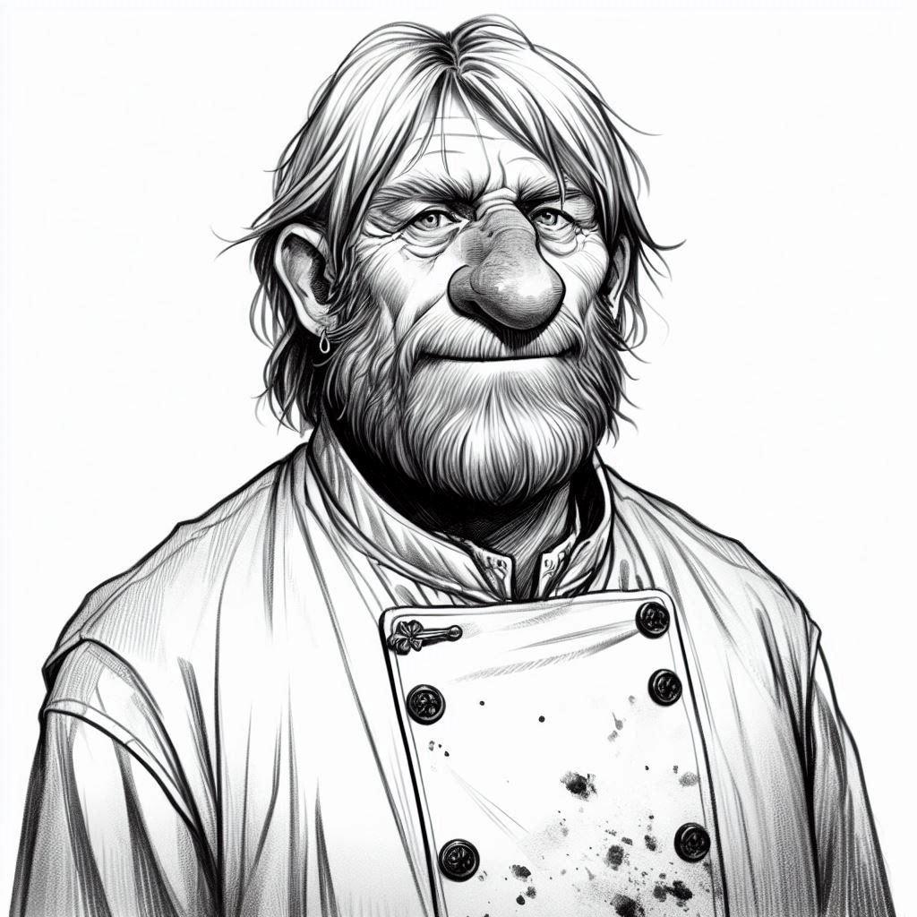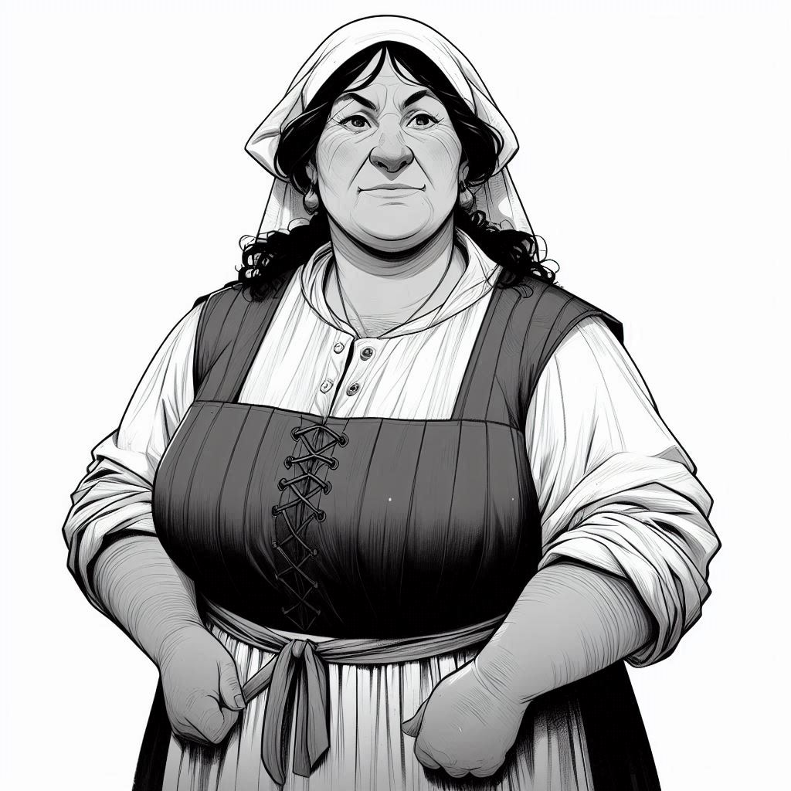
Godwina Bester, Baker Eadric le Fer, Chef Hilda Welbourne, Laundress

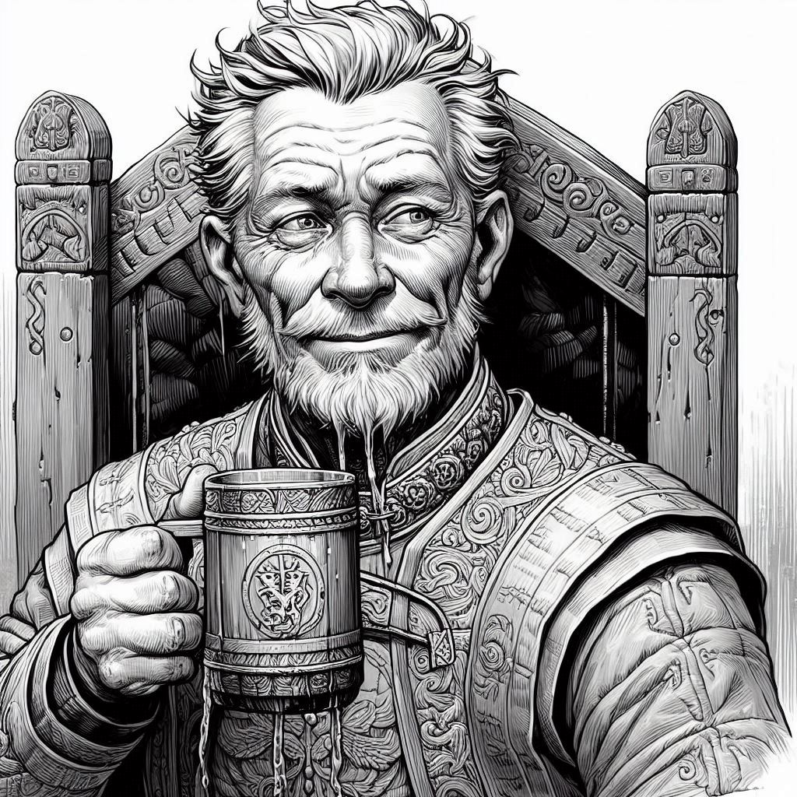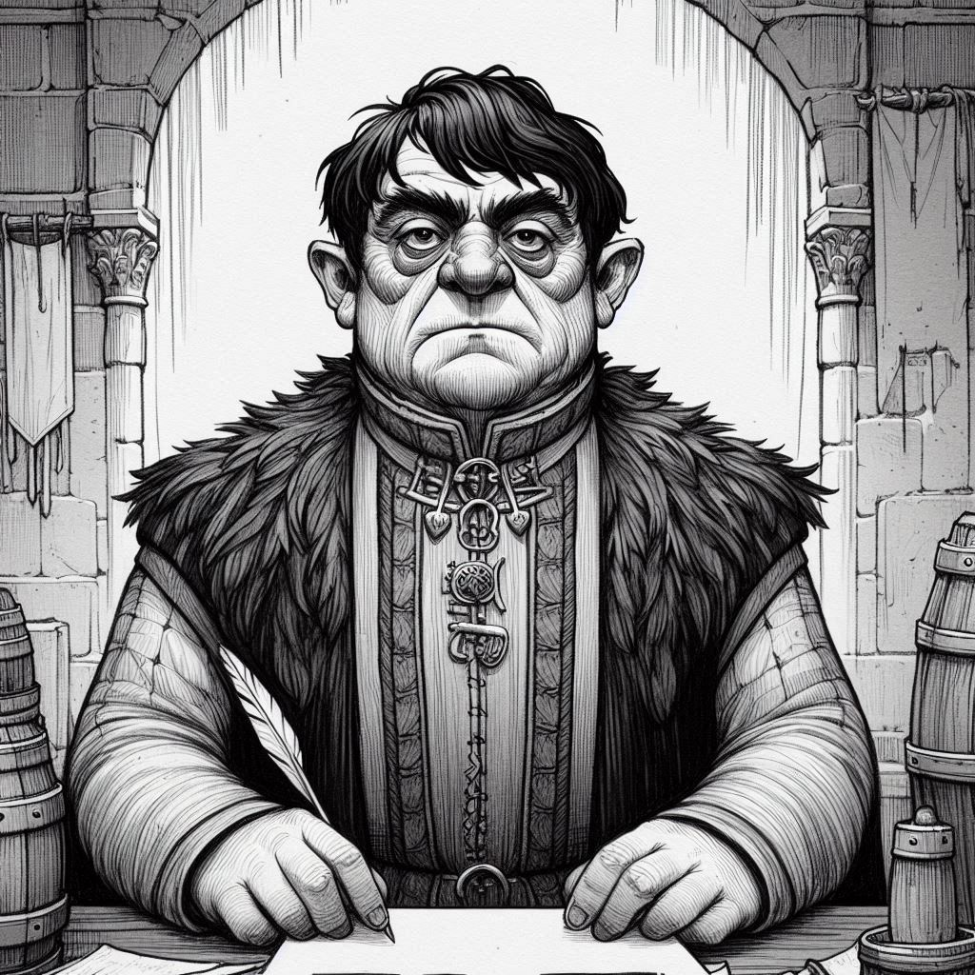
Bertram Keyes, Butler Reginald Harrow, Pantler
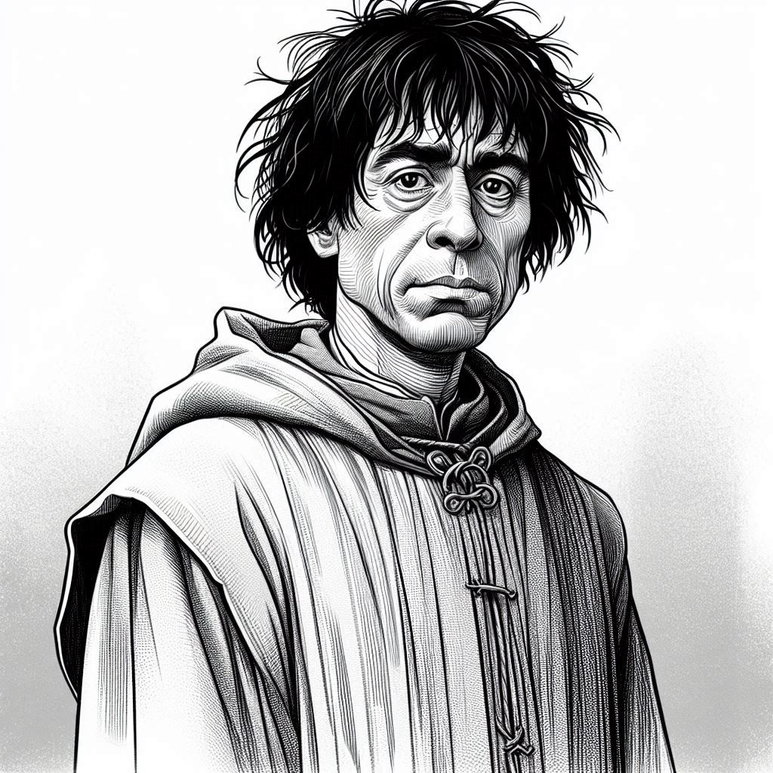
Osbert Barham, Swineherd

Microsoft Designer
AI Prompt: “Draw me a black-and-white half-length portrait of a medieval era character in a fantasy setting dressed in Anglo Saxon attire. Do not include words or text in the image. This is a portrait Leofwin Harcourt, of one of the castle's grooms, who takes care of

