Notes on the lands of the Elves

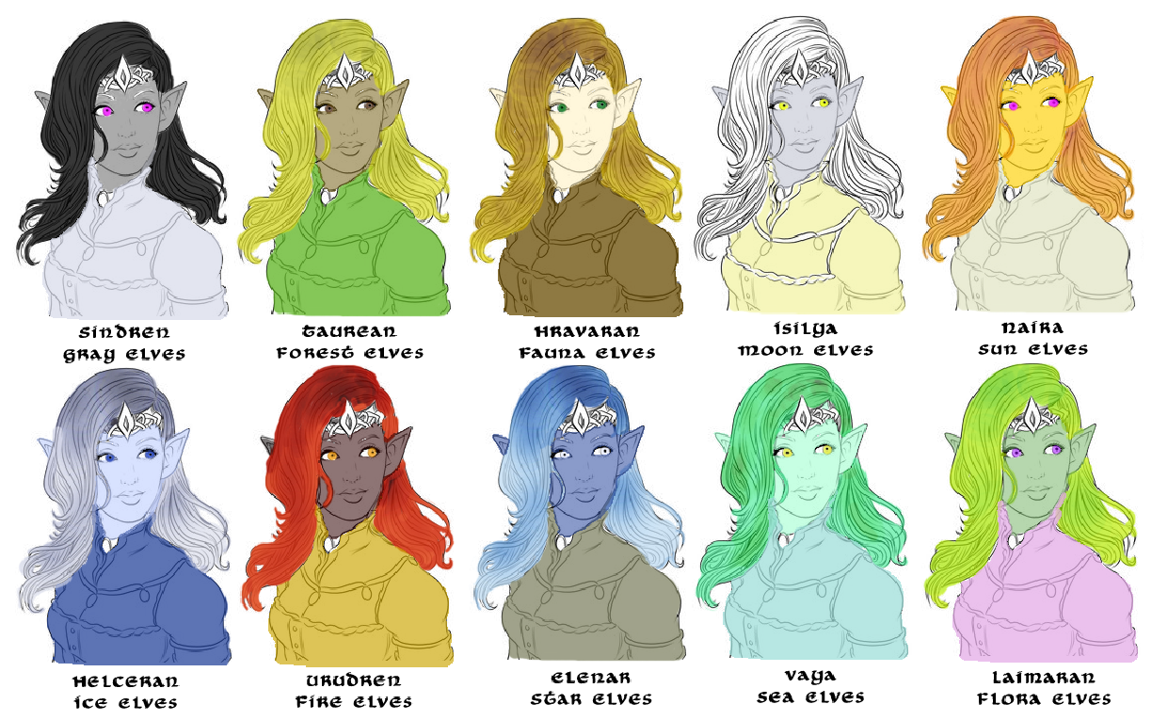

* **Overview**
* **Elven Domains**
* **Best in the Land**
* **Combined History**
* **Notes on Culture**
  + **Types of Elves**
  1. Sindren or Gray Elves
  2. Taurean or Forest Elves
  3. Hravaran or Fauna Elves
  4. Isilya or Moon Elves
  5. Naira or Sun Elves
  6. Helceren or Ice Elves
  7. Urudren or Fire Elves
  8. Elenar or Star Elves
  9. Vaya or Sea Elves
  10. Laimaran or Flora Elves
  11. Drow
* **Magical Items**
* **Developer Notes**

**Overview**

The elves have long been the custodians of Nemmyrl. They know her magics better than anyone, they keep her history, they safeguard her secrets. At the dawn of recorded history, they were the first to tread the world and bring order to the chaos. All elves ultimately pay homage to the gray elves of Adulien, but most make their homes throughout the world. Forest, fauna, and flora elves dwell in the forests, sun elves in the jungles, ice elves in the frozen peaks in the far north, fire elves in magma-covered broken lands, moon and star elves in places that grant them sight of the heavens, and the sea elves the watery depths. Man may seek to conquer and win fame. Dwarves may tunnel for gems and precious metals. But elves seek knowledge and harmony in nature.

The gray elves, eldest of all, stay confined to their mountain peaks on the Isle of Adulien. Here they tarry, keeping track of the millennia with the Adulien Calendar and a close eye on the happenings around the world via their Brightstar Fonts. They have little to do with the outer world, except in times of greatest need. The most ancient of magical secrets are theirs to keep. While kingdoms rise and fall, the gray elves of Adulien mark their passing.

It is the drow of which the least is known. Keeping to their subterranean lairs, they are rumored to rule beneath the wastelands of Ongolk and the mountains of Adhanar. They have conquered the Kang Mountains in Xiandai and may have even entered the Arcanan Mountains in Celedon. Theirs is a reign of terror so great even the haughty dwarves are grateful for help from elven kind to battle the drow. Some say that all great caverns somehow connect into one great under dark, although there is no proof. But if there is a place hidden from the sun then the drow will seek to exploit it.

**Elven** **Domains**

1. Laaktala – Yggdrasil Forest, lands of Norgarde, symbol of the snow owl, Helceren or Ice Elves
2. Adulien – Gidoran Forest, Isle of Adulien, symbol of the white swan – Sindren or Gray Elves; Taurean of Forest Elves
3. Aldalinh – Final Forest, Plenish Marchlands, symbol of the black swan – Taurean or Forest Elves
4. Ulynar – Tredfut Forest, lands of Treviland, symbol of the barn owl – Taurean or Forest Elves
5. Ari'Aahn – Great Elderwood, lands of Tirudor, symbol of the woodpecker – Taurean or Forest Elves
6. Teinhir – Fletcher Forest, lands of Erigoth, symbol of the snow goose – Taurean of Forest Elves
7. Eida'Las – Idenbor Forest, Central Amadar, symbol of the osprey – Hravaeran or Fauna Elves
8. Elgelor – Lost Light Forest, lands of the Haka’Na, symbol of the cardinal – Hravaeran or Fauna Elves
9. Elyon – Forest of the Great Stag, lands of the Haka’Na, symbol of the bluejay – Hravaeran or Fauna Elves
10. Cetaris – Great Horn Mts, lands of the Haka’Na – Elenar or Star Elves
11. Arbeiera – Ningarnim Forest, lands of Celedon, symbol of the pheasant – Hravaeran or Fauna Elves
12. Lo'Shella – Alona Forest, lands of Mythens, symbol of the horned owl – Hravaeran or Fauna Elves
13. Cascadrel – Crescent Forest, lands of Kyre, symbol of the hummingbird – Isilya or Moon Elves
14. Sirathren – Valley of Svarog, lands of Adhanar, symbol of the phoenix – Urudren or Fire Elves
15. Teliddia – Kitsune Forest, lands of Katura, symbol of the kingfisher – Laimaran or Flora Elves
16. Ithronel – Jungle of Deepnight, lands of Kaduru, symbol of the lovebird – Naira or Sun Elves

**Elven Domains within the oceans**

(these are covered in detail in the Domains of the Sea Elves document)

1. Aelfala – Heedless Straits, Norgarde
2. Llyrial – Isle of Daysend, Western Amadar
3. Celerithe – Isle of Wanahila, Eastern Amadar
4. Thalasa – Isle of Sabina, Western Arnland
5. Nammure – Isle of Verigon, Central Amadar
6. Bithyala – Isle of Ariago, Central Amadar
7. Ezerenis – Sea of Mazu, Xiandai
8. Isostei – Isle of Cassia, Western Arnland
9. Euryale – Sea of Thundra, Western Gaeadon
10. Varuna – Bay of Pengali, Mahabar
11. Danuhei – The Dark Shores, Mahabar
12. Ikatere – Isle of the Sea Elves, the Great Maelstrom
13. Cermeyil – Cliffs of Elegua, Kaduru

**Best in the Land**

Every elven domain watch over their forest in much the same way: hunting, cultivating, studying, and preparing defenses. But some domains excel in certain areas that make them the preeminent authorities on the subjects.

Laaktala – the study of order magic

Adulien – lore and history, caretakers of the Adulien Calendar

Aldalinh - archery

Ulynar – sword smithing / artifact of the

Ari'Aahn – woodcraft / wood sculpting / artifact of power

Teinhir – animal husbandry / artifact of life essence

Eida'Las - war strategy / artifact of

Elgelor - sailing, boat building, and naval combat / artifact of the sea

Elyon – care and stewardship of riverways / artifact of time

Cetaris – the study of the stars

Arbeiera – the study and practice of arcane magic ; artifact of knowledge

Lo'Shella – music and dance ; artifact of the heart

Cascadrel – the study and practice of divine magic ; artifact of the heavens

Sirathren – the study of chaos magic

Teliddia – silviculture / horticulture ; artifact of

Ithronel – swordsmanship

**Laaktala**

**Helceren or Ice Elves**

**Yggdrasil Forest in the lands of Norgarde**

* Laaktala
  + Jorildyn – large town, population 5,000, guards / soldiers 50, militia 250
  + Reysalor – large town, population 5,000, guards / soldiers 50, militia 250
  + Ylyndar – large town, population 5,000, guards / soldiers 50, militia 250
  + Ralyndur – large town, population 5,000, guards / soldiers 50, militia 250
  + Brindarry – large town, population 5,000, guards / soldiers 50, militia 250
  + Yundraer – large city, population 25,000, guards / soldiers 250, militia 2250
  + Stilmyst – large town, population 5,000, guards / soldiers 50, militia 250

**Notes on this Domain**

**Traits of this Domain**

**Animal companions**: snow owls

**Weapon of choice**: long bow, throwing axe

**Natural enemies**: rhemorhaz, ice mephitis

**Favored mounts**: dire reindeer

**Custom**: Laaktala Elves fashion gems of ice that never melt, each with a snowflake inscription unique to their name. These are given as tokens of friendship to any who earn their trust.

**Common saying**: “May the ice be your friend,” answered with “For when it breaks you will know your enemies.”

**Adulien**

**Sindren or Gray Elves & Taurean or Forest Elves**

**Gidoran Forest on the Isle of Adulien**

* Adulien – Gidoran Forest, Isle of Adulien
  + Caldalir - large town, population 5,000, guards / soldiers 50, militia 250
  + Elebreth - large city, population 25,000, guards / soldiers 250, militia 2250
  + He’inatha - large town, population 5,000, guards / soldiers 50, militia 250
  + Merelien - large town, population 5,000, guards / soldiers 50, militia 250
  + (Druindar) – human large town, part of Plenia (?)

**Notes on this Domain**

Island has a massive navy defending her shores

The forest elves of Adulien dwell in Gidoran Forest but are at the service of the Gray Elves that live far above them in the mountains.

Elves occupy large wooded areas throughout Nemmyrl, but all pay homage to Adulien.

The Gray Elves rule over all of Elvendom from their mountain hideaways. They have a palace of great splendor at the top of Mt. Singol, where they also hold the oldest of libraries and many secrets.

Masters of the Nén Calima Elen “Waters of Brightstar” which communicates with all the Brightstar Fonts throughout the world

**Traits of this Domain**

**Animal companions**:

**Weapon of choice**:

**Natural enemies**:

**Favored mounts**: asperii

**Custom**:

**Common saying**:

**Aldalinh**

**Taurean or Forest Elves**

**Final Forest in the Plenish Marches**

* Aldalinh
  + Gylledha – large town, population 5,000, guards / soldiers 50, militia 250
  + Ellashor – large city, population 25,000, guards / soldiers 250, militia 2250
  + Faenion – large town, population 5,000, guards / soldiers 50, militia 250
  + Lydeira – large town, population 5,000, guards / soldiers 50, militia 250
  + Silveroak – large town, population 5,000, guards / soldiers 50, militia 250

**Notes on this Domain**

* Mages here study the course of history, the deeds of people, the yearning and ambitions that both elevate kingdoms and burn them to the ground. It is said the ancient order of magic, the Tharthalion, was founded here and canvassed the world for knowledge of magic. The great library of Aldalinh rivals the mighty halls of Sargon itself.
* homes built into living wood, high in the trees
* still maintain a modest fleet of trading and exploration vessels that they harbor up-river within the woods. The hidden port is called Naiana and only trusted friends of the elves are allowed to harbor there.
* friends of sea elves that inhabit the shoreline along western Plenia
* Mastery of archery and innovations made in the field make them the authorities on the subject among elvenkind
* Weapon of choice: Aldalinh longbows, the finest in the world, which sing when their bowstrings are loosed. Many legendary bows have hailed from here, their names striking fear into the hearts of orc tribes.
* Natural enemies:
* Favored mounts: talimbé steeds
* Custom:
* Common saying:

**Traits of this Domain**

**Animal companions**: horse, griffon

**Weapon of choice**:

**Natural enemies**:

**Favored mounts**:

**Custom**:

**Common saying**:

**Ulynar**

**Tredfut Forest in the lands of Treviland**

**Taurean or Forest Elves**

* Ulynar
  + Orinaan - large town, population 5,000, guards / soldiers 50, militia 250
  + Na'irean - large town, population 5,000, guards / soldiers 50, militia 250
  + Haloreth - large city, population 25,000, guards / soldiers 250, militia 2250
  + Rithyra - large town, population 5,000, guards / soldiers 50, militia 250
  + Eleyolen - large town, population 5,000, guards / soldiers 50, militia 250
  + Omanarra - large town, population 5,000, guards / soldiers 50, militia 250

**Notes on this Domain**

Ulynar enjoys relative solitude from the humans of Treviland since the area is lightly populated and heavily wooded. Elves here enjoy a special bond with the elves of Ari’Aahn and travel the **Path of the Aching Heart** to visit one another. They serve as protectors of Faerdeep Vale in Kendor and the fey court of Faerie Queen Aradia. They are uneasy friends of the dwarves of Daeumundra, from whom they obtain special ore for their steel forges from the **Gwaedaear** a special mine in the Evermore Mts. They regard the humans of Treviland as children to be watched. Ulynar elves are masters at sword smithing, making them the authorities on the subject among elvenkind

**Traits of this Domain**

**Animal companions**: giant owls, leopards

**Weapon of choice**: longswords, some of them the Gwaedaer swords the best in the world

**Natural enemies**:

**Favored mounts**: horse, griffon

**Custom**: known to set snares on trees so that low branches will swat the back sides of humans passing this way on command – it is their reminder to the humans that they can often be naughty

**Common saying**: “May the skies be fair for friends,” answered by “may friends be true when skies turn foul.”

**Ari'Aahn**

**Great Elderwood in the lands of Erigoth**

**Taurean or Forest Elves**

* Ari'Aahn
  + Elashor – large town, population 5,000, guards / soldiers 50, militia 250
  + Vaella – large city, population 25,000, guards / soldiers 250, militia 2250
  + Aelesar – large town, population 5,000, guards / soldiers 50, militia 250
  + Brightsong – large town, population 5,000, guards / soldiers 50, militia 250
  + Faenor – large town, population 5,000, guards / soldiers 50, militia 250

**Notes on this Domain**

* faced centuries of opposition with the humans in this region but there is an uneasy truce now; the Treaty of Corlaer dictates that no non-elf shall enter the woods themselves without permission.
* enjoy a special bond with the elves of Ulynar and travel the **Path of the Aching Heart** to visit one another.
* Master at woodcraft and wood sculpting make them the authorities on the subject among elvenkind
  + Every camp in their domain is decorated with breathtaking decorative wooden sculptures. Their main camp in Vaella features **Heaven’s Arbor** and is an ornately carved mall of carved wooden arches reaching to the heavens rivaling the world’s greatest cathedrals.

**Traits of this Domain**

**Animal companions**: giant owls, leopards

**Weapon of choice**: magic hardened wood staves, composite longbows of exceptional making

**Natural enemies**:

**Favored mounts**: horse, griffon

**Custom**: Make annual quests over the Evermore Mts. to enter the Lost Northern Lands and the Friendless Fringes. It is called the Forodren Faroth or Northern Hunt and its purpose is to hunt orcs and goblins in their mission to rid those lands of evil.

**Common saying**: Lothron cin gal- in cín foeir iór

**Teinhir**

**Fletcher Forest in the lands of Erigoth**

**Taurean or Forest Elves**

* Teinhir
  + Talandren – large town, population 5,000, guards / soldiers 50, militia 250
  + Rivvikyn – large town, population 5,000, guards / soldiers 50, militia 250
  + Ellarion – large city, population 25,000, guards / soldiers 250, militia 2250
  + Darkstar – large town, population 5,000, guards / soldiers 50, militia 250

**Notes on this Domain**

Master of animal husbandry make them the authorities on the subject among elvenkind

**Traits of this Domain**

**Animal Companions**:

**Weapon of choice**:

**Natural enemies**:

**Favored mounts**: giant moose

**Custom**:

**Common saying**:

**Eida'Las**

**Idenbor Forest in the lands of Oberon**

**Hravaeran or Fauna Elves**

* Eida'Las
  + Noldorin – large town, population 5,000, guards / soldiers 50, militia 250
  + Othorion – large town, population 5,000, guards / soldiers 50, militia 250
  + Faerondil – large town, population 5,000, guards / soldiers 50, militia 250
  + Tiatha – large city, population 25,000, guards / soldiers 250, militia 2250
  + Kelerandri – large town, population 5,000, guards / soldiers 50, militia 250
  + Rivleam – large town, population 5,000, guards / soldiers 50, militia 250

**Notes on this Domain**

* the last guardians of the once-proud lands around the Sea of Oberon
* Isolated by the occupation of orcs and goblin tribes in the Oberon Sea region, they have had to learn to master battlefield strategy and are the undisputed leaders in land combat
* Elven towns are fortresses that command the treetops. The Elves here are wary of strangers and their hospitality is lacking even towards fellow Elves who journey here.
* Each elf from this domain wears a necklace bearing the five symbols of the domains that fell to the Scourge of Hrolith in the Fourth Ancient Age: Dagohorn Forest, Neversun Forest, Greydon Wood, Nastrond Forest, and Elfrend Wood
* superior war tactics and strategy make them the authorities on the subject among elvenkind
* Inhabitants are almost always dressed in camouflage with their faces painted in dark woodland colors; most feel naked without their camouflage paint and consider it rude to go without it or be seen without it.
* Elves here have developed systems of communicating with one another over long distances without alerting enemy forces that surround the region.
  + At night Eida’las elves climb to the tops of the tallest trees in the Idenbor Forest and use special shuttered lanterns to signal one another. The lights mimic the behavior of fireflies, so the elves are called Fireflies.
  + Another method uses special reeds constructed to sound like the high-pitched calls of birds. With their exceptional hearing and eyesight, Eida’las elves can detect the signals from fifty miles away or more.
  + A less discrete signal system involves hollowed out wooden tubes that the elves strike, creating an eerie percussion noise that travels for miles. Before battle the elves will strike these tubes, which also have a pleasant musical quality to them, to intimidate their enemies and throw off attempts to locate their forces or size up how many of them there are. After a victory or between battles these pipes are used as both percussion and blown instruments to create festive songs.

**Traits of this Domain**

**Animal Companions:**

**Weapon of choice:** double-ended spears, longbows

**Natural enemies:** orcs, goblins, gnolls

**Favored mounts:** giant lynx

**Custom:** Eida’las elves are fond of practical jokes that prepare one another for the grim reality of the region: surrounded by enemies and being ready for defense. They will regularly drug one of their members and leave them bound in dangerous locations, challenging them to make it home alive. Members win extra points for bringing back the ears of the enemy. Suspicious as they are, they will often employ this custom on strangers that they have met and decide are not a threat. It is in fact a gesture of friendship to those outside the domain, but few who experience it from the outside see it that way.

**Common saying:** “Death waits for no one,” answered with “May you strike before death opens its eyes.”

**Elgelor**

**Lost Light Forest in the lands of Haka’Na**

**Hravaeran or Fauna Elves**

* Elgelor
  + Adanell – large town, population 5,000, guards / soldiers 50, militia 250
  + Venlana – large city, population 25,000, guards / soldiers 250, militia 2250
  + Briareth – large town, population 5,000, guards / soldiers 50, militia 250
* Elyon elves have developed a close bond to the wild beasts of the land that goes beyond the normal bond elves share with nature. Here they spend years living among the animals and becoming part of their packs. Most Elyon elves adopt traits of the animals to whom they’ve bonded. Many wear antlers and furs (with the permission of their packs, of course), some grow out nails like claws, and most can speak fluently in the animal tongues.
  + Circles have formed in the elven settlements around animals that the elves have in common: wolf-elves forming close ties, stag elves the same, etc. There have been dark periods in their history when the elves that bonded with predator animals turned on those that bonded with the animals that were their prey. But no one wants to talk about that part of their history and they have vowed never to let that repeat itself. In fact, the elves of Elyon are aware of the danger of becoming too close to the animals, for a very few become lost and wander into the wild as feral elves.
  + A very few among the elves, those touched with special magic, have developed the ability to enter the minds of animals, taking them over and inhabiting their bodies. These are called the Bereg-Emels, or those who journey to other bodies.

**Traits of this Domain**

**Animal Companions:**

**Weapon of choice:**

**Natural enemies:**

**Favored mounts:** giant eagle

**Custom:**

**Common saying:**

**Elyon**

**Great Stag Forest in the lands of Haka’Na**

**Hravaeran or Fauna Elves**

* Elyon
  + Oritiris - large town, population 5,000, guards / soldiers 50, militia 250
  + Naerdya - large town, population 5,000, guards / soldiers 50, militia 250
  + Nabreith - large town, population 5,000, guards / soldiers 50, militia 250
  + Alais - large town, population 5,000, guards / soldiers 50, militia 250
  + Evanara - large city, population 25,000, guards / soldiers 250, militia 2250
  + Moondown - large town, population 5,000, guards / soldiers 50, militia 250
  + Silvyr - large town, population 5,000, guards / soldiers 50, militia 250

**Notes on this Domain**

* Elyon elves have developed a close bond to the wild beasts of the land that goes beyond the normal bond elves share with nature. Here they spend years living among the animals and becoming part of their packs. Most Elyon elves adopt traits of the animals to whom they’ve bonded. Many wear antlers and furs (with the permission of their packs, of course), some grow out nails like claws, and most can speak fluently in the animal tongues.
  + Circles have formed in the elven settlements around animals that the elves have in common: wolf-elves forming close ties, stag elves the same, etc. There have been dark periods in their history when the elves that bonded with predator animals turned on those that bonded with the animals that were their prey. But no one wants to talk about that part of their history and they have vowed never to let that repeat itself. In fact, the elves of Elyon are aware of the danger of becoming too close to the animals, for a very few become lost and wander into the wild as feral elves.
  + A very few among the elves, those touched with special magic, have developed the ability to enter the minds of animals, taking them over and inhabiting their bodies. These are called the Bereg-Emels, or those who journey to other bodies.

**Traits of this Domain**

**Animal Companions:**

**Weapon of choice:**

**Natural enemies:**

**Favored mounts:** a magical breed of horses that the Haka’Na call the Johano. They are magical creatures that are said to have come from the sky god and that come in one of the five colors of the day-time sky: turquoise, white shell, pearly shell, red shell, and coal.

**Custom:**

**Common saying:** “Only a fool fights the river. A wise man is the river.”

**Cetaris**

**Great Horn Mountains in the lands of the Haka’Na**

**Elenar or Star Elves**

**Notes on this Domain**

* Spend long nights staring up at the skies, meditating on the secrets revealed to them by the faraway lights.
* Upon reaching adulthood, each Elgelor elf receives a vision from one of the many stars in the sky. Thereafter the star is their primary focus of attention in life and the two develop a special relationship. The elf communes regularly with the star, watching its movements, noting its patterns of light, and searching for messages from the far-off illumination. It is not uncommon for a member of the Elgelor to awaken from a long night of meditating on the stars and feel compelled to undertake a perilous quest that they believe is ordered by their star. Some even claim to be able to hear their star speaking to them within their minds.
* On nights that there are spectral light shows in these northern skies, the elves of Elgelor are especially entranced and some say they gain special powers.
* the study and knowledge of astronomy and the power of the stars make them the authorities on the subject among elvenkind and earned them the term **Star Ciphers**

**Traits of this Domain**

**Animal companions**:

**Weapon of choice**:

**Natural enemies**:

**Favored mounts**: giant elk

**Custom**:

**Common saying**:

**Arbeiera**

**Ningarnim Forest in the lands of Celedon**

**Hravaeran or Fauna Elves**

* Arbeiera
  + Devanna - large city, population 25,000, guards / soldiers 250, militia 2250
  + Lavellin - large town, population 5,000, guards / soldiers 50, militia 250
  + Arduith - large town, population 5,000, guards / soldiers 50, militia 250
  + Seryniel - large town, population 5,000, guards / soldiers 50, militia 250

**Notes on this Domain**

**Traits of this Domain**

**Animal companions**:

**Weapon of choice**:

**Natural enemies**:

**Favored mounts**: pegasus

**Custom**:

**Common saying**:

**Lo'Shella**

**Alona Forest in the lands of Mythenia**

**Hravaeran or Fauna Elves**

* Lo'Shella
  + Seiveril – large town, population 5,000, guards / soldiers 50, militia 250
  + Talaedra – large city, population 25,000, guards / soldiers 250, militia 2250
  + Calarel – large town, population 5,000, guards / soldiers 50, militia 250
  + Wrenfaren – large town, population 5,000, guards / soldiers 50, militia 250

**Notes on this Domain**

* more mythical creatures than any other forest due to its location in Mythenia.
* Excellence in music and dance make them the authorities on the subject among elvenkind

**Traits of this Domain**

**Animal companions**:

**Weapon of choice**:

**Natural enemies**:

**Favored mounts**: hippogriff

**Custom**: One ritual of the singing elves is to subject themselves to the **Anwa Lírë**, or **Song of the Truth.** It is a serious ritual, meant to cause reflection on one’s self and to face one’s flaws. Much like a high-pitched tone can reveal the defects in solid matter, the song moves through the mind of the listener and creates resonance in any schisms that lie within one’s mind. It can be an uncomfortable process, but if done right and the listener accepts the song and lets it pass over them without fighting it, they are made aware of their inner conflicts and better able to work through them.

**Common saying**: “Give voice to your heart,” answered by “and ears to the chorus”

**Cascadrel**

**Crescent Forest in the lands of Kyre**

**Isilya or Moon Elves**

* Cascadrel
  + Ebalarin - large town, population 5,000, guards / soldiers 50, militia 250
  + Illyndra - large town, population 5,000, guards / soldiers 50, militia 250
  + Reyhimra - large city, population 25,000, guards / soldiers 250, militia 2250
  + Phaeredryn - large town, population 5,000, guards / soldiers 50, militia 250
  + Hamdamar - large town, population 5,000, guards / soldiers 50, militia 250

**Notes on this Domain**

* The High Cathedral of **Ithil Galad** is the center of faith for followers of Corellon Larethian and is visited by pilgrims year-round who come to pay homage with hunts in the Crescent Forest.
* friends of sailors, of the sea, and of the elements. They are the protectors of the Syren Strait and often times hang lights along the shores to guide the boats that pass that way
* Mastery in the study and practice of divine magic make them the authorities on the subject among elvenkind

**Traits of this Domain**

**Animal companions**:

**Weapon of choice**: crescent-shaped khopesh

**Natural enemies**: drow

**Favored mounts**: horse, griffon

**Custom**: Tradition of hunting humanoid races that travel at night. It is common for an elder elf to mark a younger elf with ashes on their forehead, signifying the youth has a lesson to learn in life. The ash remains until the elder is convinced they’ve learned it.

**Common saying**: “May the light find you when all others fail,” sometimes answered with “and carry it forth so others may see”

**Sirathren**

**Valley of Svarog, Lands of the Adhanar**

**Urudren or Fire Elves**

**Notes on this Domain**

**Traits of this Domain**

**Animal companions**:

**Weapon of choice**:

**Natural enemies**:

**Favored mounts**: fire lizard, young wyvern

**Custom**:

**Common saying**:

**Teliddia**

**Shujin Forest in the lands of Sakura**

**Laimaran or Flora Elves**

* Teliddia
  + Mavra – large town, population 5,000, guards / soldiers 50, militia 250
  + Mevera – large town, population 5,000, guards / soldiers 50, militia 250
  + Elawarin – large city, population 25,000, guards / soldiers 250, militia 2250
  + Taerylin – large town, population 5,000, guards / soldiers 50, militia 250
  + Panarel – large town, population 5,000, guards / soldiers 50, militia 250
  + Taerylin – large town, population 5,000, guards / soldiers 50, militia 250

**Notes on this Domain**

* Known by the Sakuran humans as Youkai, wild and mischievous elves that harass travelers and plague farmers and hunters
* Teliddian elves are masters of the study and cultivation of a wide array of plant life from all over the world. They are always eager to discover and retrieve new specimens to add to their gardens for study. They experiment with cross-pollinating plants and invent new breeds. Their study has gone so far as to capture and study magical plant aberrations.
* Good friends with the Kodama, tree spirits of this land
* A light haze surrounds the Kitsune Forest. The air is filled with countless spores from the elves’ gardens. Spores along the perimeter of the forest are designed to render intruders unconscious. Those closer to the interior create pleasant smells and euphoria. Some special groves feature clouds of other herbs that elevate the mind. It is not uncommon to find Teliddian elves meditating or asleep while surrounded by clouds of smoke or some other plant matter.
* Mastery of silviculture and horticulture make them the authorities on the subject among elvenkind

**Traits of this Domain**

**Animal companions**:

**Weapon of choice**:

**Natural enemies**: Kijimuna tree sprites, Tsurube-otoshi tree-dwelling monsters, Jubokko vampire trees

**Favored mounts**: ki-rin

**Custom**:

**Common saying**: “For a single rose, we are servants to a thousand thorns.”

**Ithronel**

**Jungle of Deepnight in the lands of Kaduru**

**Naira or Sun Elves**

* Ithronel
  + Orbryn – large town, population 5,000, guards / soldiers 50, militia 250
  + Felduin – large town, population 5,000, guards / soldiers 50, militia 250
  + Zylaeren – large city, population 25,000, guards / soldiers 250, militia 2250
  + Eilris – large town, population 5,000, guards / soldiers 50, militia 250
  + Senthyra – large town, population 5,000, guards / soldiers 50, militia 250
  + Daealla – large town, population 5,000, guards / soldiers 50, militia 250

**Notes on this Domain**

* Mastery of swordsmanship make them the authorities on the subject among elvenkind
* Living so close to the desert, the Ithronel elves have perfected irrigation techniques to preserve their lush jungle from the arid climate

**Traits of this Domain**

**Animal Companions:**

**Weapon of choice**:

**Natural enemies**:

**Favored mounts**: ostrich

**Custom**:

**Common saying**:

**Aelfala**

**Heedless Straits, Lands of Norgarde**

**Vaya or Sea Elves**

**Notes on this Domain**

**Traits of this Domain**

**Animal Companions:** dolphins

**Weapon of choice**: trident, net, spear

**Natural enemies**: sahaugin

**Favored mounts**: giant seahorse, giant sea turtle

**Custom**:

**Common saying**:

**History**

**First Primordial Age (PA1)**

0 PA1 - Corellon Larethian encircles the Isle of Adulien in a protective aura that contains the sleeping Elven children rescued from the Battle of the Vail; she meditates in a garden that becomes the Gidoran Forest

10 PA1 - Corellon Larethian draws forth waters within the Gidoran Forest and enchants them to become the Nén Calima Elen “Waters of Brightstar”

20 PA1 - (Cascadrel) Lolth burrows under the Shatterpeak Mountains and begins to set up her underground palace

100 PA1 - The High Circle of Elven Elders awaken from a century-long sleep on the Isle of Adulien and assess the new world following the cataclysm of the Battle of Vail. They begin recording their work in the Great Tome of Meditations.

100 PA1 – (Cascadrel) The High Imperium of Drow Elders awaken from a century-long sleep deep beneath the Shatterpeak Mountains in Gaeadon.

220 PA1 - High Circle commissions the Order of Aloevan, ranger ambassadors, to go out into the world and establish havens in every great forest to assume stewardship over the lands; Aloevan rangers take the magical Waters of Brightstar, which can be poured into fonts to communicate back to Adulien

340 PA1 - Rangers of Aloevan complete their hundred-year mission and report back to Adulien via the Brightstar Fonts

**Second Primordial Age (PA2)**

280 PA2 - the Sea Elves visit the Matu archipelago and choose one of the islands as their home; it will survive the Great Cataclysm of Undrizaar when the Maelstrom destroys Matu

**Third Primordial Age (PA3)**

410 PA3 - People of Iolanth are joined by the Elves of Gwyllion Forest and battle demons emerging from the Svarog Valley

740 AA2 - Apes of Wakabi drive out humans and Elves from Onechanbara Jungle and form Ape City

**Fourth primordial Age (PA4)**

60 PA4 - The Elven Order of Tharthanion forms in Adulien; it is an order of mages that study esoteric magic; in a magical accident they discover/create the Sidra'tasti: a sentient artifact that is attuned to magical phenomena and capable of traveling to loci of magic tied to fateful events; wizards use it to help in their studies

290 PA4 - King Aleaume of the Phrane Empire wages war with the elves of Ulynar, Aldalinh, and Ari'aanh; the elves utterly wipe out the Phrane armies and slay Aleaume

340 PA4 - Dragons from Elderwyrm Mountains wipe out the Elven settlements in the Catalpa Forest, Crying Forest, and on the Isle of Amphiera

505 PA4 - Elves of Roku Forest are wiped out by forces led by Dractus of Kazeldun

523 PA4 - Dractus destroys the Elven settlement in the Donguri Forest

526 PA4 - Dractus destroys the Elven settlement in the Hundred Man Forest

529 PA4 - Dractus destroys the Elven settlement in the Whispering Wood

800 PA4 - the evil cleric Waiofar the Wicked claims the Many-Thorned Mantle and raises his banner at Wulver Lake; he assembles a dark horde of humanoids to take over NW Amadar

810 PA4 - Battle of Darkwood – Aldlalinh elves march from the Final Forest to mount a furious retaliation and destroy Waiofar's forces; the Many-Thorned Mantle is lost

811 PA4 - Elves of Aldalinh reclaim the Darkwood and establish the Kingdom of Kalanon

**First Ancient Age (AA1)**

170 AA1 - War of the Fallen Fae - Orcs march down from the Vale of Hileia into Adhanar, wiping out fairy colonies and human settlements; the Elves of Gwyllion Forest manage to defeat the Orcs but not before Iolantha is destroyed

**Second Ancient Age (AA2)**

40 AA2 - (Laaktala) Fall of the Elven settlement in the Stolen Forest as Krong's giants destroy the land

70 AA2 - Battle of the Godsbeard - Dwarves of Amberon, joined by Norgardian and elven warriors of Laaktala, fight Krong's forces and barely survive

140 AA2 - Fall of Elven settlement in Koro Jungle in Kaduru before the forces of the Bokarra armies during the War of the Four Empires

180 AA2 - Fall of Elven settlement in Kuthu Jungle in Kaduru before the forces of Bokarra armies during the War of the Four Empires

200 AA2 - Fall of Elven settlement in Shanza Jungle in Kaduru before the forces of Bokarra armies during the War of the Four Empires

740 AA2 - Elves driven out of Onechanbara Jungle in Kaduru by the apes of Wakabi

**Third Ancient Age (AA3)**

60 AA3 - War of the Chant - evil forces in Suramir encircle the elven kingdom of Ealoren

70 AA3 - end of War of the Chant - elven kingdom of Ealoren is wiped out by armies from Suramir

75 AA3 - elves driven out of Suramir settle in Kitsune Forest in Sakura and begin to drive out evil creatures ravaging the forest

120 AA3 - elven kingdom of Teliddia is established in Kitsune Forest in Sakura

90 AA3 – Red Leaf War - human forces in western Amadar wage war on elven kingdom of Aldalinh

110 AA3 - Elven settlements in Bane Wood and Treacle Forest wiped out by human armies in the Red Leaf War

140 AA3 - end of the Red Leaf War - elven forces from Adulien and Ulynar encircle and wipe out human armies, rescuing Aldalinh

850-873 AA3 - Great Orc War of the West

851 AA3 - The Great Orc Army splits into four forces: The Banners of Blood, Bone, Claw, and Teeth; Blood and Bone march west, Claw invades the Dwarven Kingdom of Citerak, Teeth marches east into the Friendless Fringes

852 AA3 - Orcs of the Blood and Bone Banners assault the Great Darkwood Forest and the Kingdom of Kalanon

852 AA3 - Battle of Amrathain River - Orcs of the Blood and Bone Banners crush the Elven forces of Kalanon; the Elven towns of Kalanon are laid to waste

852 AA3 - Elves of Aldalinh and Adulien march to aide Kalanon

853 AA3 - the Orcs of Blood and Bone withdraw to Wyvern Pass; Elves of Aldalinh and Adulien are surrounded and ambushed at Wyvern Pass ; they flee west in retreat

854 AA3 - fall of the Elven settlements in Fangel Forest, Bane Wood, and the Faun Forest

854 AA3 - Banners of Blood and Bone assault Final Forest

857 AA3 - Elves of Ulynar march west, Elves of Ari'Aahn march east

858-872 AA3 - Kingdom of Aldalinh falls to the Orc invaders; fighting continues off and on around the Plenish Marches, Bane Wood, the Gunnar Gap, and the Plains of Arbock

873 AA3 - a series of victories over the Orcs drive them back from the Plenish Marches and the lands east of the Evermore Mountains; Aldalinh is liberated but the lands north of the Augemere Sea are lost to orc and goblin tribes

**Fourth Ancient Age (AA4)**

180 AA4 - Ahelissa Marais and her band of heroes come to the rescue of the Elves on Adulien, the elves invite them to settle on the island; town of Druindar is founded

230 AA4 - Fall of Elven settlement of Dagohorn Forest to Orcs in Scourge of Hrolith

250 AA4 - Fall of Elven settlement of Neversun Forest to Orcs in Scourge of Hrolith

280 AA4 - Fall of Elven settlement of Greydon Wood to Orcs in Scourge of Hrolith

300 AA4 - Fall of Elven settlement of Nastrond Forest to Orcs in Scourge of Hrolith

330 AA4 - Fall of Elven settlement of Elfrend Wood to Orcs in Scourge of Hrolith

530 AA4 - Elven settlements fall in the Talon Jungle in the wake of Orc armies waging war on the region

812 AA4 - War of the Maddened Moon - the evil druid Vromorn manifests the Amber Portal, a device that generates amber-hued clouds that cover the land and transmute the moon's light into a ray of madness

812-815 AA4 - the lands of Adhanar and Kyre are plagued with insanity as lycanthropes massacre hundreds

816 AA4 - after four years of fighting the dark forces plaguing the land, the Moon Elves track down Vromorn and consecrate the clouds, destroying the Amber Portal

**First Written Age (WA1)**

410 WA1 - Elves of Gwyllion Forest disappear without explanation

940 WA1 - War of Sorannus WA1 - Orc tribes the Acarnan, Volturnus, and Tauran Mountains rise up behind the wizard Sorannus to invade Celedon lands

960 WA1 - Massacre at Furina - Dwarves of Berylor and Elves of Arbeiera are defeated by the Orcs of Sorannus at Furina Pass in Celedon

**Second Written Age (WA2)**

5 WA2 - Fall of Elves in the Aradia Forest before the Orcs of Sonorus

10 WA2 - Fall of the Elves in Minerva Forest before the Orcs of Sonorus

WA2 - Fall of Elves in the Ceres and Radiant Forests before the Orcs of Sonorus

30 WA2 - Fall of the Elves in Orbona and Rusina Forests before the Orcs of Sonorus

50 WA2 - Elven Kingdom of Arbeiera falls; Elves flee the lands of Celedon by ship, vowing to return one day

340 WA2 - Elves of Arbeiera return to Celedon, make their way to the Forest of Ningarnum

360 WA2 - Elven Kingdom of Arbeiera rises from the ashes, driving Orcs out of Ningarnum

720 WA2 - Elven settlement in Wendigo Wood falls

**Third Written Age (WA3)**

370 WA3 - War of the Black Widow - the Elves of Arbeiera battle Drow invading the Ningarnim Forest

375 WA3 - Elves of Arbeiera, aided by Celedonians from Vesta, track the Drow to an underground empire linking the Arcanian and Volturnus Mts.

380 WA3 - Battle of Volturnus - Elves of Arbeiera are joined by the Dwarves of Berylor in defeating the Black Widow Queen Sethria of the Drow

457 WA3 - Elves of Teliddia attack the Orcs of Harnhak and help contain his advance

640 WA3 - Second Dark Crusade

641 WA3 - Elves of Eida'Las march out to stop Mortavay at the Battle of Erstwyn River; Elven forces decimated and forced to flee the Idenbor Forest

662 WA3 - Elves of Ari'Aahn join with the Dwarves of Garnettren to aide the humans in encircling Mortavay's forces in Erigoth

663 WA3 - Trevilish and Tirudoran cities still free rally to attack Mortavay's center forces, cutting them off from the east; joined by the Elves of Ulynar attacking from Tredfut Forest

666 WA3 - Elves of Aldalinh join Plenish forces from Chryssla and Phaeria to battle Mortavay's central arm

670 - Mortavay defeated; end of the Second Dark Crusade

700 WA3 - Battle of Idenbor: Elves of Ari'Aahn return and take back the Idenbor Forest, restoring their kingdom

**Fourth Written Age (WA4)**

190 WA4 - Gorgol Orcs threaten the Cascadrel Elves of Crescent Wood; rangers of the Virgin Vale out of Kelenon come to the aide of the Elves

200 WA4 - Elves of Cascadrel reward the people of Kelenon with the Elatha Grange

250 WA4 - War of the Sea Elves: King Beirkuld of Geirdir wins a decisive victory over the Aelfala sea elves and steals the Crown of Iargwyn

350 WA4 - Fall of Oarana - Gnoll forces encircle the Matwa Jungle, wiping out the Elven settlement there and destroying Oarana

**Notes on Culture**

**There are ten sub-races of Elves in Nemmyrl. Below are notes on each sub-race and their cultures.**



**Types of Elves**

Sindren or Gray Elves - pale gray skin; raven black hair; amber or violet eyes

Taurean or Forest Elves - light brown skin; blonde to brown hair; brown or green eyes

Hravaran or Fauna Elves - pale skin; blonde, brown, or red hair; green eyes

Isilya or Moon Elves - silver skin; white hair; silver or yellow eyes

Naira or Sun Elves - dark brown skin; reddish hair; violet eyes

Helceren or Ice Elves – pale blue skin; silver hair; blue eyes

Urudren or Fire Elves - dark brown skin; red hair; hazel eyes

Elenar or Star Elves - dark blue skin with white freckles; white hair; silver eyes

Vaya or Sea Elves - light green skin; green hair; yellow eyes

Laimaran or Flora Elves - dark green skin; brown or sunflower yellow hair; purple eyes

Drow – pale white skin; white hair; black or red eyes

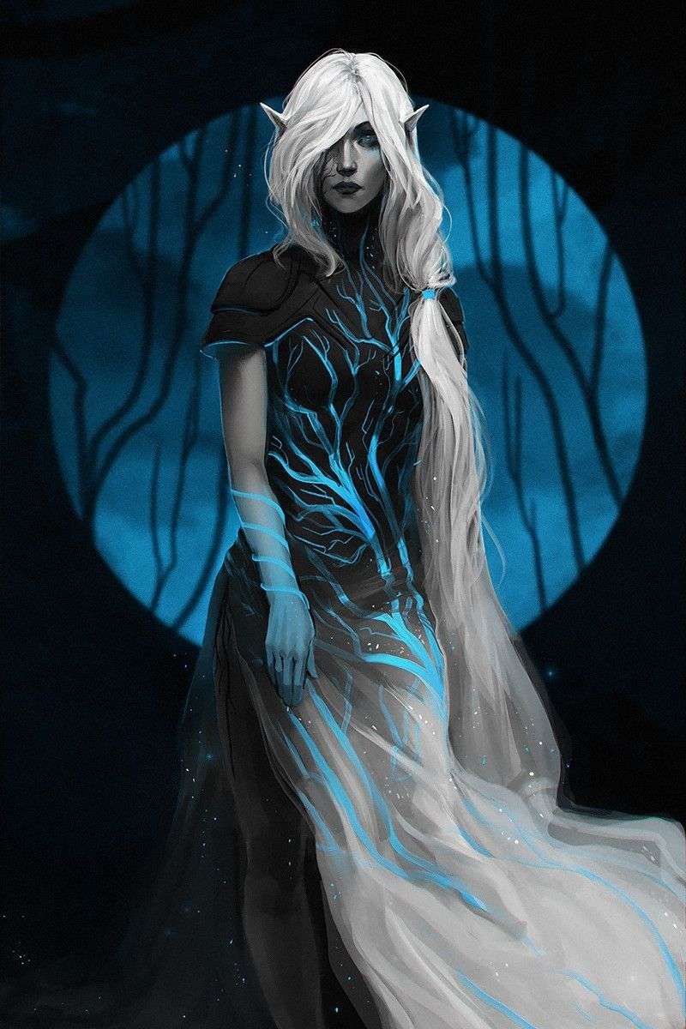**Sindren or Gray Elves**

**Location: Adulien**

**Appearance:** pale gray skin; raven black hair; amber or violet eyes

**Culture:** Gray Elves are the most intelligent of all elven races and thought to be the oldest. Aloof and reclusive, they prefer the isolation of high mountain peaks and spend much of their time in meditation or study. They are impatient with outsiders but will treat with envoys from the other Elven sub-races as needed. Gray elves are soft spoken and most often lost in thought. They are also prone to melancholy, possessing limitless lore that compels them to reflect endlessly on history and destiny.

**Common Attire:** white, silver, yellow, or gold and cloaks of deep blue or purple

**Traits**: Gray elves are the most intelligent of all elves but also the frailest. They are masters of lore, able to recall history to the beginning of time. They are also the creators and custodians of the Adulien Calendar and the Brightstar Fonts, as well as holders of ancient secrets of magic. Gray Elves are thought to have mental powers, which some suspect is why other Elves follow their lead. This may also be whey they are the archenemies of the Illithid race.

**Ability and Skill Modifiers:** -3 Constitution, +3 Intelligence, with each level they become able to cast spells at will from the cleric magic domain spell list:

* Magic Domain
* Granted Power: Use scrolls, wands, and other devices with spell completion or spell trigger activation as a wizard of one-half your level (at least 1st level). For the purpose of using a scroll or other magic device, if you are also a wizard, actual wizard levels and these effective wizard levels stack.
* Magic Domain Spells

1. Magic Aura: Alters object’s magic aura.
2. Identify: Determines properties of magic item.
3. Dispel Magic: Cancels magical spells and effects.
4. Imbue with Spell Ability: Transfer spells to subject.
5. Spell Resistance: Subject gains SR 12 + level.
6. Antimagic Field: Negates magic within 10 ft.
7. Spell Turning: Reflect 1d4+6 spell levels back at caster.
8. Protection from Spells M F: Confers +8 resistance bonus.
9. Mage’s Disjunction: Dispels magic, disenchants magic items.

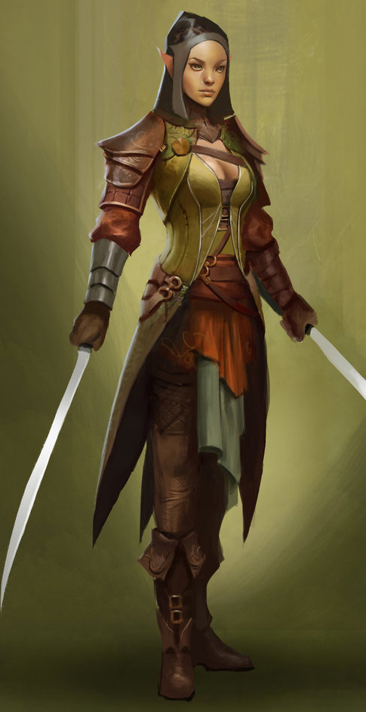**Taurean or Forest Elves**

**Locations: Adulien, Aldalinh, Ulynar, Ari’Aahn, Teinhir**

**Appearance:** light brown skin; blonde to brown hair; brown or green eyes

**Culture:** Forest Elves are the most athletic, curious, and eager to explore of all their kin. They are fond of stories and songs, both in the hearing and the performing. They are playful, mirthful, and relate well to other races. Forest Elves prefer the wilderness but welcome visitors to their lands. They relish life to the point that they are considered unruly by the more cerebral elves.

Unlike their kin among the fauna elves, however, forest elves are more civilized. They spend most of their lives in communion with nature, but do not form the primal bonds with animals that fauna elves attain. Likewise, they are stewards of nature but create fantastic architecture that complements their surroundings, while fauna elves build elaborate structures that are almost indiscernible from the ecosystem.

**Common Attire**: dark shades of green and earth tones

**Traits**: Taller than most elves and disciplined warriors. They are familiar with magic but without any special focus or natural spell-like abilities. Some say forest elves are the bravest of all the elven kind and are steadfast in fighting for the sake of high ideals. Others remark they are second only to the gray elves in their ability to recall countless songs and lore. Certainly forest elves, in spite of their name, are the most comfortable with human civilization and working with other races.

**Ability and Skill Modifiers:** same as standard elf in PHB

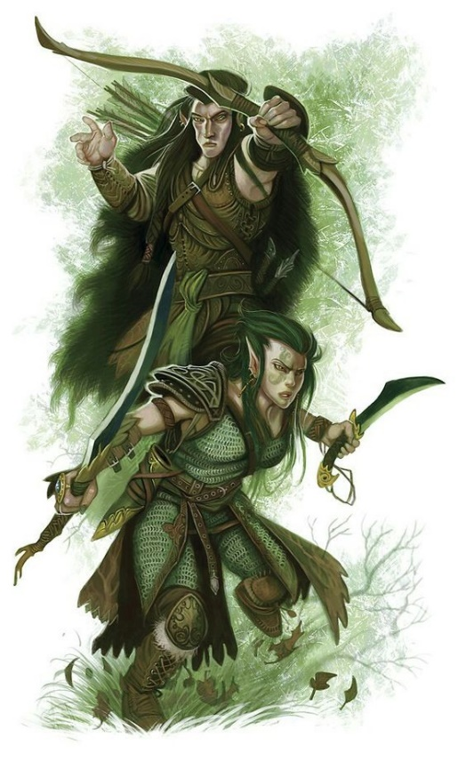**Hravaeran or Fauna Elves**

**Locations: Eida’Las, Elgelor, Elyon, Arbeiera, Lo’Shella**

**Appearance**: pale skin; blonde, brown, or red hair; green eyes

**Culture:** Fauna Elves, also called Wild Elves, are less civilized than their distant cousins. Considered barbaric by most, they create very few works of art or literature. Instead, they live as one with the land and form primal bonds with the beasts. Some Wild Elves even have feral qualities. They are the most athletic of all Elves and regarded for their rugged endurance. Wild elves are reclusive, rarely tolerating the company of those outside of their tribes. They particularly fierce in the protection of their lands. Fauna elves enjoy a special friendship with the fay, even more so than Elves do already. This is thought to be because their wild natures hearken to the free spirits of the fay and their ilk.

**Common Attire**: animal skins or woven plants, covered in tribal markings, some dye their skin in natural pigments

**Traits**: Fauna Elves have a natural strong connection to wild beasts. Many develop mental connections to a specific type of animal and, with it, some of their traits. They have the highest constitution of the elven races but also the lowest intelligence.

**Ability and Skill Modifiers:** +2 Constitution, -2 Intelligence,with each level they become able to cast spells at will from the cleric animal domain spell list:

* Animal Domain
* Granted Powers: You can use speak with animals once per day as a spell-like ability. You may add twenty ranks of Knowledge (nature) to your list of class skills.
* Animal Domain Spells

1. Calm Animals: Calms (2d4 + level) HD of animals.
2. Hold Animal: Paralyzes one animal for 1 round/level.
3. Dominate Animal: Subject animal obeys silent mental commands.
4. Summon Nature’s Ally IV*: Calls creature to fight.
5. Commune with Nature: Learn about terrain for 1 mile/level.
6. Antilife Shell: 10-ft. field hedges out living creatures.
7. Animal Shapes: One ally/level polymorphs into chosen animal.
8. Summon Nature’s Ally VIII*: Calls creature to fight.
9. Shapechange F: Transforms you into any creature, and change forms once per round.
   * *Can only summon animals.

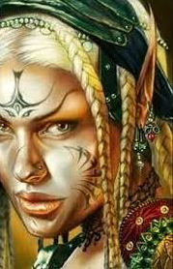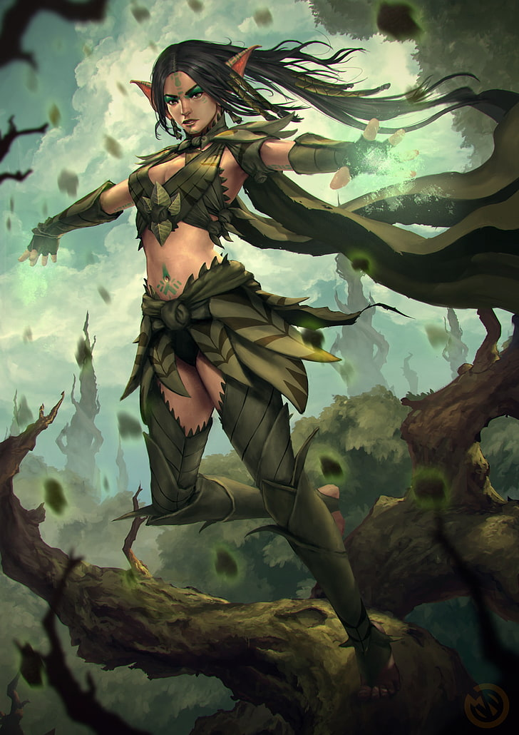

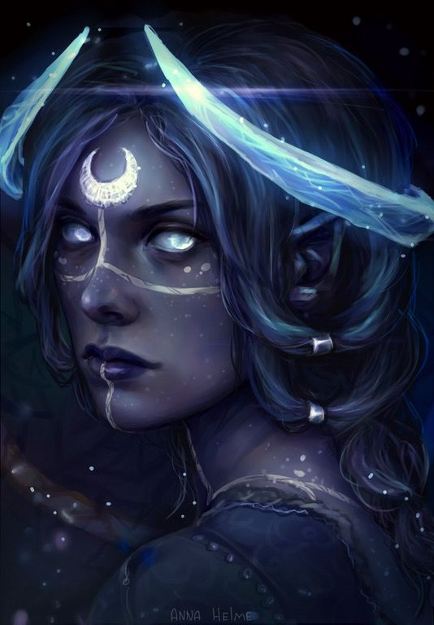**Isilya or Moon Elves**

**Location: Cascadrel**

**Appearance**: silver skin; white hair; silver or yellow eyes

**Culture:** Moon Elves are nocturnal creatures, rarely venturing out during daylight. They are enigmatic creatures, prone to wild swings between quiet reflection and frantic action. They are highly intelligent but some say they are also slightly unstable, given to unconventional and abstract thinking. They are constantly meditating on the moon and are fond of dancing in full moonlight to a song only they can hear.

**Common Attire**: pale yellow and eggshell colors during the day, deep indigo and black during the night, slender silver jewelry

**Traits**: Moon Elves are excellent hunters. A few of their kind can become invisible in during a full moon. Their abilities vary over the course of each month as they embody different traits corresponding to phases of the moon. They are also sensitive to magic related to demons and devils and are compelled to hunt them.

**Ability and Skill Modifiers:** -2 Dexterity (in daylight), 50% of the time: +2 Intelligence, +2 Wisdom; other 50% of the time: -2 Intelligence, -2 Wisdom, with each level they become able to cast spells at will from the cleric chaos domain spell list:

* Chaos Domain
* Granted Power: You cast chaos spells at +1 caster level.
* Chaos Domain Spells

1. Protection from Law: +2 to AC and saves, counter mind control, hedge out elementals and outsiders.
2. Shatter: Sonic vibration damages objects or crystalline creatures.
3. Magic Circle against Law: As protection spells, but 10-ft. radius and 10 min./level.
4. Chaos Hammer: Damages and staggers lawful creatures.
5. Dispel Law: +4 bonus against attacks by lawful creatures.
6. Animate Objects: Objects attack your foes.
7. Word of Chaos: Kills, confuses, stuns, or deafens nonchaotic subjects.
8. Cloak of Chaos F: +4 to AC, +4 resistance, SR 25 against lawful spells.
9. Summon Monster IX*: Calls extraplanar creature to fight for you.
   * *Cast as a chaos spell only.

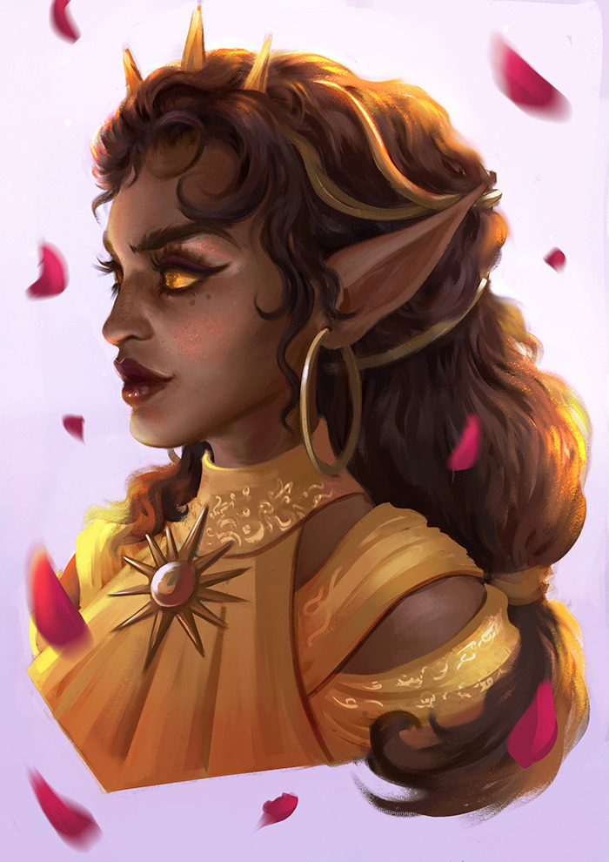**Naira or Sun Elves**

**Location: Ithronel**

**Appearance**: dark brown skin; black, brown, or reddish hair; violet eyes

**Culture:** Sun elves are proud, headstrong, and honor-driven. They are less drawn to the esoteric studies and more attuned to the study of their environment and devising and executing strategies. Much of their time is spent in athletic pursuits and mastering riding, climbing, running, and combat training. Their art and literature are vibrant and infused with the luster of life. Similar to fire elves in temperament, sun elves do not embrace chaos wholly but temper it with experience and a knack for decisive action. While the sun elves gain strength from the sun and relish in its life-giving power, they also temper their zeal with the wisdom to harness it. In contrast, the fire elves place no limits to the powers granted by the sun and molten earth and harness it with unbridled enthusiasm.

**Common Attire**: tend to wear loose tunics and robes, preferring light colors highlighted in gold, orange, and red as well as light earthen tones. During the height of day many sun elves prefer minimal clothing as they soak up the sun’s rays.

**Traits**: Sun Elves are extremely athletic and the strongest of the elves. Drawing in power from the sun, their strength grows with the height of day and wanes towards dusk. Sun Elves have poor vision compared to other elves. They are sensitive to detecting minor temperature changes, have infra-vision, and are resistant to extremes of heat but not to the extent that fire elves are.

**Ability and Skill Modifiers:** +2 Strength, -2 Wisdom, Endure Elements (heat), with each level they become able to cast spells at will from the cleric strength domain spell list:

* Strength Domain
* Granted Power: You can perform a feat of strength as a supernatural ability. You gain an enhancement bonus to Strength equal to your cleric level. Activating the power is a free action, the power lasts 1 round, and it is usable once per day.
* Strength Domain Spells

1. Enlarge Person: Humanoid creature doubles in size.
2. Bull’s Strength: Subject gains +4 to Str for 1 min./level.
3. Magic Vestment: Armor or shield gains +1 enhancement per four levels.
4. Spell Immunity: Subject is immune to one spell per four levels.
5. Righteous Might: Your size increases, and you gain combat bonuses.
6. Stoneskin M: Ignore 10 points of damage per attack.
7. Grasping Hand: Large hand provides cover, pushes, or grapples.
8. Clenched Fist: Large hand provides cover, pushes, or attacks your foes.
9. Crushing Hand: Large hand provides cover, pushes, or crushes your foes.

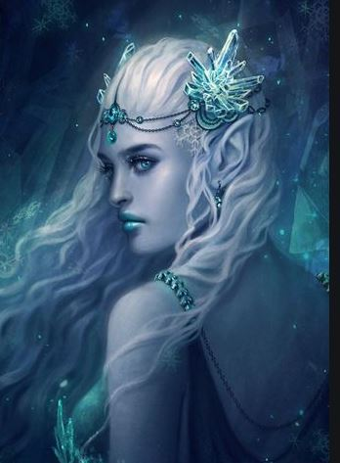**Helceren or Ice Elves**

**Location: Domain of Laaktala, Yggdrasil Forest, Norgarde**

**Appearance**: pale blue skin; silver hair; blue eyes

**Culture:** Ice elves are a distrustful people, reclusive and intolerant of other races. They are also vengeful towards foes and hold a deep hatred of fire elves. Driven by a sense of order, they create elaborate ice sculptures that follow complex patterns to which they assign deep meaning. Ice elves are highly intelligent and calculating. They speak very little and do so with precise language and measured words. They are both feared and respected by the Norgarde humans, who think them trickster spirits and dub them “Alfar.” Homes are made in the boughs of trees, stark and ominous as they tower over the landscape. Order and its call for perfection are the core values of the ice elves. For this and other reasons they despise fire elves with their sense of chaos and mayhem.

**Common Attire**: elaborate tunics, neutral colors, beautiful gray furs with hoods that resemble animal faces

**Traits**: masters of order-aligned magic, study the esoteric logic of magic, resistant to extremes of cold

**Ability and Skill Modifiers:** +1 Intelligence, -1 Charisma, Resist Energy (Cold) 10, Endure Elements (cold), with each level they become able to cast spells at will from the cleric law domain spell list:

* Law Domain
* Granted Power: You cast law spells at +1 caster level.
* Law Domain Spells

1. Protection from Chaos: +2 to AC and saves, counter mind control, hedge out elementals and outsiders.
2. Calm Emotions: Calms creatures, negating emotion effects.
3. Magic Circle against Chaos: As protection spells, but 10-ft. radius and 10 min./level.
4. Order’s Wrath: Damages and dazes chaotic creatures.
5. Dispel Chaos: +4 bonus against attacks by chaotic creatures.
6. Hold Monster: As hold person, but any creature.
7. Dictum: Kills, paralyzes, slows, or deafens nonlawful subjects.
8. Shield of Law: +4 to AC, +4 resistance, and SR 25 against chaotic spells.
9. Summon Monster IX*: Calls extraplanar creature to fight for you.
   * *Cast as a law spell only.

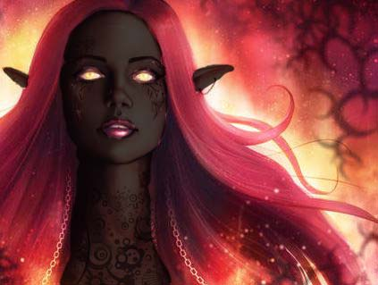**Urudren or Fire Elves**

**Location: Sirathren**

**Appearance**: dark brown skin; red hair; hazel eyes

**Culture:** Fire Elves are mercurial, ill tempered, impatient, and vengeful. They are intolerant of other races and hold a deep hatred of ice elves. They are driven by a sense of chaos. They enjoy talking and singing loudly, and have a tendency to speak in hyperbole.

Fire elves share much in common with the sun elves in Kaduru. While the sun elves gain strength from the sun and relish in its life-giving power, they also temper their zeal with the wisdom to harness it. In contrast, the fire elves place no limits to the powers granted by the sun and molten earth and harness it with unbridled enthusiasm. Chaos and its endless possibilities are the core values of the fire elves. For this and other reasons they despise ice elves with their sense of order and cold, unwavering ways.

**Common Attire**: tunics and short robes with sashes, earthen colors with tones of red, yellow, and orange

**Traits**: Fire Elves are masters of the entropic principles of magic. They are also resistant to extremes of heat.

**Ability and Skill Modifiers:** +1 Charisma, -1 Wisdom,Resist Energy (Fire) 10, with each level they become able to cast spells at will from the cleric fire domain spell list:

* Fire Domain
* Granted Power: Turn or destroy water creatures as a good cleric turns undead. Rebuke, command, or bolster fire creatures as an evil cleric rebukes undead. Use these abilities a total number of times per day equal to 3 + your Charisma modifier. This granted power is a supernatural ability.
* Fire Domain Spells

1. Burning Hands: 1d4/level fire damage (max 5d4).
2. Produce Flame: 1d6 damage +1/ level, touch or thrown.
3. Resist Energy*: Ignores 10 (or more) points of damage/attack from specified energy type.
4. Wall of Fire: Deals 2d4 fire damage out to 10 ft. and 1d4 out to 20 ft. Passing through wall deals 2d6 damage +1/level.
5. Fire Shield: Creatures attacking you take fire damage; you’re protected from heat or cold.
6. Fire Seeds: Acorns and berries become grenades and bombs.
7. Fire Storm: Deals 1d6/level fire damage.
8. Incendiary Cloud: Cloud deals 4d6 fire damage/round.
9. Elemental Swarm**: Summons multiple elementals.
   * *Resist cold or fire only.
   * **Cast as a fire spell only.

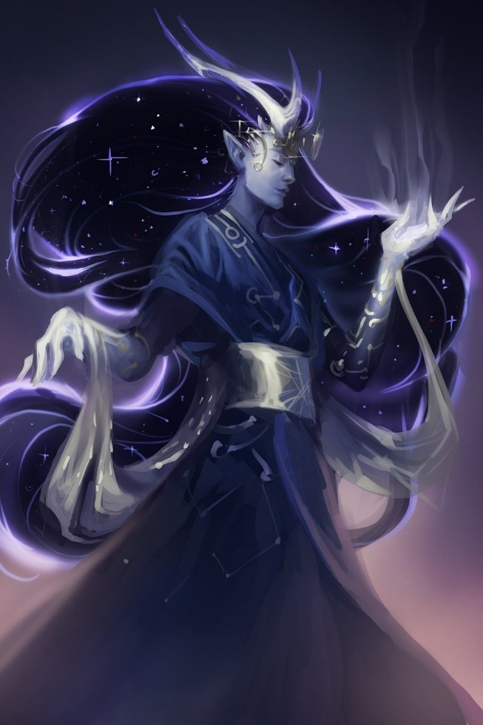**Elenar or Star Elves**

**Location: Cetaris**

**Appearance**: dark blue skin with white freckles; black or white hair; silver eyes

**Culture:** Star Elves have a far-off, haunted quality to them. They speak in a flat tone and often in whispers. They are reflective, thoughtful, have wandering minds, and often mumble to themselves. They are nocturnal creatures, rarely venturing out in broad daylight. They are considered strange and off-putting to most including fellow elves of other sub-races.

**Common Attire**: elaborate tunics, neutral colors

**Traits**: Shortest of the elves, Star Elves are some of the weakest of their race. They develop a bond with a single star at birth and cultivate this relation over a lifetime. This prompts them to often enter walking trances, speaking to unseen others. A few of this race are gifted with prophetic visions while others are able to contact other planes. There are legends of some Elenar able to travel into the past or future, nocturnal

**Ability and Skill Modifiers:** Strength -2, +2 Wisdom +2, Dexterity -2 (in daylight). With each level they become able to cast spells at will from the cleric luck domain spell list:

* Luck Domain
* Granted Power: You gain the power of good fortune, which is usable once per day. This extraordinary ability allows you to reroll one roll that you have just made before the game master declares whether the roll results in success or failure. You must take the result of the reroll, even if it’s worse than the original roll.
* Luck Domain Spells

1. Entropic Shield: Ranged attacks against you have 20% miss chance.
2. Aid: +1 on attack rolls, +1 against fear, 1d8 temporary hp +1/level (max +10).
3. Protection from Energy: Absorb 12 points/level of damage from one kind of energy.
4. Freedom of Movement: Subject moves normally despite impediments.
5. Break Enchantment: Frees subjects from enchantments, alterations, curses, and petrification.
6. Mislead: Turns you invisible and creates illusory double.
7. Spell Turning: Reflect 1d4+6 spell levels back at caster.
8. Moment of Prescience: You gain insight bonus on single attack roll, check, or save.
9. Miracle X: Requests a deity’s intercession.

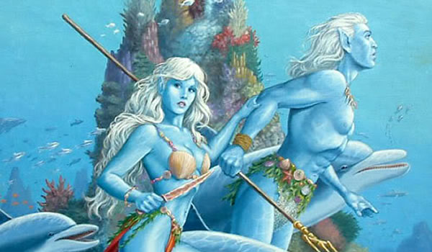**Vaya or Sea Elves**

**Locations: Aelfala, (more TBA)**

**Appearance**: light green skin; green hair; yellow eyes

**Culture:** Sea Elves are playful, curious, fond of song, and very vain. They enjoy lounging in the sun and are mischievous to others. They are easily distracted by shiny objects. They are highly protective of their waters and are bitter foes of sahuagin and other evil aquatic races.

**Common Attire**: close-fitting garments made up of intricate overlapping scales in patterns of blue-green, silver, faint pink; out of water wear gossamer gowns of light aquamarine with metallic sheen to them

**Traits**: Water Elves have gills and can breathe underwater. They are also capable of emitting high-pitched whistles, which they use to speak with sea creatures. They have very thick skin, capable of withstanding enormous pressures. They are strong in natural magic related to charms, but do not craft magic items themselves.

**Ability and Skill Modifiers:** Dexterity +2, Charisma +2, Constitution drops by 1 point for every day out of water, with each level they become able to cast spells at will from the cleric water domain spell list:

* Water Domain
* Granted Power: Turn or destroy fire creatures as a good cleric turns undead. Rebuke, command, or bolster water creatures as an evil cleric rebukes undead. Use these abilities a total number of times per day equal to 3 + your Charisma modifier. This granted power is a supernatural ability.
* Water Domain Spells

1. Obscuring Mist: Fog surrounds you.
2. Fog Cloud: Fog obscures vision.
3. Water Breathing: Subjects can breathe underwater.
4. Control Water: Raises or lowers bodies of water.
5. Ice Storm: Hail deals 5d6 damage in cylinder 40 ft. across.
6. Cone of Cold: 1d6/level cold damage.
7. Acid Fog: Fog deals acid damage.
8. Horrid Wilting: Deals 1d6/level damage within 30 ft.
9. Elemental Swarm*: Summons multiple elementals.
   * *Cast as a water spell only.

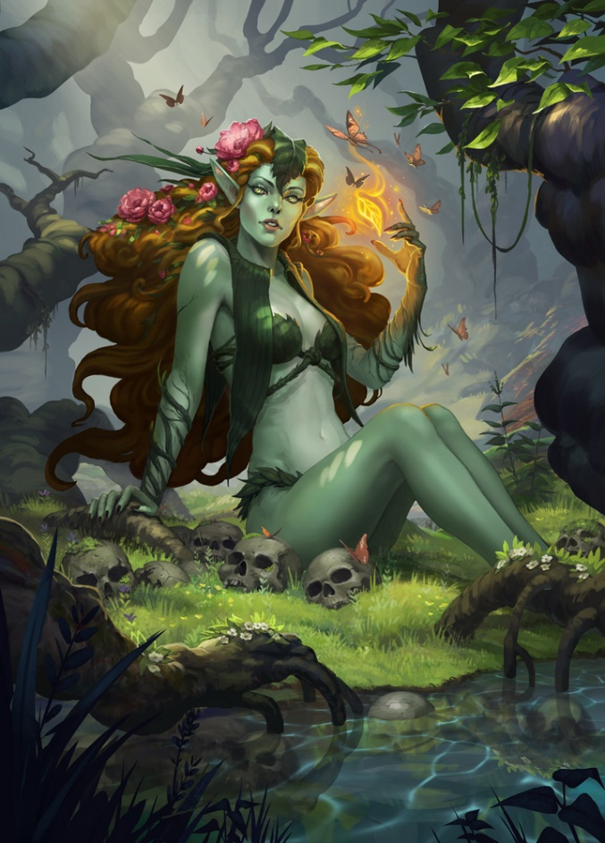**Laimaran or Flora Elves**

**Location: Teliddia**

**Appearance**: dark green skin; brown or sunflower yellow hair; purple eyes

**Culture:** Flora Elves are placid, moving and talking at a leisurely pace. They tend enormous magical groves and collect exotic plants grown from tiny samples collected from all over the world. They are also inquisitive of plant-based magical aberrations. They enjoy a strong bond with dryads and fey creatures fond of flowers. They are whimsical with a strange sense of humor. They are also fond of partaking in mind-altering herbs and mushrooms to enter a spirit realm where they can travel out of their bodies

**Common Attire**: dressed entirely in vegetation woven into clothing, hair festooned with elaborate flower headdresses, wear elaborate flower garlands

**Traits**: Flora Elves are born with the ability to speak with plants. They can sense the presence and health of plant life from a distance. They are a frail subrace but masters of herbs and poisons.

**Ability and Skill Modifiers:** -2 Constitution, +2 Charisma,suffer +2 additional damage on any heat or fire attacks,with each level they become able to cast spells at will from the cleric plant domain spell list:

* Plant Domain
* Granted Powers: Rebuke or command plant creatures as an evil cleric rebukes or commands undead. Use this ability a total number of times per day equal to 3 + your Charisma modifier. This granted power is a supernatural ability.
* Add Knowledge (nature) to your list of cleric class skills.
* Plant Domain Spells

1. Entangle: Plants entangle everyone in 40-ft.-radius.
2. Barkskin: Grants +2 (or higher) enhancement to natural armor.
3. Plant Growth: Grows vegetation, improves crops.
4. Command Plants: Sway the actions of one or more plant creatures.
5. Wall of Thorns: Thorns damage anyone who tries to pass.
6. Repel Wood: Pushes away wooden objects.
7. Animate Plants: One or more trees animate and fight for you.
8. Control Plants: Control actions of one or more plant creatures.
9. Shambler: Summons 1d4+2 shambling mounds to fight for you.

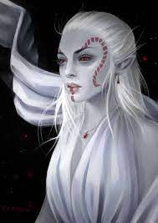**Drow**

**Location: Helviana, Duskryn, Morenrin, Saszar, Hadronath, Zauvorel, Xiltiriy**

**Appearance**: pale white skin; white hair; black or red eyes

**Culture:** Also known as dark elves, drow are a depraved and evil subterranean offshoot. White is the most common hair color among drow, but almost any pale shade is possible. Drow tend to be smaller and thinner than other sorts of elves, and their eyes are often a vivid red.

**Common Attire**:

**Traits**:

**Ability and Skill Modifiers:** +2 Dexterity, +2 Intelligence, +2 Charisma, –2 Constitution

* Immunity to magic sleep effects, and a +2 racial saving throw bonus against enchantment spells or effects.
* Darkvision out to 120 feet.
* Spell resistance equal to 11 + class levels.
* Weapon Proficiency: A drow is automatically proficient with the hand crossbow, the rapier, and the short sword.
* Spell-Like Abilities: Drow can use the following spell-like abilities once per day: dancing lights, darkness, faerie fire. Caster level equals the drow’s class levels.
* Light Blindness: Abrupt exposure to bright light (such as sunlight or a daylight spell) blinds drow for 1 round. On subsequent rounds, they are dazzled as long as they remain in the affected area.
* +2 racial bonus on Will saves against spells and spell-like abilities.
* +2 racial bonus on Listen, Search, and Spot checks. A drow who merely passes within 5 feet of a secret or concealed door is entitled to a Search check to notice it as if she were actively looking for it.
* Automatic Languages: Common, Elven, Undercommon. Bonus Languages: Abyssal, Aquan, Draconic, Drow Sign Language, Gnome, Goblin.

**Magical Items**

**Great Tome of Meditations** – created in 100 PA1 in Adulien, records the works of the High Elves when the world begins and onward, later taken over by the Gray Elves

**Waters of Brightstar** – taken by the Order of Aloevan, ranger ambassadors, to go out into the world and establish havens in every great forest to assume stewardship over the lands; can be poured into fonts to communicate back to Adulien

**Brightstar Fonts**

**Sidra'tasti** – a sentient artifact that is discovered/created by accident by the Elven Order of Tharthanion, an order of mages that study esoteric magic. The artifact is attuned to magical phenomena and capable of traveling to loci of magic tied to fateful events. The wizards use it to help in their studies.

**Many-Thorned Mantle**

**Developer Notes**

June 12, 2021

Why a document on Elves all to itself, as well as documents on each Elven domain? The atlases on human kingdoms are the main thrust of Nemmyrl’s stories. They go into much greater detail than any other race, and each kingdom includes sections on Elves, Dwarves, and other major civilizations. So why so much detail across several documents?

Elves are so omnipresent a race in fantasy and in Nemmyrl that the information takes on layers. The main document focuses on who they are essentially: their role in Nemmyrl, their sub-races, and their combined history. At first it also included a central directory of all settlements (roughly approximated as ‘towns’ for sake of the human model) but I leave the directory to be covered in the document “0.2.Nemmyrl.Towns.and.Cities.xlsx.” Next, we have documents on each domain, allowing for detail on each settlement. Lastly, we have the inclusion of each domain in the human document for which it is co-located. Three documents covering a single domain poses the risk of duplication of information, creating extra work and errors. So, a publication system works best.

* Elven main document
  + Directory of domains at a top-level, no list of settlements
  + List of sub-races and detailed discussion of each
  + Combined history
  + Combined high-level magic items
* Elven Domain documents
  + Description of the domain as a whole, including notes drawn from the main sub-race document and allowing for deviations from it if there are multiple cases of this sub-race in the world; where there is a single case (Ice Elves, for example) it is a straightforward expansion on the sub-race definition.
  + Map of each domain
  + Details on each settlement within the domains
  + Stub file in the Culture section – published from the main document
* Human Kingdom documents
  + Reference to the elven domains in this region, but only a summary drawn from the main elven domain document

It seemed unwieldy to lump all the Dwarven and Elven lands into a single document. So, for each “kingdom” of Dwarves and Elves I have an abridged directory covering what I think is the relevant amount of detail.

• Overview

• Towns and Cities - descriptions

• Best in the Land - REMOVED

• Points of Interest – REMOVED, CAN BE COVERED IN “Local Lore”

• History

• Local Goods – REMOVED, CAN BE COVERED IN “Local Goods” IN EACH TOWN/CITY

• Notes on Culture

• Local Deities - REMOVED

• Creatures - REMOVED

• Magical Items

• NPC Templates - REMOVED

• Developer Notes

When considering the Elf population in Nemmyrl, it’s important to remember that they are long-lived, culturally tranquil, and prefer their privacy. So where humans might build enormous cities, wage land wars, and engage in brisk trade the Elves would be content to hold dominion over the forest lands and live in harmony with nature. The Dwarves would likely be more industrious, and therefore have larger settlements than the Elves, but even they aren’t as driven to expand and populate like the humans do. For the Elves I’ve decided each forest where their kingdoms reside there is one large city and a number of towns or maybe just several villages. I can’t see a metropolis-sized settlement spanning several square miles and fifty thousand Elves. Rather, I see a much smaller city where the architecture is no less impressive but takes up much less space and uses far less resources.

Leftover names that can be used?

Calyondon & Lútheldë Shalothdal

Adanir & Lostauriel Kevalynnryl

Dûrion & Ghilwen Runaldal

Erutádur & Raida Laragaial

Tûrin & Daufindiel Mithvantinu

Nibenonion & Vaniel Nhatanellyn

Aindur & Raina Nallmiel

Vanithil & Faelilla Laeraidren

Tidurron & Laielena Rolodiir

Authaias & Talawen Sharondalan

**Types of Elves**

From 3.5e PHB pp 101-104

* High elves - ???
* Gray elves – arrogant and aloof, reclusive;
  + silver hair, amber eyes or pale golden hair and violet eyes
  + Prefer clothing of white, silver, yellow, or gold and cloaks of deep blue or purple
* Wild elves – aka grugach, barbaric and tribal
  + Hair ranges from black to light brown, lightening to silvery white with age
  + dress in simple clothing of animal skins and basic plant weaves
  + often sorcerers or barbarians
* Wood elves – aka sylvan elves
  + hair ranges from yellow to a coppery red, most muscular, clothing is in dark shades of green and earth tones
  + animal companions of giant owls or leopards

From <https://en.wikipedia.org/wiki/Elf_(Dungeons_%26_Dragons)>

<https://forgottenrealms.fandom.com/>

* Moon Elves or Silver Elves (Teu-Tel'Quessir)
  + The moon elves are the most common of all the elves in Faerûn and are also known as silver elves. They typically have fair skin and hair that runs in hues from silver-white to black or blue. While human style hair colors are rare, eye color can be remarkably similar, with colors ranging from blue to green. The majority of the half-elves in Faerûn come from parings between humans and moon elves. In 4th edition, moon elves are eladrin.
* High Elves
  + High elves are the original eladrin and the original elves that awoke on the Isle of Adulien (dark, sun, moon, green, lythari and star elves), and most commonly encountered by other races, and the most open and friendly of their kind. They travel to other lands more than other elves. They are generally dark-haired and green-eyed, with very pale complexions the color of new cream. High elves prefer to wear light pastels, blues and greens and violets, and often dwell in homes built into living wood, high in the trees.
* Moon Elves or Silver Elves (Teu-Tel'Quessir)
  + The moon elves are the most common of all the elves in Faerûn and are also known as silver elves. They typically have fair skin and hair that runs in hues from silver-white to black or blue. While human style hair colors are rare, eye color can be remarkably similar, with colors ranging from blue to green. The majority of the half-elves in Faerûn come from parings between humans and moon elves. In 4th edition, moon elves are eladrin.[28]
* Star Elves or Mithral Elves (Ruar-Tel'Quessir)
  + This subrace left the forests of Yuirwood for an extraplanar realm known as Sildëyuir. They have recently considered returning due to increasing threats by the alien nilshai.
* Sun Elves or Gold Elves (Ar-Tel'Quessir)
  + Sun elves are primarily found upon the island of Evermeet and because of this, they are less common across the rest of Faerûn. With bronze colored skin; gold, black, or green eyes; and gold, blond, black, or (rarely) red hair, they are also called gold elves. Sun elves are less physically fit, but more intellectually advanced, than their counterparts. Sun elves are the primary practitioners of elven High Magic, and are among the greatest magic-users of Toril, both arcane and divine. In 4th edition, sun elves are eladrin.
* Wild Elves or Green Elves (Sy-Tel'Quessir)
  + The most reclusive of all the elves, the wild elves pride themselves on their isolation and skill at keeping hidden. Their skin tends to be brown and they have similar colored hair which lightens with age. In 4th edition, wild elves are elves.
* Wood Elves, Copper Elves, or Sylvan Elves (Or-Tel'Quessir)
  + Wood elves are a reclusive subrace, preferring to live in such areas as the High Forest. They place more emphasis on strength than learning. Wood elves are considered by other elven subraces (particularly the austere sun elves) to be boisterous and hedonistic. They have a zest for life and pleasure. According to Races of Faerûn (which was published in March 2003 and only mentions aquatic elves, avariel, drow, lythari, moon elves, sun elves, wood elves, and wild elves), wood elves are the only elven subrace that is native to Toril. They slowly formed for centuries from some of the other elven subraces after the last Crown War. They see their realms as the natural successors to past nations such as Eaerlann and Cormanthyr. In 4th edition, wood elves are elves

**My first attempt to consolidate the rule book descriptions into templates**:

*Star Elves*

*Appearance: Light-colored skin; hair of gold, red, or silver; eyes of violet or gray with gold flecks*

*Common attire: clothing: elaborate tunics, neutral colors*

*Culture: aloof and cautious*

*Gray Elves*

*Appearance: pale gray skin; silver or pale golden hair; amber or violet eyes*

*Common attire: white, silver, yellow, or gold and cloaks of deep blue or purple*

*Culture: arrogant, aloof, reclusive*

*High Elves / Eladrin*

*Appearance: pale skin like new cream; dark hair; green eyes*

*Common attire: light pastels, blues and greens and violets*

*Culture: avid travelers, friendly with other races, homes built into living wood, high in the trees*

*Sylvan / Wood Elves*

*Appearance: light brown skin; hair of yellow to coppery red; green or brown eyes*

*Common attire: dark shades of green and earth tones*

*Culture: boisterous and hedonistic; they have a zest for life and pleasure*

*Animal companions: giant owls, leopards*

*Green / Wild Elves*

*Appearance: brown skin; black to light brown hair; green or brown eyes*

*Common attire: animal skins or woven plants*

*Culture: barbaric and tribal*

*Gold / Sun Elves*

*Appearance: bronze skin; gold, blonde, black, red hair; gold, black, or green eyes*

*Common attire: at once beautiful and understated, with subdued colors like blue or green favored over bolder hues. Most sun elves decorated themselves with gold or mithral embroidery in subtle patterns woven into the design of their clothes and which added to the beauty of the clothing without seeming flashy or showy. Similarly, most sun elven jewelry was simple in appearance, but in fact exquisitely complex both in construction and design.*

*Culture: less physically fit, but more intellectually advanced, haughty and arrogant, powerful with magic*

*Silver / Moon Elves*

*Appearance: fair, icy blue skin; hair of silver-white to black or blue; eyes of blue or green*

*Common attire: simple design but exquisite making, using the finest textiles and most beautiful weaving designs available but typically making simple cuts and measurements, finding showy flourishes unnecessary. Moon elven clothing is often flashy in other ways, however, with bright colors featured.*

*Culture: the most impulsive, with a strong distaste for complacency or isolation. longed to be on the road, traveling and exploring the untamed wilderness that lay between cities and nations. This extroverted quality was part of the reason why moon elves got along uncommonly well with other races*

Idea scratch pad:

* Much of their garb is flower themed and they wear garlands of flowers on their heads
* Much of their wardrobe features bird feathers
* Green and silver fabric
* “If I listen, I have the advantage; if I speak, others have it.”
* We will be known forever by the tracks we leave
* Elven mounts
  1. Dire stag
  2. Hippogriff
  3. Giant eagle
  4. Giant lynx – Eida’las
  5. Giant elk – Elgelor
  6. Giant moose - Teinhir
  7. Asperii
  8. Pegasus
  9. Elven steed
  10. Giant owl - Adulien
  11. Griffin
  12. Unicorn
  13. ~~Moon horse~~
  14. Giant bumblebee
  15. Giant butterfly
  16. Giant lizard (drow)
  17. Giant beetle
  18. Giant spider (drow)
  19. Giant hornet / wasp (drow)
  20. Johano horses – Elyon
* Elven past-times
  1. Cloud watchers
  2. Grass Herders
  3. Tree talkers
  4. River Shepherds
  5. Star Ciphers - Laaktala
  6. Sun Scholars
  7. Moon Whisperers
  8. Flower Conductors