Notes on the Elven Kingdom of Elyon

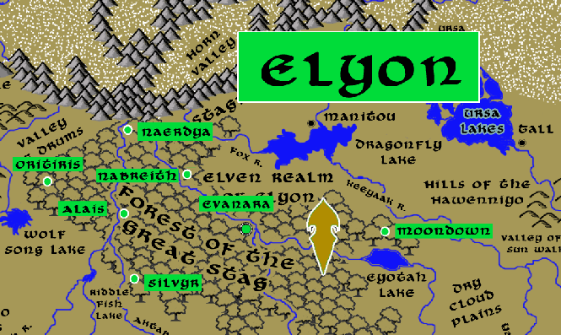

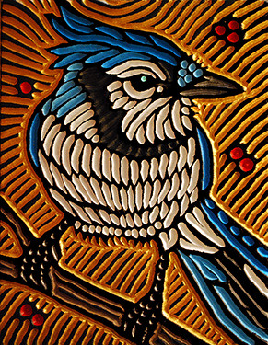

**Sign of the Bluejay**

**Location: Forest of the Great Stag, Eastern Amadar bordering the Lands of the Haka’Na**

* **Overview**
* **Towns and Cities**
* **History**
* **Notes on Culture**
* **Magical Items**
* **Developer Notes**

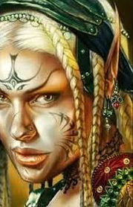**Overview**

The largest settlement of wild elves in Nemmyrl, Elyon peacefully co-exists with the Haka’Na tribes of humans of eastern Amadar. Rarely do the elves venture from their woods, but emissaries are received in peace from nearby Manitou. Unlike other elven kingdoms, Elyon eschews grand, cathedral-like palaces amidst the trees in favor of earthier dwellings that blend in better with the foliage. Elyon elves are wary of outsiders, especially those that don't seem at home in the woods or are not from Manitou, and they are keen to hide their presence. It is boasted than an unknowing traveler could stroll through the midst of the Great Stag Forest without even knowing they were in the presence of a sprawling elven kingdom. The scouts of Elyon are reputed to be the best rangers in the world and virtually invisible in their environment. The elves of these woods have fought a centuries-old war with the Drow kingdom that lurks beneath the Hills of the Tuyok to the west.

**Towns and Cities**

* Elyon
  + Oritiris - large town, population 5,000, guards / soldiers 50, militia 250
  + Naerdya - large town, population 5,000, guards / soldiers 50, militia 250
  + Nabreith - large town, population 5,000, guards / soldiers 50, militia 250
  + Alais - large town, population 5,000, guards / soldiers 50, militia 250
  + Evanara - large city, population 25,000, guards / soldiers 250, militia 2250
  + Moondown - large town, population 5,000, guards / soldiers 50, militia 250
  + Silvyr - large town, population 5,000, guards / soldiers 50, militia 250

**Oritiris**

**Size:** large town, population 5,000, guards / soldiers 50, militia 250

**Trade Goods:**

**Local Goods:**

**Standard:**

**Colors:**

**Ruler:** Ascal Palynn

**Home**:

**Steward**: Agandaur Farharice

**Marshal**: Haera Elnorin (f)

**House Priest:**  Aelrie Keyxalim (f)

**House Adviser (Scholar/Mage/etc):**  Kesefeon Chaevalur

**Captain of the Guard**: Mitalar Helewraek

**Chief Warriors in Service**:

Inchel Virrora

Tiarsus Torra

Ialantha Kealana (f)

**Local Powers:**

**Local Sites:**

**Description:**

**Industry:**

**Key Figures:**

**Local Lore:**

**History:**

**Customs:**

**Naerdya**

**Size:** large town, population 5,000, guards / soldiers 50, militia 250

**Trade Goods:**

**Local Goods:**

**Standard:**

**Colors:**

**Ruler:** Durlan Eilroris

**Home**:

**Steward**: Folmon Yinthyra

**Marshal**: Kylantha Trissandoral (f)

**House Priest:**  Triandal Xilydark

**House Adviser (Scholar/Mage/etc):**  Allynna Phinan (f)

**Captain of the Guard**: Elisen Xilwarin (f)

**Chief Warriors in Service**:

Lierin Eljor (f)

Almithara Omasalor (f)

Iymbryl Engeiros

**Local Powers:**

**Local Sites:**

**Description:**

**Industry:**

**Key Figures:**

**Local Lore:**

**History:**

**Customs:**

**Nabreith**

**Size:** large town, population 5,000, guards / soldiers 50, militia 250

**Trade Goods:**

**Local Goods:**

**Standard:**

**Colors:**

**Ruler:** Pyrravyn Inalana

**Home**:

**Steward**: Athtar Luric

**Marshal**: Luvon Morxisys

**House Priest:**  Raenisa Orihana (f)

**House Adviser (Scholar/Mage/etc):**  Darunia Morydark

**Captain of the Guard**: Wirenth Yessandoral

**Chief Warriors in Service**:

Folwin Liakian

Bialaer Enren

Ithronel Ravalana (f)

**Local Powers:**

**Local Sites:**

**Description:**

**Industry:**

**Key Figures:**

**Local Lore:**

**History:**

**Customs:**

**Alais**

**Size:** large town, population 5,000, guards / soldiers 50, militia 250

**Trade Goods:**

**Local Goods:**

**Standard:**

**Colors:**

**Ruler:** Zentha Carven (f)

**Home**:

**Steward**: Glarald Torkian

**Marshal**: Alok Miahana

**House Priest:**  Folluin Kelro

**House Adviser (Scholar/Mage/etc):**  Calarel Qiwraek (f)

**Captain of the Guard**: Eltaor Yelcan

**Chief Warriors in Service**:

Elasha Keydove (f)

Dasyra Facaryn (f)

Mylaela Omafaren (f)

**Local Powers:**

**Local Sites:**

**Description:**

**Industry:**

**Key Figures:**

**Local Lore:**

Kaliska the green dragon roams the forest lands near here.

**History:**

**Customs:**

**Evanara**

**Size:** large city, population 25,000, guards / soldiers 250, militia 2250

**Trade Goods:** dyes

**Local Goods:**

**Standard:**

**Colors:**

**Ruler:** Kerym Valrieth

**Home**:

**Steward**: Glynnii Elrora (f)

**Marshal**: Vulmer Eilrie

**House Priest:**  Tehlmar Beilana

**House Adviser (Scholar/Mage/etc):**  Akkar Kelran

**Captain of the Guard**: Bialaer Ehrendil

**Chief Warriors in Service**:

Viessa Bryleth (f)

Halueve Mariklen

Elorshin Oriydark

**Local Powers:** Band of the Venyra (rangers), Othorion Sanctum (school of magic)

**Local Sites:**

**Description:**

**Industry:**

**Key Figures:**

**Local Lore:**

**History:**

**Customs:**

**Moondown**

**Size:** large town, population 5,000, guards / soldiers 50, militia 250

**Trade Goods:**

**Local Goods:**

**Standard:**

**Colors:**

**Ruler:** Amaranthae Kelthyra (f)

**Home**:

**Steward**: Erlareo Mianeiros

**Marshal**: Darshee Yelnelis (f)

**House Priest:**  Ailas Elawraek

**House Adviser (Scholar/Mage/etc):**  Hagmar Kelsalor

**Captain of the Guard**: Urricea Balgeiros (f)

**Chief Warriors in Service**:

Darfin Lorawarin

Ivasaar Keynala

Kendel Wynfina

**Local Powers:**

**Local Sites:**

**Description:**

**Industry:**

**Key Figures:**

**Local Lore:**

**History:**

**Customs:**

**Silvyr**

**Size:** large town, population 5,000, guards / soldiers 50, militia 250

**Trade Goods:**

**Local Goods:**

**Standard:**

**Colors:**

**Ruler:** Halaema Vengwyn (f)

**Home**:

**Steward**: Darunia Quiwenys

**Marshal**: Kylantha Lukrana (f)

**House Priest:**  Elorshin Fapeiros

**House Adviser (Scholar/Mage/etc):**  Laiex Keygolor

**Captain of the Guard**: Kavrala Elavalur (f)

**Chief Warriors in Service**:

Fenian Wysaceran

Ascal Trisdove

**Local Powers:**

**Local Sites:**

**Description:**

**Industry:**

**Key Figures:**

**Local Lore:**

**History:**

**Customs:**

**History**

**First Primordial Age (PA1)**

**Second Primordial Age (PA2)**

**Third Primordial Age (PA3)**

**Fourth primordial Age (PA4)**

340 PA4 - Dragons from Elderwyrm Mountains wipe out the Elven settlements in the Catalpa Forest, Crying Forest, and on the Isle of Amphiera

**First Ancient Age (AA1)**

**Second Ancient Age (AA2)**

**Third Ancient Age (AA3)**

**Fourth Ancient Age (AA4)**

**First Written Age (WA1)**

**Second Written Age (WA2)**

720 WA2 - Elven settlement in Wendigo Wood falls

**Third Written Age (WA3)**

**Fourth Written Age (WA4)**

**Notes on Culture**

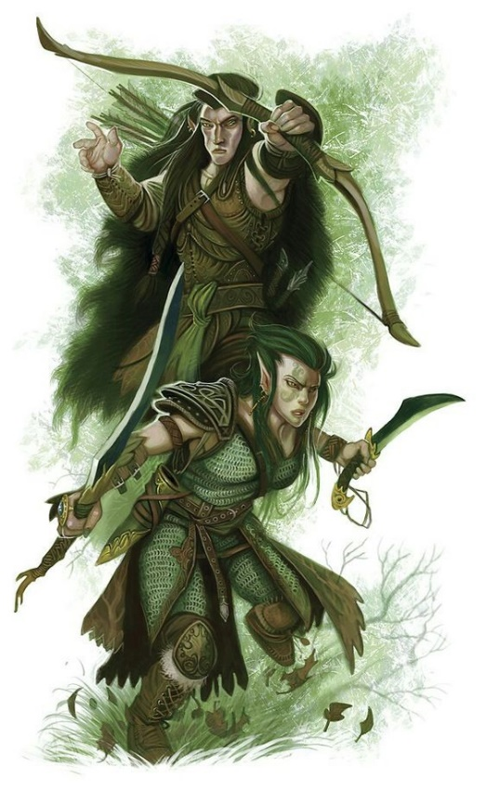**Hravaeran or Fauna Elves**

**Locations: Eida’Las, Elgelor, Elyon, Arbeiera, Lo’Shella**

**Appearance**: pale skin; blonde, brown, or red hair; green eyes

**Culture:** Fauna Elves, also called Wild Elves, are less civilized than their distant cousins. Considered barbaric by most, they have very few works of art or literature. Instead they live as one with the land and form close ties with the beasts. Some Wild Elves even have feral qualities. They are the most athletic of all Elves and regarded for their toughness. They are reclusive and protective of their lands. They enjoy a special partnership with the fay, even more so than Elves do already.

**Common Attire**: animal skins or woven plants, covered in tribal markings, some dye their skin in natural pigments

**Traits**: Fauna Elves have a natural strong connection to wild beasts. They have the highest constitution of the elven races but also the lowest intelligence.

**Ability and Skill Modifiers:** +2 Constitution, -2 Intelligence,with each level they become able to cast spells at will from the cleric animal domain spell list:

* Animal Domain
* Granted Powers: You can use speak with animals once per day as a spell-like ability. You may add twenty ranks of Knowledge (nature) to your list of class skills.
* Animal Domain Spells

1. Calm Animals: Calms (2d4 + level) HD of animals.
2. Hold Animal: Paralyzes one animal for 1 round/level.
3. Dominate Animal: Subject animal obeys silent mental commands.
4. Summon Nature’s Ally IV*: Calls creature to fight.
5. Commune with Nature: Learn about terrain for 1 mile/level.
6. Antilife Shell: 10-ft. field hedges out living creatures.
7. Animal Shapes: One ally/level polymorphs into chosen animal.
8. Summon Nature’s Ally VIII*: Calls creature to fight.
9. Shapechange F: Transforms you into any creature, and change forms once per round.
   * *Can only summon animals.

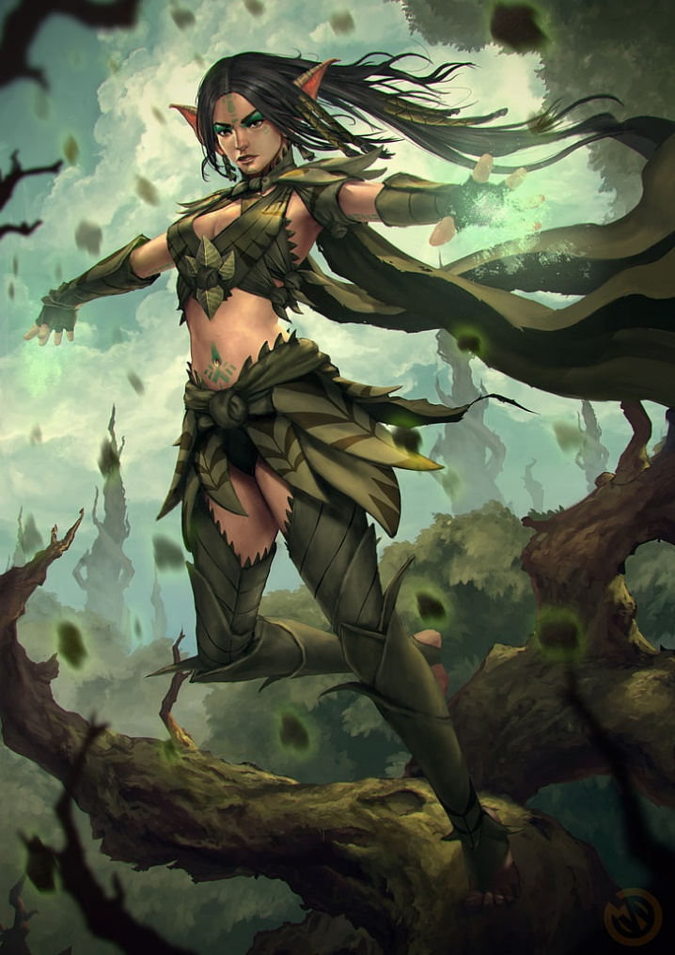**Magical Items**

**Developer Notes**