Notes on the Elven Kingdom of Elgelor

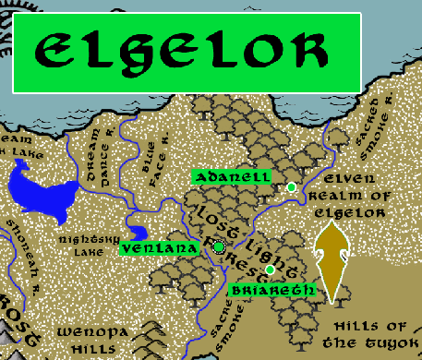

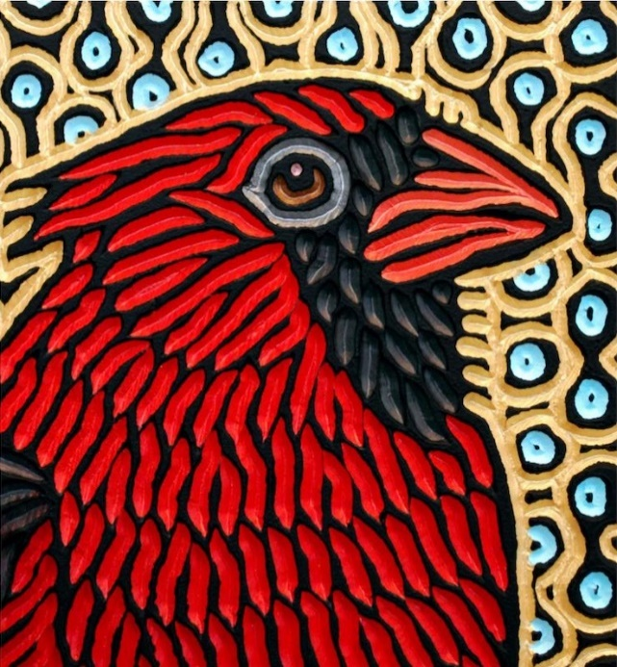

**Sign of the Cardinal**

**Location: Lost Light Forest, Eastern Amadar bordering the lands of the Haka’Na**

* **Overview**
* **Towns and Cities**
* **History**
* **Notes on Culture**
* **Magical Items**
* **Developer Notes**

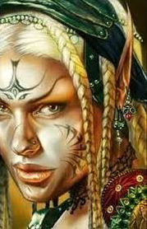**Overview**

The wild elves of Elgelor have made Lost Light Forest their citadel in the cold northern reaches. They are experts at fighting the wendigo, the yeti, and many other monsters unique to the Haka’Na wilderness. They pray to older gods than most elves do, and study the facets of nature that seem beneath consideration. It is nothing for an Elgelor elf to study the moss on a rock for days, or listen to a tiny brook to decipher if it is speaking. Of all the fauna elves, those from Elgelor are a breed apart.

The elves of Elgelor are not overly friendly, having little to do with humans. Sometimes they make an exception for the Snowbird People, who understand the region and share a common struggle above the snow line. Every spring a group will meet with the Buffalo People when they make their trek north. The Washpaw People in Tiruwe amuse and annoy them. They know of their custom to send young hunters up the Sacred Smoke River into their lands. If the hunter shows proper respect, they are tolerated. But more than one human has been sent downriver strapped to a log for their impudence.

**Towns and Cities**

* Elgelor
  + Adanell – large town, population 5,000, guards / soldiers 50, militia 250
  + Venlana – large city, population 25,000, guards / soldiers 250, militia 2250
  + Briareth – large town, population 5,000, guards / soldiers 50, militia 250

**Adanell**

**Size:** large town, population 5,000, guards / soldiers 50, militia 250

**Trade Goods:**

**Local Goods:**

**Standard:**

**Colors:**

**Ruler:** Nimeroni Lorarona (f)

**Home**:

**Steward**: Uevareth Helephyra

**Marshal**: Itham Presralei

**House Priest:**  Loreleia Miraydark (f)

**House Adviser (Scholar/Mage/etc):**  Iefyr Yelgwyn

**Captain of the Guard**: Kyrtaar Kealamin

**Chief Warriors in Service**:

Elred Omanala

Myantha Qixidor (f)

Calarel Wysawarin (f)

**Local Powers:**

**Local Sites:**

**Description:**

**Industry:**

**Key Figures:**

**Local Lore:**

**History:**

**Customs:**

**Venlana**

**Size:** large city, population 25,000, guards / soldiers 250, militia 2250

**Trade Goods:** medicine, timber

**Local Goods:**

**Standard:**

**Colors:**

**Ruler:** Alavara Morxidor (f)

**Home**:

**Steward**: Haglath Adorellan

**Marshal**: Felinar Valvyre

**House Priest:**  Amra Faequinal (f)

**House Adviser (Scholar/Mage/etc):**  Folred Magleth

**Captain of the Guard**: Ibryn Inavalur

**Chief Warriors in Service**:

Civren Glorandal (f)

Helartha Persidor (f)

Alaion Keyrona

**Local Powers:** Band of the Amlaril (rangers)

**Local Sites:**

**Description:**

**Industry:**

**Key Figures:**

**Local Lore:**

**History:**

**Customs:**

**Briareth**

**Size:** large town, population 5,000, guards / soldiers 50, militia 250

**Trade Goods:**

**Local Goods:**

**Standard:**

**Colors:**

**Ruler:** Uevareth Helephyra

**Home**:

**Steward**: Vulred Panelis

**Marshal**: Tsarra Yeszeiros (f)

**House Priest:**  Vulred Aranala

**House Adviser (Scholar/Mage/etc):**  Hamalitia Elahice (f)

**Captain of the Guard**: Ariawyn Keyrie (f)

**Chief Warriors in Service**:

Tarron Iaryarus

Camus Faephyra

Finnea Aerie (f)

**Local Powers:**

**Local Sites:**

**Description:**

**Industry:**

**Key Figures:**

**Local Lore:**

**History:**

**Customs:**

**History**

**First Primordial Age (PA1)**

**Second Primordial Age (PA2)**

**Third Primordial Age (PA3)**

**Fourth primordial Age (PA4)**

340 PA4 - Dragons from Elderwyrm Mountains wipe out the Elven settlements in the Catalpa Forest, Crying Forest, and on the Isle of Amphiera

**First Ancient Age (AA1)**

**Second Ancient Age (AA2)**

**Third Ancient Age (AA3)**

**Fourth Ancient Age (AA4)**

**First Written Age (WA1)**

**Second Written Age (WA2)**

720 WA2 - Elven settlement in Wendigo Wood falls

**Third Written Age (WA3)**

**Fourth Written Age (WA4)**

**Notes on Culture**

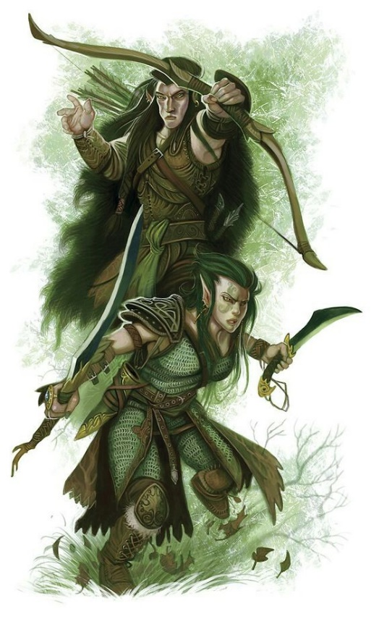**Hravaeran or Fauna Elves**

**Locations: Eida’Las, Elgelor, Elyon, Arbeiera, Lo’Shella**

**Appearance**: pale skin; blonde, brown, or red hair; green eyes

**Culture:** Fauna Elves, also called Wild Elves, are less civilized than their distant cousins. Considered barbaric by most, they create very few works of art or literature. Instead they live as one with the land and form primal bonds with the beasts. Some Wild Elves even have feral qualities. They are the most athletic of all Elves and regarded for their rugged endurance. Wild elves are reclusive, rarely tolerating the company of those outside of their tribes. They particularly fierce in the protection of their lands. Fauna elves enjoy a special friendship with the fay, even more so than Elves do already. This is thought to be because their wild natures hearken to the free spirits of the fay and their ilk.

**Common Attire**: animal skins or woven plants, covered in tribal markings, some dye their skin in natural pigments

**Traits**: Fauna Elves have a natural strong connection to wild beasts. Many develop mental connections to a specific type of animal and, with it, some of their traits. They have the highest constitution of the elven races but also the lowest intelligence.

**Ability and Skill Modifiers:** +2 Constitution, -2 Intelligence,with each level they become able to cast spells at will from the cleric animal domain spell list:

* Animal Domain
* Granted Powers: You can use speak with animals once per day as a spell-like ability. You may add twenty ranks of Knowledge (nature) to your list of class skills.
* Animal Domain Spells

1. Calm Animals: Calms (2d4 + level) HD of animals.
2. Hold Animal: Paralyzes one animal for 1 round/level.
3. Dominate Animal: Subject animal obeys silent mental commands.
4. Summon Nature’s Ally IV*: Calls creature to fight.
5. Commune with Nature: Learn about terrain for 1 mile/level.
6. Antilife Shell: 10-ft. field hedges out living creatures.
7. Animal Shapes: One ally/level polymorphs into chosen animal.
8. Summon Nature’s Ally VIII*: Calls creature to fight.
9. Shapechange F: Transforms you into any creature, and change forms once per round.
   * *Can only summon animals.

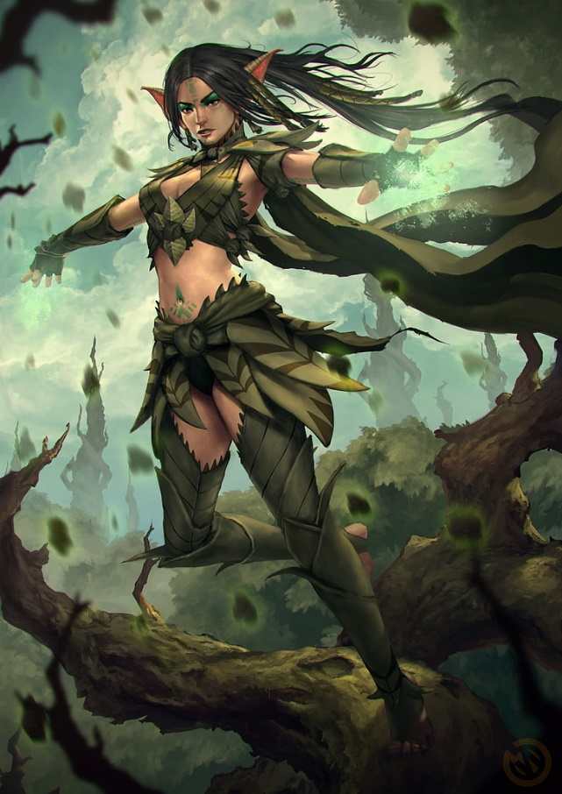**Magical Items**

**Developer Notes**