Notes on the Elven Kingdom of Eida’Las

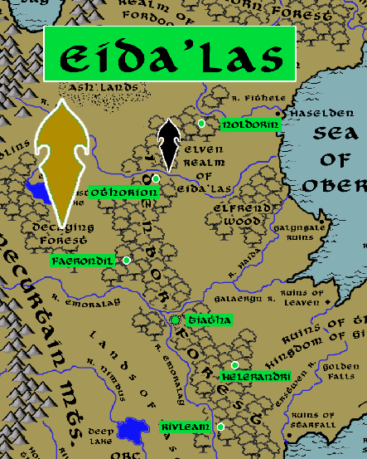

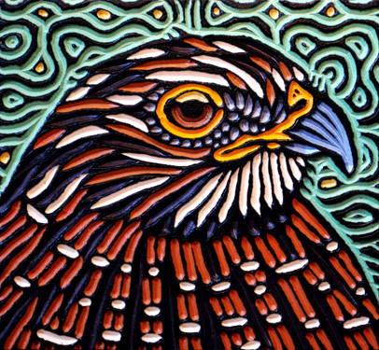

**Sign of the Osprey**

**Location: Idenbor Forest, Lands of Oberon**

* **Overview**
* **Towns and Cities**
* **History**
* **Notes on Culture**
* **Magical Items**
* **Developer Notes**

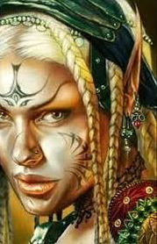**Overview**

The Elves of Eida’las are the last guardians of the once-proud lands around the Sea of Oberon. Ever since the fall of the human Kingdom of Gildran two thousand years ago, evil creatures have moved in and taken over much of this region. Goblin tribes dominate the west, scuttling in the shadow of the Stonecurtain Mountains. Orc armies roam the Nettle Plains to the South and regularly challenge the borders of the Idenbor Forest. Even the Oberon Sea is rife with malicious creatures.

For many centuries the kingdom of Eida’las has persevered, making Idenbor their stronghold. Elven towns are fortresses that command the treetops. The Elves here are wary of strangers and their hospitality is lacking even towards fellow Elves who journey here.

**Towns and Cities**

* Eida'Las
  + Noldorin – large town, population 5,000, guards / soldiers 50, militia 250
  + Othorion – large town, population 5,000, guards / soldiers 50, militia 250
  + Faerondil – large town, population 5,000, guards / soldiers 50, militia 250
  + Tiatha – large city, population 25,000, guards / soldiers 250, militia 2250
  + Kelerandri – large town, population 5,000, guards / soldiers 50, militia 250
  + Rivleam – large town, population 5,000, guards / soldiers 50, militia 250

**Noldorin**

**Size:** large town, population 5,000, guards / soldiers 50, militia 250

**Trade Goods:**

**Local Goods:**

**Standard:**

**Colors:**

**Ruler:** Gantar Wysamyar

**Home**:

**Steward**: Ailwin Ravalee

**Marshal**: Lierin Crasalor (f)

**House Priest:**  Jhaeros Nerina

**House Adviser (Scholar/Mage/etc):**  Phaerille Naewarin (f)

**Captain of the Guard**: Inchel Dafina

**Chief Warriors in Service**:

Virion Dagolor

Glanduil Ertris

Urricea Reyfiel (f)

**Local Powers:**

**Local Sites:**

**Description:**

**Industry:**

**Key Figures:**

**Local Lore:**

**History:**

**Customs:**

**Othorion**

**Size:** large town, population 5,000, guards / soldiers 50, militia 250

**Trade Goods:**

**Local Goods:**

**Standard:**

**Colors:**

**Ruler:** Erlareo Tratoris

**Home**:

**Steward**: Alen Jostina

**Marshal**: Ivaran Cralamin

**House Priest:**  Ava Keakas (f)

**House Adviser (Scholar/Mage/etc):**  Aerilaya Sylynore (f)

**Captain of the Guard**: Olaurae Enmyar

**Chief Warriors in Service**:

Sinaht Adjeon

Ameria Virdithas (f)

Delmuth Facan

**Local Powers:**

**Local Sites:**

**Description:**

**Industry:**

**Key Figures:**

**Local Lore:**

**History:**

**Customs:**

**Faerondil**

**Size:** large town, population 5,000, guards / soldiers 50, militia 250

**Trade Goods:**

**Local Goods:**

**Standard:**

**Colors:**

**Ruler:** Traeliorn Triszorwyn

**Home**:

**Steward**: Tannivh Luven

**Marshal**: Omylia Daxidor (f)

**House Priest:**  Raeran Presnorin

**House Adviser (Scholar/Mage/etc):**  Sundamar Zyldan

**Captain of the Guard**: Aeson Virrel

**Chief Warriors in Service**:

Anlyth Wysajor

Athtar Herzumin

Naeryndam Ralogolor

**Local Powers:**

**Local Sites:**

**Description:**

**Industry:**

**Key Figures:**

**Local Lore:**

**History:**

**Customs:**

**Tiatha**

**Size:** large city, population 25,000, guards / soldiers 250, militia 2250

**Trade Goods:** medicine, timber

**Local Goods:**

**Standard:**

**Colors:**

**Ruler:** Tassarion Wranynore

**Home**:

**Steward**: Mirthal Qiquinal

**Marshal**: Urddusk Torphine

**House Priest:**  Essaerae Iarydark (f)

**House Adviser (Scholar/Mage/etc):**  Faeranduil Tramaris

**Captain of the Guard**: Meira Miaric (f)

**Chief Warriors in Service**:

Kyrtaar Reycan

Gantar Zinydark

Uevareth Sylgeiron

**Local Powers:** Band of the Galeath (rangers), Elawarin Sanctum (school of magic)

**Local Sites:**

**Description:**

**Industry:**

**Key Figures:**

**Local Lore:**

**History:**

**Customs:**

**Kelerandri**

**Size:** large town, population 5,000, guards / soldiers 50, militia 250

**Trade Goods:**

**Local Goods:**

**Standard:**

**Colors:**

**Ruler:** Almon Carthana

**Home**:

**Steward**: Anfalen Morqirelle

**Marshal**: Dilya Royarus (f)

**House Priest:**  Elashor Morbanise

**House Adviser (Scholar/Mage/etc):**  Leena Helerieth (f)

**Captain of the Guard**: Maeral Uridan

**Chief Warriors in Service**:

Elen Aekrana

Wirenth Balpeiros

Rania Magzumin (f)

**Local Powers:**

**Local Sites:**

**Description:**

**Industry:**

**Key Figures:**

**Local Lore:**

**History:**

**Customs:**

**Rivleam**

**Size:** large town, population 5,000, guards / soldiers 50, militia 250

**Trade Goods:**

**Local Goods:**

**Standard:**

**Colors:**

**Ruler:** Siveril Petmyar

**Home**:

**Steward**: Avourel Zinzumin

**Marshal**: Aymon Balqirelle

**House Priest:**  Celaena Virralei (f)

**House Adviser (Scholar/Mage/etc):**  Elluin Grebella

**Captain of the Guard**: Rhalyf Keljeon

**Chief Warriors in Service**:

Thuridan Krisbalar

Flinar Xyrpetor

Amarille Elren (f)

**Local Powers:**

**Local Sites:**

**Description:**

**Industry:**

**Key Figures:**

**Local Lore:**

**History:**

**Customs:**

**History**

**First Primordial Age (PA1)**

**Second Primordial Age (PA2)**

**Third Primordial Age (PA3)**

**Fourth primordial Age (PA4)**

**First Ancient Age (AA1)**

**Second Ancient Age (AA2)**

**Third Ancient Age (AA3)**

**Fourth Ancient Age (AA4)**

230 AA4 - Fall of Elven settlement of Dagohorn Forest to Orcs in Scourge of Hrolith

250 AA4 - Fall of Elven settlement of Neversun Forest to Orcs in Scourge of Hrolith

280 AA4 - Fall of Elven settlement of Greydon Wood to Orcs in Scourge of Hrolith

300 AA4 - Fall of Elven settlement of Nastrond Forest to Orcs in Scourge of Hrolith

330 AA4 - Fall of Elven settlement of Elfrend Wood to Orcs in Scourge of Hrolith

**First Written Age (WA1)**

**Second Written Age (WA2)**

**Third Written Age (WA3)**

640 WA3 - Second Dark Crusade

641 WA3 - Elves of Eida'Las march out to stop Mortavay at the Battle of Erstwyn River; Elven forces decimated and forced to flee the Idenbor Forest

662 WA3 - Elves of Ari'Aahn join with the Dwarves of Garnettren to aide the humans in encircling Mortavay's forces in Erigoth

663 WA3 - Trevilish and Tirudoran cities still free rally to attack Mortavay's center forces, cutting them off from the east; joined by the Elves of Ulynar attacking from Tredfut Forest

666 WA3 - Elves of Aldalinh join Plenish forces from Chryssla and Phaeria to battle Mortavay's central arm

670 - Mortavay defeated; end of the Second Dark Crusade

700 WA3 - Battle of Idenbor: Elves of Ari'Aahn return and take back the Idenbor Forest, restoring their kingdom

**Fourth Written Age (WA4)**

**Notes on Culture**

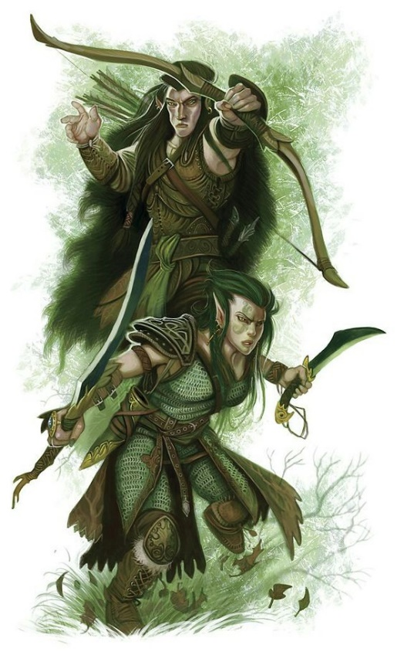**Hravaeran or Fauna Elves**

**Locations: Eida’Las, Elgelor, Elyon, Arbeiera, Lo’Shella**

**Appearance**: pale skin; blonde, brown, or red hair; green eyes

**Culture:** Fauna Elves, also called Wild Elves, are less civilized than their distant cousins. Considered barbaric by most, they create very few works of art or literature. Instead they live as one with the land and form primal bonds with the beasts. Some Wild Elves even have feral qualities. They are the most athletic of all Elves and regarded for their rugged endurance. Wild elves are reclusive, rarely tolerating the company of those outside of their tribes. They particularly fierce in the protection of their lands. Fauna elves enjoy a special friendship with the fay, even more so than Elves do already. This is thought to be because their wild natures hearken to the free spirits of the fay and their ilk.

**Common Attire**: animal skins or woven plants, covered in tribal markings, some dye their skin in natural pigments

**Traits**: Fauna Elves have a natural strong connection to wild beasts. Many develop mental connections to a specific type of animal and, with it, some of their traits. They have the highest constitution of the elven races but also the lowest intelligence.

**Ability and Skill Modifiers:** +2 Constitution, -2 Intelligence,with each level they become able to cast spells at will from the cleric animal domain spell list:

* Animal Domain
* Granted Powers: You can use speak with animals once per day as a spell-like ability. You may add twenty ranks of Knowledge (nature) to your list of class skills.
* Animal Domain Spells

1. Calm Animals: Calms (2d4 + level) HD of animals.
2. Hold Animal: Paralyzes one animal for 1 round/level.
3. Dominate Animal: Subject animal obeys silent mental commands.
4. Summon Nature’s Ally IV*: Calls creature to fight.
5. Commune with Nature: Learn about terrain for 1 mile/level.
6. Antilife Shell: 10-ft. field hedges out living creatures.
7. Animal Shapes: One ally/level polymorphs into chosen animal.
8. Summon Nature’s Ally VIII*: Calls creature to fight.
9. Shapechange F: Transforms you into any creature, and change forms once per round.
   * *Can only summon animals.

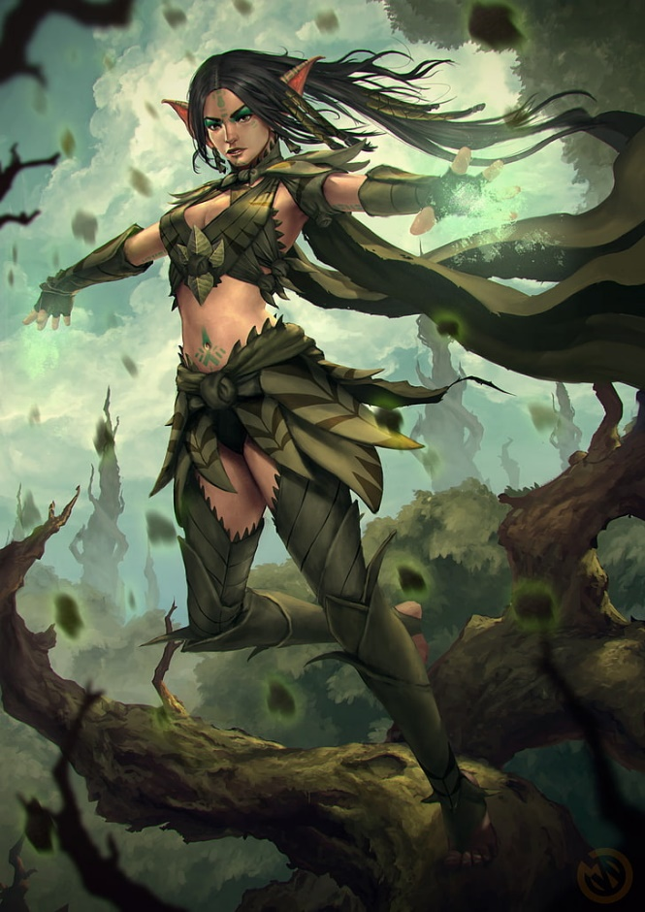**Magical Items**

**Developer Notes**