Notes on the Elven Kingdom of Teinhir

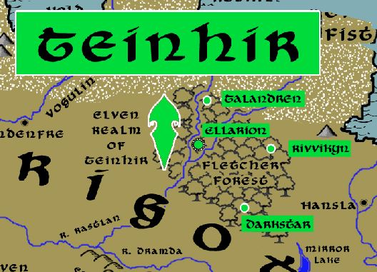

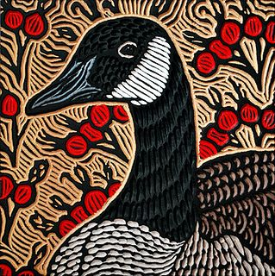

**Sign of the Northern Goose**

**Location: Fletcher Forest, Western Amadar bordering the Kingdom of Erigoth**

* **Overview**
* **Towns and Cities**
* **History**
* **Notes on Culture**
* **Magical Items**
* **Developer Notes**

**Overview**

**Towns and Cities**

* Teinhir
  + Talandren – large town, population 5,000, guards / soldiers 50, militia 250
  + Rivvikyn – large town, population 5,000, guards / soldiers 50, militia 250
  + Ellarion – large city, population 25,000, guards / soldiers 250, militia 2250
  + Darkstar – large town, population 5,000, guards / soldiers 50, militia 250

**Talandren**

**Size:** large town, population 5,000, guards / soldiers 50, militia 250

**Trade Goods:**

**Local Goods:**

**Standard:**

**Colors:**

**Ruler:** Raeran Vengwyn

**Home**:

**Steward**: Hagluin Reyren

**Marshal**: Entrydal Omathana

**House Priest:**  Haera Eladi (f)

**House Adviser (Scholar/Mage/etc):**  Klaern Fenkrana

**Captain of the Guard**: Halflar Perjyre

**Chief Warriors in Service**:

Phelorna Herric (f)

Gormar Zyllana

Eldar Zinlen

**Local Powers:**

**Local Sites:**

**Description:**

**Industry:**

**Key Figures:**

**Local Lore:**

**History:**

**Customs:**

**Rivvikyn**

**Size:** large town, population 5,000, guards / soldiers 50, militia 250

**Trade Goods:**

**Local Goods:**

**Standard:**

**Colors:**

**Ruler:** Madris Neriynore (f)

**Home**:

**Steward**: Rychell Dasalor

**Marshal**: Garrik Olovyre

**House Priest:**  Jhanandra Waesquinal (f)

**House Adviser (Scholar/Mage/etc):**  Thalanil Zinlynn

**Captain of the Guard**: Nylathria Ballana (f)

**Chief Warriors in Service**:

Alinar Presmaris

Kymil Xyrhice

Nylathria Sartumal (f)

**Local Powers:**

**Local Sites:**

**Description:**

**Industry:**

**Key Figures:**

**Local Lore:**

**History:**

**Customs:**

**Ellarion**

**Size:** large city, population 25,000, guards / soldiers 250, militia 2250

**Trade Goods:** timber

**Local Goods:**

**Standard:**

**Colors:**

**Ruler:** Tordynnar Reybanise

**Home**:

**Steward**: Aerilaya Norzorwyn (f)

**Marshal**: Vesper Glynlar

**House Priest:**  Triandal Umekian

**House Adviser (Scholar/Mage/etc):**  Garrick Enlee

**Captain of the Guard**: Kerym Jojella

**Chief Warriors in Service**:

Amra Yelleth (f)

Goren Fawraek

Aumanas Iannan

**Local Powers:**

**Local Sites:**

**Description:**

**Industry:**

**Key Figures:**

**Local Lore:**

**History:**

**Customs:**

**Darkstar**

**Size:** large town, population 5,000, guards / soldiers 50, militia 250

**Trade Goods:**

**Local Goods:**

**Standard:**

**Colors:**

**Ruler:** Eldaerenth Joralei

**Home**:

**Steward**: Allynna Aracan (f)

**Marshal**: Aimon Gilralei

**House Priest:**  Alea Ersandoral (f)

**House Adviser (Scholar/Mage/etc):**  Edyrm Admaris

**Captain of the Guard**: Hagwin Wynkas

**Chief Warriors in Service**:

Kyrenic Kelphyra

Malgath Heilana

Thaciona Iargwyn (f)

**Local Powers:** Band of the Wranfaren (rangers)

**Local Sites:**

**Description** :

Set at the edge of Fletcher Forest, the town of Darkstar bears witness to the evils wrought by Orcs in the open plains to the south. On nights where the crescent moon hangs high, riders on giant elk raid the plains to slay any Orc they find in the open. This is called the Crescent Culling and is savage to behold.

**Industry:**

**Key Figures:**

**Local Lore:**

**History:**

**Customs:**

**History**

**First Primordial Age (PA1)**

**Second Primordial Age (PA2)**

**Third Primordial Age (PA3)**

**Fourth primordial Age (PA4)**

**First Ancient Age (AA1)**

**Second Ancient Age (AA2)**

**Third Ancient Age (AA3)**

**Fourth Ancient Age (AA4)**

**First Written Age (WA1)**

**Second Written Age (WA2)**

**Third Written Age (WA3)**

**Fourth Written Age (WA4)**

**Notes on Culture**

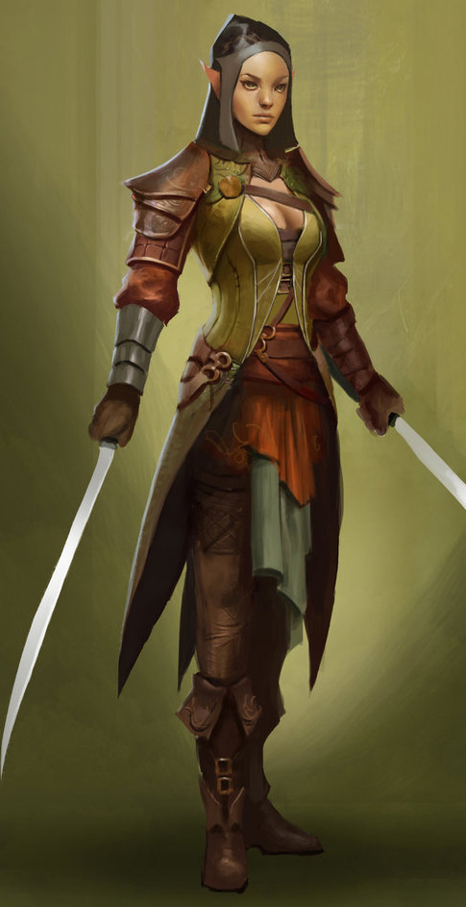**Taurean or Forest Elves**

**Locations: Adulien, Aldalinh, Ulynar, Ari’Aahn, Teinhir**

**Appearance:** light brown skin; blonde to brown hair; brown or green eyes

**Culture:** Forest Elves are athletic, curious, and eager to explore. They are fond of stories and songs, both in the hearing and the performing. They are playful, mirthful, and relate well to other races. Forest Elves prefer the wilderness but welcome visitors to their lands. They relish life to the point that they are considered unruly by the more cerebral elves.

**Common Attire**: dark shades of green and earth tones

**Traits**: Taller than most elves and disciplined warriors. They are familiar with magic but without any special focus or natural spell-like abilities.

**Ability and Skill Modifiers:** same as standard elf in PHB

**Magical Items**

**Developer Notes**