Notes on the Elven Kingdom of Ari’Aahn

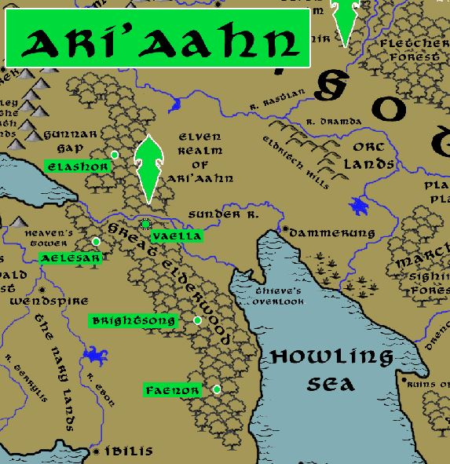

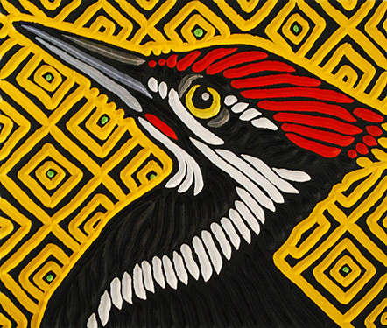

**Sign of the Carpenter Bird**

**Location: Great Elderwood, Western Amadar, bordering the Kingdoms of Erigoth and Tirudor**

* **Overview**
* **Towns and Cities**
* **History**
* **Notes on Culture**
* **Magical Items**
* **Developer Notes**

**Overview**

The Ari’Aahn elves have faced centuries of opposition with the humans in this region. This is partly because the Great Elderwood sits between Erigoth and Tirudor and armies march through here during times of war. It is also where the Augemere Sea empties into the Howling Sea so conflicts over water between Treviland and the other two kingdoms tend to move this way. After centuries of fighting there has been an uneasy truce called. Traffic is freely allowed along the river and the road that cuts east-west through the woods, but the **Treaty of Corlaer** dictates that no non-elf shall enter the woods themselves without permission.

Legend has it that the **Alyndra** of Ari’Aahn and **Hatharal** of Ulynar, children of elven lords, were once in love but their fathers denied them to see one another. The two would meet in secret on the shores of the Augemere Sea just west of Heaven’s Tower. One day the daughter stumbled across an invading army of orcs emerging from the Gunnar Gap (Second Dark Crusade, 662 WA3). Mortally wounded, she made it to Ulynar where she warned them of the invasion before dying in the arms of Hatharal. After the war, Hatharal spent his days retracing their path to the rendezvous spot overlooking the Augemere Sea. It is said where Alyndra’s blood fell along the way special flowers bloom. This is the **Path of the Aching Heart.** The flowers have special magical properties. It is said the couple buried a token of their love somewhere along the way that holds the key to removing a curse still suffered in both domains.

**Towns and Cities**

* Ari'Aahn
  + Elashor – large town, population 5,000, guards / soldiers 50, militia 250
  + Vaella – large city, population 25,000, guards / soldiers 250, militia 2250
  + Aelesar – large town, population 5,000, guards / soldiers 50, militia 250
  + Brightsong – large town, population 5,000, guards / soldiers 50, militia 250
  + Faenor – large town, population 5,000, guards / soldiers 50, militia 250

**Elashor**

**Size:** large town, population 5,000, guards / soldiers 50, militia 250

**Trade Goods:**

**Local Goods:**

**Standard:**

**Colors:**

**Ruler:** Melarue Brycan (f)

**Home**:

**Steward**: Ilimitar Faesalor

**Marshal**: Keryth Eladi

**House Priest:**  Ygannea Thefiel (f)

**House Adviser (Scholar/Mage/etc):**  Merellien Umetumal

**Captain of the Guard**: Aien Heixina

**Chief Warriors in Service**:

Ailas Torfir

Alluin Theharice

Alyndra Zumzorwyn (f)

**Local Powers:**

**Local Sites:**

**Description:**

**Industry:**

**Key Figures:**

**Local Lore:**

**History:**

**Customs:**

**Vaella**

**Size:** large city, population 25,000, guards / soldiers 250, militia 2250

**Trade Goods:** medicine, timber

**Local Goods:**

**Standard:**

**Colors:**

**Ruler:** Sharaera Querolor

**Home**:

**Steward**: Ruvyn Elerro

**Marshal**: Kavrala Miathor (f)

**House Priest:**  Vesstan Trafaren

**House Adviser (Scholar/Mage/etc):**  Herlynn Yalathanil

**Captain of the Guard**: Aescil Adnorin

**Chief Warriors in Service**:

Lurina Heixalim (f)

Ninlen Wysathlan

Kiirion Liayra

**Local Powers:** Cathedral of Nueleth Dorthana, Order of the Woodland Shield (paladins), Band of the Beldroth (rangers)

**Local Sites:**

**Description:**

**Industry:**

**Key Figures:**

**Local Lore:**

**History:**

**Customs:**

**Aelesar**

**Size:** large town, population 5,000, guards / soldiers 50, militia 250

**Trade Goods:**

**Local Goods:**

**Standard:**

**Colors:**

**Ruler:** Ena Xilbalar (f)

**Home**:

**Steward**: Purtham Paynore

**Marshal**: Axilya Roxalim (f)

**House Priest:**  Folas Zinzeiros

**House Adviser (Scholar/Mage/etc):**  Theodmon Sylceran

**Captain of the Guard**: Nephinae Ernelis (f)

**Chief Warriors in Service**:

Fhaornik Adrie

Vaalyun Genlee

Azariah Quimys (f)

**Local Powers:**

**Local Sites:**

**Description:**

**Industry:**

**Key Figures:**

**Local Lore:**

Urexon the green dragon dwells near here.

Just outside of the settlement are the tombs of the lovers **Alyndra** of Ari’Aahn and **Hatharal** of Ulynar, children of elven lords who denied them to see one another. The two would meet in secret on the shores of the Augemere Sea just west of Heaven’s Tower. One day the daughter stumbled across an invading army of orcs emerging from the Gunnar Gap (Second Dark Crusade, 662 WA3). Mortally wounded, she made it to Ulynar where she warned them of the invasion before dying in the arms of Hatharal.

**History:**

**Customs:**

**Brightsong**

**Size:** large town, population 5,000, guards / soldiers 50, militia 250

**Trade Goods:**

**Local Goods:**

**Standard:**

**Colors:**

**Ruler:** Shael Loraquinal (f)

**Home**:

**Steward**: Arbane Torjeon

**Marshal**: Eltaor Phihana

**House Priest:**  Omylia Dorphyra (f)

**House Adviser (Scholar/Mage/etc):**  Ganamede Ulalee

**Captain of the Guard**: Elanalue Xilran (f)

**Chief Warriors in Service**:

Kyrenic Yllalynn

Entrydal Toryarus

Reptien Ulamaer

**Local Powers:**

**Local Sites:**

**Description:**

**Industry:**

**Key Figures:**

**Local Lore:**

**History:**

**Customs:**

**Faenor**

**Size:** large town, population 5,000, guards / soldiers 50, militia 250

**Trade Goods:**

**Local Goods:**

**Standard:**

**Colors:**

**Ruler:** Galather Virlana

**Home**:

**Steward**: Nindrol Liawenys

**Marshal**: Nanthaliene Neritumal (f)

**House Priest:**  Sinaht Olaren

**House Adviser (Scholar/Mage/etc):**  Aymar Xiljor

**Captain of the Guard**: Fhaornik Torcyne

**Chief Warriors in Service**:

Lyklor Daegwyn

Durlan Wranjeon

Taranath Bryjor

**Local Powers:**

**Local Sites:**

**Description:**

**Industry:**

**Key Figures:**

**Local Lore:**

**History:**

**Customs:**

**History**

**First Primordial Age (PA1)**

**Second Primordial Age (PA2)**

**Third Primordial Age (PA3)**

**Fourth primordial Age (PA4)**

290 PA4 - King Aleaume of the Phrane Empire wages war with the elves of Ulynar, Aldalinh, and Ari'aanh; the elves utterly wipe out the Phrane armies and slay Aleaume

**First Ancient Age (AA1)**

**Second Ancient Age (AA2)**

**Third Ancient Age (AA3)**

**Fourth Ancient Age (AA4)**

**First Written Age (WA1)**

**Second Written Age (WA2)**

**Third Written Age (WA3)**

640 WA3 - Second Dark Crusade

641 WA3 - Elves of Eida'Las march out to stop Mortavay at the Battle of Erstwyn River; Elven forces decimated and forced to flee the Idenbor Forest

662 WA3 - Elves of Ari'Aahn join with the Dwarves of Garnettren to aide the humans in encircling Mortavay's forces in Erigoth

663 WA3 - Trevilish and Tirudoran cities still free rally to attack Mortavay's center forces, cutting them off from the east; joined by the Elves of Ulynar attacking from Tredfut Forest

666 WA3 - Elves of Aldalinh join Plenish forces from Chryssla and Phaeria to battle Mortavay's central arm

670 - Mortavay defeated; end of the Second Dark Crusade

700 WA3 - Battle of Idenbor: Elves of Ari'Aahn return and take back the Idenbor Forest, restoring their kingdom

**Fourth Written Age (WA4)**

**Notes on Culture**

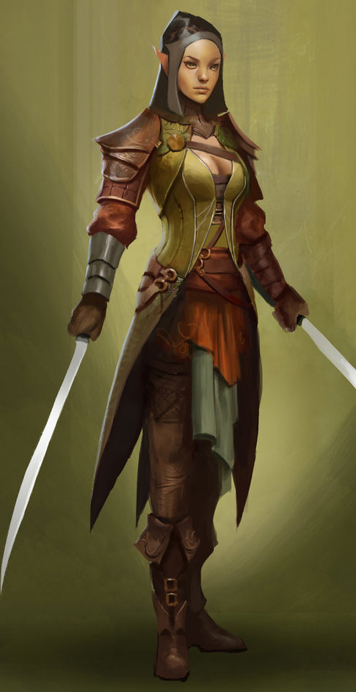**Taurean or Forest Elves**

**Locations: Adulien, Aldalinh, Ulynar, Ari’Aahn, Teinhir**

**Appearance:** light brown skin; blonde to brown hair; brown or green eyes

**Culture:** Forest Elves are athletic, curious, and eager to explore. They are fond of stories and songs, both in the hearing and the performing. They are playful, mirthful, and relate well to other races. Forest Elves prefer the wilderness but welcome visitors to their lands. They relish life to the point that they are considered unruly by the more cerebral elves.

**Common Attire**: dark shades of green and earth tones

**Traits**: Taller than most elves and disciplined warriors. They are familiar with magic but without any special focus or natural spell-like abilities.

**Ability and Skill Modifiers:** same as standard elf in PHB

**Magical Items**

**Developer Notes**