Notes on the Elven Kingdom of Aldalinh

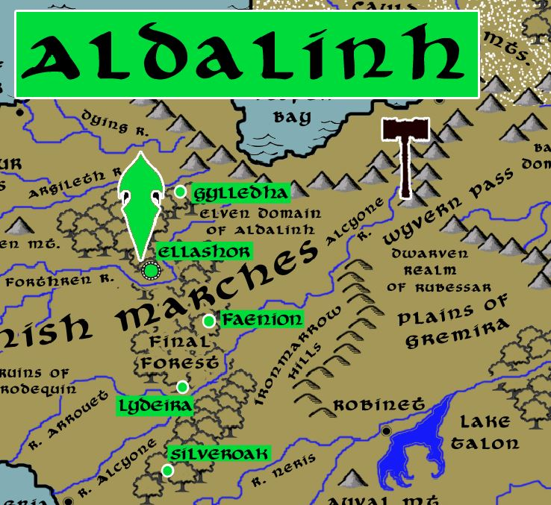

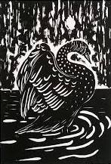**Sign of the Black Swan**

**Location: Final Forest, Western Amadar**

* **Overview**
* **Towns and Cities**
* **History**
* **Notes on Culture**
* **Magical Items**
* **Developer Notes**

**Overview**

290 PA4 King Aleaume of the Phrane Empire wages war on Ulynar, Aldalinh, and Ari’Aanh; Phrane armies are wiped out and the kingdom falls

811 PA4 – reclaim the Darkwood and establish the Kingdom of Kalanon

90 AA3 - Red Leaf War; King Sevre of the Harduins wages are on Aldalinh, but Aldalinh is rescued by Adulien and Ulynar

852 AA3 - Great Orc War of the West, march to save Kalanon but fail; armies ambushed and fight the orc invaders around the Plenish Marches; Aldalinh falls along with the human Harduin kingdom

875 AA3 – rebuilding of Aldalinh

666 WA3 - Second Dark Crusade – fight Mortavay’s forces

The high lady **Elisven Rodara** (f) rules over and protects the Elven people of Aldalinh, who make their home in the Final Forest and the march lands of Plenia. Here, the Taurean or Forest Elves serve as wardens of the forest as well as of the Three Sisters: the rivers Arglieth, Forthren, and Alcyone flowing westward out of the Cauldron Mountains.

The Aldalinh were once bound to the sea, but their coastal settlements fell during the Great Orc War of the West. Today they navigate the rivers by small boats that are harbored within the wood at **Naiana**, a secret harbor only trusted friends are allowed to use. They also operate a fleet of small ships in the Neringa Sound. The Llyrial domain of Vaya, or sea elves, that inhabit the shores of the Isle of Daysend are on-again, off-again allies. In truth the Aldalinh have little patience with the Lyrial Elves, for they seem frivolous and uninteresting.

**Towns and Cities**

* Aldalinh
  + Gylledha – large town, population 5,000, guards / soldiers 50, militia 250
  + Ellashor – large city, population 25,000, guards / soldiers 250, militia 2250
  + Faenion – large town, population 5,000, guards / soldiers 50, militia 250
  + Lydeira – large town, population 5,000, guards / soldiers 50, militia 250
  + Silveroak – large town, population 5,000, guards / soldiers 50, militia 250

**Gylledha**

**Size:** large town, population 5,000, guards / soldiers 50, militia 250

**Trade Goods:**

**Local Goods:**

**Standard:**

**Colors:**

**Ruler:** Zelphar Zinxalim

**Home**:

**Steward**: Flinar Qiwarin

**Marshal**: Vaeri Fabalar (f)

**House Priest:**  Ivaran Yinberos

**House Adviser (Scholar/Mage/etc):**  Akkar Eilphyra

**Captain of the Guard**: Imra Ravaxalim (f)

**Chief Warriors in Service**:

Meriel Krispeiros (f)

Vianola Oloberos (f)

Faelar Yesrora

**Local Powers:**

**Local Sites:**

**Description:**

**Industry:**

**Key Figures:**

**Local Lore:**

**History:**

**Customs:**

**Ellashor**

**Size:** large city, population 25,000, guards / soldiers 250, militia 2250

**Trade Goods:** dyes

**Local Goods:**

**Standard:**

**Colors:**

**Ruler:** Elisven Rodara (f)

**Home**:

**Steward**: Sana Brylen (f)

**Marshal**: Agandaur Thestina

**House Priest:**  Rydel Aelynn

**House Adviser (Scholar/Mage/etc):**  Adamar Grephyra

**Captain of the Guard**: Elyon Ulatris (f)

**Chief Warriors in Service**:

Wirenth Inavaris

Vesstan Fenbalar

Zhoron Elyra

**Local Powers:** Order of Vierendeel (paladins), Band of the Faunalyn (rangers)

**Local Sites:**

**Description:**

**Industry:**

**Key Figures:**

**Local Lore:**

**History:**

**Customs:**

**Faenion**

**Size:** large town, population 5,000, guards / soldiers 50, militia 250

**Trade Goods:**

**Local Goods:**

**Standard:**

**Colors:**

**Ruler:** Rathal Inazana

**Home**:

**Steward**: Irhaal Baljor (f)

**Marshal**: Halflar Helezana

**House Priest:**  Ayla Phigella (f)

**House Adviser (Scholar/Mage/etc):**  Rolim Ventris

**Captain of the Guard**: Elanalue Perkalyn (f)

**Chief Warriors in Service**:

Imra Naekian (f)

Kindroth Wranrora

Intevar Eilmenor

**Local Powers:**

**Local Sites:**

**Description:**

**Industry:**

**Key Figures:**

**Local Lore:**

**History:**

**Customs:**

**Lydeira**

**Size:** large town, population 5,000, guards / soldiers 50, militia 250

**Trade Goods:**

**Local Goods:**

**Standard:**

**Colors:**

**Ruler:** Keenor Gilhorn (f)

**Home**:

**Steward**: Phraan Xyrtoris

**Marshal**: Fenian Farvyre

**House Priest:**  Meorise Helesys (f)

**House Adviser (Scholar/Mage/etc):**  Fylson Shasys

**Captain of the Guard**: Rathal Sarzeiros

**Chief Warriors in Service**:

Pirphal Arabalar

Shaerra Luthana (f)

Elmar Magdan

**Local Powers:**

**Local Sites:**

**Description:**

**Industry:**

**Key Figures:**

**Local Lore:**

**History:**

**Customs:**

**Silveroak**

**Size:** large town, population 5,000, guards / soldiers 50, militia 250

**Trade Goods:**

**Local Goods:**

**Standard:**

**Colors:**

**Ruler:** Eriladar Loraynore

**Home**:

**Steward**: Elorshin Therieth

**Marshal**: Holone Heimys (f)

**House Priest:**  Aumanas Aratoris

**House Adviser (Scholar/Mage/etc):**  Anarzee Raloydark (f)

**Captain of the Guard**: Fhaornik Daesatra

**Chief Warriors in Service**:

Mihangyl Shalynn

Feno Beistina

Symania Genleth (f)

**Local Powers:**

**Local Sites:**

**Description:**

**Industry:**

**Key Figures:**

**Local Lore:**

**History:**

**Customs:**

**History**

**First Primordial Age (PA1)**

**Second Primordial Age (PA2)**

**Third Primordial Age (PA3)**

**Fourth primordial Age (PA4)**

290 PA4 - King Aleaume of the Phrane Empire wages war with the elves of Ulynar, Aldalinh, and Ari'aanh; the elves utterly wipe out the Phrane armies and slay Aleaume

800 PA4 - the evil cleric Waiofar the Wicked claims the Many-Thorned Mantle and raises his banner at Wulver Lake; he assembles a dark horde of humanoids to take over NW Amadar

810 PA4 - Battle of Darkwood – Aldlalinh elves march from the Final Forest to mount a furious retaliation and destroy Waiofar's forces; the Many-Thorned Mantle is lost

811 PA4 - Elves of Aldalinh reclaim the Darkwood and establish the Kingdom of Kalanon

**First Ancient Age (AA1)**

**Second Ancient Age (AA2)**

**Third Ancient Age (AA3)**

90 AA3 – Red Leaf War - King Sevré of the Harduins wages war on elven kingdom of Aldalinh

90 - the Amulet Veritae, amulet of kings, is sundered in two at the act of Sevré's treachery; the second half is lost

110 AA3 - Elven settlements in Bane Wood and Treacle Forest wiped out by Harduin armies in the Red Leaf War

140 AA3 - end of the Red Leaf War - elven forces from Adulien and Ulynar encircle and wipe out Harduin forces, rescuing Aldalinh; King Sevré falls in battle when elves wield the second half of the Amulet Veritae and slay him

850-873 AA3 - Great Orc War of the West

851 AA3 - The Great Orc Army splits into four forces: The Banners of Blood, Bone, Claw, and Teeth; Blood and Bone march west, Claw invades the Dwarven Kingdom of Citerak, Teeth marches east into the Friendless Fringes

852 AA3 - Orcs of the Blood and Bone Banners assault the Great Darkwood Forest and the Kingdom of Kalanon

852 AA3 - Battle of Amrathain River - Orcs of the Blood and Bone Banners crush the Elven forces of Kalanon; the Elven towns of Kalanon are laid to waste

852 AA3 - Elves of Aldalinh and Adulien march to aide Kalanon

853 AA3 - the Orcs of Blood and Bone withdraw to Wyvern Pass; Elves of Aldalinh and Adulien are surrounded and ambushed at Wyvern Pass ; they flee west in retreat

854 AA3 - fall of the Elven settlements in Fangel Forest, Bane Wood, and the Faun Forest

854 AA3 - Banners of Blood and Bone assault Final Forest

857 AA3 - Elves of Ulynar march west, Elves of Ari'Aahn march east

858-872 AA3 - Kingdom of Aldalinh falls to the Orc invaders; fighting continues off and on around the Plenish Marches, Bane Wood, the Gunnar Gap, and the Plains of Arbock

873 AA3 - a series of victories over the Orcs drive them back from the Plenish Marches and the lands east of the Evermore Mountains; Aldalinh is liberated but the lands north of the Augemere Sea are lost to orc and goblin tribes

**Fourth Ancient Age (AA4)**

**First Written Age (WA1)**

**Second Written Age (WA2)**

**Third Written Age (WA3)**

640 WA3 - Second Dark Crusade

641 WA3 - Elves of Eida'Las march out to stop Mortavay at the Battle of Erstwyn River; Elven forces decimated and forced to flee the Idenbor Forest

662 WA3 - Elves of Ari'Aahn join with the Dwarves of Garnettren to aide the humans in encircling Mortavay's forces in Erigoth

663 WA3 - Trevilish and Tirudoran cities still free rally to attack Mortavay's center forces, cutting them off from the east; joined by the Elves of Ulynar attacking from Tredfut Forest

666 WA3 - Elves of Aldalinh join Plenish forces from Chryssla and Phaeria to battle Mortavay's central arm

670 - Mortavay defeated; end of the Second Dark Crusade

700 WA3 - Battle of Idenbor: Elves of Ari'Aahn return and take back the Idenbor Forest, restoring their kingdom

**Fourth Written Age (WA4)**

**Notes on Culture**

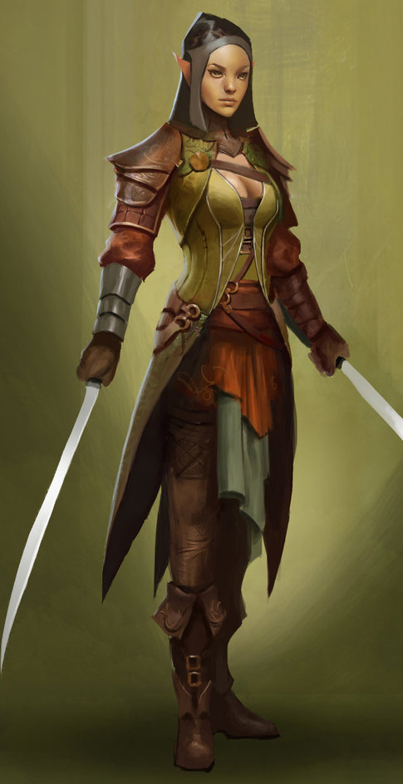**Taurean or Forest Elves**

**Locations: Adulien, Aldalinh, Ulynar, Ari’Aahn, Teinhir**

**Appearance:** light brown skin; blonde to brown hair; brown or green eyes

**Culture:** Forest Elves are the most athletic, curious, and eager to explore of all their kin. They are fond of stories and songs, both in the hearing and the performing. They are playful, mirthful, and relate well to other races. Forest Elves prefer the wilderness but welcome visitors to their lands. They relish life to the point that they are considered unruly by the more cerebral elves.

Unlike their kin among the fauna elves, however, forest elves are more civilized. They spend most of their lives in communion with nature, but do not form the primal bonds with animals that fauna elves attain. Likewise, they are stewards of nature but create fantastic architecture that complements their surroundings, while fauna elves build elaborate structures that are almost indiscernible from the ecosystem.

**Common Attire**: dark shades of green and earth tones

**Traits**: Taller than most elves and disciplined warriors. They are familiar with magic but without any special focus or natural spell-like abilities. Some say forest elves are the bravest of all the elven kind and are steadfast in fighting for the sake of high ideals. Others remark they are second only to the gray elves in their ability to recall countless songs and lore. Certainly forest elves, in spite of their name, are the most comfortable with human civilization and working with other races.

**Ability and Skill Modifiers:** same as standard elf in PHB

**Magical Items**

**Developer Notes**