Notes on the Domains of the

Drow

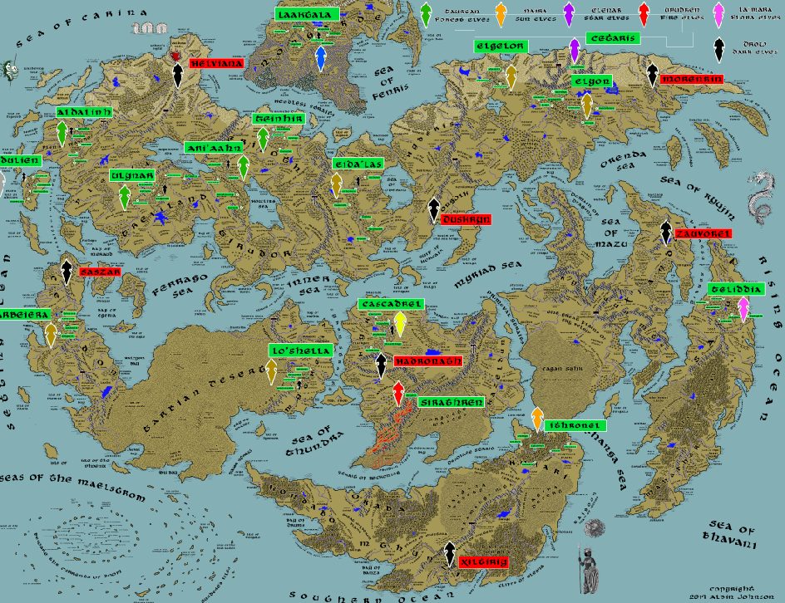

* **Overview**
* **Domains of the Drow**
* **History**
* **Notes on Culture**
* **Magical Items**
* **Developer Notes**

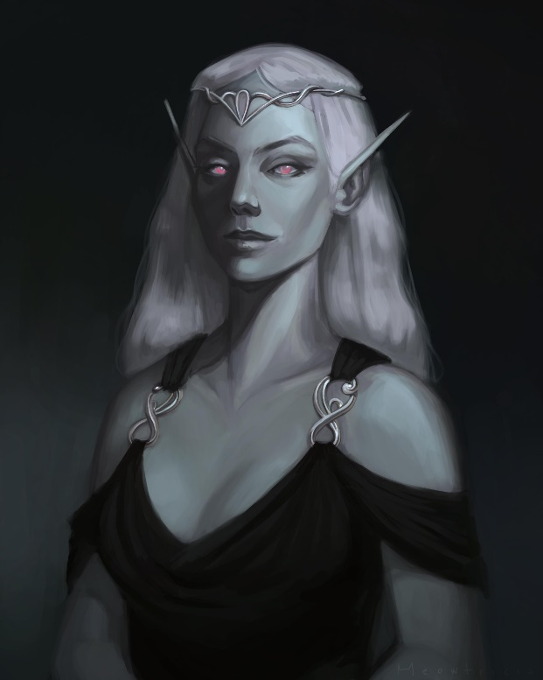**Overview**

**Domains of the** **Drow**

1. Helviana – Caldura Mountains, Lost Northwest
2. Duskryn - Silvercap Mountains, Ongolk
3. Morenrin – High Fist Mountains, Sadara
4. Saszar - Arcanian Mountains, Celedon
5. Hadronath - Eldedure Mountains, Gaeadon
6. Zauvorel - Kang Mountains, Xiandai
7. Xiltiriy - Dead Peaks, Kaduru

**Helviana** **–** Caldura Mountains, Lost Northwest

**Size:** large town, population 5,000, guards / soldiers 50, militia 250

**Trade Goods:**

**Local Goods:**

**Standard:**

**Colors:**

**Ruler:** Moggyr Mezoldrur and his consort Gidunni (f)

**Home**:

**Steward**: Gulmedh Mistrumu (f)

**Marshal**: Bomer Drildrid

**House Priest:**  Thunzair Arthi

**House Adviser (Scholar/Mage/etc):**  Urdredh the Wand Weaver

**Captain of the Guard**: Dierloth Dezrumad (f)

**Chief Warriors in Service**:

Thonca Bhuvraga

Tecraedh Dharded

Brundru Gadu

**Local Powers:**

**Local Sites:**

**Description:** The dark forces of the Helviana have secured the Caldura Mountains as their infernal domain, controlling armies of lesser creatures in the Lost Northwest. Wizards summon fire elementals from the lava pools that bubble within the valley, wreaking untold destruction to the Great Darkwood and beyond. At the center of their unholy temple, they worship the power of the cursed artifact, the **Blightstone**, a giant purplish gem that is a doorway into other dimensions. The gem drains souls and lends the priests unthinkable power over life. It is the aim of Lord Mezoldrur to find the lost artifacts buried in the lost Elven domain of Kalanon. Legend tells of powerful wards that protect lost treasures of the elves, but so far, their search has been fraught with failure. Their enemies remain the Blood and Bone Banners of Orc tribes, who hate the drow and seek to drive them from their mountain home.

**Industry:**

**Key Figures:**

**Local Lore:**

**History:**

**Customs:**

**Duskryn** **-** Silvercap Mountains, Ongolk

**Size:** large town, population 5,000, guards / soldiers 50, militia 250

**Trade Goods:**

**Local Goods:**

**Standard:**

**Colors:**

**Ruler:** Mistress Thalfe Budasi (f) and her slave Iornos

**Home**:

**Steward**: Godrul Memrush (f)

**Marshal**: Nendan Crigreet

**House Priest:** Rhamdry the Spider Tamer

**House Adviser (Scholar/Mage/etc):**  Invrush the Plane Stalker

**Captain of the Guard**: Crizunir the Masked

**Chief Warriors in Service**:

Dunsade Kriurdish

Rikhipe Piuvrosh

Kheglur Congeh (f)

**Local Powers:**

**Local Sites:**

**Description:** The southern Silvercap Mountains have been the staging grounds for the Duskryn Drow in their long battle to control the Ongolk region. Their hated enemies, the Dwarves of the Agatren Kingdom, have waged ceaseless war to keep the Drow from advancing northward up the mountains. Each full moon the Duskryn mount their monstrous spiders and raid the region around the Oberon Sea, taking slaves and victims for their sacrifices. Their temple is home to the **Gossamer Vault**, an ancient sarcophagus the size of a large hill, within which lives a gaseous demon named **Hephrix**. The Drow serve the demon, releasing it when it reaches its greatest strength, spreading a supernatural fog into the surrounding lands. All who are caught in the tendrils of the swirling monstrosity are consumed in agony. Mistress Thalfe is thought to sacrifice prisoners to the fog to convert them into mindless slaves, whom she sends as spies to Sentry Keep in an attempt to infiltrate the Agatren Kingdom.

**Industry:**

**Key Figures:**

**Local Lore:**

**History:**

**Customs:**

**Morenrin**– High Fist Mountains, Sadara

**Size:** large town, population 5,000, guards / soldiers 50, militia 250

**Trade Goods:**

**Local Goods:**

**Standard:**

**Colors:**

**Ruler:** Gondok Zaevruc and his companion Sudnan (f)

**Home**:

**Steward**: Zalvul Needinriut

**Marshal**: Micibne Golve (f)

**House Priest:** Mibelva (f) of the Soul Well

**House Adviser (Scholar/Mage/etc):** Ezoth the Eaten

**Captain of the Guard**: Samdre Biemrash (f)

**Chief Warriors in Service**:

Bhigno Sardiut

Ibzier Phorlan

Khona Tanrish

**Local Powers:**

**Local Sites:**

**Description:** The cursed lands of Sadara have been long bereft of human overlords. They were crushed by the Haka’Na centuries ago. So now the Morenrin prevail, having left the High Fist Mountains to rule the lands above and below. Deep within their mountain palace the **Great Emberpit** burns with a cursed flame consuming the bodies of a hundred slain demons. The black souls create a thick smoke that covers the skies above Sadara, casting the world in gloom. Large dire bats circle overhead, their Drow riders locked in constant combat and preparing for the day they lead their armies westward against the Haka’Na. Unnatural screams echo across the landscape, thought to be the fading souls of the tortured demons below. Lord Zaevruc bides his time, seeking out the lost treasures of the fallen city of Namakek of old. His warriors lay in wait along the Frostbite Shores, ready to pounce on unsuspecting sailors who attempt to weather the arctic seas there.

**Industry:**

**Key Figures:**

**Local Lore:**

**History:**

**Customs:**

**Saszar** – Arcanian Mountains, Celedon

**Size:** large town, population 5,000, guards / soldiers 50, militia 250

**Trade Goods:**

**Local Goods:**

**Standard:**

**Colors:**

**Ruler:** Molnine Thaerudil (f) and her consort Calnadi (f)

**Home**:

**Steward**: Chosukhi Ramosrith

**Marshal**: Titrin Zirthies

**House Priest:** Brurdruh Senra (f) the Demon Stoker

**House Adviser (Scholar/Mage/etc):** Bubuzrod of the Crystal Eyes

**Captain of the Guard**: Thumloh Palnebai (f)

**Chief Warriors in Service**:

Rhihepho Anree

Brecnul Thogilnod

Caemmaerth Shreedobiac

**Local Powers:**

**Local Sites:**

**Description:** The Drow kingdom of Saszar, once the master of the Arcanian Mountains, has returned to its place of dominion. Three hundred years ago the Empress Zecubel summoned the lost Sunder Staff from the Abyss and conquered the mountains and all of northern Celedon (111 WA4). Now the Drow command the Kranag and Ardrakar Orc tribes, deploying them against Evolos and Lucina. The Arbeiera Elves out of Devana in the Ningarnim Forest counter the Saszar as soon as they venture south into the Equus Plains.

**Industry:**

**Key Figures:**

**Local Lore:**

**History:** The Drow of Saszar rose to power shortly after the fall of Aquila in 60 WA2, expanding across the entire Arcanian Mountain range and subjugating the **Kranag** and **Ardrakar** tribes of Orcs. Their empress, **Lasaril,** captured the lost **Sunder Staff** from the ruined vaults of Aquila and used it to create giant earthquakes that toppled towers and swallowed up entire towns. But after three hundred years a prophecy yielded a Drow touched by the gods of light. Young **Heriena** was born with the birthmark of **Sariel**, a star sacred to all of elven kind. The Saszar nobles hunted the young Drow, but she escaped and united other Drow sympathetic to life and other peoples. She returned years later, the Paladin of Sariel, and with the help of the Elves of Arbeiera, destroyed the armies of the Saszar and tossed the Sunder Staff into the Abyss.

80 WA2 - the Drow kingdom of Saszar, sensing the Celedonians at their weakest, is led by their empress Lasaril to conquer the Arcanian Mountains and most of the northern lands; the Sunder Staff is wielded to create giant earthquakes and swallow up entire towns

512 WA2 - a prophecy yields a Drow of light named Heriena, who escapes the Saszar and becomes the paladin of the elven star Sariel

804 WA2 - Heriena, Drow paladin of Sariel, leads the elves of Abeiera to conquer the Saszar and free northern Celedon from their terror; the Sunder Staff is destroyed

370 WA3 - War of the Black Widow - the Elves of Arbeiera battle Saszar Drow invading the Ningarnim Forest

375 WA3 - Elves of Arbeiera, aided by Celedonians from Vesta, track the Drow to an underground highway linking the Volturnus Mts. to the Saszar in the Arcananians to the north

380 WA3 - Battle of Volturnus - Elves of Arbeiera are joined by the Dwarves of Berylor in defeating the Black Widow Queen Sethria of the Saszar Drow

111 WA4 - Empress Zecubel summons the lost Sunder Staff from the Abyss and conquers northern Celedon, restoring the Saszar kingdom of Drow to its former glory

**Customs:**

**Hadronath** – Eldedure Mountains, Gaeadon

**Size:** large town, population 5,000, guards / soldiers 50, militia 250

**Trade Goods:**

**Local Goods:**

**Standard:**

**Colors:**

**Ruler:** Iemryrn Marzun (f) and her consort Zulvikh

**Home**:

**Steward**: Erdriod Kebunrer

**Marshal**: Amnyl Woldru

**House Priest:** Faidrith (f) of the Chiming Cave

**House Adviser (Scholar/Mage/etc):** Krenzo the Unbidden

**Captain of the Guard**: Rhimoca Ziebadril (f)

**Chief Warriors in Service**:

Zudru Ceelziush

Pharonu Shrinvred

Rhidonshi Pusamun

**Local Powers:**

**Local Sites:**

**Description:** Long have the Drow of Hadronath coveted the Vale of Hileia and the mountains in the south that seethe with flame. Their tunnels wind beneath the Eldedure Mountains, wandering eastward to Tiroth Pass. But they would have all of southern Gaeadon, including the sacred fairy forest of Tethra. It was one thousand years ago that their empress Olorala last united them in a war that shook the land. Now they seek to return to their former glory and end the humans and elves and fay that bar their destiny. The Drow particularly hate the fire elves of Sirathren and have waged war since time unremembered to own the Svarog Vale.

The conflict has reached a high point in the last hundred years, as the Hadronath have discovered the **Cauldron of Virdroth**, an artifact that can magically poison the very fire of the fire elves. But the Sirathren have countered with their own weapon, the **Staff of Candronor,** which emanates a magical ether capable of cause the very blood of the Drow to burst into flames.

**Industry:**

**Key Figures:**

**Local Lore:**

**History:**

390 WA3 - War of the Hidden Sun: Olorala of the Drow kingdom of Hadronath attacks Adhanar; elves of Cascadrel march southward to battle the Drow

400 WA3 - Olarala slain by the heroes Albondiel, Saegifu, and Morrin

302 - 415 WA4 - **War of the Green Flame**: **Empress Becred** of the Hadronath uses the **Cauldron of Virdroth** to magically taint the fires of Svarog Vale, which cast a green flame and poison the land; the Sirathren fire elves fight a desperate war to defend their valley

311 WA4 - the Sirathren fire elves counter with the **Staff of Candronor**, which emanates a magical ether capable of cause the very blood of the Drow to burst into flames

415 WA4 - **Battle of Tiroth Pass**: the Sirathren crush the invading army of Hadronath, sending them home and ending the War of the Green Flame

**Customs:**

**Zauvorel**– Kang Mountains, Xiandai

**Size:** large town, population 5,000, guards / soldiers 50, militia 250

**Trade Goods:**

**Local Goods:**

**Standard:**

**Colors:**

**Ruler:** Parano Venvrus and his consort Gehane (f)

**Home**:

**Steward**: Dherun Drosrur

**Marshal**: Nydrin Ustairic

**House Priest:** Gremnyn Dhelzur of the Empty Heart

**House Adviser (Scholar/Mage/etc):** Masorsha (f) the Plagued

**Captain of the Guard**: Athrys Khunzinesh

**Chief Warriors in Service**:

Thianir Wovanor

Koutuid Khizairae (f)

Elra Kridibail (f)

**Local Powers:**

**Local Sites:**

**Description:** The Drow kingdom of Zaurovel dwells in the Kang Mountains, wielding its power in the region with few rivals. The Orc tribe of the Four Fingers has historically bristled at the idea of working with the Drow, but the two are currently uneasy allies. **Tiangou**, mythical large black dogs that have magical powers, dwell in these mountains and are enemies of Zaurovel. Meanwhile, there are two factions vying for power among the Drow: those who seek to continue their evil ways and those who seek just and noble aims. Civil war has waged here for two centuries.

**Industry:**

**Key Figures:**

**Local Lore:**

**History:**

**Customs:**

**Xiltiriy**– Dead Peaks, Kaduru

**Size:** large town, population 5,000, guards / soldiers 50, militia 250

**Trade Goods:**

**Local Goods:**

**Standard:**

**Colors:**

**Ruler:** Rhabensa Khagulreth (f) and her consort Chabnora (f)

**Home**:

**Steward**: Ugluh Turic

**Marshal**: Rylmuk Diamasir

**House Priest:** Kyggoss (f) the Reaper

**House Adviser (Scholar/Mage/etc):** Vozoron of the Moving Eye

**Captain of the Guard**: Dirykh Kraeral

**Chief Warriors in Service**:

Thitass Korthuge

Duumret Dhomiesir

Chunzuna Govre (f)

**Local Powers:**

**Local Sites:**

**Description:** The Drow of the Xiltiriy have long held dominion over the **Valley of the Dead Peaks**. Their efforts to expand northward into the Aramanga Mountains have historically clashed with the **Dwarves of Amethek**. Diamond Keep has been the site of many battles between the two kingdoms. The Xiltiriy have instead expanded eastward into the Kaduru Lost Lands and allied with the **Esiriess** tribe of saurians that dwell near the Nightshade Rivers. Xiltiriy warriors mounted on giant scorpions form raiding parties southward, assaulting the human town of Kemba. Queen Rhabensa is the illegitimate daughter of the former king. She slew her family to assume the throne and is eager to user her people into a new age of conquest. Her advisors have explored the Great Crevasse to the west and are mining its depths to unleash a molten pocket that will flow eastward into the Dwarven tunnels.

**Industry:**

**Key Figures:**

**Local Lore:**

**History:**

**Customs:**

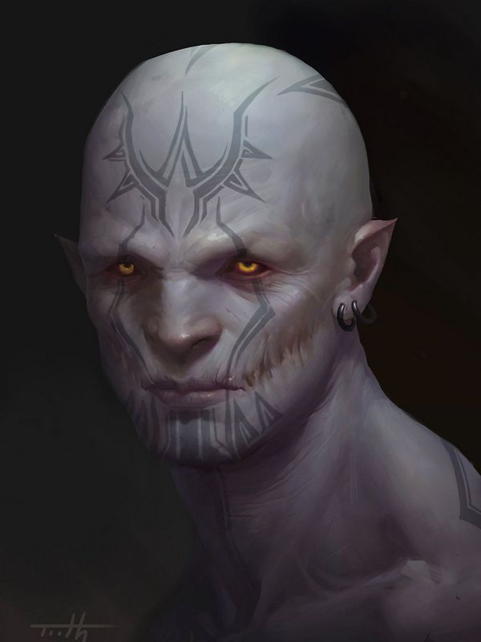**History**

**First Primordial Age (PA1)**

**Second Primordial Age (PA2)**

**Third Primordial Age (PA3)**

**Fourth primordial Age (PA4)**

**First Ancient Age (AA1)**

**Second Ancient Age (AA2)**

**Third Ancient Age (AA3)**

**Fourth Ancient Age (AA4)**

**First Written Age (WA1)**

**Second Written Age (WA2)**

**Third Written Age (WA3)**

**Fourth Written Age (WA4)**

**Notes on Culture**

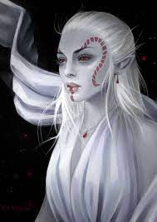**Drow**

**Location: Helviana, Duskryn, Morenrin, Saszar, Hadronath, Zauvorel, Xiltiriy**

**Appearance**: pale white skin; white hair; black or red eyes

**Culture:** Also known as dark elves, drow are a depraved and evil subterranean offshoot. White is the most common hair color among drow, but almost any pale shade is possible. Drow tend to be smaller and thinner than other sorts of elves, and their eyes are often a vivid red.

**Common Attire**:

**Traits**:

**Ability and Skill Modifiers:** +2 Dexterity, +2 Intelligence, +2 Charisma, –2 Constitution

* Immunity to magic sleep effects, and a +2 racial saving throw bonus against enchantment spells or effects.
* Darkvision out to 120 feet.
* Spell resistance equal to 11 + class levels.
* Weapon Proficiency: A drow is automatically proficient with the hand crossbow, the rapier, and the short sword.
* Spell-Like Abilities: Drow can use the following spell-like abilities once per day: dancing lights, darkness, faerie fire. Caster level equals the drow’s class levels.
* Light Blindness: Abrupt exposure to bright light (such as sunlight or a daylight spell) blinds drow for 1 round. On subsequent rounds, they are dazzled as long as they remain in the affected area.
* +2 racial bonus on Will saves against spells and spell-like abilities.
* +2 racial bonus on Listen, Search, and Spot checks. A drow who merely passes within 5 feet of a secret or concealed door is entitled to a Search check to notice it as if she were actively looking for it.
* Automatic Languages: Common, Elven, Undercommon. Bonus Languages: Abyssal, Aquan, Draconic, Drow Sign Language, Gnome, Goblin.

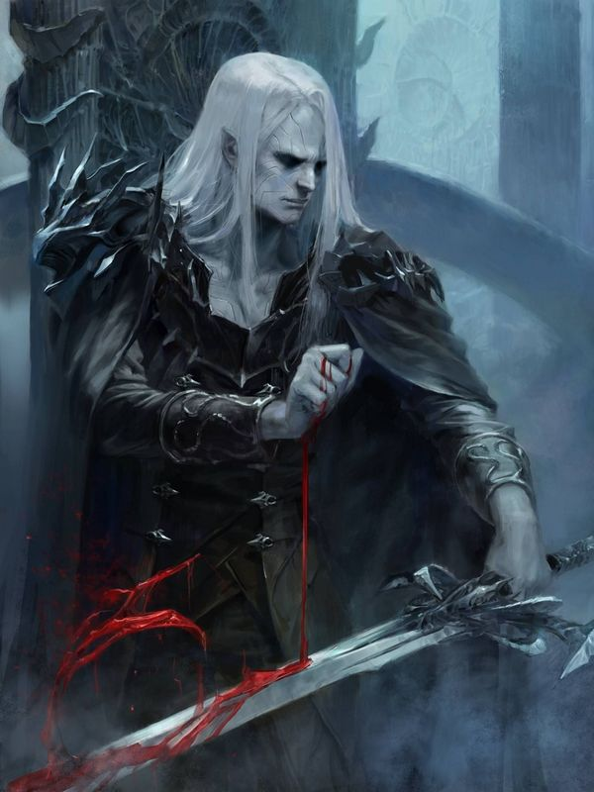**Magical Items**

**Developer Notes**