Notes on the Domains of the

Sea Elves

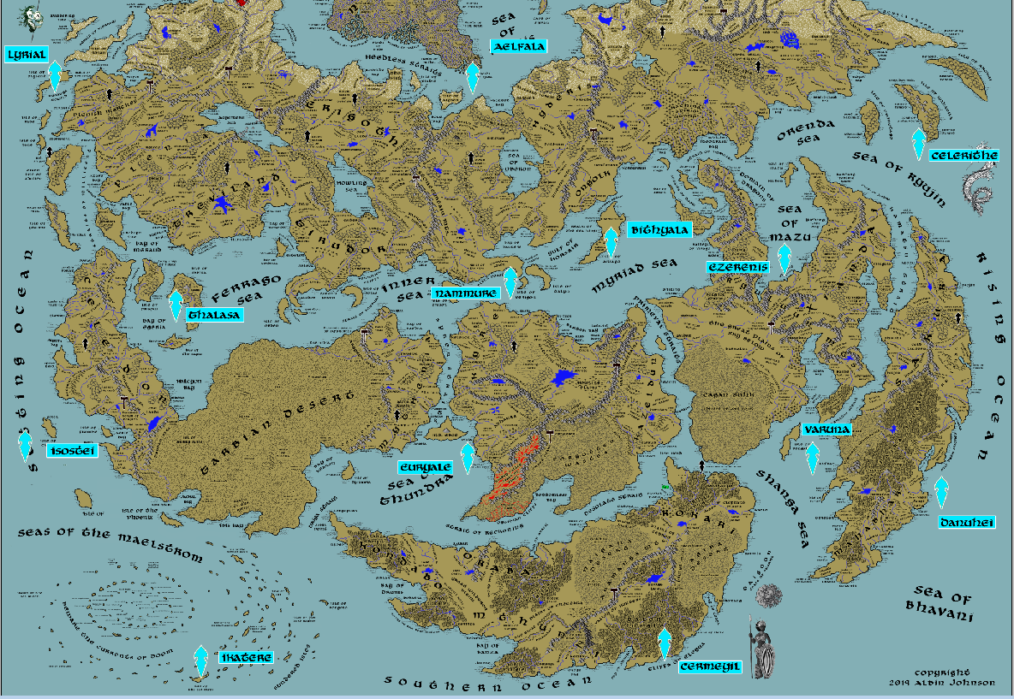

* **Overview**
* **Domains of the Sea Elves**
* **History**
* **Notes on Culture**
* **Magical Items**
* **Developer Notes**

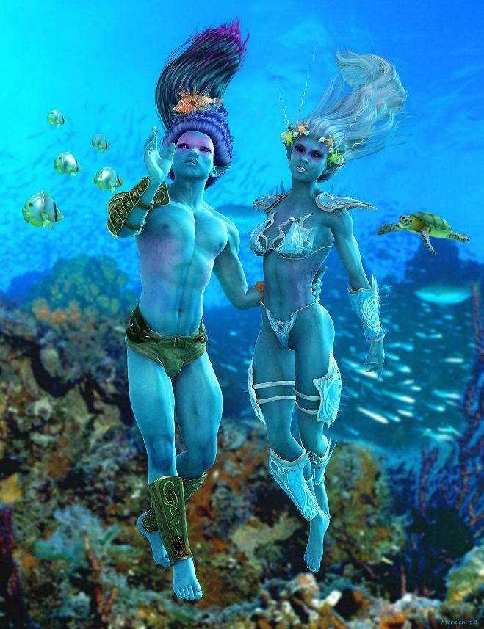**Overview**

The wide expanse of oceans in Nemmyrl are teeming with a vast array of enchanted races. Chief among them are the sea elves, who long ago were drawn to the call of the sea. There they commune with ocean life, building majestic palaces of coral and shell and sounding the songs of the deep. They have little to do with the plights of their landed kin, but are of the same mind in being stewards of the natural world.

**Domains of the Sea Elves**

1. Aelfala – Heedless Straits, Norgarde
2. Llyrial – Isle of Daysend, Western Amadar
3. Celerithe – Isle of Wanahila, Eastern Amadar
4. Thalasa – Isle of Sabina, Western Arnland
5. Nammure – Isle of Verigon, Central Amadar
6. Bithyala – Isle of Ariago, Central Amadar
7. Ezerenis – Sea of Mazu, Xiandai
8. Isostei – Isle of Cassia, Western Arnland
9. Euryale – Sea of Thundra, Western Gaeadon
10. Varuna – Bay of Pengali, Mahabar
11. Danuhei – The Dark Shores, Mahabar
12. Ikatere – Isle of the Sea Elves, the Great Maelstrom
13. Cermeyil – Cliffs of Elegua, Kaduru

**Aelfala** – Heedless Straits, Norgarde

**Size:** large town, population 5,000, guards / soldiers 50, militia 250

**Trade Goods:**

**Local Goods:**

**Standard:**

**Colors:**

**Ruler:**

**Home**:

**Steward**:

**Marshal**:

**House Priest:**

**House Adviser (Scholar/Mage/etc):**

**Captain of the Guard**:

**Chief Warriors in Service**:

**Local Powers:**

**Local Sites:**

**Description:**

**Industry:**

**Key Figures:**

**Local Lore:**

**History:**

**Customs:**

**Llyrial** – Isle of Daysend, Western Amadar

**Size:** large town, population 5,000, guards / soldiers 50, militia 250

**Trade Goods:**

**Local Goods:**

**Standard:**

**Colors:**

**Ruler:**

**Home**:

**Steward**:

**Marshal**:

**House Priest:**

**House Adviser (Scholar/Mage/etc):**

**Captain of the Guard**:

**Chief Warriors in Service**:

**Local Powers:**

**Local Sites:**

**Description:**

**Industry:**

**Key Figures:**

**Local Lore:**

**History:**

**Customs:**

**Celerithe**– Isle of Wanahila, Eastern Amadar

**Size:** large town, population 5,000, guards / soldiers 50, militia 250

**Trade Goods:**

**Local Goods:**

**Standard:**

**Colors:**

**Ruler:**

**Home**:

**Steward**:

**Marshal**:

**House Priest:**

**House Adviser (Scholar/Mage/etc):**

**Captain of the Guard**:

**Chief Warriors in Service**:

**Local Powers:**

**Local Sites:**

**Description:**

**Industry:**

**Key Figures:**

**Local Lore:**

**History:**

**Customs:**

**Thalasa** – Isle of Sabina, Western Arnland

**Size:** large town, population 5,000, guards / soldiers 50, militia 250

**Trade Goods:**

**Local Goods:**

**Standard:**

**Colors:**

**Ruler:**

**Home**:

**Steward**:

**Marshal**:

**House Priest:**

**House Adviser (Scholar/Mage/etc):**

**Captain of the Guard**:

**Chief Warriors in Service**:

**Local Powers:**

**Local Sites:**

**Description:**

**Industry:**

**Key Figures:**

**Local Lore:**

**History:**

**Customs:**

**Nammure** – Isle of Verigon, Central Amadar

**Size:** large town, population 5,000, guards / soldiers 50, militia 250

**Trade Goods:**

**Local Goods:**

**Standard:**

**Colors:**

**Ruler:**

**Home**:

**Steward**:

**Marshal**:

**House Priest:**

**House Adviser (Scholar/Mage/etc):**

**Captain of the Guard**:

**Chief Warriors in Service**:

**Local Powers:**

**Local Sites:**

**Description:**

**Industry:**

**Key Figures:**

**Local Lore:**

**History:**

**Customs:**

**Bithyala**– Isle of Ariago, Central Amadar

**Size:** large town, population 5,000, guards / soldiers 50, militia 250

**Trade Goods:**

**Local Goods:**

**Standard:**

**Colors:**

**Ruler:**

**Home**:

**Steward**:

**Marshal**:

**House Priest:**

**House Adviser (Scholar/Mage/etc):**

**Captain of the Guard**:

**Chief Warriors in Service**:

**Local Powers:**

**Local Sites:**

**Description:**

**Industry:**

**Key Figures:**

**Local Lore:**

**History:**

**Customs:**

**Ezerenis**– Sea of Mazu, Xiandai

**Size:** large town, population 5,000, guards / soldiers 50, militia 250

**Trade Goods:**

**Local Goods:**

**Standard:**

**Colors:**

**Ruler:**

**Home**:

**Steward**:

**Marshal**:

**House Priest:**

**House Adviser (Scholar/Mage/etc):**

**Captain of the Guard**:

**Chief Warriors in Service**:

**Local Powers:**

**Local Sites:**

**Description:**

**Industry:**

**Key Figures:**

**Local Lore:**

**History:**

**Customs:**

**Isostei** – Isle of Cassia, Western Arnland

**Size:** large town, population 5,000, guards / soldiers 50, militia 250

**Trade Goods:**

**Local Goods:**

**Standard:**

**Colors:**

**Ruler:**

**Home**:

**Steward**:

**Marshal**:

**House Priest:**

**House Adviser (Scholar/Mage/etc):**

**Captain of the Guard**:

**Chief Warriors in Service**:

**Local Powers:**

**Local Sites:**

**Description:**

**Industry:**

**Key Figures:**

**Local Lore:**

**History:**

**Customs:**

**Euryale** – Sea of Thundra, Western Gaeadon

**Size:** large town, population 5,000, guards / soldiers 50, militia 250

**Trade Goods:**

**Local Goods:**

**Standard:**

**Colors:**

**Ruler:**

**Home**:

**Steward**:

**Marshal**:

**House Priest:**

**House Adviser (Scholar/Mage/etc):**

**Captain of the Guard**:

**Chief Warriors in Service**:

**Local Powers:**

**Local Sites:**

**Description:**

**Industry:**

**Key Figures:**

**Local Lore:**

**History:**

**Customs:**

**Varuna** – Bay of Pengali, Mahabar

**Size:** large town, population 5,000, guards / soldiers 50, militia 250

**Trade Goods:**

**Local Goods:**

**Standard:**

**Colors:**

**Ruler:**

**Home**:

**Steward**:

**Marshal**:

**House Priest:**

**House Adviser (Scholar/Mage/etc):**

**Captain of the Guard**:

**Chief Warriors in Service**:

**Local Powers:**

**Local Sites:**

**Description:**

**Industry:**

**Key Figures:**

**Local Lore:**

**History:**

**Customs:**

**Danuhei** – The Dark Shores, Mahabar

**Size:** large town, population 5,000, guards / soldiers 50, militia 250

**Trade Goods:**

**Local Goods:**

**Standard:**

**Colors:**

**Ruler:**

**Home**:

**Steward**:

**Marshal**:

**House Priest:**

**House Adviser (Scholar/Mage/etc):**

**Captain of the Guard**:

**Chief Warriors in Service**:

**Local Powers:**

**Local Sites:**

**Description:**

**Industry:**

**Key Figures:**

**Local Lore:**

**History:**

**Customs:**

**Ikatere** – Isle of the Sea Elves, the Great Maelstrom

**Size:** large town, population 5,000, guards / soldiers 50, militia 250

**Trade Goods:**

**Local Goods:**

**Standard:**

**Colors:**

**Ruler:**

**Home**:

**Steward**:

**Marshal**:

**House Priest:**

**House Adviser (Scholar/Mage/etc):**

**Captain of the Guard**:

**Chief Warriors in Service**:

**Local Powers:**

**Local Sites:**

**Description:**

**Industry:**

**Key Figures:**

**Local Lore:**

**History:**

**Customs:**

**Cermeyil** – Cliffs of Elegua, Kaduru

**Size:** large town, population 5,000, guards / soldiers 50, militia 250

**Trade Goods:**

**Local Goods:**

**Standard:**

**Colors:**

**Ruler:**

**Home**:

**Steward**:

**Marshal**:

**House Priest:**

**House Adviser (Scholar/Mage/etc):**

**Captain of the Guard**:

**Chief Warriors in Service**:

**Local Powers:**

**Local Sites:**

**Description:**

**Industry:**

**Key Figures:**

**Local Lore:**

**History:**

**Customs:**

**History**

**First Primordial Age (PA1)**

**Second Primordial Age (PA2)**

**Third Primordial Age (PA3)**

**Fourth primordial Age (PA4)**

**First Ancient Age (AA1)**

**Second Ancient Age (AA2)**

**Third Ancient Age (AA3)**

**Fourth Ancient Age (AA4)**

**First Written Age (WA1)**

**Second Written Age (WA2)**

**Third Written Age (WA3)**

**Fourth Written Age (WA4)**

**Notes on Culture**

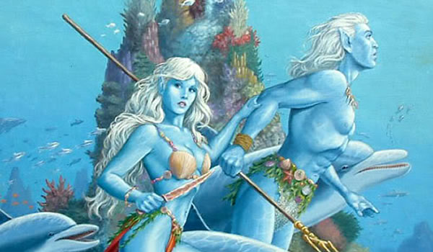**Vaya or Sea Elves**

**Locations: Aelfala, (more TBA)**

**Appearance**: light green skin; green hair; yellow eyes

**Culture:** Sea Elves are playful, curious, fond of song, and very vain. They enjoy lounging in the sun and are mischievous to others. They are easily distracted by shiny objects. They are highly protective of their waters and are bitter foes of sahuagin and other evil aquatic races.

**Common Attire**: close-fitting garments made up of intricate overlapping scales in patterns of blue-green, silver, faint pink; out of water wear gossamer gowns of light aquamarine with metallic sheen to them

**Traits**: Water Elves have gills and can breathe underwater. They are also capable of emitting high-pitched whistles, which they use to speak with sea creatures. They have very thick skin, capable of withstanding enormous pressures. They are strong in natural magic related to charms, but do not craft magic items themselves.

**Ability and Skill Modifiers:** Dexterity +2, Charisma +2, Constitution drops by 1 point for every day out of water, with each level they become able to cast spells at will from the cleric water domain spell list:

* Water Domain
* Granted Power: Turn or destroy fire creatures as a good cleric turns undead. Rebuke, command, or bolster water creatures as an evil cleric rebukes undead. Use these abilities a total number of times per day equal to 3 + your Charisma modifier. This granted power is a supernatural ability.
* Water Domain Spells

1. Obscuring Mist: Fog surrounds you.
2. Fog Cloud: Fog obscures vision.
3. Water Breathing: Subjects can breathe underwater.
4. Control Water: Raises or lowers bodies of water.
5. Ice Storm: Hail deals 5d6 damage in cylinder 40 ft. across.
6. Cone of Cold: 1d6/level cold damage.
7. Acid Fog: Fog deals acid damage.
8. Horrid Wilting: Deals 1d6/level damage within 30 ft.
9. Elemental Swarm*: Summons multiple elementals.
   * *Cast as a water spell only.

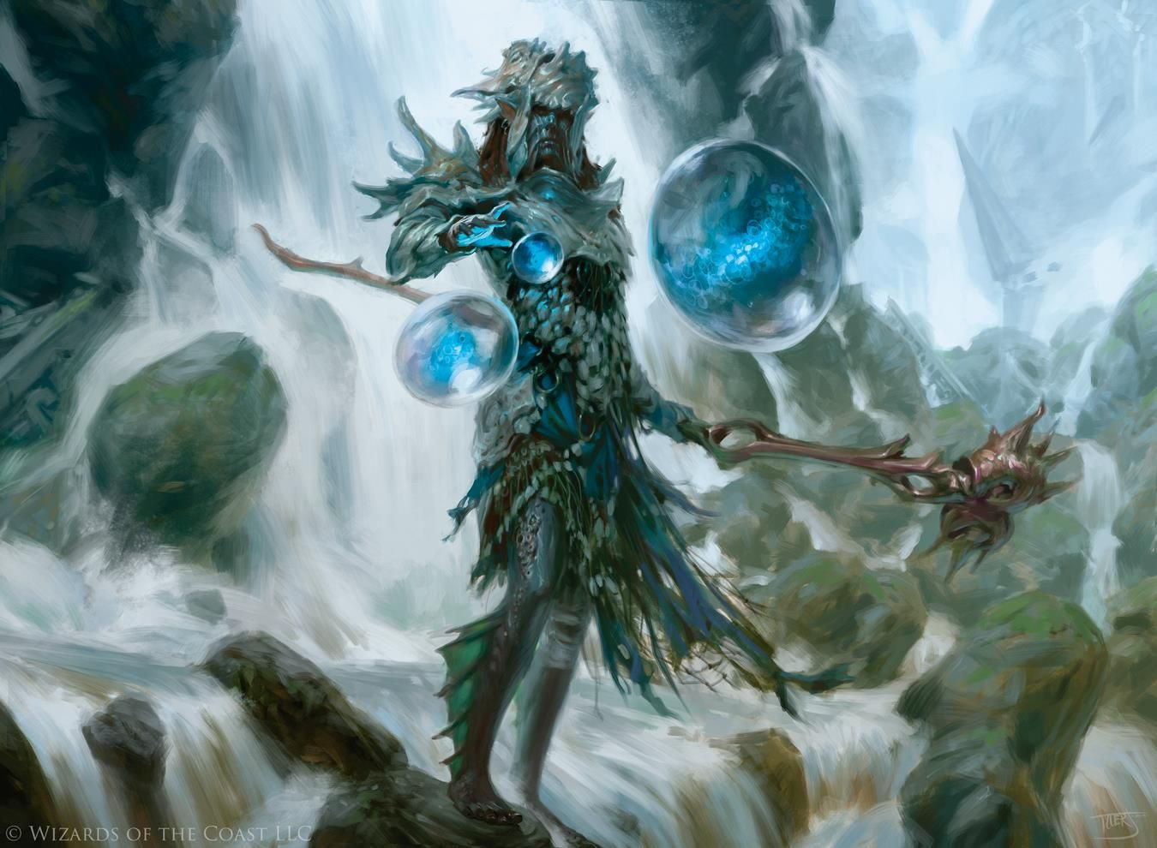

**Magical Items**

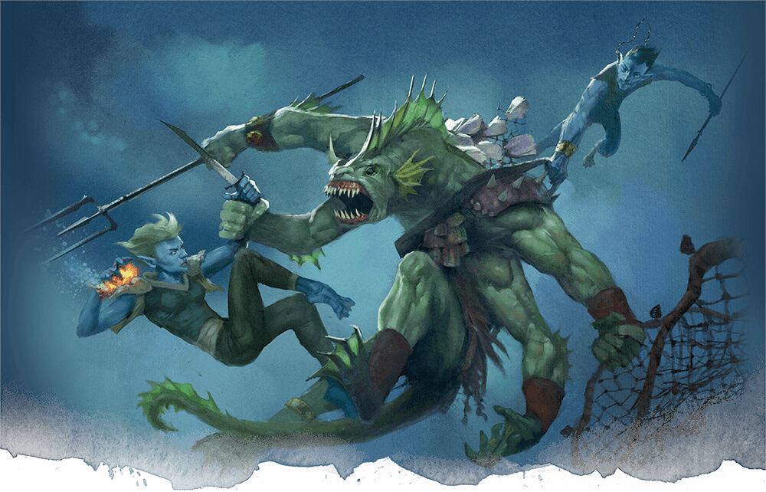**Developer Notes**