Notes on the Elven Kingdom of Ithronel

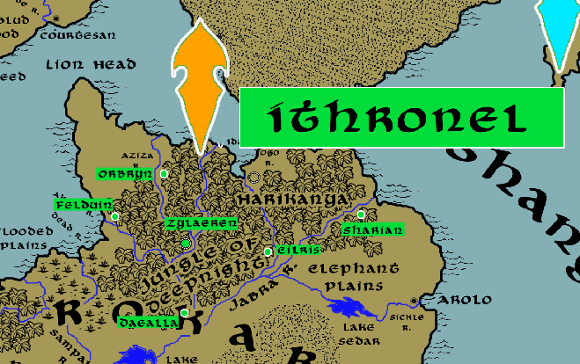

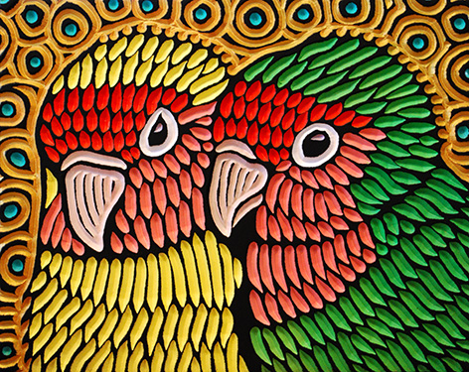**Sign of the Lovebird**

**Location: Jungle of Deepnight, Continent of Kaduru**

* **Overview**
* **Towns and Cities**
* **History**
* **Notes on Culture**
* **Magical Items**
* **Developer Notes**

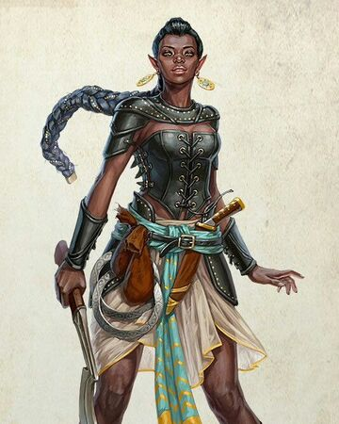**Overview**

Living so close to the desert, the sun elves of Ithronel have perfected irrigation techniques to preserve their lush jungle from the arid climate. They are the most versatile in adapting to a variety of challenging climates. Within the jungle canopy they have built soaring natural structures decorated with breathtaking works of art. Music, literature, and artwork are studied with great zeal just as they pursue vigorous athletic achievements in the face of Kaduru’s tropical environment.

Ithronel is vigilant against the threats that exist within this wild region and are allies in defense of the human city of Harikanya. They are proud custodians of the land and hold to a rigid sense of honor.

It was here the elven general **Aien Lorafaren** fell during the invasion by Dractus of Kazeldun eight thousand years ago. Lorafaren’s tomb is buried deep within the jungle and is a place of honor among elves around the world. Legend has it that the great sword of evil, **Bardikaran**, plucked from the armada that invaded from Kazelduun in the Fourth Primordial Age, is buried in the tomb. Anti-paladins from abroad have sought to find and steal the blade, but it remains safe thanks to the diligence of the Ithronel.

**Towns and Cities**

* Ithronel
  + Orbryn – large town, population 5,000, guards / soldiers 50, militia 250
  + Felduin – large town, population 5,000, guards / soldiers 50, militia 250
  + Zylaeren – large city, population 25,000, guards / soldiers 250, militia 2250
  + Eilris – large town, population 5,000, guards / soldiers 50, militia 250
  + Sharian – large town, population 5,000, guards / soldiers 50, militia 250
  + Daealla – large town, population 5,000, guards / soldiers 50, militia 250

**Orbryn**

**Size:** large town, population 5,000, guards / soldiers 50, militia 250

**Trade Goods:**

**Local Goods:**

**Standard:**

**Colors:**

**Ruler:** Haladavar Trisdi

**Home**:

**Steward**: Elred Reywarin

**Marshal**: Halueve Enquinal

**House Priest:**  Phyrra Daena (f)

**House Adviser (Scholar/Mage/etc):**  Durothil Helevyre

**Captain of the Guard**: Cithrel Herwenys (f)

**Chief Warriors in Service**:

Alen Ilinan

Tannivh Balran

Iolas Baldithas

**Local Powers:**

**Local Sites:**

**Description:**

**Industry:**

**Key Figures:**

**Local Lore:**

**History:**

**Customs:**

**Felduin**

**Size:** large town, population 5,000, guards / soldiers 50, militia 250

**Trade Goods:**

**Local Goods:**

**Standard:**

**Colors:**

**Ruler:** Ilsevel Beiwraek (f)

**Home**:

**Steward**: Galan Naezeiros

**Marshal**: Umilythe Torhice (f)

**House Priest:**  Sudryal Xilpeiros

**House Adviser (Scholar/Mage/etc):**  Kyrtaar Qifaren

**Captain of the Guard**: Ayduin Reyyarus

**Chief Warriors in Service**:

Umilythe Qipetor (f)

Artin Urigella (f)

Iolas Leobella

**Local Powers:**

**Local Sites:**

**Description:**

**Industry:**

**Key Figures:**

**Local Lore:**

The black dragon **Ebusuku** dwells south of here where the jungle meets the swamp lands.

**History:**

**Customs:**

**Zylaeren**

**Size:** large city, population 25,000, guards / soldiers 250, militia 2250

**Trade Goods:** dyes, spices

**Local Goods:**

**Standard:**

**Colors:**

**Ruler:** Taliel Sazana (f)

**Home**:

**Steward**: Lysanthir Gilthira

**Marshal**: Haladavar Heihorn

**House Priest:**  Eriladar Perthiel

**House Adviser (Scholar/Mage/etc):**  Muerlara Eladove (f)

**Captain of the Guard**: Osonia Inalana (f)

**Chief Warriors in Service**:

Selussa Rovaris (f)

Bellas Liamenor

Ruardh Sharen

**Local Powers:** Band of the Phaendar (rangers)

**Local Sites:**

**Description:**

**Industry:**

**Key Figures:**

**Local Lore:**

**History:**

**Customs:**

**Eilris**

**Size:** large town, population 5,000, guards / soldiers 50, militia 250

**Trade Goods:**

**Local Goods:**

**Standard:**

**Colors:**

**Ruler:** Castien Yesgeiros

**Home**:

**Steward**: Yesanith Shakas

**Marshal**: Lithoniel Preszana (f)

**House Priest:**  Kerym Farjeon

**House Adviser (Scholar/Mage/etc):**  Micaiah Farhorn (f)

**Captain of the Guard**: Gormer Chaelee

**Chief Warriors in Service**:

Valindra Ralona (f)

Ailuin Shavyre

Ornthalas Waesbella

**Local Powers:**

**Local Sites:**

**Description:**

**Industry:**

**Key Figures:**

**Local Lore:**

**History:**

**Customs:**

**Sharian**

**Size:** large town, population 5,000, guards / soldiers 50, militia 250

**Trade Goods:**

**Local Goods:**

**Standard:**

**Colors:**

**Ruler:** Chandrelle Adris (f)

**Home**:

**Steward**: Aithlin Keymyar

**Marshal**: Bellaluna Keadithas (f)

**House Priest:**  Delmuth Yessatra

**House Adviser (Scholar/Mage/etc):**  Cyran Valsatra

**Captain of the Guard**: Faelyn Rotumal

**Chief Warriors in Service**:

Miirphys Naekrana

Isarrel Olajeon (f)

Valindra Ralokrana (f)

**Local Powers:**

**Local Sites:**

**Description:**

**Industry:**

**Key Figures:**

**Local Lore:**

**History:**

**Customs:**

**Daella**

**Size:** large town, population 5,000, guards / soldiers 50, militia 250

**Trade Goods:**

**Local Goods:**

**Standard:**

**Colors:**

**Ruler:** Ilyrana Keaxidor (f)

**Home**:

**Steward**: Cailu Mormenor

**Marshal**: Eldar Valbanise

**House Priest:**  Eshenesra Elmenor (f)

**House Adviser (Scholar/Mage/etc):**  Taredd Oloxidor

**Captain of the Guard**: Bonaluria Zinsandoral (f)

**Chief Warriors in Service**:

Aeson Ravarona

Ryul Elavalur

Tialha Balkrana (f)

**Local Powers:**

**Local Sites:**

**Description:**

**Industry:**

**Key Figures:**

**Local Lore:**

**History:**

**Customs:**

**History**

**First Primordial Age (PA1)**

**Second Primordial Age (PA2)**

**Third Primordial Age (PA3)**

**Fourth primordial Age (PA4)**

514 PA4 - General Dractus of Kazeldun invades Kaduru, does battle with elves of Ithronel; Dractus' forces are defeated in the jungles but the elven chieftain Aien Lorafaren falls

**First Ancient Age (AA1)**

**Second Ancient Age (AA2)**

140 AA2 - Fall of Elven settlement in Koro Jungle in Kaduru before the forces of the Bokarra armies during the War of the Four Empires

180 AA2 - Fall of Elven settlement in Kuthu Jungle in Kaduru before the forces of Bokarra armies during the War of the Four Empires

200 AA2 - Fall of Elven settlement in Shanza Jungle in Kaduru before the forces of Bokarra armies during the War of the Four Empires

740 AA2 - Elves driven out of Onechanbara Jungle in Kaduru by the apes of Wakabi

**Third Ancient Age (AA3)**

**Fourth Ancient Age (AA4)**

530 AA4 - Elven settlements fall in the Talon Jungle in the wake of Orc armies waging war on the region

**First Written Age (WA1)**

**Second Written Age (WA2)**

**Third Written Age (WA3)**

**Fourth Written Age (WA4)**

350 WA4 - Fall of Oarana - Gnoll forces encircle the Matwa Jungle, wiping out the Elven settlement there and destroying Oarana

**Notes on Culture**

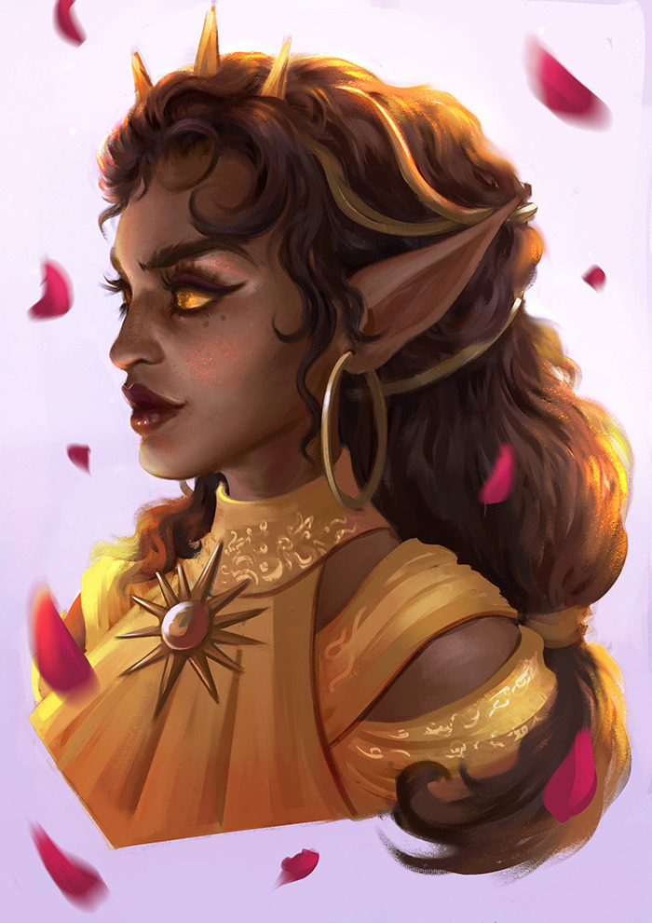

**Naira or Sun Elves**

**Location: Ithronel**

**Appearance**: dark brown skin; black, brown, or reddish hair; violet eyes

**Culture:** Sun elves are proud, headstrong, and honor-driven. They are less drawn to the esoteric studies and more attuned to the study of their environment and devising and executing strategies. Much of their time is spent in athletic pursuits and mastering riding, climbing, running, and combat training. Their art and literature are vibrant and infused with the luster of life. Similar to fire elves in temperament, sun elves do not embrace chaos wholly but temper it with experience and a knack for decisive action. While the sun elves gain strength from the sun and relish in its life-giving power, they also temper their zeal with the wisdom to harness it. In contrast, the fire elves place no limits to the powers granted by the sun and molten earth and harness it with unbridled enthusiasm.

**Common Attire**: tend to wear loose tunics and robes, preferring light colors highlighted in gold, orange, and red as well as light earthen tones. During the height of day many sun elves prefer minimal clothing as they soak up the sun’s rays.

**Traits**: Sun Elves are extremely athletic and the strongest of the elves. Drawing in power from the sun, their strength grows with the height of day and wanes towards dusk. Sun Elves have poor vision compared to other elves. They are sensitive to detecting minor temperature changes, have infra-vision, and are resistant to extremes of heat but not to the extent that fire elves are.

**Ability and Skill Modifiers:** +2 Strength, -2 Wisdom, Endure Elements (heat), with each level they become able to cast spells at will from the cleric strength domain spell list:

* Strength Domain
* Granted Power: You can perform a feat of strength as a supernatural ability. You gain an enhancement bonus to Strength equal to your cleric level. Activating the power is a free action, the power lasts 1 round, and it is usable once per day.
* Strength Domain Spells

1. Enlarge Person: Humanoid creature doubles in size.
2. Bull’s Strength: Subject gains +4 to Str for 1 min./level.
3. Magic Vestment: Armor or shield gains +1 enhancement per four levels.
4. Spell Immunity: Subject is immune to one spell per four levels.
5. Righteous Might: Your size increases, and you gain combat bonuses.
6. Stoneskin M: Ignore 10 points of damage per attack.
7. Grasping Hand: Large hand provides cover, pushes, or grapples.
8. Clenched Fist: Large hand provides cover, pushes, or attacks your foes.
9. Crushing Hand: Large hand provides cover, pushes, or crushes your foes.

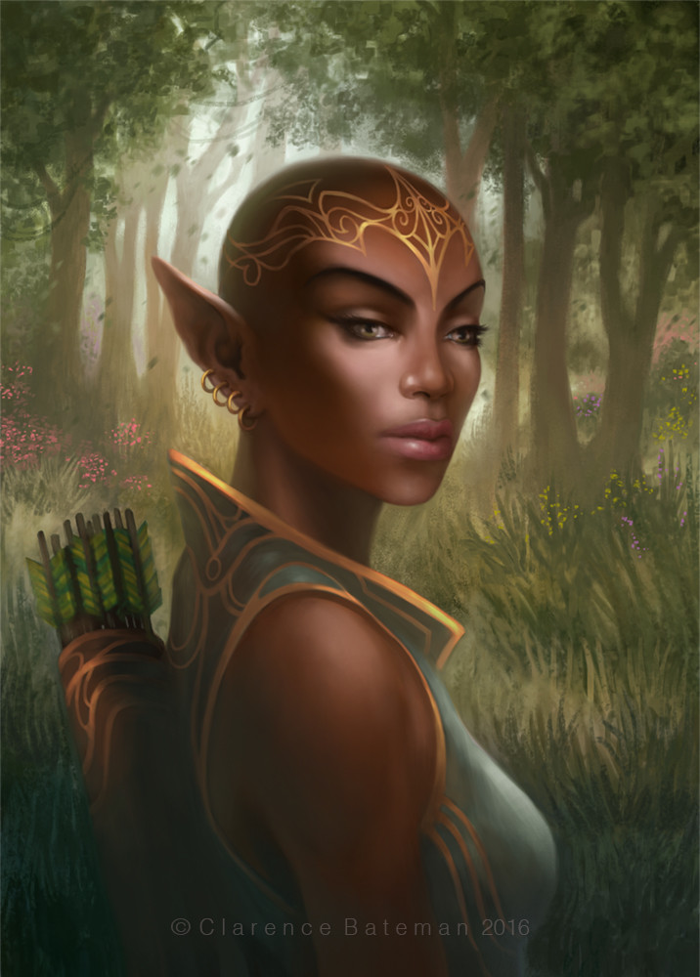**Magical Items**

The great sword of evil, **Bardikaran**, plucked from the armada that invaded from Kazelduun in the Fourth Primordial Age, is buried in the tomb of the elven general **Aien Lorafaren**, who fell during the invasion by Dractus of Kazeldun eight thousand years ago. Lorafaren’s tomb is buried deep within the jungle and is a place of honor among elves around the world. Legend has it that Anti-paladins from abroad have sought to find and steal the blade, but it remains safe thanks to the diligence of the Ithronel elves.

**Developer Notes**