Notes on the Elven Kingdom of Cascadrel

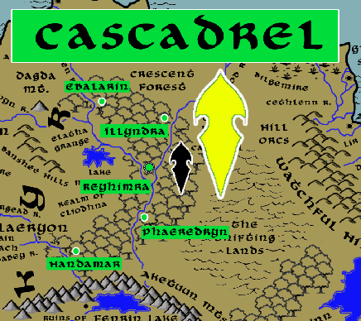

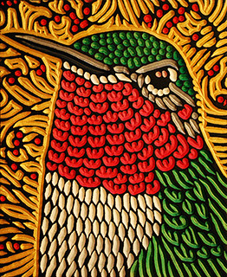

**Sign of the Hummingbird**

**Location: Crescent Forest, Continent of Gaeadon bordering the Kingdom of Kyre**

* **Overview**
* **Towns and Cities**
* **History**
* **Notes on Culture**
* **Magical Items**
* **Developer Notes**

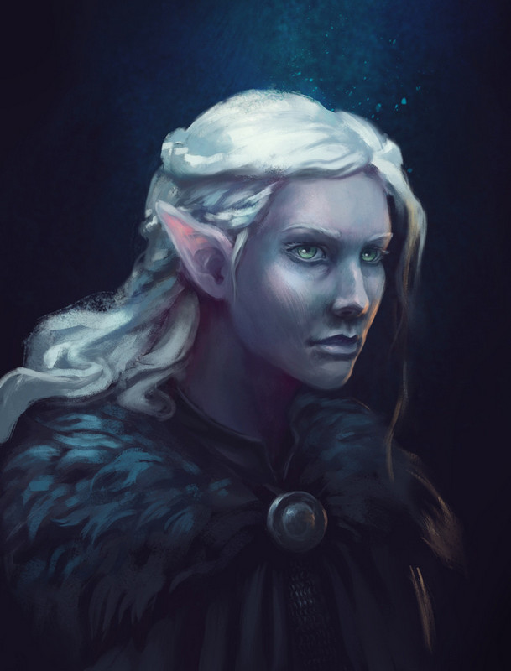**Overview**

Dwelling in the Crescent Forest are the Isilya moon elves, masters of the nighttime forest and innately tied to the moon and its powers. From their woodland abode, the elves are protectors of the land and any peoples looking to dwell there in peace. This often extends outside of the forest into Kyre to the west, the Vale of Hileia to the south, and even to the broken lands eastward in the interior of the continent of Gaeadon.

The elves of Cascadrel also extend their influence to the nearby sea and frequent the rivers to Kelenon and Claeryon. They are considered friends of sailors, of the sea, and of the elements. They are the protectors of the Syren Strait and are thought to have influence from the moon itself. Many nights there are lights seen on the shores of Kyre and attributed to the elves, guiding ships along the coast. Other legends tell of the moon maiden **Darthalion** herself, for whom the strait was named, who would appear on the promontories aglow of silver. Her song was said to carry over the seas and bewitch the elves as far away as Lo’Shella.

The elves of Cascadrel are fond of the night and so have a tradition of hunting fell creatures that prowl at when only the moon is shining. The Isilya are friendly to humans and dwarves alike, but keep to themselves unless entreated. They are particularly close to druids of all kinds, finding kinship in their ties to nature and the powers of the moon. Many druids make a pilgrimage to Cascadrel to learn from the Isilya and gain their favor.

The High Cathedral of Corellon Larethian is the center of faith for her followers and is visited by pilgrims year-round who come to pay homage with hunts in the Crescent Forest.

**Towns and Cities**

* Cascadrel
  + Ebalarin - large town, population 5,000, guards / soldiers 50, militia 250
  + Illyndra - large town, population 5,000, guards / soldiers 50, militia 250
  + Reyhimra - large city, population 25,000, guards / soldiers 250, militia 2250
  + Phaeredryn - large town, population 5,000, guards / soldiers 50, militia 250
  + Hamdamar - large town, population 5,000, guards / soldiers 50, militia 250

**Ebalarin**

**Size:** large town, population 5,000, guards / soldiers 50, militia 250

**Trade Goods:**

**Local Goods:**

**Standard:**

**Colors:**

**Ruler:** Fenian Leofir

**Home**:

**Steward**: Tarron Miazeiros

**Marshal**: Lyra Shawenys (f)

**House Priest:**  Tolith Preskas

**House Adviser (Scholar/Mage/etc):**  Shaerra Daejeon (f)

**Captain of the Guard**: Braern Valee

**Chief Warriors in Service**:

Sharian Arapeiros

Myantha Hernala (f)

Arnarra Paharice (f)

**Local Powers:**

**Local Sites:**

**Description:**

**Industry:**

**Key Figures:**

**Local Lore:**

**History:**

**Customs:**

**Illyndra**

**Size:** large town, population 5,000, guards / soldiers 50, militia 250

**Trade Goods:**

**Local Goods:**

**Standard:**

**Colors:**

**Ruler:** Ulesse Sylstina (f)

**Home**:

**Steward**: Ruith Aera

**Marshal**: Saleh Zummoira

**House Priest:**  Hagre Ianlana

**House Adviser (Scholar/Mage/etc):**  Naevys Beina (f)

**Captain of the Guard**: Lathai Norra

**Chief Warriors in Service**:

Laeroth Valfaren

Ailluin Presgwyn

Sihnion Vadove

**Local Powers:**

**Local Sites:**

**Description:**

**Industry:**

**Key Figures:**

**Local Lore:**

**History:**

**Customs:**

**Reyhimra**

**Size:** large city, population 25,000, guards / soldiers 250, militia 2250

**Trade Goods:** medicine, religious center

**Local Goods:**

**Standard:**

**Colors:**

**Ruler:** Sarren Foloren

**Home**:

**Steward**: Edea Bryvarin (f)

**Marshal**: Aias Jotren

**House Priest:**  Elpaerae Naefina

**House Adviser (Scholar/Mage/etc):**  Palwyn Ralororis

**Captain of the Guard**: Duilya Morran (f)

**Chief Warriors in Service**:

Elluin Norstina

Orndacil Kemoira

Ethera Fenjinon (f)

**Local Powers:** High Cathedral of Corellon Larethian (world seat of power for the worshippers of Corellon Larethian), Cicle of the Velvet Leaf (druids), Order of the Silver Moon (paladins), Band of the Eyes of Lunula (rangers), Eldarneth Sanctum (school of magic)

**Local Sites:**

**Description:**

Where the rivers Ariona and Branwen split, the land sinks into a dell. There, between the twin waterfalls of the rushing rivers, sits Reyhimra, seat of the lord of the Isilya. Wooden cottages of handsome design decorate the taller trees here, with rope bridges passing between them. Crystals of purple and blue hang from the higher boughs, catching the sunlight at day and the moonbeams at night. A wide circle is marked out on the forest floor below, decorated with stones and mistletoe saplings: a proper druid circle. Low, merry music drifts on the air here. It is a peaceful haven that druids the world wide consider a holy place to celebrate the moon.

Downriver are hidden boat houses. From there, messengers travel downriver to Illyndra and Ebalarin. Travel to Phaeredryn and Handamar to the south is overland by foot.

**Industry:**

**Key Figures:**

**Local Lore:**

The green dragon **Ornarax** dwells just west of here on the outer edges of the Crescent Forest overlooking Lake Nuada. Ornarax is an aging dragon that has gotten restless in his old age. On occasion he takes wing into the Cliodhna farmlands or over Elatha Grange, picking off sheep. The elves of Reyhimra years ago did battle with the beast, but found him too powerful. Now a stalemate is observed, but the elves keep a watchful on his lair.

**History:**

**Customs:**

**Phaeredryn**

**Size:** large town, population 5,000, guards / soldiers 50, militia 250

**Trade Goods:**

**Local Goods:**

**Standard:**

**Colors:**

**Ruler:** Hamalitia Inaceran (f)

**Home**:

**Steward**: Purtham Chaeric

**Marshal**: Vaeril Farsalor

**House Priest:**  Aerilaya Yescyne (f)

**House Adviser (Scholar/Mage/etc):**  Ratha Elaydark (f)

**Captain of the Guard**: Urdusin Thewenys

**Chief Warriors in Service**:

Folen Norrona

Agis Ralolee

Zestari Joneiros (f)

**Local Powers:**

**Local Sites:**

**Description:**

**Industry:**

**Key Figures:**

**Local Lore:**

**History:**

**Customs:**

**Hamdamar**

**Size:** large town, population 5,000, guards / soldiers 50, militia 250

**Trade Goods:**

**Local Goods:**

**Standard:**

**Colors:**

**Ruler:** Vulre Umejor

**Home**:

**Steward**: Folas Olaynore

**Marshal**: Grathgor Luxisys

**House Priest:**  Llorva Theqirelle (f)

**House Adviser (Scholar/Mage/etc):**  Elwin Heleven

**Captain of the Guard**: Sorisana Tranorin (f)

**Chief Warriors in Service**:

Ascal Presneiros

Myantha Inarora (f)

Llorva Fenrel (f)

**Local Powers:**

**Local Sites:**

**Description:**

**Industry:**

**Key Figures:**

**Local Lore:**

**History:**

**Customs:**

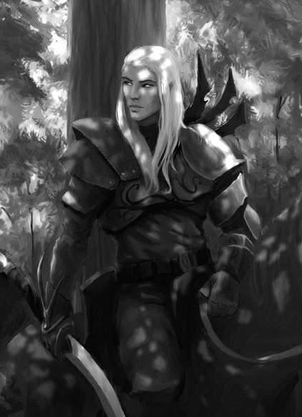**History**

**First Primordial Age (PA1)**

20 PA1 - (Cascadrel) Lolth burrows under the Shatterpeak Mountains and begins to set up her underground palace

100 PA1 – (Cascadrel) The High Imperium of Drow Elders awaken from a century-long sleep deep beneath the Shatterpeak Mountains in Gaeadon.

**Second Primordial Age (PA2)**

**Third Primordial Age (PA3)**

**Fourth primordial Age (PA4)**

**First Ancient Age (AA1)**

171-182 AA1 - War of the Fallen Fey - Orcs march down from the Vale of Hileia into Adhanar, wiping out fairy colonies and human settlements

181 AA1 - Fall of Adhanar - Orc armies surround Iolantha and destroy it; human armies are wiped out and the peoples of Adhanar scattered

182 AA1 - the Elven Retribution - elves of Gwyllion Forest, joined by the moon elves of Cascadrel, avenge the human city by destroying the orc host and driving them into the mountains

**Second Ancient Age (AA2)**

**Third Ancient Age (AA3)**

**Fourth Ancient Age (AA4)**

902 AA4 - War of the Maddened Moon - the evil druid Vromorn manifests the Amber Portal, a device that generates amber-hued clouds that cover the land and transmute the moon's light into a ray of madness

902-905 AA4 - the lands of Adhanar and Kyre are plagued with insanity as lycanthropes massacre hundreds

906 AA4 - after four years of fighting the dark forces plaguing the land, the Moon Elves track down Vromorn and consecrate the clouds, destroying the Amber Portal

**First Written Age (WA1)**

410 WA1 - Elves of Gwyllion Forest disappear without explanation

**Second Written Age (WA2)**

**Third Written Age (WA3)**

390 WA3 - War of the Hidden Sun: Olorala of the Drow kingdom of Hadronath attacks Adhanar; elves of Cascadrel march southward to battle the Drow

**Fourth Written Age (WA4)**

190 WA4 - Gorgol Orcs threaten the Cascadrel Elves of Crescent Wood; rangers of the Virgin Vale out of Kelenon come to the aide of the Elves

200 WA4 - Elves of Cascadrel reward the people of Kelenon with the Elatha Grange

**Notes on Culture**

**Isilya or Moon Elves**

**Location: Cascadrel**

**Appearance**: silver skin; white hair; silver or yellow eyes

**Culture:** Moon Elves are nocturnal creatures, rarely venturing out during daylight. They are enigmatic creatures, prone to wild swings between quiet reflection and frantic action. They are highly intelligent but some say they are also slightly unstable, given to unconventional and abstract thinking. They are constantly meditating on the moon and are fond of dancing in full moonlight to a song only they can hear.

**Common Attire**: pale yellow and eggshell colors during the day, deep indigo and black during the night, slender silver jewelry

**Traits**: Moon Elves are excellent hunters. A few of their kind can become invisible in during a full moon. Their abilities vary over the course of each month as they embody different traits corresponding to phases of the moon. They are also sensitive to magic related to demons and devils and are compelled to hunt them.

**Ability and Skill Modifiers:** -2 Dexterity (in daylight), 50% of the time: +2 Intelligence, +2 Wisdom; other 50% of the time: -2 Intelligence, -2 Wisdom, with each level they become able to cast spells at will from the cleric chaos domain spell list:

* Chaos Domain
* Granted Power: You cast chaos spells at +1 caster level.
* Chaos Domain Spells

1. Protection from Law: +2 to AC and saves, counter mind control, hedge out elementals and outsiders.
2. Shatter: Sonic vibration damages objects or crystalline creatures.
3. Magic Circle against Law: As protection spells, but 10-ft. radius and 10 min./level.
4. Chaos Hammer: Damages and staggers lawful creatures.
5. Dispel Law: +4 bonus against attacks by lawful creatures.
6. Animate Objects: Objects attack your foes.
7. Word of Chaos: Kills, confuses, stuns, or deafens nonchaotic subjects.
8. Cloak of Chaos F: +4 to AC, +4 resistance, SR 25 against lawful spells.
9. Summon Monster IX*: Calls extraplanar creature to fight for you.
   * *Cast as a chaos spell only.

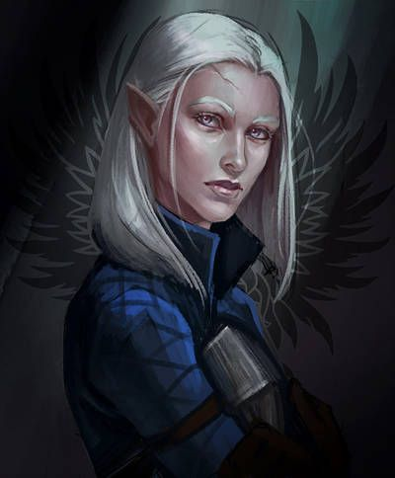**Magical Items**

The Bronzewood Coil

Wondrous item, very rare

This wooden relic is carved from bronzewood, in the shape of a serpent, and adjusts to fit snugly around your forearm. It writhes occasionally, when you see it out of the corner of your eye. When you use Wild Shape to take the form of a constrictor snake or giant constrictor snake, you can use this relic to increase your maximum hit points in that form by 2d10 + twice your Wisdom modifier. You can add your Wisdom modifier to damage that you deal with your Bite and Constrict attacks. This snake form looks as if it is carved from bronzewood, and stories are carved into your scales. You can use this relic once, and regain use of it at sunrise.

Pouch of Nature’s Balm

Wondrous item, very rare (requires attunement)

This small leather pouch is filled with strong-smelling healing herbs. If you use Wild Shape while holding this relic, it is subsumed into your form. When you spend spell slots to heal yourself with the Combat Wild Shape feature, you can choose one creature you can see within 10 feet. That creature regains hit points equal to your Wisdom modifier + the level of the spell slot you expended.

Silver Moon Relic

Rod, very rare

This two-foot-long wooden rod bears a silver wolf’s-head at the tip, and its length is inscribed with moon-sigils. If you hold this in your hand while you use the Wild Shape feature to adopt the shape of a wolf, you instead assume the form of the Greatmoon Hunter, a wolf of myth and legend. The silver moon relic can grant you this form once, and regains the ability to do so at moonrise.

If you belong to the Circle of the Moon and you’re at least 9th level, use the following statistics. Otherwise, use the dire wolf statistics.

Greatmoon Hunter

Large beast, unaligned

Armor Class 14 (natural armor)

Hit Points 67 (9d10 + 18)

Speed 40 ft.

STR DEX CON INT WIS CHA

16 (+3) 15 (+2) 14 (+2) 3 (-4) 13 (+1) 6 (-2)

Skills Perception +3 , Stealth +4

Senses darkvision 60 ft., passive Perception 13

Languages Common, Sylvan

Challenge 4 (1,100 XP)

Keen Hearing and Smell. The Greatmoon Hunter has advantage on Wisdom (Perception) checks that rely on hearing or smell.Pack Tactics. The Greatmoon Hunter has advantage on attack rolls against a creature if at least one of the Hunter’s allies is within 5 feet of the creature and the ally isn’t unconscious.

Under the Great Moon. When the moon is visible, the Greatmoon Hunter gains resistance to radiant and necrotic damage.

Actions

Multiattack. The Greatmoon Hunter makes two bite attacks.

Bite. Melee Weapon Attack: +5 to hit, reach 5 ft., one target. Hit: 12 (2d8 + 3) piercing damage. If the target is a creature, it must succeed on a DC 12 Strength saving throw or be knocked prone.

Well, writing a new stat block for each item is going to be more than any of us really want to see for a magic item’s entry. Especially when it needs to be more involved than the baseline monster block. I’d just release a monster supplement full of these alternate forms, but then Moon druids without the item could implicitly adopt that form. I can cordon it off by making its type Monstrosity rather than Beast (as with worgs, etc.), and the item is a specific exception to the rule that you can’t Wild Shape into monstrosity forms, but… I’m not thrilled with that either. There’s something to untangle here and I don’t have it yet. Let’s look at some other comparable implementations.

Boar’s-Head Idol

Wondrous item, very rare

This carving of a boar is made of quartz and no longer than a person’s thumb. If you use Wild Shape while holding this relic, it is subsumed into your form. When you use Wild Shape to adopt the form of a creature with the Charge feature, you gain the following:

Your animal form appears to be made out of quartz.

Your maximum hit points in this form increase by 1d10 + your Wisdom modifier.

You can add your Wisdom modifier to the damage you deal with a Charge.

The DC to resist being knocked prone is your spellcasting DC.

Cat’s Claw Talisman

Wondrous item, legendary

This talisman is carved from jet, in the shape of a panther’s claw. If you use Wild Shape while holding this relic, it is subsumed into your form. While you use Wild Shape to adopt the form of a lion, panther, saber-toothed tiger, or tiger, you gain the following:

Your maximum hit points in that form increase by 2d10 + your Wisdom modifier.

You can add your Wisdom modifier to damage you deal with a Bite or Claw attack.

Your skill bonus for Dexterity (Stealth) is the form’s Dexterity modifier + double your proficiency bonus.

You can use a bonus action to Dash, Disengage, or Hide.

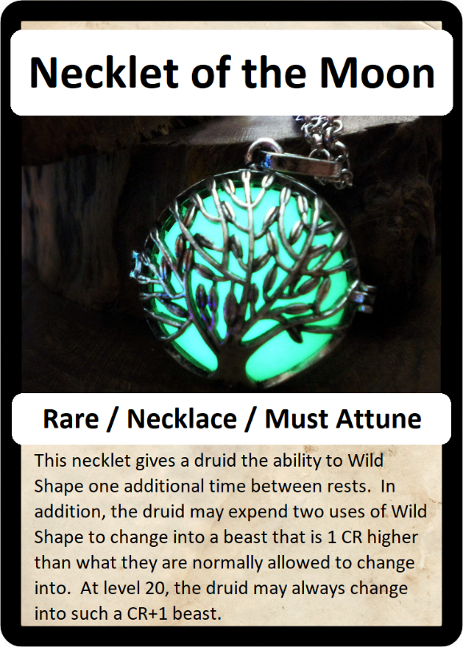

**Developer Notes**