Notes on the Elven Kingdom of Arbeiera

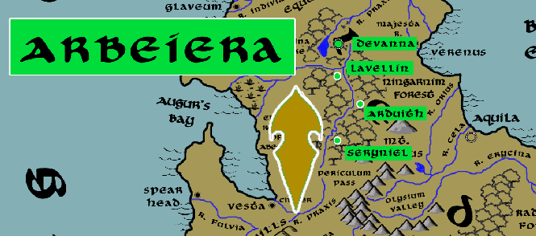

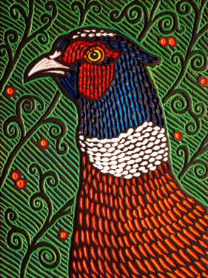**Sign of the Pheasant**

**Location: Ningarnim Forest, Continent of Arnland bordering the Kingdom of Celedon**

* **Overview**
* **Towns and Cities**
* **History**
* **Notes on Culture**
* **Magical Items**
* **Developer Notes**

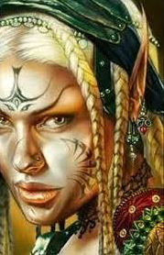**Overview**

The elves of Arbeiera occupy the Ningarnim forest in the center of the Celedon lands in eastern Arnland. They are Hravaeran or Fauna Elves, sometimes called Wild Elves. They have little love for the cruel and ambitious Celedonians, but have little time for their enmity for the land is overrun with greater evils. Ever since the Doom of Dregidus in the Second Written Age, the land has seen hordes of demons and fell creatures pouring out of the Vale of Abraxas. Arbeiera sees it as their duty to safeguard the land from this onslaught of evil.

**Lady Riniya Kelrora** is a firm and demanding ruler. She exacts a demanding regimen of training and vigilance from her subjects. She has no patience for outsiders and is quick to subject strangers to various trials to prove their worth. Lady Kelrora is known far and wide as the **Wind Wanderer**, for her ability to take flight and appear in every corner of her domain seemingly at will. She is a friend of the great eagle **Hyperia** and her kind that dwell on Aurora Mountain and has summoned them to her aide in many battles. Her greatest foe is **Ankiedren Hex**, who leads the **Saszar** kingdom of Drow to the north in the Arcanian Mountains.

**Towns and Cities**

* Arbeiera
  + Devanna - large city, population 25,000, guards / soldiers 250, militia 2250
  + Lavellin - large town, population 5,000, guards / soldiers 50, militia 250
  + Arduith - large town, population 5,000, guards / soldiers 50, militia 250
  + Seryniel - large town, population 5,000, guards / soldiers 50, militia 250

**Devanna**

**Size:** large city, population 25,000, guards / soldiers 250, militia 2250

**Trade Goods:** medicine, timber

**Local Goods:**

**Standard:**

**Colors:**

**Ruler:** Riniya Kelrora (f)

**Home**:

**Steward**: Kelvhan Sandoran

**Marshal**: Thedwin Heivra

**House Priest:**  Reeden Presorem

**House Adviser (Scholar/Mage/etc):**  Aneirin Arabanise (f)

**Captain of the Guard**: Nevarth Carharic

**Chief Warriors in Service**:

Cyithrel Baldella (f)

Soora Luyarus (f)

Pharem Dormenor

**Local Powers:** Band of the Ilimitar (rangers)

**Local Sites:**

**Description:**

**Industry:**

**Key Figures:**

**Local Lore:**

**History:**

**Customs:**

**Lavellin**

**Size:** large town, population 5,000, guards / soldiers 50, militia 250

**Trade Goods:**

**Local Goods:**

**Standard:**

**Colors:**

**Ruler:** Ilyrana Maghana (f)

**Home**:

**Steward**: Myrdin Ulapeiros

**Marshal**: Saida Valpetor (f)

**House Priest:**  Taerentym Bryqen

**House Adviser (Scholar/Mage/etc):**  Symania Caikrana (f)

**Captain of the Guard**: Ninthalor Trispeiros

**Chief Warriors in Service**:

Arun Iantoris

Artin Orifina (f)

Ahrendue Keybanise (f)

**Local Powers:**

**Local Sites:**

**Description:**

**Industry:**

**Key Figures:**

**Local Lore:**

**History:**

**Customs:**

**Arduith**

**Size:** large town, population 5,000, guards / soldiers 50, militia 250

**Trade Goods:**

**Local Goods:**

**Standard:**

**Colors:**

**Ruler:** Malruthiia Umebella (f)

**Home**:

**Steward**: Aywin Wyngolor

**Marshal**: Tasar Valrona

**House Priest:**  Rallientha Faquinal (f)

**House Adviser (Scholar/Mage/etc):**  Erendriel Presric

**Captain of the Guard**: Inchel Olastina

**Chief Warriors in Service**:

Jannalor Yinbalar

Ecaeris Qigwyn (f)

Syndra Xyrmyar (f)

**Local Powers:**

**Local Sites:**

**Description:**

**Industry:**

**Key Figures:**

**Local Lore:**

**History:**

**Customs:**

**Seryniel**

**Size:** large town, population 5,000, guards / soldiers 50, militia 250

**Trade Goods:**

**Local Goods:**

**Standard:**

**Colors:**

**Ruler:** Cithrel Helegwyn (f)

**Home**:

**Steward**: Ayre Iarfiel

**Marshal**: Ehrendil Pamys

**House Priest:**  Ninthalor Aeyarus

**House Adviser (Scholar/Mage/etc):**  Faylen Lurieth (f)

**Captain of the Guard**: Elaith Farphyra

**Chief Warriors in Service**:

Anlyth Bihice

Ascal Shasatra

Ilmadia Sylthyra (f)

**Local Powers:**

**Local Sites:**

**Description:**

**Industry:**

**Key Figures:**

**Local Lore:**

**History:**

**Customs:**

**History**

**First Primordial Age (PA1)**

**Second Primordial Age (PA2)**

**Third Primordial Age (PA3)**

**Fourth primordial Age (PA4)**

**First Ancient Age (AA1)**

**Second Ancient Age (AA2)**

**Third Ancient Age (AA3)**

**Fourth Ancient Age (AA4)**

**First Written Age (WA1)**

940 WA1 - War of Sorannus WA1 - Orc tribes the Acarnan, Volturnus, and Tauran Mountains rise up behind the wizard Sorannus to invade Celedon lands

960 WA1 - Massacre at Furina - Dwarves of Berylor and Elves of Arbeiera are defeated by the Orcs of Sorannus at Furina Pass in Celedon

**Second Written Age (WA2)**

5 WA2 - Fall of Elves in the Aradia Forest before the Orcs of Sonorus

10 WA2 - Fall of the Elves in Minerva Forest before the Orcs of Sonorus

WA2 - Fall of Elves in the Ceres and Radiant Forests before the Orcs of Sonorus

30 WA2 - Fall of the Elves in Orbona and Rusina Forests before the Orcs of Sonorus

50 WA2 - Elven Kingdom of Arbeiera falls; Elves flee the lands of Celedon by ship, vowing to return one day

340 WA2 - Elves of Arbeiera return to Celedon, make their way to the Forest of Ningarnum

360 WA2 - Elven Kingdom of Arbeiera rises from the ashes, driving Orcs out of Ningarnum

**Third Written Age (WA3)**

370 WA3 - War of the Black Widow - the Elves of Arbeiera battle Drow invading the Ningarnim Forest

375 WA3 - Elves of Arbeiera, aided by Celedonians from Vesta, track the Drow to an underground empire linking the Arcanian and Volturnus Mts.

380 WA3 - Battle of Volturnus - Elves of Arbeiera are joined by the Dwarves of Berylor in defeating the Black Widow Queen Sethria of the Drow

**Fourth Written Age (WA4)**

**Notes on Culture**

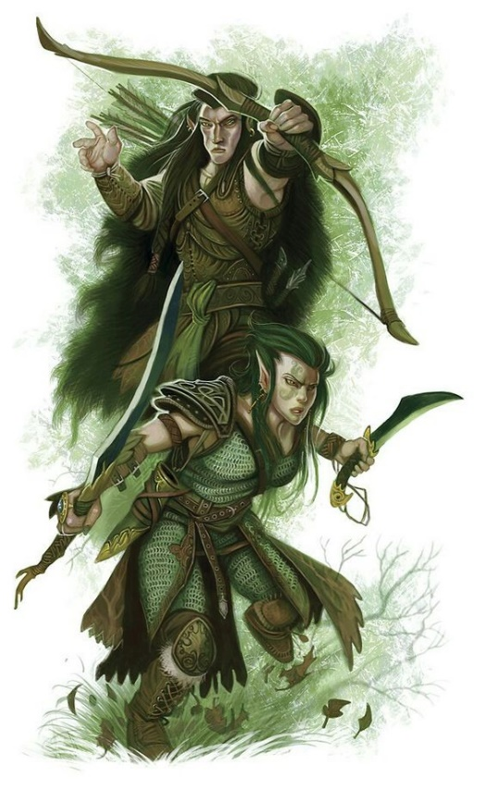**Hravaeran or Fauna Elves**

**Locations: Eida’Las, Elgelor, Elyon, Arbeiera, Lo’Shella**

**Appearance**: pale skin; blonde, brown, or red hair; green eyes

**Culture:** Fauna Elves, also called Wild Elves, are less civilized than their distant cousins. Considered barbaric by most, they create very few works of art or literature. Instead they live as one with the land and form primal bonds with the beasts. Some Wild Elves even have feral qualities. They are the most athletic of all Elves and regarded for their rugged endurance. Wild elves are reclusive, rarely tolerating the company of those outside of their tribes. They particularly fierce in the protection of their lands. Fauna elves enjoy a special friendship with the fay, even more so than Elves do already. This is thought to be because their wild natures hearken to the free spirits of the fay and their ilk.

**Common Attire**: animal skins or woven plants, covered in tribal markings, some dye their skin in natural pigments

**Traits**: Fauna Elves have a natural strong connection to wild beasts. Many develop mental connections to a specific type of animal and, with it, some of their traits. They have the highest constitution of the elven races but also the lowest intelligence.

**Ability and Skill Modifiers:** +2 Constitution, -2 Intelligence,with each level they become able to cast spells at will from the cleric animal domain spell list:

* Animal Domain
* Granted Powers: You can use speak with animals once per day as a spell-like ability. You may add twenty ranks of Knowledge (nature) to your list of class skills.
* Animal Domain Spells

1. Calm Animals: Calms (2d4 + level) HD of animals.
2. Hold Animal: Paralyzes one animal for 1 round/level.
3. Dominate Animal: Subject animal obeys silent mental commands.
4. Summon Nature’s Ally IV*: Calls creature to fight.
5. Commune with Nature: Learn about terrain for 1 mile/level.
6. Antilife Shell: 10-ft. field hedges out living creatures.
7. Animal Shapes: One ally/level polymorphs into chosen animal.
8. Summon Nature’s Ally VIII*: Calls creature to fight.
9. Shapechange F: Transforms you into any creature, and change forms once per round.
   * *Can only summon animals.

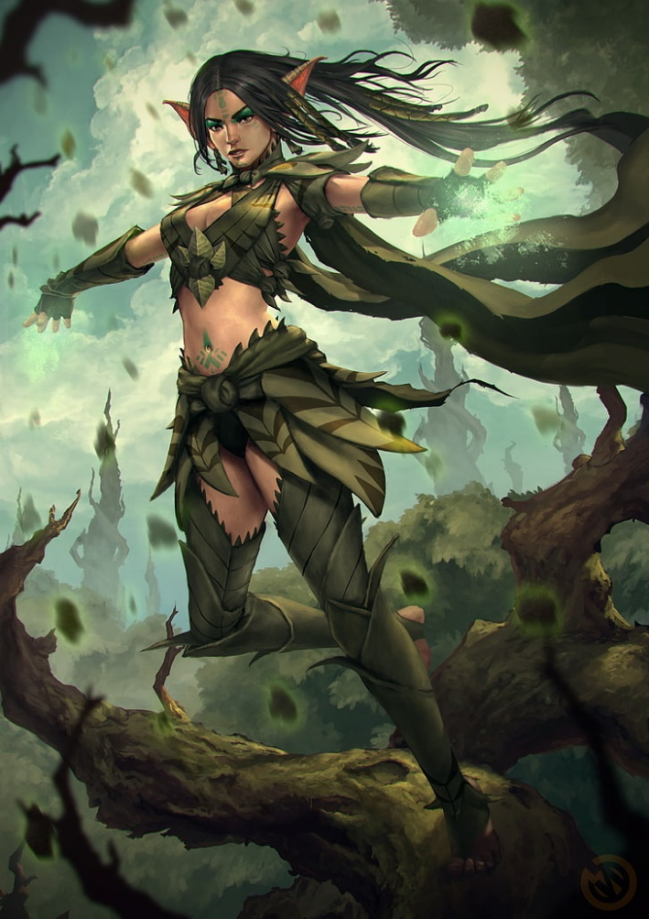**Magical Items**

**Developer Notes**