Notes on the Elven Kingdom of Cetaris



**Location: Great Horn Mountains, Eastern Amadar**

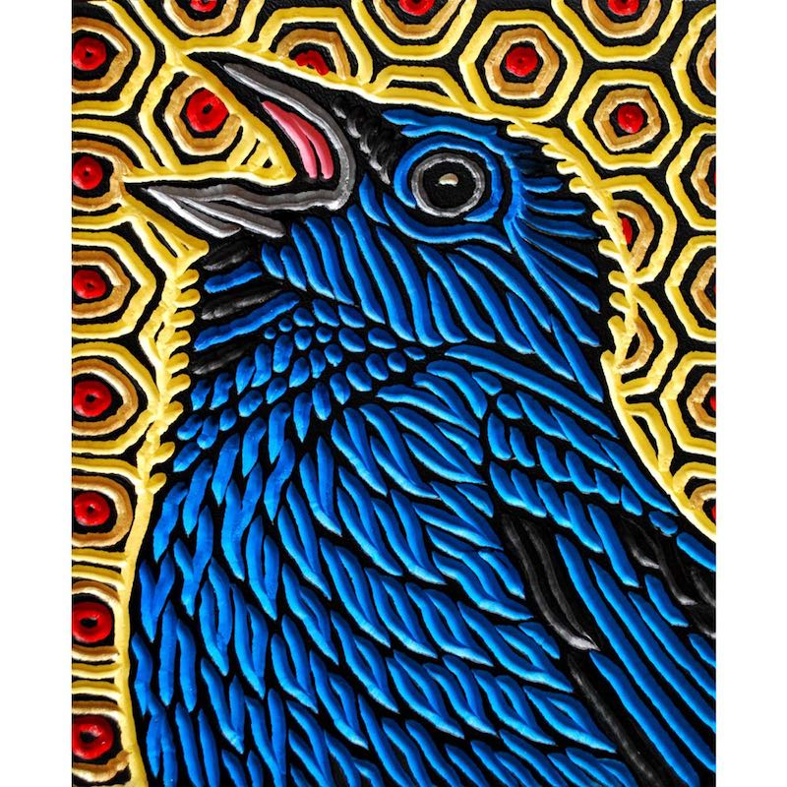**Sign of the Star Bird**

* **Overview**
* **Towns and Cities**
* **History**
* **Notes on Culture**
* **Magical Items**
* **Developer Notes**

**Overview**

The **Star Citadel**, as the elven town of Aldebaran is so named, stands a lonely vigil in the high peaks of the far north of Western Amadar. A reclusive and enigmatic race of elves, the Elenar or star elves dwell here in solitude. They have little to do with the world, even the rest of elven kind. Here they tarry in peace, pondering the heavens and consulting complex diagrams of the constellations. Some say they seek information on the future, others say they are masters of time itself. Few who travel here ever remember what their eyes befell, but speak of a place of serenity and great wonders.

**Towns and Cities**

* Aldebaran - large town, population 5,000, guards / soldiers 50, militia 250

**Aldebaran**

**Size:** large town, population 5,000, guards / soldiers 50, militia 250

**Trade Goods:**

**Local Goods:**

**Standard:**

**Colors:**

**Ruler:** Merethyl Kellar (f)

**Home**: the Star Citadel

**Steward**: Fylson Eilbalar

**Marshal**: Llarm Glynwarin

**House Priest:** Selphia Venxalim (f)

**House Adviser (Scholar/Mage/etc):**  Uthorim Orivalur

**Captain of the Guard**: Ghilanna Liabella (f)

**Chief Warriors in Service**:

Thalia Miarel (f)

Horith Zylfaren

Voron Thelee

**Local Powers:**

**Local Sites:**

**Description**:

Perched atop the lonely, cold peaks of the Great Horn Mountains is the dark blue citadel of Aldebaran, home of the star elves. By day its slender spires can be seen from miles away, at night its magical walls twinkle with a thousand lights on a sea of black stone. Topping the thin towers are spherical structures of amazing design, observatories where the elves meditate upon the celestial skyscape above. It is unearthly quiet here. The caretakers of this realm drift idly as if in a dream. What music can be heard is eerie and not of this world. Ornate fountains trickle soundlessly into silvery pools that glow with visions of the heavens. From this haven the star elves roam across the peaks of these lands, always looking upward to divine the deeper secrets that the cosmos may reveal.

Star elves spend long nights staring up at the skies, meditating on the secrets revealed to them by the faraway lights. On many nights that there are spectral light shows in these northern skies, the elves of Elenar are especially entranced and some say they gain special powers. The study and knowledge of astronomy and the power of the stars make them the authorities on the subject among elvenkind and earned them the term **Star Ciphers.**

Upon reaching adulthood, each elf receives a vision from one of the many stars in the sky. Thereafter the star is their primary focus of attention in life and the two develop a special relationship. The elf communes regularly with the star, watching its movements, noting its patterns of light, and searching for messages from the far-off illumination. It is not uncommon for a member of the Elenar to awaken from a long night of meditating and feel compelled to undertake a perilous quest that they believe is ordered by their star. Some even claim to be able to hear their star speaking to them within their minds.

**Industry:**

The Elenar conduct no business with the outside world. Only a handful of wizards from around the world are welcome here. Those who are trusted may request a draught of enchanted waters from one of their celestial pools, which is said to be of great value. Such a boon is normally exchanged for rare magical items from far away or acts of service.

**Key Figures:**

**Local Lore:**

**History:**

492 WA2 - the fall of Chogan: Haka'Na braves, joined by shaman from all over the land and the Elenar star elves of Cetaris, defeat the Wendigo and slay Chogan; the Blood Star ring is lost

**Customs:**

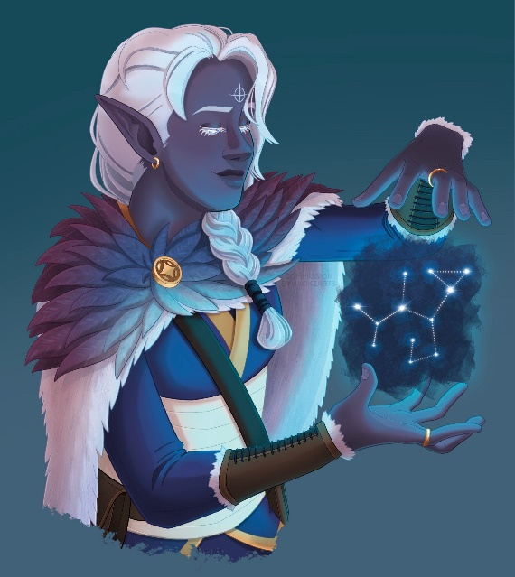**History**

**First Primordial Age (PA1)**

**Second Primordial Age (PA2)**

**Third Primordial Age (PA3)**

**Fourth primordial Age (PA4)**

**First Ancient Age (AA1)**

**Second Ancient Age (AA2)**

**Third Ancient Age (AA3)**

**Fourth Ancient Age (AA4)**

**First Written Age (WA1)**

**Second Written Age (WA2)**

**Third Written Age (WA3)**

**Fourth Written Age (WA4)**

**Notes on Culture**

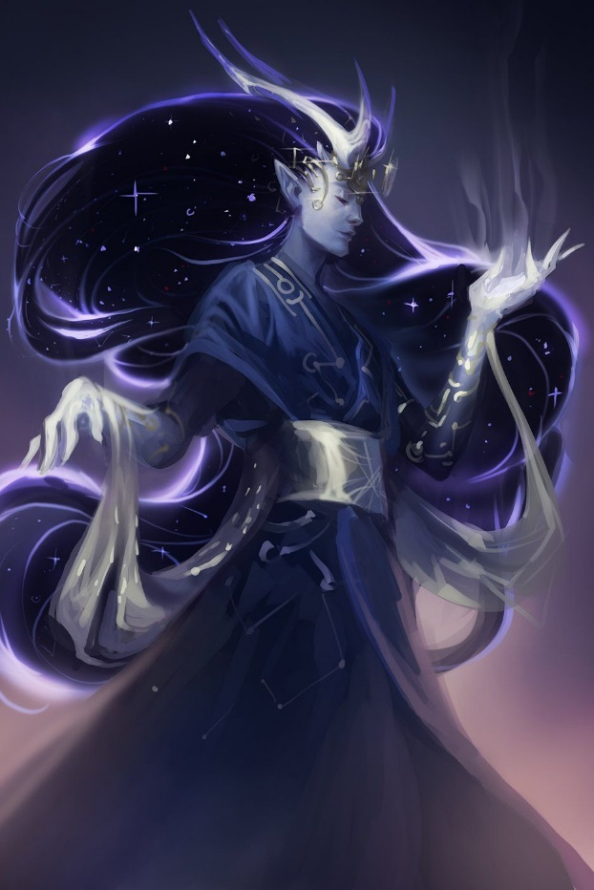**Elenar or Star Elves**

**Location: Cetaris**

**Appearance**: dark blue skin with white freckles; black or white hair; silver eyes

**Culture:** Star Elves have a far-off, haunted quality to them. They speak in a flat tone and often in whispers. They are reflective, thoughtful, have wandering minds, and often mumble to themselves. They are nocturnal creatures, rarely venturing out in broad daylight. They are considered strange and off-putting to most including fellow elves of other sub-races.

**Common Attire**: elaborate tunics, neutral colors

**Traits**: Shortest of the elves, Star Elves are some of the weakest of their race. They develop a bond with a single star at birth and cultivate this relation over a lifetime. This prompts them to often enter walking trances, speaking to unseen others. A few of this race are gifted with prophetic visions while others are able to contact other planes. There are legends of some Elenar able to travel into the past or future, nocturnal

**Ability and Skill Modifiers:** Strength -2, +2 Wisdom +2, Dexterity -2 (in daylight). With each level they become able to cast spells at will from the cleric luck domain spell list:

* Luck Domain
* Granted Power: You gain the power of good fortune, which is usable once per day. This extraordinary ability allows you to reroll one roll that you have just made before the game master declares whether the roll results in success or failure. You must take the result of the reroll, even if it’s worse than the original roll.
* Luck Domain Spells

1. Entropic Shield: Ranged attacks against you have 20% miss chance.
2. Aid: +1 on attack rolls, +1 against fear, 1d8 temporary hp +1/level (max +10).
3. Protection from Energy: Absorb 12 points/level of damage from one kind of energy.
4. Freedom of Movement: Subject moves normally despite impediments.
5. Break Enchantment: Frees subjects from enchantments, alterations, curses, and petrification.
6. Mislead: Turns you invisible and creates illusory double.
7. Spell Turning: Reflect 1d4+6 spell levels back at caster.
8. Moment of Prescience: You gain insight bonus on single attack roll, check, or save.
9. Miracle X: Requests a deity’s intercession.

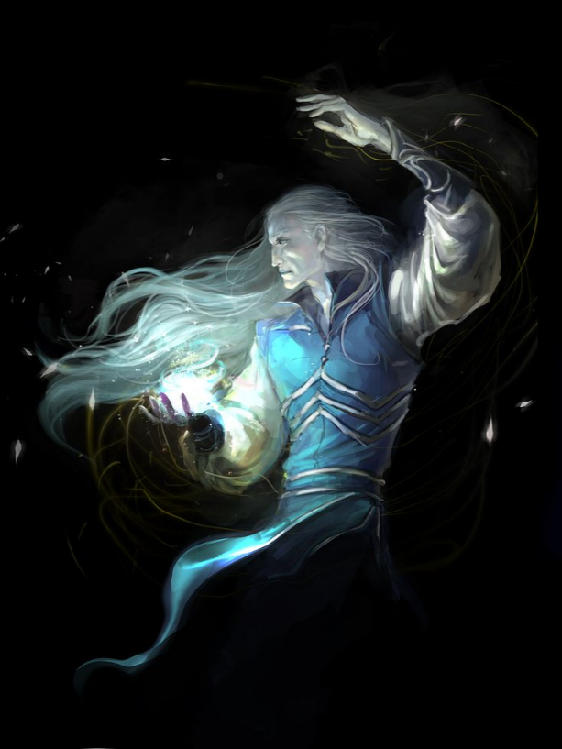**Magical Items**

**Robe of Stars**

Wondrous Item, very rare (requires attunement)

This black or dark blue robe is embroidered with small white or silver stars. You gain a +1 bonus to saving throws while you wear it.

Six stars, located on the robe's upper front portion, are particularly large. While wearing this robe, you can use an action to pull off one of the stars and use it to cast magic missile as a 5th-level spell. Daily at dusk, 1d6 removed stars reappear on the robe.

While you wear the robe, you can use an action to enter the Astral Plane along with everything you are wearing and carrying. You remain there until you use an action to return to the plane you were on. You reappear in the last space you occupied, or if that space is occupied, the nearest unoccupied space.

**Ring of Shooting Stars**

Ring, very rare (requires attunement)

While wearing this ring in dim light or darkness, you can cast dancing lights and light from the ring at will. Casting either spell from the ring requires an action. The ring has 6 charges for the following other properties. The ring regains 1d6 expended charges daily at dawn.

* Faerie Fire. You can expend 1 charge as an action to cast faerie fire from the ring.
* Ball Lightning. You can expend 2 charges as an action to create one to four 3-foot-diameter spheres of lightning. The more spheres you create, the less powerful each sphere is individually.

Each sphere appears in an unoccupied space you can see within 120 feet of you. The spheres last as long as you concentrate (as if concentrating on a spell), up to 1 minute. Each sphere sheds dim light in a 30-foot radius.

As a bonus action, you can move each sphere up to 30 feet, but no farther than 120 feet away from you. When a creature other than you comes within 5 feet of a sphere, the sphere discharges lightning at that creature and disappears. That creature must make a DC 15 Dexterity saving throw. On a failed save, the creature takes lightning damage based on the number of spheres you created.

**Spheres Lightning Damage**

4 2d4

3 2d6

2 5d4

1 4d12

Shooting Stars. You can expend 1 to 3 charges as an action. For every charge you expend, you launch a glowing mote of light from the ring at a point you can see within 60 feet of you. Each creature within a 15-foot cube originating from that point is showered in sparks and must make a DC 15 Dexterity saving throw, taking 5d4 fire damage on a failed save, or half as much damage on a successful one.

Notes: Damage, Utility, Combat, Jewelry

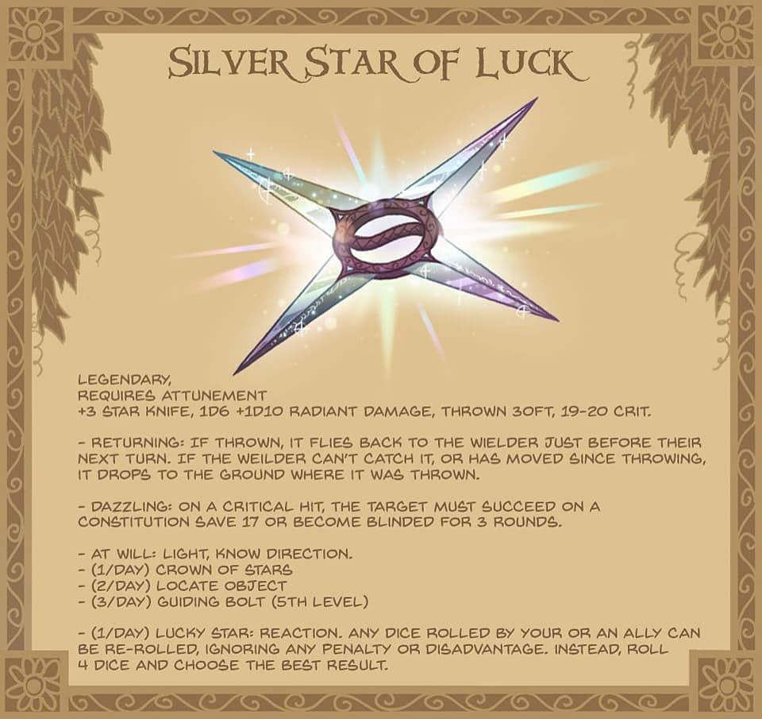

**Developer Notes**