Notes on the lands of the Dwarves

- Overview
- Dwarven Kingdoms
- Towns and Cities
- History
- Notes on Culture
- Magical Items
- Developer Notes

Overview
The Dwarves have staked out a world unto themselves, burrowing deep into the hearty mountain ranges of Nemmyrl and establishing kingdoms that span hundreds of miles. The Dwarves, if asked, will tell you that Nemmyrl is theirs. They own the princely kingdoms under the mountains and dominate the ores and precious stones the gods left to plunder.

Two distinct groups of Dwarves emerged in the Primordial Ages that led to the tribes that persist today.

First, Dwarves of Central Amadar calling themselves the Underheim appeared in the First Primordial Age in the Evermore Mountains. Racknem the Chain Breaker led the Underheim Dwarves to freedom from bondage at the hands of Orcs in 130 PA2. This began the Chainbreaker lineage of Dwarven rulers, as Racknem's five sons ventured out to begin four other kingdoms (his sixth, illegitimate, son would found a fifth kingdom). Lastly, two other kingdoms would be founded as extensions from these original kingdoms. These are attributed to the Chainbreaker legacy, but their rulers claim no blood ties to the original family.

Second, Dwarves calling themselves the Darkheim appeared in Gaeadon in the First Primordial Age in the Aketuun Mountains. Aella Understorm led the Darkheim Dwarves to conquer an ancient order of Beholder mages as well as Drow and Duergar in 863 PA1. Aella would begin the Understorm lineage of Dwarven rulers in the south, as Aella's three sons and two daughters would create five other kingdoms.

Together there are now fourteen Dwarven Kingdoms: eight that trace back to the Underheim and Chainbreaker lineage and six that trace back to the Darkheim and the Understorm lineage.

Today the kingdoms keep to themselves, as Dwarves tend to do. But they are bound by blood, and will come to one another’s defense in the direst of times. Envoys occasionally set out in the spirit of trade and the exchange of ideas. Some kingdoms have secret routes connecting them that snake through the darkest depths and even beneath the seas. There, in the under dark, whole wars can be waged with orcs and goblins without word making it to the ears of men. For this reason, the Dwarves know they hold the real power of the world and fight evil on their own terms.

Dwarven tribes that exist outside these kingdoms settle in hills and unclaimed mountains. Some are cast-off tribes and others are colonies (called Veins). Some maintain allegiances with their kingdoms, others are more free-spirited. But the Dwarven Kingdoms are the centers of power. It is here they hold fast, venturing out to deal with humans and elves only when it suits them. Some come forth for war against the orc tribes, some ply the merchant routes, and some seek new mountains to conquer. Once every ten years the dwarven kingdoms honor the tradition of the Dvergeråd, the great meeting of the dwarves.

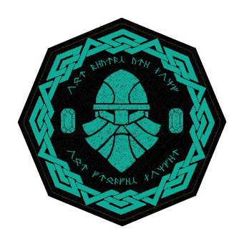
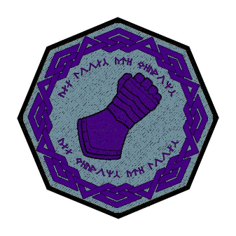
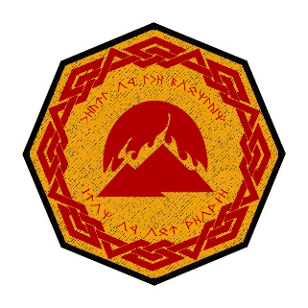
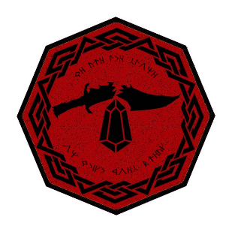
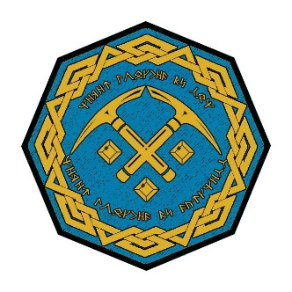
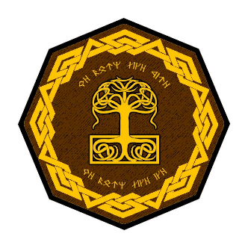
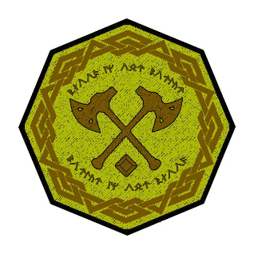
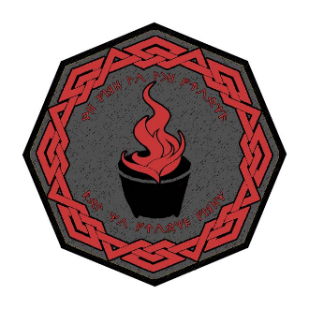
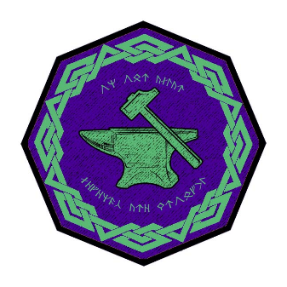
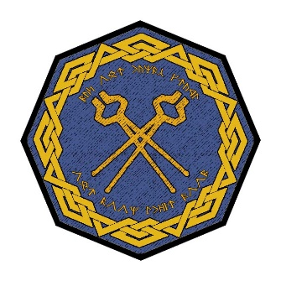
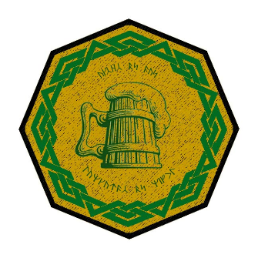
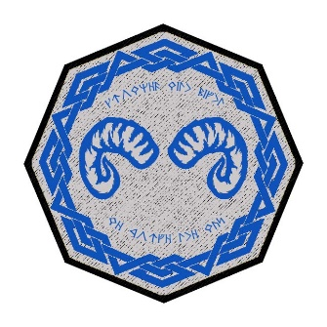
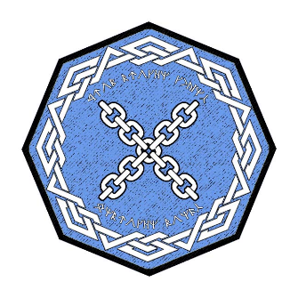
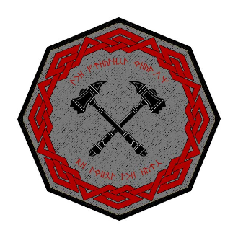
Dwarven Kingdoms

Kingdom | Continent | Mountains | founded | founder
Amberon | Norgarde | Hydar Mts. | 630 PA2 | Krorher Thunderslag
Rubelor | W. Amadar | Cauldron Mts. | 570 PA2 | Yuddolin Chainbreaker
Citerak | W. Amadar | Ordren Mts. | 540 PA2 | Strokkol Chainbreaker
Demundra | W. Amadar | Evermore Mts. | 160 PA2 | Racknem the Chain Breaker
Gartenak | Lands of Oberon | Stonecutter Mts. | 590 PA2 | Noldrum Chainbreaker
Agatren | Hyderis | Direfrost Mts. | 40 PA3 | Torelgren Truetower
Kartzuum | Haka'Na | Horn Mts. | 100 PA3 | Khekgrik Underlander
Berylor | Celedon | Volturnus Mts. | 600 PA2 | Alforrun Chainbreaker
Sapphurnus | Mythenia | Alcyone Mts. | 868 PA2 | Malakai Understorm
Emaraad | Gaeadon | Shatterpeak Mts. | 881 PA1 | Aella Understorm
Obseidon | Kazeldun | Karn Mts. | 699 PA2 | Horkem Understorm
Pellafor | Xiandai | Ryuluun Mts. | 66 PA3 | Gamarak Understorm
Turakor | Sakura | Domaru Mts. | 393 PA3 | Hagguda Understorm
Amethek | Kaduru | Aramanga Mts. | 161 PA3 | Morrok Understorm

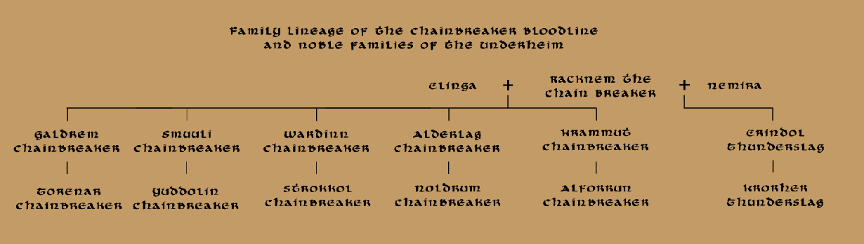

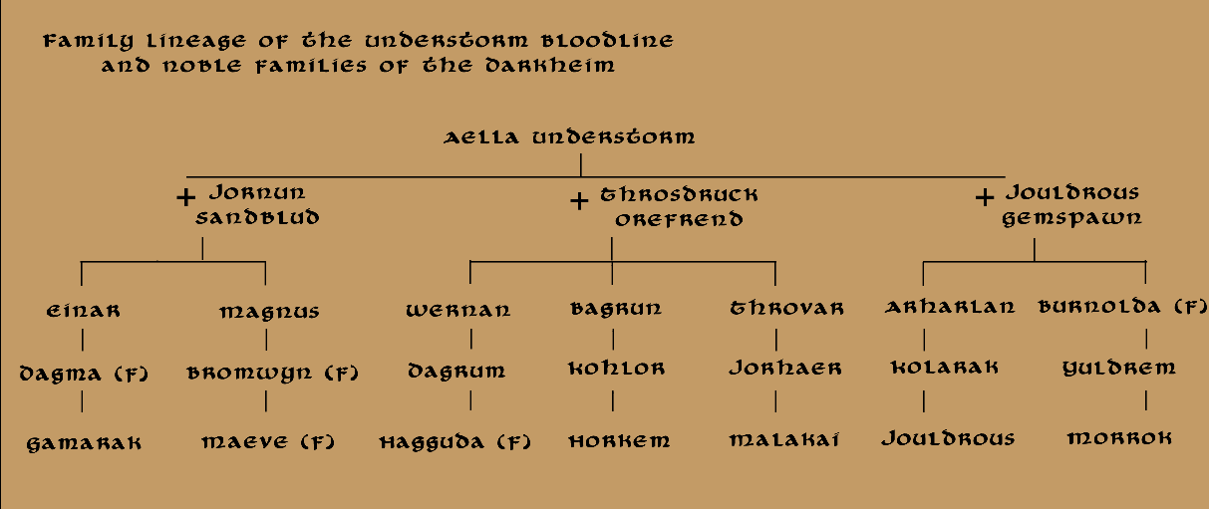

Best in the Land
Every dwarven kingdom engages in mining, excavating, metalsmithing, and stone masonry. But some kingdoms excel in certain areas that make them the preeminent authorities on the subjects.

Amberon – goldsmiths, silversmiths (whitesmiths), delicate metal work
Bonus skills:
Profession: Goldsmith 4 ranks, Profession: Whitesmith 4 ranks, Appraisal 4 ranks
Extra Equipment: Set of Masterwork Delicate Metalworking Tools, Masterwork Merchant Tools (set of scales, jeweler’s loupe, tweezers, etc)
Rubelor – smithing / forging / metalworks
Bonus skills:
Knowledge: Metallurgy 6 ranks, Profession: Blacksmithing 6 ranks
Extra Equipment: Hammer, Tongs, and Totem of Kullivar’s Anvil
Citerak – lapidarists: cutting, grinding, and polishing precious stones
Bonus skills:
Knowledge: Lapidary 6 ranks, Profession: Gem-cutting 6 ranks
Extra Equipment: Set of Masterwork Lapidary Tools including jeweler’s loupe, Masterwork Merchant Tools (set of scales, jeweler’s loupe, tweezers, etc)
Demundra – diplomacy, hydrogeology
Bonus skills:
Diplomacy 6 ranks, Knowledge: Hydrogeology 6 ranks
Extra Equipment: Masterwork Mining Tools, Enchanted Divining Rod
Gartenak – study and mastery of arcane magic
Bonus skills:
Knowledge: Arcane 6 ranks; Use Magic Device 6 ranks; Speak Language: Draconic
Extra Equipment: Wand of detect magic
Agatren – stealth, camouflage, spy craft, and trapmaking
Bonus skills:
Twelve skill points to be distributed as desired between: Forgery, Gather Information, Disguise, Search (Traps), Disable Device, Move Silently
Extra Equipment: Disguise Kit, Masterwork Lockpick Set, Cloak of Concealment
Kartzuum – animal husbandry and subterranean farming
Bonus skills:
Twelve skill points to be distributed as desired between: Handle Animal, Ride, Survival, Profession: Farming
Extra Equipment: Veterinary Healing Kit, Soil and Plant Analysis Kit
Berylor – strategy and battle tactics; siege engines
Bonus skills:
Profession: Seige Engine Construction 6 ranks, Gather Information 6 ranks
Extra Equipment: Tovard’s Magical Map, Eyes of the Eagle, Tovard’s Manual on Seige Engines
Sapphurnus – commerce and trade, haggling and appraisal
Bonus skills:
Appraisal 4 ranks, Diplomacy 4 ranks, Profession: Commerce 4 ranks
Extra Equipment: Masterwork Merchant Tools (set of scales, jeweler’s loupe, tweezers, etc)
Emaraad – brew masters, lore masters and chroniclers of history
Bonus skills:
Profession: Brewing 6 ranks, Knowledge: History 6 ranks
Extra Equipment: Halgra’s Brewer’s Pouches x20
Obseidon – weapon smithing
Bonus skills:
Profession: Weapon Smithing 6 ranks; Knowledge: Metallurgy 6 ranks
Extra Equipment: Hammer, Tongs, and Totem of Kullivar’s Anvil
Pellafor – study and mastery of divine magic
Bonus skills:
Knowledge: Religion 6 ranks, Speak Language: Celestial, Can pray for Divine Spells as Adept of the same level as the character’s ECL
Extra Equipment:
Turakor – stonemasonry, architecture, and engineering
Bonus skills:
Knowledge: Stone Masonry 4 ranks, Knowledge: Architecture 4 ranks, Knowledge: Engineering 4 ranks
Extra Equipment: Masterwork Mason’s Tools
Amethek – delving, mining, and exploring the under dark; mastery of aquifers
Bonus skills:
Knowledge: Hydrogeology 4 ranks, Profession: Mining 4 ranks, Knowledge: Survival (Underdark) 4 ranks
Extra Equipment: Masterwork Mining Tools, Enchanted Divining Rod

Totem of Kullivar’s Anvil – this is a tiny decorative stone crafted in the shape of an anvil. When activated, the totem grows into full-sized, functional anvil. The anvil will remain full-sized for 24 hours, at which point it will revert to a totem. The anvil can be activated once per day. While full-sized, the anvil operates like a Masterwork anvil, capable of having any items forged or wrought upon it. The totem does not come with a heat source, however, only the working surface for forging.

Halgra’s Brewer’s Pouches – These are burlap pouches weighing a quarter-pound each and containing concentrated blends of hops, malts, and herbs that are the result of a long brewing process. These concentrated blends are prepared for use outside of the user’s normal brewing facilities. A pouch placed in ten gallons of clean water and sealed tight will produce ten gallons of quality ale in one day.

Tovard’s Magical Map – This is an enchanted piece of canvas that is folded six times into a square measuring 3” x 3”. When unfolded and activated, the canvas transforms into a perfect rendition of any terrain that the user can summon from memory. The level of detail and accuracy of the terrain depends on the user’s access to the landscape, and can be enhanced by divination spells, shared sight from animal companions, or any other magical means. The map will also create any number of battle tokens to appear and move at the user’s command.

Tovard’s Manual on Seige Engines – This is a leather-bound volume containing the master treatises on siege craft and siege weaponry. It includes diagrams for constructing siege engines as well as instructions on collapsing, transporting, and setting them up. There are invaluable detailed tables for calculating artillery fire, establishing sapper trenches, undermining castle walls, etc.

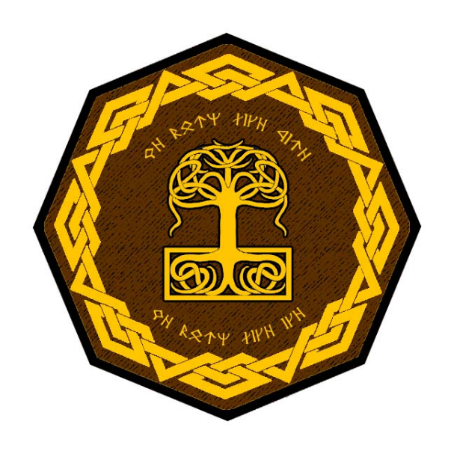
Amberon
Roros Mts. in the lands of Norgarde
- A close-knit community where hospitality is valued and where work and conversation are taken at a slow and purposeful pace.
- Amberon has the best decorative metalsmiths in all of Dwarven kind. They work in precious metals but they are the best whitesmiths (working in tin and pewter). They are experts in creating delicate, masterful works of ornate jewelry, framing the humblest gems in intricate woven bands and decorations.
- Appearance: Amberon Dwarves have a bluish tint to their hair, bright blue eyes, and prominent noses. They then to have smaller fingers than their far-off kin, making them adept at precision work.
- Common Attire: They tend to wear snow-shoe boots for navigating the icy terrain. They wear tunics, knit caps and mittens made from subterranean fibrous plants.
- Weapon of Choice: pick axes and hand axes
- Natural Enemies: remorhaz, ice trolls, duergar, frost giants
- Favored Mounts: dire mountain goats
- Traits: highly resistant to cold, tend to be slow and measured in their work and speech
- Customs: Amberon dwarves can be exhausting with the level of hospitality they extend and the small gestures they make towards outsiders. Amberon dwarves are said to see all non-Dwarven visitors as children needing care.
  - Amberon Dwarves enjoy the game “sledge,” said to originate here. In it, opposing teams of fourteen attempt to move an enormous rock in opposite directions over the surface of a stone island. The game is won when the rock is heaved over one of the sides into the depths. Members of both teams alternate between pushing and harassing the members of the opposite team. Games of sledge sometimes take days to complete and are savagely contested.
- Common Saying: “You never really know your real friends until the ice breaks.”
- Kingdom Motto: “We burn like fire, we burn like ice.”
- Founder: Krorher Thunderslag, illegitimate grandson of Racknem the Chainbreaker

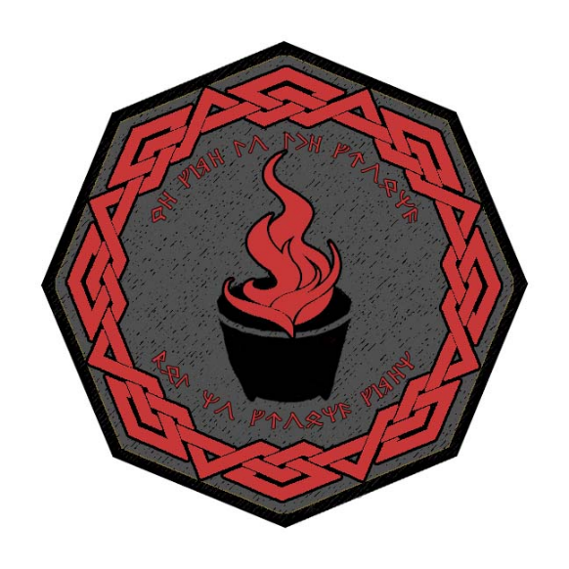
Rubelor
Cauldron Mts. in Western Amadar
Known by Dwarves as the Ofnheim, or Oven-Home, the kingdom of Rubelor lies deep beneath the Cauldron Mountains astride a series of subterranean volcanic vents. Great clouds of steam and sulfur fill the soot-covered halls here. No greater joy is found than that of the flame and the magic it works on stone, ore, and gem. The Rubelor Dwarves delight in the heat, probing the secrets of blacksmithing and metal working. Great tools and metal structures they wrought and of incomparable strength. The people are considered crude and unmannered by their kind: most are ill at ease with written and spoken language and are consumed by their work. They are quick tempered and given fighting before talking.
- Rubelor Dwarves are the best at smithing, forging, and metal works in all of Dwarven kind. Considered simple crafts by other kingdoms, here they are elevated to an art form. Large scale metal works, thought impossible elsewhere, stand the test of time here in the form of long-span bridges, towering archways, and decorative walls of iron and steel and more exotic alloys.
- Appearance: Ruddy skin, flushed faces, and auburn or red hair. Rubelor Dwarves always look like they are blushing, an observation they do not find amusing in the slightest. Some say their appearance comes from working for centuries near the hottest of forge known: the great Kar-ka-raak, or Dread-Kiln.
- Common Attire: Dwarves here are fond of wearing dragon hide, with scales as a form of prestige (red dragon scales a favorite).
- Weapon of Choice: great axe
- Natural Enemies: orcs, goblins, ogres, fire giants (in particular, the Karzunn tribe of Fire Giants known by their sign of the Burning Ram – they roam the Cauldron Mountains and beneath them, drawn to the delicious heat of the Kar-ka-raak and the open heat vents deep underground)
- Favored Mounts: giant beetles
- Traits: The kingdom shares a strong bond with Citerak after years of fighting the dark forces side-by-side in northern Amadar. They enjoy a friendly rivalry over their trophy collections, which are piled with skulls, banners, and a dark array of savage weapons of the orc and goblin.
- Customs: tossing valuable items into a fire for good luck, thinking it shows the gods one embraces the conflicts ahead rather than the treasures to be gained from them
- Common Saying: “Life is a crucible. Never fear the proving.”
- Kingdom Motto: “We give to the ground - but no ground given.”
- Founder: Yuddolin Chainbreaker, one of the five grandsons of Racknem the Chainbreaker
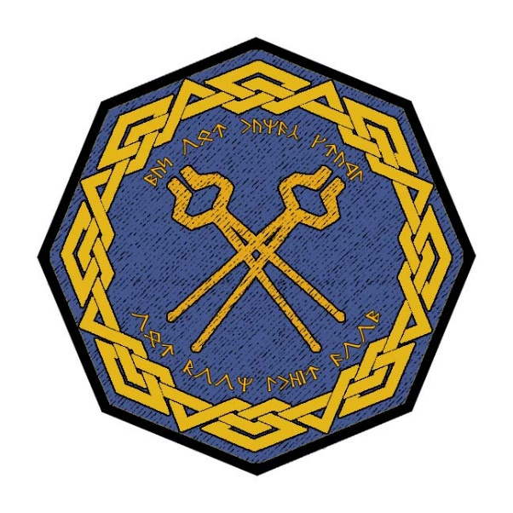
Citerak
Ordren Mts. in Western Amadar

Famed are the glittering halls of Citerak, its walls and ceilings are canvases of twinkling crystals and polished jewels. Where other kingdoms boast of towering vaulted ceilings, Citerak runs throughout with smaller spaces bedecked with luster. Here dwell the greatest of Dwarven gem-cutters. Keen are the eyes of these Dwarves, for they see oceans of brilliance where others see a mere stone.
- Citerak is an enterprising community that works well with Elves and in humans in this remote part of the world. Dwarves here are always creating projects for improving their kingdom.
- Citerak Dwarves are the best lapidarists in all of Dwarven kind. They are masters at the cutting, grinding, and polishing of precious stones. Their unaided eyes see patterns and flaws most cannot see without the aid of a jeweler’s loupe. Citerak is often called upon when casters require a perfect gem for their magic devices.
- Appearance: Citerak Dwarves have light brown skin with reddish-blonde hair. Their eyes have a heavy-lidded appearance, lending them the appearance of squinting. But the eyes of a Citerak Dwarf are the keenest in their race, beset with bright green flecks if one looks close enough, and able to see tiny details within gems and crystals without the aide of a jeweler’s loupe.
- Common Attire: They tend to wear leather dyed in different hues of yellow, from pale sunflower to brilliant gold. They are fond of gloves and gauntlets. Ornate handwear serves as an important status symbol.
- Weapon of Choice: great axe
- Natural Enemies: orcs, goblins, ogres, hill giants
- Favored Mounts: giant beetles
- Traits: Citerak Dwarves craft polished stones that most would find worthless. They are called Furtha, which translates to ‘wonder’ in the common tongue. Wonder stones are highly sought after by humans, who marvel at the brilliant and intricate patterns running through them. They can be of any color and are usually translucent. Some consider them good luck charms and there are tales told of their hidden magic qualities.
  - The kingdom shares a strong bond with Rubelor after years of fighting the dark forces side-by-side in northern Amadar. They enjoy a friendly rivalry over their trophy collections, which are piled with skulls, banners, and a dark array of savage weapons of the orc and goblin.
  - Citerak Dwarves enjoy a game called Kerf in which two teams of three use special chisels to carve a channel through an enormous stone to the other side first. Players take turns circling the stone, carefully reading the monolith to try and deduce the best place to strike. Cracks can be made offensively, working to extend it to the opponents’ side; or defensively, creating fissures that block the other team’s incision. It can appear quite boring to outsiders, but Citerak Dwarves gather round to watch and cheer and place bets on what will unfold. It is said that once a long time ago a Dwarf named Hreldig struck a single blow so perfectly it cracked the stone through and won the game in one round.
- Customs: Dwarves here are fond of lobbing stones at one another at random times in the course of a day, with the target expected to react quickly and catch the stones. Those from Citerak are in the habit of offering a formal greeting when meeting strangers, which may end with a stone being thrown just overhead to test if they can catch it.
- Common Saying: “Life’s more labor than luck,” answered with “a mountain of slag for just one ingot.”
- Kingdom Motto: “May our hands craft our boon, their doom.”
- Founder: Strokkol Chainbreaker, one of the five grandsons of Racknem the Chainbreaker

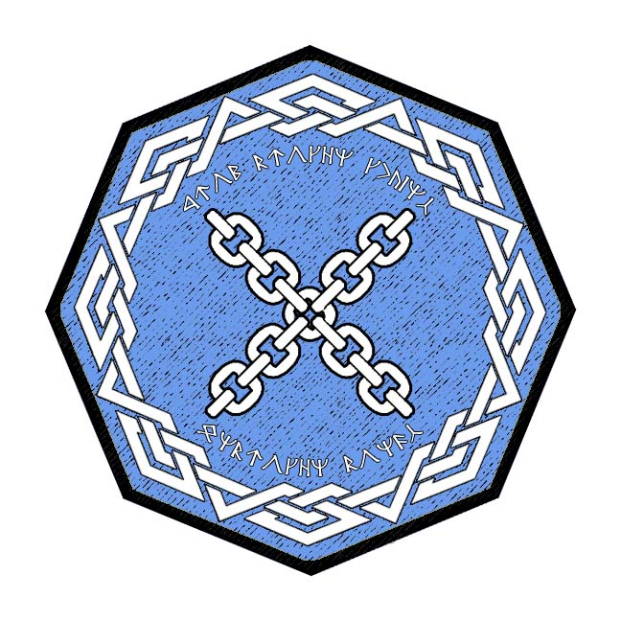
Demundra
Evermore Mts. in Western Amadar
- a tradition-minded community with a venerable history; holds itself in high esteem as the leaders of the dwarven peoples; very formal in their planning and execution of everything with an eye for etiquette, somewhat elitist
- the best at diplomacy and matters of state in all dwarven kind; also, the best at hydrogeology or the management of subterranean river systems and lakes
- Appearance: ruddy brown skin and dark black hair. Some say their toes are webbed, for all the time they spend around water, but this isn’t true. What is true is that each Demundra Dwarf has an oversized knuckle on each hand. The knuckle is different for each Dwarf and tends to run in ancestral lines. Superstitions and legends abound over the meaning of which knuckle means what. Some have joked it comes from the first Demundra Dwarf plugging a leaky dam with his finger, causing it to swell.
- Common Attire: dark brown leather that has a slight sheen to it from water resistant slime they apply to it; Wear boots that have enormous traction and can even adhere to near-vertical surfaces; fond of bright copper buttons with various symbols on them
- Weapon of Choice: warhammer
- Natural Enemies: umberhulks, orcs, kobolds, bugbears
- Favored Mounts: giant badgers
- Traits: have a slight elitist air, fond of recounting their family tree back several thousand years
- are more comfortable around water than most other dwarves. They are adept not only at working on boats and swimming and are adept at water containment measures.
- Customs: digging a hole and burying a piece of gold in it or some other treasure before embarking on any journey, the belief being they have something to return for and it gives them resolve
- Common Saying: “May yer beard be long,” followed in response by “and may ye live like ye earned it.”
- Kingdom Motto: “From broken chains: unbroken bonds”
- Founder: Racknem the Chain Breaker, patriarch of all the Underheim and the Chainbreaker lineage of rulers

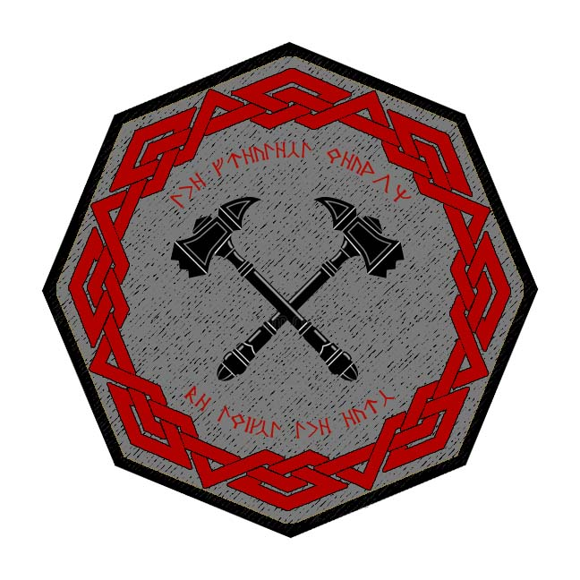
Gartenak
Stonecutter Mts. on the edge of the Lands of Oberon
- thoughtful community of simple folk who embrace a frontier lifestyle but are avid readers and always curious
- the best at the study and mastery of arcane magic in all dwarven kind
- Appearance: dark brown skin and hair
- Common Attire: dark green colors, wear the small bones of random creatures
- Weapon of Choice: dwarven waraxe
- Natural Enemies: duergar, gnolls, orcs, goblins
- Favored Mounts: dire boars
- Traits: long earlobes, prodigious noses, and the occasional extra toe that folks in these parts call a “tren-toe” and consider it a mark of good luck; tight bond with Agatren, sharing bloodlines as well as mutual war with dark forces in Central Amadar; captains wear rings that are struck together when their armies meet
- Customs: Gartenak dwarves are fond of masterfully-wrought belt buckles. They are keen to exchange them with newfound friends and during ceremonies.
- Common Saying: “know yer foe,” often replied to with “down to his favorite toe”
- Kingdom Motto: “The greatest weapon be twixt the ears”
- Founder: Noldrum Chainbreaker, one of the five grandsons of Racknem the Chainbreaker

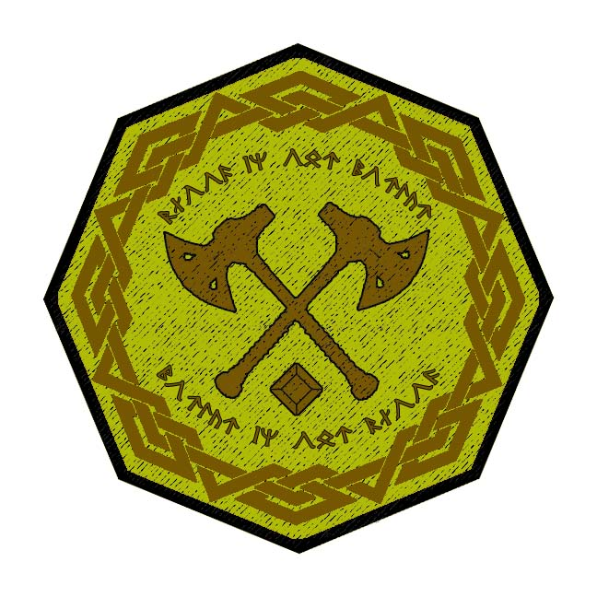
Agatren
Direfrost Mts. in the region of Hyderis
- a paranoid and suspicious community who keeps away from the affairs of other races, wary after years of dealing with dark forces in the region, clever mindset working out schemes and traps, considered master strategists
- the best at stealth, camouflage, spy craft, and trapmaking
- Appearance: dark brown skin and hair
- Common Attire: browns and greys, usually featuring stripes or bands
- Weapon of Choice: dwarven waraxe
- Natural Enemies: duergar, gnolls, orcs, goblins
- Favored Mounts: dire boars
- Traits: long earlobes, prodigious noses, and the occasional extra toe that folks in these parts call a “tren-toe” and consider it a mark of good luck; tight bond with Gartenak sharing bloodlines as well as mutual war with dark forces in Central Amadar; captains wear rings that are struck together when their armies meet.
- Customs: Agatren dwarves are incurable pranksters, they range from simple tricks to constructing elaborate ruses that are performed on one another and on strangers with the mindset to always keep one’s mind sharp and be prepared
- Common Saying: “A hole can be a trap or a home. Just depends on what you put in it.”
- Kingdom Motto: “Blood in our mortar - mortar in our blood”
- Founder: Torelgren Truetower, explorer from Gartenak; the kingdom is considered a part of the Underheim legacy, but the rulers are not of the bloodline of Racknem Chainbreaker

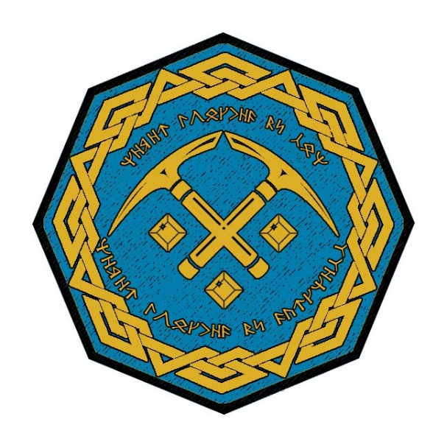
Kartzuum
Horn Mts. in the Haka’Na lands
- pious community valuing religious service as the highest priority, congenial to outsiders in a condescending way, intolerant of any threats to their way of life
- the best at animal husbandry and subterranean farming in all dwarven kind
- Appearance: slight traces of blue in the hair and skin and very resilient to cold
- Common Attire: deep oranges and dark yellows garnished with a variety of furs
- fond of elaborate and colorful paintings on the walls of their tunnels and halls
- Weapon of Choice: dwarven urgrosh (axe and spear double weapon)
- Natural Enemies: wendigo, frost giants, purple worms
- Favored Mounts: dire mountain goats
- Traits: one in ten Kartzuum Dwarves have one blue eye, which they see as a sign of greatness; those with a blue left eye are accused of being unlucky
- Customs: love stories and will spend hours telling old tales and debating their virtues
- Common Saying: “less thunder in the mouth and more lightning in the hand.”
- Kingdom Motto: “Never touched by sun - never touched by darkness”
- Founder: Khekgrik Underlander, explorer from Amberon; the kingdom is considered a part of the Underheim legacy, but the rulers are not of the bloodline of Racknem Chainbreaker
The Dwarves of the Staghorn Mountains are a pious folk, given to prayers and veneration of the gods. Moradin and his kin occupy the center of Kartzuum culture. The kingdom is ruled by the clerics, with a high priest appointed to rule in the largest city, Kwartzenor. Dwarves wear special sashes that hang from their belts. Around their neck they adorn themselves with polished stones inscribed with holy symbols. A great horn sits at the base of Kwartzenor. Each day it sounds, a different time each day. Its sound carries as vibrations throughout the caverns leading to the other cities. When the horn is heard (or in some cases just felt) all Kartzuum Dwarves stop whatever they are doing to kneel and pray.
Massive statues stand throughout the kingdom honoring Moradin, Berronar, Clanggedin, Dugmaren, Dumathoin, Haela, Marthammor, Mya, Sharindlar, Ulaa, and Vergadain. Lesser ones are built to honor Abbathor, Gorm, Hanseath, Muamman, Roknar, Thard Harr, Tharmekhul, Thautam, and Valkauna. Fires burn eternally at shrines to the gods, with sacrifices made daily in the form of everything from food to precious metals. Disrespect shown to any of the gods is met with brutal retribution and imprisonment.
Each subject of the kingdom is free to call on any one deity as their patron deity, and none may claim one is greater than the other. At least not outside the period set aside each week called The Suffering. This is a ritual where Dwarves are encouraged to boast on their gods and their superiority to all the others. Loud and raucous debates arise, with much drinking and hurling of insults. A winner is declared, and for that week the winner’s deity is declared the greatest while all others must suffer the claim.

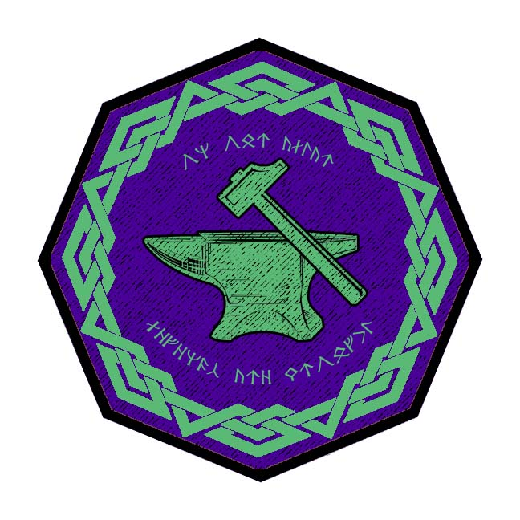
Berylor
Volturnus Mts. in the region of Celedon
- very determined community driven by honor; dangerously xenophobic of other races, an elitist air of dwarven manifest destiny, driven for conquest with designs on larger sections of subterranean lands, possible war with other dwarven kingdoms
- the best at battle strategy and crafting siege weapons in all dwarven kind
- the best at harnessing gases found in subterranean places
- Appearance: black skin with red hair and beards. Skin bears warts that the dwarves consider very lucky, like stalagmites growing on them
- Common Attire: Berylor Dwarves prefer banded armor. They tend to tie spikes into their beards and use them as pitons and stabbing weapons.
- Weapon of Choice: bastard sword
- Natural Enemies: formians, orcs, troglodytes
- Favored Mounts: dire rams
- Traits: Berylor dwarves have a keen sense of taste, able to detect poisons or other strange agents. They collect soil from all over the world, prizing the most faraway soil or soil that is near impossible to retrieve. They hold contests guessing what part of the world dirt comes from.
- Customs: Berylor dwarves are keenly aware of their surroundings, often breaking off pieces of rock or scooping up soil to taste it. It is not uncommon for a dwarf to offer an outsider a chunk of dirt and ask them to taste it and tell them what they think about it. They are also fond of elaborate games of strategy. Their favorite is called Vexillum, which features a board made from root-wood and glittering stone pieces where the object is to steal the other player’s largest stone.
  - Berylor Dwarves are the best at collecting what they call Firedamp, flammable gas found in coal mines, typically coalbed methane. The gas accumulates in pockets in the coal and adjacent strata and when they are penetrated the release can trigger explosions. The Dwarves have harnessed the gas, creating cannisters of it they use as explosives against their enemies.

- Common Saying: “The weak are meat; the strong eat.”
- Kingdom Motto: “On our altar legends are wrought”
- Founder: Alforrun Chainbreaker, one of the five grandsons of Racknem the Chainbreaker

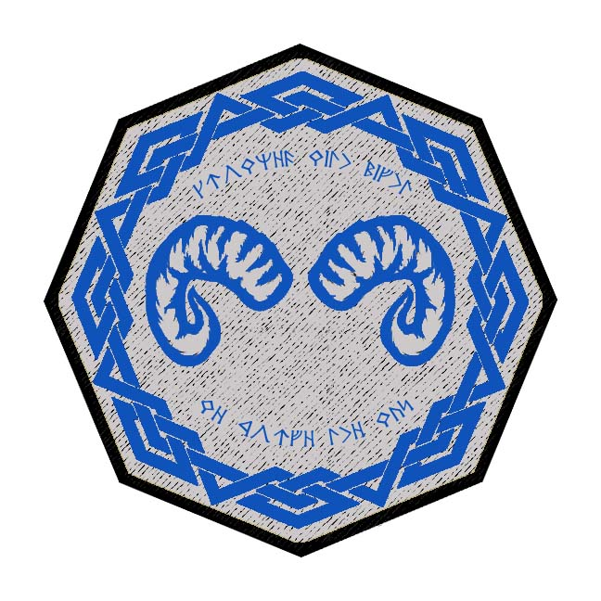
Sapphurnus
Alcyone Mts. in the region of Mythenia
- Very open to outside races, entrepreneurial mindset driven by commerce, very good hagglers and persuaders but also fond of deceit and guile; rumored to be thieves and swindlers
- the best at commerce and trade, haggling and appraisal in all dwarven kind
- Appearance: black skin with red hair and beards
- Common Attire: very light grays with loose sashes and hoods they wear up over their heads when above ground, always wear a blue sapphire stone on a band around their foreheads
- Weapon of Choice: bastard sword
- Natural Enemies: formians, orcs, troglodytes, minotaur
- Favored Mounts: giant scorpions
- Traits: are the keenest of all dwarves in commerce and appraisal, have partnerships formed with Darmiddian merchants. Sapphurnus Dwarves have a quick head for math and counting, famously able to guess the exact number of coins in a sack.
- Customs: master deal-makers, Sapphurnus dwarves work trades and bargains into every day conversation with everyone they meet; they will sacrifice what they consider small losses to learn the motives of those with whom they treat; it is common to offer someone a tempting lopsided deal and feign ignorance just to see if they are dealing with the unscrupulous
- Common Saying: “Little and lasting is better than much and passing.”
- Kingdom Motto: “Crowned with might we forge the way”
- Founder: Malakai Understorm, one of the

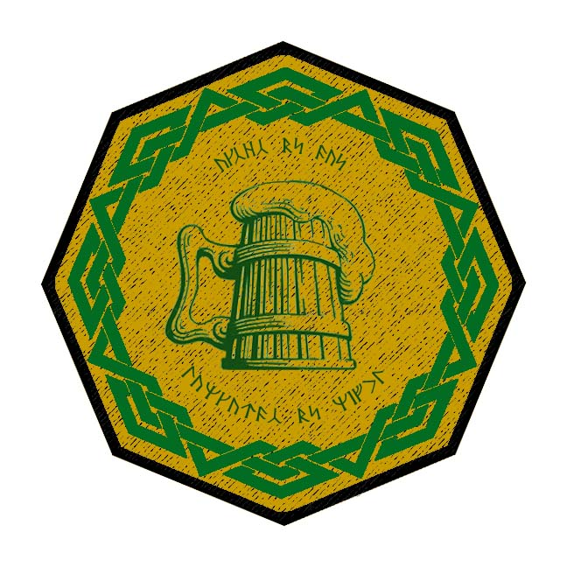
Emaraad
Shatterpeak Mts. in western Gaeadon lands
- A merry community, fond of stories and songs and food and drink, friendly with other races, very connected with the outside lands and feel an obligation to be good stewards of the land; masters of brewing ale, Emaraad ale is the most popular among dwarves worldwide
- the best at the brewing of ales and distilling spirits in all dwarven kind
- the best lore masters and chroniclers of dwarven history
- Appearance: pale brown skin and blondish hair and beards
- Common Attire: dark blues and purples with touches of gold; each dwarf wears a tiny bell that is a family heirloom
- Weapon of Choice: warhammer
- Natural Enemies: drow, fire giants, kobolds, driders
- Favored Mounts: giant badgers
- Traits: Fond of jokes and pranks, the jokes seem dark and not very funny to non-dwarves; tend to carry pet moles in their beards. When nervous, often fall into talking in rhyme.
- Customs: frequently give gifts, even to strangers, and gifts are never refused; this tradition sometimes cuts the other way when undesirable gifts are forced on rivals to send a message; the gift of a stone shaped to look like a fish is a traditionally insulting gesture for some reason – this is called the stygfisk and often leads to brawls
- Common Saying: “Work is work,” answered by “and beer is beer!”
- Kingdom Motto: “Axes by day - tankards by night”
- Founder: Aella Understorm, matriarch of all the Darkheim and the Understorm lineage of rulers

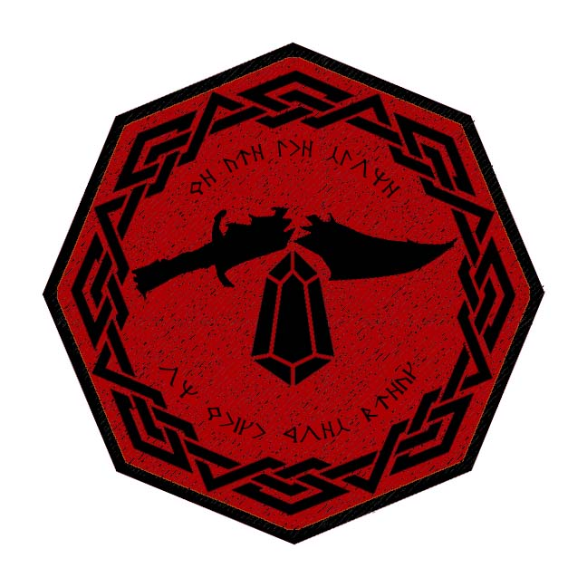
Obseidon
Karn Mts. in the region of Kazeldun
- A bellicose community, intent on war and preparation for war, ill-tempered and cruel, entertaining designs on conquest of other dwarven kingdoms, unpredictable and violent
- the best at weapon smithing in all dwarven kind
- Appearance: paint themselves for battle in an array of earth colors and metallic blue, skin is covered all over in tattoos, most of them depicting their fallen enemies; Apply metal to their teeth
- Common Attire: armor is almost always dark black with dents painted in red for every kill a warrior has. Spikes cover the armor and helmets feature a face plate painted with a skull or demonic face.
- Weapon of Choice: morningstar
- Natural Enemies: basilisks, gricks, piercers, fire giants
- Favored Mounts: giant spiders / cave fishers
- Traits: enjoy a rousing relationship with the warlike humans of Kazeldun, paint themselves for battle in an array of earth colors and metallic blue
  - a surly and vicious lot, love of warfare outpaces their love of stonework or even precious stones and gold, spend most of their time perfecting engines of destruction.
- Customs: in every battle, a dwarf is chosen to carry a spiked metal ball called the “belastig”; if they survive the ordeal they are celebrated and get to choose the next dwarf who carries the ball into battle
  - Their armies employ powerful drums that shake the depths and strike fear in their enemies.
  - They chew on Rabid Root before and during battle, driving them mad with strength, speed, and immunity to pain.
  - leaders are impossible to talk to when their minds are set on warfare.

- Common Saying: “Fire we took from the gods,” responded with “and with it we forge the world.”
- Kingdom Motto: “We are the stone on which foes break”

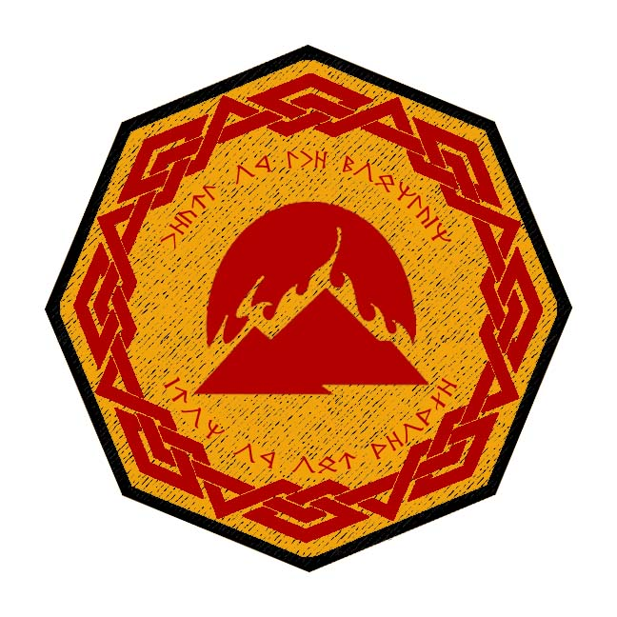
Pellafor
Ryuluun Mts. in the region of Xiandai
- A wise community in touch with the spirit world, dedicated to the studies of divine magic and integrating it into their subterranean realm, fond of philosophy and thoughtful action
- the best at the study and mastery of divine magic in all dwarven kind
- Appearance: dark brown skin with gray hair; Large, prominent foreheads that give them a frowning expression
- Common Attire: leather outer garments cut like short robes, leather sashes that bear the symbols of their studies
- Each dwarf is tattooed with a unique birth symbol that is tied to their family history
- Very sensitive to vibrations, believe they can hear the song of the deep emanating from every rock
- Weapon of Choice: bar mace
- Natural Enemies: gibbering mouthers, orcs, goblins, xorn
- Favored Mounts: yaks and water buffalo
- Traits: a quiet people, often going hours without speaking a word; given to long bouts of pondering and meditating with a good pipe; outsiders are often taken aback when Pellafor Dwarves answer the unspoken questions of one of their kin, leading some to wonder if they share a mild telepathic bond
- Customs: they find great entertainment in posing philosophical questions and riddles, some of which have no answers; tirelessly quiz one another and outsiders to measure their ability to form conjecture or ideas; outsiders find it annoying when Pellafor Dwarves hold up an entire conversation with the simple response of ‘yes, but why?’
- Common Saying: “Crooked rocks still make good bridges.”
- Kingdom Motto: “Heart of the mountain - iron of our people”

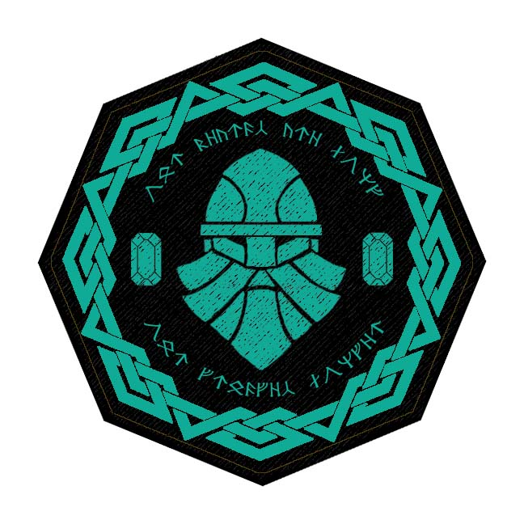
Turakor
Domaru Mts. in the Sakura lands
- A stoic and proud community that hails the virtue of precision and incorporates it into all of their work; by far the greatest stonemasons of all dwarven kind, capable of engineering breathtaking structures and sculptures that are out of reach of most master masons and stone smiths. Difficult to talk to or understand, they are often misunderstood but are highly sought after for their advice.
- the best at stone masonry, architecture, and engineering in all dwarven kind
- Appearance: light brown skin with gray hair; braid their hair and beards in a fashion that carries a symbolic meaning
- Common Attire: bandoliers stocked with a wide array of masterwork mason’s hammers and chisels. Wear leather lacings and tassels: Work the sinews of giant beasts into leather cords that they lace into their armor and clothing, feature tassels of bright colors to designate their station
- Weapon of Choice: dire flail
- Natural Enemies: drow, spirit naga, driders, beholders
- Favored Mounts: giant beetle
- Traits: Tend to talk in mumbling tones that are hard to understand for non-dwarves. Very impersonable. They mumble even in front of one another and at the same time; it is considered rude to speak while someone else is mumbling, so they wait until it is quiet before speaking, which can take some time in large gatherings. Turakor Dwarves have odd thumbs that they can lock into a perfect right angle, which they use often in their mason work
- Customs: Turqorzem dwarves are obsessed with balance and will adjust objects they come across to restore symmetry or balance, including rearranging random stones or even items on another person
- Common Saying: “even the tallest mountain begins underground”
- Kingdom Motto: “Our beards are long - our grudges are longer”

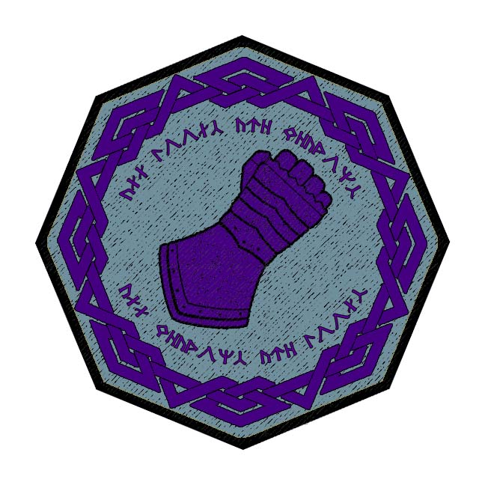
Amethek
Aramanga Mts. in the Kaduru region
- Isolationist community, seldom attend the Dvergeråd, the great meeting of the dwarves that happens every ten years.
- the best at delving, mining, and exploration in all dwarven kind - capable of excavating and exploring in expert fashion and have explored twice as much of the underdark as any other kingdom; also, experts in managing aquifers and subterranean bodies of water locked in sand; like those in Demundra, are more familiar than most other dwarves with subterranean rivers and water sources.
- suspicious and unwelcoming to all visitors except for the few earth shamans they have befriended from Kaduru tribes.
- Appearance: skin striated with bands of earthen colors, dark brown hair; skin tends to be tough but smooth from the constant wearing of sand across it, and there tends to be color striations across the skin that has earned Amethek dwarves the nickname “marbled dwarves” and “tiger dwarves.” Their eyes have a purplish tint to them from a tonic they drink that is ceremonial and derived from a native root; Their hands are red from a ritual test they go through to test their pain, pounding rock or sticking their hands into very hot springs
- Common Attire: Some helmets have decorated masks worked into them, influenced by the tribal masks they’ve seen used by the humans.
- Weapon of Choice: heavy flail
- Natural Enemies: umberhulks, purple worms, lizardfolk
- Favored Mounts: giant lizards
- Traits: more comfortable with heat than most dwarves but not as much as those from Citerak
  - Giant reptiles from the nearby Valley of Hunters are caught and used as mounts and pets.
- Customs: collect the claws from giant lizards and other predatory animals and wear them as tokens of courage; tend to give the claws to one another or outsiders if they distinguish themselves
- Common Saying: “If you fear the dragon’s cave, you will never see its fortune.”
- Kingdom Motto: “All tools are weapons - all weapons are tools”

Directory of Dwarven Towns and Cities within each Kingdom
- Amberon
  - Frostfang Keep – small town, population 2,000, guards / soldiers 20, militia 100
  - Horndeep – large city, population 25,000, guards / soldiers 250, militia 2250
  - Thunderhame – large town, population 5,000, guards / soldiers 50, militia 250
  - Hreidmar – large town, population 5,000, guards / soldiers 50, militia 250
  - Lindwyrm Keep – small town, population 2,000, guards / soldiers 20, militia 100
  - Yaramir – large town, population 5,000, guards / soldiers 50, militia 250
  - Plunder Keep – small town, population 2,000, guards / soldiers 20, militia 100
- Rubelor
  - Western Keep – small town, population 2,000, guards / soldiers 20, militia 100
  - Morkil – large town, population 5,000, guards / soldiers 50, militia 250
  - Hammer Keep – small town, population 2,000, guards / soldiers 20, militia 100
  - Godhelm – metropolis, population 50,000, guards / soldiers 500, militia 2500
  - King’s Keep – small town, population 2,000, guards / soldiers 20, militia 100
  - Stonruun – small town, population 2,000, guards / soldiers 20, militia 100
  - Northern Keep – small town, population 2,000, guards / soldiers 20, militia 100
  - Feldspear – large city, population 25,000, guards / soldiers 250, militia 2250
  - Queen’s Keep – small town, population 2,000, guards / soldiers 20, militia 100
  - Gilderok – large town, population 5,000, guards / soldiers 50, militia 250
  - Eastern Keep – small town, population 2,000, guards / soldiers 20, militia 100
- Citerak
  - Anvil Keep – small town, population 2,000, guards / soldiers 20, militia 100
  - Hanfast – small town, population 2,000, guards / soldiers 20, militia 100
  - Glitren – large city, population 25,000, guards / soldiers 250, militia 2250
  - Silverok – large town, population 5,000, guards / soldiers 50, militia 250
  - Hardkiln – small town, population 2,000, guards / soldiers 20, militia 100
  - Dark Keep – small town, population 2,000, guards / soldiers 20, militia 100

- Demundra
  - Long Keep – small town, population 2,000, guards / soldiers 20, militia 100
  - Longdelve – large town, population 5,000, guards / soldiers 50, militia 250
  - Barrel Keep – small town, population 2,000, guards / soldiers 20, militia 100
  - Merryhorn – large town, population 5,000, guards / soldiers 50, militia 250
  - River Keep – small town, population 2,000, guards / soldiers 20, militia 100
  - Drakebane – large town, population 5,000, guards / soldiers 50, militia 250
  - Eagle Keep – small town, population 2,000, guards / soldiers 20, militia 100
  - Hammerfine – large city, population 25,000, guards / soldiers 250, militia 2250
  - Broadren – large town, population 5,000, guards / soldiers 50, militia 250
  - Lonely Keep – small town, population 2,000, guards / soldiers 20, militia 100
  - Khundrukar – (ruins)
- Gartenak
  - Iron Keep – small town, population 2,000, guards / soldiers 20, militia 100
  - Raskelor – large town, population 5,000, guards / soldiers 50, militia 250
  - Warbow – large town, population 5,000, guards / soldiers 50, militia 250
  - Gildax – large city, population 25,000, guards / soldiers 250, militia 2250
  - Oremaul – large town, population 5,000, guards / soldiers 50, militia 250
  - Bedrock Keep – small town, population 2,000, guards / soldiers 20, militia 100
  - Keystone – large town, population 5,000, guards / soldiers 50, militia 250
  - Archdeep – large town, population 5,000, guards / soldiers 50, militia 250
  - Crystal Tear Keep – small town, population 2,000, guards / soldiers 20, militia 100
- Agatren
  - Frost Keep – small town, population 2,000, guards / soldiers 20, militia 100
  - Kalaraak – large town, population 5,000, guards / soldiers 50, militia 250
  - Mithrilhame – large town, population 5,000, guards / soldiers 50, militia 250
  - Silverlode – large city, population 25,000, guards / soldiers 250, militia 2250
  - Firemantle – large town, population 5,000, guards / soldiers 50, militia 250
  - Darkshine – large town, population 5,000, guards / soldiers 50, militia 250
  - Sentry Keep – small town, population 2,000, guards / soldiers 20, militia 100
  - Ember Keep – small town, population 2,000, guards / soldiers 20, militia 100
- Kartzuum
  - Wardrum Keep - small town, population 2,000, guards / soldiers 20, militia 100
  - Kwartzenor - large city, population 25,000, guards / soldiers 250, militia 2250
  - Slateshield - large town, population 5,000, guards / soldiers 50, militia 250
  - Granite Keep - small town, population 2,000, guards / soldiers 20, militia 100
  - Stone Harbor - large town, population 5,000, guards / soldiers 50, militia 250
  - Underspire - large town, population 5,000, guards / soldiers 50, militia 250
  - Blue Keep - small town, population 2,000, guards / soldiers 20, militia 100
- Berylor
  - Skullbeard Keep – small town, population 2,000, guards / soldiers 20, militia 100
  - Sowblock Keep – small town, population 2,000, guards / soldiers 20, militia 100
  - Athora – large city, population 25,000, guards / soldiers 250, militia 2250
  - Ingot Keep – small town, population 2,000, guards / soldiers 20, militia 100
  - Raurak – large town, population 5,000, guards / soldiers 50, militia 250
  - Duriggok – large town, population 5,000, guards / soldiers 50, militia 250
  - Hardhewn – large town, population 5,000, guards / soldiers 50, militia 250
  - Stromnos – large town, population 5,000, guards / soldiers 50, militia 250
  - Wardrum Keep – small town, population 2,000, guards / soldiers 20, militia 100
- Sapphurnus
  - Fuller Keep – small town, population 2,000, guards / soldiers 20, militia 100
  - Hogback – large town, population 5,000, guards / soldiers 50, militia 250
  - Undercloud – large town, population 5,000, guards / soldiers 50, militia 250
  - Lucern Keep – small town, population 2,000, guards / soldiers 20, militia 100
  - Petra – large city, population 25,000, guards / soldiers 250, militia 2250
  - Mandrel Keep – small town, population 2,000, guards / soldiers 20, militia 100
  - Ironmaul – large town, population 5,000, guards / soldiers 50, militia 250
  - Krusibul – large town, population 5,000, guards / soldiers 50, militia 250
  - Helvent Keep – small town, population 2,000, guards / soldiers 20, militia 100
- Emaraad
  - Ashlar Keep – small town, population 2,000, guards / soldiers 20, militia 100
  - Vosakaar – large town, population 5,000, guards / soldiers 50, militia 250
  - Konaar – large town, population 5,000, guards / soldiers 50, militia 250
  - Hamaar – large city, population 25,000, guards / soldiers 250, militia 2250
  - Corbel Keep – small town, population 2,000, guards / soldiers 20, militia 100
  - Merlonn – large town, population 5,000, guards / soldiers 50, militia 250
  - Bartizan – large town, population 5,000, guards / soldiers 50, militia 250
  - Lakunaar – large town, population 5,000, guards / soldiers 50, militia 250
  - Slagsmelt Keep – small town, population 2,000, guards / soldiers 20, militia 100
  - Graver Keep – small town, population 2,000, guards / soldiers 20, militia 100
- Obseidon
  - Anvil Keep – small town, population 2,000, guards / soldiers 20, militia 100
  - Stryker Keep – small town, population 2,000, guards / soldiers 20, militia 100
  - Ruthara – large town, population 5,000, guards / soldiers 50, militia 250
  - Sledge – large town, population 5,000, guards / soldiers 50, militia 250
  - Blackseam – large town, population 5,000, guards / soldiers 50, militia 250
  - Nengenor – large city, population 25,000, guards / soldiers 250, militia 2250
  - Bandenar – large town, population 5,000, guards / soldiers 50, militia 250
  - Helver Keep – small town, population 2,000, guards / soldiers 20, militia 100
  - Bellows Keep – small town, population 2,000, guards / soldiers 20, militia 100
- Pellafor
  - Watcher Keep – small town, population 2,000, guards / soldiers 20, militia 100
  - Kerkehewn – large town, population 5,000, guards / soldiers 50, militia 250
  - Plinth Keep – small town, population 2,000, guards / soldiers 20, militia 100
  - Bertelgrim – large town, population 5,000, guards / soldiers 50, militia 250
  - Valadur – large city, population 25,000, guards / soldiers 250, militia 2250
  - Coffer Keep – small town, population 2,000, guards / soldiers 20, militia 100
  - Kaeldin – large town, population 5,000, guards / soldiers 50, militia 250
  - Quoin Keep – small town, population 2,000, guards / soldiers 20, militia 100
  - Hillwatch Keep – small town, population 2,000, guards / soldiers 20, militia 100
  - Sunderkhar – large town, population 5,000, guards / soldiers 50, militia 250
- Turakor
  - Basilisk Keep – small town, population 2,000, guards / soldiers 20, militia 100
  - Duridor – large town, population 5,000, guards / soldiers 50, militia 250
  - Hammerfel – large city, population 25,000, guards / soldiers 250, militia 2250
  - Darkforge Keep – small town, population 2,000, guards / soldiers 20, militia 100
  - Keterak – large town, population 5,000, guards / soldiers 50, militia 250
  - Harkilum – large town, population 5,000, guards / soldiers 50, militia 250
  - Firestoke Keep – small town, population 2,000, guards / soldiers 20, militia 100
  - Endegarn – large town, population 5,000, guards / soldiers 50, militia 250
- Amethek
  - Diamond Keep – small town, population 2,000, guards / soldiers 20, militia 100
  - Dourbeard – large town, population 5,000, guards / soldiers 50, militia 250
  - Volterran – large city, population 25,000, guards / soldiers 250, militia 2250
  - Glittervein – large town, population 5,000, guards / soldiers 50, militia 250
  - Ironhead – large town, population 5,000, guards / soldiers 50, militia 250
  - Ederoch – large town, population 5,000, guards / soldiers 50, militia 250
  - Sandstone Keep – small town, population 2,000, guards / soldiers 20, militia 100
  - Motherstone Keep – small town, population 2,000, guards / soldiers 20, militia 100

History of the Dwarves
First Primordial Age (PA1)
440 - the first organized Dwarven tribes in the north form a community under the Evermore Mountains and call themselves the Underheim

500 - the first organized Dwarven tribes in the south form a community under the Vagabond Mountains and call themselves the Darkheim ruled by Throsdruck

630 - War of the Chains - Orcs ruling the Evermore Mountains wage war on the Underheim Dwarves

670 - Throsdruck begins the Dwarven Kingdom of Emaraad in the Darkheim

690 - War of the Chains ends in the Dwarven defeat at the Battle of Lost Hope - Orcs of Evermore enslave the Dwarven people of Underheim and almost wipe them out completely

720 - Bagrun leads a company of Dwarves from Darkheim east and begins the Dwarven Kingdom of Obseidon in the Karn Mountains

840 - Jornon leads a company of Dwarves from Darkheim west under the sea and begins the Dwarven Kingdom of Sapphurnus under the Alcyon Mountains in Arnland

Second Primordial Age (PA2)
130 - The Great Dwarven Uprising - Underheim revolts against their Orc masters led by the hero Racknem the Chain Breaker
140 - The Dwarven Holy War - Moradin charges the Underheim to organize the loose Dwarven tribes of Amadar to purge the Evermore Mountains of all goblinoids and orcs living there
160 - End of Dwarven Holy War - Orc and Goblin tribes are exterminated throughout the Evermore region; the Kingdom of Daemunndra is begun with Racknem as its first king. Racknem later sires five sons, who become known as the Five Brothers of Underheim.

430 - Moradin charges four of the Five Brothers of Underheim (Strokkol, Yuddolin, Noldrum, and Alforrun) to go forth into the world and forge Dwarven kingdoms; a sixth brother (Krorher) is spurned for being a bastard but is commissioned by Moradin in secret to form his own kingdom
440 – the flag is raised for the first time over the Dwarven kingdom of Daemunndra; Torenar, the eldest of the Five Brothers, assumes rule of Daemunndra
540 - Strokkol of the Five Brothers goes north and begins the Dwarven Kindgom of Citerak

570 - Yuddolin of the Five Brothers goes west and begins the Dwarven Kingdom of Rubelor
590 - Noldrum of the Five Brothers goes east and begins the Dwarven Kingdom of Gartenak
600 - Alforrun of the Five Brothers goes south under the sea and begins the Dwarven Kingdom of Berylor

630 - Krorher, a sixth brother, is spurned by the Five Brothers of Underheim for being a bastard; Moradin leads him north under the sea and he begins the Dwarven Kingdom of Amberon
760 - Jouldrous leads two tribes to break off from Obseidon and go east under the sea to Xiandai to form the Dwarven Kingdom of Pellafor under Ryuluun Mountains
810 - civil war in Pellafor; Thakdred leads the second tribe breaks off to go under the sea and form the Dwarven Kingdom of Turakor under the Domaru Mountains in Sakura
810 - 920: Siege of Amberon by Norgarde armies

877 PA2 - Morrok Marblek leads a tribe of Dwarves from Emaraad south under the sea and begins the Dwarven Kingdom of Amethek under the Aramanga Mountains in Kaduru

Third Primordial Age (PA3)

40 - Torelgren leads a tribe of Dwarves from Gartenak and heads east and begins the Dwarven Kingdom of Agatren
100 - Khekgrik leads a tribe of Dwarves from Amberon and heads east to begin the Dwarven Kingdom of Kartzuum; crosses under the sea into Agatren and then moves east

210 - Princess Hagguda of Pellafor refuses to marry her father's choice of suitor, she delves beneath the Kamatsu Strait and finds the Domaru Mountains where she founds the Turakor Kingdom
340 - Folly of Thrunndi - Dwarven excavation by Emaraad miners unearths a boulder-sized gem and name it after the miner who found it

400 - War of Fire and Stone - The Thrunndi Gem unleashes a terrible curse, opening a portal to hell and beginning an invasion of demons and devils throughout the Svarog Valley region

790 - King Thundrir of Demundra challenges all of Dwarven kind to fashion the perfect cut gem from the discarded stones from his largest quarry

Fourth Primordial Age (PA4)
110 – The Sybalite Stone is created: After three hundred years and countless Dwarven gem cutters attempting, a Dwarven apprentice by the name of Loberen cuts Thundrir’s stone without permission and creates the Sybalite Stone: the greatest and largest diamond the world has ever seen
532 - The Dwarven Kingdom of Pellafor emerges from the Ryuluun Mountains to attack and destroy Dractus' rear guard at the Northern Pass

First Ancient Age (AA1)
450 - The Sybalite Stone is stolen from Demundra by the Duergar wizard Gergerim

480 - Gergerim is driven mad by the Sybalite's splendor and uses it to focus enormous magical energies to destroy half of the kingdom of Gartenak

481 - The Sybalite War - Dwarves from Demundra, Gartenak, and Agatren converge on the Stonecurtain Mountains to rescue the Sybalite and stop Gergerim

492 - end of the Sybalite War - After years of bloody conquest the armies of Gergerim are defeated and the Sybalite restored to Demundra

870 - the dwarves of Citerak tap a magma fissure so great it feeds a mighty furnace they name Yaramir

Second Ancient Age (AA2)
20-180 The War of the Giants in Norgarde; giants from the Godsbeard, Hydar, and Raros Mountains wage war on Dwarves, humans, and Elves

70 - Battle of the Godsbeard - Dwarves of Amberon, joined by Norgarde warriors, fight Krong's forces and barely survive

Third Ancient Age (AA3)
190 - Shimney Footbeard of Obseidon faces the great under-serpent Vrydeth and slays it; according to legend, this creates such a shower of serpent's blood that Obseidon dwarven clerics captured it and made it into a potion of great power called Vrydeth

720 - Springs of Karana built in the Kingdom of Amethek by old king Grakkin as a wedding present to his bride Karana from the Dwarven kingdom of Emralden

Fourth Ancient Age (AA4)
140 - Borothin Whetaxe of Sapphurnus finds the lair of a great serpent in its pool and bends it to his will, riding the seas and slaying terrors of the deep
210 - Great Orc War of the West - Orc armies led by chieftain Koggar and his war wizards threaten to wipe out the Dwarven Kingdoms of Citerak and Rubelor
230 - the legendary Five Hammers of the Deep are lost in the Great Orc War of the West
455-458 - Dwarves of Turakor battle the Orcs at Cold Lantern Pass

620 - the ice giant Norg is slain in Norgarde by Uldraen wielding the magic pick axe Irsolas

First Written Age (WA1)
290 - an ancient dragon named Sephiran descends on Kartzuum and drives out the entire kingdom, razing every town and hording their treasure

630 - a Dwarven band of Kartzuum refugees led by Kuruk the Homeless steals the Sybalite from Demundra

632 - Kuruk and his band enter Kartzuum and beguile the dragon Sephiran; the dragon is enthralled by the diamond and consumes it, unleashing power that destroys the dragon utterly; Kuruk reclaims Kartzuum and becomes its new king

940 - War of Sorannus - Orc tribes the Acarnan, Volturnus, and Tauran Mountains rise up behind the wizard Sorannus to invade Celedon lands

960 - Massacre at Furina - Dwarves of Berylor and Elves of Arbeona are defeated by the Orcs of Sorannus at Furina Pass in Celedon

990 - Massacre of Atia Vale - Dwarves of Berylor are defeated by the Orcs of Sorannus in Atia Vale in Celedon

Second Written Age (WA2)
155 - Khaleela, priestess of Tarbian city of Skai, travels to Dwarven city of Saphurnus; Gogrumri Caskbreaker gifts her the Seeds of Nemmyrl, which she uses to create the giant fortifications around Skai

235 - hero Erlond Durhak falls protecting the Hall of Rubelor from being razed by Duergar mercenaries

270 - reinforcements from Daemunndra save the Dwarves of Western Amadar from destruction, Koggar's head is mounted as a trophy in Rubelor Hall

812 WA2 - foraging party from Mast Deep crosses the Karn Mountains and encounters the Dwarves of Obseidon, establishing an alliance

820 WA2 - War of Syzith's Wrath: Wolfenfels and Stonbrek go to war with Dwarves of Demundra in central Amadar

833 WA2 - the pirate ship Rosie Death runs aground at the mouth of the Cethlen River and its crew disappears

840 WA2 - War between Men and Dwarves awakes the dragon Syzith, who destroys all Demundra settlements north of the Rastalan River

842 WA2 - Wolfenfels, sickened by the destruction of Syzith, joins the Dwarves in driving the dragon back; Stonbrek instead attacks the weakened Dwarves

843 WA2 - Wolfenfels strikes an alliance with Demundra; Stonbrek begins its feud with both Wolfenfels and the Dwarves

855 WA2 - the hero Airk Braven of Mast Deep leeds a group of warriors to help the Dwarves retrieve a precious amulet stolen by the orcs of Karn

Third Written Age (WA3)
110 - War of the Coals - Orc armies emerge out of the Land of Flames in the Aramanga Mts, destroying everything in their path; a third of the Dwaves of Amethek are caught by surprise and wiped out

115 - after years of war the Dwarves of Amethek send a vanguard of warriors into the Land of Flame and destroy the demon Goggith640 - Second Dark Crusade

644 - Battle of Tarvos: Dwarves of Gartenak join Tirudoran forces to stop Mortavay at Tarvos Pass; Mortavay destroys the human and dwarven host and continues westward

662 - Elves of Ari'Aahn join with the Dwarves of Gartenak to aide the humans in encircling Mortavay's forces in Erigoth

663 - Trevilish and Tirudoran cities still free rally to attack Mortavay's center forces, cutting them off from the east; joined by the Elves of Ulynar attacking from Tredfut Forest

665 - Dwarves of Citerak and Rubelor rouse from their mountains and attack Mortavay's forces in Gremira

Fourth Written Age (WA4)
40 - Durgeddin the Black travels afar from Rubelor; skirting the Evermore Mountains he delves deep and claims the Carnor Mountains in Kendor as a colony, begins building the Glitterhame
300 - Durgeddin and his peers wiped out by orcs in the Carnor Mountains of Kendor
405 - Gunnar Sverker, king in Ragnvald, aids the dwarves of Amberon in defeating an army of trolls

Notes on Culture

Dwarven Life Span
mature 50 years
middle age 125 years
old age 188 years
venerable 250 years
extreme max age 450 years

Dvergeråd - the great meeting of the dwarves that happens every ten years. The meeting location alternates between the great halls in Demundra and Emaraad. Emissaries from every kingdom travel for weeks to sit at the council.

Cavern Guilds
While Dwarves are known mostly for mining and warfare, only a fraction of them dedicate their people specialize in a number of professions that work with their subterranean environs. These specialists are organized into trade clans. Each member wears a metal badge that identifies them as part of that clan. Families are tied to their occupations, taking great pride in their work and passing their knowledge down for generations. Each settlement is divided up into districts where these artisan families live and house their workshops.
- Root farmers – Dwarves have long lived in harmony with underground ecosystems, harvesting fungi and other strange flora that surface dwellers would find repugnant. Vast root systems extend downward into caverns, some of them as dense as above-ground forests. Root farmers cultivate these systems and care for them as special rangers and druids unseen by all but their kin above. They also care for subterranean creatures as shepherds and wardens.
- Masons – A good number of Dwarves dedicate their entire lives to the dressing of stone and creation of breathtaking underground structures. Masons are known by the sign of the Plumb Line, a mark of the balance and perfection they seek to achieve in all things. These are crafty engineers who have a sense of stone cunning even more so than normal Dwarves inherently have. Some families of masons spend generations on a single project: vaulted ceilings, aqueducts, great halls, etc. Every impressive edifice in a Dwarven settlement bears the mark of the family that worked on it in the form of a stone seal placed somewhere near the base where it can be seen.
- Sculptors – A special class of stone artisans specializes in the decorative elements of Dwarven architecture. These artisans are known by their badge showing the sign of a chisel. They work on the statues large and small, elaborate decorative detailing, and massive tableaus decorated with pictures depicting battles. Any inscription of masterful work is done by the sculptors. Some even study magic and imbue inscriptions with special properties.
- Miners – Dwarves are known for their mining skills and all Dwarves spend time training in the mines. Mining families are experts who are responsible for all mines within a kingdom, overseeing all work and developing maps and safety measures. They consult with their settlement’s leader, briefing them on progress and being directed as to what is to be mined. They are also careful to advise on what areas pose a danger to the settlement. They are known by the badge of the miner’s pick.
- Gem cutters – A small and specialized guild of Dwarves are lapidarists, experts at cutting and polishing gems. Some study magic to help better understand the properties of rare enchanted stones. A few rare Dwarves can actually communicate with gems. The gem cutter Dwarves are known by the badge of the gem.
- Metal workers – The Dwarves who work the furnaces are usually red-faced and short tempered. They smelt and purify ore and refine various metals. They are unfairly seen as less talented than the smiths, for they work with the raw materials delivered by the miners. But they have a deep understanding of metals, even more so than the smiths, and often work closely with the masons when architecting spaces that involve both stone and metal. They are known by the badge of the crucible.
- Smiths -
- Weapon and armor smiths -
- Warriors – All Dwarves train with weapons and are drilled to be ready for war. But a small contingent of Dwarves work exclusively as the standing army for their kingdom and are masters of warfare. These tend to be high level fighters who make the military their life’s calling. They are known by the badge of the war hammer. They organize training exercises for the other Dwarves and serve as instructors to the youth. In times of war these Dwarves assume command of their kin and direct them in battle.

Deities
Abbathor (AB-ba-thor[15]) is the dwarven deity of greed. His holy symbol is a jeweled dagger. Abbathor manifests as a very large dwarf, fat and piggy-eyed. He wears leather and furs made from those non-dwarves who have opposed him in the past. He is the only evil power in the dwarven pantheon of Morndinsamman, but is tolerated and supports the other deities in conflicts.

Berronar Truesilver is the dwarf deity of safety, truth, home, and healing. She shares a realm with Moradin, Erackinor, on the plane of Mount Celestia. She acts as Moradin's consort. She is an intermediate deity that is of the Lawful Good alignment. Berronar appears as a powerful female dwarf with a beard braided into four rows, wearing chain mail and a silver helm.

Clanggedin Silverbeard is the dwarf deity of battle. Clanggedin's realm is named Mount Clanggedin after himself, located on the plane of Arcadia. Clangeddin appears as a craggy, middle-aged, bald, silver-bearded dwarf in chain mail. He is usually armed with paired battle axes, and appears powerful and always smiling. He is an intermediate deity of Lawful Good alignment with the domains of Good, Law, Strength, War and Dwarf.

Dugmaren Brightmantle is the dwarf deity of scholarship, discovery, and invention. Dugmaren shares the Dwarven Mountain on the Outlands with Dumathoin and Vergadain. Dugmaren appears as an elderly dwarf with sparkling blue eyes. He is slightly hunched over and he wears the bright blue cloak that is his namesake. He irritates his father by wandering away from his projects before he completes them or before he finds a use for the knowledge he has collected. He is of the Chaotic Good alignment, his domains are Chaos, Good, Knowledge and is worshiped by dwarves and some gnomes who are scholars, inventors, engineers, or tinkers.
Dumathoin (DOO-muh-THOE-in) is the patron of mountain dwarves, and the dwarf deity of mining and underground exploration. He is also the protector of the dwarven dead. His holy symbol is a cut, faceted gem inside of a mountain. He is an intermediate deity of Neutral alignment with the domains of Earth, Knowledge, Protection and also Cavern, Craft, Dwarf, and Metal in Forgotten Realms.
Gorm Gulthyn, also known as Fire Eyes, Lord of the Bronze Mask and the Eternally Vigilant, was a dwarven lesser deity who held the portfolios of defense and watchfulness and was the guardian of all dwarves.
Haela Brightaxe (D): Goddess of luck in battle, joy of battle, dwarven fighters; is now a dead power.
Hanseath is the dwarven deity of war, carousing, and alcohol. He is a lesser deity of Chaotic Neutral alignment and his domains are Chaos, Strength, Travel, War.
Marthammor Duin (Mar-tham-more doo-ihn), is the dwarven deity of Travel and Protection in the Forgotten Realms campaign setting. He is also known as the Finder of Trails, the Watcher over Wanderers, the Watchful Eye, and the Wanderer. He is the patron of dwarves who have left the clanholds to explore the world. His holy symbol is an upright mace in front of a fur-trimmed leather boot.
Moradin is the chief deity in the dwarven pantheon in the Dungeons & Dragons game and is a member of the default D&D pantheon. Moradin's domains are Creation, Earth, Good, Law, and Protection.[28] He is the creator deity of the first dwarves out of earthen materials in the Dungeons & Dragons lore. Moradin is the head of the dwarven pantheon. He is married to Berronar Truesilver and lives with her in Erackinor, on the plane of Mount Celestia.

Muamman Duathal (Moo-AM-man Doo-AH-thuhl) is the dwarf deity of wanderers and expatriates. He is also the dwarven god of lightning, which he uses as an omen. His symbol is an upright mace over a single leather boot trimmed with fur, or a mace clutched by a pair of gauntleted fists. He is a lesser deity of the Neutral Good alignment and has the domains of Good, Protection, Travel[30] Muamman appears as a weathered, nondescript dwarf dressed in plain clothes, usually green. He is thin, with a beard of deep black. He wields Glowhammer, a mace that glows as if were still cooling from being forged. Often, he carries a weathered staff. Muamman's realm is the Cavern of Rest in the ever-shifting subterranean layer of Nidavellir on the plane of Ysgard.

Mya is a greater goddess of clan, family and wisdom.
Roknar is a lesser god of greed, intrigue, lies and earth.

Sharindlar (I): Goddess of healing, mercy, romantic love, fertility, dancing, courtship, the moon.
Thard Harr (thard harr), the dwarven god of jungle survival and hunting, is the patron of the wild dwarves; he watches over them and works to ensure their continued survival. His followers revere the jungles they live in and do their best to live in harmony with and to protect the jungles (and themselves) from outsiders who would do either of them harm. His followers tend to be suspicious and isolationist, and they rarely willingly interact with outsiders. Only those who have proven themselves over a long period time can gain their trust. Thard Harr is also an exarch of Moradin. Thard's clerics and druids are known as vuddor ("those of the jungle") and due to the wild dwarves' general ignorance of deities other than Thard, have a position of great prominence in their society. They lead hunts, act as generals and representatives of their race.
Tharmekhûl is a god of the forge, fire and warfare.
Thautam is an intermediate god of magic and darkness.
Ulaa is the goddess of Hills, Mountains, and Gemstones. Her holy symbol is a mountain with a ruby heart; she places rubies in the earth as gifts to miners, who do her husband's work. Ulaa is depicted as a dwarven woman with gnomish facial features. She wields a mighty hammer called Skullringer. Ulaa's realm in the Outlands is called the Iron Hills. She also spends time in the Seven Heavens. Her husband, Bleredd, is said to dwell with the gnomish gods in Bytopia.
Valkauna is an intermediate goddess of oaths, death and birth.
Vergadain (VUR-guh-dain) is the dwarf deity of Wealth and Luck. He is an intermediate deity of the Neutral alignment; his domains are Luck, Trickery and also Dwarf and Trade in Forgotten Realms. Vergadain appears as a tall dwarf dressed in the brown and yellow garb of a merchant; often his clothes are tattered and dusty from his long travels. Underneath this, he wears armor and often carries musical instruments (Vergadain has a great singing voice and is said to be a great poet), disguises, and sacks of treasure protected with poisonous snakes and vermin. His boots contain concealed weapons such as knives or garrotes, or hidden places or both. He shares the Dwarven Mountain on the Outlands with Dugmaren and Dumathoin.

Duergar Deities
Deep Duerra (dwair-uh), also known as Queen of the Invisible Art or the Axe Princess of Conquest, was the duergar demigod of psionics, conquest and expansion.

Laduguer (LAH-də-gwur)[7][10] is the evil deity of the duergar, the Underdark-dwelling cousins of dwarves. He is an intermediate deity of the Lawful Evil alignment with the domains of Evil, Law, Magic, Protection and also Craft, Dwarf, and Metal in Forgotten Realms settings. Laduguer appears as a tall, gaunt duergar with skin that can change between gray and brown to match the nearby rock. He is bald and perpetually frowning. He was in the Morndinsamman, but he exiled himself over a point of honor. His realm, Hammergrim, is located on the plane of Acheron

Magical Items
(see individual Kingdom atlases)

Developer Notes

The atlases on human kingdoms go into much greater detail than any other race. However, it seemed unwieldy to lump all the Dwarven and Elven lands into a single document. So for each “kingdom” of Dwarves and Elves I have an abridged directory covering what I think is the relevant amount of detail.

• Overview
• Towns and Cities -
• Best in the Land - REMOVED
• Points of Interest – REMOVED, CAN BE COVERED IN “Local Lore”
• History
• Local Goods – REMOVED, CAN BE COVERED IN “Local Goods” IN EACH TOWN/CITY
• Notes on Culture
• Local Deities - REMOVED
• Creatures - REMOVED
• Magical Items
• NPC Templates - REMOVED
• Developer Notes

Names: Dwarven names from www.fantasynamegenerators.com
Religions: http://archive.wizards.com/default.asp?x=dnd/ex/20040807a

10/6/2022 changes
Daemundra Demundra
Garnettren Gartenak
Onyklesh Kartzuum (changed to smoky quartz)
Emraldren Emaraad
Jasprendren Pellafor (changed to Fire Opal)
Turquorzem Turakor

Old names for Dwarven Kingdoms:
Amberon Grimnir Bolterros Yaramiir
Rubelor Kalaraak Raurak
Citerak Vosakaar Hamar
Demundra Yaramir
Gartenak Raurak Vosakaar
Agatren Hamar Konaar
Kartzuum Konaar Kalaraak
Berylor Berylor Ederoch
Sapphurnus Triboras
Emaraad Voltan Triboras
Obseidon Voltan
Pellafor Ederoch
Turakor Knorvos
Amethek

- Weapon of Choice:
- Natural Enemies:
- Favored Mounts:
- Traits:
- Customs:
- Common Saying:
- Kingdom Motto:

