Notes on the Dwarven Kingdom of Sapphurnus

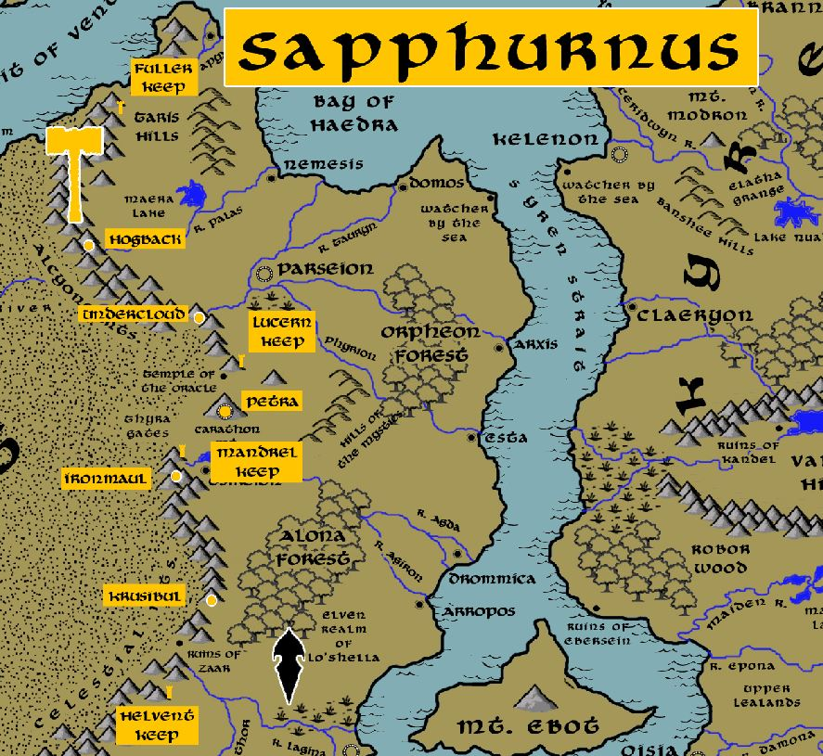

**Location: Alcyone Mountains, Continent of Arnland, bordering the Kingdom of Mythenia**

* **Overview**
* **Towns and Cities**
* **History**
* **Notes on Culture**
* **Magical Items**
* **Developer Notes**

**Overview**

Founded in 840 PA1 by Jornon Sandblud when he led a tribe of Dwarves off from the Kingdom of Emraldren.

Located beneath the Alcyone Mountains in Mythenia, this kingdom has fashioned tunnels that run beneath the Inner Sea and connects with the southernmost tip of the Stonecurtain Mountains in Amadar. Unlike most dwarves, the Sapphurnus dwarves are adept at dealing with marine races that frequent the sub-aquatic tunnels. A common jest is that there be now a race of dwarven mermaids as a result, but it is unwise to mention the joke to a Sapphurnus dwarve. They are more like to brag of slaying sea monsters and adorn their halls with their skulls. Legend tells of Borothin Whetaxe who found the lair of a great serpent in its pool and bent it to his will, riding the seas and killing krakens a thousand years hence. Sapphurnus dwarves brew a heady ale of foamy green that seafaring men call Wetaxe, a nod to the old legend as much as to the bite of the ale itself.

* Very open to outside races, entrepreneurial mindset driven by commerce, very good hagglers and persuaders but also fond of deceit and guile; rumored to be thieves and swindlers
* the best at commerce and trade, haggling and appraisal in all dwarvenkind
* appearance: black skin with red hair and beards
* common attire: very light grays with loose sashes and hoods they wear up over their heads when above ground, always wear a blue sapphire stone on a band around their foreheads
* weapon of choice: bastard sword
* natural enemies: formians, orcs, troglodytes, minotaur
* favored mounts: giant scorpions
* are the most keen of all dwarves in commerce and appraisal, have partnerships formed with Darmiddian merchants
* Custom: master deal makers, Sapphurnus dwarves work trades and bargains into every day conversation with everyone they meet; they will sacrifice what they consider small losses to learn the motives of those with whom they treat; it is common to offer someone a tempting lopsided deal and feign ignorance just to see if they are dealing with the unscrupulous
* Common saying: “Little and lasting is better than much and passing.”

**Towns and Cities**

* Sapphurnus
  + Fuller Keep – small town, population 2,000, guards / soldiers 20, militia 100
  + Hogback – large town, population 5,000, guards / soldiers 50, militia 250
  + Undercloud – large town, population 5,000, guards / soldiers 50, militia 250
  + Lucern Keep – small town, population 2,000, guards / soldiers 20, militia 100
  + Petra – large city, population 25,000, guards / soldiers 250, militia 2250
  + Mandrel Keep – small town, population 2,000, guards / soldiers 20, militia 100
  + Ironmaul – large town, population 5,000, guards / soldiers 50, militia 250
  + Krusibul – large town, population 5,000, guards / soldiers 50, militia 250
  + Helvent Keep – small town, population 2,000, guards / soldiers 20, militia 100

**Fuller Keep**

**Size:** small town, population 2,000, guards / soldiers 20, militia 100

**Trade Goods:**

**Local Goods:**

**Standard:**

**Colors:**

**Ruler:** Benmiir Broadstrike

**Home**:

**Steward**: Elmura Herihart (f)

**Marshal**: Armrim Keenbuster

**House Priest:** Dearbelle Graldikun (f)

**House Adviser (Scholar/Mage/etc):** Muirgrum Lighthorn

**Captain of the Guard**: Emnik Stroram

**Chief Warriors in Service**:

Brandohr Trollblood

Dulgrum Grahaln

Graliggs Glabranehk

**Local Powers:**

**Local Sites:**

**Description:**

**Industry:**

**Key Figures:**

**Local Lore:**

**History:**

**Customs:**

**Hogback**

**Size:** large town, population 5,000, guards / soldiers 50, militia 250

**Trade Goods:**

**Local Goods:**

**Standard:**

**Colors:**

**Ruler:** Bannus Goldshield and his wife Bonnaren (f)

**Home**:

**Steward**: Kharnus Broadforce

**Marshal**: Germor Strongkith

**House Priest:** Krummor Trollgrace

**House Adviser (Scholar/Mage/etc):** Gwenmura Blackpride (f)

**Captain of the Guard**: Armnar Halfhammer

**Chief Warriors in Service**:

Bundrak Todiheg

Hulmar Torthuvik

Brumnur Glutgirum

**Local Powers:**

**Local Sites:**

**Description:**

**Industry:**

**Key Figures:**

**Local Lore:**

**History:**

**Customs:**

**Undercloud**

**Size:** large town, population 5,000, guards / soldiers 50, militia 250

**Trade Goods:**

**Local Goods:**

**Standard:**

**Colors:**

**Ruler:** Tharryl Grayflight and his wife Gemra (f)

**Home**:

**Steward**: Bramgurn Mightmender

**Marshal**: Raenleil Bigbrow (f)

**House Priest:** Jynwin Brightgift (f)

**House Adviser (Scholar/Mage/etc):** Khardohr Daethgaherr

**Captain of the Guard**: Bennom Drodark

**Chief Warriors in Service**:

Dardir Strekehir

Bhardal Lenhinarr

Belmek Fonkeln

**Local Powers:**

**Local Sites:**

**Description:**

**Industry:**

**Key Figures:**

**Local Lore:**

**History:**

**Customs:**

**Lucern Keep**

**Size:** small town, population 2,000, guards / soldiers 20, militia 100

**Trade Goods:**

**Local Goods:**

**Standard:**

**Colors:**

**Ruler:** Bardor Strongkind

**Home**:

**Steward**: Gulgrim Flintpast

**Marshal**: Gulmun Moltenhead

**House Priest:** Daerrielle Battledin (f)

**House Adviser (Scholar/Mage/etc):** Bengrun Graypast

**Captain of the Guard**: Regdahr Fetgonn

**Chief Warriors in Service**:

Hurdren Culbrehem

Brylnia Mollahr (f)

Malnar Frostboot

**Local Powers:**

**Local Sites:**

**Description:**

**Industry:**

**Key Figures:**

**Local Lore:**

**History:**

**Customs:**

**Petra**

**Size:** large city, population 25,000, guards / soldiers 250, militia 2250

**Trade Goods:** mithril, copper, platinum, stone

**Local Goods:**

**Standard:**

**Colors:**

**Ruler:** Thogal Thrdar the Obsidian

**Home**:

**Steward**: Thirnouk Mithrabrand

**Marshal**: Lonaebelynn Steelsunder (f)

**House Priest:**  Deddrim Orcpike

**House Adviser (Scholar/Mage/etc):**  Thazzog Lightmaster

**Captain of the Guard**: Gradum Ironbelly

**Chief Warriors in Service**:

Kinomora Berylkin (f)

Harborli Sedimentor

Bukholin Glintblade

**Local Powers:**

**Local Sites:** Sash and Scroll Inn & Tavern

**Description:**

**Industry:**

**Key Figures:**

**Local Lore:**

**History:**

**Gogrum Caskbreaker** was once king over Sapphurnus two thousand years ago (155 WA2). It is said that **Khaleela**, priestess to the Tarbian god Seker, came to him on a large magical falcon and told her of the Sahaar attacking her city of Skai. Gogrum received her gifts of desert jewels and took pity on her plight. He gifted her a handful of magical stones he called the Seeds of Nemmerle. These she took back and planted along the outer walls of the city in the dark of a moonless night. To her amazement a mountain rose up, lifting the city above the sands. The city was saved and to this day the mountain stands with the city perched atop it.

**Customs:**

**Mandrel Keep**

**Size:** small town, population 2,000, guards / soldiers 20, militia 100

**Trade Goods:**

**Local Goods:**

**Standard:**

**Colors:**

**Ruler:** Bretsael Moltenstand (f)

**Home**:

**Steward**: Krumrak Glunganog

**Marshal**: Nalmura Glodak (f)

**House Priest:** Tymir Bardenom

**House Adviser (Scholar/Mage/etc):** Krommin Deepeye

**Captain of the Guard**: Anlin Tethgik (f)

**Chief Warriors in Service**:

Tydur Gruldonohk

Ragthran Halfaxe

Umren Habrert

**Local Powers:**

**Local Sites:**

**Description:**

**Industry:**

**Key Figures:**

**Local Lore:**

**History:**

**Customs:**

**Ironmaul**

**Size:** large town, population 5,000, guards / soldiers 50, militia 250

**Trade Goods:**

**Local Goods:**

**Standard:**

**Colors:**

**Ruler:** Jenbera Broadroar (f)

**Home**:

**Steward**: Murnum Melluvag

**Marshal**: Torthiel Reldugenn (f)

**House Priest:** Tynum Battlefast

**House Adviser (Scholar/Mage/etc):** Dulnom Bloodfinder

**Captain of the Guard**: Tybrek Darkforge

**Chief Warriors in Service**:

Benmyr Hardfoe

Ermnik Thrumner

Grilrim Muhekaln

**Local Powers:**

**Local Sites:**

**Description:**

**Industry:**

**Key Figures:**

**Local Lore:**

**History:**

**Customs:**

**Krusibul**

**Size:** large town, population 5,000, guards / soldiers 50, militia 250

**Trade Goods:**

**Local Goods:**

**Standard:**

**Colors:**

**Ruler:** Baermyl Truehelm and his wife Enlenna (f)

**Home**:

**Steward**: Gerkahm Lemnegohr

**Marshal**: Thulmun Stoutale

**House Priest:** Grannar Thrumnohk

**House Adviser (Scholar/Mage/etc):** Myrnis Darkmight (f)

**Captain of the Guard**: Grengus Drotgihk

**Chief Warriors in Service**:

Grilgrun Loudlaff

Horiggs Durim

Dulmond Brollenak

**Local Powers:**

**Local Sites:**

**Description:**

**Industry:**

**Key Figures:**

**Local Lore:**

**History:**

**Customs:**

**Helvent Keep**

**Size:** small town, population 2,000, guards / soldiers 20, militia 100

**Trade Goods:**

**Local Goods:**

**Standard:**

**Colors:**

**Ruler:** Krumadin Korbelkin and his wife Brollin (f)

**Home**:

**Steward**: Bardohr Stonerest

**Marshal**: Bhaldrak Bonkegok

**House Priest:** Brulma Boldhand (f)

**House Adviser (Scholar/Mage/etc):** Ebmin Drohuk

**Captain of the Guard**: Galgrim Dongert

**Chief Warriors in Service**:

Gimrom Thrungihk

Marvia Frostbrow (f)

Torwaen Gefdar (f)

**Local Powers:**

**Local Sites:**

**Description:**

**Industry:**

**Key Figures:**

**Local Lore:**

**History:**

**Customs:**

**History**

**First Primordial Age (PA1)**

840 PA1 - Jornon Sandblud leads a company of Dwarves from Darkheim west under the sea and begins the Dwarven Kingdom of Sapphurnus under the Alcyon Mountains in Arnland

**Second Primordial Age (PA2)**

**Third Primordial Age (PA3)**

**Fourth primordial Age (PA4)**

**First Ancient Age (AA1)**

**Second Ancient Age (AA2)**

**Third Ancient Age (AA3)**

**Fourth Ancient Age (AA4)**

140 AA4 - Borothin Whetaxe of Sapphurnus finds the lair of a great serpent in its pool and bends it to his will, riding the seas and slaying terrors of the deep

**First Written Age (WA1)**

**Second Written Age (WA2)**

155 WA2 - Khaleela, priestess to Seker, travels to Dwarven kingdom of Saphurnus; Gogrum Caskbreaker gifts her the Seeds of Nemmyrl, which she uses to create the giant fortifications around Skai

**Third Written Age (WA3)**

**Fourth Written Age (WA4)**

**Notes on Culture**

**Magical Items**

**Developer Notes**

Names: Dwarven names from [www.fantasynamegenerators.com](http://www.fantasynamegenerators.com)

small town, population 2,000, guards / soldiers 20, militia 100

large town, population 5,000, guards / soldiers 50, militia 250

small city, population 12,000, guards / soldiers 120, militia 600

large city, population 25,000, guards / soldiers 250, militia 2250

metropolis, population 50,000, guards / soldiers 500, militia 2500