Notes on the Dwarven Kingdom of Berylor

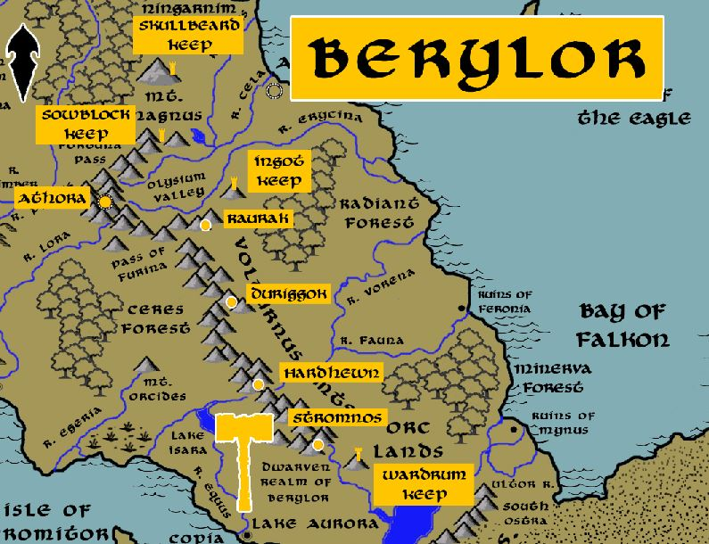

**Location: Volturnus Mountains, Arnland Continent, near the Kingdom of Celedon**

* **Overview**
* **Towns and Cities**
* **History**
* **Notes on Culture**
* **Magical Items**
* **Developer Notes**

**Overview**

One of the four kingdoms founded by the sons of Raknem the Chainbreaker. In 600 PA2 Alforrun Chainbreaker headed out from the Kingdom of Daemunndra and established the Berylor colony.

Located beneath the Volturnus mountains dividing the southern Celedon lands, the Berylor dwarves are a proud and furtive people who have little to nothing to do with the humans of this part of the world. Long ago the Celedon Empire made bitter enemies of the Berylor and to this day any human seen in a Celedon battle uniform will be treated with suspicion. The people of Celedon place great mystical importance on the Berylor and both fear and respect them. It is their belief that the dwarves are related to the mischievous gods of their religion. They respect for their role as allies in battling the orc tribes that have overrun the land since the fall of the great Celedon Empire. The Berylor prefer to leave humans to their beliefs and trade seldomly with them here. Every so often they do impose their control of Fortuna Pass which connects eastern and western shores of Celedon.

* very determined community driven by honor; dangerously xenophobic of other races, an elitist air of dwarven manifest destiny, driven for conquest with designs on larger sections of subterranean lands, possible war with other dwarven kingdoms
* the best at battle strategy and crafting siege weapons in all dwarvenkind
* appearance: black skin with red hair and beards
* Skin bears warts that the dwarves consider very lucky, like stalagmites growing on them
* common attire: banded armor, tie spikes into their beards and use them as pitons and stabbing weapons
* weapon of choice: bastard sword
* natural enemies: formians, orcs, troglodytes
* favored mounts: dire rams
* custom: Berylor dwarves are keenly aware of their surroundings, often breaking off pieces of rock or scooping up soil to taste it; it is not uncommon for a dwarf to offer an outsider a chunk of dirt and ask them to taste it and tell them what they think about it
* common saying: “The weak are meat; the strong eat.”

**Towns and Cities**

* Berylor
  + Skullbeard Keep – small town, population 2,000, guards / soldiers 20, militia 100
  + Sowblock Keep – small town, population 2,000, guards / soldiers 20, militia 100
  + Athora – large city, population 25,000, guards / soldiers 250, militia 2250
  + Ingot Keep – small town, population 2,000, guards / soldiers 20, militia 100
  + Raurak – large town, population 5,000, guards / soldiers 50, militia 250
  + Duriggok – large town, population 5,000, guards / soldiers 50, militia 250
  + Hardhewn – large town, population 5,000, guards / soldiers 50, militia 250
  + Stromnos – large town, population 5,000, guards / soldiers 50, militia 250
  + Wardrum Keep – small town, population 2,000, guards / soldiers 20, militia 100

**Skullbeard Keep**

**Size:** small town, population 2,000, guards / soldiers 20, militia 100

**Trade Goods:**

**Local Goods:**

**Standard:**

**Colors:**

**Ruler:** Karrik Broodhelm and his wife Sarsyl (f)

**Home**:

**Steward**: Gulryl Bubrahk

**Marshal**: Murrus Broaddelver

**House Priest:** Bralleryl Thrabrork (f)

**House Adviser (Scholar/Mage/etc):** Ermnir Coldsong

**Captain of the Guard**: Branmun Graymight

**Chief Warriors in Service**:

Thurnum Munhuck

Rotthrun Gofdukuhr

Daermyl Tabrahr (f)

**Local Powers:**

**Local Sites:**

**Description:**

**Industry:**

**Key Figures:**

**Local Lore:**

**History:**

**Customs:**

**Sowblock Keep**

**Size:** small town, population 2,000, guards / soldiers 20, militia 100

**Trade Goods:**

**Local Goods:**

**Standard:**

**Colors:**

**Ruler:** Hurram Bekenihr and his wife Anvan (f)

**Home**:

**Steward**: Hjoldrak Irontale

**Marshal**: Karwin Strongbeard (f)

**House Priest:** Hjulmus Bigsong

**House Adviser (Scholar/Mage/etc):** Jenndora Lethgirk (f)

**Captain of the Guard**: Therdrom Glafdohek

**Chief Warriors in Service**:

Baldrak Mightbrow

Ummar Foller

Gimgron Strumnehr

**Local Powers:**

**Local Sites:**

**Description:**

**Industry:**

**Key Figures:**

**Local Lore:**

**History:**

**Customs:**

**Athora**

**Size:** large city, population 25,000, guards / soldiers 250, militia 2250

**Trade Goods:** mithril, copper, gold, stone

**Local Goods:**

**Standard:**

**Colors:**

**Ruler:** Darthen Anfik the Stone-Smoother

**Home**:

**Steward**: Nelorok Chainbrek

**Marshal**: Yotun Gildedagger

**House Priest:**  Mablum Nightnose

**House Adviser (Scholar/Mage/etc):**  Noralbena Hillbow (f)

**Captain of the Guard**: Vatrum Magmakin

**Chief Warriors in Service**:

Saldrun Ironmantle (f)

Brokerlun Grayhorn

Groutuck Ironguard

**Local Powers:**

**Local Sites:** The Golden Truss

**Description:**

**Industry:**

**Key Figures:**

**Local Lore:**

**History:**

**Customs:**

**Ingot Keep**

**Size:** small town, population 2,000, guards / soldiers 20, militia 100

**Trade Goods:**

**Local Goods:**

**Standard:**

**Colors:**

**Ruler:** Kromrig Boldfist and his wife Bonnlin (f)

**Home**:

**Steward**: Bharthran Muldok

**Marshal**: Dulgran Mountainhorn

**House Priest:** Rundeth Bankovem (f)

**House Adviser (Scholar/Mage/etc):** Ermtharn Trollbane

**Captain of the Guard**: Malthrun Delbrun

**Chief Warriors in Service**:

Tasvan Glullom (f)

Urmthran Firekith

Umbrek Deepfists

**Local Powers:**

**Local Sites:**

**Description:**

**Industry:**

**Key Figures:**

**Local Lore:**

**History:**

**Customs:**

**Raurak**

**Size:** large town, population 5,000, guards / soldiers 50, militia 250

**Trade Goods:**

**Local Goods:**

**Standard:**

**Colors:**

**Ruler:** Thalmyl Sternaxe and his wife Amra (f)

**Home**:

**Steward**: Ebmur Strertherr

**Marshal**: Umdram Halfflight

**House Priest:** Ragdain Stormfall

**House Adviser (Scholar/Mage/etc):** Barva Deepkith (f)

**Captain of the Guard**: Bromtharm Coldheart

**Chief Warriors in Service**:

Urmmin Grankunerk

Balrig Tobrart

Raenria Keenbeard (f)

**Local Powers:**

**Local Sites:**

**Description:**

**Industry:**

**Key Figures:**

**Local Lore:**

**History:**

**Customs:**

**Duriggok**

**Size:** large town, population 5,000, guards / soldiers 50, militia 250

**Trade Goods:**

**Local Goods:**

**Standard:**

**Colors:**

**Ruler:** Baldus Burthark and his wife Beretra (f)

**Home**:

**Steward**: Thaldrom Dunhugik

**Marshal**: Theltharm Rutgekuck

**House Priest:** Dimwin Glehig (f)

**House Adviser (Scholar/Mage/etc):** Adryl Ironflight

**Captain of the Guard**: Bundrum Mabrack

**Chief Warriors in Service**:

Ermmor Boulderchin

Melrigg Drullaln

Amren Madhandle

**Local Powers:**

**Local Sites:**

**Description:**

**Industry:**

**Key Figures:**

**Local Lore:**

**History:**

**Customs:**

**Hardhewn**

**Size:** large town, population 5,000, guards / soldiers 50, militia 250

**Trade Goods:**

**Local Goods:**

**Standard:**

**Colors:**

**Ruler:** Hurmur Stormbrow and his wife Myrnis (f)

**Home**:

**Steward**: Thormyl Banhokom

**Marshal**: Dolthran Grudar

**House Priest:** Ebgurn Grehuln

**House Adviser (Scholar/Mage/etc):** Bonras Keenstrike (f)

**Captain of the Guard**: Daerren Lightbreaker

**Chief Warriors in Service**:

Addain Bronzegrace

Benkuhm Firstboots

Mistrin Mellert (f)

**Local Powers:**

**Local Sites:**

**Description:**

**Industry:**

**Key Figures:**

**Local Lore:**

The copper dragon Coderiex dwells just north of here in the Volturnus Mountains.

**History:**

**Customs:**

**Stromnos**

**Size:** large town, population 5,000, guards / soldiers 50, militia 250

**Trade Goods:**

**Local Goods:**

**Standard:**

**Colors:**

**Ruler:** Hurmar Stonetale and his wife Jarya (f)

**Home**:

**Steward**: Hurren Brulbrorr

**Marshal**: Thorthrum Deepdrum

**House Priest:** Brylleniss Stoutbeard (f)

**House Adviser (Scholar/Mage/etc):** Emthrun Silverchin

**Captain of the Guard**: Daerkam Stouthelm

**Chief Warriors in Service**:

Dulryl Fozzuverk

Hormund Fathgekem

Beradin Denbreaker

**Local Powers:**

**Local Sites:**

**Description:**

**Industry:**

**Key Figures:**

**Local Lore:**

**History:**

**Customs:**

**Wardrum Keep**

**Size:** small town, population 2,000, guards / soldiers 20, militia 100

**Trade Goods:**

**Local Goods:**

**Standard:**

**Colors:**

**Ruler:** Garmin Everbrow

**Home**:

**Steward**: Krummyr Strerek

**Marshal**: Dalram Gunkurag

**House Priest:** Edbera Hammerbane (f)

**House Adviser (Scholar/Mage/etc):** Galmor Hardfist

**Captain of the Guard**: Nysvia Brawnstand (f)

**Chief Warriors in Service**:

Mistri Dereck (f)

Meldus Torthanohr

Vongurn Wildforge

**Local Powers:**

**Local Sites:**

**Description:**

**Industry:**

**Key Figures:**

**Local Lore:**

**History:**

**Customs:**

**History**

**First Primordial Age (PA1)**

**Second Primordial Age (PA2)**

600 PA2 - Alforrun of the Five Brothers departs Daemundra and goes south under the sea to establish the Dwarven Kingdom of Berylor

**Third Primordial Age (PA3)**

**Fourth primordial Age (PA4)**

**First Ancient Age (AA1)**

**Second Ancient Age (AA2)**

**Third Ancient Age (AA3)**

**Fourth Ancient Age (AA4)**

**First Written Age (WA1)**

940 WA1 - (Berylor) War of Sorannus - Orc tribes the Acarnan, Volturnus, and Tauran Mountains rise up behind the wizard Sorannus to invade Celedon lands

960 WA1 - Massacre at Furina - Dwarves of Berylor and Elves of Arbeona are defeated by the Orcs of Sorannus at Furina Pass in Celedon

990 WA1 - Massacre of Atia Vale - Dwarves of Berylor are defeated by the Orcs of Sorannus in Atia Vale in Celedon

**Second Written Age (WA2)**

**Third Written Age (WA3)**

380 WA3 - Battle of Volturnus - Elves of Arbeona are joined by the Dwarves of Berylor in defeating the **Black Widow Queen Sethria** of the Drow

**Fourth Written Age (WA4)**

**Notes on Culture**

**Magical Items**

**Developer Notes**

Names: Dwarven names from [www.fantasynamegenerators.com](http://www.fantasynamegenerators.com)