Notes on the Dwarven Kingdom of Agatren

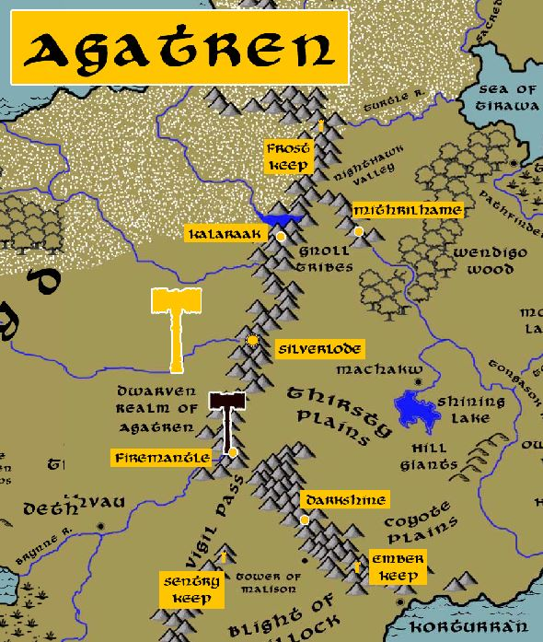

**Location: Silvercap Mountains, Lands of Hyderis**

* **Overview**
* **Towns and Cities**
* **History**
* **Notes on Culture**
* **Magical Items**
* **Developer Notes**

**Overview**

Founded in 40 PA3 by Torelgren Truetower, splitting off from the Kingdom of Garnettren.

Agatren dwarves are a

Agatren shares a strong bond with the kingdom of Garnettren to the west. Dwarves from the two kingdoms have physical traits in common, namely the long earlobes, prodigious noses, and the occasional extra toe that folks in these parts call a “**tren-toe**” and consider it a mark of good luck. Both kingdoms have shared bloodlines, originating back from when Agatren split-off in the Third Primordial Age, also because intermarriage between the two kingdoms is common.

The two kingdoms also share the struggle against the dark forces that bubble up from the lands around the Oberon Sea. Orc, goblin, and gnoll armies have ruled the lands between the Stonecurtain Mountains and the Direfrost Mountains for the last four thousand years since the Scourge of Hrolith. It has been a never-ending struggle for both dwarven kingdoms as these creatures ceaselessly encroach into their mountains. Both kingdoms have sworn oaths to come to the aide of the other in times of crisis. One tradition the dwarves hold is the **Ringing of the Rings**. Captains in the armies from either kingdom are given rings bearing two stones: a garnet and an agate, crafted in the form of a hammer and anvil. Whenever companies from both kingdoms meet, it is customary for them to strike the rings together, creating a loud thunderclap that sounds like a hammer striking an anvil.

* a paranoid and suspicious community who keeps away from the affairs of other races, wary after years of dealing with dark forces in the region, clever mindset working out schemes and traps, considered master strategists
* the best at stealth, camouflage, spy craft, and trapmaking
* appearance: dark brown skin and hair
* common attire: browns and greys, usually featuring stripes or bands
* weapon of choice: dwarven waraxe
* natural enemies: duergar, gnolls, orcs, goblins
* favored mounts: dire boars
* long earlobes, prodigious noses, and the occasional extra toe that folks in these parts call a “**tren-toe**” and consider it a mark of good luck; tight bond with Garnettren sharing bloodlines as well as mutual war with dark forces in Central Amadar; captains wear rings that are struck together when their armies meet
* custom: Agatren dwarves are incurable pranksters, they range from simple tricks to constructing elaborate ruses that are performed on one another and on strangers with the mindset to always keep one’s mind sharp and be prepared
* common saying: “A hole can be a trap or a home. Just depends on what you put in it.”

**Towns and Cities**

* Agatren
  + Frost Keep – small town, population 2,000, guards / soldiers 20, militia 100
  + Kalaraak – large town, population 5,000, guards / soldiers 50, militia 250
  + Mithrilhame – large town, population 5,000, guards / soldiers 50, militia 250
  + Silverlode – large city, population 25,000, guards / soldiers 250, militia 2250
  + Firemantle – large town, population 5,000, guards / soldiers 50, militia 250
  + Darkshine – large town, population 5,000, guards / soldiers 50, militia 250
  + Sentry Keep – small town, population 2,000, guards / soldiers 20, militia 100
  + Ember Keep – small town, population 2,000, guards / soldiers 20, militia 100

**Frost Keep**

**Size:** small town, population 2,000, guards / soldiers 20, militia 100

**Trade Goods:**

**Local Goods:**

**Standard:**

**Colors:**

**Ruler:** Muirduhr Sternhorn and his wife Niswin (f)

**Home**:

**Steward**: Gargurn Bredogerr

**Marshal**: Ketthiel Boulderbane (f)

**House Priest:** Nesryl Mebrokar (f)

**House Adviser (Scholar/Mage/etc):** Melrak Lastkith

**Captain of the Guard**: Admor Tulbrok

**Chief Warriors in Service**:

Gremnir Bokonn

Torgarn Thruzzorr

Bentharn Bankak

**Local Powers:**

**Local Sites:**

**Description:**

**Industry:**

**Key Figures:**

**Local Lore:**

The white dragon **Aukstuma** dwells just north of here in the Direfrost Mountains, while the gold dragon **Gudraiseth** dwells just south of here in the Direfrost Mountains.

**History:**

**Customs:**

**Kalaraak**

**Size:** large town, population 5,000, guards / soldiers 50, militia 250

**Trade Goods:**

**Local Goods:**

**Standard:**

**Colors:**

**Ruler:** Kathlynn Bartheln (f)

**Home**:

**Steward**: Mormur Glathgirt

**Marshal**: Jynris Goldguard (f)

**House Priest:** Harrus Lastbleeder

**House Adviser (Scholar/Mage/etc):** Eindille Duhivann (f)

**Captain of the Guard**: Murtharn Hardbane

**Chief Warriors in Service**:

Krumdahr Lastbreaker

Muirmund Boldtale

Rotryl Brutgan

**Local Powers:**

**Local Sites:**

**Description:**

**Industry:**

**Key Figures:**

**Local Lore:**

**History:**

**Customs:**

**Mithrilhame**

**Size:** large town, population 5,000, guards / soldiers 50, militia 250

**Trade Goods:**

**Local Goods:**

**Standard:**

**Colors:**

**Ruler:** Adryl Brafderr

**Home**:

**Steward**: Misma Strukehr

**Marshal**: Gremnir Bokonn

**House Priest:** Lesdora Mukevir (f)

**House Adviser (Scholar/Mage/etc):** Armadin Tufdogerr

**Captain of the Guard**: Hulnir Hulbruck

**Chief Warriors in Service**:

Rynbelle Glezzin (f)

Bentharn Bankak

Galren Drunkeyes

**Local Powers:**

**Local Sites:**

**Description:**

**Industry:**

**Key Figures:**

**Local Lore:**

**History:**

**Customs:**

**Silverlode**

**Size:** large city, population 25,000, guards / soldiers 250, militia 2250

**Trade Goods:** mithril, silver, gems, stone

**Local Goods:**

**Standard:**

**Colors:**

**Ruler:** Gardarek Korimar the Flintsplit

**Home**:

**Steward**: Houdun Flatshoulder

**Marshal**: Sikherlig Greystrat

**House Priest:**  Bubik Frostbeard

**House Adviser (Scholar/Mage/etc):**  Vamror Woldsunder

**Captain of the Guard**: Dhuddere Onyxfeet (f)

**Chief Warriors in Service**:

Lurmengra Alegut (f)

Horlig Warmheart

Norstag Honorbroad

**Local Powers:** Band of the Thulgen (order of rangers)

**Local Sites:** The Cracked Keystone Inn & Tavern

**Description:**

**Industry:**

**Key Figures:**

**Local Lore:**

**History:**

**Customs:**

**Firemantle**

**Size:** large town, population 5,000, guards / soldiers 50, militia 250

**Trade Goods:**

**Local Goods:**

**Standard:**

**Colors:**

**Ruler:** Ermman Gonhekarr and his wife Lysswynn (f)

**Home**:

**Steward**: Rynthel Sternkith (f)

**Marshal**: Einla Halfstrike (f)

**House Priest:** Thogrum Halffury

**House Adviser (Scholar/Mage/etc):** Emdal Darkeye

**Captain of the Guard**: Dargurn Brulbren

**Chief Warriors in Service**:

Ragmund Glomnunn

Krommyr Brumnen

Beldor Battlefall

**Local Powers:**

**Local Sites:**

**Description:**

**Industry:**

**Key Figures:**

**Local Lore:**

**History:**

**Customs:**

**Darkshine**

**Size:** large town, population 5,000, guards / soldiers 50, militia 250

**Trade Goods:**

**Local Goods:**

**Standard:**

**Colors:**

**Ruler:** Brylria Luhakenn (f)

**Home**:

**Steward**: Thydahr Moltenboot

**Marshal**: Hjalthran Bunkahk

**House Priest:** Grenthrun Baekart

**House Adviser (Scholar/Mage/etc):** Torgarn Thruzzorr

**Captain of the Guard**: Maerlyl Duher (f)

**Chief Warriors in Service**:

Gimgrum Trollroar

Gerbrek Boldbreaker

Baerdal Bravebreath

**Local Powers:**

**Local Sites:**

**Description:**

**Industry:**

**Key Figures:**

**Local Lore:**

Jaleirys the brass dragon dwells near here in the mountains.

**History:**

**Customs:**

**Sentry Keep**

**Size:** small town, population 2,000, guards / soldiers 20, militia 100

**Trade Goods:**

**Local Goods:**

**Standard:**

**Colors:**

**Ruler:** Maldram Hammersong

**Home**:

**Steward**: Gwanrielle Cenkehr (f)

**Marshal**: Thodir Grenkun

**House Priest:** Grenrom Darkward

**House Adviser (Scholar/Mage/etc):** Bargrim Lightfinder

**Captain of the Guard**: Braendille Grurtheguk (f)

**Chief Warriors in Service**:

Rynras Bigkith (f)

Emgrim Evertankard

Adnir Burrowfront

**Local Powers:**

**Local Sites:**

**Description:**

**Industry:**

**Key Figures:**

**Local Lore:**

**History:**

**Customs:**

**Ember Keep**

**Size:** small town, population 2,000, guards / soldiers 20, militia 100

**Trade Goods:**

**Local Goods:**

**Standard:**

**Colors:**

**Ruler:** Tazva Rulbrevar (f)

**Home**:

**Steward**: Dolmyl Drofden

**Marshal**: Horryl Hammerfront

**House Priest:** Jenbera Tonhehr (f)

**House Adviser (Scholar/Mage/etc):** Kaitria Barthikart (f)

**Captain of the Guard**: Granmor Lonhavar

**Chief Warriors in Service**:

Therdrom Goblinrest

Graldek Cunkenack

**Local Powers:**

**Local Sites:**

**Description:**

**Industry:**

**Key Figures:**

**Local Lore:**

**History:**

**Customs:**

**History**

**First Primordial Age (PA1)**

**Second Primordial Age (PA2)**

**Third Primordial Age (PA3)**

40 PA3 - Torelgren Truetower leads a tribe of Dwarves from Garnettren and heads east and begins the Dwarven Kingdom of Agatren in the Direfrost Mountains

490 PA3 - Quillock defeated by an alliance between humans and the Dwarves of Agatren

**Fourth primordial Age (PA4)**

**First Ancient Age (AA1)**

481 AA1 - The Sybalite War - Dwarves from Daemundra, Garnettren, and Agatren converge on the Stonecurtain Mountains to rescue the Sybalite and stop Gergerim

492 AA1 - end of the Sybalite War - After years of bloody conquest the armies of Gergerim are defeated and the Sybalite restored to Daemundra

**Second Ancient Age (AA2)**

**Third Ancient Age (AA3)**

**Fourth Ancient Age (AA4)**

210-340 AA4 - Scourge of Hrolith - Orcs unite under the warlord Hrolith and sweep across Central Amadar

240 AA4 - Fall of the Kingdom of Aldavel; Dwarven forces of Agatren, fighting for years to aid the humans, are defeated by Hrolith's forces and forced to retreat back into their mountains

**First Written Age (WA1)**

**Second Written Age (WA2)**

720 WA2 - Mortavay unites orc tribes and marches east into Haka'Na lands; wipes out Machakw, attacks Turuwe and Hurit

721 WA2 - Dwarven armies of Agatren are defeated by Mortavay and their mountain halls invaded

732 WA2 - Dwarven Kingdom of Garnettren fights a desperate losing battle to counter Mortavay's forces in Central Amadar

747 WA2 - Dwarven Kingdoms of Garnettren and Agatren destroy the last of Mortavay's invaders and are liberated

**Third Written Age (WA3)**

**Fourth Written Age (WA4)**

**Notes on Culture**

**Magical Items**

**Developer Notes**

Names: Dwarven names from [www.fantasynamegenerators.com](http://www.fantasynamegenerators.com)

small town, population 2,000, guards / soldiers 20, militia 100

large town, population 5,000, guards / soldiers 50, militia 250

small city, population 12,000, guards / soldiers 120, militia 600

large city, population 25,000, guards / soldiers 250, militia 2250

metropolis, population 50,000, guards / soldiers 500, militia 2500