Notes on the Dwarven Kingdom of Citerak

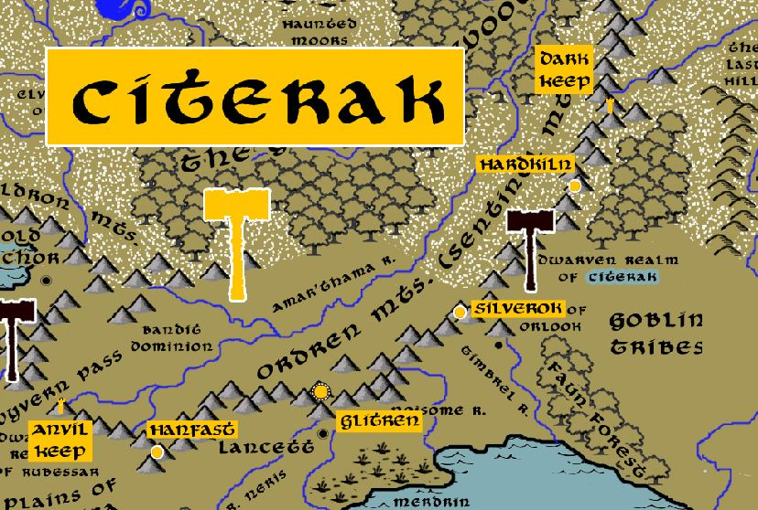

**Location: Ordren Mountains, Western Amadar, between the Kingdom of Plenia and the lost northern lands**

* **Overview**
* **Towns and Cities**
* **History**
* **Notes on Culture**
* **Magical Items**
* **Developer Notes**

**Overview**

One of the four kingdoms founded by the sons of **Raknem the Chainbreaker**. In 540 PA2 **Strokkol Chainbreaker** headed out from the Kingdom of Daemunndra and established the Citerak colony.

The Dwarven kingdom of Citerak is located in the Ordren Mountains in the northern reaches of Western Amadar. They are rumored to have tapped a magma fissure deep in the earth that now feeds a mighty furnace named **Yaramir**. This furnace has enabled the Dwarves to forge weapons and tools of unique strength and qualities and has diverted their attention from mining to forging. The dwarves of Citerak are commonly red-faced and red-haired, thought to come from centuries of tending the hot fires of the mighty Yaramir. They are quick to temper and tend to avoid complicated conversations in favor of using their fists to settle problems.

Citerak along with their neighbor Rubelor are constantly in a state of war with the orc and goblins in this part of the world. Citerak’s main hall is reputed to host the largest collection of goblin skulls in the world, rivaled by the orc collection hosted by Rubelor. In fact, the two kingdoms enjoy a rivalry with one another as to which trophy collection is larger.

Two dragons of renown live in the Cauldron Mountains: **Evior**, the silver dragon, in the south and **Malisus**, the white dragon, in the far north

* a reclusive community of very dedicated artisans and engineers who specialize in blacksmithing and metal working; are ill at ease with dialogue and are consumed by their work; quick tempered and tend to fight before talking; known to forge tools and large metal structures of unique strength and qualities
* the best at smithing / forging / metal works in all dwarvenkind
* appearance: red-faced with auburn or red hair - appearance comes from working for centuries near the hottest of all dwarven forges: the Yaramir.
* common attire: dragon scales as a form of prestige, red dragon scales a favorite
* weapon of choice: greataxe
* natural enemies: orcs, goblins, ogres, fire giants
* favored mounts: giant beetles
* shares a strong bond with Rubelor over fighting the dark forces of the north together and enjoy a rivalry over their trophy collections
* custom: tossing valuable items into a fire for good luck, thinking it shows the gods one embraces the conflicts ahead rather than the treasures to be gained from them
* Common saying: “Life is a crucible. Never fear the proving.”

**Towns and Cities**

* Citerak
  + Anvil Keep – small town, population 2,000, guards / soldiers 20, militia 100
  + Hanfast – large town, population 5,000, guards / soldiers 50, militia 250
  + Glitren – large city, population 25,000, guards / soldiers 250, militia 2250
  + Silverok – large town, population 5,000, guards / soldiers 50, militia 250
  + Hardkiln – large town, population 5,000, guards / soldiers 50, militia 250
  + Dark Keep – small town, population 2,000, guards / soldiers 20, militia 100

**Anvil Keep**

**Size:** small town, population 2,000, guards / soldiers 20, militia 100

**Trade Goods:**

**Local Goods:**

**Standard:**

**Colors:**

**Ruler:** Ebron Coldfist

**Home**:

**Steward**: Brolbera Truestrike (f)

**Marshal**: Belmyr Hardguard

**House Priest:** Grilkohm Smugpride

**House Adviser (Scholar/Mage/etc):** Gwinlynn Marblefist (f)

**Captain of the Guard**: Tormund Ironstorm

**Chief Warriors in Service**:

Melthrum Lunknek

Magrim Goldhart

Krammin Graystand

**Local Powers:**

**Local Sites:**

**Description:**

**Industry:**

**Key Figures:**

**Local Lore:**

Evior the Silver Dragon dwells in the Ordren Mts near here.

**History:**

**Customs:**

**Hanfast**

**Size:** large town, population 5,000, guards / soldiers 50, militia 250

**Trade Goods:**

**Local Goods:** Hanfast Dwarves excel in the art of siege warfare as well as siege defenses. The entire town is reinforced and bristling with defense works. The best battering rams and other weapons are built here and named before being sent into service throughout the kingdom and abroad.

**Standard:**

**Colors:**

**Ruler:** Dhukhoserd Brighthead (f)

**Home**:

**Steward**: Muvraeg Hammergut

**Marshal**: Norazouth Beastbelly

**House Priest:**  Berger Blessedhead

**House Adviser (Scholar/Mage/etc):**  Durifreas Emberbasher

**Captain of the Guard**: Dukdreabyrn Bloodforged (f)

**Chief Warriors in Service**:

Loggudeth Iceguard (f)

Umisgrud Twilightshaper

Brourumlin Dragonback

**Local Powers:**

**Local Sites:**

**Description:**

**Industry:**

**Key Figures:**

**Local Lore:**

**History:**

**Customs:**

**Glitren**

**Size:** large city, population 25,000, guards / soldiers 250, militia 2250

**Trade Goods:** mithril, gems, religious center, stone

**Local Goods:** Glittren lives up to its name, as the Dwarves here are master gem cutters and polishers.

**Standard:**

**Colors:**

**Ruler:** Agaro Tongar the Smelt Breaker

**Home**:

**Steward**: Hamrea Sapphrek (f)

**Marshal**: Bruggi Wyvernkelt

**House Priest:**  Frokhud Blackbrik

**House Adviser (Scholar/Mage/etc):**  Setheak Jadejaw

**Captain of the Guard**: Thiberlig Forgekin

**Chief Warriors in Service**:

Erigga Hardchin (f)

Hulgred Orrock

Brouken Dourmace

**Local Powers:** Order of the Crucible (order of paladins)

**Local Sites:** The Bartizan Inn & Tavern

**Description:**

**Industry:**

**Key Figures:**

**Local Lore:**

**History:**

**Customs:**

**Silverok**

**Size:** large town, population 5,000, guards / soldiers 50, militia 250

**Trade Goods:**

**Local Goods:** The Dwarves of Silverok are master weapons makers.

**Standard:**

**Colors:**

**Ruler:** Tharhomi Forgebuster

**Home**:

**Steward**: Skatdrat Giantforge

**Marshal**: Skonwaebelynn Deepblade (f)

**House Priest:**  Brounmuck Amberfury

**House Adviser (Scholar/Mage/etc):**  Umigneline Ashjaw (f)

**Captain of the Guard**: Toregrol Earthmaul

**Chief Warriors in Service**:

Grabaes Dragonhide

Dorabaen Bonebeard

Whufobelle Bittercloak (f)

**Local Powers:**

**Local Sites:**

**Description:**

**Industry:**

**Key Figures:**

**Local Lore:**

**History:**

**Customs:**

**Hardkiln**

**Size:** large town, population 5,000, guards / soldiers 50, militia 250

**Trade Goods:**

**Local Goods:** the people of Hardkiln are fond of working with clays found deep in the ground and working them into magnificent ceramic works of art as well as durable goods. This may not seem like typical Dwarf craftsmanship, but the workers of Hardkiln have seen the potential in this otherwise discarded material.

**Standard:**

**Colors:**

**Ruler:** Broumdog Metalbrand

**Home**:

**Steward**: Thuzarlug Whitrock

**Marshal**: Lukgrout Lightbrew

**House Priest:**  Lukgrout Lightbrew

**House Adviser (Scholar/Mage/etc):**  Daresoc Metalarm

**Captain of the Guard**: Groorhirlum Onyxfeet

**Chief Warriors in Service**:

Dhukrik Kegbelly

Dhonath Ashtank

Norsumi Rubystone

**Local Powers:**

**Local Sites:**

**Description:**

**Industry:**

**Key Figures:**

**Local Lore:**

**History:**

**Customs:**

**Dark Keep**

**Size:** small town, population 2,000, guards / soldiers 20, militia 100

**Trade Goods:**

**Local Goods:**

**Standard:**

**Colors:**

**Ruler:** Erithic Nightbreaker

**Home**:

**Steward**: Alfotraelyn Koldkiln (f)

**Marshal**: Thrakkuc Forgemantle

**House Priest:**  Beldrack Thunderbranch

**House Adviser (Scholar/Mage/etc):**  Rukkusli Marblesword (f)

**Captain of the Guard**: Tharhack Shatterbeard

**Chief Warriors in Service**:

Demorlun Whitmail

Thivroud Leadhead

Bhargack Bouldergrip

**Local Powers:**

**Local Sites:**

**Description:**

**Industry:**

**Key Figures:**

**Local Lore:**

Malisus the white dragon dwells in this part of the Ordren Mountains.

**History:**

**Customs:**

**History**

**First Primordial Age (PA1)**

**Second Primordial Age (PA2)**

540 PA2 - Strokkol of the Five Brothers departs Daemundra and goes north to establish the Dwarven Kindgom of Citerak

**Third Primordial Age (PA3)**

720 PA3 - The Silver War - Phrane armies storm the Dwarven kingdom of Citerak, triggering bloody war for a century

830 PA3 - End of the Silver War in Citerak

**Fourth primordial Age (PA4)**

**First Ancient Age (AA1)**

870 AA1 - the dwarves of Citerak tap a magma fissure so great it feeds a mighty furnace they name Yaramir

**Second Ancient Age (AA2)**

**Third Ancient Age (AA3)**

850-873 AA3 - Great Orc War of the West

851 AA3 - The Great Orc Army splits into four forces: The Banners of Blood, Bone, Claw, and Teeth; Blood and Bone march west, Claw invades the Dwarven Kingdom of Citerak, Teeth marches east into the Friendless Fringes

852 AA3 - Dwarves of Rubelor march to Citerak to aide their brethren

853 AA3 - Orcs of the Claw Banner conquer Dark Keep, Hardkiln, and Silverok

854 AA3 - Banner of Claw takes Glitren and holds off reinforcements from Rubelor

854 AA3 - the legendary Five Hammers of the Deep are lost in the ensuing battles

855 AA3 - Orcs of the Teeth Banner meet the Dwarves of Daemundra at Long Keep in the Evermore Mountains and defeat them; Orc forces cross the Evermore Mountains into Erigoth

857 AA3 - Orcs of the Claw lure Rubelor and Citerak forces into Glitren and unleash demons from a deep fissure they have created

858-872 AA3 - fighting continues off and on around the Plenish Marches, Bane Wood, the Gunnar Gap, and the Plains of Arbock

873 AA3 - a series of victories over the Orcs drive them back from the Plenish Marches and the lands east of the Evermore Mountains

**Fourth Ancient Age (AA4)**

**First Written Age (WA1)**

**Second Written Age (WA2)**

230-250 WA2 - War of the Gray Ghosts: Duergar spies infiltrate the Kingdom of Rubelor, open the gates to a Duergar invasion by their warlord Koggar the Clever

235 WA2 - hero Erlond Durhak falls protecting the Hall of Rubelor from being razed by Duergar mercenaries

250 WA2 - reinforcements from Citerak save the Dwarves of Western Amadar from destruction at the hands of the Duergar invasion; Koggar's head is mounted as a trophy in Rubelor Hall

**Third Written Age (WA3)**

640-670 WA3 - Second Dark Crusade

642 WA3 - Mortavay's forces invade Dwarven Kingdom of Garnettran; a second front opens south at Tarvos Pass

644 WA3 - Dwarven kingdoms of Daemundra, Citerak, and Rubelor dispatch armies to join the fight

644 WA3 - Battle of Tarvos: Dwarves of Garnettren join Tirudoran forces to stop Mortavay at Tarvos Pass; Mortavay destroys the human and dwarven host and continues westward

662 WA3 - Elves of Ari'Aahn join with the Dwarves of Garnettren to aide the humans in encircling Mortavay's forces in Erigoth

663 WA3 - Trevilish and Tirudoran cities still free rally to attack Mortavay's center forces, cutting them off from the east; joined by the Elves of Ulynar attacking from Tredfut Forest

665 WA3 - Dwarves of Citerak and Rubelor rouse from their mountains and attack Mortavay's forces in Gremira

670 - Mortavay defeated; end of the Second Dark Crusade

**Fourth Written Age (WA4)**

**Notes on Culture**

Citerak dwarves tend to appear as red-faced dwarves with auburn or red hair, they are quick tempered and tend to fight before talking. It is believed their appearance comes from working for centuries near the hottest of all dwarven forges: the Yaramir. Dwarves here have diverted their attention from mining to forging, are known to forge weapons and tools of unique strength and qualities. Citerak along with their neighbor Rubelor are constantly in a state of war with the orcs and goblins in this part of the world and therefore the two kingdoms share a strong bond. Citerak and Rubelor enjoy a rivalry with one another and boast about which has the largest trophy collection of orc and goblin heads.

**Magical Items**

**Developer Notes**