Notes on the Dwarven Kingdom of Turquorzem

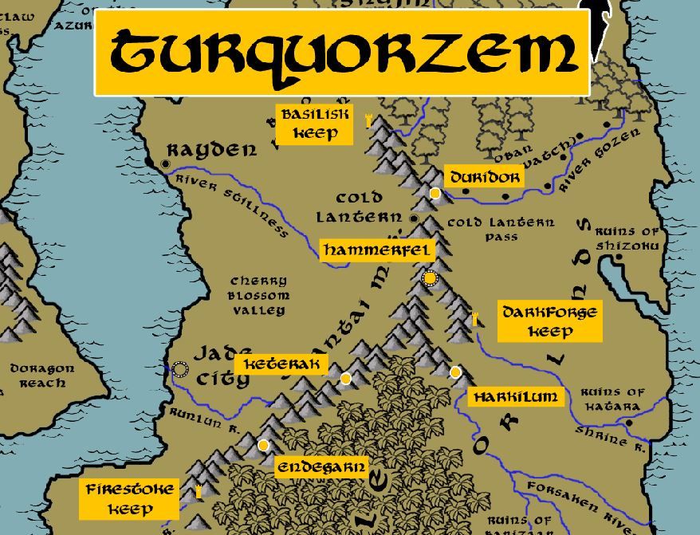

**Location: Shantai Mountains, Kingdom of Sakura**

* **Overview**
* **Towns and Cities**
* **History**
* **Notes on Culture**
* **Magical Items**
* **Developer Notes**

**Overview**

In 210 PA3 **Hagguda Fireforge** refused to marry her father's choice of suitor. She delved beneath the Kamatsu Strait and found the Domaru Mountains where she founded the Turquorzem Kingdom

* A stoic and proud community that hails the virtue of precision and incorporates it into all of their work; by far the greatest stonemasons of all dwarvenkind, capable of engineering breathtaking structures and sculptures that are out of reach of most master masons and stone smiths. Difficult to talk to or understand, they are often misunderstood but are highly sought after for their advice.
* the best at stone masonry, architecture, and engineering in all dwarvenkind
* appearance: light brown skin with gray hair; braid their hair and beards in a fashion that carries a symbolic meaning
* Tend to talk in mumbling tones that are hard to understand for non-dwarves. Very impersonable.
* Common attire: bandoliers stocked with a wide array of masterwork mason’s hammers and chisels. Wear leather lacings and tassels: Work the sinews of giant beasts into leather cords that they lace into their armor and clothing, feature tassels of bright colors to designate their station
* weapon of choice: dire flail
* natural enemies: drow, spirit naga, driders, beholders
* favored mounts: giant beetle
* custom: Turqorzem dwarves are obsessed with balance and will adjust objects they come across to restore symmetry or balance, including rearranging random stones or even items on another person
* common saying: “even the tallest mountain begins underground”

**Towns and Cities**

* Turquorzem
  + Basilisk Keep – small town, population 2,000, guards / soldiers 20, militia 100
  + Duridor – large town, population 5,000, guards / soldiers 50, militia 250
  + Hammerfel – large city, population 25,000, guards / soldiers 250, militia 2250
  + Darkforge Keep – small town, population 2,000, guards / soldiers 20, militia 100
  + Keterak – large town, population 5,000, guards / soldiers 50, militia 250
  + Harkilum – large town, population 5,000, guards / soldiers 50, militia 250
  + Firestoke Keep – small town, population 2,000, guards / soldiers 20, militia 100
  + Endegarn – large town, population 5,000, guards / soldiers 50, militia 250

**Basilisk Keep**

**Size:** small town, population 2,000, guards / soldiers 20, militia 100

**Trade Goods:**

**Local Goods:**

**Standard:**

**Colors:**

**Ruler:** Huldar Deepguard

**Home**:

**Steward**: Tasmyla Branhohk (f)

**Marshal**: Balgus Lightfist

**House Priest:** Helfin Hardgrace

**House Adviser (Scholar/Mage/etc):** Magaram Frosteye

**Captain of the Guard**: Morgrum Mightstorm

**Chief Warriors in Service**:

Amgron Rufduk

Malkam Panhole

Hurnom Nubbin

**Local Powers:**

**Local Sites:**

**Description:**

**Industry:**

**Key Figures:**

**Local Lore:**

**History:**

**Customs:**

**Duridor**

**Size:** large town, population 5,000, guards / soldiers 50, militia 250

**Trade Goods:**

**Local Goods:**

**Standard:**

**Colors:**

**Ruler:** Gremmus Broodhorn

**Home**:

**Steward**: Amnir Deepforge

**Marshal**: Roduhr Trollfell

**House Priest:** Thynom Hardmantle

**House Adviser (Scholar/Mage/etc):** Rejikom “Rej” Hotmire

**Captain of the Guard**: Mardelle Bronzeback (f)

**Chief Warriors in Service**:

Thulkum Broodekor

Garkum Donhir

Balaria Starkkin (f)

**Local Powers:**

**Local Sites:**

**Description:**

**Industry:**

**Key Figures:**

**Local Lore:**

**History:**

**Customs:**

**Hammerfel**

**Size:** large city, population 25,000, guards / soldiers 250, militia 2250

**Trade Goods:**

**Local Goods:**

**Standard:**

**Colors:**

**Ruler:** Vamweg Glyntdagger (f)

**Home**:

**Steward**: Korsim Delvemaster

**Marshal**: Nomuth Anvilchin

**House Priest:**  Bomun Steelhelm

**House Adviser (Scholar/Mage/etc):**  Nuruldi Barrelbelt

**Captain of the Guard**: Gowebelyn Bittermantle (f)

**Chief Warriors in Service**:

Thandroli Coinstruk

Thraldi Gemhelm

Radragin Volcanis

**Local Powers:**

**Local Sites:** Flint and Flask Inn & Tavern

**Description:**

**Industry:**

**Key Figures:**

**Local Lore:**

**History:**

**Customs:**

**Darkforge Keep**

**Size:** small town, population 2,000, guards / soldiers 20, militia 100

**Trade Goods:**

**Local Goods:**

**Standard:**

**Colors:**

**Ruler:** Grangrim Ironmask

**Home**:

**Steward**: Belkom Brightale

**Marshal**: Hjuldren Faherek

**House Priest:** Brydilla Tharinel (f)

**House Adviser (Scholar/Mage/etc):** Banmyl Crystaltoe

**Captain of the Guard**: Amdrek Marbleale

**Chief Warriors in Service**:

Thorgrim Threren

Gembrek Stralbarr

Murrom Bigkin

**Local Powers:**

**Local Sites:**

**Description:**

**Industry:**

**Key Figures:**

**Local Lore:**

**History:**

**Customs:**

**Keterak**

**Size:** large town, population 5,000, guards / soldiers 50, militia 250

**Trade Goods:**

**Local Goods:**

**Standard:**

**Colors:**

**Ruler:** Marwaen Silverkin (f)

**Home**:

**Steward**: Admond Smugpass

**Marshal**: Thormus Thrunhillen

**House Priest:** Ednia Trulith (f)

**House Adviser (Scholar/Mage/etc):** Vonigg Bronikuhr

**Captain of the Guard**: Belren Gladaxe

**Chief Warriors in Service**:

Beldrak Fuldohk

Daernur Grellurk

Bertyl Marblefist (f)

**Local Powers:**

**Local Sites:**

**Description:**

**Industry:**

**Key Figures:**

**Local Lore:**

The copper dragon **Kireina** dwells just north of here in the Domaru Mountains.

**History:**

**Customs:**

**Harkilum**

**Size:** large town, population 5,000, guards / soldiers 50, militia 250

**Trade Goods:**

**Local Goods:**

**Standard:**

**Colors:**

**Ruler:** Khariggs Ironbeard and his wife Nesnura (f)

**Home**:

**Steward**: Gwansyl Greatstrike (f)

**Marshal**: Magren Halfbrow

**House Priest:** Hjolmiir Drelbrugenn

**House Adviser (Scholar/Mage/etc):** Marsyl Darkstand (f)

**Captain of the Guard**: Guldir Frozenblood

**Chief Warriors in Service**:

Thalryl Fankann

Kharkum Strozzurk

Muirbrek Lellann

**Local Powers:**

**Local Sites:**

**Description:**

**Industry:**

**Key Figures:**

**Local Lore:**

**History:**

**Customs:**

**Firestoke Keep**

**Size:** small town, population 2,000, guards / soldiers 20, militia 100

**Trade Goods:**

**Local Goods:**

**Standard:**

**Colors:**

**Ruler:** Vonrus Firebane

**Home**:

**Steward**: Kromgarn Giltaxe

**Marshal**: Armdir Halfbeard

**House Priest:** Ebrig Everbranch

**House Adviser (Scholar/Mage/etc):** Tymyl Stormdrink

**Captain of the Guard**: Ermmyr Bloodmantle

**Chief Warriors in Service**:

Myrnera Derthevar (f)

Brumrus Greatbow

Hortharn Caerthem

**Local Powers:**

**Local Sites:**

**Description:**

**Industry:**

**Key Figures:**

**Local Lore:**

**History:**

**Customs:**

**Endegarn**

**Size:** large town, population 5,000, guards / soldiers 50, militia 250

**Trade Goods:**

**Local Goods:**

**Standard:**

**Colors:**

**Ruler:** Garron Truehold

**Home**:

**Steward**: Rotren Flintbrow

**Marshal**: Hjalrom Coldstand

**House Priest:** Ebrig Madgrace

**House Adviser (Scholar/Mage/etc):** Meldus Rathgag

**Captain of the Guard**: Hulgram Grothgem

**Chief Warriors in Service**:

Tasdille Frozenhold (f)

Bunren Fotgerk

Granrik Drellivann

**Local Powers:**

**Local Sites:**

**Description:**

**Industry:**

**Key Figures:**

**Local Lore:**

**History:**

**Customs:**

**History**

**First Primordial Age (PA1)**

**Second Primordial Age (PA2)**

**Third Primordial Age (PA3)**

210 PA3 - Princess Hagguda Fireforge of Jasprendryn refuses to marry her father's choice of suitor, she delves beneath the Kamatsu Strait and finds the Domaru Mountains where she founds the Turquorzem Kingdom

**Fourth primordial Age (PA4)**

**First Ancient Age (AA1)**

**Second Ancient Age (AA2)**

**Third Ancient Age (AA3)**

**Fourth Ancient Age (AA4)**

**First Written Age (WA1)**

**Second Written Age (WA2)**

**Third Written Age (WA3)**

455-458 WA3 - Dwarves of Turquorzem battle the Orcs at Cold Lantern Pass

**Fourth Written Age (WA4)**

**Notes on Culture**

**Magical Items**

**Developer Notes**

Names: Dwarven names from [www.fantasynamegenerators.com](http://www.fantasynamegenerators.com)