Notes on the lands of Ongolk AND the Pirate Cities
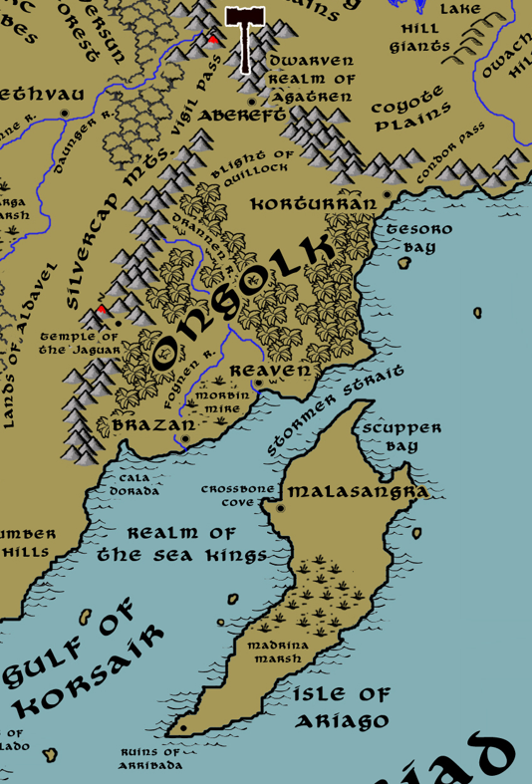

Table of Contents
- Overview
- Towns and Cities
- Best in the Land
- Stewards of Power in this Land
- Points of Interest
- History
- Local Goods
- Notes on Culture
- Local Deities
- Creatures
- Other Races
- Magical Items
- NPC Templates
- Developer Notes
Overview
Turmoil and chaos have been the legacy of Central Amadar. The lands around the Oberon Sea, between the Stonecurtain and Direfrost Mountain ranges, are vast stretches of treacherous wilderness. Ruins of ancient civilizations dot the landscape: towers, keeps, and roads that are crumbling and forgotten.
They are chaotic lands ruled over by barbarians, humanoid tribes, magical creatures, and mad reclusive wizards. To the north lies the barbaric kingdom of Hyderis, to the west the vast graveyard of kingdoms long since fallen. But lying to the southeast, shielded by the Silvercap Mountains on one side and the sea to the other, is the massive valley region of Ongolk. It is here that the ancient Dzama people rose to heavenly heights at the dawn of history, only to fall lower than any other place in Nemmyrl.

The Ongolk Empire was a mighty power in the Primordial Ages. At the dawn of time ancient priests won the favor of the gods. The land was blessed with rich soil, steady rainfall, abundant crops, and gifts of the heavens. But the priests ran afoul of the gods, turning to human sacrifice in a bid to outdo one another. The gods curled their lips at the sight and heaped down world-shattering curses. The once-proud kingdom of Ongolk was reduced to a blasted wasteland, never to recover. Now fallen priests and necromancers pick among the ruins, looking for powerful artifacts that will convince the dark gods to reshape the land to their former glory.

South of these cursed lands and dense jungles, hugging the shores beyond the Gulf of Korsair, is the Realm of the Sea Kings: a series of pirate towns tucked away where western powers fear to tread. Each ruled over by a pirate baron, and each baron owing fealty to the Sea Queen in Malasangra. Pirate law, such as it is, is the only order in each town. Denizens are free to cheat, steal, and kill to their heart’s content so long as they don’t interfere with anyone or anything under a pirate baron’s protection. Out of reach of the civilized kingdoms, they have asserted their own brand of control over the open seas.

Towns and Cities
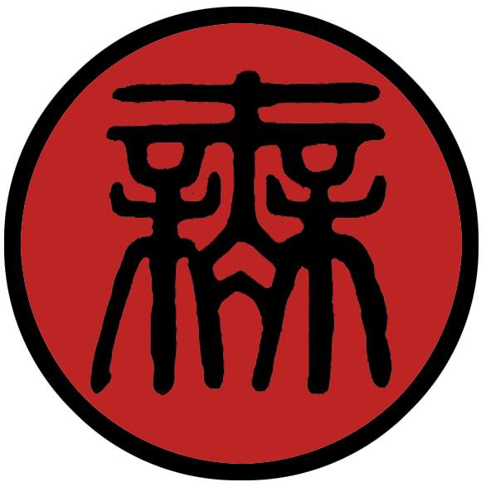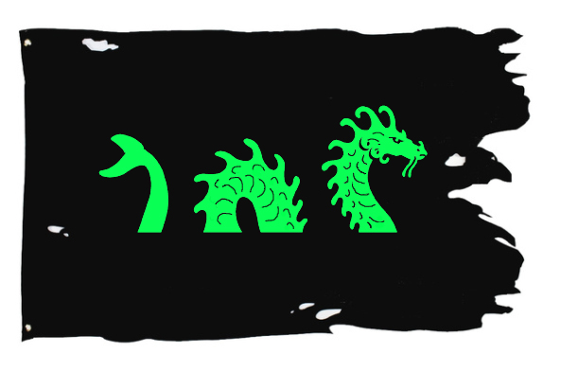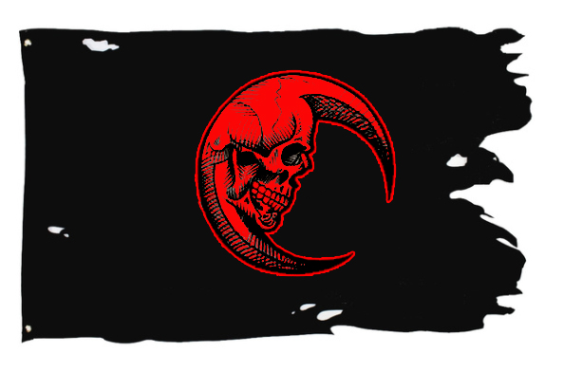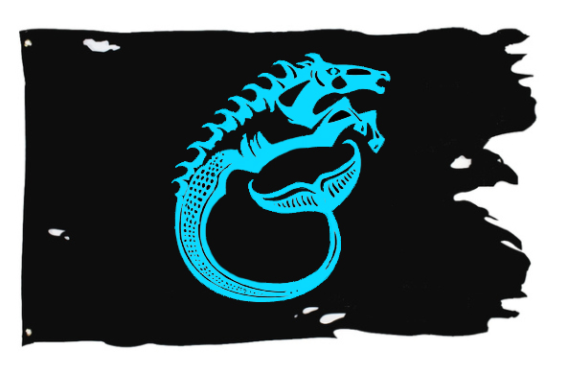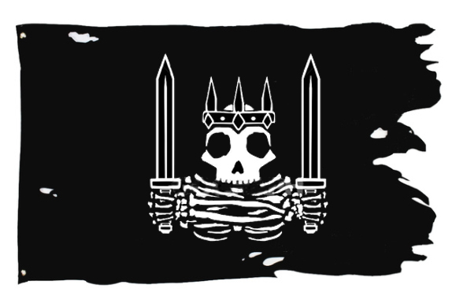
- Lands of Ongolk – ancient kingdom, now occupied by dark forces
  - Abereft – small city, sign of the eyes of transformation
- The Pirate Cities – free towns as part of the Realm of the Sea Kings
  - Brazan – small town, sign of the sea serpent
  - Reavan – large town, sign of the skull moon
  - Korturran – small city, sign of the hippocampus
  - Malasangra – large city, sign of the dead king

Best in the Land
Trade Hub:
Religion: Abereft: world center for the worship of Erythnul
Arts:
Magic:
Spirits:
Steel: Malasangra
Grain:
Crafted Goods (e.g. Pottery, Textiles, Metal Wares):
Harvested Goods (e.g. Aromatics, Medicine, Dyes): Reaven: cotton and opium
Mined Goods: Korturran: stone, tin, lead; Malasangra: clay
Precious Metals: Abereft: platinum; Brazan: gems
Ship Building: Malasangra
Other:

Stewards of Power in this Land
Kings and their armies are not the only wielders of power. There are many unseen friends and foes that shape the destiny of the land. Each of the groups listed below are well known to the people of this region. Some are feared, others venerated. All of them play their part in the grand drama of this land’s story.

Merchant Companies
(none)

Mercenary Companies
Stormwind – Malasangra, Isle of Ariago

Smuggling Rings
The Phantom Caravan – Brazen

Centers of Worship (Churches, Cathedrals, Shrines, Lodges, Temples)
High Cathedral of Erythnul – Abereft
Cathedral of the Godmother - Malasangra

Orders of Paladins
Order of the Night Sun – Abereft

Druidic Circles
Circle of the Blood Moon – Korturran

Bands of Rangers
Band of the Wild Boar – Reavan

Schools of Magic
(none)

Bardic Colleges
(none)

Warrior Academies
(none)

Assassins Guilds
The Black Spot – Reavan

Cults
Camazotz the Death Bat – Abereft

Other Guilds
(none)

Monasteries
(none)

Pirates
Captain Bilge Baarsunj - Brazen
Captain Silver Darrow Addington - Reavan
Captain Alsen Westersun Sarmiento - Malasangra

Points of Interest
- Isle of Ariago – The largest island in the Myriad Sea, Ariago once dominated this region of the oceans when Arribada was a proud city dedicated to Hah-nu-nah the great sea turtle. Cleared of sahuagin by the wizard Nestoron in the Primordial Ages, it was the home of the Thaumaturge Order before its citadel sank into the Madrina Swamp. In the Fourth Ancient Age sahuagin and orcs took the island over once again and destroyed Arribada and the city of Madrina. Now the island is mostly wild except for pirates reclaiming the ruins of Madrina on the northern end of the island where their capital, Malasangra, now sits.
  - Bithyala – Sea Elf Domain
- Madrina Marsh – home to the black dragon Sudarion, also the location of the ancient Citadel of the Thaumatergem Order founded in the Primordial Ages; 370 PA4 - Fall of the Thaumaturgem Order: wizards battled over possession of the Singularian, a stone that creates a portal to pure magical potential, and are eradicated in the battle; the citadel sank to the bottom of Madrina Marsh. Some say a host of strange magical experiments and artifacts remain in the submerged tower, but none have managed to descend the mire to explore it.
  - Clan of the Igorzo – A large tribe of Saurians occupy the forbidding marsh lands. Bearing the mark of the fish bone on their skin, they are a proud people but not unreasonable. The pirates of Malasangra learned long ago to leave their half of the island alone and occasionally bring them tribute (sometimes in the form of prisoners).
  - The black dragon Sudarion dwells in the Madrina Marsh. He is an old and cranky beast, but gave leave to the pirates centuries ago to share the island as long as they keep their distance. The pirates pay regular tribute to the dragon in the form of treasure (emeralds being his favorite). Only once did Sudarion agree to work with the pirates, brokering a deal with his kin in the Elderwyrm Mountains to allow them passage through the Straits of Immolas. He is a wily dragon and open to working for hire, but he is notorious for turning on his allies.
- Ruins of Arribada – Once a beautiful city dedicated to Hah-nu-nah, the Great Turtle of the seas, Arribada fell to sahuagin forces invading the island in the Fourth Ancient Age during the Scourge of Hrolith.

- Crossbone Cove – A deep water port sheltered from the worst of storms, this cove on the northwestern tip of the Isle of Ariago sits at the feet of the town of Malasangra. Skeletons hang as decorations from the masts of ships submerged on the outskirts of the cove, creating a grisly spectacle. A dragon turtle is said to lurk in these waters and guard the port, happy to serve as it’s paid regularly by the Sea Kings. Some say more treasure sits at the bottom of the cove than in all the Pirate Throne’s horde.
- Scupper Bay – The wide expanse of inlet on the northeast end of the island is so named for a hole in a ship's side to carry water overboard from the deck. Here there are many waterfalls cascading from the high cliffs overlooking the ocean. There are few places of safe purchase for ships here, but stories tell of renegades making shore and stowing their loot in cliffside caves behind the waterfalls to avoid paying their tribute to the throne in Malasangra. The waters here are made perilous by shallow reefs and shoals of piranha.
  - Here lurk the tribe of Sahuangin known as the Mordrak, known by their sign of a shark’s open maw with jagged teeth.
- Cala Dorada “Golden Bay”
  - Here lurk the tribe of Sahuangin known as the Naltokar, known by their sign of two harpoons crossed.
- Gulf of Korsair – A wide swath of ocean flanked by the Isles of Talyn and Ariago lying north of the Myriad Seas. Waters are warmer here closer to land, creating squalls as well as hosting an abundance of sea life. Sahuagin tribes rule the waters along the Amadar coastline, but often tangle with the sea elves of Bythyala that dwell east of Ariago. From her tower on the mainland to the north, the powerful sea witch Zatara holds sway over these waters and is a terrible force to be reckoned with.
- Stormer Strait – Brave is the captain who steers her boat through these straits. As its name suggests, the narrow channel north of Ariago is infamous for being tossed by the very same easterly winds the island shields for the Gulf of Korsair. Choppy waves, hidden reefs, and heavy winds make for a perilous passage. The strait is only used when vessels seek a quick escape or shorter passage to the eastern seas.
  - Some old hands tell a tale wherein Captain Canstibar, founder of Malasangra and the first Pirate King, cheated playing tiles with Fengshen, Xiandai god of wind. Fengshen blew a wind that followed the captain home, and those Easterlies plague the region to this day.
  - On the eastern shore, overlooking the Stormer Straits, stands the tower of Hozanek of the Sun Bird, Arch Mage of the Ongolk Lands.
- Tesoro Bay “Treasure Bay” – The wide expanse of waters of Tesoro Bay were the site of a brief war thousands of years ago when rumors of platinum from the Direfrost Mountains sparked an invasion of prospectors. In 670 AA3 invaders battled Haka'Na warriors alongside the Dwarves of Agatren. Thousands died at battling at Condor Pass before the invaders were repelled and the conflict named the War of Tesoro. The name stuck, leaving many still exploring this region for the infamous treasure. Some believe the dwarves collapsed the tunnels and are mining it from a deeper set of tunnels.
  - Here lurk the tribe of Sahuangin known as the Kelvorrath, known by their sign of a spiked dorsal fin.

- Ahauka River – Descending from the Silvercap Mountains, the Ahauka is a wide, slow moving river featuring lush jungle growth: algae blooms, giant lily pads, an overhead canopy of trees blocking out the sun in places with low-hanging vines. Crocodiles and piranha are a constant threat to anyone swimming or traveling in small boats. Countless stone statues of fierce bats hang from the trees and watch over the river. These in fact are the Camazotz, giant death bats that come from Xibalba. At night they are ravenous predators, hunting down anything on two legs and lopping off their heads with their vorpal bite before feasting on the corpses. At the first light of day the giant bats transform to stone if caught in the sunlight, sleeping until night time when they transform back into their living forms.
- Ixchuna River – The Ixchuna breaks off from the Ahauka River, breaking west and south and skirting the Morbin Mire before emptying into the Gulf of Korsair. The river is wide and slow and just as lush with jungle growth and crocodiles as its sister river. Countless stone carvings of heads sit on the banks of the river, small spheres depicting mostly humans but other races as well. All stare with horrified expressions into the river. These are the heads of the victims of Camazotz, giant death bats that come from Xibalba. The heads transmute into stone on the next sunrise after being removed, then are placed on the banks as mementos.

- Morbin Mire – This marsh sits in the lowlands between the Ixchuna and Ahauka Rivers. Saurian villages control the northern section of the mire, which is teeming with life. The southern half is marked by deadly sink holes which emanate an invisible, odorless gas that is also flammable. Residents of the town of Brazan harness the gas in leather satchels, which they use as explosive artillery in the town’s defense. The swamps at night are an eerie sight as pockets of gas feed small flames here and there.
  - Baxhsa Clan – A large tribe of Saurians control the northern part of the wetlands here. They are recognized by the three ‘X’ marks they carve into their skin and weapons.

- Silvercap Mts – The Silvercap range runs a couple hundred miles, breaking off from the Direfrost Range in the north near Vigil Pass and extending southwest to the sea. The range forms the western boundary of the Ongolk valley region. Contrary to its name, the mountains have yet to yield silver deposits but gems are found in abundance. These resources tempted the normally-friendly Gildran and Aldavel kingdoms into a brief war in the Second Ancient Age. Orcs dwell here, which caused the invading Celedon troops trouble in the First Written Age.
- Mt. Muziaq – (unlabeled volcano on map at the southern end of the Silvercap Mts.)
  - Here dwell the tribe of Fire Giants known as the Haethrazii

- Vigil Pass – Vigil Pass is a hundred-mile stretch of narrow road that descends southward from a break in the Direfrost Mountains then skirts the northern edge of the Silvercap Mountain range as it butts up against the Neversun Forest. The pass has been an important strategic location since the dawn of history, first as the entryway east into Haka’Na lands, then later as the site of many military movements including the First and Second Dark Crusades out of Ongolk. It is said that the wizards of Abereft have transformed a hundred or more outcroppings of the mountains into rock golems that constantly guard this area. Other wards such as arcane marks or ravens under the command of the Tower of Malison also make this a dangerous stretch of land to pass through.
  - Older Haka’Na warriors from the Order of the Rain Bird retire to a special lodge they built overlooking Vigil Pass in the Direfrost Mountains. They watch the pass, always remembering the evil that has emerged out of Ongolk in the past.
  - the copper dragon Jaleirys dwells in the mountains overlooking Vigil Pass

- Realm of the Sea Kings – the waters between the Isle of Ariago and the Ongolk coastline have become the haven for notorious pirates and privateers from all over the world. The three free cities on the mainland host ships that come and go, but all pay tribute to the Pirate Queen or King (depending on who’s in charge at any given time) in the pirate capital Malasangra, on the Isle of Ariago.
- Blight of Quillock – the lands of northern Ongolk region are still marred by the acts of the evil priest Quillock thousands of years ago. The soil is like dry ash, the stones give off a sulfurous smoke, the air is thick and hard to breathe. Plant life is scarce and that which does thrive is cursed and feeds on walking and flying creatures.

- Agatren - Dwarven Kingdom
  - Darkshine - Dwarven town of Agatren
  - Firemantle - Dwarven town of Agatren
  - Silverlode - Dwarven city of Agatren
  - Kalaraak - Dwarven town of Agatren
  - Mithrilhame - Dwarven town of Agatren
  - Sentry Keep - Dwarven outpost of Agatren
  - Ember Keep - Dwarven outpost of Agatren
  - Frost Keep - Dwarven outpost of Agatren
- Duskryn – Drow Kingdom
  - The southern Silvercap Mountains have been the staging grounds for the Duskryn Drow in their long battle to control the Ongolk region. Their hated enemies, the Dwarves of the Agatren Kingdom, have waged ceaseless war to keep the Drow from advancing northward up the mountains. Each full moon the Duskryn mount their monstrous spiders and raid the region around the Oberon Sea, taking slaves and victims for their sacrifices. Their temple is home to the Gossamer Vault, an ancient sarcophagus the size of a large hill, within which lives a gaseous demon named Hephrix. The Drow serve the demon, releasing it when it reaches its greatest strength, spreading a supernatural fog into the surrounding lands. All who are caught in the tendrils of the swirling monstrosity are consumed in agony. Mistress Thalfe is thought to sacrifice prisoners to the fog to convert them into mindless slaves, whom she sends as spies to Sentry Keep in an attempt to infiltrate the Agatren Kingdom.

- Temple of the Jaguar – Once the home of the Order of the Night Sun, paladins of the sun god Kinikau who were elite Jaguar Warriors. Some say that the paladins disappeared after the gods turned their back on this land in the First Ancient Age. Others say a few carry on in the Temple, defending the land against evil and praying for the gods to lift their curse on this land. It is rumored these warriors have the ability to actually change into the form of jaguars themselves.
- 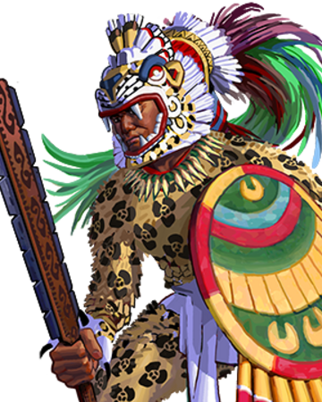
- Scattered Ruins of the Dzama people
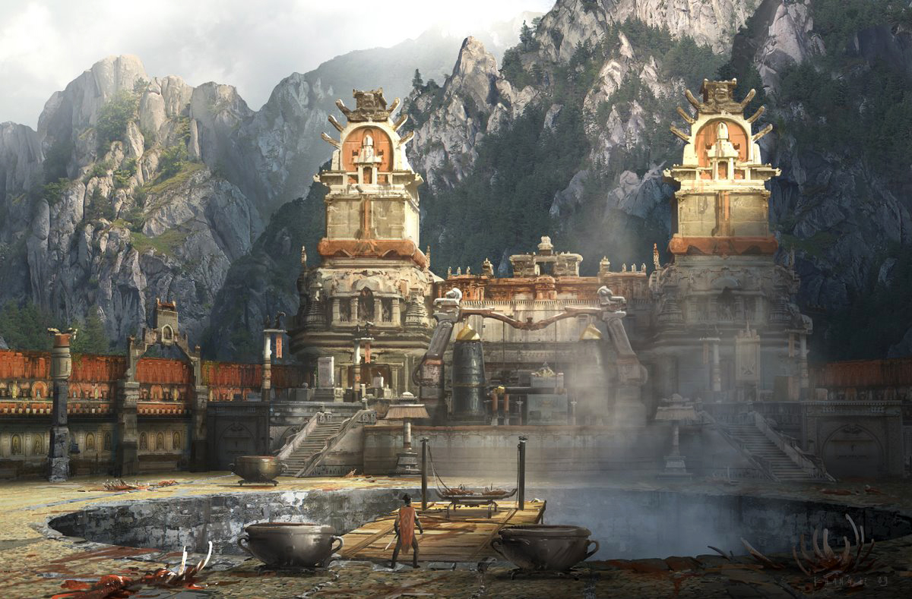

Lands of the fallen kingdom of Ongolk
The lands that stretch between the Silvercap Mountains and the southern end of the Direfrost Mountains have a history of darkness and death. Ongolk is a blasted, ruined stretch of plains in the north, once covered in tall grasses but now cracked and desiccated. This is called the Blight of Quillock, so named for the evil wizard who rose Ongolk to unprecedented power in 450 PA3 and later ruined the land. The break in the Direfrost range to the far north is called Vigil Pass and leads into the lands of the Haka’Na people. Such was the evil emanating from Ongolk in the Primordial Ages that the Haka’Na placed powerful magical wards on the pass and watch it still to this day.

To the south there are heavy jungles and swamps along the coast overlooking the Stormer Strait and the Myriad Sea beyond. Hidden within the jungles are tall temples made of stone covered in intricate carvings, placed in perfect arrangement with the world’s magical ley lines and the paths of the moon and sun in the sky. Here the Dzama people flourished, creating elaborate palaces and temples in the jungles and developing an advanced culture.

It was here nine thousand years ago (450 PA3) that the evil cleric Quillock of the Dzama people rose to power by slaying all wizards and priests in Ongolk as well as the rulers. He drew power from the ley lines beneath the land, which resulted in death to the plants, soil, and animals. This sickening of the land continues to this day as the Blight of Quillock. Quillock harnessed the overwhelming power within the Ebony Macuahuitl, a bladed weapon of the Ongolk. Forty years of horror came to an end in 490 PA4 when an alliance of humans and Dwarves from the Kingdom of Agatren united and destroyed Quillock.

In the Fourth Primoridal Age the Wizard War erupted. Telemechus of Ongolk united evil wizards to conquer the world. A good-aligned alliance of wizards opposes them; epic battles wage all over the world, destroying cities and upsetting the balance of magic. While the forces of Telemechus were defeated, it was Dragan, a general from the ranks of men, who saw a means to end magic forever and defiled the ley lines beneath Ongolk. This led to the Dead Century, where all magic around the world fell silent. After the end of the Dead Century the gods of Ongolk gave up on the land, turning their back on it and sending down a hail of curses. It was the fall of the Dzama kingdom and the land never recovered.

In the Second and Third Written Ages Ongolk rose again as a dark power. First in 710 WA2 Mortavay the Fair, a sorceress from Tirudor, ventured into the dark ruins of Ongolk and discovered the Crown of Power. She enchanted a horde of thousands to march on the west, beginning the First Dark Crusade. The combined forces of orc, goblin, and gnoll tribes marched westward and absorbed Hyderis and Central Amadar around the Oberon Sea. At last, at the Battle of Fangring, she was stopped by Queen Raseda of Tirudor at Tarvos Pass and the crown was destroyed.

Almost a thousand years after the first of its name, the Second Dark Crusade erupted in 600 WA3. Mortavay returned as a lich and again assembled the Crown of Power. This time her invasion of the west was far more destructive: her armies conquered the Elves of Eida’Las, Tirudor, Erigoth, Treviland, and most of Plenia. At last, in 670 she was defeated a second time just before destroying the city of Phaeria where a prophecy foretold her doom.

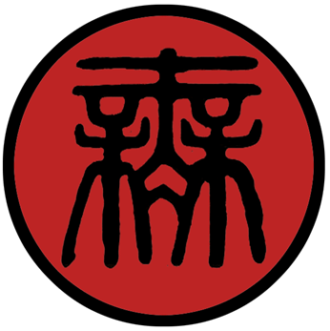
Abereft
Size: small city, population 12,000, guards / soldiers 120, militia 600
Trade Goods: platinum, religious center (Erythnul)
Local Goods: the storied secrets and relics of the ancient powers beneath the city attract many unscrupulous merchants and scholars
Standard: eyes of transformation
Colors: red and black
Patron Deity: Erythnul (but many dark gods are worshiped here)
Ruler: Dark Lord Desibys the Consumer

Home: Tower of Malison
Steward: Zvonklim Kavran
Marshal: Budimir Grzan
House Priest: Vrineth Iguzahr
House Adviser (Scholar/Mage/etc): Oxar Invokalis
Captain of the Guard: Davor Wafaris
Chief Warriors in Service:
Urodel Triforn
Unorim Izaforn
Ilatorn Duvnjak

Local Powers: The Cult of Kamazotz the Death Bat, High Cathedral of Erythnul
Local Sites:

Description:
The foundations of the ancient city of Abereft hail from the last original great cities of the Dzama people and dates back to the Primordial Ages. Reworked over thousands of years, the obsidian-black walls rise to the sky, its slender arched windows decorated in delicate tracery forged in a long-forgotten style. Tall towers reach skyward, narrowing at the top to give them the appearance of giant skeletal fingers reaching up from the depths. A thousand stone figures adorn the battlements: horrific, misshapen creatures from the darkest imagination. A lake of sulfur encircles the keep, pungent gases rising up from it in a thin, green veil. All about the plains beneath the city can be seen the shambling, lurching figures of undead creatures wandering the landscape. Overhead a perpetual gloom hangs over the sky, dark clouds that never give way for the sun. Lightning flashes persistently, illuminating the shadows briefly before the deafening rumble of thunder cascades over the land. It is a place without light or cheer and utterly devoid of life.

Industry:
Abereft sits on a fortune of platinum in the Direfrost Mountains and its store of rare and powerful magic is eagerly sought after by those willing to pay handsomely for a tour. Nothing of agricultural value is yielded in this land. What little life dwells in Ongolk is sustained either by creatures feeding on one another or by the provender brought back by its armies.

Key Figures:

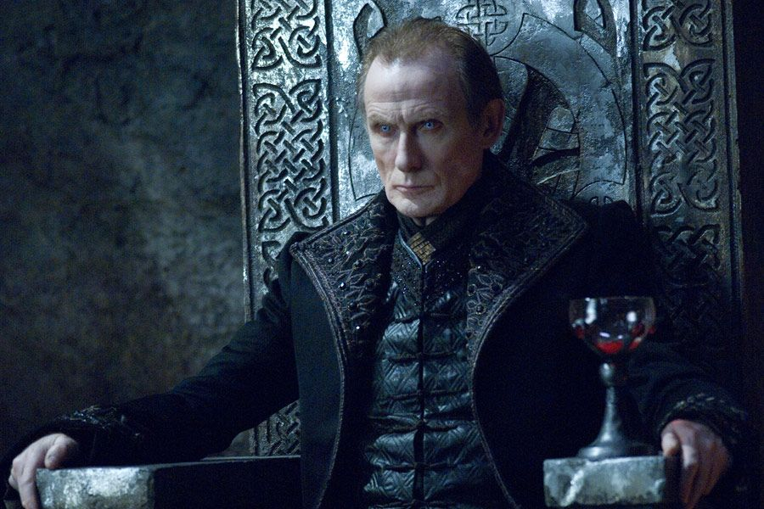

Dark Lord Desibys the Consumer – pure evil, power hungry, brilliant, bloodthirsty

Lord Desibys is a tall, thin man with pale skin, grey eyes ringed with dark circles, and long, thin blonde hair. His gaunt face has a noble bearing to it: high cheeks and prominent chin of a patrician likeness. His thin lip, pursed in thought, part when he speaks to reveal unnaturally long, sharp teeth. His voice is like a deep, eloquent voice from an open grave. He wears silver-gray robes trimmed in ermine and embroidered with dark red gemstones. In his hand he brandishes the Staff of Undoing, a powerful relic from the dawn of time that wields immeasurable power. It is said that with a touch of the staff any boon may be given out, but comes at a terrible price.

Desibys is a man of singular cruelty and greed, reveling in the pleasures of pain he inflicts and the treasures he strips from others. He sits upon the Ossuary Seat, a throne of dried, bleached bones that has grown over the decades to extend outward to cover his throne room floor. Some say it is a living entity, hungry for the flesh of the living, and that Desibys feeds his enemies to it. Behind the throne are stacked a thousand mundane items that he has collected from his victims. Very few of them carry any magic, save for the sheer bliss he recalls in the value their owners had for them and their pain at his taking them.

Like many other ambitious mages, Desibys left his homeland to seek out the dark secrets of Malison Tower. Once there he joined with other acolytes in all manner of forbidden rituals. Over time he rose up in the ranks of the acolytes many of whom he murdered. Through sheer determination he braved the cursed crypts beneath the city to unlock Ongolk’s sleeping dark powers. He has spent the last two decades conquering the levels of the under-city and purging his enemies. Now he is master over all of Ongolk and has his eyes set on expanding his domain.

Local Lore:
The city of Abereft dates back to the very beginning of the ages and the dawn of men. It was here that magic was first harnessed to great effect, first by the mightiest of Dzama light mages, then later by the dark masters. The city extends for nine hundred levels beneath the ground, each older than the one above it. No one who enters the under-city returns alive, save for only the most clever.

It is here that many of the strongest ley lines of magic converge. Quillock the fallen priest of Kukulcan attempted to tap into these fields of magic in 460 PA3.

History: Abereft sits on the foundations of Yaxhacoch, he first city of the ancient Ongolk people. At dawn of history the tribes of this region won great favor with the sun god Kinikau along with Kukulcan, god of water and wind, and Ixachel, goddess of fertility and harvests. So great were their virtue and their courage that the gods smiled upon this land and this was its greatest city (650 PA1).

But the next two millennia saw Quillock and Telemechus defile the land and so the gods turned their back and the land was cursed. Yaxhacoch was no more. In 670 AA1 the ruins of Yaxacoch were taken over by the Gnoll chieftain Yarglik, ushering in a long reign in Ongolk by Gnoll tribes. The city was renamed Abereft and became a major attraction to cults, necromancers, and dark priests from around the world. All came to seek out the dark powers buried deep beneath the city. The obsidian relics and blades of legend, once kissed with light, became tools to channel the darkness.

Customs:
Any person asking entry into the city is required to bring ten souls of their own race as an offering.

The Pirate Cities

Brazan
Size: small town
Trade Goods: gems
Local Goods:
Standard: sign of the sea serpent
Colors: black and green
Patron Deity:
Ruler: Elgar Wylmot and his wife Truda (f)

Home: Agave Keep
Steward: Evrardus Auger
Marshal: Christoffer Loffen
House Priest: Carsten Lainbart
House Adviser (Scholar/Mage/etc): Almenara de Alva (f)
Captain of the Guard: Wulfwin Bryan
Chief Warriors in Service:
Gamel Thornburr
Gilot Leclair
Simon de Pavia

Local Powers: Lockjacks (thieves guild), The Phantom Caravan (smuggling ring)
Local Sites: The Haughty Dwarf Inn & Tavern, The Crooked Cutlass Inn & Tavern, Slattern Keep (brothel)

Description:
Brazan was once a frontier town founded by explorers from the kingdom of Gildran before its fall. Settlers mined gems in the Silvercap Mountains, but knew the danger posed by Orc tribes on their western side. Prospectors began pilot mines on the eastern face of the Silvercaps, but made their base camps east of the Ixchuna River. This put the river between the camp and any approaches from the west. It also put the swamps to their backs.

The camp attracted some of the less savory elements from Gildran, but their pioneer spirit made them tough and resourceful. Envoys from the kingdom who came to inspect the camp were taken aback by the atmosphere of the residents. In their reports they complained that “the people are uncouth and lacking in manners, but their brazen courage keeps them alive in frightful conditions.” From this the miners named the camp ‘Brazan’ and it persists to this day. Others say the lights on the swamp were referred to as braziers and that is the source of the town’s name.

Industry:
Today Brazan is an independent town and one of the four settlements in the Realm of the Sea Kings. Gem merchants have brokered a deal to help oversee the gem mines and get the best price for them on the market. In exchange the pirates leave their ships alone.

The Phantom Caravan smuggling ring is based out of Brazen. It is particularly good at moving merchandise up into Hyderis, either around the southern tip of the Silvercap Mountains or north through Vigil Pass.

Key Figures:
Elgar Wylmot – Known as the Lord High Commodore (a name the Pirate throne in Malasangra tolerates), Elgar is a short, barrel-chested man with fleshy jowls, twinkling eyes, and a wide, crooked smile. He dresses in the finest doublets (usually stained) and breeches stitched in gold thread. His speech is interrupted occasionally with fancy words Elgar has picked up from languages of other lands, mostly Tirudor. Like most pirate lords of Korsair Bay, he has pillaged, cheated, betrayed, and murdered his way to controlling Brazan and earning a seat at the Sea King Table. He carries with him the famed cutlass Dubius Mente, a cursed blade that has made many a pirate rich before their untimely demises.

Truda Wylmot – The wife of Elgar, master of Brazan, Truda is a middle-aged woman of medium height, flaming red hair, and sea green eyes. She has a radiant beauty of a woman many years younger and a confidence that commands a room. She is normally bedecked in dresses of a simple cut but made of elegant fabrics with intricate brocade work. Once a resident of Slattern Keep in Brazan, she charmed Elgar long ago and made sure to keep him on a short leash. She is smart enough to let Elgar appear the master of their marriage in public, for she knows how fickle power can be for leaders seen to be weak. But in private she runs the town. Truda is keen to know secrets and dabbles in magic, mostly of the divination school. In her apartment in Torre Vieja she has the Corazon del Mar, a crystal ball once used by a famous sea witch. The sphere has the power to see for hundreds of miles, but its range is almost limitless when looking out upon the open seas.

Local Lore:
The swamps are a noisome and treacherous to cross. Vapors leaking up from the swamp are flammable and toxic. At night the darkness is illuminated by tiny jets of flame that spring up at random. This made for less than a scenic view but a defensible position for the camp.

The swamp to the north of Brazen is unnamed but many refer to it as Fire Swamp or Firemire. Pockets of flammable gas bubble to the surface regularly, creating a nasty stench in the area. Every so often the gas ignites into bursts of flame ranging from small, brief gusts to large explosions. Most last only a few seconds but there are always some slowly burning steady plumes of flame. The air here is filled with noxious gases that will test the constitution of any creature passing through it. Extended exposure to the gas can be deadly. There are rumors that a great pirate ship was beached on the mire decades ago and sank beneath the muck. Stories tell of grizzled corpses rising from the wreck at night to find their lost treasure.

History:
When the kingdom of Gildran fell (330 AA4) the people of Brazan took in survivors fleeing from the orc hordes. By this time a palisade had been built to defend the town. The townsfolk also discovered that the swamp released an invisible humor that erupted in flame. They had taken leather bags and trapped the humors and learned to devise flammable satchels that could be lit and launched as artillery.
An orc tracking party followed the survivors to the river but it took some time to discover the town. When they launched an attack they were surprised by the fighting spirit of the residents. They were also overwhelmed by the ‘Swamp Fire’ artillery that devastated their ranks.

Customs:

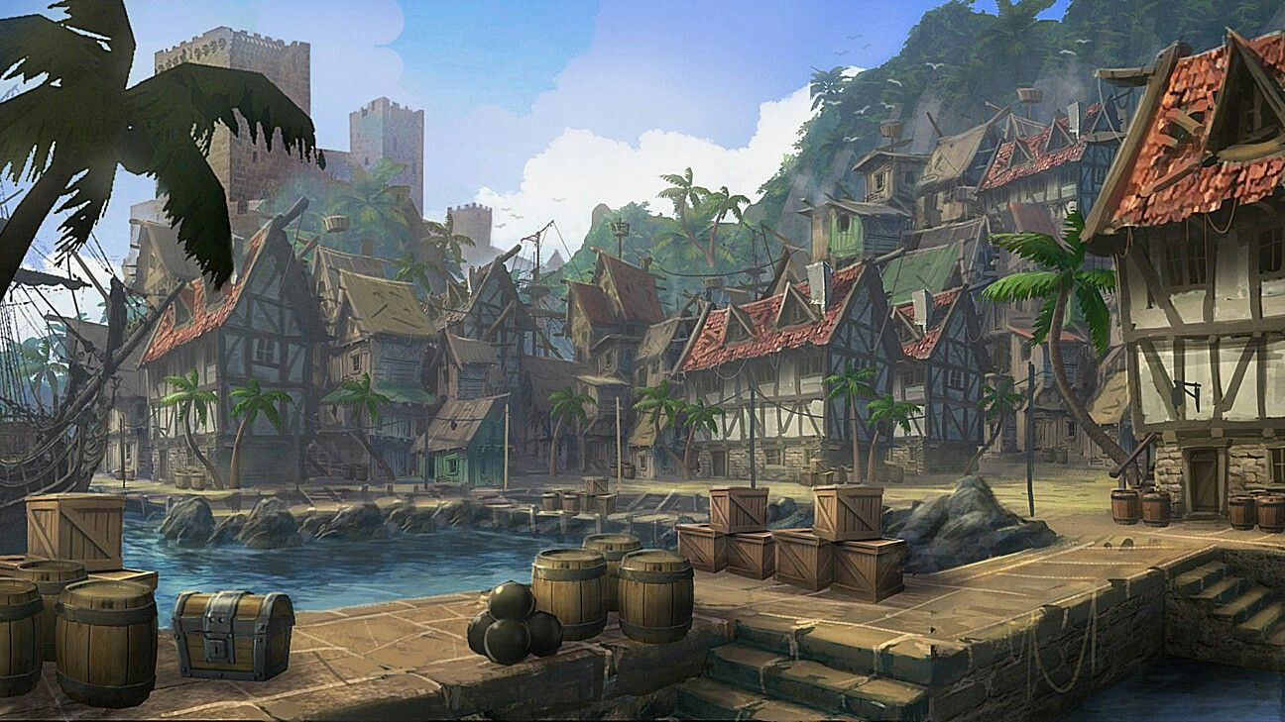

Reaven
Size: large town
Trade Goods: cotton, opium, fishing
Local Goods: Reaver’s Dream (opium)
Standard: sign of the skull moon
Colors: black and red
Patron Deity:
Ruler: Borredan Sevilla and his wife Guinelle (f)

Home: Trogon Keep
Steward: Aelric Oliver
Marshal: Godfrey Ermyn
House Priest: Janucho de Gaona
House Adviser (Scholar/Mage/etc): Sabilina Mazet (f)
Captain of the Guard: Huet Duverger
Chief Warriors in Service:
Joseph Fleet
Natalis Piaget
Allecke Grave

Local Powers: The Night Kahns (thieves guild), Band of the Wild Boar (order of rangers), The Black Spot (assassin’s guild)
Local Sites: The Mistress Mattress Inn & Tavern, The Privateer Inn & Tavern

Description:
Reaven is the town where east meets west. Fields of cotton sit side-by-side with fields of opium plants. Sailors from Xiandai retire in cottages next to sailors from Tirudor. The town itself is encircled by a tall wooden palisade fashioned from jungle trees, outside of which is a low earthen wall made of packed sand hardened with sun-dried mud. The outer wall and most buildings are painted in a rainbow of bright colors, with decorative elements from all over the world. At the center of town stands a low hill, on top of which stands the lord’s manor house and a stone tower keep.

Reavan was built on the ruins of an ancient town that fell during the Blight of Quillock (250-290 AA3), which devastated everything within the split of the Silvercap Mountains. It sits alongside the Ahauka River with a view of the Stormer Straits. To the west, the vast swamplands lie on the far side of the river. They are avoided at all costs, thought to be cursed and known to be the dwelling place of Saurian tribes. Off to the south, on a clear night one can make out the twinkling lights of the pirate haven Malasangra sitting across the seas on the Isle of Ariago.

Industry:
Commodities like wool and opium are strategically located in this part of the world to reach markets where they are otherwise in short supply (wool in the east and opium in the west). Merchants are always keen to be selected as the broker of choice among pirates to access the stores grown in Reaven.

The town does well as an agricultural center in spite of its history. Cotton fetches a good price in the east and thrives in the soil enriched by the river delta. On one journey to the east the pirate Silas Hackshear learned the value of the poppy plants grown by the farmers in Xiandai. He brought back a batch of the seeds the locals claim had been contaminated. Silas cultivated the seeds into a strain that is distinct from those elsewhere in the world. Dubbed the Reaver’s Dream, opium made from this strain of poppy manifests powerful visions in those who smoke it. There are rumors that Planes Walkers make effective use of the opium to fuel their Spirit Walks. This and conventional opium are manufactured in Reaven and sold on the black market.

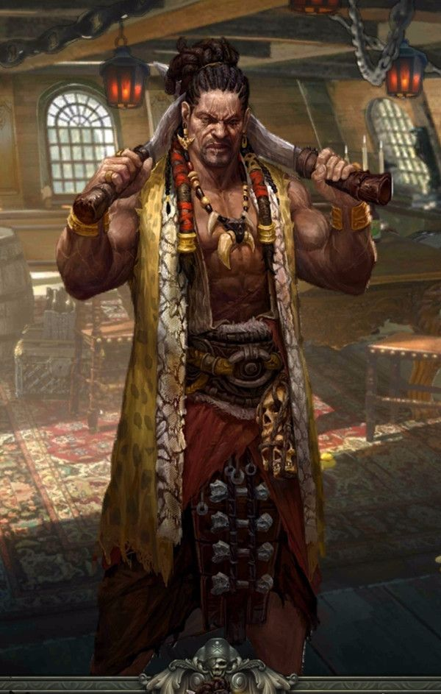
Key Figures:
Borredan Sevilla – Borredan is a tall, dark man of Kaduru lineage with long black dreadlocks and close-cut sideburns. He wears a content look on his face and an air of being in control. He wears clean white shirts that he leaves open and tucked into his bright red sash at his waist. His baggy trousers are tied with ribbons or garters near the knee, harking back to his days as a sailor. About his neck on and on his fingers are glittering gold jewelry, keepsakes of his past. Only the sword at his side indicates his station as master of Reaven: the handsomely jeweled twin blades called Mchukua “the Takers” rumored to take men’s souls.
Borredan affects a casual air, but he is very shrewd and takes note of details in everything. He holds great parties for pirates and merchants alike, keeping the mood light and defusing any tensions that may mount over fortunes passing hands. All the while he is watching and making note of parties moving through Reaven, for he trusts no one. Borredan is curious about the Saurian tribes in the marshes and meets with them, hoping to defuse another potential conflict and perhaps gain allies. The Saurians regard him in high regard.

Local Lore:
Saurian tribes from the Morbin Mire are frequent visitors to Reaven and at times allies to the humans.

History:
It’s not clear if the name of the town came from the word “reaving,” which scholars used to describe the pirates living here, or if it had to do with the pirate Captain Ligmire who ruled the place and was known to have a pet raven perched on his shoulder. Over time the two words must have merged with “Reaven” being the name now.

Pirates have made use of Reavan as a base for their ships for centuries ever since Captain Ligmire’s ships discovered ruins on the coast in 580 WA2. The bay is a safe spot amidst the treacherous currents of the Stormer Straits to the east.

Customs:

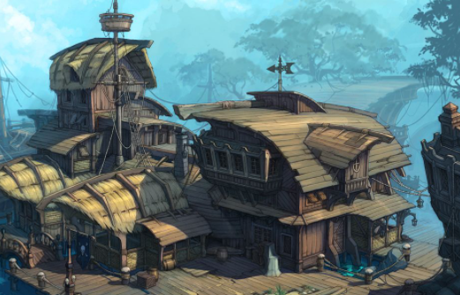

Korturran
Size: small city
Trade Goods: lead, tin, stone
Local Goods:
Standard: sign of the hippocampus
Colors: black and blue
Patron Deity:
Ruler: Baudrain Breguet and his wife Roesia (f)

Home: Castle Golondrina (“wood swallow”)
Steward: Reginald Ferrer
Marshal: Perrot Durand
House Priest: Isabellis Crozier (f)
House Adviser (Scholar/Mage/etc): Helyot Azéma
Captain of the Guard: Conrrat Souchon
Chief Warriors in Service:
Sewel Killigrew
Severin Hardler
Dieguito Martil

Local Powers: Five Finger Fold (thieves guild), Circle of the Blood Moon (order of druids)
Local Sites: The Highwayman Inn & Tavern, The Motley Mast Inn & Tavern, Jenny’s Tea Cup (brothel)

Description:
Korturran occupies the shell of the crumbling fortress, Castle that once stood vigil over Condor Pass at the southeastern end of the Silvercap Mountains. The walls, still strong but in shambles, extend from the last mountain all the way to the sea, blocking any passage eastward into Eastern Amadar and the lands of the Haka’Na.

Industry:
Active mines harvest lead, tin, and stone from the mountain range. Ships not busy with raids are loaded up with trade goods and sailed to open markets, which may have been ports they raided on previous trips.

Ships travelling to Korturran come dangerously close to the area around Northern Xiandai where dragons live. Only the brave or foolhardy continue eastward to the Strait of Immolas. There they can pass on to the far east, but only if the ever-watchful sky drakes don’t burn them first. Those coming from the west who seek passage into Haka’Na territories often consider paying off the pirate baron of Korturran to travel by foot instead.

Key Figures:
Baudrain Breguet – Known as Captain Ballast (for his affinity for mining), Baudrain is a thin man with pale skin, pale eyes, and thinning hair he hides beneath a broad-brimmed sailing hat. He is an earnest man with a stern look about him. His fingers move nervously at his long moustache, which is always untidy. He wears a worn blue officer’s coat from the Plenish fleet, a memento of his days in their service, along with plain breeches and tall black boots. At his side he carries the rapier of his family, a masterwork enchanted blade called “Finger of God,” rumored to never miss when needed most.

Baudrain is a man of numbers, both at sea and now in the industry of his town. Years of discipline in the Plenish fleet have given him a quick wit when it comes to organizing labor and leading men. Despite his small stature, the people of Korturran revere him as a man who can turn their fortunes around. Currently Baudrain is leading expeditions to the island of Muya to the east. It is his hope to strengthen ties with the Haka’Na people in the town of Hurit.

Local Lore:
The land west of Korturran is blasted and cursed, remnants of the Blight of Quillock. Strange creatures stalk the night. The water and soil are poisoned. Only to the east, through winding narrow passages, can the Eastern lands be reached. This area is unspoiled and under the stewardship of the nomadic Haka’Na, who as a rule do not trust pirates.

History:

Customs:

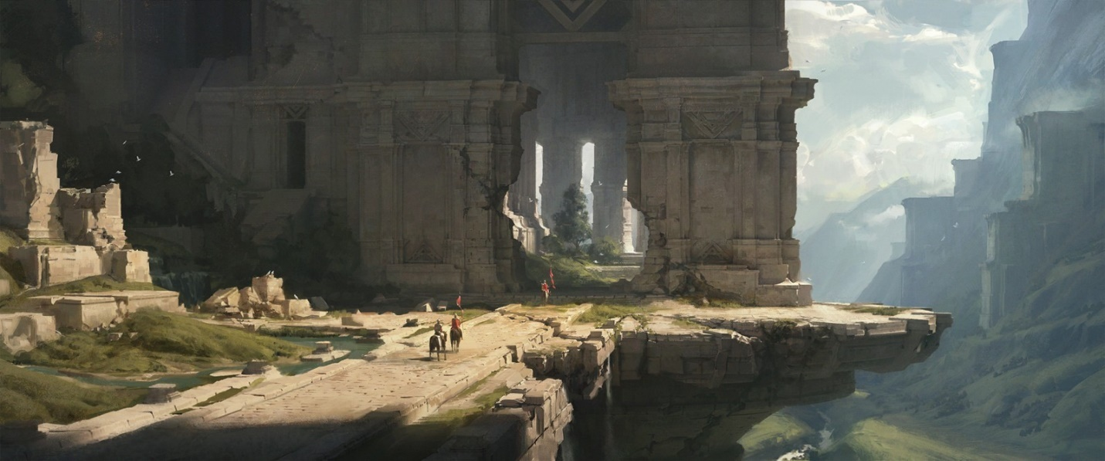

Malasangra “Bad Blood”
Size: large city
Trade Goods: steel, clay, fishing, ship building
Local Goods:
Standard: sign of the dead king
Colors: black and silver
Patron Deity: none to speak of
Ruler: Gilia (f) Sprenger and her husband Bartolde

Home: Castle Arzonne
Steward: Gilbert Hennequin
Marshal: Fulk Everdon
House Priest: Alleck Maÿger
House Adviser (Scholar/Mage/etc): Wathelet the Holder of Wands
Captain of the Guard: Arnold Corby
Chief Warriors in Service:
Guillaume De La Croix
Johan Manjeras
Aubertin Allais

Local Powers: The Cozen Coven (thieves guild), Stormwind (mercenary company), Cathedral of the Godmother
Local Sites: The Hempen Halter Inn & Tavern, The Red Mistress Inn & Tavern

Description:
Malasangra is a pirate’s paradise, the storied haven that all privateers dream of visiting. The name is Tirudoran and means “Bad Blood.” Here rules the pirate king (or sometimes queen), sitting atop a throne stolen three hundred years ago from the King of Tirudor in Colova.
At the center of town stands the abandoned cathedral of Our Sister Johanna, where the pirate court makes its home. It is rumored that the lower crypt is filled with immeasurable treasure gathered over centuries of plunder. Here the leaders of pirate bands from all the world over convene once every three years to plot and scheme.

Industry:
The pride of Malasangra are her shipyards. Here master boat builders craft vessels for speed, strength, and tactical advantage over the open seas. It is said some of the greatest innovations in ship building have been born right here out of necessity. Necessity has driven the pirates to keep ahead of the wealthy merchant guilds and their well-funded ships. When completed the ships fetch hefty commissions from pirate bands all over the world.

Malasangra is also the home to local industry. Steel works take iron ore and refine it into ingots for export or shape it into masterwork weapons. The infamous clay pits outside of town are where prisoners taken by the pirates know they will toil until they die or someone pays their ransom. They are hot, miserable, and swarming with mosquitoes. Those lucky enough to work the kilns will sweat the ovens while creating ceramic goods. Prisoners often inscribe messages for help inside the earthen vessels. When found by the rich in other countries it makes for mild amusement to read the pitiful pleas.

Key Figures:
Gilia Sprenger – Gilia is a tall woman with dark hair, dark eyes, and a cocoa complexion. Her slender frame belies a strength and speed she learned fighting her way to becoming Queen of Pirates and ruler of Malasangra. From her left ear dangles a different bejeweled earring every day, some of which hold secret powers. Gilia dresses in a close-fitting nautical jacket over a simple blouse and well-worn breeches tucked into her dirty black boots. At her side hangs the legendary cutlass Verdugo (“executioner”), which flashes when swings and has an ebony handle decorated with a dragon’s skull. Verdugo is the badge of office for the Pirate King or Queen for over five hundred years and is feared by captains around the world. Legend has it that it was once worn by a hunter of buccaneers, Toribio Cañero, but taken as a prize when the first Pirate King cut him down.
Gilia is a shrewd and capable leader, always suspicious of others and hatching a multitude of schemes (some of which work counter to one another). Her style is to win the favor of every fortune-hunter, even if the generous deals she strikes will never pay off. She is eager to meet everyone who makes port at Malasangra, even the prisoners. Her secret ambition is to find the Golden Gecko of legend, a fabulous statue crafted by the Dzama that bestows great power and disgorges limitless gems. Few in her circle know Gilia was cursed by the Sea Witch Zatara years ago. The prophecy foretells that one day she will find her fortune, but that the one who brings her the news will be her doom.

Local Lore:

The black dragon Sudarion dwells in the Madrina Marsh. (see Madrina Marsh in Points of Interest)

History:
Malasangra was once a shining city named Madrina and part of the Gildran Empire. But during the Scourge of Hrolith four thousand years ago the city fell and was left to ruin (300 AA4).

Three thousand years ago (530 WA1) the Celedonian Primus fleet entered the Bay of Korsair and landed at the Isle of Ariago. Meeting little resistance from the local fishing villages, they built a strong fortress on the island in the ruins of Madrina. The Minyan Legion garrisoned the fort and used it as a base of operations to sack the villages along the Amadar coast ten years later. In 850 WA1 the Minyan Garrison became disillusioned with the politics of the dwindling Celedon Empire. They forsook their oaths to become pirates operating out of Madrina.

Over twenty-three hundred years ago (150 WA2) the famed pirate Canstibar, fleeing Tirudoran ships in the midst of a terrible storm, steered into the Stormer Strait. His enemies followed, but only Canstibar emerged from the other side. Finding the quiet, savage island appealing, he dropped anchor and waded ashore to find the ruins of Madrina. After many misadventures, including losing his ship in a game of cards to a tribe of Saurians then winning it back again, the lusty sailor decided this was his new home. He named the place Malasangra and established it as a seat of power. Pirates all over the world heard of the conquest and rushed to make alliances with Canstibar.

Customs:
The Hall of the Dead hosts parties every night. Rich foods and heady drinks are passed around amidst music and dance and all manner of hijinks. Law is almost nonexistent here. Strength can win the day but guile gets one farther. Power is decided by duels, which can decide who captains a ship, how booty is divided, or even if there should be a new pirate king.

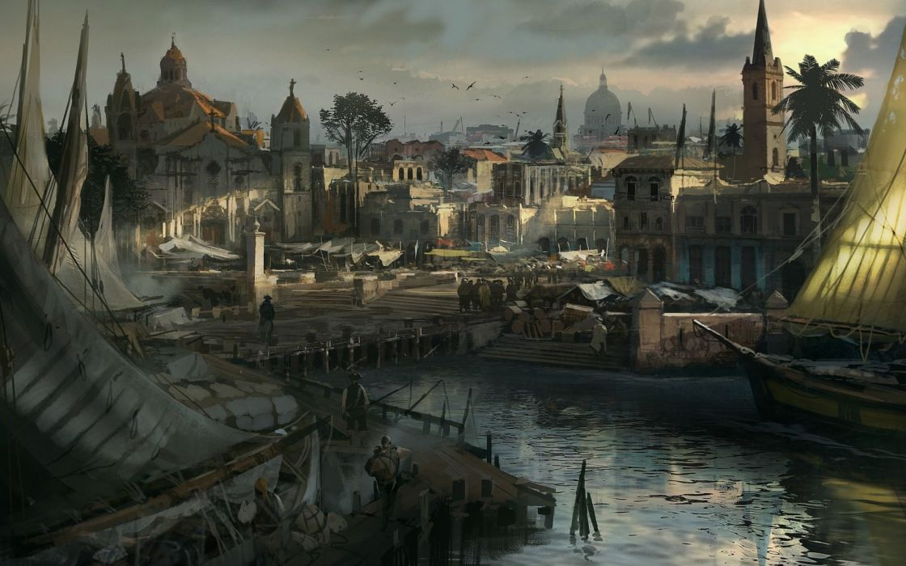

History of Ongolk and the Pirate Cities
First Primordial Age (PA1)
440 PA1 - the mighty feathered serpent Quetzalcoatl appears as emmisary to the humans of Ongolk

460 PA1 - the early Ongolk people win the favor of the sun god Kinikau along with Kukulcan, god of water and wind, and Ixachel, goddess of fertility and harvests

650 PA1 - Yaxhacoch is founded, greatest city of the Ongolk people

710 PA1 - Arch mage Nestoron purges the Isle of Ariago of fell creatures

820 PA1 - the Thaumaturge Order of wizards is founded on the Isle of Ariago and erects Medrina as its home; the order recruits mages banished from other lands

840 PA1 - Thaumaturge citadel of magic is created outside of Medrina

Second Primordial Age (PA2)
390 PA2 - the Order of the Night Sun forms, paladins of the sun god Kinikau who are elite Jaguar Warriors

652 PA2 - Yumakem the god of death emerges from Xibalba, unleashing a wave of demons; thousands are slain or dragged to nine underworlds

658 PA2 - the Jaguar Warriors of the Night Sun carry out an epic campaign, slaying the demons of Yumakem and sending them back to Xibalba

Third Primordial Age (PA3)
450 PA3 - Quillock, high priest of Kukulkan, forms a secret order of priests that engage in human sacrifice to harness great power

453 PA3 - Quilock wins over the people and overthrows the royal family of Ongolk; human sacrifices commence publicly

460 PA3 - Quillock forges the Ebony Macuahuitl, a bladed weapon that harnesses the enormous power from the magical ley lines beneath Ongolk; beginning of the Blight of Quillock, a sickening of the land in northern Ongolk

468 PA3 - hosts of terrible creatures converge on Ongolk and fall under the thrall of Quillock;
490 PA3 - Battle of the Jaguar: Quillock's forces are defeated by an Ongolk army allied with the Dwarves of Agatren and paladins of the Night Sun temple, the Order of the Jaguar

490 PA3 - Quillock is destroyed by priests of Kukulcan; the godess Ixachel heals the blight of the land

Fourth primordial Age (PA4)
370 PA4 - Fall of the Thaumaturge Order: wizards battle over possession of the Singularian, a stone that creates a portal to pure magical potential, and are eradicated in the battle; the citadel sinks to the bottom of Madrina Marsh

870 PA1 - Telemechus, last of the Thaumaturge, discovers the ley lines beneath Ongolk are weakened by the Blight of Quillock a millenium ago; he convinces the priests of Ongolk to break their oaths and summon the dark powers of Xibalba, all the time hoping to command all the world's magic from this powerful access point

872-888 PA4 - The Wizard War: Telemechus triggers a world-wide war of mages, some of whom march on Ongolk to stop him and some who join him in attacking the ley lines in their lands; epic battles wage all over the world, destroying cities and upsetting the balance of magic

888 PA4 - The Battle of Forlorn: Telemechus is slain but not before rupturing the magical ley lines permeating Nemmyrl; the victorious general Dragan of Celedon seizes the opportunity to rid the world of magic and ruptures the Singularion as it is embedded in the ley lines; the resulting explosion sends a shock wave that ruptures the magical ley lines around the world and triggers the Dead Century

First Ancient Age (AA1)
0-100 AA1 - The Dead Century: the Wizard War results in all magic suffering a terrible blow, all artifacts not protected in special shrines are rendered inert, magical creatures who do not seek shelter in other planes die a horrible death

101 AA1 - The Union of the Great Circle: Druids all over the world receive a vision calling them to chant in unison to heal the world; armies of man mobilize to exterminate the druids to maintain power

102 AA1 - after a full year of heroes rising up to defend the druids, the chant is complete with the final Unuttered Word and the lay lines of Nemmyrl are restored; magic returns to the world

103 AA1 - the gods of Ongolk, angered by the treachery of the priests allied with Telemechus, call down horrible curses upon the land; thousands die and the cities left to crumble as the land decays and never recovers

670 AA1 - the ruins of Yaxacoch are taken over by the Gnoll chieftain Yarglik ushering in a long reign in Ongolk by Gnoll tribes; the city is renamed Abereft

Second Ancient Age (AA2)

Third Ancient Age (AA3)
540 AA3 - The Great Squall: a massive storm system rolls west across the Myriad Sea and into Korsair Bay, destroying everything in its path

670 AA3 - War of Tesoro - rumors of platinum in the Ongolk valley region spark an invasion of prospector ships; invaders battle Haka'Na warriors alongside the Dwarves of Agatren; thousands die before the invaders are repelled

Fourth Ancient Age (AA4)
300 AA4 - fall of the Isle of Ariago and the city of Madrina to Orc forces
First Written Age (WA1)
550 WA1 - Celedonian Conquest: Latus Legion invades the Lands of Ongolk

707 WA1 - Celedonian Conquest: Aethon Legion marches through Ongolk to Vigil Pass and are almost wiped out by orcs

840 WA1 - madness takes over the Aethon and Latus Legions; they wipe each other out for power over the Ongolk region

850 WA1 - Minyan Garrison becomes disillusioned with Celedonian politics, forakes the Empire to become pirates operating out of Madrina

Second Written Age (WA2)
10 WA2 - pirates operating out of the ruins of Madrina steal the jeweled eggs of the dragon Echiyon; Echiyon emerges from the Elderwyrm Mts and lays waste to Madrina

290 WA2 - Great Plague of the East wipes out thousands in Ongolk, rumor has it by a magical curse

710 WA2 - Mortavay the Fair, a sorceress from Tirudor, travels to the dark ruins of Ongolk to study its ancient evil, becomes the new ruler of Ongolk

720 WA2 - Mortavay unites orc tribes and marches east into Haka'Na lands; wipes out Machakw, attacks Turuwe and Hurit

721 WA2 - Dwarven armies of Agatren are defeated by Mortavay and their mountain halls invaded
724 WA2 - Mortavay's forces are stopped near Moon Lake in the Battle of Moon Lake

730 WA2 - First Dark Crusade: Mortavay discovers the Crown of Power and enchants a horde of thousands to march on the west, beginning the First Dark Crusade WA2 - combined forces of orc, goblin, and gnoll tribes join and march westward and absorb Hyderis and Central Amadar around the Oberon Sea

732 WA2 - Dwarven Kingdom of Garnettren fights a desperate losing battle to counter Mortavay's forces in Central Amadar

740 WA2 - Queen Raseda of Tirudor unites the kingdoms of the west to march against Mortavay's growing army

745 WA2 - Battle of Fangring; after years of carnage the forces of the west meet Mortavay's army at Tarvos Pass; Queen Raseda falls in battle, but eight heroes arise to slay Mortavay and destroy her crown; end of the First Dark Crusade

747 WA2 - Dwarven Kingdoms of Garnettren and Agatren destroy the last of Mortavay's invaders and are liberated

Third Written Age (WA3)
600 WA3 - the sorceress Mortavay returns as a lich; her agents comb the world for the Crown of Power

610 WA3 - Mortavay's armies begin to muster slowly as the sorceress gains power

640 WA3 - Second Dark Crusade: Mortavay finds the last piece of the Crown of Power, deploys an army of creatures from Ongolk and around the Oberon Sea; pirates and settlers around the Gulf of Korsair flee the region

641 WA3 - Elves of Eida'Las march out to stop Mortavay at the Battle of Erstwyn River; Elven forces decimated and forced to flee the Idenbor Forest

641 WA3 - Hyderian death riders check Mortavay's northern armies at the Daunger River, forcing them southward; Haka'Na tribes check Mortavay's forces at Vigil Pass

641 WA3 - Mortavay's forces conquer all of the Oberon Sea region, marches west to seek her revenge on all of the western kingdoms; her aim is to destroy Phaeria before the prophecy can summon the eight heroes; arrives at the Stonecurtain Mountains

642 WA3 - Mortavay's forces invade Dwarven Kingdom of Garnettran; a second front opens south at Tarvos Pass

643 WA3 - Mortavay's forces break through the Stonecurtain Mountains near Faldyn Forest, destroy the Erigoth town of Ketzel

644 WA3 - Tirudoran town of Onor falls; Dwarven kingdoms of Daemundra, Citerak, and Rubelor dispatch armies to join the fight

644 WA3 - Battle of Tarvos: Dwarves of Garnettren join Tirudoran forces to stop Mortavay at Tarvos Pass; Mortavay destroys the human and dwarven host and continues westward

645 WA3 - Mortavay rolls west like an unstoppable wave, raising undead soldiers from the fallen of each battle

645 WA3 - Tirudoran and Erigot cities fall as they attempt to stop Mortavay: Osorio, Esideron, Ibilis, Dammerung

647 WA3 - Norgardian boats arrive to help Erigoth forces battle the enemy, multiple companies check Mortavay's forces along the Rastalan River keeping them south of the river

648 WA3 - Battle of Causeway Bay - Erigoth troops trapped in the Gunnar Gap are rescued by Tirudoran soldiers who build a makeshift bridge across the Ebon River from timbers from the Elderwood Forest; the holding action results in several companies making it west before Mortavay's forces overwhelm the region

650 WA3 - western cities in the path of Mortavay fall: Wendspire, Cerrulea, Pelham, Bastion,

655 WA3 - Plenish cities fall defending the path to Phaeria: Valcouer, Ataia, Highvow

660 WA3 - Mortavay's northern and southern forces link up outside Lancett, an offensive is mounted across the Plains of Gremira

661 WA3 - Norgarde ships land in Northern Amadar to liberate their colonies, swear revenge on Mortavay and open a second front on her northern forces; Erigot forces join the Norgardians in the northern fight

662 WA3 - Elves of Ari'Aahn join with the Dwarves of Garnettren to aide the humans in encircling Mortavay's forces in Erigoth

663 WA3 - Trevilish and Tirudoran cities still free rally to attack Mortavay's center forces, cutting them off from the east; joined by the Elves of Ulynar attacking from Tredfut Forest

665 WA3 - Dwarves of Citerak and Rubelor rouse from their mountains and attack Mortavay's forces in Gremira

666 WA3 - Elves of Aldalinh join Plenish forces from Chryssla and Phaeria to battle Mortavay's central arm

668 WA3 - Battle of Arrione - paladins of Arrione are wiped out defending the city as Mortavay's southern arm focuses all its strength in taking the city

670 WA3 - Mortavay vanquished, end of Second Dark Crusade

Fourth Written Age (WA4)

260 WA4 - the Black Spot War: Captain Ruby Ballister is issued the black spot by the Malasangra table; war breaks out as pirates pick sides, several ships sunk; Ballister flees, swearing revenge

Local Goods of Ongolk and the Pirate Cities
Cereals: wheat, spelt (wheat), einkorn (wheat), barley, oats, rye; (pseudo-cereals) quinoa
Fiber:
Fruits: araza, avocado, butia fruit, cape gooseberry (uchuva), chirimoya, guaviyu fruit, guarana berries, guava, papaya, passion fruit, pineapple, pitanga berries, sauco, honeydew melon, watermelon, canary melon, cantaloupe melon
Meat and poultry: beef, pork, chicken, lamb, mutton, duck, geese, pheasant, quail, venison, veal, rabbit, goat
Nuts: peanut, breadnut, pekea nut, paradise nut, pinyon nut,
Vegetables: cassava, oca, papalisa, potatoes, sweet potatoes, squash, tomato, lupin beans, pigeonpea, peanuts
Herbs: achiote, anacahuita, boldo, cat's claw, coca, cilantro, courbaril, guaco, guayusa, lemon-verbena, marcela, yerba mate, mesquite
Oils:
Fermented Drink:
Salt-water fish:
Fresh-water fish:
Wood: balsa, fir, pine, oak, mahogany, laurel, willow, crabwood, greenheart, purpleheart, snakewood
Textiles:
Dishes:

Notes on Culture
Weapons and Armor of the native Ongolk people
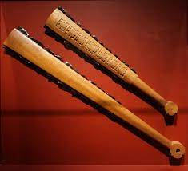
Macuahuitl (equiv of swords) - a wooden club with several embedded obsidian blades. The name is derived from the Nahuatl language and means "hand-wood"

Tepoztopilli (spear) - A pole-arm, halfway between a halberd and a spear, from 3 feet to 7 feet in length. It was a slashing and thrusting weapon. The wedge-shaped wooden head was edged with razor-sharp obsidian blades which were deeply set in grooves carved into the head. They were cemented in place with bitumen or plant resin as an adhesive. The greater length gives the weapon a superior reach, allowing the user to stand behind a line of more experienced warriors and then "shove or jab the weapon" into an adversary.
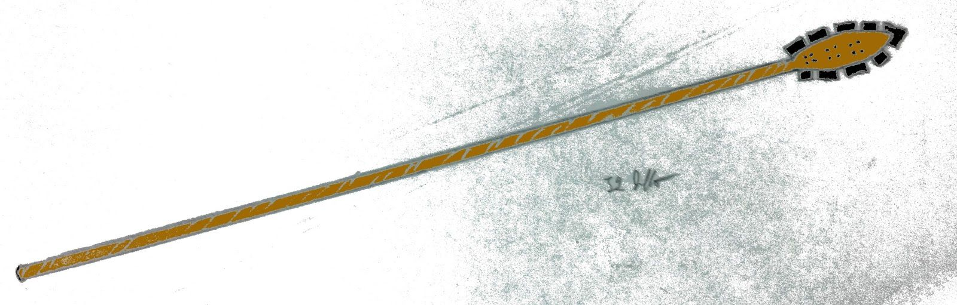

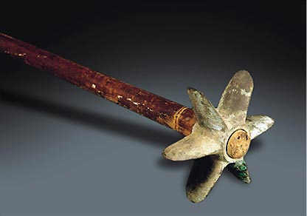
Chaska chuqui (“star spear”) (equiv. to heavy mace) – a wooden club weapon whose tip was in a star shape to maximize the potential to break bone. A common weapon of warriors. Gold or silver is used for the star for chieftains and war party leaders. This is the equivalent of a heavy mace of the western kingdoms.

Chambi (equiv. to light mace) weapons which consists of a wooden shaft with a heavy metal (copper or bronze) or stone object at the end. This is the equivalent of a light mace from the western kingdoms.
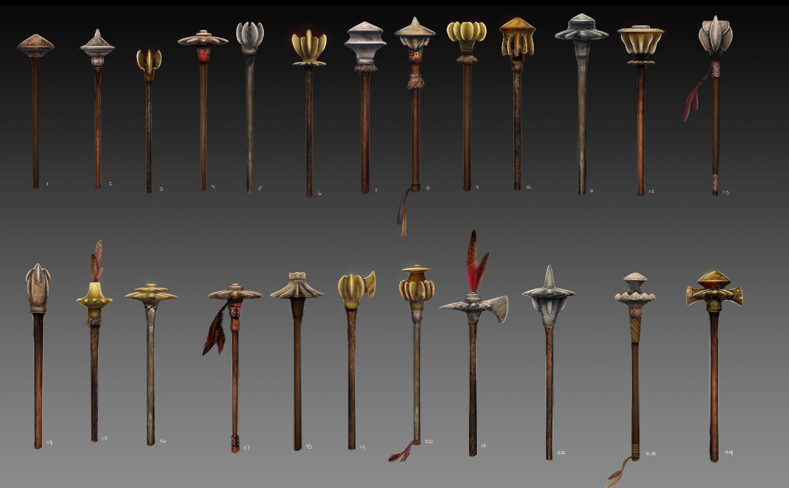

Spear Thrower (aka atl atl) – a tool that uses leverage to achieve greater velocity in dart or javelin-throwing. It may consist of a shaft with a cup or a spur at the end that supports and propels the butt of the spear. It's usually about as long as the user's arm or forearm. The user holds the spear-thrower in one hand, gripping near the end farthest from the cup. The user puts the butt end of the spear, or dart, in the cup, or grabs the spur with the end of the spear. The user reaches back with the spear pointed at the target. Then they make an overhand throwing motion with the thrower while letting go of the spear with the fingers. The spear-thrower is a low-mass, fast-moving extension of the throwing arm, increasing the length of the lever. This extra length allows the thrower to impart force to the dart over a longer distance, thus imparting more energy and higher speeds.
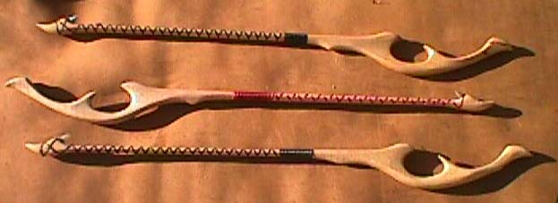
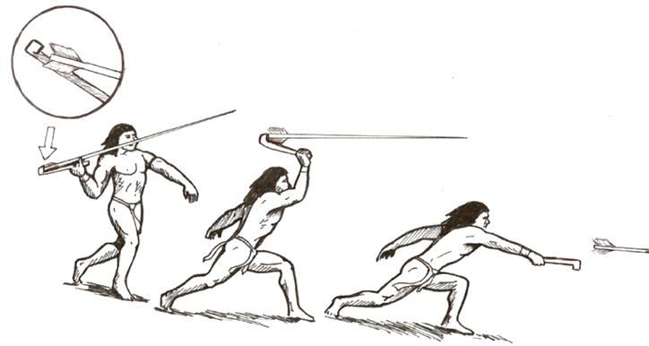

Waraka (equiv. to sling) - slingers are trained from childhood for hunting and self-defense, thus improving their dexterity in the weapon. Its simplicity and effectiveness (the projectiles could reach 120km/h) explains why the bow and arrow haven’t replaced it. Generally made of wool, there were also ceremonial slings, which were used in meetings as an ornament.
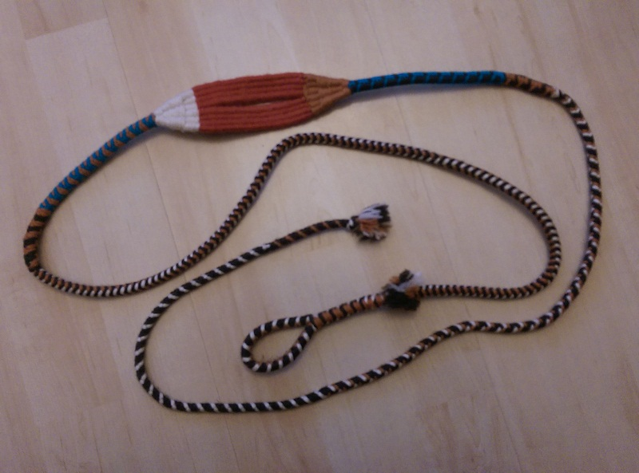
Waqtana (equiv. to great club) – Thick clubs made of wood; its efficiency is only remarkable against unarmored warriors. It is long and both hands have to be employed to use it. It wasn't very popular due to its slowness and the time it took to make each hit.
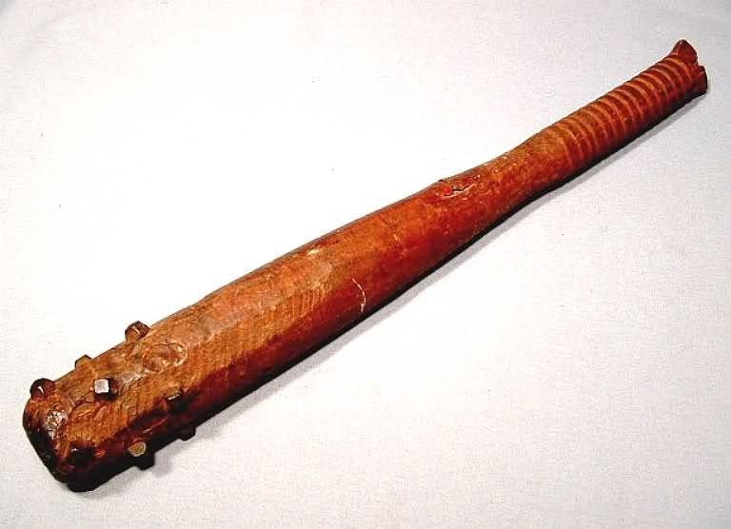
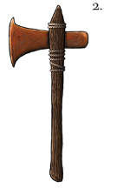
Itztopilli (hand axe) -
Tuksina (equiv. to dagger) – used by soldiers for executions or as a weapon of last resort, but not for direct combat. Some are made of flint, others of iron or crude steel.
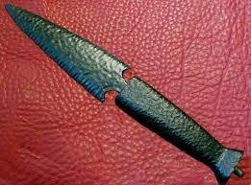

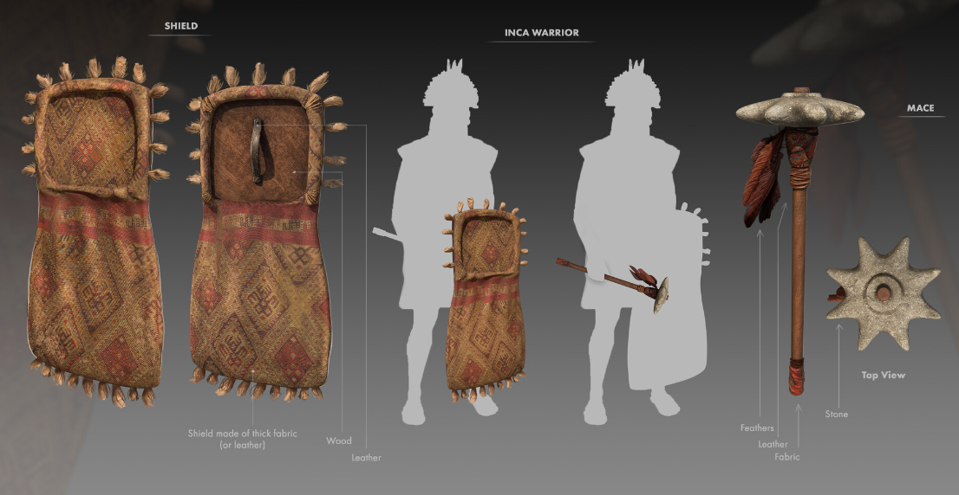

Armor is made up of cotton sandwiched between layers of cloth and leather and stitched together, creating quilted vests and body suits. This cotton armor is very dense and can be two fingers thick, repelling arrows and spears almost as well as a steel breastplate.

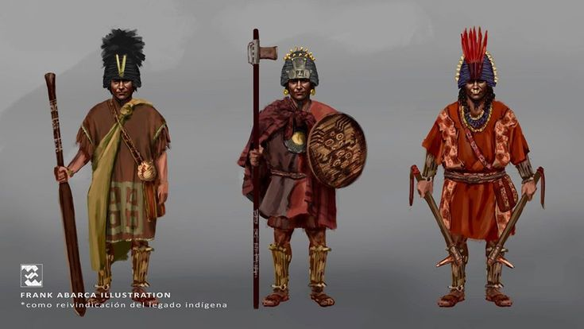

Capes (Quechua: Yaqulla): These capes are made of thick alpaca wool and effective in blocking arrows and reducing the damage of other weapons
Chestplates and bracers (Quechua: Awqana Kusma): Used by officers and noblemen, consist of thickly quilted and padded cotton tunics, with wooden plates to reinforce them. They also served as the base for the gold or bronze plates that the nobles use as a distinction.
Helmets (Quechua: Uma chuku): Created from wood, some were reinforced with small copper plates. The officers wear metallic helmets of copper, bronze, or gold depending on their rank, as well as the ornaments.
Shields (Quechua: Wallqanqa): These shields are made of wood and covered with leather, useful for blocking enemy projectiles and slightly reducing damage from hits, on the front were the symbols of the ayllu of his bearer.
Square shield: Include a small cape made of wool in the lower part of the shield to protect the legs.
Round Shield: their easy maneuverability make them appropriate for the deserts and valleys
Rectangular shield: Large shields made of wood brought from the jungle, are placed on the back and are used by soldiers who have to use both hands to fight.

Standard Armor and Weapons:
- Conscript Infantry (well-equipped):
  - Armor
    - Leather AC +2 (Awqana Kusma)
    - Light Wooden Shield AC +1 (Wallqanqa)
  - Weapons
    - Short Sword 1d6 / 19-20 (Macuahuitl) or Mace, heavy 1d8 / x2 (Chaska chuqui)
    - Spear 1d8 / x3 (Tepoztopilli)
    - Projectile Thrower (add 1d4 dmg) (Atlatl)
    - Bola (entangle)
    - Blowgun
- Conscript Infantry (poorly-equipped):
  - Armor
    - Padded Armor AC +1 (Awqana Kusma)
    - Buckler (back) AC +1 (Wallqanqa)
  - Weapons
    - Mace, light 1d6 / x2 (Chambi) or Hand Axe 1d6 / x3 (Itztopilli)
    - Spear 1d8 / x3 (Tepoztopilli)
    - Projectile Thrower (add 1d4 dmg) (Atlatl)
    - Bola (entangle)
    - Blowgun 1d4 + special
- Professional Infantry (well-equipped):
  - Armor
    - Breastplate AC +5 (Awqana Kusma)
    - Heavy Wooden Shield AC +2 (Wallqanqa, with apron)
  - Weapons
    - Longsword 1d8 / 19-20 (Macuahuitl)
    - Mace, heavy 1d8 / x2 (Chaska chuqui)
    - Spear 1d8 / x3 (Tepoztopilli)
    - Projectile Thrower (add 1d4 dmg) (Atlatl)
    - Bola (entangle)
    - Blowgun 1d4 + special
- Professional Infantry (poorly-equipped):
  - Armor
    - Hide Armor AC +3 (Lamellar)
    - Heavy Wooden Shield AC +2 (Wallqanqa, with apron)
  - Weapons
    - Longsword 1d8 / 19-20 (Macuahuitl)
    - Mace, heavy 1d8 / x2 (Chaska chuqui)
    - Spear 1d8 / x3 (Tepoztopilli)
    - Projectile Thrower (add 1d4 dmg) (Atlatl)
    - Bola (entangle)
    - Blowgun 1d4 + special
- Archers (well-equipped):
  - Armor
    - Leather AC +2 (Awqana Kusma)
    - Buckler (back) AC +1 (Wallqanqa)
  - Weapons
    - Dart 1d4 / x2 (multiple)
    - Javelin 1d6 / x2 (multiple)
    - Projectile Thrower (add 1d4 dmg) (Atlatl)
    - Sling 1d4 / x2 (Waraka)
    - Blowgun 1d4 + special
- Archers (poorly-equipped):
  - Armor
    - Padded Armor AC +1 (Awqana Kusma)
    - Buckler (back) AC +1 (Wallqanqa)
  - Weapons
    - Dart 1d4 / x2 (multiple)
    - Javelin 1d6 / x2 (multiple)
    - Projectile Thrower (add 1d4 dmg) (Atlatl)
    - Sling 1d4 / x2 (Waraka)
    - Blowgun 1d4 + special
- Mounted Cavalry (well-equipped):
  - Armor
    - Breastplate AC +5 (Awqana Kusma)
    - Heavy Wooden Shield AC +2 (Wallqanqa, with apron)
  - Weapons
    - Longsword 1d8 / 19-20 (Macuahuitl)
    - Mace, heavy 1d8 / x2 (Chaska chuqui)
    - Spear 1d8 / x3 (Tepoztopilli)
  - Mount: Dire Jaguar
- Mounted Cavalry (poorly-equipped):
  - Armor
    - Hide Armor AC +3 (Lamellar)
    - Heavy Wooden Shield AC +2 (Wallqanqa, with apron)
  - Weapons
    - Longsword 1d8 / 19-20 (Macuahuitl)
    - Mace, heavy 1d8 / x2 (Chaska chuqui)
    - Spear 1d8 / x3 (Tepoztopilli)
  - Mount: Dire Jaguar

Local Deities
Kukulcan – derived from Kukulcan, deity of water and wind
Kinikahu – derived from Kinich Ahau the sun god, generator of light, time, heat, and the four directions
Ixachel – derived from Ix Chel the goddess of the moon, fertility, harvests, sexuality
Yumakem – derived from the god of death Ah Puch aka Yum Kimil; depicted as being in a state of decay, with his skeletal mask, protruding belly (filled with rotting matter), body adorned with bones, and a necklace hanging with eyeless sockets. He was generally accompanied by a dog or owl and he thrived on human sacrifice, people were thrown into a Cenote, a sacred well, as human ritual sacrifices for Ah Puch. He took pleasure in extinguishing the very essence of souls and keeping them in the underworld where they could be tortured.
Buluctan – derived from Buluc Chabtan the god of war; is typically portrayed with a thick black line around his eyes and down one cheek. It’s also common for him to be in images where he’s setting fire to buildings and stabbing people with a spit which he uses to roast them over a fire. He’s often pictured with the god of death.

Creatures

Camazotz – giant death bats that come from Xibalba; after the fall of Ongolk in the First Ancient Age these creatures were loosed upon the world. They are huge carnivorous bats that come out only at night. During the day they are transformed into statues if exposed to the sun, but will revert again to bat form when the sun sets. They are keen to remove the heads of living creatures, which also transform to stone permanently, and adorn the ruins with them.

Other Races
Elves

Dwarves
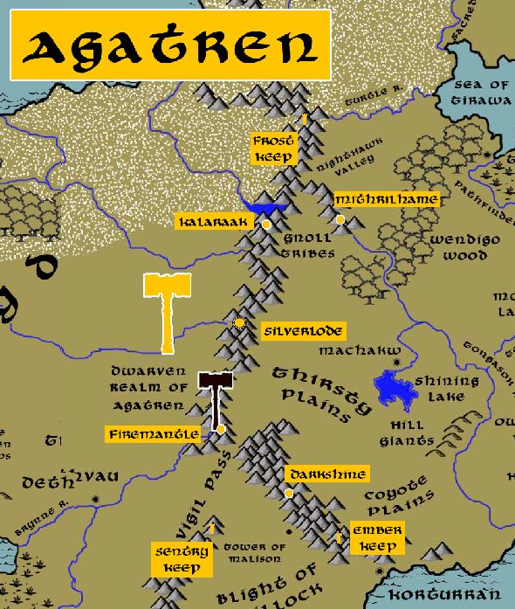

Magical Items
Ebony Macuahuitl – wielded by Quillock in the Fourth Primordial Age to unleash an unspeakable terror on the lands of Ongolk. Current whereabouts unknown.
Ossuray Seat – a throne of dried, bleached bones that has grown over the decades to extend outward to cover his throne room floor. Some say it is a living entity, hungry for the flesh of the living, and that Desibys feeds his enemies to it.
Staff of Undoing - a powerful relic from the dawn of time that wields immeasurable power. It is said that with a touch of the staff any boon may be given out, but comes at a terrible price.

Singularian - a stone that creates a portal to pure magical potential; led to the downfall of the Thaumatugem Order of wizards in Ongolk in 370 PA4
Dubius Mente, a cursed blade that has made many a pirate rich before their untimely demises. Currently owned by Elgar Wylmot, master of the town of Brazan.
Corazon del Mar - a crystal ball once used by a famous sea witch. The sphere has the power to see for hundreds of miles, but its range is almost limitless when looking out upon the open seas. Currently owned by Truda Wylmot, mistress of the town of Brazan.
Mchukua “the Takers” - handsomely jeweled twin blades rumored to take men’s souls. Currently owned by Borredan Sevilla, master of Reaven.
Ossuary of Yumakem - 140 WA4 - Fall of Desvelado - pirates retrieve the Ossuary of Yumakem out of Ongolk and bring it to the Isle of Talyn; within weeks the entire population goes mad and kills one another

NPC Templates
This is a list of notes and stats to help develop NPC’s relevant to this region.

Developer Notes
This is a list of notes on the development of this document, including notes on history, culture, and changes to the document.
Ongolk: a blend of Mayan, Aztec, and Inca culture and mythology

Ayllu is a word in both the Quechua and Aymara languages referring to a network of families in a given area, often with a putative or fictive common ancestor.[1] The male head of an ayllu is called a mallku which means, literally, “condor”, but is a title which can be more freely translated as “prince”.

The high priest of the kingdom ('province') was called ahau can mai or ah kin mai, with mai being either a family name or a functional designation. The position was hereditary, usually passed on to sons or close relatives. The high priest lived from the contributions of his town priests and the gifts of the lords. The responsibilities of the ahau can mai included the writing of books; the teaching of the Maya script and the Maya calendar to the novices; examining and appointing new priests and providing them with books; performing the more important rituals; and advising the other lords.[11]
The town priest was called ah kʼin, a word with a basic meaning of 'diviner' (kʼin by itself meaning 'sun' or 'day').[12] The ah kʼinob had the responsibility of conducting public and private rituals within individual towns throughout the province. They "preached and published the festival days," determined the appropriate steps in case of need, made sacrifices, and administered the "sacraments", acts connected to life cycle rituals.[13] The town priests were assisted by four old men called chac.[14]
The priests carrying out human sacrifice were called ah nakom; their status was relatively low. Priests giving oracles were known as chilan or chilam, 'oracular priest' (often translated as 'prophet'; an influential role, with the Chilam Balam as a prime example). The chilan may have used mind-altering substances.[15]
Possible Priest Titles in Ongolk
Ahkinmai – high priest of the kingdom
Ahkin – town priests
Ahnakom – low level priests serving the higher offices
Chilam – oracle priests

Major deities of the Mayans
Itzamna - This is one of the most important gods of the Mayan Gods. He is often depicted as a toothless old man with a large nose. He was the son of the creator god Hunab Ku and, he was associated with the sun god Kinich Ahau as well as the goddess Ix Chel. There are many stories and myths about him since he was considered a cultural hero, because of his contributions to the cultivation of corn, the creation of calendars, and the discovery of Maya medicine. The god Itzamná is the symbol that represents wisdom as well as the teaching of knowledge.
Chaac - This is the famous Maya rain god. The story says that he carried an ax in one hand with which he struck the clouds to make it rain. Another legend tells that Chaac was the brother of the sun god and together they defeated their adoptive parents. In this legend, it is also said that Chaac committed adultery with his brother’s wife for which he was punished, and when he cries in repentance, the sky becomes cloudy and it rains. He was considered the protector of agriculture, so even today rituals are offered for a good harvest. He is often depicted with a huge nose, bulging eyes, and a body full of reptile-like scales. This representation can be found in different archaeological sites of the Maya world, such as Uxmal and Chichén Itzá.
Ix Chel - Ix Chel is known as La Blanca and is one of the most important goddesses in the vast Maya Pantheon. She was wife to Itzamná, one of the most powerful gods. Together they fathered 13 children, including Yum Kaax; corn god and Ek Chuah; god of merchants, cocoa, and war.
A legend tells that Itzamná fell in love with her while weaving on a backstrap loom, of which she was the inventor. She was the lady of the moon and was thought to have control over the cycles of the moon. Like all the Mayan Gods, Ix Chel had other attributes such as being the goddess of fertility, harvests, sexuality, and pregnancy, so women entrusted her with the protection of their children.
Every year the Sacred Maya Journey is held in honor of Ix Chel and taking place in Xcaret Park, where hundreds of canoers cross the Caribbean Sea to Cozumel Island in search of their message.
Kinich Ahau
He is the Sun god of Maya culture. Often represented by a jaguar, eagle, or deer; animals that depicted power. It is said that he was a generator of light, time, heat, and the four directions that the universe had in its vast expanse. However, the most common representation of this great god was an old man with a prominent nose dressed in invaluable garments, a mocking gesture, and crossed eyes. The importance of this Mayan God was such that the rulers in the classical era of Mayan culture used the word “kinich” in their titles. Kinich Ahau was idolized with dances and sacrifices for being a being of war with which they sought to obtain protection.

Hun Nal Ye - According to the Popol Vuh, Hu Nal Ye is known as the first father and his name in Mayan means “first seed of corn”. Also, this ancient book of the Maya tells the man was created from this seed. It narrates that Hun Nal Ye built a house divided into eight parts oriented towards all the cardinal points of the universe. At the center of his creation, he placed three stones to indicate its beginning, as well as a huge tree that represented the four winds of life, and that was the bridge between heaven, earth, and the underworld: the ceiba tree. This Mayan God was the father of the Hunahpú and X’Balamque twins, who descended into the underworld to search for him. These famous twins fought great fights with the lords of Xibalbá.

Ah Puch - He is the god of death in the Maya Pantheon and was also called the Flatulent (Kisin), the Lord of Death (Yum Kimil), and was the sovereign of the lowest of nine underground worlds of the Maya. His image is depicted as a being with exposed ribs and spine with black details suggesting decomposition.
Ah Puch is considered the opposing side of the god Itzamná, the god of life. The name of the fleshless god has two hieroglyphs; the first represents the head of a corpse with its eyes closed and the second the head of the god himself with a truncated nose, gaunt jaws accompanied by a flint knife. His representations in the world were owls, dogs, and bats, animals considered by the Maya to be a bad omen. A legend tells that this god went out at night to visit the houses of the sick to feed on them or take them to Xibalbá. The living had the advantage of being able to hear his bells and necklaces that moved with every step that the god took to hide from him.

Ek Chuah - The duality of the Mayan gods is perfectly represented with Ek Chuah, while he was the god of merchants and cocoa, he was the god of war, chaos, and destruction too. His benevolent side was represented by a man with a large cane that worked as a lance and carrying various items on his back. His warrior side always appeared fighting and defeating enemies or, on the contrary, being defeated by other warrior gods. One of the offerings made to Ek Chuah took place once during the month of Muan, which corresponded to cocoa farmers, in which dogs dyed with the color of cocoa were sacrificed, as well as blue iguanas, probably painted with pigments of the time, offerings that were later consumed by the Maya.

Kukulcan - He is the most well-known god of the Maya Pantheon, who has been an ambassador of the great Maya culture around the world due to the Kukulcán Castle in Chichen Itza; one of the Seven Wonders of the Modern World. He is the deity of water, wind and some suggest that Kukulcán and Quetzalcóatl are the same being. As we explore the Maya world, we find different names for this god such as Muku Le Chan in Tabasco or Q’uk’umatz in Guatemala. The importance of Kukulcán can be verified in the majestic Chichén Itzá, one of the most important cities in the Maya world, where its founders, the Itzaes, worshiped the feathered serpent through offerings and integrating it into their architecture. Today we can relive during the spring equinox what the ancient Maya could see hundreds of years ago; this occurs when the angle of the sun reflects its shadows on the north staircase of Chichén Itzá, giving the illusion of how a great serpent descends to the ground. This is one of the most amazing experiences to live in the Maya World.
GOD L LORD OF THE UNDERWORLD
The name of this Maya Pantheon deity is unknown. What we do know, is that he is related to the night and the underworld, as well as death and the moment of creation of the cosmos. As in the other powerful gods of the Maya culture, his image is represented through an old man with jaguar ears and black painted body parts.
One of the most distinctive features of this god is a kind of hat decorated with owl feathers of the horned species. His back is covered by a huge jaguar skin or he appears naked showing the flaccidity of his belly.

The steps of the Temple of Kukulcan (also known as El Castillo) run steeply down from the temple at the summit of the pyramid to stone serpent heads at the base of the stairs. On the twin equinoxes each year, the sun casts the shadow of a serpent which moves slowly down the stairs from the temple to the stone heads and creates the image of a serpent descending to the earth. Kukulcan (also known as Gucamatz and, more famously, Quetzalcoatl) was the most popular god among the Maya and it is not surprising that, even today, many of the Maya, and non-Mayan people, congregate at the temple twice a year to receive the blessings of his visit to the earth.

Free City Names: mix of Renaissance Names (English, French, German, Spanish)

