Notes on the Fallen Kingdoms of Oberon and the Holy City of Indiron

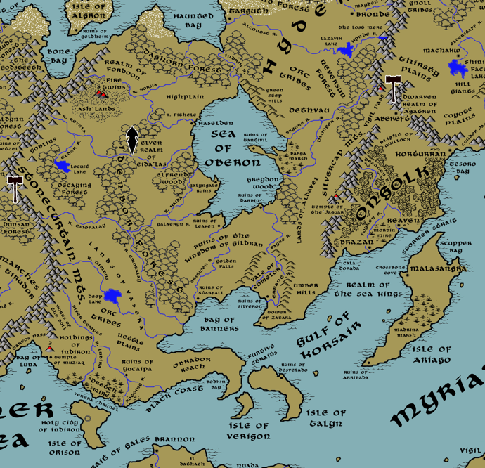

**Table of Contents**

* **Overview**
* **Towns and Cities**
* **Best in the Land**
* **Stewards of Power in this Land**
* **Points of Interest**
* **History**
* **Local Goods**
* **Notes on Culture**
* **Local Deities**
* **Creatures**
* **Other Races**
* **Magical Items**
* **NPC Templates**
* **Developer Notes**

**Overview**

The lands surrounding the Oberon Sea are vast stretches of treacherous wilderness, chaotic lands ruled over by barbarians, humanoid tribes, magical creatures, and mad wizards. Ruins of ancient civilizations dot the landscape: palaces, keeps, and roads that are crumbling and forgotten.

Here once stood the kingdoms of old. To the east, hugging the Silvercap Mountains, were the lands of Aldavel. To the west, stretching down to the Myriad Sea, were the lands of Vasera. To the south the Gildran Kingdom overlooked the Bay of Banners. To the southeast dwelt the ancient menace of Ongolk, hiding behind the Silvercap and Direfrost mountain ranges. All were powerful dominions in their time but fell to ruin. It is here that humanoid tribes gather under the thrall of old magic or wizards who seek to resurrect hidden powers.

**Towns and Cities**

* Lands of the fallen kingdom of Vasera – ancient kingdom, now occupied by orc tribes
  + **Yucaipa** – ruins
* Lands of the fallen kingdom of Gildran – ancient kingdom, now occupied by orc tribes
  + **Starfall** - ruins
  + **Silveron** - ruins
  + **Leaven** - ruins
  + **Darbin** - ruins
  + **Galyngale** - ruins
  + **Tantavil** - ruins
* Lands of the fallen kingdom of Aldavel – ancient kingdom, now occupied by orc tribes
* Holy City of Indiron – located on the island of Orison

**Best in the Land**

Trade Hub:

Religion:

Arts:

Magic:

Spirits:

Steel:

Grain:

Crafted Goods (e.g. Pottery, Textiles, Metal Wares):

Harvested Goods (e.g. Aromatics, Medicine, Dyes):

Mined Goods:

Precious Metals:

Ship Building:

Other:

**Stewards of Power in** **this Land**

Kings and their armies are not the only wielders of power. There are many unseen friends and foes that shape the destiny of the land. Each of the groups listed below are well known to the people of this region. Some are feared, others venerated. All of them play their part in the grand drama of this land’s story.

**Merchant Companies**

(none)

**Mercenary Companies**

(none)

**Smuggling Rings**

(none)

**Centers of Worship (Churches, Cathedrals, Shrines, Lodges, Temples)**

Mornastra Cathedral – Indiron, Isle of Orison

**Orders of Paladins**

Order of the Luminous Sword – Indiron, Isle of Orison

**Druidic Circles**

(none)

**Bands of Rangers**

(none)

**Schools of Magic**

(none)

**Bardic Colleges**

(none)

**Warrior Academies**

(none)

**Assassins Guilds**

(none)

**Cults**

(none)

**Other Guilds**

(none)

**Monasteries**

**Pirates**

Captain Angel Korsana – the Black Coast

**Points of Interest**

* **Isle of Algron** – a dark and uninviting frozen rock in the northern seas, Algron has been home to many banished Norgardsmen. It was in 540 AA4 that Heinar Hoarbeard, defeated by the king in Geirdir, retreated here and fell under the spell of a witch who promised him great power. Heinar built the town of Geldheim and waged savage war on his kinsmen across the waters. Algron became the seat of a small but powerful line of rogue rulers called the Hoarkings and Hoarqueens. The ruins of Geldheim stand here today, haunted by the ghosts of reavers and maniacs as well as fell creatures drawn to its evil. Some say there are fortunes laying in hiding far beneath the surface, but none dare risk being cursed by it.
  + **Ruins of Geldheim**
* **Isle of Orison** – The Isle of Orison is under the control of the High Holy Church of Hieroneous. Here stands Indiron, home of the high seat and the church, famed for its holy relics and the power it holds over the world. It was on this island in 60 AA3 the priests of Heironeous built the first holy city, which was later destroyed and rebuilt. The soil here was once volcanic ash and unfit for much more than scrub brushes. Monks from Indiron have worked the land to produce lush vineyards of grapes and olives. Separated from the wild mainland around the Oberon Sea, Orison is filled with peaceful villages from peoples from all over the world. It is a major shipping destination at the eastern eds of the Inner Sea. Some mark it as the last stop of the Western Kingdoms before passing eastward into the Myriad Seas.
* **Isle of Verigon** – A small island overlooking the passage from the Strait of Gales to the Myriad Sea, it is a forbidding island covered in volcanic rock and thick jungles.
  + It was here in the Second Written Age that **Hjarrandi Hagisson**, Norgardian pirate named the **Sjømester** (the Sea Master), built his headquarters, the **Sørseil Keep**. It is a small castle built of ruddy stones set into the side of the only mountain on the isle. Hagisson and his successors dominated the seas in the region for almost three hundred years. The Keep is abandoned now, and some say haunted by Norgardian ghosts guarding their hidden treasure.
* **Isle of Talyn** – A large island covered in dense jungle growth; the Isle of Talyn has been the bane of many a traveler. Rumors tell of a bejeweled ossuary that was stolen by thieves out of Ongolk and taken here. But the ossuary was cursed and unleashed the wrath of Yumakem, Ongolk god of death. Any who venture onto this island begin to hear a low and persistent chanting whisper, leading to madness. It is said the entire island is cursed with a thousand deadly creatures and plants. Those who do survive become mindless servants of Yumakem. Tirudoran explorers established the town of Desvelado here
  + Site of the Ruins of Desvelado.
  + Here lurk the tribe of Sahuangin known as the **Syltharash**, known by their sign of two sharp fangs crossed.
* Haunted Bay
* Sea of Oberon –
  + **Orysya** is the most famous Rusalka, water spirits of women who drowned and haunt the lands of Hyderis; she rules from the bottom of the Oberon Sea. She is temperamental, sometimes fascinated with the plights of man and at other times vengeful towards them. In 345 WA4 the farm boy Petro Bodnar was called by Azov, Mistress of Copper Mountain, to seek the magical Sword of Kalinov; after many adventures the boy retrieved the sword from the Orysya and used it to slay the witch Oksana to become Korol (king) of Hyderis.
  + On the eastern shore of the sea, at the tip of a short peninsula stands the keep of the **Twin Witches, Zandstra (f) and Spoelstra (f),** Arch Mages of the Lands of Oberon
  + Within the depths of the sea lurk the tribe of Sahuangin known as the **Thalkuri**, known by their sign of a large, serrated tooth.
* Black Coast
* Bay of Banners
* Furtive Straits
* Bodkin Bay
* Daghorn Forest – the green dragon **Vezemra** dwells in the Daghorn Forest
* **Decaying Forest**
  + These lands are dominated by the **Blugtuk** tribe of goblins, known by their sign: a green toadstool.
* Idenbor Forest
  + **Eida'Las** - Elven Domain
    - Noldorin - Elven town of Eida'Las
    - Othorion - Elven town of Eida'Las
    - Faerondil - Elven town of Eida'Las
    - Tiatha - Elven city of Eida'Las
    - Helerandri - Elven town of Eida'Las
    - Rivleam - Elven town of Eida'Las
* Elfrend Wood
  + These lands are dominated by the **Blikken** tribe of goblins, known by their sign: a purple feathered poison dart.
* Greydon Wood
* Highplain
* **Ash Lands**
  + These lands are dominated by the **Yargug** tribe of orcs, known by their sign: a volcano peak erupting.
* Nettle Plains
* Fithele River
* Revela River
* Elder River
* Galaeryn River
* Nimbus River
* Tempas River
* Lubira River
* Erstwen River
* Fayne River
* Errant River
* Locust Lake
* **Deep Lake** – The waters of Deep Lake are eerily calm, almost glass-like in appearance. Nothing seems to stir the brooding waters, even when high winds blow or rain falls. It is thought to be cursed and bottomless, home to dark and writhing shapes.
  + It was here in the Fourth Ancient Age that the beautiful city of **Hylum** once stood, towering over the lake’s banks. But it mysteriously burst into flames and fell into the lake, taking with it every trace of its existence but for scattered stones where towers once stood. Some say here was the meeting place of the **Order of Cathirix**, a band of wizards from the three kingdoms of yore: Aldavel, Gildran, and Vasera. It is rumored their abuses of the magics in these lands led to the destruction of Hylum and, eventually, to the kingdoms themselves.
* Barga Marsh
* Dretch Mire
* **Stonecurtain Mountains** – one of the massive mountain ranges of Amadar, it stretches from the seas to the north to the Inner Sea to the south and forms the westernmost barrier to the lands of the Oberon Sea.
* **Silvercap Mts.**
  + Here dwell the tribe of Stone Giants called the **Ikagag** (“brutal ones”)
* **Fire Twins Mts.**
  + The tribe of Fire Giants called the **Zharkozhii** ("Flame Beasts") dwells around the molten rivers of the Fire Twin Mountains.
* **Umber Hills**
  + Here dwell the tribe of Hill Giants called the **Argulek**
* Golden Falls
* **Vigil Pass** (referenced from Ongolk atlast) – Vigil Pass is a hundred-mile stretch of narrow road that descends southward from a break in the Direfrost Mountains then skirts the northern edge of the Silvercap Mountain range as it butts up against the Neversun Forest. The pass has been an important strategic location since the dawn of history, first as the entryway east into Haka’Na lands, then later as the site of many military movements including the First and Second Dark Crusades out of Ongolk. It is said that the wizards of Abereft have transformed a hundred or more outcroppings of the mountains into rock golems that constantly guard this area. Other wards such as arcane marks or ravens under the command of the Tower of Malison also make this a dangerous stretch of land to pass through.
  + the copper dragon **Jaleirys** dwells in the mountains overlooking Vigil Pass
* Vale of Comelor
* Temple of Muziaq
* Realm of Fordoon
* Goblins
* Orc Tribes
* **Nammure** – Sea Elf Domain
* Duskryn – Drow Domain
* **Tower of Zatara** – Zatara is rumored to be the most powerful sea witch of the Written Ages. Her tower, once a lighthouse, is covered in countless sea shells and barnacles that she has summoned to armor it. It is a hideous looking tower and reeks of rot. From the tower Zatara commands most of the sea life in Banner Bay and surrounding areas.
* **Fallen Lands of Vasera**
  + These lands are dominated by the **Ghorza** tribe of orcs, known by their sign: a white wishbone. The orcs, like all fell creatures in the Oberon Sea region, are born with wine-colored markings on their faces. This comes from when Mortavay's clerics took drops of her black blood and anointed the fell creatures of the Oberon Sea region; the blood burned them, marking generations of orcs and goblins as children of Mortavay.
* **Fallen Lands of Gildran** 
  + These lands are dominated by the **Mazog** tribe of orcs, known by their sign: a bird skull. The Mazog’s faces bear the wine-stain markings on their faces that mark them as descendants of the children of Mortavay.
* **Fallen Lands of Aldavel** 
  + These lands are dominated by the **Bahgigoth** tribe of orcs, known by their sign: two snakes in a circle, each consuming the other’s tail. The Bahgigoth’s faces bear the wine-stain markings on their faces that mark them as descendants of the children of Mortavay.
* Obrador Reach
* Holdings of Indiron
* **Ruins of Haselden** – once a city of the kingdom of Aldavel, it was burned to the ground when the kingdom fell to the Bahgigoth orcs during the Great Scourge of Hrolith in 240 AA4. Later, in 260 WA3, Norgardian raiders sacked the orc stronghold during the Great Erobring and decimated the remains of the city further.
* **Ruins of Tantivil** – once a city of the kingdom of Aldavel, it was burned to the ground when the kingdom fell to the Bahgigoth orcs during the Great Scourge of Hrolith in 240 AA4
* **Ruins of Galyngale** – once a city of the kingdom of Aldavel, it was burned to the ground when the kingdom fell to the Bahgigoth orcs during the Great Scourge of Hrolith in 240 AA4
  + 330 AA2 - Galyngale grows into a thriving town boosted by friendship with the elves of the nearby wood, which is named Elfrend; the town becomes a hub of culture and magic
* **Ruins of Leaven** – once a city of the kingdom of Gildran, it was burned to the ground when the kingdom fell to the Mazog orcs during the Great Scourge of Hrolith in 330 AA4
* **Ruins of Darbin** – once a city of the kingdom of Gildran, it was burned to the ground when the kingdom fell to the Mazog orcs during the Great Scourge of Hrolith in 330 AA4
* **Ruins of Starfall** – once a city of the kingdom of Gildran, it was burned to the ground when the kingdom fell to the Mazog orcs during the Great Scourge of Hrolith in 330 AA4
* **Ruins of Silveron** – once a city of the kingdom of Gildran, it was burned to the ground when the kingdom fell to the Mazog orcs during the Great Scourge of Hrolith in 330 AA4
* **Ruins of Yucaipa** – once a city of the kingdom of Vasera, it was burned to the ground when the kingdom fell to the Ghorza orcs during the Great Scourge of Hrolith in 270 AA4
* **Ruins of Desvelado** – Once the site of the city of Desvena of the kingdom of Vasera, it was burned to the ground when the kingdom fell to the Ghorza orcs during the Great Scourge of Hrolith in 270 AA4
  + In 50 WA4 Tirudoran explorer Piero Cosvaldo founded the town of Desvelado on the Isle of Talyn. But in 140 WA4 the town fell into ruin. Pirates retrieved the Ossuary of Yumakem out of Ongolk and brought it to the Isle of Talyn; within weeks the entire population went mad and killed one another.

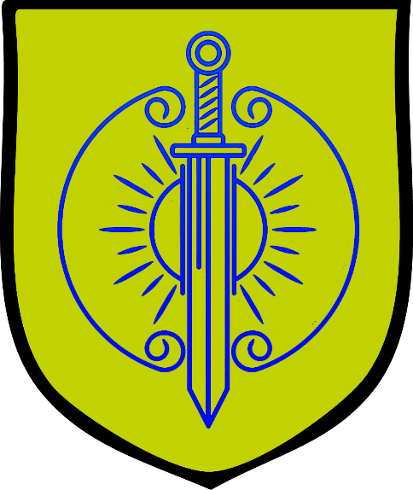**The Holy City of Indiron**

**Size:** small city

**Trade Goods:** grain, wine, religious center

**Local Goods:** center of religion for the worldwide followers of Heironeous

**Standard:** sign of the sword and sun

**Colors:** gold and blue

**Patron Deity:** Heironeous

**Ruler:** Stagio Calbi and his wife Vittoria (f)

**Home**: Castle Cornoba (“noble heart”)

**Steward**: Manetto Calandri

**Marshal**: Arrigo Albarenno

**House Priest:**  Olympia Albirio (f)

**House Adviser (Scholar/Mage/etc):**  Ysabeta Albergati (f)

**Captain of the Guard**: Bonino Barbani

**Chief Warriors in Service**:

Taddeo Boldu

Lorenza Carafa (f)

Palla Abagio

**Local Powers:** Roof Runners (thieves guild), Mornastra Cathedral: High Cathedral of Heironeous, Order of the Luminous Sword (order of paladins)

**Local Sites:** Barrel and Bottle Inn & Tavern, The Whistling Windlass Inn & Tavern, Sanguine Vineyards

**Description**:

Indirron is the high holy seat of power for the worldwide followers of Heironeous. At the center of the city is the massive cathedral complex, encircled by walls and baileys. The complex houses hundreds of priests, acolytes, paladins, and household staff who support the kitchens, stables, and so on. Outside of the complex are the rest of the city quarters where more secular buildings stand. The city is run much like others except there are no gambling houses or brothels and the city is patrolled by penitent soldiers of the faith with no tolerance for the irreverent. This doesn’t mean the city is crime-free, only that it is less obvious than in other cities.

**Industry:**

Vast orchards and plantations dot the island, all of them in service to the city. Sanguine Vineyards is the collective entity controlling all vineyards and produces a special wine, named **Imeblas**, which is exported as holy wine blessed by the priests of Hieroneous. Wheat harvested in the fields is processed into grain stores that have multiple purposes befitting the church: some are used to supply expeditions by the church while others are dispensed as relief to lands requesting aide. What isn’t clear is how much of the charitable grain is either sold on the black market or used as leverage in securing cooperation in the lands that most need it.

**Key Figures:**

Stagio Calbi, his holiness the high seat of the Church of Heironeous –

Father Calibi is a tall man in his middle ages with the solid build of a farmer but the soft hands of a clerk. Olive-skinned with dark, receding hair and large gray eyes, Calibi has a soft, broad face and a reassuring smile. He is a hard-working man, rising early and engaging in a long day of meetings that take him well into the night. Each morning he walks alone into the city, disguising himself as a commoner. He visits the slums to pray at a modest shrine that was his morning ritual as a boy growing up on the streets. While in the palace he dresses in simple priestly vestments cut from muslin cloth, eschewing the common practice of high priests to dress in silk. He carries with him at all time a reliquary of soil from Heaven’s Mount blessed by Heironeous. At official events he carries in his hand the powerful mace, **Malis Inimicus**, ancient artifact and weapon of **Helisent Dufour**, the first High Priestess of Hieroneous in the Primordial Ages.

Calbi is an intelligent man from common stock. He rose from a simple scribe to the highest levels of the church through his keen analysis of forgotten ancient writings and his knack for choosing the right words for the right ears at the right time. He senses that there are dark forces at work in the church, members of the clergy who appear pious but have secular ambitions. Worse, there are rumors of a cult of extremists who seek to take over Indiron. Calbi seeks to finance expeditions to support churches and defend the weak. He has pulled back Indiron’s financial interests in the Holding Houses and paying off rulers for favors. This has put him at odds with many of the powerful priests in Indiron.

The **Order of the Luminous Sword** is one of the most revered orders of paladins in the world. Especially appointed by the high priest, the Luminous Swords are the elite of holy warriors serving Heironeous. Devoted warriors come to Indiron only by special invitation, sometimes after earning recognition in the church’s expeditions abroad. A few are referred by nobility who sponsor candidates for consideration. Once accepted, initiates must pass a grueling year-long process of purification. Those that pass are members of the order for life and given incredible powers representing the church. Each member of the order is branded with the sign of the sun and sword and wears the **Ring of Ephemera** which grants them an aura of protection and power over light and darkness. The name **Ephemera** comes from the angel of heaven said to have appeared to the paladin **Armin Philidor** and charged him to begin the order two thousand years ago.

Like any religious center, there are those that manipulate their office for power. The inner circle of the church has aims that reach far beyond their island sanctum. Decrees from the high seat are considered sacrosanct by dedicated followers throughout the world. Political pressure on kings, the launching of holy expeditions, the controlling of goods in trading hubs: all of it is fair game.

**Local Lore:**

**History:**

The church of Heironeous can be traced back nine thousand years to the anointing of Helisent Dufour as the first High Priestess during the Phrane wars (490 PA3). Followers first founded the holy city of Indiron on the Isle of Oeren over five thousand years ago (60 AA3). The city fell to the Celedonian Empire in the First Written Age, but was rebuilt three thousand years ago and the Island was renamed Orison. The priests took over the massive harbor and fortifications that had controlled the Inner Sea. With the church of Pelor spreading north from Celedon into Western Amadar, the clerics of Heironeous saw an opportunity to spread their faith eastward. There were new frontiers in Erigoth, Hyderis, and Gildran. Four hundred years later the Holy Wars erupted and lasted almost three hundred years (470-751WA2). The Church of Heironeous controlled the movement of troops in their campaign against Pelor from the safety of their island citadel. In the wake of the west being split between faiths, the church has financed churches and crusades all over the world. At times the city has had an interest in finances and political power, but at other times the church follows its original principles and merely seeks to fight evil wherever it emerges. The battle between the secular interest of the church and its nobler aspirations is a constant struggle in Indiron.

460 PA3 - Helisent Dufour, the lone survivor of a village destroyed by the armies of Hextor, makes the pilgrimage to Heaven's Mount and vows to serve Heironeous: she is blessed with supernatural powers in the service of Heironeous

470 PA3 - Helisent Dufour leads a band of paladins to defend commoners caught up in the Phrane Wars; Heironeous blesses her mace, naming it the Malis Inimicus; the mace becomes a symbol of the church of Heironeous

490 PA3 - Helisent Dufour is named the first every High Priestess of Heironeous, beginning the organized church of Heironeous

60 AA3 - priests of Heironeous build the first holy city of Indiron on the Isle of Oeren

174 WA1 - Celedonian Conquest: Primus navy enters the Strait of Gales, takes Isles of Oeren (present-day Orison), Verigon, and Talyn; destroys the city of Indiron, home of the church of Heironeous

753 WA1 - priests of Heironeous carry the Malis Inimicus, mace of Helisent Dufour, to the Isle of Oeren and drive out the Celedonians; they rename the island to Orison and rebuild the holy city of Indiron on the ruins of the original church of Heironeous

99 WA2 - Introduction of Heironeous in the West: the Holy City of Indiron dispatches an army of priests into the West; temples to Heironeous begin to appear in every major town and city

470-751 WA2 - The War of Cathedrals between the High Holy Churches of Hylux and Indiron

**Customs:**

The residents of Indirron are a mix of peoples from all over Western Amadar. Some have travelled here to serve the church while others settled here in their travels through the inner seas. Almost everyone on the island is a worshiper of Heironeous and wears his holy symbol. People of other faiths travel here to do business and in the past were occasionally mistreated for not pledging fealty to the church. But it is a more tolerant time and as long as a faith is not openly evil it is not singled out here.

**History of the Oberon Sea region**

**First Primordial Age (PA1)**

Dawn of the Krenns

820 PA1 - The village of Starfall is founded on the site of a fallen star; the region around Starfall is abundant in crops and the heavenly stone is revered as a gift of the gods

**Second Primordial Age (PA2)**

**Third Primordial Age (PA3)**

170 PA3 - War of the Plains - Krenn tribes expand to the north and encounter the nomadic riders of the Hyderin plains; war breaks out that lasts two hundred years with massive losses on both sides

380 PA3 - Hyderin nomads drive out the last of the Krenn armies and secure the lands north of the Brynne River

660 PA3 - Raastig the Black recruits a gnoll army out of the Neversun Forest to march on Krenn lands

663 PA3 - Youlen the Crazed leads a gnoll army out of the Decaying Forest to march on Krenn lands

665 PA3 - Gnoll armies harass the Krenn tribes for twenty years, seeking to rule the land

681 PA3 - Damana of the Sacred Song, paladin of Heironeous, leads a massive campaign to destroy the Gnoll armies; the war ends with the two Gnoll armies pitted against one another: both Gnoll hosts are wiped out and disband leaving the Krenns in peace

**Fourth primordial Age (PA4)**

180 PA4 - Parseion partners with Kasylla, Nemesis, and Domos on a series of expeditions that land in Tirudor and the Krenn lands

290 PA4 - The Oberon War: Tribal wars break out among the Krenns;

320 PA4 - End of the Oberon Wars; three tribes assert dominance in the region: the Varenns, the Gidrenns, and the Audenns

350 PA4 - Varenns settle the valley between the Stonecurtain Mts and Idenbor Forest and the Obrador Peninsula

361 PA4 - Gidrenns settle the region south of the Oberon Sea all the way to the Bay of Banners

365 PA4 - Audenns settle the land east of Oberon Sea up to the Silvercap Mts.

640 PA4 - Krenn tribes unite to drive out all Mythenian invaders in the Bay of Banners region

670 PA4 - silver is discovered in Comelor Valley, catapulting a tiny village into a large town named Silveron; it becomes the hub of all commerce in the Bay of Banners region

861 PA4 - Battle of Umber Hills: goblins invade Comelor Vale in vast numbers, eager for silver from the mines; chieftain Berhard the Just rallies the Gidrenn people to defend the valley

872-888 PA4 - The Wizard War: Telemechus triggers a world-wide war of mages, some of whom march on Ongolk to stop him and some who join him in attacking the ley lines in their lands; epic battles wage all over the world, destroying cities and upsetting the balance of magic

888 PA4 - The Battle of Forlorn: Telemechus is slain but not before rupturing the magical ley lines permeating Nemmyrl; the victorious general Dragan of Celedon seizes the opportunity to rid the world of magic and ruptures the Singularion as it is embedded in the ley lines; the resulting explosion sends a shock wave that ruptures the magical ley lines around the world and triggers the Dead Century

**First Ancient Age (AA1)**

110 AA1 - Kingdom of Gildran forms

120 AA1 - the heavenly stone of Starfall is harvested to build a collection of magical weapons called the Star Blades

220 AA1 - Kingdom of Aldavel forms

430 AA1 - Kingdom of Vasera forms

**Second Ancient Age (AA2)**

10 AA1 - Tantivil is founded in Aldavel; overlooking the sea of Oberon, it becomes a major hub of trade and culture in the north and enforces justice on the Oberon Sea

130 AA1 - kingdoms of Aldavel and Gildran wage war over access to the Silvercap Mts

140 AA1 - war between Aldavel and Gildran ends; Aldavel grants access to the southern end of the Silvercap Mts while Gildran grants access to the open banks of the Oberon Sea

330 AA1 - Galyngale grows into a thriving town boosted by friendship with the elves of the nearby wood, which is named Elfrend; the town becomes a hub of culture and magic

440 AA1 - Followers of Heironeous from all over Western Amadar establish the Holy City of Indirron on the Isle of Orison (formerly known as the Isle of Oeren); it is hoped that the west can unite under one church to end bloodshed like that of recent wars

**Third Ancient Age (AA3)**

120 AA3 - war erupts between Vasera and Gildran, incited by agents from the Drow dwelling beneath the Stonecurtain Mts

131 AA3 - elves of Idenbor broker peace between Vasera and Gildran after unveiling the Drow faction and destroying it

450 AA3 - explorers from Vasera seek to expand the kingdom northward, found the town of Haselden as a trade port on the Oberon coast

455 AA3 - expansion of Vasera meets disaster as explorers incite the anger of the red dragon Xethra ruling over the Fire Twins Mts.

456 AA3 - Battle of the Baleful Twins: Xethra rages against the northern armies of Vasera; goblins and orcs are summoned out of the Decaying Forest and cut off the Vaseran armies' retreat; Vaseran forces are wiped out

461 AA3 - Vaseran expansion into the north is abandoned but Haselden endures on the northern shores of Oberon, sustained by sea trade and protected by elaborate defensive works

540 AA3 - The Great Squall: a massive storm system rolls west across the Myriad Sea and into Korsair Bay, destroying everything in its path

**Fourth Ancient Age (AA4)**

10 AA4 - Gildran attempts to colonize Barter Bay by founding the fort town of Alirith

210 AA4 - Scourge of Hrolith - Orcs unite under the warlord Hrolith and sweep across Central Amadar

240 AA4 - Fall of the Kingdom of Aldavel to the Bahgigoth orcs; Dwarven forces of Agatren, fighting for years to aid the humans, are defeated by Hrolith's forces and forced to retreat back into their mountains

270 AA4 - Fall of the Kingdom of Vasera to the Ghorza orcs; Dwarven forces of Garnettren, fighting for years to aid the humans, are defeated by Hrolith's forces and forced to retreat back into their mountains

300 AA4 - fall of the Isle of Ariago and the city of Madrina to Orc forces

330 AA4 - Fall of the Kingdom of Gildran to the Mazog orcs

340 AA4 - The Scourge of Hrolith ends with Orc tribes occupying all of Central Amadar but warring among themselves; the Elves of Eida'Las are cut off from the outside world and barely survive, hiding in the Idenbor Forest

540 AA4 - Heinar Hoarbeard, defeated by the king in Geirdir, retreats to the Isle of Algron; there he falls under the spell of a witch who promises him great power; Heinar builds the town of Geldheim and Algron becomes the seat of a small but powerful line of rogue rulers called the Hoarkings and Hoarqueens.

**First Written Age (WA1)**

170 WA1 - Primus navy enters Strait of Gales, takes Isles of Orison, Verigon, and Talyn

300 WA1 - Primus navy controls the Bay of Banners, Nemean Legion invades the region that was once the Kingdom of Gildran and encounters Orc tribes

310 WA1- after years of pitched battles Yucaipa is burned to the ground by Tereus Legion

320 WA1 - Orcs holding the former cities of Silveron and Starfall are conquered by the Nemean Legion in Gildran ; Celedonian Tertius navy wins critical victories against the Norgardians, take the town of Hammer Hold with help from Celedonian Thoon Legion in Erigot

330 WA1 - last of the Orc forces in Gildran fall to the Nemean Legion; Nemean Legion forms a garrison in the ruins of Silveron

410 WA1 - Celedonian Dryas Legion launches a second invasion of Wyvern Pass in Western Amadar; the Dryas Legion is slaughtered by orc tribes and never seen again

420 WA1 - Celedonian Tereus Legion breaks through the orc tribes in Vasera, east of the Stonecurtain Mountains, and push to the Oberon Sea

430 WA1 - Celedonian Crantor Legion marches through Aldavel east of the Oberon Sea and attack Dethvau, all the time beseiged by orcs from the Silvercap Mountains

490 WA1 - Celedonian Tereus and Crantor Legions surround the Sea of Oberon and maintain a fragile hold over the wild lands

530 WA1 - Celedonian Primus navy takes the Isle of Ariago, Minyan Legion establishes a garrison

540 WA1 - Celedonian Primus navy sacks the towns of Brazan and Reavan

550 WA1 - Celedonian Latus Legion invades the Lands of Ongolk

710 WA1 - Celedonian Aethon Legion marches through Ongolk to Vigil Pass and are almost wiped out by orcs

810 WA1 - Tereus Legion is surprised by a sudden overwhelming strike by Orcs around the Sea of Oberon and wiped out

850 WA1 - Minyan Garrison becomes disillusioned with Celedonian politics, takes over the pirate operations and founds the city of Madrina to control the seas

**Second Written Age (WA2)**

160 WA2 - Mother Chiara from the holy city of Indiron arrives in Ibilis, carrying the faith of Hieroneus and beginning a campaign to convert the Western Kingdoms

470-560 WA2 – War of the Cathedrals; the churches of Hylux and Indiron wage holy war throughout Western Amadar, pitting the kingdoms against one another in bloody civil war

560 WA2 - Battle of the Heavens - Indiron forces win a decisive victory over the Hylux armies, ending the war; Treviland, Plenia, and Tirudor remain split in their faiths

**Third Written Age (WA3)**

260 WA3 - Norgarde raiders sack Targuth and the Bahgigoth orc stronghold in Haselden

640 WA3 - Second Dark Crusade reaches Central Amadar

651 WA3 - Mortavay's clerics take drops of her black blood and annoint the fell creatures of the Oberon Sea region; the blood burns them, marking generations of orcs and goblins as children of Mortavay

**Fourth Written Age (WA4)**

50 WA4 - Tirudoran explorer Piero Cosvaldo founds the town of Desvelado on the Isle of Talyn

120 WA4 - Alaraas the Wizard wields the Flail of Hextor and rallies all Orc tribes to his banner

140 WA4 - Fall of Desvelado - pirates retrieve the Ossuary of Yumakem out of Ongolk and bring it to the Isle of Talyn; within weeks the entire population goes mad and kills one another

**Local Flora and Fauna**

**Cereals:** wheat, spelt (wheat), einkorn (wheat), barley, oats, rye; (pseudo-cereals) quinoa

**Fiber:**

**Fruits:** araza, avocado, butia fruit, cape gooseberry (uchuva), chirimoya, guaviyu fruit, guarana berries, guava, papaya, passion fruit, pineapple, pitanga berries, sauco, honeydew melon, watermelon, canary melon, cantaloupe melon

**Meat and poultry:** beef, pork, chicken, lamb, mutton, duck, geese, pheasant, quail, venison, veal, rabbit, goat

**Nuts:** peanut, breadnut, pekea nut, paradise nut, pinyon nut,

**Vegetables:** cassava, oca, papalisa, potatoes, sweet potatoes, squash, tomato, lupin beans, pigeonpea, peanuts

**Herbs:** achiote, anacahuita, boldo, cat's claw, coca, cilantro, courbaril, guaco, guayusa, lemon-verbena, marcela, yerba mate, mesquite

**Oils:**

**Fermented Drink:**

**Salt-water fish:**

**Fresh-water fish:**

**Wood:** balsa, fir, pine, oak, mahogany, laurel, willow, crabwood, greenheart, purpleheart, snakewood

**Textiles:**

**Notes on Culture**

**Local Deities**

**Creatures**

Orcs, goblins, and all fell creatures in the Oberon Sea region are born with wine-colored markings on their faces. This comes from when Mortavay's clerics took drops of her black blood and anointed the fell creatures of the Oberon Sea region during the Second Dark Crusade in 651 WA3. The blood burned them, marking generations of orcs and goblins as children of Mortavay. Some say the children of Mortavay possess unholy powers unknown to normal orcs, but a part of them are still beholden to the Lich Queen and will serve any powerful cleric who invokes her name.

**Other Races**

**Elves**

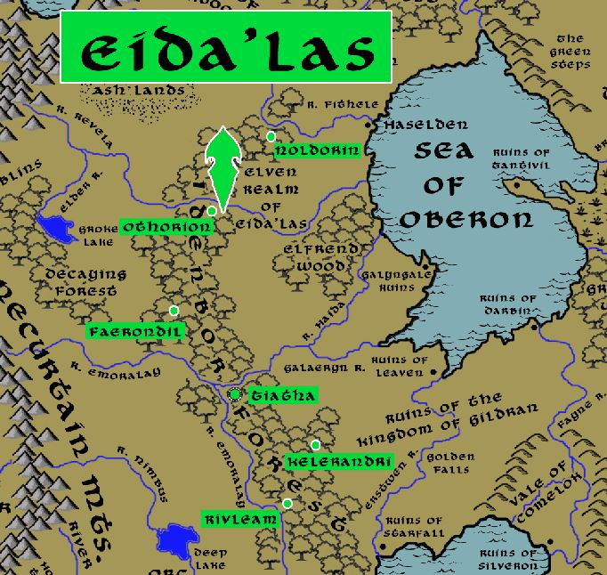

**Dwarves**

**Magical Items**

**Ring of Ephemera** - ring worn by paladins of the Order of the Luminous Sword, which grants them an aura of protection and power over light and darkness.

**Cloaks of Cathirix** – In the Fourth Ancient Age there was a cabal of wizards from the three great kingdoms that ruled the Oberon Sea region. The wizards tapped into the ley lines of the land, despoiling it as they siphoned off dangerous amounts of magical energy. The order was destroyed during the Wrath of Hrolith, but many of their implements lingered. Of these, the cloaks are resplendently colored with golden highlights and retain their original luster. They pulse with magical energy but it is wild and difficult to control.

**Stakes of Cathirix** – these were the long, iron rods measuring 15’ tall that are laced with eldritch metals and were used by the wizards of Cathirix when tapping into the ley lines of the land.

**NPC Templates**

This is a list of notes and stats to help develop NPC’s relevant to this region.

**Developer Notes**

This is a list of notes on the development of this document, including notes on history, culture, and changes to the document.

Indiron Names: Renaissance Italian <http://www.fantasynamegenerators.com/italian-renaissance-names.php>