Notes on the lands of Erigoth

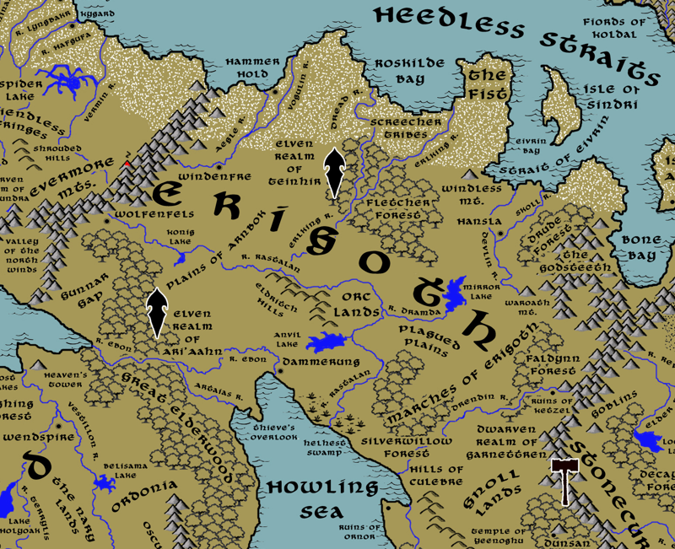

**Table of Contents**

* **Overview**
* **Towns and Cities**
* **Best in the Land**
* **Stewards of Power in this Land**
* **Points of Interest**
* **History**
* **Local Goods**
* **Notes on Culture**
* **Local Deities**
* **Creatures**
* **Other Races**
* **Magical Items**
* **NPC Templates**
* **Developer Notes**

**Overview**

Erigoth is a cold and remote land, far from the more civilized kingdoms to the south. Bound by mountains east and west and coastlines north and south, Erigoth is a removed and wild land. Firs and spruces top the rolling hills like a winter coat. A fourth of the land is perennially covered in hoar frost. Ale and the smell of a freshly fallen hind on the spit are celebrated in songs that sound reminiscent of those sung by the north men across the Heedless Straits. Sacred trees called the **Irminsul** can be seen standing in glens and on hilltops, symbols of the old gods here. Orc and goblin tribes threaten this frontier land, as do sub-human Screecher tribes in the mountains to the east. It is a barbaric region but one where the people carry themselves with regal bearing. People here know a wild freedom unlike the life of the silken nobles down below.

At the dawn of ages the **Gaufs** tribes wandered this land. The god **Taranis** came forth and blessed the Gaufs and challenged them to survive. This they did, and recklessly so. They made war with the **Phranes** and lost, waged expeditions west of the Evermores and were turned back, and stood up to the rising evil of the **Darkwood** only to be wiped out at the **Battle of the Shrouded Hills**.

Centuries later came the **Vorgs**, distant cousins of the Gaufs from the banks of the Howling Sea. For centuries the Vorgs worked to prove themselves worthy of the land, surviving the cannibal Screecher hordes coming down from their mountain lairs. Then, in the Second Ancient Age, came the north men sailing down from Norgarde. After hundreds of years of battling the Norgarde invaders, the land was finally theirs. But by the end of the Ancient Ages intermarriage and co-existence had blended the people into a new breed calling themselves **Erigots**.

It was in the Written Ages that the Erigots eventually drove out the Norgardian jarls for good and assumed autonomous rule over their land. The king sent envoys south to meet with the kingdoms of Plenia, Treviland, and Tirudor. The Erigots brought back heretofore unseen trade goods like wine, linen, and glass. They learned new artisan skills and took note of the customs from the south. The Erigots had tasted civilization and were keen to try it, but in their own rustic fashion.

Erigoth is unique compared to other western dominions. Settlements are more rural and center on large towns that unite the resources of scores of villages rather than building up to large cities. Erigot lands are tribal, with familial ties the most important bonds.

Dammerung has been the seat of power in Erigoth for over four hundred years. The **Konigren** house overthrew the **Lorner** dynasty and wrested control from Wolfenfels (50 WA4). Trade and commerce had once flowed predominantly over the **Augemere Sea** and through the **Great Elderwood**. But now it moves southward over the **Howling Sea** to **Esideron**. Longstanding ties with the Elves of **Ari’Aahn** and **Teinhir** are now strained. Human expansion is checked by growing orc and gnoll tribes who seek to take back control of Central Amadar. In spite of this, all five houses (Stein, Smitern, Berhart, Kuldren, and Konigren) continue to plot against one another to seize control of all the Erigot lands.

**Towns and Cities**

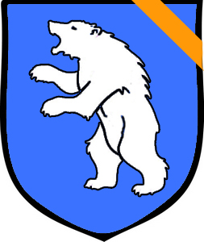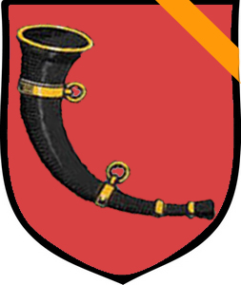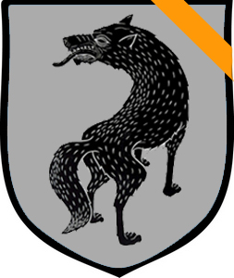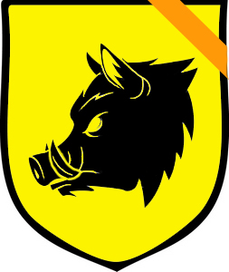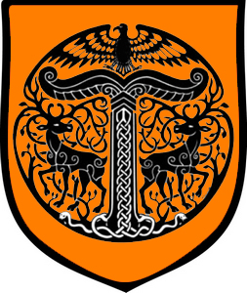

* Hammer Hold – large town, sign of the polar bear, House Smitern
* Windenfre – large town, sign of the horn, House Berhart
* Wolfenfels – large town, sign of the wolf, House Stein
* Hansla – large town, sign of a boar’s head, House Kuldren
* Dammerung – large city, sign of the Irminsul sacred tree, House Konigren

**Best in the Land**

Trade Hub: Hammer Hold

Religion: Dammerung

Arts:

Magic: Dammerung

Spirits: Windenfre, Dammerung

Steel: Hammer Hold

Grain:

Crafted Goods (e.g. Pottery, Textiles, Metal Wares):

Harvested Goods (e.g. Aromatics, Medicine, Dyes):

Mined Goods: Hammer Hold (iron), Windenfre (salt), Wolfenfels (iron, stone), Dammerung (clay)

Precious Metals: Windenfre (silver), Hansla (copper)

Ship Building:

Other:

**Stewards of Power in** **this Land**

Kings and their armies are not the only wielders of power. There are many unseen friends and foes that shape the destiny of the land. Each of the groups listed below are well known to the people of this region. Some are feared, others venerated. All of them play their part in the grand drama of this land’s story.

**Merchant Companies**

Winds of Fate Traders – Hammer Hold

**Mercenary Companies**

Rotklau (“redclaw”) – Dammerung

**Smuggling Rings**

The Night Farmers – Dammerung

**Centers of Worship (Churches, Cathedrals, Shrines, Lodges, Temples)**

High Temple of Obad-Hai

**Orders of Paladins**

Order of the Golden Stag – Windenfre

Order of the Morning Star – Dammerung

**Druidic Circles**

Circle of the Mossy Oak – Wolfenfels

**Bands of Rangers**

Band of the Sleeping Bear – Hansla

**Schools of Magic**

Huldra Sanctum – Dammerung

**Bardic Colleges**

(none)

**Warrior Academies**

Eberstreike – Hansla

**Assassins Guilds**

The Shellycoats – Dammerung

**Cults**

(none)

**Other Guilds**

(none)

**Monasteries**

Monastery of the Death Bird - Eldritch Hills

Monastery of the Mystic Mortar - southern tip of the Great Elderwood

Monastery of the Woven Flame - northern tip of the Great Elderwood

**Pirates**

(none)

**Points of Interest**

* **Isle of Sindri** – The Isle of Sindri is an uninhabitable rock covered in petrified volcanic formations. Countless birds and sea lions rule the whole of it, filling the place with a cacophony of sounds. It often becomes a refuge for ships that run into trouble on the Heedless Straits. Kuo-toa have created a maze of caverns beneath the surface and attack anyone they find on their island. It is said king **Drukshaith** of the kuo-toa dwells here in a giant cavern filled with treasures from shipwrecks over the centuries.
* **Roskilde Bay** – is a vast, frost-covered stretch of coast overlooking a calm estuary for the Dread and Erlking Rivers. In the winter violent nor’easter winds chop the waters and make sailing treacherous. It was here in the Ancient Ages that invaders from Norgardia first entered the Erigoth Lands. A priest of Taranis called down such power on the bay that its waters are forever enchanted to battle ships that enter here. Screecher Tribes now stalk the land here, fearful of the many ghosts of drowned sailors who roam the surf.
* **The Fist** – The Fist is a wide peninsula extending into the Heedless Straits. It is permanently covered in hoar frost. The terrain is treacherous and uneven, made up of icy hummocks. Members of the Screecher tribes regard the area as sacred and make pilgrimages here to a massive vertical column of crystalline rock. This the Erigoth call the **Sonnenfänger “Sun Catcher.”** The crystal catches the rays of the sun and stores them, glowing with twinkling radiance at night and emanating a welcome warmth in this tundra environment.
* Eivrin Strait
* Eivrin Bay
* **Bone Bay** – Bone Bay is a desolate place and dangerous. Creatures from the Godsteeth Mountains lurk here, preying on the unwary. Caves along the shore are rumored to be the old lairs of pirates and sea travelers. Halslaf, a Norgardian raider, once operated out of this bay and his treasures are said to lie hidden somewhere in this region along with his ghost.
* **Howling Sea** – No enclosed body of water has witnessed more naval battles than here. Over the last several hundred years ships have waged war to command the routes between the shores. During times of peace merchant boats travel this way with goods, but as the name implies weather shifts unpredictably so it is never without risk. Some say an ancient sea god retired from the open ocean to make this place their home and it is ruled by their temper. And just like its name, the winds of the Howling Sea make a haunting noise.
* **Thieves' Overlook** – The northern shores of the Howling Sea are dominated by a towering outcropping of upturned land that projects over the waters. It is a steep climb to the end of the peninsula so few travel this way. Attempts to build a fort or keep here have always failed. Some say the ground here won’t support such structures, others say there is a curse upon it. Tunnels beneath the ground lead to openings along the southern face, offering a view of the sea all the way to the horizon. The place earned its name for the tradition of smugglers and thieves spying on sea traffic here. Kobolds have constructed tunnels of their own much deeper than this and have recently burrowed upward to take over all of Thieve’s Overlook. It is now a dangerous place, with many traps and snares guarding all of the tunnels and the surface. **Klabautermann** are known to reside somewhere in this area. These are small magical creatures, some say water kobolds. They are merry and diligent creatures, with an expert understanding of most watercraft, and an irrepressible musical talent. They are believed to rescue sailors washed overboard. They are also fond of stowing away on passing ships and aiding their adopted crew in repairs on the ship. No one onboard ever sees a klabautermann. They only ever become visible to the crew of a doomed ship.
* **Great Elderwood** – The Great Elderwood is a vast stretch of forest that dates back to the Primordial Ages of Nemmyrl. Within her protective boughs remain secrets and living things that bore witness to the dawn of the world. It is said to be the birthplace of the **Treefolk** and more than a few of their kind live here. It is here that **Holunder**, the most ancient of Treefolk and the stuff of legend, resides. This is also home to the Elves of Ari’Aahn, wood elves who protect this forest. A green dragon named **Urexon** has taken up at the far northern corner near Causeway Bay.
  + At the southern end of the Great Elderwood is the site of the **Monastery of the Living Lavender**, where monks train and study in the ways of **Aermid,** goddess of healing and herbalism
  + At the northern tip of the Great Elderwood is the site of the **Monastery of the Woven Flame**, where monks train and study in the ways of **Belisama**, goddess of crafts and the forge, of fire and of light
* **Fletcher Forest** – Perched between the Screecher tribes to the north and the Orc lands to the south, Fletcher Forest is a cold and besieged wilderness protected by the Elves of Teinhir. The Teinhir are a unique mix of Wood and Wild Elven bloodlines, observing the traditions of both. Emissaries regularly treat with the Wild Elves of Laaktala in Norgarde, but in this heavily contested land the Wood Elves of the Ari’Aahn are close allies.
* Silverwillow Forest
* Faldynn Forest
  + Here dwells the Gnoll tribe, the **Gnashrak**, known by their sign of the upside-down horse.
* **Drude Forest** – The Drude Forest grows hard by the western slopes of the Godsteeth Mountains. It is a dark and forbidding place, filled with bogs and mounds of rotting plant life. Rangers steer away from the place, as do druids, for the life force here is ailing and under a curse. It is the dwelling place of a forgotten coven of witches who call on the **Druden**, minor demons who plague the living. On special nights the Druden ride forth across the land on dark ethereal mounts. They call this the **Wild Hunt**, and they are accompanied by a host of mounted ghostly figures who are the souls of the damned. The sounds of the Hunt are haunting and can be heard for miles across the plains when they ride. It is believed the Hunt rides just before a calamitous event or someone’s death. Those unfortunate enough to behold the Wild Hunt with their own eyes are in peril of being whisked away to join them. Accounts tell of certain Erigoth town folk never waking the morning after the Hunt is heard and it is believed their souls were wrested away to the underworld. A **Drudenstein** is a pebble with a naturally formed hole in the center. In Erigoth such pebbles are hung in rooms, on cradles or in stables to ward off these evil spirits.
  + Here dwells the Gnoll tribe, the **Okkippa**, known by their sign of the flaring nostrils.
* **Plains of Arnbock** – The wide-open plains of Erigoth are a marvel to behold and carry great tradition here. Lords of old mounted great rides across these plains on their steeds, crossing from one town to the visit the next. Intrepid farmers have planted large wheat and barley fields, but the open area has historically proven difficult to defend against invaders. Most battles between Erigoth towns took place on these plains, earning it a reputation for a bloodstained place and a place of honor for the fallen.
* **Plagued Plains** – Orc invaders have defiled these plains in their years of occupation. The ground is soft here, covered in grassy hummocks, and carries a strange odor. Rangers and druids are loath to cross this way, claiming the soil is corrupted. Strange plants grow here. Some produce bulbs that sit on stalks that, if disturbed, rupture and emit poisonous fumes or even fast-moving thorns that are painful or even dangerous.
* **Gunnar Gap** – The Gunnar Gap is a lightly forested plain between the Evermore Mountains and the Great Elderwood Forest that leads to the shores of the Augemere Sea and Causeway Bay. It is a frequent route used by Wolfenfels to transport goods southward. Several lean-to campsites can be found where merchants hole up during their voyages. Travelers should beware of primitive humans lurking in the foothills here. These are called the **Lurkers**, for they watch travelers from their caves and waylay any they see as easy prey. They mark their territory with the sign of a large female figure some interpret to be a fertility goddess.
  + It is said the green dragon **Urexon** dwells in this part of the Elderwood and is known to snatch horses and humans traveling this way.
* Marches of Erigoth -
* Aegle River
* Vogulin River
* Mondren River
* Erlking River
* Devlin River
* Skoll River
* Rastalan River
* Kreigen River
* Grim River
* Drachen River
* Drendin River
* Ebon River
* Mirror Lake – On the southern bank of the lake stands the secret keep of **Hennecke the Handless,** Arch Mage of the Erigoth lands.
* Konig Lake
* Anvil Lake
* **Helhest Swamp** – Where the Rastalan River empties into the Howling Sea the waters overflow and saturate the surrounding delta. Here the Helhest Swamp is a noisome and treacherous mire infested with flying insects and strange clouds of green gas. Here is the dwelling place of hags
* **Evermore Mts.** – The largest range of mountains in Western Amadar, the Evermores stretch from the Heedless Straits across the Augemere Sea and into Treviland far to the west. It is home to the Dwarven Kingdom of Daemundra, as well as the ruinous domain of the black dragon **Syzith**. Many tales from the ancient ages speak of the Evermores and the calamities the mountains have seen. Sages tell their pupils to fret not over the trivial things in life, for they are temporary. Only the mountains persist, and will ever more.
  + Here dwells the **Hrakathuun** tribe of Storm Giants, who some claim hold sway over the winds and waves at the western end of the Heedless Straits. Some sailors leave offerings at the icy shores, hoping for favorable weather. A few intrepid souls seek out the giants for counsel.
* **Godsteeth Mts**. – Here lies the secret location of the cavern hall of the Rangers of the Sleeping Bear. The mountains are also the home to the mighty silver dragon **Balinor**
  + Here dwells the goblin tribe called the **Kroduks**, known by their sign of the broken wing.
* **Glänzend Vale** – The tiny valley south of the Godsteeth Mountains was once a favorite resting place of dragons. Now it is a strange pocket of wild magic: oversized flowers blossom eternally, rainbows arc in twos and threes over fields filled with songbirds, unicorns frolic in the open without care. Here and there everything seems alive and animated. Even the streams seem to actually sing. This place is called Glänzend, which means “shiny” in the Erigoth tongue. It was so named by a strange little girl named Heleva two hundred years ago after she used powerful magic to transform the place to her liking. Heleva persists here today, ageless and dressed in the court gowns in which she was raised.
  + It was in the year 212 WA4 the Curse of **Heleva** began: crafty wizards in Dammerung raised the king's discarded and forgotten bastard child, intent on using her as a pawn. They used their dark powers to imbue her with ageless beauty and grace, all to enthrall the people in a bid to seize the throne. But twelve-year-old Heleva, her dark eyes burning beneath her golden curls, turned on the wizards and slayed them. She embraced her masters’ merciless ways and sought power of her own. She left, taking their cursed artifacts as toys. After five years of wandering, she found herself at the Vale of Hrol south of the Godsteeth Mts. There she unleashed her unthinkable power and transformed the valley into a brilliant landscape of unicorns and rainbows she named **Glänzend** (“shiny”). For centuries she has remained a cherubic little girl dressed in finery, but she rules the region with a tyrannical hand, capturing Orcs and torturing them by dressing them up as dolls. Travelers wandering this way may come across survivors of the valley: Orcs and Gnolls, empty-eyed and senseless, decorated in hair bows and gaudy make-up, babbling of the horrors within. Heleva is a mercurial child, prone to mood swings and outbursts. While the land is normally kept in a state of magical reverie, anything that upsets Heleva results in catastrophic events in this place. None should upset the child, and those who beguile her should be wary of losing her favor.

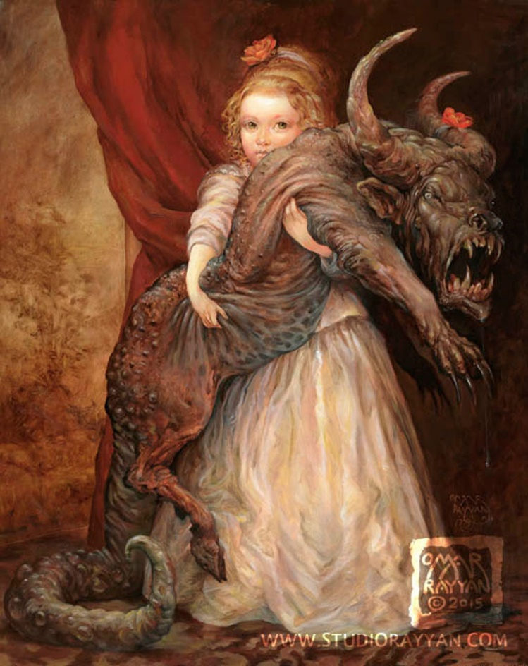

* **War Oath Mt**. - Legend tells of a young Vorg warrior named Kavven who came to this mountain to appeal to the gods for protection over the Vorg villages. The gods created a great wall of stone trees encircling the area around present-day Hansla. Kevvan was charged with nurturing the stone trees with the blood of his enemies each year. It was then that the mountain was named Waroath Mountain. It remains a place of solemn oaths for warriors to this day and the sacrifices are still observed.
* **Windless Mt.** – **Volkbert** the mad wizard dwells atop this eerily silent peak. From there he watches from on high, studying the miasma of cruelty and beauty in this land. The peak is shrouded in mists, which Volkbert controls. It is said he sends forth clouds to travel across the land and spy on those below. He finds an ally in the half-elven ranger Hemma of the Sleeping Bear, who hails from Hansla. To what purpose no one knows.
* **Eldritch Hills** –
  + Site of the **Monastery of the Death Bird**, where monks study and train in the way of Ankou god of death and the underworld
  + Orcs have massed in enormous numbers east of the Eldritch Hills. **Galgag the Cleaver** has risen up as their chieftain and has his eye on conquering Dammerung. His shamans have spent years atop the Eldritch Hills and tapped dark magic that can corrupt the land. The Galgag Orcs bide their time, preparing to unleash an apocalypse on the humans of Erigoth. The Orc tribe is known by the sign of the blood red star.
  + 152 AA3 - Battle of Eldritch Hills - Leuthard calls on Taranis to help him fulfill his oath - Leuthard is gifted with the Hundred Heavenly Hammers, which the Vorg famously use to utterly crush the Orc advance
  + Eldritch hills are the dwelling place of a mighty red dragon, **Seffiregh**
* **Ari'Aahn** - Elven Kingdom, Forest of the Elderwood, Sign of the Carpenter Bird
  + The Ari’Aahn elves have faced centuries of opposition with the humans in this region. This is partly because the Great Elderwood sits between Erigoth and Tirudor and armies march through here during times of war. It is also where the Augemere Sea empties into the Howling Sea so conflicts over water between Treviland and the other two kingdoms tend to move this way. After centuries of fighting there has been an uneasy truce called. Traffic is freely allowed along the river and the road that cuts east-west through the woods, but the **Treaty of Corlaer** dictates that no non-elf shall enter the woods themselves without permission.
    - Band of the Faunalyn – Elven rangers that safeguard these lands
  + **Elashor** - Elven town of Ari'Aahn
  + **Aelesar** - Elven town of Ari'Aahn
  + **Vaella** - Elven city of Ari'Aahn
  + **Brightsong** - Elven town of Ari'Aahn
  + **Faenor** - Elven town of Ari'Aahn
  + **Teinhir** - Elven Kingdom, Fletcher Forest, Sign of the Snow Goose
  + Band of the Wranfaren – Elven rangers that safeguard these lands
  + **Talandren** - Elven town of Teinhir – The northernmost settlement of Elves in the Fletcher Forest, the Elves of Talandren keep the Screecher tribes at bay.
  + **Ellarion** - Elven city of Teinhir
  + **Rivvikyn** - Elven town of Teinhir
  + **Darkstar** - Elven town of Teinhir – set at the edge of Fletcher Forest, the town of Darkstar bears witness to the evils wrought by Orcs in the open plains to the south. On nights where the crescent moon hangs high, riders on giant elk raid the plains to slay any Orc they find in the open. This is called the Crescent Culling and is savage to behold.
* **Screecher Tribes** – The frozen wastes along Roskilde Bay are inhabited by nomadic savage humans. They are called Screechers for the bone chilling screams they make. They are mindless savages even the wildest Norgardians consider strange. They worship dark gods and consume the flesh of other humans. Their faces are painted dark at all times and they wear hides and the bones of several creatures including orcs, goblins, and humans. They mark their territory with the sign of a spiral circle. Screechers raid the northern Erigoth lands, mounting large assaults every hundred moons. The town of Hansla is their favored enemy. They steer clear of the Fletcher Forest, for the Elves of Teinhir keep them in check.
* **Daemundra** – Dwarven Kingdom, Evermore Mountains
  + **Long Keep** – is the northernmost reach of the Daemundra Kingdom. Emissaries from here treat with the people of Wolfenfels and train them in the secrets of Dwarven stone masonry. Hundreds of years ago the armies of Wolfenfels came to their aide against the black dragon **Syzith**, who wiped out all Dwarven holdings north of here.
* **Garnettren** - Dwarven Kingdom, Stone Curtain Mountains
  + **Iron Keep** - Dwarven outpost of Garnettren
  + **Raskelor** - Dwarven town of Garnettren
  + **Warbow** - Dwarven town of Garnettren
  + **Gildax** - Dwarven city of Garnettren
  + **Oremaul** - Dwarven town of Garnettren (outside of Erigoth lands)
  + **Bedrock Keep** - Dwarven outpost of Garnettren (outside of Erigoth lands)
  + **Keystone** - Dwarven town of Garnettren (outside of Erigoth lands)
  + **Archdeep** - Dwarven town of Garnettren (outside of Erigoth lands)
  + **Crystal Tear Keep** - Dwarven outpost of Garnettren (outside of Erigoth lands)
* **Ruins of Ketzel** – Ketzel was among the first of the great settlements to be built by the Norgardians in this new land. Built in 410 AA4, the town became wealthy from gold found in the Stonecurtain Mountains and dominated trade in the Howling Sea. Then in 643 WA3 a great Orc army rose up from the mountains and laid waste to the town during the Second Dark Crusade. The Orcs went on to wipe out all human life in the present-day Marches of Erigoth. Many traditions and famous legends were wiped from history.

**Hammer Hold**

**Size:** large town, population 5,000, guards / soldiers 50, militia 250

**Trade Goods:** trade hub, iron, steel, flax, fishing, whaling

**Local Goods:** Tolthan’s Teeth (ale)

**Standard:** sign of the polar bear

**Colors:** blue and white (with orange ribbon for Erigoth)

**Patron Deity:** Taranis - god of storms and ships

**Ruler:** Baron Adelgis Smitern

**Home**: Bearshead Keep

**Steward**: Wilmar Harloch

**Marshal**: Rigobert Fredeger

**House Priest:**  Matron Sina of the Mandela (f)

**House Adviser (Scholar/Mage/etc):**  Tamara the Winter Witch (f)

**Captain of the Guard**: Sir Gernot Hadebrand

**Knights in Service**:

Sir Oslen Stirner

Sir Reimar Kriegen

Sir Luthar Hoffbek

**Local Powers:** Lords of the Lift (thieves guild), Winds of Fate Trading Company

**Local Sites:** Brigid’s Tub Inn & Tavern, The Grinning Badger Inn & Tavern, The Windy Willow (brothel)

**Description:**

Built into the icy cliffs overlooking the Heedless Straits, Hammer Hold is a frozen citadel and the northern-most town of Erigoth. Giant iron-bound timbers form an imposing bulwark around the town. Gleaming curved mammoth tusks protrude from the walls like gleaming white horns. Blue banners chased in white offer the only color here. It is a grim, forbidding place swept by the icy winds blowing in from the north.

Within the walls the town is surprisingly welcoming. Natural hot springs run through the rocks below, heating the streets and gardens. Heated waters bubble up into saunas and pools where town folk mingle at the end of each day. Vents have been channeled to heat the very walls of the houses. It is said there are underground caverns where these waters seethe and unnatural creatures still lurk. The odor can be a bit peculiar but people do not seem to notice.

**Industry:**

Life is hard here, with fields covered in snow much of the year. The townspeople are shrewd farmers, pulling what they can from the river delta each spring. But fishing and whaling are the main forms of provender as well as a hearty breed of sheep and oxen that are bred here to survive the cold. Flax groves bred for the elements cling to life within the walls of the town. Iron mined from the Evermore Mountains is transported down river. Hammer Hold secured an agreement with the town of Windenfre far up river for rights to the iron. In return Windenfre holds onto the silver mines. The iron is of much more use in Hammer Hold where the finest steel smiths of the north craft weapons coveted by the hungry armies in this region.

**Tolthan’s Teeth** is ale brewed deep beneath the frozen town. It is a dark and bitter draught and very strong. Waters from the subterranean vents are used to create a unique taste. Only the hearty people of Hammer Hold would enjoy such a brew, but it is eagerly sought after by the Dwarves of other lands.

**Key Figures:**

Baron Adelgis Smitern – warrior, eager for battle, dismissive of authority

Baron Smitern is a hard bitten warrior cast in the mold of the Norgardians across the water. He welcomes war and often takes his long boats out to find it. Often as not he hosts Norgardians at his table and drinks to their shared history. Other towns question which side Smitern would be on if Norgarde were to invade Erigoth again. He is a tall man with balding brown hair and a generous beard, but he stoops a bit from his war wounds. His cloak and boots are made from the skin of a sea serpent he claims he slew himself. His great hall is legendary for both its size and the spirits in its cellar. Within his walls he considers himself a high lord who need not answer to anyone else, even the throne in Dammerung.

**Local Lore:**

Giant polar bears dwell in the frost laden lands along the coast. Some of them, dire polar bears, stand larger and are more fierce for having been touched by magic. The folk of Hammer Hold have a tradition of taming these beasts and either use them as advanced shock elements in battle or, in rare cases, as mounts. The **Eisbären**, a special unit of the Hammer Hold guard, are the fiercest of warrior-rangers who are never seen without their polar bear mounts.

**History:**

**Tostvag the Terrible** held the town four hundred years ago as the last stronghold of Norgarde power in the land, but was defeated by the combined armies of Erigoth warriors (90 WA4). Today there is regular trade with the Norgardian settlements and Hammer Hold boasts a mighty naval fleet built in the same styles as the northern long ships.

In the first modern age over three thousand years ago it took the combined might of the **Thoon and Echidna Legions** from Celedon to conquer this land. The Echidna Legion formed a garrison stronghold in Hammer Hold, the ruins of which still stand to this day.

During the **Great Erobring**, the armies of Norgarde swept into Erigoth in the Third Written Age and decimated every town (90 WA3).

**Customs:**

Hammer Hold is the northernmost Erigoth town and still holds close to the traditions of the Norgardian settlers who founded it centuries ago. When the peoples of Erigoth began to break with their rulers across the sea, it was here where many of the greatest battles raged.

**Windenfre**

**Size:** large town, population 5,000, guards / soldiers 50, militia 250

**Trade Goods:** silver, salt, ale

**Local Goods:** Bergmönch ale

**Standard:** sign of the horn

**Colors:** red and black (with orange ribbon for Erigoth)

**Patron Deity:** Asteron - goddess of the dawn

**Ruler:** Baron Bors Berhart and his wife Irmela

**Home**: Kindred Keep

**Steward**: Adelbrand Aurbach

**Marshal**: Wolfram Rambrand

**House Priest:** Brother Isenbert of the Shroud

**House Adviser (Scholar/Mage/etc):**  Helge the Unnatural (f)

**Captain of the Guard**: Adalbero Halberd

**Knights in Service**:

Sir Falko Ottokar

Sir Guntram Kutwulf

Sir Landolf Silber

**Local Powers:** Shadow Court (thieves guild), Brethren of the Golden Stag (warriors trained in hunting creatures of the night)

**Local Sites:** Moat and Tower Inn & Tavern, Bergmönch Ale House, The Nizzled Nymph Inn & Tavern, Hackler House (brothel)

**Description:**

Windenfre straddles the mighty **Aegle River** and marshals the strength of scores of villages in the region.

**Industry:**

Much of the town’s industry is tied to the salt and silver mines upriver in the **Evermore Mountains**. While Wolfenfels’ trade route leads south into Treviland, Windenfre moves goods downriver to Hammer Hold and their trade hub. In exchange, Windenfre grants rights to the iron mines to Hammer Hold, as the steelworks there make much better use of it. This agreement has been in place for generations and is a sore spot when conflict arises.

The **Bergmönch Ale House** produces one of the finest ales in Nemmyrl and barrels the ale for export to taverns all over Western Amadar. It is said to contain silver dust, giving it a bright color. The people here swear it does wonders for the constitution.

**Key Figures:**

Baron Berhart is a devious ruler, ever plotting destruction to the town of Wolfenfels to the south. A thick, barrel-chested man, Berhart lost both his legs in battle years ago. He had a carpenter create special shoes he wears on the ends of his stumps. Berhart refuses to be seen standing, for fear of ridicule. But to his surprise, his stature earned him the adoration of Dwarven envoys visiting from **Long Keep,** part of the **Kingdom of Daemundra**. He has since embraced his new legs and fancies himself an ally of the Dwarves.

Unknown to the rest of the court, the mage **Helge the Unnatural** makes regular trips to the Evermores. There she treats with the ancient black dragon **Syzith** who she has gained as an ally. Every so often farmers disappear in Windenfre, victims of Helge’s tribute to the dragon.

**Local Lore:**

Rumor has it that mysterious creatures living in the Evermore Mountains are fond of traveling into town on druid high holy nights. Doppelgangers and werewolves, in particular, are known to walk amongst the townsfolk. Many townfolk belong to the **Brethren of the Golden Stag**, an order of monster-hunters who are trained to fight creatures of the night.

**Feldgeister** are also a problem for the town. Every harvest season large corn dolls are created from the stalks and leaves and then hacked and burned in a ceremony to dispel the corn spirits. Women of the town are trained in the creation of magical wards and anti-curses that fight evil creatures that threaten the farms in the region.

**Syzith**, the mighty black dragon, sleeps in the Evermore Mountains north of where the **Aegle River** emerges. Thousands of years ago it terrorized the Dwarves of Daemundra and laid claim to the northern Evermores. It is said the dragon has gobbled up enough humans and dwarves to prefer their taste. Every ten years or so, the dragon descends from the mountains to hunt and plunder. It is not unheard of for rulers of Windenfre to stake out a group of young men and women as tribute to keep the dragon’s wrath at bay.

**Cup of Konrada** – cup created by the gods to aide the Erigot people in times of trouble, including helping choose kings and queens. It is housed in the keep of the Order of the Golden Stag.

**History:**

Windenfre has a long history of enmity with its rival town of Wolfenfels. Battles wage between the towns every other generation. Some say they fight over control of the Evermores, some say it is just in their blood to feud.

In 760 AA4 the Windenfre armies marched forth and took Hammer Hold and Wolfenfels, beginning years of control over northen Erigoth. Thirty years later, Windenfre marched on the Fletcher Forest and declared war on the Elves of Teinhir. This bloody conflict lasted over one hundred years. Finally, in 920 AA4 the end came to the Fletcher Wars. Orcs out of the Eldritch Hills destroyed the Windenfre armies, forcing the humans to retreat back to their towns and ending Windenfre domination.

During the Great Erobring, the armies of Norgarde swept into Erigoth in the Third Written Age and decimated every town (90 WA3).

**Customs:**

Horns are an important part of the culture here. Artisans craft horns for hunting, for battle, for music, and a wide range of other uses. Each child of Windenfre is gifted a horn when they come of age. And each horn is unique: a native to Windenfre can pick out the signature of just about any horn he or she hears sounded in the region and has a chance to know who it belongs to. It is a tradition at feasts for horns to be played for music, and often many members of the town join in to harmonize. Elaborate tunes exist in the Windenfre lore. Visitors may find the music overbearing, but to the seasoned listener the music forms a complex symphony that carries meaning.

**Monster Parade** - Once a year, the town folk gather at sunset to wear elaborate monster costumes and construct multistory beasts mounted on wheeled carts with movable parts and participants riding inside. Magicians are hired for special effects and create terrifying illusions and pyrotechnics, all accompanied by eerie music. The final attraction in the parade is the “holy paladin” with an elaborate armor outfit and costume weapons who is driving the “monsters” away. The role of the paladin is chosen by popularity contest or some other method and is almost never an actual paladin.

**Wolfenfels**

**Size:** large town, population 5,000, guards / soldiers 50, militia 250

**Trade Goods:** iron, stone, furs

**Local Goods:** Dark Drake (heavy stout)

**Standard:** sign of the wolf

**Colors:** white and black (with orange ribbon for Erigoth)

**Patron Deity:** Weylund - weird and malicious blacksmith god

**Ruler:** Baron Gerlach Stein and his wife Gerda

**Home**: Farrier Keep

**Steward**: Sieghard Gotthahl

**Marshal**: Arnfred Colbreg

**House Priest:**  Sister Freya of the Chapel Mount (f)

**House Adviser (Scholar/Mage/etc):**  Rechlig the Revenant

**Captain of the Guard**: Manegold Harstuut

**Knights in Service**:

Sir Siegbert Bolsong

Sir Alida Wendswep (f)

Sir Volkmar Raban

**Local Powers:** Thrift Dealers (thieves guild), Circle of the Mossy Oak (order of druids)

**Local Sites:** Bieresal’s Inn & Tavern, The Giant’s Wake Inn & Tavern, The Wizard’s Sleeve (brothel)

**Description:**

Built into the sides of the Evermore foothills, Wolfenfels is an imposing sentinel overlooking the landscape. Farrier Keep sits atop a low peak, high enough one can survey the land for hundreds of miles. Stone mined from the Evermores has been laid with precision to create an impenetrable stronghold in this wild region of the world. The **River Rastalan** runs down a waterfall in the midst of the town and feeds a reservoir that eventually empties outside the town walls. Two giant wolf heads, each carved into the mountainside and standing fifty feet high, stare down with eyes enchanted to glow red at night.

The Dwarves of Daemundra are grudging allies with the humans of Wolfenfels, but it was not always so. For centuries the humans of Wolfenfels and Stonbrek allied with one another in a fight against the Dwarves, who were jealous of any stone taken from the Evermores. In 820 WA2 war was declared and their fight moved above ground and below, and the clamor was such it awoke an ancient dragon. The dragon **Syzith** wrought great destruction on both Dwarves and men and lay waste to every Dwarven holding in the mountains north of the Rastalan River. Wolfenfels, feeling pity for the Dwarven plight, rushed to keep the dragon from marching further south. Soldiers of Stonbrek, fighting on a southern front, took the opportunity to cut down their shaken Dwarven foes. In the end the dragon was driven back by Daemundra and Wolfenfels. Ever since, the Dwarves remember which town fought with them.

Relations are good with the elves of **Ari’Aahn** in the **Great Elderwood** to the south. The elves allow the Erigots of Wolfenfels to hunt the northern arm of the forest and aid in defending the town from orcs and kobolds from the Evermores. Generations ago the famed Erigot Warrior **Siglan the Sharp** married an elven maiden named **Cyanethiel** (520 WA3). This secured a strong alliance between elves and men in this region. Romantic stories of their love abound to this day.

**Industry:**

Among the Erigots, Wolfenfels is known as the **Stone Kingdom** in the west. Long has the town worked to build military and commercial might to rival any other town in the region. The people have endured a long and protracted struggle with the wild tribes of men in the **Gunnar Gap** and there is a long rivalry with the Trevilish town of **Stonbrek** to the west. The Erigots here work the mines of the Evermore Mountains, gathering wealth in stone, precious metals, and gems. Goods are sent down the **Rastalan River**, then transported by caravan down to Dammerung.

Ale brewing is a trademark of the Erigots. The Wolfenfels breweries are famed far and wide as the best brew masters. Golden hops are harvested on the eastern banks of the Rastalan and used to create famed brews such as **Dark Drake** (a heavy stout). Barrels of Wolfenfels beer are eagerly sought abroad, carried by merchants across the Gunnar Gap to the Augemere Sea as well as down to the Howling Sea.

**Key Figures:**

Baron Stein is a charming mad man, prone to hearing voices. Oft times he is given to changing his personality dramatically and demands to be addressed by different names. Regardless, he is a clever tactician and politician. He plies favors with everyone in the region: the **Dwarves of Daemundra**, the Trevilish in **Stonbrek**, even the wild tribes in the Gunnar Gap.

**Sister Freya** of the Chapel Mount is a devout leader of the Pelor Faith. She oversees a massive academic center called the **Scriptorium** where holy texts are transcribed with loving care by her army of priestly scribes.

**Local Lore:**

The **Giant’s Wake** is an inn located in a unique spot: it rests at the bottom of a deep depression in the ground just at the edge of town. Measuring fifty feet in length and ten feet in depth, it is in the shape of an enormous footprint. Rumor has it the largest giant in history stumbled through Wolfenfels and left this footprint in its wake.

**Holunder** dwells south of here in the Great Elderwood. He is the oldest of all Treefolk and wise beyond measure.

Kobolds have a strong presence in the region around Wolfenfels, chief among them the **Emberclaw** clan, known by their sign of an eye set within a diamond. Dwelling in vast tunnel systems within the Evermores, they are loathe to see humans so close to their mountains. They set traps throughout the region, from simple pits and snares to prepared avalanches. Occasionally they launch artillery from atop the peaks onto Wolfenfels below.

It is rumored the king’s treasury contains the **Cold Carnelian**, a fist-sized chalcedony gem colored blood red. Legend has it that the stone is enchanted and can control the very snows that blow into the world this far north.

**History:**

Wolfenfels remembers a day when it was the seat of power in these lands. Four hundred and fifty years ago the **Lorner Dynasty** was overthrown by the **Konigren** family. The throne, along with the profitable trade routes, moved to Dammerung (50 WA4). Today **Baron Stein** sends tribute to Dammerung, but conducts his own secretive trade along routes into Treviland.

Wolfenfels has a long history of enmity with its rival town of Windenfre. Battles wage between the towns every other generation. Some say they fight over control of the Evermores, some say it is just in their blood to feud.

During the Great Erobring, the armies of Norgarde swept into Erigoth in the Third Written Age and decimated every town (90 WA3).

**Customs:**

The people of Wolfenfels are a superstitious lot, wary of ill fortune besetting them. To ward off bad luck a wizard from Wolfenfels crafted an enchanted hat over two thousand years ago. It is a horned head piece they call the **Lackaday**. Each day a resident of the town is picked to wear the hat. For a full day that person is thought to attract all the bad luck of the town and keep it to him/herself. Visitors to the town are often picked to wear the hat, for then the back luck might leave with them.

**Hansla**

**Size:** large town, population 5,000, guards / soldiers 50, militia 250

**Trade Goods:** livestock, copper, wool

**Local Goods:** **Wetwitch** (a bitter amber ale that excites the senses), Ice Wine

**Standard:** a boar’s head

**Colors:** yellow and black (with orange ribbon for Erigoth)

**Patron Deity:** Baduhenna - matron goddess of war

**Ruler:** Baron Harsden Kuldren and his wife Aeva

**Home**: Boneblood Keep

**Steward**: Dankrad Oderon

**Marshal**: Wigand Hasenclever

**House Priest:** Brother Heiko of the Olden Oak

**House Adviser (Scholar/Mage/etc):**  Heimrad the Unseen

**Captain of the Guard**: Sir Brunner Aeglyn

**Knights in Service**:

Sir Hademar Bernhelm

Sir Filibret Hardigger

Sir Markulf Froech

**Local Powers:** Finger Smiths (thieves guild), Band of the Sleeping Bear (order of rangers), Eberstreike (band of warriors)

**Local Sites:** The Plough Inn & Tavern, The Brazen Bull Inn & Tavern, The Honey Mead (brothel)

**Description:**

Situated at the far eastern edge of Erigoth lands, the town of Hansla is an endangered stronghold in the wilderness. It is threatened by **Screecher tribes** to the west, orc tribes to the south, gnoll tribes to the east, and raids by Norgardesmen from the north. It is an embattled town. But it has a pioneering spirit, and the people are fiercely independent.

Hansla sits atop a rise where the **Skoll** and **Delvin** rivers split. Atop the rise they built a low stone wall surrounding the town and keep. From here the townspeople have a commanding view in all directions. Below the rise grows a forest of trees made of living stone. The stone trees, rising to forty feet in some areas, lines the banks of the rivers all the way north to the sea. This forms a wall around the farmlands of Hansla that is difficult to penetrate.

**Industry:**

Farmlands flourish in the land between the rivers. Livestock are moved from one side of the river to the other depending on reports given by scouts looking for attacks. A modest copper mine operation out of the **Godsteeth Mountains** upriver provides revenue to traders by sea and tribute to **Dammerung**.

**Ice Wine** is made in Hansla that is a type of dessert wine produced from grapes that have been frozen while still on the vine.

**Key Figures:**

Baron Harsden Kuldren - thin, nervous energy, short-tempered

**Baron Kuldren** is a thin, wiry man full of nervous energy. He is short-tempered and untrusting towards outsiders. His seven sons are all warriors and form Kuldren’s personal guard. He has challenged each of them to fight the others to win the right to rule Hansla after he passes. So far there is no clear winner amongst the sons. Kuldren seems to delight in playing his sons against one another. Secretly he knows his successor will need to be clever to help Hansla survive.

Kuldren is mindful of the town’s perilous situation but is loath to call on aide from other Erigot nobles. The baron has designs to expand west, harvest timber from Fletcher Forest, and build up enough strength to assert itself as a separate kingdom. But that will take time. For now Hansla works hard to fend off nearby enemies and grow stronger from the test. Kuldren seeks to ally with the **Teinhir** elves, but years of bad blood have to be overcome. Kuldren has sent each of his seven sons to **Darkstar**, the Elven town at the edge of the **Fletcher Forest**. He hopes for them to build a stronger relationship with the Elves. His youngest son, **Gurf**, has won the heart of an Elven maiden named **Deirynya** but they keep the romance secret.

**Rangers of the Sleeping Bear** know these lands and are ever watchful of Screecher parties and Orcs. They make regular trips to the **Godsteeth Mountains** where high in the peeks their ancient order holds court in their secret cavern hall. It is said to be filled with many curiosities from the land: cursed apples of pure gold, writhing vines that whisper lies, bog waters that grant brief glimpses into the past. The half Elven maiden **Hemma** is their leader. She treats regularly with the Elves of Teinhir, but refuses Baron Kuldren’s orders to win them to his cause. For some reason known only to her, she occasionally travels to the **Windless Mountain** to do the bidding of the mad wizard **Volkbert**, who dwells there.

**Local Lore:**

Legend tells of a young Vorg warrior from Hansla named **Kavven** who traveled up the **Skoll River** to the solitary mountain from whence it flowed. There he swore a blood oath to **Baduhenna**, matron goddess of war, to honor her with his life if she would help him defend his people in this savage land. Baduhenna gave to the boy five tests of his courage and strength. The fifth test was to return with the bodies of one hundred enemies, armed only with what he could find in the wild. Kavven did so and Baduhenna was pleased. She made the mountain come alive and send its roots downriver to the Vorg villages. There, where the rivers split, the mountain thrust up its roots and created a great wall of stone trees encircling the place. Kevvan was charged with nurturing the stone trees with the blood of a hundred of the evil each year. From this tale the mountain earned the name **Waroath Mountain**.

**History:**

Hansla has a long history of conflict with the **Screecher Tribes** that inhabit the peninsula to the north and east near the **Drude Forest**. A primitive band of savages, their bestial ways disgust even the most savage Norgardians. The Screechers regularly raid the region around Hansla to plunder food and slaves. Every one hundred moons they mount a massive campaign westward, sometimes mobilizing an army capable of wiping out Hansla. One hundred and fifty years ago (340 WA4) Screecher tribes marched on Hansla with a shaman bearing the magic relic **The Helmet of Tusks**. Erigot armies quickly marched to surround and stop the Screechers but only after terrible losses and the walls of Hansla being breached. This was called the **March of the Screechers** and is still whispered about in dread to this day.

During the Great Erobring, the armies of Norgarde swept into Erigoth in the Third Written Age and decimated every town (90 WA3).

**Customs:**

Priests of the old ways regularly make pilgrimages upriver to leave offerings at the summit of Waroath Mountain. Every fall the warriors of Hansla ride out to claim at least one hundred kills among the orc tribes. In the tradition of Kavven’s blood sacrifices their bodies are draped from the upper limbs of the trees of stone outside the town. It is said to help the trees grow even higher.

The greatest warriors of Hansla are the **Eberstreike**, an ancient order of men and women who give themselves over to wild frenzies in battle. They are known by the boars’ heads they don in battle, some by their teeth which are ground into sharp fangs. Legends say they hail from the same blood lines as the **Svinfylking**, boar warriors of Skogul in Norgarde. It is expected upon meeting one of the Eberstreike the only proper greeting is to strike them as hard as one can and expect a strike in return.

**Dammerung**

**Size:** large city, population 25,000, guards / soldiers 250, militia 2250

**Trade Goods:** magic center, wool, clay, religious capital, ale

**Local Goods:** armada of small warships

**Standard:** sign of the Irminsul sacred tree

**Colors:** orange and black

**Patron Deity:** Sandraudigr - goddess of wealth and military might; she appears with outstretched hands stained red with blood but gold covering her feet, patron deity of Dammerung

**Ruler:** Queen Arnelda Konigren

**Home**: Castle Nuelda

**Steward**: Erhard Wenheld

**Marshal**: Roland Emrick

**House Priest:** Brother Alwin of the Unwritten Ledger

**House Adviser (Scholar/Mage/etc):**  Aristeo the Spellbinder

**Captain of the Guard**: Sir Merlon Wedekind

**Knights in Service**:

Sir Hilger Dannen

Sir Danken Shleck

Sir Ortwin Exener

**Local Powers:** High Temple of Obad-Hai (world seat of power for the Church of Obad-Hai), Order of the Morning Star (order of paladins), Knuckler House (thieves guild), The Night Farmers (smuggling ring), Huldra Sanctum (school of magic), The Shellycoats (assassin’s guild), Rotklau (“redclaw”) (mercenary company)

**Local Sites:** The Golden Hart Inn & Tavern, Weissfrau Ale House, The Shorn Sheep Inn & Tavern, House of Abandon (brothel)

**Description:**

Known as the **Eagle in the North**, the city of Dammerung sits at the northern edge of the Howling Sea. The city is squat and broad, appearing like an immovable fixture in this land. Walls of black stone shroud it on the north, giving it a sinister look on the landscape. At night tiny points of twinkling light shine from the walls, an enchantment giving it the appearance of a starry sky. To the south the city opens up to the sea with a harbor bristling with a myriad of small to medium-sized ships. Carracks cross the sea carrying goods. Flat-bottomed warships stand ready. Fishing boats plod along the coastline, marshes, and upriver. To all appearances Dammerung operates like a city near one of the great oceans.

Within the city stately old timber buildings sit alongside tall stone towers built with techniques borrowed from the southern kingdoms. It is here that ancient traditions blend with new ones. Twenty two hundred years ago **King Errud** was impressed by envoys from Tirudor who described their palaces. So the **Elden Hall of Yorik** was abandoned and a massive structure erected that blended the elements of Norgardian and Erigot buildings with the flying buttresses and vaulted ceilings of the west (400 WA2). The hall was named **Nuelda** which, ironically, meant “new old.” The city is considered pretentious to the northern towns.

**Industry:**

Perched on the northern banks of the Howling Sea, with the Sunder River running through it, Dammerung is the gateway for trade goods from the north to Tirudoran merchants in **Esideron** and **Ibilis**. Furs, timber, gold, amber, and spices of the north are traded for silver, fine steel, silks, and perfumes of the south and beyond. The **Holding House of Dammerung** generates more profit from coin exchange here than anywhere other inland city.

The **Weissfrau Ale House** packages a heady ale for export throughout Erigoth and beyond. Called the “**White Lady**” in other tongues, it is a celebrated beer in taverns all over Western Amadar.

**Key Figures:**

Queen Konigren is a shrewd ruler, able to manage merchants as well as generals. She understands the strategic place she holds at the sea’s edge, controlling shipping and the revenue it brings in. As a child, she learned from her tutors of the deeds of Celedon and what civilization can accomplish. To this end she is determined both to keep the Erigot people united and to rid the land of the vermin of orcs and gnolls and primitive tribes creating chaos. Konigren prays to the gods of order and quietly builds an army to back her power.

Word has traveled of Konigren the unmarried to distant lands. Many suitors call on her, hoping to win her hand and her lands. But she will not be distracted from her ambitions. She is free with her affections with young princelings, and smiles when she tosses them away like toys.

**Sir Wedikind** serves earnestly as the queen’s captain of the guard. He is an old soldier, and knows little of courtly poise. His lust is for battle on the open plains of Arnbock and sending orcs to their gods. He is restless playing a defensive game in the city. He regularly takes his soldiers on raids across the countryside.

**Rotklau** – Rotklau is an elite mercenary fighting company made up of warriors whose lineage dates back to the First Written Age. The invading Celedonians sought to quickly quell the native Vorg tribes and threatened to execute any able-bodied warrior who bore tribal markings. It was Bodobad the Vorg warlord who united the land’s best warriors around the northern Howling Sea lands. Each man and woman bloodied themselves on the severed claw of an eagle, earning them the name Red Claws and consigning themselves to death unless they fought together. While the Celedonians prevailed through treachery, the progeny of this army lives on in a mercenary company known for its unbridled savagery.

**Order of the Morning Star** - A tradition the order has kept for the last eight hundred years has been that of the **Penitent Pledge of Ornor** and they keep it in partnership with the Order of the Silver Dragon in the city of Colova. When the town of Ornor was besieged in 293 WA3 her pleas to the Colova and Dammerung for aide were ignored. The song of the bard Esteban the Blind, a survivor of the fallen city, brought great shame to the clerics of both mighty cities. Since then, the two orders have joined in a pledge: that each year a single initiate from both orders shall venture forth to meet at Sentry Mountain. From there, they venture to the ruins of Ornor where they will spend four years fighting the forces of evil and rebuilding the city with their bare hands. It is a seemingly hopeless task which has claimed the lives of not a few young paladins and clerics. But members of both orders who return proudly wear the badge of Ornor’s old city crest. It is seen as a sign of honor they rendered service there and, hopefully, erased some of the shame of that dark time.

**Local Lore:**

Orcs have massed in enormous numbers east of the Eldritch Hills. **Galgag the Cleaver** has risen up as their chieftain and has his eye on conquering Dammerung. His shamans have spent years atop the Eldritch Hills and tapped dark magic that can corrupt the land. The Galgag Orcs bide their time, preparing to unleash an apocalypse on the humans of Erigoth.

Urexon the green dragon dwells in the Great Elderwood to the west.

**Klabautermann** are known to reside somewhere in this area. These are small magical creatures, some say water kobolds. They are merry and diligent creatures, with an expert understanding of most watercraft, and an irrepressible musical talent. They are believed to rescue sailors washed overboard. They are also fond of stowing away on passing ships and aiding their adopted crew in repairs on the ship. No one onboard ever sees a klabautermann. They only ever become visible to the crew of a doomed ship.

**History:**

Dammerung’s history has been a bloody one. Five thousand years ago (20 AA4) Norgardian explorers made camp here, thinking they had found the southern seas. Their boats made raids on the southern banks of the Howling Sea, plundering and turning the town into a thieves’ paradise. **Thieves’ Overlook** to the west was named for the tower built there to spy for approaching ships seeking revenge, and it stands there still to this day. Erigot tribes took the town back five hundred years later (540 AA4) but it has changed hands multiple times since. When the Erigot tribes began to develop a sense of independence from their Norgarde masters across the waters, it was Dammerung where the tribal leaders met to formulate their revolt.

During the Great Erobring, the armies of Norgarde swept into Erigoth in the Third Written Age and decimated every town (90 WA3).

Five hundred years ago, a surprise attack from Tirudor wrested control of Dammerung from the Erigots. The fall of Dammerung was sung as the **Baleful Day** (780 WA3). But fifteen years later the Erigots mounted a counter-attack that not only liberated the city but chased down and eradicated the Tirudoran inner fleet of ships, a victory hailed in song as the **Rageful Day** (795 WA3). Erigot kings continued to fight over the city, one conquering another for over a century. At last the forces of **King Aegelf** destroyed his enemies in the **Battle of Sunder** (290 WA4) north of the Sunder River and marched to control Dammerung and begin a dynasty that has lasted two hundred years.

**Customs:**

The people of Dammerung are more civilized than their northern cousins but they still cling to the same gods of old.

**Villages throughout Erigoth**

Below are rough ideas for villages that can be used almost anywhere in this region.

* **Harn** – Harn is surrounded by mists for miles around and hard to find. It is haunted by ghosts, both friendly and malevolent. Locals think nothing of the spirits that frequent their streets and even commune with them like normal villagers. It is rumored there is a rift to the spiritual plane that makes this area strong in spectral activity.
* **Garder** – Garder sits within a recessed area atop a low mountain, surrounded on all sides by dense walls of ivy. The only entrance to Garder is a passage that leads behind a mighty waterfall. Enemies traveling from afar will have a hard time finding the secluded village, which is peaceful and enjoys its solitude.
* **Voltska** – The people of Voltska are spirited fighters and hunters. They brew a heavy ale they call **Beske**, a name which is derived from the old Erigot word for Berserker. The culture of Volstka is still close to that of their kin in Norgarde. Warriors of the village keep the tradition of the berserker alive, working themselves up into maddened rages while consume beske. Dammerung often calls on the famed Voltska warriors when marshaling for military campaigns.

**History of Erigoth**

**Line of Kings and Queens in Erigoth**

(Celedonian occupation)

757 WA1 – 23 WA2 – rule of House Hakenhand (first Erigot ruler)

25 WA2 – 276 WA2 – rule of House Herzen in Wolfenfels

287 WA2 – 689 WA2 - rule of House Zÿmern

690 WA2 – 734 WA2 – rule of House Magdalena

751 WA2 – 106 WA3 – rule of House Vogel

108 WA3 – 472 WA3 – rule of House Vandrad (Norgardian occupation)

472 WA3 – 645 WA3 – rule of House Lorner

672 WA3 – 50 WA4 – rule of House Ortenberg

50 WA4 – Present – rule of House Konigren

**First Primordial Age (PA1)**

Dawn of the Gaufs

130 PA1 - the god Taranis visits the world and charges the Gaufs as his favored people

**Second Primordial Age (PA2)**

180 PA2 - Phranesh armies conquer the Gaufs in present-day Erigoth

830 PA2 - the Gaufs drive the Phranes out of the region of present-day Erigoth

**Third Primordial Age (PA3)**

450 PA3 - Guntramn the Ruthless, chieftain among the Gauf people, leads an expedition west over the Evermore Mountains to explore the northwest lands of Amadar

520 PA3 - The Great Goblin Wars - the Gaufs wage war on the goblins north of the Augemere Sea

740 PA3 - The Battle of Spider Lake - two thousand Gauf soldiers march near Spider Lake to quell the region and are never seen again

**Fourth primordial Age (PA4)**

500 PA4 - the evil cleric Waiofar the Wicked claims the Many-Thorned Mantle and raises his bannerat Wulver Lake; he assembles a dark horde of humanoids to take over NW Amadar

510 PA4 - Battle of Darkwood - Orc, Goblin, and Gnoll armies rise up in a cloud of dark terror, attacking the Gauf tribes in the region

512 PA4 - Waiofar's forces conquer the Great Darkwood; fall of the Elven settlement in the Great Darkwood

520 PA4 - The Battle of the Shrouded Hills - the Gauf general Hagan is surrounded and his armies crushed, ending the occupation of the Gaufs west of the Evermore Mts.

700 PA4 - Rise of the Vorgs: a minor sub-tribe of Gaufs residing around the Howling Sea begin to expand and claim the land

872-888 PA4 - The Wizard War: Telemechus triggers a world-wide war of mages, some of whom march on Ongolk to stop him and some who join him in attacking the ley lines in their lands; epic battles wage all over the world, destroying cities and upsetting the balance of magic

888 PA4 - The Battle of Forlorn: Telemechus is slain but not before rupturing the magical ley lines permeating Nemmyrl; the victorious general Dragan of Celedon seizes the opportunity to rid the world of magic and ruptures the Singularion as it is embedded in the ley lines; the resulting explosion sends a shock wave that ruptures the magical ley lines around the world and triggers the Dead Century

**First Ancient Age (AA1)**

0-100 AA1 - The Dead Century: the Wizard War results in all magic suffering a terrible blow, all artifacts not protected in special shrines are rendered inert, magical creatures who do not seek shelter in other planes die a horrible death

101 AA1 - The Union of the Great Circle: Druids all over the world receive a vision calling them to chant in unison to heal the world; armies of man mobilize to exterminate the druids to maintain power

102 AA1 - after a full year of heroes rising up to defend the druids, the chant is complete with the final Unuttered Word and the lay lines of Nemmyrl are restored; magic returns to the world

120-150 AA1 - Conquest of the Screecher Tribes: Vorg tribes wage a desperate war against cannibal tribes that dominate eastern Erigoth; victories push the Screecher Tribes into the eastern marches

380 AA1 - The Terror of Caldura - the demented wizard Banasar wields the Crown of Power; he calls forth dark powers in the Caldura Mountains in Northwestern Amadar; an unstoppable army of Orcs marches southward to destroy and defile

420 AA1 - Heroes from Plenia and Erigoth band together with the Scepters of Power and defeat Banasar; Orc armies retreat north where evil still lingers beyond the mountains

600 AA1 - a young warrior named Kavven swears a bload oath to Baduhenna on the solitary peak now known as Waroath Mt.

**Second Ancient Age (AA2)**

750 AA2 - Norgarde tribes begin to invade Vorg lands, conquering them and building settlements

864 AA2 - Vorg tribes drive back Norgarde raiders, but many of their offspring are raised in Hammer Hold

**Third Ancient Age (AA3)**

140 - Slogdag the Reaper leads an army of Orcs out of the Godsteeth Mts. bent on destroying human settlements

141 - Leuthard, hero of the Vorg people, marches his men to the Godsteeth to stop Slogdag

142 - Battle of Bone Bay - Vorg and Orc forces fight furiously, with the Vorg nearing victory - Screecher tribes flank the Vorg through the Drude Forest

143 - Leuthard's forces fight on the run and are driven back to Waroath Mountain; recalling the legend of the mountain he ascends the peak and swears to Baduhenna to defeat the Orcs

151 - after years of fighting, Slogdag has pushed the Vorg all the way back to the Eldritch Hills

152 - Battle of Eldritch Hills - Leuthard calls on Baduhenna to help him fulfill the pledge he made on Waroath Mt.; Leuthard's personal guard is gifted with the Hundred Heavenly Hammers, which the Vorg famously use to utterly crush the Orcs

**Fourth Ancient Age (AA4)**

20 AA4 - Norgarde raiders sack Dammerung and use it to launch raids across the Howling Sea for the next five hundred years

540 AA4 - Vorg tribes liberate Dammerung from Norgarde conquerors; the years of intermarriage between Norgardians and Vorg create tribes identifying as Erigots

760 AA4 - Windenfre armies march forth and take Hammer Hold and Wolfenfels, beginning years of control over northen Erigoth

790 AA4 - The Fletcher Wars - Windenfre marches on the Fletcher Forest and declares war on the Elves of Teinhir

878 AA4 - End of the Fletcher Wars: Orcs out of the Eldritch Hills destroy the Windenfre armies, forcing the humans to retreat back to their towns

**First Written Age (WA1)**

170 WA1 - Celedonian Thoon Legion strikes north of Treviland, invades Erigot lands

210 WA1 - Celedonian Thoon Legion crushes the last of the Erigot tribes, moves north to the sea, take control of the Howling Sea

380 WA1 - last of the Vorg tribes are destroyed by the Echidna Legion; Celedon controls all of Western Amadar except for the Friendless Fringes; Echidna forms a garrison at Hammer Hold

680 WA1 - Rise of the Erigot tribes resisting Celedon occupation

830 WA1 - Erigot tribes win critical victories and isolate the Celedonian Echidna Legion in Hammer Hold

900 WA1 - Norgarde ships destroy the last of the Tertius fleet based out of Hammer Hold; the city falls shortly thereafter and the Thoon and Echidna Legions are sacrificed to the sea

**Second Written Age (WA2)**

280 WA2 - Kingdom of Erigoth forms; King Hathal the First is coronated with a crown made from gold stolen from the Norgardians

400 WA2 - Palace of Nuelda is built in Dammerung, blending Norgardian and Tirudoran architectural styles

820 WA2- Wolfenfels and Stonbrek go to war with Dwarves of Daemundra in central Amadar

840 WA2- War between Men and Dwarves awakes the dragon Syzith, who destroys all Daemundra settlements north of the Rastalan River

842 WA2- Wolfenfels, sickened by the destruction of Syzith, joins the Dwarves in driving the dragon back; Stonbrek instead attacks the weakened Dwarves

843 WA2 - Wolfenfels strikes an alliance with Daemundra; Stonbrek begins its feud with both Wolfenfels and the Dwarves

890 WA2- foraging party from Mast Deep crosses the Karn Mountains and encounters the Dwarves of Obseidon, establishing an alliance

**Third Written Age (WA3)**

90 WA3 - Norgarde conquers Hammer Hold, Hansla, and Windenfre in Erigoth

100 WA3 - Norgarde conquers Wolfenfels and Dammerung in Erigoth

470 WA3 - End of the Great Erobring: Norgarde driven out of Amadar

520 WA3 - famed Erigot Warrior Siglan the Sharp of Wolfenfels marries elven maiden Cyanethiel of the kingdom of Ari'Ahn, securing ties between Wolfenfels and the elves

590 WA3 - Dammerung attacks Esideron

640 - Second Dark Crusade

643 - Mortavay's forces break through the Stonecurtain Mountains near Faldyn Forest, destroy the Erigoth town of Ketzel

645 - Mortavay rolls west like an unstoppable wave, raising undead soldiers from the fallen of each battle

645 - Erigot city of Dammerung falls as it attempts to stop Mortavay

647 - Norgardian boats arrive to help Erigoth forces battle the enemy, multiple companies check Mortavay's forces along the Rastalan River keeping them south of the river

670 - Mortavay vanquished, end of Second Dark Crusade

780 WA3 - Baleful Day, fall of Dammerung to Tirudor invaders

795 WA3 - Rageful Day - Ergot forces liberate Dammerung

**Fourth Written Age (WA4)**

50 WA4 - Konigren house overthrew the Lorner dynasty and wrested control from Wolfenfels, power shifted to Dammerung

90 WA4 - Tostvag the Terrible is defeated by Ergot tribes, liberating Hammer Hold as the last Norgarde-controlled town in Erigoth

130 WA4 - Dammerung attacks Esideron

290 WA4 - Battle of Sunder: King Aegelf destroys his enemis north of the Sunder River, beginning his dynastic rule over Erigoth Kingdom

340 WA4 - March of the Screechers - Screecher tribes march on Hansla and threaten to destroy it with the help of a shaman bearing the magic relic The Helmet of Tusks; Ergot armies quickly march to surround and stop the Screechers but only after terrible losses and the walls of Hansla being breached

**Local Goods**

**Cereals:** wheat, spelt (wheat), barley, oats, rye

**Fiber:** cotton, hemp, flax

**Fruits:** blackcurrant, damsons, juniper berry, pear, raspberry, bilberry

**Meat and poultry:** beef, pork, boar, chicken, lamb, mutton, duck, geese, pheasant, quail, venison, veal, rabbit, goat

**Nuts:** chestnuts, hazelnut

**Vegetables:** angelica, cabbage, parsnips, radish, rapeseed, turnip, potatoes, carrots

**Herbs:** caraway, dill, hops, tarragon, thyme, oregano, wormwood, ramson, borage, celery, chives, gale, horseradish, juniper, mugwort, southernwood, water cress

**Oils:**

**Fermented Drink:** beer (ale, lager, malt, stout) with the following types: amber, blonde, brown, cream, dark, pale, strong, wheat, red, pilsner, golden, fruit, honey, and merchant; wines red and white

**Salt-water fish:** herring, cod, oysters, mussels and scallops

**Fresh-water fish:** pike, carp, bream, perch, lamprey, and trout

**Wood:** willow, alder, ash, beech, birch, chestnut, fir, hornbeam, larch, oak, pine, poplar, spruce, walnut, sycamore

**Textiles:**

**Dishes:**

**All** sop (pieces of bread served with broth, soup or wine, salt water)

**Erigoth** sausages

**Tirudor** maccu (soup prepared with dried and crushed fava beans (also known as broad beans) and fennel),

**Notes on Culture**

**Clothing and attire**

While Erigoth is a blend of cultures from Norgarde and those of the western kingdoms, style of dress resembles that of the western kingdoms with hints of northern styles.

People in the western kingdoms tend to wear woolen clothing with undergarments made of linen. Men tend to wear woolen tunics with hose, leggings and/or breeches. Men of station wear doublets, a close-fitted padded garment with long sleeves. Sometimes they wear jerkins, a tight-fitted sleeveless jacket, over the doublet. Women wear long gowns with sleeveless tunics and wimples to cover their hair. Sheepskin cloaks and woolen hats and mittens are worn in winter. Women of station wear flowing gowns and elaborate headwear, ranging from headdresses shaped like hearts or butterflies to tall steeple caps and Italian turbans.

Peasants wear simple hide shoes or footwear made of cloth bound by leather straps. Commoners wear leather boots of varying heights, sometimes with straps and buckles. The wealthy may wear boots of great quality and decoration. Dyes are common, so even peasants wear colorful clothing. Fabrics of the brightest and richest colors are found on nobility and the very rich. Brighter colors, better materials, and a longer jacket length are usually signs of greater wealth.

Clothing of the aristocracy and wealthy merchants tend to be elaborate and change according to the dictates of fashion. Some materials are sable, velvet, cloth of gold, or silk. Garments are often lined with fur or garnished with silver or gold thread.

**Military Clothing, Weapons, and Armor**

**Clothing:** The typical soldier of the west, high-born or low, is attired in a mid-length tunic, breeches, belt, and leather boots or shoes. Knights and well-funded soldiers may wear a higher quality cloth, some even silk, decorated in threadwork and high boots of rich leather and shiny buckles.

**Armor:** Common foot soldiers and archers wear a gambeson (also aketon, padded jack, pourpoint, or arming doublet), which is a padded, quilted defensive jacket constructed of linen or wool. Professional soldiers and knights wear medium to heavy armor over this jacket. Foot soldiers carry kite shields or, in some cases, tower shields. Cavalry carry light shields.

**Weapons:** Conscripts carry only a spear and perhaps a short sword or dagger. Militia and professional soldiers carry long swords, battle axes, heavy maces, or some form of polearm. Mounted soldiers carry a heavy lance as well as a longword, light mace, flail, or battle axe.

**Base Stats:** (Infantry) Splint Mail +6 AC, Heavy Steel Shield +2 AC, Longsword 1d8 / 19-20, Spear 1d8 / x3, Mace, light 1d6 / x2; (Archer) Scale Mail +4, Long Bow 1d8; (Conscript) Leather +2, Spear 1d8 / x3, Short Sword 1d6 / 19-20, Light Wooden Shield +1; (Cavalry) heavy or medium armor, long sword 1d8 / x2, lance 1d8 / x3, heavy metal shield +2 AC, Long Sword 1d8 / x2

**Markings and Standards:** Western armies prominently display the devices and colors of their local lord or lady on banners, shields, and clothing. Soldiers of the king or queen bear the device and color of the throne. Vassal armies feature a diagonal sash of the kingdom’s color on their shields and banners to show their allegiance. Knights and high-ranking soldiers may wear a tabard, a sleeveless jerkin or loose overgarment, bearing the colors of their lord. Conscripts carry no device on their shields, but may be issued a ribbon of their house or kingdom color to wear on their left arm. In well-funded campaigns, conscripts receive a tabard of coarse cloth.

The **Irminsul**: sacred trees that have stood in the forests of Erigoth since the dawn of time. Taller than most trees, the Irminsul is known by strange markings that grow naturally in their bark. Their roots exude a red ichor that resembles blood. Prayers are made to the gods at these trees. They are said to bestow special powers. Even the dryads fear these trees, for they tie into a wild form of magic and are unpredictable, sometimes even cruel.

(historical reference: Irminsuls were sacred pillar-like objects erected from a sacred tree in sacred groves. The Irminsul was a Germanic pagan pillar-like structure that towered over the landscape. The structure played an important role in the spiritual ceremonies of the Saxons, and probably other tribes as well. The oldest chronicle describing an Irminsul refers to it as a tree trunk erected in the open air.)

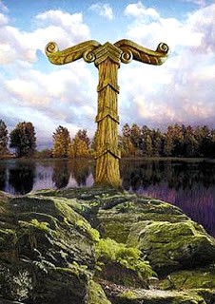

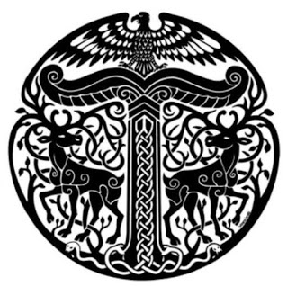

Armies of Erigoth march into battle sounding the carnyx, a type of bronze trumpet with an elongated S shape, held so that the long straight central portion is vertical. The bell is styled in the shape of the head of an open-mouthed boar or other animal. The instrument's significant height allows it to be heard over the heads of the participants in battles or ceremonies. It produces a range of bellowing sounds, from high, shrill notes to low, growling tones. Enemies fear its otherworldly sound.

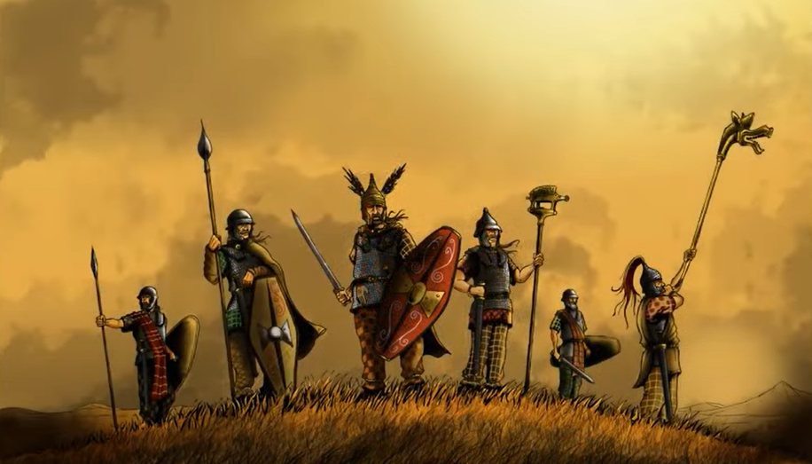

**Local Deities**

Taranis - god of storms and ships, patron deity of Hammer Hold

Asteron - goddess of the dawn, patron deity of Windenfre

Weylund - weird and malicious blacksmith god, patron deity of Wolfenfels

Baduhenna - matron goddess of war, patron deity of Hansla

Sandraudigr - goddess of wealth and military pride, patron deity of Dammerung

**The Old Gods of the West**

While the other western kingdoms turn their backs on the old gods, Erigoth has held tight to them. These are the gods of the druids and rangers. These are the powers of nature that the common folk still call upon in their darkest hour. In lonesome monasteries hidden along the countryside the disciples of these old gods pray to harness the powers of the wind and earth, stars and moon. Their wandering prophets are called the **Faidh** and they speak riddles and the dooms of men. The old gods are the same among all Western Amadar, having hailed from the Primordial Ages when the western tribes were as one.

* **Aermid** – goddess of healing and herbalism
* **Áine and Grian** - goddesses of the summer sun and winter sun
* **Ankou** – god of the dead and the underworld, appears as a skeleton wearing a black robe and a large hat which conceals his face, or, on occasion, simply as a shadow. He wields a scythe and sits atop a cart for collecting the dead. Sometimes he drives a black coach drawn by four black horses accompanied by two ghostly figures on foot. He protects grave yards and, as the saying goes, “When the Ankou comes, he will not go away empty.” Anytime a wagon wheel squeaks or the cry of an owl is heard, it is said to be the squeaking of Ankou’s cart. The owl is referred to by some as the “Death Bird” for this reason.
* **Anotemen** – goddess of the sacred grove
* **Artaius** – protector god of sheep and cattle herders, takes the form of a bear
* **Asteron** – goddess of the dawn, beginnings, and resurrection, patron deity of Windenfre
* **Baduhenna** - matron goddess of war, patron deity of Hansla
* **Belisama** – goddess of crafts and the forge, of fire and of light
* **Branwen** – goddess of love and beauty
* **Brighid** - goddess of healing, poetry and smithcraft
* **Bussumarus** - weather deity who controlled the rain, wind, hail and fog
* **Cathubodua** – goddess of war
* **Grannus** – god of thermal springs, healing
* **Hillon** – god of sun and music
* **Matona** - river goddess
* **Nehalennia** - protector goddess of ships and sea trade
* **Noctiluca** – goddess of magic
* **Niskus** – god of the sea
* **Ogma** – god of eloquence and poetry
* **Rosmerta** – goddess of fertility and abundance
* **Rhiannon** – goddess of fertility, the moon, night, and death; her name means “night queen”; she is strong minded, intelligent, politically strategic, and famed for her wealth and generosity
* **Sandraudigr** - goddess of wealth and military pride; she appears with outstretched hands stained red with blood but gold covering her feet, patron deity of Dammerung
* **Sirona** – star goddess
* **Sucellos** – god of agriculture and wine; carried a large mallet and a barrel
* **Taranis** - god of thunder who carries a hammer and a wheel, patron deity of Hammer Hold
* **Weylund** - weird and malicious blacksmith god, patron deity of Wolfenfels

* Underlined indicates a monastery dedicated to this god or goddess

**Creatures**

**Klabautermann** – These are small magical creatures, some say water kobolds. They are merry and diligent creatures, with an expert understanding of most watercraft, and an irrepressible musical talent. They are believed to rescue sailors washed overboard. They are also fond of stowing away on passing ships and aiding their adopted crew in repairs on the ship. No one onboard ever sees a klabautermann. They only ever become visible to the crew of a doomed ship.

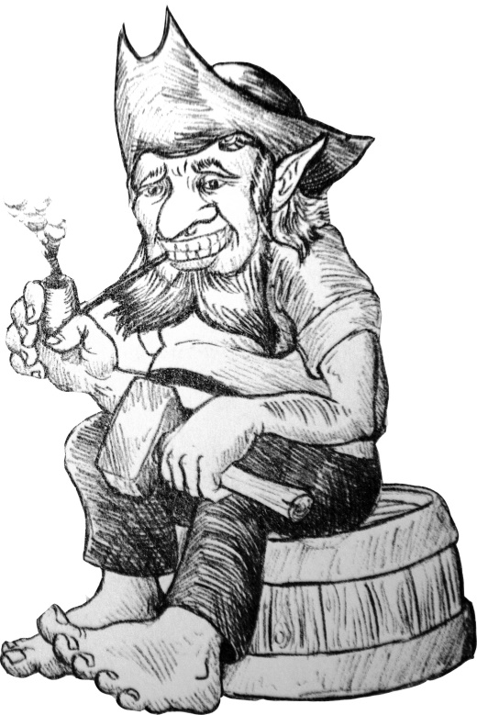

Feldgeister

Werewolves

Doppelgangers

Kobolds

Screecher tribes

Orcs

Syzith, ancient black dragon

Urexon, green dragon

Balinor, silver dragon

Seffiregh, red dragon

**Holunder**, eldest of Treefolk

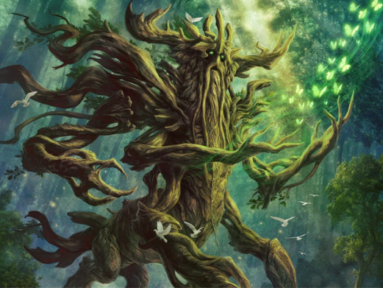

Draugr – Undead warriors who guard their treasures and terrorize the living, often found in Norse mythology.

Einherjar – Fallen warriors chosen by Valkyries to reside in Valhalla, awaiting Ragnarok.

Jötunn (plural: Jötnar) – Giants in Norse mythology, often in conflict with the gods, embodying chaos and nature’s raw power.

Fenrir – The giant, monstrous wolf prophesied to bring about Ragnarok by devouring the god Odin.

Níðhöggr – A serpent or dragon that gnaws at the roots of Yggdrasil, the world tree.

Lindworm – A large serpent or dragon-like creature found in Germanic and Norse folklore.

Valkyrie – Warrior maidens who serve Odin, guiding fallen heroes to Valhalla.

Alfr (Elf) – Magical, otherworldly beings often associated with light or dark forces; thought to inhabit Alfheim.

Troll – Giant or monstrous beings, often slow-witted, dwelling in mountains, caves, or forests.

Nisse – A household or farm spirit in Norse and Scandinavian folklore, often bringing good fortune if treated kindly.

Krampus – A horned creature that punishes misbehaving children during the Christmas season, originating in Alpine traditions.

Huldra – Enchanting forest beings with hollow backs, often luring humans and embodying the spirit of the wild.

Mara – A night spirit or demon causing nightmares, thought to sit on sleepers' chests.

Ratatoskr – The squirrel that scurries up and down Yggdrasil, delivering messages between the eagle at the top and Níðhöggr below.

Dvergr (Dwarf) – Skilled craftsmen and miners who dwell in mountains and caves, often associated with metalwork and magic.

Fossegrim – A water spirit or river-dwelling creature known for playing enchanted music on the fiddle, usually in Norwegian and Scandinavian folklore.

Alp – A supernatural being thought to cause nightmares and nocturnal terrors, similar to the "nightmare" spirit.

Wichtel – A small, sprite-like being often helping with household tasks, akin to household elves.

Skogsrå – A forest spirit with an alluring appearance from the front but with a hollow back, associated with seduction and enchantment in Scandinavian lore.

Heimchen – Mischievous, imp-like beings in German folklore who play tricks or assist humans, depending on their nature.

**Other Races**

**Elves**

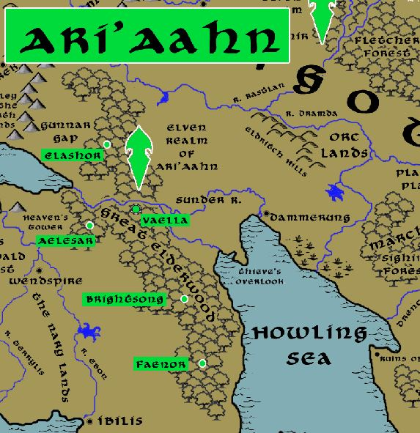

**Dwarves**

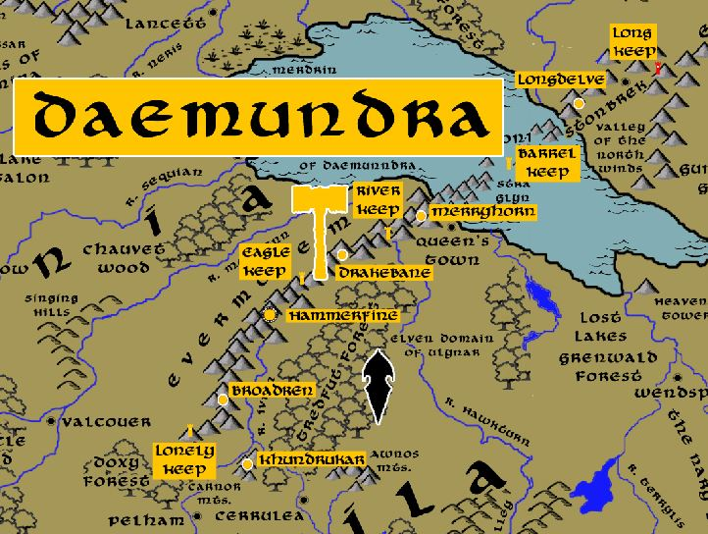

**Magical Items**

**Cold Carnelian**, a fist-sized chalcedony gem colored blood red. Legend has it that the stone is enchanted and can control the very snows that blow into the world this far north. Currently held in Wolfenfels.

**Armor of Adolar** – Enchanted half plate armor imbued with the ability to ward off evil. It was stolen in 420 AA1 by Arnfriend the Gauf hero from the fallen wizard Banasar’s trove of artifacts. Arnfried took the armor back to Erigoth. Its removal caused the release of several evil objects in the wizard Banasar’s lair, including the wizard’s robes which were later fashioned into the Four Banners of Banasar. It is now lost, having been stolen back during the great Orc War of the West in the Third Ancient Age.

Cup of Konrada – magical chalice created by the gods to aide the paladins of the Order of the Golden Stag. It has been used to perform many miracles, as well as choose who is to be king or queen when there are times of trouble. It is currently housed at the keep of the Order of the Golden Stag in Windenfre.

**NPC Templates**

This is a list of notes and stats to help develop NPC’s relevant to this region.

**Developer Notes**

This is a list of notes on the development of this document, including notes on history, culture, and changes to the document.