Notes on the Maelstrom Islands

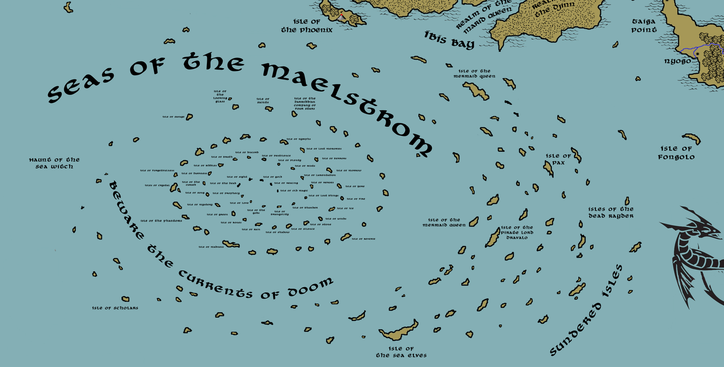

**Table of Contents**

* **Overview**
* **Towns and Cities**
* **Best in the Land**
* **Stewards of Power in this Land**
* **Points of Interest**
* **History**
* **Local Goods**
* **Notes on Culture**
* **Local Deities**
* **Creatures**
* **Other Races**
* **Magical Items**
* **NPC Templates**
* **Developer Notes**

**Overview**

Three thousand years ago the Sextus fleet from Celedon sailed into this region to conquer the islands. It was not prepared for the mighty Maelstrom that controls this region. Almost every ship from the Sextus fleet was swallowed by the mighty vortex and never seen again. A few ships did survive and managed to make it to various islands. While the Celedonians were never a real threat to the region, there are still tales of their tyranny wherever they landed. Ruins of old Celedonian ships are encountered from time to time, as well as sailors who claim to be descendants of the lost fleet.

**Towns and Cities**

**Best in the Land**

Trade Hub:

Religion:

Arts:

Magic:

Spirits:

Steel:

Grain:

Crafted Goods (e.g. Pottery, Textiles, Metal Wares):

Harvested Goods (e.g. Aromatics, Medicine, Dyes):

Mined Goods:

Precious Metals:

Ship Building:

Other:

**Stewards of Power in this Land**

Kings and their armies are not the only wielders of power. There are many unseen friends and foes that shape the destiny of the land. Each of the groups listed below are well known to the people of this region. Some are feared, others venerated. All of them play their part in the grand drama of this land’s story.

**Merchant Companies**

(none)

**Mercenary Companies**

(none)

**Smuggling Rings**

(none)

**Centers of Worship (Churches, Cathedrals, Shrines, Lodges, Temples)**

(none)

**Orders of Paladins**

(none)

**Druidic Circles**

(none)

**Bands of Rangers**

(none)

**Schools of Magic**

(none)

**Bardic Colleges**

(none)

**Warrior Academies**

(none)

**Assassins Guilds**

(none)

**Cults**

(none)

**Other Guilds**

(none)

**Monasteries**

Shrine of the Sea Truth – Isle of Pax in the Southern Seas

**Pirates**

Captain Galius Sovereign – Unnamed Island

Captain Farrid Skinsail Khuddan - Isle of Dravalo

**Points of Interest**

* Gates of Charibdys
* The Sundered Isles (many unnamed)
* Isle of the Mermaid Queen
* Isle of the Pirate Lord Dravalo
* Isle of the Sea Elves – also home to the mighty bronze dragon **Talimalo**
* Isle of the Scholars
* Isle of Savage
* Isle of the Looking Glass
* Isle of Saints
* Isle of the Darmiddian Company of Four Stars
* Island (unnamed)
* Island (unnamed)
* Island (unnamed)
* Island (unnamed)
* Island (unnamed)
* Island (unnamed)
* Isle of Storms
  + Here dwell the small tribe of Storm Giants known as the **Perofeta**, or “Prophets.” They dwell within a castle of coral they call **Male Matagi Keep “Windbreak Keep**.” They are known by their sign of the cloud within an open hand.
* Island (unnamed)
* Island (unnamed)
* Island (unnamed)
* Isle of Reverie
  + Standing alone on the isle is the tower of **Hanu Keeti the Reef Shepherd**, Arch Mage over all the islands of the Maelstrom.
* Island (unnamed)
* Island (unnamed)
* Island (unnamed)
* Island (unnamed)
* Island (unnamed)
* Isle of Madness
* Island (unnamed)
* Island (unnamed)
* Island (unnamed)
* Island (unnamed)
* Isle of Crystal
* Isle of Forgetfulness
* Island (unnamed)
* Island (unnamed)
* Island (unnamed)
* Island (unnamed)
* Island (unnamed)
* Island (unnamed)
* Isle of Nymphs
* Isle of Lost Memories
* Isle of Terrors
* isle of Morrow
* Isle of Yore
* Isle of Fire
* Isle of Ice
* Isle of Winds
* Isle of Stone
* Isle of Silence
* Isle of Shadow
* Isle of Rain
* Isle of Bones
* Isle of Green
* Isle of Mystery
* Isle of Song
* Isle of the Cursed
* Isle of Darkness
* Isle of Riddles
* Isle of Truth
* Isle of Discord
* Isle of Pestilence
* Isle of Plenty
* Isle of Mists
* Isle of Lamentation
* Isle of Heroes
* Isle of Lost Things
* Isle of Thunder
* Isle of Tranquility
* Isle of the Gods
* Isle of Love
* Isle of Prophecy
* Isle of the Dead
* Isle of Sight
* Isle of Gold
* Isle of Healing
* Isle of Old Magic
* **Ikatere** – Sea Elf Domain
* Countless Sahuagin clans populate the seas around the Maelstrom. The three largest tribes are the **Trassek** to the northeast, known by the sign of twin eels twisting together, the **Kalgorr** in the southeast, known by their sign of a sea horse with broken neck, and the **Raxxavar** in the west, known by their sign of the drowned figure floating above a rock to which it is chained.

**(town or city)**

**Size:**

**Trade Goods:**

**Local Goods:**

**Standard:**

**Colors:**

**Patron Deity:**

**Ruler:**

**Home**:

**Steward**:

**Marshal**:

**House Priest:**

**House Adviser (Scholar/Mage/etc):**

**Captain of the Guard**:

**Chief Warriors in Service**:

**Local Powers:**

**Local Sites:**

**Description**:

**Industry:**

**Key Figures:**

**Local Lore:**

**History:**

**Customs:**

**History of the South Sea Islands**

**First Primordial Age (PA1)**

Dawn of the Tua peoples

220 PA1 - Matu Matu rises from the sea and blesses the archipelago of the southwest ocean

620 PA1 - the Mermaid Queen claims her home as one of the islands north of the Matu archipelago; it is one of the few that survive the Great Malestrom of the Fourth Primordial Age

**Second Primordial Age (PA2)**

280 PA2 - the Sea Elves visit the Matu archipelago and choose one of the islands as their home; it will survive the Great Cataclysm of Undrizaar when the Maelstrom destroys Matu

**Third Primordial Age (PA3)**

**Fourth primordial Age (PA4)**

400 PA4 - The Great Cataclysm of Undrizaar the Wizard creates the Great Maelstrom of the Sea

402 PA4 - the Matu archipelago crumbles under the pressure of the vast whirlpool; enormous land masses are sucked into the vortex, leaving a swirl of islands marooned within the eternal vortex's arms

872-888 PA4 - The Wizard War: Telemechus triggers a world-wide war of mages, some of whom march on Ongolk to stop him and some who join him in attacking the ley lines in their lands; epic battles wage all over the world, destroying cities and upsetting the balance of magic

888 PA4 - The Battle of Forlorn: Telemechus is slain but not before rupturing the magical ley lines permeating Nemmyrl; the victorious general Dragan of Celedon seizes the opportunity to rid the world of magic and ruptures the Singularion as it is embedded in the ley lines; the resulting explosion sends a shock wave that ruptures the magical ley lines around the world and triggers the Dead Century

**First Ancient Age (AA1)**

**Second Ancient Age (AA2)**

**Third Ancient Age (AA3)**

**Fourth Ancient Age (AA4)**

**First Written Age (WA1)**

60 WA1 - the Mythenian seer Themistoklis foresees the attack on Sargon and transports several hundred ancient tomes to a distant island in the region of the Great Maelstrom; the Isle of Scholars is founded

240 WA1 - Celedonian Sextus navy launches new campaign to take the Isles of the Maelstrom

260 WA1 - half of Celedonian Sextus navy lost to the Maelstrom

**Second Written Age (WA2)**

**Third Written Age (WA3)**

420 WA3 - the pirate lord Dravalo claims one of the islands as his home base; generations of pirates will go by the name Dravalo and operate from this island

**Fourth Written Age (WA4)**

20 WA4 - the Four Stars merchant company of Darmiddia claims one of the outer isands of the Great Maelstrom region as its base of operations

**Local Goods**

**Cereals:**

**Fiber:** tree ferns, hemp, jute

**Fruits:** galo, bugnay, breadfruit, entawak, breadnut, jackfruit, cempedak, lakuch, marang, tipuho, bilimbi, star fruit, wax gourd, red silkwood, edible rattan, kaffir lime, mountain citron, papeda, calamansi, kalpi, coconut, katmon, alupag, longan, dragon plum, lando, alomit, rukam, binukaw, mangosteen, piris, jiddo, banana, bulala, lychee, santol, water apple, plum, jamos, lubeg, lusong, ayosep, pare (bitter melon), bananas, plantains, mangoes, papayas, pineapples

**Meat and poultry**: snake, bat, tortoise

**Nuts:** areca nut, karuka, macadamia

**Vegetables:** island cabbage, spinach, amaranth, pako, bottle gourd

**Herbs:** taro root, lemongrass, pandan, cubeb pepper, celebes pepper, long pepper, lolot pepper, panax, clove, bay leaf

**Oils:** coconut, palm oil

**Fermented Drink:** okolehao, switchel, tumunu, mitiore

**Salt-water fish:** crab, stingray

**Fresh-water fish:**

**Wood:** balsa, cocuswood, lancewood, rosewood, mahogany, lignum vitae (also called guayacan), palm

**Textiles:**

**Dishes:** kava (drink), roast suckling pig, roast chicken pieces, taro root steamed in coconut milk, sliced yams, steamed crabs, poi (sticky porridge made from the taro root), ika mata (raw fish with coconut milk, finely chopped vegetables), Umu food (prepared in the traditional earth oven), curried eke (octopus in coconut curry), rukau (taro leaves, usually cooked with coconut cream), poke (cooked fruit pudding with banana or pawpaw) served with coconut milk), firifiri (sugared dough treats)

**Notes on Culture**

**Matai** – village chieftain - expected to provide leadership in all aspects of family life. He encourages warm family relations, offers advice, directs religious participation, and oversees disputes. A matai must have different demeanor than everyone else. Matais are also in charge of the economy, managing the amount of food brought in and what is to be stored away for when times are hard.

**Aiga** - The main leader of each individual household and extended family. Each Aiga is the owner of their extended family's land. On that piece of land, families live, grow crops, cook and do other household chores. Due to the large number of households within a single village, there are a large amount of aiga. So much so that some are able to trace back their aiga timeline over a dozen different aiga.

**Aumaga** - these are men in the village that are untitled, they perform most the heavy labor. The aumaga are tasked with building houses, repairing roads, planting and harvesting gardens, fishing, and cutting and selling coconut meat. The aumaga also have ceremonial responsibilities, such as helping the chief in ritual cooking and serving the food at ceremonies. They also serve as informal keepers of the peace, interacting with each other as a large group of friends.

**Manaia** - The aumaga are supervised by a relative of the chief, called the manaia (supervisor), who helps organize the aumaga and plan their activities. Despite not always truly being the son of the matai (chief), the manaia is still called “son” by the matai.

**Local Deities**

Matu Matu

Rehua, the star god with the power of healing.

Rongo, the god of crops and peace

Urutengangana, the god of the light.

Hina, sister, or uncommonly, wife of Māui, associated with the moon.

Tāwhirimātea, the god of storms and violent weather.

Whaitiri, goddess and personification of thunder

Tāwhaki, a semi-supernatural being associated with thunder and lightning.

Elemental gods

* Mahuika, the goddess of fire.
* Papatūānuku, the primordial earth mother.
* Ranginui, the primordial sky father.
* Tangaroa, the god of the sea and fish.

Whiro, the lord of darkness and embodiment of all evil and death.

Aituā, the god of death, disaster, and misfortune.

Hinenuitepō, the goddess of night and death, and ruler of the underworld.

Makeatutara, the father of Māui and guardian of the underworld.

Kahukura, a war god who appears as the upper bow of a double rainbow

Punga / Hairi, the ancestor of sharks, lizard, rays, and all deformed, ugly things.

Tūtewehiwehi, the father of all reptiles.

**Creatures**

**Other Races**

**Elves**

**Dwarves**

**Magical Items**

* Totems of Tufuga – these elaborately carved statues stand 3-5 meters high and protect an island, creating a magical barrier of illusion as well as carrying a bane spell on any with ill intent approaching the island; thought to cause shipwrecks
* Ink Well of Matatumua – this is an ink pot that never runs dry and is used in the painful process of creating tattoos on the skin in the island tradition; shamans use the ink well to create tattoos with permanent magical properties
* War Club of Salamasina

**NPC Templates**

Types of weapons

* Club
* Spear
* Sword-club

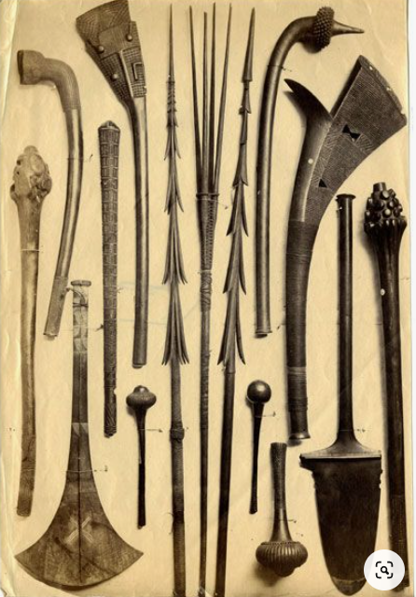

**Developer Notes**

The term “islanders” includes a wide array of cultures from all over the world. In this document I will borrow heavily and randomly to create a fusion of the islander culture for the Nemmyrl world.

Village titles taken from Samoan information: https://en.wikipedia.org/wiki/Samoans

Inspiration: Nan Madol in Micronesia

City featured a system of strong sea walls surrounding 92 man-made islets, all connected by canals and all built on top of a giant coral reef. Walls and structures were constructed from basalt rock floated downriver from a volcanic site roughly 10 miles inland. The island is covered in mangrove trees, making overland travel difficult. A system of streams and rivers cutting through the jungle allows for faster movement by boat. Walls are as high as 22 feet and some structures are as high as 48 feet.

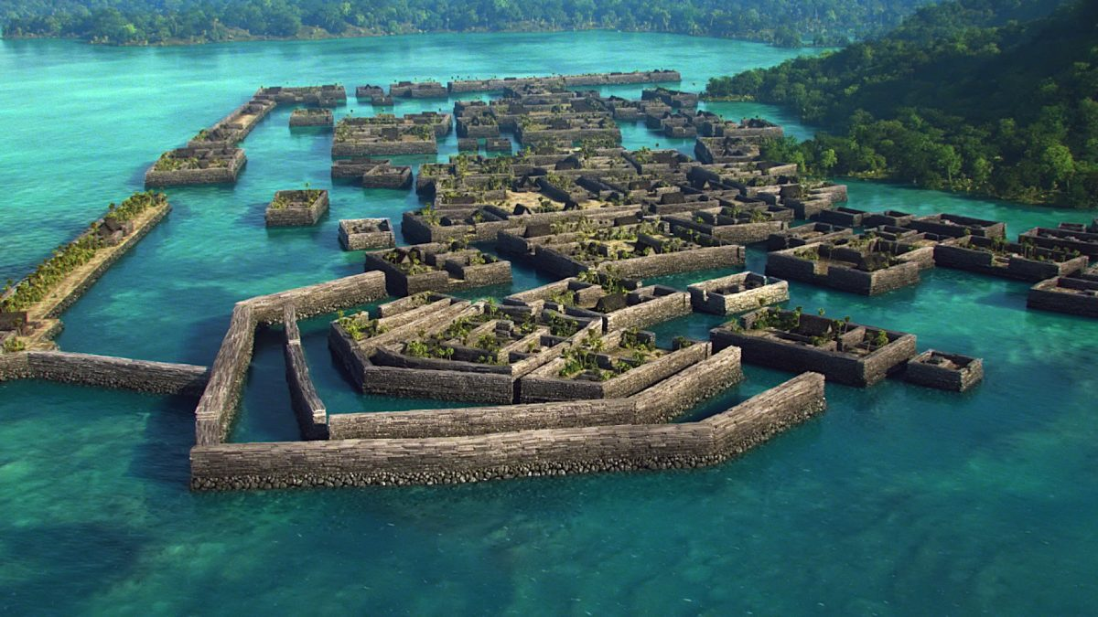

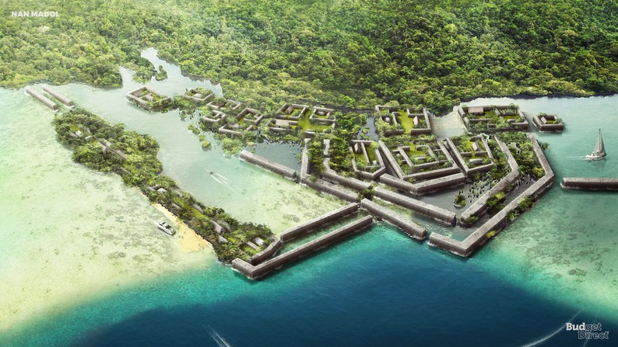

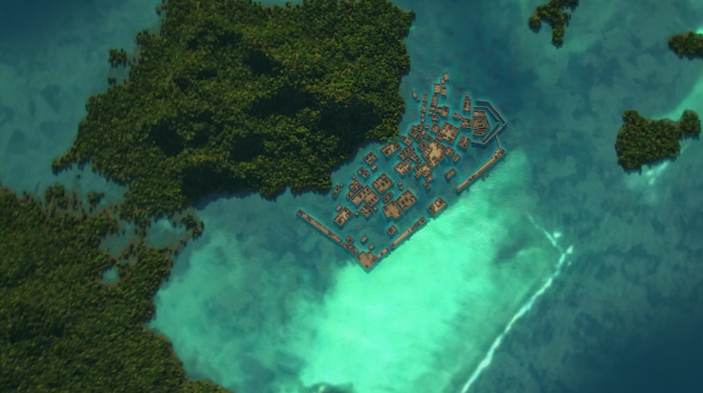

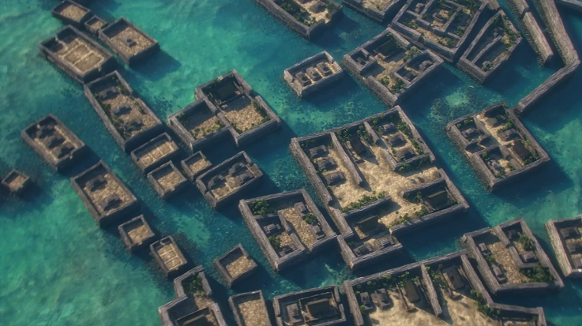

Customs

**Wero** also known as taki, is a traditional Māori challenge, performed as part of the Māori protocol. Its purpose is to ensure that visitors come in peace.

**Weapons**

shark toothed club - somewhat a misnomer, due to the fact that the shark toothed weapons were used for slashing weapons. A round weapon may have 30 or more shark teeth around the edges, other varieties featured as few as 3 in a claw shape. Shark tooth also a proffered weapon of islander nobles. Many weapons were hooked to grab limbs.

Short spears were not larger at the base like the longer pikes.

Stone clubs were in fact stone maces.

Pikoi - wooden tripping weapons had long cords attached to variously shaped club-like heads with or without handles. The weighted part of the rope was thrown at an opponent’s legs to trip him, and then another weapon, perhaps a stone hand club shaped like today’s hand-held weights with bulbous ends and a slimmer connecting section to grasp, would be used to finish off the tripped enemy.

Types of islander daggers:

* heavy truncheon dagger with a hole in the handle for a loop made of olona fiber to be attached
* long-bladed daggers
* shark-tooth or marlin bladed daggers
* bludgeon daggers
* curved bladed daggers
* double daggers - about a foot and a half long, sharpened at one or both ends, and secured to the hand by a string. Its use is to stab in close fight having a handle in the middle with which they are better enabled to strike both ways

(Maori)

The **taiaha** is a traditional Maori weapon, a close-quarters staff weapon made from either wood or whalebone, and used for short, sharp strikes or stabbing thrusts with efficient footwork on the part of the wielder. Taiaha are usually between 5 to 6 feet in length. It has three main parts. The arero (tongue) used for stabbing the opponent and parrying. The upoko (head) the base from which the tongue protrudes and ate (liver) the long flat blade used for striking and parrying. **Mau rakau** is the martial art that teaches the use of the taiaha and other Maori weapons in combat. As with other martial arts students spend years mastering the skills of timing balance and Co-ordination necessary to wield the weapon effectively. The weapon is also widely known due to its use in the **wero** ¨ the traditional Maori challenge. The **upoko** in this example is adorned with a **tauri** (collar) of **muka** bound material which is decorated with prestigious **kuri** dog hair the tassels of which form the awe. The kuri dog figured extensively in Maori tradition and had its place in ritual. For example when the aid of **Tu** (the war-god) was sought prior to the commencement of a battle. The enjoining of the **kuru** to the **taiaha** was a prestigious act which reflected the status and **mana** of the warrior chief whom this taiaha once belonged.

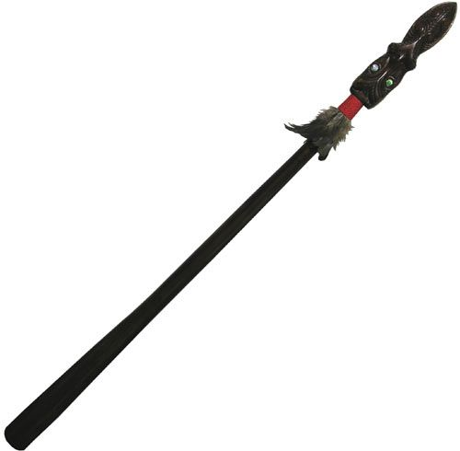

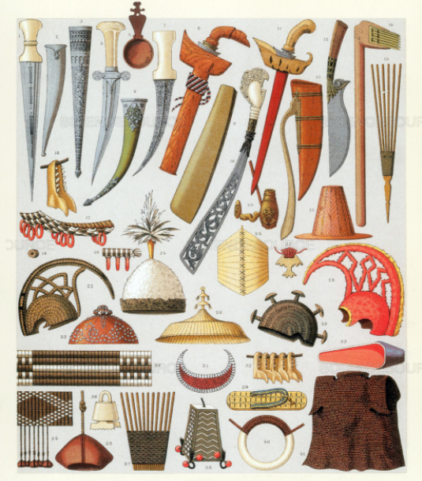

Maori customs

**Tikanga** are the customs and traditions that have been handed down through the passages of time. They come from tika, things are true and not teka, things that are false. The foundations of Tikanga rest at the dawn of time, when events were happening, the worlds were being made, domains being decided, the balance was being put in place. There are 10 Stages of **Pohiri**, or Powhiri, the traditional Maori Welcome Ceremony.

1 – Ko Nga Tangata (the people) – If there are no people, than there can be no pohiri. There are two groups required for a Pohiri to commence, TangataWhenua (hosts) and Manuhiri (visitors). The minimum number required for a Pohiri is 4. Two males and two females. One female to do the karanga (call) and one male to do the mihi (speech) on either side.

2 – Inoi – prayer - An inoi is said to ensure the safety of the people and to ensure that all stages are carried out without disturbance. An inoi should be said by both Manuhiri and Tangata Whenua.

3 – Wero – challenge – carried out to ascertain the intentions of the visiting group. Wero were executed by the fastest and fittest male warriors of the Tangata Whenua. Dependent on the way in which the taki (dart) was placed down and picked up, would deem whether the Manuhiri had come in peace, or with warlike intentions.

4 – Karanga – call – performed by a female elder

5 – Haka Pohiri – welcome dance

6 – Mihi - speeches

7 – Oriori / Waiata – chant/song

8 – Koha – gift

9 – Hongi – traditional form of greeting

10 – Kai – food

Nainoa

Cloudy conditions over equator

Navigating islands using birds

Navigating islands tasting the sea and the mud of the area

Using three fingers to orient constellation of Orion

Examine trade winds

Yudoye

Trevethan