Notes on the Lands of Oraba
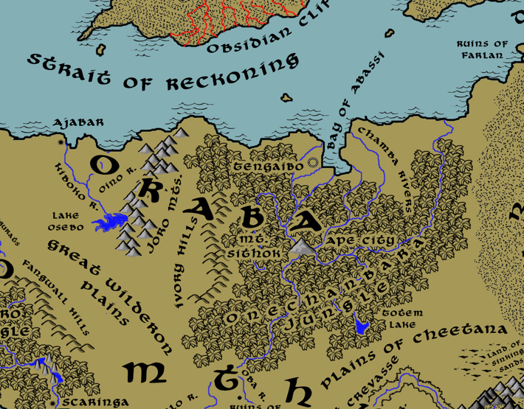

Table of Contents
- Overview
- Towns and Cities
- Best in the Land
- Stewards of Power in this Land
- Points of Interest
- History
- Local Goods
- Notes on Culture
- Local Deities
- Creatures
- Other Races
- Magical Items
- NPC Templates
- Developer Notes

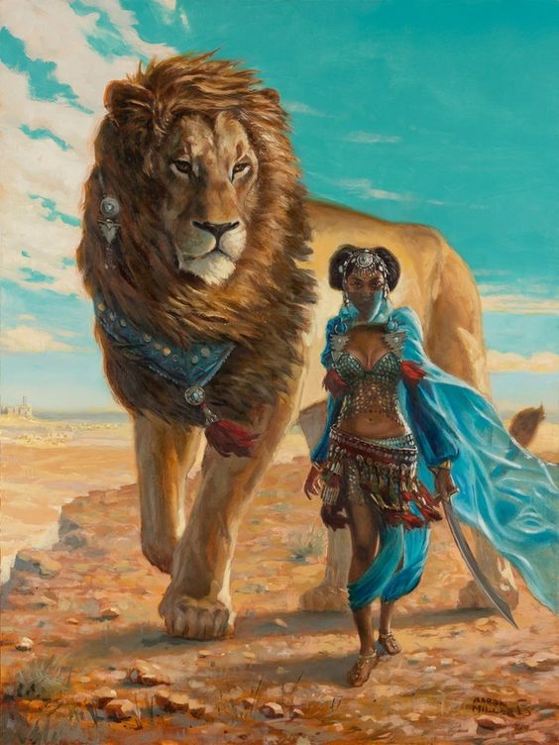
Overview
Kaduru is a wide continent stretching along the southern edges of Nemmerle. It is a tropical land, covered in dense jungles separated by arid plains and deserts. The interior of Kaduru remains largely unexplored wilderness, but towns along the coasts have built up into powerful hubs of sea trade. Chieftains, or Sumba, control groups of tribes and smaller towns. Their seats of power are hereditary but are constantly challenged by rivals in personal combat. The kings, called Masumba, have consolidated power in the four regions and waged wars by land and sea to control the continent. The people here are proud, fierce, and crafty warriors not to be underestimated.

The Ora people rule over these lands and have done so since 750 WA1 when the tribes drove out the Celedonian invaders. They crowned their first Masumba and united the towns and cities of the region.

Towns and Cities
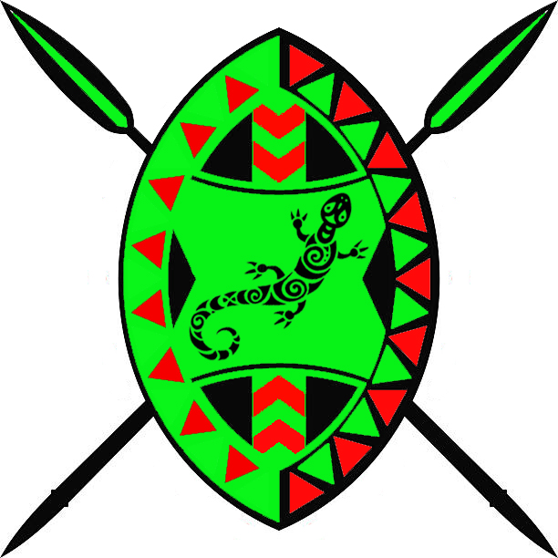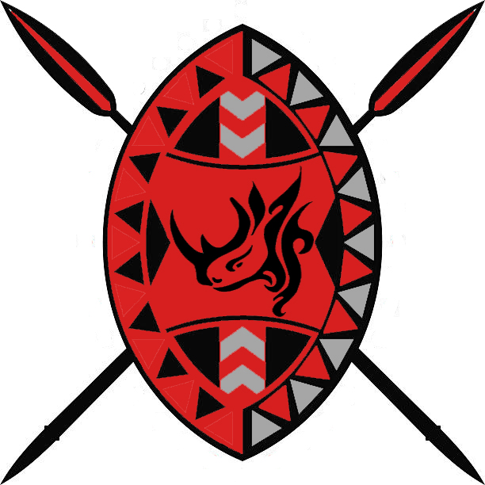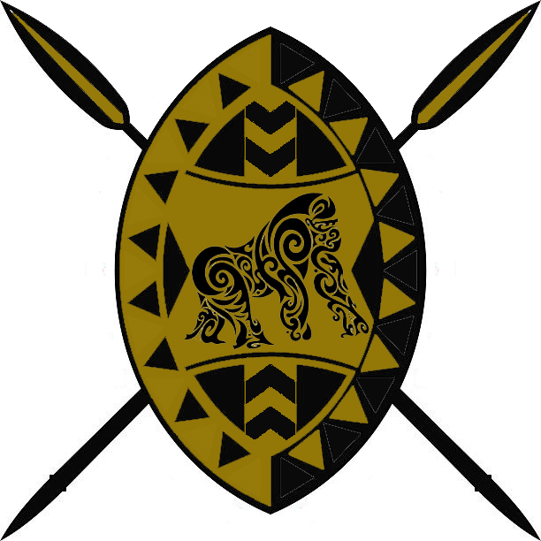
- Oraba (Northern Kaduru)
  - Tengaibo - large city, seat of power in Oraba, sign of the gecko
  - Ajabar - large town, sign of the rhino
- Wakabi (“Ape City”) - small city, sign of the ape – independent city

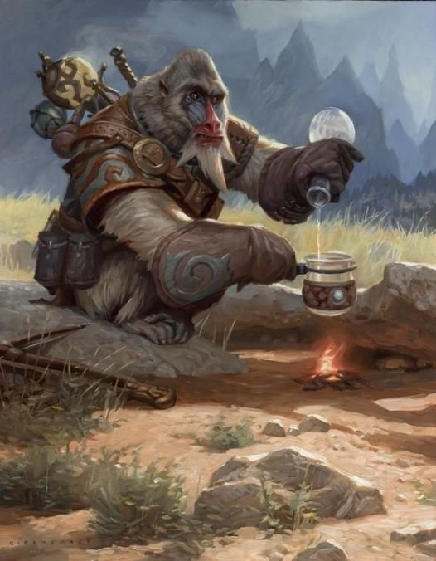
Best in the Land
Trade Hub: Longspear, Tengaibo, Harikanya, Jaloro
Religion: Harikanya
Arts: Harikanya
Magic: Harikanya
Spirits: Jaloro
Steel: Ajabar
Grain: (none)
Crafted Goods (e.g. Pottery, Textiles, Metal Wares): Harikanya
Harvested Goods (e.g. Aromatics, Medicine, Dyes): Bokarra, Sikaar, Wakabi
Timber: Tengaibo, Nyogo, Masuba
Mined Goods:
Precious Metals:
Ship Building: Longspear, Keromang
Livestock: Bokarra
Ivory: Bokarra, Tengaibo, Wakabi, Harikanya, Arolo
Tobacco: Sikaar, Ramala, Scaringa, Redwall, Keromang
Other:

Stewards of Power in this Land
Kings and their armies are not the only wielders of power. There are many unseen friends and foes that shape the destiny of the land. Each of the groups listed below are well known to the people of this region. Some are feared, others venerated. All of them play their part in the grand drama of this land’s story.

Merchant Companies
Fair Sky Traders - Tengaibo

Mercenary Companies
The Vifaru – Ajabar

Smuggling Rings
The Nguchiro – Tengaibo

Centers of Worship (Churches, Cathedrals, Shrines, Lodges, Temples)
Cathedral of Oya – Tengaibo

Orders of Paladins
Wamaji Order – Tengaibo

Druidic Circles
(none)

Bands of Rangers
(none)

Schools of Magic
Sanctum of Masks – Tengaibo

Bardic Colleges
(none)

Warrior Academies
(none)

Assassins Guilds
(none)

Cults
(none)

Other Guilds
Maktaba Library – Tengaibo

Monasteries
Shrine of the Quiver Tree - Joro Mountains
Shrine of the Chameleon - North of Onechanbara Jungle

Pirates

Points of Interest
- Bay of Abassi
- Strait of Reckoning
- Desolate Strait – these were once called the Tebri Strait, after the Tebri people who populated the Gaeadon continent. But after the Molten Queen of Svarog Vale wrought her vengeance on the Cebraki, she blasted the Gladden Fields and Tebri Strait into ruin. They have since been known as the Forgotten Wastes and the Desolate Strait.

- Onechanbara Jungle

- Great Wilderon Plains
  - In the northern region of the Wilderon plains dwells the Gnahynde tribe of gnolls, known by their sign of the bloody zebra leg
  - In the southern region of the Wilderon plains dwells the Grissla tribe of gnolls, known by their sign of the bloody antelope head

- Kiboko River
- Oino River
- Chamba Rivers
  - Here dwells the Salavra tribe of gnolls, known by their sign of the curved tongue with teeth above and below

- Osebo Lake
- Totem Lake

- Joro Mts
  - home to the copper dragon Hadithi (“story”)
  - Here dwell the tribe of Storm Giants known as the Mubayura, known by their sign of the mountain with waterfall.
- Mt. Sithok

- Ivory Hills
  - Standing atop the tallest hill is the tower of Makeda (f) of the Serpent Circle, Arch Mage of all the lands of Oraba.

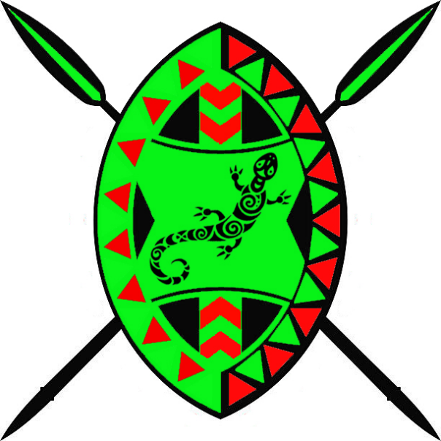
Tengaibo
Size: large city, population 25,000, guards / soldiers 250, militia 1250
Trade Goods: trade hub, ivory, timber, sugar, gems, salt
Local Goods: trade port, ship building, skilled craftsmen, fishing
Standard: gecko
Colors: red and green
Patron Deity: Oya, river goddess, influences commerce, weather, transporting the dead to the afterlife
Ruler: Masumba Umo of the Kuende tribe and his wife Simphiwe (f)

Home: Ebony Palace
Steward: Motuma
Marshal: Muna (f)
House Priest: Tengene
House Adviser (Scholar/Mage/etc): Zonkizizwe the Walker
Captain of the Guard: Atikem
Chief Warriors in Service:
Sithembele
Abongameli
Desta (f)

Local Powers: Fair Sky Traders, Ten Spears (thieves guild), The Nguchrio (smuggling ring), Cathedral of Oya, Maktaba Library, Wamaji Order (order of paladins), Sanctum of Masks (center of magic)
Local Sites: King Agongolo Inn & Tavern, The Angry Elephant Inn & Tavern, Songura (brothel)

Description:
Overlooking the Bay of Abassi, Tengaibo appears like a silhouette with its high black walls of polished obsidian. To travelers it is called the “Night City”. It is a powerful city controlling the vast swath of farmlands stretching to the Chamba River and beyond. Its impressive naval fleet dominates the Strait of Recknoning and patrols the Thundra Sea to ward off unwelcome ships. The massive Onechanbara Jungle encircles the delta and the city to the south. Tengaibo is the seat of power along the northern coastline of Kaduru and the Oraba region.

The people of Tengaibo are a proud and refined people. Centuries of war with the Tivvian peoples long ago taught them to be wary. Trade with Adhanar and Kazeldun have opened doors into the worlds to the north. Tengaibo citizens are scholars of history and the large Maktaba Library is a testament to that. Within its stone walls are scrolls telling tales from all over Kaduru and parts beyond. Below, the sacred vaults are said to house ancient writings and sacred texts seen only by its curators, who are called the Maktaban Monks.

Industry:
A peace treaty signed with the Wakabi apes of Mt. Sithok allow for the harvesting of elephant ivory from designated grave yards. Poachers are tempted to venture into the Onechanbara Jungle to exploit more ivory, but the city guard is watchful lest war breaks out anew with the apes. Gems are also a prime source of revenue, but come second-hand from the apes who find little value in the shiny stones and trade for other goods at a healthy rate of exchange.

Most of the trade done along the Strait of Reckoning and the Desolate Straits is dominated by the Fair Sky Traders. The merchant house employs a strong contingent of warriors to safeguard their boats, for pirates are common and Kazeldun merchants unscrupulous. Diplomatic ties to Oisia and Argeia are strong out of respect for the value of trade between them.

The river lands around the Bay of Abassi are very important to the people of Tengaibo. Their patron goddess Oya watches over these lands and blesses the weather and those working here. Upriver sugarcane fields line the banks of the waterways, which lead into deltas where salt deposits are harvested.

Key Figures:
Masumba Umo is a learned man and a great thinker. He spent most of his childhood at the feet of the Maktaba Monks in the city’s great library. Umo is middle-aged, with a long gray beard. The people love him and revere the figure he cuts in his purple kaftan and white jillaba, every inch the vision of a masumba. His intellect has seen past trivial conflicts with other cities to secure strong alliances with Argeia in Mythenia and with Oisia in Gaeadon. He has arranged marriages for two of his children, a son and a daughter, to nobles in these lands. Over forty years he has successfully edged out competition from Longspear to make Tengaibo a powerful trade center.

Umo’s wife, Simphiwe, is a descendant of Queen Malaka of Tengaibo, who went on to become the Molten Queen in Svarog Vale across the waters in Gaeadon. She secretly struggles with the power of the Svarog flame that she inherited from her bloodline. Zonkizizwe, the court wizard, has tutored her to become an elementalist with the ability to wield the power of the flame. Simphiwe makes clandestine trips to Svarog Vale twice each year to test her powers.

The Cathedral of Oya is a dazzling site in Tengaibo. Tall towers of ebony chased in gold encircle a forty foot statue of the goddess. She stands facing the bay, one hand outstretched as if controlling the weather, the other hand pointed upwards to the sky. She is the goddess of winds, lightning, and violent storms. She is also the goddess of death and rebirth, and her control of the rivers and their dangers are what remind the people of her fickle favor. Flowers blossom about her statue in her favorite colors of red, black, and purple. The Paladins of the Wa Maji Order serve Oya and protect the region from evil. Dressed in her colors, they are each armed with spears that call down lightning and with shields that summon rain and wind.

The Sanctum of Masks is a unique center for magic and its studies. Most tribes in Kaduru honor the tradition of crafting and wearing ceremonial masks for either religious practices or to wear in battle. Here in the Sanctum of Masks, the crafting and study of magical masks is the specialty. There are tens of thousands of masks here, collected from all over the world. The outside of the tower for the sanctum is in fact one tall mask with the entrance passing through the mouth and the mask guarding it as an animated object. Shaman who work here study the power of masks and work to explore their wonders. Some fear the practice could grow out of control and so they observe it from here and watch for trouble.

Local Lore:
The rivers around Tengaibo are the home to the maniwata, spirits of the waters. These appear similar to mermaids: the upper body of a woman with the lower body of a fish, but sometimes of a serpent. Most times they appear with a serpent coiled about their necks. These are their animal companions and do their bidding. Unlike mermaids, the maniwata can transform to human form at will and are able to shape-shift to appear in any human form they desire. The spirits are capable of kindness but are wild and unpredictable. It is said they will occasionally abduct a human they find interesting and take them beneath the sea to show them their home. The humans almost always return later, gifted with great wisdom and good fortune from the experience.

Tengaibo was the last known location of the Dark Ikula, a short sword forged in the Ikula style that was enchanted with power over light and darkness. It is said the blade has powers that change with the phases of the moon.

History:
Nine thousand years ago the city of Tivvian had grown to such power that it conquered the molten people native to Svarog Vale. Soon after, the Sultan of Tivvian launched an all-out attack on northern Kaduru and ignited the Svarog War. The flaming host of Svarog swept over Ajabar and Tengaibo and threatened to burn the Onechanbara Jungle. In 707 PA3 Queen Malaka of Tengaibo called on the water goddess Oya and defeated the armies of Svarog. But it was not without cost. Within a few years Queen Malaka found she had been tainted by the fire fever of Svarog's demons. Gradually she transformed into a flaming humanoid like those native to Svarog Vale. Heartbroken she could not live among her people, Malaka reluctantly agreed to become the new Molten Queen over Svarog Vale.

Six thousand years ago the gods Ogun, Olorun, Takhar, and Shango bickered over Kaduru and who among the peoples there were the mightiest. As a test they dispatched the Four Spears of Ogun to Bokarra, Tengaibo, Harikanya, and Jaloro. This sparked the rise of the Four Kaduru Empires.
In 140 AA2 Tengaibo armies marched across central Kaduru, claiming the Onechanbara Jungle, Wakabi (Ape City), and all villages and towns. This transpired at the same time Bokarra, far to the southwest, was mounting a similar campaign to take all of western Kaduru lands. Bokarra and Tengaibo clashed at the edge of the Wilderon Plains. In 200 AA2 Tengaibo invaded southern Gaeadon and held the lands there for three hundred years before its power subsided. In 550 AA2 the Battle of the Sky Spears saw Masumbas of all four Kaduru Empires meet on the Plains of Cheetana to claim all of Kaduru. It was the single greatest battle ever seen in Kaduru and ended with the destruction of all four armies and their Masumbas. This signaled the decline of the Four Kaduru Empires. Later, in 740 AA2 the Apes of Wakabi drove out humans and Elves from Onechanbara Jungle and formed Ape City.

Customs:
Tengaibo, along with Ajabar, are a distinct people and culture from the rest of Kaduru. They both share the dialect and traditions of the Oraba people. Tengaibo frowns on Ajabar’s free-spirited and open atmosphere. The large city is much more conservative and protective against outsiders in its enclave around the river lands.

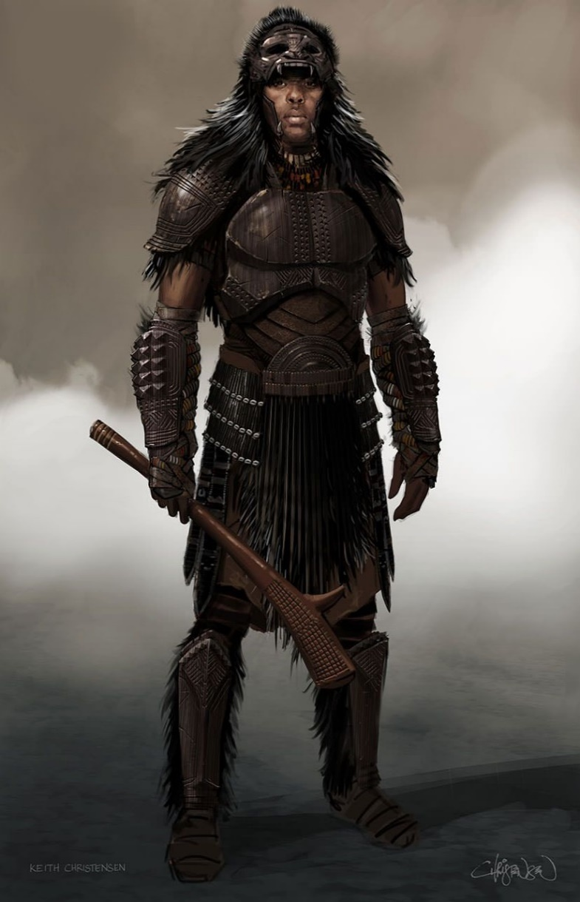

Ajabar
Size: large town, population 5,000, guards / soldiers 50, militia 250
Trade Goods: steel, iron, sugar, furs, gold
Local Goods: fishing, trade, textiles (Kente cloth)
Standard: rhino
Colors: gray and red
Patron Deity: Obatala: son of Olorun, greatest of the Orishas, drunken creator of the human race
Ruler: Sumba Abasi of the Chanua tribe and his wife Nhalahla (f)

Home: Savanna Keep
Steward: Themba (f)
Marshal: Qhude
House Priest: Fundani
House Adviser (Scholar/Mage/etc): Andila (f)
Captain of the Guard: Nataye
Chief Warriors in Service:
Zere
Wadafera
Siyabo

Local Powers: Open Grave (thieves guild), The Vifaru (mercenary company)
Local Sites: The Clever Turtle Inn & Tavern, The Shepherd’s Staff Inn & Tavern

Description:
Ajabar is a colorful city full of artists and musicians. Seated at the mouth of the Kiboko River, Ajabar is a minor port for trade with outlanders, often overlooked as travelers venture eastward to Tengaibo. It is heavily populated with Gaeodon peoples who have made a living there and been accepted as ‘guests’.

The town walls and every building are brightly colored, covered in paints created from a variety of powders. These are mined from the exotic sands and clays found around the river delta.

Regular caravans leave to cross the Great Wilderon Plains to reach Scaringa and Redwall in the far south. The caravans are an important part of trade and communication between these towns and their surrounding villages.

Ajabar has a long history of taming and riding rhinoceroses. The town’s cavalry, called the Vifaru, make frequent patrols across the Great Wilderon Plains, protecting caravans and defending against creatures from the Joro Mountains. It is a fearsome sight to see a company of Vifaru charging in the open field. Many wars have been decided by these unstoppable juggernauts, and they are often hired as mercenaries in far-off wars.

Ajabar pays homage to Tengaibo, which is the seat of power in Northern Kaduru. Both settlements share a common Oraba culture. Tengaibo frowns on the progressive and open customs of Ajabar, sometimes mocking it as a ‘party town.’ But it relies on Ajabar for both shipping lanes further west as well as the caravans coming across the Wilderon Plains.

The patron deity of Ajabar is Obatala, son of Olorun, greatest of the Orishas. He is the white cloth god and drunken creator of the human race, forced to create mankind as a punishment and did so while drunk so mankind is imperfect.

Industry:
As in Longspear, Darmiddian merchants have set up shop here and work to control as much of the trade as the native Kaduru people will allow. Guides are aplenty here to take travelers into the interior of Kaduru, but some of them will take their money and abandon them on the plains.

Ajabar is surrounded by sugarcane fields, the twenty-foot stalks obscuring the myriad pathways that cut back and forth like a maze. These fields stay in place year-round, for once the stalks are chopped off the base stalks are left to grow new stalks. Large store houses are set up where workers carry heavy loads of the stalks to the cutting and washing floors. There the workers press the stalks and collect the syrup run-off. Dried sugarcane fiber is burned beneath enormous vats on the outskirts of the fields. There the syrup is thickened by boiling off the water.

Kente is a handwoven cloth made in elaborate designs with strips of silk and cotton. Historically the fabric is worn in a toga-like fashion by royalty or those being honored by royalty on special occasions. It is a very popular textile out of Arolo and Ajabar and is being worked into simple dresses and robes.

Key Figures:

Local Lore:

History:
On several occasions the Ajabar people have faced near destruction from invaders. Nine thousand year ago the mad Sultan of Tivvian launched a full scale invasion of Northern Kaduru. This was the Svarog War (703 PA3). The Sultan brought with him his newly conquered allies, the molten beasts of Svarog Vale. Ajabar was almost completely wiped out. If not for the valiant druids of the Joro Mountains and the rhino cavalry, the Svarog soldiers would have burned the grasslands as well as the Onechanbara Jungle.

Five thousand years ago (120 AA3) the Gnahynde gnolls marched on the town, vowing to rid the region of human interference. The great gnoll general Thraag poisoned the Kiboko river and sent flaming barges to block the waterway. They then crossed the plains east of the town with hill giants to topple the town’s walls. In a climactic fight the Vifaru cavalry charged their rhinos into the gnoll host. The hero Rukiya was triumphant, leading her forces in a series of attacks that eviscerated the giants and the gnoll infantry.

Three thousand years ago (200 WA1) Celedonian naval forces Quartus and Quintus attacked the Kaduru towns of Sikaar, Ajabar, and Skaringa in a coordinated campaign. They deployed the Gerana and Acanthis Legions to move behind Kaduru forces holding the Wilderon. The town was held hostage for hundreds of years under Celedon rule. Ancient military buildings can still be found crumbling in parts of the town.

Customs:
The culture here is an open-minded one. Obtala, the patron god of Ajabar, was the drunken creator of mankind, and credited for the folly of men and women. In this tradition, people are seen as flawed regardless of where they come from. So it is a tolerant atmosphere and welcoming of strangers.

Festivals take place year-round involving the throwing of colorful powders and paints, each color having a different meaning. Visitors to Ajabar are often doused with a yellow powder as a ritual means of purifying them of their outside impurities. The well-meaning traveler is wise to accept the gesture as a sign of good luck and acceptance.

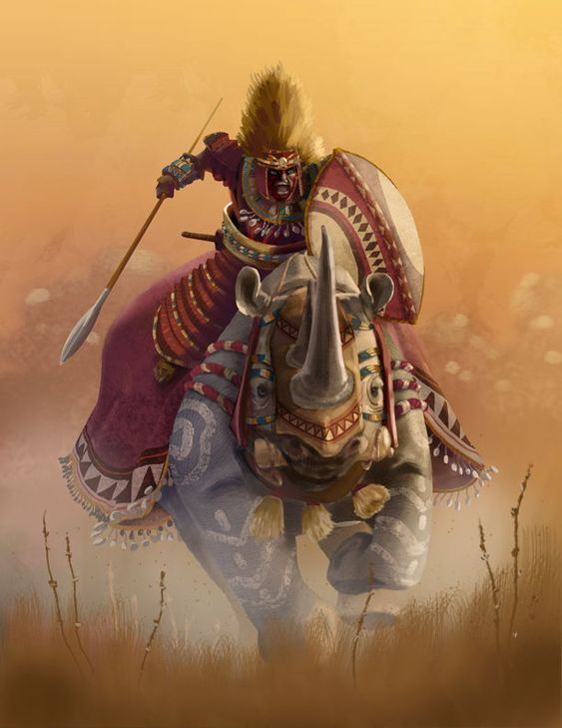

Wakabi (“Ape City”)
Size: small city, population 12,000, guards / soldiers 120, militia 600
Trade Goods: medicine, ivory, silver, gems
Local Goods:
Standard: ape
Colors: black and brown
Patron Deity: Ngi, the gorilla god of strength
Ruler: Bardru, king of apes, and his mate

Home: Raffia Palace
Steward:
Marshal:
House Priest:
House Adviser (Scholar/Mage/etc):
Captain of the Guard:
Chief Warriors in Service:

Local Powers: The Bone Collectors (thieves guild)
Local Sites: Mahanga’s Inn & Tavern, Ufiti’s Ghost Inn & Tavern

Description:
Deep within the Onechanbara Jungle hides the legendary Ape City. Set at the foot of Mount Sithok, it is a sprawling open-air vista of grassy terraces alternating with tall stone walls covered in ornate carvings and overgrown with giant vines. The terraces climb upwards to the eastern side of Mt. Sithok itself, the architecture perfect for the native population of intelligent apes which took it over centuries ago. Known as Wakabi in their tongue, the inhabitants range from large gorillas to orangutans to chimpanzees.

The Wakabi apes speak their own language, fashion metal and wood works, and have a simple written alphabet they use to record their history. All apes train to be warriors and are handy with clubs and spears. Their leaders wear elaborate gold helmets and breastplates. Outsiders are treated savagely unless coaxed into friendship, which can be a strong bond once Wakabi has accepted someone. There are no relations with outsiders and while the presence of Wakabi is well known, no one but the most keen of guides know the location of the city.

Wakabi is composed of three distinct areas: the mountain terraces, the warrens, and the great wall.
The Terraces: The base of Mount Sithok in this area ascends sharply in areas and levels off three times as it climbs, creating three relatively flat areas. Here the apes have inhabited natural caves in the steep walls climbing up the mountainside, as well as small structures in the flat areas. A large river issues forth from a fourth, higher terrace that it is not occupied. The river descends in large, cascading waterfalls and creates small pools which run off into more waterfalls and so forth down to the base of the mountain. Here the Chamba and Bara Rivers begin, the Chamba heading north and the Bara south.
The Warrens: The Wakabi apes have erected stone fences within the jungle to create enclosed spaces. These are the Warrens and each one houses high tree platforms where apes work or sleep in bad weather (they normally sleep in the open). Each Warren has its own purpose: crafting items, research, armed guards, markets, etc. A head ape is elected by each Warren to supervise it and reports directly to the king.
The Great Wall is a fifty foot wall made of purple marble erected far outside the warrens and forming a perimeter around the city at the base of the mountain. Only one gate passes through it, at the southern road running alongside the Bara River. This road passes between the two soldier warrens and through the main warren and up to the main city hall at the base of the mountainside.

Rafia Palace is so named for the rafia palms that are indigenous to this region.

Industry:

Raffia palms indigenous to this region are harvested for the fiber that can be made from its palm fronds. This is fashioned into a twine used in rope, building materials, mats, baskets, and painted decorative items.

Ogogoro is a sweet raffia wine made from the tree’s fermented sap.

Key Figures:

Local Lore:

History:
In 740 AA2 the Apes of Wakabi drove out humans and Elves from Onechanbara Jungle and formed Ape City.

Warrens
1 -

Customs:

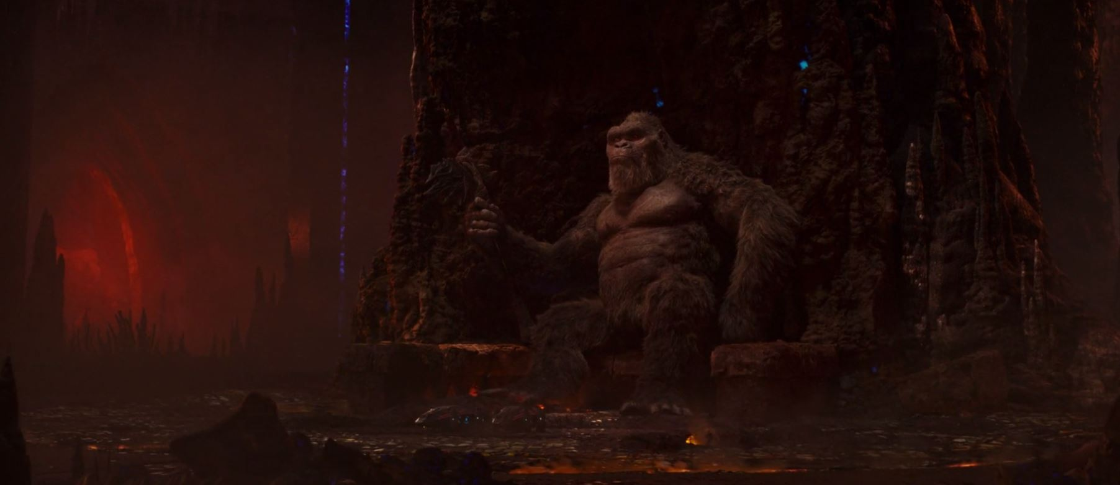

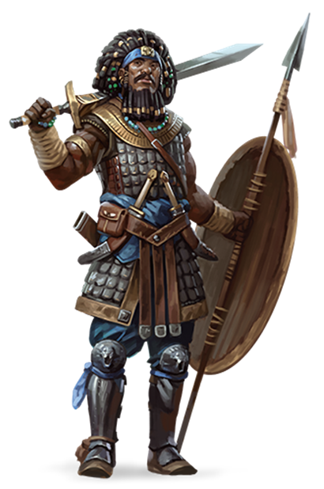
History of Oraba
First Primordial Age (PA1)
Dawn of the Watu people: The first people of Kaduru, the Watu, emerge in the savage jungle valley east of the Aramanga Mountains; it is a primal struggle to survive as the gods see if humans are fit to live in this new land.

50 PA1 - the gods Olorun, Ogun, Oya, and Eleduwa arrive in Kaduru and wager to divide the land up between them

173 PA1 - the Watu are challenged by the gods to explore all of Kaduru; any who can survive the savage lands are invited to settle what lands they find most appealing

505 PA1 - After years of adversity surviving the perils of the land, Watu tribes from the Southern lands reach Northern Kaduru and begin building permanent settlements. The trials of the gods have made them strong and they quickly adapt to their new home.

Second Primordial Age (PA2)
200 PA2 - the druid Ayanda enters a trance atop Mt. Sithok and becomes one with all living creatures in the Onechanbara Jungle; to this day those uttering Ayanda's name while in the jungle may seek his aide

Third Primordial Age (PA3)
610 PA3 - Wakabi is founded in the Onechanbara Jungle; humans refer to it as Ape City

707 PA3 - War of Svarog - Queen Malaka of Tengaibo calls on the water goddess Oya, defeats the armies of Svarog

708 PA3 - fleeing to Svarog Vale, the Sultan of Tivvian is incinerated by the enslaved Molten Queen after she frees herself; the Molten Queen dies from the effort

709 PA3 - Queen Malaka, tainted by the fire fever of Svarog's demons, transforms into a flaming humanoid like those native to Svarog Vale; the people of Svarog Vale convince her to beome their next Molten Queen

Fourth primordial Age (PA4)
872-888 PA4 - The Wizard War: Telemechus triggers a world-wide war of mages, some of whom march on Ongolk to stop him and some who join him in attacking the ley lines in their lands; epic battles wage all over the world, destroying cities and upsetting the balance of magic
888 PA4 - The Battle of Forlorn: Telemechus is slain but not before rupturing the magical ley lines permeating Nemmyrl; the victorious general Dragan of Celedon seizes the opportunity to rid the world of magic and ruptures the Singularion as it is embedded in the ley lines; the resulting explosion sends a shock wave that ruptures the magical ley lines around the world and triggers the Dead Century

First Ancient Age (AA1)

Second Ancient Age (AA2)
130 AA2 - the gods Ogun, Olorun, Takhar, and Shango bicker over Kaduru; they send the Four Spears of Ogun to Bokarra, Tengaibo, Harikanya, and Jaloro; sparks the Four Kaduru Empires

140 AA2 - Tengaibo armies march across central Kaduru, claiming the Onechanbara Jungle, Ape City, and all villages and towns

150 AA2 - Bokarra armies march across western Kaduru, claiming all towns and villages as far as the Joro Mountains and the Nonthelelelu River, clash with Tengaibo's armies at the edge of the Wilderon Plains

200 AA2 - Oraba, kingdom of Kaduru, invades southern Gaeadon: Adhanar, Vale of Svarog, and the Forgotten Wastes

550 AA2 - Oraba forces leave Adhanar, answering the call of the great war in Kaduru; some Oraba people stay behind and dwell among the people here

550 AA2 - the Battle of the Sky Spears - Masumbas of all four Kaduru Empires meet on the Plains of Cheetana to claim all of Kaduru; it is the single greatest battle ever seen in Kaduru and ends with the destruction of all four armies, signaling the decline of the Four Kaduru Empires

740 AA2 - Apes of Wakabi drive out humans and Elves from Onechanbara Jungle and form Ape City

Third Ancient Age (AA3)
120 AA3 - the gnoll general Thraag of the Gnahynde tribe leads an army to crush Ajabar; the hero Rukiya counters with the Vifaru cavalry and destroys them

Fourth Ancient Age (AA4)

First Written Age (WA1)
200 WA1 - Celedonian naval forces Quartus and Quintus attack Kaduru towns of Sikaar, Ajabar, and Skaringa, deploys the Gerana and Acanthis Legions to move behind Kaduru forces holding the Wilderon

270 WA1 - Celedonian Quartus navy deploys forces at Tengaibo and are repelled; Lampus Legion seizes lands east of the Chamba River

340 WA1 - Celedonian Lampus Legion finally takes Tengaibo, Quartus fleet controls the Desolate Straits

650 WA1 - Celedonian Lampus Legion marches into Onechanbara Jungle and is destroyed by the forces from Ape City

750 WA1 - Rise of the Ora people as they crown their first Masumba and unite the towns and cities of the region.

Second Written Age (WA2)

Third Written Age (WA3)

Fourth Written Age (WA4)

Local Goods

Cereals: sorghum, fonio, finger millet, teff, emmer (wheat)
Fiber: cotton, capok, sisal, palm, flax, hemp, jute, kenaf, coconut, pinewood, baobab bark
Fruits: baobab, bananas, cassava, monkey orange, marula, gac (melon), pare (bitter melon), charentais melon, kiwano (horned melon), egusi (wild melon), watermelon, safou (butter fruit), dika, honeydew melon
Meat and poultry: beef, chicken, pig, lamb and mutton
Nuts: dika nuts, marama nuts, marula nuts, mongongo nuts, palm nuts
Vegetables: okra, black-eyed pea, corn, eggplant, cowpea, lablab, moringa, bambara bean, locust bean, pigeonpea, potato, enset, marama, moringa
Herbs: grains of paradise, kani pepper, sesame, silphion, tamarind
Oils: marula oil, maringa oil, palm oil, panda nut oil
Fermented Drink: marula beer, abada, akpeteshie, kumi kumi, chouk
Salt-water fish: oysters, shrimp, octopus, prawn,
Fresh-water fish: bream, tilapia
Wood: sapele, abura, walnut, agba, avodire, ebony, gaboon, iroko, mahogany, mansonia, obeche, zebrano, teak, bloodwood, podo, olive
Textiles:
Dishes: fufu, amala, poundo, kenkey, piri piri chicken (hot piri piri and creamy coconut sauces, with hints of cashews and peanuts), jollof rice and egusi soup (rice, tomatoes, onions and pepper), suya (skewered meat), sadza (maize porridge), kapenta (fried bream dish), nsima (stiff porridge), chambo (fish stew), ndiwo (relish made of pumpkin or cassava leaves, tomatoes and groundnut powder), ifisashi (a dish of greens in a peanut sauce), muamba (spicy, somewhat oily stew made with with palm oil or palm butter, garlic, chilis and okra), breyani (fragrant dish comprising layers of marinated meat, rice, lentils and spices topped with crisp-fried onions and hard-boiled eggs), biryani (humble vegetable assemblages sometimes incorporating meat and seafood), pilau (meat dish generously spiced with cardamom, cumin and pepper), nyama na irio (mashed-up potatoes, peas, beans, corn and onion and often served with spiced roasted meat),
Other: coffee, kola

Teff grass – unique to the Oraba region is this cereal crop that grows here indigenously and was domesticated in the Primordial Ages; it is used to make injera or Tayta

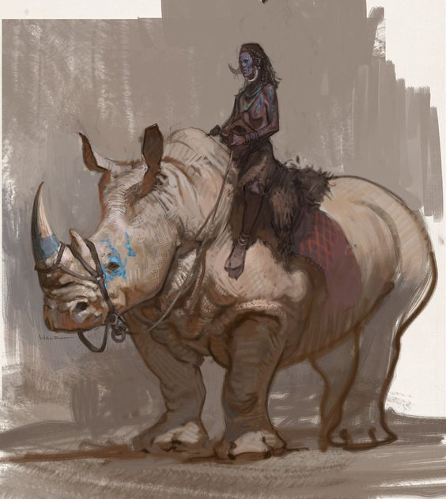

Notes On Culture

Clothing
The various peoples of the Kaduru continent share some commonalities in their attire. Their dress, like many other lands, depends on location and function. For the most part, Kaduru clothing is fashioned from wool in the colder months, cooler cotton or linen in the summer, and silk for the very rich. Regional differences influence the cut, color, and decoration of the clothing, as well as what is worn as jewelry. For the most part Kaduru folk use earth tones of brown, tan, black, and dark red as a base and decorate them with brilliant geometric designs in yellow, white, orange, green, blue, and purple. Much of their attire is fashioned from lengths of woven cloth that is dyed and painted. The cloth is wrapped in a variety of ways to cover the body, creating shirts, skirts, dresses, head wraps, and sashes. Each region has its own unique style of ornamental cloth, decorated with symbols and even words that are significant to the people of that kingdom or region.

Outside of towns and while working, many commoners keep to minimal clothing to free up movement. Remote villagers and hunters may wear only a loin cloth along with animal skins and feathers and a sarong of cloth. In the towns people wear more substantive clothing, albeit with the same degree of elaborate decorative patterns as those in the wild. Short- and long-sleeved tunics with loose, high-cut trousers for men, sarong dresses and head wraps for women. Over these can be robes of various cuts.

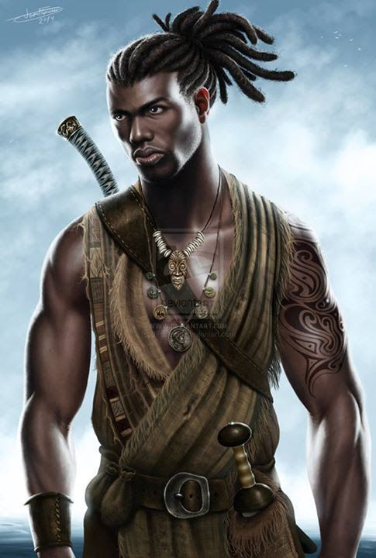
Men
Outside of town men tend to wear baggy, knee-length pants. Their upper torso may remain bare, or they wear sashes of cloth that cross in the front, or a sleeveless tunic shirt. Around this they sometimes wear a long sash of cloth wrapped around the body.

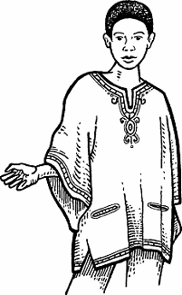
Closer to towns, men often wear a Dashiki, a unisex loose-fitting shirt, long or full-sleeved, with an embroidered V-shaped collar. This comes in many forms and colors and elaborate designs along the edges.

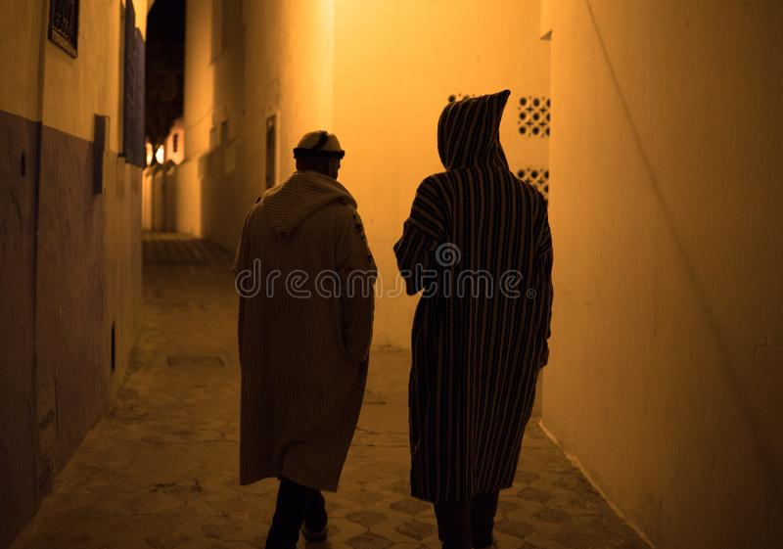
Commoners tend to wear robes to ward off the elements. The Jillaba is long, loose-fitting unisex outer robe with full sleeves and pointed hood. This is a general-purpose robe worn by everyone including travelers. It can be floor-length and made from wool for winter or shorter and made from cotton for the summer. The baggy hood, called a gob, comes to a point in the back. It is used both to keep out the sun, sand, or cold, as well as to serve as a roomy pocket for carrying food.

Kaftan - a variant of the robe or tunic, worn in a number of cultures around the world for thousands of years and is of Xiandai origin. It may be made of wool, cashmere, silk, or cotton, and may be worn with a sash. The kaftan is often worn as a coat or as an overdress, usually having long sleeves and reaching to the ankles. In regions with a warm climate, it is worn as a lightweight, loose-fitting garment. In some cultures, the kaftan has served as a symbol of royalty.

Men’s Formal Wear:
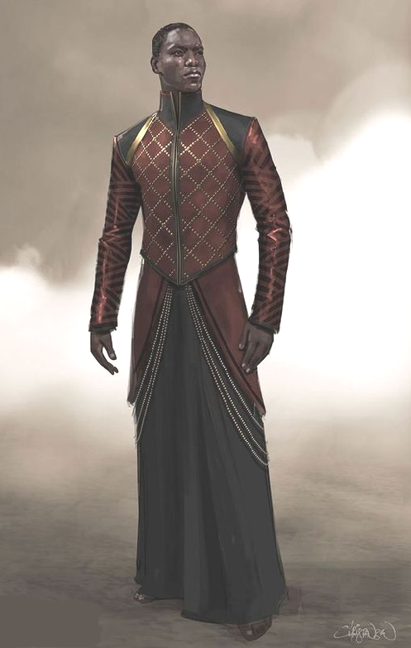
On formal occasions men may wear a Kanzu, a floor-length, long-sleeved tunic over which they can wear a flowing robe. These are close-fitted, often tailored with silver or gold threadwork.

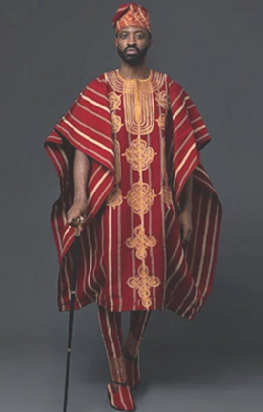
Priests or officials may wear an Agbada, a flowing wide-sleeved robe of cotton decorated with intricate embroidery. The Agbada consists of three pieces: a pair of tie-up trousers that narrow towards the ankles (known as a ṣokoto), a long-sleeved shirt, and a wide, open-stitched sleeveless gown worn over these. The three pieces are generally of the same color.

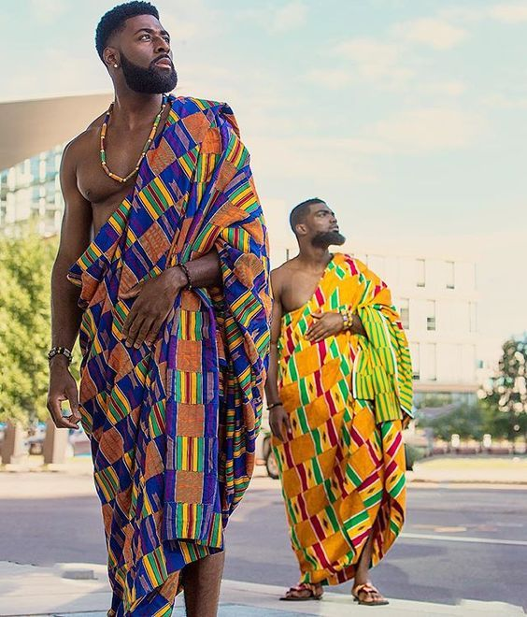
In very formal settings, nobility and the very wealthy may wear the traditional Kente. Kente is a handwoven cloth made in elaborate designs with strips of silk and cotton. Historically the fabric is worn in a toga-like fashion by royalty or those being honored by royalty on special occasions. It is a very popular textile out of Arolo and Ajabar. The material is sometimes worked into less formal dresses and robes.

Women’s Attire

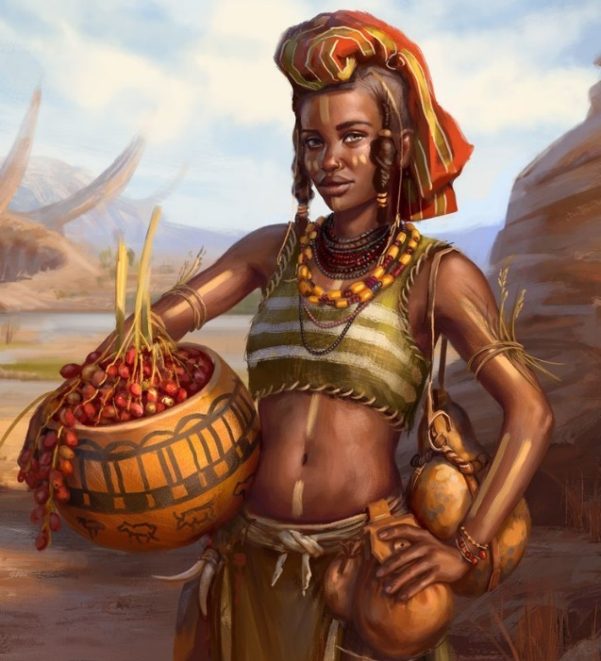
Outside of towns women wear wrap skirts or baggy, knee-length pants with a wrap-top or halter. At times they may wear a sarong (Kitenge) as a wrap or two of them, one each for the upper or lower torso. They may also carry a Shuka, a square-cut piece of colorfully dyed cloth, which they drape over their shoulder or wear as a wrap-dress.

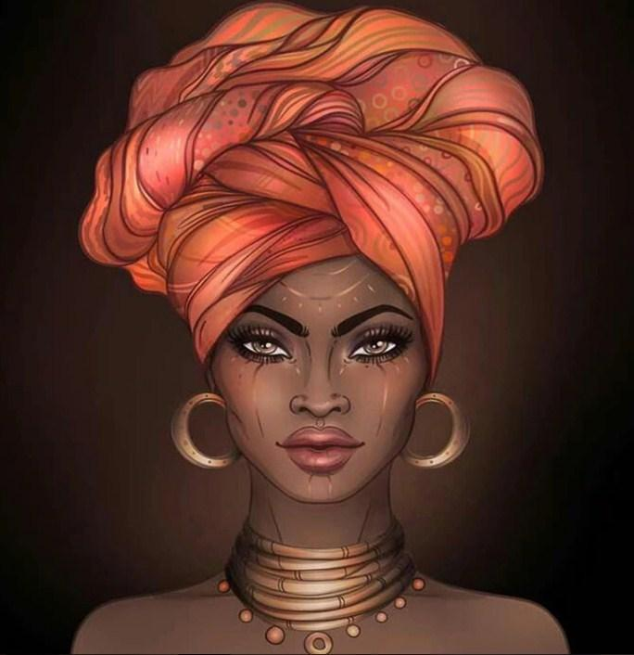
The most versatile piece of clothing worn by women is the Kitenge. It is a single two-yard length of fabric dyed in brilliant colors with elaborate designs. Similar to a sarong, they are often worn by women and wrapped around the chest or waist, over the head as a headscarf, or as a baby sling. They can also be used as decorations on dinner tables or hung on walls.
The headwraps are made from mud cloth, the name given to handwoven cotton fabric that is hand-dyed and painted. The color, design, and how the headwrap is tied are all closely related to the woman’s position. Multiple Kitenge can be worn, covering head, upper torso, lower torso, and one slung over the shoulder.

In the towns and cities of Kaduru the residents often wear more elaborate clothing. Below are some examples.

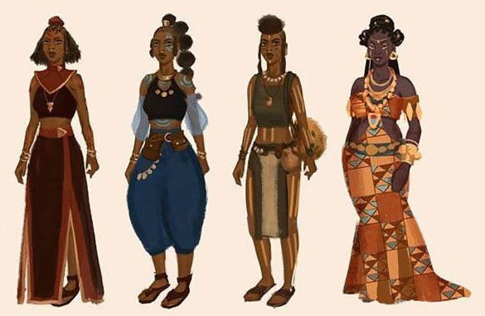
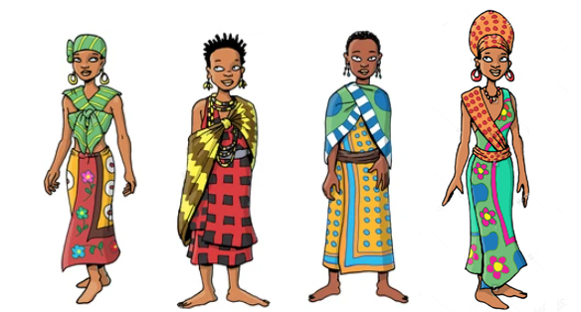

Women’s dresses are incredibly varied across the continent. Some women wear a halter or sarong top with a long, flowing skirt. Some may wear a wrap or sarong dress. Some may wear crossing sashes across the chest or use a length of cloth as a head wrap. Over these another length of cloth is worn as a wrap. Each region has its own traditional production of the cloth, usually made of cotton, and its own unique style of pigmentation and decoration. The patterns woven or painted into the lengths of cloth may contain meaningful symbols, patterns, or even words.

Examples of various handwoven cloths throughout Africa

Kente – Ghana: handwoven cloth made in elaborate designs with strips of silk and cotton. Historically the fabric is worn in a toga-like fashion by royalty or those being honored by royalty on special occasions. Below are colors that carry symbolic meaning in a Kente:
  - black: maturation, intensified spiritual energy, spirits of ancestors, passing rites, mourning, and funerals
  - blue: peacefulness, harmony, and love
  - green: vegetation, planting, harvesting, growth, spiritual renewal
  - gold: royalty, wealth, high status, glory, spiritual purity
  - grey: healing and cleansing rituals; associated with ash
  - maroon: the color of mother earth; associated with healing
  - pink: assoc. with the female essence of life; a mild, gentle aspect of red
  - purple: assoc. with feminine aspects of life; usually worn by women
  - red: political and spiritual moods; bloodshed; sacrificial rites and death.
  - silver: serenity, purity, joy; associated with the moon
  - white: purification, sanctification rites and festive occasions
  - yellow: preciousness, royalty, wealth, fertility, beauty
- Bogolan aka Mud Cloth – Mali: cotton fabric traditionally dyed with fermented mud
- Kitenge - Great Lakes Region: thicker cloth with edging on only a long side, used for formal dresses, sometimes includes a proverb in the decoration
- Kanga – Great Lakes Region: printed cotton fabric with a border along all four sides, can be used as a skirt, head-wrap, apron, pot-holder, towel, and much more. Due to its ritual function, they do not always include a proverb
- Shweshwe – South Africa: printed dyed cotton fabric widely used for traditional clothing. Originally dyed indigo, the fabric is manufactured in a variety of colors and printing designs characterized by intricate geometric patterns.
- Shuka – Maasai of Tanzania, Kenya: striped and checkered cloth, usually colored red and black or blue and black; durable, strong, and thick, used to wrap around the body for protection against the harsh weather and terrain of the savannah
- Toghu – Bamileke people of NW Cameroon: black velvety fabric embroidered with colorful patterns

Women’s formal dress
A Zuria is a dress worn that goes to the ankles, sometimes with a gauze hood around the head and shoulders. It typically comes in gray, beige or white and features multi-colored accents sewn along the waistband, cuffs, or hems. It is usually worn at formal events, holidays and invitations.

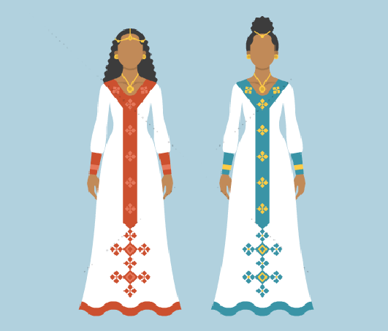

Kanga - great lakes region
The kanga is a colorful fabric similar to kitenge, but lighter, worn by women and occasionally by men throughout the African Great Lakes region. It is a piece of printed cotton fabric, about 1.5 m by 1 m, often with a border along all four sides (called pindo in Swahili), and a central part (mji) which differs in design from the borders. They are sold in pairs, which can then be cut and hemmed to be used as a set. Whereas kitenge is a more formal fabric used for nice clothing, the kanga is much more than a clothing piece, it can be used as a skirt, head-wrap, apron, pot-holder, towel, and much more. Due to its ritual function, they do not always include a proverb.

Kitenge - great lakes region
Kitenges are similar to kangas and kikoi, but are of a thicker cloth and have an edging on only a long side.

Kangas are also similar to Kishutu and Kikoy which are traditionally worn by men.

gomesi dresses

Hairstyles
Kaduru hairstyles are as varied as the clothing. Men and women both choose from shaved heads, intricate braids, woven locks, and woven rows plaited close to the head.

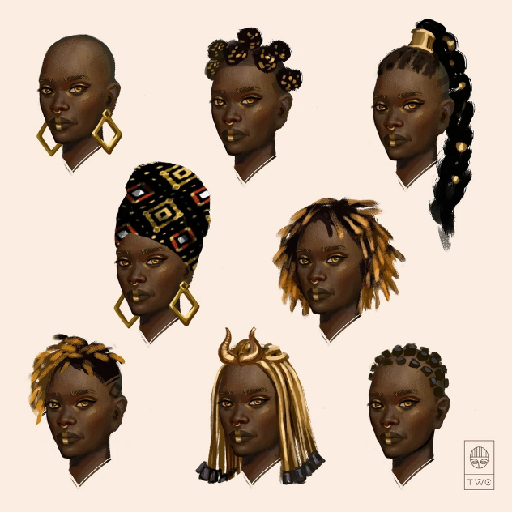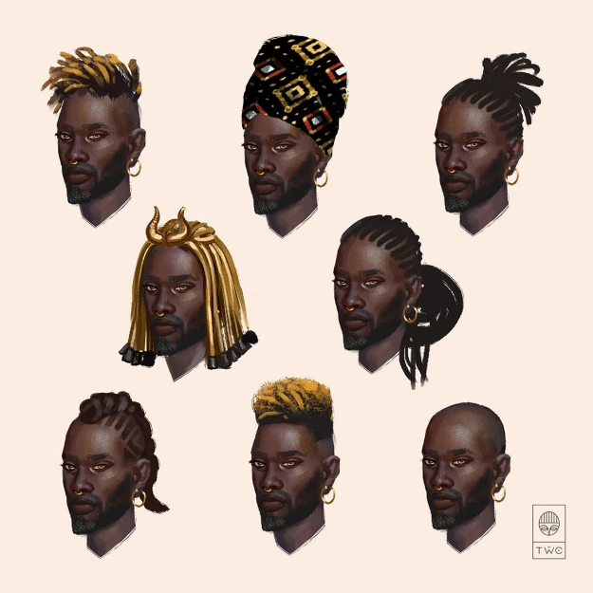

(note: I skipped the Habesha Kemis style dress because, according to some, the word habesha means “mixed” in Arabic and is sometimes equivalent to calling someone a slave)

Mud cloth, also known as “Bogolanfini,” is a common cloth used throughout the Kaduru continent. It is worn by hunters as ritual protection and as a badge of status. Immediately after childbirth, women are wrapped in the cloth, as it is believed to have the power to absorb pain and deflect anything negative or dangerous. The cloth is first dyed using tea leaves and branches, then dried in the sun. The vibrant and beautiful designs are painted on with fermented mud or sludge, after which the cloth is washed. Mud cloth patterns are rich in cultural significance as well, referring to historical battles, mythological concepts or Malian proverbs. The process is passed down generationally, and oftentimes, pattern meanings are known only to small communities of people.

African Weapons
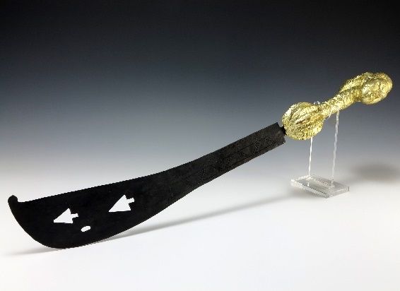
Akrafena – curved sword, much like a scimitar

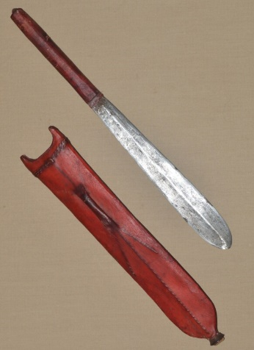
Seme – short sword

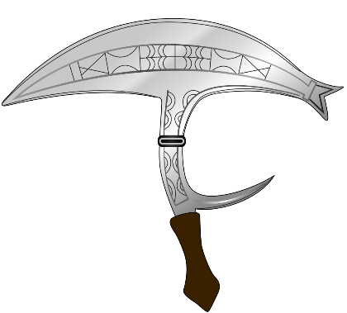

Onzil – punching dagger, throwing knife

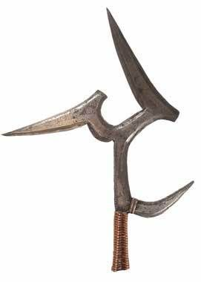
Mambele - an iron blade with a curved back section and rearward spike. It can be used in close combat as a hatchet or dagger, or more typically as a throwing weapon. It usually consists of four blades, three on top and one on the side. The curved hook was used to keep the weapon in the victim, and if pulled out, caused further damage. It would have been about 22 inches in length. These African iron weapons are thrown with a rotatory motion, and can inflict deep wounds with their projecting blades.

Knobkierie – war club with a large knob at one end and can be used for throwing; similar to a rungu

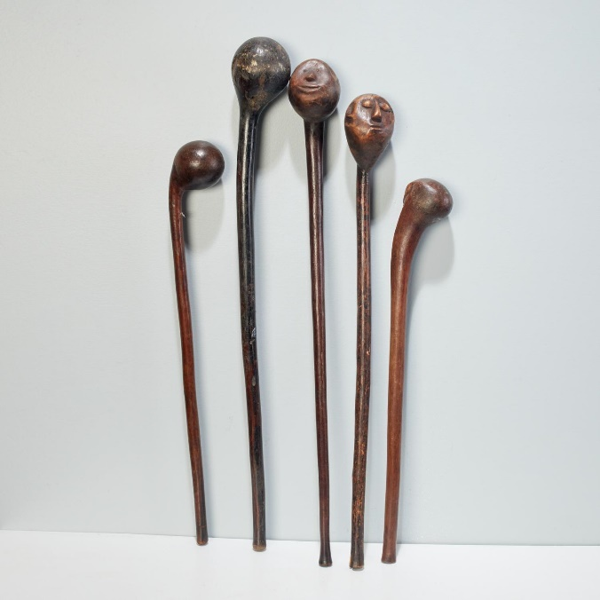

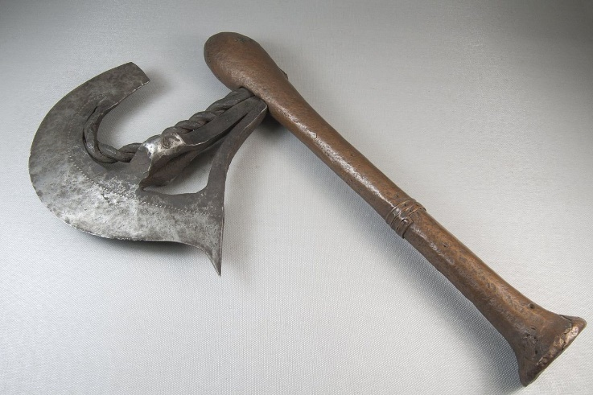
Nzappa – battle axe

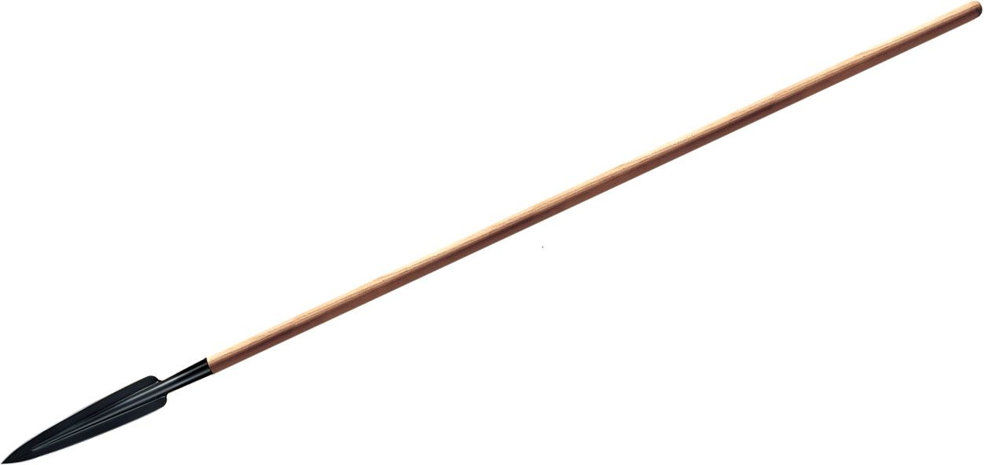
Assegai – light spear, javelin – wooden shaft, iron head

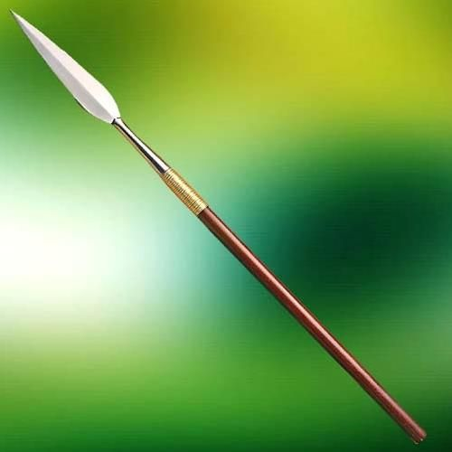
Iklwa - shorter stabbing spear with a two-foot (0.61 m) shaft and a larger, broader blade one foot (0.3 m) long. This weapon is otherwise known as the iklwa or ixwa, after the sound that was heard as it was withdrawn from the victim's wound

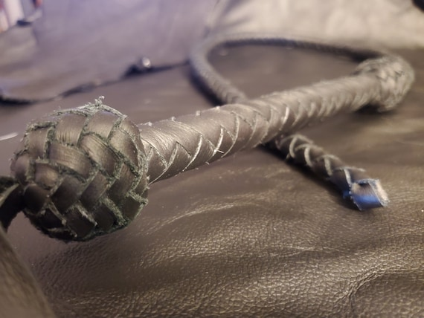
Sjambok – whip made from hippopotamus hide, about five feet in length

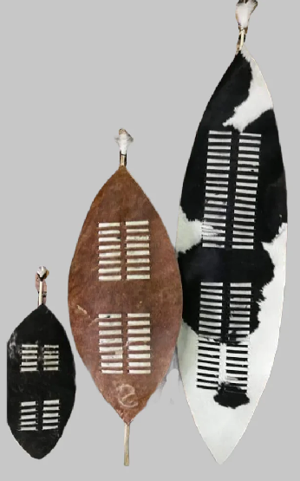
Shields

Isihlangu – large oval-shaped war shield, 5 feet (1.5 m) in length; warriors use it in an offensive way by hooking the opponent's shield during hand-to-hand fighting; similar to a tower shield

Umbumbuluzo – heavy oval-shaped war shield, 3.5 feet (1.1 m) in length, easily held in one hand; similar to a heavy wooden shield

Ihubelo - small oval-shaped shield used for hunting, smaller than isihlangu, but larger than the ihawu; similar to a light wooden shield

Ihawu - a small to medium-sized shield used at dances; similar to a buckler

African Musical Instruments
- Kora – one of the most famous stringed instruments; also known as the “Jali.” The design of the instrument is similar to that of a guitar. It features 21 strings placed on a gourd covered with the skin/hide of an animal.
- Kalimba – aka the thumb piano, consists of strips of varied lengths placed on a resonator. A sound is produced by plucking the ends of the flexible strips. Originally made from bamboo strips but moderns strips are metal. The resonator is made from wood.
- Talking Drum – probably the most known drum in Africa. It is an hour-glass-shaped drum usually placed under the arm. To vary the pitch or sound, the player presses or squeezes the narrow edge.
- The Balafon – resembles a xylophone or African marimba. It is a percussion instrument made from wooden planks that are loosely bound by a string and placed over large gourdes. Sound is produced by hitting it with miniature clubs/mallets.
- Shekere – one of the most famous shakers in Africa. The instrument consists of closely woven beads that form a net placed around a gourd. Sound is produced by either shaking it or slamming it against the hands.
- Djembe / Jembe – a type of drum consisting of animal skin or hide stretched over a curved piece of wood. A hole is curved out in the upper region of the wood where the skin is stretched out. The top surface is usually wider than the bottom surface.
- Udu – a type of drum that resembles the vessels or jars used to draw water from the river. Unlike most percussion instruments, it is made from clay instead of wood. The sound or pitch is influenced by the hollow, size, and style of playing.
- Marimba – a type of African Xylophone made by placing small wooden planks on a wooden box (resonator). The different-sized planks are secured loosely using a piece of chord/string. Sound is produced by hammering the planks using sticks or mallets.
- Mbira – a thumb piano that resembles the Kalimba; made up of two rows of metal strips that come in staggered dimensions. They are placed on a wooden resonator (sound box) and plucked by finger.
- Algaita – a popular wind instrument closely related to the oboe. Unlike the oboe, it comes with a wider opening at the base as well as open finger holes. It is made from reeds.

Tribal Masks found in Kaduru and the Sanctum of Masks https://en.wikipedia.org/wiki/Traditional_African_masks

Tribal masks are an ancient tradition unique to Kaduru, involving the crafting and wearing of masks on the face or on top of the head. Masks usually have a spiritual and religious meaning and are used in ritual dances and social and religious events. A special status is attributed to the artists that create masks to those that wear them in ceremonies to evoke some principle or message. Masks are worn for sacred ceremonies, in battle, or to memorialize ancestors or famous rulers. Many masks are enchanted with divine powers cast by priests or shaman.
The person who wears a ritual mask loses his or her human life and turns into the spirit represented by the mask itself. This transformation of the mask wearer into a spirit usually relies on other practices, such as specific types of music and dance, or ritual costumes that contribute to the shedding of the mask-wearer's human identity. The mask wearer thus becomes a sort of medium that allows for a dialogue between the community and the spirits (usually those of the dead or nature-related spirits). Masked dances are a part of most traditional African ceremonies related to weddings, funerals, initiation rites, and so on.
Animal masks represent the spirit of animals, so that the mask-wearer becomes a medium to speak to animals themselves (e.g. to ask wild beasts to stay away from the village); in many cases, nevertheless, an animal is also a symbol of specific virtues.
A common variation on the animal-mask theme is the composition of several distinct animal traits in a single mask, sometimes along with human traits. Merging distinct animal traits together is sometimes a means to represent unusual, exceptional virtue or high status.
The dead is also a common subject for masks, honoring dead ancestors. These are crafted around a skull motif with markings that relate to the ancestor. They are often worn on the hip of the one memorializing the ancestor.
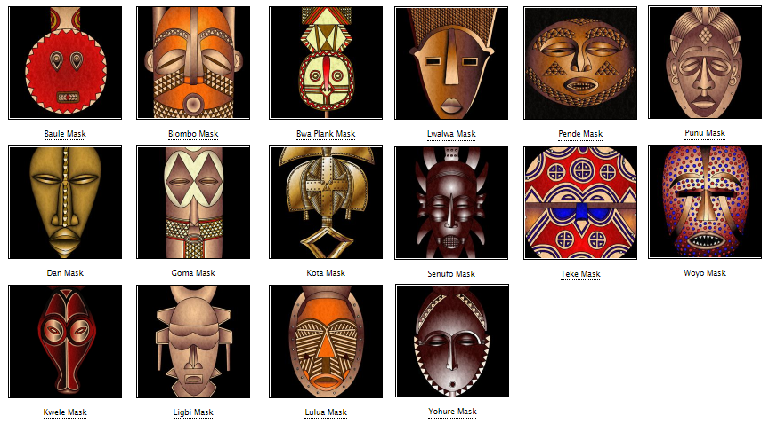
- Baule mask which is also known as a Goli mask. It is used in tribal dances during harvest festivals, in processions to honour distinguished visitors and at the funerals of important figures.
The circular face represents the life-giving force of the sun and the horns symbolize the great power of the buffalo.
- Bwa - These masks are plank shaped with a circular face at one end and a crescent moon at the other. Their wearer looks through a hole in the mouth. The eyes are based on an owl and the hooked nose comes from the hornbill. Both these birds are thought to possess magical powers. Used to celebrate children’s initiation into adulthood, represent information about the myths and morality that the child must learn before they can be accepted into adult society
- Nwantantay masks represent the flying spirits of the forest; since these spirits are deemed to be invisible, the corresponding masks are shaped after abstract, purely geometrical forms
- Bwa and Buna - hawk masks, with the shape of the beak identifying a mask as either Bwa or Buna. In both cases, the hawk's wings are decorated with geometric patterns that have moral meanings; saw-shaped lines represent the hard path followed by ancestors, while checkered patterns represent the interaction of opposites (male-female, night-day, and so on)
- Senufo - have their eyes half closed, symbolizing a peaceful attitude, self-control, and patience
- (name) - small eyes and mouth represent humility
- (name) - wide, protruding forehead represents wisdom
- Gabon - large chins and mouths represent authority and strength
- Grebo - masks with round eyes to represent alertness and anger, with the straight nose representing an unwillingness to retreat
- Poro secret societies - masks that celebrate the exceptional power of the society by merging three different "danger" symbols: antelope horns, crocodile teeth, and warthog fangs
- Baoule - buffalo (usually representing strength, as in the Baoulé culture)
- (name) - crocodile
- (name) - hawk
- (name) - hyena
- (name) - warthog
- Dogon – antelope, representatives of agriculture; masks are highly abstract, with a general rectangular shape and many horns as a representation of abundant harvest.
- Chiwara - antelope masks have long horns representing the thriving growth of millet, legs (representing roots), long ears (representing the songs sung by the working women at harvest time), and a saw-shaped line that represents the path followed by the sun between solstices
- Makuria - depicts dancing masks decorated with cowrie shells imitating some animal with long snouts and big ears
- Punu - mask celebrating ideal of feminine beauty long curved eyelashes, almond-shaped eyes, thin chin, and traditional ornaments on their cheeks, as all these are considered good-looking traits
- Baga – mask celebrating women of strength, features ornamental scars and breasts
- Awa – used by cults of the dead
- Bini – used by cults of the communication with the spirits
- Lebe – used by cults of nature

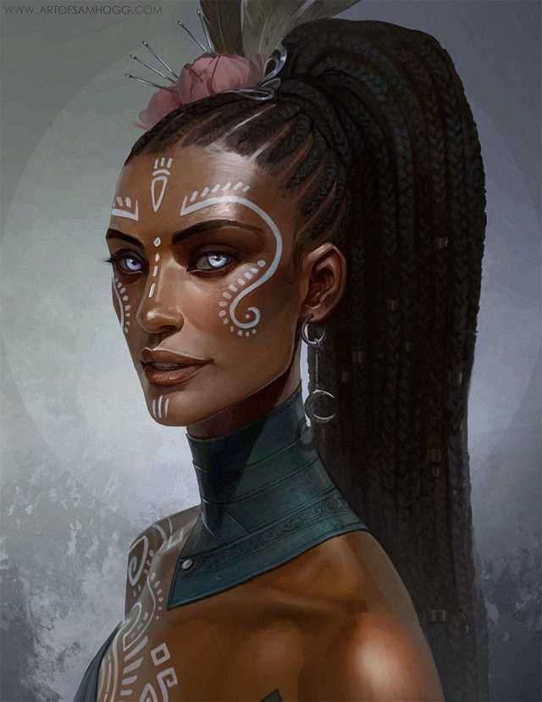
Local Deities
- Ogun – hunting god of lethal metalwork, specializes in weapons, honors warriors who honor their weapons, he inhabits metal and bestows his strength upon it, deals with justice and oaths (people will invoke his name in an oath but must be touching a piece of metal while doing so), if you treat Ogun with respect he’ll be trustworthy and protective; brother to Shango and the two do not get along well. Patron deity of Bokarra.
- Elegua – messenger of Olorun, trickster god, guardian of the Crossroads of Life, offers mortals the chance between opportunity and disaster in the form of propositions or wagers. Patron deity of Longspear.
- Aje, patroness of trade and wealth. Patron deity of Nyogo.
- Obaluaye – god of healing; One of the ORISHAS, he will do his best against infections and epidemics, especially the nasty infestations created by his spirit cousin Shakpana. He also has two dogs to sniff out infection. His favorite colors are brown, black and purple — the hues of bruising. Patron deity of Sikaar.
- Oya – river goddess, influences commerce, weather, transporting the dead to the afterlife, dresses in a brilliant display of colors; consort to Shango which is often a rocky romance. Patron deity of Tengaibo.
- Obatala – son of Olorun, greatest of the Orishas, white cloth god and drunken creator of the human race, forced to create mankind as a punishment and did so while drunk so mankind is imperfect. Patron deity of Ajabar.
- Ngi, the gorilla god of strength. Patron deity of Wakabi.
- Olorun – chief deity; He’s the great king of the Universe and the glorious pinnacle of Yoruba mythology. He is a three-in-one trinity god — comprising OLORUN the Lord of Heaven, OLODUMARE, the Ultimate Creator and OLOFI the Messenger. Patron deity of Harikanya.
- Anansi, spider god of stories and trickery. Patron deity of Oarana.
- Orunmila - Demi-God of Divinity and Wisdom; One of the ORISHAS, he’s a very useful spirit of knowledge. He has his own priests known as Babalawo. They are equipped with divining chains, but how these work is something you will have to ask them. Patron deity of Arolo.
- Shango – spirit of thunder, storms, drums, and dance, Oya is his mistress and the fight often, does not get along well with his brother Ogun. Patron deity of Ramala.
- Yemaya – wife to Obatala, moon goddess, mother of water and childbirth, blue and crystal skirts billow in wave-like motions, has an aversion to salt. Patron deity of Jaloro.
- Nyaminyami, protector of rivers and waterways. Patron deity of Scaringa.
- Eleduwa (Oduduwa) – hero god, younger brother of Obatala, created the world when Obatala was too drunk, appointed by his dad Olorun to rule over the world. Patron deity of Redwall.
- Takhar, god of justice and vengeance. Patron deity of Kemba.
- Shakpana – god of sickness, son of Yemaya; An old hobbling figure, he is responsible for inflicting pox and madness. Patron deity of Keromang.
- Ochosi - One of the Orishas, he’s a hunter spirit who is great at scouting for prey and sniffing out likely targets. As a barefoot detective of enormous cunning, OCHOSI is also good at uncovering that most elusive of animals — truth. Where required he can also dish out justice with his bow and arrow. Patron deity of Masuba.
- Orishas – multi-talented spirits under Olorun, several hundred of them, have various powers and motives.

Creatures of Oraba
Adze - The adze is a vampiric creature in this region. The adze takes the form of a firefly, though it will transform into human shape upon capture. When in human form, the adze has the power to possess humans. People possessed by the adze are called abasom by the locals and begin to carry out whatever evil schems the adze commands. In firefly form, the adze can pass through closed doors at night and suck blood from people as they sleep, causing the victim to fall sick and die.

Asanbosa – ogres with large blood-shot eyes, long legs, and feet pointing both ways. Its favorite trick is to sit on the high branches of a tree and dangle its legs so as to entangle the unwary hunter. It preys on humans and feasts on them with their iron teeth.

Buadu – It is said that long ago an evil sorcerer summoned dark spirits in the land. The spirits roam free and seek to possess the unwary who scoff at the gods. The budo is translated as the “evil eye” and anyone possessed by such a spirit takes on the evil eye. Some say this reveals itself as the power to strike people with sickness or worse with their malevolent gaze. When confronted, the Budo can transform into a hyena and flee. Priests of Kaduru are familiar with the rites for creating talismans, called a kitab, that protect against the Budo.
Eloko – Eloko are diminutive creatures dwelling in the darkest parts of the jungles. They are the size of a dwarf, have no hair, and are covered in moss that grows on their bodies. They hide in the jungle, fiercely protective of the fruits and wild game that live there as if they were their treasure. They have piercing eyes, snouts with mouths that can be opened wide enough to admit a human body, alive or dead, and long, sharp claws. Eloko savor human flesh. They wear tiny bells that are create a beautiful sound, and their voices can change to be soothing. Unwary travelers in the jungles who hear the bells or their voices may fall under their charms and be eaten.

Kongamato – are large pterosaur-like cryptid living in the Valley of Hunters region of Kaduru. Its name means 'breaker of boats' or 'overturner of boats', as the kongamatos are said to have capsized the canoes of natives and attacked people who ventured too close to the nearby rivers. It is described as a reddish lizard with membranous wings and teeth in its beak. Its wingspan ranges from 4 to 100 feet across. It is thought to eat mostly fish, but occasionally humans. Kongamato is also said to dig graves and steal human corpses.

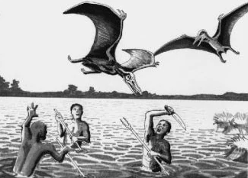

The Impundulu or Lightning Bird – a black and white bird which is said to summon thunder and lightning with its wings and talons. It is a small creature but can change its shape and size up to the size of a human. It is a vampiric creature associated with witchcraft, often the servant or familiar of a witch or witch doctor, which attacks the witch's enemies. It is said to have an insatiable appetite for blood. Sometimes it takes the form of a beautiful young man who seduces women.
The fat of the bird is believed to be of significance either as the fuel that the bird sets on fire when it throws down a lightning strike or as a component in valuable traditional medicine. The fat is believed to be procured by catching the bird at the moment when the lightning strikes the ground. The bird is believed to lay a large egg underground at the location of the lightning strike. This may be a good or bad omen that may require digging to procure or dispose of the eggs.
It is said that the lightning bird is immortal, because it outlives its masters. Legend recounts that the bird is passed down in a witch's family from mother to daughter, doing the bidding of its owner, and the impundulu has only one known weakness. The lightning bird is impervious to bladed weapons, most magic, and you cannot poison it or drown it. But it is said that the creature can be destroyed by fire.

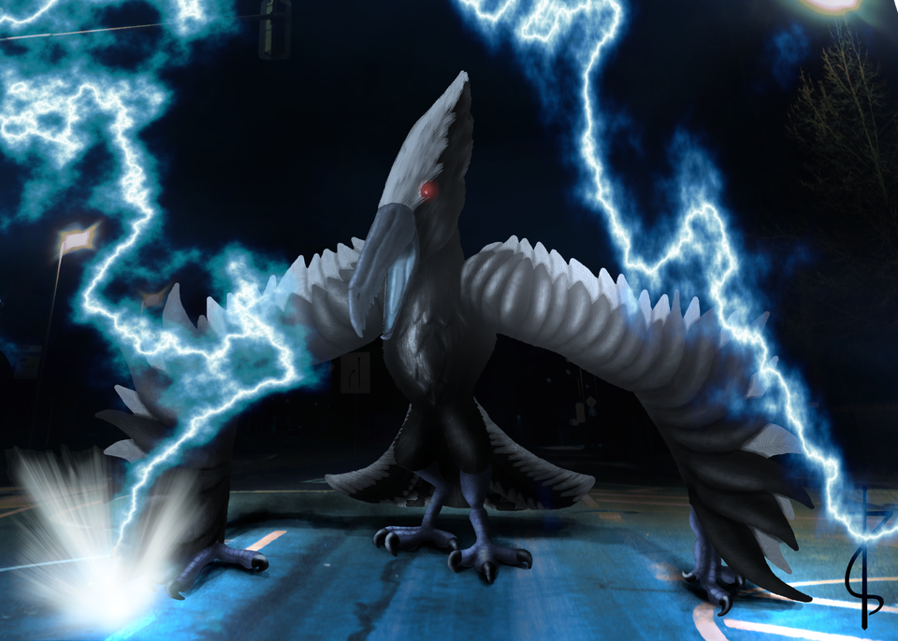

Grootslang - Great serpent-like creatures the size of an elephant. They were created by the gods in ancient times, but they proved to be too powerful and were split into snakes and elephants. One grootslang managed to escape and led to the creation of all modern grootslangs. They harbor great animosity towards the gods that attempted to destroy them. Grootslang dwell in deep subterranean places near or under the mountains. They have a love of gemstones, especially diamond, and can be bribed to let people to pass if given such stones.
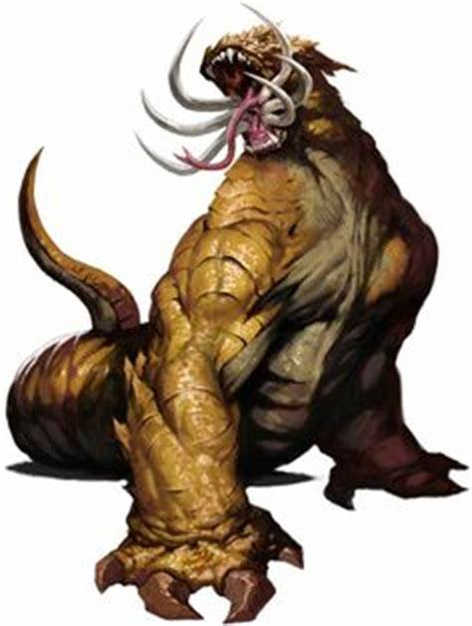

Umdhlebi – Also called the Dead Man’s Tree, it is a large poisonous shrub that grows throughout the Kaduru wilderness. The sap is harmful and gives off an irritating vapor. Contact with the eye can cause temporary or even permanent blindness. Contact with the mouth results in a rash, swelling, and peeling of the skin. Prolonged exposure or worsening of the injuries can even lead to death. The sap is sometimes used in the medicine of shamans but more commonly used in traps. Used by witches, it is usually considered wholly vile, any association with umdlebe is proof the person in question is an umthakathi: one who secretly uses evil medicine or charms.

Rompo is a mythological beast with the head of a hare, human ears, a skeleton-like body, the front arms of a badger, and the rear legs of a bear. It feeds only on human corpses and it is said to croon softly as it eats.
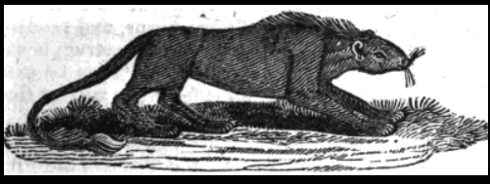

Mokele-mbembe – is a creature of brownish-gray color with a smooth skin, its size is approximately that of an elephant; at least that of a hippopotamus. It is said to have a long and very flexible neck and only one tooth but a very long one; some say it is a horn. They have a long, muscular tail like that of an alligator. Canoes coming near it are said to be doomed; the animal is said to attack the vessels at once and to kill the crews but without eating the bodies. The creature is said to live in the caves that have been washed out by the river in the clay of its shores at sharp bends. It is said to climb the shores even at daytime in search of food; its diet is said to be entirely vegetable
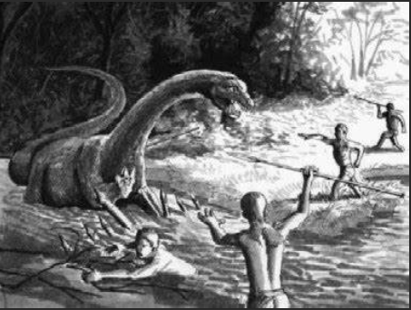

Maniwata – These are spirits of the water. They appear similar to mermaids: the upper body of a woman with the lower body of a fish, but sometimes of a serpent. Most times they appear with a serpent coiled about their necks. These are their animal companions and do their bidding. Unlike mermaids, the maniwata can transform to human form at will and are able to shape-shift to appear in any human form they desire. The spirits are capable of kindness but are wild and unpredictable. It is said they will occasionally abduct a human they find interesting and take them beneath the sea to show them their home. The humans almost always return later, gifted with great wisdom and good fortune from the experience.

Other Races
Elves

Dwarves

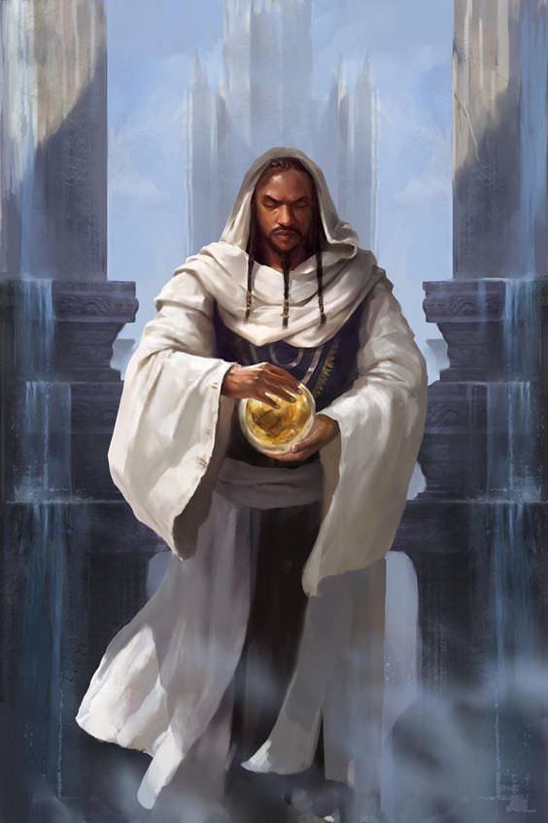
Magical Items

NPC Templates
This is a list of notes and stats to help develop NPC’s relevant to this region.

Developer Notes
The five regions of Kaduru should ideally reflect five different regions and cultures of Africa.
Possible ways to define the Kaduru kingdoms based on African regions:
- 6 Cultural regions: North Africa, West Africa, Central Africa, North East Africa, East Africa, Southern Africa.
  - 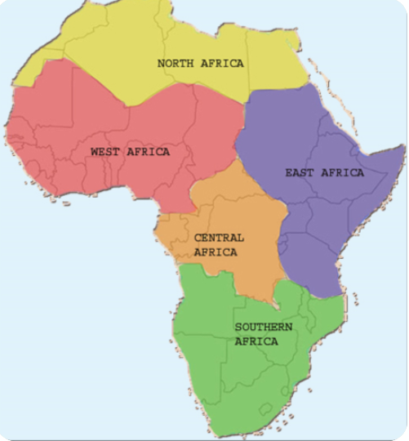
- 8 major physical regions (based on geography, separate from the human geography): the Sahara, the Sahel, the Ethiopian Highlands, the savanna, the Swahili Coast, the rain forest, the African Great Lakes, and Southern Africa
- 4 main language families, or phyla, of the continent are now considered to be Niger-Congo, Nilo-Saharan, Afro-Asiatic, and Khoisan.
- Ancient kingdoms that were present in Africa:
  - E.g. the ancient kingdom of Saba which is thought to have been located in present-day Yemen, Eritrea, Somalia and Ethiopia. One prominent feature of the Saba kingdom was the Queen of Sheba, mentioned in many religious texts. We can morph this figure into an original powerful female figure, whether current or in the past. Bilquis is the term used in Islamic texts and inspired the character in American Gods. Perhaps modify this to an original concept, perhaps with divine powers or just a powerful sorceress or powerful ruler.
  - Azania – ancient Greek name for lands around southeastern tropical Africa including the Swahili coast
  - Bantu region – region in west-central Africa where the Bantu family of languages is thought to have originated and expanded into sub-equatorial Africa due to the commonalities between the languages spoken there
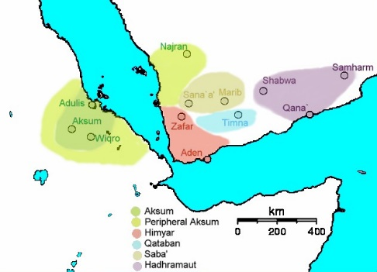
https://en.wikipedia.org/wiki/List_of_ethnic_groups_of_Africa
https://qz.com/africa/1210704/black-panthers-african-cultures-and-influences/
https://kidadl.com/articles/all-of-the-african-god-names-and-their-mythologies

Ultimate correlation between Kaduru and African regions:
- Kondabo – loosely based on the northeastern Africa region, with middle-eastern influences; the people originating out of the Lake Akdabat region and migrating westward, then becoming influenced by Tarbia; source reference Hausa, Amhara, Oromo, Somali, Nilotes peoples
- Oraba – loosely based on the Congo River Basin region of Africa; source reference Kongo, Mongo, Luba, Tutsi, Kikuyu, Ethiopian, Maasai peoples
- Rokari – loosely based on the Yoruba region of southern west Africa; source reference Yoruba, Ewe, Dahomey, Igbo, Akans, Mandinka, Fulani, Cameroon people
- Mthunzi – loosely based on the Swahili Coast region of Africa, which has the savanna and great rifts in common with this region; source reference Zulu, Ndebele, Basotho, Shona, Chewa people
- Desert Regions; source reference Tuareg, Berber people
- Lost Lands - ???

Kondabo Names
Oromo https://www.fantasynamegenerators.com/oromo-names.php
Hausa https://www.fantasynamegenerators.com/hausa-names.php

Oraba Names
Kikuyu https://www.fantasynamegenerators.com/kikuyu-names.php
Ethiopian http://www.fantasynamegenerators.com/ethiopian-names.php
Tshiluba https://www.fantasynamegenerators.com/tshiluba-names.php

Rokari Names
Akan https://www.fantasynamegenerators.com/akan-names.php
Igbo http://www.fantasynamegenerators.com/igbo-names.php
Mandinka https://www.fantasynamegenerators.com/mandinka-names.php
Cameroonian http://www.fantasynamegenerators.com/cameroonian-names.php

Mthunzi Names
Zulu https://www.fantasynamegenerators.com/zulu-names.php
Ndebele https://www.fantasynamegenerators.com/ndebele-names.php
Basotho http://www.fantasynamegenerators.com/basotho-names.php
Shona https://www.fantasynamegenerators.com/shona-names.php

One hundred rare and mysterious masks with extraordinary powers
http://dndspeak.com/2018/08/100-masks/
- Barn Owl Mask: grants advantage on perception checks that rely on hearing and sight.
- Oni Mask: grants advantage on intimidation checks.
- Cracked-clay Jester Mask: holds 5 charges of friends and one charge of charm person. Once all charges have been used the mask crumbles to dust.
- Luchador Masks: take advantage on grapple and acrobatics checks.
- Mask of Many Faces: This mask gives you advantage on deception checks to pretend to be someone else.
- Mask of Othersight: This mask begins blank, but can be re-sculpted to resemble the face of another person. The name can also be carved in. While worn, the wearer cannot see in front/around themselves, but does see essentially through the eyes of the person represented by the mask. Depending on how powerful the person represented by the mask is while the mask is worn, that person may or may not be aware of the fact.
- Spider Mask: While wearing the mask you ignore movement restrictions caused by webbing, Once per long rest you can use the mask to cast the spider climb spell as an action.
- Wolf Mask: Grants advantage on Wisdom (Perception) checks that rely on hearing or smell.
- Winter Wolf Mask: Grants advantage on Wisdom (Perception) checks that rely on hearing or smell, as well as advantage on Dexterity (Stealth) checks made to hide in snowy terrain.
- Mask of Silence: Anyone who sees the wearer of this mask will forget seeing them as soon as they look away.
- Mask of Mediocrity: penalty to remembering the wearer. Could also take effect when trying to follow them in a crowd.
- Deathmask of the Whiteface: +2 rounds of Raging if barbarian otherwise taking damage can (wearer’s choice, free action) trigger the spell Uncontrollable Rage for 2 rounds, forcing the wearer to attack the source of the damage.
- Mask of the (pick an animal): At the beginning of their turn the user can shapeshift (as the wildshape druid ability) into the matching animal lasting until the end of their next turn.
- Mask of the Dragon: wearer has a breath weapon that can be used once per short rest corresponding to the color of the mask, 30ft. Line 4d6 damage. Curse: the wearer cannot the remove the mask without making a DC 18 Wisdom save made only once per day. While wearing the mask they gain the flaw: ‘I sometimes forget that I’m not the beast this mask resembles.’
- Mask of Mechanus: An uncomfortable piece made mostly of metal and clockwork. While wearing this mask a creature rerolls every 1 and 20. They must take the second roll.
- Mask of Juiblex: Not so much a solid piece as an ooze that is rubbed over the face and head and remains there. While wearing this mask, a creature can move through a space as narrow as one inch wide without squeeze. A creature wearing this mask must eat a full meal every hour or suffer 2d12 acid damage as it begins to consume itself. Curse: A creature must succeed on a DC 15 Charisma saving throw to remove this mask. A creature can only attempt this saving throw once it has finished eating.
- Mask of Mystery: A creature wearing this mask is proficient in Charisma (Deception) checks. If the creature already proficient, it doubles its proficiency. In addition, a creature can cast Alter Self once a day.
- The Iron Mask: requires attunement by a monk. While attuned to and wearing this mask, a creature rolls an additional die for each unarmed strike.
- Mask of the Fey: This beautiful mask was created in the feywild by a fey creature of great power. A creature attuned to and wearing this mask is always under the effects of the spell Glibness. A creature wearing this mask during a long rest has a ten percent chance of being plane shifted into the court of the mask’s creator. Curse: This mask can only be removed by its creator.
- Mask of the Monarch: Advantage on persuasion checks for buying/selling items.
- Aku Aku Mask: This wooden tribal mask has feathers across the forehead and glowing yellow eyes. A sentient and good hearted shaman spirit lives within. the wearer has a +1 bonus to AC and may cast Arcane Lock once per day. The wearer gains Nature proficiency, but disadvantage on Intimidation. The wearer LOVES FRUITS. If a wearer of the Uka Uka mask is met, they shall each compare their wares. Whoever has a greater total gold value of GEMS gains 3 health and 5 speed PERMANENTLY.
- Uka Uka Mask: This wooden tribal mask has sharp teeth, glowing yellow eyes and a beard of leaves. A sentient and evil shaman spirit lives within this mask. this mask is CURSED and cannot be removed without harming the face. It grants a +1 bonus to AC. The wearer may cast Knock once per day. You gain poison and necrotic resistance, but Silvered vulnerability. You gain Intimidation advantage, but disadvantage with all other CHA checks. If a wearer of the Aku Aku mask is met, they shall each compare their wares. Whoever has a greater total gold value of GEMS gains 3 health and 5 speed PERMANENTLY. OPTIONAL: The wearer may spend 1 day crafting 1 stick of dynamite which requires a Dex, Int, and Wis check.
- Mask of Angels: This porcelain mask features a beautiful womanly face with closed eyes. The porcelain has a slight golden hue and gleam to it. Healing spells the wearer casts can critically strike (double healing). The mask sheds dim light and the wearer can cast Light at will. Once per day the wearer can choose to re roll a dice theyve used to determine a healing total (from a spell they cast).
- Mask of the Fallen Angel: Looks identical to the Mask of Angels, but has a slight black hue to it. This mask is CURSED and it dims the light around it. It grants the Chill Touch cantrip and necrotic damage resistance. All standard healing damages you, and instead you may use Chill Touch to heal yourself, undead, or any evil character (1d8 + modifier of YOUR CHOICE). If you are hit with a healing spell, or radiant damage you can choose to double the damage you take. When you do so the eyes of the mask open wide and the mask lets out a horrifying Banshee Screech. All creatures that hear the screech must make a con save. If they fail they lose Half of their total health and are deafened for 1 turn, if they succeed they take 3d6 psychic damage.
- The Grand Jester’s Smirk: This porcelain mask features a laughing face and a wide open mouth, and has all manner of colours and inlays on it. Inside the open mouth is just a black void, but if it is inspected a Jack-In-The-Box pops out. The mouth is in fact a 2×2 foot bag of holding. The wearer may cast Tasha’s Hideous Laughter 2 times per day, however they may also choose to do so telepathically by succeeding a Charisma check.
- Sludgy Ooze Mask of Goop: This disgusting mask is dripping with ooze. It may be any colour. While this mask has eye sockets and a mouth, they are mostly obscured by the ooze constantly emanating from it. The wearer has resistance to physical damage. The wearer can cast Sludgeous Form once day, which is like gaseous form but they cannot fly and look like sludge. 10 feet movement speed and climbing speed in this form. this mask is not cursed but requires a strength check to remove.
- Scarecrow Mask: This mask is CURSED and cannot be removed unless it is ripped from the face. Once the wearer is cursed, they walk in a bowlegged manner and their movement speed is reduced by 5. This mask is made from burlap, and has a half sown half shredded mouth. This mask grants immunity to the frightened condition. The wearer may cast Cause Fear 3 times, and Fear once per day. All critical hits (including intimidation) cause the frightened status effect. Once per day the wearer may (as a bonus or reaction) cause a frightened target to become incapacitated and scream for another turn.
- Bandaged Mask: A mask of bandage wrappings, that has some strands loosely hanging off and others stained with dried blood. This mask is CURSED. This mask has a slight smell of flesh putrefaction. It grants 1d10 health regeneration per turn. General injuries heal within minutes, and a major injury (like a broken bone) can be healed in a matter of days. If the body is healthy, the mask compels it to begin to grow cancerous tumours in different places. The only way to stop this is to have to body become injured so that the cancer is not the focus of the regeneration. If the cancer is left to grow the wearer will eventually turn into a gibbering mouther.
- Broken Porcelain Mask: This porcelain mask features cracks across it. The bottom right of the mask, from the jawline to the cheekbone to the chin is broken off. You can just make out the expression of terror carved into the remaining features of the mask. The wearer has 120 feet of tremorsense, and can cast earth tremor at 4th level once per day.
- Scorched Dryad Mask: This wooden mask features a head crest of branches. The entirety of the mask is scorched wood and it smells like charcoal. The wearer may roll a d20 if they are hit by fire damage. If they roll 11 or higher, they are healed instead. Being on fire gives the wearer inspiration that scales up to a d12 for being on fire each turn. They may designate one of their weapons to adopt the Flametongue trait and may cast Aganazzar’s Scorcher from the weapon once per day.
- Sabretooth Skull Mask: This mask is part of the skull of a sabretoothed tiger, without the bottom jaw. The eyes sockets are large, and the top jaw features 2 massive fangs that extend downward. The fangs can be removed and used as daggers. The wearer can cast Locate Creature once per day and has advantage on the first strike against it. The Located Creature has disadvantage on perception checks against the wearer.
- Plague Doctor Raven Mask: Smells of pleasant incense (replace each week). Grants you advantage on madness conditions + ALL crits (spells, melee attacks, but also intimidation, persuasion, deception) force your targets to make a save for a short term madness condition. Roll a d100 for the result of the effect.
- Mask of Anubis: Coloured black and gold, this mask gives you advantage on death saving throws and gives your targets disadvantage on saving throws if you brought them to 0 HP. Those you slay may be interacted with as ghosts for a short time before they are sent to the afterlife (1 hour).
- Jack of Blades Mask: If you die, your soul is magically transported into the mask where it may remain until you choose to move on to the afterlife. Anyone who puts on the mask can hear and speak to your soul. Until they take off the mask, you can keep talking to them.
- Mask of Drought: This red clay mask is cracked all over, resembling soil that has been drained off all water and cracked. This mask grants fire resistance, and Con save advantage from heat exhaustion, and grants the ranger’s Natural Explorer trait for DESERTS.
- Triceratops Mask: a large bone or wood mask with lots of potential for war paint. This mask grants the triceratops gore+trampling charge attack once per long rest. Damage is 1d8+5 at level 1 and scales with level. Only the target takes damage but every unit passed through must make a strength saving throw of decreasing difficulty (simulates momentum loss) or be knocked prone. This mask ALSO grants a +1 to AC when attacked from the front (90 degree).
- Dragonturtle Mask: This mask is turtle coloured and features the dragonturtle’s menacing hooked beak. This mask grants the dragonturtle’s steam breath ability once per long rest: 2d6+2 at level 1 and scales up. It ALSO grants +1 bonus AC when attacked from behind. Hidden ability: gain inspiration if you roleplay as a TMNT.
- Cthulhu Mask: Roll for colour. Straight up immunity to madness. Once per long rest you may cause ALL intelligent creatures in a 30 foot cone to make an INT saving throw. If they fail they spend the turn incapacitated and screaming. If they succeed they each gain 2 WIS for the duration of combat. If this is abused for WIS gains, you can summon Cthulhu to annihilate the PC.
- Dwarven Runebeard Mask: This mask has a beautifully carved runic beard. You gain the effects of Belt of Dwarvenkind. You can also mine significantly faster and you have a strange affinity to pickaxes.
- Mask of the Faceless: This mask causes your face to appear completely indiscernible and have all of its features obscured by a churning shadow. Your intentions, alignment, goodness/evilness are completely obscured. Insight does not work on you and you cannot be charmed. In fact, being charmed gives YOU inspiration. Spooky.
- Leshen mask: The wearer can phase through trees. This costs half your movement. The more its abused, the more prone the wearer is to exhaustion.
- Guy Fawkes Mask: This mask grants proficiency in CHA saves. Once per day, it may be activated with a command word to grant advantage on charisma checks for 1 hour.
- Gladiator Maximus Mask: Specifically grants the Gladiator’s By Popular Demand feature from the character backgrounds (Entertainer Variant). Adorning this mask gives the wearer opportunities to gain inspiration. This effect is triggered on all combat crits and killing blows. For such an event the wearer can choose to perform it with some ‘pizazz’: choose to make a performance, athletics, or acrobatics check. If successful, gain inspiration.
- Mosquito Mask: Huge eyes, antennae, proboscis. Once per long rest, you can spend 10 minutes siphoning the blood of a fresh victim. This heals half of your total health and grants 2d10 temporary Hit Points. Try not to get aids.
- Bunny Mask: Cute or creepy, your choice. Your speed is increased by 10 feet. You can cast Jump 3 times per day without expending spell slots. Once per day you can also choose to force an opportunity attack to miss you if the hit lands.
- Berserker Mask: This mask reminds you of skyrim. It grants Rage Beyond Death. In combat, if you drop to 0 hitpoints, you can choose to go unconscious or not. You still make death saving throws. You immediately go unconscious if combat ends after using this effect, and you wake up with one level of exhaustion. 1 use per day.
- Valkyrie Mask: This mask resembles a beautiful womanly face. It has wings on either side. It allows the wearer to cast Compelled Duel once per day. Whenever entering combat, if you are not surprised you can also choose to yell a morale boosting battle cry that acts as a weaker version of the Bless spell (does not grant a persistent d4 bonus, only a 1 time use d4 inspiration to 3 characters of the wearer’s choice).
- Predator mask: This wide mask has ornamented dread-locks, and large alien eyes. The wearer may cast Invisibility once per day. However, during this cast they may choose to ‘target’ a particular creature. A red dot appears on the targetted creature. The targetted creature has disadvantage one perceiving the predator. If the targetted creature is attacked, it always hits (you only need to roll if you crit or not). If you crit, you deal max damage. This mask also grants 120 feet of darkvision.
- Mask of Seduction: This mask resembles a succubus/incubus, though the wearer can choose for it to be hidden or not. If hidden, your eyes merely change colour to red. It lets the wearer speak and understand Infernal and abyssal. Once per day the wearer may cast the Succubus’s Draining Kiss ability. This mask also grants advantage on performance and persuasion checks that deal with flirting, charming, being sexy, and sexing.
- Mask of Mimicry: This mask may resemble a feathery Raven, or any bird of paradise. The wearer is granted the Mimicry ability, that it can perform at will.
- Beholder Mask: This mask is merely a large eye. Its pupil may be reptilian or cat like or human or anything really. Roll for colour of the eye. The wearer may activate the Beholder’s Antimagic Cone ability once per day. 120 foot cone of anti-magic that lasts 2 turns. At the end of the 2nd turn the wearer shoots an eye laser out of it. Roll for which laser is shot obviously. The laser must be shot unless an INT save is made. If it is failed, the wearer takes significant psychic damage.
- Blood Mage Mask: this porcelain mask is smooth and beautiful, except for the tears of blood coming from the eye sockets. The blood and the mask itself can be any combination of colour, but would most likely be found as a white mask with red or black blood. This mask gives the user a brand new spell: Shape Blood, which may be cast 2 times per day. This spell is exactly like Shape Water but is exclusive to blood. Damage is up to the discretion of the DM but my implementation is that it deals Magical physical damage (like silvered weapons).
- Blood Knight Mask: This porcelain mask resembles a skull with its mouth sowed shut. Your melee attacks deal magical damage. Whenever you strike an enemy they must make a con save. each time they fail they suffer a bleed d.o.t. that increases per failed save. It scales as 1d4, 1d6, 1d8, 1d10, 1d12, 2d12, 3d12, 4d12 etc. The bleed stops after 2 turns if its effect is not refreshed. Blood doesnt heal you, but you do enjoy a glass with your dinner.
- Patron’s Overwhelming Favour Mask: This porcelain mask is not particularly menacing, for it is very intricately made with many bright colours. Gold flairs and pseudo embroidery. Paisley shapes and the like. The wearer may add their Charisma modifier to all attack rolls. When you reduce a hostile creature to zero hit points, you gain temporary health equal to your level + Charisma modifier. You can hold your breathe indefinitely and you do not require any sustenance or sleep (you must sleep only to remove physical exhaustion). You gain 30 feet of Devil’s sight AND you cannot be charmed. Once attuned, this mask CANNOT be removed unless the wearer wishes to rip their own face off. Donning this mask binds your physical body, metaphysical body, and entirety of your soul to a particular patron, no matter what class you are (even if you choose to rip off the mask).
- The Trickster God’s Blessing: This porcelain jester mask is simple, and merely has an unsettling smile carved in. The eyes show the same glee that a child shows as they burn ants with a piece of glass, not fully grasping the value of life. This mask compels to wearer to tell jokes and play tricks. Often times they are twisted ones. The wearer also gains inspiration for successfully tricking, riddling, or pranking others as well as for killing. This effect stacks. Once per day, If the wearer is hit, they can choose to roll a Charisma Save. If successful they can laugh off the damage, no matter how painful it was.
- The Mask of Manipulation: This porcelain mask is serious. Its eye sockets are straight and focussed. A 9 pointed star is carved into the forehead, and the lips of the mask are made of a very exotic material. This mask allows the wearer to cast Modify Memory once per WEEK, and Zone of Truth once per DAY, and friends AT WILL. This mask also grants the wearer the Awakened Mind Warlock trait. This mask has a special ability in which the wearer may command the mask to cast Ultimate Modify Memory which is the same as Modify Memory but effects any intelligent creatures of the wearer’s choice up to a max radius of 1 Mile (no saves required). Once this ability is used the mask loses all of its abilities for good.
- Hoppy’s Mask: While wearing this mask one small weapon such as a dagger or throwing implement becomes enchanted with a 2d6 Of necrotic damage. It also makes it so that the weapon returns to your hand after you’ve thrown it, or it is no longer in your hand.
- Mask of Nightmares: You take on the appearance of what ever being or creature the observer is scared of. This could cause you to look different to different people as not everyone is scared of the same thing.
- Grey Man Mask: wearer of the mask becomes uninteresting to all observers.
- Mask of Eyes: allows wearer to see in all directions, bonus to sight perception rolls
- Skull Mask: causes undead to think you are just another undead. Intelligent undead will have a neutral reaction to you, so long as you don’t do anything the angers them they will not attack you.
- Grim Reaper Mask: Grants wearer death touch (save or die) once per day. Also grants the wearer the ability to see spirits and the ability to send any spirit, soul, undead to its appropriate after life or Pergatory.
- Mask of Infinity: looks like any other kind of mask. If anyone other than the wearer tries to pull the mask off, it creates a copy of the mask. The wearer appears to be wearing the same mask under the first mask. This works no matter how many time they try to pull the mask off. If the wearer removes the mask they can choose to create a copy or actually remove the mask. Note copies start fading away after about 20 mask are created or after 1 minute.
- Rebreather Mask: allows wearer to breath underwater and makes wearer immune to inhaled toxins.
- SCUBA Mask: similar to rebreather mask except it makes a lot of bubbles when wearer breaths underwater.
- Mask of the Bat: strike terror in the hearts of villains, learn martial arts, build cool gadgets, & beat the crap out of villains.
- Mask of Swarms: The mask resembles a giant locust head, recreated in remarkable detail. A close look reveals that it was created using the exoskeletons and body parts of millions of other bugs. When worn, insects, bugs, spiders, roaches, and any other creepy crawlies emerge, creating a swarm that engulfs the wearer’s body. The swarming bodies make the wearer more difficult to target and absorb damage. (Adds 20 Temporary HP, and, when worn during the day, adds 1 to AC. When worn at night or underground, imposed disadvantage on attacker).
- Mask of Brutality – This mask resembles a growling devil’s face shaped from a single piece of a dark grey metal, save that the eyes and mouth are covered by bars like a prison cell. The mask, when put on, immediately deals 1d8 damage to the wearer as sharp needles pierce the skull and begin pumping a potent alchemical mixture of growth hormones and other substances into the cranial cavity, fiendish in nature. 2d6 rounds afterwards, the wearer gains a +5 boost to STR as their muscles bulge and swell, and their bones thicken. However, the mixture introduced into the wearer’s body results in an equal penalty to INT, reducing the wearer to a drooling, beastly hulk. Removing the mask deals 2d8 damage to the wearer as the needles tear free of the skull; the effects of the mask wear off after a long rest.
- Mask Of The Half-Breed: This mask cannot be removed until the wearer is killed. When you are reduced to 0 Hit Points but not killed outright, you can drop to 1 hit point instead. You can’t use this feature again until you finish a Long Rest.
- Mask of Many Colors: This mask appears to be a muti-colored dragon skull. While wore the bearer transforms into a chromatic Dragonborn or Half-dragon of their choosing. If a Dragonborn or Half-dragon wears the mask they will transform into a full-fledged dragon. Curse: whomever wears said mask, has an overwhelming desire to hoard treasure, and to serve Tiamat.
- Red Mask: choose an enemy before combat starts. It has disadvantage on Initiative.
- Iron Mask of the Hallowed Eve: A somewhat heavy mask with intricately carved patterns and runes. Presumably made out of some sort of iron, although it is impossible to tell. The wearer is immune to mind-affecting magic and is much harder to identify with magic.
- Mask of the Shimmering Rainbow: A mask crafted from simple cloth and wood, it seems to change colour over time. The wearer can cast Absorb Elements at will. In addition, they have advantage on saving throws to resist petrification, charmed, frightened, and magical sleep.
- Shadowy Mask of the Eclipse: The mask is always the colour of shadows, no matter what the light level is. The wearer gains 120 feet of darkvision, or an extra 60 feet if they already had darkvision. The wearer can also cast Darkness as a level two spell three times a day.
- Grinning Mask of the Serpent: This mask resembles a snake’s head. The wearer cannot be frightened and has advantage on saving throws to resist charm effects. They also have advantage on intimidation checks and perception checks. However, they have disadvantage on persuasion checks.
- Mask of The Mask: An green tinged, hand carved wooden mask. Transforms the wearer into a ridiculous caricature of their former self (banana yellow zuit suit optional). Advantage on all Charisma/Dexterity rolls, +3 to Performance checks. When wearing the mask, you must make a DC10 Wisdom saving throw or suffer a bout of temporary madness.
- Mask of Lettuce: A large leaf of green lettuce pierced with two eyeholes. The wearer of this mask can polymorph into a head of lettuce for 1hr once a day. While they are a head of lettuce they retain their intelligence and wisdom, but all other ability scores are zero and they have 1hp. As a head of lettuce the player may speak to plants at will.
- Mask of Crystal Vision: A crystal mask cut at many angles. It’s wearer can simultaneously see (and comprehend) at every angle within 30ft. While they are wearing this mask they are incapacitated.
- Mask of Temples: a triangular clay mask embossed with a brick pattern. The mask has 5 charges. Spend one charge to cast one of the following spells: Moonbeam, Stone Skin, Spirit Guardians, Meld into Stone, Lighting Bolt, Hallucinatory Terrain. Each spell can only be cast once per day. Regain 1d4 charges a day. If the mask ever has zero charges it loses all magical abilities and it just a mask.
- Mask of Shadows: A black velvet mask with eye holes and no detailed features. The wearer can use the hide action as a bonus action while in dim light or darkness. Once per day the wearer may cast Gaseous Form on itself.
- Mask of Barnacles: A wooden mask covered in barnacles — it is always wet. The wearer may walk across water (or other liquid surfaces) as if it were solid ground. Once per day the wearer may cast Control Water.
- Mask of Maw: this silver tiger (or bear/lion/dragon) mask has row of pointed razor sharp teeth. The wearer may take a bite action as a bonus action. (Bite: +Dex to hit; 5ft reach; 2d6+3 piercing damage). Once per day the wearer may cast Fear as an action.
- Mask of the Time Druid: A silver mask with no eye mouth or nose holes. Adorning the mask lets the wearer see 3 hours into the past. The wearer cannot hear any sounds from the past or present while the mask is on.
- Mask of the godmaker: The name of the mask is never capitalised when referred to, as while the being within the mask has godlike powers, every being who knows about it will agree that it is no god. The mask itself is seemingly unremarkable, a multi coloured mask which looks like it was made of paper mache by a child, and painted haphazardly. However, when worn, the wearer will come into contact with a power being that will grant any one wish to the wearer. However, the wish will be granted as broken as possible, similar to a djinn or genie, causing the wearer to slowly transform into a powerful beast that is themed around their wish, bent on destruction of everything they held dear, while screaming praises to the godmaker.
- Mask of the Godbreakers: a mask that is wrought out of cast iron, and has the symbol of a large hammer embossed on the front. The mask belongs to a line of hunters that are bent of challenging the godmaker, usually consisting of loved ones of the godmaker’s chosen. When wearing the mask, the wearer can tap into the memories of those who had ever worn one of these masks, not just the mask they wear, as well as provide a mental link to others who wear the mask, allowing for a group of hunters to work in tandem perfectly. Said to be made from an older shattered mask, there are only a handful in existence.
- Mask of the Blinded One: a mask that resembles a bat, but is badly made, with the face being malformed, and the ears taking up much of the mask. When worn, the user loses all sight, and instead, is given the ability of perfect echolocation, being able to see with sound. Does not work well in places with a lot of hanging or free floating objects, such as in snow or the desert, but in solid places, such as caves and cities, is equal to or better than sight. Is capable of being used underwater. When removed sight is restored.
- The Perplexing Gaze: a large mask that encompasses the head, it resembles a human eye, veins and all, with a pink mass in the back resembling the muscles, as well as an optic nerve hanging from the back as if it was a pony tail. When worn,anyone who makes eye contact with the mask is unable to break eye contact, while no matter which direction they look at the mask from, it looks like they are still making eye contact. While eye contact is being made, all staring will have to make a roll to stop looking, with failed rolls causing them to be unable to do anything. User can cause the mask to ‘blink’, even though the mask lacks an eyelid, breaking eye contact with everyone, but stunning them for a round.
- Mask of the Forgotten Friend: A featureless mask, similar in colour to pale skin. Has no hole for eyes, nose or mouth, but allows the user to function as if not wearing a mask at all when worn. While it is worn, all but the strongest of minds will perceive the wearer as a friend or close one, but anyone who knew the wearer before would have no memory of them, simply knowing them as a friend. False memories can be implanted by suggestion from the wearer, but takes considerable skill to do well. If worn for too long, wearer can suffer from dissociative identity disorder or depersonalisation disorder, among other things.
- Dwarven mining mask – Designed and crafted by ingenious dwarven artificers and metal workers, this breathing mask was made to combat the dangerous brimstone fumes found deep under the earth. Grants the user immunity to any status effects and resistance to any damage from inhaling any form of dust or gas.
- An organic ‘mask’ that’s akin to a facehugger. It slowly drains the wearers constitution until their death.
- Face of the Arbiter: A delicate clay mask without holes, shaped in such a way that it requires no straps in order to be worn. The face on the mask is stern and emotionally neutral, with sharp red lines accenting the hard edges and sweeping curves of the otherwise bland white face piece. While the mask is being worn by it’s bound owner, they are able to see through the covered eyes of the mask. The owner is able to detect a consciously made lie made in their presence, though lies made unknowingly and lies of omission are not detected in this way. If the bound owner asks a direct question to a single creature, the creature must make a Wisdom saving throw against a DC of 8 + the owner’s proficiency modifier + the owner’s Wisdom modifier or be compelled to truthfully answer the question to the best of their knowledge. In addition, the wearer of the mask is unable to knowingly speak a lie, directly or through omission. The supernatural properties of the mask can only be used by a single person, someone who had a part of their face removed and used in the making of the mask. A part can take the form of a small chunk of skin and flesh, a few teeth, or even a nose or an eye. The part is mixed into the mask, binding the article to the donator and making it so that the power of the mask can only be used by them. Upon the bound owner’s death, the magic is severed and mask becomes a normal face piece.
- Face of the Harvester: A delicate clay mask without holes, shaped in such a way that it requires no straps in order to be worn. The face on the mask is steadfast and peaceful, with orange, yellow, and green lines forming simple yet appealing patterns across the earthy tones of the brow and cheeks. While the mask is being worn by it’s bound owner, they are able to see through the covered eyes of the mask. The owner is able to identify and harvest plants with greater clarity and efficiency, giving the wearer advantage and doubling their proficiency modifier on Nature and Survival ability checks to understand and collect vegetation, so long as the wearer has proficiency in that skill. If the wearer does not have proficiency in one or both of the skills, they do not benefit from the mask’s bonus to that particular skill. In addition, the bound owner is more likely to receive a fruitful harvest while wearing the mask. If the bound owner harvests a plant while wearing the mask, the freshness and potency of the plant is extended for one and a half times the duration it would otherwise last. If the owner has actively and personally cultivated the growth of the plant, the freshness and potency of the plant is instead extended for twice its original duration. The supernatural properties of the mask can only be used by a single person, someone who had a part of their face removed and used in the making of the mask. A part can take the form of a small chunk of skin and flesh, a few teeth, or even a nose or an eye. The part is mixed into the mask, binding the article to the donator and making it so that the power of the mask can only be used by them. Upon the bound owner’s death, the magic is severed and mask becomes a normal face piece.
- Le Masque Noirci: This wooden mask covers the upper half of the face and has a few shallow scratches over the left eye that cannot be removed or fixed, no matter who or what tries to fix it. The mask was most likely originally stained either jet black or a dark purple, but the color has faded over time. While worn, the owner cannot discern between different colors, seeing the world only in shades of black and white. That said, they receive an empowered darkvision that can pierce through even magical darkness, even if things can only be seen in black and white. Said darkvision extends out to 60 ft., but if the wearer possesses normal darkvision that extends farther, the effects will carry out to that distance. If the wearer of the mask attempts to look directly at anything emitting a light, they will suffer from temporary blindness that lasts for 15 to 30 seconds as a result. According to an old journal entry found with the mask, repeated attempts to look at light sources will increase the blindness time exponentially, to the point where the effect is permanent.
- Face of the Terrified: A papier-mâché mask, vaguely resembling the face of a wide-eyed screaming humanoid. To work properly, this mask must be bound to over the course of a day, worn 24 hours by the desired owner. While the mask is being worn by an unbound owner, they find average things frightening and receive disadvantage on saving throws against the Frightened status. While the mask is being worn by a bound owner, they are instilled with a strange sense of courage, receiving advantage on saving throws against the Frightened status. Also, once per day, the user may cast the spell Cause Fear as a 1st level spell without expending a spell slot. While casting the spell, the mask contorts and emits a high pitched screech, layered over the wearer’s own yelling.
- The Fencer’s Facemask: If an opponent scores a critical hit against you while you are wearing the mask, roll 1d6 and subtract that from the total damage.
- Surgical Mask: gain advantage on any medicine checks.
- Mask of the Hanged Man: A burlap sack around which hangs a noose. Upon putting on the mask, the rope tightens considerably, though not enough to choke the wearer. The fabric is ordinary sackcloth with a pair of scant eyeholes crudely torn into the front. The wearer must succeed in a DC15 Will save or become overcome with despair, suffering disadvantage on skill checks. Wearer can command the rope to attempt to grapple foes with advantage as a bonus action. Long term exposure to the mask causes 1d6 psychic damage per hour. Upon reaching 0 from this damage, the wearer simply becomes comatose, unwilling to move or take any action. Removal of the mask requires a will save of 15. This rough sack was the last thing that some condemned soul saw. As it hung with the recently dead, keeping them company as the carrion birds found them, it absorbed some malign energy.
- Exfoliating mask – reduces blemishes and grants the user +1 charisma for 2d6 hours after wearing this mask during a short rest. Only usable once.
- The Statue’s Shroud – a marble facemask that grants the effects of the spell stoneskin to the user while wearing the mask. However, the user’s speed is reduced by 5 ft./round and is further reduced by an additional 5 ft every hour that the mask is worn. If the user’s speed reaches 0, they are petrified and turned into marble.
- The Planar Visor – An obsidian mask with diamonds worth 100 gp each in the eye sockets. Wearing the mask and speaking the name of a plane of existence will allow the wearer to see into that plane through the eyes of the mask for 2d4 hours. One the time is up, the diamonds are absorbed into the mask and new ones must be placed in the eye sockets in order for the mask to work again.

