**Notes on the Lands of Mahabar**

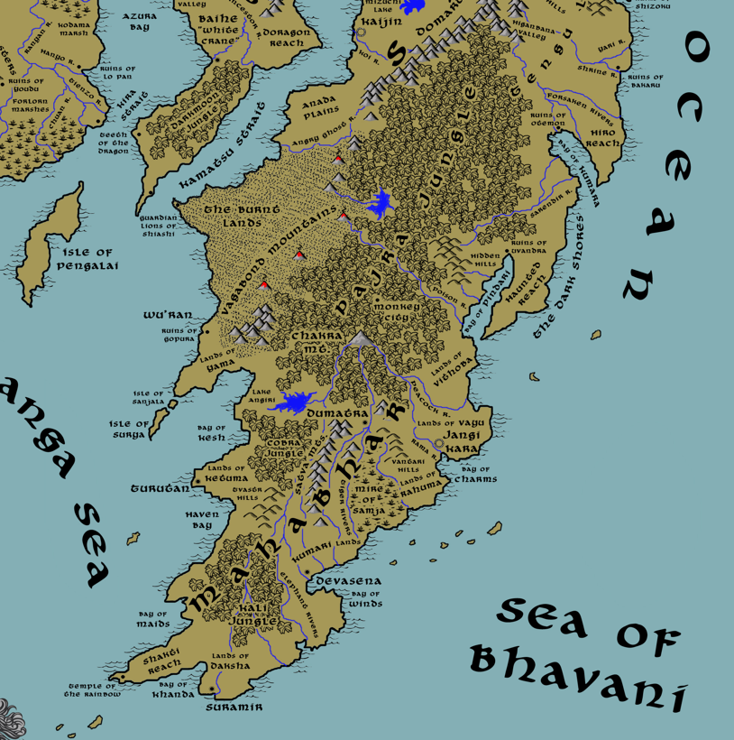

**Table of Contents**

* **Overview**
* **Towns and Cities**
* **Best in the Land**
* **Stewards of Power in this Land**
* **Points of Interest**
* **History**
* **Local Goods**
* **Notes on Culture**
* **Local Deities**
* **Creatures**
* **Other Races**
* **Magical Items**
* **NPC Templates**
* **Developer Notes**

**Overview**

Dominating the southern portion of the Katura continent, the tropical kingdom of Mahabar is an ancient one incubated in jungles and the ebb and flow of the many rivers flowing through it. Gods here are givers and takers of life. Dangerous beasts stalk the edge of every village and school humans in the lessons of survival. Majestic beauty lives in sharp contrast with the darkest of nights.

A description of Mahabar begins with Chakra Mountain and the Pajra Jungle in the north. The mountain stands at the head of the Satva range that runs south and dominates the center of the land. The mountains are the source of all major rivers flowing south and, combined with the region’s monsoon seasons, owes to the region’s water-drenched conditions. The Pajra jungle is vast and has, along with the Burnt Lands to the west and Haunted Lands to the east, sealed off the upper half of the Katura continent, isolating Mahabar. A thousand years ago the northern regions of Mahabar fell to invasion by creatures from the mountains and jungles. The ruins of Gopura in the west and Uvandra in the east are silent reminders of ancient Mahabar and may still hold ancient treasures.

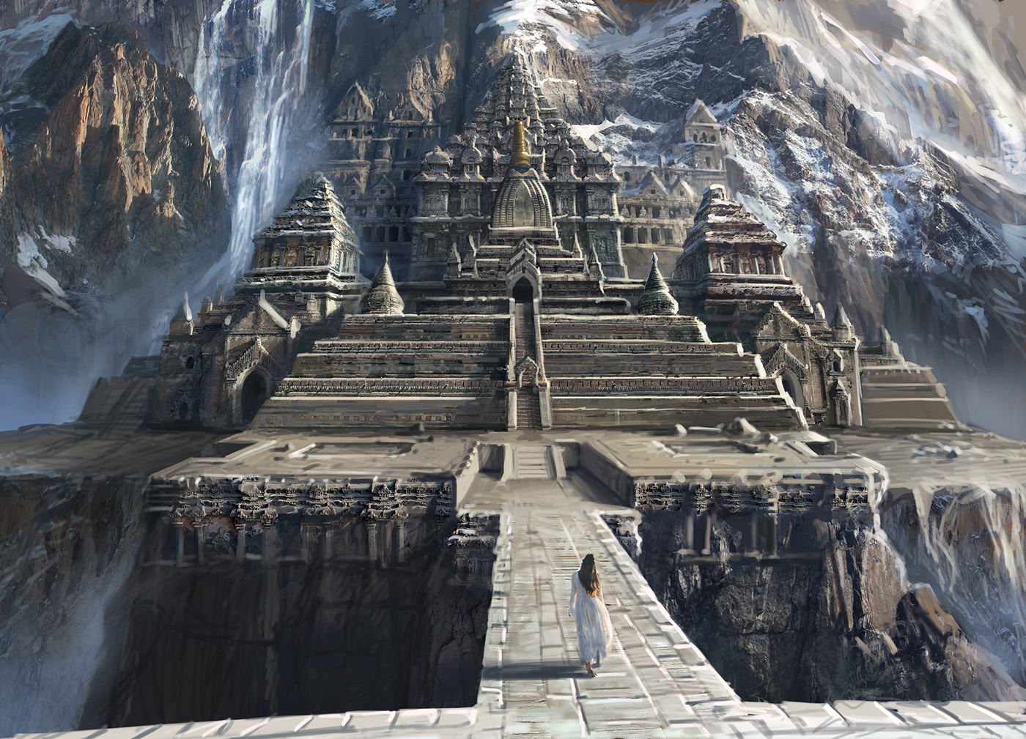

**Towns and Cities**



* Mahabar
  + Turutan – large city, sign of the waves
  + Jangi Kara – metropolis, sign of the tiger
  + Dumatra – large town, sign of the panther and chakrem
  + Devasena – large city, sign of the
  + Suramir – large city, sign of the thirteen stars on crescent moon
* Monkey City – (free city) large city, sign of the

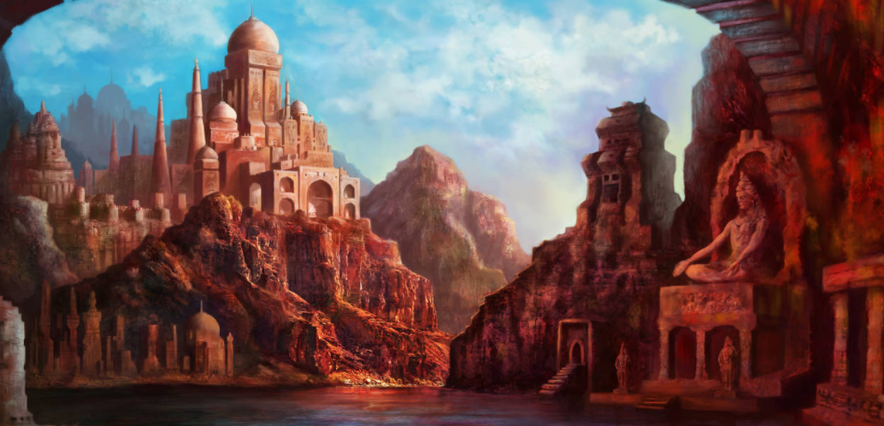

**Best in the Land**

* Trade Hub: Turutan, Jangi Kara
* Religion: Suramir
* Arts:
* Magic: Jangi Kara, Suramir
* Spirits:
* Steel:
* Grain:
* Crafted Goods (e.g. Pottery, Textiles, Metal Wares): Devasena (dyes, papyrus)
* Harvested Goods (e.g. Aromatics, Medicine, Dyes): Turutan (sugar, tea, flax, spices), Dumatra (medicine), Devasena (sugar, timber), Suramir (sugar, ivory)
* Mined Goods: Jangi Kara (clay), Dumatra (stone)
* Precious Metals: Jangi Kara (gold, gems)
* Ship Building: Suramir
* Other: Jangi Kara (perfume), Suramir (incense)

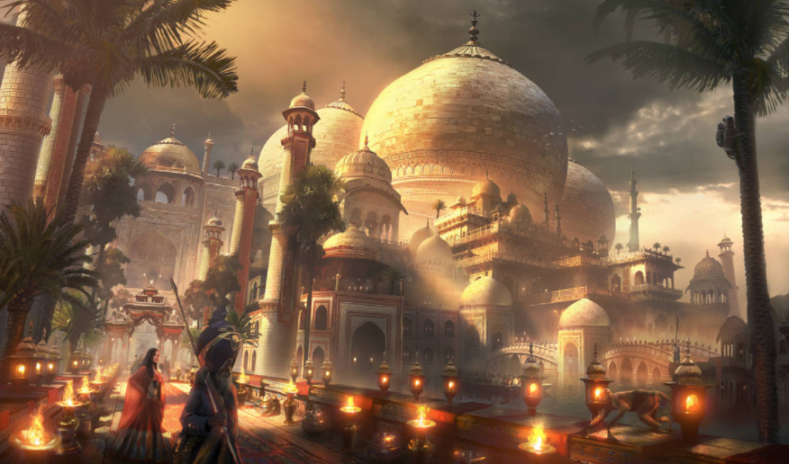

**Stewards of Power in this Land**

Kings and their armies are not the only wielders of power. There are many unseen friends and foes that shape the destiny of the land. Each of the groups listed below are well known to the people of this region. Some are feared, others venerated. All of them play their part in the grand drama of this land’s story.

**Merchant Companies**

Nine Barrels Trading Company - Turutan

Twilight Treaders Company – Jangi Kara

**Mercenary Companies**

(none)

**Smuggling Rings**

Sons of Naga – Turutan

**Centers of Worship (Churches, Cathedrals, Shrines, Lodges, Temples)**

Temple of Chandrashala - Turutan

Temple of Indrani - Jangi Kara

Temple of the Mystic Elephant - Dumatra

Temple of Matsya - Devasena

High Temple of Wee Jas - Suramir

**Orders of Paladins**

Order of the Dark Scimitar – Suramir

**Druidic Circles**

Circle of the Bamboo – Dumatra

**Bands of Rangers**

Band of the Macaque – Devasena

**Schools of Magic**

Nakshatra Sanctum – Jangi Kara

Chamra Sanctum – Suramir

**Bardic Colleges**

Chitrasena – Jangi Kara

**Warrior Academies**

(none)

**Assassins Guilds**

The Ajakava – Devasena

**Cults**

(none)

**Other Guilds**

Saravati Dye Guild - Devasena

Avratha Incense Guild - Suramir

**Monasteries**

Monastery of the Coming Storm - Vagabond Mts.

Monastery of the Night Sky - Shakra Mountains, at the head of the Peacock River

Monastery of the Divine Spear - Isle of Surya

Monastery of the Serpent Hand - Vantari Hills

Monastery of the Star Guide - Tvastri Hills

Monastery of The Golden Bird - Southern End of the Satva Mts.

Monastery of the Hidden Root - Bay of Maids

Monastery of the Unmoving Tree - Elephant Rivers

Monastery of the Poison River - Hidden Hills overlooking Poison River

Monastery of the Many Arms - Lake Angiri

Monastery of the Ten Faces - Mire of Samja

Monastery of the Twinkling Eye - Bay of Khanda

**Pirates**

Captain Kao Fang the Sea Minister - Isle of Pengalai

Captain Zapran Damanis - Bay of Pindari

**Points of Interest**

* Isle of Pengalai
  + Varuna – Sea Elf Domain
* Isle of Sanjala
  + home to the bronze dragon **Kalatamaka**
* Isle of Surya
  + Monastery of the Divine Spear - Isle of Surya
* Bay of Kumara
* The Dark Shores
* Bay of Pindari
* Bay of Charms
* Bay of Kesh
  + Perched on the northern shore, overlooking the bay, is the tower of **Birendra Vivekanda Holder of Eyes**, Arch Mage of the Mahabar lands
* Haven Bay
* Bay of Maids
* Bay of Khanda
* Bay of Winds
* **Pajra Jungle** – an immense densely grown wilderness that separates the northern and southern ends of the Katuran continent.
  + At the southern end of the jungle dwells the **Surasa** tribe of Yuan-Ti, known by their sign of the horizontal line with one vertical line then one curved line descending (the letter 'S' in draconic)
* Cobra Jungle
  + Here dwells the **Vasuuk** tribe of Yuan-Ti, known by their sign of the horizontal line with one curved line then one vertical line descending (the letter 'V' in draconic)
* Kali Jungle
  + Here dwells the **Patanya** tribe of Yuan-Ti, known by their sign of the horizontal line with three vertical lines descending and one curved line ascending (the letter 'P' in draconic)
* Haunted Reach
* **Burnt Lands** – so named for the scorched lands caused by the volcanic eruptions of the Vagabond Mountains. The first such eruption was in 780 PA3 at the Battle of Skyfire, which ended one hundred years of the Myrmeke invasion of Mahabar. The Mahabaran monk Dogari called on the gods to save the people of Mahabar; the Vagabond Mountains erupted, engulfing the Myrmekes armies and wiping them out.
  + home to the brass dragon **Mazedara**
* Shakti Reach
* River (unnamed)
* Sarendir River
* River (unnamed)
* River (unnamed)
* River (unnamed)
* Poison River
* Peacock River
* Rama River
* Tiger Rivers
* Tiger Rivers
* Tiger Rivers
* Elephant Rivers
* Elephant Rivers
* Elephant Rivers
* Elephant Rivers
* Elephant Rivers
* Elephant Rivers
* Lake (unnamed)
* Angiri Lake
* Mire of Samja
* Chakra Mt
* Satva Mts
  + Here dwell the tribe of Stone Giants called the **Shilrath**.
* **Vagabond Mts** – The loose, scattered mountains that trail off from the southern end of the Domaru Mountain Range descend into the middle of the Katuran continent into the Mahabar lands of Yama. The Vagabonds are mysterious, dangerous mountains of which little is known. What is known is that they are intermittent volcanic peaks that have erupted to blacken the Burnt Lands. In 780 PA3 the Battle of Skyfire ended one hundred years of the Myrmeke invasion of Mahabar. The Mahabaran monk Dogari calls on the gods to save the people of Mahabar; the Vagabond Mountains erupt, engulfing the Myrmekes armies and wiping them out.
  + Here dwells the **Tethireth** tribe of Yuan-Ti, known by their sign of the horizontal line with three vertical lines descending (the letter 'T' in draconic)
  + Here dwell the tribe of Fire Giants called the **Agnirosh**, who are known by their sign of the burning demon face.
* **Hidden Hills**
  + Here dwells the **Azalath** tribe of Yuan-Ti, known by their sign of the three horizontal lines (the letter 'A' in draconic)
* Vantari Hills
* Tvastr Hills
  + Here dwell the tribe of Hill Giants known only as the **Girikoot**.
* Lands of Yama
* Lands of Ketuma
* Lands of Daksha
* Lands of Kumari
* Lands of Rahuma
* Lands of Vayu
* Lands of Vithoba
  + Here dwell the tribe of Storm Giants known as the **Meghnath**, known by their sign of the fist holding a lightning bolt in a tornado.
* Temple of the Rainbow
* Ruins of Uvandra
* Ruins of Gopura

**Turutan**

**Size:** large city

**Trade Goods:** trade hub, sugar, tea, flax, spices

**Local Goods:** bhang thandai (cannabis-infused drink)

**Standard:** sign of the waves

**Colors:** green and black

**Patron Deity:** Padma - Goddess of Beauty and Good Fortune

**Ruler:** Zamindar Shindi Gul Nanda and his wife Lipika (f)

**Home**: Dahlia Palace

**Steward**: Shalar Tirmizi

**Marshal**: Rustam Jat

**House Priest:** Bakhwal the Barefooted

**House Adviser (Scholar/Mage/etc):** Ghakhtalay the Crimson

**Captain of the Guard**: Zgard Hiraj

**Chief Warriors in Service**:

Chetan Yogine

Daya Gurudutt

Aakash Vaidyanaath

**Local Powers:** Nine Barrels Trading Company, Dark Diamonds (thieves guild), Sons of Naga (smuggling ring), Temple of Chandrashala

**Local Sites:** Sanjrani’s Inn & Tavern, The White Tiger Inn & Tavern, Vasantasena (brothel)

**Description:**

Turutan sits like a pale green crown at the tip of the Ketuma promontory. Pink-hued barrier reefs encircle the harbor where sails sway to and fro bearing the markings of Kaduru kingdoms, of Xiandia and Sakura. Here sits the busiest of ports in the Shanga Sea and where much of Mahabar’s exports make their way to the world. People crowd the streets: fishmongers and merchants, pirates and monks, street performers, beggars, and silk-draped princes. The air here is hot and humid and carries the smell of the sea intermingled with musky scents of aromatics and spices. Ornamental portals appear along the sea breaks, walls built to withstand the heavy storms here. Every few minutes geysers of water spew upward from the portals as they eject the force of the crashing waves. These are affectionately called the Fountains of Turutan by travelers who see them for the first time.

Called the **Sea Wall City**, Turutan is built to survive the worst the Shanga Sea has to dish out. Inside the coral reefs an enormous sea break was constructed in the First Written Age. It is made of boulders piled one on top of the other over a five hundred period span, stretching from the tip of the peninsula southward in a semi-circle, protecting the city from eastward assaults during storms. The break opens to the south, allowing ships to approach from Haven Bay.

She is the western most of the Mahabar cities. To the north stretches the **Bay of Kesh** and the barren coastline of a forgotten kingdom of old. To the south **Parashuram Bay** is a deep and safe haven from the tropical storms. Pirate ships of the **Sea Claws** out of Pengalai Bay and the **Reevers** from Keromang troll the horizon. Only military ships Jangi Kara stations here keep them at bay, but the pirates linger patiently waiting for a careless merchant ship to cross their lines.

**Industry:**

Trade ships from Xiandai and Kaduru frequent the massive port here to gain access to the land’s exotic spices. Fields of flax, sugar, and tea surround the city, thriving in the damp heat of the region. Cinnamon, cassia, cardamom, ginger, pepper, saffron, and turmeric sell quickly to merchants hoping to charge dearly for them abroad. Spice merchants can be seen carrying their traditional **Masaladabbi** spice boxes with them, offering merchants samples of their wares.

**Bhang thandai** is a local drink made in Turutan which is infused with cannabis and highly intoxicating. Though it is not normally exported outside the kingdom, the drink is popular throughout Mahabar and has earned quite a reputation.

**Key Figures:**

**Local Lore:**

It is rumored that **Kadru**, goddess of serpents and queen of the nagas, rules the **Cobra Jungle** to the east. Few dare to venture into the darkness of that place. It is filled with evil magic, which has drawn the weak minded to join the cult that worships there. Members of the **Cult of Kadru** bear the tattoo of the cobra somewhere on their body. They avoid bright light and shun it. When provoked it is said they even display fangs given to them by Kadru. Caught in the spell of the queen, cult members are thought to kidnap unsuspecting farmers and take them off to be human sacrifices.

**History:**

Turutan is the seat of power over the Ketuma region, which for the longest time was an independent kingdom. Two hundred years ago Turutan fell to the Pashadr armies (292 WA4). The neighboring lands of **Daksha** to the south and **Savitr** to the east have been regular foes for countless centuries. But these western powers united when the eastern lands rose up. Dumatra in particular is remembered for her atrocities during the Jangi Kara conquest. Though they were pressed into the war, the Dumatrans were ruthless towards the Turutan people. To this day, Turutan and her people hold a special place of hatred in their hearts for anyone Dumatran.

Mahabar’s most famous sailor and adventurer, **Shudraka,** hailed from Turutan. He lived here eight hundred years ago and is a legend of the whole kingdom. Stories are told of his battles against the Xiandai pirates, beguiling the sea serpents of their magic, and rescuing kidnapped princesses from the deep parts of Kaduru (620-640 WA3). A jungle cat named **Bosari** was his companion and in battle the two fought like twenty men. Shudraka wielded a magic Mahabar-style sword called the **khanda**. He named it **Ananta**, after the sea serpent he took it from. Some say the sword is lost and Ananta looks for it still.

**Customs:**

Each full moon the city erupts into a festival of competing worshippers called the **Daanav Devata**. It is held to honor the slaying of a demon that took place here centuries ago. Idols of a hundred gods make a procession through the streets. Peasants from the countryside gather in raiment befitting their faith and begin thrashing each other with laathi (bamboo sticks) to show their fervor. It is not done to intentionally harm anyone, but it gets quite violent and no one backs down even when drenched with blood all over their bodies. This goes on until the break of dawn, with festival goers counting the scraps of their opponents’ clothing on their sticks as a sign of victory.

**Jangi Kara**

**Size:** metropolis

**Trade Goods:** trade hub, Mahima (perfume), magic center, wine, opium, clay, gold, gems

**Local Goods:**

**Standard:** sign of the tiger

**Colors:** blue and gold

**Patron Deity:** **Indrani**, queen of the gods

**Ruler:** Maharaja Bazgar Pashadr and his wife Jaya (f)

**Home**: Jasmine Palace

**Steward**: Zamda Jalbani (f)

**Marshal**: Dagar Masood

**House Priest:** Hukam the Giver of Blessings

**House Adviser (Scholar/Mage/etc):**  Izat the Conjurer

**Captain of the Guard**: Gran Bulfali

**Chief Warriors in Service**:

Aadi Omanand

Niraj Yuval

Upanshu Mitesh

**Local Powers:** Twilight Treaders Trading Company, Steel Eyes (thieves guild), Nakshatra Sanctum (school of magic), Chitrasena (bardic school for Kathakar (bards) and Arjuna dance), Temple of Indrani

**Local Sites:** The Red Mongoose Inn & Tavern, Bahubali’s Inn & Tavern, Sura Farm, House of Suvanna (brothel)

**Description:**

Tales are told the world round of the mighty **Jeweled City** of Jangi Kara. Sailors boast of seeing its glittering towers from miles out to sea. Merchants speak in hushed tones of gems pulled from **Chakra Mountain** and the gold of the **Satvas**. Though it sits on the far side of Mahabar, sea traffic from all over the world finds its way to the massive seaport.

Pirates are a constant threat to merchant ships sailing to and from Jangi Kara. The **Fayurei** pirates hunt the waters far to the north, the **Reavers** prowl the waters off the coast of Suramir. The primary threat are the **Makara**, which are based just north in the **Bay of Pindari**. The sea captain **Arun Shriva** keeps a constant watch along the Vayu and Vithora coastlines for his longtime nemesis, **Zapran Damanis**, captain of the Makara. Many fear the sails marked with the fish-tailed stag.

Jangi Kara is famous for its wild array of psychedelic delights. Poppy plants are cultivated along the Rama River and transported by the **Twilight Traders** into Xiandai and Kaduru. This blend of opium is referred to as **Ramahesh** and is used in religious practices throughout Mahabar. Outside of the city is the sprawling estate of the **Sura Plantation**. It is here that the Sura wine, popular in Mahabar, is bottled. **Mahima** is an intoxicating perfume that is created in Jangi Kara and his famous for its alluring scent.

**Industry:**

The perfumers of Jangi Kara

jasmine, patchouli, oud, sandalwood, rose, pepper, chai, guggul

**Key Figures:**

**Local Lore:**

**History:**

Jangi Kara is the traditional seat of power over the Vayu region. The lands of Vithoba to the north and Rahuma to the south have been longtime foes of the Vayu. But when Jangi Kara conquered Dumatra, these regions capitulated and joined the city in taking the rest of Mahabar.

Two hundred years ago marked the **War of Opals** (280 WA4). **Raja Varuni** of Jangi Kara challenged **Raja Gagan** of Dumatra for power and demanded tribute. Gagan answered by sending glass marbles instead of the customary gift of Opals. War ensued and lasted for ten bloody years. Jangi Kara prevailed in the **Battle of Komal** (290 WA4) and pressed Dumatra into a conquest for the rest of Mahabar.

proceeded to enforce its will on the other lands to the south and west. In 297 WA4 Pashadr was named **Samraat** (Emperor) of all Mahabar, beginning of the **Pashadr** dynasty. Since then the Pashadr dynasty has ruled all of Mahabar, but its enemies are growing.

**Customs:**

The **Arjuna** art of dance is unique to Mahabar, involving sensuous movements in both slow, enticing patterns as well as wild, frenetic patterns, all designed to evoke various emotions. Some dances are arranged to be accompanied by a **Kathakar**, a traveling bard or storyteller. Arjuna dancers have a reputation for being powerfully seductive, the dance able to bedevil the strongest men or change the course of history. Rumors speak they may have magical influences woven into them. Some kingdoms ban these dancers for fear of their seductive powers. Others pay top coin to have them visit their courts. The **Chitrasena** is the premier school in Jangi Kara and produces the finest Arjuna performers. Kings regularly send their concubines to Jangi Kara to have them trained in this forbidden art.

**Dumatra**

**Size:** large town

**Trade Goods:** medicine, sugar, furs, stone

**Local Goods:**

**Standard:** panther and chakrem

**Colors:** red and black

**Patron Deity:** **Sarama** - mother of the brindled Dogs of Yama, the Huntress

**Ruler:** Zamindar Yama Kureshi and his wife Meena (f)

**Home**: Balsamine Keep

**Steward**: Khush Mousavi

**Marshal**: Darwesh Dehwar

**House Priest:**  Selai the Softspoken (f)

**House Adviser (Scholar/Mage/etc):**  Hiraj of Many Names

**Captain of the Guard**: Sangar Rahija

**Chief Warriors in Service**:

Yayati Vyomaang

Inoday Akash

Toya Amish

**Local Powers:** The Eastern Gate (thieves guild), Circle of the Bamboo (order of druids), Temple of the Mystic Elephant, Mastizaade Academy (warrior school), The Mastizaade (mercenary company)

**Local Sites:** Twin Ruby Inn & Tavern, Samundra’s Palace Inn & Tavern

**Description:**

Dumatra was once a sovereign kingdom that ruled from the **Satva Mountain** region, controlling all the lands from **Lake Angiri** to the **Vantari Hills** and south to the end of the Satva Mountain range. Historically Dumatra and Jangi Kara have been bitter foes. Today Dumatra answers the will of the **Pashadr** throne, but it is secretly working to break away.

**Industry:**

The primary industries of Dumatra are furs from the exotic animals of the **Pajra Jungle**, quality stone from the Satva Mountain quarries, and sugar from plantations west of the city. Rare plants from the Pajra are collected and worked into valuable medicines by the city apothecaries. The city makes use of the mighty river system to farm but also to move goods up and down from the coast. There are plans underway to build an independent merchant fleet to extend markets outside of Mahabar.

**Key Figures:**

Rangers from Dumatra are experts in navigating the treacherous **Pajra Jungle**. It was the ranger **Vakpati the Frond-Footed** who discovered Chakra Mountain centuries ago and helped to establish the gem mines that now feed Jangi Kara’s fortunes. **Kureshi** house has recognized this and is slowly choking off the gem supply to their overlords. Druids from the **Circle of Bamboo** are masters of the Pajra Jungle. They have long been the guardians against those who would corrupt it.

The people of Dumatra have earned a reputation for fearlessness, having survived in this hostile region for millennia. Young soldiers who pass the rigorous training at the **Mastizaade Academy** are anointed into its corps of elite warriors. Three thousand years ago the Mastizaade conquered all of Mahabar. Today the mere mention of their names causes rulers to fear. Some have even paid handsomely to recruit them into their own wars.

**Local Lore:**

The **Temple of the Mystic Elephant** is a holy place of great power. Honors are paid to the elephants of the Pajra, for it is believed that the first elephant created the jungles with their mighty feet and swinging tusks. The elephant god is a patron of good fortune who provides prosperity, fortune and success. He is the lord of beginnings and the remover of obstacles of both material and spiritual kinds. Interestingly, he also places obstacles in the path of those who need to be checked.

The mountains flanking the **Mire of Samja** are rumored to be the home of a powerful Rakshasa the last three hundred years. Some say his name is **Garikahn** and he lives in a manse atop the mountain, ruling over the evil creatures in the swamps. Garikhan used to hunt humans in the outlying villages south of Dumatra (170 WA4). In his old age, he sends lesser creatures to do his evil bidding. It is said that he plots against the lords of Mahabar, seeking to build his treasure and turn the cities against one another. A generation ago he was said to have acquired the **Katar of Lies**, a magical dagger that can enslave the minds of any who are pierced by it. Enemies of the Rakshasa believe he has secreted the dagger from one court to another, slowly bringing key nobles under his control.

The Pajra Jungle is home to the **Yaksha** a race of nature-spirits, usually benevolent, who are caretakers of the natural treasures hidden in the ground and tree roots. The feminine form of the word is **yakṣī**. Some yakṣha appear as inoffensive nature-fairies, associated with woods and mountains. But there is also a darker version of the yakṣha, which is a kind of ghost (**bhuta**). The bhuta haunt the wilderness and devour travelers, similar to the rakshasa.

The **Mire of Samja** is a treacherous place. Haunted by evil spirits, it is avoided at all costs. The outer edges are often braved for rare plants, but sometimes explorers disappear without a trace. On nights with a new moon, eerie voices and moans emanate from the mire and can be heard for miles. It is said that a cult of witches, called the **Daayan**, infest the mire. The primary source of a Daayan's power is her long, plaited hair or ("choti"). She is described as having long and monstrous black nails, and feet that face backward. It is also said that once a Daayan lays her evil eye on someone, it is a bad omen for the whole household of that person. Mahabar history tells of seductive women of low birth marrying into noble houses, some of which are revealed to be Daayan. To this day every marriage in Dumatra includes a ritual to test if the bride is a Daayan.

**History:**

Dumatra was once the seat of a mighty empire. Long ago the general of the city’s armies was a famed hero named **Arun the Unbreakable** (20 AA4). During a visit from Jangi Kara’s raja, Arun gazed upon **Lavanya**, daughter of the raja, and was stricken lovesick. Lavanya spat upon the ground at Arun’s confession of love and set off a decade of war.

Arun, obsessed with Lavanya, sought out the goddess Sarama for her help to hunt his prey. Sarama gifted him with the **Belt of the Ceaseless Hunter**. Arun overthrew the Raja of Dumatra to gain power and led the elite Mastizaade troops to invade Jangi Kara. Within a year the city had fallen, but Lavanya fled by ship to Devasena. Over the next three years Arun pursued Lavanya to Devasena, Suramir, and Turutan, with the Mastizaade conquering each city as Lavanya fled just ahead of them. At last in Turutan Arun planned ahead and sent spies to convince the princess that they would secret her out of the city before it fell. As the city fell the spies kidnapped Lavanya and took her to Arun (29 AA4). Two years later Arun was anointed the Samraat, emperor of all Mahabar, and his dynasty would rule for the next four hundred years.

When Jangi Kara conquered it two hundred years ago in the **War of Opals,** Dumatra’s army was pressed into war to take the rest of Mahabar (290 WA4). Soldiers were infused with strange tonics that made them forget their own names but incited them to great fury. The Dumatran shock troops, historically the most feared warriors in these lands, meted out savage attacks throughout Turutan in the west before the war was over. Today Dumatra seeks their aide in rebelling against Jangi Kara, but the people of Turutan still hold a grudge against anyone from the Dumatra region.

**Customs:**

**Devasena**

**Size:** large city

**Trade Goods:** dyes, papyrus, timber, sugar, fishing

**Local Goods:**

**Standard:** sign of the triple sword and chakra (aka khanda)

**Colors:**

**Patron Deity:** Durga - Warrior Goddess, rode tigers into battle

**Ruler:** Zamindar Selab Janwari and his wife Malini (f)

**Home**: Scarlet Palace

**Steward**: Sangin Mir

**Marshal**: Sohrab Ashkani

**House Priest:** Shindi of the Hidden Mouth

**House Adviser (Scholar/Mage/etc):**  Ambrin of the Many Eyes (f)

**Captain of the Guard**: Gul Qalat

**Chief Warriors in Service**:

Gopi Ojas

Gopee Jawahar

Daya Salil

**Local Powers:** The Gold Katar (thieves guild), Temple of the Matsya, Band of the Macaque (order of rangers), Ajakava (assassins guild), Saravati House (dye guild)

**Local Sites:** The Lazy Leopard Inn & Tavern, The Diamond Choker Inn & Tavern, Chandra’s (brothel)

**Description:**

Devasena is the seat of power over the **Savitr** region, which for the longest time was an independent kingdom. The city has long been the master of the river lands of **Somati**, ruling over the estuaries formed by the mighty rivers that run the length of Mahabar. While it is not a major trade hub it still oversees hundreds of fishing boats and other small vessels. Control of the rivers translates to control over the flow of goods within the kingdom.

Each year the rivers swell during monsoon season. Flood waters swallow entire valleys while mud slides threaten to wipe away villages. Lightning storms dominate the skies for weeks. Worshippers flock to the **Temple of Matsya**, erected in honor of the god who saved man during the first floods. The blessings of the monsoon season are that they carry fresh water to thousands of farms.

In contrast to monsoon season, each year has a dry season where the rivers shrink as do water holes in the outlying regions. Creatures from the Kali Jungle tend to emerge during this time, looking for water. Herds of water buffalo walk the plains. Villagers come out to anoint the buffalo during their drought festivals. But with the water buffalo come more reclusive, more dangerous beasts. Wild cats of the jungle, hunting the herds, often prey on humans.

**Industry:**

The city has developed timber works upriver in the **Tvastr Hills**. There the camp harvests pine, spruce, fir, cedar, larch, and cypress. Logs are sent downriver to Devasena where they are milled and sold to merchant ships.

The **Saravati Dye Guild** is a powerful group whose reach is felt all over Mahabar and abroad. They impose exacting standards, controlling supplies to merchants, and amassing great wealth and influence among the nobility. It is said a Mahabar princess will consult a Saravati color advisor with the same piety as others consult a priest. Battles have been delayed while waiting on a Saravati color expert to weigh in on whether an army’s standard was the correct shade of red or blue. Their reach is worldwide, with Saravati Guildsmen often butting heads with Darmidian merchants over supply and demand.

The guild’s massive works are located in the outskirts of Devasena. The mordants and dyestuffs produce strong odors, and the process depends on a good supply of fresh water, storage areas for bulky plant materials, vats which can be kept heated (often for days or weeks) along with the necessary fuel, and airy spaces to dry the dyed textiles. Plants from the region include catechu for brown, gamboge tree resin for dark yellow, rhubarb for bright yellow, indigo for blue, kamala tree for red, madder root for pink and orange, and myrabolan fruit for green and black.

**Key Figures:**

**Local Lore:**

**History:**

Five hundred years ago during the **War of the Rajas** the army of Devasena was ordered to draw up against the Mire of Samja to meet an overwhelming army from Dumatra. **General Chattar** saw the futility of such a maneuver. Watching their allies from Suramir being overwhelmed in the Bhavani Sea, he commandeered the countless fishing boats at rest in the bay. In a surprise move the Devasena army was deployed to the rear of Jangi Kara’s navy, boarded it, and set it aflame. The battle was dubbed the **Battle of the Sea Hornets** (912 WA3).

The neighboring lands of **Ketuma** to the north and **Daksha** to the west have been regular foes for countless centuries. But these western powers united when the eastern lands rose up to conquer all of Mahabar. Two hundred years ago Devasena fell to the Pashadr armies (294 WA4).

**Customs:**

Leopards wander freely through Devasena and the surrounding countryside. Residents are told to be careful leaving food scraps out as it only invites the leopards to seek meals in human settlements which may include humans themselves. Wise residents know how to coexist with the creatures, leaving them good far out from their villages and not panicking when they are nearby. Shrines to the **Waghoba**, the leopard god, are scattered outside the city. Worshippers leave food there, asking for protection from the beasts as well as calling on Waghoba for strength and cunning in their own lives.

Each year Saravati Dye Guild holds the **Festival of Colors**. People crowd the streets, dressed in their most colorful regalia. Flowers festoon the walls and doorways of the city; colored powders are thrown in the air, covering everyone in a rainbow of bizarre pigments. Contests are held among commoners for who can achieve the most perfect blue, red, green, and so forth, all judged by the guild mistresses. Legend tells of a poor girl from an outlying village who achieved the most perfect shade of deep blue that everyone present was enchanted by its supernatural magic. That girl was blessed by the goddess of arts, Saravati, for whom the guild is named. The guild uses this festival as a kind of reveal party for their latest styles. It is said fashion-conscious nobility on the far side of the world eagerly await news from this festival and compete with one another on how quickly they can obtain fabrics carrying the latest colors.

**(older copy on the festival, moved from Turutan entry)**

Every spring the city celebrates **Festival of Colors**. Brilliantly colored powders are thrown into the air by revelers (and at one another). The festival signifies the victory of good over evil, the arrival of spring, end of winter, and for many a festive day to meet others, play and laugh, forget and forgive, and repair broken relationships. Anyone and everyone is fair game, friend or stranger, rich or poor, man or woman, children and elders. The frolic and fight with colors occurs in the open streets, open parks, outside temples and buildings. Groups carry drums and other musical instruments, go from place to place, sing and dance. People visit family, friends and foes to throw colored powders on each other, laugh and gossip, then share Mahabar delicacies, food and drinks.

**Suramir**

**Size:** large city

**Trade Goods:** incense, ivory, magic center, sugar, religious center, ship building

**Local Goods:**

**Standard:** sign of the thirteen stars on a crescent moon

**Colors:**

**Patron Deity:** Manasa-Devi - Serpent Goddess, identified with the Moon

**Ruler:** Zamindar Sanga Sumbali (f)

**Home**: Pomegranate Palace

**Steward**: Laila Derawa (f)

**Marshal**: Breshna Lakhani (f)

**House Priest:**  Qadiri the Realm Walker (f)

**House Adviser (Scholar/Mage/etc):**  Zarlakhta the Doom Seer (f)

**Captain of the Guard**: Lalzari Idrisi (f)

**Chief Warriors in Service**:

Yashmit Ikshan

Balchandra Vyshnav

Mitul Hanish

**Local Powers:** High Temple of Wee Jas (seat of power for the Wee Jas faith), The Shifting Sands (thieves guild), Order of the Dark Scimitar (order of paladins), Chamra Sanctum (school of magic), Thirteen Witches of Suramir (coven), Avratha Incense Guild

**Local Sites:** The Purple Peacock Inn & Tavern, House of Viper Inn & Tavern

**Description:**

Nestled on the rising terraces of a large set of hills, the city of Suramir overlooks the **Daksha Peninsula** at the southern tip of Mahabar. It is the first sight for travelers traversing the **Sou’East Jaunt** around Kaduru. It is also the famed city of ships for the kingdom.

Suramir is known as the **Enchanted City**. It is home to three powerful institutions of magic: **Chamra Sanctum**, which trains students in the ancient ways of Mahabaran sorcery, the High Cathedral of Wee Jas, the goddess of magic, death, vanity, and law, and the Order of the Dark Scimitar, paladins to Wee Jas. Dark powers are suspected at the center of both, but no one dares to oppose them. On the contrary, many of the Mahabar faith believe them to be necessary to bring balance to the wide array of good-aligned gods worshipped in the land. And on more than one occasion both the priestesses and the sorceresses have come to the kingdom’s defense.

**Industry:**

Here the earliest trade ships and war ships were built, and the ship building tradition continues to this day. Sugar plantations and ivory are other trade goods from here, but the most lucrative is incense production.

Suramir is the largest producer of incense in the world, and even introduced the concept to Xiandai and Katura. The Avratha guild manages groves of bamboo, charcoal production, as well as the resins that all together make up the ingredients for incense sticks, called agarbathi. Various resins, such as amber, myrrh, frankincense, and halmaddi are used, along with honey to keep the resin pliable. These create different aromas for use in religious ceremonies as well as for aesthetic uses. This process defines the traditional masala incense, unique to Mahabar.

**Key Figures:**

For over two thousand years the sanctum has been ruled by **Thirteen Witches of Suramir.** The witches are feared by everyone in the kingdom, including the Maharaja. Little is known of these sorceresses, except that each has taken their place by killing a previous witch of the sanctum circle and that this practice has been observed since the beginning. Unknown to most citizens, the Thirteen Witches coven controls every aspect of the city.

**Local Lore:**

**History:**

Suramir is the seat of power over the **Daksha** region, which for the longest time was an independent kingdom. The neighboring lands of **Ketuma** to the north and **Savitr** to the east have been regular foes for countless centuries. But these western powers united when the eastern lands rose up to conquer all of Mahabar. Two hundred years ago Suramir fell to the Pashadr armies (295 WA4). Today Suramir pays tribute to the throne in Jangi Kara, but the western allies scheme to end the Samraat’s reign.

**Customs:**

**Monkey City**

**Size:** large city

**Trade Goods:**

**Local Goods:**

**Standard:**

**Colors:**

**Patron Deity:**

**Ruler:**

**Home**:

**Steward**:

**Marshal**:

**House Priest:**

**House Adviser (Scholar/Mage/etc):**

**Captain of the Guard**:

**Chief Warriors in Service**:

**Local Powers:**

**Local Sites:**

**Description:**

**Industry:**

**Key Figures:**

**Local Lore:**

**History:**

**Customs:**

**History of Mahabar**

**First Primordial Age (PA1)**

Dawn of the Jani people

310 PA1 - Kadra, Queen of the Naga, gives birth to countless evil children and roam the lands of Mahabar to feast on her people

450-680 PA1 - Reign of the Cult of Kadra

680 PA1 - the druid Lakhviar joins forces with Kajala the cleric of Indrani; they hunt down and shatter the cult of Kadra

820 PA1 - the Great Flood; the god Matsya intervenes and saves all of Mahabar

**Second Primordial Age (PA2)**

150 PA2 - the priest Rajpek travels the lands of Mahabar, dropping magical seeds from which spring the Arbor Shrines of the gods

**Third Primordial Age (PA3)**

690-780 PA3 - War of the Myrmekes: ant-like creatures emerge from the jungles and wage war on the human settlements

780 PA3 the Battle of Skyfire ended one hundred years of the Myrmeke invasion of Mahabar. The Mahabaran monk Dogari calls on the gods to save the people of Mahabar; the Vagabond Mountains erupt, engulfing the Myrmekes armies and wiping them out.

**Fourth primordial Age (PA4)**

170 PA4 - Thirteen Witches of Suramir - coven forms for the first time; thirteen noble maidens from Xiandai and Sakura form a pact to curse their elder sisters; the pact becomes a binding pact with hell and curses the thirteen maidens into service forever

517 PA4 - Dractus conquers Turutan and finds the eleventh piece of the Crown of Power

535 PA4 - Turutan liberated from the forces of Dractus and rebuilding begins

868 PA4 - Founding of the Temple of the Mystic Elephant in Dumatra

872-888 PA4 - The Wizard War: Telemechus triggers a world-wide war of mages, some of whom march on Ongolk to stop him and some who join him in attacking the ley lines in their lands; epic battles wage all over the world, destroying cities and upsetting the balance of magic

888 PA4 - The Battle of Forlorn: Telemechus is slain but not before rupturing the magical ley lines permeating Nemmyrl; the victorious general Dragan of Celedon seizes the opportunity to rid the world of magic and ruptures the Singularion as it is embedded in the ley lines; the resulting explosion sends a shock wave that ruptures the magical ley lines around the world and triggers the Dead Century

**First Ancient Age (AA1)**

190 AA1 - founding of the Chamra Sanctum in Suramir

405 AA1 - the Great Katuran War: Sakuran armies march south to Mahabar, half to the lands of Yama and half to Vithoba

407 AA1 - Sakuran forces deal devastating strikes to Mahabar, taking Turutan and Dumatra

410 AA1 - Sakuran warships blockade Devasena while ground forces occupy the Tiger Rivers; Mahabar is divided with Jangi Kara isolated from Suramir

411 AA1 - Sakuran conquerors brand the Mahabar people and claim them as slaves

420 AA1 - After ten years of seige, Suramir falls to Sakuran forces; Jangi Kara pulls back its ships to protect the city

422 AA1 - Masuharu's head priest Gonuhan climbs Chakra Mountain and finds the tomb of Indrani's first prophet; he steals the headpiece of Indrani, a relic of great power

425 AA1 - Jangi Kara falls; Sakura takes control of all of Mahabar

625 AA1 - Jayadeva Lion Eye, a paladin of Indrani, launches a brutal counter assault on the Sakuran occupiers

627 AA1 - Jayadeva is drawn to Chakra Mountain where the goddess Indrani gifts him with the Badala Talwar (sword of revenge)

629 AA1 - The Lion Eye army crushes the Sakuran forces, striking from the jungles

630 AA1 - Jayadeva hunts down the heirs to the priest Gonuhan, slaying them and liberating several Mahabar relics including the headpiece of Indrani

631 AA1 - a mysterious monsoon rolls in just as Jayadeva's forces liberate Devasena; the Sakuran forces are dragged out to sea

635 AA1 - Battle of Jangi Kara : Jayadeva is slain in the retaking of Jangi Kara but the Sakuran back is broken and Mahabar forces retake their land with savage ferocity

637 AA1 - Tivra, sister of Jayadeva, is crowned Maharani of the land, beginning the rise of the Jani people

640 AA1 - the first Kathakar appear in Mahabar; singers and story-tellers, they usher in a new age of culture for the land

**Second Ancient Age (AA2)**

210 AA2 - Rokari, kingdom of Kaduru, invades Kazeldun, the Caghun Suhk, parts of Mahabar

450 AA2 - the great island kingdom of Tanthalsel erupts when the evil elven mage Halaeron insults the gods; the island sinks beneath the waves at the current location of the Sea of Bhavani

550 AA2 - Rokari forces leave Adhanar, answering the call of the great war in Kaduru

**Third Ancient Age (AA3)**

162 AA3 - Rangana, head witch of Suramir, is tempted by a demon to seize the Crown of Power from hell itself

165 AA3 - Rangana sends the witches of Suramir to the far corners of Mahabar, poisoning the land and summoning dark creatures to destory the kingdom

166 AA3 - Rangana lays waste to the Chandrabha paladins, destroying their entire order

168 AA3 - the lords of the land hide in their palaces, their armies laid to waste by Rangana's host; a holy man named Chidakash fails to recruit heroes of the land, is captured by the Dayaakar pirates

170 AA3 - Chidakash convinces the Dayaakar pirates to take up the cause against Rangana, leads them on a quest to claim the Eight Spears of Ligh

175 AA3 - after many adventures, the Dayaakar pirates pursue Rangana to the Satva Mountains and wage an epic battle that destroys Rangana and her witches and sends the crown to hell

320 AA3 - Xiandai invades Mahabar

590 AA3 - Shreya, the Iridescent Maharani, rallies the peasants of Mahabar to drive out the Xiandai invaders

592 AA3 - the Shreya calls on the gods to rebuild the land, creating an era of the greatest architecture and art in Mahabar history; the era is called the Iridescent Era

600 AA3 - the six Khanda of Nagari are forged, each gifted with powers by one of the gods, and are dispatched to all six cities as symbols of protection

**Fourth Ancient Age (AA4)**

20 AA4 - Rise of the Dumatra Empire - Lavanya Singh, daughter of the Raja in Jangi Kara, spurns the affections of Arun, commander of Dumatra's army

21 AA4 - General Arun, obsessed with Lavanya, seeks out the goddess Sarama for her help to hunt his prey; Sarama gifts Arun with the Belt of the Ceaseless Hunter

22 AA4 - Arun overthrows the Raja of Dumatra to gain power, leads the elite Mastizaade troops and invades Jangi Kara

23 AA4 - Jangi Kara falls, Lavanya flees by ship to Devasena

25-28 AA4 - Arun pursues Lavanya to Devasena, Suramir, and Turutan; the Mastizaade conquer each city as Lavanya flees just ahead of them

29 AA4 - Turutan falls and Lavanya is seized as Arun's queen

31 AA4 - Arun is annointed the Samraat, Emperor of all Mahabar; this is considered the end of the Iridescent Era of Mahabar as the throne turns to the art of warfare over culture and beauty

420 AA4 - Civil War in Mahabar - the House of Arun collapses, ending Imperial rule as regions reclaim their independence; this also marks the end of the reign of the Jani people and the rise of the peasant class: the Mahabri

**First Written Age (WA1)**

400 WA1 - the Daayan witches move into the Mire of Samja near Dumatra

680 WA1 Celedonian Quartus navy takes the Isle of Pengali

740 WA1 Celedonian Quintus navy attacks the ships off the coast of Mahabar

760 WA1 - sailors from the Quintus navy begin to disappear, strange creatures infest the ships; the Quintus navy departs Mahabar waters

800 WA1 - Witches of Suramir send agents to Celedon to empower the Orc tribes for the overthrow of the Celedon Empire

**Second Written Age (WA2)**

250 WA2 - Mythenia and Suramir give up on Gaeadon

440 WA2 - 13 witches take over Suramir, ruling from the Chamra Sanctum

760 WA2 - Vakpati the Frond-Footed discovers Chakra Mountain and its bounty of gems

**Third Written Age (WA3)**

150 WA3 - Kadra Rebellion: followers of the serpent goddess Kadra assassinate the zamandars in every city, including the maharaja; the Maharaja's son escapes

170 WA3 - Shoreh Aghdash returns from exile and launches a campaign against the Kadra cultists in power, crushing opposition thoughout Mahabar; Aghdash is named the new Maharaja

620-640 WA3 - Adventures of the hero Shudraka and his victories over the Xiandai pirates

630 WA3 - Shudraka slays the sea serpent Ananta

777 WA3 - War of the Rajas

779 WA3 - Battle of the Sea Hornets

**Fourth Written Age (WA4)**

10 WA4 - War of Shrines between Xiandai and Sakura and parts of Mahabar

170 WA4 - Garikhan the Rakshasa takes residence near the Mire of Samja

280 WA4 - War of the Opals: Raja Varuni of Jangi Kara challenges Raja Gagan of Dumatra, demanding tribute. Gagan answers by sending glass marbles instead of the customary gift of Opals. This triggers a war between the regions.

290 WA4 - Battle of Komal - Jangi Kara defeats Dumatra and presses its armies into conquering the rest of Mahabar

292 WA4 - Fall of Turutan to the Pashadr armies to the Pashadr armies

294 WA4 - Fall of Devasena to the Pashadr armies

295 WA4 - Fall of Suramir to the Pashadr armies

297 WA4 - Pashadr named Samraat (Emperor) of all Mahabar, beginning of the Pashadr dynasty ruling over all Mahabar regions

**Local Goods**

**Cereals:** rice, millet, barley; (pseudo-cereals)) kuttu ka atta (buckwheat)

**Fiber:** sugar cane, jute, bamboo

**Fruits:** mango, jackfruit, banana, wood apple, orange, lemon, lime, coconut, black plum, sweet orange, kiwifruit, persimmon, apple, apple guava, karuka, pare (bitter melon), winter melon, golden langkawi melon, ten me melon (most expensive melon), jade dew melon

**Meat and poultry:** ox, duck, pork, chicken

**Nuts:** cashew, candlenut, eastern chestnut, karuka, Betel or areca nuts, jackfruit nuts, pine nuts

**Vegetables:** moringa, cooking banana, okra, snake gourd, ivy gourd, eggplants, pigeon pea, vigna mungo (black lentil), castor bean, pigeonpea, soybean, ginseng

**Herbs:** basil, black cardamom, black cumin, curry leaf, long pepper, mango, orange, pandanus, turmeric, cardamom, ginger, mustard, ashwagandha, neem, gooseberry, ajwain, sesame, cinnamon, coriander, curry tree, asafoetida, caraway, clove, holy basil, black pepper, nigella sativa, black cumin, betal leaf, jakhya, spearmint, bay leaf, tamarind

**Oils:** coconut, castor bean, yellow sarson (mustard), sesame oil, palm oil

**Fermented Drink:** dark tea, basi

**Salt-water fish:**

**Fresh-water fish:**

**Wood:** teak, ebony, gurjun, oak, padouk, satinwood, silver fir, spruce, walnut, rose wood

**Textiles:**

**Dishes:** chutney (sauce that includes such forms as a spicy coconut dip, a tomato relish, a ground peanut garnish or a dahi (yogurt), cucumber, and mint dip)

**Animal-derived dyes**

Cochineal insect (red)

Cow urine (Indian yellow)

Lac insect (red, violet)

Murex snail (purple, indigo blue)

Octopus/Cuttlefish (sepia brown)

**Plant-derived dyes**

Catechu or Cutch tree (brown)

Gamboge tree resin (dark mustard yellow)

Chestnut hulls (peach to brown)

Himalayan rhubarb root (bronze, yellow)

Indigofera leaves (blue)

Kamala seed pods (yellow)

Madder root (red, pink, orange)

Mangosteen peel (green, brown, dark brown, purple, crimson)

Myrobalan fruit (yellow, green, black, source of tannin)

Pomegranate rind (yellow)

Teak leaf (crimson to maroon)

Weld herb (yellow)

Juglans Nigra or Black Walnut hulls (brown, black, source of tannin)

Rhus typhina or Staghorn Sumac tree (brown, source of tannin)

**Notes on Culture**

**Clothing**

Turban – In Mahabar the turban is referred to as a **pagri**, meaning the headdress that is worn by men and is manually tied.

**Seasons**

Mahabar has six seasons: **Grishmo** (summer), **Borsha** (rainy), **Shorot** (fall), **Hemanta** (cool), **Sheet** (winter), and **Boshanto** (spring). This wide variety of seasons speaks to the turbulent cycle of nature here. The river system flowing out of Mount Chakra and the Satva range swell in the Borsha season when monsoons threaten to flood the land.

**Flora**

Mahabar forest life is the most diverse of any other part of the world. Pines, junipers, and deodars are found in the Satva Mountains. Jungles and tropical rainforests cover the land, with the Pajra Jungle being the largest. Teak wood dominates western Mahabar low lands, shala the east, babul to the south. Pine, spruce, fir, cedar, larch, and cypress are the timber-yielding plants of the hilly regions of Mahabar.

**Spices**

Mahabar hosts a dizzying number of spices: fennel seed, asafetida, black cardamom, white pepper, black pepper, peppercorns, black cumin, capers, capsicum, radhuni seed, charoli, bay leaf, cinnamon, cloves, coriander, cubeb, cumin, curry tree (sweet neem leaf), fennel, gummi-gatta, garlic, ginger, cardamom, bedellium tree, jakhya, sour dried mango, mint, mustard seed, nigella seed, nutmeg, mace, holy basil, panch phoron, pomegranate seed, poppy seed, fresh hemp cannabis, saffron, sesame seed, tamarind, carom, and turmeric.

**Garam Masala** is a blend of several spices. Each family has their own secret recipe.

**Panch phoron** is a spice mix that combines fennel seeds, cumin seeds, fenugreek seeds, mustard seeds, and nigella seeds.

**Royal Titles**

Maharaja – king

Maharani – queen

Kumar – prince

Kumari – princess

Samraat – ancient term for emperor, only used three times in all of Mahabar history when one city ruled all of Mahabar; currently Jangi Kara’s Pashadr house

Zamindar – noble lords serving the Maharaja

Other Mahabar terms:

**Kathakar** are bards or storytellers who travel the land telling stories and accompanying the famous **Arjuna** dancers.

**Khanda** – traditional sword of Mahabar

**Weapons**

**Chakrem** - The dreaded circular blade made its mark not just because of its unique shape, but also the proficiency of those you used it.

It was primarily used as a throwing weapon, famous for decapitating people with one well-aimed blow, but could also be used in hand-to-hand combat.

**Haladie** - The tri-bladed Haladie was more a status symbol among Rajputs than a weapon of war, but skilled fighters could still put its three-pronged blades to great use.

**Parashu** - An Indian battle-axe, Parashus were either single or double bladed and made of iron.

In Hindu mythology, it was the weapon of Lord Shiva who handed it to Parashurama, the sixth Avatar of Vishnu.

**Gada** - One of the most popular weapons from antiquity, the Gada was a mace of great weight, effective against heavy armour that couldn’t be pierced by lighter blades.

Traditionally the weapon of Lord Hanuman, the Gada even has its own martial arts style attached to it with 20 ways to handle the formidable weapon.

**Bagh Nakha** - Literally meaning Tiger Claw, the Bagh Nakha was popularly worn as a concealed weapon.

Inspired by the paws of predatory cats, poisoned Bagh Nakha were apparently used by the Rajputs for assassinations. But the weapon only really gained notoriety when it was used by Shivaji Maharaj to defeat Afzal Khan. Nihang Sikhs were known to wear it inside their turbans to maintain the element of surprise as well.

**Urumi** - One of the most bizarre weapons ever made, accounts of the Urumi go back as far as the Maurya empire. It was a was a flexible whip blade that was extremely dangerous to use. Only warriors who had mastered all the other forms of weaponry were taught to wield it. The Sri Lankan version attached up to 32 blades on each arm.

**Dandpatta** - A deadly combination of gauntlet and sword, the Dandpatta utilized either locally made blades or even parts from swords after the British invasion. It was mainly used during the Mughal era and was used against armoured infantry to great effect.

**Khukuri** - A curved machete, the Khukuri is most associated with Gorkha regiments in the Indian army. A popular weapon among Nepali and Assamese warriors, the Khukuri is still used in various Nepalese rituals, including weddings.



**Katar** - Characterized by its unique hand grip, the Katar had multiple ceremonial as well as defensive uses. The weapon originated in South India and was later used by many high-class Mughals and Rajputs to hunt with. It was thought that killing a beast like a Tiger with such a weapon was a sure sign of immense bravery.

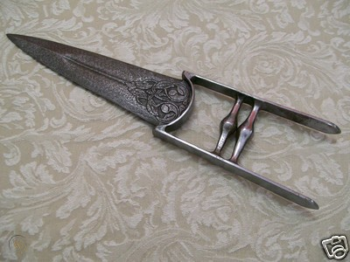

**Kirpan** - The Kirpan originated during the Mughal occupation of Punjab, when Sikhism arose as a counter to mainstream Hindu and Muslim religious teachings. At that point in time, the relationship between the Sikhs and Mughals was favorable because of King Akbar’s religious tolerance, however, under the reign of Jehangir, it was much more strained. This is what led to the forming of the sant-sipahi and the last Guru, Gibind Sinh making the carrying of a Kirpan mandatory so the Sikhs could defend themselves against oppression.

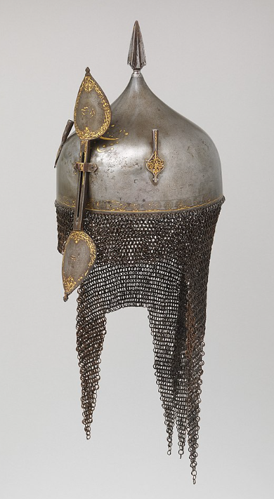**Khula Khud** helmets are worn my captains and mounted officers in the Mahabar armies. They are also worn in Tarbia and Hyderis. Made of steel, these bowl-shaped helmets are designed as either low and flat, or high and pointed. They sometimes contain a spike socket at the top of the helmet, which resembles a spearhead with a cross-like section. Two or three plume holders are attached on either side of the skull, used to mount feathers from birds such as the egret.

The helmet has an iron-and-brass or brass-and-copper aventail that hangs at the base of the helmet to protect the neck, shoulders and the temple of the face. Sometimes, the aventail extends down to cover the eyes and the nose. The low end of the aventail is often shaped in a zig-zag triangular pattern (vandyked).

A bar made of iron or steel is attached to the front of the helmet with a bracket and can be adjusted in position - so when not in use, it can slide upward and fasten with a link, a hook, or a set screw. The two ends of the bar expand into leaf-shaped plates, forming a final. In some Khula Khud helmets the lower end of the bar is designed as a large crescent-shaped metal guard that protects most of the face below the eye level.

Despite the similarity in their design, the Khula Khud helmets are decorated with a wide degree of variations depending on the tribes or regions from which they were created. Decorations often appear in the skull and the nasal bar, which are often heavily decorated with patterned motifs of inlaid brass, silver or gold; or decorated with figurative images.

**Colors of India**

Colors are virtually everywhere in India: they’re on the streets, in the buildings, and worn as traditional outfits as well. These colors symbolize something that the wearer (or the architect) wants to express, and have a far deeper meaning than just being beautiful.

If you’re wondering what to wear for your business meeting in India, here’s a lesson on the most commonly used colors and their meaning.

Red symbolizes purity, fertility and prosperity.

Red is the color of a traditional Hindu wedding dress; and during many other religious ceremonies, a red mark is sometimes applied on the foreheads of participants. Married women wear red paint on the parting of their hair (this is called sindoor). The color of the Bindi (a dot worn on the forehead between the eyebrows to mark the place of the third eye chakra) is usually red as well. In the southern part of India, red may also be associated with force and disruption.

Saffron (golden yellow) is a sacred color for Hindus.

It symbolizes purity, light, and religious abstinence. Many Hindu holy men and ascetics are depicted wearing saffron, which symbolizes their quest for light.

Green is the color of festivities.

It represents life, peace, happiness, and nature. For Muslim Indians, green has a significance as well, since Islam is usually associated with this color. For Muslims, green means peace, and according to their beliefs, inhabitants of paradise will be clothed in green. Legend says it was the Prophet Muhammad’s favorite color.

Yellow is the color of learning.

It represents spring, as well as mental development, peace, and meditation. Participants at spring festivals wear yellow, and it’s the traditional color worn by single girls in search of a partner. Vishnu, the God of Protection and Preservation of Good is often depicted wearing yellow garments, along with Krishna, the God of Tenderness and Love, and Ganesha, the God of New Beginnings.

Blue is associated with the creation of the world.

It symbolizes bravery, determination, stable mind and depth of character. Krishna therefore is often shown with blue-ish skin.

Black is the absence of light.

It’s often associated with lack of desirability, negativity, evil, even death. Interestingly, black is also the color of protection against evil; sometimes a black dot is painted under a person’s chin or behind the ears to protect against the evil eye.

White is the absence of color.

Widows traditionally wear white, because it means that they abstain from all pleasures and luxuries of life. Mourners at funerals often wear white as well. For Muslims, white is associated with peace and purity; white is the color Muslims wear for prayers and sacred rites.

For Muslims, white is associated with peace and purity, and is the color Muslims wear for prayers and sacred rites.

If you’re about to attend a business meeting with Indians, it’s best to stick to formal wear and pastel colors, as Indians usually prefer a more formal dress code for business purposes. Avoid bright colors, because they might be interpreted as the concepts they represent instead of simple fashion choices. You can do no wrong with dark blue, gray, or beige.

Agriculture

Rice growing is a year-round affair in this tropical kingdom. But growing an aquatic crop in the dry season—October through March—is complicated, requiring high-yield plant strains and additional irrigation. Drying the grains is more straightforward, though: As workers spread rice thinly over a large field, heat from the sun warms it and the surrounding air, creating an arid environment to vaporize moisture within the grains. It's tough, toasty work—and important to boot, given that rice is a staple crop in Mahabar.

**Local Deities**

**Padma** - Goddess of Beauty and Good Fortune. Patron deity of Turutan.

**Indrani** - queen of the gods. Patron deity of Jangi Kara.

**Sarama** - mother of the brindled Dogs of Yama, the Huntress. Patron deity of Dumatra.

**Durga** - Warrior Goddess, rode tigers into battle. Patron deity of Devasena.

**Manasa-Devi** - Serpent Goddess, identified with the Moon. Patron deity of Suramir.

Kadra – serpent goddess, center figure of the cult of Kadra

Wahgoba – leopard god

In Buddhist and Hindu religions, the following figures are prominent:

**Devas** – benevolent deities

**Asuras** – powerful superhuman figures, some good, some evil; the asuras battle constantly with the devas; aka titans, demigods, anti-gods

**Yakshas** – nature spirits

**Rakshasas** – ogres, ghosts

**Monasteries –** honoring other deities or forces

Coming Storm Indra, god of storms Vagabond Mts. Chaotic Good

Night Sky Varuna, god of truth Shakra Mountains Lawful Good

Divine Spear Kartikeya, god of war Isle of Sanjala Lawful Good

Serpent Hand Gogaji, lord of snakes Vantari Hills Neutral Good

Star Guide Nakshatra Tvastri Hills True Neutral

Golden Bird Garuda, god of birds Southern Satva Mts. Chaotic Good

Hidden Root Kubera, king of Yakshas Bay of Maids Chaotic Neutral

Unmoving Tree Vinayaka, god of arts Elephant Rivers Neutral Good

Poison River Vitra, serpent of drought Hidden Hills Chaotic Evil

Many Arms Ravana, demon king Lake Angiri Neutral Evil

Ten Faces Thotsakan, Demon King Mire of Samja Lawful Evil

Twinkling Eye Kala, god of time and death Bay of Khanda Neutral Evil

**Creatures**

<https://en.wikipedia.org/wiki/List_of_legendary_creatures_in_Hindu_mythology>

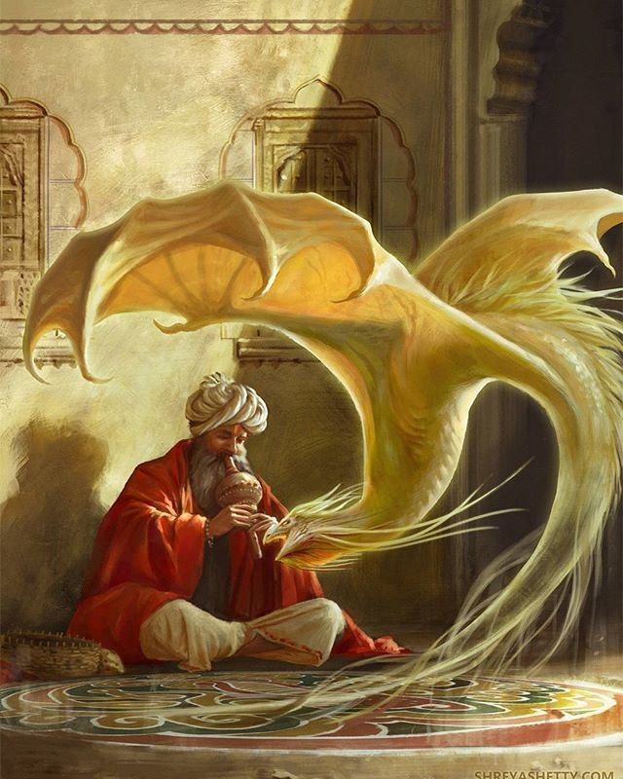

**Ájakava** - a poisonous scorpion

**Rainbow Fish** - a fish that was as large as a whale.

**Timingila** - a huge aquatic creature that can swallow whole whales in one bite

**Antaboga** – a mammoth sized serpent

Naga is an entity or being, taking the form of a very great snake — specifically the king cobra. A female nāga is a nāgī or nāgiṇī. Notable nagas.

Rakshasah

Byangoma - wise, fortune-telling birds that help the deserving.

**Other Races**

**Elves**

**Dwarves**

**Magical Items**

**Amrita** - The elixir of life, also known as elixir of immortality and sometimes equated with the name philosopher's stone, is a potion that supposedly grants the drinker eternal life and/or eternal youth. This elixir was also said to cure all diseases

**Kalash** - A vessel filled with water, five green leaves placed on it and a coconut put on the leaves. The Kalash is believed to contain amrita, the elixir of life, and thus is viewed as a symbol of abundance, wisdom, and immortality. Metal pot or Kalasha represents material things: a container of fertility - the earth and the womb, which nurtures and nourishes life. The mango leaves associated with Kama, the god of love, symbolize the pleasure aspect of fertility. The coconut, a cash crop, represents prosperity and power. The water in the pot represents the life-giving ability of Nature.

**Staff of Samundra** – named for the ancient goddess of the oceans, this staff controls weather and is used by clerics to stave off the destruction of the annual floods and storms that wreak havoc on the land

**NPC Templates**

This is a list of notes and stats to help develop NPC’s relevant to this region.

**Developer Notes**

This is a list of notes on the development of this document, including notes on history, culture, and changes to the document.

Chandrashala - The circular or horseshoe arch that decorates many Indian cave temples and shrines.

Jagati - A raised surface, platform or terrace upon which an Indian temple is placed.

Mandapa - In Indian architecture, a pillared outdoor hall or pavilion for public rituals.