Notes on the Moghun Lands

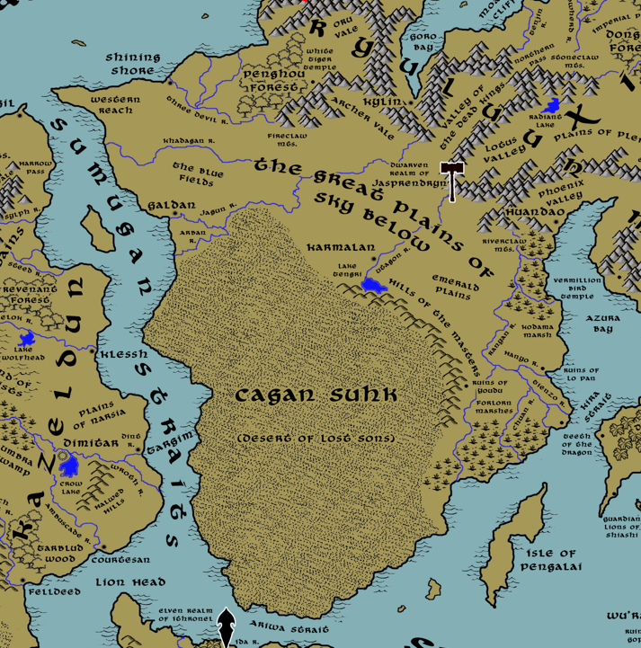

**Table of Contents**

* **Overview**
* **Towns and Cities**
* **Best in the Land**
* **Stewards of Power in this Land**
* **Points of Interest**
* **History**
* **Local Goods**
* **Notes on Culture**
* **Local Deities**
* **Creatures**
* **Other Races**
* **Magical Items**
* **NPC Templates**
* **Developer Notes**

**Overview**

The continent of Xiandai dominates the eastern part of the world, stretching from the **Orenda Sea** in the north to the **Shanga Sea** to the south. Its coastline has views into Haka’Na, Gaeadon, Sakura, and Kaduru, with straits running between them where sea traffic is a steady supply line of goods and travelers curious to see the far east. The **Ryuluun Mountains** run back and forth across the mid-section of the continent, separating the Xiandai Kingdom proper from the open plains and deserts of the Moghun peoples. The northwest branch of the continent juts out into the **Myriad Sea**. There the **Elderwyrm Mountains** stand, which have been infested with dragons for millennia and which pose a serious obstacle to ships traveling this way.

“The great horse lords of the plains were born from the sky,” spoke the Moghun prophet Arninghwat, “as Tengri caressed the skin of his love, Eje, the mother world. He swept up the grains of sand she offered from her body and he cast them aloft, as crying babies into the world. Some were eaten by the falcons, others by the wolves, the deer, and the horse. From each of those grew ten tribes, each with their own gifts. These forty children grew from the Life Tree.”

The Moghun are nomadic people who occupy the lands of Xiandai south of the Ryuluun Mountains, stretching from the Myriad Sea in the west to Azura Bay in the east. Some tribes travel by horse across the plains, which they call the Sky Below. Others dwell in the deserts in the south, called the Cagun Suhk.

It is unclear when the Moghun people first appeared in southern Xiandai. Some say that they invaded from Gaeadon, others say they were banished from upper Xiandai. Their history is unwritten. It relies on their oral tradition handed down by their Tuuli, or anointed story tellers.

The Moghun by tradition have forty tribes among them. There are stories of new tribes breaking off, but when this happens the new tribe typically drives off another tribe to make room for it on the Life Tree.

Xiandai the continent has endured an embattled history between the Moghun and the Xiandai, the term used for any people north of the Ryuluuns. Moghuns feel that all land is their land and recognize no borders except among their people. Even then, borders are open to consideration in the form of combat. For this reason the Moghun have long made inroads into the northern lands to conquer, settle, and farm what they want.

While the Moghun are not as developed as some cultures, their prowess on the plains is feared by all who know them. Some term them barbarians, but they have a culture of their own and a code of fealty to their tribal leaders.

As Arninghwat wrote, “The Moghun are an army with the bearing of peasantry…but they are also a peasantry with the heart of an army. All of them, great and small, noble and base, in time of battle becoming swordsmen, archers, lancers and devising whatever methods it takes to accomplish victory over their enemies.”

**Towns and Cities**

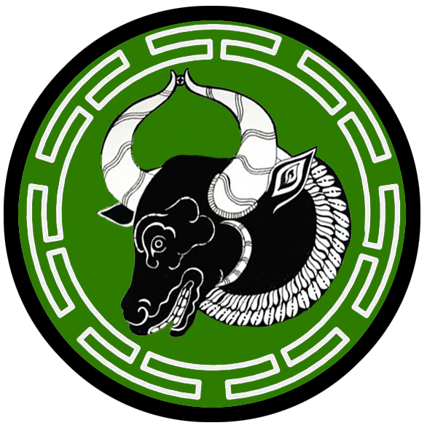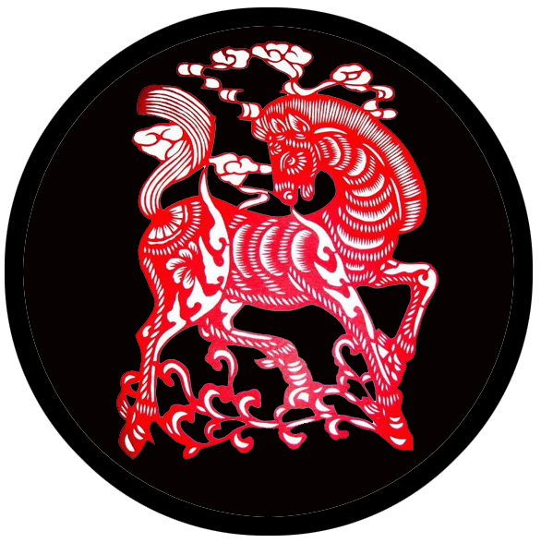

* Shining Shore – large city, sign of the monkey
* Galdan – small city, sign of the ox
* Karmalan – large city, sign of the horse

**Best in the Land**

Trade Hub:

Religion:

Arts:

Magic:

Spirits:

Steel:

Grain:

Crafted Goods (e.g. Pottery, Textiles, Metal Wares):

Harvested Goods (e.g. Aromatics, Medicine, Dyes):

Mined Goods:

Precious Metals:

Ship Building:

Other:

**Stewards of Power in this Land**

Kings and their armies are not the only wielders of power. There are many unseen friends and foes that shape the destiny of the land. Each of the groups listed below are well known to the people of this region. Some are feared, others venerated. All of them play their part in the grand drama of this land’s story.

**Merchant Companies**

Sisters of the Sea Traders – Shining Shore

**Mercenary Companies**

Deathmaw – Shining Shore

**Smuggling Rings**

(none)

**Centers of Worship (Churches, Cathedrals, Shrines, Lodges, Temples)**

Temple of Nüwa - Shining Shore

Temple of Eje - Galdan

Temple of Tengri - Karmalan

**Orders of Paladins**

(none)

**Druidic Circles**

(none)

**Bands of Rangers**

(none)

**Schools of Magic**

(none)

**Bardic Colleges**

(none)

**Warrior Academies**

(none)

**Assassins Guilds**

(none)

**Cults**

(none)

**Other Guilds**

(none)

**Monasteries**

Monastery of the White Tiger - Western Xiandai, at the edge of the Fireclaw Mountains

Monastery of the Phoenix Flame - Hills of the Masters

Monastery of the Warden of the Winds - Northern tip of the Ryuluun Mountains, overlooking Oru Vale

Monastery of the Drowned Demon - Riverclaw Mts.

Monastery of the Fire Fury - Hills of the Masters

**Pirates**

(none)

**Points of Interest**

* Penghou Forest
* Great Plains of Sky Below
* Western Reach
* **The Blue Fields** - so named for the vast carpet of blue delphina blossoms for as far as the eye can see. It is a common flower, but the people call them **Tsenkra**. The plains people consider this a sacred place, where **Eje** the world mother and **Tengri** the sky god come together in perfect harmony. No battles are fought here if it can be helped. It is said that warriors come here to receive the gods’ blessings and that those of pure heart may receive a vision from Tengri or Eje. Some holy men come here to meditate. It is said that a true holy man can enter such a deep trance that the blue fields become the sky itself and the believer can travel great distances in their mind and see far away things.

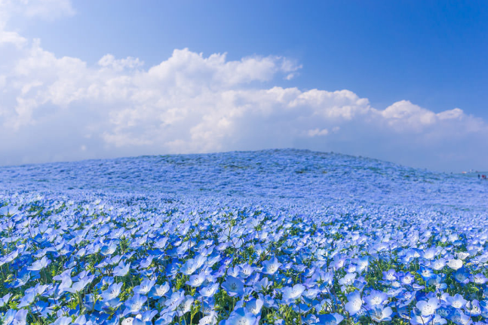

* The Emerald Plains
* Cagan Suhk (Desert of Lost Sons) –
  + The northern reaches of the desert, flanking the Arban River, is the home to the **Reesla** tribe of Saurians, known by their sign of the wavy centipede
  + the southern reaches of the desert, overlooking the sea, are home to the mighty brass dragon **Khoshin** (“humorous”) that enjoys telling and hearing stories and reputedly has a keen sense of humor
* Three Devil Rivers
* Three Devil Rivers
* Three Devil Rivers
* Khadagan River
* Jagun River
* Arban River
* Utagon River
* Ranyan River
* River (unnamed)
* River (unnamed)
* Hanyo River
* Tienzo River
* Chuan River
* River (unnamed)
* Lake Tengri
* Forlorn Marshes –
  + home to the mighty black dragon **Khuuramch** (“deceitful”)
  + here dwells the **Haarith** tribe of Saurians, known by their sign of the scorpion stinger
* Fireclaw Mts. –
  + Along the northern peaks of the Fireclaw Mountains is the **Monastery of the White Tiger**
  + In the valley encircled below stands the tower of **Narangerel (f) of the Sacred Fire,** Arch Mage of the Moghun Lands.
* Riverclaw Mts. – location of the **Monastery of the Drowned Demon**
* **Hills of the Masters** –
  + To the far north lies the **Monastery of the Phoenix Flame**
  + The central region of the hills is home to the **Arataan** tribe of orcs, known by their sign of the severed horse head
  + The southern end of the hills is home to the **Gulgek** tribe of orcs, known by their sign of the broken horse leg
  + to the far south lies the **Monastery of the Fire Fury**
  + Here dwell the tribe of Hill Giants named the **Kibraka**
* Oru Vale – location of the **Monastery of the Warden of the Winds**
* Archer Vale
* White Tiger Temple
* Ruins of Lo Pan
* Ruins of Youdu

**Shining Shore**

**Size:** large city, population 25,000, guards / soldiers 250, militia 2250

**Trade Goods:** trade hub, pottery, grain, silk, clay, silver, ship-building

**Local Goods:**

**Standard:** sign of the monkey

**Colors:** orange and black

**Patron Deity:** Nüwa, the mother goddess

**Ruler:** Batachikhan and his wife Yan (f)

**Home**: Asena Fortress

**Steward**: Zayaat

**Marshal**: Yurukhan

**House Priest:**  Khaidu

**House Adviser (Scholar/Mage/etc):**  Khojin (f)

**Captain of the Guard**: Chidukhul

**Chief Warriors in Service**:

Khaishan

Buyirugh

Suongke

**Local Powers:** Sisters of the Sea Traders, The Blue Crescent (thieves guild), Temple of Nüwa, Deathmaw (mercenary company)

**Local Sites:** Shyfish Inn & Tavern, The Broken Abacus Inn & Tavern, Wandereye (brothel)

**Description:**

Rising out of the flat terrain of the northern Moghun plains stands the brown, sun baked city of Shining Shore. It is a strange place, built on top of the ancient Xiandai city that was seized by the Moghun tribes and developed by Darmidian merchants to serve as a trade port in the east. The streets are wide and clean, the buildings a mix of architectures and of a pragmatic design. The old quarter is the Xaindai quarter, retaining the last of the original buildings and a community that clings to their traditions. The other quarters are a mix of different cultures, with buildings adorned with mosaics and arched doorways hinting of Tarbian influence.

Shining Shore is a melting pot. People here are more accustomed to other cultures and languages. The Darmidian merchant guild runs the town’s affairs, but answers to the Moghun chieftains who take turns moving from the plains to reside here. The plainsmen find city life boring, but tribes conscript riders to spend a month or more at a time to maintain control and protect the city from attacks from the sea.

The nomadic chieftains took over the palace when they conquered the city, but erected stronger walls around it. The palace space is built on a platform surrounded by double-tiered terraces, pavilions and pools.

The **Sisters of the Sea** trading company works ostensibly with the Darmidians as brokers to facilitate buyers for goods from Xiandai as well as bring goods to port that the Moghun find desirable.

**Industry:**

**Key Figures:**

**Yurukhan** is marshal to house **Batachikhan**. He oversees the granting of the **Temdeg**, or **Badge of the Sky Stallion**, to travelers who wish to pass into the Moghun lands.

**Local Lore:**

While Shining Shore is no longer a subject of Xiandai, the **Bi An** from ancient times still watches over this place. The creature is one of the **Nine Sons of the Dragon,** beasts that have guarded the Xiandai regions for millennia. The **Bi An** is a hybrid of tiger and dragon and its nature is to seek justice. Totems of the Bi An feature prominently in decorations and architecture in this region. Some are placed over prison gates in order to keep guard.

**History:**

Shining Shore was once the fishing town of **Shǎnshǎn**. The name translates in Xiandai to “glittering,” referring to the light of the sun on the waters. Fourteen hundred years ago the Xiandai Civil War erupted and all able-bodied warriors were called north to **Mingyun**. In 90 WA3 the Moghun conquered the town without opposition.

A thousand years ago Darmidian merchant ships made land fall and sought an audience with the masters of the town. The Moghun, ever suspicious, drove them away. But Darmidians are keen to smell a profit and would not give up. In 560 WA3 they sent spies into the lands to study the Moghun people. Among them was the famed Darmidian explorer, **Vorna Kalpar**. Kalpar studied the land south of the Ryuluun Mountains and took stock of what he saw. He returned the following year, bringing with him the finest horsemen, the finest wines, and the finest archers he could find in all of Tarbia. Kalpar met with the Moghun riders and entered the **Naadam**, the wrestling, archery and horseracing festival held by the plains people. Though the Moghun prevailed, they were intrigued by Kalpar’s courage and invited the strangers to their camp. Kalpar was made a friend of the Moghun people and given a copper disc bearing the great **Stallion of the Sky**. With this, he was granted passage to travel the Plains of Sky Below and all Moghun who saw the disc would allow him passage.

Over the course of ten years, Kalpar convinced the plains chieftains of his vision to bring fortunes to their shores. The Moghun consented to masons, carpenters, and laborers to be brought in and modernize the town. The Moghun saw the value in trade with outsiders and the Darmidians were keen to help them. When the Darmidians asked the Moghun what name they wanted to bless their new town, the tribal chief recalled the name of the old fishing town. The old Xiandai word for ‘glittering’ became ‘shining’ and the name translated to common. Shining Shore became an advertisement of prosperity and fortune to partners out of the west. After another decade the coastline changed. Where there once was but ocean now stood a handsome frontier town with a massive port for trade ships.

**Customs:**

Shining Shore is an eclectic city, a mixture of traders who have arrived here and been granted leave to do business. A Darmidian official, appointed as town steward by the Moghun, controls who receives the coveted merchant badges allowing one to do business. Intelligent travelers make a great effort to show deference to the Moghun chieftain in charge at the time, offering gifts and flattery.

Outlanders who are befriended by the Moghun are gifted a copper disc bearing the great **Stallion of the Sky**. With this, they are granted passage to travel the Plains of Sky Below and all Moghun who see the disc will allow them passage.

**Galdan**

**Size:** small city, population 12,000, guards / soldiers 120, militia 600

**Trade Goods:** dyes, glassware, grain, fishing

**Local Goods:**

**Standard:** sign of the ox

**Colors:** green and silver

**Patron Deity: Eje,** the world mother

**Ruler:** Dogar Nayaga and his wife Orbei

**Home**: Tsenkra Fortress

**Steward**: Maqali Tudan

**Marshal**: Olzi Esenaji

**House Priest:**  Yabuqa of the Sea Cloud

**House Adviser (Scholar/Mage/etc):**  Xorxoi the Mad

**Captain of the Guard**: Narin Kegen

**Chief Warriors in Service**:

Dodai Jajiradai

Dinget Bogorchu

Abaka Tordung

**Local Powers:** The Monkey Kings (thieves guild)

**Local Sites:** Fifty Coins Inn & Tavern, Shennong House Inn & House

**Description:**

Galdan sits on the western edge of the Xiandai continent overlooking the **Primeval Straits**. The **Jagun River** empties into an estuary rich in fish stock but not well suited for a port. What ships come this way mostly come from the towns of Vigil and Klessh. But **Red Fang** pirates prowl the waters just west, making trouble for any ship that passes.

To the north of Galdan are the vast **Blue Fields**, so named for the vast carpet of blue delphina blossoms for as far as the eye can see. It is a common flower, but the people call them **Tsenkra**. The plains people consider this a sacred place, where **Eje** the world mother and **Tengri** the sky god come together in perfect harmony. No battles are fought here if it can be helped. It is said that warriors come here to receive the gods’ blessings and that those of pure heart may receive a vision from Tengri or Eje. Some holy men come here to meditate. It is said that a true holy man can enter such a deep trance that the blue fields become the sky itself and the believer can travel great distances in their mind and see far away things.

**Industry:**

The city has many farming villages in the valley between the banks of the **Jagun** and **Arban Rivers**. Farms produce grain that feeds the Moghun tribes. The people also cultivate plants for dyeing. Sands from the nearby desert are used in kilns to create beautiful glassware popular in Kazelduun.

**Key Figures:**

**Local Lore:**

The deserts south of Galdan are home to the mighty blue dragon **Ayanga** (“lightning”)

**History:**

Battles are common between the horse masters of this region and invaders from Kazelduun. Klessh in particular has a long history of invading southern Xiandai. On occasion Klessh forces have made significant inroads into the lands north of the Cagun Suhk. Three hundred years ago the Klessh invader **Ulkan** nearly destroyed Galdan, surprising the city in a night-time raid (180 WA4). The Moghun were forced to retreat and Ulkan’s men occupied the entire river valley. Further advances saw the Klessh army take half the lands to the north, almost as far as the **Khadagan River**. But within a year the Moghun tribes had reassembled and attacked from the east. Ulkan and his army were surrounded and decimated. To this and other invasions the Moghun say, “Let the invaders come. We have swords rusting from lack of use and boys as green as grass. We welcome a good game.”

Galdan has been known to engage in raids of its own. Fourteen hundred years ago it was the destruction of the Xiandai town of Shanshan (90 WA3). Four hundred years after that it was the destruction of another Xiandai town: Lo Pan (470 WA3). Six hundred years ago the city of Vigil was conquered by Galdan raiders, seemingly on a dare, and the Kazeldun overlords were driven out (900 WA3).

No greater test of the city’s resilience was that of holding off the Celedonians three thousand years ago. In a long and protracted fight, Galdan repelled the attack by Celedonian Sterope Legion. The Legion, eager to invade the continent but losing costly casualties to the horse lords, were forced to invade the interior of the Caghun Suhk (670 WA1).

**Customs:**

Outlanders who are befriended by the Moghun are gifted a copper disc bearing the great **Stallion of the Sky**. With this, they are granted passage to travel the Plains of Sky Below and all Moghun who see the disc will allow them passage.



**Karmalan**

**Size:** large city, population 25,000, guards / soldiers 250, militia 2250

**Trade Goods:** lead, tin, grain, wine, Khövökh opium

**Local Goods:** airag (fermented milk)

**Standard:** sign of the horse

**Colors:** black and red

**Patron Deity:** Tengri, the red god of war

**Ruler:** Bora Gunutei and his wife Odval (f)

**Home**: Thunderhoof Fortress

**Steward**: Tumun Yurukhan

**Marshal**: Amal Kamala

**House Priest:** Ogodei of the Sacred Steed

**House Adviser (Scholar/Mage/etc):** Narangerel the Death Dancer (f)

**Captain of the Guard**: Aruktai Hogelun

**Chief Warriors in Service**:

Sanchir Agujam

Arik Delger

Orda Jaghatai

**Local Powers:** Lords of Fate (thieves guild), Temple of Tengri

**Local Sites:** Suhaimi’s Inn & Tavern, The Cloven Hoof Inn & Tavern, Airag Farm

**Description:**

Karmalan is the seat of power for the mighty Moghun kingdom, a vast army of nomadic horsemen whose tribes rule the plains. Though the Moghun are a nomadic people, they all regard the city of Karmalan as their sacred home. The city began as a camp set up along the Utagon where nomads met briefly, rested, swapped stories, and moved on. Gradually some tribesmen stayed as caretakers of the place. As more and more tribes visited and offered plunder to the god Tengrit the city became a going concern.

**Industry:**

Some of the Moghun have explored the **Hills of the Masters** and opened tin and lead mines. These metals they transport up to **Shining Shore** where they are sold and the coin brought back to Karmalan. Karmalan has also developed farm lands along the rich banks of **Tengrit Lake**. Among the plants farmed are poppies. Opium is produced here that has both religious and monetary value to it.

**Airag** is a popular drink among the nomadic peoples of southern Xiandai. Made from fermented milk, it is considered barbaric to those with a taste for fine wine. But it has acquired a following among travelers. There is heavy demand for it in Kazelduun, where it is considered a test of virility. **Khövökh** (“float”) is a blend of opium made in Karmalan that delivers a powerful psychedelic punch and is often used by experienced dream-travelers.

**Key Figures:**

Gunutei is a hunched, somber figure with long black hair that is pulled up into a ceremonial knot. Though heavily muscled, he was born with a disfigurement of the spine that leaves him stooped and dragging his left foot. It is said that he was cast out at a young age for his weakness, only to return from the wild strong and keen. He fought in many battles and killed off his rivals, winning the leadership of the Moghun tribes. He longs for the days when his people conquered Xiandai and is determined to lead his armies over the Ryuluun Mountains again.

**Local Lore:**

Legend holds that when the tribal warlord **Yabuqa** made his first trek across the plains of Sky Below he slew ten thousand men along the way. The blood of the men flowed like a river from the **Ryuluun Mountains** all the way to where Yabuqa stopped and rested. When Yabuqa grew thirsty he called on Tengrit the sky god and asked him for water. Tengrit rewarded Yabuqa’s deeds by turning the trail of blood into the mighty **Utagon River**. Where it stopped the sky god brought forth a bubbling font which formed the lake known by his name.

Rumor has it that there are spirits out on the sands. They speak in voices in the night, hoping to lure men to their dooms. They are called **Hayalet**. They are never seen but are thought to be malicious ghosts of the underworld.

**History:**

While Karmalan has been the origin of many armies terrorizing the surrounding lands, itself is seen as a target. Five thousand years ago during the rise of the Xiandai Empire, Emperor Hano decimated the Moghun and sacked Karmalan (240 AA3). Three thousand years before that, the city was the object of Kazeldun warlord Dractus. The general was a brilliant tactician and had studied his foe. At the Battle of the Fallen Horses: Dractus defeated the four Moghun chieftains in a decisive battle and absorbed their forces. He went on to take all of southern Xiandai (504 PA4). But thirty years later, the Moghun would have its revenge. After suffering a cataclysmic defeat and the death of their general, Dractus' army fled Xiandai. Moghun hordes waiting for them south of the Ryuluun Mountains destroyed what was left of Dractus' mighty army.

**Customs:**

Outlanders who are befriended by the Moghun are gifted a copper disc bearing the great **Stallion of the Sky**. With this, they are granted passage to travel the Plains of Sky Below and all Moghun who see the disc will allow them passage.

**History of Moghun**

**First Primordial Age (PA1)**

**Second Primordial Age (PA2)**

**Third Primordial Age (PA3)**

**Fourth primordial Age (PA4)**

502 PA4 - General Dractus of Kazeldun conquers Galdan

504 PA4 - Battle of the Fallen Horses: Dractus defeats the four Moghun chieftains in a decisive battle and absorbs their forces; marches to take all of southern Xiandai

872-888 PA4 - The Wizard War: Telemechus triggers a world-wide war of mages, some of whom march on Ongolk to stop him and some who join him in attacking the ley lines in their lands; epic battles wage all over the world, destroying cities and upsetting the balance of magic

888 PA4 - The Battle of Forlorn: Telemechus is slain but not before rupturing the magical ley lines permeating Nemmyrl; the victorious general Dragan of Celedon seizes the opportunity to rid the world of magic and ruptures the Singularion as it is embedded in the ley lines; the resulting explosion sends a shock wave that ruptures the magical ley lines around the world and triggers the Dead Century

**First Ancient Age (AA1)**

**Second Ancient Age (AA2)**

210 AA2 - Rokari, kingdom of Kaduru, invades Kazeldun, the Caghun Suhk, parts of Mahabar

550 AA2 - Rokari forces occupying Moghun lands remain here instead of answering the call home; they form a Moghun tribe of their own and adopt their ways

**Third Ancient Age (AA3)**

245 AA3 - Battle of Aemelek - Hano devises brilliant strategy to lure the Moghun forces into a trap, slays the leaders of all eleven tribes

**Fourth Ancient Age (AA4)**

818 AA4 - the evil wizard Wai Hen returns when a novice wizard accidentally opens a portal to the Void; Wai Hen uses his centuries in the Void to learn of the Crown of Power and seeks it out

820 AA4 - Wai Hen takes over the Valley of Dead Kings and animates an army of stone soldiers

821 AA4 - Wai Hen and the Stone Army defeat Moghun tribes and recruit several thousand of their riders; Wai Hen opens the way into northern Xiandai

**First Written Age (WA1)**

660 WA1 - Celedonian Septimus navy attacks Galdan and deploys the Sterope Legion

670 WA1 - Sterope Legion takes Galdan meets heavy resistance from Moghun forces outside Galdan

690 WA1 - Celedonian Secundus navy beseiges the fishing town of Shanshan (location of modern day Shining Shore)

702 WA1 - Celedon Conquest: Shanshan falls to the Abraxas Legion

730 WA1 - Celedonian Abraxas and Sterope Legions march into the Blue Fields of the Moghun Lands and are driven back by Moghun cavalry

870 WA1 - Moghun warlords take back Galdan and march to Shanshan with the heads of the Sterope Legionnaires

880 WA1 - Abraxas Legion in Shanshan surrenders the city and departs by boat to Vigil; Ladon Legion in Vigil breaks with Celedon and forms the Eastern Imperium

**Second Written Age (WA2)**

**Third Written Age (WA3)**

90 WA3 - Fall of Shanshan: Moghun raiders destroy the fishing town of Shanshan, located on the western shores of Xiandai where now stands the modern merchant city of Shining Shore.

470 WA3 - Fall of the town of Lo Pan to Moghun raiders

560 WA3 - Shining Shore is founded: Darmiddian explorer Vorna Kalpar convinces Moghun lords to build a trade port on the old site of the fishing town of Shanshan.

852 WA3 - Vigil conquered by Moghun invasion; Kazeldun overlords driven out

**Fourth Written Age (WA4)**

90 WA4 - Moghun warlord Kamalchek, dispossessed by his tribe, leads a small army over the Ryuluun to seek his fortune elsewhere

93 WA4 - Kamalchek descends on Kylin and conquers it

105 WA4 - hero Huen Fong, mentored by an ancient wizard known only as Hai Wushi, the Sea Wizard, uses the Sword of the Jiaoren to lead an uprising and free Kylin of the Moghun invaders

180 WA4 - Ulkan of Klessh invades and nearly destroys Galdan, surprising the city in a night-time raid

183 WA4 - Ulkan’s army from Klessh advance as far as the Khadagan River

184 WA4 - Moghun tribes reassemble and attack the Klessh army; Ulkan and his army are surrounded and decimated

**Local Goods of the Moghun**

**Cereals:** rice, millet, barley; (pseudo-cereals)) kuttu ka atta (buckwheat)

**Fiber:** sugar cane, jute, bamboo

**Fruits:** mango, jackfruit, banana, wood apple, orange, lemon, lime, coconut, black plum, sweet orange, kiwifruit, persimmon, apple, apple guava, karuka, pare (bitter melon), winter melon, golden langkawi melon, ten me melon (most expensive melon), jade dew melon

**Meat and poultry:** ox, duck, pork, chicken

**Nuts:** cashew, candlenut, eastern chestnut, karuka, Betel or areca nuts, jackfruit nuts, pine nuts

**Vegetables:** moringa, cooking banana, okra, snake gourd, ivy gourd, eggplants, pigeon pea, vigna mungo (black lentil), castor bean, pigeonpea, soybean, ginseng

**Herbs:** basil, black cardamom, black cumin, curry leaf, long pepper, mango, orange, pandanus, turmeric, cardamom, ginger, mustard, ashwagandha, neem, gooseberry, ajwain, sesame, cinnamon, coriander, curry tree, asafoetida, caraway, clove, holy basil, black pepper, nigella sativa, black cumin, betal leaf, jakhya, spearmint, bay leaf, tamarind

**Oils:** coconut, castor bean, yellow sarson (mustard), sesame oil, palm oil

**Fermented Drink:** dark tea, basi

**Salt-water fish:**

**Fresh-water fish:**

**Wood:** teak, ebony, gurjun, oak, padouk, satinwood, silver fir, spruce, walnut, rose wood

**Textiles:**

**Dishes:** chutney (sauce that includes such forms as a spicy coconut dip, a tomato relish, a ground peanut garnish or a dahi (yogurt), cucumber, and mint dip)

**Notes on Culture**

The Ger - Set up to be a portable home, the ger has been a traditional part of the life of the nomadic herders for millennia. Building a Moghun ger begins with a circular wooden frame: an assembly of lattice wall sections, a door frame, straight roof poles, and a crown held together with rope.

Moghun fighters honor the tradition of the **Qubchur**, a payment they must make to their superiors. In this tradition, the soldiers of the army are not paid. Rather, they rely on plunder they take in battle. From that plunder they are to make payment to their tribal chief.

Horses are the mainstay of the Moghun fighting forces. So important are horses that they keep vast numbers of them available. When one tires out, a replacement is ready at hand. The average Moghun fighter may have as many as six to thirteen horses. Riding is an art taught from a young age. Children are tied to the saddles of young horses and raised there.

Moghun cavalry are rugged survivors. Riders cycle their horses to cross extreme distances in short periods. Riders survive off of any food source available, from vermin to mare’s milk to horse meat from the spare horses. A typical provision they carry would be non-salted butter and curd from cow’s milk which was hardened and taken on campaigns. Riders are also rumored to practice blood-letting on their horses when provisions are scarce.

Moghun cavalry is considered particularly dangerous for a number of reasons: riding prowess, discipline and tactical acumen of the cavalry units, ability to fire bows from the backs of moving mounts, and the mix of horse archers and heavy cavalry wearing lamellar armor and armed with spears. Other tactics employed by Moghun riders included placing straw dummies on extra horses in battle to convince the enemy of a greater fighting force, tying sticks to the horses’ tails to stir up dust and create the illusion of reinforcements behind the army. The Moghun are also trained in the art of the guttural war cry that is alarming to hear when they charge into battle.

**Tuuli** are the singers and storytellers of the oral history of the Moghun. The epics are performed to musical accompaniment on instruments such as the morin khuur (horse-head fiddle) and tovshuur (lute).

**Naadam** - a wrestling, archery and horseracing festival

Superstitions and Customs

A shooting star is considered an omen of death. Each star represents a person. Each person has an energy line and a shooting star is a person’s energy line dying out, representing that person’s death. If a Moghun sees a shooting star, they spit and say ‘it’s not mine.’

If you’re sitting with your legs outstretched, bring them in rather than let people walk over them. Try not to point your feet towards other people or important items such as the fire or family altar. Although there is no definite reason, it is believed that the head is the most sacred part of the body so the feet must be the dirtiest. ​

Try not to touch a hat belonging to someone else. A hat should not be placed on the floor as it is an honoured possession and a very personal item.

​ Try not to touch someone with your foot. The thinking behind this is that you have invaded their social space and you may create bad feelings. If you do touch someone’s foot, you can balance this out by shaking that person’s hand so that they know you did not mean it. The same applies everywhere in Mongolia – whether that be on a bus, in a bar or a ger. ​

Inside A Moghun Ger: Within the ger, the two supports in the centre of the ger provide stability to the ger. Tradition forbids passing anything through them or leaning against them. Don’t put rubbish directly onto the fire in the stove – fire is sacred.

**Local Deities**

Nüwa, the mother goddess. Patron deity of Shining Shore.

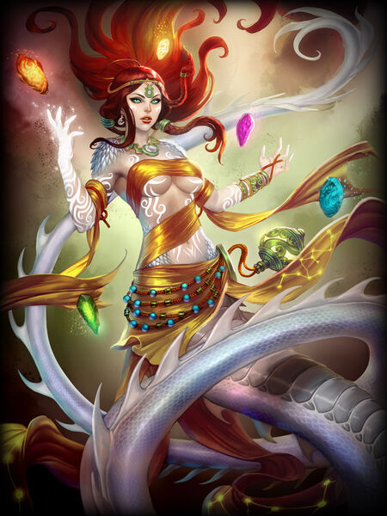

* Sometimes referred to as a serpent goddess, had a hand in creating humans
* her three subordinates—the Thousand-Year Vixen (later becoming [Daji](https://en.wikipedia.org/wiki/Daji)), the [Jade Pipa](https://en.wikipedia.org/wiki/Pipa_Jing), and the [Nine-Headed Pheasant](https://en.wikipedia.org/wiki/Jiutou_Zhiji_Jing)
* Nüwa created the five-colored stones to protect the dynasty with occasional seasonal rains and other enhancing qualities.

Eje, the world mother. Patron deity of Galdan.

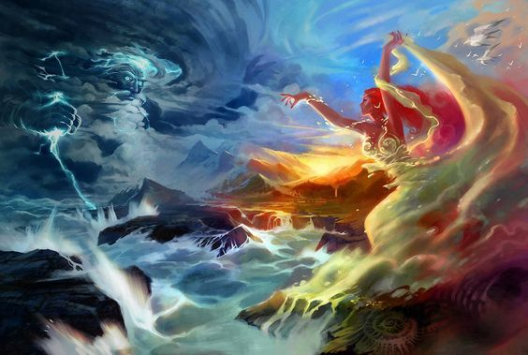

Tengri, the red god of war. Patron deity of Karmalan.

**Monasteries**

Monastery of the Black Tortoise Northern Xiandai, Kang Mountains

Monastery of the White Tiger Western Xiandai, Fireclaw Mountains (Moghun lands)

Monastery of the Vermillion Bird Southern Xiandai, in the Ryuluun Mountains

Monastery of the Azure Dragon Eastern Xiandai, at the foot of the Chime Forest

Monastery of the Phoenix Flame Hills of the Masters (Moghun lands)

Monastery of the Flaming Pearl Mountain of the Flaming Pearl

Monastery of the Bottomless Well at the mouth of the Virago Valley

Monastery of the Woodland Way Donguri Forest near the Imperial Pass

Monastery of the Mountain King Ryuluun Mountains, Lotus Valley

Monastery of the Sea Shepherd Isle of Mazu

Monastery of the Warden of the Winds Ryuluun Mountains, Oru Vale (Moghun lands)

Monastery of the Dragon God Elderwyrm Mts overlooking Virago Valley

Monastery of the Watching Eye Dark Hills

Monastery of the Dead Retainers Valley of the Dead Kings

Monastery of the Empty Void Runlun River overlooking the Bay of Nuwa

Monastery of the Ill Wind Windclaw Mts.

Monastery of the Drowned Demon Riverclaw Mts. (Moghun lands)

Monastery of the Ancient Speech Ryuluun Mountains, overlooking Ancestor River

Monastery of the Fire Fury Hills of the Masters (Moghun lands)

Monastery of the Trackless Path Dark Moon Jungle

**Creatures**

**Other Races**

**Elves**

**Dwarves**

**Magical Items**

**NPC Templates**

This is a list of notes and stats to help develop NPC’s relevant to this region.

**Developer Notes**

This is a list of notes on the development of this document, including notes on history, culture, and changes to the document.