Notes on the Lost Lands of the Amadar NOrthwest

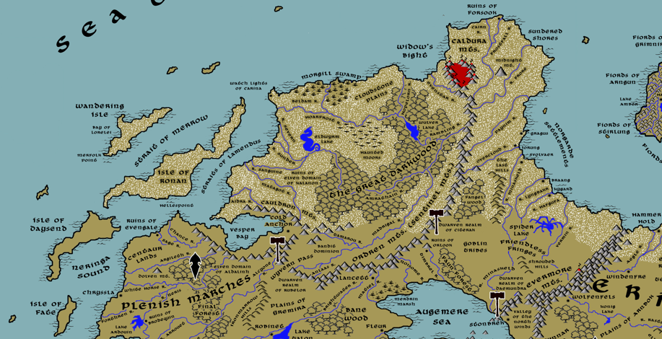

**Table of Contents**

* Overview
* Towns and Cities
* Best in the Land
* Stewards of Power in this Land
* Points of Interest
* History
* Local Goods
* Notes on Culture
* Local Deities
* Creatures
* Other Races
* Magical Items
* NPC Templates
* Developer Notes

**Overview**

“None may sleep in peace when the devil is at their back door. So, fie on the kings of the west who sleep soundly this night.”

* Berned Senclare, Baron of Lancett and Guardian of the Plenish Northern Lands

The kingdoms of Western Amadar pride themselves as civilized, the height of modern sophistication. Yet they cannot answer for the blight of darkness and chaos that lies just north of the **Augemere Sea** and west of the **Ordren Mountain** range. There, decay settles over the tattered remains of the Elven **Kingdom of Kalanon**. Shadows lurk in the **Great Darkwood** and around **Elderwyrm Lake**. Fires of doom seethe in the **Caldura Valley** as unknown eyes look on from nearby **Midnight Mountain**. Goblin tribes march without care across the **Friendless Fringes** and around the **Spider Lake** region.

The **Dire North**, as it is called by the common folk, is a dark place lost to men and elves since the **Great Orc War of the Third Ancient Age**. The wizard **Agorim the All Knowing** united a thousand Orc tribes and empowered them with mighty weapons. The Great Orc Armies of Blood, Bone, Claw, and Teeth conquered the Elven Kingdoms of Kalanon and Aldalinh and the Dwarves of Citerak before invading the Plenish Marches, the Friendless Fringes, and parts of Erigoth and Plenia. Even after major victories over the Orcs, the lands north of Wyvern Pass and west of the Evermores are an uncontested land of chaos ruled by mad wizards, tribal chieftains, and hordes of bloodthirsty creatures.

In the Third Written Age Norgarde launched the **Great Erobring**, invading the river systems all along Amadar. In 130 WA3 hardy pioneers carved out encampments along the shores east of the Ordren Mountains. Many tragedies befell them, but eventually the camps grew into the small towns of **Gragus, Iorung, Svolvaer, Braand, and Kygard**. The determined north men and women now call this hellish landscape their own and scrape out a living in this embattled land.

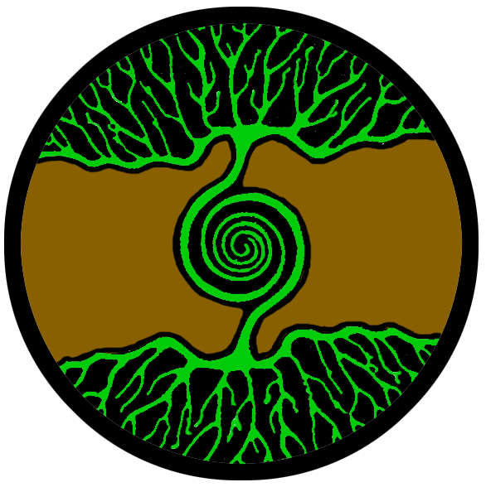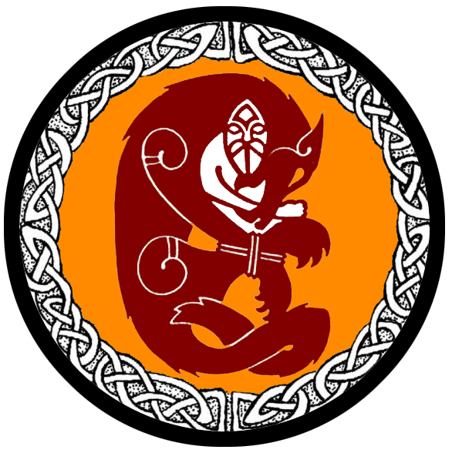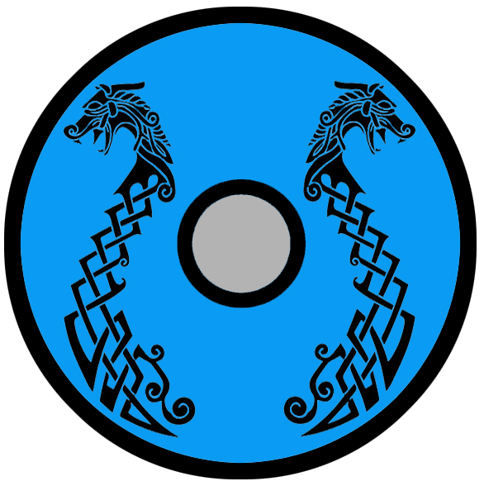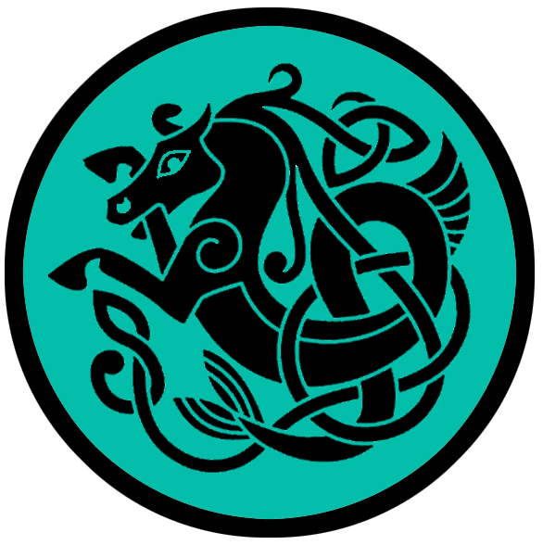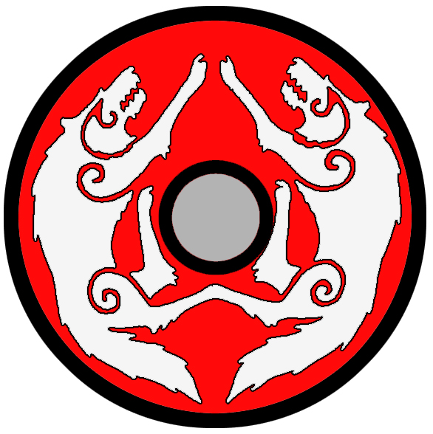

**Towns and Cities**

* Gragus – small town – settlement in Western Amadar, sign of the **life tree**, ruled by Jarl Audun
* Iorung – small town – settlement in Western Amadar, sign of the **bound wolf**, ruled by Jarl Veigar
* Svolvaer – small town – settlement in Western Amadar, sign of the **twin masts**, ruled by Jarl Thormundur
* Braang – small town – settlement in Western Amadar, sign of the **water horse**, ruled by Jarl Annilius
* Kygard - small town – settlement in Western Amadar, sign of the **twin wolves**, ruled by Jarl Jonssun

**Best in the Land**

(suggested categories for any prominent towns/cities that are leaders in a particular good)

Trade Hub:

Religion:

Arts:

Magic:

Spirits:

Steel:

Grain:

Crafted Goods (e.g. Pottery, Textiles, Metal Wares):

Harvested Goods (e.g. Aromatics, Medicine, Dyes):

Mined Goods:

Precious Metals: Gragus (platinum), Iorung (silver)

Ship Building: Svolvaer

Other:

**Stewards of Power in** **this Land**

Kings and their armies are not the only wielders of power. There are many unseen friends and foes that shape the destiny of the land. Each of the groups listed below are well known to the people of this region. Some are feared, others venerated. All of them play their part in the grand drama of this land’s story.

**Merchant Companies**

(none)

**Mercenary Companies**

(none)

**Smuggling Rings**

(none)

**Centers of Worship (Churches, Cathedrals, Shrines, Lodges, Temples)**

Hov of Idun - Gragus

**Orders of Paladins**

(none)

**Druidic Circles**

(none)

**Bands of Rangers**

(none)

**Schools of Magic**

(none)

**Bardic Colleges**

(none)

**Warrior Academies**

(none)

**Assassins Guilds**

(none)

**Cults**

(none)

**Other Guilds**

(none)

**Monasteries**

Hov of Winged Victory - Sentinel Mountains, head of Overcloud River

Monastery of Seething Sea - Isle of Daysend

Monastery of the Watchful Bear - Ordren Mountains at the head of the Noisome River

**Pirates**

Captain Harwood the Butcher Buckley

**Points of Interest**

* Wandering Isle
* Bay of Lorelei
* Merfolk Point
* Isle of Ronan
* Watchlights of Carina
* Isle of Daysend – site of the Monastery of the Seething Sea, where monks worship **Niskus** the sea god
  + The coastline here is the home of the **Llyrial** Sea Elves (also known as the Vaya Elves)
* Strait of Merro
* Straits of Lamendus
* Vesper Bay
* Widow's Bight
* Sundered Shores
  + Here lurk the tribe of Sahuangin known as the **Krauneth**, known by their sign of circular swirl with jagged edges.
* The Great Darkwood – Once the site of the Elven Kingdom of **Kalanon**.
  + The green dragon **Pergeria** dwells here.
  + Dominated by the **Claw Banner** tribe of Orcs, known by their sign of four claws arranged in a square.
* Fangel Wood
* Faun Forest – here is the secret keep of **Olyn Owle the Banished**, Grand Mage of the Lost Northwest.
* Cloudstone Plains
* Friendless Fringes – dominated by the goblin tribes of the **Skreeks**, who are known by their sign of the knotted worm
* River Aidra
* Matagot River
* Sanguine River
* Sunder River
* Severn River
* Amra River
* Darkstar River
* Hoar Frost River
* Hopelorn River
* Beldam River
* Tamarou River
* Madrigal River
* Noisome River –
  + Here dwell the **Glyx** Goblin Tribes, known by their sign of the white thistle.
  + site of the **Monastery of the Watchful Bear**, where monks study and train in the ways of **Artaius**, the protector god of herds and shepherds who took the form of a bear; it is an isolated monastery in the Sentinel Mountains and always on guard for humanoid tribes in this unfriendly region
* Timbrel River
* Sylva River
* Evenstar River
* Frostfall River
* Frore River
* Cairn River
* Paynim River
* Overcloud River – site of the Hov of **Winged Victory**, a monastery dedicated to Hretha goddess of victory
* Skeld River
* Sivra River
* Avris River
* Vermin River
* Eldwyrm Lake
  + The **Rastee** tribe of Kobolds live here, known by their sign of the three X’s. It is said that a dragon of old once lived in the lake, and the tribe descended from those who once served the old serpent. They live in fear and hope of the dragon’s return, praying to its spirit and always thinking a hidden egg may hatch to bring their lives meaning.
* Wulver Lake
* Spider Lake –
  + The **Tooth Banner** tribes of Orcs dwell here, known by their sign of the four fangs arranged in a square
* **Morgill Swamp** 
  + dwelling place of the **Oorith** tribe of Saurians, known by their sign of the fallen tree
  + A cold marshland forested with oaks, green ash, red maple, and cottonwood. Near the coast are white cedar, tamarack, and black spruce.
* Haunted Moors
* **Merdrin Marsh** – dwelling place of the **Krussik** tribe of Saurians, known by their sign of the cracked egg
* **Cauldron Mts.** 
  + Here dwells the **Dwarven Kingdom of Rubelor** (see Plenia Atlas)
  + In the southern and eastern peaks dwell the **Karzunn** tribe of Fire Giants known by their sign of the Burning Ram – they roam the Cauldron Mountains and beneath them, drawn to the delicious heat of the Kar-ka-raak furnace of the Rubelor Dwarves as well as the many open heat vents deep underground.
  + In the western most peaks dwell the **Hrooshn** tribe of Storm Giants, known by their sign of the six-pointed snow flake. Some claim they hold sway over the winds and waves in the **Straits of Lamendus**. Ships passing through here often leave offerings at the rocky shores, hoping for favorable weather. A few intrepid souls seek out the giants for counsel.
* **Ordren (Sentinel) Mts.** stretch from the Wyvern Pass in the south all the way up to the coldest reaches where it meets with the Caldura Mountains. There are a host of creatures that roam amidst the peaks.
  + Here dwell the **Frostkriger** tribe of Frost Giants, who sometimes roam eastward to harass the Norgardian colonies overlooking the sea. They are known by their sign of the cracked iceberg.
  + Dwarven Kingdom of Citerak (see below)
  + The **Blood Banner** tribes of Orcs dwell in the Northern Ordren Mts.; their sign is four red stripes drawn in a square shape
  + The **Bone Banner** tribes of Orcs dwell in the Southern Ordren Mts.; their sign is four bones arranged in a square
  + **Malisus** the white dragon dwells here, far to the north
  + **Evior** the silver dragon dwells here, far to the south near the town of Lancett
* **Caldura Mts.** – At the top of the world a ring of volcanic peaks flare and spit up clouds of ash. Gouts of molten lava descend into the valley within, forming a bubbling lake of fire in this land of ice. Red light illuminates the interior at night, creating a hellish landscape.
  + **Ardereon**, the red dragon, lays claim over the entire valley
  + Beneath the mountains lies the domain of the **Helviana Drow,** whose lairs wind for miles southward. Centuries past have seen them battle endlessly with the Citerak Dwarves.
  + Here dwells the **Harna**rog tribe of Fire Giants, known by their sign of the burning fist.
* **Midnight Mt.** – Sitting by itself east of the Calduras is a massive peak shrouded in darkness. The evil necromancer **Lazarriun** dwells here in the fortress called **Sickle Keep**. It was once the home of the dread wizard **Banasar** of the First Ancient Age.
* **Evermore Mountains –** The eastern edge of the Lost North is guarded by this mountain range.The largest range of mountains in Western Amadar, the Evermores stretch from the Heedless Straits across the Augemere Sea and into Treviland far to the west. It is home to the Dwarven **Kingdom of Daemundra**, as well as the ruinous domain of the black dragon **Syzith**. Many tales from the ancient ages speak of the Evermores and the calamities the mountains have seen. Sages tell their pupils to fret not over the trivial things in life, for they are temporary. Only the mountains persist, and will ever more.
  + Here dwells the **Hrakathuun** tribe of Storm Giants, who some claim hold sway over the winds and waves at the western end of the Heedless Straits. Some sailors leave offerings at the icy shores, hoping for favorable weather. A few intrepid souls seek out the giants for counsel.
* **The Last Hills** – The **Tooth Banner** tribes of Orcs dwell here, known by their sign of the four fangs arranged in a square
* **Shrouded Hills**
  + Here dwell the **Lahgbahg** tribe of Hill Giants
* Wyvern Pass
* **Llyrial** – Sea Elf Domain
* **Helviana** – Drow Domain
  + The dark forces of the Helviana have secured the Caldura Mountains as their infernal domain, controlling armies of lesser creatures in the Lost Northwest. Wizards summon fire elementals from the lava pools that bubble within the valley, wreaking untold destruction to the Great Darkwood and beyond. At the center of their unholy temple, they worship the power of the cursed artifact, the **Blightstone**, a giant purplish gem that is a doorway into other dimensions. The gem drains souls and lends the priests unthinkable power over life. It is the aim of **Lord Mezoldrur** to find the lost artifacts buried in the lost Elven domain of Kalanon. Legend tells of powerful wards that protect lost treasures of the elves, but so far, their search has been fraught with failure. Their enemies remain the Blood and Bone Banners of Orc tribes, who hate the drow and seek to drive them from their mountain home.
* **Citerak** - Dwarven Kingdom
  + Glitren - Dwarven city of Citerak
  + Hanfast - Dwarven town of Citerak
  + Silveron - Dwarven town of Citerak
  + Hardkiln - Dwarven town of Citerak
  + Dark Keep - Dwarven outpost of Citerak
  + Anvil Keep - Dwarven outpost of Citerak
* Bandit Dominion
* Goblin Tribes
* Ruins of Forsook
* Ruins of Orlook
* Ruins (unnamed)
* Ruins of Kalanon (elves) – This once proud kingdom fell during the Great Orc War in the Third Ancient Age. Their ruins can be found decaying in the Great Darkwood.

**The Norgarde Settlements**

During the **Great Erobring** in the Third Written Age (80 to 470 WA3) the ships of Norgarde made many landfalls on Amadar. The Norgardsmen who sailed to the frozen northwestern reaches of Amadar were filled with tales of gold and fertile fields. How many times had their forefathers rounded this coastline and wondered what life could be had here? Surely they were surprised that even they, men of the north, were so hardly pressed by the land. It was as cold as their homeland yet filled with many more dangers than anyone could imagine. Cold, hunger, and the maws of dark creatures gnawed at them. The first settlements appeared thirteen hundred years ago. They fell and were heard from no more. Then more came, a hundred years later and doomed to meet the same fate. At last the third wave came and somehow found purchase on the ruins of their predecessors.

The inhabitants of the Norgarde settlements are much like their cousins across the sea. They speak the same language and observe the same customs. People in Norgarde refer to them as **Farbrodir** (distant brothers) but less charitable terms exist such as **Fargestr** (distant strangers). Where once they were colonists owing tribute to a patron, such as a jarl or king, the **Skirta Uprising** ended that. Today they owe fealty to no king or jarl. But, in turn, they live under no one’s protection. Initially the settlements agreed upon a joint peace between them. If one camp were to come under attack, then the others would rush to help defend them. But that truce has withered with time. Eventually the ne’er-do-wells were shuffled off to Kygard and the mixed fortunes of each camp turned them against one another.

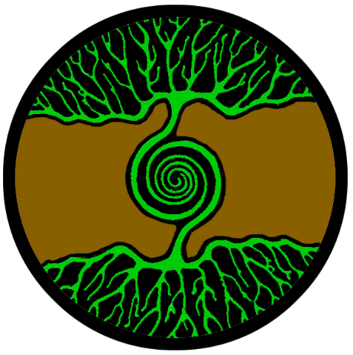**Gragus (colony)**

**Size:** small town, population 2,000, guards / soldiers 20, militia 100

**Trade Goods:** ivory (walrus), platinum

**Local Goods:**

**Standard:** life tree

**Colors:** green and brown

**Patron Deity: Gullveig the Golden Branch** – goddess of magic and gold

**Ruler:** Fridbiern Audun and his wife Yrsa (f)

**Home**: Hall of the Vakr ("vigilant")

**Steward**: Grimolf Valladur

**Marshal**: Sigfinn Kodran

**House Priest:**  Florent of the Seeing Circle

**House Adviser (Scholar/Mage/etc):**  Heidlaug the Hidden

**Captain of the Guard**: Embrek Reinar

**Chief Warriors in Service**:

Audna Krister (f)

Oelvir Hannsun

Hunroedur Hagbardur

**Local Powers:** The Illgotten (thieves guild), Temple of Igun

**Local Sites:** The Muddied Ram Inn & Tavern, The Battered Shield Inn & Tavern

**Description** :

Gragus is the northernmost of the Norgarde settlements. It sits at the edge of a spit of land overlooking the Heedless Straits. Surrounding it is a ring of large granite slabs that protrude up from the ground. Mortar and filler rock have been built up between the slabs, which stand twenty feet tall. From the outside the town appears to be a natural formation of rock like a low berm and part of the landscape.

The people of Gragus are hard and unfriendly products of this land. Survival amidst Orc tribes has made them exceedingly good at lying and constructing plots to win them fortune. Their fishing boats are often employed in raids on ships making their way along the Norwest Jaunt.

**Industry:**

Svelren, first chieftain of Gragus led expeditions up the **Paynim River** to the **Ordren Mountains**. There they found traces of platinum. This he kept secret from the orcs in the region. When stopped by the Orcs he offered them turnips which they claimed were a delicacy from the mountains. The orcs thought the humans foolish and weak for working so hard for such paltry fare. But the ruse worked. To this day shipments of platinum down the Paynim River are concealed beneath bales of turnips.

The platinum made Gragus wealthy enough to build up their defenses. Mages were brought in who raised stone works up from the ground to surround the town.

**Key Figures:**

Jarl Fridbiern Audun – nervous, greedy, manipulator

Jarl Fridbiern is a thin whisper of a man. He dresses all in black, seal skin leather and high boots. His thinning hair is pulled back into a top knot. He carries no adornments on his person, for treasure of any kind in this land would only attract attention. He is a calculating and paranoid leader, quick to send his town folk abroad on dangerous missions to avoid risk to himself. Desperate to gain some kind of leverage, he frequently descends the dungeons beneath the town to consult Heidlaug the Hidden, a reclusive mage who was shipwrecked here years ago and is kept as a prisoner.

Political Mindset: Fridbiern is nervous of Norgarde, fearful someone ambitious may hear of his platinum mines and sack the town to take over. He deals exclusively with the **Long Chain** smugglers out of Halgar, trading his ore in secret for weapons to arm his town. Towards Rafnkell of Iorung he has only contempt. The Dwarf-loving jarl is his bitter enemy and he hopes one day to conquer the town and add it to his own. Towards Jarl Dania of Svolvaer, Fridbiern is enthralled with her in spite of her handicap. He sees her as weak and unthreatening, which has driven him to want to possess her. In spite of his greed, which tells him to conquer her and further his ends of domination, a part of him is truly bewitched by her peculiar nature. As for Edvard of Braang, Fridbiern regards him too destitute of any wealth or ambition to be of any threat. But, he thinks, perhaps the plainspoken man may be pliable with the proper remuneration. Finally as to Steinen, he feels a kindred spirit: a man with a calculating mind and willingness to employ the savages of this land to obtain goals by any means necessary. He sees a powerful partnership with him could make conquest in this land much easier.

**Local Lore:**

Orcs from the Ordren Mountains make regular treks across the ice near Gragus. The **Blood Banner** tribe of Orcs has an uneasy alliance with Gragus. Their chieftain, **Harsk No Nose**, believes the puny humans harmless but valuable in the event other humans make landfall here.

Frost worms are very active this far north. The people of Gragus are wary of travel over land for fear of the beasts. It was the ranger **Hansa Hallgeir** (f) who discovered techniques for taming the beasts. To this day the town employs at least one or two frost worms as protection against the orc tribes. This has earned the humans grudging respect from the orcs. **Hansa** also developed techniques for evading the creatures over one hundred years ago. She established a route north to the Paynim River that was safer than most, using rock outcroppings from the ground to travel overland. The route is not difficult for a typical ranger to pick out but slows movement to half that of normal overland movement.

**History:**

The first settlers here attempted to make camp further north next to the **Paynim River**. But the region was exposed to attack from orcs and other creatures in the land. Thus, they settled at the top of a hill overlooking a protective cove. The waters proved to be plentiful for fishing.

Gragus was first settled thirteen hundred years ago in the Third Written Age, during the **Great Erobring** (war). Multiple settlements sprang up in the forbidden Northwest region of Amadar as Norgardians were eager to conquer a new land. The people of these fledgling settlements still hold to their Norgardian roots and are called the Kastav people by those in Norgarde.

Two hundred years ago a clever chieftain named **Svelren** made an unlikely alliance with the orc tribes in these parts. The partnership is an uneasy one, strengthened only by the town folk vowing to fight alongside the orcs against their enemies. This alliance stands to this day and has put the town of Iorung in an unfavorable light with their fellow Norgardesmen.

**Customs:**

Gragus despises the friendship their cousins in Iorung have made with the dwarves of Citerak. They have turned their backs on the pact made centuries ago among the settlements to protect one another, and now hold themselves as a separate and superior tribe.

**Iorung (colony)**

**Size:** small town, population 2,000, guards / soldiers 20, militia 100

**Trade Goods:** ivory (walrus), silver

**Local Goods:**

**Standard:** bound wolf

**Colors:** orange and red

**Patron Deity: Rinda** - giantess goddess and mother to vengeance

**Ruler:** Rafnkell Veigar and his wife Hella (f)

**Home**: Hall of Hnikarr ("spear-lord")

**Steward**: Runar Stormur

**Marshal**: Forni Hreimur

**House Priest:**  Maron the Withered

**House Adviser (Scholar/Mage/etc):** Svangeir of the Talking Stones

**Captain of the Guard**: Narsin Oerlyg

**Chief Warriors in Service**:

Brynjolf Kristmann

Benna Thormar (f)

Jona Audberg (f)

**Local Powers:** The Hidden Holders (thieves guild)

**Local Sites:** Ent and the Axeman Inn & Tavern, The Lusty Wench Inn & Tavern

**Description** :

Iorung is built high on a hill overlooking the sea and ringed by a low wall of well-crafted stone. The walls are topped with defensive works including large scorpions. Orc tribes that once found the previous inhabitants easy prey are now wary of the barrage of missiles Iorung rains upon them. Within the walls the air is noticeably warmer, as is the ground. Tunnels dug deep into the soil tap into a thermal fissure, which the Dwarves have helped craft into a system of vents running throughout the town.

**Industry:**

Only in recent years have explorers discovered a silver mine in the Ordren Mountains. Miners are careful to encase the silver ore in blocks of ice, which they float down the river to the town.

**Key Figures:**

Jarl Rafnkell Veigar – generous, brave, curious

Jarl Rafnkell is a short, fat man with large red cheeks and a billowing beard. Above his eyes are bright red eyebrows that twitch as he thinks. He dresses much in the fashion of the Dwarves of Citerak, with soil-toned colors and bits of silver on his boots and belt. Rafnkell inherited the spirit of exploration from his Norgardian ancestors and thrills at the prospect of his town making it big here. He is a man of few letters but he loves maps and enjoys stories from travelers who pass this way. Rafnkell believes wholeheartedly in the spirit of the colonies here, willing to help any of the towns along the coast. He fervently believes the gods are watching and wish them to succeed for the sake of their people.

Political Mindset: Rafnkell is a fan of the Dwarves of Citerak and is eager to visit their kingdom and learn more of their secrets. Towards Jarl Friebiern of Gragus, he is leery. He feels the man is not to be trusted and suspects treachery. Towards Jarl Dania, Rafnkell sees her as a kindred spirit: passionate for the wellbeing of her people and curious in the ways of the world outside those of their people. He feels a protective instinct towards her, sensing her physical frailties put her noble aims in jeopardy. As for Edvald of Braan, Rafnkell feels pity and a measure of disappointment. It is clear the man is an expert seaman, but has no spirit of adventure. He finds the man droll and confounding, unable to commit to any plans or enterprises or even a tall tale over a stiff drink. He is an uncertain ally at best. Steinen he finds the least bearable. He knows the man to be duplicitous and beguiling. His spies keep him informed of the man’s alliances with humanoid tribes. Rafnkell secretly prepares for the day the man will be at his gate as an invader.

**Local Lore:**

Killer whales are a danger in the waters off of Iorung. Fishermen take great pains to watch for the beasts and avoid them. This does create a natural defense for the town from sea attacks, as most boats that do not know the secrets of navigating the surf will be attacked viciously.

Frost giants are seldom a threat to the town, but miners travelling up the river are watchful for them. **Krugwar**, chief of frost giants in the Ordren Mountains, is greedy and always hunting for humans and dwarves who make off with silver from his mountains.

**History:**

Iorung was first settled thirteen hundred years ago in the Third Written Age, during the **Great Erobring** (war). Multiple settlements sprang up in the forbidden Northwest region of Amadar as Norgardians were eager to conquer a new land. The people of these fledgling settlements still hold to their Norgardian roots and are called the Kastav people by those in Norgarde.

The settlers of Iorung were at first just as desperate as their kin in the other settlements. It was an expedition up the river that brought them their first good fortune. At the base of the **Ordren Mountains** their rangers were discovered by the dwarves of the **Citerak Kingdom**. Scouts from the **Dark Keep** captured the humans and questioned them. The dwarves laughed at the folly of men venturing into these dark lands, but offered them grudging respect. Food and supplies were sent down river to aid the starving colonists and a pact was born between men and dwarves. When the humans described their travels at sea, the dwarves marveled at the mention of icebergs: mountains that floated upon the water. From that point on the dwarves called the people of Iorung the **Jokulbar, the Ice Mountains**.

**Customs:**

To this day the people of Iorung are firm allies with the **Citerak** dwarves. Warriors pledge terms of service to the dwarves in ranging the mountains and ridding the land of foul creatures. In return the dwarves have trained the men in the ways of mining and defense. Stones were ferried down to build strong walls all around Iorung. In return the humans traded silver and ivory from walruses and introduced the dwarves to delicacies of the sea. Norgardsmen from the old country who visit are surprised at the friendship the Iorung people have made with dwarves. In the old country dwarves are considered greedy and beneath men. Here they are revered as masters of the land and of war.

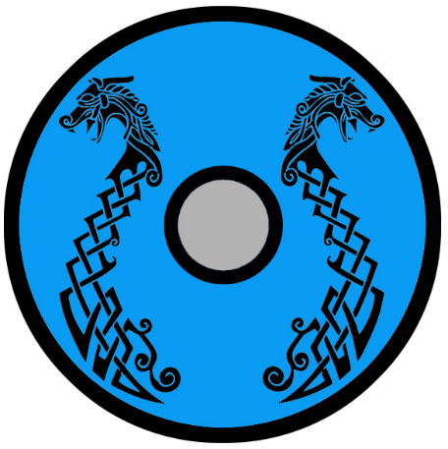**Svolvaer (colony)**

**Size:** small town, population 2,000, guards / soldiers 20, militia 100

**Trade Goods:** ship-building

**Local Goods:**

**Standard:** twin masts

**Colors:** blue and black

**Patron Deity: Gefion** – Fertility goddess associated with the plow; patron of virgins and the bringer of good luck and prosperity

**Ruler:** Dania Thormundur (f)

**Home**: Ýrungr Hall ("stormy")

**Steward**: Jona Arnesdottir (f)

**Marshal**: Reyr Bairing

**House Priest:**  Hermundur of the Silver Chalice

**House Adviser (Scholar/Mage/etc):**  Yngvi the Tattered

**Captain of the Guard**: Geir Ulfhrafn

**Chief Warriors in Service**:

Josef Edvarsun

Bryndis Marisdottir (f)

Ulfgeir Dagfaris

**Local Powers:** Otter’s Ransom (thieves guild)

**Local Sites:** Thunder Hall Inn & Tavern, Ask and Embla Inn & Tavern

**Description** :

Today Svolvaer thrives as a well-defended port town where ships are built in the fashion of the old country. Ships are sold to the other settlements, which bring in harvests of fish to feed the people as well as to explore and plunder afar. The river **Minaskeld** flows alongside the town, emptying into the sea.

**Industry:**

Outside of Norgarde, no other town but Svolvaer possesses the craftsmen and expertise to build longboats in the tradition of the north. The shipwrights here take great pride in their work, anointing their tools and planks in the rites of their ancestors. Many who covet the boats of the north pay handsomely to commission one to be built here. For the other colonies along the coast, Svolvaer ships are the only source to build up their fleets for it is far too expensive to have them brought in from Norgarde and the old country seems loath to share with their far-off kin.

**Key Figures:**

Jarl Dania Thormundur (f) – intelligent, impaired, protective

Jarl Dania is a descendant of **Sagala**, the famous shield maiden. But she is not the strong woman her predecessor was: Dania is short and thin with pale blonde hair and pale blue eyes. Her left leg is limp, a product of her harsh birth, and this has made it difficult for her to be the warrior her kin expect her to be. For all her frailty, she is not to be underestimated. She is an avid reader of books and spends her personal fortune to have more books brought in on the boats. Dania was left in the cold to die as a young girl after her parents were lost at sea. There she was befriended by a pack of wolves that taught her to respect the land. Now Dania is an accomplished Ice Druid. When her elder brothers died in battle she returned to Svolvaer to claim her rightful place as jarl. Her personal guard are utterly loyal to her and believe she is the one to best lead the town and its people.

Political Mindset: Dania rankles at the thought of dealing with Jarl Fridbiern of Gragus. She knows him to be evil and watches his every move. But she is smart enough to accept his flatteries when he visits and hides her abilities, feigning to be a weak ruler by inheritance. Towards Jarl Rafnkell she has a great fondness and respect. He seems to be a genuine leader and curious of the ways beyond those of men. Edvald of Braang strikes her as a harmless fisherman tasked with leading a town, nothing more. She has sought his help in the past, but has been disappointed in his lack of willingness to become allies without terms of payment. As for Steinen, Dania finds the man disarming and mysterious. She ignores her own better judgment that tells her he is dangerous. In her mind Steinen is a tortured soul that no one understands. She harbors a willingness to trust him, certain she can rescue him.

**Local Lore:**

Winter wolves travel in great packs along the Minaskeld River. It is said great wolf **Sköll**, king of the winter wolves, still prowls these lands. He is hungry for revenge against the humans who wounded him but still fearful of Sagala’s spear. The howls of his wolves can be heard at night, filling the air with dread. Sagala’s magic spear, **Valderlag**, remains in the town’s great hall ready to be used by the jarl’s guards if need be.

**Druur the Dark** dwells on the outskirts of town. Druur is a demon who turned his back on the abyss and now dwells in seclusion. A century ago he earned his redemption through an act of defiance against the underworld. Druur has little to do with anyone, preferring to walk the icy plains to find peace. He came to live here after rescuing Dania as a child when he found her in the wilderness. Dania is the only one who has Druur’s trust and she feels the same way in kind.

**History:**

Svolvaer was another colony settled thirteen hundred years ago in the Third Written Age, during the **Great Erobring** (war). Multiple settlements sprang up in the forbidden Northwest region of Amadar as Norgardians were eager to conquer a new land. The people of these fledgling settlements still hold to their Norgardian roots and are called the Kastav people by those in Norgarde.

When the Norgarde explorers first made camp in these lands they knew they were being watched. A thousand eyes could be seen surrounding them at night as they caught the campfire light. The men knew them to be arctic wolves. **Sköll** was their chief, a giant of a wolf at fifteen feet tall and clever with the speech of men. It is said Sköll’s pack devoured the first three expeditions that settled here. When the fourth and fifth expeditions came, the men were prepared and built defenses. But Sköll deceived them with flattering talk and pretending to be afraid. So they, too, fell.

It was on the sixth expedition that **Sagala**, shield maiden from Volsung, came. She was not as easily tricked by Sköll’s flattery, for she had not the weakness of man’s pride. She heard the words of the wolf and feigned fear for her people. She begged the wolf for peace and offered the meat stores from their ships. But the wolf did not know she had prepared the ships with traps. When the wolves began to devour the offerings of meat, a torrent of oil was released and covered their fur. Sagala sprung her trap, setting aflame the oil and the wolves with it. In an epic battle the Norgardsmen battled the flaming wolves in darkness and slew them all (480 WA3). Sagala herself wounded the mighty Sköll and sent him fleeing.

**Customs:**

Warriors of Svolvaer carry on the Norgarde tradition of the berserkers, who are keen to enter a state of absolute fury and wade into battle without armor. Here they wear the skins of wolves and are called the **Úlfhéðnar**, or “wolf coats.”

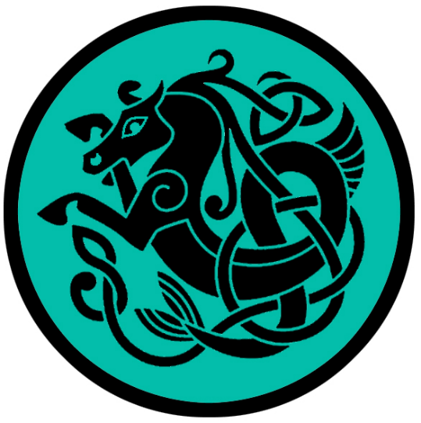**Braang (colony)**

**Size:** small town, population 2,000, guards / soldiers 20, militia 100

**Trade Goods:** fishing

**Local Goods:** hákarl, fermented shark

**Standard:** water horse

**Colors:** teal and black

**Patron Deity:** **Nine Daughters of Aegir**

**Ruler:** Edvald Annilius and his wife Baldvina (f)

**Home**: Hjarrandi Hall ("screamer")

**Steward**: Numi Hjarna

**Marshal**: Dalvin Janisson

**House Priest:**  Dara Wife of Kord

**House Adviser (Scholar/Mage/etc):**  The Wandering Boas

**Captain of the Guard**: Haflid Rikhardur

**Chief Warriors in Service**:

Hermundur Skairing

Audna Arsaill (f)

Marik Thomar

**Local Powers:** Streetwatch (thieves guild)

**Local Sites:** The Longboat Inn & Tavern, The White Horse Inn & Tavern

**Description** :

Braang is a simple fishing town with nothing remarkable about it at first sight. Built at the top of white cliffs overlooking the sea, the town is a ramshackle tangle of wooden fishing huts surrounding the inner town square. Large barns are situated outside the town where sharks and other large fish hang and rot to create **hákarl**, a local delicacy. The air around the bars creates a smell displeasing to outsiders. Oyster shells have been piled up in enormous heaps outside the town, creating bleached mounds that serve as makeshift barriers against overland invaders. A fifty-foot tall lighthouse dating back to the founding of the town stands just outside the town and is painted in ancient Norgardian runes. Surrounding the town are nine towers that stand thirty feet in height in a circle about the town. These were the original nine altars erected to the **Nine Daughters of Aegir**, sea spirits who shared the secrets of the songs of the sea with the town.

**Industry:**

While Braang is nothing more than a fishing town, the industry does exceedingly well owing to the ability of its fishermen in bringing in rare delicacies other towns find impossible to catch. The singing fishermen of Braang lure even the deepest creatures to their nets with their mystical song.

**Key Figures:**

Jarl Edvald Annilius – quiet, superstitious, cautious, weather prophet

Jarl Edvald is a tall, squarely built man with a thick white beard and dark piercing eyes. He wears a whaleskin leather tunic and pants with tall boots and a large fisherman’s hat. An antique pipe sits upon his lips at all times. He walks purposefully, his lifelong sea legs teaching him the value of surefootedness. His attitude as leader follows in his birthright from generations of fishermen and boat captains. He speaks little, is watchful, and proceeds cautiously. Some say he is born of a wind witch and has an uncanny ability to forecast the seas and the weather.

Political Mindset: Edvald’s opinions of the other coastal jarls are secrets he mostly keeps to himself. He is a cautious man who assumes every boat that calls on Braang brings trouble with it. Friedbiern of Gragus seems to him a dark cloud on the horizon, a man brewing for trouble. Rafnkell seems like a brisk tail wind, eager to push a boat forward but dangerous if no hand stays on the rudder. As for Dania, Edvald sees her as the eye of a storm: calm, appearing harmless, but promising great calamity in the end. It is Steinen that Edvald finds the most unsettling. Like a dangerous reef hidden beneath a safe harbor, Steinen is a danger to everyone who meets him. Edvald measures his words around the man and prepares for the day he inevitably becomes an enemy.

**Local Lore:**

A mighty kingdom of sahuagin lies deep beneath the waves just off the coast here.

**History:**

The settlement began as a simple camp built amongst the ruins of the earlier attempts to settle here. The first town was created here thirteen hundred years ago in the Third Written Age, during the Great Erobring (war). Multiple settlements sprang up in the forbidden Northwest region of Amadar as Norgardians were eager to conquer a new land. The people of these fledgling settlements still hold to their Norgardian roots and are called the Kastav people by those in Norgarde.

**Oddvar** was a priest to Kord who came on the first boats. Upon landfall he made offerings to Kord to bless the people and save them from starvation. When the hunters returned empty-handed, Oddvar added stones to his altar and prayed again. When the farmers found that their seeds held no purchase on the soil, Oddvar built his fires even larger. When the fishermen’s nets came back empty, Oddvar set flame to the wooden chapel and stripped himself in desperation before Kord.

At last the people of Braang grew tired of Oddvar so they cast him into the sea and left him to die.

By some luck or miracle Oddvar survived. He found himself within an underwater grotto, surrounded by nine maidens of sea-green hair and undulating bodies. They introduced themselves as the **Daughters of Aegir** and bid him to help them. A vision had foretold of a hero who would rid the water spirits of the terrible sahuagin creatures who terrorized them. Oddvar was overcome with love for the maidens. He took up his sword and single-handedly drove off the foul water demons. For this the daughters blessed Oddvar.

When the former priest returned to Braang he was a changed man. He forgave his assailants and bid them build nine altars to the Nine Daughters. He told them that Kord could not see this new land, and that it was the sea they would worship. He taught a select few the song of the sea, which could be used to charm the very fish in the ocean. The next day the fishing nets returned full to almost bursting. Oddvar became the village’s champion. The nine stone altars became a symbol for the town. Each spring the town folk add stones from the sea and surrounding countryside. The altars are now thirty-foot-tall towers that stand in a circle about the town as a reminder of the sea and the nine daughters of Aegir.

**Customs:**

The Order of Aegir still keeps the secret of the sea song alive. Travelers can hear the fishermen in their boats, singing to the fish, and the story goes that that is how Braang became so prosperous in bringing in such rare delicacies of the sea that fetch top coin.

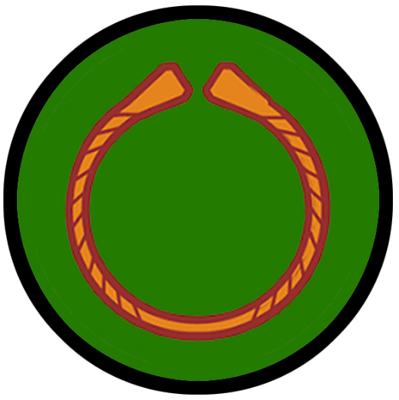**Kygard (colony)**

**Size:** small town, population 2,000, guards / soldiers 20, militia 100

**Trade Goods:** fishing

**Local Goods:** whale oil

**Standard:** twin wolves

**Colors:** red and white

**Patron Deity: Buri** - primeval god who spawned other gods at the dawn of time

**Ruler:** Steinen Jonassun and his wife Geirrun (f)

**Home**: Hall of Sigtýr ("victory-god")

**Steward**: Sif Bjartthor (f)

**Marshal**: Austmar Fridmund

**House Priest:**  Aigir the Chanter

**House Adviser (Scholar/Mage/etc):**  Arey the Green

**Captain of the Guard**: Styr Runar

**Chief Warriors in Service**:

Kristlaug Ottars (f)

Brynjolf Olrafh

Sesar Hafniss

**Local Powers:** Draugr (thieves guild)

**Local Sites:** Oar and Anchor Inn & Tavern, The Flaming Sword Inn & Tavern

**Description** :

Kygard is a bleak black stain on the white cliffs overlooking the sea. The Avris River rages through the center of town before arcing outwards over the cliffs. Behind the great falls are tunnels leading into the depths. The squalid tar-black buildings clustered together stand beneath enormous pitch-covered arches made from the ribs of a sea monster slain thousands of years ago. A good distance from the falls a giant circular disc of solid ice sits in the center of the water, slowly rotating at a bend in the river. The ice formation is a hundred meters in diameter and has been here since before the town was settled. A tower of ice stands at the center of the disc, home to the town’s wizard.

**Industry:**

Fishing is the only trade here, other than thieving and pirating. Ships are fitted for whaling as well as for battle on the open sea. Whale oil is traded in Volsung and other frozen towns in the north. But Kygard sailors are known to switch sails on the return trip and hunt for other merchant ships. To prevent their deeds leading back home the ships rarely sail their own colors.

**Key Figures:**

Jarl Steinen Jonassun – homicidal, charming, cowardly

Jarl Steinen is a thin, pale man with blue eyes and a light, patchy beard. He dresses in dark colors with a whale skin leather coat. His face, neck, and arms bear many scars which he owes to his mishaps at sea. He has a charming smile but his eyes have a haunted look to them. Steinen speaks softly and soothingly, winning over visitors to his town. But his friendly demeanor hides a sadistic and cruel spirit. He is a man fully aware of his town’s dangerous surroundings. He lives in terror of the long dark winters and the wolves that circle his people. The fear has driven him to embrace the evil ways of the ice goblins. He has seen the horrors they mete out on foes, and has decided to be the hunter instead of the hunted. Steinen enters into alliances with multiple tribes of humanoids and schemes on against the other. This aggression has turned to calculating contempt for the other Norgardian settlements. He truly believes that doom is ever at hand and he will be the last man standing.

Political Mindset: Steinen sees every other jarl as either a pawn or a victim. Fridbiern of Gragus he sees as a fellow hunter, but sloppier and less clever. This is a man he can see befriending, but only with the aim of cutting his throat after he has accomplished his tasks. Of Rafnkell and Dania, he finds tedious and predictable. Both frown on his dealings with goblins, so he is careful not to make that part of his life too obvious. It is Edvald Steinen finds the most disturbing. The man is easy to negotiate with, for he only thinks of trading for goods his poor town does not have. But his eyes have an otherworldly look to them, which makes Steinen uneasy. He does not like an unreadable foe.

**Local Lore:**

Located on the southern banks of the **Avris River**, the town is perilously situated among roaming tribes of fell creatures around **Spider Lake**. Kygard warriors are no strangers to making alliances with goblins and other humanoids.

The waters off of Kygard are also the hunting grounds of the feared **Hafgufa and Lyngbakr**, a pair of massive sea monsters. Hafgufa is the mother of all sea monsters and feeds on whales, ships, men, and anything it can catch. She is said to live underwater, and when the tide is low at night, her nose and head rise out of the water, which is often mistaken for two massive rocks rising from the sea. Lyngbakr in turn is often mistaken for a small island. It is said the creatures hunt by belching out food that attracts all the nearby fish. Once a large number has crowded into their mouths, they close their mouths and devour them all at once.

**History:**

Multiple settlements sprang up in the forbidden Northwest region of Amadar as Norgardians were eager to conquer a new land. The people of these fledgling settlements still hold to their Norgardian roots and are called the Kastav people by those in Norgarde.

Kygard began as a fishing camp for settlers from Braang who were expelled for one reason or another. After word spread to the other settlements, undesirables from every camp made their way here. Eventually jarls back in Norgarde were shipping their criminals marked for banishment to Kygard. For this reason, the people here are nicknamed the **uønskede**, or unwanted ones.

**Customs:**

The people of Kygard are unfriendly and inhospitable to strangers. Their reputation as an outlaw town has given them a sense of independence from other Norgarde settlements. There is a strange blend of pride and determination in its people, mixed with self-reliance. Kygard folk know they are on their own. Laws are observed more casually, with most disagreements being settled with personal combat.

**History**

**First Primordial Age (PA1)**

**Second Primordial Age (PA2)**

**Third Primordial Age (PA3)**

**Fourth primordial Age (PA4)**

872-888 PA4 - The Wizard War: Telemechus triggers a world-wide war of mages, some of whom march on Ongolk to stop him and some who join him in attacking the ley lines in their lands; epic battles wage all over the world, destroying cities and upsetting the balance of magic

888 PA4 - The Battle of Forlorn: Telemechus is slain but not before rupturing the magical ley lines permeating Nemmyrl; the victorious general Dragan of Celedon seizes the opportunity to rid the world of magic and ruptures the Singularion as it is embedded in the ley lines; the resulting explosion sends a shock wave that ruptures the magical ley lines around the world and triggers the Dead Century

**First Ancient Age (AA1)**

**Second Ancient Age (AA2)**

**Third Ancient Age (AA3)**

850-873 AA3- Great Orc War of the West : the wizard Agorim the All Knowing enters a dark pact with an arch demon to lay waste to the West; he unites a thousand Orc tribes and empowers them with mighty weapons then unleashes them to destroy everything in their path

851 AA3- The Great Orc Army splits into four forces: The Banners of Blood, Bone, Claw, and Teeth; Blood and Bone march west, Claw invades the Dwarven Kingdom of Citerak, Teeth marches east into the Friendless Fringes

852 AA3- Orcs of the Blood and Bone Banners assault the Great Darkwood Forest and the Kingdom of Kalanon

852 AA3- Battle of Amrathain River - Orcs of the Blood and Bone Banners crush the Elven forces of Kalanon; the Elven towns of Kalanon are laid to waste

852 AA3 - Elves of Aldalin and Adulien march to aide Kalanon; Dwarves of Rubelor march to Citerak to aide their brethren

853 AA3- the Orcs of Blood and Bone withdraw to Wyvern Pass; Elves of Aldalinh and Adulien are surrounded and ambushed at Wyvern Pass ; they flee west in retreat

853 AA3- Orcs of the Teeth Banner conquer goblinoid tribes around Spider Lake, enslaving them into their armies; Orcs of the Claw Banner conquer Dark Keep, Hardkiln, and Silverok

854 AA3- Banners of Blood and Bone assault Final Forest; Banner of Claw takes Glitren and holds off reinforcements from Rubelor

855 AA3- Orcs of the Teeth Banner meet the Dwarves of Daemundra at Long Keep in the Evermore Mountains and defeat them; Orc forces cross the Evermore Mountains into Erigoth

856 AA3- Plenia and Erigoth, realizing too late the danger, rush forces to stop the Orc invaders

857 AA3- Orc banners of Blood and Bone meet Plenish forces on the Plains of Gremira; Orcs of the Teeth banner take Windenfre; Orcs of the Claw lure Rubelor and Citerak forces into Glitren and unleash demons from a deep fissure they have created

857 AA3 - Treviland and Tirudor marshal forces to aide the western kingdoms of men; Elves of Ulynar march west, Elves of Ari'Aahn march east

858-872 AA3- fighting continues off and on around the Plenish Marches, Bane Wood, the Gunnar Gap, and the Plains of Arbock; Kingdom of Aldalinh falls to the Orc invaders

873 AA3- a series of victories over the Orcs drive them back from the Plenish Marches and the lands east of the Evermore Mountains; Aldalinh is liberated

**Fourth Ancient Age (AA4)**

**First Written Age (WA1)**

**Second Written Age (WA2)**

**Third Written Age (WA3)**

**Fourth Written Age (WA4)**

**Local Goods**

**Cereals:** einkorn (wheat), barley, oats, rye

**Fiber:** nettle, hemp and flax

**Fruits:** sloes, plums, apples, blackberries, lingenberries, blueberries, bilberries, raspberries, elderberries, cloudberried (hjortron), hawthorn berries, cherries, sour cherries, bullaces, cloudberries, strawberries, crabapple, rose hips, rowan berries, cranberries (tranbär), juniper berries (enbär)

**Meat and poultry:** beef, mutton, lamb, goat, pork, horse, chicken, geese, ducks

**Nuts:** hazelnuts

**Vegetables:** carrots, parsnips, turnips, celery, spinach, wild celery, cabbage, radishes, fava beans, beets, angelica, mushrooms, leeks, onions, edible seaweeds, potatoes, rutabaga, beans, peas

**Herbs:** sage, dill, coriander, hops, poppyseed, black mustard, fennel, watercress, cumin, mustard, horseradish, lovage, parsley, mint, thyme, marjoram, wild caraway, juniper berries

**Oils:** cod liver oil, shark liver oil, sheeps wool oil, other fish liver oil

**Fermented Drink:** barley for beer, honey for mead, hops and bog myrtle were used to flavor ale, bjórr - a drink which was both very alcoholic and which is described as being sweet, akvavit fermented from grain and potatoes

**Salt-water fish:** cod, coalfish, herring, haddock, flat-fish, ling, horse mackerel, smelt, saithe, roach, rudd, bream, whale meat

**Fresh-water fish:** perch, pike

**Esturiane fish:** oysters, cockles, mussels, winkles, smelt, eels, salmon, and scallops

**Wood:** alder, aspen, ash, birch, boxwood, elder, elm, fruitwood (cherry, blackthorn, apple, pear, hawthorne), hazel, maple, oak, poplar, pine, spruce, spindlewood, willow, yew, beechwood, sweet chestnut

**Textiles:** wool, linen (flax)

**Dishes:** Osyrat Kornbröd (Barley Flatbread), Green Soup, Nässelsoppa (Nettle Soup), Rökt Fisk (Smoked Fish), Chicken Stew With Beer, Honey Glazed Root Vegetables, Kokt Svinmålla (Boiled Lambsquarters), Pancake with Berries, Färskost (Skyr), Kornmjölsgröt (Barley Porridge)

**Hákarl** - fermented shark which has been cured and hung to dry for four to five months. It has a strong ammonia-rich smell and fishy taste, making hákarl an acquired taste. It is most often served as part of a þorramatur, a selection of traditional Norgardian food served at the midwinter festival **þorrablót (Thorrablot)**.

**Notes on Culture**

The only human settlements north of the Augemere Sea are the ones established by Norgardians along the coast. In every way these settlers maintain the same culture, language, and attire of their kin in Norgarde. This includes their warriors.

Norgardian men wear trousers and tunics, while women dress in strap dresses worn over undergarments. Ordinary clothes are made of local materials, like wool and flax, woven by the women. But the wealthy import more expensive material for their clothing, such as silk. Norgardian attire does not contain buttons or pockets. Hoods or some kind of head garment made wool or linen are common during winter. During the winter Norgardians don heavy wool socks, scarves, and mittens. Shoes are ankle height or full calf boots made of leather.

Norgardian fabrics run the range of white, black, blue, red, yellow, and various other colors. But some colors are harder to come by than others. Red is a valuable color for prestige, being more expensive as it derives from the madder plant root, a plant that isn’t native to Norgarde.

**Men**

Norgardian men wear undergarments of linen covered by a tunic that extends to the knees. This tunic often features decorative borders along the neck, sleeve edges, and bottom edge. Base garments are lighter and shorter sleeved in the warmer months and thicker and longer during the dark of winter. Trousers are simple wool or linen, and can be either loose-fitting or tight. Men also wear leggings or wool wrappings from their knees down to their ankles and feet.

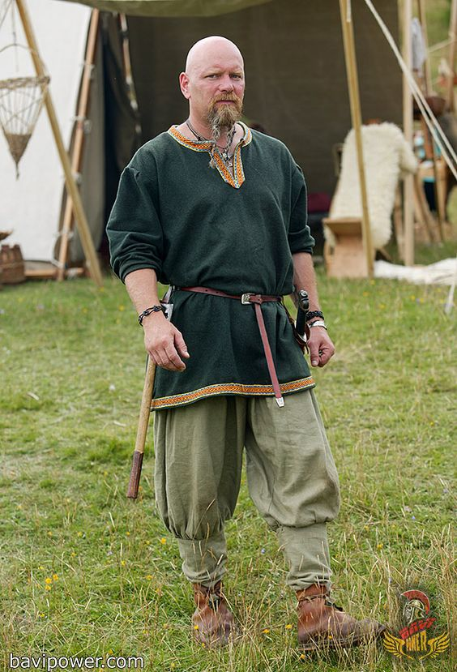

**Women**

Norgardian women wear a linen under-dress, which stretches from the shoulder down to ankle length. This layer is either plain or patterned depending on what community one belongs to. Over this they wear a wool strap dress which is slightly shorter in length. The two layers are fastened together at the straps by two iron or bronze brooches. If a woman is of very high standing, she might have had gold brooches. Over this she wears a cloak or furs in the colder seasons.

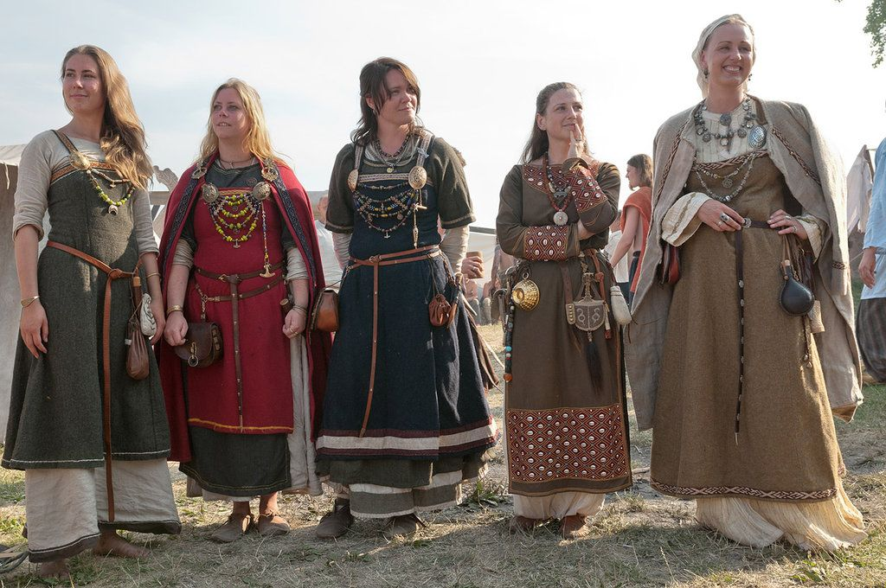

**Military Attire, Weapons, and Armor**

**Clothing:** Norgardian warriors wear undergarments of linen covered by a tunic that extends to the knees. Base garments are lighter and shorter sleeved in the warmer months and thicker and longer during the dark of winter. Trousers are simple wool or linen, and can be either loose-fitting or tight. Men also wear leggings or wool wrappings from their knees down to their ankles and feet.

**Armor:** Norgardian warriors wear heavy cloaks and much thicker tunics of sheep's skin or some other hides. A strong leather belt around the waist holds weapons in place. Warriors wear thick, leather body armor, round shields, and metal helmets. Norgardians do not prefer overly heavy clothing or armor, largely because it is a hindrance in battle. In some cases, they may wear chain shirts. They tend to carry light wooden shields and wear steel caps with nasal guards or face plates.

**Weapons:** Norgardian warriors tend to carry short or long swords, battle axes, throwing axes, and short bows.

**Base Stats:** Chain Shirt +5 AC, Light Wooden Shield +1, Throwing Axe 1d6 / x2, Shortbow 1d6 / x3, Steel Cap with Face Plate

**Markings and Standards:** Norgardian armies are recognized by the colors and designs on their shields, which match the standard for their jarl or chieftain. All other parts of their clothing and armor are of mundane and varied colors and patterns. They do not typically carry standards or flags.

Norgeld – tribute paid to Norgarde raiders to buy them off and send them away from a raided kingdom/region

Alva / Vala – female seers, mystics, oracles

Portage – carrying of Norgarde longboats over land from one river system to another

Danvikka – fortifications made by Norgarde raiding parties when beaching their boats on a river bank and reinforcing an area to protect from local armed forces, composed of wooden palisades and earthen works both moats and embankments

* Naked Run
* Polar Bear Plunge
* **Thorrablot** "feast of Thorri" - eating of disgusting foods before winter consisting of sour ram testicles, boiled sheep heads, blood pudding, liver sausage and fermented shark. Thorri is the personification of winter. Eating is seen as a sign of strength and girding one for winter’s wrath.
* The **kransen** is a gilt circlet worn by maidens of Norgarde. A symbol of virginity, among other things, it is stored before a wedding for a bride’s future daughter. During the wedding ceremony, the kransen is replaced with a bridal crown.
* **Weddings** : In the lead up to a wedding, Norse brides and grooms are separated so they can strip away their former selves before entering their new lives together. For the bride, this means being stripped of old clothing and any symbols of her unwed status, such as her kransen, a gilt circlet worn by Scandinavian girls. The kransen, symbolic of virginity, among other things, is stored for the bride’s future daughter. During the wedding ceremony, the kransen is replaced with a bridal crown.   
  During her sequestration, the bride cleanses herself in a bathhouse. Hot stones are placed in the tub to produce steam, and women often switch themselves with birch twigs to induce perspiration, which symbolically washes a bride’s maiden status away. Once the bath is finished, the bride plunges into cold water to close the pores and end the cleansing process. Throughout these preparations, women are attended by their mother, married sisters, and other married female relatives and friends.
  + Like Norgarde brides, grooms undergo symbolic rituals before entering their new lives as married men. His attendants are his father, married brothers and other married male friends. In order to rid themselves of bachelor hood and destroy all vestiges of the unmarried self, Norgarde men participated in a symbolic sword ceremony.   
    The ceremony entails a groom-to-be breaking into a grave in order to retrieve the sword of an ancestor, which is placed there by his attendants. In order to obtain the sword, the groom has to enter the grave and emerge with the sword. Through this action, he enters death as a boy and emerges into a life a man, reborn, but the same.   
    Once the groom has his sword, he, like his bride, goes to a bath house to symbolically wash away his bachelor status and purify himself for the wedding ceremony. During his cleansing, he gains insight and instruction on husbandly and fatherly duties from his attendants.
* Norgarde brides don’t wear elaborate costumes or gowns. Rather, the ornamental focus is on her hair and crown. A woman's hair is very important in Norgarde culture, and indicative of her sexual allure. The longer, the better. As a replacement for the kransen, brides wear a bridal-crown, which is typically a family heirloom. These crowns are usually made of silver adorned with rock-crystals and elaborate designs such as crosses and clover leaves, and draped with red and green garland silk cords. Some bridal-crowns are beautifully woven from straw and wheat, then garlanded with flowers.
* During a Norgarde wedding, the groom presents his ancestral sword to his bride, which she keeps for any future sons they might have. The bride then gifts the groom a sword of her ancestors, symbolizing a transfer of a father’s protection of a bride to the husband. This gift exchange symbolizes a sacred union, sanctified by mystic rites. The bride and groom then exchange rings to further consecrate their wedding vows, offering rings to one another on the hilt of their new swords.
* At the feast, a simulacrum of Kord is placed in the bride’s lap as she asked for Kord’s blessing. The goddess Vár is said to witness a couple's vows and perhaps watch over the feast.
* The bride and groom drink bridal-ale together at their post-wedding feast. Their union is only binding once they did so. The ale is usually honey-based mead, and the wedding can only go forward if the couple have had enough of it to last a month; it has to be drunk throughout their honeymoon. The first serving is presented to the groom by his wife in a vessel called the **kåsa**, known as a "loving-cup." The bride might recite a formal verse while presenting the ale. Before drinking it, the groom consecrates the ale to Kord by making the sign of a hammer over it, and toast to Kord. He then sips and passes the cup to his bride, who makes a toast to Freyja before drinking.
* Raid and warfare tactics : <https://en.wikipedia.org/wiki/Viking_raid_warfare_and_tactics>
* The board game enjoyed most often by Norgardians is Hnefatafl. Two players of unequal strength engage in the game. One player is by far the strongest, with the most pieces. His job is to corner the king, who is defending his castle with a much smaller force.

**Local Deities**

**The Old Gods of the West**

Still yet, the old gods persist, even to this day. Their crumbling stone shrines, covered in clover and moss, still whisper to the common folk who listen. These are the gods of the druids and rangers. These are the powers of nature that the common folk still call upon in their darkest hour. In lonesome monasteries hidden along the countryside the disciples of these old gods pray to harness the powers of the wind and earth, stars and moon. Their wandering prophets are called the **Faidh** and they speak riddles and the dooms of men. The old gods are the same among all Western Amadar, having hailed from the Primordial Ages when the western tribes were as one.

* **Aermid** – goddess of healing and herbalism
* **Áine and Grian** - goddesses of the summer sun and winter sun
* **Ankou** – god of the dead and the underworld, appears as a skeleton wearing a black robe and a large hat which conceals his face, or, on occasion, simply as a shadow. He wields a scythe and sits atop a cart for collecting the dead. Sometimes he drives a black coach drawn by four black horses accompanied by two ghostly figures on foot. He protects grave yards and, as the saying goes, “When the Ankou comes, he will not go away empty.” Anytime a wagon wheel squeaks or the cry of an owl is heard, it is said to be the squeaking of Ankou’s cart. The owl is referred to by some as the “Death Bird” for this reason.
* **Anotemen** – goddess of the sacred grove
* **Artaius** – protector god of sheep and cattle herders, takes the form of a bear
* **Asteron** – goddess of the dawn, beginnings, and resurrection, patron deity of Windenfre
* **Baduhenna** - matron goddess of war, patron deity of Hansla
* **Belisama** – goddess of crafts and the forge, of fire and of light
* **Branwen** – goddess of love and beauty
* **Brighid** - goddess of healing, poetry and smithcraft
* **Bussumarus** - weather deity who controlled the rain, wind, hail and fog
* **Cathubodua** – goddess of war
* **Grannus** – god of thermal springs, healing
* **Hillon** – god of sun and music
* **Matona** - river goddess
* **Nehalennia** - protector goddess of ships and sea trade
* **Noctiluca** – goddess of magic
* **Niskus** – god of the sea
* **Ogma** – god of eloquence and poetry
* **Rosmerta** – goddess of fertility and abundance
* **Rhiannon** – goddess of fertility, the moon, night, and death; her name means “night queen”; she is strong minded, intelligent, politically strategic, and famed for her wealth and generosity
* **Sandraudigr** - goddess of wealth and military pride; she appears with outstretched hands stained red with blood but gold covering her feet, patron deity of Dammerung
* **Sirona** – star goddess
* **Sucellos** – god of agriculture and wine; carried a large mallet and a barrel
* **Taranis** - god of thunder who carries a hammer and a wheel, patron deity of Hammer Hold
* **Weylund** - weird and malicious blacksmith god, patron deity of Wolfenfels

* Underlined indicates a monastery dedicated to this god or goddess

**Creatures**

(along the coast near the Norgarde settlements)

Ice Golem

Ice Druids

Frost Giants

Ice Mephit

Killer Whale

Mammoth

Polar Bear

Remorhaz

Winter Wolf

White Dragon

Yeti

**Other Races**

**Elves**

The Great Darkwood – Once the site of the Elven Kingdom of Kalanon.

**Dwarves**

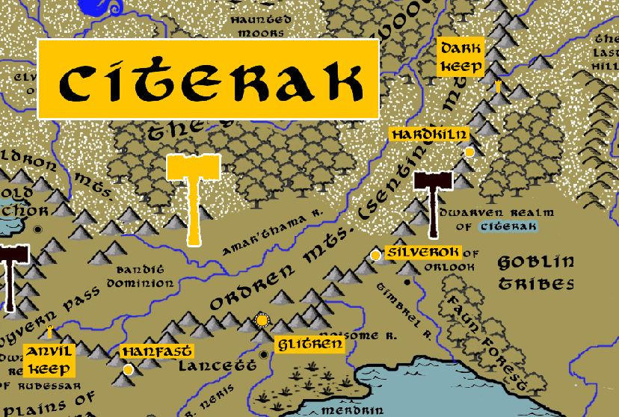

**Magical Items**

**The Four Banners of Midnight** – There were four primary banners carried by the four armies of Great Orc War of the West. Cursed by the dark gods Gruumsh and Nerull, each banner radiated powerful spells of disease, enfeeblement, and pestilence on any who opposed the Orc armies. They were fashioned from the robes of the fallen wizard **Banasar**, who was defeated in the First Ancient Age.

* **The Banner of Blood** -
* **The Banner of Bone** -
* **The Banner of Teeth** -
* **The Banner of Claw** -



**Horn of Banasar** - a lost relic created by Banasar the wizard in the First Ancient Age to rally the Orcs of the Northwest. It was also used to launch the Great Orc War of the West. During the Second Dark Crusade Mortavay found the horn and blows it. The horn enthralls the western Orcs descended from the Great Orc War. The Orcs rose up and begin attacking the people in the West in advance of Mortavay's planned invasion.

**NPC Templates**

This is a list of notes and stats to help develop NPC’s relevant to this region.

**Developer Notes**

This is a list of notes on the development of this document, including notes on history, culture, and changes to the document.

Name Sources:

Fantasynamegenerators.com

Colonies: Icelandic names

Norgardian settlements:

Western – Norwegian names

Central – Viking names

Eastern – Swedish names

|  |
| --- |
| <https://en.wikipedia.org/wiki/Trade_during_the_Viking_Age> |
| Honey, tin, wheat, wool, various types of fur and hides, feathers, falcons, whalebone, walrus ivory, and amber. |