Notes on the lands of Xiandai
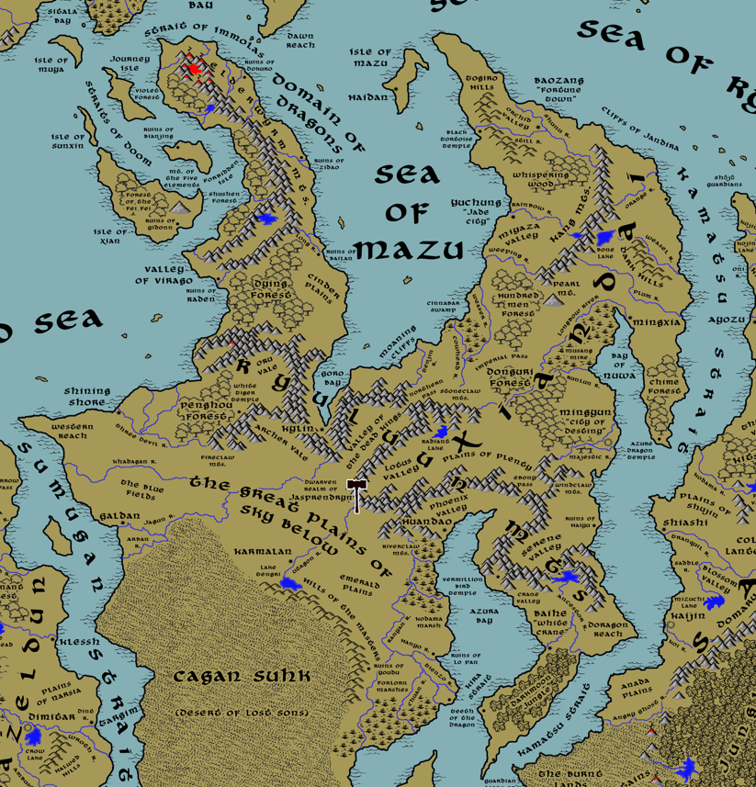

Table of Contents
- Overview
- Towns and Cities
- Best in the Land
- Stewards of Power in this Land
- Points of Interest
- History
- Local Goods
- Notes on Culture
- Local Deities
- Creatures
- Other Races
- Magical Items
- NPC Templates
- Developer Notes

Overview
The continent of Xiandai dominates the eastern part of the world, stretching from the Orenda Sea in the north to the Shanga Sea to the south. Its coastline has views into Haka’Na, Gaeadon, Sakura, and Kaduru, with straits running between them where sea traffic is a steady supply line of goods and travelers curious to see the far east. The Ryuluun Mountains wind across the mid-section of the continent, separating the Xiandai Kingdom proper from the open plains and deserts of the Moghun peoples. The northwest branch of the continent juts out into the Myriad Sea. There the Elderwyrm Mountains stand, which have been infested with dragons for millennia and which pose a serious obstacle to ships traveling this way.

Xiandai is an old civilization steeped in traditions honoring its ancestors. Fishing villages slowly grew to cities of magnificent art, music, and innovation. Power has shifted between the many regions but now provinces have formed around eight major towns and cities. Towering over them all are the Jade City in the north, Yuchung, and the City of Destiny in the south, Mingyun. South of the Ryuluun Mountains the mighty Moghun nomads rule the Great Plains of Sky Below as well as the deserts of the Caghun Suhk.

Towns and Cities

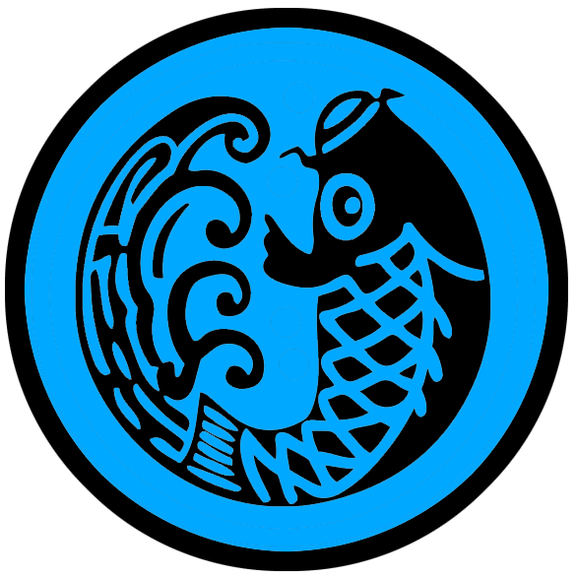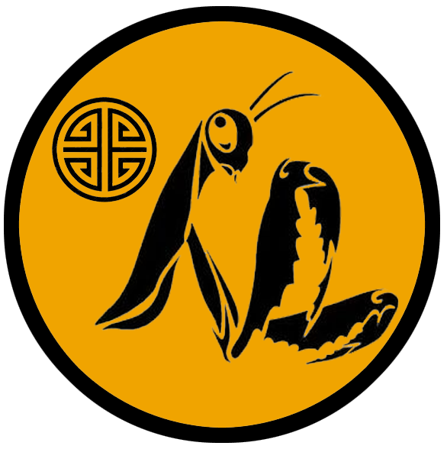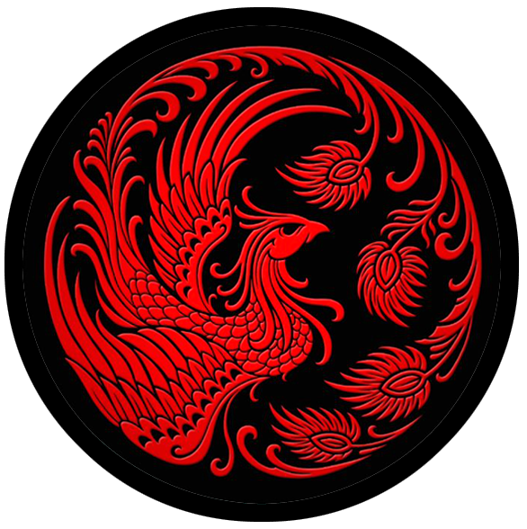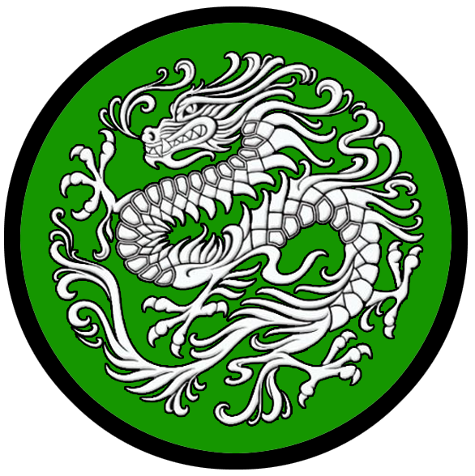
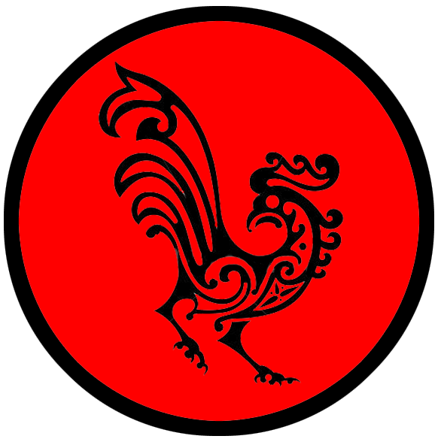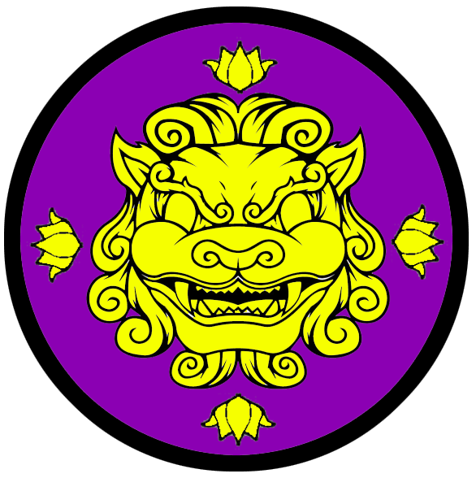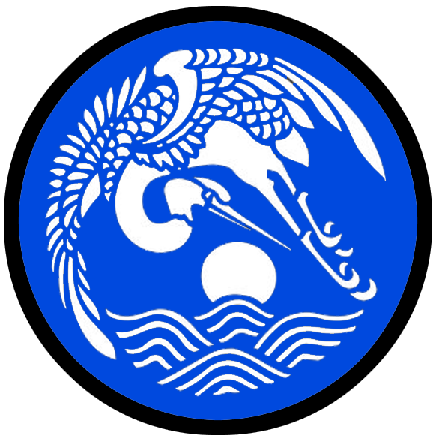

- Haidan – small town, sign of the fish
- Bǎozàng “Fortune Town” – large town, sign of the mantis
- Kylin – small town, sign of the phoenix
- Yuchung “Jade City”– large city, sign of the dragon
- Mingxia – small city, sign of the rooster
- Mìngyùn “City of Destiny” – metropolis, sign of the lion dog
- Huandao – small city, sign of the ox
- Báihè “White Crane” – large city, sign of the crane

Best in the Land
Trade Hub: Boazang “Fortune Town”, Baihe “White Crane”
Religion:
Arts: Yuchung “Jade City” (dance, calligraphy), Baozang “Fortune Town” (instrumental music), Baihe “White Crane” (vocalists)
Magic: Mingyun “City of Destiny”
Spirits: Mingyun “City of Destiny”
Steel: Yuchung “Jade City”
Grain:
Crafted Goods (e.g., Pottery, Textiles, Metal Wares): Baihe “White Crane” (porcelain)
Harvested Goods (e.g., Aromatics, Medicine, Dyes): Haidan (Tea), Kylin (Tea)
Mined Goods:
Precious Metals:
Ship Building: Haidan, Baihe “White Crane”
Other:

Stewards of Power in this Land
Kings and their armies are not the only wielders of power. There are many unseen friends and foes that shape the destiny of the land. Each of the groups listed below are well known to the people of this region. Some are feared, others venerated. All of them play their part in the grand drama of this land’s story.

Merchant Companies
Kurakami Trading Company - Bǎozàng “Fortune Town”
Gongono Traders Company – Báihè “White Crane”

Mercenary Companies
Fury March – Bǎozàng “Fortune Town”

Smuggling Rings
The Black Net – Haidan
Zhou-Sizhe - Kailin
Gossamer Web - Yuchung “Jade City”

Centers of Worship (Churches, Cathedrals, Shrines, Lodges, Temples)
Temple of Haishen - Haidan
Temple of Fengshen - Bǎozàng “Fortune Town”
Temple of Shanshen - Kylin
Temple of Zhurong - Yuchung “Jade City”
Temple of Shuishen - Mingxia
Temple of Xihe - Mingyun “City of Destiny”
Temple of Mushen - Huandao
Temple of Yueshen - Báihè “White Crane”

Orders of Paladins
Order of Panlong - Yuchung “Jade City”
Order of the Flaming Pearl - Mingyun “City of Destiny”

Druidic Circles
Circle of the Hidden Spring - Bǎozàng “Fortune Town”

Bands of Rangers
Band of the Divine Archer - Bǎozàng “Fortune Town”
Band of the Fox Tail - Mingxia
Band of the Yeren - Huandao

Schools of Magic
Feilong Sanctum - Mingyun “City of Destiny”

Bardic Colleges
Flying Daggers (music school) - Bǎozàng “Fortune Town”
Bird of Dawn (dance school) - Yuchung “Jade City”
Gardenia Conservatory (song) - Báihè “White Crane”
Warrior Academies
(none)

Assassins Guilds
Black Lotus - Bǎozàng “Fortune Town”
Jintao - Yuchung “Jade City”
Soldiers of Youdu - Mingyun “City of Destiny”

Cults
(none)

Other Guilds
Hanja school of calligraphy - Yuchung “Jade City”
Heaven Dome (colosseum) - Mingyun “City of Destiny”
Kaolin Guild (porcelain) - Báihè “White Crane”

Monasteries
Monastery of the Black Tortoise - Northern Xiandai, Kang Mountains
Monastery of the Vermillion Bird - Southern Xiandai, in the Ryuluun Mountains
Monastery of the Azure Dragon - Eastern Xiandai, at the foot of the Chime Forest
Monastery of the Flaming Pearl - Mountain of the Flaming Pearl
Monastery of the Bottomless Well - at the mouth of the Virago Valley
Monastery of the Woodland Way - Donguri Forest near the Imperial Pass
Monastery of the Mountain King - Ryuluun Mountains, Lotus Valley
Monastery of the Sea Shepherd - Isle of Mazu
Monastery of the Dragon God - Elderwyrm Mts overlooking Virago Valley
Monastery of the Watching Eye - Dark Hills
Monastery of the Dead Retainers - Valley of the Dead Kings
Monastery of the Empty Void - Runlun River loverlooking Bay of Nuwa
Monastery of the Ill Wind - Windclaw Mts.
Monastery of the Ancient Speech - Southern tip of the Ryuluun Mountains, overlooking Ancestor River
Monastery of the Trackless Path - Dark Moon Jungle

Pirates
Captain Xu Shun the Sea Demon - East of the Elderwyrm Mts.
Captain Lu Gong the Sea Prince - Phoenix Valley
Captain Makia Ironsail (f) - Doragon Reach

Points of Interest
- Journey Isle - One of four Isles of Doom at the northern tip of the Xiandai continent, all of which sit in the shadow of the Domain of Dragons. So named because it sits closest to the Strait of Immolas and was once a stopover for ships passing into the east. Now it is a barren place bereft of civilization.
- Isle of Sunxin - One of four Isles of Doom at the northern tip of the Xiandai continent, all of which sit in the shadow of the Domain of Dragons. Seamen daring the Immolas Straits still make port on the western side, where pirates have created small shelters in the rocky cliffs to hide their boats.
- Isle of Xian – One of four Isles of Doom at the northern tip of the Xiandai continent, all of which sit in the shadow of the Domain of Dragons.
  - Here is the location of the Mountain of Five Elements and the Purple Palace, ancient home of the Eight Immortals. Built in the Primordial Ages, it was the site of the battle between the Eight Immortals and the White Bone Demon, Baigujing. Here they defeated the demon and entombed it in a magical well.
- Forbidden Isle - One of four Isles of Doom at the northern tip of the Xiandai continent, all of which sit in the shadow of the Domain of Dragons.
  - location of the ruins of Bianjing
- Isle of Mazu – A prominent island of the Xiandai lands and home of the northern most of its towns, Haidan.
  - Here is the location of the Monastery of the Sea Shepherd

- Ezerenis – Sea Elf Domain

- Strait of Immolas – Known as the Burning Strait, the passage between the continents of Amadar and Xiandai is infamous for attacks on ships by dragons ruling the Elderwyrm Mountains. Merchant ships often choose to take the long Noreast Jaunt or south through the Sumugan Straits to reach eastern lands.
- Straits of Doom – The group of islands west of Xiandai’s northern peninsula, called the Isles of Doom, have long since been abandoned since the Great Dragon War. Dragons from the Elderwyrm Mountains regularly visit the islands and some breeds prefer them over the mountains. Sailors have dubbed the waters between these islands the Straits of Doom, for no boat can safely pass without the likely encounter with danger.
- Goro Bay – At the far southern end of the Bay of Mazu the coastline on either side draws closer together, forming a narrow channel with high mountains crowding in to blot out the sun. It is here the town of Kylin is nestled, far removed from the warmer seas. Strange creatures lurk in the shadowy waters here and there is an unnatural silence. Sailors are often spooked by the eerie echoes traveling across the water, often like voices answering from one mountain range to others on the opposite side.
- Moaning Cliffs
- Cliffs of Jandira
- Shojo Guardians – Standing at the northern mouth of the Kamatsu Straits, one on the Xiandai coast and one on the Sakura coast, these 100-foot-tall statues depict a Xiandai warrior and a Sakuran warrior brandishing spears that point heavenward. They were erected in the First Ancient Age by two princes who waged the cruel and pointless Fisher King War as a reminder of the friendship once shown between Xiandai and Sakura and the pledge to strength during peace time.
- Kamatsu Strait
- Bay of Nuwa
- Azura Bay
- Guardian Lions of Shiashi – During the occupation of the Mahabar lands in the Alabaster Dynasty (240 AA3 – 700 AA3) monks of Xiandai prayed to the gods for protection of the Kamatsu Strait. In 420 AA3 they were gifted by two enormous sentinels: 100-foot-tall giant magical lions. The lions made war on many who passed this way. At last in 320 AA4 the wizards in Hanshu's court of the rising Azura Kingdom petrified the great Guardian Lions of Shiashi, turning them to stone.
- Kira Strait
- Teeth of the Dragon

- Violet Forest
- Forest of the Fei Fei – home to the Fei Fei, diminutive magical creatures
- Shushen Forest – long ago was the home of magical beings the locals called the tree gods of Xiandai, but the forest has grown dark since the occupation of the dragons in these parts. Some lore masters suspect these were Treefolk but none have been seen to confirm this.
- Dying Forest – is the realm of Bai Gu Jing the Yaoguai. Lady Baigujing is a shapeshifting demoness and in her true form she is appears as a skeleton. Lady Baigujing dwells in an ancient tower within the forest which some call White Bone Keep. Beneath the keep it is said there lays a portal to hell itself. Baigujing hungers for mischief and human souls. She is keen to wander the lands, tricking the innocent into calamity. She is feared by even the most powerful monks. It is said she wanders the Cinder Plains, where she arranges corpses like one would arrange flowers in a garden.

- Whispering Wood
  - The rangers of the Band of the Divine Archer roam these woods and consider it under their protection.
- Hundred Men Forest
- Chime Forest – Chime Forest is a tranquil forest of trees and bamboo where large pandas roam peacefully. The greatest among them is Hépíng, a nature spirit born at the dawn of time who appears as an enormous panda. She only appears on this plane when it suits her, looking after panda children and their home in the Chime Forest.
  - The rangers of the Band of the Fox Tail regularly patrol these woods and consider it under their protection.
  - Countless years ago, the monks of the Azure Dragon installed tiny strips of bamboo into the trunks of trees, arranging them in a staircase pattern spiraling up the trees. Every time an acorn or any other fruit from the trees drops onto these chimes, they make an otherworldly music as they roll and strike the strips.
  - The Monastery of the Azure Dragon is located deep within the forest. They enjoy the solitude of the forest and are fierce protectors of its borders.
- Donguri Forest is a vast and enchanted forest. It is the home of the Huli Jing, shapeshifting nine-tailed foxes that transform into the form of a beautiful woman. It is said that they bewitch men and lead to their downfall. Others say they are pure of heart and only evil men preying on women cast them in this undeserved reputation. Many other creatures dwell here and it is not a safe place for town folk.
  - location of the Monastery of the Woodland Way
- Darkmoon Jungle
  - location of the Monastery of the Trackless Path

- Cinder Plains – Before the Great Dragon War the plains were lush fields of wild grass and fruit trees. Now it is a scorched stretch of land hated by dragons who remember the armies who marched here against them. Every few years dragons return and raze the land again, determined to eradicate any life here. It is said the trees that grew here bore special the Shengli pears, fruit of such divine blessing that they bestowed speed, strength, and valor. Some say there may still be surviving sprouts of the Shengli trees hidden from destruction. Adventurers occasionally venture here on quests to find one and achieve greatness.
- Plains of Plenty
- Doragon Reach

- River (unnamed)
- River (unnamed)
- River (unnamed)
- River (unnamed)
- River (unnamed)
- River (unnamed)
- River (unnamed)
- River (unnamed)
- River (unnamed)
- River (unnamed)
- River (unnamed)
- Long River
- River (unnamed)
- River (unnamed)
- Still River
- Shunu River
- Orange River
- Rainbow River
- Weasel River
- Weeping River
- Plum River
- Longbow River
- Weaver River
- Cowherd River
- Runlun River – location of the Monastery of the Empty Void, overlooking the Bay of Nuwa
- Tenjin River
- Majestic River
- River (unnamed)
- Ancestor River – location of the Monastery of the Ancient Speech
- Moon Rabbit River – so named for Yuè tù, the pet rabbit of the moon goddess Cháng'é

- Lake (unnamed)
- Lake (unnamed)
- Lake (unnamed)
- Bone Lake
- Radiant Lake
- Lake (unnamed)

- Cinnabar Swamp – this is a mire formed in the bed of dark ash pushed up from the depths after repeated volcanic activity from underground fissures. Trails of toxic sulfur fumes rise up from bubbling pockets of ooze. In times of low activity peasants don masks and brave the swamps in boats to search for precious stones that bubble up from the depths. Cinnabar is collected as a decorative paint used in pottery and painting but is handled carefully for it can be poisonous.
  - Standing here, overlooking the Bay of Mazu, stands the tower of Jiang Fang of the Golden Feather, Arch Mage of the Xiandai lands.
- Musang Mire – Named Musang for the civets that sometimes wander through here from the nearby Donguri Forest.
- Kodama Marsh

- Elderwyrm Mts. – Home of dragons, the Elderwyrm Mountains were taken over by dragons thousands of years ago.
  - Countless kobold warrens snake beneath the Elderwyrm Mountains. The small reptilian creatures serve the evil dragons that dwell here, carving out tunnels, setting traps, and decorating illustrious caverns for their masters. Of the nameless swarms of kobold, four large tribes have evolved:
    - Wyrm Delve, known by their sign of the vertical row of four triangles, the top triangle filled in
    - Sootfoot, known by their sign of the vertical row of four triangles, the second triangle filled in
    - Glasdark, known by their sign of the vertical row of four triangles, the third triangle filled in
    - Ashblak, known by their sign of the vertical row of four triangles, the fourth triangle filled in
  - location of the Monastery of the Dragon God
- Kang Mts.
  - Here dwells the Four Fingers tribe of orcs, known by their mark of the black hand with four severed fingers.
  - Monastery of the Black Tortoise is located here.
  - Home to the mighty silver dragon Gaojia (“elevated one”)
  - Home to the forge of the fire god Zhurong. Hidden deep beneath the world, Zhurong’s steel works are a massive complex of gears and steam-powered machinations. Here, the fire god toils at various projects, keeping things running that move the land itself.
  - Tiangou, mythical large black dogs that have magical powers, dwell in these mountains.
  - Zauvorel – Drow Domain - The Drow kingdom of Zaurovel dwells in the Kang Mountains, wielding its power in the region with few rivals. The Orc tribe of the Four Fingers has historically bristled at the idea of working with the Drow, but the two are currently uneasy allies. The Tiangou are enemies of Zaurovel. Meanwhile, there are two factions vying for power among the Drow: those who seek to continue their evil ways and those who seek just and noble aims. Civil war has waged here for two centuries.
- Mountain of the Five Elements – This is a tall and imposing mountain with almost no discernible means of reaching the top except for a single road fraught with curses. It is the location of the Purple Palace and ancient home of the Eight Immortals, who ruled in the Primordial Ages and have long since ascended to heaven. The Eight Immortals were He Xiangu the Sound Mind, Cao Guojiu the Voice, Li Tieguai the Healer, Lan Caihe the Youth, Lü Dongbin Leader, Han Xiangzi the Harmony, Zhang Guolao the Chaotic, and Zhongli Quan the Death Alchemist.
- Pearl Mountain – Pearl Mountain is one of the holiest places in Xiandai. Dense forests lead up its slopes, often causing explorers to become lost. The peak is cast in a strange glow that can be seen for miles and changes colors over time. This is the site where the first Flaming Pearl descended from heaven at the beginning of time. It is a sentient agent from the gods bestowing spiritual energy, wisdom, prosperity, and power on those it chooses. Many a fate of men was changed when the pearl shined its light on those considered unworthy. The Monastery of the Flaming Pearl is located here, where its monks guard the hidden doorways leading to the pearl’s realm of magic. The monks are neutral good and meditate on Xihe, a great sun goddess.
- Ryuluun Mts. – A long and winding range of mountains that traverses the continent of Xiandai, splitting it into northern and southern halves. According to legend the mountains are the remains of the Cosmic Dragon who, after being wounded from the Battle of Vail, reclined here and entered the sleep of ages; his body became the Ryuluun Mountains.
  - Orc tribes dwell all along the length of this mountain range.
    - The Skulstik tribe of orcs overlook the Oru Vale region and are known by their sign of the black head on spear.
    - The Ear Pole tribe of orcs overlook the Valley of Dead Kings region and are known by their sign of the four white severed ears.
    - The Red Rain tribe of orcs overlook the Lotus Valley region and are known by their sign of the red ribbon of entrails.
    - The Bone Mask tribe overlook the Doragon Reach region and are known by their sign of the white pelvic bone with eyes.
  - In the southern reaches dwells the Dedferet tribe of goblins, known by their mark of the dead ferret. The Dedferet goblins control a large section of the peaks from which they launch raids into the Lotus and Phoenix valleys. The town of Huandao has a long history of conflict with this tribe.
  - Three tribes of giants dwell in the Ryuluun Mountains. To the north lie the Storm Giants called the Yunlei, who watch over both the Myriad and Mazu Seas. They are known by their sign, twin streaming swirls emanating from either side of a mountain. Southward, along the center of the mountain range, dwell the Shigu Stone Giants, and to the far south the Jianshi Stone Giants.
- Stoneclaw Mts.
- Windclaw Mts. – The Windclaw Mountains are frightful, twisting slopes carved by centuries of winds. The whistling sound of the currents passing through the rocks can often rise to a crescendo of howls, possibly from divine powers. It is the location of the Monastery of the Ill Wind, a lawful evil monastery seeking to master the powers of the winds.

- Togiro Hills
  - Here dwells the Juren tribe of giants, who terrorize the surrounding lands but avoid Orchid Valley after their sound defeat there . History has seen Xiandai warlords hire the Juren in their campaigns against one another.
- Dark Hills – location of the Monastery of the Watching Eye

- Valley of Virago – Wedged within the crook of the Elderwyrm Mountains, the valley is abandoned of any civilization except for the Monastery of the Bottomless Well. Dragons roam freely amidst the mountains, making their homes and preying on anything that moves. The ruins of villages stand here and there, relics from thousands of years ago. There are strange mists all about, some of them poisonous. The monks travel without fear here, having learned to become almost invisible.
- 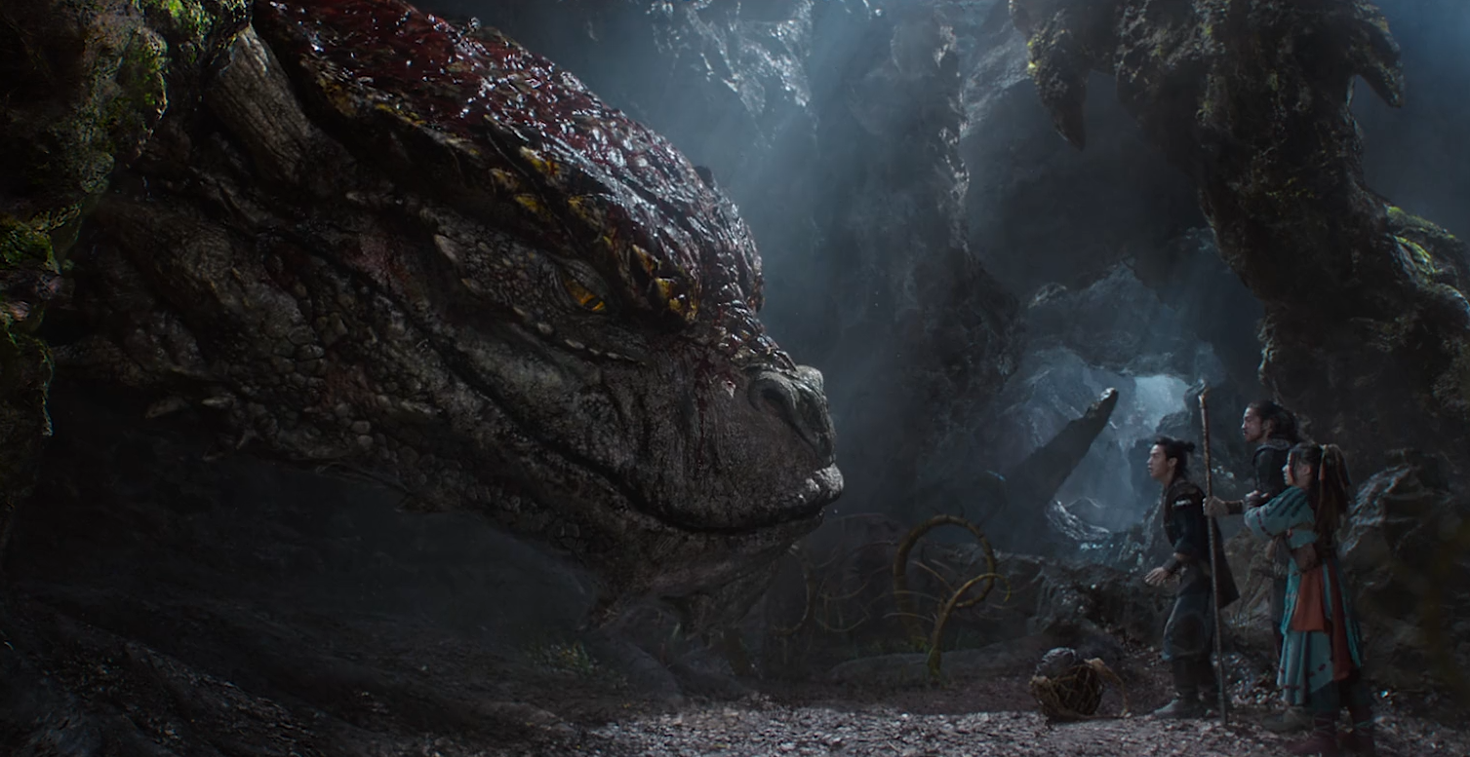
- Orchid Valley – Orchid Valley is a magical, pastoral place. The lands descend gradually from the Togiro Hills into the Shunu and Still Rivers. The terrain here is moist with rice fields interspersed with large groves of colorful wildflowers.
- Miyaza Valley
- Imperial Pass – The break between the Hundred Men and Donguri Forests is a strategic pass connecting the southern kingdom to the lands of the north. Many armies have marched this way in the conflicts between Jade City and the City of Destiny. Even today warriors looking for something to prove travel this way spoiling for a fight with those from rival cities. It is said that on nights of a full moon one can see the ghosts of soldiers who fell here in the many battles that the fields have seen.
- Northern Pass – Hidden amidst the peaks of the Ryuluun Mountains, this pass was regularly exploited by the Moghun to invade the lands of Xiandai. Wizards have destroyed the pass multiple times, bringing down rock slides and erecting the stones into walls. But time has seen the pass opened time and again. Now a magical archway stands with a shimmering barrier of energy barring any who seek to pass. The archway was built long ago and its secrets long forgotten.
- Ebony Pass
- Valley of the Dead Kings – In the Ancient Ages the Jindun kings named this valley to be sacred and all nobility were interred here in elaborate tombs. Holong the Resplendent was chief among these kings and commissioned a vast network of tombs he called the Resplendent Palace of the Dead. His necromancer Pailan wrought terrible curses upon the king’s personal guard, transforming them into living statues to protect the palace (680 AA1). Other kings followed suit, cursing their tombs with unspeakable horrors. None dare venture into these parts for fear of waking the ghosts in this place. In 940 AA4 the evil wizard Wai Hen took over the Valley of Dead Kings and animated the stone soldiers to wreak havoc on the land and bring down the Azuran Kingdom before he and the army were destroyed on Pearl Mountain.
  - The valley is also the location of the Monastery of the Dead Retainers. The monks here have special connections to the other worlds and have no fear of the spirits of the valley.
- Lotus Valley – The valley is a serene place, full of lush vegetation and flowers of incredible beauty. It is also a bewildering place, for it is said the flowers emit a strange and pleasant odor that traps the minds of the unwary in dreams of their own making. Many who venture here are later found wandering naked and in a trance.
  - Here is the location of the Monastery of the Mountain King. The monks are guardians of the eternal Heaven Lotus, which blossomed at the beginning of ages and has enormous divine powers. The monks honor Shanshen the mountain god. Their master, Lai Lin, oversees their training which involves the manipulation of the earth and hardening their bodies and minds. Each monk carries a lode stone that helps attune their abilities.
- Phoenix Valley –
  - The rangers of the Band of the Yeren patrol this valley and consider it under their protection.
- Serene Valley
- Crane Valley

- Jasprendryn - Dwarven Kingdom
  - Kerkehewn - Dwarven town of Jasprendryn
  - Bertelgrim - Dwarven town of Jasprendryn
  - Valadur - Dwarven city of Jasprendryn
  - Sunderkhar - Dwarven town of Jasprendryn
  - Haeldin - Dwarven town of Jasprendryn
  - Watcher Keep - Dwarven outpost of Jasprendryn
  - Plinth Keep - Dwarven outpost of Jasprendryn
  - Coffer Keep - Dwarven outpost of Jasprendryn
  - Hillwatch Keep - Dwarven outpost of Jasprendryn
  - Quoin Keep - Dwarven outpost of Jasprendryn

- Domain of Dragons – The northwestern reaches of Xiandia, it is the region around the Elderwyrm Mountains. Since the Great Dragon War in 310 PA4, dragons of every kind have made these mountains and the surrounding region their domain. Every few hundred years a new dragon rises up to rule over his or her kind and great battles commence that shake the world. The surrounding lands and seas for hundreds of miles are often raided by the dragons for food, plunder, or sport.
- Black Tortoise Temple – Located in the far north of Xiandai, alongside the Still River and downriver from Baozang “Fortune Town”, this is a monastery of lawful good monks. The temple is situated on the coast overlooking the Sea of Mazu. Monks here meditate on Xuánwǔ, one of the four guardian spirits, depicted as a turtle entwined together with a snake, embodying the north and the winter season.
  - 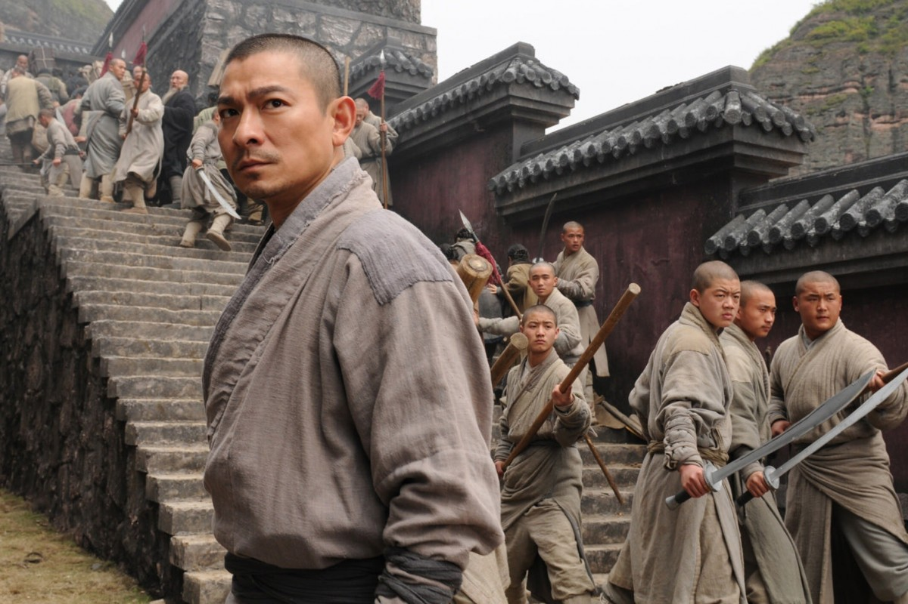
- Azure Dragon Temple – Located at the tip of the peninsula in eastern Xiandai, just south of the Chime Forest, overlooking the Kamatsu Strait, this is a monastery of lawful good monks who meditated on Qīnglóng, one of the four guardian spirits. It is a dragon that embodies the spring season.
  - 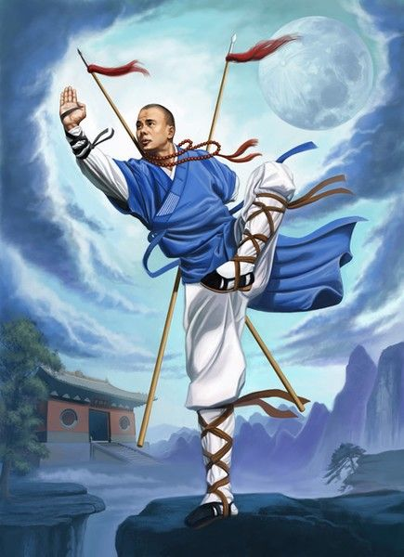
- Vermillion Bird Temple – Located in an unreachable valley in the southern Ryuluun Mountains, overlooking Azura Bay, this is a monastery of neutral good monks. The Monastery of the Vermillion Bird focuses on Zhū Què, one of the four guardian spirits. It is a red bird that resembles a pheasant with a five-colored plumage and is perpetually covered in flames. It is a personification of the fire-element, the direction south, and the season summer.
  - 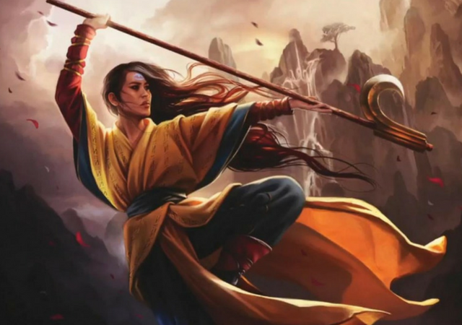
- White Tiger Temple – Located south of the Ryuluun Mountains in Moghun Lands, just outside Penghou Forest and near the Oru Vale. Monks here are chaotic good and meditate on Bái Hǔ, one of the four guardian spirits. It embodies the spirit of the west and the autumn season.
  - 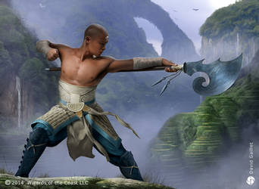
- Ruins of Bianjing – located on Forbidden Isle, destroyed in the Great Dragon War in
- Ruins of Gidonn – located on Isle of Xian
- Ruins of Dokuro – sits in the shadow of the Elderwyrm Mountains
- Ruins of Zidao – sits in the shadow of the Elderwyrm Mountains
- Ruins of Raden – located at the mouth of the Virago Valley
- Ruins of Bailan – sits in the shadow of the Elderwyrm Mountains alongside the Long River
- Ruins of Haiyu – east of the Valley of Serenity, overlooking the Kamatsu Strait

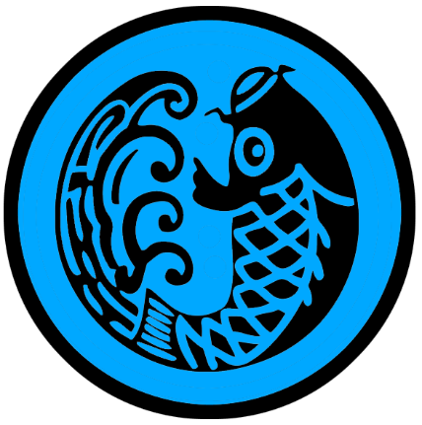
Haidan
Size: small town, population 2,000, guards / soldiers 20, militia 100
Trade Goods: tea, fishing, ship building
Local Goods:
Standard: fish
Colors: blue and black
Patron Deity: Haishen - sea god aka Haiye
Ruler: Kouriki Katanaga and his wife Hisa (f)

Home: Cormorant Keep
Steward: Honma Terumoro
Marshal: Ogura Kageuji
House Priest: Miyake the Silent Judge
House Adviser (Scholar/Mage/etc): Miura the Shapeshifter (f)
Captain of the Guard: Kuroda Tokitsune
Chief Warriors in Service:
Kujou Mitsukage
Ise Morikuni
Soejima Atsukata

Local Powers: Sacred Wind (thieves’ guild), The Black Net (smuggling ring), Temple of Haishen the sea god
Local Sites: The Lucky Cabbage Inn & Tavern

Description:
Known as the Sea Urchin, Hǎidǎn is a colorful fishing town on the far-off island of Mazu. Brightly painted houses dot the slopes of the hills surrounding a large harbor. Merchant ships from Kylin, Baozang, and Yuchung come and go while a fleet of two hundred fishing boats, large and small, tend to their nets. Elaborate kites float far overhead shaped like fish, stingrays, octopi, and every sort of marine creature.

Colorful artwork is ubiquitous in town. Figures from Xiandai legend are featured in murals on the sides of the larger buildings. Countless smaller symbols and patterns are worked into columns, archways, and railings. Most of the decorative symbols tell the stories of the Eight Immortals, others were inspired by travelers who told of gods from far away. It is said that all gods meet in Haidan and the artwork tells their conversation if one is wise enough to notice.

Haidan also has a section of very conservative people which frown on the colorful houses near the water. These are mostly descendants of aristocracy that came here from Sakura during its occupation of the island. They have a very old-fashioned mindset and are open with their contempt for how the populace treats their lord. It is common for rulers of Haidan to come from these families.

Haidan was originally settled as a fort to monitor ships coming in and out of the Sea of Mazu. When the Elderwyrm Mountains became overrun with dragons, traffic to Mazu slowed to a trickle. The sea fort was left half-finished and still stands there to this day.

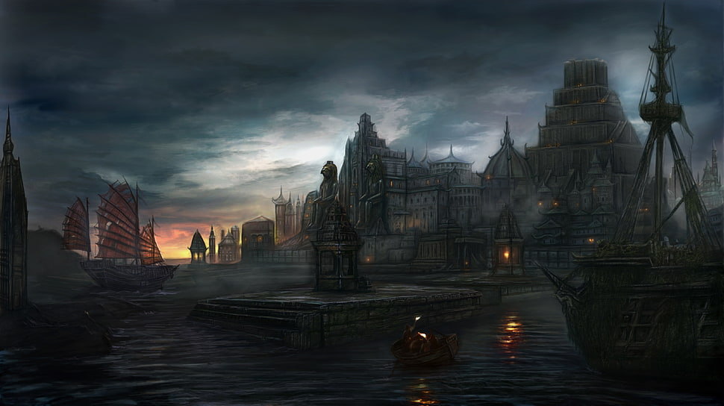

Industry:
Haidan started as a small fishing village. Now it is a small fishing town with a tea plantation and a shipyard. Shipwrights migrated to Mazu in the early days to help support a naval yard for the fort. Their descendants have stayed on and continue their tradition, but craft more than just war ships.

Key Figures:
Kouriki Katanaga – vain, oppressive, obsessed
Ruler Katanaga is a short man who smiles little and dresses fastidiously. He bears a burn scar along the left side of his face. Under his first command his ship and crew were destroyed by a dragon. He comes from a long line of men who have served in the Emperor’s navy, though he is of Sakuran blood. When he was made ruler of Haidan he saw it as just another assignment. But the largess of the seat has seduced him into enjoying the power. He rules his people with fear and intimidation, thinking them the best tools for discipline. He is impatient with his counselors, feeling his keen tactical thinking will make the best decisions for his island. Working through the Black Net smuggling ring, he uses his strategic location to tap into western trade routes.
Katanaga is aware the Elderwyrm Mountains are close and with them the threat of dragons. Katanaga’s scar will forever be a reminder to him of his purpose. His obsession is to find the Amulet of Tiamat and gain control of the dragons. With them, he believes, he can rule all of Xiandai and become the first Dragon Emperor in millenia.

Political Mindset: Katanaga is convinced the other rules of Xiandai look down upon him for ruling over a forsaken island, but he is determined to prove them wrong. He shows proper deference to Emperor Yating in Jade City, but despises the oaf. Lord Shuren of Kylin he finds an appalling excuse for a leader: weak, scared, spending too much time at shrines. Xuefeng of Fortune Town he hates most of all. He is sure that the minor calamities Haidan’s ships are meeting on the open sea are due to Xuefeng’s mischief. Katanaga especially hates the smirk that Xuefeng wears on his face and the lack of respect towards an elder and fellow ruler. When the Amulet of Tiamat is in his hands, Katanaga thinks, Xuefeng will be the first to die when Katanaga takes over Xiandai.

Miura the Shapeshifter (f) – court sorcerer – vengeful, elusive, manipulative
Miura is a small woman with fair skin and engaging eyes. Her lips remain pursed in silent defiance. She wears a dark black dress covered in intricate designs stitched in glittering gold thread. A comb in the shape of a bird sits perched in her hair. She carries a bag of bones at her hip along with a wand made from a bamboo fishing reed. She carries a seething kettle of rage within her, having been branded a witch as a child and taken from her parents to be sold to Haidan. Miura conceals the secret that her grandmother was a Huli Jing, a female fox shapeshifting spirit. Sometimes late at night she sneaks out of the compound and travels the island in fox form. Some accused her of bewitching men, but those men have disappeared.

Local Lore:
Xiandai legends speak often of evil spirits dwelling in nature. The old collective term for these was Wangliang, but today the scholars call them Jingshen. The names for each of these, depending on where they dwell in nature, are Fangxiang (graveyard ghosts who feast on the dead), Fangliang (demons lurking beneath the ground), Kui (demons lurking in the mountains), Long (demons lurking in freshwater rivers and lakes), Yu (traveling fever spirits spreading disease, sometimes appearing as a tortoise), Guoyu (appearing as inanimate rocks), and Muzghon (appearing as trees). The most notorious of these Jingshen are those that wander into villages and appear as a small human, resembling a three-year-old child, with a red-black or brown skin color, red eyes, long ears, and beautiful hair.

There are Nine Sons of the Dragon that guard these lands and protect its people. These are dragon hybrids that resemble a cross between a dragon and another beast. Each region has a guardian dragon. The Chi Wen protects Haidan and the Isle of Mazu. It is a hybrid of fish and dragon: a creature that likes swallowing. Totems of the Chi Wen are worked into the decorations in this region, typically placed on both ends of the ridgepoles of roofs (to swallow all evil influences).

Monastery of the Sea Shepherd is located on the Isle of Mazu. It is a monastery dedicated to Hiaye the sea god. The head monk, Xiang Xuegang (f), oversees the training of the monks in meditation, prayers, and the ceremonial emptying and refilling of sacred water basins. Each monk is instructed to build an elaborate fountain from tiny rocks. This is their life’s work and what they use to divine truths from the waters. It is said a Sea Shepherd monk can communicate with fish, dive underwater for long periods of time, and even divine truths from bodies of water they come across. Each monk carries a special stone they’ve found while diving to the bottom of the bay. This rock is their totem and focuses their energy.

History:

In 970 WA3 the Isle of Mazu was seized by Sakuran general Kiroko on orders from Ayozu. Two years later Xiandai ships attacked Sakuran forces around Mazu. The conflict escalated until both kingdoms' fleets converged on the waters. The next year, in 973 WA3, the War of the Flaming Ships erupted. Hundreds of ships of various sizes engaged in multiple battles until dragons out of the Elderwyrm Mountains appeared and destroyed both fleets. Haidan would be a base of Sakuran naval power until 990 WA3. Xiandai warriors secretly entered the Isle of Mazu disguised as fishermen. They wiped out the Sakuran guard holding the island, returning Haidan to Xiandai control.

Customs:
Five hundred years ago the island was captured by Sakura. Though it has passed back into Xiandai control, the local population is a mix of both cultures today. It is rumored that some of its inhabitants work as spies for Sakura, monitoring ships coming and going through this part of the world.

Cormorant fishing is a traditional fishing method in Haidan. Fishermen use trained cormorants to fish the waters around Mazu Isle. They tie a snare near the base of the bird's throat. This prevents the birds from swallowing larger fish, which are held in their throat, but the birds can swallow smaller fish.

Every household in Haidan keeps a pet fish for good luck. A red or gold dragonfish or arowana is considered especially beneficial as they are also colors of luck.

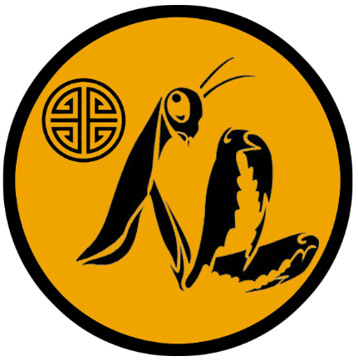
Bǎozàng “Fortune Town”
Size: large town, population 5,000, guards / soldiers 50, militia 250
Trade Goods: trade hub, grain, silk, platinum, arts
Local Goods: Jiaoren sea silk and pearls, the most accomplished musicians
Standard: sign of the mantis
Colors: orange and black
Patron Deity: Fengshen - wind god aka Fei Lian
Ruler: Lei Xuefeng and his wife Xinya (f)

Home: Golden Toad Keep aka Jin Chan Keep
Steward: Lai Yan
Marshal: Cai Yimu
House Priest: Feng Qiu
House Adviser (Scholar/Mage/etc): Cheng Yahui (f)
Captain of the Guard: Cui Xun
Chief Warriors in Service:
He Xieren
Luo Jiahao
Xiang Zhelan

Local Powers: Kurakami Trading Company, The Night Stalkers (thieves’ guild), Circle of the Hidden Spring (order of druids), Black Lotus (assassin’s guild), Temple of Fengshen the wind god, Fury March (mercenary company), Band of the Divine Archer (order of rangers), Flying Daggers (bardic college of musical instruments)
Local Sites: The Fifth Door Inn & Tavern, The Silken Knot Inn & Tavern, Yumi House (brothel)

Description:
Overlooking Orchid Valley, where the Shunu River departs from the Still River, Baozang is a beacon to the worlds north of Xiandai. Red-stained buildings topped with dark rooftops sit amidst curving bridges leading down into the valley floor. Glittering gold discs hang from elaborate stands, catching the sunlight and dazzling visitors traveling upriver to this frontier town of opportunity. Towering above the town walls glitters the tower of Golden Toad Keep, paneled in gold plates inscribed with magical letters. The tower is named for Jin Chan, the mythical toad that sits in the Moon Palace and bestows luck and fortune.

Indeed, Baozang is a town of fortune as its nickname declares: a bristling harbor dug out from the Still River hosts a myriad of ships from other lands. Markets line the streets where merchants from afar come to sell their wares and bring back rare items from the east. People here are bold and outgoing, friendly to strangers and eager hosts.

Industry:
Using the two rivers, the city is able to tap into sea traffic on both sides of the continent. The Still River opens into the Sea of Mazu, where Baozang trades with coastal villages and towns like Haidan and Kylin. The Shunu River leads to the Orenda Sea and the shipping lanes for the Noreast Jaunt and the Oreanda Crossing. The Kurakami Trading Company does a brisk business, working to corner the business on outlander traffic. They are also keen to work with the Haka’Na peoples to the north, who are new to the business of trade.

Platinum mines in the Kang Mountains have helped Fortune Town earn its name. Fortune Town is the common tongue translation for the name Baozang and is the term most often used by traders from other lands.

Xuefeng is careful to keep on good terms with the Jade City, Yuchung, to the south. Jade City has traditionally been the seat of power in northern Xiandai, locked in an endless power struggle with Mingyun, the City of Destiny. For Fortune Town, war is bad for business. So Xuefeng happily pays tribute to the masters of the north.

Key Figures:
Lei Xuefeng – mirthful, ambitious, risk-taking
Lei is an average sized man and young for his station. A smile sits ever on this face and his eyes are bright and merry. Some say he looks like a merchant, dressed in the finest silk robes and the largest of rings on his fingers. He walks with a purposeful stride, a retinue of advisers and scribes in his wake. Lei is a bold man with large dreams. Baozang came to him after his father, the previous ruler, passed. But while his father was a bureaucrat and catered to the whims of other rulers, Lei is less traditional and very direct in his speech. He sees a future for Baozang and he takes great risks on many ventures. Some call him “Lucky Lei” for the many misadventures he has escaped, both physical and political. Other towns see him as a young peacock with no respect for tradition, but he does not seem to value his position in court.

Political Mindset:
Xuefeng reluctantly supports Jade City in defending the north, but is wary of being dragged into war. He personally loathes Emperor Yating and his excesses. He has not planned an outright overthrow of the Emperor but he is more than happy to occasionally cause trouble for his merchant ships. Lord Shurenn of Kylin is easier to work with, even if he is a recluse scared of his own shadow. To Xuefeng this makes him easier to control as an ally and trade partner. Katanaga of Haidan, however, is a source of annoyance. Xuefeng does not do well around the man’s military terseness and need for control. Haidan’s boats are also the frequent victim of Fortune Town’s mischief, which has soured the relationship between the two rulers.

The followers of Vecna established a cathedral here eight hundred years ago. Persecuted by the churches of the older gods, Vecna faithful wandered from land to land seeking a home. It was here in Fortune Town, where travelers are most welcome and coin is king, that they found a ruler willing to accommodate them. This is not to say that the people of Xiandai have any special love for Vecna. The ruler of this prefect is happy to charge exorbitant rates for the church. In return the cathedral has removed itself to the far end of the city behind high walls. The port city is an ideal location for worshippers travelling from afar to reach their holy site easily by sea.

The Fury March is a profession company of swords for hire that bivouac permanently outside of town. Years ago, Baozang hired Fury March out of desperation to counter the other towns and cities from invading. But the mercenaries never left and find the trading hub an excellent location for deploying when hired abroad. Gao Gang, leader of Fury March, is a ruthless warrior and eager to turn a profit. He routinely bullies the local officials to turn a blind eye when his soldiers make trouble in town, which is often.

Band of the Divine Archer – The Band of the Divine Archer are named after legendary Hou Yi, hero who it was rumored shot down nine of the ten sons of the Jade Emperor who had taken up roles as actual suns in the sky and were tormenting the world. The rangers protect the region of the Whispering Wood and the surrounding region. They are superhuman archers, carrying enchanted bows that are imbued with the power of Hou Yi himself.

Local Lore:
Rumor has it that the Kang Mountains are home to the Tiangou, mythical large black dogs that have magical powers. In legend, the Tiangou of the sky threatened to eat the sun. In more recent accounts, rangers exploring the Kang Mountains reported auras of darkness rolling in immediately before the appearance of a ravenous large black dog that attacked them. These dogs were said to hover above the ground, moving without regard for the hilly terrain, and descending on victims without warning. To this day the rangers of Fortune Town warn travelers to avoid the Kang Mountains for fear of the Tiangou.

There are Nine Sons of the Dragon that guard these lands and protect its people. These are dragon hybrids that resemble a cross between a dragon and another beast. Each region has a guardian dragon. The Bi Xi protects the lands around Baozang. It is a hybrid of a turtle and dragon: a creature with a large shell able to carry heavy objects. Totems of the Bi Xi are worked into the decorations in this region and are normally found on tombstones.

The coastlines around Fortune Town are rumored to be home to the Jiaoren, which are merfolk unique to Xiandai. They have been spotted all along the cliffs of Jandira as well as all along the western shores down to the port city of Kylin. These are reclusive creatures who rarely interact with humans. Legend has it that they weave ‘sea silk’ from the filaments secreted by deep water mollusks. The Jiaoren are said to weep pearls. Both of these rumors have led greedy sailors to capture the Jiaoren for their treasures, which are highly valued. Few who hunt the merfolk live to tell the tale. But the markets of Fortune Town do on rare occasion have sea silk and Jiaoren pearls if one knows who to ask.

The Monastery of the Black Tortoise is located in the Kang Mountains.

History:
Laong House ruled over Fortune Town for centuries, relying on the Juren hill giants of Togiro to protect them. In the War of Fortuneless Giants six hundred years ago the Jade City armies marched on Fortune Town and were almost defeated (642 WA3). The famed general Ko Hang managed to slay the Juren giants with his magic sword, Shu Dao. Laong House was thrown out and Xuefeng put in its place.

Customs:

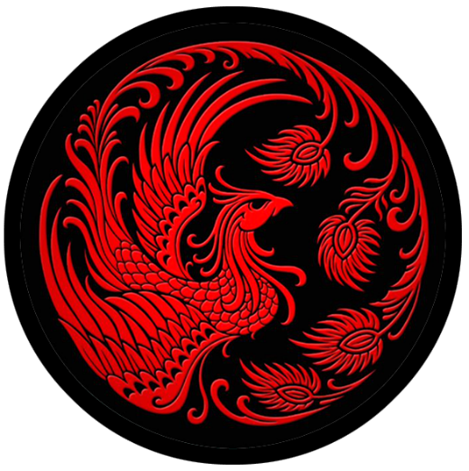
Kylin
Size: small city, population 12,000, guards / soldiers 120, militia 600
Trade Goods: dyes, Qiji opium, silk, silver, tea
Local Goods: osmanthus tea, osmanthus beer
Standard: sign of the phoenix
Colors: black and red
Patron Deity: Shanshen - mountain god
Ruler: Huang Shuren and his wife Yi (f)

Home: Castle Osmanthus
Steward: Chen Hanying
Marshal: Xai Guiying
House Priest: Kulong of the Ancestral Stair
House Adviser (Scholar/Mage/etc): Teng of the Many Ribbons (f)
Captain of the Guard: Zhuan Lin
Chief Warriors in Service:
Shen Jun
Kang Min
Zhu Bai
He Wuhan

Local Powers: The Burglars of Baolan (thieves’ guild), Zhou-Sizhe (smuggling ring), Temple of Shanshen the mountain god
Local Sites: Three Fish Inn & Tavern, The Red Fan Inn & Tavern

Description:
Tucked into the far southern corner of the Sea of Mazu, Kylin is a city that holds power over all the fishing villages west of the Tenjin River. This far south of Mazu there is little regular sea traffic. The shadows of the Ryuluun Mountains cast the city in deep shadows much of the time, giving it a veiled look from the sea.

Kylin’s seclusion may also be due to the proximity of the Moghun hordes, which lie on the far side of the Ryuluun Mountains. Though the Moghun are not a threat, their presence is felt. Once in a generation the horse lords manage to find a pass through the mountains when the spring thaws the ice. Even a small force of these warlords can wreak havoc. For this reason, Kylin long ago built defensive works around the land side of the city that includes trenches and pits surrounding a low stone wall.

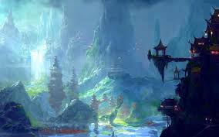

Industry:
Dragons in the Elderwyrm Mountains to the north and west result in very little shipping traffic this far into the Sea of Mazu. Kylin quietly mines silver in the Ryuluuns and oversees farms of poppies and dye plants. Another blessing of their seclusion, Kylin produces high quality opium without the oversight of their lords in Jade City. Opium is smuggled over the Ryuluun to far off Shining Shore, using mountain passes to the west that are kept secret. Qiji (“wonder”) opium is cultivated in Kylin and is enjoyed in many underground parlors throughout the city.

Osmanthus trees bloom all over the mountainside around Kylin. The purple berries are combined with black or green tea leaves to make osmanthus tea. They are also used to flavor beer unique to the Kylin region. Travelers refer to these blends as Kylin Tea and Kylin Beer.

Key Figures:
Huang Shuren – paranoid, penitent, reclusive
Lord Shuren is a frail man, hindered from a war injury he suffered years ago. Tall and slender, he wears pale robes and many holy charms. He has a face worn by worry. His hair has come out early so he wears a wig to conceal his shame. Shuren is a devout follower of Shanshen the Mountain god. He closes himself up in his regal cottage and prays constantly for strength to face his enemies. And his enemies, he would think, are everywhere. Only Kulong, his house priest, has his full confidence. But this may well be his undoing, for Kulong sensed his master’s frailties long ago. He and Shuren’s wife, Yi, actively conspire to manipulate and exploit the ruler’s weaknesses.

Political Mindset: Lord Shuren is deathly afraid of Emperor Yating and jumps whenever Jade City calls on Kylin. This is atypical of most rulers of Kylin, for the town likes to think of itself as independent. Shuren has lost a lot of credibility locally for pandering to the Emperor more than he needs to. But he does not want to take any chances. He is almost as afraid of Lord Katanaga, who openly abuses and disrespects him. Shuren finds Xuefeng more reasonable than the others and puts his trust in the young ruler. Privately Shuren is most motivated to seek the Shanshen’s favor and is actively working with Kulong the house priest to call on the gods to protect Kylin.

Kulong of the Ancestral Stair – house priest
Kulong is an old man, slight in frame but in good health and sharp-witted. He wears dark color robes that are speckled like the granite of the mountains. A magic stone hangs around his neck, the fabled Shān Xīn (mountain heart). Wrested from the Dwarves millennia ago, it has the power to call down earth elementals and create earthquakes. Kulong is faithful to his master Lord Shuren and is actively working to gather the power of the mountains to build defenses around Kylin, open new tunnels into the mountains looking for gold, and launch attacks on its enemies.

Local Lore:
The Sea of Mazu is home to many legends. One legend is that of the Shen, a race of magical giant clams that shape-shift and create mirages to lure sailors to their doom. The Shen are thought to transform at will into flocks of sparrows, a pack of dolphins, or even a magical lady atop an open clam shell. Some are said to exude a cloud of smoke, in which fishing boats can become lost. Most dangerous is their ability to create false illusions of fortune or boats that are in peril. Shen will swallow up entire boats and consume a dozen men at a time. Kylin fishermen are wary of these legends. Young Shen are harvested for their shells, which are used in religious ceremonies as offerings to the gods. The meat of Shen are a delicacy and the oil from them is made into fragrant aromatics and candles.

There are Nine Sons of the Dragon that guard these lands and protect its people. These are dragon hybrids that resemble a cross between a dragon and another beast. Each region has a guardian dragon. The Ya Zi protects the lands around Kylin. It is a hybrid of a wolf and a dragon. It likes to fight and hungers for battle. Totems of the Ya Zi can be seen in the architecture and decorations throughout the region, especially on the cross-guards of swords as ornaments.

There is the gold dragon Fuhao living in the Ryuluun Mountain above Kylin.

History:
Four hundred years ago the Moghun warlord Kamalchek, dispossessed by his tribe, led a small army over the Ryuluun to seek his fortune elsewhere (90 WA4). He descended on Kylin with a rain of flaming arrows and ten thousand men on foot (for their horses could not manage the overland passage). Kemlecheck was successful in scaling the walls and for twelve years controlled the city. His men destroyed much of Kylin’s art and culture and seized the fishing boats to form a pirate fleet. The fishing villages along the coast rallied under a hero named Huen Fong, who was mentored by an ancient wizard known only as Hai Wushi, the Sea Wizard. Hai was said to wield the staff called Water Lightning and bestowed on Huen the Sword of the Jiaoren, the merfolk of these parts. Together they led an uprising the drove out Kemelchek’s warriors (105 WA4). Kemelchek took his boats and departed, raiding the seas as a pirate. It is said the ghost boats of Kemelchek haunt the Sea of Mazu to this day.

Customs:

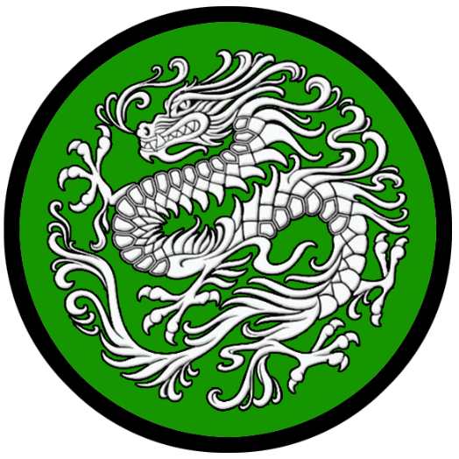
Yuchung “Jade City”
Size: large city, population 25,000, guards / soldiers 250, militia 2250
Trade Goods: papyrus, grain, salt, livestock, iron, steel, arts
Local Goods: the best in calligraphy and dance arts, camellia oil, camellia tea
Standard: sign of the dragon
Colors: green and white
Patron Deity: Zhurong - fire god aka Huoshen
Ruler: Xuan Yating and his wife Jingyi (f)

Home: Palace of the Ten Suns
Steward: Yi Fang
Marshal: Lang Zhihao
House Priest: Xue Hu (f) Guardian of the Gate
House Adviser (Scholar/Mage/etc): Yin Lan of the Water Spirits
Captain of the Guard: Zhong Qigang
Chief Warriors in Service:
Liang Heng
Kang Ru
Liao Jianhong

Local Powers: Fox Moon (thieves’ guild), Gossamer Web (smuggling ring), Bird of Dawn (dance conservatory), High Temple of Zhurong the fire god, Order of Panlong (paladins), Jintao (assassin’s guild), Hanja School of Calligraphy
Local Sites: The Sow’s Ear Inn & Tavern, The Sunken Stone, House of the Water Lily (brothel)

Description:
Yuchung, better known to travelers from other lands as Jade City, is a magnificent city boasting the finest palaces of the east, the mightiest warriors, and the most beautiful art and music. Standing proud along the banks of the Rainbow River, it shines like a jewel facing the west and overlooking the Mazu Sea. The palace complex and other royal buildings tower above the many walls protecting Yuchung. These are towers in the ancient Xandai tradition: wooden frames in four-, six-, and eight-sided arrangements built on multiple platforms. They are topped with ornate sloped eaves, colored in jade-green and covered in elaborate gold carvings and symbols telling of the city’s history. The red fan-shaped sails of a hundred ships drift in the sprawling bay.

In the court of the Northern Emperor, as Lord Yating calls himself, there are the finest dancers and calligraphers of Xiandai. The halls are filled with the sound of the pipa and the erhu, accompanied by gongs and bamboo flutes. The most skilled musicians train in Baozang, but the court here employs the most. Dancers from the Bird of Dawn Conservatory brandish fans and parasols, experts in the rigorous traditional dances they’ve trained a lifetime to perfect.

Where the City of Destiny lays claim to the oldest traditions and history, the Jade City boasts new innovations and markets opening up to the west. Where the City of Destiny has the most powerful navy in this part of the world, the Jade City boasts mighty infantry. Steel is crafted by the finest metalsmiths, arming an infantry with the best swords in the east.

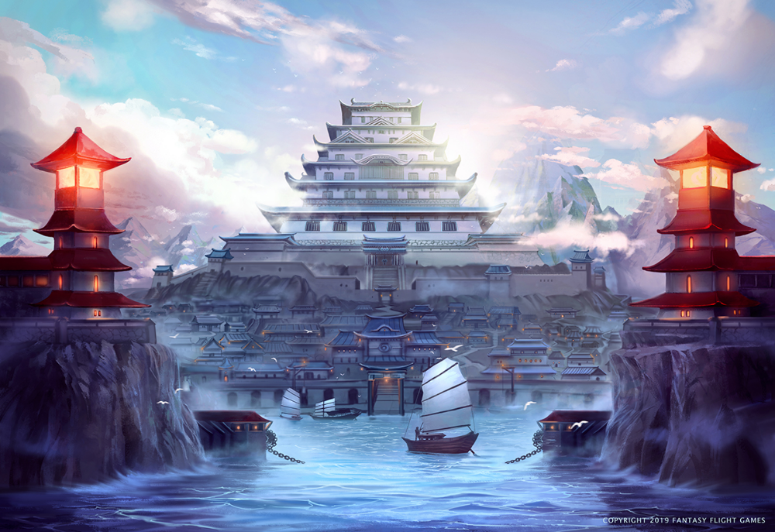

Industry:
The Miyaza Valley is home to hundreds of rice, millet, and wheat fields under the control of Jade City. Armed patrols along the Weeping River to the south diligently guard against attacks on the heartland of the northern kingdom. Herds of oxen and other cattle are sent north of the Rainbow River to graze and are the other major food industry of the city. Papyrus and tea plant groves sit closer to the river.

While the arts may flourish here, the pride of the generals is the iron mines in the Kang Mountains, which bring ore downriver to be expertly crafted into steel. Swords from Jade City are abundant and have created an infantry that is feared throughout Xiandai.

Red, white, and pink camellia blooms line the banks of the Rainbow River. The flowers are used to create healing oils as well as oils for sharpening blades. Yuchung Tea is a local favorite, flavored from camellia leaves.

Key Figures:
Emperor Xuan Yating - gluttonous, greedy, manipulative
Emperor Yating is a short, rotund figure with heavy jowls and a portly belly. He wears the finest silks, always dyed in various shades of green and cut in dazzling designs. He wears as many jewels as he can squeeze onto his fingers and around his neck. Always reclining on a throne that seconds as a couch, he giggles cruelly when receiving guests at his court and barely pays attention while flirting with concubines or feasting on shellfish. Yating is a picture of decadence and is proud of it. He hosts all-night orgies with abandon and spends lavish sums on pet projects that amount to nothing.
Yating is the sixteenth ruler of the Northern Kingdom since the Age of Two Kingdoms began four hundred and seventy years ago. He sees the north as his divine inheritance to do with as he pleases. He is a devious ruler and a master manipulator. Through the smuggling operation Gossamer Web, he has spies and fences on every deal going on in Xiandai.

Political Mindset: Emperor Yating finds great joy in manipulating his subordinate rulers and exploiting his authority to benefit his city. He misses no opportunity to mock Katanaga, finding him proud and arrogant. He calls him the Emperor of Fish Island. Yating sees as an ambitious man in Xuefeng of Fortune Town, which would normally concern him. But Xuefeng is so silver tongued that Yating takes delight in his flattery and leaves him be. Shuren of Kylin is one of his favorite play things: Yating finds sadistic pleasure in tormenting the man.
Yating is aware Emperor Yazhou has his eyes on reclaiming the north and restoring Mingyun’s glory. He has laid careful plans to ensnare Mingyun in a trap if they are to march to war. His agents in the Jintao assassin’s guild are already deploying intricate operations to tip the balance between the two kingdoms.

The Hanja school of Calligraphy is a place of reverence and great study. Here great masters of the written word practice the revered exercise of pouring emotion and purpose into carefully styled letters. Masters scrutinize the calligraphers based on the precision, meaning, and aesthetic qualities of each letter painted. The well-manicured courtyards of the school are places of reflection and tranquility. Large sand tables are laid out where students practice their strokes with ceremonial staves. It is said the greatest sword masters spend time here, learning from this art form to perfect their fighting styles. Wizards of Xiandai take a special interest in the Hanja school, for prophecies abound of calligraphers blessed by the gods who can draw shapes that capture enormous power for good and evil and even tell the future.

The Panlong Order is a revered company of paladins that have protected northern Xiandai since the Ancient Ages. They are known by their symbol of the coiled dragon and wear green armor and white crane feather plumes. They are dedicated to the god Zhurong, god of fire, but serve the needs of all good-aligned deities in hunting down Yaoguai demons and other agents of evil.

Local Lore:
Hanba are nature spirits that personify drought. They appear as fair maidens dressed in yellow. They possess the magical ability to draw water and moisture out of the immediate area where they appear. Some call them demons, others water vampires. While most are harmless to humans, farmers that grow weary of Hanbu and attack her suddenly find themselves the victims of the Hanba’s wrath. When angered, a Hanba can pull the very water out of a living creature, killing them within seconds and leaving a dry husk. Sometimes Hanba can be beneficial after monsoon season. Villagers have been known to call on Hanba after floods, asking the spirits to remove flood waters from their fields and houses.

There are Nine Sons of the Dragon that guard these lands and protect its people. These are dragon hybrids that resemble a cross between a dragon and another beast. Each region has a guardian dragon.
The Fu Xi protects the region around the Jade City. It is a hybrid of snake and dragon: a creature that likes to drink water. Totems of the Fu Xi can be seen in the architecture and decorations throughout the region and is typically used on bridge structures.

Far up the river Rainbow in the depths of the Kang Mountains resides the forges of Zhurong the fire deity. Few know of its presence and fewer still brave a journey to seek his peerless mastery of steel and magic weapon craft.

History:
After a series of seemingly endless wars a thousand years ago Lord Kang crushed all resistance in the north (450 WA3 to 700 WA3). Now Jade City is master of the northern Xiandai. Only Yuchung, the City of Destiny in the south, is its equal. The two are bitter enemies and have spent the last thousand years quarreling over control of all of Xiandai. Infantry is the strength of the north. For the south, it is naval power.

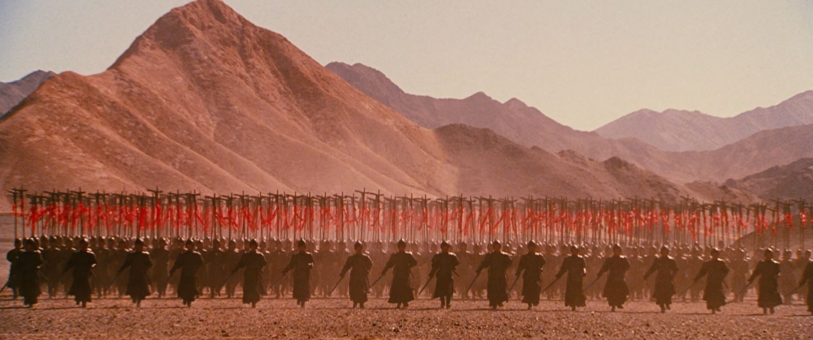
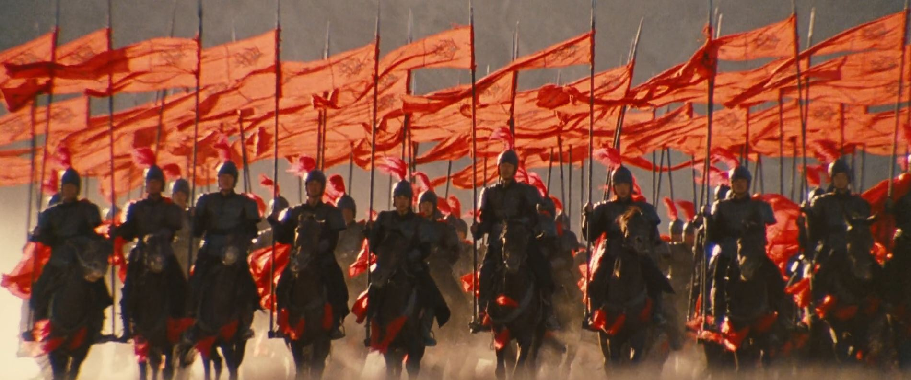
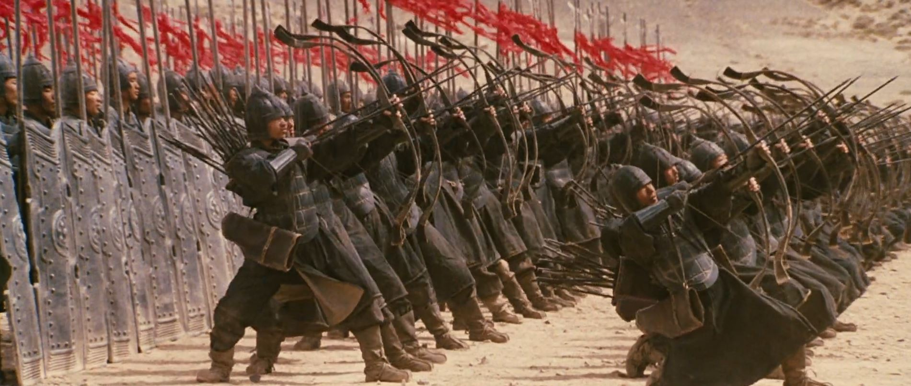

Fifteen hundred years ago witnessed the Great Civil War of Xiandai (30 WA3). In it the great cities of Jade City and the City of Destiny wage bloody war over all the lands. This lasted for over a hundred years when, in 160 WA3, the Civil War ended with Jade City consolidating power in the north and the City of Destiny in the south.

Customs:
The people of Jade City are a vain and aristocratic lot compared to anyone from the countryside. Even the master craftsmen and laborers put their noses in the air towards anyone from outside. It is everyone’s belief that Jade City represents the future and will one day rule all of Xiandai out of the murky past that Mingyun represents.

Mingxia
Size: small city, population 12,000, guards / soldiers 120, militia 600
Trade Goods: incense, ivory, silk, flax, livestock
Local Goods:
Standard: sign of the rooster
Colors: red and black
Patron Deity: Shuishen, water god
Ruler: Zhou Guanyu and his wife Jiao (f)

Home: Cascading Castle
Steward: Ren Bai
Marshal: Ye Ru
House Priest: Meng Guo
House Adviser (Scholar/Mage/etc): Jin Tao
Captain of the Guard: Gong Yang
Chief Warriors in Service:
Zhang Bo
He Cheng
Fan Qing

Local Powers: Jingshen (thieves’ guild), Band of the Fox Tail (order of rangers), Temple of Shuishen the water god
Local Sites: Okuda’s Inn & Tavern, House of Ebisu Inn & Tavern

Description:
Mingxia sits alongside the Longbow River where it empties into the Bay of Nuwa. It is a quiet city with a more rustic air. Her thick gray walls are topped by wide walkways that command a view of pastoral orchards and fields. At the center stands Waterfall Castle: a tall fortress built of river stones and so named for the sluice gates and channels built into it that are fed by the river and that plunge from the top of the castle’s sides. The water turns several water wheels before emptying into a wide moat that feeds channels in the streets and eventually the fields outside the walls.

Clusters of hamlets are scattered in the distance, made up of farmers and herdsmen who regularly visit the city to bring the fruits of their labors to the market and the cattle district. The people here are simple and hardworking. They greet strangers with a friendly bow but with few words as they make their way to the Altar of Grain and Soil. Here they pray for a good harvest and good weather. In the streets there are cookfires and stalls offering up the smells of a thousand countryside dishes. Herds of oxen and elephants mingle close to the city walls.

Mingxia soldiers are experts in guerilla warfare. They use the swamps to the west to move freely in their region, attacking enemy units and retreating into concealment.

Industry:
Mingxia is a farming and livestock city, making its living with cattle that graze along the peninsula. It also grows flax and silk, which have fostered a trade route to Sakura by way overland to the Plum River. Lacking a proper trade port, Mingxia employs fishing boats from the Plum River villages to the Sakuran city of Ayozu. The marshes to the west offer rare plants that the locals have crafted into valuable incense. This blend of incense is unique to this region and more common on trade ships returning to northern routes than the incense from Mahabar farther south. Elephants are unique to this part of Xiandai. They are employed for building projects and are regarded as divine beasts. An elephant graveyard was built outside of the city where the elephants’ tusks are harvested for ivory.

Key Figures:
Zhou Guanyu – noble minded, protective, haunted
Lord Guanyu is tall and broad-shouldered with a strong jawline but a homely face with dull eyes. In another lifetime he would have made a great warrior, but he walks with his shoulders slumped and tends to be clumsy. He wears the robes of his position, but to courtiers he appears out of place in them. He is a man of few words, allowing his advisers to do most of the talking.
Lord Guanyu was the third son of the previous ruler. When his older brothers were being trained in the ways of leadership, Guanyu was sent to the monks to learn humility and service. But then his father and both brothers were killed in war. Guanyu was pulled from the monastery and burdened with authority. In no time he was married to the daughter of a court official. Today his wife, Jiao, wears the pants in their marriage. Indeed, she makes many of the decisions for Mingxia. But in spite of his flaws Guanyu is a dedicated servant to the people and works for their wellbeing. He is protective of his lands and consents to illicit trade with Sakura if it means his people prosper.

Jiao, wife of Guanyu, is a shrewd woman. Short of stature and less fair than any woman at court, she has used her wits to accomplish what she wants. Currently she has signed a pact with the Sakuran city of Ayozu to support its campaign to take over the northern lands of Sakura. She has kept this arrangement a secret from all but her husband. She takes great pleasure in seeing her rivals across the strait battle one another.

Band of the Fox Tail – This band of rangers patrols the lands of the Chime Forest and are sometimes called to address problems arising out of the Musang Mire. They venerate Húshén, the Immortal Fox Woman, and practice rites that invoke her powers. It is said the rangers are as clever as their mentor, able to disappear to the eyes of their enemies, and move at great speeds through the underbrush. Each ranger wears a totem containing a strand of fox hair, said to come from Húshén at the completion of their trials.

Local Lore:
There are Nine Sons of the Dragon that guard these lands and protect its people. These are dragon hybrids that resemble a cross between a dragon and another beast. Each region has a guardian dragon. The Pu Lao guards the lands around Mingxia. It is a hybrid of dog and dragon: a creature that likes to scream. Totems of the Pu Lao can be seen in the architecture and decorations throughout the region and are typically used on the tops of bells, used as handles.

History:
In the Ancient Ages Mingxia ruled over its own tiny kingdom, made up of all lands east of the Kang Mountains. In the third Ancient Age city fell under the control of the City of Destiny, its naval fleet dominating the bay (140 AA3). But villages to the north fell under the control of Jade City and the northern kingdom.
In the Great Civil War of Xiandai between the northern and southern lands (30 WA3 to 160 WA3), Mingxia played both the powers to its advantage. This is a tricky proposition, as any show of disloyalty towards the City of Destiny has brought harsh recriminations. For this reason the people of Mingxia are practiced in diplomacy, as well as in clever war tactics.

Customs:

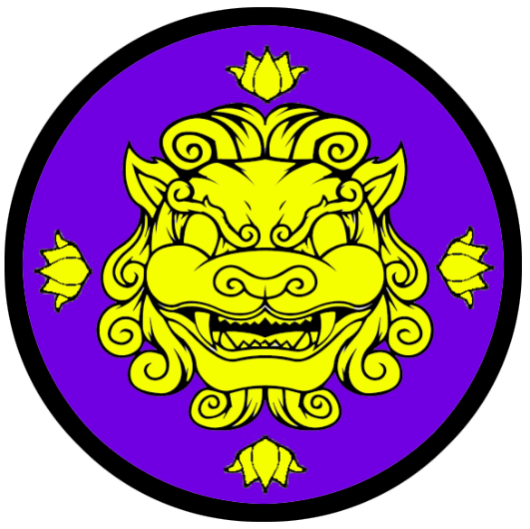
Mingyun “City of Destiny”
Size: metropolis, population 50,000, guards / soldiers 500, militia 2500
Trade Goods: Sifuren perfume (osmanthus), grain, magic center, wine, silk, textiles, gold, religious center
Local Goods:
Standard: sign of the lion dog
Colors: purple and gold
Patron Deity: Xihe - great sun goddess aka Taiyangshen
Ruler: Qian Yazhu and his wife Wu (f)

Home: Pale Moon Palace
Steward: Ye Ruogang
Marshal: Xu Yating
House Priest: Pan Wuying
House Adviser (Scholar/Mage/etc): Xiong Qiu (f)
Captain of the Guard: Lei Yong
Chief Warriors in Service:
Zou Guanyu
Yin Zheng
Yu Huan

Local Powers: The Poison Dao (thieves’ guild), Order of the Flaming Pearl (order of paladins), Feilong Sanctum (school of magic), High Temple of Xihe the sun goddess, Soldiers of Youdu (assassin’s guild)
Local Sites: The Angry Mantis Inn & Tavern, Kameosa House Inn & Tavern, Jiushen House (winery), House of the Water Lily (brothel), the Heaven Dome (colosseum)

Description:
Mingyun has historically been the powerhouse uniting the southern Xiandai lands and for many centuries imposed itself as the throne over all Xiandai.

Mingyun is a stately metropolis, with proud royal buildings standing tall in lacquered rooftops and glittering gold statuary. Well-manicured gardens cover the terraces overlooking the sprawl of a busy cityscape. The Pale Moon Palace dominates the center of the city, with its namesake water lilies blooming in white, yellow, pink, red, and orange in the many reflecting pools on the grounds. Mingyun has the oldest and finest of Xiandai culture and craftsmanship.

Where the Jady City boasts mighty infantry, the City of Destiny has the most powerful navy in this part of the world. Where the Jade City boasts new innovations and markets opening up to the west, the City of Destiny lays claim to the oldest traditions and history.

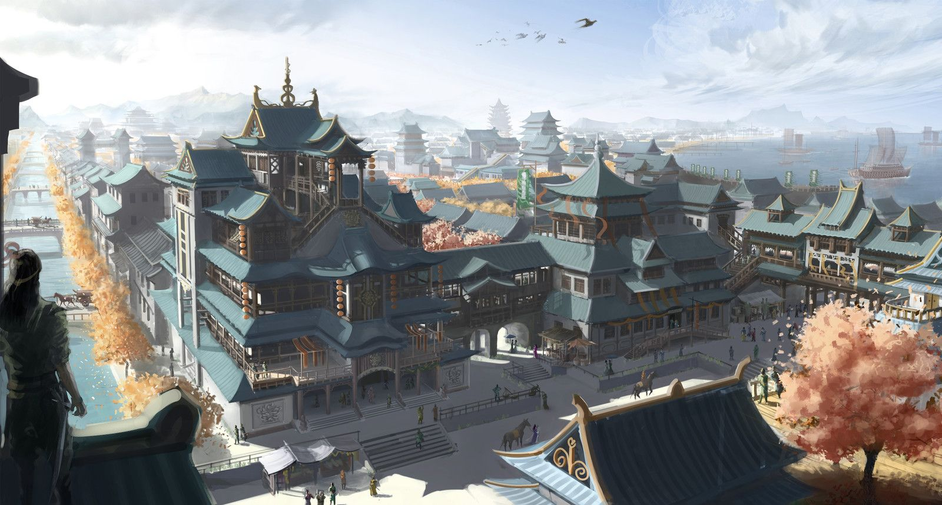

Industry:
Mingyun commands grain and gold resources that, by themselves, would be enough for two cities. The Plains of Plenty to the west offer a boundless stream of rice and millet. The city jealously guards these plains, sending armed patrols throughout its expanse to control the farmers. It also stations hundreds of soldiers along the Runlun River to the north. It is almost certain death to try to cross the river without an Imperial letter, for spies in the past have wrought havoc in the plains. Gold mines operate in the Stoneclaw Mountains that have filled the coffers of emperors and kept the city in good fashion. Mingyun silkworm groves feed the city’s famed textile quarter. Dressmakers here carry on in the techniques handed down over thousands of years. Mingyun fashion may seem dated to the people of the north, but it has a classic look to it that carries great respect.

A large plantation outside of the city is home to the Jiushen House. Here the rice wine of the same name is produced and exported. Also made here is Sifuren perfume, which is said to be the most popular scent from the east. It is made from the fruit of the osmanthus trees that grow in Donguri Forest.

Key Figures:
Qian Yazhu – conservative, cruel, resistant to change
Emperor Yazhu is the fifteenth Emperor to sit in Mingyun since the current Two Kingdoms Age began four hundred and seventy years ago. Of medium build and fit, he is still an imposing figure at his advanced age. His hair and long beard have finally turned white but his eyes are sharp and he has a sagacious aspect to him. The priests have anointed him the Son of Star and Sky as his official royal name. But those close to him call him the Sullen Stone, for he is a fixture of tradition in the land and stubborn about proposals for change. Yazhu is also a cruel and uncaring sovereign. He ignores pleas for help for the poor and rejects civil works that would benefit the populace. Instead he pours the treasury into engines of war, particularly ships commissioned in Hundao and White Crane. The Emperor consults his wizards and priest daily, more than even his war advisers. He is convinced it is his destiny to finally destroy Jade City in the north and begin the Sixth Dynasty. He will stop at nothing to see this accomplished.

The Hall of the Flaming Pearl is home to the paladins of the order of the same name, storied champions of the people. And Feilong Sanctum is the stronghold for the Emperor’s most powerful mages, who tap into arcane methods for overcoming all foes.

Local Lore:
There are Nine Sons of the Dragon that guard these lands and protect its people. These are dragon hybrids that resemble a cross between a dragon and another beast. Each region has a guardian dragon. The Suan Ni watch over the lands around Mingyun. It is a hybrid of a lion and a dragon and it appears sitting in vigilance. Totems of the Suan Ni can be seen in the architecture and decorations throughout the region and are typically used on the bases of religious shrines and idols.

History:
Mingyun was the first great city in all of Xiandai, rising up in the primordial ages to establish order among the scattered villages of the land. Many emperors have ruled here, with some even gaining control over all of Xiandai and beyond.

The Age of the Xiandai Empire saw the high point of power out of Mingyun and earned it the name City of Destiny. In 240 AA3 Emperor Hano claimed to receive a vision of his destiny to rule the known world. He launched a campaign to bolster Xaindai's army and crushed any regional ruler who did not comply with his wishes. Within five years he had crushed the Moghun peoples south of the Ryuluun Mountains. Over the course of the next one hundred years his son would go on to invade Kazeldun, Sakura, Mahabar, and Kaduru and seize large swaths of land. Eight generations of Hano’s dynasty would rule the east and exert enormous power over the world. After four hundred years the descendants of Hano began to quarrel. In 650 AA3 the Battle of Kaihei in Sakura would spell the end of the era. General Doruhan crushed the Xiandai armies, freeing the kingdom. This caused a chain of events where each of the Hano armies were ejected from conquered lands. At last in 700 AA3 the last descendant of Hano was assassinated and Xiandai returned to its own borders.

Mingyun’s more recent domination of Xiandai came in the wake of orc armies invading from the Ryuluun Mountains twenty-two hundred years ago in what would be called the War of Dark Mountains. Lord Gengxin, leader of the Red Banners, united the clans in defense of the land and was named the fourth Emperor of Xiandai in 304 WA2. Gengxin lost no time. He ordered timber procured from the Donguri Forest, commissioned great earth works to be built north of the Majestic River, and had a fortified town built within a year. His soothsayers advised him it was Xiandai’s destiny to defeat the orcs and claim this land. They blessed the region and anointed Gengxin blessed savior from the gods. After twenty years of hard-won victories the orcs were driven back into the Ryuluun Mountains and Mingyun remained (323 WA2). With brutal cunning Gengxin routed the dark armies and secured peace for the land for four centuries.

Mingyun’s grasp would not last. Fifteen hundred years ago the Jade City of Yuchung rose up and established itself as the capitol in the north. This sparked the Xiandai Civil War (30 WA3). Mingyun immediately sent ships to the Sea of Mazu to quell the rebellion. The greatest sea battle between the two powers, the Battle of Mazu Sea, ended with Yuchung still standing and Mingyun’s navy in flames (50 WA3). This sparked a thousand years of on-and-off wars between the two. History has seen the power shift briefly between the two but it is at a stalemate at this time. Fifteen hundred years ago witnessed the Great Civil War of Xiandai (30 WA3). In it the great cities of Jade City and the City of Destiny wage bloody war over all the lands. This lasted for over a hundred years when, in 160 WA3, came the end of the Civil War: Jade City consolidated power in the north, the City of Destiny in the south.

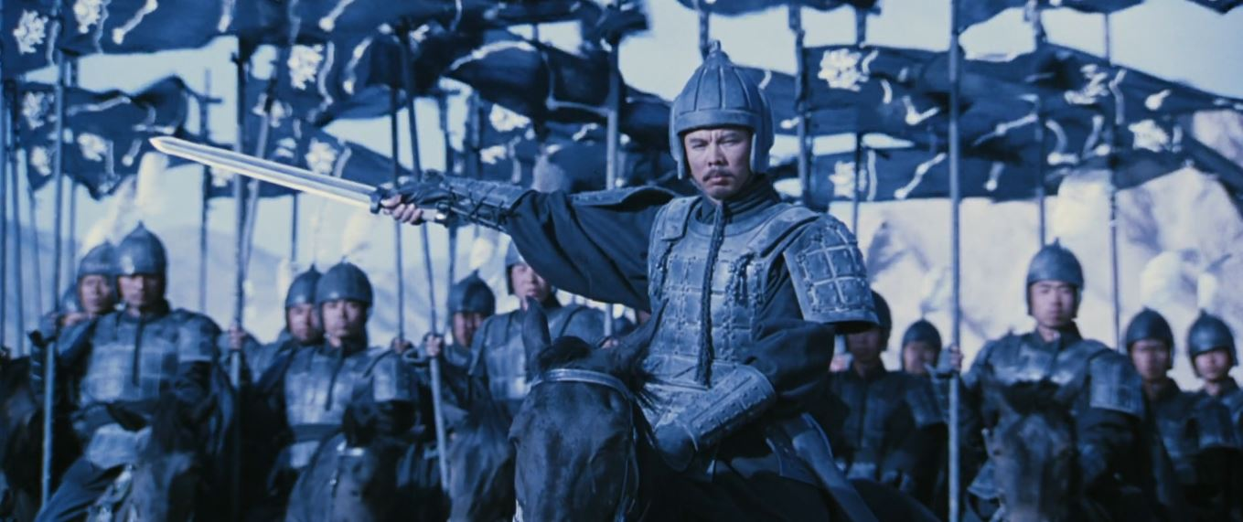
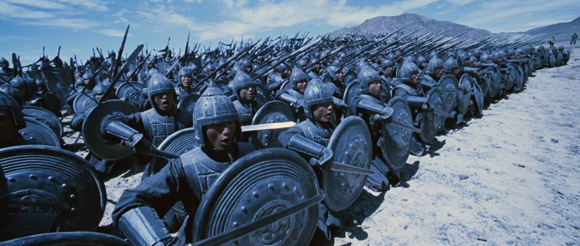

Customs:
Once each month the Emperor holds a competition in the Heaven Dome. Each competition has its own theme, but each one is designed to win honor for the victor in whatever field he or she is a master.
There is the Tournament of Tigers open to armed and armored warriors, the Phoenix Duels pitting wizards against one another, the Rabbit Games testing the athletic abilities of the contestants in elaborate and dangerous obstacles courses while chased by dogs, the Empty Stair where monks combat one another with death-defying skills, the Locust Swarm where mobs of commoners work as teams to assemble stones into fortresses while working to destroy the fortresses of their opponents, and the Dragon Tournament where acrobats build and operate stunning dragon costumes empowered by magic and do battle with one another. There is even a competition amongst musicians, where their instruments and voices are bolstered by colorful displays of illusions and fireworks. The Emperors have always taken great delight in their games and villages from all over Xiandai bestow great favors on those who win them honor in Mingyun. All winners carry a special magical brand of their victory, which they are proud to show wherever they go. It is a sign of great accomplishment and common people worship such victors as minor deities.
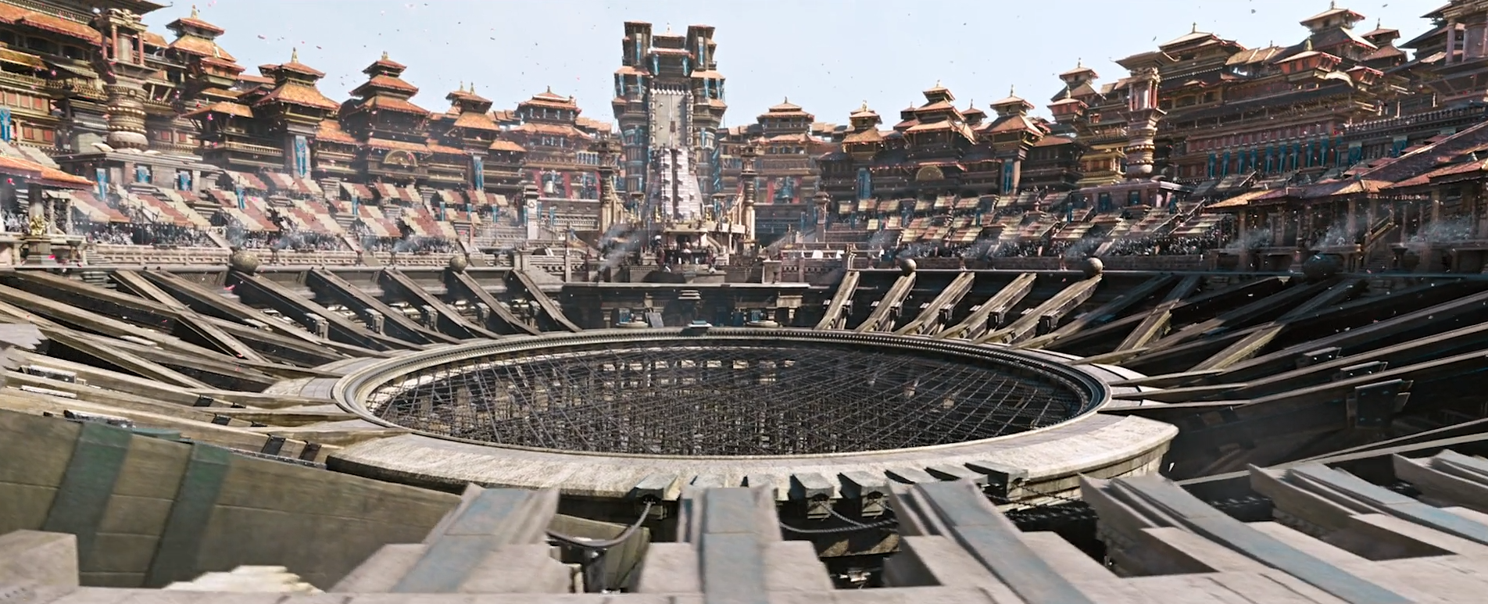
(reference only: from the movie Double World)

Huandao
Size: small city, population 12,000, guards / soldiers 120, militia 600
Trade Goods: silk, textiles, stone, silver, grain
Local Goods:
Standard: sign of the ox
Colors: yellow and black
Patron Deity: Mushen - woodland god aka Jumang
Ruler: Wen Zhenya and his wife Jiao (f)

Home: Heaven Blade Castle
Steward: Shen Chen
Marshal: Wen Su
House Priest: Cui Shun (f)
House Adviser (Scholar/Mage/etc): Fan Shun
Captain of the Guard: Tian Zemin (f)
Chief Warriors in Service:
Wan Tao
Ma Kang
Tao Lingxin

Local Powers: The Henan Circle (thieves’ guild), Band of the Yeren (rangers), Temple of Mushen the woodland god
Local Sites: The Silver Serpent Inn & Tavern, The Stout Staff Inn & Tavern, Seven Heavens (brothel)

Description:
Huandao was settled over four thousand years ago to oversee a farming settlement in support of the City of Destiny (590 AA3). The city sits in the shadow of the River Claw Mountains overlooking Azura Bay. Most goods are transported to the capitol by a road leading up through Vigil Pass to the north. This is heavily guarded to prevent incursions from the Moghun tribes.

Huandao is a plain city in comparison to White Crane. While it has the some of the sense of frontier spirit and self-reliance that White Crane has, it is closer to the capitol and connected by land. There are far fewer outlanders that visit here by sea. The market caters mostly to outlying farmers, the language most heard here is Xiandai.

What Huandao does have, however, are sturdier soldiers. Hardened in the cauldron of constant battles with the mountain orcs and the Dedferet tribe of goblins, the Huandao infantry are well drilled and tenacious. The Emperor in the City of Destiny often calls on them as marine infantry to be deployed from his navy from White Crane.

Industry:
Huandao spent the first couple hundred years developing rice fields in the rich land of the Phoenix Valley. Soon silk groves were developed and weavers brought in to develop the silk into woven products. Expeditions into the River Claw Mountains found rich deposits of silver and mining operations were established. Quality stone was also discovered and became a source in high demand by the City of Destiny for its defensive works. The people of Huandao long ago befriended the Dwarves of Jasprendryn and have learned many secrets to stonework from them. Emissaries travel to the Dwarven town of Sunderkhar often.

Key Figures:
Wen Zhenya - fearful, tradition-minded, sullen
Lord Wen is a short, stocky man with laborer’s hands. He has a squashed, flat nose and small worried eyes. He dresses in a plain manner out of step with current fashion, feeling more comfortable in simple raiment. Wen is the fifth generation of the Zhenya rulers over Huandao and follows in the tradition of loyal subjects to the throne. He is a man full of worries, which can be read by his expression and his hand-wringing. His thoughts are always on orc and goblin attacks from the mountains, the threat of Moghun raiders from over the river, or the displeasure of the Emperor’s advisers. Wen’s only real joy is in his work, involving himself with the stone work his town excels at and the silver mines in the mountains. He is not a cheerful man and is one of few words.

Band of the Yeren – Rangers from this band patrol the Phoenix Valley region and the adjoining Ryuluun Mountains. They follow the way of Yeren, a large ape creature that roams the Ryuluun Mountains and is a protector of nature. The Yeren rangers are said to wear bracers made of the fur of fallen mountain gorillas that have been gifted to them by Yeren upon completion of their training. It is said the bracers imbue great strength and constitution to the Yeren rangers, as well as uncanny climbing abilities in the mountains.

Local Lore:
Evil creatures lurk in the Ryuluun Mountains, but few are as large as the Bashe. Bashe are gigantic pythons that dwell in the mountains and foothills. They are fond of eating elephants and are always hungry. Entire herds of oxen can disappear in one night when this creature wanders near a village.

There are Nine Sons of the Dragon that guard these lands and protect its people. These are dragon hybrids that resemble a cross between a dragon and another beast. Each region has a guardian dragon. The Chao Feng presides over the lands around Huandao. It is a hybrid of a goat and dragon. It is a creature that likes to climb and eat. Totems of the Chao Feng can be seen in the architecture and decorations throughout the region and are typically placed on the four corners of roofs.

History:
The city of Huandao has had a hard history. In the beginning orc tribes from the mountains kept the camp under constant attack. These continue to be a frequent problem to this day. More troubling, however, are the Moghun tribes coming around the eastern edge of the River Claws. Huandao was forced to build several defensive walls between the mountains and the coast to protect the city and its farmlands. On more than one occasion the city has been completely lost, only to be retaken by troops from the capitol. Its sister city of Lo Pan, built much farther to the south along the Hanyo River estuary, was not so fortunate. In spite of hastily built defenses to protect it from the west, it was overrun by Moghun hordes a thousand years ago. It is ruins now and said to be the dwelling place of an ancient evil force.

White Crane and Huandao were part of the Azuran Kingdom, which rose up in the Azura Bay region in 310 AA4. The Azuran Kingdom fell in 945 AA4 and was absorbed back into the control of Mingyun. The people here still retain a sense of pride in their region, but are loathe to show it for fear of the Emperor and his soldiers.

A famous battle recounted by the storytellers in Huandao is from four hundred years ago. It tells of the Hanging Heads, a tribe of orcs that dwell in the River Claw Mountains and who are infamous for centuries of attacking the city. It was in the Battle of the Broken Blades that the orcs fell on Huandao in such might that the walls of the city were breached and every weapon was sundered. The priests of the temple cried out to Shangdai for salvation. A bright yellow light shone down and a fisherman’s son named Moyao stepped into it. He claimed the Blade of the Seven Heavens and with it charged the banner of the Hanging Heads. He slew the orcs’ general and his entire host. It is said the blade possessed the lightning of the heavens as well as other mighty powers. The blade was taken into heaven after Moyao died years later. It is rumored to wait in the mountains for the next savior of Huandao that needs it.

Customs:

Báihè “White Crane”
Size: large city, population 25,000, guards / soldiers 250, militia 2250
Trade Goods: trade hub, ship building, clay, pottery, silk, textiles, arts
Local Goods: the most accomplished vocalists, Kaolin porcelain
Standard: sign of the crane
Colors: blue and white
Patron Deity: Cháng'é - moon goddess aka Changxi aka Yueshen
Ruler: Mao Ruogang and his wife Guanyu (f)

Home: Lodestone Castle
Steward: Kong Qiu
Marshal: Wen Xinyue (f)
House Priest: Mo Zhenya
House Adviser (Scholar/Mage/etc): Deng Zhou
Captain of the Guard: Chen Xinyue
Chief Warriors in Service:
Zhang Chin
Hu Zan
Luo Tai

Local Powers: The Plunder Men (thieves’ guild), Gongono Traders, Temple of Yueshen the moon goddess, Kaolin Guild (porcelain), Gardenia Conservatory (bardic college of song)
Local Sites: Dragons of the Four Seas Inn & Tavern, The Oxcart Wheel Inn & Tavern, House of the Twelve Delights (brothel)

Description:
Standing atop the water like its namesake, White Crane extends out from the mainland in a jumbled and beautiful mess of city blocks floating atop large platforms. Homes, store houses, temples, shrines, even towering pagodas take up individual platforms that are lashed together. Wide waterways cut between the buildings, with small to medium-sized boats making their way through the city. Throughout the season the platforms detach and re-attach, allowing the city to constantly shift and change. Visitors who return to White Crane after only a few months will find themselves in a totally new city. Only the Old Quarter on the mainland remains the same, with its densely packed houses resting in the shadow of the fortress and protective walls.

Of all the cities in Xiandai, Baihe is the most diverse and open to the outside world. The sails of every southern kingdom can be seen in port. The market place teems with the goods of other nations as well as their foods. Large parties are held every night on the water, with brightly lit lanterns floating on or just above the water and creating a welcoming glow.

Baihe has traditionally been known as ‘White Crane’ since before written history. It was settled over two thousand years ago to develop shipyards to support the City of Destiny. Its fortress, Lodestone Castle, is so named because the first compasses were invented here from magnetic rocks found in the mountains far upriver. The compass revolutionized sea exploration and helped the Azura Kingdom gain great power before its fall.

The city of Huandao is a close ally, requiring aid when Moghun threats arise. Both cities are beginning to develop a sense of identity that is separate from that of their Xiandai cousins. Here the people speak their own dialect, drawn from years of dealing with outlanders from across the Shanga Sea.

South of the city lies the Strait of Kira, which is the opening to Azura Bay. Either side of the strait is guarded by stone keeps called Lóng yá, the Teeth of the Dragon. Imperial troops are stationed there to fire artillery on any unwelcome ships passing this way. Only those bearing the seal of the emperor may pass. However, the city regularly makes exceptions to this custom as it sees the benefits of inviting trade partners into her ports.

Industry:
The industries supporting White Crane have evolved over time. The first settlers four thousand years ago were commissioned by the City of Destiny to develop rice fields and build ships (640 AA3). Centuries later silk groves were started and were expanded. Settlers also learned the clays around the Ranyan estuary were of great value as well and with them a tradition of ceramics began. White Crane potters developed methods for creating very thin elegant porcelain, which brought even more coin. Eventually, the shipping traffic from the City of Destiny led to the building of a sophisticated port and shipyard. The rapid growth of the town led to the rise of the Azura Kingdom here in 310 AA4. The Azuran Kingdom fell in 945 AA4 and was absorbed back into the control of Mingyun. Today the city is a major trade hub serving markets in Harikanya in Kaduru and Turutan in Mahabar.

The Gongono Trading Company is a powerful entity here and sometimes works outside of imperial mandate to help benefit the city and its own coffers. It works with the forts to allow passage to any who it deems are worthy customers.

Kaolin is the term for the white clay that is dredged from the river delta in this region. It is of such unique quality that it creates an elegant porcelain found nowhere else in the world. The Kaolin Guild controls the manufacturing of these treasures, employing master artisans who dedicate their lives to the making of it. Merchants refer to the porcelain as simply Kaolin and its more delicate version as Fine Kaolin used to make cups and saucers.

The Gardenia Academy is a conservatory training the most gifted vocalists in the arts of traditional Xiandai song. Children throughout the land are taught singing in temples, but those who exhibit the rare talent to make the Otherworld Chime ring are brought here to study. It is the greatest honor of temple priests to find such a prodigy and send them to the academy. Graduates go on to great fame, touring palaces and temples, where their voice is said to be able to channel the divine power of the gods.

Key Figures:
Mao Ruogang - curious, clever, independent
Lord Mao is a slender man with a thin moustache and beard and a narrow face. His eyes have a soft gaze of scrutiny. He dresses in high court fashion but is known to add touches of fabric and adornment from other lands. Mao is a man of many worlds, treating with merchants of other lands who visit his port and curious of their many ways. This attitude he tries to keep discrete for it is not popular in the City of Destiny. But he is a clever man and maintains two guises: one for the lands south of the Ryuluun Mountains and one for the Emperor’s court. This includes his financial dealings, for he controls the Gongono Trading Company and allows certain ships into Azura Bay that do not bear the Emperor’s seal. Above all Mao is a curious and visionary man and feels less restrained by tradition.

Local Lore:
There are Nine Sons of the Dragon that guard these lands and protect its people. These are dragon hybrids that resemble a cross between a dragon and another beast. Each region has a guardian dragon. The Qui Niu watches over the lands around White Crane. It is a hybrid of a cow and dragon. It is a creature that likes music. Totems of the Qui Niu are featured in art and architecture in this region and are used to adorn musical instruments.

A hundred miles up the coast is the Monastery of the Vermillion Bird sitting in the shadow of the Ryuluun Mountains.

History:
White Crane and Huandao were part of the Azuran Kingdom, which rose up in the Azura Bay region in 310 AA4. The Azuran Kingdom fell in 945 AA4 and was absorbed back into the control of Mingyun. The people here still retain a sense of pride in their region, but are loathe to show it for fear of the Emperor and his soldiers.

830 WA3 - Battle of the Broken Blades: Orc tribes attack Huandao; the hero Moyao wields the Blade of the Seven Heavens and defeats the Orcs

Customs:
Being a port town, White Crane is a melting pot of cultures that sets it apart from the lands north of the Ryuluun Mountains. People here are rugged, having learned to survive so far south of the Xiandai homeland. Travelers to White Crane will find an open-minded atmosphere in her people. Many languages are spoken and many businesses cater to the tastes of those from Kaduru and Mahabar.

History of Xiandai
Rulers of Xiandai
240 AA3 – 700 AA3 - rule of the Alabaster Dynasty
310 AA4 - - Azura Kingdom of the South
844 AA4 – 140 WA1 - First Imperial Dynasty
245 WA1 – 821 WA1 – Moghun rule of Xiandai
822 WA1 – 191 WA2 - Second Imperial Dynasty
302 WA2 – 473 WA2 - Orc occupation of Xiandai
474 WA2 -
30 – 160 WA2 – Civil War: Thrones in Yuchung and Mingyun

First Primordial Age (PA1)
Dawn of the Yun

10 PA1 - The gods of the limitless heavens appear in Nemmyrl for the first time and find the continent of Xiandai to their liking: Haishen, Zhurong, Shanshen, Fengshen, Shuishen, Xihe, Mushn, and Yueshen.

120 PA1 - the Cosmic Dragon, wounded from the Battle of Vail, reclines across the Xiandai continent and slumbers in the sleep of ages; his body becomes the Ryuluun Mountains

150 PA1 - The Eight Immortals appear from among the Yun peoples; they are individuals of peerless enlightenment with great powers against evil
260 PA1 - The Purple Palace is constructed on Xian Island

440 PA1 - the first Flaming Pearl descends from heaven atop the mountain now known as Pearl Mountain; it becomes a powerful gift bestoing spiritual energy, wisdom, prosperity, and power

620 PA1 - the Heaven Lotus blooms for the first time in Lotus Valley

Second Primordial Age (PA2)

80 PA2 - the Bull Demon King Niumowang appears with his army from hell to savage the land and almost sink the continent; the Xiandai gods unite and send forth Four Guardians to drive out the demons: the Black Tortoise, the Azure Dragon, the Vermillion Bird, and the White Tiger

84 PA2 - After many devastating battles the Bull Demon King is defeated by the Four Gaurdians, who then restore balance to the land by each residing in a different place as wardens of the land: the Black Tortoise to the North, Azure Dragon to the East, Vermilion Bird to the South and White Tiger to the West

Third Primordial Age (PA3)
270 PA3 - the Eight Immortals unite to destroy a plague of demons led by Baigujing the White Bone Demon; the Immortals are almost defeated, retreating back to the Isle of Xian

271 PA3 - after a great battle atop the Mountain of the Five Elements, the Eight Immortals defeat the White Bone Demon and its armies and entomb them in a magical well

Fourth primordial Age (PA4)
300 PA4 - The wizard Alqebrin forges the Amulet of Tiamat and summons an army of dragons to his lair in the Valley of Virago

310 PA4 - The Great Dragon War - Alqebrin unleashes his army of dragons on Xiandai, destroying everything for hundreds of miles.

312 PA4 - dragons from Virago destroy the towns of Bianjing, Gidonn, Dokuro, Zidao, Raden, and Bailan

350 PA4 - The Great Dragon War - the wizard Fong Lu rallies a band of heroes and metallic dragons to battle Alqebrin to contain his evil dragons; the Amulet of Tiamat is destroyed, the dragons consume Alqebrin, and the evil dragons hide beneath the mountains of Virago Valley

380 PA4 - the red dragon Immolax, now an adult, gathers the survivors of the Great Dragon War to rule over the region; the mountains henceforth are known as the Elderwyrm Mountains

512 PA4 - Fall of villages along Azura Bay to forces of General Dractus of Kazeldun

521 PA4 - Battle of the Crying Bones - Dractus brings all his forces to bear to defeat the Xiandai armies guarding the Northern Pass; Dractus invades northern Xiandai

525 PA4 - Fall of Mingyun to forces of General Dractus of Kazeldun; the city is utterly destroyed

527 PA4 - Fall of Mingxia to forces of General Dractus of Kazeldun; the city is utterly destroyed

528 PA4 - Fall of Jade City to forces of General Dractus of Kazeldun; the city is utterly destroyed

529 PA4 - Fall of Fortune Town to forces of General Dractus of Kazeldun; the city is utterly destroyed
530 PA4 - Eight monks come down from the Mountain of the Flaming Pearl wielding the Scepters of Creation, decimating Dractus' forces along the Longbow River

531 PA4 - Xiandai forces from Juhua, Kylin, and Huandao rally behind the eight monks and attack Dractus' forces

533 PA4 - Dractus, fighting on four fronts, personally attacks the army of the Eight Monks; in an epic battle Dractus, the Crown, the monks, and the Scepters are destroyed, ending the scourge of Dractus

534 PA4 - Dractus' army flees Xiandai. Moghun hordes waiting for them south of the Ryuluun Mountains destroy what is left of Dractus' mighty army.

872-888 PA4 - The Wizard War: Telemechus triggers a world-wide war of mages, some of whom march on Ongolk to stop him and some who join him in attacking the ley lines in their lands; epic battles wage all over the world, destroying cities and upsetting the balance of magic
888 PA4 - The Battle of Forlorn: Telemechus is slain but not before rupturing the magical ley lines permeating Nemmyrl; the victorious general Dragan of Celedon seizes the opportunity to rid the world of magic and ruptures the Singularion as it is embedded in the ley lines; the resulting explosion sends a shock wave that ruptures the magical ley lines around the world and triggers the Dead Century

First Ancient Age (AA1)
0-100 AA1 - The Dead Century: the Wizard War results in all magic suffering a terrible blow, all artifacts not protected in special shrines are rendered inert, magical creatures who do not seek shelter in other planes die a horrible death

101 AA1 - The Union of the Great Circle: Druids all over the world receive a vision calling them to chant in unison to heal the world; armies of man mobilize to exterminate the druids to maintain power

102 AA1 - after a full year of heroes rising up to defend the druids, the chant is complete with the final Unuttered Word and the lay lines of Nemmyrl are restored; magic returns to the world

320 AA1 - Gengxin of the town of Mingxia launches attacks on the Yun tribes east of the Kang Mountains

323 AA1 - Gengxin unites all people east of the Kang Mountains into the sovereign kingdom of Mingxia

508 AA1 - The luxury boats of Prince Liu of Ayozu and prince Katyo of Mingxia meet in the Kamatsu Straits; neither gives way to the other and they enter a petty quarrel that ignites the two cities into all-out war

508-522 AA1 - The Fisher Kings War: thousands of war ships and fishing boats wage war between Ayozu and Mingxia, all in a bid to control the Kamatsu Straits

523 AA1 - Monks from the Azure Dragon monastery in Xiandia join the monks from the Monastery of All that Flows in Sakura to defeat the princes and end the War of the Fisher Kings

524 AA1 - Stricken by the suffering they caused, the princes erect the Shojo Guardians, 100-foot-tall statues depicting warriors of each land that watch over the northern opening of the Kamatsu Straits as a reminder of peace along these waters

680 AA1 - Holong the Resplendent is the first king to be buried in the Valley of the Dead Kings. His Resplendent Palace of the Dead is guarded by living statues created by his wizard Pailan.

Second Ancient Age (AA2)
140 AA2 - Mingyun invades kingdom of Mingxia and adds its domain to its own

770 AA2 - Junjii pirates raid Azura Bay, raiding farms and towns and controlling the region for forty years
810 AA2 - sea druid Tomotan aides the farmers in the Azura Bay region by trapping the Junjii ships within the bay and calling down devastating storms to destroy the pirates' ships

Third Ancient Age (AA3)

240 AA3 - Xiandai Empire: Emperor Hano of Mingyun claims to receive a vision of his destiny to rule the known world, launches campaign to bolster Xaindai's army; Hano crushes any regional ruler who doesn't comply

242 AA3 - Emperor Hano adopts the title Radiant One, his followers worship him as a god; Hano launches a campaign into Southern Xiandai to crush the Moghun

245 AA3 - Battle of Aemelek - Hano devises brilliant strategy to lure the Moghun forces into a trap, slays the leaders of all eleven tribes

270 AA3 - Xiandai invades Kazeldun
290 AA3 - Xiandai invades Sakura
320 AA3 - Xiandai invades Mahabar

340 AA3 - Xiandai invades Kaduru

390 AA3 - Xiandai invades the islands of Ominotago and Wanahila

570 AA3 - Xiandai is driven out of Kaduru

590 AA3 - The town of Huandao is established as a farming resource to support the City of Destiny
630 AA3 - The town of Baihe (White Crane) is established as a ship-building resource to support the City of Destiny

650 AA3 - Battle of Kaihei - General Doruhan crushes the Xiandai armies in Sakura, freeing the kingdom
680 AA3 - Caerron tribes drive out the last remnants of the Xiandai invaders

700 AA3 - Last descendant of Hano is assassinated, ending the Xiandai Empire

Fourth Ancient Age (AA4)
40 AA4 - The Fall of Heaven and Rise of Hell - the evil cleric Wai Hen angers the gods and triggers a massive earthquake that sunders the land; beasts from the underworld emerge and plague the land

45 AA4 - the scourge is driven back by Paladins from the Orders of Panlong and of the Flaming Pearl; Wai Hen is cast into the Void

310 AA4 - General Hanshu unites Huandao and Baihe and all lands south of the Ryuluun Mts. To form the Azura Kingdom

440 AA4 - Azura Kingdom marches through Vigil Pass and wages war on Mingyun

448 AA4 - Mingyun falls to Azura forces

455 AA4 - Azura Kingdom takes Mingxia

470 AA4 - Azura forces attack and conquer Baozang

479 AA4 - Azura takes Haidan, begins three hundred years of raids on the open seas from the island

484 AA4 - Azura takes Kylin

590 AA4 - Azura forces attack the Elderwyrm Mountains, succeed in slaying several dragons

606 AA4 - Faofang the ancient dragon rises up and destroys the Azuran forces in the Elderwyrm Mts; Faofang takes revenge by flying to Baihe and stealing the Emperor's children

818 AA4 - the evil wizard Wai Hen returns when a novice wizard accidentally opens a portal to the Void; Wai Hen uses his centuries in the Void to learn of the Crown of Power and seeks it out

820 AA4 - Wai Hen takes over the Valley of Dead Kings and animates an army of stone soldiers

821 AA4 - Wai Hen and the Stone Army defeat Moghun tribes and recruit several thousand of their riders; Wai Hen opens the way into northern Xiandai

822 AA4 - Wai Hen and the Stone Army march on Mingyun; High Temple of Xihe is destroyed along with the paladins of the Flaming Pearl

825 AA4 - Wai Hen takes over the Valley of the Dead Kings and animates an army of stone soldiers from a portion of the vast petrified soldiers entombed there.

831 AA4 - Wai Hen hears of heroes roaming the land, liberating people from his reign of terror; launches a campaign to march on Pearl Mountain where the Crown was defeated four thousand years ago

835 AA4 - a rag tag group of Xiandai heroes confronts Wai Hen atop Pearl Mt and defeat him; the cosmic blast causes Pearl Mt to glow at night to this day

844 AA4 - First Imperial Dynasty: with the fall of the Azuran Kingdom Xiandai unites under a single Emperor in Mingyun for the first time in history

First Written Age (WA1)

140 WA1 - End of First Imperial Dynasty: Emperor Hanying collects all ten Rings of Opulence and is destroyed resulting in a curse on the land and sending it into chaos for centuries

142 WA1 - War of the Sons of Dragon : towns fall into a hundred year of war between one another over territory, civilization collapses

245 WA1 - Moghun Rule - War chief Bataar of the Moghun marches over the Ryuluun Mountains and conquers Xiandai, settning up Moghun rule for six hundred years

720 WA1- Celedonian Primus navy enters the Strait of Immolas and are destroyed by dragons

800 WA1- Mingmei Song (f) of Mingyun receives a vision from Xihe the great sun goddess to unite the lands of Xiandai; bestows upon her the Sword of the Forever Sun

801-821 WA1- Forever Sun Wars - Mingmei Song battles lords of every town and city north of the Ryuluun Mountains and unites them all

822 WA1- Mingmei Song crowned Empress over all Xiandai, ushering in a new age of culture and civilization; Second Imperial Dynasty begins

Second Written Age (WA2)
190 WA2 - Battle of the Flaming Sails - great sea battle in which the Mingyun fleet wiped out the ships from Shiashi

191 WA2 - Xiandai falls into chaos as the Mingyun is invaded and sacked; end of he Second Imperial Dynasty

302 WA2 - The War of Dark Mountains: Orc armies invade all of Xiandai, pouring out of the Ryuluun Mountains

304 WA2 - Lord Gengxin, leader of the Red Banners, unites the clans of all Xiandai in defense against invading Orc armies. He is named Emperor of Xiandai

323 WA2 - With brutal cunning Emperor Gengxin routs the dark armies

324 WA2 - beginning of the Third Imperial Dynasty

780 WA2 - Kamatsu War - Xiandai ships land at Anada Plains and wipe out farms and villages, setting off decades of naval sea battles between Xiandai and Sakura

870 WA2 - Battle of Nuwa - Sakuran ships pursue the remnants of the Xiandai fleet to Nuwa Bay and decimate them, resulting in Sakuran naval superiority for the next two hundred years

875 WA2 - The Jade Age - Feng Ning of Yuchung invades Mingyun and overthrows the Emperor, power shifts to Yuchung the Jade City; end of the Third Imperial Dynasty

Third Written Age (WA3)
30 WA3 - Civil War in Xiandai: the great cities of Yuchung (the "Jade City") and Mingyun (the "City of Destiny") wage bloody war over Xiandai

50 WA3 - Battle of Mazu Sea - Mingyun sends ships to the Sea of Mazu to quell the rebellion of Yuchung. It ends with Yuchung still standing and Mingyun’s navy in flames

160 WA3 - End of the Civil War in Xiandai: Jade City consolidates power in the north, the City of Destiny in the south; start of the Mazu Kingdom Age

450 WA3 - Wars of Northern Xiandai: Jade City wages endless wars to secure control of the North

470 WA3 - Fall of the town of Lo Pan to Moghun raiders

630 WA3 - Laong House of Fortune Town recruits the Juren hill giants of Togiro to protect them

640 WA3 - Fortune Town defies Jade City

642 WA3 - War of the Fortuneless Giants: Jade City attacks Fortune Town and is almost defeated; famed General Ko Hang manages to slay the Juren giants with his magic sword, Shu Dao. Xuefeng House executes Laong House and takes over Fortune Town, resumes war with Yuchung

700 WA3 - Jade City defeats Fortune Town; End of the Wars of Northern Xiandai

710 WA3 - Mingyun attacks a weakened north and overcomes it, restoring Imperial rule; end of the Mazu Kingdom Age and beginning of the Fourth Imperial Dynasty

830 WA3 - Battle of the Broken Blades - Orc tribes attack Huandao; the hero Moyao wields the Blade of the Seven Heavens and defeats the Orcs

841 WA3 - Isle of Mazu seized by Sakuran general Kiroko on orders from Ayozu

843 WA3 - Xiandai ships attack Sakuran forces around Mazu; conflict escalates until both kingdoms' fleets converge on the waters

844 WA3 - Mazu War: hundreds of ships of various sizes engage in multiple battles until dragons out of the Elderwyrm Mountains appear and destroy both fleets

866 WA3 - Xiandai warriors secretly enter the Isle of Mazu disguised as fishermen; they wipe out the Sakuran guard holding the island, returning it to Xiandai control

Fourth Written Age (WA4)
10 WA4 - War of Shrines between Xiandai and Sakura and parts of Mahabar
30 WA4 - Jade City takes advantage of a weakened Mingyun and breaks away, restoring independent rule over the North; end of Fourth Imperial Dynasty, start of the Second Two Kingdoms Age
90 WA4 - Moghun warlord Kamalchek, dispossessed by his tribe, leads a small army over the Ryuluun to seek his fortune elsewhere
93 WA4 - Kamalchek descends on Kylin and conquers it
105 WA4 - hero Huen Fong, mentored by an ancient wizard known only as Hai Wushi, the Sea Wizard, uses the Sword of the Jiaoren to lead an uprising and free Kylin of the Moghun invaders
331 WA4 - Baozang attacks the town of Ayaabe, set on conquering it to colonize Haka'Na lands; Ayaabe warriors decimate the Xiandai mercenaries and burn their ships

Brief History of Kingdoms in Xiandai

The Great Dragon War 310 PA4 – 350 PA4 (40 years)
Scourge of Dractus 512 PA4 – 534 PA4 (22 years)
Mingxia Kingdom 323 AA1 – 140 AA2 (717 years)
Xiandai Empire / Alabaster Dynasty 242 AA3 – 700 AA3 (458 years)
Azuran Kingdom 310 AA4 - 945 AA4 (635 years)
First Imperial Dynasty 960 AA4 - 140 WA1 (180 years)
War of the Sons of Dragon 142 WA1 - 245 WA1 (103 years)
Moghun Rule 245 WA1 – 822 WA1 (477 years)
Second Imperial Dynasty 822 WA1 - 191 WA2 (269 years)
Sakuran occupation 191 WA2 – 302 WA2 (111 years)
Orc invasion: War of Dark Mountains 302 WA2 – 473 WA2 (171 years)
Third Imperial Dynasty 474 WA2 - 875 WA2 (401 years)
Jade Age 875 WA2 - 30 WA3 (155 years)
Xiandai Civil War 30 WA3 - 160 WA3 (130 years)
Mazu Kingdom Age 160 WA3 - 710 WA3 (560 years)
Fourth Imperial Dynasty 710 WA3 - 30 WA4 (320 years)
Two Kingdoms Age 30 WA4 WA4 - present (470 years)

Local Goods of Xiandai
Cereals: rice, millet, sorghum; (pseudo-cereals) kuttu ka atta (buckwheat)
Fiber: bamboo, flax, kenaf, ramie, jute
Fruits: coconut, apple, barberry, arhat, che, jujube (red date), ash pumpkin, pear, durian, goumi (cherry silverberry), kiwi, jackfruit, chamoe melon, black currant, gooseberry, lanzones, lapsi, longan, loquat, lychee, mango, mangosteen, mock strawberry, nungu, peach, persimmon, rambutan, sageretia (mock buckthorn), gac (melon), sprite melon, chamoe (melon), bailan melon, hami melon
Meat and poultry: ox, duck, pork, chicken
Nuts: ginkgo (from the maidenhair tree), eastern chestnut, pine nuts
Vegetables: cabbage, azuki bean, soybean, pigeonpea, yams, cucumber, red beans, green beans
Herbs: chameleon plant, cassia, ginger, lesser galanga, perilla, sichuan pepper, star anise, wasabi, water pepper, horse radish, fiddleheads, butterbur buds
Oils: coconut
Fermented Drink: herbal wine, rice wine, millet wine (sweet, low-alcoholic content), dark tea
Salt-water fish: tuna, crab, cod
Fresh-water fish: carp (grown in ponds, often on silk farms, very popular)
Wood: spruce, walnut, birch, camphorwood, laurel, magnolia, larch, maple, oak, pine, poplar, fir
Textiles:
Other: shiitake mushrooms, tea
Dishes: raw fish and rice: (nare-zushi, namanare, haya-zushi), misu karu (drink made of 7-10 different grains), jeok (meat dish with skewers served with vegetables and mushrooms), doubanjiang ( spicy, salty paste made from fermented broad beans, soybeans, salt, rice, and various spices), congee (rice pudding), mantou (cloud-like steamed bread), soybeans and cucumber, bean curd, noodles, anfu ham (dry-cured ham), babaofan (glutinous rice), doubanjiang, wonton, zongzi (rice dumplings, glutinous rice stuffed with different fillings and wrapped in bamboo leaves), nian gao (glutinous rice cake), Provisions stored in castles: (Beans – red, green, soy – kept dry when stored, Rice (koku), Salt Storehouse, Dried giant horse-radish, Dried Fiddleheads, Miso Paste, Dried codfish, Butterbur buds – herbs)

Notes On Culture
The continent of Xiandai is divided width-wise by the Ryuluun Mountains. North of the mountains is occupied by the Xiandai people, who have a long history of tradition and culture. To the south are plains and deserts that are home to the Moghun people.
Traditionally there has existed a power struggle within Xiandai between the north, ruled by Yuchung “Jade City,” and the south, ruled by Mingyun “City of Destiny.” Some regions south of the Ryuluun Mountains are also of Xiandai culture but feel less control by either city: Shining Shore on the western shores uses its trade power to pay off the Moghun, while Hundao and Baihe “White Crane” to the east use the river lands as protection.

Tulou Houses
Xiandai commoners live in huge multistory earthen houses called tulou (pronounced tu-lo). These are walled communal buildings, normally round but sometimes rectangular, where families dwell in apartments overlooking a central courtyard. Families within each tolou become very close and feel a tight communal kinship with one another. In times of trouble the single arched entryway is closed with a heavy wooden or metal door and barred. The largest can span 60 meters in diameter with four floors. The ground floor is the kitchen and dining area, the next is the granary. The top floors are bedrooms.

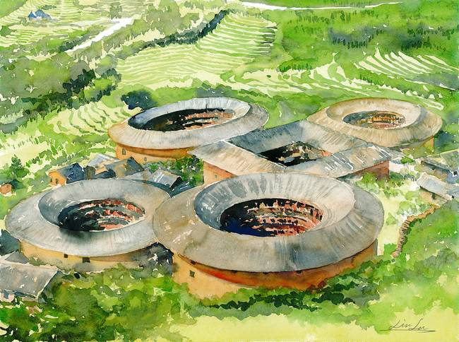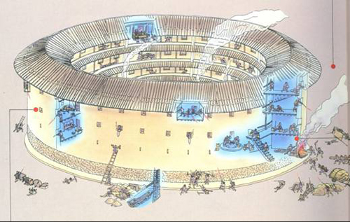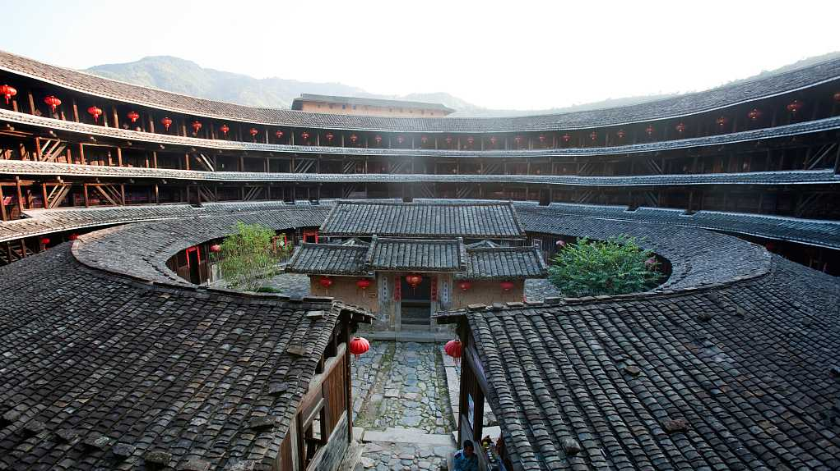

Clothing
A typical set of Xiandai clothing is assembled from several pieces of clothing and can consist of two or three layers. The first layer of clothing is the zhongyi which is typically the inner garment of simple shirt and pants. The next layer is mostly closed at the front, typically robes or shirts for the upper garment, while the lower garment is commonly a pleated skirt. Men typically wear a zhiju, a cross-collar robe with a long skirt and sash. Women wear ruqun, cross-collar robes with sleeves of various lengths. The ruqun is worn with a skirt, waist skirt, sash, and a braid that hangs from the waist. The braid is adorned with a weighted pendant such as a gold or jade ornament. There can be an optional third layer, an overcoat called a zhaoshan, which is open at the front, or a sleeveless vest. For footwear, white socks and black cloth shoes (with white soles) are the norm.

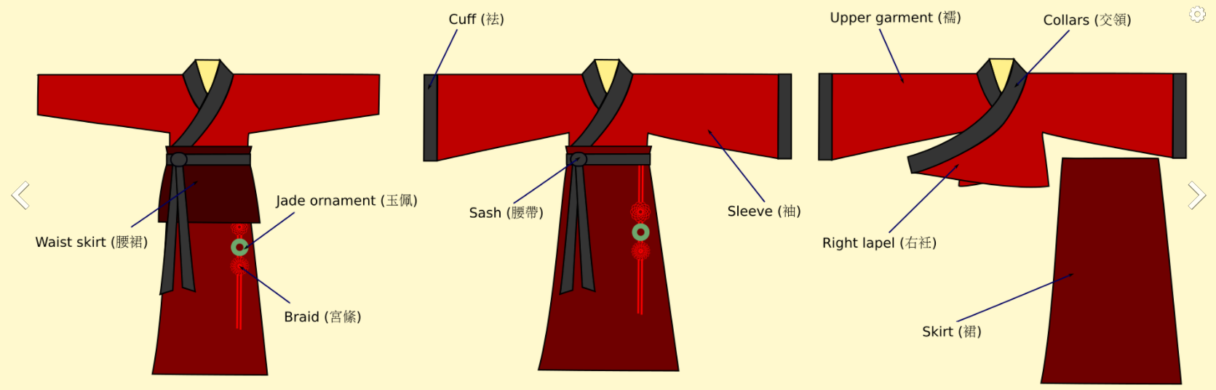
Ruqun (women)
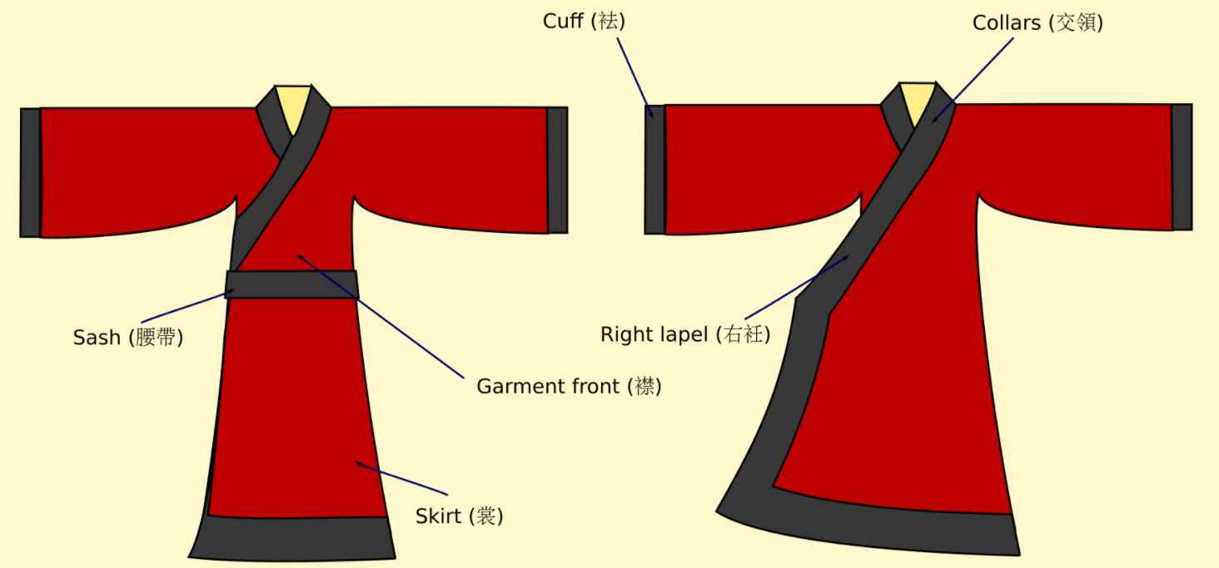
Zhiju (men)

Clothing can be made semi-formal by the addition of a pleated skirt, a long front cloth panel attached from the waist belt, a long open fronted coat or any formal hats. Generally, this form of wear is suitable for meeting guests or going to meetings and other special cultural days. This form of dress is often worn by the nobility or the upper-class as they are often expensive pieces of clothing, usually made of silks and damasks. The coat sleeves are often deeper to create a more voluminous appearance.

One can often tell the profession or social rank of someone by what they wear on their heads. The typical types of male headwear are soft caps, stiff hats, or formal headdress. Officials and academics have a separate set of hats.

Xiandai men and women stop cutting their hair once they reach adulthood. This is marked by the coming-of-age ceremony Guan Li, usually performed between ages 15 to 20. This observes a famous Xiandai proverb: 'My body, hair and skin are given by my father and mother, I dare not damage any of them, as this is the least I can do to honor and respect my parents'. Every male is obliged to tie his long hair into a bun either on or behind his head and always cover the bun up with different kinds of headdresses. Monks are exempt from these rules, keeping their heads completely shaved to show that they're cut off from the bonds of the mortal world. Cutting one's hair off in Xiandai is a legal punishment called 'Kun’ to humiliate criminals, along with branding one’s face with a tattoo called ‘Qing.’

Weapons
Dao: a single-edged curved sword or saber
Qiang: a spear
Jian: a double-edged straight sword, often with a colorful tassel hanging from the pommel
Ji: a halberd or polearm

Mingxia armies are typically dressed in scale mail and cowled helmets. Officers wear tassels atop their helmets. Infantry carry spears or halberds along with Dao swords and rectangular shields. Archer regiments are armed with laminated wood bows, horn bows, composite bows, or crossbows. Specialized regiments come armed with large crossbows operated by two men: one sitting on the ground to brace the crossbow while the second standing to arm and fire it. Armed processions are usually accompanied by large war drums.

The Chinese had what may be termed dukes, marquises, earls, barons, and baronets. These ranks are respectively named: Koong (duke), How (marquis), Paak (earl), Tze (baron), and Nan (baronet).

Hungry Ghost Festival

Musical Instruments
stringed instruments
erhu - two-string, violin-like instrument that is played with a bow, popular with peasants
pipa - four-string, pear-shaped guitar-like instrument played by plucking the strings
guzheng - large 21-string, played sitting at desk, more formal, played solo usually by women
yangqin - dulcimer, played with bamboo 'hammers' to strike the strings or to pluck the strings
guqin - seven-string, very old, large table instrument

wind instruments
dizi - bamboo flute, six or more finger holes

Local Deities
Xiandia is home to many cosmic beings. Some are deities, some are common people blessed by heaven with supernatural powers, and some are divine or infernal creatures sent to Nemmyrl to defend or plague mankind. These entities are:
- Deities
- The Eight Immortals
- The Four Guardians and the Four Perils
- Demigods

Xiandai Deities
- Haishen - sea god aka Haiye. Patron deity of Haidan.
- Fengshen - wind god aka Fei Lian. Patron deity of Bǎozàng “Fortune Town”
- Shanshen - mountain god. Patron deity of Kylin.
- Zhurong - fire god aka Huoshen. Patron deity of Yuchung “Jade City”
  - A gentle giant...though he has a fearsome two headed fire scarf dragon and a formidable reputation, he is a chilled deity who will enjoy a good scenery with his smoking pipe. He holds a staff-baton that emits a fiery whirlwind that lights up the darkest dark. He is a rather relaxed brute, but one whose wrath is best not tempted. 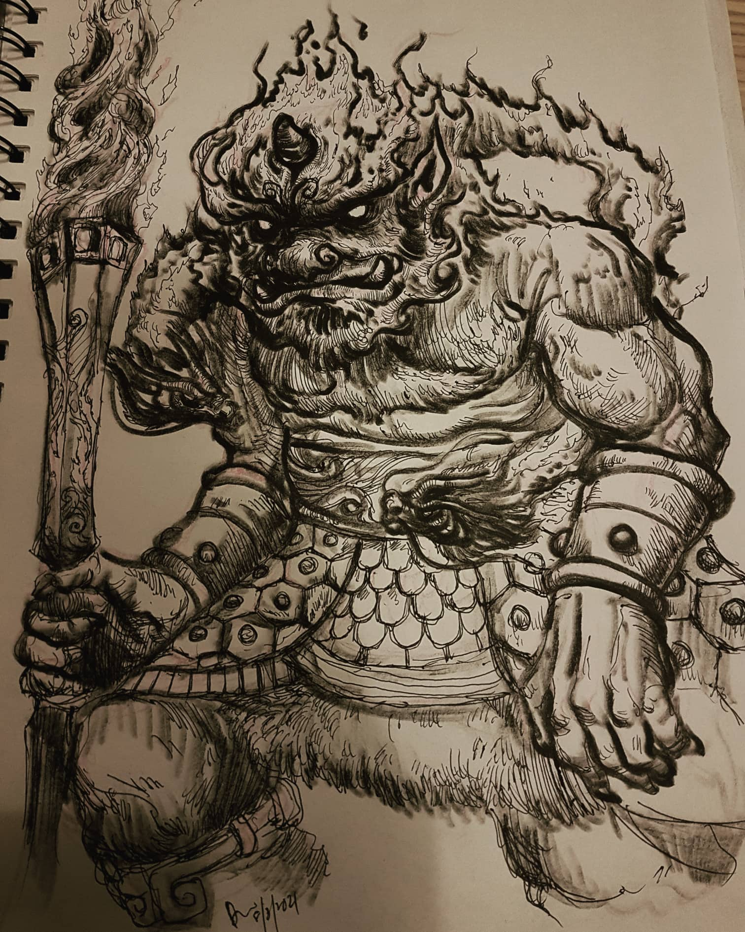
Huoshen, the fire god
Illustration by Dave Liew

- Shuishen - water god. Patron deity of Mingxia.
- Xihe - great sun goddess aka Taiyangshen. Patron deity of Mingyun “City of Destiny”.
- Mushen - woodland god aka Jumang. Patron deity of Huandao.
- Yueshen - moon goddess aka Changxi. Patron deity of White Crane.

The Four Guardians - There are four chief temples guarding the four corners of Xiandai:
- Kenbo: the Black Tortoise of the North (aka Xuanwu) representing water
- Byakko - the White Tiger of the West (aka Baihu) representing metal
- Seiryū - the Azure Dragon of the East (aka Qinglong the green dragon of the East) representing wood
- Suzaku - the Vermilion Bird of the South (aka Zhuque) representing fire
- (a fifth element, Earth, is incorporated into this system, represented by the Yellow Dragon at the Center)

These mythological creatures have been synthesized into the 5-element system. In this system, the fifth element Earth is represented by the Yellow Dragon of the Center.
Water (水 shui) is associated with the potential of new life hidden in the dark ground beneath the snows of winter.
Wood (木 mu) is associated with the exuberance of new growth as it shoots up from the earth in the spring.
Fire (火 ho) is associated with the process of maturation that takes place under the warmth of the summer sun.
Earth (土 tu) is associated with ripening of grains in the yellow fields of late summer.
Metal (金 jin) is associated with the harvest of autumn and the storage of seed for next years planting and a new cycle.

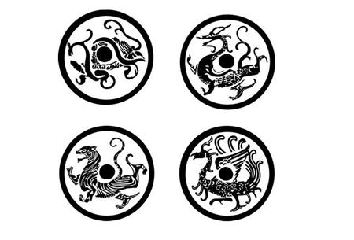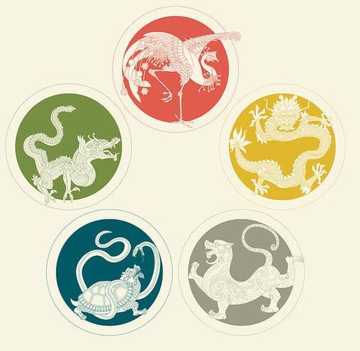

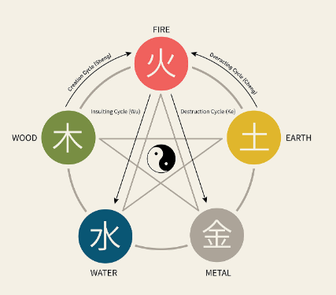

The Creation Cycle
Wood feeds Fire
Fire creates Earth (ash)
Earth bears Metal
Metal collects Water
Water nourishes Wood

The Destruction Cycle
Wood parts Earth
Earth dams (or absorbs) Water
Water extinguishes Fire
Fire melts Metal
Metal chops Wood

The Eight Immortals
A group of legendary Xian ("immortals"). Each immortal's power can be transferred to a vessel (法器) that can bestow life or destroy evil. Together, these eight vessels are called the "Covert Eight Immortals" They are said to live on a group of five islands in the Myriad Sea. They reside in The Purple Palace atop the Mountain of the Five Elements. They are often accompanied by Jade Hand Maidens, commonly depicted servants of the higher ranked deities, or other images showing great spiritual power.

The Immortals are:
He Xiangu – “The Sound Mind” - At birth, she had six long hairs on the crown of her head. When she was about 14 or 15, a divine personage appeared to her in a dream and instructed her to eat powdered mica so that her body might become etherealized and immune from death. He Xiangu's lotus flower improves one's health, mental and physical. She carries a lotus flower, and sometimes with the musical instrument known as sheng, or a fenghuang (Chinese phoenix) to accompany her. She may also carry a bamboo ladle or fly-whisk.
Magic Vessel: The Lotus Flower of Xiangu

Cao Guojiu – “The Voice” - A princely actor among the eight. Cao is often depicted dressed in official robes and holding a jade tablet or castanets. He is also regarded as the patron deity of acting and theatre.
Magic Vessel: The Jade Tablet of Guojiu

Li Tieguai – “The Healer” - He is sometimes described as irascible and ill-tempered, sometimes mentally disturbed. He is also benevolent to the poor, sick and the needy, whose suffering he alleviates with special medicine from his gourd. He is often portrayed as an ugly old man with dirty face, scraggy beard, and messy hair held by a golden band. He often has a gourd slung over his shoulder or held in his and. He often is depicted as a clown figure who descends to earth in the form of a beggar who uses his power to fight for the oppressed and needy. A vapor cloud emanates from the gourd, and within it is the sage's hun (soul); which may be depicted as a formless shape or as a miniature double of his bodily self. On more grand occasions he is depicted riding a Qilin.
Magic Vessel: The Gourd of Tieguai

Lan Caihe – “The Youth” - This particular immortal and their gender is considered to be ambiguous. He is patron of florists and gardeners. He appears as a young person. Lan represents eternal youth and innocence. A wandering musician, he plays clappers made of wood or bamboo and sometimes cymbals. Lan carries a basket of fruit and/or flowers and a hoe slung over one shoulder. Lan's basket contains plants and medicinal herbs associated with longevity, including: the magic fungus (lingzhi mushroom, Ganoderma lucidum), which resists decay, and in Traditional Chinese medicine is used to prolong life; sprigs of bamboo and pine, which as evergreen plants, symbolize longevity; flowering and leafless plum, because they show vitality in blooming in early spring from seemingly lifeless branches; chrysanthemums; and heavenly bamboo with red berries. Lan Caihe wears feminine or masculine clothing at different times and wears a shoe on only one foot, a symbol of life persisting past death. In one story, the eight immortals take to the sea and demonstrate their power. This incited the Dragon King to envy them but Lan gave the Dragon King his clapper as a gift to appease him.
Magic Vessel: The Basket of Caihe

Lü Dongbin – “The Leader” - Considered to be the leader of the Eight Immortals, he was a poet, a womanizer, and often engaged in bouts of rage or drunkenness. After passing Ten Trials of his patience, he proved he was truly enlightened and achieved status as an Immortal. These trials tested him against impatience, lust, laziness, greed, and other vices. Dressed as a scholar and he often carries a sword on his back that dispels evil spirits.
Magic Vessel: The Sword of Dongbin

Han Xiangzi – “The Harmony” - A peerless flutist, fell in love with the seventh daughter of the Dragon King and the two are lovers.
Magic Vessel: The Flute of Xiangzi

Zhang Guolao - “The Chaotic” - He is associated with old age. He walks with the aid of an iron crutch and is believed by some to be able to transform himself into a bat, another symbol of permanence. Zhang is the most eccentric of the Eight Immortals, often making himself invisible, drinking water from the petals of poisonous flowers, snatching birds in flight from the sky, as well as wilting flowers simply by pointing in their direction. He rides a white donkey or mule. When his journey is finished, he folds his mule up and places it in his pocket or a small box. When he wishes to use the mule again, he pours water on it from his mouth and the mule regains its form.
Magic Vessel: The Iron Crutch of Guolao

Zhongli Quan – “The Death Alchemist” - He is a master alchemist and is associated with death. He wields a large fan which can resurrect the dead and transform stones into silver or gold. He is described as having features of greatness: a broad forehead, thick ears, long eyebrows, deep eyes, red nose, square mouth, high cheeks, and scarlet lips.
Magical Vessel: The Fan of Quan

The Monkey King – Sun Wukong
Sun Wukong is a hero imbued with supernatural powers, gifts from the gods. He battles demons of the highest rank, using his magical bo staff while defying death with his acrobatic skills. It is said he ate several of the Heaven Peaches, each of which grants a person eternal life. So, he is considered by many to be another immortal.
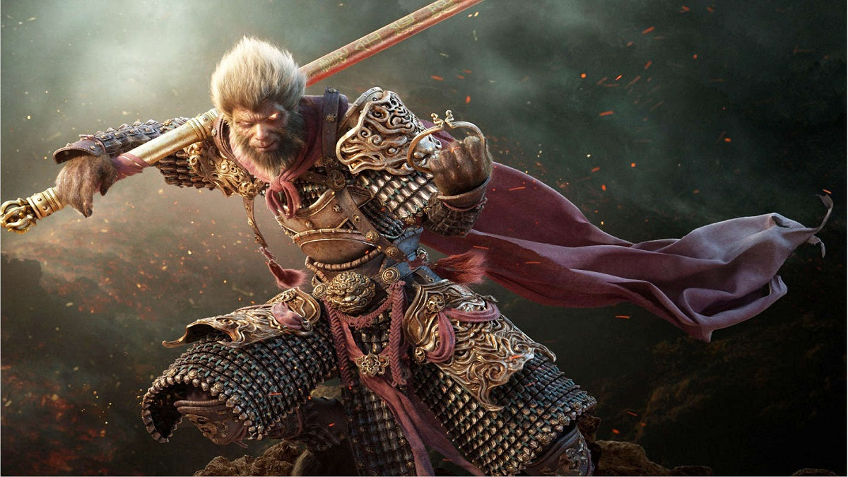

The Sanxing “Three Stars” appear as three old men with long beards. They are Fu, Lu, and Shou and are the embodiments of Fortune (Fu), Prosperity (Lu), and Longevity (Shou).

Monasteries

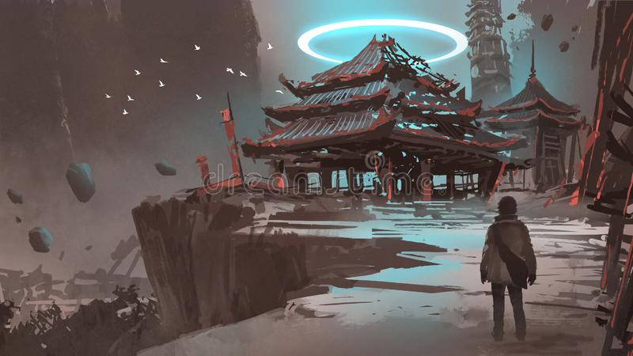

There are several monasteries scattered throughout Xiandai. The most powerful are located in isolated settings where the monks train in solitude.

Temples in Xiandai Lands
Temple Name Aln Faith Location
Black Tortoise LG LG Northern Xiandai, Kang Mountains
Vermillion Bird NG NG Southern Xiandai, Ryuluun Mountains
Azure Dragon LG LG Eastern Xiandai, Chime Forest
Flaming Pearl NG NG Mountain of the Flaming Pearl
Bottomless Well LG Shuishen - water god Mouth of the Virago Valley
Woodland Way CN Mushen - woodland god Donguri Forest near the Imperial Pass
Mountain King NG Shanshen - mountain god Ryuluun Mountains, Lotus Valley
Sea Shepherd CG Haishen - sea god Isle of Mazu
Dragon God NE Longshen the Dragon God Elderwyrm Mts Virago Valley
Watching Eye LE LE Dark Hills
Dead Retainers NE NE Valley of the Dead Kings
Empty Void TN TN Runlun River, Bay of Nuwa
Ill Wind LE LE Windclaw Mts.
Ancient Speech LE LE Southern Ryuluun Mts, Ancestor River
Trackless Path CE CE Dark Moon Jungle

Temples in Moghun Lands
Temple Name Aln Faith Location
White Tiger CG CG Fireclaw Mountains
Phoenix Flame CG CG Hills of the Masters
Warden of the Winds NG Fengshen - wind god Ryuluun Mts, Oru Vale
Drowned Demon CE CE Riverclaw Mts.
Fire Fury N Zhurong - fire god Hills of the Masters

Creatures
The lands of Xiandai are tightly bound to dragons. Though the Elderwyrm Mountain region to the west is filled with dangerous wyrms of great destruction, there are Nine Sons of the Dragon that guard these lands and protect its people. These are dragon hybrids that resemble a cross between a dragon and another beast. Each region has a guardian dragon.

Nine Sons of the Dragon

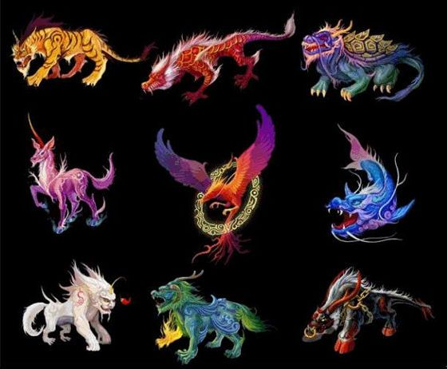

The Chi Wen - Hybrid of fish and dragon: a creature that likes swallowing, are placed on both ends of the ridgepoles of roofs (to swallow all evil influences). Protects the region around Haidan.

The Bi Xi - Hybrid of turtle and dragon: a creature with a large shell able to carry heavy objects and are normally found on tombstones. Protects the region around Baozang “Fortune Town.”
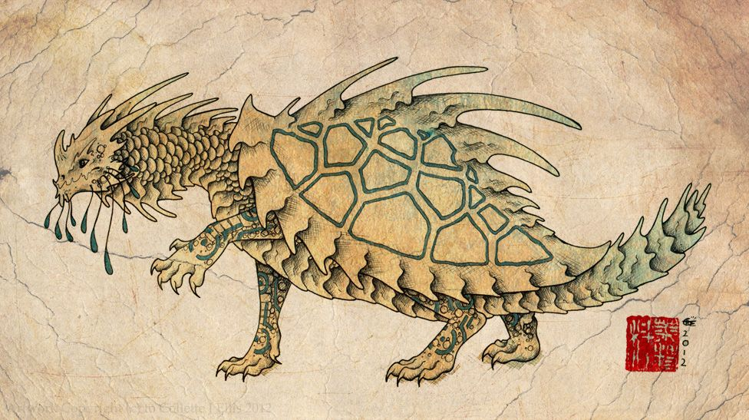

The Ya Zi - Hybrid of wolf and dragon: a creature that likes to fight, is aggressive and is normally found on cross-guards on sword as ornaments. Protects the region around Kylin.

The Fu Xi - Hybrid of snake and dragon: a creature that likes to drink water, and is typically used on bridge structures. Protects the region around Yuchung “Jade City.”

The Pu Lao - Hybrid of dog & dragon: a creature that likes to scream, and are represented on the tops of bells, used as handles. Protects the region around Mingxia.

The Suan Ni - Hybrid of lion and dragon: a creature that likes to sit down, are represented upon the bases of religious shrines and idols. Protects the region around Mingyun “City of Destiny.”

The Chao Feng - Hybrid of goat and dragon: a creature that likes to climb and eat. They are typically placed on the four corners of roofs. Protects the region around Huandao.

The Qui Niu – Hybrid of a cow and a dragon:
Protects the region around Baihe “White Crane.”

The Bi An - Hybrid of tiger and dragon: a creature that seeks justice, totems of the Bi An are placed over prison gates in order to keep guard. Protects the region around Shining Shore.

Yaoguai – demons
Bai Gu Jing (the white bones demon) – a Yaoguai, Lady Bai Gu Jing is a shapeshifting demoness, and in her true form she is appears as a skeleton dripping in green flames. She is capable of passing through walls at will, turning transparent or even invisible, and feigning death. In human form she carries twin Dao swords, but when she reveals her true form her fingers become long sharp claws capable of great damage. During combat she may phase into the ground, leaving behind a false clone of herself that attacks in her place. In the Primordial Ages she raised an army of demons and the undead to slay all that lived in Xiandai. She was stopped by the Eight Immortals who trapped her army in a magical well on the Mountain of the Five Elements.

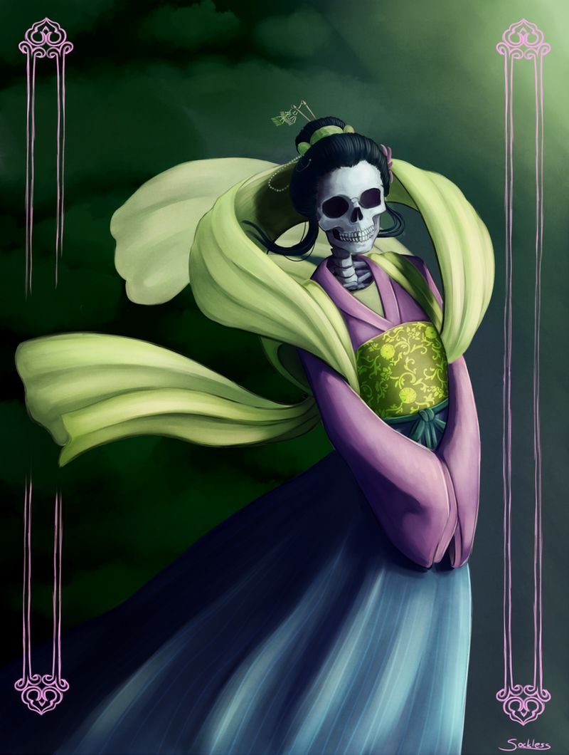

Jingshen
Xiandai legends speak often of evil spirits dwelling in nature. The old collective term for these was Wangliang. The most notorious of these Jingshen are those that wander into villages and appear as a small human, resembling a three-year-old child, with a red-black or brown skin color, red eyes, long ears, and beautiful hair. The names for each of these, depending on where they dwell in nature, are:
- Fangxiang - graveyard ghosts who feast on the dead
- Fangliang - demons lurking beneath the ground
- Kui - demons lurking in the mountains
- Long - demons lurking in freshwater rivers and lakes
- Yu -traveling fever spirits spreading disease, sometimes appearing as a tortoise
- Guoyu - appearing as inanimate rocks
- Muzghon - appearing as trees
Jiangshi - vampires

Tiangou
Rumor has it that the Kang Mountains are home to the Tiangou, mythical large black dogs that have magical powers. In legend, the Tiangou of the sky threatened to eat the sun. In more recent accounts, rangers exploring the Kang Mountains reported auras of darkness rolling in immediately before the appearance of a ravenous large black dog that attacked them. These dogs were said to hover above the ground, moving without regard for the hilly terrain, and descending on victims without warning. To this day the rangers of Fortune Town warn travelers to avoid the Kang Mountains for fear of the Tiangou.

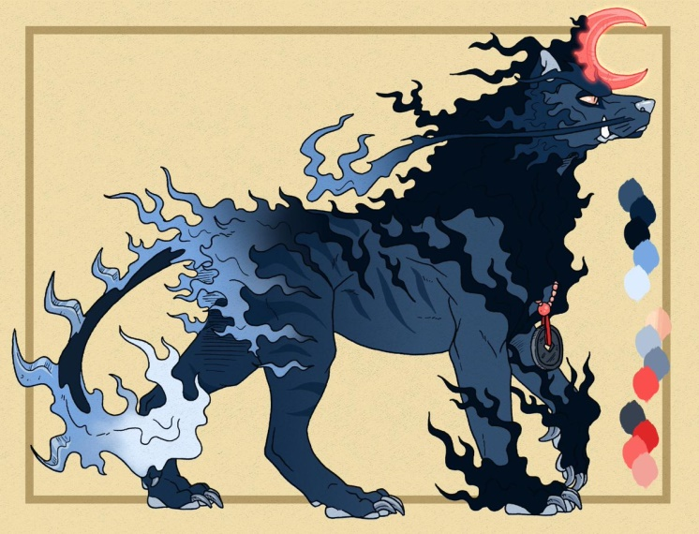

Jiaoren
The coastlines around Fortune Town are rumored to be home to the Jiaoren, which are merfolk unique to Xiandai. They have been spotted all along the cliffs of Jandira as well as all along the western shores down to the port city of Kylin. These are reclusive creatures who rarely interact with humans. Legend has it that they weave ‘sea silk’ from the filaments secreted by deep water mollusks. The Jiaoren are said to weep pearls. Both of these rumors have led greedy sailors to capture the Jiaoren for their treasures, which are highly valued. Few who hunt the merfolk live to tell the tale. But the markets of Fortune Town do on rare occasion have sea silk and Jiaoren pearls if one knows who to ask.

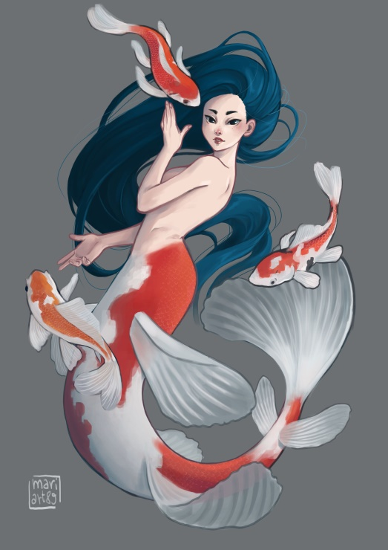

Shen
Shen, a race of magical giant clams that shape-shift and create mirages to lure sailors to their doom. The Shen are thought to transform at will into flocks of sparrows, a pack of dolphins, or even a magical lady atop an open clam shell. Some are said to exude a cloud of smoke, in which fishing boats can become lost. Most dangerous is their ability to create false illusions of fortune or boats that are in peril. Shen will swallow up entire boats and consume a dozen men at a time. Kylin fishermen are wary of these legends. Young Shen are harvested for their shells, which are used in religious ceremonies as offerings to the gods. The meat of the Shen are a delicacy and the oil from them is made into fragrant aromatics and candles.

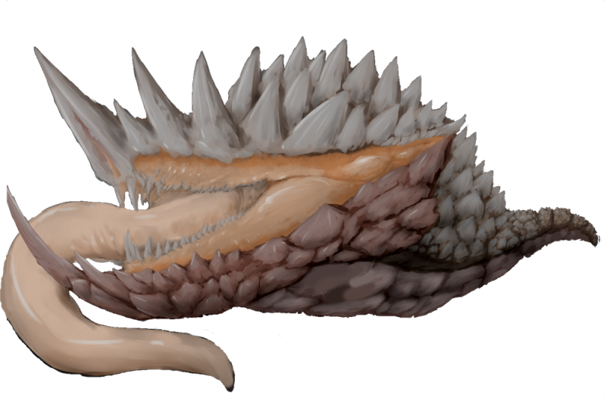
Bashe
Bashe are gigantic pythons that dwell in the mountains and foothills. They are fond of eating elephants and are always hungry. Entire herds of oxen can disappear in one night when this creature wanders near a village.

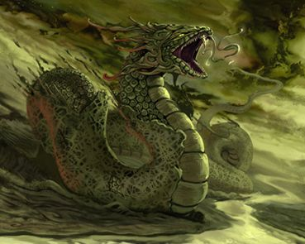

Hanba
Hanba are nature spirits that personify drought. They appear as fair maidens dressed in yellow. They possess the magical ability to draw water and moisture out of the immediate area where they appear. Some call them demons, others water vampires. While most are harmless to humans, farmers that grow weary of Hanbu and attack her suddenly find themselves the victims of the Hanba’s wrath. When angered, a Hanba can pull the very water out of a living creature, killing them within seconds and leaving a dry husk. Sometimes Hanba can be beneficial after monsoon season. Villagers have been known to call on Hanba after floods, asking the spirits to remove flood waters from their fields and houses.

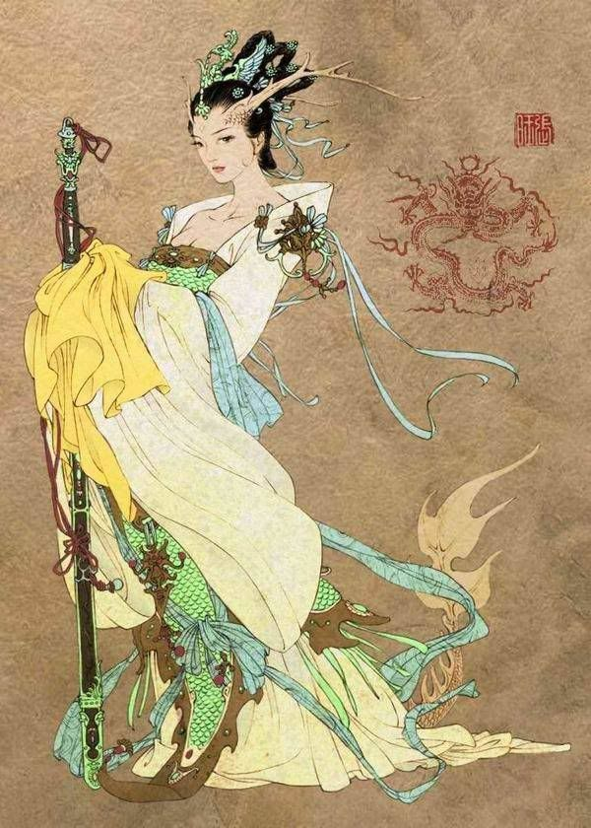

Kenku
(from MM, derived from Tengu)

Pixiu
Pixiu are medium sized magical creatures resembling a winged lion with antlers (the male has only one antler). The Pixiu only eats gold, silver, and jewels but whatever wealth it ingests is never expelled. The female Pixiu is said to be capable of granting good fortune and even deflecting calamity. Nobility and the wealthy are ever on the watch for these beasts, fearing for their fortunes. Anyone foolish enough to attack a Pixiu to open it up and claim its treasure are met with a powerful magical attack before the creature teleports back to the celestial plane.
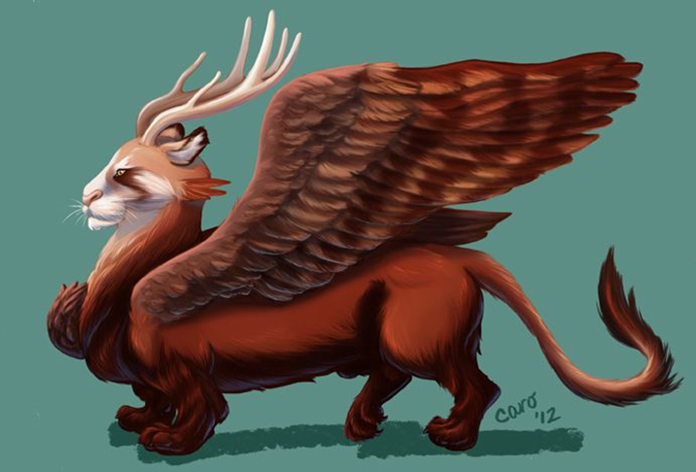
Pandas – located in the Chime Forest, these are peaceful creatures. The greatest among them is Hépíng, a nature spirit born at the dawn of time. She is an enormous creature and only appears on this plane when it suits her, looking after panda children and their home in the Chime Forest. She is a peaceful magical creature of neutral good alignment. She speaks many languages and is curious to speak to those who venture into the forest. But if attacked he is a terrible force of nature and will utterly destroy anyone threatening the forest or its inhabitants.
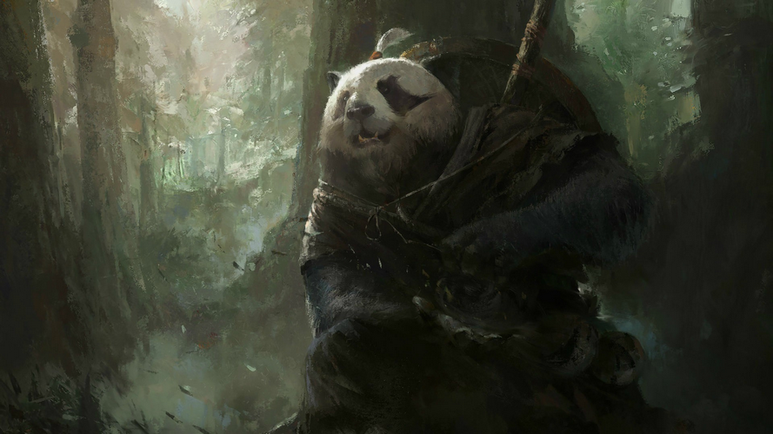
Quilin – a luck dragon, eyes with thick eyelashes, manes that always flow upward and beards. The body is fully or partially scaled and often shaped like an ox, deer, or horse, they have proud antlers
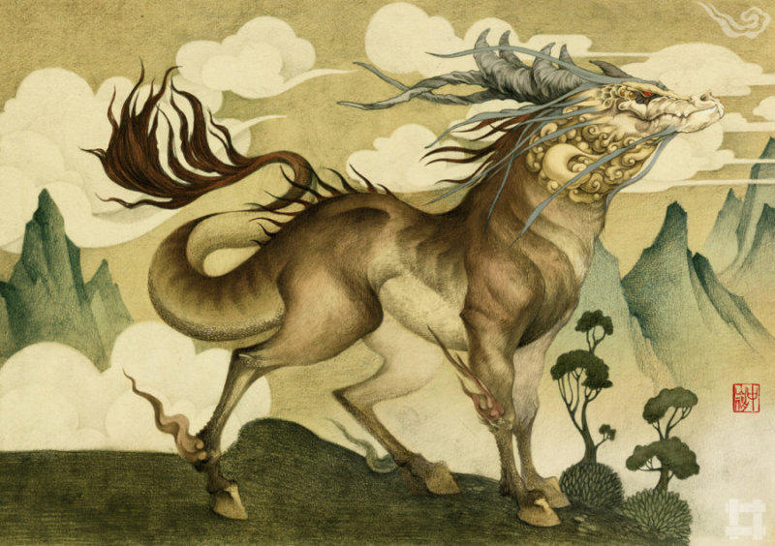
Zheng – mountain beast with five tails and one horn, a roar like thunder, and taking tigers and leopards as food
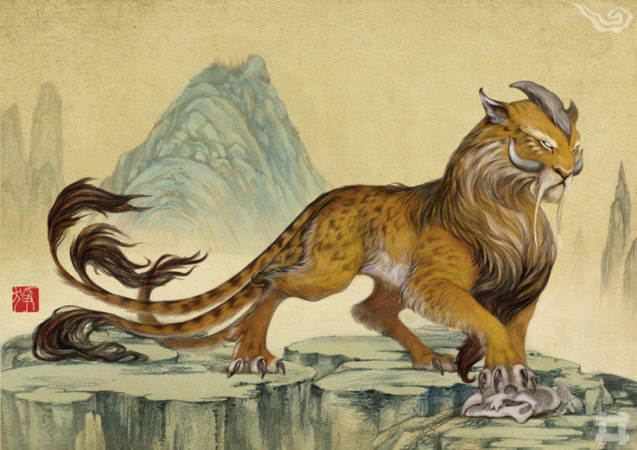
Xiqu - A man-eating, boar-like creature
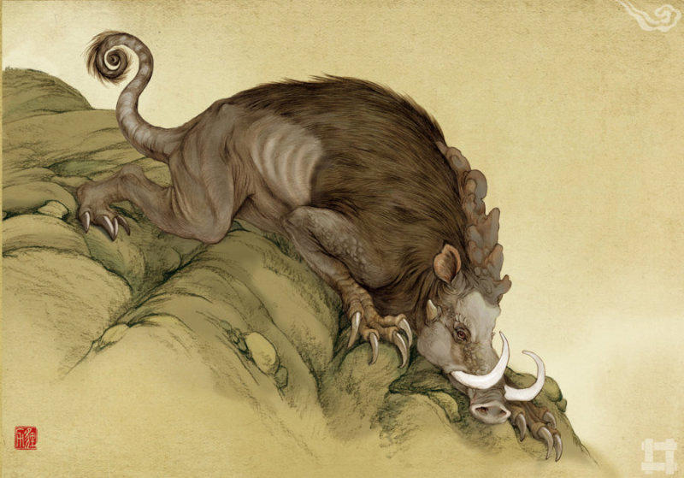
Huan Cat
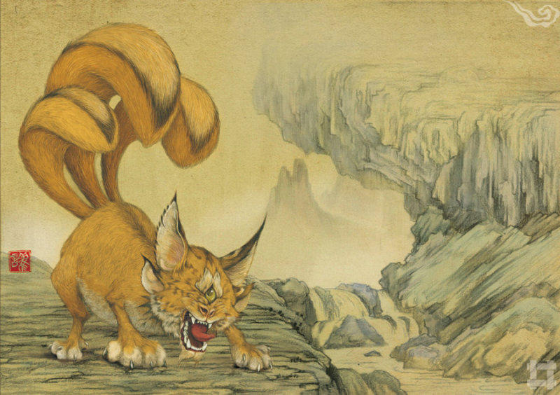
Gudiao - horned, man-eating, and with an awful shriek like that of a human baby
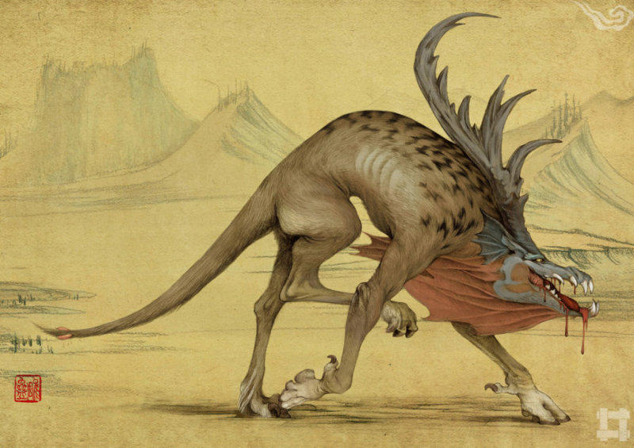
Sanwei – four horned behemoth that feasts on humans
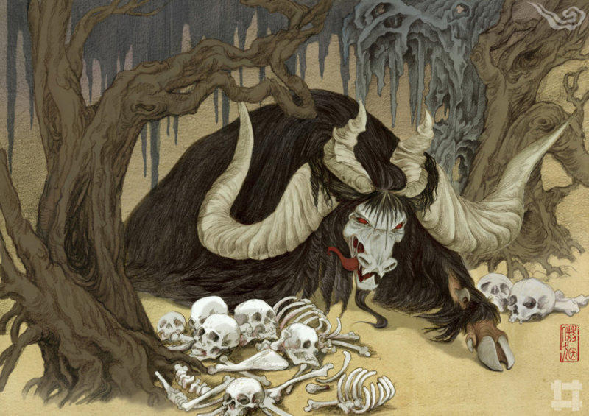

Jiuweihu – nine-tailed fox, fox spirits that can be good or evil depending on the spirit;
When a fox is fifty years old, it can transform itself into a woman; when a hundred years old, it becomes a beautiful female, or a spirit medium. Such beings are able to know things at more than a thousand miles' distance; they can poison men by sorcery, or possess and bewilder them, so that they lose their memory and knowledge; and when a fox is thousand years old, it ascends to heaven and becomes a celestial fox. (Known as the Kumiho in some regions of Xiandai)
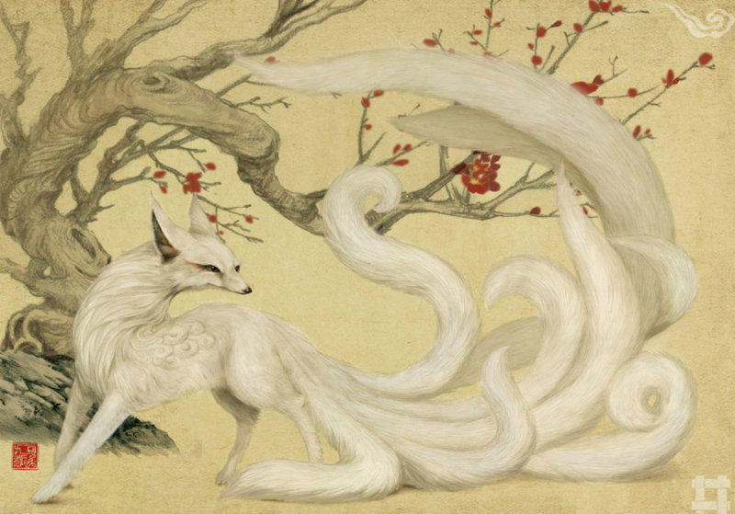

Xiandai legends speak often of evil spirits dwelling in nature. The old collective term for these was Wangliang, but today the scholars call them Jingshen. The names for each of these, depending on where they dwell in nature, are Fangxiang (graveyard ghosts who feast on the dead), Fangliang (demons lurking beneath the ground), Kui (demons lurking in the mountains), Long (demons lurking in freshwater rivers and lakes), Yu (traveling fever spirits spreading disease, sometimes appearing as a tortoise), Guoyu (appearing as inanimate rocks), and Muzghon (appearing as trees). The most notorious of these Jingshen are those that wander into villages and appear as a small human, resembling a three-year-old child, with a red-black or brown skin color, red eyes, long ears, and beautiful hair.

The Black Guard Impermanence (Wu-jiu Fan) and the White Guard Impermanence (Xie Bi’an) are the guardians of hell, whose job is to conduct the souls of the spirits in the world of the dead. They are benign entities. They are respectively in charge of Good and Evil. They are venerated in some Chinese temples and are colloquially called Da Ye Bo and Er Ye Bo. They wear tall hats and long robes that cover their whole body. On the palm of the right hand they bear seals and on the left sticks with pieces of clothes attached. In some legends they appear during the Hungry Ghost Festival, rewarding the good with gold. In temples they are often depicted with monstrous and ferocious faces, with long red tongues.
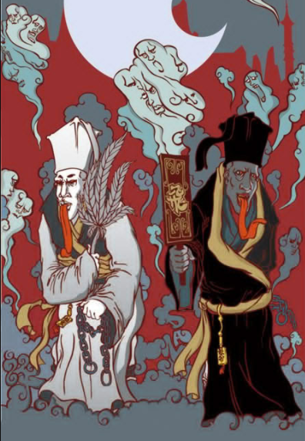

Huli Jing - shapeshifting nine-tailed foxes that transform into the form of a beautiful woman. It is said that they bewitch men and lead to their downfall. Others say they are pure of heart and only evil men preying on women cast them in this undeserved reputation.
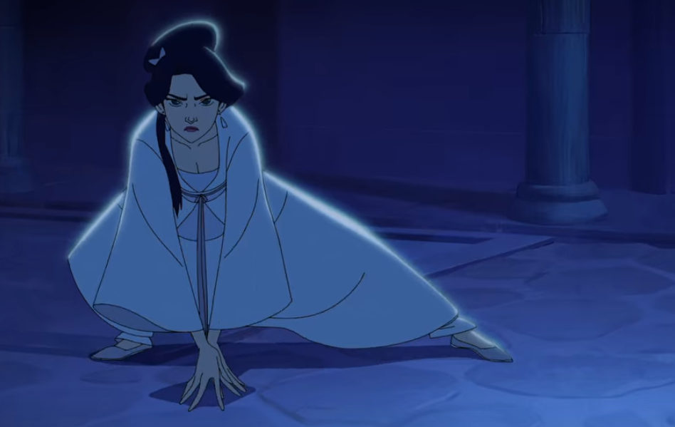
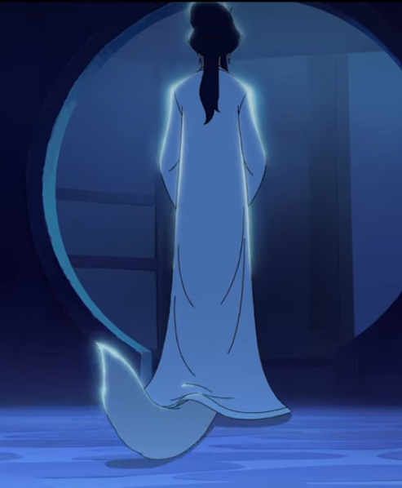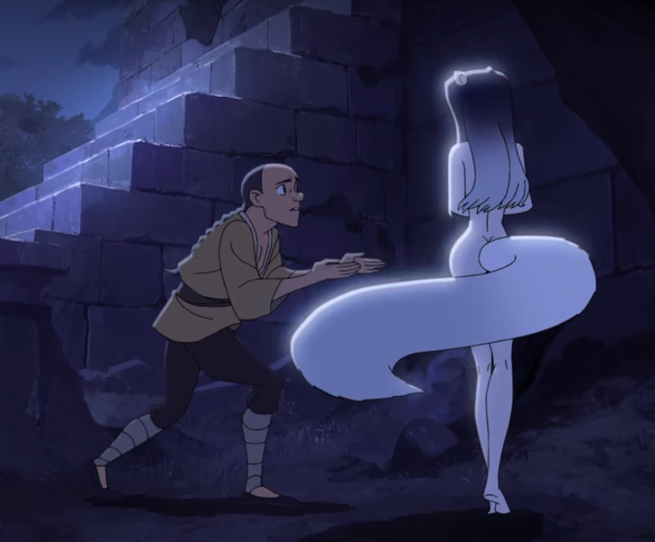

Bull Demon King (Niumowang) – an arch demon from hell, the Bull Demon King sought to rule Xiandai in the Primordial Ages but his army of demons was routed by the Four Gaurdians in 85 PA2. He appears as a giant upright bull with an iron staff.
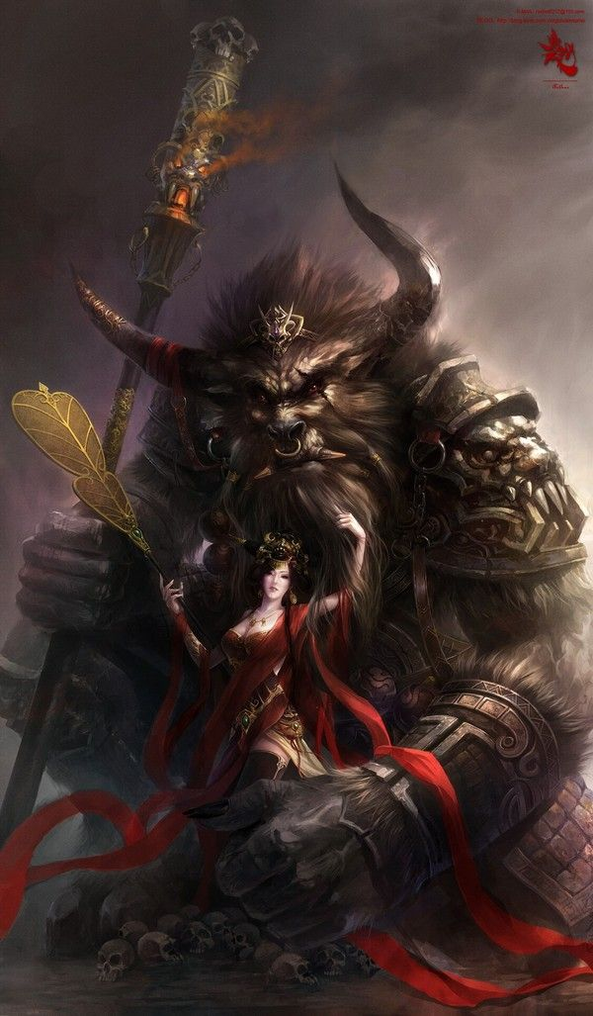
Yellow Robe Demon (the Wood Wolf) – The Wood Wolf is an arch demon who once loved a Jade Maiden from heaven. The two took human form and lived in peace in Xiandai, until one day the Wood Wolf’s nature overcame him and he began to devour the people from the countryside.
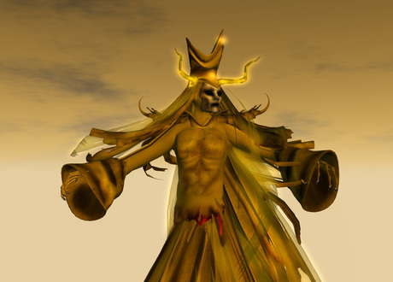
The Four Malevolent Beings aka the Four Perils
The four malevolent beings are the antagonistic counterparts of the Four Benevolent Animals or Four Guardians.
- the Hundun (混沌; Hùndùn; 'chaotic torrent'), a yellow winged creature of chaos with six legs and no face;
- the Qiongqi (窮奇; Qióngqí; 'poor and strange'), a monstrous creature that eats people, considered the same in Japan as Kamaitachi
- the Taowu (檮杌; Táowù; 'stupid stump'), a reckless, stubborn creature;
- the Taotie (饕餮; Tāotiè; 'greedy glutton'), a gluttonous beast.

Taotie - green-skinned four-legged creatures, with massive jaws filled with multiple rows of razor-sharp teeth. They have eyes located on their shoulders, which is one of their only vulnerable spots. Their armored hides are tough to pierce. Their heads bear a strange pattern from which the Tao Tie motif comes when the Xiandai write of them in records. They live in a hive system similar to ants, emerging and attacking every sixty years to collect food to feed their queen. The queen communicates with her foot soldiers by means of a web membrane she unfolds from the top of her head. The membrane vibrates rapidly, sending signals to sensitive hairs on the ridges located on each Taotie’s back. The queen is usually accompanied by larger Taotie that also have extendable head-fan membranes but which are tougher and form a living shield to protect the queen on the battlefield. It has been noted that magnets or objects with magnetic properties, when brought close to a Taotie, have a sedating effect on them. The Taotie are vicious, unrelenting attackers when ordered to attack, very acrobatic and exceedingly intelligent even known to bypass traps and lure enemies into traps of their own.
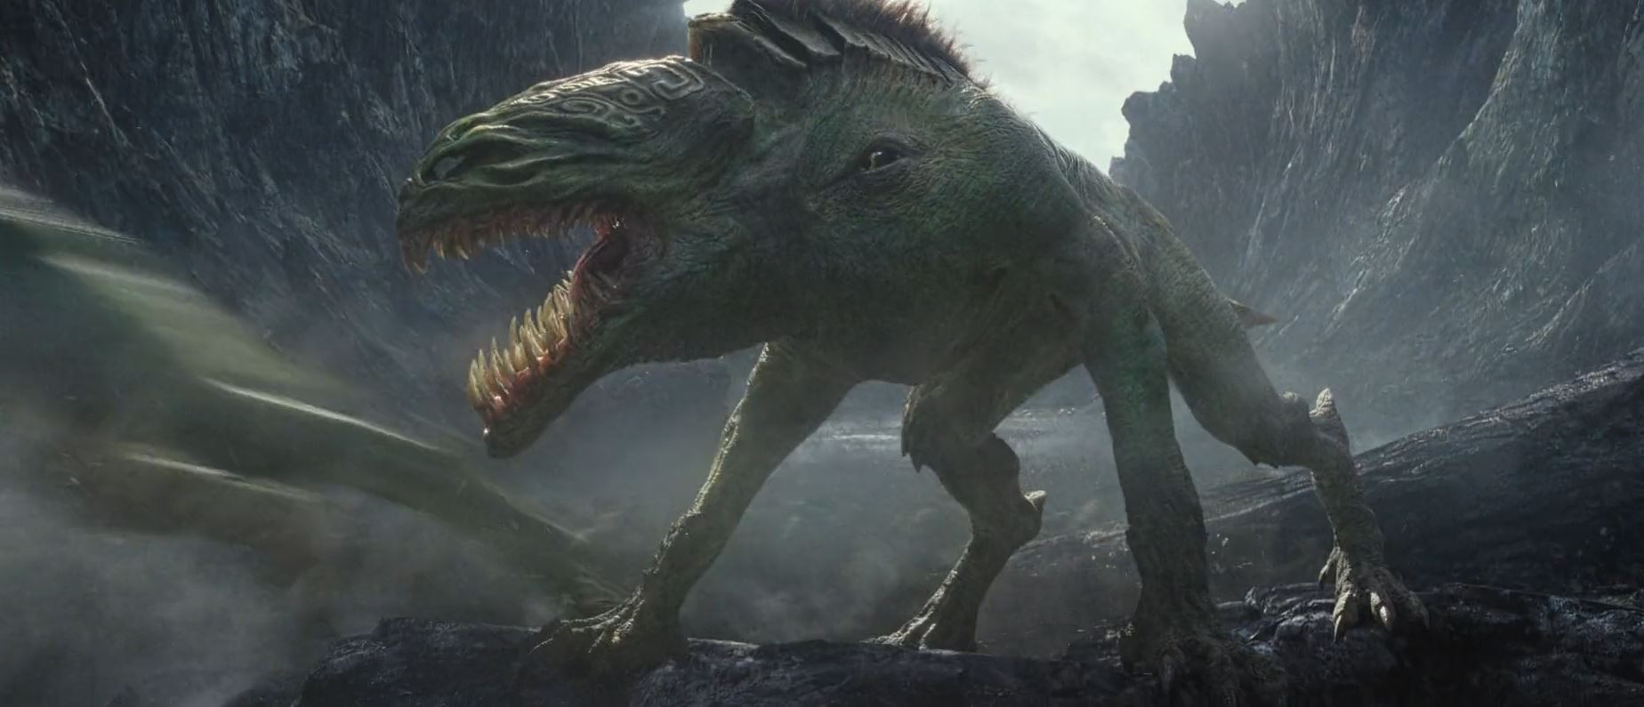
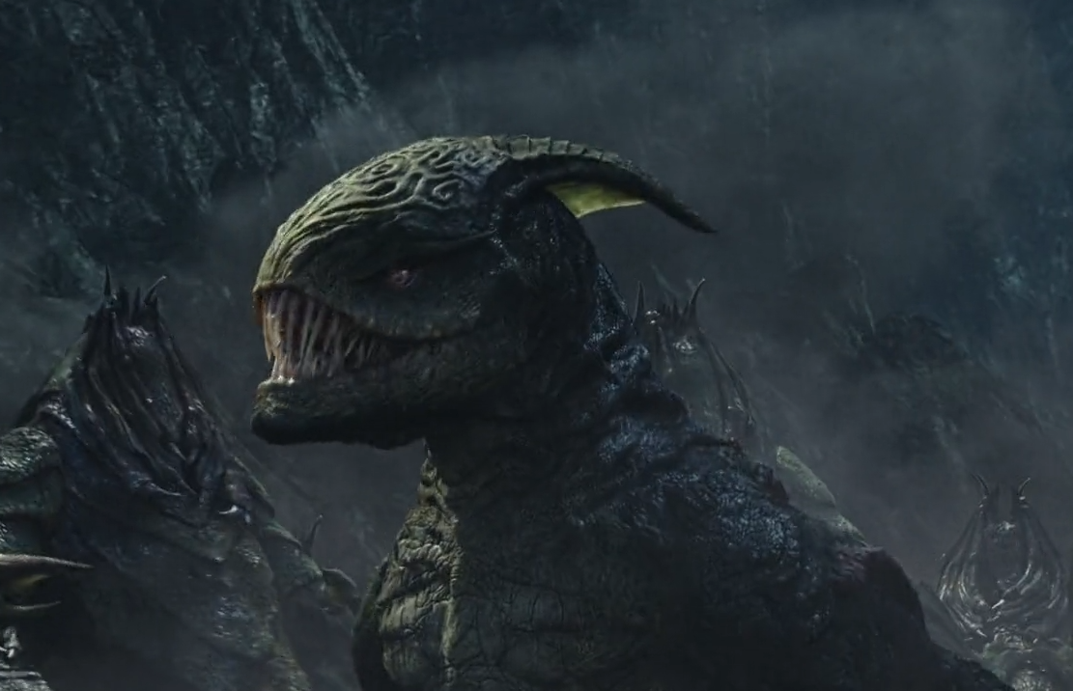
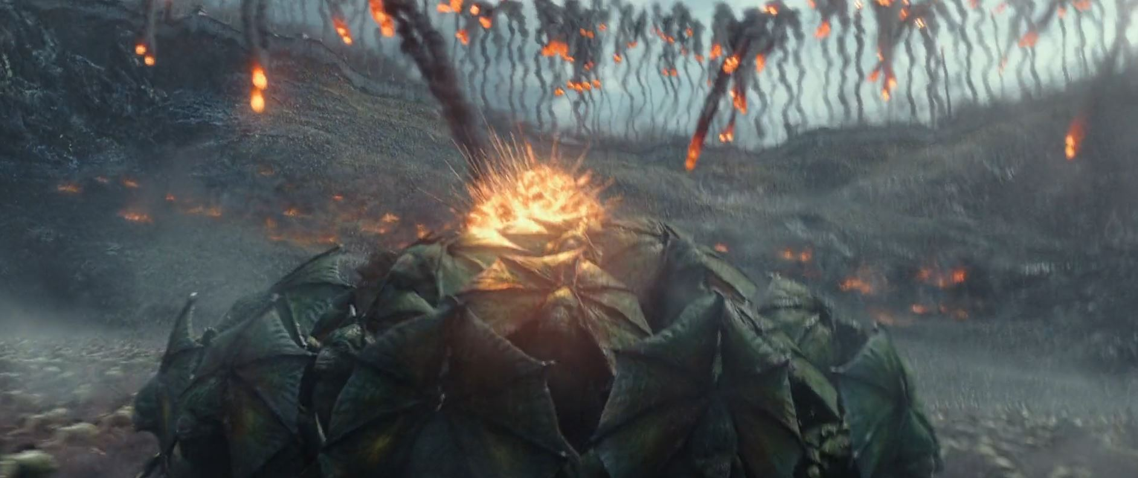
Yeren - a large ape creature that roams the Ryuluun Mountains overlooking the Phoenix Valley. Yeren dates back before recorded history, thought to be a divine animal spirit and a protector of nature. The Yeren rangers are said to wear bracers made of the fur of fallen mountain gorillas that have been gifted to them by Yeren upon completion of their training. It is said the bracers imbue great strength and constitution to the Yeren rangers, as well as uncanny climbing abilities in the mountains.
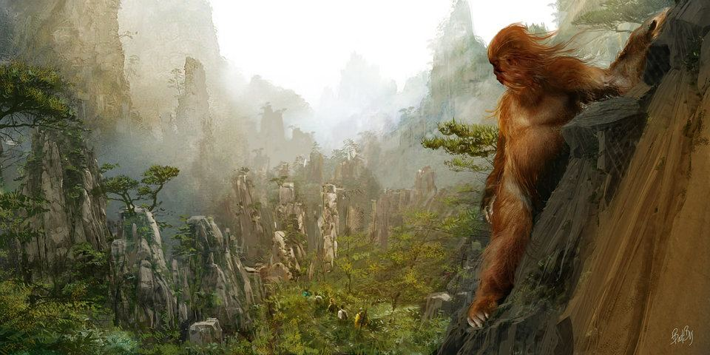

Xiandai Orcs – Orcs inhabit every corner of the world, but vary in their appearance just as humans do. Orcs in Xiandai tend to make homes in the mountains and dark valleys. The hair covering their heads, eyebrows, and forearms is thick and grows into circular curls. They are often referred to in Xiandai texts as Shan Xiao or Gui Chai, which translates to types of ogres in the common tongue.
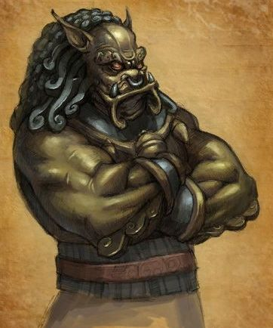

Other Races
Elves

Dwarves
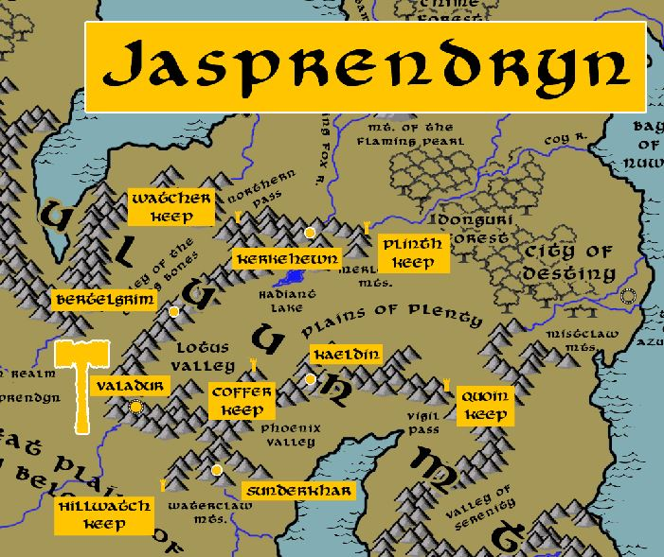

Magical Items
- Flaming Pearls (multiple)
- Heaven Lotus – blossomed at the beginning of ages in Lotus Valley
- Amulet of Tiamat – used during the Great Dragon War to control the evil dragons that now reside in the Elderwyrm Mountains
- Scepters of Creation (avatar of the Eight Scepters of Power, destroyed)
- The Stone Army of Wai Hen – animated from the Valley of the Dead Kings
- Ten Rings of Opulence
- Magic sword Shu Dao of General Ko
- Blade of the Seven Heavens – wielded by the hero Moyao to defend Huandao against an Orc invasion
- Sword of the Forever Sun of Mingmei Song
- Staff of Water Lightning
- Sword of the Jiaoren merfolk
- Ghost Boats of Kemelcheck
- The Lotus Flower of Xiangu, one of the Eight Immortals
- The Jade Tablet of Guojiu, one of the Eight Immortals
- The Gourd of Tieguai, one of the Eight Immortals
- The Basket of Caihe, one of the Eight Immortals
- The Sword of Dongbin, one of the Eight Immortals
- The Flute of Xiangzi, one of the Eight Immortals
- The Iron Crutch of Guolao, one of the Eight Immortals
- The Fan of Quan, one of the Eight Immortals
- Five Flavored Tea of Forgetfulness – brewed by Old Lady Meng, a spirit in the service of Diyu (hell) to help people forget; creates permanent amnesia
- Shān Xīn (mountain heart). Wrested from the Dwarves millennia ago, this amulet has the power to call down earth elementals and create earthquakes.
- Shengli pears – once found plentiful on the Cinder Plains, they are all but extinct now but some still hazard the plains to find one. They are said to be gifted by divine powers to bestow speed, strength, and valor to those who seek greatness.
The Sanxing “Three Stars” appear as three old men with long beards. They are Fu, Lu, and Shou and are the embodiments of Fortune (Fu), Prosperity (Lu), and Longevity (Shou).
Scroll of Fu Xing –
Tablet of Lu Xing –
Peach of Immortality held by Shou Xing –
Gourd of Life held by Shou Xing -

NPC Templates
This is a list of notes and stats to help develop NPC’s relevant to this region.

Developer Notes
Historical periods of China
Ancient China
2.1 Xia dynasty (2070 – 1600)
2.2 Shang dynasty (1600 – 1046)
2.3 Zhou dynasty (1046 – 256 BC)
2.4 Spring and Autumn period (722 – 476 BC)
2.5 Warring States period (476 – 221 BC)

Imperial China
3.1 Qin dynasty (221 – 206 BC) 15 years
3.2 Han dynasty (206 BC – AD 220) 26 years
3.3 Three Kingdoms (AD 220 – 280) 60 years
3.4 Jin dynasty (AD 266 – 420) 154 years
3.5 Northern and Southern dynasties (AD 420 – 589) 169 years
3.6 Sui dynasty (AD 581 – 618) 37 years
3.7 Tang dynasty (AD 618 – 907) 289 years
3.8 Five Dynasties and Ten Kingdoms (AD 907 – 960) 54 years
3.9 Song, Liao, Jin, and Western Xia dynasties (AD 960 – 1279) 319 years
3.10 Yuan dynasty (AD 1271 – 1368) 97 years
3.11 Ming dynasty (AD 1368 – 1644) 276 years
3.12 Qing dynasty (AD 1644 – 1912) 268 years

Chinese Armor
https://en.wikipedia.org/wiki/Chinese_armour

- Hook Shield
- During the Warring States era, most armour was made of leather or bronze (occasionally iron), or a combination of both. The metal that was used most for military purposes was bronze. Cast iron began to appear in the 5th century BC, but did not begin to replace bronze until the 2nd century BC.
- Most infantrymen wore lamellar or coat of plates cuirasses. The lamellar cuirass worn by these men was made of hundreds of small overlapping metal and/or leather plates laced together to make a flexible and light coat of armour. Coat of plates consisted of hundreds of small non-overlapping metal or leather plates stitched or riveted together. Shoulder guards and helmets were often used, but leather caps seem to have been more common for ground infantry.

- Lamellar armour is a type of body armour, made from small rectangular plates (scales or lamellae) of iron or steel, leather (rawhide), or bronze laced into horizontal rows. Lamellar armor was used over a wide range of time periods in Central Asia, Eastern Asia (especially in China, Japan, Mongolia, and Tibet), Western Asia, and Eastern Europe. Lamellar armour consists of small platelets known as "lamellae" or "lames", which are punched and laced together, typically in horizontal rows. Lamellae can be made of metal, leather cuir bouilli, horn, stone, bone or more exotic substances. Metal lamellae may be lacquered to resist corrosion or for decoration. Unlike scale armour, which it resembles, lamellar armour is not attached to a cloth or leather backing (although it is typically worn over a padded undergarment). In Asia, lamellar armor eventually overtook scale armour in popularity as lamellar restricted the user's movements much less than scale armour.
- Dark Armor - The only trait known about dark armour is that it reflected the sun's rays. This probably means dark armour was made of high quality steel, which was often associated with black ferrous material.
- Brilliant Armor - Brilliant armour was made of decarburized steel, which shines blue-black when polished, giving it its name.
- "fine five-colored armour" (wuse xikai) was so dazzling it blinded the eye. This was probably similar in construction to brilliant armour.
- Cord and plaque - "Cord and plaque" armour consisted of double breast plates in the front and back held together, sometimes on a frame, by two shoulder straps and waist cords, worn over the usual lamellar armour.
- Banded Armor - This type of armour was built up of long horizontal bands or plates, similar to the lorica segmentata. The imperial guards of the Jurchen Jin dynasty have been described wearing banded armour. The left guards wore blue banded armour and held yellow dragon flags while the right guards wore red banded armour and held red dragon flags.
- The current theory is that this type of armour is made from a multitude of small pieces of iron or steel shaped like the Chinese character for the word "mountain" (山). The pieces are interlocked and riveted to a cloth or leather backing. It covers the torso, shoulders and thighs while remaining comfortable and flexible enough to allow movement.
- By the Tang dynasty it was possible for armour to provide immense personal protection. In one instance Li Shimin's cousin, Li Daoxuan, was able to cut his way through the entire enemy mass of Xia soldiers and then cut his way back again, repeating the operation several times before the battle was won, at which point he had so many arrows sticking out of his armour that he looked like a "porcupine." The effective range of a composite bow against armoured troops in this era was considered to be around 75 to 100 yards.
- Infantry armour became more common in the Tang era and roughly 60 percent of active soldiers were equipped with armour of some kind. Armour could be manufactured natively or captured as a result of war. Armour and mounts, including pack animals, were supplied by the state through state funds, and thus considered state property. Private ownership of military equipment such as horse armour, long lances, and crossbows was prohibited. Possession was taken as intent of rebellion or treason. The army staff kept track of armour and weapons with detailed records of items issued. If a deficiency was discovered, the corresponding soldier was ordered to pay restitution. The state also provided clothing and rations for border garrisons and expeditionary armies. Soldiers not on active duty were expected to pay for themselves, although "professional" soldiers were given tax exemptions.
The Eighteen Legendary Weapons from the movie of the same name
- Rope dart
- Double tiger hook swords
- Double hammers
- Battle axe (Chinese: 鈇; pinyin: Fū)
- Snake Halberd
- Kwan Dao
- Twin broadswords
- Double-edged sword
- Chinese Spear
- Three-section chain whip
- Double daggers (Chinese: 匕首; pinyin: Bǐ shǒu)
- Double crutches
- Monk's spade
- Staff
- Tiger fork (Chinese: 叉; pinyin: Chā)
- Rattan shield (Chinese: 藤牌; pinyin: Téngpái)
- Single butterfly sword
- Three-section staff

Link to Chinese Myths:
https://www.shenyunperformingarts.org/explore/category/chinese-myths-legends?utm_source=Adwords_Search&utm_campaign=v8_NB_EN_SYPA_[DSA-tCPA]&utm_adgroup=[dsa]__G-category&device=m&keyword=&gclid=CjwKCAjw8MD7BRArEiwAGZsrBQbd48utbMlcdyMp0KF3QQeKi7QDVnQIYGuGVs21CWDQq8JnBClUcxoCJTwQAvD_BwE&campaignId=9946790526&adgroupId=101672337318&network=g&gclid=CjwKCAjw8MD7BRArEiwAGZsrBQbd48utbMlcdyMp0KF3QQeKi7QDVnQIYGuGVs21CWDQq8JnBClUcxoCJTwQAvD_BwE

