Notes on the Lands of Adhanar

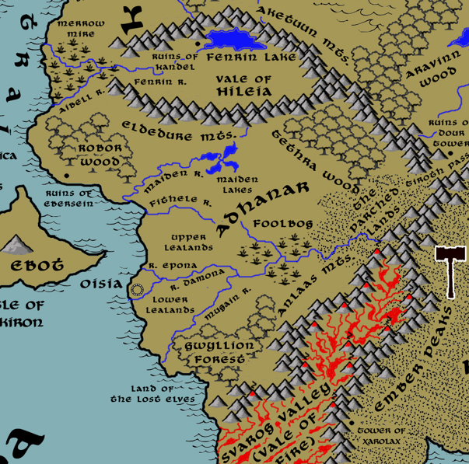

**Table of Contents**

* **Overview**
* **Towns and Cities**
* **Best in the Land**
* **Stewards of Power in this Land**
* **Points of Interest**
* **History**
* **Local Goods**
* **Notes on Culture**
* **Local Deities**
* **Creatures**
* **Other Races**
* **Magical Items**
* **NPC Templates**
* **Developer Notes**

**Overview**

Gaeadon is a hybrid continent, a crossroads situated at the center of the world. The massive **Karn Mountain** range runs from the northeast corner of the land mass at a diagonal, splitting off into the **Aketuun and Eldedure Ranges**, which head west and form the **Vale of Hileia**, and the **Anlaas and Ember Ranges**, which continue on to the southwest and border **Svarog Valley**. This divides Gaeadon into distinct regions, each of which have a character of their own.

The **Kingdom of Kyre** dominates the northwestern region, colonized there four thousand years ago by travelers from north of Treviland (190 AA4). Kyreans have worked to gentrify the region to resemble western Amadar and much of their culture resembles the kingdoms there. The culture is a highly superstitious one, reflecting the untamed spirits of the land. The **Ondirron Elves** that live in the **Crescent Forest** have proven a stalwart ally to humans, helping fight back Orc tribes from the east.

**Kazelduun** is a chaotic and barbaric region along the eastern shores of Gaeadon, ruled over by a series of tyrants that have made the city of **Dimitar** their customary base of power.

The northern area of **Barter Bay** is much less organized, made up of port towns dotting the coastline. Privateers make their home here and the laws in the land are dominated more by shifting alliances among merchants than any ruler.

Far to the south and west, sitting between the **Eldedure** and the **Anlaas Mountain ranges**, is a stretch of land from a forgotten time, once settled by a people known only as the Tebri, who have long since disappeared. Mostly unexplored wilderness, the interior is slowly being claimed by powers from the coastal city of **Oisia**, which was colonized by traders out of **Mythenia**.

The southern third of Gaeadon is taken up by the vast **Forgotten Wastes**. This is a desert stretching from the **Karn and Ember Peaks** ranges all the way to the sea. What few towns there were on the coast are ruins now. Nomads travel the wastes, but they hold no seats of power. It is rumored they have organized hidden cities but that has never been confirmed.

Most of Gaeadon is completely wild, and mapped only according to legend. The central region of the continent is particularly dangerous to travelers. Orc tribes range out from the hills and mountains to plunder everything from the **Howling Plains** to the **Valley of Strife** to **Aravinn Wood**. The **Sea of Spirits** would make an inviting place for settlements if there were safe roads to reach it, but that has never been the case. Of particular note is the sharp rise in the central region compared to the rest of the continent. Millenia ago a dark druid sought to rule the interior of Gaeadon and caused the entire region to rise up two hundred feet from the surface. What remains is a rough escarpment of rock around the base that gives the region the look of one enormous elevated citadel. It is rumored that remnants of the Celedon invaders were trapped in this region and have long since settled it with their descendants.

**Towns and Cities**

* Oisia – large city, sign of the moon and faerie

**Best in the Land**

Trade Hub:

Religion:

Arts:

Magic:

Spirits:

Steel:

Grain:

Crafted Goods (e.g. Pottery, Textiles, Metal Wares):

Harvested Goods (e.g. Aromatics, Medicine, Dyes):

Mined Goods:

Precious Metals:

Ship Building:

Other:

**Stewards of Power in this Land**

Kings and their armies are not the only wielders of power. There are many unseen friends and foes that shape the destiny of the land. Each of the groups listed below are well known to the people of this region. Some are feared, others venerated. All of them play their part in the grand drama of this land’s story.

**Merchant Companies**

Green Sails Traders – Oisia

**Mercenary Companies**

(none)

**Smuggling Rings**

The Plunder Merchants – Oisia

**Centers of Worship (Churches, Cathedrals, Shrines, Lodges, Temples)**

(none)

**Orders of Paladins**

(none)

**Druidic Circles**

(none)

**Bands of Rangers**

Band of Nicnevin – Oisia

**Schools of Magic**

(none)

**Bardic Colleges**

(none)

**Warrior Academies**

(none)

**Assassins Guilds**

(none)

**Cults**

(none)

**Other Guilds**

(none)

**Monasteries**

Monastery of the Singing Stone - Vale of Hileia

Monastery of the Strange Waters - near Gwyllion Forest

**Pirates**

(none)

**Points of Interest**

* **Robor Wood** – is a weathered and venerable-looking forest. The trees along its western border gleam with whitened trunks, giving them the appearance of being dead and sun-bleached. But alive they are, though hardened by some unknown effect that hangs heavy on the entire wood. Brine pools sit in the crook of massive tree roots, glowing a soft gold-green at night. The soil here is dark and hard. The place has a very forbidding air to it during the day. But at night it is the realm of **Digala**an, a high dryad and ruler over this place. Older than most dryads, she once roamed the forests of Mythenia before being captured by a lord of Drommica who sought her as a plaything. The tyrant hired druids to pull up Digalaan’s sacred tree and bring it with them as they sought to colonize the wild Gaeadon lands. There they built a port that would later grow to the town of Ebersein. But Digalaan bided her time until the evil man grew old and careless. At last she burst free and slew her human captors. Now she reigns over all the woodland creatures in Robor Wood, including her inner court of satyrs and hamadryads. She is a harsh mistress, savagely dealing out justice to any who threaten the forest.
* **Tethra Wood** – If there is a magical wood pulsing with the wild spirit of a fairy’s heart, it is Tethra Wood. Trees here grow in strange and beautiful shapes, their bark bearing strange markings that resemble faces. Moss hangs from limbs in wide, gauzy swaths that create a catacomb-like interior. Toadstools grow in rings where fae creatures mingle and frolic to the music and dance of hamadryads and satyrs. At night it is lit with countless swarms of lightning bugs. It is said that Tethra Wood is the home of **Elfane**, queen of the fairies. Her court is said to be hidden to all eyes except those she wants to see it. The ranger order **Band of Nicnevin** is thought to be among those welcome to her court.

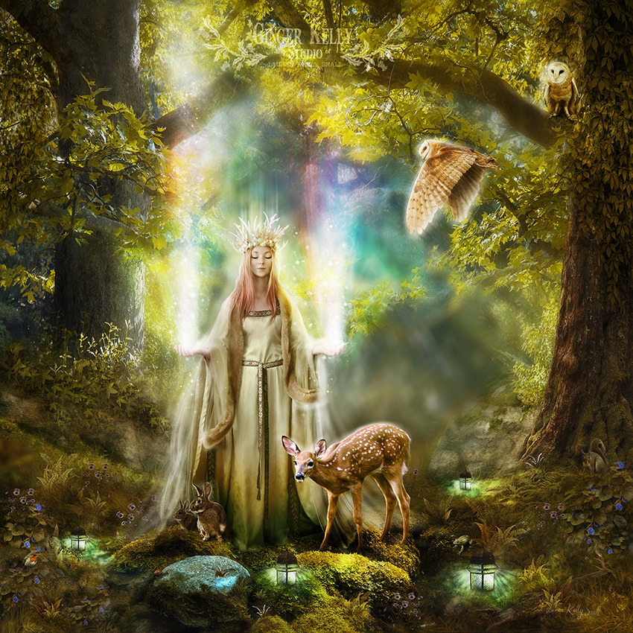

* **Gwyllion Forest –** Gwyllion Forest is a lush and healthy place but carries a wild and unpredictable energy. Ruled over by Borboros, the self-styled Satyr King, the woodland is a place of raucous and sometimes dangerous mischief. Both animal- and plant-life grow out of control and prey upon unwary travelers for their sport.
  + Site of the **Monastery of Strange Waters**, where monks study and train the ways of **Grannus**, god of thermal springs, healing, and the sun
* **The Parched Lands** – As its name implies this is a dry region with little to no life. In 40 WA4 the evil druid **Tossak** summoned the heat of the Forgotten Wastes over the Anlaas Mountains to lay waste to Adhanar’s armies in advance of the invading Behemar Orcs. Adhanar forces were withered by the spell until the Adhanar cleric **Heldra** summoned lightning and used the dry air to blast the Orc army into oblivion. Since then, the area has been permanently ruined. It is enchanted to draw the very life out of anyone who passes this way. Desiccated skeletons litter the plains where unwary travelers have fallen victim to the spell. Here and there are pools of molten glass where Orc skeletons mark Heldra’s wrath from above.
* Upper Lealands - The River Fithele to the north and Mugaine to the south feed into these lands, creating fertile soil. Fields for grain and cotton are cultivated by farms protected by the city of Oisia. During the rainy season some parts of the Lealands become wetlands and perilous to cross.
* Lower Lealands - The River Damona to the north and Epona to the south feed into these lands, creating fertile soil. Fields for grain and cotton are cultivated by farms protected by the city of Oisia. During the rainy season some parts of the Lealands become wetlands and perilous to cross.
* Maiden River
* Fithele River
* Epona River
* Damona River
* Mugain River
* Fenrin River
* Aibell River
* Maiden Lakes
  + Looming just south of here is the tower of **Camedyr the Cloaked**, Arch Mage of the Adhanar lands.
* Lake Fenrin
* Foolsbog – East of Oisia the Mugain River splits off from the Fithele River. Here the land dips and streams from the two rivers feed into a dank and boggy wetland.
  + Here dwells the **Saaris** tribe of Saurians, known by their sign of the twin cattail chutes.
* Merrow Mire
  + Here dwells the **Irithis** tribe of Saurians, known by their sign of the three black lily pads.
* Aketuun Mts
  + In the western peaks dwells the **Harhog** tribe of orcs, known by their sign of the bleeding eyes.
  + In the eastern peaks, just overlooking Tiroth Pass, dwells the **Behemar** tribe of orcs, known by their sign of the six broken teeth.
* Hadronath – Drow Domain
* **Eldedure Mts** – the southern arm of mountains that breaks off from the Aketuun range, the Eldedure range forms the southern boundaries of the Hileia Vale. The peaks here form strangely beautiful spires, twisting into elaborate geometric patterns as a result of harmonics that resonate deep below the mountains.
  + **Harmonic Garden** – at the foot of the Eldedure Mountains is a dell where a magical song has taken hold. The very land and all its features are touched by the harmonics of various melodic vibrations. This has caused the plant and animal life here to grow in wild and colorful ways. Anyone entering this place is filled with an unconscious sense of peace. Anyone taking the time to meditate upon the sounds, which are normally just below hearing, can tap into the music all around them and special gifts that come from them. These gifts last only for a short while after leaving this land, but the melodies stay on in memory. It is here an enchantress named **Cymatica** dwells. She is of lawful neutral alignment, caring naught for the outside world but conjuring subharmonic melodies and curating them. She dwells in a cave of crystals, each of which stores a special melody Cymatica has collected.
  + home to the mighty red dragon **Sinjerin**
  + Here dwell the tribe of Stone Giants called the **Cabarak**
* **Tiroth Pass** – Tiroth Pass is a breach between the Aketuun and Anlaas Mountain ranges and offers passage between the lands of Adhanar to the west into the interior of the Gaeadon continent. The pass has been the site of many battles over the centuries as creatures good and evil waged wars for control. It is a desolate and haunted place, with ghosts of former guardians still lurking here fulfilling their charge long after their generals have faded. It
* **Vale of Hileia –** Bordered by the Aketuun Mountains to the north and the Eldedure to the south, the Vale of Hileia is a vast and secluded region of the Gaeadon continent. Strange flora and fauna grow here that are found nowhere else in the wide world. A deep enchantment lays over this place, likely the product of a multitude of fairy queens and arch wizards who have taken up residence over the centuries. This was once the site of the fledgling **Kingdom of Kandel**, which thrived for a thousand years until the city fell in the Second Written Age.
  + Site of the **Temple of the Singing Stone**, where monks study and train in the ways of **Brighid**, goddess of healing, poetry and smithcraft
  + Here dwells the **Kabreek** tribe of goblins, known by their sign of the impaled hand.
  + Here dwells the **Arbash** tribe of orcs, known by their sign of the scorpion pincers.
* **Ruins of Kandel** – Kandel was a town birthed in the First Written Age (209 WA2) by those fleeing the Celedonian occupiers. It became a town in 22 WA2 and later the center of the prosperous small **Kingdom of Finndra** until it fell in 420 WA2. Kandel was a beacon of light in the land for many years, its people living in peace and harmony with all creatures of the vale. It was ultimately the greed of Lord Rivas the Usurper who stole the Staff of Comalainn from the fairies and sparked the Hileian War, spelling the end for Kandel. It is now the site of crumbling ruins that even to this day speak to the simple majesty of the architecture of the Finndrans.
* Ruins of Dour Tower
* Land of the Lost Elves

**Sidhe** are Kyrean soil mounds, which in folklore are believed to be the home of the **Aos Sí** (the people of the mounds). They are variously said to be the ancestors, the spirits of nature, or goddesses and gods. A notable feature of the sidhe is that they have distinct tribes, ruled over by fairy kings and queens in each territory.

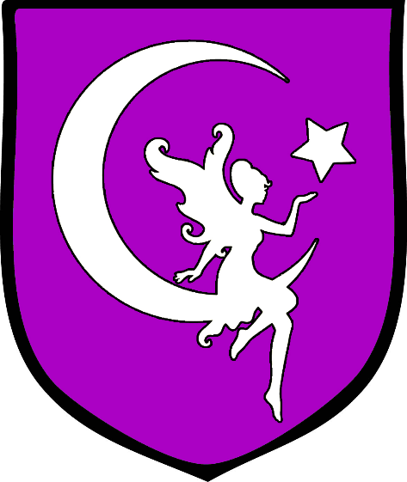**Oisia**

**Size:** large city, population 25,000, guards / soldiers 250, militia 2250

**Trade Goods:** trade hub, grain, cotton, silver, platinum, spices

**Local Goods:**

**Standard:** fairy and crescent moon

**Colors:** purple and silver

**Patron Deity:**

**Ruler:** Ivar Staly and his wife Crera (f)

**Home**: Castle Rodona

**Steward**: Fayrhare Quael

**Marshal**: Berman More

**House Priest:** Cristen Piper

**House Adviser (Scholar/Mage/etc):**  Sorscha Hane of the Speaking Stones (f)

**Captain of the Guard**: Flan Danvid

**Chief Warriors in Service**:

Morris Kerdar

Inry Comais

Moris Gawe

Urmen Reshmon

**Local Powers:** Green Sails Traders, Barren Barristers (thieves guild), The Plunder Merchants (smuggling ring), Band of Nicnevin (rangers)

**Local Sites:** The Jagged Blade Inn & Tavern, The Red Dragon Inn & Tavern, House of Respite (brothel)

**Description:**

Tucked away in the southwest corner of the Gaeadon continent stands the free city Oisia in the land of **Adhanar**. Visitors to the city will marvel at its white walls and towers, capped with burnished bronze fixtures that gleam in the sun. Signs of Elven architectural influences are evident here, with curling vine motifs on the walls, elegant archways, and the presence of nature growing amidst even the busiest of streets. The **River Damona** plunges in a great waterfall into the valley, close enough to the city its mists can be felt when the winds blow out to sea. An ancient aqueduct, rumored to have been built by the Celedonians long ago, carries water into the city where it springs forth in fountains scattered throughout the place. To the west the city overlooks the **Thundra Sea**, where the shores of **Isle of Skiron** greet the eye. Standing over the central city square are fifty-foot statues of **Salmus, Asamud, Kaafiyah**, and **Aggelos**, the four priests who came to this land hundreds of years ago to establish a new kingdom of peace.

The original inhabitants of this land were the Tebrin, who were originally scattered tribes in who migrated out of the interior of the Gaeadon continent into the west. They disappeared millennia ago; their city buried deep beneath the present-day streets. Stories tell of the city being named **Iolanth** which in the days of old ruled over the lands west of Aketuun and Anlaas mountain ranges(720 PA2). The builders of Oisia diverted the Damona waters into a sewer system underground. This has flooded what remained of the original city, submerging its secrets.

The **Epona** and **Damona Rivers** have created a lush region for farmlands, divided between the **Upper and Lower Lealands**. Here fertile fields for grain and cotton are cultivated. Spices too are grown here as well as being collected upriver in **Foolsbog**. While the elves of Gwyllion Forest are gone, the humans have held most of the forest and created a road up into the **Anlaas** foothills. There they have commissioned silver and platinum mines, from which the city has profited greatly.

The **Green Sails** trading company carries the name of the original explorers who arrived in the Third Ancient Age and later built Oisia (441 AA3). The company has established strong ties with the city of **Aurya** in Mythenia as well as the cities of **Longspear** and **Ajabar** in Kaduru. The Green Sails is one of the few companies welcomed to visit **Paradise Island** and trade with her people. The merchants who run the company hold fast to the philosophy of an honest business and helping others where they can. Their work is frustrated by the **Plunder Merchants** smuggling ring that operates in secrecy in Oisia.

The lands of **Adhanar** extend from the western reaches of the **Eldedure Mountains** in the north to the southern end of the **Anlaas Mountains** to the south. It was once ruled from the city of Iolanth, which was destroyed. Remains of the kingdom can be found here and there but no one knows how it came to fall.

**Industry:**

**Key Figures:**

**Local Lore:**

The region is wild and both beautiful and dangerous. **Hamadryads** and **satyrs** frolick in the forests of **Robor, Tethra, and Gwyllion**. Water nymphs are common all along the **Mugain River** system and are thought to call the **Maiden Lakes** their home.

But upriver Foolsbog is ruled by the Saurian kingdom of **Saaris**. Orc and goblin tribes are in great numbers in the mountains both north from the Aketuun and Eldedure Mountain ranges and from the south and the Anlaas Mountains. History tells of their many marches across Adhanar and against Oisia.

Most troubling is the Drow kingdom of **Hadronath**, whose tunnels range deep within the ground between the mountain ranges. The Drow have long sought to conquer the Vale of Hileia, the Vale of Svarog, and everything in between. They will stop at nothing to poison the land and wipe out every human, elf, and fay that stand in their way of total domination.

It is also said that **Tethra Wood** is the home of **Elfane**, queen of the fairies. Her court is said to be hidden to all eyes except those she wants to see it. The ranger order **Band of Nicnevin** is thought to be among those welcome to her court.

**History:**

Settled here by explorers, it was once a camp for adventurers seeking inroads into Gaeadon. They came from Kaduru, Mythenia, Kyre, and lands further abroad, financed by merchants who sought fortune. The explorers made friends with the **Lost Elves** of **Gwyllion Forest**, aiding them in ridding this region of Orc dominion. Over time the elves disappeared (410 WA1), but not before they nurtured the camp into a small town with the tools to build a stronghold for good. Word spread there was a haven in Gaeadon for the dispossessed, and so people fleeing oppression found their way here to start anew. Why the Elves went missing is still a mystery. But the city of Oisia remains as a light in this beautiful but dangerous land.

One famous epic tells of the **War of the Hidden Sun**, which took place one thousand years ago (390 WA3). It tells of the Hadronath sorceress-turned-queen named **Olorala Teken'ana**, who offered 10,000 sacrifices to the goddess **Llolth**. Olorala was granted power through a staff called **Araneae**, which could spread poison over vast distances. Her Drow army created huge plumes of smoke to rise up from the Svarog Valley and it covered all the land. Olorala poisoned the lakes and streams, turning them black. Her massive spider warriors emerged from holes in the ground and marched on Oisia. From Oisia came **Albondiel** (f) paladin of Ehlonna, the drunken wizard **Saegifu Barantyn**, and the huntress **Morrin Ní Finn**, who vowed to have the head of the sorceress. While Albondiel led the armies of men and elves against the drow armies, Saegifu and a band of warriors scaled to the top of the Karn Mountains to fight the dark clouds that covered the land. But it was Morrin who led a raiding party behind the enemy lines and battled Olorala to the death. She broke the staff and took Olorala’s head and cast it into the **Vale of Fire**.

**Customs:**

**History of** **Adhanar**

Rulers of Adhanar

444 AA3 - Morvoren, half-fae hero of the people, crowned first Queen of Adhanar

**First Primordial Age (PA1)**

**Second Primordial Age (PA2)**

560 PA2 - Dawn of Tebrin: tribes of southwestern Gaeadon migrate out of the internor into the west and coalesce into the Tebrin people

720 PA2 - The Tebrin erect the city of Iolanth as their capital city

**Third Primordial Age (PA3)**

410 PA3 - People of Iolanth are joined by the Elves of Gwyllion Forest and battle demons emerging from the Svarog Valley; the city of Iolanth burns but is saved

**Fourth primordial Age (PA4)**

230 PA4 - Drommica and Arropos occupy Isle of Skiron and Tebrin lands

498 PA4 - Dractus invades the Tebrin lands in W. Gaeadon, sacks Iolanth, drives out the invaders from Drommica and Arropos; his spies report rumors of the Crown of Power being collected by a wizard in Svarog Vale

872-888 PA4 - The Wizard War: Telemechus triggers a world-wide war of mages, some of whom march on Ongolk to stop him and some who join him in attacking the ley lines in their lands; epic battles wage all over the world, destroying cities and upsetting the balance of magic

888 PA4 - The Battle of Forlorn: Telemechus is slain but not before rupturing the magical ley lines permeating Nemmyrl; the victorious general Dragan of Celedon seizes the opportunity to rid the world of magic and ruptures the Singularion as it is embedded in the ley lines; the resulting explosion sends a shock wave that ruptures the magical ley lines around the world and triggers the Dead Century

**First Ancient Age (AA1)**

171-182 AA1 - War of the Fallen Fey - Orcs march down from the Vale of Hileia into Tebrin, wiping out fairy colonies and human settlements

181 AA1 - Fall of Tebrin - Orc armies surround Iolanth and destroy it; human armies are wiped out and the Tebrin people scattered

182 AA1 - the Elven Retribution - elves of Gwyllion Forest, joined by the moon elves of Cascadrel, avenge the human city by destroying the orc host and driving them into the mountains

**Second Ancient Age (AA2)**

200 AA2 - Oraba, kingdom of Kaduru, invades southern Gaeadon: Tebrin, the Vale of Svarog, and the Forgotten Wastes

550 AA2 - Oraba forces leave Tebrin, answering the call of the great war in Kaduru; some Oraba people stay behind and dwell among the people here

**Third Ancient Age (AA3)**

256 AA3 - the Green Sails arrive at the shores of the old Tebrin lands; the four priests: Salmus, Asamud, Kaafiyah, and Aggelos bless the land and are welcomed by the local gods to settle here in peace

441 AA3 – Founding of the city of Oisia: after years of toil and peril the refugee people who fled under the Green Sails build a permanent town on the sight of the old Tebrin city of Iolanth; the people from many lands erect a great statue to the four priests who safeguarded them here and name themselves the Adhanar

**Fourth Ancient Age (AA4)**

812 AA4 - War of the Maddened Moon - the evil druid Vromorn manifests the Amber Portal, a device that generates amber-hued clouds that cover the land and transmute the moon's light into a ray of madness

812-815 AA4 - the lands of Adhanar and Kyre are plagued with insanity as lycanthropes massacre hundreds

816 AA4 - after four years of fighting the dark forces plaguing the land, the Moon Elves track down Vromorn and consecrate the clouds, destroying the Amber Portal

**First Written Age (WA1)**

200 WA1 - Kyrean explorers enter the Vale of Hileia; they settle here and intermarry with the local barbarian tribes

290 WA1 - the town of Kandel is founded in the Vale of Hileia

**Second Written Age (WA2)**

50 WA2 - the Kingdom of Finndra grows out of Kandel; it is a prosperous kingdom where humans live in harmony with the creatures of Hiliea Vale and enjoy an abundant farming culture

380 WA2 - Lord Rivas, the head commander of Finndra's army, grows jealous of power and slays the fairies of Hileia to steal the cursed Staff of Comalainn "Power and Greed" under their protection

382 WA2 - Rivas slays the king and rules with greed, sparking the Hileian Wars

420 WA2 - Fall of Finndra - Orcs and goblins overwhelm the city of Kandel and burn it to the ground

**Third Written Age (WA3)**

390 WA3 - War of the Hidden Sun: Olorala of the Drow kingdom of Hadronath attacks Adhanar; elves of Cascadrel march southward to battle the Drow

400 WA3 - Olarala slain by the heroes Albondiel, Saegifu, and Morrin

**Fourth Written Age (WA4)**

40 WA4 - **Battle of the Parched Lands**: the evil druid Tossak summons the heat of the Forgotten Wastes over the Anlaas Mountains to lay waste to Adhanar’s armies in advance of the invading Behemar Orcs, creating the Parched Lands; Adhanar forces are withered by the spell until the Adhanar cleric Heldra summons lightning and uses the dry air to blast the Orc army into oblivion

302 - 415 WA4 - **War of the Green Flame**: **Empress Becred** of the Hadronath uses the **Cauldron of Virdroth** to magically taint the fires of Svarog Vale, which cast a green flame and poison the land; the Sirathren fire elves fight a desperate war to defend their valley

311 WA4 - the Sirathren fire elves counter with the **Staff of Candronor**, which emanates a magical ether capable of cause the very blood of the Drow to burst into flames

415 WA4 - **Battle of Tiroth Pass**: the Sirathren crush the invading army of Hadronath, sending them home and ending the War of the Green Flame

**Local Goods of Oisia**

**Cereals:** wheat, emmer (wheat), spelt (wheat), einkorn (wheat), durum (wheat), barley, oats, rye, millet

**Fiber:** hemp, flax

**Fruits:** pear, apples, figs, plums, vitis vinifera (grapes), black mulberry, cornelian cherry, date palm, fig, grape (called raisin, sultana, or currant when dried), jujube, olive, pomegranate, sycamore fig

**Meat and poultry:** beef, pork, chicken, lamb, mutton, duck, geese, rabbit, goat

**Nuts:**

**Vegetables:** pea, turnip, olives, beets, broccoli, brussel sprouts, cauliflower, kale, kohirabi (turnips), broad bean, lentil, chickpea, lupin beans

**Herbs:** ajwain, anise, centaurium, coriander, cumin, fennel, hyssop, garden cress, lavender, mahaleb cherry, myrtle, nigella, oregano, olive, rocket, rosemary, rue, sage, saffron, savory, sesame, sumac, thyme, black lovage, mastic, samphire, pennyroyal, calamint, pine nuts, purslane

**Oils:** linseed (flax), sesame oil, olive oil, palm oil

**Fermented Drink:**

**Salt-water fish:** sardines, anchovies, yellowfin tuna, red mullet, ray, swordfish, sturgeon, squid, octopus, shellfish, skaren (probably parrotfish - cheapest of fish)

**Fresh-water fish:** eels, pike fish, carp, catfish, mullus aka the goatfish (its scales turn red when dying out of water, often used as a meal presentation)

**Wood:** lignum vitae (also called guayacan), loquat, quince, fig, pomegranate, carob, mulberry, almond, cypress, palm, eucalyptus, olive, stone pine,

**Textiles:**

**Dishes:** tracta (bread, pastry, or pancake), testaroli (pasta or bread prepared using water, flour and salt, which is sliced into triangular shapes), melas zomos or black soup (soldier food a staple soup made of boiled pigs' legs, blood, salt and vinegar), acquacotta (hot broth-based bread soup, a peasant food of stale bread), lucanica (short, fat, rustic pork sausage), placenta cake (many dough layers interspersed with a mixture of cheese and honey and flavored with bay leaves, then baked and covered in honey), oxygala (yoghurt and honey), moretum (herb cheese spread made of herbs, fresh cheese, salt, oil and some vinegar), jusselle (broth-based soup dish prepared using grated bread, eggs, sage and saffron), garum (fermented fish sauce, universal condiment and almost replaces salt, production within a city is forbidden due to the smell), focaccia bread, flatbread, mixture of ground, lean meat mixed with fat by grinding, sieving, or puréeing the ingredients such as pork, fish, game meats, poultry, game birds, veal, and pork livers)

**Notes on Culture**

The people of Adhanar are a colorful mix of cultures and ethnicities from all around the southern half of the world. Influences of Arnland, particularly Mythenia, built an early foundation here: food, architecture, and clothing are all reminiscent of Celedon, Tarbia, and most notably nearby Mythenia. Later, in the Second Ancient Age, the invasion of Oraba introduced bright-colored woven materials heavy with symbolic geometry, curling archway designs, the use of masks and headdresses in ritual attire, and new culinary delights.

Adhanarans tend to dress in colorful loose-fitting cotton tunics, with women wearing longer tunics hemmed in beadwork. Over these are typically worn robes with wide sleeves. Soft slippers are worn on the feet and are decorated with designs and non-precious stones.

People here are a contemplative lot, given to reading Mythenian wisdoms and debating them at length. The culture here is an open one, tolerant and even curious about every religion, language, custom, song, dance, and even mating ritual. Envoys from other lands find this openness inviting at first, but often wrinkle their nose when seeing their native traditions blending in with those of others. Some say Adhanar is a confused and irresolute place, unable to settle on a system of traditions that they can call their own.

Adhanarans are particularly keen to see cultures explored and combined. They are ever curious, yet unwilling to keep any form static. This is demonstrated of their custom of the **Suidara**: a traveler from another land is gifted with something that may or may not be valuable, but is considered intriguing and compelling and is almost always from somewhere outside of the region. The expectation is for the traveler to gift something of theirs in return. The return gift is, again, not necessarily of great value in coin but may be something novel and peculiar that comes from their land. Often times merchants know to have a few worthless oddities on hand that are visually striking, just for the chance to exchange it with an Adhanaran who unknowingly holds something that would fetch a price elsewhere. Darmidians are the most notorious for this and have adopted the term ‘Suidara’ as a joke for pawning off garbage for treasure from unknowing fools.

**Local Deities**

**Creatures**

**Other Races**

**Elves**

**Dwarves**

**Magical Items**

**Staff of Araneae** – magical staff gifted by Llolth to the Hadronath sorceress-turned-queen named **Olorala Teken'ana**; it could spread poison over vast distances. During the **War of the Hidden Sun** (390 WA3) Olorala’s Drow army created huge plumes of smoke to rise up from the Svarog Valley and it covered all the land. Olorala poisoned the lakes and streams, turning them black. The huntress **Morrin Ní Finn** broke the staff when she took Olorala’s head and cast it into the **Vale of Fire**.

**Staff of Comalainn** – a cursed staff that was guarded by the fairies of the Hileian Vale for centuries until Lord Rivas of Kandel stole it in 380 WA2 and used it to slay the Finndrian king and sow destruction in the vale before himself being destroyed by Orc and goblin armies. It is said the staff not only transmutes stone to gold, but can incite madness and rage in those who wield it and their followers.

**Heldra Glass** – In the Battle of the Parched Lands (WA4) the evil druid Tossak summoned the heat of the Forgotten Wastes over the Anlaas Mountains to lay waste to Adhanar’s armies in advance of the invading Behemar Orcs, creating the Parched Lands; Adhanar forces were withered by the spell until the Adhanar cleric Heldra summoned lightning and used the dry air to blast the Orc army into oblivion. It is said that the molten glass can still be found in the Parched Lands and contains residual energy that an alchemist can use to create powerful weapons that channel electricity.

**Sword of Winters** – During the Saurian Wars (44-63 PA3) Tebrin hero Keverne Treglown quests into Tethra Wood, where he is gifted the Sword of Winters by the witch Cailleach; with it he leads a withering campaign to drive back the Saurians into the swamps and puts them to sleep for a hundred years

**NPC Templates**

This is a list of notes and stats to help develop NPC’s relevant to this region.

**Developer Notes**

This is a list of notes on the development of this document, including notes on history, culture, and changes to the document.