Notes on the Lands of Kyre

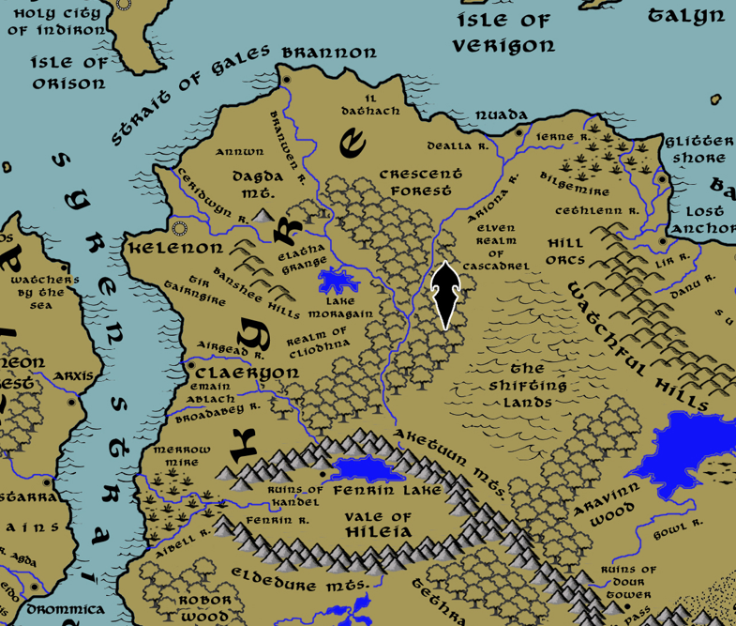

**Table of Contents**

* **Overview**
* **Towns and Cities**
* **Best in the Land**
* **Stewards of Power in this Land**
* **Points of Interest**
* **History**
* **Local Goods**
* **Notes on Culture**
* **Local Deities**
* **Creatures**
* **Other Races**
* **Magical Items**
* **NPC Templates**
* **Developer Notes**

**Overview**

Gaeadon is a hybrid continent, a crossroads situated at the center of the world. The massive **Karn Mountain** range runs from the northeast corner of the land mass at a diagonal, splitting off into the **Aketuun and Eldedure Ranges**, which head west and form the **Vale of Hileia**, and the **Anlaas and Ember Ranges**, which continue on to the southwest and border **Svarog Valley**. This divides Gaeadon into distinct regions, each of which have a character of their own.

The **Kingdom of Kyre** dominates the northwestern region, colonized there four thousand years ago by travelers from north of Treviland (190 AA4). Kyreans have worked to gentrify the region to resemble western Amadar and much of their culture resembles the kingdoms there. The culture is a highly superstitious one, reflecting the untamed spirits of the land. The **Ondirron Elves** that live in the **Crescent Forest** have proven a stalwart ally to humans, helping fight back Orc tribes from the east.

**Kazelduun** is a chaotic and barbaric region along the eastern shores of Gaeadon, ruled over by a series of tyrants that have made the city of **Dimitar** their customary base of power.

The northern area of **Barter Bay** is much less organized, made up of port towns dotting the coastline. Privateers make their home here and the laws in the land are dominated more by shifting alliances among merchants than any ruler.

Far to the south and west, sitting between the Eldedure and Anlaas Mountain ranges, is a stretch of land still being settled. Mostly unexplored wilderness, the interior is slowly being claimed by powers in the coastal city of **Oisia**, which was colonized by traders out of **Mythens**.

The southern third of Gaeadon is taken up by the vast **Forgotten Wastes**. This is a desert stretching from the Karn and Shatterpeak ranges all the way to the sea. What few towns there were on the coast are ruins now. Nomads travel the wastes, but they hold no seats of power. It is rumored they have organized hidden cities but that has never been confirmed.

Most of Gaeadon is completely wild, and mapped only according to legend. The central region of the continent is particularly dangerous to travelers. Orc tribes range out from the hills and mountains to plunder everything from the **Howling Plains** to the **Valley of Strife** to **Aravinn Wood**. The **Sea of Spirits** would make an inviting place for settlements if there were safe roads to reach it, but that has never been the case. Of particular note is the sharp rise in the central region compared to the rest of the continent. Millenia ago a dark druid sought to rule the interior of Gaeadon and caused the entire region to rise up two hundred feet from the surface. What remains is a rough escarpment of rock around the base that gives the region the look of one enormous elevated citadel. It is rumored that remnants of the Celedon invaders were trapped in this region and have long since settled it with their descendants.

**Towns and Cities**

* Kingdom of Kyre
  + Brannon – small city, sign of the chain link knot
  + Kelenon – metropolis, sign of the heart and crown knot
  + Nuada – small city, sign of the twin fish knot
  + Claeryon - large city, sign of the

**Best in the Land**

Trade Hub:

Religion:

Arts:

Magic:

Spirits:

Steel:

Grain:

Crafted Goods (e.g. Pottery, Textiles, Metal Wares):

Harvested Goods (e.g. Aromatics, Medicine, Dyes):

Mined Goods:

Precious Metals:

Ship Building:

Other:

**Stewards of Power in this Land**

Kings and their armies are not the only wielders of power. There are many unseen friends and foes that shape the destiny of the land. Each of the groups listed below are well known to the people of this region. Some are feared, others venerated. All of them play their part in the grand drama of this land’s story.

**Merchant Companies**

Bounty Ventures – Kelenon

**Mercenary Companies**

(none)

**Smuggling Rings**

The Gadai Dubh – Claeryon

**Centers of Worship (Churches, Cathedrals, Shrines, Lodges, Temples)**

High Cathedral of Saint Cuthbert – Kelenon

Cathedral of Saint Loghlan – Claeryon

**Orders of Paladins**

Order of the Blessed Well – Kelenon

**Druidic Circles**

Circle of the Laughing Brook – Claeryon

**Bands of Rangers**

Band of the Virgin Vale – Kelenon

**Schools of Magic**

(non)

**Bardic Colleges**

Filidhe College – Brannon

**Warrior Academies**

(none)

**Assassins Guilds**

Killing Floor – Brannon

**Cults**

(none)

**Other Guilds**

(none)

**Monasteries**

Monastery of the Battle Crow – Banshee Hills

**Pirates**

(none)

**Points of Interest**

* Strait of Gales
* **Crescent Forest** – home to the Elven Realm of Cascadrel
  + Also home to the mighty green dragon **Ornorax**; the dragon has made a large hill in the midst of the forest as his home. The many winding tunnels beneath the hill date back to ancient burial tombs and is laced with traps and enchantments. While the Elves of Cascadrel are loath to tolerate Ornorax’ presence in their region, the dragon is too powerful and well protected for most to dare confrontation.
* Plains of Emain Ablach
* Plains of Tir Airngire
  + Standing sentinel over this region is the tower of **Odhran O'Dargan of the Under Wood**, Arch Mage of the Kyrean lands.
* Plains of Annwn
* Plains of Il Dathach
* Elatha Grange
* Broadabey River
* Airgead River
* Fuath River
* Ceridwyn River
* Branwen River
* Dealla River
* Ariona River
* Fetch River
* Moragain Lake
* Dagda Mt.
* **Banshee Hills**
  + Site of the **Monastery of the Battle Crow**, where monks study and train in the ways of **Cathubodua**, the warrior goddess.
  + Here dwell the **Lethangren**, a tribe of Stone Giants.
  + Here dwell the **Bacach** tribe of goblins, known by their sign of the white four-pointed caltrop. Centuries ago the haughty King Goire bungled an attack on the goblins of the Banshee Hills, which led to him being unhorsed because of a caltrop and his walking with a limp. Ever since that day, the goblins have been referred to with the old Kyrean slang for one who limps. Interestingly enough, it also refers to guests who drag their feet leaving where they are no longer welcome. The goblins, not being very intelligent, thought the name was their idea and adopted the term as their name ever since.
* **Cascadrel - Elven Kingdom**
  + Ebalarin - Elven town of Cascadrel
  + Illyndra - Elven town of Cascadrel
  + Reyhimra - Elven city of Cascadrel
  + Phaeredryn - Elven town of Cascadrel
  + Handamar - Elven town of Cascadrel
* Lands of Cliodhna
* **Sidhe** are Kyrean soil mounds, which in folklore are believed to be the home of the **Aos Sí** (the people of the mounds). They are variously said to be the ancestors, the spirits of nature, or goddesses and gods. A notable feature of the sidhe is that they have distinct tribes, ruled over by fairy kings and queens in each territory.

The Kingdom of Kyre was founded four thousand years ago by dispossessed nobles from Northern Treviland (190 AA4). **Lord Donagal** was the second son of a lord and a notorious swindler, gambler, and liar. He persuaded several wealthy noblemen to invest in a campaign to start a new land and reap its riches. Some say his proposition started as a ruse to make money and grew out of control. But history still marks Donagal as the father of Kyre and hails him a hero.

The lands of Kyre were named after the various lands of legend: **Il Dathach, Annwn, Tir Tairngire, and Emain Ablach**.

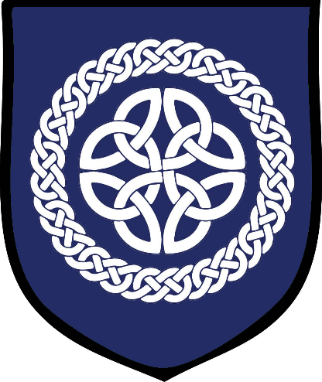**Brannon**

**Size:** small city, population 12,000, guards / soldiers 120, militia 600

**Trade Goods:** grain, timber, steel

**Local Goods:**

**Standard:** three interlocking chain links

**Colors:**

**Patron Deity: Macha**the Kyrean goddess of war, horses and sovereignty

**Ruler:** Lord Iomhar Dubhain and his wife Ysbal (f)

**Home**: Castle Epona

**Steward**: Eamon Floinn

**Marshal**: Finbar Maolduin

**House Priest:**  Father Lubhras of the Silver Cup

**House Adviser (Scholar/Mage/etc):**  Ciara the Dark-Eyed Witch (f)

**Captain of the Guard**: Leenane Carthaigh

**Chief Warriors in Service**:

Cruinn Argain

Cofach Sabhain

Riona Braonain (f)

**Local Powers:** The Dandy Dirks (thieves guild), Killing Floor (assassin’s guild), Filidh College (bardic college)

**Local Sites:** Keak and Brangle Inn & Tavern, The Merry Minstrel Inn & Tavern, Lighthouse of Brannon, House of Overdone (brothel)

**Description:**

Brannon is the oldest settlement of Kyre, founded four thousand years ago (210 AA4) by pioneers from north of present-day Treviland. The original Kyreans were hardy people. Farmers, soldiers, craftsmen, and merchants, all organized under the ambitions of **Lord Donagal** who sought to begin a new kingdom in a land of promise. The city of Brannon still carries the fighting spirit of Donagal and those first settlers. Giant rune stones stand throughout the city, reminders of the early times as well as holders of the first protective wards cast around the place.

Perched atop a high promontory, the famous **Lighthouse of Brannon** marks the doorway to the east and is a welcome sight to westbound sailors crossing the Inner Sea. East of Brannon and Nuada there are pirates who roam freely, attacking any ship caught off guard.

**Industry:**

Today Brannon does brisk trade with Plenia, Treviland, and Tirudor as well as newer allies to the east. The Holy City of Ondiron is a regular trade partner with Brannon.

**Key Figures:**

**Local Lore:**

It is rumored that on the passage over from Treviland a **Bodach** accompanied the first settlers. His name was **Carnilan**, and he tempted Lord Donagal with promises of prosperity in the new world. While everyone knows of Donagal’s successes in founding Brannon, few know that Donagal was beset with personal tragedies. Owing a debt to the noblemen who funded his venture, he took on three of their children to manage his affairs: **Airdgal, Oison, and Niamh** (f). All three went on to found the cities of Kelenon, Nuada, and Claeryon and surpass Donagal’s fortunes. It is also said that the Brodach snuffed the lives of every member of the Donagal family and before that sent them into ruin. Some say that Carnilan lurks in Brannon today, wearing a smile and luring poor souls into damnation.

While the official religion of Kyre is **St. Cuthbert**, the people still look to the old gods. **Macha**is the Kyrean goddess of war, horses and sovereignty. She is the patron deity that the common folk look to in Brannon.

**History:**

**Customs:**

Kyrean culture is famous for having a poetic element. Much of the language has a lyrical quality and much of life is celebrated in limerick and song in the taverns. **Filidh College** is the center of the Kyrean tradition of poetry and music. Bards of Kyre are known as **Shanachie** and are masters of the complex rhyming structure of the Kyrean style of music and storytelling. Shanachie are highly revered in the courts of Kyre and abroad. Nobles pay handsomely for their services and often hire them to spread their fame (or slander their foes).

When the clerics of the Church of St. Cuthbert set to writing down the history of Kyre centuries ago they were dismayed by the rivalry between their works and that of the oral storytellers. Over time the liturgical writings of the clerics adopted a poetic flair to it as well. For this reason the holy books of St. Cuthbert are distinct from those of other lands, for they have a melodic tone to them unlike any other.

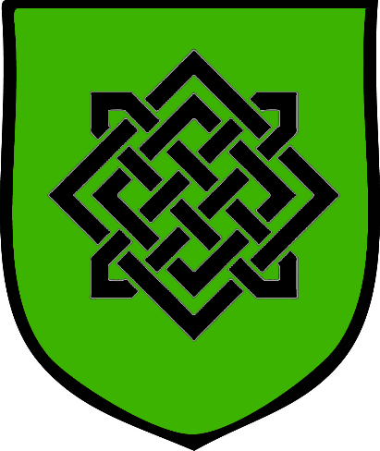**Kelenon**

**Size:** metropolis, population 50,000, guards / soldiers 500, militia 2500

**Trade Goods:** trade hub, magical center, religious center, lead, wool

**Local Goods:** timber from the Crescent Forest, gold from the Banshee Hills

**Standard:** an intricate Kyrean knot design in the shape pf a heart with a crown

**Colors:**

**Patron Deity:Áine** is the Kyrean goddess of love, summer, and wealth

**Ruler:** King Patrig Asgaill and his wife Lysagh (f)

**Home**: Castle Tuatha

**Steward**: Bethaill Cuarta (f)

**Marshal**: Raghnall Somachlen

**House Priest:**  Caireann of the White Staff (f)

**House Adviser (Scholar/Mage/etc):**  Diarmid Coryn

**Captain of the Guard**: Barhan Magoill

**Chief Warriors in Service**:

Rian Coluim

Darragh Amoinn

Fynlo Gilvorra

**Local Powers:** Bounty Ventures Trading Company, High Cathedral of Saint Cuthbert (world seat of power for the Church of St. Cuthbert), The Trove Lifters (thieves guild), Order of the Blessed Well (order of paladins), Band of the Virgin Vale (order of the rangers)

**Local Sites:** The Cat and Sack Inn & Tavern, Second Moon Inn & Tavern, Molly Malone (brothel)

**Description:**

Kelenon is the second oldest Kyrean settlement after Brannon.

Kelenon has held on rigidly to its Kyrean roots but has kept an open door to travelers from Mythens to keep the trade healthy.

**Industry:**

A hundred farms till their soil in the Elatha Grange and send goods downriver to Kelenon. In addition, the Elves send their finest timber downstream to be sold in the city.

**Key Figures:**

The rangers of the **Virgin Vale** make regular expeditions up the Ceridwyn River into the Crescent Forest. There they have secured a firm friendship with the **Elves of Cascadrel**. When the **Baingol Orcs** rose up out of the Aketuun Mountains three hundred years ago (190 WA4) and marched on the Crescent Forest, the rangers rallied the city’s troops to come to the aid of the Elves. Cascadrel remembered this deed and helped with the founding of the **Elatha Grange** west of the Crescent Forest.

**Local Lore:**

Folklore suggests that ancient spirits of the land blessed the soil around Kelenon and made it fertile. Other tales tell of evil spirits from the hills being defeated by Kyrean priests and forced to give over the secrets of the land. While the official religion of Kyre is St. Cuthbert, the people still look to the old gods. **Áine** is the Kyrean goddess of love, summer, and wealth. She is the patron deity of Kelenon.

The goblins of the **Bachram** tribe lurk in the Banshee Hills. The area is threatened by endless bands of goblins as well as banshees.

**History:**

Shortly after Lord Donagal’s success with founding Brannon, he had a mind to expand his territory. Years of asking favors from noblemen to help fund his projects had left him indebted to them. So when an ambitious young nobleman’s son named **Airdgal** asked to lead his expedition west, Donagal begrudgingly agreed. Airdgal’s expedition planted their flag in 240 AA4.

Within ten years Airdgal’s town on the **Ceridwyn River** was booming. The young man had secured investors from Darmidia, brokered a deal with the **Church of Obad-Hai** to host their new cathedral, and opened markets all over the kingdom of Mythens. He even named the new town Kelenon, after his new wife’s maiden name. She, who had once been Donagal’s mistress but Airdgal had stolen away. It seemed everything Airdgal touched turned to gold.

When trade began to flourish with Mythens at the mouth of the Ceridwyn River, the city flourished with it. Airdgal gambled on loans for developing a massive trading port but the investment paid off.

Three thousand years ago the Celedon Empire’s infamous **Primus navy** besieged Kelenon and the Kyrean coast (120 WA1). The **Echion Legion** was deployed to take the city. Employing superior siege weapons the city fell within a year. The Echion Legion garrisoned the city and built impressive sea fortifications in the harbor as well as high inner walls. The Celedonian citadel still stands to this day.

**Customs:**

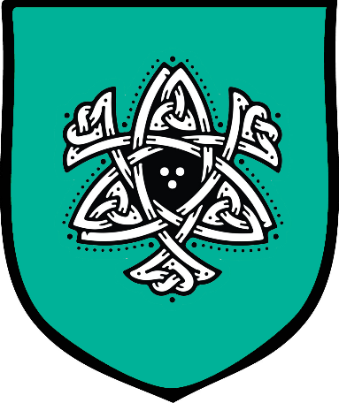**Nuada**

**Size:** small city, population 12,000, guards / soldiers 120, militia 600

**Trade Goods:** papyrus, wine, wool

**Local Goods:** timber from the Crescent Forest, farming, clays, whaling, fishing

**Standard:** twin fish in a Kyrean knot design

**Colors:**

**Patron Deity:Manannán mac Lir** is the Kyrean god of the seas

**Ruler:** Lord Coireall Allurain and his wife Dianaimh (f)

**Home**: Castle Amergin

**Steward**: Michan Ruana

**Marshal**: Niallan Conaill

**House Priest:**  Father Agastas the Speaker of Truths

**House Adviser (Scholar/Mage/etc):**  Eachna the Shade (f)

**Captain of the Guard**: Malachy Raghailligh

**Chief Warriors in Service**:

Tierney Dubhuir (f)

Cadhan Canaigh

Aengus O’Rinn

**Local Powers:** The Passing Shades (thieves guild)

**Local Sites:** Kith and Kin Inn & Tavern, The Dusky Diamond Inn & Tavern, Fuisca Vineyards

**Description:**

Nuada stands past the eastern edge of the civilized seas.

**Pirates out of the Black Coast** regularly raid the lands surrounding Nuada and hide in the swamps east of the **Irne River**. Over time the Kyreans built up high walls to defend themselves. This is one reason the town has earned the nickname **“Coy Lady”** by privateers who’ve taken the hint. The other reason is that craftier crews will beach far from the town’s watch and enter under cover to trade, carouse, and make contact with respectable merchants from the west.

**Industry:**

Nuada sits between the Ariona and Dealla Rivers. The land here is fertile and scores of farms dot the countryside. Sheep are plentiful and the Kyreans are clever wool mongers. Trade with the Mythenians has introduced the papyrus plant to Nuada. It is harvested from the swamps to the east and fashioned into papyrus paper, which is a valuable trade good.

The **Lusairiona Vineyards** outside of the city produce a respectable wine that is exported to much of the continent but is met with disdain in Mythens. It is simply known as **Nuada** wine and sometimes “**Fire Wine,”** for its strong flavor. The vineyard is also the site of a distillery that produces a hard brown liquor simply known as **Fuisca**. Fuisca is unique to the Kyrean people but becoming a popular and sought-after spirit to have in taverns. It is very popular in the Free Cities and throughout Treviland.

**Key Figures:**

Nuada has traveled up the **Ariona River** and met with the **Elves of Cascadrel**. While the Elves are allies, they have never been as close as the relationship with Kelenon. Allegedly the Nuada rangers mistook the Elves for leprechauns at their first meeting. Ever since that first meeting the attitude of the Elves towards Nuada has been less than enthusiastic.

**Local Lore:**

The legend goes on that Ierne transformed the green land into a swamp, burying treasure she left there for a suitor who never came.

While the official religion of Kyre is St. Cuthbert, the people still look to the old gods. **Manannán mac Lir** is the Kyrean god of the seas and is the patron deity of Nuada.

**History:**

It was **Oison**, vassal of Lord Donagal of Brannon, who founded the city of Nuada in 230 AA4. He was sent east to build another town for the newly arrived Kyreans. “Go as far east as the land will let you,” Donagal told the lad, “and set down your flag o’er the sea.” Oison set out and along the way he met three sisters: **Dealla, Ariona, and Ierne**. All three seemed to fancy Oison and their father asked the lad to choose one for a bride. Oison thought about it and chose the middle daughter, **Ariona**. The two married and Oison set off with his new bride.

On the road out of town the youngest daughter, Ierne, who was a witch, told Oison that his choice was unwise. For, though the middle daughter was the fairest, it was Ierne who was the wisest. Ierne then prophesied that if he were so keen on settling on a middling daughter, he would settle for a middling land. The legend goes on to say that Oison crossed the first two of the three rivers and gazed upon the green plains beyond the third. But he came against great hardship with brigands in that land and could not cross over into the green fields. And so, Oison never crossed the third river and settled for the ground on which Nuada now sits.

**Customs:**

One custom the people of Nuada hold to is to **‘anoint’** travelers who are embarking to the east and the treacherous open seas. Strangers’ foreheads are marked with soot and saluted with drink and feasting before they leave. Those who manage to return are crowned with garlands of clover to mark their accomplishment. They are dubbed **Journeymen of** **Mag Mell**, which is a fabled magical road over the sea which can only be visited on the golden path made by the sun on the ocean.

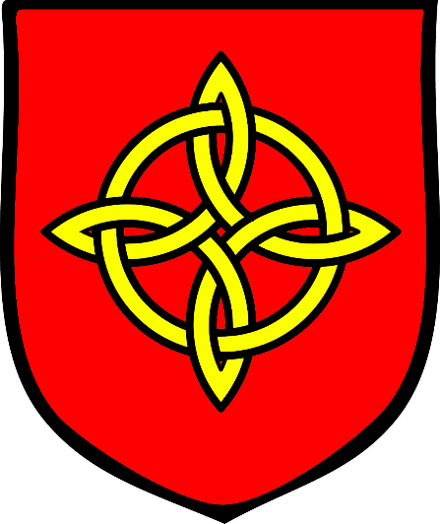**Claeryon**

**Size:** large city, population 25,000, guards / soldiers 250, militia 2250

**Trade Goods:** papyrus, flax, dyes, stone, copper

**Local Goods:**

**Standard:**

**Colors:**

**Patron Deity: Drobaderg** is the ancient Kyrean harvest goddess as well as a goddess of war

**Ruler:** Mawde Corryn (f)

**Home**: Castle Airmid

**Steward**: Peric Gilhast

**Marshal**: Gilmere Kewley

**House Priest:**  Doncan Gilpeder

**House Adviser (Scholar/Mage/etc):**  Nora Crawe (f)

**Captain of the Guard**: Aleyn Caw

**Chief Warriors in Service**:

Donald Mychel

Maurice Auley

Alister Helly

Silvester Curry

**Local Powers:** The Cellar Dwellers (thieves guild), The Gadai Dubh (smuggling ring), Cathedral of Saint Loghlan, Circle of the Laughing Brook (order of druids)

**Local Sites:** The Vexed Vixen (brothel), Song and Scroll Inn & Tavern, The Dappled Doe Inn & Tavern

**Description:**

Claeryon was founded in the fertile valley between the **Airgead River** to the north and the **Broadabey River** to the south. It overlooks the Syren Straits from high atop cliffs dappled in pink quartz. The Mythenian towns of Arxis and Esta across the water are on-again, off-again allies and rivals with Claeryon.

An inscription on the **Cathedral of Saint Loghlan** reads “Under the shelter of each other, people survive.” It has been the motto of the city since it was first founded and speaks to the fighting spirit of her people.

**Industry:**

**Key Figures:**

**Local Lore:**

While the official religion of Kyre is St. Cuthbert, the people still look to the old gods. **Drobaderg** is the patron deity of Claeryon. She is an ancient Kyrean harvest goddess as well as a goddess of war. Her name means "red claw". The people of Claeryon often wear an emblem of a red claw in her honor.

**History:**

When **Lady Niamh** (f) was dispatched here by Lord Donagal with the task of establishing a camp, she was fully expected to fail. Donagal had a dim view on women and only sent her to relieve her father, to whom he owed many debts. But Lady Niamh proved to be savvier than anyone gave her credit for, including her retainers.

The early days of the city were grim. Settlers coming down from Kelenon were met with hostile savages as well as goblins and orcs coming up from the **Aketuun Mountains**. Mythenian war ships were loath to see the land settled by Amadarans and sought to wipe them out. Only a decree from the **Cathedral of St. Cuthbert** in Kelenon saved the early settlement. Paladins from the **Order of the Blessed Well** answered the call and drove back the enemy. In a famous speech from **Sir Dulden** to the town, “We have answered your clarion call. Now build a city for St. Cuthbert that will one day answer the calls of your brethren.” From that came the name of the city, and ever since Claeryon has faithfully supported her fellow Kyrean cities in their times of need.

But no army could help ensure the city’s long-term prospects. Six hundred years ago **Lord Bellen** married **Melete**, a Mythenian noble woman from Arxis (620 WA3). This ushered in a new age of cooperation between Claeryon and her rivals across the waters.

**Customs:**

**History of Kyre**

**Kings and Queens of Kyre**

661 AA4 – 814 AA4 - rule of House Dolan

**First Primordial Age (PA1)**

Dawn of the Morden peoples

350 PA1 - Morana, first Queen of the Fae, takes up residence in the Vale of Hileia in Gaeadon

**Second Primordial Age (PA2)**

**Third Primordial Age (PA3)**

**Fourth primordial Age (PA4)**

250 PA4 - Arxis and Estarra subjugate the Mordens in the Bay of Morda (present-day Barter Bay)

872-888 PA4 - The Wizard War: Telemechus triggers a world-wide war of mages, some of whom march on Ongolk to stop him and some who join him in attacking the ley lines in their lands; epic battles wage all over the world, destroying cities and upsetting the balance of magic

888 PA4 - The Battle of Forlorn: Telemechus is slain but not before rupturing the magical ley lines permeating Nemmyrl; the victorious general Dragan of Celedon seizes the opportunity to rid the world of magic and ruptures the Singularion as it is embedded in the ley lines; the resulting explosion sends a shock wave that ruptures the magical ley lines around the world and triggers the Dead Century

**First Ancient Age (AA1)**

**Second Ancient Age (AA2)**

**Third Ancient Age (AA3)**

**Fourth Ancient Age (AA4)**

190 AA4 - Lord Donagal of Treviland leads the first expedition to the coast of northwestern Gaeadon, promising a new land for dispossessed Trevilish farmers and merchants

210 AA4 - City of Brannon is founded in Kyre, begins as a simple fortified camp

230 AA4 - City of Nuada is founded in Kyre, begins as a simple fortified camp

240 AA4 - City of Kelenon is founded in Kyre, begins as a simple fortified camp

250 AA4 - City of Claeryon is founded in Kyre, begins as a simple fortified camp

812 AA4 - War of the Maddened Moon - the evil druid Vromorn manifests the Amber Portal, a device that generates amber-hued clouds that cover the land and transmute the moon's light into a ray of madness

812-815 AA4 - the lands of Adhanar and Kyre are plagued with insanity as lycanthropes massacre hundreds

816 AA4 - after four years of fighting the dark forces plaguing the land, the Moon Elves track down Vromorn and consecrate the clouds, destroying the Amber Portal

**First Written Age (WA1)**

120 WA1 - Celedonian Primus navy invades Gaeadon, routed at Adhanar, moves north into Kyre, Primus deploys the Echion Legion which sacks Claeryon and Kelenon; Echion forms a garrison at Kelenon

990 WA1 - Kelenon falls as local tribes drive the Echion Legion out of Gaeadon

**Second Written Age (WA2)**

270 WA2 - Battle of Bacach: King Goire of Kelenon leads Kyrean forces against the goblins from the banshee hills; the King is unseated when his horse falls victim to the goblins' caltrop barrage; neither side prevails but the haughty king walks with a limp thereafter.

**Third Written Age (WA3)**

620 WA3 - Lord Bellen of Claeryon marries Melete, a Mythenian noble woman from Arxis; this ushers in a new age of cooperation between Claeryon and her rivals across the waters

**Fourth Written Age (WA4)**

190 WA4 - Baingol Orcs threaten the Elves of Crescent Wood; rangers of the Virgin Vale out of Kelenon come to the aide of the Elves

200 WA4 - Elves of Cascadrel reward the people of Kelenon with the Elatha Grange

**Local Goods of Kyre**

**Cereals:** wheat, spelt (wheat), barley, oats, rye

**Fiber:** cotton, hemp, flax

**Fruits:** blackcurrant, damsons, juniper berry, pear, raspberry, bilberry

**Meat and poultry:** beef, pork, boar, chicken, lamb, mutton, duck, geese, pheasant, quail, venison, veal, rabbit, goat

**Nuts:** chestnuts, hazelnut

**Vegetables:** angelica, cabbage, parsnips, radish, rapeseed, turnip, potatoes, carrots

**Herbs:** caraway, dill, hops, tarragon, thyme, oregano, wormwood, ramson, borage, celery, chives, gale, horseradish, juniper, mugwort, southernwood, water cress

**Oils:**

**Fermented Drink:** beer (ale, lager, malt, stout) with the following types: amber, blonde, brown, cream, dark, pale, strong, wheat, red, pilsner, golden, fruit, honey, and merchant; wines red and white

**Salt-water fish:** herring, cod, oysters, mussels and scallops

**Fresh-water fish:** pike, carp, bream, perch, lamprey, and trout

**Wood:** willow, alder, ash, beech, birch, chestnut, fir, hornbeam, larch, oak, pine, poplar, spruce, walnut, sycamore

**Textiles:**

**Dishes:**

**All** sop (pieces of bread served with broth, soup or wine, salt water)

**Notes on Culture**

**Clothing and attire**

People in the western kingdoms tend to wear woolen clothing with undergarments made of linen. Men tend to wear woolen tunics with hose, leggings and/or breeches. Men of station wear doublets, a close-fitted padded garment with long sleeves. Sometimes they wear jerkins, a tight-fitted sleeveless jacket, over the doublet. Women wear long gowns with sleeveless tunics and wimples to cover their hair. Sheepskin cloaks and woolen hats and mittens are worn in winter. Women of station wear flowing gowns and elaborate headwear, ranging from headdresses shaped like hearts or butterflies to tall steeple caps and Italian turbans.

Peasants wear simple hide shoes or footwear made of cloth bound by leather straps. Commoners wear leather boots of varying heights, sometimes with straps and buckles. The wealthy may wear boots of great quality and decoration. Dyes are common, so even peasants wear colorful clothing. Fabrics of the brightest and richest colors are found on nobility and the very rich. Brighter colors, better materials, and a longer jacket length are usually signs of greater wealth.

Clothing of the aristocracy and wealthy merchants tend to be elaborate and change according to the dictates of fashion. Some materials are sable, velvet, cloth of gold, or silk. Garments are often lined with fur or garnished with silver or gold thread.

**Military Clothing, Weapons, and Armor**

**Clothing:** The typical soldier of the west, high-born or low, is attired in a mid-length tunic, breeches, belt, and leather boots or shoes. Knights and well-funded soldiers may wear a higher quality cloth, some even silk, decorated in threadwork and high boots of rich leather and shiny buckles.

**Armor:** Common foot soldiers and archers wear a gambeson (also aketon, padded jack, pourpoint, or arming doublet), which is a padded, quilted defensive jacket constructed of linen or wool. Professional soldiers and knights wear medium to heavy armor over this jacket. Foot soldiers carry kite shields or, in some cases, tower shields. Cavalry carry light shields.

**Weapons:** Conscripts carry only a spear and perhaps a short sword or dagger. Militia and professional soldiers carry long swords, battle axes, heavy maces, or some form of polearm. Mounted soldiers carry a heavy lance as well as a longword, light mace, flail, or battle axe.

**Base Stats:** (Infantry) Splint Mail +6 AC, Heavy Steel Shield +2 AC, Longsword 1d8 / 19-20, Spear 1d8 / x3, Mace, light 1d6 / x2; (Archer) Scale Mail +4, Long Bow 1d8; (Conscript) Leather +2, Spear 1d8 / x3, Short Sword 1d6 / 19-20, Light Wooden Shield +1; (Cavalry) heavy or medium armor, long sword 1d8 / x2, lance 1d8 / x3, heavy metal shield +2 AC, Long Sword 1d8 / x2

**Markings and Standards:** Western armies prominently display the devices and colors of their local lord or lady on banners, shields, and clothing. Soldiers of the king or queen bear the device and color of the throne. Vassal armies feature a diagonal sash of the kingdom’s color on their shields and banners to show their allegiance. Knights and high-ranking soldiers may wear a tabard, a sleeveless jerkin or loose overgarment, bearing the colors of their lord. Conscripts carry no device on their shields, but may be issued a ribbon of their house or kingdom color to wear on their left arm. In well-funded campaigns, conscripts receive a tabard of coarse cloth.

**Musical Instruments**

The **Bodhrán** is the traditional Kyrean frame drum. The cross braces and laminated rosewood strengthen the shell of this goatskin-covered drum. Bodhrán is struck with a double-headed mallet called a cipín (tipper).

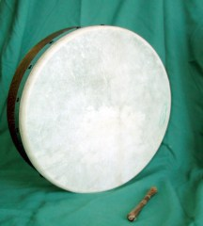

**Keening** is a traditional form of vocal lament for the dead. It is a vocal ritual artform, performed at the wake or graveside in mourning of the dead. Keens are said to have contained raw unearthly emotion, spontaneous word, repeated motifs, crying and elements of song.

**Local Deities**

Macha, goddess of war, horses and sovereignty. Patron deity of Brannon.

Áine, goddess of love, summer, and wealth. Patron deity of Kelenon.

Manannán mac Lir, god of the seas. Patron deity of Nuada.

Drobaderg, harvest goddess as well as a goddess of war. Patron deity of Claeryon.

**Tuatha Dé** – tribe of supernatural humans from the dawn of time. The Tuath Dé are often depicted as kings, queens, druids, bards, warriors, heroes, healers and craftsmen who have supernatural powers. They are associated with the sídhe: prominent ancient burial mounds, which are entrances to Otherworld realms.

Prominent members of the Tuath Dé include:

* **The Dagda** ("the great god") - the Dagda is portrayed as a father-figure, king, and druid. He is associated with fertility, agriculture, manliness and strength, as well as magic, druidry and wisdom. He can control life and death, the weather and crops, as well as time and the seasons. He is often described as a large bearded man or giant wearing a hooded cloak. He owns a magic staff, club, or mace (the lorg mór or lorg anfaid), of dual nature: it kills with one end and brings to life with the other. He also owns a cauldron (the coire ansic) which never runs empty, and a magic harp (uaithne) which can control men's emotions and change the seasons. The Dagda is said to be husband or lover of the Morrígan and Boann. His children include Aengus, Brigit, Bodb Derg, Cermait, Aed, and Midir.
* **The Morrígan** ("the great queen" or "phantom queen") - The Morrígan is mainly associated with war and fate, especially with foretelling doom, death, or victory in battle. In this role she often appears as a crow, the badb. She incites warriors to battle and can help bring about victory over their enemies. The Morrígan encourages warriors to do brave deeds, strikes fear into their enemies, and is portrayed washing the bloodstained clothes of those fated to die.
* **Lugh** - Lugh is portrayed as a warrior, a king, a master craftsman and a savior. He is associated with skill and mastery in multiple disciplines, including the arts. Lugh also has associations with oaths, truth and the law, and therefore with rightful kingship. Lugh is linked with the harvest festival of Lughnasadh, which bears his name. His most common epithets are Lámfada ("long hand" or "long arm", possibly for his skill with a spear or his ability as a ruler) and Samildánach ("equally skilled in many arts"). Lugh has several magical possessions. He wields an unstoppable fiery spear, a sling stone, and owns a hound named Failinis.
* **Nuada** – had the nickname "silver hand/arm"; was the first king of the Tuatha Dé Danann. He is also called Nechtan, Nuadu Necht and Elcmar, and is the husband of Boann. He is mostly known from the tale in which he loses his arm or hand in battle, and thus his kingship, but regains it after being magically healed by Dian Cécht who builds him a silver arm.
* **Aengus** – young god son of Dagda, associated with youth, love, summer and poetic inspiration; also known as Macan Óc ("the young boy" or "young son")
* **Brigid** – goddess daughter of Dagda, associated with wisdom, poetry, healing, protection, blacksmithing and domesticated animals.
* **Manannán** - a warrior and king of the Otherworld in Irish mythology who is associated with the sea and often interpreted as a sea god; also known as Manannán mac Lir (“son of the sea”). During the sunset of the Tuatha he used the mist of invisibility (féth fíada) to cloak the whereabouts of his home as well as the sidh dwellings of the others. He is said to own a self-navigating boat named Sguaba Tuinne ("Wave-sweeper"), a horse Aonbharr which can course over water as well as land, and a deadly strength-sapping sword named Fragarach, though the list does not end there. He is seen as the ruler and guardian of the Otherworld, also referred to as the Plain of Delights or Land of Promise
* **Dian Cécht the Healer** – god of healing; Dian Cécht ministered to the injured by soaking them in "Slainge's Well" (Old Irish: Tiprait Slainge) or rather the "well of healing" (Tipra Sláíne). The well was located at Achad Abla ('Field of the Apple Tree'), northwest of Magh Tuireadh (Moytura). He also ground medicinal herbs nearby on Lusmag "Herb-plain", or else, he chanted spells over the well together with his two sons Miach and Octriuil and daughter Airmed.
* **Goibniu the Smith** - one of the Trí Dé Dána ("three gods of craft"). He was the metalsmith of the Tuatha Dé Danann. He is believed to have been a smithing god and is also associated with hospitality. His name is related to the Welsh Gofannon and the Gaulish Gobannus.
* **Nechtan** – god of the underworld, he inhabited the otherworldly **Síd Nechtain**
* **Airmid** – daughter of **Dian Cécht the Healer**, sister to Miach; she mourned over her brother's grave after being killed by their father. As her tears fell, all the healing herbs of the world grew from the grave. Airmid arranged and catalogued the herbs, but then Dian Cécht again reacted with anger and jealousy and scattered the herbs, destroying his daughter's work as well as his son's. For this reason, it is said that no human now knows the healing properties of all the herbs.

Tethra of the Fomorians ruled Mag Mell after dying in the Second Battle of Mag Tuiredh.[1] After the battle, his sword, Orna, was taken by Ogma and it then recounted everything it had done

**The Old Gods of the West**

While the kingdoms of the west have turned away from the old gods, the people of Kyre carried them with them when they settled these lands long ago. These are the gods of the druids and rangers. These are the powers of nature that the common folk still call upon in their darkest hour. In lonesome monasteries hidden along the countryside the disciples of these old gods pray to harness the powers of the wind and earth, stars and moon. Their wandering prophets are called the **Faidh** and they speak riddles and the dooms of men. The old gods are the same among all Western Amadar, having hailed from the Primordial Ages when the western tribes were as one.

* **Aermid** – goddess of healing and herbalism
* **Áine and Grian** - goddesses of the summer sun and winter sun
* **Ankou** – god of the dead and the underworld, appears as a skeleton wearing a black robe and a large hat which conceals his face, or, on occasion, simply as a shadow. He wields a scythe and sits atop a cart for collecting the dead. Sometimes he drives a black coach drawn by four black horses accompanied by two ghostly figures on foot. He protects grave yards and, as the saying goes, “When the Ankou comes, he will not go away empty.” Anytime a wagon wheel squeaks or the cry of an owl is heard, it is said to be the squeaking of Ankou’s cart. The owl is referred to by some as the “Death Bird” for this reason.
* **Anotemen** – goddess of the sacred grove
* **Artaius** – protector god of sheep and cattle herders, takes the form of a bear
* **Asteron** – goddess of the dawn, beginnings, and resurrection, patron deity of Windenfre
* **Baduhenna** - matron goddess of war, patron deity of Hansla
* **Belisama** – goddess of crafts and the forge, of fire and of light
* **Branwen** – goddess of love and beauty
* **Brighid** - goddess of healing, poetry and smithcraft
* **Bussumarus** - weather deity who controlled the rain, wind, hail and fog
* **Cathubodua** – goddess of war
* **Grannus** – god of thermal springs, healing
* **Hillon** – god of sun and music
* **Matona** - river goddess
* **Nehalennia** - protector goddess of ships and sea trade, patron deity of Dammerung
* **Noctiluca** – goddess of magic
* **Niskus** – god of the sea
* **Ogma** – god of eloquence and poetry
* **Rosmerta** – goddess of fertility and abundance
* **Rhiannon** – goddess of fertility, the moon, night, and death; her name means “night queen”; she is strong minded, intelligent, politically strategic, and famed for her wealth and generosity
* **Sirona** – star goddess
* **Sucellos** – god of agriculture and wine; carried a large mallet and a barrel
* **Taranis** - god of thunder who carries a hammer and a wheel, patron deity of Hammer Hold
* **Weylund** - weird and malicious blacksmith god, patron deity of Wolfenfels

* Underlined indicates a monastery dedicated to this god or goddess

**Creatures**

**Dearg-Due**

Dearg-Due was once a beautiful maiden who fell in love with a peasant boy, but whose father forced her into an arranged marriage with a clan chieftain. Her husband locked her in a tower and was keen to run his dagger across her skin, slowly bleeding her. Forlorn, the lass starved herself to death. After the funeral, she rose up from the grave a vampire and killed her husband and her family out of revenge. She is known to sing a haunting song on the moors, mesmerizing men to their doom.

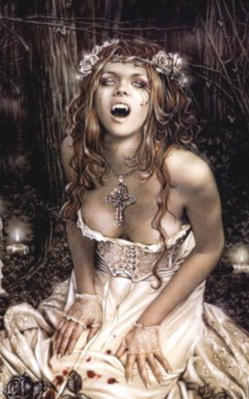 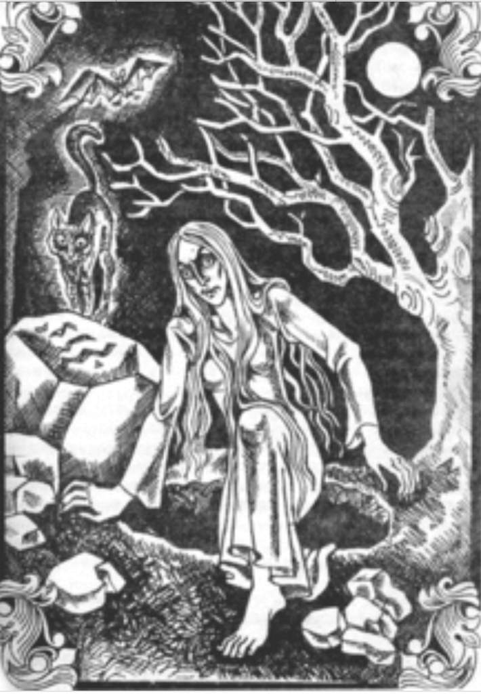

Leprechaun

Fairy - fairies are divided into two groups: **Seelie fairies** and **Unseelie fairies**. Seelie fairies have a friendly demeanor and are helpful to humans. Unseelie fairies are evil and tend to terrorize humans. Most fairies are said to live in naturally beautiful locations that haven’t been built on by humans, such as forests and meadows. They have magical powers and use these for good and mischief.

**Abhartach** – vampire that comes from an evil tyrant who had been killed and buried upside down after he had been terrorizing his people. He brought himself back to life with his magical powers to seek revenge and drink the blood of his victims. The only way to stop the Abhartach is to repeat what had been done to him before: kill him and bury him upside down.

**Far Darrig** - Many consider the Far Darrig to be the leprechaun’s evil twin since it is similar in appearance. Instead of green, it wears a red cape and a red hat, which is how it gets its name, which translates to ‘red man’. Far Darrigs are evil tricksters who take pleasure in terrorizing people. They carry a sack, which they use to kidnap people. If you want to escape the traps that Far Darrigs leave out for humans, you have to declare “you will not mock me”. They are known by their long snouts and skinny tails.

Joint-Eater

Leanan Sidhe – a creature of the fae who appears as a beautiful woman, most often around barrows. They often take a human lover, but lovers of the leannán sídhe are said to live brief, though highly inspired, lives.

Abcán

**Cailleach** - a hag said to date to the creation of the world. Often referred to as the Queen of Winter, she possesses an immense ability to influence the weather. Her appearance was often depicted as frightening, with features such as blue skin and one eye.

Villagers often regard long-abandoned turf-roofed huts in the countryside as shrines to Cailleach. Each year, on the last full moon before winter, the custom is to take a stone representing the goddess out of the shrine. The stone is returned to the hut the first full moon of spring. Some Kyrean households carve the Cailleach's face, or a close representation, into a wooden log before tossing it into the fire to signal new beginnings and say goodbye to any dark troubles from the past.

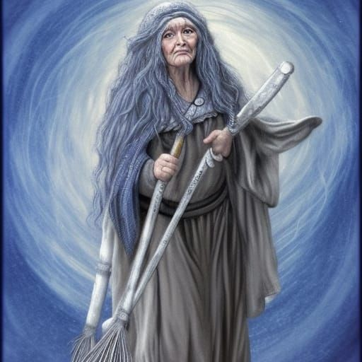 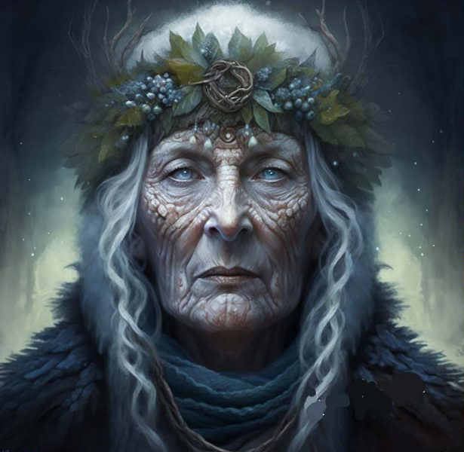

Banshee - female spirit who heralds the death of a family member, usually by screaming, wailing, shrieking, or keening. Her name is connected to the enchanted tumuli or "mounds" that dot the Kyrean countryside, which are known as síde (singular síd). Sometimes she has long streaming hair, which she may be seen combing, with some legends specifying she can only keen while combing her hair. She wears a grey cloak over a green dress, and her eyes are red from continual weeping. She may be dressed in white with red hair and a ghastly complexion

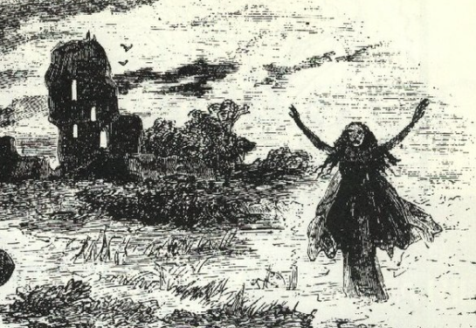

Púca - The Pooka is an evil shape-shifting fairy who wreaks havoc on people at night. Pookas will take on the form of a horse to stampede people’s property and destroy buildings. They also tend to steal crops, which is why some farmers would allocate a section of their crops to the Pooka as a way of appeasing it. When feeling evil, pookas can take the form of a human-like goblin. They will call out the name of their victims outside a house and wait for them to emerge. If they do come out, the pooka will kidnap them. If they don’t, the pooka will destroy their property outside. According to the legends, the pooka can be good or evil depending on their mood and is usually a trickster that can transform its appearance.

Dullahan - a faerie that takes the form of a headless rider on a black horse. According to legend, it uses the spine of a human as a whip. The Dullahan can also foreshadow deaths. If he calls out your name, you will immediately drop dead.

Kelpie - Kelpies are evil water spirits that live in rivers and lakes. They usually appear as horse-like creatures and they try to entice children into the water. Once their victim is on their back, they swim underwater, taking their victim with them.

Fomorians

Werewolves of Ossory - They are a tribe of man-wolves, who were regularly called upon for help by old Kyrean kings to help in battle. They’re said to be ancient descendants of Kyrean royalty.

Amadan Dubh –

Changeling – A changeling is a creature that replaces human babies to terrorize parents. They’re thought to be deformed fairy babies that are swapped with a human baby by their fairy parents. This is because fairies are known for being obsessed with beauty, so they will steal a human baby in order to have a beautiful child. Changelings thrive on bringing destruction to their human parents and feed off good fortune.

Balor –

Fear Gorta – zombie-like creatures that are corpses who have risen from the dead. They have protruding bones and rotten blue skin. Fear Gortas are usually seen in times of famine. They walk the streets asking those who they encounter for food. If you give the creature food, you’ll be blessed with prosperity and fortune. If you don’t, you’ll be cursed with poverty and misfortune. The moral of the legend of Fear Gortas is to share what you have and look after each other.

Aos Sí –

Clurichaun

Clíodhna

Aibell – guardian spirit; played a magic harp. It is believed that whoever listened to her play would die rather sooner than later.

Oilliphéist

Bánánach - are a supernatural race that are rumored to haunt battlefields. These airborne shrieking demons sometimes have a goat-like appearance and are associated with violence and death.

Sluaghs - restless spirits that are said to be neither welcome in hell or heaven, so they are left to roam the lands. According to legend, the Sluaghs were angry about their fate and would snatch the soul of anyone with who they cross paths.

Ellén Trechend – three-headed dragons / vultures

Merrow – friendly mermaids native to Kyrean lakes and rivers; half fish (from the waist down) and half beautiful woman (from the waist up) and, according to legend, is friendly and modest.

Clurichaun takes on the appearance of an old man that’s too fond of alcohol and that likes to play tricks on people…

Selkie -

**Other Races**

**Elves**

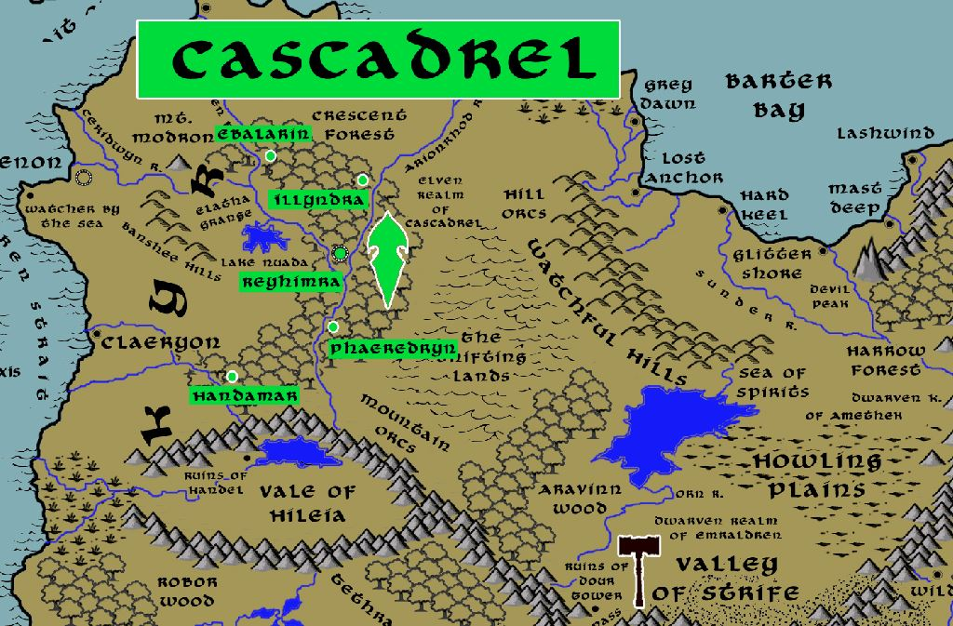

**Dwarves**

**Magical Items**

**The Lorg Mór** – Dagda’s magic mace of dual nature: it kills with one end and brings to life with the other.

**The Coire Ansic** – Dagda’s cauldron which never runs empty

**Uaithne** – Dagda’s magic harp which can control men's emotions and change the seasons.

**Cloak of Airmid** – Airmid was one of the Tuatha Dé Danann, a race of supernatural humans with great powers. She possessed the power of healing and knew the secrets of healing herbs. One who wears the Cloak of Airmid can use it once per day to locate herbs within their vicinity as well as possess the knowledge to distill them into healing potions.

**Flute of Amergin** – Amergin was a bard/druid from the early times of Kyre. Any who play on Amergin’s flute can either cause plants to grow at a tremendous rate once per day or entrance an entire audience of any creatures who listen once per day. Using the flute will cause the musician using it to develop a scaly bark-like exterior to their skin. This does not convey any protection until the bark covers the entire body, which normally happens after one hundred uses of the flute.

The Tuatha Dé Danann brought four magical treasures with them to Kyre, one apiece for the four cities:

* Dagda's Cauldron
* The Spear of Lugh
* Lia Fáil (The Stone of Fal)
* Claíomh Solais (The Sword of Light)

**Sguaba Tuinne "Wave-sweeper"** – the self-navigating boat owned by the god Manannán of the Tuatha

**Aonbharr** - a horse which can course over water as well as land; owned by the god Manannán of the Tuatha

**Fragarach** - a deadly strength-sapping sword named Fragarach; owned by the god Manannán of the Tuatha

**Féth Fíada** – a mist of invisibility used by the god Manannán of the Tuatha to cloak the whereabouts of his home as well as the sidh dwellings of the others

**Tipra Sláíne "Well of Healing"** – magical well of Dian Cécht, god of healing, who ministered to the injured by soaking them in "Slainge's Well" while chanting spells over it

**Well of Segais aka Nechtan's Well** – Nechtan's well of wisdom is situated under nine hazel trees, the nuts of which impart wisdom. In that well swims the Salmon of Wisdom. Only Nechtan or his three cupbearers can visit the well and only Nechtan can draw water from the well, otherwise it will overflow and create a flood great enough to form new rivers. It is believed the waters of the well can cleanse one of any wrongdoing. But the well drown the person drawing water from it if it judges them unfit for redemption.

Terriblis – In 652 AA4 Reece Dolan was gifted the sword Terriblis by the Queen of the Fae and advised to tame the hordes of men creating chaos in the lands of present-day Kyre. He did so, earning him a crown as the first king of Kyre. Terriblis lived up to its name, inflicting grievous wounds on its enemies and casting a pall of fear in its wake. It now resides in Kelenon as the ancestral sword of the throne.

**NPC Templates**

This is a list of notes and stats to help develop NPC’s relevant to this region.

**Developer Notes**

This is a list of notes on the development of this document, including notes on history, culture, and changes to the document.

(may be applicable to all western kingdoms, with some variations based on culture)

(may want to collect here and copy over to other atlases)

Men and women wore a simple shift, or long shirt, over which they layered outer garments. It is often called a saffron shirt, for the plant used to dye it. Some rulers forbid the dyeing of shifts and enforce a sumptuary tax for this.

Women sometimes wore a kirtle or gown, which they called the guna, over the shift. This buttoned or laced up the front and has embroidery along the edges and hem and is sometimes lined with a different color fabric. Gold embroidery and anything of Irish design was outlawed by English sumptuary laws.

An outer gown women wore was the còta-mòr, or great coat. These had long sleeves and the cuffs were elongated and hung to the ground. A common fashion was to tuck the gowns into their waistband to display the colorful lining underneath. This was also banned by certain laws.

Women were to cover their hair if married but unmarried women could go with their heads uncovered.

A houppelande or houpelande is an outer garment, with a long, full body and flaring sleeves, that was worn by both men and women in Europe in the late Middle Ages. Sometimes the houppelande was lined with fur.