Notes on the Lands of Celedon

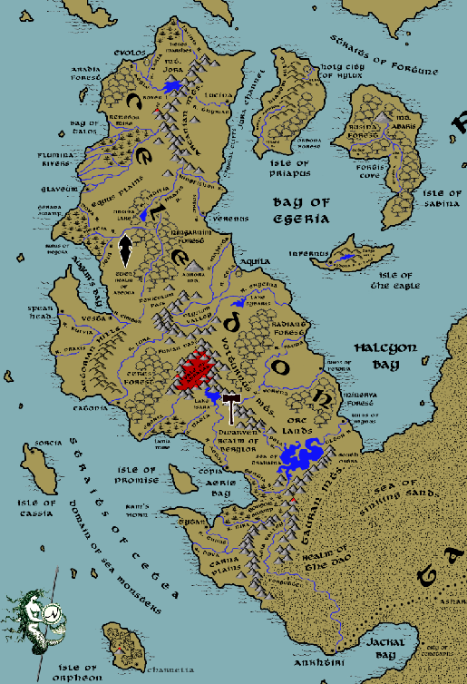

**Table of Contents**

* **Overview**
* **Towns and Cities**
* **Best in the Land**
* **Stewards of Power in this Land**
* **Points of Interest**
* **History**
* **Local Goods**
* **Notes on Culture**
* **Local Deities**
* **Creatures**
* **Other Races**
* **Magical Items**
* **NPC Templates**
* **Developer Notes**

**Overview**

Great were the deeds of the Celedonians in their time. Vast empires fell before them, entire armies cut down before their might. Where there was darkness, their legions brought order by sword and by chariot. Today their fortresses still stand across half the world, their roads and markers a beacon of civilization from a bygone age. But that was then. The mighty empire fell, and with it her once-proud civilization. Where once stood tall statues and palaces, now are overgrown ruins infested by fell creatures.

The western peninsula of Arnland is a land of coastal cities divided from one another by extensive Orc tribes. While the land is rich, there is constant vigilance against encroaching hordes looking to topple a civilization that once ruled half the world.

The Aurans were the first people here, followed by the Tavians in 450 PA4 after the Battle of Stolen Stones. Four thousand years later the city of Aqulia was taken over by patricians calling themselves Celedonians. It would be the Celedonians who formalized their society with philosophy, culture, and brutal trade tactics that were mirrored in the art of warfare.

The **Olysium Valley** is a fertile, well-protected region served by three rivers emptying into the Bay of Egeria. There the ancient city of **Aquila** formed (80 AA2), and from it the proud Celedon engine of construction and warfare. The Celedon Empire developed roads, aqueducts, and an efficient agriculture. Following its efficiency came an ambition to expand.

Beginning with the **Battle of Arinol** (30 WA1) Celedon armies invaded the Tarbian Desert, rolled over the primitive peoples of Western and Central Amadar, subjugated Mythens, and held most of the Gaeadon continent. To this day there are impressive architectural structes in these lands as reminders of Celedonian occupation.

Today the Celedon homeland is a pale reflection of the empire that spanned half of Nemmerle almost three millennia ago. Civil wars, overstretched supply lines, corruption, and a loss of the ideals of the early times have all taken their toll. What remains is still Celedonian, with the same language and love of arts, civic works, and discipline. But the cities and towns have fractured into their own power bases, always at odds with one another. Orc tribes have sensed the change in power and descended from the mountains, working outward to reclaim the land.

The core of Celedon remains the **Olysium Valley** and **Aquiline Delta**. Rich crops grow in abundance and the state of plenty has allowed rich trade with Darmiddia. This has been funneled to preserving and expanding the stately buildings and statuary around the capital. Aquila maintains a robust force of arms, which it trades with the cities of Celedon. The rest are spent beating back the Orc tribes encroaching from the Arcanian, Volturnus, and Tauran mountain ranges.

Celedon holdings remain strong in and around the remaining cities and towns that hide behind strong walls. Evolos, Lucina, Glaveum, and Verenus to the north are well entrenched, but do not hold firm control of the lands between them. Saszar Drow control the north around the Arcanian Mountains. Celedonian naval strength varies from city to city, but affords the ability to move by water rather than confront the humanoid tribes roaming the interior. This also allows regular support of the Island of Priapus and the Holy City of Hylux, which is the seat of power in the Church of Pelor worldwide.

In the central region, Aquila holds absolute control over the delta and passes to the north of the valley, connecting with Vesta and Augur’s bay to the west and Catonia and the Lora river basin to the south-west. Regular foot patrols through the Periculum Pass maintain these lanes of movement and secure the rivers.

To the far south of the peninsula, the situation is more embattled. The towns of Copia and Tytan hold the north and south of Aerie Bay, but not much else. The **Terog** tribe of orcs coming out of the **Volturnus** mountains have put down roots around the **Lake Aurora** area while the **Fammis** tribe holds the lands around Ceres Forest and the **Sangor** tribe out of the Taurans holds much of the Carnor Plains.

Travel by boat is all that keeps these holdings connected to other settlements. Heavy coin is paid to Aquila for troops being deployed to countermand enemy attacks.

Only the Dwarven domain of Berylor operating out of Volturnus has kept Orc troop strength from growing. Berylor has no formal alliance with Celedon so their fight is purely out of hatred for the Orcs.

Celedon has a long tradition of maintaining ample food resources. In addition to the massive amounts of food they brought back during their world conquest days, there are also advanced farming techniques that have served it well. Their farming techniques are far more efficient than those of other civilizations. During their imperial period their scholars were keen to find and bring back new plants and study them, diversifying their crops. Most crops revolve around the Celedon triangle: wheat, olive oil, and wine. Grain fields and vineyards are cultivated throughout the land.

There are two distinct classes of citizens in Celedon: **Patricians**, which are the noble class, and commoners, which include everyone from artisans to farmers. Cities and towns are ruled by **Magisters** or **Magistras** who handle local affairs. The **High Council** in Aquila handles affairs of the kingdom, such as it is, but it what was a unified body is now a forum where Consuls from the different cities and towns meet and try to work together. It is an uneasy partnership, as each settlement works to build up their power and try to assert more and more control over Celedon.

**Towns and Cities**

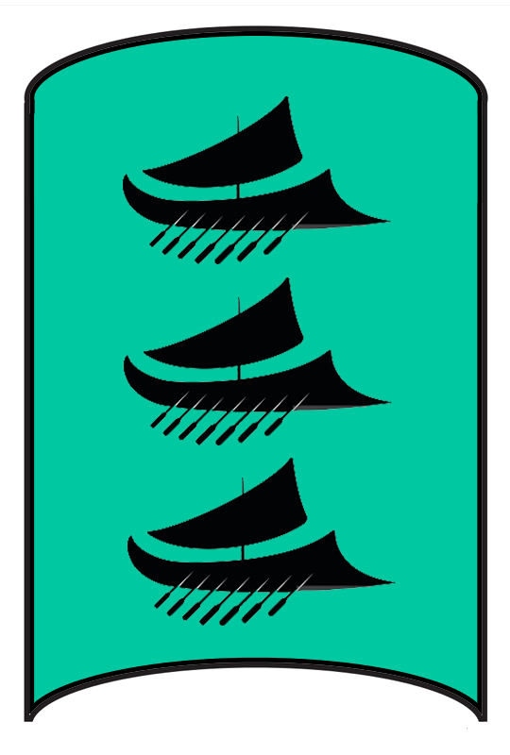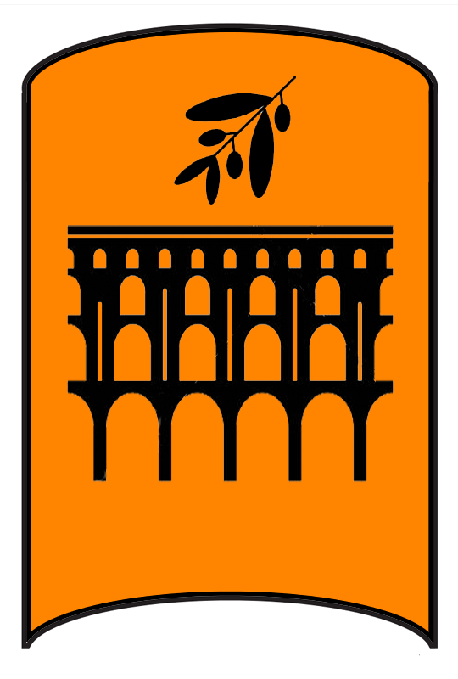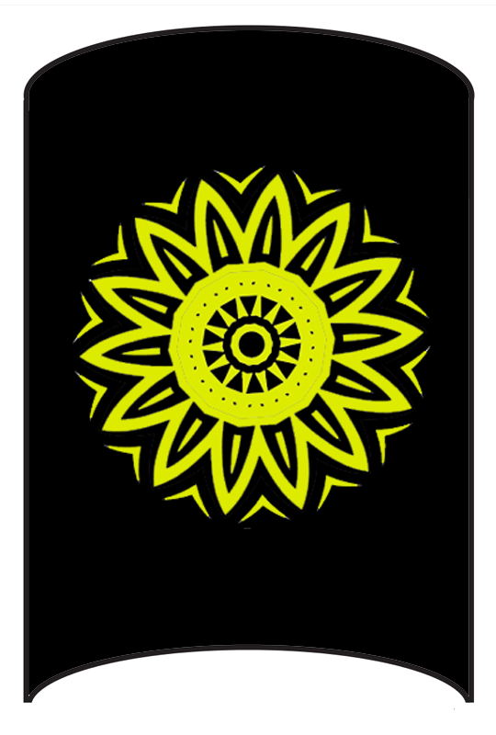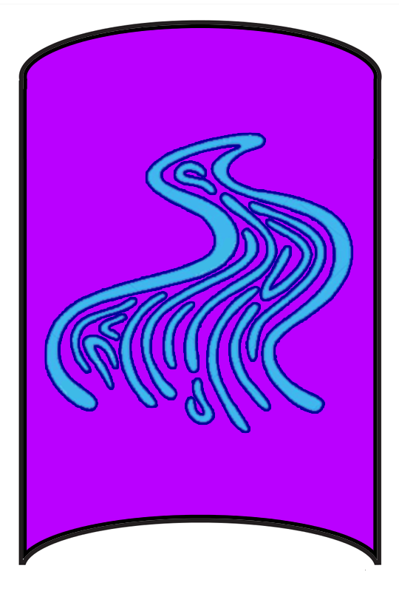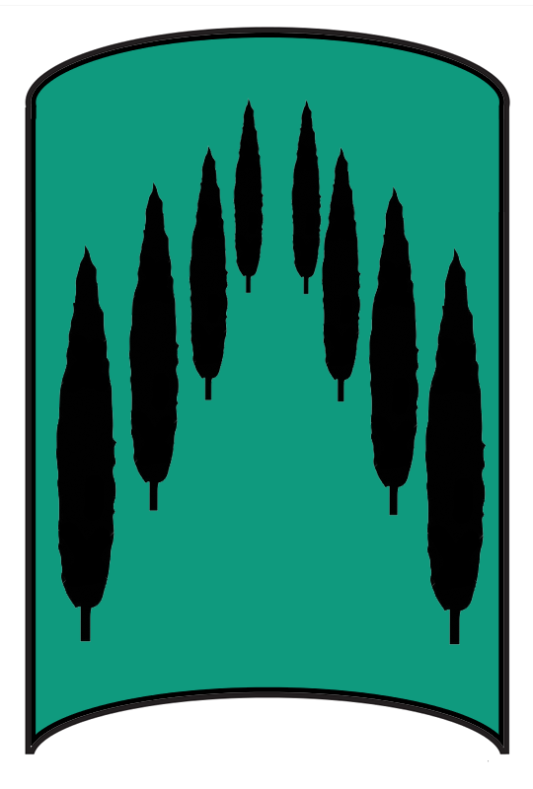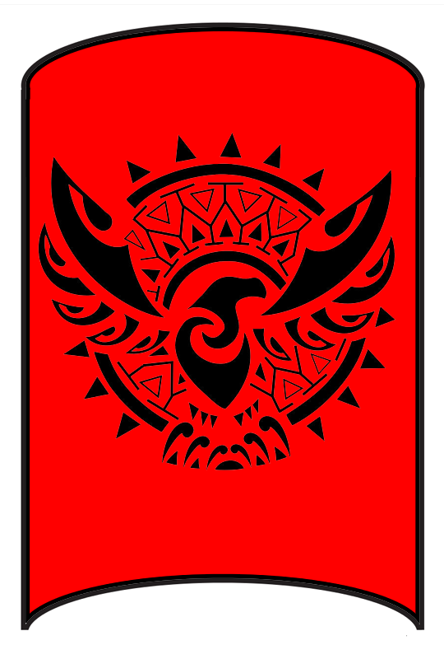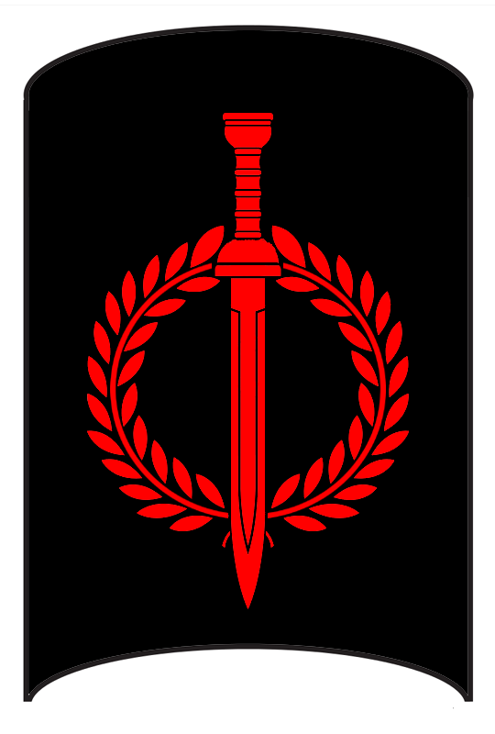

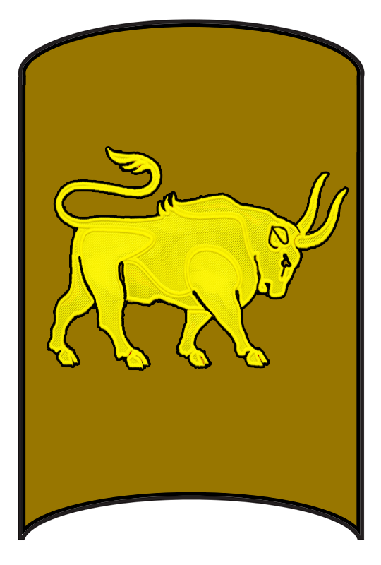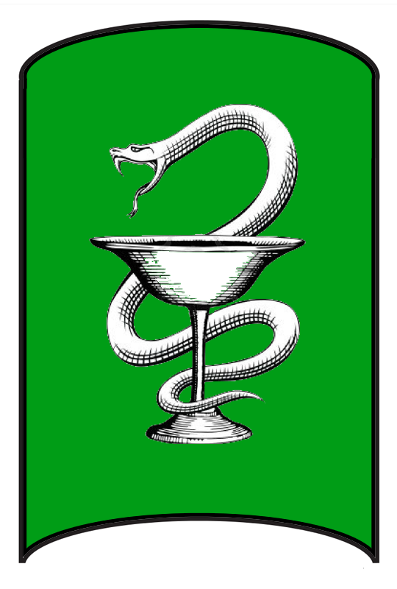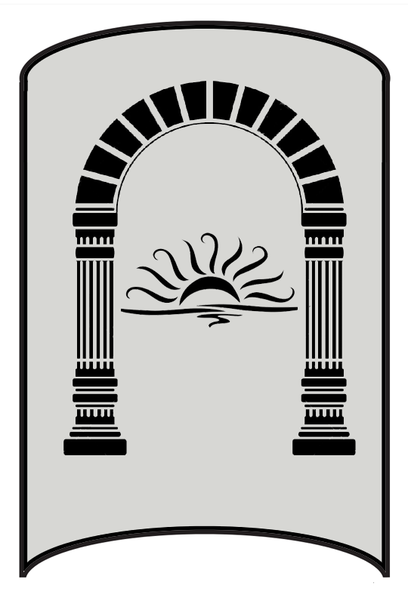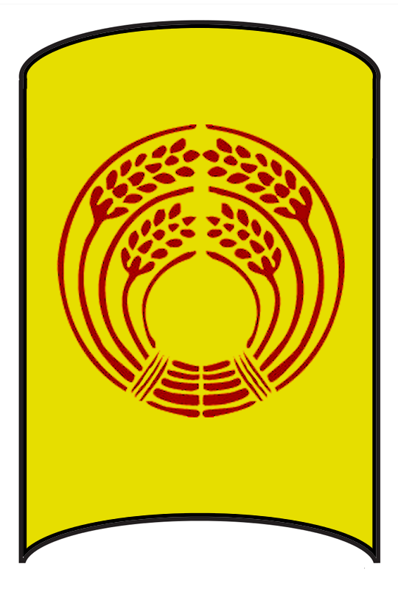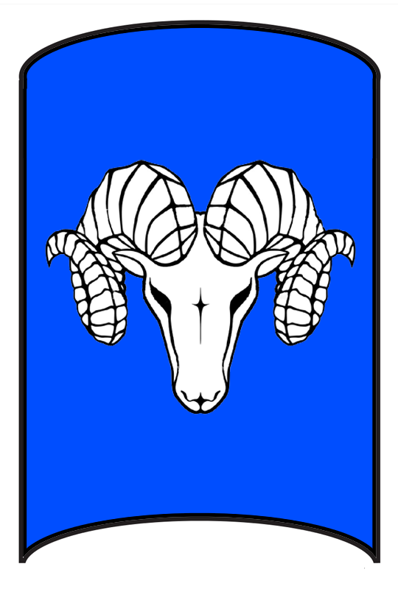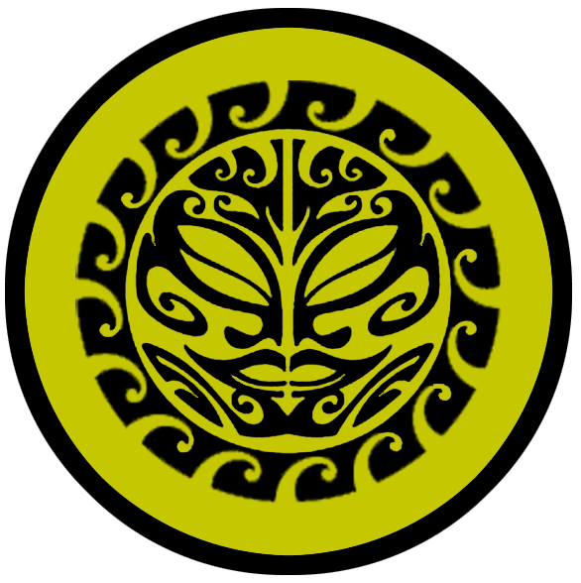

* Evolos – large city, 44th Legion “The Sea Legion”
* Lucina – large city, 99th Legion “The Gold Legion”
* Hylux – small city, 30th Legion “The Light Legion”
* Glaveum – large town, 18th Legion “The River Legion”
* Verenus – large town, 22nd Legion “The Watchful Legion”
* Aquila – metropolis, 1st Legion “The Imperial Legion”
* Infernus – large town
* Spearhead – small town, 50th Legion “The Spear Legion”
* Vesta – small city, 70th Legion “The Silver Legion”
* Catonia – large town, 62nd Legion “The Stone Legion”
* Copia – large town, 12th Legion “The Wolf Legion”
* Tytan – small city, 29th Legion “The Horn Legion”
* Sorcia – small town

**Best in the Land**

Trade Hub:

Religion:

Arts:

Magic:

Spirits:

Steel:

Grain:

Crafted Goods (e.g. Pottery, Textiles, Metal Wares):

Harvested Goods (e.g. Aromatics, Medicine, Dyes):

Mined Goods:

Precious Metals:

Ship Building:

Other:

**Stewards of Power in this Land**

Kings and their armies are not the only wielders of power. There are many unseen friends and foes that shape the destiny of the land. Each of the groups listed below are well known to the people of this region. Some are feared, others venerated. All of them play their part in the grand drama of this land’s story.

**Merchant Companies**

Halocline House Traders – Evolos

Aura Mercatores – Lucina

Traders Delphina – Aquila

Sons of Triton – Catonia

**Mercenary Companies**

The Hyperium Guard – Sorcia, Isle of Cassia

**Smuggling Rings**

Argus Syndicate - Glaveum

Aethon Syndicate - Verenus

**Centers of Worship (Churches, Cathedrals, Shrines, Lodges, Temples)**

High Cathedral of Pelor – Hylux, Isle of Ondironn

Temple of the Ancient Luminance - Aquila

Temple of the War Drum – Infernus, Isle of the Eagle

Temple of the Known Unknown - Copia

Temple of Furina - Tytan

High Temple of Boccob – Sorcia, Isle of Cassia

**Orders of Paladins**

Order of Chiron – Hylux

**Druidic Circles**

Circle of the Hemlock – Catonia

**Bands of Rangers**

Band of the Ivy Leaf – Verenus

**Schools of Magic**

Chimera Sanctum – Aquila

Sanctum of the Infernal Word – Copia

Order of Auxentia – Sorcia, Isle of Cassia

**Bardic Colleges**

Cornua Amphitheater – Lucina

Cithara Amphitheater – Aquila

**Warrior Academies**

44th Legion “The Sea Legion” - Evolos

99th Legion “The Gold Legion” - Lucina

30th Legion “The Light Legion” – Hylux, Isle of Priapus

18th Legion “The River Legion” - Glaveum

22nd Legion “The Watchful Legion” - Verenus

1st Legion “The Imperial Legion” - Aquila

Fortress Infernus – Infernus, Isle of the Eagle

50th Legion “The Spear Legion” - Spear Head

70th Legion “The Silver Legion” - Vesta

62nd Legion “The Stone Legion” - Catonia

12th Legion “The Wolf Legion” - Copia

29th Legion “The Horn Legion” - Tytan

**Assassins Guilds**

The Pisonian – Lucina

**Cults**

(none)

**Other Guilds**

Pendulum House (mason's guild) – Lucina

House of Vitruvius (mason's guild) – Catonia

**Monasteries**

Temple of Luna - Arcanan Mountains

Temple of the Life Spring - Volturnus Mountains, Pass of Furrina

Temple of the Healing Arrow - Tauran Mountains

**Pirates**

Captain Aylmer Holdforth – Isle of Sabina

Captain Hamood el-Ameen – Ruins of Feronia

**Points of Interest**

* **Isle of Priapus** – The Holy City of Hylux is situated on the northern end of the **Isle of Priapus** in the shadow of the **Justitian Hills**. It is the religious seat for many of the ancient gods of Celedon. Pelor is the chief god and has the grandest temple. It was built in 410 AA1.
  + This was once the site of the Cult of Decima in the Fourth Primordial Age. The sorceress Decima was driven from the mainland and reigned terror from her glittering citadel overlooking the Bay of Egeria. She was slain in 84 PA4 but the tombs running underground all over the island still hold dark threats.
* Jura Channel
* Orbona Forest
* Elda River
* Argirion River
* Vikare River
* Diadem Hills
* **Isle of Sabina** – The large island of Sabina has long been coveted by explorers. With its verdant forest, wide rivers, deep cove safe from storms, and its strategic location overlooking the Ferrago Sea it was once home to a great sea power in the Primordial Ages. Today ships steer clear of the island, for it holds dangers to those unbidden. In 866 PA4 Achradina, powerful high priestess, took over the Isle of Sabina and destroyed the Tavian forces sent to colonize it. She fashioned the island into a magical paradise after her own fashion. The land has since been ruled over by high priestesses who are called from their homelands to serve as the island’s protector. Some say women of the utmost piety are called in a dream to board a boat and are transported here. The current ruler of Sabina is a priestess of Pelor named **Arethusa**. Even the holy city of Hylux has acknowledged the island’s autonomy, for it is clear the island is under divine protection outside of the power of the church.
  + **Kourai Khryseai** – the **Golden Maidens** of the Gods dwell here. They are mysterious figures that appear to be human but their bright gold skin and hair mark them as creatures of divine origin. It is said Achradina either created them or summoned them from the celestial plane when she took over the island in the Fourth Primordial Age. The Golden Maidens serve the high priestess that rules over Sabina. Those who invade the island are at first beguiled by the creatures, but soon find they are stronger and more cunning than they seem.
  + **Thalasa** – Sea Elf Domain
* Isle of Coriolis
* Isle of Cantatrix
  + Looming over the isle is the tower of **Polinquia (f) of the Dark Aura**, Arch Mage of the Celedonian lands.
* Fortis Cove
* Rusina Forest
* Ectur River
* Eda River
* Thetis River
* Mt. Abaris
* Isle of the Eagle
* Rodona River
* Rodona Lake
* Durga Hills
* **Straits of Cetea** – the waters between the Arnland mainland and the islands to the west are the domain of a wide array of wrathful sea monsters, collectively named the Cetea.
* Isle of Cassia
* Isostei – Sea Elf Domain
* Isle of Coriolis
* Isle of Cantatrix
* Isle of Promise
* Isle of Orpheon
* Channel of Weal
* Channel of Woe
* Bay of Talos
* Augur's Bay – the great blue dragon **Fulguron** dwells on the peninsula overlooking Augur’s Bay
* Halcyon Bay
* Aerie Bay
* Ram's Horn
* Bay of Egeria
* Aradia Forest
* Ningarnim Forest
* Ceres Forest
  + Here dwell the **Fammis** tribe of orcs, known by their sign of a bull skull.
* Radiant Forest
* Minerva Forest
  + Here dwell the **Morta** tribe of orcs, known by their sign of a figure impaled on a spear.
* Crystal Cliffs
* Equus Plains
  + Here dwell the **Harathar** tribe of orcs, known by their sign of teeth closing on bone.
* Carna Plains
* Lavinia River
* Laria River
* Aegle River
* Thyrian River
* Flumina Rivers (10)
* Kingfisher River
* Indivia River
* Praxis River
* Orius River
* Dova River
* Hestia River
* Jeul River
* Majesta River
* Cela River
* Erycina River
* Cimber River
* Fulvia River
* Lora River
* Fauna River
* Vorena River
* Egeria River
* River Naela
* Aetos River
* Pela River
* Ultor River
* Sentia River
* Nira River
* Eurus River
* Dova River
* Lake Roven
* Ursina Lake
* Lake Sybaris
* Isara Lake
* **Sea of Drakaina** – A vast body of water formed at the northern base of the Tauran Mountains, branching off into rivers that cross the Arnland continent and connect two oceans. Some reaches of the sea are fair, with clear waters and banks aflush with reeds and tiny fay creatures. The waters closest to the mountains grow darker, with strange creatures lurking beneath a green mist that hovers over the surface. One such creature is Echidne, named the Mother of Monsters. A terrible half-woman, half-serpent creature, Echidne lurks in her underwater caves full of wrath against the living. She appears at times a beautiful woman, seducing men from whom she bears horrible monsters that haunt the world.
* Keres Bog
* Nemetor Mire
* Gerana Swamp
* Lamia Mire
* Gorgon Swamp
* Juno Mts.
* **Arcanian Mts.** 
  + In the northern range dwell the **Kranag** tribe of orcs, known by their sign of the broken skull. In the south dwell the **Ardrakar** orcs, known by their sign of a burning mountain.
  + Here dwell the tribe of Stone Giants known as the **Calabak**.
  + home to the great gold dragon **Iustinar**
  + Site of the **Temple of Luna**, where monks study and train in the ways of **Sancus**, god of truth
* **Aurora Mt.**
  + Considered a sacred mountain kissed by the rays of the sun. Each dawn the peak emanates a soft haze of light. Travelers to the top retain little memory of what they saw there, but report feeling refreshed physically and spiritually. Some say Aurora, scion of the dawn, visits this place. The mountain has never been occupied by forces good or evil, magical creatures are thought to roam at will in its trees.
* **Volturnus Mts.** – home to the copper dragon **Coderiex**
  + Three tribes of orcs call this mountain range their home: In the north dwell the **Malar**, known by their sign of the burning stalks. In the central range dwell the **Faladrak**, known by their sign of the whip with four tails. In the south dwell the **Terog**, known by their sign of the three running figures with flames below.
  + Site of the **Temple of the Life Spring,** where monks study and train in the ways of **Furrina**, goddess of springs
* **Tauran Mts.**
  + Here dwell the **Sangor** tribe of orcs, known by their sign of the bleeding figure of a fallen man.
  + Site of the **Temple of the Healing Arrow**, where monks study and train in the ways of **Vejovis**, god of healing
  + At the center of the mountains, lingering about the active volcano located in its midst, dwell the Fire Giants known as the **Ignekar**, known by their sign of the volcano erupting a sword.
  + At the very southernmost tip of the Taurans, overlooking the Straits of Cetea, dwell the tribe of Storm Giants known as the **Tempestii**, known by their sign of the black cloud with lines radiating from it as if blocking the sun.
* **Aetorian Hills**
  + Here dwell the **Furnog** tribe of orcs, known by their sign of a trident pointing downward over a hole
  + Here dwell the tribe of Hill Giants called the **Stogga**
* Periculum Pass
* Olysium Valley
* Furian Pass
* **Vale of Abraxas** – At the central portion of the Volturnus Mountains there lie a half dozen active volcanoes. Molten lava oozes from them in a constant stream that collects in the valley floor between them. Noxious clouds darken the sky, casting gloom over this place. It is here that early priests of dark gods called forth demons and devils, some of whom return here. The entire valley is under a curse, controlled by mages of the **Sanctum of the Infernal Word**. Ancient writings can be found on the face of cliffs here, written in a language long forgotten. It is said that wizards trek here to learn the oldest and darkest secrets connected to the earliest written spells. **Abraxas Stones** are magically imbued stones that have had the words written upon them. Each holds a different power and is highly coveted by wizards and sorcerers everywhere in the world. Necromancers have long been attracted to this place, for it affords easier access to the infernal planes. This has left the entire region teeming with the walking undead.
  + The valley was once quite different. At the dawn of time, it was named **Rosara** and was a radiant and fertile place. The **Temple of Volitia** stood at the northern point of the valley, and it was here the gods laid out the bounty of every gift possible for mankind to partake in. Within, on the altar, sat a hundred totems representing everything from food, fertility, rainfall, peace, the arts, and more. There were even totems for wrath, fire, and power. The totems were arranged where they moved in intricate patterns that defy understanding. For centuries, kings of men would enter the Temple each spring and, by invitation from the gods, select a figurine representing the blessings they sought for their people. And for centuries kings were advised to resist temptation to take up the figurines of fortune or conquest. But at the end of the Ancient Ages the Celedons suffered an embarrassing defeat. So, **King Degridus** broke with the counsel of the priests and seized the totem of power. In a fit of madness, he destroyed all other totems. Power became his and he launched the **Celedonian Conquest**. But the curse uttered at the altar invoked the spirit of the **Infernal Word**, so called **Abraxas** by the mages. The valley erupted in flames, which Degridus and ensuing emperors exploited to mine more of the **Avadom** ore that the lava belched from the earth. Over time the valley became defiled and after centuries of neglect spat out a curse that brought the Celedonians to ruin.
  + Here dwell the tribe of Fire Giants known as the **Ferox**, known by their sign of the flame surrouned by a ring of peeks
* **Arbeiera - Elven Kingdom -** The elves of Arbeiera are Hravaeran or Fauna Elves, sometimes called Wild Elves. They have little love for the cruel and ambitious Celedonians, but have little time for their enmity for the land is overrun with greater evils. Arbeiera sees it as their duty to safeguard the land. **Lady Riniya Kelrora** is a firm and demanding ruler. She exacts a demanding regimen of training and vigilance from her subjects. She has no patience for outsiders and is quick to subject strangers to various trials to prove their worth. Lady Kelrora is known far and wide as the **Wind Wanderer**, for her ability to take flight and appear in every corner of her domain seemingly at will. She is a friend of the great eagle **Hyperia** and her kind that dwell on Aurora Mountain and has summoned them to her aide in many battles. Her greatest foe is **Ankiedren Hex** and the Saszar Drow.
  + Devanna - Elven city of Arbeiera
  + Lavellin - Elven town of Arbeiera
  + Arduith - Elven town of Arbeiera
  + Seryniel - Elven town of Arbeiera
* **Berylor - Dwarven Kingdom**
  + Athora - Dwarven city of Berylor
  + Raurak - Dwarven town of Berylor
  + Duriggok - Dwarven town of Berylor
  + Hardhewn - Dwarven town of Berylor
  + Stromnos - Dwarven town of Berylor
  + Skullbeard Keep - Dwarven outpost of Berylor
  + Sowblock Keep - Dwarven outpost of Berylor
  + Ingot Keep - Dwarven outpost of Berylor
  + Wardrum Keep - Dwarven outpost of Berylor
* **Saszar – Drow Domain**
  + The Drow kingdom of Saszar, once the master of the Arcanian Mountains, has returned to its place of dominion. Three hundred years ago the Empress Zecubel summoned the lost Sunder Staff from the Abyss and conquered the mountains and all of northern Celedon (111 WA4). Now the Drow command the Kranag and Ardrakar Orc tribes, deploying them against Evolos and Lucina. The Arbeiera Elves out of Devana in the Ningarnim Forest counter the Saszar as soon as they venture south into the Equus Plains. **Ankiedren Hex** is the ruler of the Saszar. He is ruthless, secretly controlling brigands and Orc forces to do his bidding. His greatest enemy is **Lady Riniya Kelrora,** mistress of Ningarnim and leader of the Arbeiera Wild Elves. He has long sought to pluck her heart and feed it to his giant spiders.
* Orc Lands
* Ruins of Hegora
* Ruins of Feronia
* Ruins of Mynus

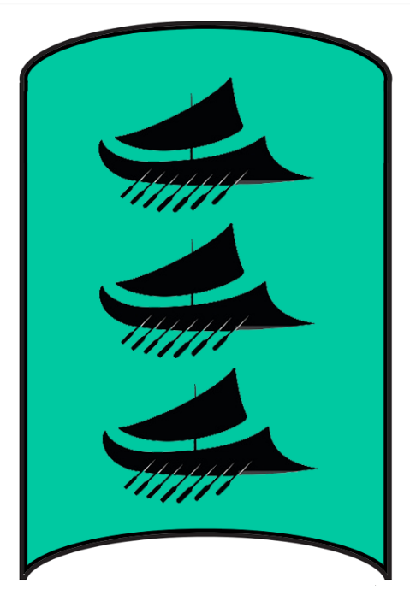**Evolos**

**Size:** large city, population 25,000, guards / soldiers 250, militia 2250

**Trade Goods:** trade hub, ship-building, gems, salt

**Local Goods:** deep-water port, wheat, olive oil, wine, cattle, masterwork art and weaponry, literature

**Standard:** oar-driven galley or longship

**Colors:** sea green and black

**Patron Deity:**

**Ruler:** Magister Appius Paratus

**Home**: Plenavela Palace

**Steward**: Servius Nemetor

**Marshal**: Primus Ulfila

**House Priest:**  Placidus the Bald

**House Adviser (Scholar/Mage/etc):**  Akeron the Collector

**Captain of the Guard**: Orpheo Bitucus

**Chief Warriors in Service**:

Lucius Coruncanius

Julianus Fadius

Stertinia Pustula (f)

**Local Powers:** Halocline House trading company, House of Neptune nautical school, The Slaying Stones (thieves guild), 44th Legion “The Sea Legion”

**Local Sites:** Folly Fate Tavern & Inn, Seven Daughters Inn & Tavern

**Description:**

Nestled in the rich delta between the Aegle and Laria Rivers, Evolos is a city at one with the sea. Celedonian engineers built extensive sea walls and sea breaks to create multiple closed harbors, protected from the open sea by complex locks and gates. Bright white plazas are decorated with pillars and cypress trees with streets leading to the water’s edge. People here wear loose togas and robes, their skins bronzing in the sun where they feel at home. It is a city of hard work but there is an air of celebration to the place as residents enjoy the fruits of Evolos’ success as masters of the sea.

**Industry:**

The finest ships in all of the Arnland continent are crafted here: fast, strong, and maneuverable. The famed nautical school, the **House of Neptune**, graduates top sailors as well as shipwrights. When other cities produce ships, they are always compared to those in Evolos.

A large network of salt mines operates out of the Arcanian Mountains to the east as well as several solar ponds in shallower parts of the surrounding ocean shelf. This is the primary source of salt in Northern Celedon and has made Evolos wealthy. Some say that Celedon only achieved greatness when they conquered the Aurans and learned the importance of salt. The town of **Catonia**, far to the south, is a rival salt exporter but it cannot match the production of Evolos.

The **Halocline**, an ancient trade house, specializes in the production and marketing of salt throughout the known world. They are a mysterious and powerful trade group whose network operates without notice. It is said many tragedies befalling salt mines around the world have been visited by the Halocline.

The Forty-Fourth Legion, dubbed the “Sea Legion,” is garrisoned in Evolos. Its mission is to protect the city and patrol the lands to the south and west to counter tribes that threaten from the Arcanian Mountains and other areas.

**Key Figures:**

Magister Paratus is believed to be a cursed man. Hidden within his palace most of the time, it is said he has a withered arm that was wrought on him for misdeeds against the gods. It is said he is hungry for knowledge of the magical world but is reckless in his endeavors to exploit magic to gain power. Anyone tied to magic who lands here is brought by force to Paratus for questioning. Paratus is in particular interested in finding the magical **Caladrius** bird. Paratus is intent on summoning enough magic to kill a man a thousand times over, but only after he can use the Caladrius to funnel the negative effects to his subjects, leaving him invincible.

Akeron the Collector, the court mage, is an evil man and completely insane. He blindly follows Paratus’ lust for magical power, procuring and experimenting on an untold number of substances, creatures, and artifacts. It is rumored Akeron has an entire collection of statues made of salt which bear an uncanny resemblance to his enemies. Locals call it the Salt Menagerie and tremble at the thought of being added to the collection.

**Local Lore:**

The **Caladrius** is a magical snow-white bird that lives in this region. It is said to be able to take any sickness into itself and then fly away, dispersing the sickness and healing both itself and the sick person.

The Arcanian Mountains are home to a great gold dragon **Iustinar**. It is also the home of the **Saszar** kingdom of Drow, who achieved military domination 300 years ago and now control much of northern Celedon.The Saszar armies harry Evolos and Lucina, attacking from the mountains and laying waste to anyone and anything they come across. Travel overland in the north is perilous without armed escorts.

**History:**

Evolos is an old city from a bygone age. It was here the **Tavians** conquered the original peoples of Celedon: the **Aurans**. Traces of the Tavian civilization still linger here amidst the statuary from Celedon’s high age.

**Customs:**

Evolos was Aquila’s biggest conquest in its expansion and there are lingering ties to older customs. The colors sea green and black can be seen everywhere and hearken to the day when Tavia was its own kingdom and dominated the western seas with its proud sea vessels.

Today Evolos is still primarily a ship-building culture, and life revolves around festivals of the fishing season, the sea, and the fortunes of sailors. A traditional greeting among locals is “salfortis” meaning a person has earned their keep and is in good standing among seaman.

Evolos residents are fond of blessing their homes with salt. They mix it in water, have it blessed by a priest, and spatter the solution over their homes and loved ones.

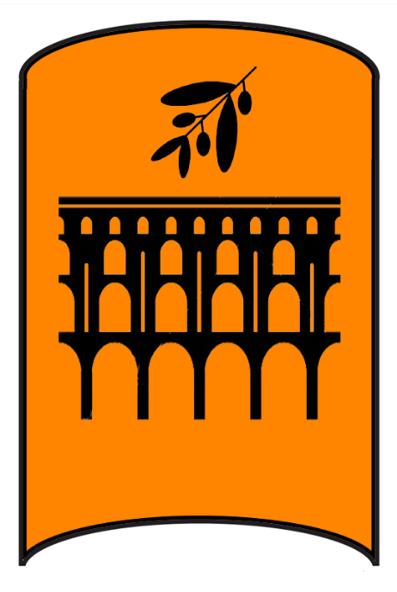**Lucina**

**Size:** large town, population 5,000, guards / soldiers 50, militia 250

**Trade Goods:** trade hub, grain, flax, gold

**Local Goods:** wheat, olive oil, wine, cattle, masterwork art and weaponry, literature, mining

**Standard:** aqueduct with olive branch

**Colors:** orange and black

**Patron Deity:**

**Ruler:** Magistra Septimia Hirra (f)

**Home**: Garden Swan Palace

**Steward**: Cerulo Sertorius

**Marshal**: Caius Libero

**House Priest:**  Decio the Wise

**House Adviser (Scholar/Mage/etc):**  Surian the Serpentine

**Captain of the Guard**: Brukan Galvisius

**Chief Warriors in Service**:

Nonus Titiedius

Servius Axius

Gallio Munius

**Local Powers:** Aura Mercatores Trading Company, Sons of Scorpio (thieves guild), Pendulum House (mason’s guild), The Pisonian (assassin’s guild), 99th Legion “The Gold Legion”, Cornua Amphitheater (bardic college)

**Local Sites:** The Lupinar Inn & Tavern, The Mortaria Inn & Tavern

**Description:**

Lucina sits astride the **Thyrian River**, which runs through the middle of the city. It is a wealthy port city that marshals the resources of hundreds of farmlands to the south.

Lucina, like many settlements in Celedon, is surrounded by high walls and a well-drilled guard, but does not hold firm control of the lands nearby.

**Industry:**

Lucina owns countless mines which produce a steady stream of gold, silver, platinum, and fine jewels. It is also the leading contractor for the building of aqueducts. The master mason house, called the **Pendulum House**, is based here and does work throughout the land on large building projects. Pendulum House is a bitter rival of **House Vitruvius** school of masons in **Catonia**.

The city wears its wealth openly, building massive statues, elaborate gardens, and impressive buildings. The city heavily courts Plenia and Treviland across the northern seas. It is known as “**Lucrative Lucina**” among merchants and money changers.

A great deal of the fortune brought into the **Holy City of Hylux** is invested in Lucina, where the **Holding House** makes a fat profit in land development projects and expedition into the **Arcanian Mountains** to the west.

**Key Figures:**

The Ninety-Ninth Legion, known as the “**Gold Legion**,” is garrisoned in Lucina. Its mission is to protect the city, the Holding House caravans of gold, and to patrol the regions to the west to counter humanoid tribes out of the Arcanian Mountains.

**Local Lore:**

The mighty **Cacus** dwells nearby in the Arcanian Mountains. Cacus is a large hill giant that breathes fire. He and his ancestors have terrorized Lucina and the surrounding countryside for centuries.

The Arcanian Mountains are home to a great gold dragon **Iustinar**. It is also the home of the **Saszar** kingdom of Drow, who achieved military domination 300 years ago and now control much of northern Celedon.The Saszar armies harry Evolos and Lucina, attacking from the mountains and laying waste to anyone and anything they come across. Travel overland in the north is perilous without armed escorts.

**History:**

**Customs:**

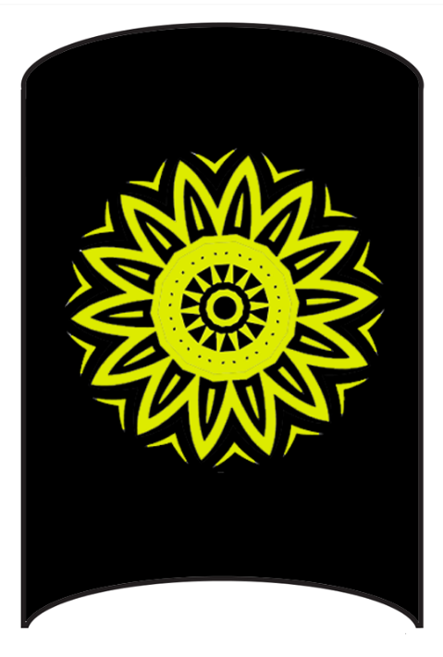**Hylux**

**Size:** small city, population 12,000, guards / soldiers 120, militia 600

**Trade Goods:** incense, wine, platinum, religious capital

**Local Goods:** wheat, olive oil, wine, religious and scholarly center

**Standard:** A sunflower resembling both the sun and a wheel

**Colors:** black and gold

**Patron Deity:**

**Ruler:** High Priestess Galeria Aemiliana

**Home**: The Golden Diadem Palace

**Steward**: Kaeso Priscillian

**Marshal**: Calidium Lucanus

**House Priest:** Vibenius the Just

**House Adviser (Scholar/Mage/etc):**  Proculus the Measurer

**Captain of the Guard**: Aulus Noster

**Chief Warriors in Service**:

Caelus Milonius

Vel Vibius Durio

Insteia Agricola (f)

Kaeso Hosidius

**Local Powers:** High Cathedral of Pelor (seat of power for the Church of Pelor), Order of Chiron (order of paladins), 30th Legion “The Light Legion”

**Local Sites:** The Altar Cup Inn & Tavern, Drosera Vineyards, Centurion’s Rest Inn & Tavern

**Description:**

Hylux is situated on the northern end of the **Isle of Priapus** in the shadow of the **Justitian Hills**. It is the religious seat for many of the ancient gods of Celedon. Pelor is the chief god and has the grandest temple. The entire city boasts the most beautiful religious artwork and temples. Rituals are held daily from one religion or the other. Hylux receives pilgrimages from around the world. Decisions are made for churches thousands of miles away, blessings are bestowed on dynastic houses, crusades are launched, paladins are anointed, and missionaries are dispatched.

**Industry:**

A steady flow of coin keeps Hylux wealthy, both from visiting faithful and those buying favor.

**Key Figures:**

The Thirtieth Legion, dubbed the “**Light Legion**” is garrisoned here. Its mission is to protect the Holy City at all costs. It also patrols the island regularly, including the Justitian Hills and the Orbona Forest.

**Local Lore:**

**History:**

Hylux was founded over seven thousand years ago in 410 AA1. In 380 AA1 the Orc chieftain **Hargarg the Bloodless** led an enormous host of armies in a thirty-year war that wiped out much of human civilization in Celedon. After the Celedonians rallied and overcame Hargarg in the **Battle of Four Banners**, there was much rejoicing in the gods’ salvation of mankind. Followers of **Pelor** celebrated the victory over the Orc invasion as a miracle and established the Holy City of Hylux. The city went on to become the seat of power over a vast religious network that dominates the west.

**Customs:**

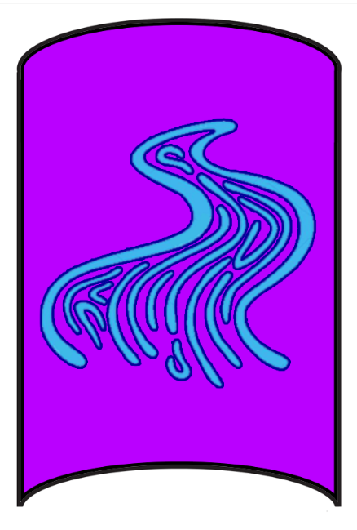 **Glaveum**

**Size:** large town, population 5,000, guards / soldiers 50, militia 250

**Trade Goods:** grain, flax, clay

**Local Goods:** wheat, olive oil, wine

**Standard:** water bearer

**Colors:** blue and purple

**Patron Deity:**

**Ruler:** Magister Polus Aquanas

**Home**: Riverbright Palace

**Steward**: Vesuvius Metilion

**Marshal**: Tullus Secundra

**House Priest:** Quirinia Mercurina (f)

**House Adviser (Scholar/Mage/etc):**  Numerianus the Black

**Captain of the Guard**: Decimus Catus

**Chief Warriors in Service**:

Augustus Valerius

Gratia Cara (f)

Kaeso Vibidius

Gaius Ummidius

**Local Powers:** The Trixium (thieves guild), Argus Syndicate (smuggling ring), 18th Legion “The River Legion”

**Local Sites:** The Ram’s Head Inn & Tavern, The Vestal Virgin Inn & Tavern

**Description:**

Glaveum is nicknamed the **Horn of Plenty** for the copious amounts of provender that passes through it. The town is seated within the **Flumina**, or **River Lands**, where several mountain streams flow from the **Arcanian Mountain** range to the sea and irrigate the land thoroughly. For this reason, Glaveum is the hub of agriculture along the northwest coastline of the Arnland peninsula.

Glaveum, like many settlements in Celedon, is surrounded by high walls and a well-drilled guard, but does not hold firm control of the lands nearby. The Harathar tribe of orcs roams the Equus Plains and lands west of the Arcanian Mountains, raiding farms along the interior of the rivers.

**Industry:**

Countless farming villages are supervised by agronomic experts that travel from this town. They manage production and schedule the gathering of grain and cattle at its market. Glaveum’s port is deep and hosts ships from Evolos to take the goods back for shipping to Western Amadar. Glaveum’s merchants are keen to control supply to ensure they keep a steady profit.

**Key Figures:**

The Eighteenth Legion, dubbed the “River Legion,” is garrisoned in Glaveum. Their mission is to protect the town and patrol the Flumina region.

**Local Lore:**

**History:**

**Customs:**

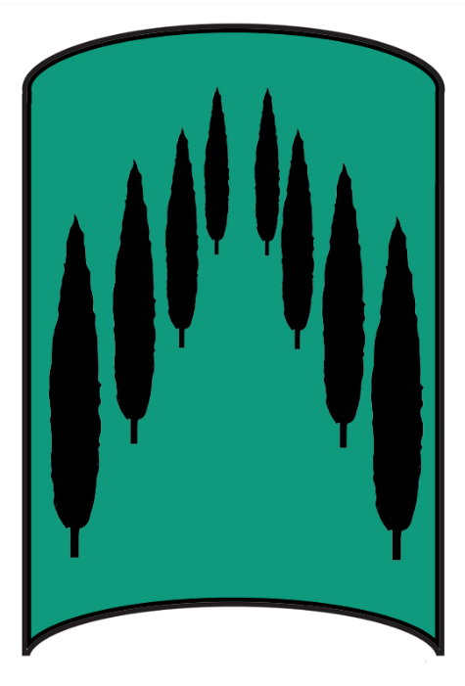 **Verenus**

**Size:** large town, population 5,000, guards / soldiers 50, militia 250

**Trade Goods:** timber, fur

**Local Goods:** wheat, olive oil, wine, special timbers

**Standard:** an elaborate branching tree

**Colors:** green and black

**Patron Deity:**

**Ruler:** Magistra Matia Regula

**Home**: Hilltree Palace

**Steward**: Lars Albanius

**Marshal**: Cossus Galerio

**House Priest:** Eulogius the Speaker

**House Adviser (Scholar/Mage/etc):**  Maecilia the Shrouded (f)

**Captain of the Guard**: Tiberius Arulus

**Chief Warriors in Service**:

Spurius Seius

Decius Juventius

Papiria Verina (f)

Proclus Stertinius

**Local Powers:** Halcyon Syndicate (thieves guild), Aethon Syndicate (smuggling ring), Band of the Ivy Leaf (order of rangers), 22nd Legion “The Watchful Legion”

**Local Sites:** The Fickle Faun Inn & Tavern, The Leaning Shield Inn & Tavern

**Description:**

Verenus is one of the oldest Celedon settlements, having been conquered and renamed first among rival kingdoms as Aquila expanded millennia ago. It has a proud history of the arts and boasts the finest theaters and galleries among the civilized towns. It is built into the side of a cliff where the passing river from the Aracnan Mountains tumbles into an impressive waterfall. For this reason the town is called the “**Mist Town**”, for the haze that hangs in the air from the nearby falls.

Verenus, like many settlements in Celedon, is surrounded by high walls and a well-drilled guard, but does not hold firm control of the lands nearby. Expeditions into the Ningarnum Forest to the west have retrieved a number of rare and beautiful trees. Arboreal experts in Verenus have cultivated many of these breeds for special timbers, to plant in lands to help fight soil erosion, and some for decorative purposes. The famous Verenus Garden is a small forest attached to the town. It is enclosed by fences and filled with a dazzling array of trees that the Arbor Men cultivate. The Garden is a sight nobles travel from all over Celedon to visit.

**Industry:**

**Key Figures:**

The Twenty-Second Legion, dubbed the “Watchful Legion” is garrisoned at Verenus. Their mission is to safeguard Verenus as well as patrol the lands up to the River Praxis, in the north, and to the Ningarnum Forest to the west.

**Local Lore:**

**History:**

**Customs:**

 **Aquila**

**Size:** metropolis, population 50,000, guards / soldiers 500, militia 2500

**Trade Goods:** trade hub, dyes, grain, wine, copper, magical center

**Local Goods:** wheat, olive oil, wine, cattle, stone, fine art, literature, scholars, military

**Standard:** an eagle with wings outstretched against a many-pointed sun

**Colors:** red and black

**Patron Deity:**

**Ruler:** Emperor Caelus Standardus

**Home**: Palazor Palace

**Steward**: Calpurnia Nelia (f)

**Marshal**: Faustus Armiger

**House Priest:** Salvius the Healer

**House Adviser (Scholar/Mage/etc):**  Papirius of the Hidden Hand

**Captain of the Guard**: Quintus Geta

**Chief Warriors in Service**:

Hostus Gryllus

Drusus Pullo

Mettius Tibullus

Caesia Catula (f)

**Local Powers:** Traders Delphina Trading Company, Circle of Janus (thieves guild), Temple of the Ancient Luminance, Chimera Sanctum (school of magic), 1st Legion “The Imperial Legion”, Cithara Amphitheater (bardic college)

**Local Sites:** The Twin Wolves Inn & Tavern, Gelos Vineyards, Cyprian House (brothel)

**Description:**

Aquila remains the capital of the Celedon kingdom. While the empire has contracted down to a fraction of the land, the mighty city retains all the splendor of its days as the capital of most of Nemmerle a thousand years ago. Here stand the great library and halls of learnin, with one section devoted to magic. Here too are the forums, where magisters and magistras from all over Celedon come to argue politics.

Aquila maintains a robust force of arms, which it dispatches to the areas of Celedon still under firm control. The rest are spent beating back the Orc tribes encroaching from the **Arcanian, Volturnus, and Tauran** mountain ranges. The armies, formed up into Legions, are housed in barracks along the perimeter of the city and are ready to muster at the sound of the great horn being blown.

In the central region, Aquila holds absolute control over the delta and passes to the north of the valley, connecting with Vesta and Augur’s bay to the west and Catonia and the Lora river basin to the south-east. Regular foot patrols through the Periculum Pass maintain these lanes of movement and secure the rivers.

**Industry:**

The core of Celedon remains the Olysium valley and Aquiline Delta. Rich crops grow in abundance and the state of plenty has allowed rich trade with Darmiddia. This has been funneled to preserving and expanding the stately buildings and statuary around the capital.

**Key Figures:**

The First Legion, dubbed the “**Imperial Legion**,” is garrisoned in Aquila and is considered the honor guard of the Emperor. Its mission is to protect the city. It is considered the highest honor to be named to the First Legion.

**Local Lore:**

**History:**

Aquila rose to prominence in 80 AA2 when **Chieftain Orius** united the tribes and founded the city state that dominated the region.

**Customs:**

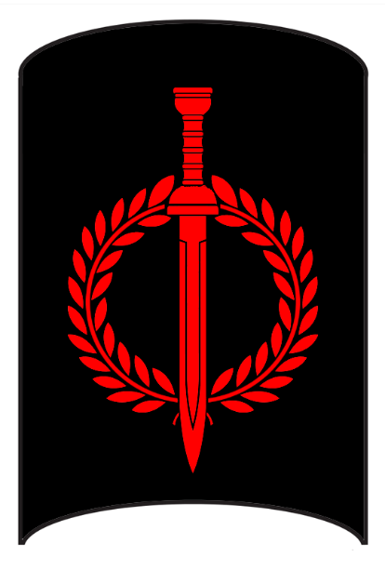 **Infernus**

**Size:** large town, population 5,000, guards / soldiers 50, militia 250

**Trade Goods:** lead, steel

**Local Goods:** military training facility

**Standard:** A sword surrounded by garland

**Colors:** black and red

**Patron Deity:**

**Ruler:** Primus Darius Baltar

**Home**: Fortress Spada

**Steward**: Caelus Excingus

**Marshal**: Velo Viducius

**House Priest:** Senecius of the Silver Chime

**House Adviser (Scholar/Mage/etc):**  Arcavia the Stellar (f)

**Captain of the Guard**: Quintus Crito

**Chief Warriors in Service**:

Placus Murrius

Primus Calavius

Blossia Pertinax (f)

Nonus Faenius

Faustus Atius

Cnaeus Barbatus

**Local Powers:** The Collabria (thieves guild), Temple of the War Drum, Fortress Infernus (warrior academy)

**Local Sites:** The Red Harpy Inn & Tavern, The Dancing Nymph Inn & Tavern

**Description:**

The **Isle of the Eagle** remains the home of the Celedonian military engine, housing the famous training fort of Infernus. Every true soldier of Celedon bears the brand of Infernus and is a product of the grueling year-long training in the hills around the island.

Several camps are located throughout the island, each of which have rustic barracks set on a dirt mound surrounded by a wooden palisade. Each camp is called a Cohort and given a number. As part of their training, cohorts launch assaults on rival camps, attacking with blunted weapons with the aim to burn down the palisades. A Cohort that fails to defend their fort spends several months rebuilding it.

In the days of Celedon’s rapid expansion it became expedient to change this and train new recruits in foreign lands as their people were conquered. But some say this was part of the downfall of Celedon’s greatness, and today that tradition has returned to be an exclusive feature of the Isle of the Eagle. Infernus does not pay allegiance to any of the battling factions of Celedon, it is considered neutral ground. Soldiers accepted to the military academy here may go on to fight one another in territorial wars, but each soldier honors the mark of a brother or sister who has emerged from Infernus.

**Industry:**

**Key Figures:**

Primus Baltar holds a religious reverence for war and the preparation for it.

**Local Lore:**

**History:**

**Customs:**

The men and women living in Infernus hold to a brutal military regime. Every manner of privation is exercised as well as hazing of younger recruits.

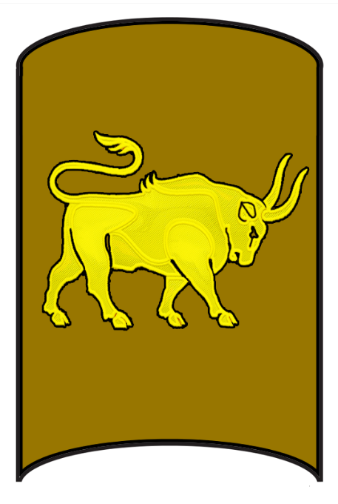**Spearhead**

**Size:** small town, population 2,000, guards / soldiers 20, militia 100

**Trade Goods:** live stock

**Local Goods:** wheat, olive oil, wine, fishing, cattle

**Standard:** a bull’s head

**Colors:** brown and gold

**Patron Deity:**

**Ruler:** Magister Cybus Coralus

**Home**: Altieri Fortress

**Steward**: Metilia Calvina (f)

**Marshal**: Nonus Cumanus

**House Priest:** Agaptus Speaker of the Gods

**House Adviser (Scholar/Mage/etc):**  Procyon the Illuminated

**Captain of the Guard**: Equitus Terenteian

**Chief Warriors in Service**:

Mettius Camelius

Tiberius Sulpicius

Paullus Petellius

**Local Powers:** The Sinister Hand (thieves guild), 50th Legion “The Spear Legion”

**Local Sites:** The Sleeping Siren Inn & Tavern

**Description:**

The small town of Spearhead was so named for the grueling task of taking the peninsula from the local tribes over a thousand years ago. Converted from a marchland garrison fortification to a town, there are still remains of the larger military complex outside of the town walls that were no longer needed when the army drew down in this region. What remains is an isolated fortified town that defends the area’s farmlands against regular Orc raids by the **Fernog** tribe. A respectable port allows for regular transport of goods to and from other Celedon settlements. Aquila supports Spearhead with regular patrols back and forth through the Ostra Mountain pass.

**Industry:**

Spearhead boasts livestock of above average size. The militia, drawn from farmers, fiercely protect the upper reaches of the peninsula to safeguard the grazing lands there. The choicest cuts of meat in Celedon are known as “**Spear Cuts**” and fetch a hefty price even outside Celedon.

**Key Figures:**

The Fiftieth Legion, dubbed the “**Spear Legion**,” is garrisoned at Spearhead. Their mission is to protect the town and patrol the areas north and south of Spearhead to counter tribes that roam the land.

**Local Lore:**

The peninsula north of Spearhead is home to a great blue dragon **Fulguron**

**History:**

**Customs:**

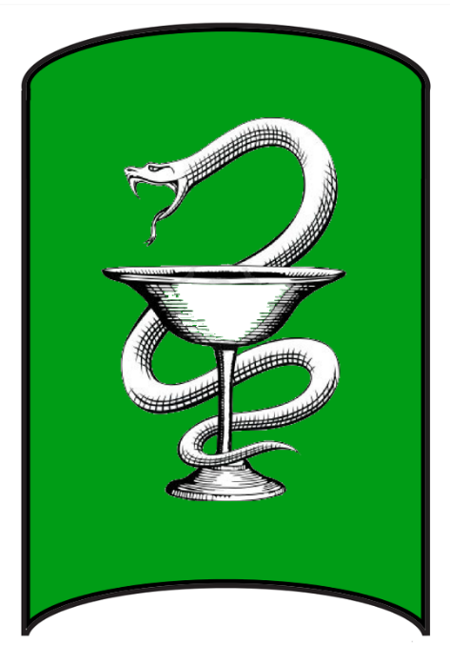 **Vesta**

**Size:** small city, population 12,000, guards / soldiers 120, militia 600

**Trade Goods:** grain, wine, salt, medicine

**Local Goods:** wheat, olive oil, wine

**Standard:** serpent and cup

**Colors:** green and white

**Patron Deity:**

**Ruler:** Magister Phylo Martulus

**Home**: Hearth Hold Palace

**Steward**: Julius Bromidor

**Marshal**: Manius Marcellus

**House Priest:** Aeacus Holder of Keys

**House Adviser (Scholar/Mage/etc):** Tanica the Possessed (f)

**Captain of the Guard**: Velius Varro

**Chief Warriors in Service**:

Quinctilia Tutor (f)

Spurius Aebutius

Quintis Octavius

**Local Powers:** Adder Collegium (thieves guild), 70th Legion “The Silver Legion”

**Local Sites:** The Silver Manticore Inn & Tavern, The Nine Muses, Ariadne Vineyards

**Description:**

Vesta is so named for the bounty of provender provided by the lush river delta and deep waters of Augur’s Bay. Farmlands along the River Cimber and northward generate an excess of crops that are exported. Solar ponds in Augur’s Bay, like those near Evolos, generate valuable salt stores that are traded in the west and transported eastward to Aquila. The Halocline company has a presence here managing the salt trade.

Aquila supports Vesta with regular patrols back and forth through the Ostra Mountain pass.

Like its neighbor to the west, Spearhead, Vesta is heavily fortified against the wild humanoid tribes that roam from the Volturnus Mountains and Aetorian Hills. But where Spearhead has the feel of a rustic frontier town, Vesta’s nobility insist on maintaining a higher degree of culture and class. Large building projects have been commissioned to decorate the outer walls as well as the buildings of the interior, and enormous statues to the gods rival those found in Aquila itself. Its white-washed walls stand out prominently at the mouth of the River Cimber as it empties into the bay.

**Industry:**

**Key Figures:**

The Seventieth Legion, dubbed the “**Silver Legion**,” is garrisoned in Vesta. Its mission is to protect the city as well as to patrol the lands from the River Cimber through the Periculum Pass, securing the road to Aquila.

**Local Lore:**

**History:**

613 - 628 PA3 - War of the Dead: Armies from Vesta, Catonia, Copia, and Tytan join with the Dwarves of Berylor to battle the undead hordes from Abraxas that threaten to take over the lands.

628 PA3 - The cleric Aeritus wields the Mirror of Aurora to lead the Celedon armies in victory over the hordes of Carnifex; the Vale of Abraxas grows silent but remains cursed

**Customs:**

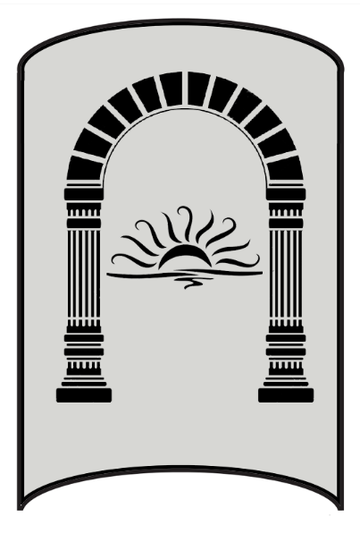**Catonia**

**Size:** large town, population 5,000, guards / soldiers 50, militia 250

**Trade Goods:** trade hub, steel, iron, stone

**Local Goods:** wheat, olive oil, wine, stone quarries, masons

**Standard:** archway and sun

**Colors:** silver and black

**Patron Deity:**

**Ruler:** Magister Aralus Tynor

**Home**: Pillaron Palace

**Steward**: Vatinius Strabo

**Marshal**: Cilnius Amulor

**House Priest:** Consentia the Truth Teller (f)

**House Adviser (Scholar/Mage/etc):**  Magnafon the Fiery

**Captain of the Guard**: Trago Tunarus

**Chief Warriors in Service**:

Sextus Silo

Titus Caristanius

Spurius Candidianus

Auria Dexion (f)

**Local Powers:** Sons of Triton trading company, The Iron Cohort (thieves guild), The Bronze Brotherhood (smuggling ring), The Circle of the Hemlock (order of druids), 62nd Legion “The Stone Legion”, House Vitruvius (mason’s guild)

**Local Sites:** The Argus Head Inn & Tavern, The Concubine’s Cup Inn & Tavern

**Description:**

Catonia sits alongside the **River Lora** in the shadow of the **Aetorian Hills**. Like all Celedon towns it is well defended against Orc tribes, but Catonia looks particularly uninviting. Thick stone walls are made up of enormous blocks of purple granite mined from veins under the Aetorian and transported here. Caught between the Fernog and Fammis tribes, Catonia is cut off from its allies by land.

**Industry:**

Catonia has made a brisk business from the mining of the granite. The House of Vitruvius is a college of masons here whose graduates are sought after throughout Celedon. Vitruvius is a bitter rival of Pendulum House in Lucina.

Catonia is the site of the largest iron mines and smelting houses. The wealth of weapons for the Celedon armies can be traced to iron mined and processed here.

**Key Figures:**

The Sixty-Second Legion, dubbed the “**Stone Legion**,” is garrisoned in Catonia. Its mission is to protect the town as well as patrol the lands from the Aetorian Hills to the Ceres Forest to counter tribes roaming in the region.

**Local Lore:**

**History:**

613 - 628 PA3 - War of the Dead: Armies from Vesta, Catonia, Copia, and Tytan join with the Dwarves of Berylor to battle the undead hordes from Abraxas that threaten to take over the lands.

628 PA3 - The cleric Aeritus wields the Mirror of Aurora to lead the Celedon armies in victory over the hordes of Carnifex; the Vale of Abraxas grows silent but remains cursed

**Customs:**

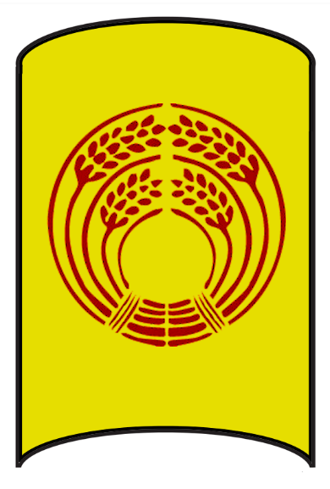 **Copia**

**Size:** large town, population 5,000, guards / soldiers 50, militia 250

**Trade Goods:** wine, clay, silver, fishing

**Local Goods:** wheat, olive oil, wine

**Standard:** twin sheaves of wheat

**Colors:** yellow and red

**Patron Deity:**

**Ruler:** Magistra Novia Praetor

**Home**: Silvermorn Palace

**Steward**: Ceionia Salvian (f)

**Marshal**: Lucius Rullo

**House Priest:** Appius the Peacemaker

**House Adviser (Scholar/Mage/etc):** Aburius the Greenmantle

**Captain of the Guard**: Calvius Sertor

**Chief Warriors in Service**:

Tullus Furius

Vopiscus Pedius

Caius Malchus

Vinicia Vedrix (f)

**Local Powers:** The Twilight (thieves guild), Temple of the Known Unknown, 12th Legion “The Wolf Legion,” Sanctum of the Infernal Word

**Local Sites:** The Bronze Eagle Inn & Tavern, The Silver Scabellum Inn & Tavern, Ceraon Vineyards

**Description:**

The town of Copia enjoys a strong alliance with the **Dwarves of Konaar** who dwell in **the Volturnus Mountains**. This has allowed Copia to farm the lands west of the Equus River all the way up to Lake Isara.

The towns of Copia and Tytan hold the north and south of Aerie Bay, but not much else. Travel by boat is all that keeps these holdings connected to Aquila and accounts for most of the troops being deployed to countermand enemy attacks. The **Terog** tribe of orcs coming out of the **Volturnus** mountains have put down roots around the **Lake Aurora** area while the **Fammis** tribe holds the lands around Ceres Forest and the **Sangor** tribe out of the Taurans holds much of the Carnor Plains. Only the Dwarven domain of Berylor operating out of Volturnus has kept Orc troop strength from growing. Berylor has no formal alliance with Celedon so their fight is purely out of hatred for the Orcs.

**Industry:**

The yield from these lands and a fleet of fishing boats has given Copia an impressive port commanding Aerie Bay. Copian boats are known as the finest fishermen in all of Celedon.

**Key Figures:**

The Twelfth Legion, dubbed the “**Wolf Legion**” from Aquila is garrisoned here with the mission of countering Orc tribes out of the Lake Aurora area.

**Local Lore:**

**Sanctum of the Infernal Word** - Far to the north lies the Vale of Abraxas. Molten lava oozes from volcanoes in a constant stream that collects in the valley floor between them. Noxious clouds darken the sky, casting gloom over this place. It is here that early priests of dark gods called forth demons and devils, some of whom return here. The entire valley is under a curse, controlled by mages of the Sanctum of the Infernal Word. Ancient writings can be found on the face of cliffs here, written in a language long forgotten. It is said that wizards trek here to learn the oldest and darkest secrets connected to the earliest written spells. Abraxas Stones are magically imbued stones that have had the words written upon them. Each holds a different power and is highly coveted by wizards and sorcerers everywhere in the world. Necromancers have long been attracted to this place, for it affords easier access to the infernal planes. This has left the entire region teeming with the walking undead.

**History:**

610 PA3 - Manius Carnifex carries on his father's work, summoning a countless horde of undead that invade the land

613 - 628 PA3 - War of the Dead: Armies from Vesta, Catonia, Copia, and Tytan join with the Dwarves of Berylor to battle the undead hordes from Abraxas that threaten to take over the lands.

628 PA3 - The cleric Aeritus wields the Mirror of Aurora to lead the Celedon armies in victory over the hordes of Carnifex; the Vale of Abraxas grows silent but remains cursed

884 PA3 - Sanctum of the Infernal Word forms in the Vale of Abraxas

**Customs:**

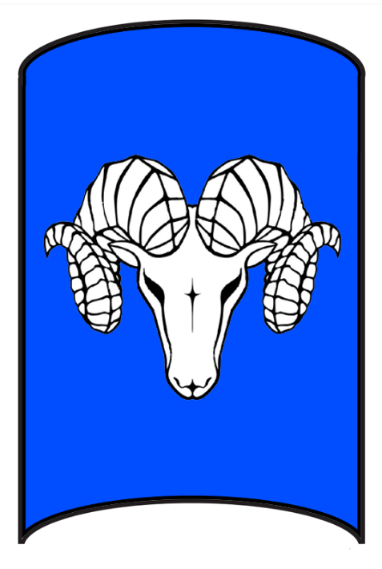 **Tytan**

**Size:** small city, population 12,000, guards / soldiers 120, militia 600

**Trade Goods:** papyrus, grain, copper, salt, stone

**Local Goods:** wheat, olive oil, wine, stone, cattle

**Standard:** a horned ram

**Colors:** blue and white

**Patron Deity:**

**Ruler:** Magister Poulus Lassini

**Home**: Fortress Madamra

**Steward**: Laterius Lazzo

**Marshal**: Canus Caralor

**House Priest:** Vedius the Calmer of Storms

**House Adviser (Scholar/Mage/etc):**  Auria the Diviner (f)

**Captain of the Guard**: Sylvius Geranon

**Chief Warriors in Service**:

Spurius Momus

Potitus Antistius

Caria Viator (f)

Augustus Munatius

**Local Powers:** Wolfshead (thieves guild), Temple of Furina, 29th Legion “The Horn Legion”

**Local Sites:** The Sun Chariot Inn & Tavern, The Full Measure Inn & Tavern

**Description:**

Dubbed the “**March Town**,” Tytan sits at the far end of the Celedon domain on the southern shore of **Aerie Bay**. The isolated settlement is cut off by natural barriers in every direction: a peninsula at its back (which they term ‘the **Ram’s Horn,**’ a nigh-impassable swamp to the northeast, and the **Tauran Mountain** range to the east and southeast. The rest is open sea, except for the **Plains of Carna** that stretch to the south.

Tytan itself has made the most of the situation, building up higher, thicker walls than most towns. The early Celedons knew what they were in for when they conquered the peninsula. They built up giant ground works before laying the foundation, giving the town a higher aspect overlooking its surroundings. Trenches and traps have been created in three concentric rings around the town, which the people maintain daily. Scouts have keen knowledge of secret passes through the swamps to the east, allowing movement to the town of Copia far to the north but only in small parties.

The towns of Copia and Tytan hold the north and south of Aerie Bay, but not much else. The **Terog** tribe of orcs coming out of the **Volturnus** mountains have put down roots around the **Lake Aurora** area while the **Fammis** tribe holds the lands around Ceres Forest and the **Sangor** tribe out of the Taurans holds much of the Carnor Plains. Travel by boat is all that keeps these holdings connected to Aquila and accounts for most of the troops being deployed to countermand enemy attacks. For this reason, the embattled town has adopted a stern lifestyle of military readiness.

**Industry:**

Life in Tytan isn’t all grim. Like Spearhead to the north, the people defend the **Ram’s Horn** farmlands and have excellent crop production. Quarries were started at the base of the Tauran Mountains but are hard to keep open with Sangor Orc attacks in the area. Solar pools are harvested at the edge of the town’s inlet, much like the pools in Vesta and Evolos. Salt stores are traded in the region as well as exported by boat. The Halocline company has a presence here and oversees the salt production and trade.

**Key Figures:**

The Twenty-Ninth Legion, the “**Horn Legion**,” is garrisoned in Tytan. Its mission is to protect the town as well as patrol the lands from the Ram’s Horn in the north to the Plains of Carna in the south.

**Local Lore:**

**History:**

613 - 628 PA3 - War of the Dead: Armies from Vesta, Catonia, Copia, and Tytan join with the Dwarves of Berylor to battle the undead hordes from Abraxas that threaten to take over the lands.

628 PA3 - The cleric Aeritus wields the Mirror of Aurora to lead the Celedon armies in victory over the hordes of Carnifex; the Vale of Abraxas grows silent but remains cursed

**Customs:**

 **Sorcia**

**Size:** small town, population 2,000, guards / soldiers 20, militia 100

**Trade Goods:** olive oil, magical center, religious capital

**Local Goods:** wheat, olive oil, wine, magical studies, sheep

**Standard:** the watchful eyes of the sorceress

**Colors:** yellow and black

**Patron Deity:**

**Ruler:** Magistra Cania Auxentia

**Home**: Radiant Fortress

**Steward**: Paullus Clodian

**Marshal**: Metilia Musa (f)

**House Priest:** Vorgus Demon Bane

**House Adviser (Scholar/Mage/etc):** Arvina of the Many Eyes

**Captain of the Guard**: Aferius Capito

**Chief Warriors in Service**:

Tiberius Bellator

Spurius Claudianus

Manius Velus

Oppius Gordio

**Local Powers:** High Temple of Boccob (seat of power for the Boccob religion), Charon Coin (thieves guild), Order of Auxentia (school of magic), The Hyperium Guard (mercenary company)

**Local Sites:** Nomeon’s Cup Inn & Tavern

**Description:**

The mysterious town of Sorcia occupies the north shore of the **Isle of Cassia**. Aside from operating as a farming town it is the haven for mystics and sorcerers that Aquila has deemed too dangerous for the mainland.

**Industry:**

**Key Figures:**

It is rumored the most powerful oracles flee here for telling secrets that Celedonian command didn’t find to their liking. The storied **Order of Auxentia** is based here, an ancient order of magicians with a library of forbidden spells.

**Local Lore:**

Sorcia is protected by powerful wards that extend out to sea. Sorcia mystics have a deep connection with the sea and can command mists, waves, and even storms to keep ships away. No one approaches the Isle of Cassia unless the mystics allow it. A lighthouse situated at the northern promontory is called the **Seeing Watchtower**. It is a tall white tower that scans the seas in every direction, night and day.

**History:**

**Customs:**

**History of Celedon**

**First Primordial Age (PA1)**

Dawn of the Aurans

320 PA1 - Pelor smiles upon the lands of western Arnland and shows himself to the Aurans; he commissions them to take up the way of the light

**Second Primordial Age (PA2)**

230 PA2 - Calaithe leads a revolt of enslaved women in Feronia (in present-day Celedon); she leads an ever-growing army east through the Tarbian Desert

231 PA2 - The slave Calaithe leads a revolt of enslaved women in Feronia (in present-day Celedon)

232 PA2 - Calaithe's army marches to other Auran cities, defeating Auran forces and freeing more enslaved women

233 PA2 - Calaithe's forces enter the Tarbian desert, beginning a grueling trek eastward to escape Auran forces

730 PA2 - Reign of the hydra Vachuno, who terrorizes Augur Bay and lays waste to boats and unwary farmers near the coast

824 PA2 - the hero Stadius slays Vachuno and weds the daughter of the chieftain of Vesta

**Third Primordial Age (PA3)**

10-280 PA3 - Reign of the Mystics: priests of darkness spread fear and oppression over the lands of Celedon

280 PA3 - end of the Reign of Mystics - the warior philosopher Oentericus leads a hunt against the dark priests and hunts them all down, destroying their order

520 PA3 - Avidius Carnifex the necromancer opens portals to the infernal planes within the Vale of Abraxas, cursing the lands forever

610 PA3 - Manius Carnifex carries on his father's work, summoning a countless horde of undead that invade the land

613 - 628 PA3 - War of the Dead: Armies from Vesta, Catonia, Copia, and Tytan join with the Dwarves of Berylor to battle the undead hordes from Abraxas that threaten to take over the lands.

628 PA3 - The cleric Aeritus wields the Mirror of Aurora to lead the Celedon armies in victory over the hordes of Carnifex; the Vale of Abraxas grows silent but remains cursed

884 PA3 - Sanctum of the Infernal Word forms in the Vale of Abraxas

**Fourth primordial Age (PA4)**

210 PA4 - expeditions from Kasylla lay claimto the eastern shores of Celedon and the Isle of Infernus

240 PA4 - Osireion's forces invade Isles of Phoenix and Orpheon as well as the Tauran Mt region of present-day Celedon

450 PA4 - Battle of Stolen Stones - King Mardu of present-day Evolos conquers the people of northern Arnland, beginning the role of the Tavians as power brokers in Arnland

750 PA4 - cut off from their patrons in Mythenia, Kasylla forces in Celedon abandon their claims, as does Osireion on the Isles of Phoenix and Orpheon and the Tauran Mt. region of Celedon

780-787 PA4 - War of the Sails - Tavian kingdom of the west battles the Aurans on the high seas; armies fight throughout the north, with the Tavians taking over Lucina and Glaveum

872-888 PA4 - The Wizard War: Telemechus triggers a world-wide war of mages, some of whom march on Ongolk to stop him and some who join him in attacking the ley lines in their lands; epic battles wage all over the world, destroying cities and upsetting the balance of magic

888 PA4 - The Battle of Forlorn: Telemechus is slain but not before rupturing the magical ley lines permeating Nemmyrl; the victorious general Dragan of Celedon seizes the opportunity to rid the world of magic and ruptures the Singularion as it is embedded in the ley lines; the resulting explosion sends a shock wave that ruptures the magical ley lines around the world and triggers the Dead Century

**First Ancient Age (AA1)**

380 AA1 - War of Extermination - orc tribes under Hargarg the Bloodless swarm over all of Celedon, wiping out villages and towns; the Aurans and Tavians broker a truce to focus on the Orc threat

390 AA1- with most of Celedon destroyed, three individual armies (one Tavian, two Auran) wage a hopeless war agains the orcs in nothern, central, and southern Celedon

400 AA1 - the Three Banners battle their way to the Valley of Elysia to take on Hargarg's army; the Battle of the Four Banners ensues and the humans are saved by a miracle

410 AA1 - Hylux founded; Followers of Pelor celebrate the victory over the Orc invasion as a miracle and establish the Holy City of Hylux; the city goes on to become the seat of power over a vast religious network

**Second Ancient Age (AA2)**

80 AA2 - founding of the city of Aquila - chieftain Orius unites the tribes and founds the city state that begins to dominate the region

274 AA2 - the mad general Vestorius sacks Sorcia, makes off with a forbidden chest holding the Eye of Helvia; Vestorius uses the relic to find the Crown of Power

280 AA2 - Vestorius raids the southern coast of the Arnland continent, sacking cities and drawing followers to his power

285 AA2 - Vestorius allies with the Malar Orcs of Volturnus, hoping to conquer Aquila and take control of Celedon

289 AA2 - the oracle Juventia puts out the call for eight heroes to oppose Vestorius; ignored by anxious generals of Aquila, she frees eight gladiators and names them wardens of the light

293 AA2 - the Eight Sentinels battle their way to the peaks of Volturnus, rescuing the Aqulian Legions, and face off against Vestorius; in a mighty eruption of a volcano the dark host and the heroes are consumed

390 AA2 - The Blight of Proserpina - famine sweeps across the lands of Celedon, rumor speaks of Proserpina being kidnapped to the underworld and her blessings taken from the land

470 AA2 - the cleric Hailona leads an army of warriors to rescue Proserpina, restoring the land and ending the famine

740 AA2 - Fall of the Aurans - armies from Evolos launch campaign to conquer the Aurans in central and southern Arnland

770 AA2 - Fall of Aquila - Auran Kingdom falls to Tavian armies, beginning Tavian rule over all of western Arnland

**Third Ancient Age (AA3)**

220 AA3 - the Paragon Wars: Emperor Malcanon begins centuries of darkness in Celedon in pursuit of perfection in the Celedonian people; he orders a purge of anyone falling outside his ideals for humanity; countless thousands are hunted down for appearing or behaving differently than the emperor’s ideal

242 AA3 - Flight of the Green Sails: the cleric Salmus secretly organizes an armada of small merchant ships for a mass evacuation of hunted people out of Celedon; their green sails are their secret sign of safety to anyone seeking refuge

313 AA3 - end of the Paragon Wars: resistance leaders throughout Celedon rise up and defeat the Paragon Emperor, Malcanon's grandson Granor, and restore the Empire to peace

**Fourth Ancient Age (AA4)**

600 AA4 - the city of Aqulia is taken over by patricians calling themselves Celedonians; Aquila revolts against the Tavian throne in Evolos

610 AA4 - Celedonians broker deals with the Darmiddians to finance a build-up in arms

770 AA4 - Fall of Evolos to the Celedonians; end of the reign of Tavian people

**First Written Age (WA1)**

27 WA1 - the Celedonian King Dregidus enters Rosaria Valley during the Festival of Quinquatria and, lusting for power, becomes the first ruler to spurn the gifts of health and plenty for his people; instead, he seizes one of the sacred totems of power: dominion

28 WA1 - a small volcanic geyser erupts in Rosaria Valley; metallurgists learn the molten ore creates superior steel and weapons with special properties; they name the metal Avadom steel for they believe it is a sign leading Celedon to world dominion

29 WA1 - the geyser dries up; Dregidus, desperate for more Avadom steel, breaks into the Temple of Volitia and attempts to steal the totem of power; in the process he destroys the rest of the totems; the act of desecration corrupts Rosaria valley and sends it into ruin but delivers enormous military might for the Celedonians

29 WA1 - volcanoes erupt all over Rosaria Valley, converting the lush green place into a molten-covered firescape veiled by smoke and ash; Celedonian miners work night and day extracting untold amounts of ore and process it into Avadom steel

30 WA1 - Celedonian Conquest: Argus Legion attacks Darmidia; start of the rise of Celedon Empire

32 WA1 - Celedonian Conquest: Battle of Arinol: Celedon naval commander Tortorus outmaneuvers the Darmidian sea captain Hakaar and sets the entire Darmidian fleet ablaze

33 WA1 - Celedonian Conquest: Darmiddia is renamed Tortorron by the Celedonians; Tortorus begins a large building project that will eventually position Darmidia as a major power in the region

40 WA1 - Celedonian Conquest: Battle of the Temples: Celedon Nessus Legion invades Ankhtiri

50 WA1 - Celedonian Conquest: Orthaon and Celerius Legions cross the Tauran Mountains; the Celerius Legion is swallowed up in the Sea of Shifting Sands; Orthaon joins Argus and Nessus to sweep across the Tarbian Desert and conquer the Seven Jeweled Cities, securing all of Tarbia

50 WA1 - Celedonian Conquest: Orthaon Legion crosses the Tauran Mountains and joins Argus and Nessus to sweep across the Tarbian Desert and conquer the Seven Jeweled Cities, securing all of Tarbia

70 WA1 - Celedonian Conquest: Secundus navy attacks Sargon and Primus attacks Kasylla, begins invasion of Mythenia

80 WA1 - Celedonian Conquest: Tertius navy takes Fredegn Isle and Giserne Isle and Spargeus Legion invades Plenia; Elves of Adulien massacre the Tertius navy when they attack their Adulien

90 WA1 - Celedonian Conquest: Secundus navy attacks Mythenian cities in the Syren Straits, takes Isle of Skiron; Orthaon Legion establishes a garrison in Tijara

100 WA1 - Celedonian Conquest: Argus and Nessus Legions defeat the Mythenians at the Thyra Gates and conquer the last of the Mythenia cities, Nessus Legion is later wiped out when invading Dymoneia Island, Argus Legion establishes a garrison in Parseion

110 WA1 - Celedonian Conquest: Spargeus Legion defeats the Plenish tribes but is surprised to find a vast host of Orcs occupying western Amadar; Celedonians purge the land of Orcs then march on the Treian tribes

120 WA1 - Celedonian Conquest: Primus navy invades Gaeadon, routed at Adhanar, moves north into Kyre, Primus deploys the Echion Legion which sacks Claeryon and Kelenon; Echion forms a garrison at Kelenon

130 WA1 - Celedonian Conquest: Spargeus Legion is joined by the Brontes Legion and defeats last of the Treian tribes, sacks Eathra (currently Illustrim)

140 WA1 - Celedonian Conquest: Spargeus Legion passes through Wyvern Pass and enters wild lands north of Plenia; thousands massacred by orc tribes; Spargeus Legion retreats to Phaeria to establish a garrison there

150 WA1 - Celedonian Conquest: Quatortus navy lands in Kaduru, Celaeno Legion sacks Longspear and moves east, stopped at the Wilderon Plains by the Kaduru armies

160 WA1 - Celedonian Conquest: Primus navy takes control of the Bay of Nereida, deploys the Phoenix Legion and begins invasion of Tirudor

170 WA1 - Celedonian Conquest: Herebus, general in the Tertius Fleet, winters on Giserne Isle and founds the town of Druindar

170 WA1 - Celedonian Conquest: Thoon Legion strikes north of Treviland, invades Vorg lands; Primus navy enters Strait of Gales, takes Isles of Oeren (present-day Orison), Verigon, and Talyn; destroys the holy city of Indiron

180 WA1 - Celedonian Conquest: Brontes Legion founds the city of Novulum and establishes it as the new seat of power in Treviland

190 WA1 - Celedonian Conquest: Primus navy takes Tirudoran peninsula, Phoenix Legion seizes the Corazon region

200 WA1 - Celedonian Conquest: naval forces Quartus and Quintus attack Kaduru towns of Sikaar, Ajabar, and Skaringa, deploys the Gerana and Acanthis Legions to move behind Kaduru forces holding the Wilderon

210 WA1 - Celedonian Conquest: Thoon Legion crushes the last of the Vorg tribes, moves north to the sea, take control of the Howling Sea

220 WA1 - Celedonian Conquest: Celaeno, Gerana, and Acanthis Legions surround the Western Kaduru forces and slaughter them in the Battle of the Wild Drums; Celaeno Legion establishes a garrison at Longspear

230 WA1 - Celedonian Conquest: Phoenix and Tereus Legions envelope the last of the Tirudoran forces and crush them; Phoenix establishes a garrison in Colova; Primus navy takes Bay of Luna while Tereus Legion occupies Obrador and invades the Black Coast to march on Yucaipa

240 WA1 - Celedonian Conquest: Sextus navy launches new campaign to take the Isles of the Maelstrom; Quartus naval force enter Bottomless Bay and Xanthus Legion establishes a Garrison at Ruins of Tivvian; Brontes Legion commissions the building of Wendspire in the Nary Lands

250 WA1 - Celedonian Conquest: Tertius navy, rebuilt after the defeat at Adulien, sail up the coast of Western Amadar, destroy the Orcs in the lands around Vesper Bay, take the outer islands

260 WA1 - Celedonian Conquest: half of Celedonian Sextus navy lost to the Maelstrom; Colchian Legion marches into Tirudoran Marches and is stopped by gnoll and orc tribes

270 WA1 - Celedonian Conquest: Quartus navy deploys forces at Tengaibo and are repelled; Lampus Legion seizes lands east of the Chamba River

275 WA1 - Celedonian Conquest: Celedonians construct a massive port and fortification complex on the Isle of Oeren, controlling the Inner Sea

280 WA1 - Celedonian Conquest: Celedonians invade present-day area of Barter Bay in Northern Gaeadon

282 WA1 - Celedonian Conquest: Secundus navy takes Barter Bay and the Phlegon Legion sacks the coastal towns; Celedon burns the settlements to the ground to punish the resistance mounted by the Sharidians; fall of the Sharidian civilization

285 WA1 - Celedonian Conquest: Celedonians found the city of Tuith on Fredegn Isle

290 WA1 - Celedonian Conquest: Tertius navy rounds the northern tip of Western Amadar and battles Norgarde ships awaiting them

300 WA1 - Celedonian Conquest: Primus navy controls the Bay of Banners, Nemean Legion invades the region that was once the Kingdom of Gildran and encounters Orc tribes

310 WA1 - Celedonian Conquest: after years of pitched battles Yucaipa is burned to the ground by Tereus Legion

320 WA1 - Celedonian Conquest: Orcs holding the former cities of Silveron and Starfall are conquered by the Nemean Legion in Gildran ; Celedonian Tertius navy wins critical victories against the Norgardians, take the town of Hammer Hold with help from Celedonian Thoon Legion in Erigot

330 WA1 - Celedonian Conquest: last of the Orc forces in Gildran fall to the Nemean Legion; Nemean Legion forms a garrison in the ruins of Silveron

340 WA1 - Celedonian Conquest: Lampus Legion finally takes Tengaibo, Quartus fleet controls the Desolate Straits

350 WA1 - Celedonian Conquest: Gerana and Acanthis Legions march eastward into Kaduru along the Plains of Cheetana, destroying villages and slaying the tribes they meet

360 WA1 - Celedonian Conquest: Phlegon Legion marches south from Barter Bay into Gaeadon and meets huge resistance from orc tribes

370 WA1 - Celedonian Conquest: Quartus navy takes Kaduru city of Oarana, deploys the Drakon Legion and begins invasion of Kazeldun

380 WA1 - Celedonian Conquest: last of the Vorg tribes are destroyed by the Echidna Legion; Celedon controls all of Western Amadar except for the Friendless Fringes; Echidna forms a garrison at Hammer Hold

390 WA1 - Celedonian Conquest: Tertius navy attempts to invade Norgardian fiords but is repelled

400 WA1 - Celedonian Conquest: Quintus navy takes Redwall, Jaloro, and Kemba; garrison is established at Jaloro with the Talos Legion

410 WA1 - Celedonian Conquest: Dryas Legion launches a second invasion of Wyvern Pass in Western Amadar; the Dryas Legion is slaughtered by orc tribes and never seen again

420 WA1 - Celedonian Conquest: Tereus Legion breaks through the orc tribes in Vasera, east of the Stonecurtain Mountains, and push to the Oberon Sea

430 WA1 - Celedonian Conquest: Crantor Legion marches through Aldavel east of the Oberon Sea and attack Dethvau, all the time beseiged by orcs from the Silvercap Mountains

440 WA1 - Celedonian Conquest: Phlegon Legion attempts a second invasion of the interior of the Gaeadon lands, half of them lost in the Shifting Lands while half make it to the Sea of Spirits

450 WA1 - Celedonian Conquest: Drakon Legion takes towns of Courtesan and Felldeed, invades the interior of Kazeldun

460 WA1 - Celedonian Conquest: Quartus navy deploys the Ixion Legion in a massive invasion of Lion Head, suffer enormous losses fighting Kaduru warriors

470 WA1 - Celedonian Conquest: Gerana and Acanthis Legions in central Kaduru reach the Naigana Desert; they are surrounded by Kaduru tribes

480 WA1 - Celedonian Conquest: Drakon Legion invades interior of Kazeldun and meets great resistance from barbarian tribes; Gerana and Acanthis Legions are wiped out by Kaduru tribes on the Plains of Cheetana in the battle called Revenge of the Drums

490 WA1 - Celedonian Conquest: Tereus and Crantor Legions surround the Sea of Oberon and maintain a fragile hold over the wild lands

500 WA1 - Celedonian Conquest: Crantor Legion finally takes Dethvau and invades interior of Hyderian lands

510 WA1 - Celedonian Conquest: Phlegon and Drakon Legions are destroyed in Kazeldun in a terrible defeat at the Battle of the Red Rocks

520 WA1 - Celedonian Conquest: Crantor Legion crushes the tribes of Hyderis, establishes a garrison at Targuth

520-526 WA1 - Celedonian Conquest: Maisara el-Salim, brilliant military commander, attracts followers in a campaign to devastate Celedonian patrols in the open desert

526 WA1 - Celedonian Conquest: Surrounded by Celedonians, Maisara el-Salim battles to keep the oversized enemy forces engaged while a Badawi wizard calls down a giant sandstorm to consume everyone including Maisara's forces

530 WA1 - Celedonian Conquest: Primus navy takes the Isle of Ariago, Minyan Legion establishes a garrison

540 WA1 - Celedonian Conquest: Primus navy sacks the towns of Brazan and Reavan

550 WA1 - Celedonian Conquest: Latus Legion invades the Lands of Ongolk and meet the horrors of Quillock's Blight

560 WA1 - Celedonian Conquest: Second Celedon invasion of Kazeldun by the Poena Legion takes the barbarian capitol of Dimitar; Poena Legion establishes a garrison there

570 WA1 - Celedonian Conquest: Quintus navy takes Kaduru town of Masuba, Cetea Legion marches north into the Talon Jungle and is never seen again

580 WA1 - Celedonian Conquest: Ixion Legion beseiges Harikanya

590 WA1 - Celedonian Conquest: Quintus navy abandons the Cetea Legion lost to the Talon Jungle and moves east, sacking Keromang and Ramala; Arion Legion forms a garrison in Keromang

600 WA1 - Celedonian Conquest: Secundus navy beseiges the city of Vigil, Ladon Legion marches north and conquers the rest of Kazeldun

610 WA1 - Celedonian Conquest: Norgarde war ships destroy most of the Celedonian Tertius navy in the Battle of Roskilde Bay

620 WA1 - Celedonian Conquest: remnants of the Tertius navy beseige Styrla

630 WA1 - Celedonian Conquest: Vigil falls, Celedon controls most of Gaeadon; Ladon Legion forms a garrison in Vigil

640 WA1 - Celedonian Conquest: Harikanya falls, Celedon controls most of coastal Kaduru; Ixion Legion forms a garrison at Harikanya

650 WA1 - Celedonian Conquest: Lampus Legion marches into Onechanbara Jungle and is destroyed by the forces from Ape City

660 WA1 - Celedonian Conquest: Septimus navy attacks Galdan and deploys the Sterope Legion

670 WA1 - Celedonian Conquest: Sterope Legion takes Galdan meets heavy resistance from Moghun forces outside Galdan

680 WA1 - Celedonian Conquest: Quartus navy takes the Isle of Pengali ; Rise of the Erigot tribes resisting Celedon occupation

690 WA1 - Celedonian Conquest: Secundus navy beseiges the fishing town of Shanshan (location of modern day Shining Shore)

702 WA1 - Celedonian Conquest: Shanshan falls to the Abraxas Legion

707 WA1 - Celedonian Conquest: Aethon Legion marches through Ongolk to Vigil Pass and are almost wiped out by orcs

708 WA1 - Celedonian Conquest: priests warn Emperor Glautus of the Curse of Abraxas and urge him to restore the Temple of Volitia by returning the totems of power; Glautus has the priests put to death and the temple destroyed; some say this is the beginning of the end for the Celedon Empire

709 WA1 - Celedonian Conquest: Primus navy enters the Strait of Immolas and are destroyed by dragons

711 WA1 - Celedonian Conquest: Abraxas and Sterope Legions march into the Blue Fields of the Moghun Lands and are driven back by Moghun cavalry

715 WA1 - Celedonian Conquest: Quintus navy attacks the ships off the coast of Mahabar

719 WA1 - Celedonian Conquest: Emperor Glautus is assassinated by his younger brother, Setulo; the spirit of the Celedonian Empire is divided between Setulo and his sister Eropene

722 WA1 - Celedonian Conquest: Genovefe of the Plenish tribes unites her people in overthrowing the Celedonian Spargeus Legion; she becomes the first queen of Plenia

728 WA1 - Celedonian Conquet: sailors from the Quintus navy begin to disappear, strange creatures infest the ships; the Quintus navy departs Mahabar waters

733 WA1 - Celedonian Conquest: the mad druid Eraric avenges the Kazeldun by luring the Xanthus Legion north into the Valley of Strife; they are never seen again

734 WA1 - Celedonian Conquest: Poena Legion, loyal to Glautus, breaks ties with Celedon and forms its own kingdom in the barbarian lands of Kazeldun

736 WA1 - Celedonian Conquest: Talos Legion marches north to the Joro Mts with tales of gold; Kaduru warriors marching out of the Koro Jungle attack from the rear; Kaduru forces cut the legions off from the coastal garrisons and wipe them out

744 WA1 - Celedonian Conquest: Battle of Daghorn: Hyderian forces lure Celedonians to an open engagement near the Nastrond Forest; the Crantor Legion is encircled by light cavalry marching out of the Daghorn Forest and slowly decimated in the Battle of Daghorn

747 WA1 - Celedonian Conquest: Tereus Legion is surprised by a sudden overwhelming strike by Orcs around the Sea of Oberon and wiped out

749 WA1 - Celedonian Conquest: Decius, grandson of Setulo, marries his cousin Aelia, granddaughter of Eropene, in a bid to bring peace to Celedon; they are both usurped by General Opiter who grabs control of the empire

755 WA1 - Celedonian Conquest: Erigot tribes win critical victories and isolate the Celedonian Echidna Legion in Hammer Hold

756 WA1 - Celedonian Conquest: madness takes over the Aethon and Latus Legions; they wipe each other out for power over the Ongolk region

758 WA1 - Celedonian Conquest: Minyan Garrison becomes disillusioned with Celedonian politics, forakes the Empire to become pirates operating out of Madrina

766 WA1 - Celedonian Conquest: General Opilio in Harikanya refuses a challenge of trial by combat from a local chieftain and executes him; the Kaduru people see this as weakness and revolt, taking back the city and slaying the Ixion Legion

767 WA1 - Celedonian Conquest: Moghun warlords take back Galdan and march to Shanshan with the heads of the Sterope Legionnaires

768 WA1 - Celedonian Conquest: Abraxas Legion in Shanshan surrenders the city and departs by boat to Vigil

772 WA1 - Celedonian Conquest: Ladon Legion in Vigil breaks with Celedon and forms the Eastern Imperium, which includes the ships of the Septimus fleet

775 WA1 - Celedonian Conquest: after a long campaign, Kaduru armies in Harikanya succeed in defeating the Arion Legion and liberating Keromang, Ramala, and Arolo

779 WA1 - Celedonian Conquest: Norgarde ships destroy the last of the Tertius fleet based out of Hammer Hold; the city falls shortly thereafter and the Thoon and Echidna Legions are sacrificed to the sea

782 WA1 - Celedonian Conquest: the Secundus fleet battles the Septimus fleet of the Eastern Imperium for control of the region; both fleets are destroyed in the Battle of Myriad Sea

785 WA1 - Celedonian Conquest: Nemean Legion, deprived of sea support, is harrassed by pirates from Ariago; forces are spread thin and fall prey to Orc tribes in the Galdan, Vaseran, and Aldavel regions; Nemean Legion is wiped out

792 WA1 - Celedonian Conquest: Ielfred of Eathra unites the Treaians to defeat the Celedonians, renames the city to Illustrim

793 WA1 - Celedonian Conquest: a large Gnoll army out of the Dunsan Forest ambushes the Colchian Legion and wipes them out

797 WA1 - War of Sorannus: Orc tribes from the Acarnan, Volturnus, and Tauran Mountains rise up behind the wizard Sorannus to invade Celedon lands

803 WA1 - Celedonian Conquest: Darmiddian Revolt: Ardhuhan the Perfumed, a prominent consort of the city, gives the signal and within the week hundreds of Celedonian soldiers lay dead, poisoned by those who had entertained them.

804 WA1 - Celedonian Conquest: Longspear falls as growing numbers of Kaduru chieftains revolt; the Celaeno Legion is wiped out

808 WA1 - Celedonian Conquest: Curse of Aquilus: a mysterious illness sweeps across Celedon and spreads to Tarbia and Mythenia

812 WA1 - Massacre at Furina - Dwarves of Berylor and Elves of Arbeiera are defeated by the Orcs of Sorannus at Furina Pass in Celedon

838 WA1 - Celedonian Conquest: Tarbian cities revolt against the Celedonian occupation; the Almadina hire mercenaries to drive the Celedonians out into the deserts, where the nomad tribes wipe them out including the Orthaon Legion

874 WA1 - Celedonian Conquest: Kelenon falls as local tribes drive the Echion Legion out of Gaeadon

**Second Written Age (WA2)**

5 WA2 - Mythenians drive out the Celedonians; at the Battle of Osireion the Argus Legion falls to the combined forces of the Mythenian cities

10 WA2 - Tirudorans destroy the Phoenix Legion at the Battle of Colova

20 WA2 - Trevilish tribes defeat the Brontes Legion and liberate Treviland; beginning of the Trevilish reign over present-day Treviland

29 WA2 - The Doom of Degridus: the once-lush Rosaria Valley crumbles into a fiery ruin and is named Abraxas; tunnels open into the depths, from which hordes of fell creatures stream forth and infest all of Celedon

30 WA2 - Sacking of Aquila by the Orc mountain tribes originally organized by the Sorceror Sonorus - Celedon Empire falls

80 WA2 - the Drow kingdom of Saszar, sensing the Celedonians at their weakest, is led by their empress Lasaril to conquer the Arcanian Mountains and most of the northern lands; the Sunder Staff is wielded to create giant earthquakes and swallow up entire towns

140 WA2 - Fall of the town of Mynus to Orc invaders

150 WA2 - Fall of the town of Feronia to Orc invaders; all lands east of the Volturnus Mts. Fall under Orc control

160 WA2 - Visellia, high priestess of Pelor, departs the Holy City of Hylux and arrives in Tirudor to spread the faith of Pelor

512 WA2 - a prophecy yields a Drow of light named Heriena, who escapes the Saszar and becomes the paladin of the elven star Sariel

804 WA2 - Heriena, Drow paladin of Sariel, leads the elves of Abeiera to conquer the Saszar and free northern Celedon from their terror; the Sunder Staff is destroyed

840 WA2 - Aquila is liberated by Drusus the Golden and three legions mustered from Infernus

**Third Written Age (WA3)**

180 WA3 - Vesta and Catonia form the Occidium Alliance and march on Aquila to take control of Celedon

182 WA3 - Battle of Periculum - Aquila and Verenus, forming the Oriem Alliance, counter the Occidium at Periculum Pass

212 WA3 - Battle of Magnus - after years of fighting, the Oriem and Occidium call a truce and honor the Volturnus Mts as the boundary of their respective regions

370 WA3 - War of the Black Widow - the Elves of Arbeiera battle Saszar Drow invading the Ningarnim Forest

375 WA3 - Elves of Arbeiera, aided by Celedonians from Vesta, track the Drow to an underground highway linking the Volturnus Mts. to the Saszar in the Arcananians to the north

380 WA3 - Battle of Volturnus - Elves of Arbeiera are joined by the Dwarves of Berylor in defeating the Black Widow Queen Sethria of the Saszar Drow

**Fourth Written Age (WA4)**

111 WA4 - Empress Zecubel summons the lost Sunder Staff from the Abyss and conquers northern Celedon, restoring the Saszar kingdom of Drow to its former glory

**Local Goods**

**Cereals:** wheat, emmer (wheat), spelt (wheat), einkorn (wheat), durum (wheat), barley, oats, rye, millet

**Fiber:** hemp, flax

**Fruits:** pear, apples, figs, plums, vitis vinifera (grapes), black mulberry, cornelian cherry, date palm, fig, grape (called raisin, sultana, or currant when dried), jujube, olive, pomegranate, sycamore fig

**Meat and poultry:** beef, pork, chicken, lamb, mutton, duck, geese, rabbit, goat

**Nuts:**

**Vegetables:** pea, turnip, olives, beets, broccoli, brussel sprouts, cauliflower, kale, kohirabi (turnips), broad bean, lentil, chickpea, lupin beans

**Herbs:** ajwain, anise, centaurium, coriander, cumin, fennel, hyssop, garden cress, lavender, mahaleb cherry, myrtle, nigella, oregano, olive, rocket, rosemary, rue, sage, saffron, savory, sesame, sumac, thyme, black lovage, mastic, samphire, pennyroyal, calamint, pine nuts, purslane

**Oils:** linseed (flax), sesame oil, olive oil, palm oil

**Fermented Drink:**

**Salt-water fish:** sardines, anchovies, yellowfin tuna, red mullet, ray, swordfish, sturgeon, squid, octopus, shellfish, skaren (probably parrotfish - cheapest of fish)

**Fresh-water fish:** eels, pike fish, carp, catfish, mullus aka the goatfish (its scales turn red when dying out of water, often used as a meal presentation)

**Wood:** lignum vitae (also called guayacan), loquat, quince, fig, pomegranate, carob, mulberry, almond, cypress, palm, eucalyptus, olive, stone pine,

**Textiles:**

**Dishes:** tracta (bread, pastry, or pancake), testaroli (pasta or bread prepared using water, flour and salt, which is sliced into triangular shapes), melas zomos or black soup (soldier food a staple soup made of boiled pigs' legs, blood, salt and vinegar), acquacotta (hot broth-based bread soup, a peasant food of stale bread), lucanica (short, fat, rustic pork sausage), placenta cake (many dough layers interspersed with a mixture of cheese and honey and flavored with bay leaves, then baked and covered in honey), oxygala (yoghurt and honey), moretum (herb cheese spread made of herbs, fresh cheese, salt, oil and some vinegar), jusselle (broth-based soup dish prepared using grated bread, eggs, sage and saffron), garum (fermented fish sauce, universal condiment and almost replaces salt, production within a city is forbidden due to the smell), focaccia bread, flatbread, mixture of ground, lean meat mixed with fat by grinding, sieving, or puréeing the ingredients such as pork, fish, game meats, poultry, game birds, veal, and pork livers)

**Celedonian Legions**

* Argus - Darmiddia, Tarbia, Mythens, garrisons in Parseion, wiped out in revolt
* Nessus - Ankhtiri, Tarbia, massacred invading Dymoneia Isle
* Orthaon - Tarbia, garrisons in Tijara, wiped out during revolt
* Spargeus - Plenia, Treviland, Eathra, routed at Wyvern Pass, garrisons at Phaeria, overthrown by Genovefe (massacred)
* Echion - routed at Adhanar, Claeryon, Kelenon, garrisons at Kelenon, driven out of Kelenon by revolt
* Brontes - joins Spargeus in Treviland, Eathra, founds Novulum, founds Wendspire
* Celaeno - Longspear, routed at Wilderon Plains, garrisons at Longspear, wiped out during revolt
* Phoenix - Tirudor, garrisons at Colova
* Thoon - Erigoth, Howling Sea, Hammer Hold, massacred by the Erigots and Norgardians
* Gerana - Wilderon Plains, Plains of Cheetana, Naigana Desert (slaughtered)
* Acanthis - Wilderon Plains, Plains of Cheetana, Naigana Desert (slaughtered)
* Tereus - Tirudor, Obrador, Black Coast, Yucaipa, destroys Yucaipa, Vasera, Sea of Oberon (slaughtered)
* Xanthus - Bottomless Bay, garrisons at Tivian, marches to Valley of Strife (massacred)
* Colchian - Tirudoran Marches, massacred by gnolls
* Lampus - Kaduru east of the Chamba River, Tengaibo, Onechanbara Jungle (massacred)
* Phlegon - coastal towns of Barter Bay, destroys the Morden, inner Gaeadon, half lost in the Shifting Lands, Battle of the Red Rocks (slaughtered)
* Nemean - Central Amadar (formerly Gildran), Silveron, Starfall, garrisons at Silveron, wiped out by Orcs and pirates out of Ariago
* Drakon - Kazeldun, Milady, Felldeed, Battle of the Red Rocks (slaughtered)
* Echidna - Erigoth, wipes out the last of the Vorg tribes, garrisons at Hammer Hold, massacred by the Erigots and Norgardians
* Talos - garrisons at Jaloro, marches north for gold in Joro Mts and is slaughtered
* Dryas - second assault at Wyvern Pass (slaughtered)
* Crantor - Aldavel, routed at Dethvau, Sea of Oberon, Dethvau, garrisons at Targuth, Daghorn (slaughtered)
* Ixion - Lion Head, Harikanya, garrisons at Harikanya, massacred by revolt
* Minyan - garrisons at Isle of Ariago, revolts against Celedon
* Latus – Ongolk, massacred fighting the Aethon Legion for control of Ongolk
* Poena - second invasion of Kazeldun, Dimitar, garrisons at Dimitar, revolts against Celedon
* Cetea - Talon Jungle (slaughtered)
* Arion - garrisons at Keromang, defeated by Harikanya forces revolting
* Ladon - Kazeldun, garrisons at Vigil, breaks with Celedon to form the Eastern Imperium
* Sterope - Galdan, routed at the Blue Fields, fell to revolt by Moghun warlords
* Abraxas - Shanshan (present-day Shining Shore), routed at the Blue Fields, surrenders the city and joins the Ladon Legion in Vigil
* Aethon - Ongolk, routed at Vigil Pass, massacred fighting the Latus Legion for control of Ongolk

**Celedonian Navies**

* **Primus** - Sylla, Gaeadon, routed at Adhanar, Bay of Nereida, Tirudor, Isles of Orison, Verigon, and Talyn, Bay of Luna, Bay of Banners, Isle of Ariago, Brazen, Reavan, destroyed in the Strait of Immolas by dragons
* **Secundus** - Sargon, Mythenian cities in the Syren Straits, Isle of Skiron, Barter Bay, Vigil, Shanshan (present-day Shining Shore), destroyed fighting the Septimus fleet in the Battle of the Myriad
* **Tertius** - Fredegn Isle, Giserne Isle, massacred at Adulien, rebuilt, Vesper Bay, Norgarde, Hammer Hold, repelled at Norgarde, routed at the Battle of Roskilde Bay, Styrla, destroyed by Norgarde ships
* **Quartus** - Kaduru, Bottomless Bay, routed at Tengaibo, Desolate Straits, Oarana, Lion Head, Isle of Pengali
* **Quintus** - Sikaar, ajabar, Skaringa, Redwall, Jaloro, Kemba, Masuba, Keromang, Ramala, Mahabar, driven off from Mahabar by strange plagues
* **Sextus** - Isles of the Maelstrom, half of it is lost to the Maelstrom
* **Septimus** – Galdan, joins the Eastern Imperium, destroyed fighting the Secundus fleet in the Battle of the Myriad

**Notes on Culture**

**Quinquatria** – every spring the Celedonians celebrate **Quinquatria**, dedicated to all the gods in thanks for their aid at the dawn of time in aiding mankind thrive. The first day is for religious observance, followed by many days of competitive games. It is during this festival that people consult fortune tellers, for it is believed numbers are signs of the future.

In days of old, during Quinquatria the high priests would accompany kings to the **Rosaria Valley,** where the **Temple of Volitia** was located. Here the kings would gaze upon the altar, upon which a magical array of totems were arranged. Some represented bounties of the gods: bountiful crops, good weather, good health, peace, and so on. Some represented gifts of power offered by the more impertinent gods: war, dominion, plunder, revenge. These totems moved about in unfathomable patterns that offered a puzzle. It was the custom for each ruler to wisely move the totems in a fashion reflecting what they wished for their people. It was believed that wise rulers who resisted the temptations of power were granted more boons during their reign. Others who chose selfishly indeed realized great power in their reign but with it many tragedies for their land.

No ruler thought to disturb the table of Volitia or question its power. Not until the 29th year of the First Written Age, when **King Dregidus** grew impatient and destroyed the table as he seized all the totems of power. He spat out a curse, which some say invoked the power of **Abraxas: the** **Infernal Word**. This resulted in the valley erupting in flames, which Dregidus exploited by mining more of the precious metal the lava revealed. It also resulted in a great evil emanating from the valley to poison all of Celedon. The great Celedon Conquest resulted with an empire that conquered half the world. But the ensuing emperors neglected the wisdom of the priests to repair the table and return the totems. In the year 708 of the same age, priests warned Emperor Glautus of the Curse of Abraxas and urge him to restore the Temple of Volitia by returning the totems of power; Glautus has the priests put to death and the temple destroyed; some say this was the beginning of the end for the Celedon Empire. In the 29th year of the Second Written Age came the cataclysm now called the **Doom of Degridus**: the once-lush Rosaria Valley crumbled into a fiery ruin and was renamed **Abraxas**; tunnels opened into the depths, from which hordes of fell creatures streamed forth and infested all of Celedon. The land has never recovered and remains in the grips of this doom.

**Moving of a god** – ceremony for moving a god from one regional temple to another where the god is believed to then reside. This conveys great influence to the new locale, for the followers of that deity then look to that temple as the center of their worship and will pilgrimage there.

**Consuls** – Each consul is accompanied in public appearance by twelve lictors, who display the magnificence of the office and served as his or her bodyguards. Each lictor holds a fasces, a bundle of rods that contain an axe. The rods symbolize the power of scourging, and the axe the power of capital punishment. When inside the pomerium, the lictors remove the axes from the fasces to show that a citizen cannot be executed without a trial. Upon entering the Comitia Centuriata, the lictors lower the fasces to show that the powers of the consuls derive from the people.

Reference Material

*First, they imported a LOT of food from other parts of the empire. Rome is now built on the remains of Roman food packaging material: broken up pottery. Romans mainly lived on what is known as the Mediterranean triangle: Wheat, wine and olive oil. Bread made up 70 to 80% of most of the Romans diet. Three kinds of food that are pretty easy to transport over longer distances. There were huge imports of grain from north Africa and Egypt. Rome lived on that grain. Wine and olive oil came from almost everywhere.*

*But that wasn't all. Not many people know this, but Rome imported many fresh fruits and vegetables as well. There are many amphorae found that had stones of fruits in it. Also huge amounts of animals were herded to the city every year, especially from the lower half of the Italian peninsula.*

*And now the second part. Romans were amazingly good at growing food. The efficiency of agricultural land and labour that the Romans had at the end of the republican era was only surpassed in the 19th century western Europe.*

*The level of agronomic knowledge was quite high. There are a few Roman agronomic handbooks left and they are very good. Romans discovered 'new' plants in the east and spread them all over their empire. Roman farmers actively cultivated bigger and tastier vegetables. In horticulture especially they were very good at managing the humidity of the soil by digging canals, using rural aqueducts or burying layers of pottery shards to facilitate drainage. Also the variety of different cultivars of plants within the species was so large that Romans had the luxury of choosing which cultivar was suited best to the climate and soil.*

*Also the Romans had excellent systems of crop rotation: alternating two or three crops of cereals one of legumes and one with fallow or green manuring (the mixture of plants sowed for green manuring being chosen for the type of soil, the crops of the cycles before and the usefulness as animal fodder).*

*Romans also had a lot of livestock. Roman cattle were twice as heavy as those in the periods before and after the Roman golden age. Most Roman farmers had some livestock kept stabled for use as source of power, milk, meat and leather but most importantly, for poop. Without poop there is no civilization and the Romans knew it (so much even that it was forbidden by law to sell a farm and its manure heap apart from each other). When land is so intensively farmed as it was around Rome. You think everybody living in Rome was just shitting in the Tiber? Nope, poop is worth money. That shit was carted out of the city to fertilize arable land for miles upon miles around Rome.*

Typical Celedonian domus

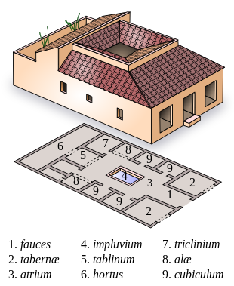

Fauces – entryway

Tabernae –

Atrium –

Impluvium – heavily shaded courtyard with fountain

Tablinum – opens onto a heavily shaded courtyard and, on the other side, a rear garden

Hortus – garden

Triclinium –

Aloe –

Cubiculum –

Legion

At one point early in the empire:

4200 infantry, 300 cavalry

First division in front: hastate – 1200 younger recruits

Second: principes – 1200 more experienced

Rear: triarii, veterans ~600 who only fought in extreme cases

Also the velites, recruited from the poorest citizens serving as light infantry

Legionnaires Carried:

Two javelins or pila (singular: pilum) (4’ long)

Long spear called a contus as well as a spatha

Gladius – short or long sword

Pugio – dagger

Mail body armor or cuirass with leather straps

Mail armor: lorica harmata

Scale armor: lorica squamata

Plate armor: lorica segmentata

Underneath the armor was a padded garment, the thorumachus

Scutum or shield – adorned with legion number and symbol, began as an oval shape, later rectangular

Helmet

Semi-cylindrical shield

Helmets: Montefortino, Coolus, Gallic, Intercisa

Leaded darts or plumbatae / martiobarbuli

Cavalry carried a smaller, lighter shield

Velites carried:

Light javelin

Light circular shield

A few had helmets but most wore wolf skins over their caps so the officers could identify them in battle

Male roman citizens wore short-sleeved tunics, but a legionary’s tunic was larger and longer and gathered at the waist by a broad belt, called the **cingulum militare**. This was an important symbol of a legionary’s status and comprised of one to nine straps and was usually ornate. They wore a patterned, rectangular cloak of heavy wool with a brooch to hold the two sides together. Some preferred the **sagum** (similar to a poncho).

Typical fighter:

**Local Deities**

Cult of Decima

**Creatures**

**Echidne, Mother of Monsters** - Long ago the gods appointed a guardian over the Oracles of Mythenia. A grand she-serpent named **Delphyne** was brought into existence, with an aspect both terrible and beautiful. When the priests of Parseion grew jealous of the Oracle of Domos, they devised a trap for Delphyne. She was banished to the outer planes and corrupted by their magic. Delphyne transformed into **Echidne**, a horrible disfigured create. She returned to Nemmyrl, but far from her home of Mythenia. She now lurks in the shadow of the Tauran Mountains in the **Sea of Drakaina**, so named for her and the terror she has spread. Here she broods in her anger, lashing out at all living creatures. She is especially vengeful of priests of any kind, snatching them up and torturing them for decades. Echdine is a seductive creature, capable of guild and illusion. She can appear as an attractive female of almost any race. Doing so, she has seduced countless victims, bearing children from them that become unspeakable monsters. For this Echidne is called **Mother of Monsters**.

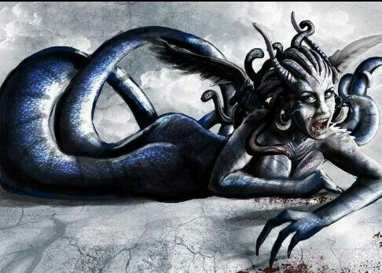

The **Aurora Aerie** - The great eagle **Hyperia** and her kin make their home high atop Aurora Mountain. They are allies of the Elves of Arbeiera and join them in their war to cleanse the land of the filth pouring out of Abraxas. They have a deep hatred of the great spiders that dwell beneath the Arcanian Mountains to the north and who serve the Saszar Drow.

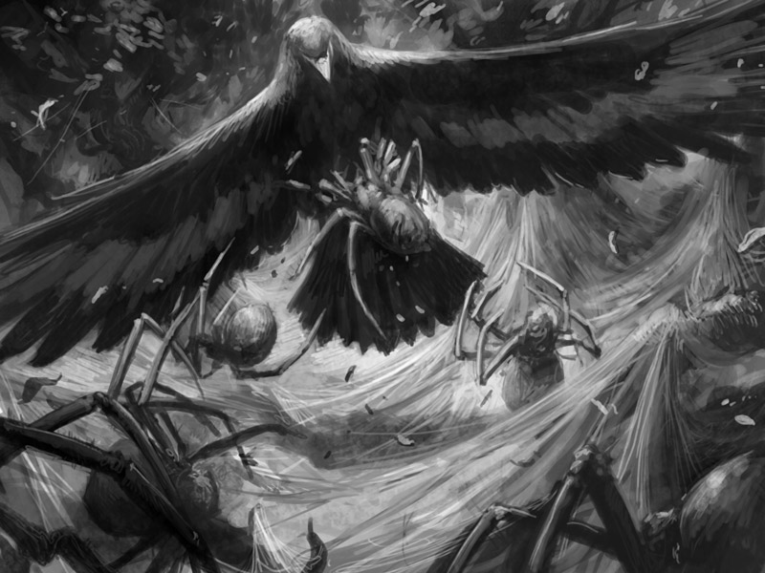

**Other Races**

**Elves**

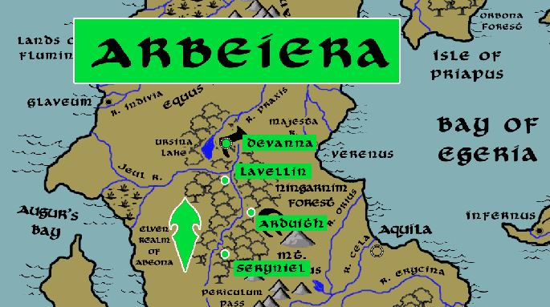

**Dwarves**

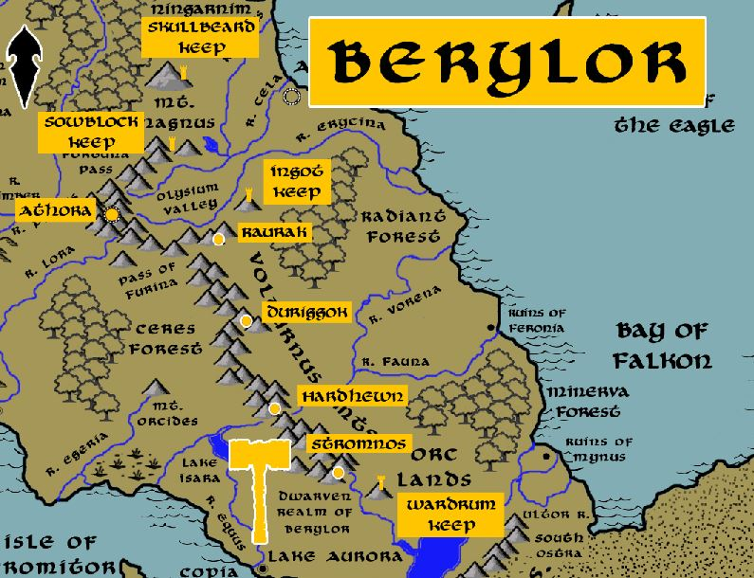

**Magical Items**

**The Sunder Staff** – an artifact capable of generating massive earthquakes, toppling mountains and swallowing entire towns. It was once wielded in 80 WA2 by the Empress Lasaril of the Drow kingdom of Saszar, who used it to conquer the Arcanian Mountains and most of the northern lands. It was lost in 804 WA2 when Heriena, Drow paladin of Sariel, led the elves of Abeiera to conquer the Saszar and free northern Celedon from their terror.

**Abraxas Stones** are magically imbued stones from the Vale of Abraxas. Each has a spell inscribed upon them in the ancient tongue of the **Sanctum of the Infernal Word**. Each holds a different power and is highly coveted by wizards and sorcerers everywhere in the world. The stones radiate pure evil and are impossible to destroy. Some say that every use of these stones brings its user a little closer to banishment to hell.

**Mirror of Aurora** – A silver mirror chased in gold trim, this artifact was gifted to man by the goddess of dawn. It is divinely blessed with the light of the dawn and the power of renewal. In 628 PA3 the cleric Aeritus wielded the Mirror of Aurora to lead the Celedon armies in victory over the hordes of Carnifex. It’s light and positive life energy utterly destroyed the undead armies from the Vale of Abraxas.

**NPC Templates**

This is a list of notes and stats to help develop NPC’s relevant to this region.

**Developer Notes**

This is a list of notes on the development of this document, including notes on history, culture, and changes to the document.

During the time of the Roman Empire, soldiers, particularly legionaries, carried a variety of essential items with them during military campaigns. These items were stored in a backpack or a wooden storage box commonly known as a "ciborium" or "cubiculum militare." Here's a list of items that would have been typically stored in a Roman soldier's locker during a military campaign:

Weapons:

Gladius (short sword)

Pugio (dagger)

Pilum (javelin)

Scutum (large shield)

Lorica Segmentata (segmented armor)

Galea (helmet)

Clothing:

Tunic (basic undergarment)

Subarmalis (padding worn under armor)

Sagum or Paenula (cloak or hooded cape)

Caligae (military sandals or boots)

Braccae (trousers)

Personal Items:

Wooden or metal mess kit (containing a bowl, cup, and utensils)

Satchel for personal items

Personal grooming items (razor, comb)

Writing materials (wax tablets, stylus)

Coins or pay tokens

Bedding and Shelter:

Cloak or blanket for warmth

Tent or tent components (if not provided by the military)

Bedroll or sleeping mat

Provisions:

Rations (grain, salted meat, dried fruit)

Cooking pot

Portable cooking utensils

Amphora or leather water container

Tools and Equipment:

Dolabra (entrenching tool)

Pioneering tools (shovel, pickaxe)

Spatha (longer sword, sometimes used by officers)

Medical kit (bandages, herbs, surgical tools)

Personal Items:

Personal religious items or talismans

Tokens or mementos from home

Sewing kit for repairs

Dice or gaming pieces for recreation

Entertainment:

Scrolls or small books for reading during downtime

Small games or dice for recreation

Miscellaneous:

Spare leather strapping and maintenance tools

Torches or oil lamps for illumination

Flasks or amphorae for carrying water or wine

Iron rations or emergency food supply

It's important to note that the exact contents could vary based on the rank, unit, and the specific needs of the campaign. Additionally, some items, like tents and cooking equipment, might be shared among soldiers in a contubernium (a small group of soldiers living and working together). The Roman military was known for its organization and discipline, and soldiers were well-equipped to endure the challenges of campaigns and military life.