Notes on the lands of the Haka’na
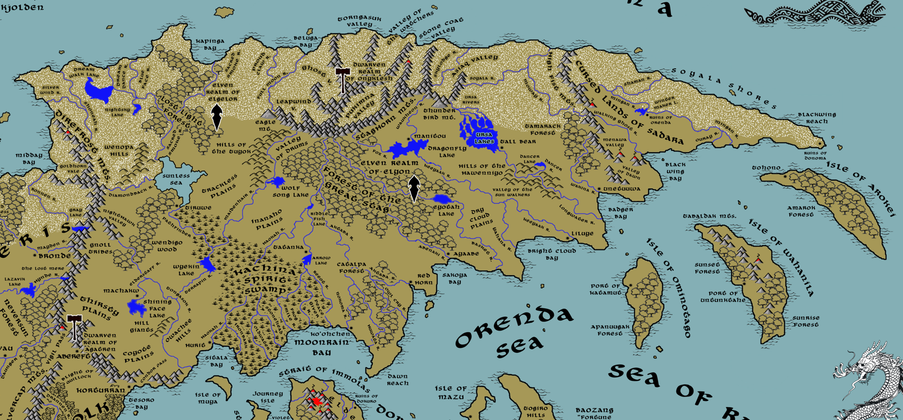

Table of Contents
- Overview
- Towns and Cities
- Best in the Land
- Stewards of Power in this Land
- Points of Interest
- History
- Local Goods
- Notes on Culture
- Local Deities
- Creatures
- Other Races
- Magical Items
- NPC Templates
- Developer Notes

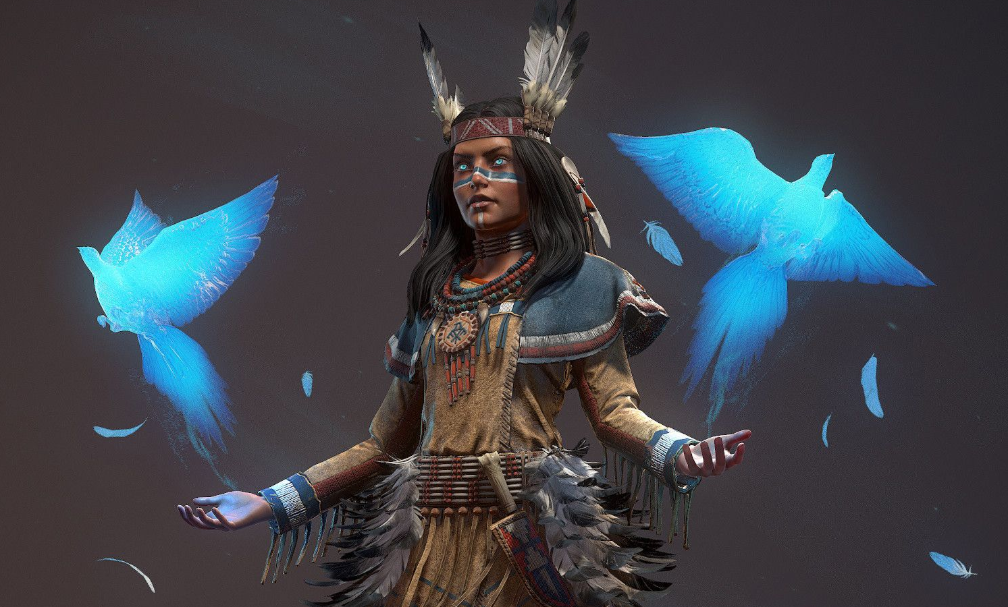

Overview
Little is chronicled of the lands east of the Direfrost Mountain range. The eastern third of the Amadar continent is a vast, unexplored wilderness settled by tribes who collectively refer to themselves as the Haka’Na or The People. Much like the center of the continent, there are no great kingdoms of men or large cities. A handful of permanent settlements have taken root around locations considered sacred to the Haka’Na. But these are no bigger than towns and few people dwell there year-round. They serve mostly as trading posts and as sacred meeting sites where ceremonies are held. Fortifications have been raised, but they look nothing like the castles and palaces elsewhere. Here stand great lodges made of timbers hardened like stone, built into cliffsides, designed around forests and marshes, in every case built along the advantages of the terrain and materials of the land.

There are sixteen tribal regions of the Haka’Na land. To the far north are the Snowbird and Sea Lion Peoples, who carve their homes into the ice above the snow line and hunt whales in the Sedna Sea. On the banks of the Sunless Sea and around the Ursa and Dragonfly lakes are the Washpaw and Otter Peoples, who live half on land and half on water. In the west, the arid plains are home to the cliff-dwelling Horse People. Those who share the Forest of the Great Stag with the elves are the forest tribes called the Elk People. The valley tribes make Sun Walker Valley their home and are called the Black Bear People. The nomadic plains tribes travel from the Hills of the Tuyok all the way to the Catalpa Forest and are the Buffalo People. The Heron People dwell in the safety of the Lost Spirit Swamps, fashioning villages amongst the reeds. And all along the southern coast Badger, Wolf, Eagle, and Moose Peoples. Finally, across the southern waters lie the island tribes who keep to themselves for the most part. They are fishermen and the only Haka’Na who have explored the open sea, and they are the People of the Geese, the Hawk, and the Whale.
Settlements (Towns and Cities, after a fashion)
The Haka’Na are mostly a nomadic people but after countless years of movement there are sacred crossroads where tribes have established settlements. While these are established towns, they differ from towns in the west as property isn’t held as the possessions of any elite class. Towns are more collections of villages working together for protection with a council of tribal leaders governing the area. When feuds break out they are settled far from the towns, as the people consider these areas as sacred. Instead, war parties ride out to the wilderness where their deeds can be seen by the spirits and their bravery acknowledged.

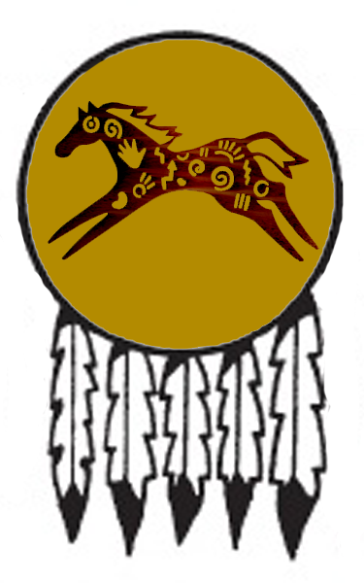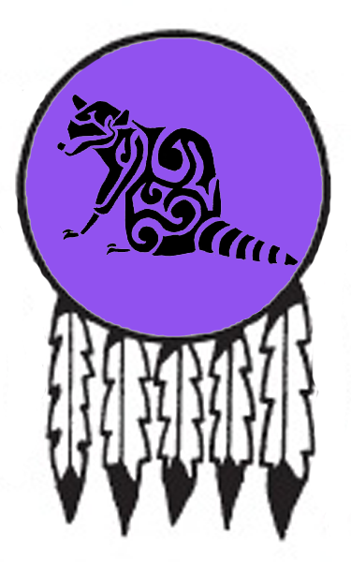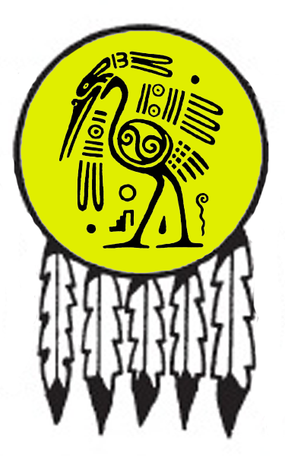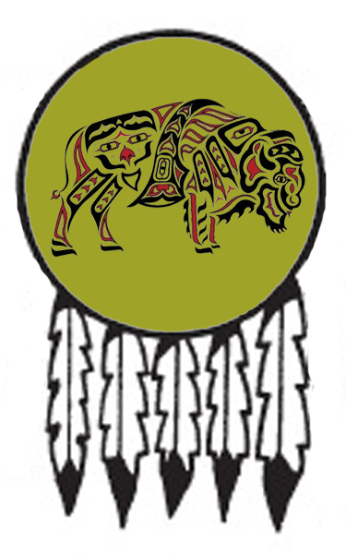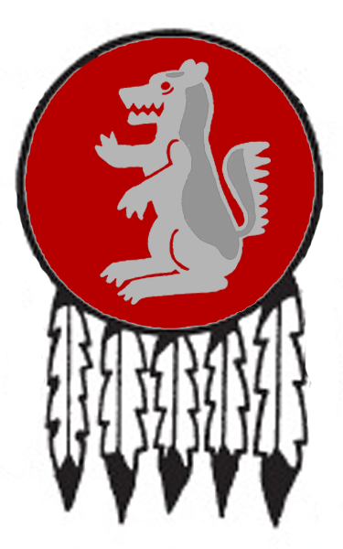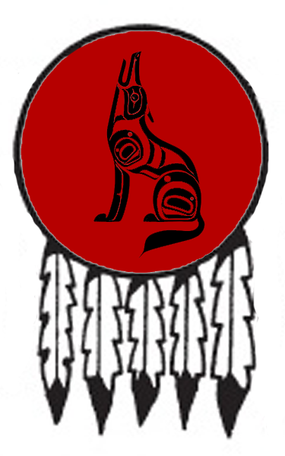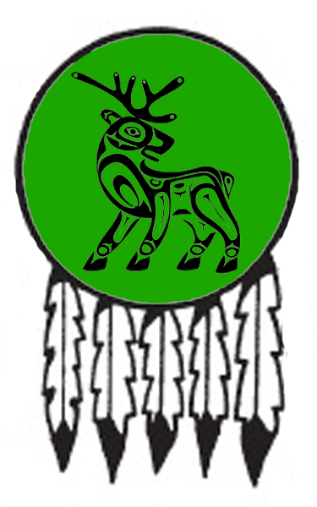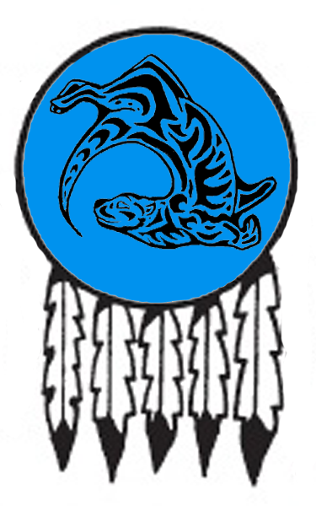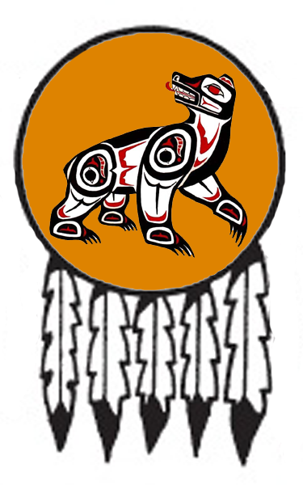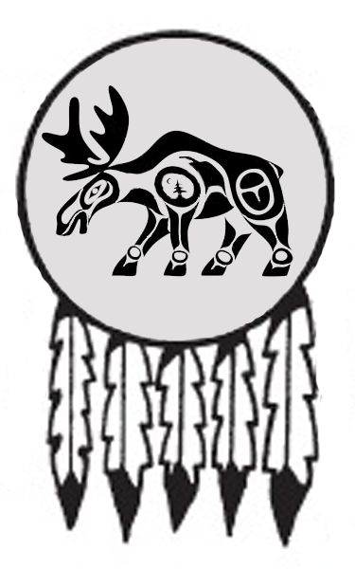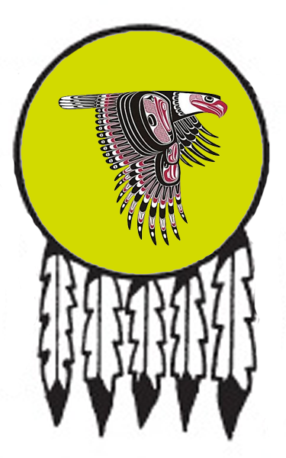
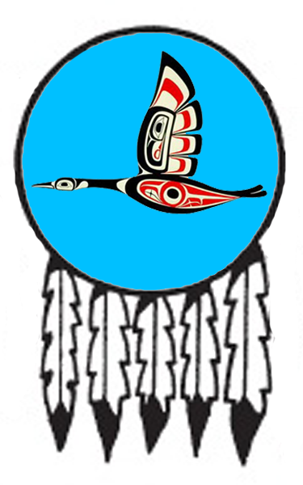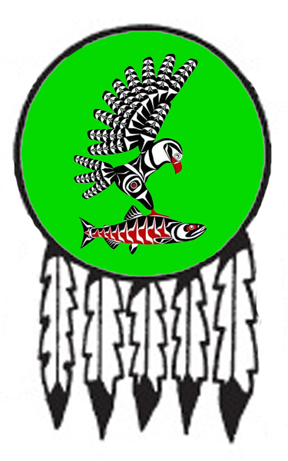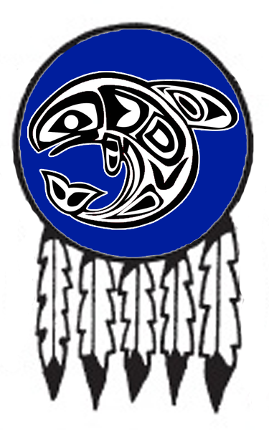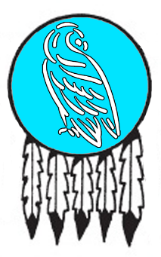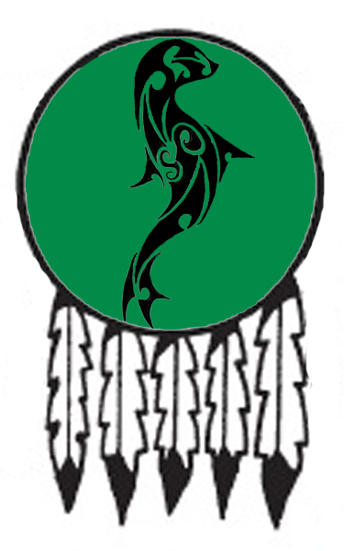
- Machakw – small town, sign of the horse, home to the Horse People
- Tiruwe – small town, sign of the raccoon, home to the Washpaw People
- Hurit – large town, sign of the heron, home to the Heron People
- Tatanka – large town, sign of the buffalo, home to of the Buffalo People
- Ko’Ohchen – large town, sign of the badger, home to the Badger People
- Ioskeha – large town, sign of the otter, home to the Otter People
- Red Horn – small town, sign of the wolf, home to the Wolf People
- Ayaabe – large town, sign of the elk, home to the Elk People
- Tall Bear – small town, sign of the bear, home to the Black Bear People
- Liluye – small town, sign of the moose, home to the Eagle People
- Unetuuwa – small town, sign of the eagle, home to the Moose People
- Katamut – small town, sign of the geese, home to the Geese People
- Untunktahe – small town, sign of the hawk, home to the Hawk People
- Tohono – small town, sign of the whale, home to the Whale People
- Snowbird People – tribes around the Dream Walk Lake far to the northwest
- Sea Lion People – tribes around the Soyala and Moway Rivers far to the northeast

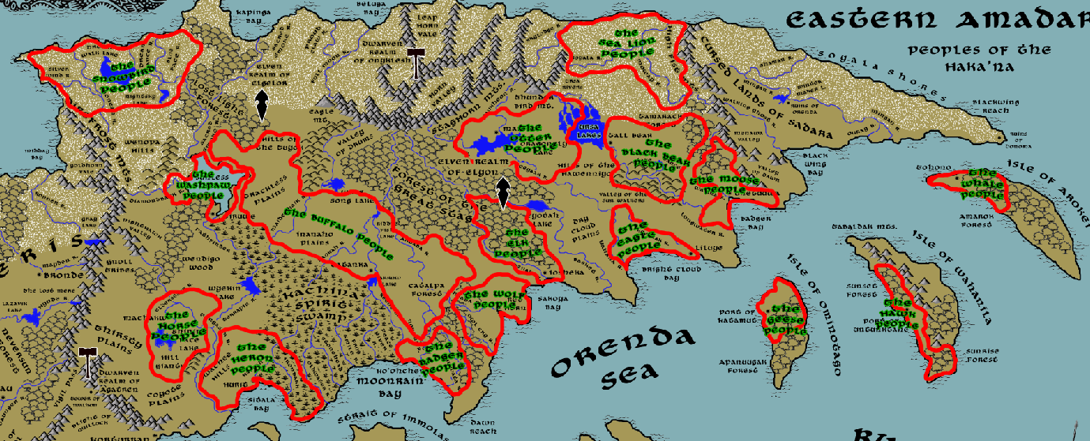

Best in the Land
Trade Hub: Ko’Ohchen, Ayaabe
Religion:
Arts: Machakw
Magic: Ioskeha
Spirits: none
Steel: none
Grain: Red Horn, Ayaabe, Liluye
Crafted Goods (e.g. Pottery, Textiles, Metal Wares):
Pottery: Tiruwe, Ko’ohchen
Harvested Goods (e.g. Aromatics, Medicine, Dyes):
Tobacco: Tiruwe, Tatanka, Red Horn, Ayaabe, Liluye, Untunktahe
Medicine: Ioskeha
Dyes: Katamut
Mined Goods: (Iron) Hurit, (Stone) Unetuuwa,
Precious Metals: (Copper) Ioskeha, (Platinum) Untunktahe, (Gems) Unetuuwa, Tall Bear (Gems)
Ship Building:
Other:

Stewards of Power in this Land
Kings and their armies are not the only wielders of power. There are many unseen friends and foes that shape the destiny of the land. Each of the groups listed below are well known to the people of this region. Some are feared, others venerated. All of them play their part in the grand drama of this land’s story.

Merchant Companies
Everwind Traders – Ayaabe
Father Sky Traders – Untunktahe

Mercenary Companies
Night Hunt – Red Horn

Smuggling Rings
Sons of Azeban – Red Horn

Centers of Worship (Churches, Cathedrals, Shrines, Lodges, Temples)
Lodge of Orenda - Machakw
Circle of Gendenwitha - Tiruwe
Lodge of Maminnic - Tatanka
Seven Fires Council - Ioskeha
Lodge of Sassaba – Tall Bear
Lodge of Tabananica - Unetuuwa
Lodge of Chetanzi - Tohono

Orders of Paladins
Order of the Rain Bird – Machakw
Order of the Sky Mother - Ioskeha
Order of the Blood Oath – Red Horn

Druidic Circles
Circle of Amadahy - Tiruwe
Circle of Uktena - Hurit
Circle of the Green Corn - Tatanka
Circle of the Sky Woman - Ioskeha
Circle of the Magpie – Tall Bear
Circle of Tainuwa - Liluye
Circle of Kiviok - Untunktahe

Bands of Rangers
Band of the Water Beetle - Machakw
Band of the Yarrow - Tiruwe
Band of the Samoset - Tatanka
Band of Kanati – Ko’Ohchen
Band of Haokah- Ioskeha
Band of the Half Moon – Red Horn
Band of the Darkwood - Ayaabe
Band of the Four Hares – Tall Bear
Band of the Mountain Lion - Unetuuwa
Band of the Thrush - Katamut
Band of the Red Throated Loon - Tohono

Schools of Magic
Tenskwatawa Sanctum – Ioskeha

Bardic Colleges
Lodge of the Twisted Hairs – Machakw

Warrior Academies
(none)

Assassins Guilds
(none)

Cults
Cult of Uncegila – Ayaabe

Other Guilds
(none)

Monasteries
Lodge of the Shadow Guardians - alongside the Dream Walk Lake
Lodge of the North Wind Bear - Horn Mountains, at the head of the Maiden Hair River
Lodge of the South Wind Fawn - Dawn Reach, southern end of the Catalpa Forest
Lodge of the East Wind Moose - In the High Fist Mountains at the head of the Wakina River
Lodge of the Stone Throwers - northern edge of the Stag Horn Mountains
Lodge of the Messenger Birds - forest of the Great Stag, along the Abenaki River
Lodge of the West Wind Panther - overlooking Night Hawk Valley
Lodge of the World Bearing Turtle - Isle of Arokei

Pirates
(none)

Points of Interest
- Standing Isle
- War Cry Island
- Kapinga Bay
- Beluga Bay
- Badger Bay
- Bright Cloud Bay
  - Here lurk the tribe of Sahuangin known as the Rivaktha, known by their sign of a circle of jagged teeth surrounding a small fish.
- Sakoya Bay
- Dawn Reach – site of the Lodge of the South Wind Fawn, where monks train and study in the ways of Ne-o-ga the South Wind Fawn
- Moonrain Bay
- Sitala Bay
- Fool’s Inlet

- Wendigo Wood – home to the wendigo
- Lost Light Forest – home to the wild elves of Elgelor
- Forest of the Great Stag –
  - Home to the Great Stag, spirit of the woods
  - home to the forest elves of Elyon
  - home to the great green dragon Kaliska
- Tamarack Forest
  - The Tamarack Forest is the home of the Gorokum tribe of gnolls, known by their sign of a bleeding moon.
- Catalpa Forest
  - The Catalpa Forest is the home of the Haraka tribe of gnolls, known by their sign of the bird divided into five parts.
- Yarrow Wood

- Silver Wind Plains
- Thirsty Plains
  - stomping grounds for the Omekh tribe of gnolls, known by their sign of the three paw prints facing inward in a pyramid arrangement
- Trackless Plains
- Inanaho Plains
- Coyote Plains
  - Kohuz tribe of gnolls roam the Coyote Plains, known by their sign of the burning rabbit
- Life Giver Plains – A long stretch of grassy plains that runs from the Aktaba River to Sakoya Bay, passing between the Great Stag and Catalpa forests. The Buffalo People make their annual pilgrimages south into these plains each winter where it is easier to find game and provender. The rich soil this far south is likely why the towns of Red Horn and Ayaabe enjoy such rich harvests.
- Dry Cloud Plains

- Nokaqua River
- Sohani River
- Shoneah River
- Dream Dance River
- Sacred Smoke River
- Wiyotka River
- Moonfall River
- Proudclaw River
- Skylodge River
- Soyala River – region is home to the Sea Lion People
- Ursa Rivers
- Watani River
- Moway River – region is home to the Sea Lion People
- Basket River
- Sandal River
- Diamondback River
- Pathfinder River
- Maidenhair River – at the head of the river is the site of the Lodge of the North Wind Bear, where monks study and train in the ways of Ya-o-gah the North Wind Bear
- Terrapin River
- Warren River
- Ironbark River
- Oldwater River
- Stonehead River
- Nakoma River
- Frog Smile River
- Peace Giver River
- Haokah River
- Reeot River
- Aktaba River
- Owl Cry River
- Abenak River
- Tishani River
- Fox River
- Waukheon River
- Kishota River
- Keeyaak River
- Hawkturn River
- Somber River
- Longwater River
- Dancer River
- Wakina River – at the head of the river is the site of the Lodge of the East Wind Moose, where monks study and train in the ways of O-yan-do-ne the East Wind Moose

- Dream Walk Lake – home to the Snowbird People
  - site of the Lodge of the Shadow Guardians, where monks train and study in the ways of Oh-do-was, the Shadow Guardians
- Nightsky Lake
- Sea of Orenda
- Shining Lake
- Wyekin Lake
- Wolf Song Lake
- Riddle Fish Lake
  - On the southern edge of the lake, where the Haokah and Reeot rivers diverge, stands the tower of Wanahton of the Wind Speakers, Arch Mage of the Haka’Na lands.
- Arrow Lake
- Dragonfly Lake
- Eyotah Lake
- Ursa Lakes
- Dancer Lake

- Kachina Spirit Swamp – The vast tracts of swampland at the center of the Haka-Na territories is a kingdom unto itself. The Haokah and Reeot rivers and the rivers that break off from them weave through this damp and marshy land, heavily forested with red, yellow, white, and black cypress trees as well as the water tupelo and various oaks. At the center of this immense swamp stands the mighty Kankakee, a massive bald cypress that dates back to the dawn of Nemmyrl itself. Kankakee is one of the largest and oldest treants. He is connected to the entire Kachina swamp and is aware of every creature in it. He patiently watches over these lands and is its custodian, caring little to interfere with the affairs of humans or any other race as long as the swamps maintain a balance of life.
  - Home to four Saurian tribes: the Slizz to the north, the Heekra to the east, the Rakarr to the south, and the Sekkasit to the west. Each is known by their mark, a simple tree symbol with an ‘X’ scratched above, below, or to either side of the tree corresponding to the location of their tribes relative to the Kankakee at the center of the swamp lands.
  - home to the great black dragon Mahkah
- Willow Mire

- Staghorn Mts.
  - At the northern-most point of the mountains, looking out onto the northern seas, is the Lodge of the Stone Throwers. Here, monks study and train in the ways of the Ga-hon-ga, the Stone Throwers.
  - Here dwell the Kilx tribe of goblins, known by their mark of three concentric half-ovals representing cave openings
  - The eastern reaches of this large mountain range complex is where dwell the Stonka tribe of goblins, known ty their mark of lightning striking a mountain peak.
  - Overlooking the Leaphorn Vale in the north is Aldebaran, home to the Elenar Star Elves and their domain of Cetaris.

- Thunderbird Mountain – Tall, grim, and imposing stands the largest peak in the eastern Staghorn Mountain range. Lightning flashes at its summit, where thin clouds encircle the top from view. Thunder rumbles through its length, sending shock waves to the surrounding area. This is home to Waukheon, the great Thunder Bird, symbol of strength and spiritual wisdom as well as guardian against the crafty giant serpent Uncegila. Few dare to scale the mountain, for tendrils of electricity and avalanches follow in the wake of Waukheon when he is angry. Only the most pious of shaman may enter, hoping for a boon from the great bird.
- Eagle Mt. – home to the great silver dragon Kiyiya

- Wenopa Hills – home to the Stone Coats, a race of stone giants
- Tuyok Hills
  - Here dwell the tribe of Hill Giants known as the Moksha ("mountain.")
- Owachee Hills
  - Here dwell the Hill Giants known as the Karawaq, so named for their chief who was slain four thousand years ago.
  - last known location of the evil witch Wambleeska
- Hawenniyo Hills
  - Here dwell the tribe of Hill Giants known as the Ohnaka ("rocky place.")
- Direfrost Mountains – this range of mountains extends from the seas in the north to the Myriad Sea in the south, creating the westernmost barrier of the Haka’Na Lands.
  - At the southernmost tip of the mountain range dwell the tribe of Storm Giants known as the Waldaha, known by their sign of the cloud trailing six diagonal lines
- Vigil Pass - Older warriors from the Order of the Rain Bird retire to a special lodge they built overlooking Vigil Pass in the Direfrost Mountains. They watch the pass, always remembering the evil that has emerged out of Ongolk in the past.
- Condor Pass – site of the War of Tesoro in the Third Ancient Age, when rumors of platinum in the Direfrost Mountains sparked an invasion of prospecting ships. Haka’Na warriors fought alongside the dwarves of Agatren to repel the armies that came, but only after thousands perished. Today the pirate town of Korturran looms on the far side. But Rangers from the Band of the Water Beetle out of Machakw guard the pass and are quick to repel any unwanted visitors.
- Nighthawk Valley – home to the Omekh tribe of gnolls
  - In the mountains overlooking Nighthawk Valley is the Lodge of the West Wind Panther, where monks study and train in the ways of Da-jo-ji, the West Wind Panther
- Valley of Drums – In the warmth of the summer season the Buffalo People make camp north of Wolf Song Lake. Some even travel as far north as the head of the Maidenhair River. Hides are cured and stretched on frames. Some are fitted for new drums. It has become a custom of these itinerant dwellers to play their drums at night, the sounds echoing off the Staghorn Mountains. Some say it is this annual tradition that wards off evil spirits that threaten during the winter.
- Leapwind Valley
- Pukimna Valley - home of the Moon Palace, temple to the moon goddess Ataeinsic. It is said on each full moon Ataensic extends a bridge from her home on the moon and visits her palace.
- Ghost Valley
- Torngasuk Valley –
  - the great white dragon Ciqala dwells in the valley here
  - within the mountain peaks here dwell the tribe of Frost Giants known as the Käsklä
  - Overlooking the Torngasuk Valley is the Elven domain of Cetaris and its isolated city Aldebaran, home to the Elenar Star Elves
- Valley of the Watchers – thin, towering spires of pale blue encompass the land on either side leading north to the ocean. Near the tops of the peaks, thick veins of sapphire sparkle in the sunlight. These are the eyes of the watchers, believed to be the mountain guardians who see all men’s deeds and remember. In some places skillful hands have carved ominous figures looking down on the valley floor. In some places, their eyes are placed perfectly around sapphire deposits, giving them an eerie blue-eyed stare. In other places small water falls or sliding rock deposits make the watchers’ eyes seem like they are weeping.
  - Here dwell the tribe of Frost Giants known as the Kuinak
- Stone Coat Valley
  - Here dwell the tribe of Stone Giants known as the Ashiwi (Zuni word for "stone.")
- Asiaq Valley
  - Here dwell the tribe of Frost Giants known as the Kusthak
- Sun Walk Valley – A verdant carpet of grasslands sits within the sheltering arms of the Hawenniyo Hills. Sunlight glistens off the Longwater River that wanders through the valley. Copses of trees bloom in the spring, filling the air with a perfumed scent. This is sacred land, blessed by the fertility spirit Hawenniyo. It is said that rain falls here without a single cloud lingering. Outlanders may wonder why tribes have not settled these lands, but that is forbidden. Haka’Na are only allowed to travel here to pray and offer sacrifices. It is customary only to lodge in tanglewood brush that naturally grow into large, circular canopies. Anyone spending the night in any man-made shelter of any kind is plagued by the wildlife and driven off.
  - It was here in 815 WA3 that the evil shaman Hehosho invaded with this Sadaran army Black Sky and defiled this holy place to make it his stronghold. At last in 821 WA3 during the Battle of Sunwalk that the combined forces of Haka’Na warriors and shaman defeated Hehosho and freed the valley from its curse.

- Elgelor - Elven Domain - Hravaeran or Fauna Elves
  - Adanell - Elven town of Elgelor
  - Venlana - Elven town of Elgelor
  - Briareth - Elven town of Elgelor
  - The wild elves of Elgelor have made Lost Light Forest their citadel in the cold northern reaches. They are experts at fighting the wendigo, the yeti, and many other monsters unique to the Haka’Na wilderness. They pray to older gods than most elves do, and study the facets of nature that seem beneath consideration. It is nothing for an Elgelor elf to study the moss on a rock for days, or listen to a tiny brook to decipher if it is speaking. Of all the fauna elves, those from Elgelor are a breed apart.
  - The elves of Elgelor are not overly friendly, having little to do with humans. Sometimes they make an exception for the Snowbird People, who understand the region and share a common struggle above the snow line. Every spring a group will meet with the Buffalo People when they make their trek north. The Washpaw People in Tiruwe amuse and annoy them. They know of their custom to send young hunters up the Sacred Smoke River into their lands. If the hunter shows proper respect, they are tolerated. But more than one human has been sent downriver strapped to a log for their impudence. They are known by their standard, the cardinal.
  - (refer to atlas on Elgelor for more information)

- Onyklesh - Dwarven Kingdom
  - Stone Harbor - Dwarven town of Onyklesh
  - Kwartzenor - Dwarven city of Onyklesh
  - Underspire - Dwarven town of Onyklesh
  - Slateshield - Dwarven town of Onyklesh
  - Wardrum Keep - Dwarven outpost of Onyklesh
  - Granite Keep - Dwarven outpost of Onyklesh
  - Blue Keep - Dwarven outpost of Onyklesh

- Elyon - Elven Domain - Hravaeran or Fauna Elves
  - Oritiris - Elven town of Elyon
  - Naerdya - Elven town of Elyon
  - Alais - Elven town of Elyon
  - Nabreith - Elven town of Elyon
  - Evanara - Elvent city of Elyon
  - Moondown - Elven town of Elyon
  - Silvyr - Elven town of Elyon
  - The largest settlement of wild elves in Nemmyrl, Elyon peacefully co-exists with the Haka’Na tribes of humans of eastern Amadar. Rarely do the elves venture from their woods, but emissaries are received in peace from nearby Manitou. Unlike other elven kingdoms, Elyon eschews grand, cathedral-like palaces amidst the trees in favor of earthier dwellings that blend in better with the foliage. Elyon elves are wary of outsiders, especially those that don't seem at home in the woods or are not from Manitou, and they are keen to hide their presence. It is boasted than an unknowing traveler could stroll through the midst of the Great Stag Forest without even knowing they were in the presence of a sprawling elven kingdom. The scouts of Elyon are reputed to be the best rangers in the world and virtually invisible in their environment. The elves of these woods have fought a centuries-old war with the Drow kingdom that lurks beneath the Hills of the Tuyok to the west. They are known by their standard, the blue jay.
  - (refer to atlas on Elyon for more information)

- Cetaris – Elven Domain - Elenar or Star Elves
  - Aldebaran, home to the Elenar Star Elves, overlooking Leap Horn Vale in the Staghorn Mountains
  - The Star Citadel, as the elven town of Aldebaran is so named, stands a lonely vigil in the high peaks of the far north of Western Amadar. A reclusive and enigmatic race of elves, the Elenar or star elves dwell here in solitude. They have little to do with the world, even the rest of elven kind. Here they tarry in peace, pondering the heavens and consulting complex diagrams of the constellations. Some say they seek information on the future, others say they are masters of time itself. Few who travel here ever remember what their eyes befell, but speak of a place of serenity and great wonders. They are known by their standard, the star bird.
  - (refer to atlas on Cetaris for more information)

- Hill Giants
- Gnoll Tribes – Omekh tribe out of Nighthawk Valley region and roam the Thirsty Plains, Kohuz roam the Coyote Plains

- Isle of Muya – uninhabited island, often used by pirates out of Korsair Bay for safe haven in storms. The land is mostly volcanic and barren. Shrubs and strange small trees grow sparsely. Enormous crabs the size of a full-grown man make this a nesting area. They are dangerous and capable of lopping off entire limbs if provoked.

- Isle of Ominotago
  - Port town of Katamut and home to the Geese People
  - Apanuugak Forest – home to the great bronze dragon Adahei
- Isle of Wahanila
  - Port town of Untunktahe and home to the Hawk People
  - Sunset Forest
  - Sunrise Forest
  - Tabaldak Mountains –
    - At the northern tip dwell the tribe of Storm Giants known as the Kipichuk, known by their sign of the broken cloud
    - At the center of the mountain range dwell the tribe of Stone Giants known as the Unguluk
  - Celerithe – Sea Elf Domain – located off the island of Wahanna
- Isle of Arokei
  - Port town of Tohono and home to the Whale People
  - Amarok Forest – home to the great gold dragon Ohitekah
  - Arokei is the site of the Lodge of the World-Bearing Turtle, where monks study and train in the ways of Hah-nu-nah, the World Bearing Turtle

Machakw
Size: small town, population 2,000, guards / soldiers 20, militia 100
Trade Goods: cotton, flax, livestock, arts
Local Goods: horse breeding
Standard: horse
Colors: brown and black
Patron Deity: Tawa – sun spirit and creator of men, flanked by his Kachina nature spirits
Ruler: Chief Kwatoko and his wife Yatyokya (f)

Home: Wildmane Lodge
Steward: Yiska
Marshal: Tohopka
Head Shaman: Spirit Walker Sikyatavo the Walker on Winds (m)
Wild Mage: Honani (f)
Head Warrior: Kachada
Chief Warriors in Service:
Haloke
Shiye
Wikvaya

Local Powers: Red Path (thieves guild), Lodge of Orenda, Band of the Water Beetle (band of rangers), Twisted Hair Lodge (bardic college), Order of the Rain Bird (order of paladins)
Local Sites: Ten Beads Inn & Tavern, The Deer Woman Inn & Tavern

Description:
Long ago, at the westerly turn of the Elderstaff River, the old shaman Kahaneweic drove his walking stick into the ground, causing the earth to seize and buckle. Mighty stones rose up and stretched high into the air, forming a wide stretch of cliffs towering over the land. Today the people of Machakw make the cliffs their home. Openings to their dwellings dot the side of the giant escarpment. Along the riverbanks below earthen dwellings sit atop a sward overlooking Shining Face Lake. The dwellings, called hogans, are a variety of shapes and sizes: round, cone-shaped, multi-sided, and square. They are arranged in concentric circles surrounding a large cleared area serving as the town square where a handful of larger, eight-sided hogans stand, just near the lake shore.

Just outside of town large yucca shrubs grow, their white flowering plumes decorating the countryside. Corrals run outside the edge of town filled with horses, sheep, and goats. North of town, white and purple fields of cotton and flax illuminate the tops of the cliffs.

Machakw sits as an oasis in the wide spaces of the western Haka’Na lands. It serves as host to the numerous nomadic tribes that cross the western plains. It is typically the first stop for overland travelers crossing the Lost Spirit Swamp region heading west or travelers coming out of Vigil Pass heading east.

Industry:
The people here are simple farmers, but their first love is for the mighty horses that they capture on the plains. When not riding the open plains, people work fields of cotton and flax. These are harvested and baled for trade with visiting tribes or taken overland to sell in Hurit. Herds of cattle are kept on the eastern side of the river and taken north to graze.

Key Figures:
Chief Kwatoko - somber, worried, cheerless

Chief Kwatoko is a tall man with broad shoulders and a proud walk. He wears his long black hair up in a tsiiyeel knot and a necklace of beads hanging low around his neck. He says little, listening to the elders of the clans who live here and envoys from visiting parties before he speaks. His dark eyes seem distracted, scanning the horizon. Kwatoko is known as the Worried Gopher to his friends, always watchful of danger approaching from the lands out of sight. He was once a brave, going out on expeditions to patrol the far lands. He has seen his share of dark creatures fouling their water, preying on their cattle and people. He sees himself as the watchmen of the west, for he knows the stories of what has come out of the Ongolk Lands. Secretly he longs to go out on the hunt and fight the unseen enemy, but the burden of leadership keeps him at home.
Around his neck Kwatoko wears the Sky Beads, given to his great-grandfather by the Rain Bird himself. It is said that each of the five colored beads does something special: one will bring rain, one will bring thunder, one will make sickness go away, one will bring courage, and one will split the land as if struck by a giant hand.

Yatyokya (f) – wife of the chief -

Order of the Rain Bird – Mounted riders that follow a path of dedication to the land are inducted into this sacred order of warriors. Their shields decorated in bright colors, they ride as far north as the Tiruwe Sea, down into the Thirsty Plains, and on past the Coyote Plains to the sea. They are protectors of all who travel these dangerous lands and seek out fell creatures who would corrupt the land. Older warriors retire to a special lodge they built overlooking Vigil Pass in the Direfrost Mountains. They watch the pass, always remembering the evil that has emerged out of Ongolk in the past.

The Band of the Water Beetle patrols the Thirsty Plains, making forays north to the Wendigo woodlands and south to the Coyote Plains and Owachee Hills. The rangers move without being seen, riding at night and watching the horizon at day. It is common for the braves to ride back to the town with the heads of evil creatures that lurk in the area.

Outside the town lies the Lodge of the Twisted Hair. It is here that master storytellers and musicians of the Haka’Na have been trained since the beginning. Each storyteller who hails from Machakw is called a Twisted Hair. Elders from tribes across the land travel here to share their oral histories. These are captured in the sacred smoke of the storytelling ceremony and preserved within mystic totem poles, called the Keepers. Master story-keepers of the Haka’Na are able to commune with these totem poles and recount the stories, sometimes even raising up the spirits of ancestors to tell the stories themselves. In this way, the Master Storytellers working with tribal singers and dancers serve the same functions as bards or minstrels from other lands. The lodge is considered the center of Haka’Na culture. Master singers, dancers, and storytellers are sent here to be trained to illuminate the people of villages all over this land.

Local Lore:
Masawu Pit – The shaman’s lodge contains a sacred Masawu fire pit. When lit, it iis connected to the Masawu fire pit in the lodge of the Seven Fires Council in Ioskeha. These were created by Masawu, the spirit known as the Skeleton Man and holder of the secrets of fire. On each new moon the flames are lit in every pit and elders from all peoples enter a trance. Masawu transports them temporarily into the ethereal plane, which they call the Fifth World, and they appear before the fire in Ioskeha as ghostly apparitions. Here, elders can commune with one another on matters of council business.

Gnoll tribes control the plains. The Omekh tribes venture south out of the Nighthawk Valley region and terrorize travelers crossing the Thirsty Plains. They are said to carry a magic stick called the Rain Thief that consumes all water that it touches and which the gnolls use to lay waste to the land. They are known by their sign of the three paw prints facing inward in a pyramid arrangement.

The Kohuz tribes of Gnolls venture north out of the Direfrost Mountains to stalk the Coyote Plains. They are notorious thieves and have become more aggressive to outlying farms. They are known by their sign of the burning rabbit.

Herds of wild horses roam the plains around Machakwe. Among these normal horses sometimes appear the Johano: a magical breed of horses that are said to have come from the spirits of the sky. They may appear in one of the five colors of the day-time sky: turquoise, white shell, pearly shell, red shell, and coal.

Tawa, the sun spirit, is the patron deity of the Horse People. Accompanied by his Kachinas, nature spirits, he protects the people. The Kachinas are:

* Eototo (weather spirit and chief of the kachinas)
* Angwusnasomtaka (Crow Mother, mother figure of all the kachinas),
* Kokopelli (the fertility spirit)
* Mongwa (owl spirit and enforcer of the law,)
* Angak'china (long haired kachina, a spirit of rain and flowers)
* Mana (corn maidens, spirits of agriculture.)
* Cheveyo - ogre kachina, very scary
* Koshari - a sacred clown

History:
Eight thousand years ago the peoples of Machakw and Hurit waged a great war in the region around the Tongasok River. The War of the Plain Spirits lasted twenty long years and cost many lives. At last the two peoples made peace and agreed to share the land (360 PA1). It is said an evil witch named Wambleeska was the cause of the war, seeking to control the region. She was never found and is rumored to dwell to this day in the Owachee Hills spreading mischief.

Three thousand years ago (400 WA1) the hill giants out of the Owachee grew restless and began raiding the town. A female brave named Ciqala led the Water Beetles on a daring counter raid. Ciqala was met on the plains by the great Rain Bird and gifted a magical weapon called the Singing Spear. The spear is said to cry with the yells of all it has slain. Over the course of eight years, she and her party slew seven terrible giants, including their chief, Karawaq. Ciqala was renamed Ciqala Singing Spear and is a legend among the people of Machakw. The few hill giants who remain in this area are referred to as Karawaq, after their chief of old.

Seventeen hundred years ago the evil sorceress Mortavay launched her First Dark Crusade, beginning with invading Haka’Na lands. Machakw was destroyed by orc armies (720 WA2). But the tribes of Haka’Na rallied quickly. With every town and tribe responding to the oncoming threat, a great host was mustered east of the Tongasok River. In 724 WA2 the Battle of Moon Lake saw the defeat of Mortavay’s forces. Several thousand Haka’Na braves fell, but the evil was checked. Once Mortavay’s armies were destroyed in 745 WA2 the Haka’Na attacked and destroyed the rest of the evil creatures occupying the Thirsty Plains. Machakw was rebuilt and a giant stone totem pole erected commemorating the struggle. Facing westward, the grimacing face of the Great Thunder Bird is ever watchful of Vigil Pass. It is said the pole is enchanted with the spirit of Waukheon himself and will defend the town against any evil.

Customs:
The people here and in the western lands are known as the Horse People. They revere the mighty steeds of the open plains and commune with them. Children are raised on the backs of horses and by the time they are young adults are experts at fighting from horseback and guiding their steeds with commands. Every warrior here is trained to fight from horseback using both hands and steering with their legs. It is a rite of passage for a young man or woman to travel into the prairies and bring back a steed as their own. One who accomplishes this has a bond for life with their horse and is marked with a special tattoo showing there are a Horse Friend.

Hospitality is freely given to travelers, for the Thirsty Plains to the west can be an arduous crossing. But warriors among the tribes are vigilant to threats coming out of Vigil Pass and Gnoll tribes to the north are a regular threat. Expeditions are sent upriver to explore the spur of peaks breaking off the Direfrost Mountains, but the risk is high moving through Wendigo Wood.

The people of Machakw traditionally wear their hair up in a knot they call a tsiiyeel. The hair is washed with yucca root, then combed with a bundle of stiff grass called a be’ezo, then wrapped in white sheep’s wool spun into yarn. It is believed the first people in this land were born of the sun and rain clouds, which formed their hair. The sun created a band of light to allow the people to tie back their hair and gather their thoughts. And so it is to this day, the Machakw tie their hair back as a sacred rite devoting themselves to clear thought and purpose.

Other traditional structures include the summer shelter, the underground home, and the sweat house. A hogan can be round, cone-shaped, multi-sided, or square; with or without internal posts; timber or stone walls and packed with earth in varying amounts or a bark roof for a summer house, with the door facing east to welcome the rising sun for wealth and good fortune.

[Developer’s Note: The Horse People are loosely based on the Apache, Navajo, Paiute, Laguna, Zuni, and Hopi]

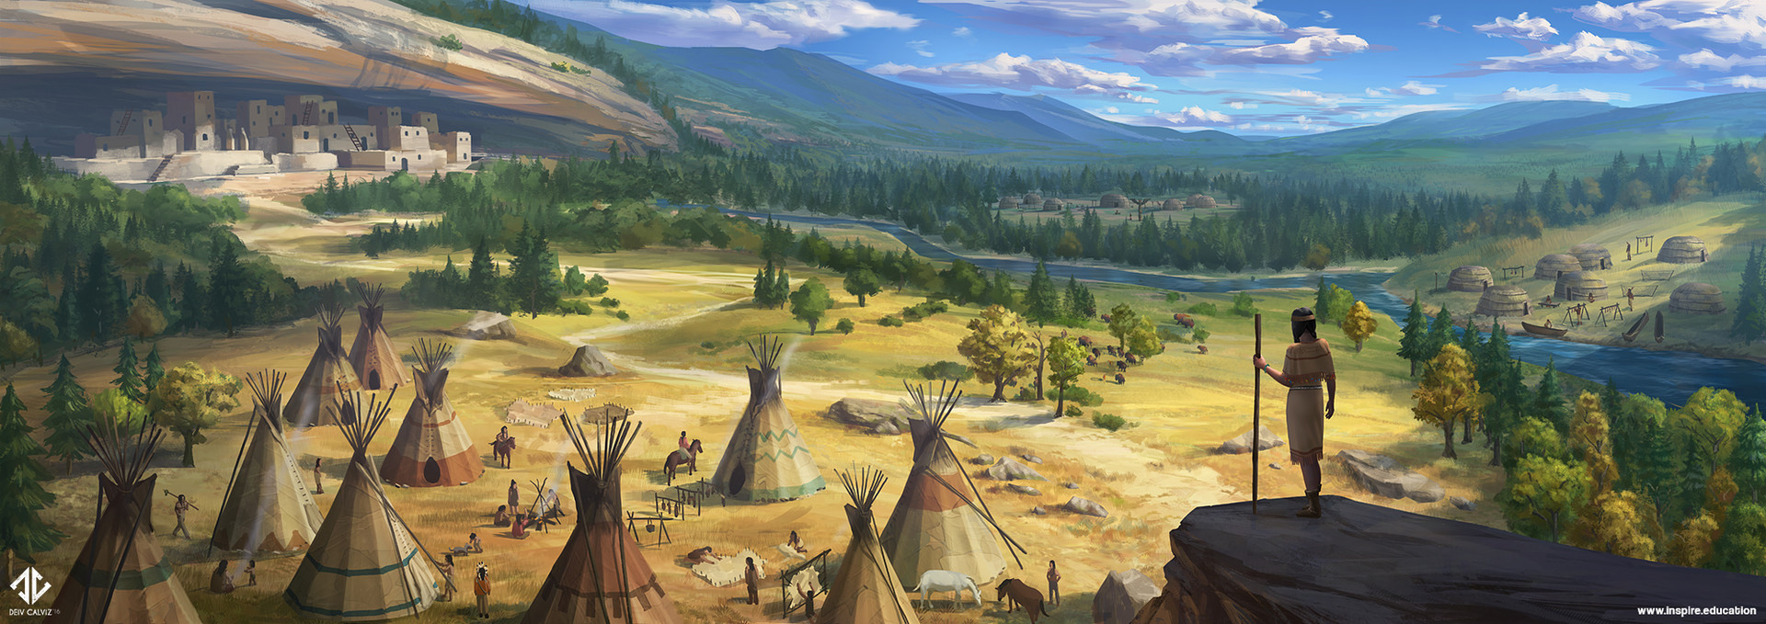

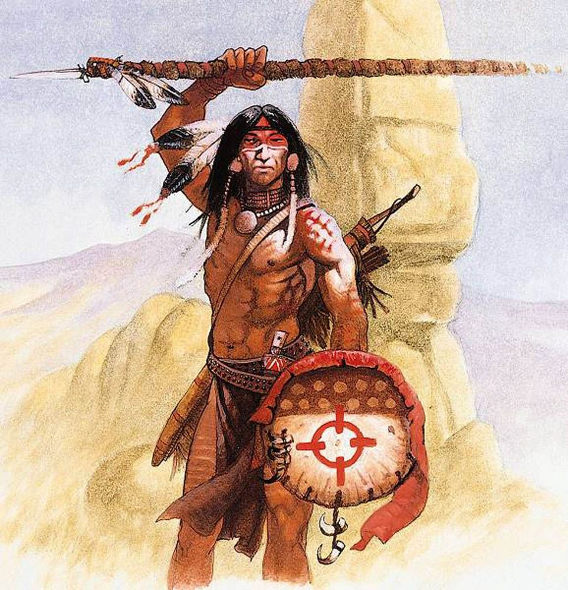

Tiruwe
Size: small town, population 2,000, guards / soldiers 20, militia 100
Trade Goods: furs, clay, tobacco, pottery
Local Goods:
Standard: raccoon
Colors: purple and black
Patron Deity: Iktomi, the trickster god
Ruler: Chief Akwiraron and his wife Ojistah (f)

Home: Ringtail Lodge
Steward: Sho'enri'se
Marshal: Okwaho
Head Shaman: Spirit Walker Kara'titahkhe the Taker of Nightmares (f)
Wild Mage: Kahwihta (f)
Head Warrior: Hasanoanda
Chief Warriors in Service:
Tehwehron
Rohahes
Shawatis
Otetiani

Local Powers: Lost Men (thieves guild), Circle of Amadahy (order of druids), Band of the Yarrow (order of rangers)
Local Sites: Journey Horse Inn & Tavern, The Flying Head Inn & Tavern, Circle of Gendenwitha

Description:
Tiruwe is a woodland settlement situated at the southern tip of the Orenda Sea. Long wooden palisade surrounds the town to the north and west, with the Pathfinder River forming a natural barrier to the south. Log homes stand on the shore of the sea, but most of the town is comprised of log-raft homes floating on the water. Timbers lashed together with hollow gourds form buoyant platforms on which dwellings from the size of a hut to a large house stand. Inhabitants use long poles to move their rafts about, anchoring them for a full season. Every spring many of the rafts untether and float about the shoreline, where residents fish and pick out new locations and new neighbors. Come the fall the rafts begin to return south, cluster together for warmth, and rebuild the town all over again.

The people of Tiruwe call themselves the Washpaw People. This is a reference to the racoon, which washes its hands when eating near streams. The people are clever and nimble like their namesake. Some even say they are sneaky and hard to trust. Other Haka’Na tribes speak of the Washpaw and say to watch your possessions around them. It is no surprise that Tiruwe is famous for its spies and its braves are often selected as scouts in times of war. Where Tiruwe lacks strength and resources they make up for with tactical savvy, which they need to survive the threats that dwell in their region.

Industry:
Clay from the shores of the Orenda are valued for making light but strong ceramics.
Tobacco is grown in fields just north of the town in fields overlooking the southern arm of the Orenda.
Along the shores of the sea large wooden pens serve as fish hatcheries. The delta from the Pathfinder River is a source for clays in a variety of colors and are used in elaborately decorated pottery.

Key Figures:
Chief Akwiraron – fearful, greedy, tyrannical

Chief Akwiraron is a lean man of average height with stooped shoulders and gray in his free-flowing black hair. The wrinkles around his dark eyes speak to the worries he carries. The lands around Tiruwe are fraught with danger and these prey on Akwiraron’s mind always. He frets every spring when the town breaks up and the house rafts move away from the shore. It is his concern that this leaves the people unprotected, but his true concern is he finds it more difficult to control the people. He is a greedy chief, exacting a duty from each member of the town whether it be gold or pelts or food. He stores his wealth in a great wooden lodge on land, which he claims is for the good of the town. But he is a keen trader and has amassed wealth trading with tribes passing by in the east along the Trackless Plains. Some say he has sat with the Saurian Tribes and used his gold to buy their friendship.

Ojistah (f) wife to the chief -

Local Lore:
Masawu Pit – The shaman’s lodge contains a sacred Masawu fire pit. When lit, it iis connected to the Masawu fire pit in the lodge of the Seven Fires Council in Ioskeha. These were created by Masawu, the spirit known as the Skeleton Man and holder of the secrets of fire. On each new moon the flames are lit in every pit and elders from all peoples enter a trance. Masawu transports them temporarily into the ethereal plane, which they call the Fifth World, and they appear before the fire in Ioskeha as ghostly apparitions. Here, elders can commune with one another on matters of council business.

In the Wendigo Wood and the Wenopa Hills live the Jo-gä-oh "Little People.” These are invisible nature spirits, similar to the fairies of the west. The Jo-gä-oh protect and guide all the natural world and protect the people from unseen hidden enemies. There are three tribes of Jo-ga-oh:
- Ga-hon-ga inhabit the rivers and rocks. They live in rocky caves beside the streams and have great strength despite their small stature. Often called the Stone Throwers.
- Gan-da-yah protect and advise the fruits and grains. They sometimes visit the people in the form of birds: a robin for good news, an owl for a warning, a bat bringing news of an imminent life-and-death struggle.
- The Oh-do-was inhabit the shadowy places under the earth. In this underworld there are forests and animals, including a white buffalo. The Oh-do-was guard against poisonous snakes and creatures of death that try to escape from the underworld. From time to time the Oh-do-was emerge from the underworld at night into the world above. There they hold festivals and dance in rings around trees in the forest where the grass afterwards doesn't grow.

The surrounding countryside is rumored to be the home of the mischievous Azeban. These are trickster spirits that are mostly harmless and often appear in the form of a raccoon. They deceive animals and men to steal their food. They are known to engage in many foolish and/or mischievous things but are not dangerous or malevolent.

Also here are the Canotila, a race of forest-dwelling creatures similar to fairies. They are considered messengers from the spirit world and dwell in the forest, but sometimes they appear in dreams.

The biggest threat in this region are the Saurians that dwell in the vast Lost Spirit Swamp. The Slizz are the northernmost tribe of Saurians and are bitter enemies with Tiruwe. The other Saurian tribes pose threats to the other towns on its borders, including Hurit (battling the Sekkasit), Tatanka (battling the Heekra), and Ko’Ohchen (battling the Rakarr).

To the far west the Wenopa Hills are home to the Stone Coats, a race of rock giants.

Wendigo Forest is home to the wendigo, fierce undead creatures who were once men but now cursed as tall, powerful creatures with antlers that consumes the flesh of the living.

Circle of Gendenwitha: Outside of town stands a series of totem poles carved with the shapes of various animals and arranged circle. Each pole corresponds to the position of a specific star as it travels across the heavens. The star is special to the people of Tiruwe: it is called Gendenwitha, who was once a young woman from this tribe.

Tales tell of Sosondowah, was a greatly skilled hunter of the Washpaw many centuries ago. He was captured by the spirit of Dawn, who admired him. Dawn commanded him to spend eternity guarding the door of her lodge in the sky. From his post, Sosondowah caught sight of the young woman Gendenwitha as she stood by a river, and fell in love. He swooped down to the river and took Gendenwitha up to the lodge in the sky to make her his bride. Dawn, angry at the defiance of Sosondowah, transformed Gendenwitha into a star and put her on Sosondowah's forehead so he must long for her throughout all time without attaining her.

History:
A thousand years ago rangers crossed the Sea of Orenda and met the elves of Lost Light Forest. These were Hravaran elves of the domain of Elgelor, wilder and less refined than their woodland cousins. The braves were captured and interrogated, but the elves soon found their company pleasing. In the elves the people of Tiruwe found much-needed allies in a land filled with enemies. The centuries saw each coming to the aide of the other. Today there is a strong bond between Elgelor and Tiruwe.

In 720 WA2 the evil sorceress Mortavay launched her First Dark Crusade, beginning with invading Haka’Na lands. Tiruwe was one of the western towns that suffered terrible losses before Mortavay’s army was checked by several Haka’Na tribes at the Battle of Moon Lake (724 WA2).

Customs:
Tiruwe natives keep to themselves, wary of strangers and especially those not of the Haka’Na.

Shaman from the town hold rites honoring the star. Each priest has the mark of a star on their forehead, taking on the burden of Sosondowah in remembering Gendenwitha.

The Sacred River leading north of the sea was so named for the nayads and dryads who live there and give aide to friends of the elves. It is a mark of courage for young warriors to make the journey north and meet with the elves of Elgelor. Any who do so are painted with a tribal stripe on their forearm to bear witness that they have touched sacred soil.

The people of Tiruwe were once part of the Buffalo people but broke off thousands of years ago.

[Developer Note: the Washpaw People are loosely based on the Iroquois (Seneca, Oneida, Onondaga, Cayuga, Mohawk)]

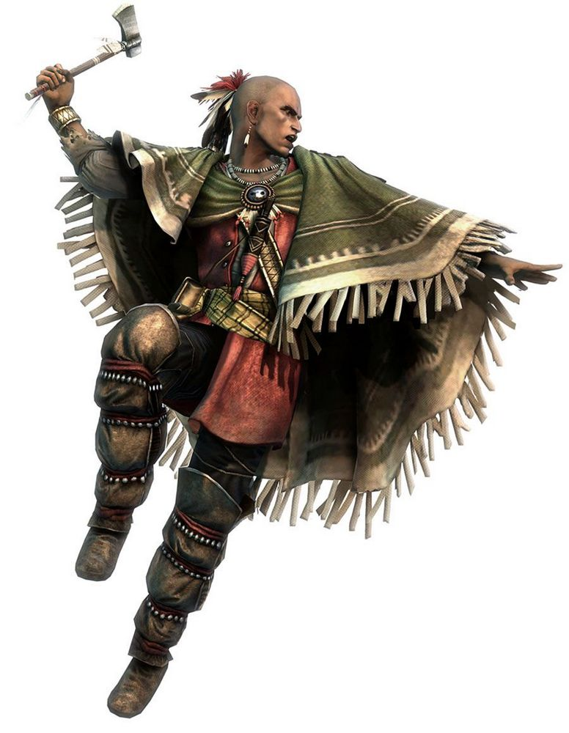

Hurit
Size: large town, population 5,000, guards / soldiers 50, militia 250
Trade Goods: iron, cotton, clay, fishing, spices
Local Goods: sweetgrass, holy grass, bog myrtle
Standard: heron
Colors: yellow and black
Patron Deity: Saqsakaew the Heron - animal spirit of luck and patience
Ruler: Chief Hakla and his wife Kamtcin (f)

Home: Cattail Lodge
Steward: Tocciinan
Marshal: Kamakic
Head Shaman: Spirit Walker Cahappaakan the Feathers of Dawn
Wild Mage: Kahitie who sees
Head Warrior: Hixmo
Chief Warriors in Service:
Holata (f)
Niilhaasi
Kitisci

Local Powers: Brothers of the Coyote (thieves guild), Circle of Uktena (circle of druids)
Local Sites: Many Rivers Inn & Tavern, The Rainbow Bird Inn & Tavern

Description:
Hurit is an oceanside settlement sitting at the mouth of the Haokah River, overlooking Sitala Bay. To the east is the Hokachin Swamp, which stretches for hundreds of miles to the north and east. The town sits atop a high hill, surrounded by a thick palisade made of large timbers that have bleached in the salt air and sun into whitened walls as hard as stone. High reeds and cattails grow up to the edge of the town, a brackish marsh forming a natural moat. Trailing moss tendrils blow in the breeze as they hang from the trees growing here. The air is thick with sea air and the scent of the wetlands. This is the ancestral home of the Heron People.

Encampments north and east of the town stretch up against the Haokah River, where they have built wooden bridges to span the river. Beyond are the swamplands, where locals travel daily to forage and hunt. Hundreds of hide canoes, some large enough to carry heavy cargo, pass up and down the river beneath the bridges. They are deployed swiftly against any threat that comes in from the sea. They are highly maneuverable and dangerous in numbers, able to strike and retreat into the swamp waterways. The people of Hurit are at home on the water and know how to live from what the wetlands provide.

While the Hurit people are hospitable, they are wary. Located close to the pirate waters around Malasangra, they are prepared for trouble. Pirates regularly travel to this part of the world, making use of the island Muya for port. They have long since learned to avoid troubling Hurit, as the town makes use of the swampy terrain for defense. The residents are skilled at navigating the swamps both for movement and fighting.

Industry:
Trade ships used to venture here from the lands of Xiandai, but Hurit’s port is less developed than the one to the east in Ko’Ohchen.

In addition to fishing the waters of Sitala Bay the people of Hurit farm the tidal areas for rice and a variety of produce which they trade with tribes migrating between here and Moon Lake in the north. Crops from the area have a unique taste due to the swamp ecology. The swamp also produces Sweetgrass and Holy Grass, herbs that when dried produce a vanilla scent used in perfume and in healing rituals of Haka’Na people. Bog Myrtle is also collected in the swamps. It is used as a substitute for hops, for tea and to flavor soups and stews.

Key Figures:
Chief Hakla – Hakla is a short, broad-shouldered man who wears many strands of shells, beads, and mementos around his neck. His thick black hair is braided and decorated with colorful bits of coral. He is an older warrior, with a thick jaw and serious eyes. He speaks little, allowing others to talk and share their concerns. But when he has made up his mind, he is a man of swift decision and even swifter action. Some say he is secretive, but he does so on purpose: always calculating the dangers around his town and devising how best to prepare for them. He carries at his side a great warclub they call Okataloa “the Water Song,” which is rumored to carry the power of life and death of the wetlands themselves. It is said to both harm and heal as needed, as well as producing a strange sound like the croaking of many frogs.

Local Lore:
Masawu Pit – The shaman’s lodge contains a sacred Masawu fire pit. When lit, it iis connected to the Masawu fire pit in the lodge of the Seven Fires Council in Ioskeha. These were created by Masawu, the spirit known as the Skeleton Man and holder of the secrets of fire. On each new moon the flames are lit in every pit and elders from all peoples enter a trance. Masawu transports them temporarily into the ethereal plane, which they call the Fifth World, and they appear before the fire in Ioskeha as ghostly apparitions. Here, elders can commune with one another on matters of council business.

Saqsakaew is the Great Heron and the patron spirit of Hurit. He signifies good luck and patience. He is a vain spirit, rewarding offers of praise for his beauty with a blessing or boon. He is also a solitary creature and, in the legends, when he aids the forces of good, he does so without consulting the other spirits. For this reason, he is hailed by young warriors of the town as a model for self-reliance.

The biggest threat in this region are the Saurians that dwell in the vast Lost Spirit Swamp. The Sekkasit are the westernmost tribe of Saurians and are bitter enemies with Hurit. The other Saurian tribes pose threats to the other towns on its borders, including Tiruwe (battling the Slizz), Tatanka (battling the Heekra), and Ko’Ohchen (battling the Rakarr).

History:
The Hurit people recall a time almost three hundred years ago when the Saurian tribes of the Slizz and Sekkasit mounted a full assault on the town and almost destroyed it completely (207 WA4). The chief at the time was named Chochmo. He called upon Saqsakaew for help. Saqsakaew appeared, but would not answer. Instead, he stood upon the bank of the river Haokah and craned his neck so that his bill touched the bank on the other side. Chochmo nodded, remembering the story of the Heron and the Wolf.

Chochmo ordered his people build a bridge across the marshes where the lizard folk threatened to attack. His men were confused, asking their chief why he would give their enemy a passage across the dangerous mires protecting the village. But the chief was wise. He instructed the bridge be to be built with weakened supports which could be removed. When the bridge was finished, the chief led his men on a foolhardy attack against the overwhelming numbers of the lizard folk. The warriors charged and did great harm to the enemy, but retreated when the lizard folk regained their courage. The enemy followed hard on their heels. As the Hurit people passed over the bridge the chief removed the supports, causing the bridge to collapse into the mire along with their enemy. The day was won, all thanks to the lesson from the Great Heron.

In 720 WA2 the evil sorceress Mortavay launched her First Dark Crusade, beginning with invading Haka’Na lands. Hurit was one of the western towns that suffered terrible losses before Mortavay’s army was checked by several Haka’Na tribes at the Battle of Moon Lake (724 WA2).

Customs:
The people of Hurit call themselves the Heron People. Each child, upon reaching maturity, is tasked with traveling deep into the Kachina Swamp. There, they are to seek out mighty Kankakee, a massive bald cypress ancient beyond reckoning who guards the swamp. Kankakee judges the character of each person who visits him, granting a boon befitting their soul.
[Developer’s Note: the Heron People loosely based on the Natchez, Seminole, Chitimacha, Chawasha, Washa, Houma]

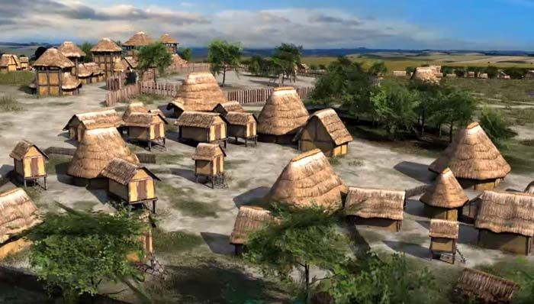

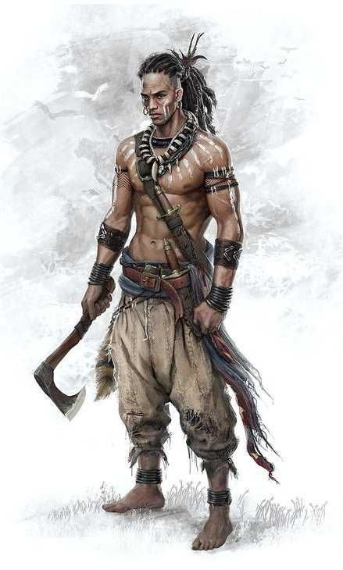

Tatanka
Size: large town, population 5,000, guards / soldiers 50, militia 250
Trade Goods: tobacco, furs, clay, salt
Local Goods: fishing, boat building, building and upkeep of ferries to cross the rivers, trade up and down the river from Horn Mountains to the coast
Standard: buffalo
Colors: brown and black
Patron Deity: Tatanka Ska, the great white buffalo and god of the hunt
Ruler: Chief Ohanzee and his wife Nahimana (f)

Home: Lodge of Many Horizons
Steward: Nahiossi
Marshal: Okhmhaka
Head Shaman: Spirit Walker Hantaywee the Dream Catcher (f)
Wild Mage: Shiriki the Earth Mover
Head Warrior: Tokala
Chief Warriors in Service:
Ciqala
Otaktay
Wanahton

Local Powers: Night Arrow (thieves guild), Lodge of Maminnic, Band of the Samoset (order of rangers), Circle of the Green Corn (order of druids)
Local Sites: Catahecassa Inn & Tavern, The Horned Serpent Inn & Tavern

Description:
Rising up from the vast flatness of the Inanaho Plains stands the dark brown silhouette of Tatanka, ancestral home of the Buffalo People. A low palisade sweeps across the prairie, thick timbers brought downriver from the Great Stag Forest. Inside, the tall and heavily walled Lodge of Many Horizons presides over smaller lodge houses and open courtyards where itinerant families pitch their tents. Arrow Lake glitters in the sun nearby, fed by the Reeot River and offering welcome to all who come in off the plains.

Buffalo herds wander the lands from the Hills of the Tuyok in the north to the Catalpa Forest in the south. With them travel the migratory tribes. Tatanka grew at the crossroads of these trails, becoming a way station for people gathering water and making their way across the rivers.

The Samoset Rangers have become stewards of the rivers, building and maintaining fords and ferries to help tribes traverse the wide waters cutting across the plains. They

Industry:
Plains people went from a pedestrian nomadic culture to a mounted one when the Horse People began to trade with them in the Ancient Ages. The Buffalo People spend a good portion of their earnings on purchasing horses in Machakw.

While various tribes of the Buffalo People travel the vast plains all year, the town of Tatanka depends upon agriculture: corn is the dominant crop, followed by squash and beans. Tobacco, sunflower, plums and other wild plants are also cultivated or gathered in the wild such berries to flavor pemmican and the prairie turnip. Typically, town folk plant crops in the spring, set out to hunt buffalo, deer, elk, and other game in the summer, return to harvest crops in the fall, and leave again to hunt buffalo in the winter.

Key Figures:
Chief Ohanzee

Local Lore:
Masawu Pit – The shaman’s lodge contains a sacred Masawu fire pit. When lit, it iis connected to the Masawu fire pit in the lodge of the Seven Fires Council in Ioskeha. These were created by Masawu, the spirit known as the Skeleton Man and holder of the secrets of fire. On each new moon the flames are lit in every pit and elders from all peoples enter a trance. Masawu transports them temporarily into the ethereal plane, which they call the Fifth World, and they appear before the fire in Ioskeha as ghostly apparitions. Here, elders can commune with one another on matters of council business.

The people of Tatanka have developed alliances with the elves of Elyon and know their way through the Forest of the Great Stag by river. To the south, boatmen pick their way carefully through Hokachin Swamp and know how to keep clear of the humanoids living there.

Arrow Lake teems with a bounty of fishing but parts of it are still haunted by water spirits. Once every six years the water snake Uncegila causes trouble here and the holy men and women of the town must purify the entire lake. Warriors accompany them if it is necessary to do battle with her.

Red-Woman is an ogress and cannibal; she is a malevolent monster who kills just for the sake of killing, sometimes mutilating her victims in horrible ways. Some say she uses witchcraft to hypnotize people or affect their minds.

Tatanka Ska is the patron spirit animal of the town. The mystical creature takes the form of a white buffalo and appears from time to time on the plains. Hunters who spot Tatanka Ska will often lay down their weapons and offer prayers to the spirit, asking for blessings on their hunt. If he is spotted during a battle, both sides will halt and wait for him to pass. Occasionally bold hunters will give the spirit pursuit, attempting to claim his heart. Tatanka Ska is not angered by such attempts, seemingly because he honors the hunters. He will give chase and, if a hunter’s spear touches him, will vanish and reward the hunter with treasure or a magical boon.

The biggest threat in this region are the Saurians that dwell in the vast Lost Spirit Swamp. The Heekra are the easternmost tribe of Saurians and are bitter enemies with Tatanka. The other Saurian tribes pose threats to the other towns on its borders, including Tiruwe (battling the Slizz), Hurit (battling the Sekkasit), and Ko’Ohchen (battling the Rakarr).

History:

Customs:
The Buffalo People tend to wear hides, with or without fur. Most of the clothing consists of the hides of buffalo and deer, as well as numerous species of birds and other small game. Plains moccasins tend to be constructed with soft brain-tanned hide on the vamps and tough rawhide for the soles. Men's moccasins tend to have flaps around the ankles, while women's have high tops, which can be pulled up in the winter and rolled down in the summer. Honored warriors and leaders earn the right to wear war bonnets, headdresses with feathers, often of golden or bald eagles.

Holy men and women of the Buffalo People are given the title Wakan. They go through many years of training to become medicine men or women, entrusted with spiritual leadership roles in the community. The buffalo is considered a holy symbol and may be represented in iconography, or parts used in regalia. Medicine bundles are the trademark of the Wakan. They possess spiritual power, are only entrusted to prominent religious figures of a tribe, and are passed down from keeper to keeper in each succeeding generation.

One of the most important gatherings for many of the plains tribes is the yearly Sun Dance, an elaborate spiritual ceremony that involves personal sacrifice, multiple days of fasting and prayer for the good of loved ones and the benefit of the entire community.

A more secretive ceremony held by some among the Buffalo People is the Ghost Dance. This is held rarely and always at night under a new moon. During the dance warriors mark themselves and dance furiously while the shamans summon the spirits of the dead.

The people of Tatanka call themselves the Buffalo People.
[Developer’s Note: the Buffalo People are loosely based on the Sioux (Lakota, Dakota), Cheyenne, Pawnee, Omaha, Ponca, Arapaho]

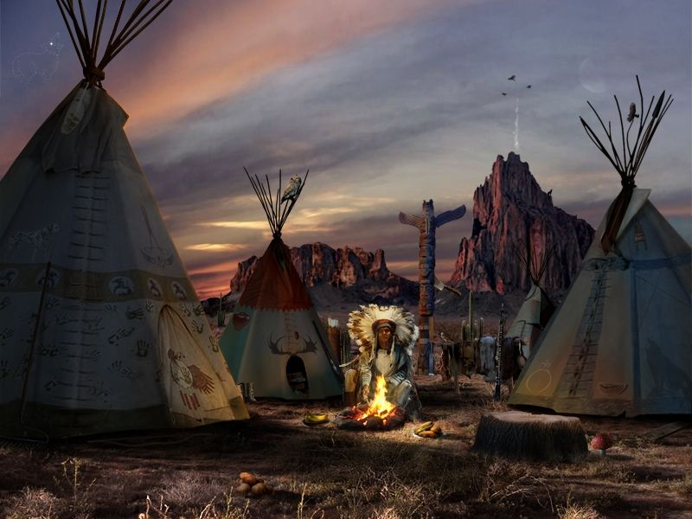
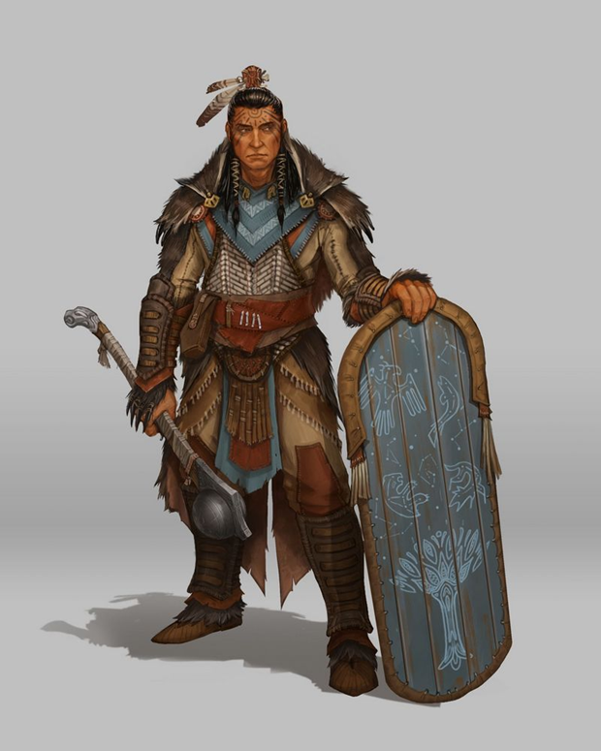

Ko’Ohchen
Size: large town, population 5,000, guards / soldiers 50, militia 250
Trade Goods: grain, pottery, timber, clay, fishing
Local Goods:
Standard: badger
Colors: red and white
Patron Deity: Corn Mother, goddess of fertility and the harvest
Ruler: Chief Huyana and his wife Papina (f)

Home: Sunwater Lodge
Steward: Motsqueh
Marshal: Muata
Head Shaman: Spirit Walker Sonoma of the Silver Cloud (f)
Wild Mage: Uzumati the Many Furs
Head Warrior: Hateya
Chief Warriors in Service:
Sahkonteic
Kosumi
Haiwee

Local Powers: Swift Wind (thieves guild), Band of Kanati (order of rangers)
Local Sites: Wahmenitu Inn & Tavern, The Wendigo Inn & Tavern

Description:
Golden fields of corn spread from the banks of the Nokoma River where it empties into Moonrain Bay. At the river’s mouth a hundred pale gray stones rise, arranged in a circular formation. Within the circle the land rises to a hill where the gleaming beams of the Sunwater Lodge preside over a cluster of wooden houses and teepees. Here is Ko’Ohchen, ancestral home of the Badger People.

Industry:
The people of Ko’Ohchen mine the clays from the Nokoma delta to create medicines and masterwork pottery. Hunters range into the Catalpa Forest to the north, where timber is cut and floated downriver. Farms have expanded east into the Catalpa Valley and up to the banks of the Huwata River. Trade is mostly with the Buffalo people when they venture south across the plains. The waters past Moonrain Bay make up the Strait of Immolas. This close to the lands of the Elderwyrm Mountains few dare to venture travel out to sea. Dragons from the Elderwyrm Mountains in Xiandai threaten any ship that passes this way. This has left Ko’Ohchen isolated in spite of being a coastal town.

Key Figures:

Local Lore:
Masawu Pit – The shaman’s lodge contains a sacred Masawu fire pit. When lit, it iis connected to the Masawu fire pit in the lodge of the Seven Fires Council in Ioskeha. These were created by Masawu, the spirit known as the Skeleton Man and holder of the secrets of fire. On each new moon the flames are lit in every pit and elders from all peoples enter a trance. Masawu transports them temporarily into the ethereal plane, which they call the Fifth World, and they appear before the fire in Ioskeha as ghostly apparitions. Here, elders can commune with one another on matters of council business.

No one knows where the great stones that surround the town came from. But the people of Ko’Ohchen have taken to chiseling markings into the stones. A thousand years or more of carvings tracks the story of the Badger People. Some say the inscriptions hold great power including protective wards over the town.

Ko’Ohchen is caught between the aggression of the Rakarr saurians that dwell in the Lost Spirit Swamp and the Haraka tribe of gnolls out of the Catalpa Forest, known by their sign of the bird divided into five parts. The Rakarr are the southernmost tribe of Saurians and are bitter enemies with Ko’ohchen. Other saurians of the great swamp pose threats to the other towns on its borders, including Tiruwe (battling the Slizz), Hurit (battling the Sekkasit), and Tatanka (battling the Heekra).

A hundred years ago an army of lizard folk marched on the town and nearly succeeded in burning it down. Three warriors emerged as saviors: Tohopka, Otskai, and Ahawi (f) fought bravely and drove them back. It is said that they called on the Corn Mother and she gave them the Kaliska stone, taken from the river and which had powers over the waters. With it they washed the enemy away (390 WA4).

Unlike the Tatanka and Red Horn people, the people of Ko’Ohchen are not as familiar with the elves of Elyon and find the journey upriver to the elves more trouble than it is worth.

The Corn Mother is the patron deity of the Ko’Ohchen people. Every year the holy men and women seek her blessing on the many farms within the region. Every so often she appears and offers counsel and blessings. A great festival is held every year to honor her and visitors are welcome to attend.

History:

Customs:

The people of Ko’Ohchen call themselves the Badger People.
[Developer’s Note: the Badger People are loosely based on the Shoshone, Ute, Nez Perce, Miwok]

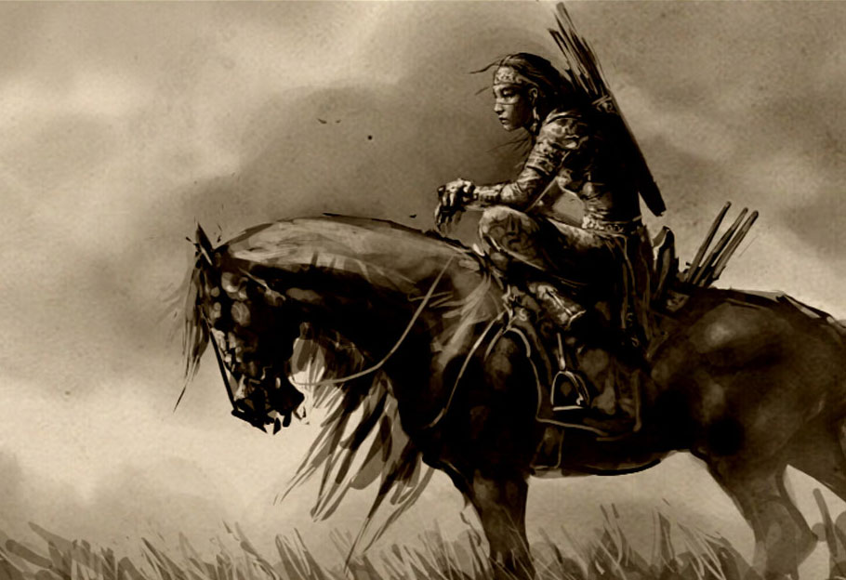
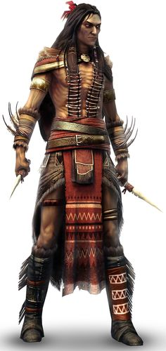

Ioskeha
Size: large town, population 5,000, guards / soldiers 50, militia 250
Trade Goods: magic center, medicine, copper, furs
Local Goods:
Standard: otter
Colors: blue and black
Patron Deity: Ataensic, the Sky Mother - bearer of good and evil, upholds balance and lives on the moon
Ruler: Chief Muktemwe “black wolf” and his wife Wawetseka (f)

Home: Dark Lake Lodge
Steward: Ogima
Marshal: Wakshi
Head Shaman: Spirit Walker Nektosha of the Spirit Stallion (f)
Wild Mage: Chas-Chunk-A
Head Warrior: Kakakshi
Chief Warriors in Service:
Beshkno
Nawkaw
Kokotni

Local Powers: Three Paws (thieves guild), Tenskwatawa Sanctum (school of magic), Order of the Sky Mother (order of paladins), Circle of the Sky Woman (order of druids), Band of Haokah (order of rangers), Seven Fires Council (sacred order of shaman)
Local Sites: The Buckskin Inn & Tavern, House of Sedna Inn & Tavern

Description:
A thick grove of jack pines, cottonwood, and balsam poplars grow along the banks of Dragonfly Lake. Peeking out from the forest cover, on a spit of land near the mouth of the Waukheon River, can be seen the red timbers of the town of Iosheka, home to the Otter People. It is a town shrouded in forest cover, with almost no approach over land. But this suits the people here, who paddle to and from the marina at the town’s edge. Inside the walls stands the long, heavy-timbered Dark Lake Lodge. Totem poles decorate the shaded yards where people come and go, parking their canoes next to their teepees while they reside here.

The name of the town, Ioskeha, is named for the hero who slew demons and taught the gift of healing. The land in this region sits atop a large aquifer, which feeds the large lake as well as permeates much of the arable land.

Industry:
The residents enjoy a peaceful life working the lake as well as the copper mines to the north in the Horn Mountains. Ioskeha is a holy town, dedicated to communing with the spirits of the world. Special plants are cultivated in the town’s gardens to produce special rare medicines. Goods are run by boats down river to the coast of Bright Cloud Bay.

Key Figures:
The Seven Fires Council is a body of holy men and women who reside in Ioskeha and pass on counsel from the gods to every corner of the Haka’Na people. Holy messengers are blessed to venture out each year and visit settlements and deliver the new words from the gods. It is said the Haka’Na are united by this regular contact and that their entire civilization moves with these messages.

Local Lore:
Masawu Pit - The lodge of the Seven Fires Council has a special fire pit created by Masawu, the spirit known as Skeleton Man and holder of the secrets of fire. When lit, the sacred fire is connected to the fire pits of elders in every Haka’Na town. Even the Snow Bird and Sea Lion people have such a pit in their sacred lodges. On each new moon the flames are lit and each elder enters a trance. Masawu transports them temporarily into the ethereal plane, which they call the Fifth World, and they appear before the fire in Ioskeha as ghostly apparitions. Here, elders can commune with one another on matters of council business.

One of the greatest holy sites among the Haka’Na is the great Thunder Bird Mountain to the north. Tall, grim, and imposing stands the largest peak in the eastern Staghorn Mountain range. Lightning flashes at its summit, where thin clouds encircle the top from view. Thunder rumbles through its length, sending shock waves to the surrounding area. This is home to Waukheon, the great Thunder Bird, symbol of strength and spiritual wisdom as well as guardian against the crafty giant serpent Uncegila. Few dare to scale the mountain, for tendrils of electricity and avalanches follow in the wake of Waukheon when he is angry. Only the most pious of shaman may enter, hoping for a boon from the great bird.

People here revere the great protector Ioskeha, for whom the town is named. Ioskeha brandishes stag horns as a weapon. Ioskeha regularly does battle with his twin brother, Tawiscara, who is known for conjuring up thorns to foul harvests and ensnare those who wander alone in the woods. In many of the battles between the brothers, Tawiscara shed tears of flint when defeated. To this day tear-shaped pieces of flint can be found and are said to imbue special magic when used as arrowheads.

History:

Customs:
The people of Ioskeha call themselves the Otter People.
[Developer’s Note: the Otter People are loosely based on the Huron/Wyandot, Kickapoo, Potawatomi, Ottawa / Odawa, Winnebago]

Wyandot medicine men were called Arendiwane

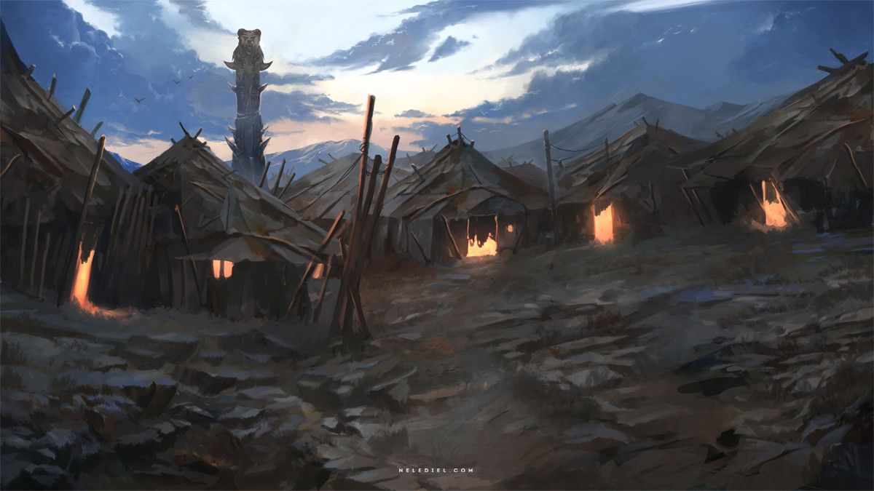
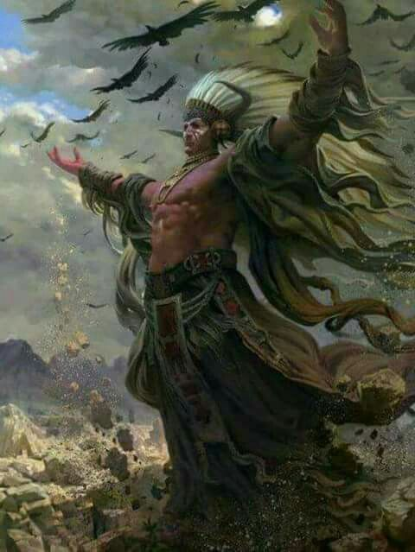

Red Horn
Size: small town, population 2,000, guards / soldiers 20, militia 100
Trade Goods: grain, tobacco, fishing
Local Goods:
Standard: wolf
Colors: red and black
Patron Deity: Moqwaio the Wolf - animal spirit of the hunt and escort of the dead
Ruler: Chief Dohate and his wife Quanah (f)

Home: Highwatch Lodge
Steward: Apiatan
Marshal: Wokohwi
Head Shaman: Spirit Walker Adoeette the Chanter, Mender of Tears (f)
Wild Mage: Kwihnai
Head Warrior: Tseena the wolf
Chief Warriors in Service:
Nashoba
Satanta
Aruka

Local Powers: The Anapi (thieves guild), Sons of Azeban (smuggling ring), Band of the Half Moon (order of rangers), Night Hunt (mercenary company), Order of the Blood Oath (order of paladins serving Moqwaio)
Local Sites: Wenopa House Inn & Tavern, Tumblebrook Inn & Tavern

Description:
Leagues north of Dawn Reach the coastline rises into jagged cliffs. Tall and forbidding, they curve outward and hang over the crashing waves as if to dive into the sea. Here lies Fool’s Inlet, a long stretch of perilous reefs that wind into the coast and form a long, slender lagoon. Strange, glistening columns of stone jut up out of the water at odd angles. Looking skyward, if one were foolish enough to steer their boat here, one would see cave openings along the walls. Here is the hidden town of Red Horn, ancestral home of the Wolf People.

Red Horn is a strange town, half above ground and half below. Along the precipice overlooking the inlet is a wide, green sward. Here, tanned hide teepees dot the land. Slender poles are staked into the ground bearing colorful beaded decorations marking the houses of a hundred families. The people take up baskets and tools and trek off towards wide fields of tobacco, and corn. Nearby the Aktaba River wanders into the town and plummets into the north end of the ravine, creating a mighty waterfall.

Below, the Wolf People have burrowed out a complex set of tunnels into the land. Food is stored in the damp, cool cellars. Heirlooms and ritual treasures are kept secure in deep sanctuaries. In times of war, the people move here where they can withstand months of siege if need be. A large hall worthy of a dwarf’s approval is called Highwatch Lodge. It is from here the chief meets with his elders and shaman. And from here several small tunnels snake out to openings that look out over the sea and beyond.

The Wolf People are by tradition aggressive and style themselves as hunter warriors. Rather than work with their neighboring tribes, they often attack the nomadic Buffalo People when they travel south or cross the Abenaki River to raid the town of Ayaabe and the Elk People.

Industry:
The rich soil of the Life Giver plains yields bounties of corn and tobacco for the Wolf People. Trade comes hard to such a warlike people, however. Neighboring Ayaabe has a sea port for their grain, but Red Horn only makes enemies with their raids. Merchants in the town have taken to dressing up in Elk People garb to meet with the Buffalo and Badger Peoples.

Many young warriors earn large rewards hiring themselves out as part of the Night Hunters, the mercenary company based out of Red Horn. Pirates, Xiandai lords, and others know of the company’s reputation as ruthless and efficient warriors who travel fast and light and able to infiltrate enemy territory.

Key Figures:
Chief Dohate is a lean, well-muscled figure with long hair worn in braids. His face is a permanent scowl, his eyes dark and piercing. Dohate assumed the seat of leadership after challenging the former chief and defeating him. He is young for such responsibility and his hot temper makes for rash decisions. Above all he wants to be known for his victories in battle, so he spends most of his time away from the town on raids into the Catalpa Forest or across the Abenaki River. He is distrustful of strangers and of outlanders in particular. It is difficult for anyone to negotiate with him, including his own people. The shamans warn him of a tragic end if he does not leaven his time with duties to his people, but he scoffs at this. In combat he brandishes the Claws of Sungmanito, the Wolf Spirit of hunting and war.

Local Lore:
Masawu Pit – The shaman’s lodge contains a sacred Masawu fire pit. When lit, it iis connected to the Masawu fire pit in the lodge of the Seven Fires Council in Ioskeha. These were created by Masawu, the spirit known as the Skeleton Man and holder of the secrets of fire. On each new moon the flames are lit in every pit and elders from all peoples enter a trance. Masawu transports them temporarily into the ethereal plane, which they call the Fifth World, and they appear before the fire in Ioskeha as ghostly apparitions. Here, elders can commune with one another on matters of council business.

The Elves of Elyon to the north are eyed with suspicion and mistrust by the Wolf People.

The Catalpa Forest is the home of the Haraka tribe of gnolls, known by their sign of the bird divided into five parts.

Moqwaio the Wolf is the animal spirit of the hunt and escort of the dead. He stalks these lands, running with packs of dire wolves and terrorizing the weak. Devotees out of Red Horn leave him bloody sacrifices seeking his favor. Each new moon, warriors sit waiting in the woods or on the plains, weapon in hand. If Moqwaio appears, they are to battle him. If they survive, the wolf spirit will lick their battered bodies and heal them. He will then bite their forearm or shoulder, leaving a permanent scar that marks them as his.

History:
The residents of Red Horn adopted a name in the common tongue centuries ago. It is so named after Holfan the Blooded, who sailed his ships from Norgarde and found the inlet during a great storm. Intent on taking the town, his men scaled the walls and surprised the Wolf People with their prowess. But the north men were driven back into the sea. And Holfan’s horn, pulled from his bloody corpse, was taken as a trophy.

293 WA3 - Holfan the Blooded sails his ships into Fool's Inlet during a great storm and discovers a Haka'Na town. After savage battles the Haka'Na drive the Norgardsmen back into the sea. And Holfan’s horn, pulled from his bloody corpse, is taken as a trophy and inspires the town to be called Red Horn.

Customs:
Young men and women are schooled at an early age in the art of warfare. Raids are carried out routinely on the Haraka gnolls in the Catalpa Forest. Great honors are placed on warriors who bring back gnoll ears and teeth. There is a culture here of fear and preparedness, which distances the Wolf People from other tribes. Young men and women undergo a coming-of-age ceremony where they swim out to War Cry Island and undertake blood rites bestowed by their war shamans.

The people of Red Horn call themselves the Wolf People.
[Developer’s Note: the Wolf People are loosely based on the Comanche, Kiowa, and Osage]
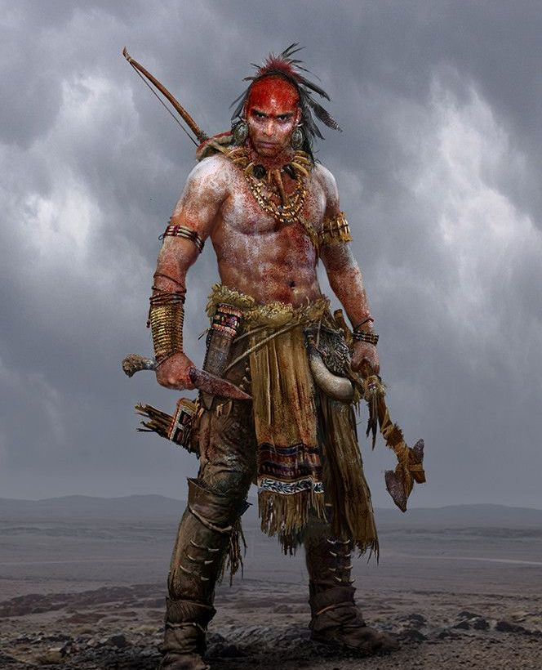

Ayaabe
Size: large town, population 5,000, guards / soldiers 50, militia 250
Trade Goods: trade hub, grain, timber, tobacco, fishing
Local Goods:
Standard: elk
Colors: green and black
Patron Deity: Deer Woman - spirit of fertility and love
Ruler: Chief Chogan and his wife Nokomis (f)

Home: Yellowstaff Lodge
Steward: Abequa
Marshal: Samoset
Head Shaman: Spirit Walker Pannoowau of the Silent River
Wild Mage: Nagamo the Singer (f)
Head Warrior: Ayasha
Chief Warriors in Service:
Eluwilussit
Wematin
Tihkoosue

Local Powers: Everwind Traders, The Dark Watchers (thieves guild), Band of the Darkwood (order of rangers), Cult of Uncegila
Local Sites: Chumani Inn & Tavern, The Dark Horse Inn & Tavern

Description:
At the southern end of the Life Giver Plains the Abenaki River spills into Sakoya Bay. Here, amidst the shady boughs of the Great Stag Forest wide, squat wooden longhouses stand atop a low plateau overlooking the plains, river, and the sea. A long wooden palisade runs along the base of the plateau. Its western gate stands open to welcome plains travelers, its eastern gate opens onto a wide harbor. Sails of ships from Xiandai can be seen berthed along the docks. Winds blow in from the ocean, casting the place in a cool, salty air. Town folk move back and forth from wide fields of corn and tobacco wearing baskets atop their heads. Enormous logs float lazily down the Abenaki to the cutting house north of the town. This is the town of Ayaabe, ancestral home of the Elk People.

Industry:
The rich soil of the Life Giver plains yields bounties of corn and tobacco for Ayaabe, which they trade with Xiandai ships as well as the nomadic Buffalo People who venture here in the winter. Timber is floated downriver from the Great Stag Forest and fashioned into dugouts, barges, totem poles, and crafted into sturdy longhouses.

Ayaabe is one of the few trade port towns in Haka’Na lands. Located east of the Immolas Strait, traffic here is mostly limited to ships out of Xiandai. Few ships from the west dare to venture this way for fear of the dragons of the Elderwyrm Mountains. Thankfully, this includes most pirates out of Korsair Bay. Occasionally, a Norgardian ship may make the perilous Noreast Jaunt to come this way. Ayaabe mostly sees ships out of the Xiandai town of Baozang, with whom they have an informal partnership. The only other Haka’Na town to operate a trading seaport is Untunktahe far to the east, which has a partnership with the Sakuran city of Ayozu. While neither town feels a competition for trade, it has created a rivalry between merchants in Boazang and Ayozu for Haka’Na goods.

Key Figures:
Chief Chogan –
Chogan is the caretaker of the legendary magic spear named Darkless. Crafted by the Elves of Elyon, it was gifted to Aranck Proud Paw in 230 WA2 after Ayaabe rescued the town of Sylvir from a Haraka gnoll invasion. It is a symbol of friendship between Elk People and Elyon. It is said to have the power of sight in total darkness for whoever wields it, and strikes true when none can see.

The Darkwood Rangers see the Great Stag Forest as under their protection. They travel for months into the forest, treating with Elyon and working with them against any evils that emerge in the wood.

Local Lore:
Masawu Pit – The shaman’s lodge contains a sacred Masawu fire pit. When lit, it iis connected to the Masawu fire pit in the lodge of the Seven Fires Council in Ioskeha. These were created by Masawu, the spirit known as the Skeleton Man and holder of the secrets of fire. On each new moon the flames are lit in every pit and elders from all peoples enter a trance. Masawu transports them temporarily into the ethereal plane, which they call the Fifth World, and they appear before the fire in Ioskeha as ghostly apparitions. Here, elders can commune with one another on matters of council business.

The elves of Elyon have had a long friendship with the Elk People, especially after Ayaabe rescued the town of Sylvir from invasion centuries ago.

To the west, the Wolf People of Red Horn are aggressive warriors and make yearly sorties on Ayaabe in the spring. The Elk People have tried to head off the attacks with gestures of friendship, but they have learned to be prepared for each year’s new crop of hot-headed young warriors looking to earn distinction in battle.

It is said that the Deer Woman dwells in this region. She is a spirit who offers boons of fertility and love. Though a benign spirit to those of good heart, she is also shown to lure promiscuous men to their death. She appears as either a beautiful young woman or deer.

It is said that Uncegila the evil river snake lurks in the river and is revered by a cult that carries out evil deeds in his name. Shamans from other towns are vigilant to these misguided people, for they know the creature to have the powers of a demon. Stories are told of the great serpent appearing in times of conflict, of the dark magic practiced by cult, and the offering up of human sacrifice to persuade Uncegila to foul the crops of Haka’Na villages.

History:
A hundred years ago, the town of Baozang tried to conquer Ayaabe and expand its influence. But they were pushed back into the sea and the Elk People earned their respect by building defensive works and keeping a standing militia at the port (331 WA4). Today, the two towns have a trade partnership but each keeps a keen eye on the other.

230 WA2 - Aranck Proud Paw, defender of Ayaabe, rescues the elven town of Sylvir from a Haraka gnoll invasion; the domain of Elyon names him and his people Elf Friend and bestows the town a magic spear called Darkless

331 WA4 - Baozang attacks the town of Ayaabe, set on conquering it to colonize Haka'Na lands; Ayaabe warriors decimate the Xiandai mercenaries and burn their ships

Customs:
The people of Ayaabe call themselves the Elk People. Ayaabe is the word for ‘deer’ in the dialect of the Elk People. It is a rite of the people to make spirit journeys into the northern forest to commune with the spirit of the Great Stag. Those making the pilgrimage and who have looked upon the Stag are marked with a holy symbol for all to see.

[Developer’s Note: the Elk People are loosely based on the Algonquin (Cree, Ojibwe / Chippewa, Abenaki), Sauk-Fox, Assiniboine, Mohican]

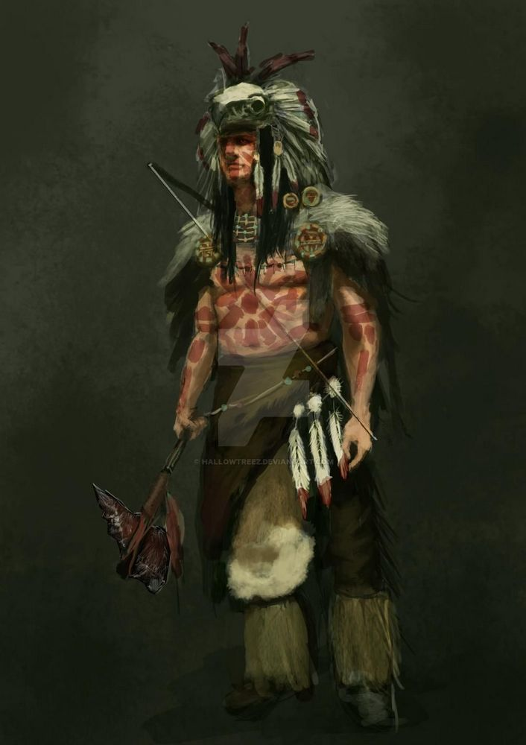

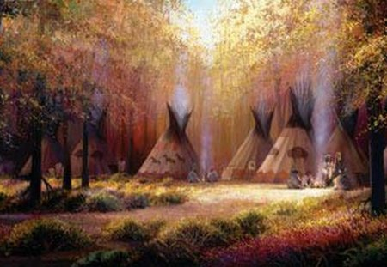

Tall Bear
Size: small town, population 2,000, guards / soldiers 20, militia 100
Trade Goods: flax, furs, gems
Local Goods:
Standard: bear
Colors: orange and black
Patron Deity: Kaiti the Bear - animal spirit of strength and resilience
Ruler: Chief Kanuna and his wife Tayanita (f)

Home: Stonetree Lodge
Steward: Onacona
Marshal: Adsila
Head Shaman: Spirit Walker Gawonii the Breathless One
Wild Mage: Atsadi (f) the Forest Talker
Head Warrior: Tooantuh
Chief Warriors in Service:
Awenasa
Degotoga
Yaholo

Local Powers: Harefoot (thieves guild), Lodge of Sassaba, Circle of the Magpie (order of druids), Band of the Four Hares (order of rangers)
Local Sites: Ochekka Inn & Tavern, Elderbranch Inn & Tavern

Description:
Under a steel gray sky that Ursa Lakes stretch to the horizon. To the south, a high hill stands watch where the lakes empty into the Long Water River. A low granite wall runs the perimeter of the hill, topped by a wooden palisade. Within the walls are stone and timber longhouses, chief among them the massive Stonetree Lodge. Here is the town of Tall Bear, ancestral home of the Bear People.

The people of this region are rumored to have sprung from the snows of the north and wandered south looking for a home. They are taller and broader than most in the Haka’Na lands. The Bear People are quiet, stoic, and have simple tastes. Enduring the hardships of the north are their tradition. Strength is the most admired trait here, both physically and in character. Each winter brings snow spirits, yeti, dire wolves, and other terrors of the north. The people of Tall Bear hold fast to their guardian spirit and work the land in quiet determination.

Industry:
Fields of cold-resistant flax are spun and woven into linen, then dyed and are traded down river in Liluye and Unetuuwa. Hunters canoe the lakes and rivers to trap for furs. Some make the journey to the Hawenniyo Hills and Sun Walker Valley, where rare gems can be found by those brave enough to mine for them.

Tall Bear’s closest neighbor is Ioskeha, a hundred miles by water followed by another two hundred over land. The Bear People meet with them each spring to trade, traveling over water to the western reaches of the lakes where they meet their neighbors. In the summer they paddle upriver on a week-long pilgrimage to visit Thunderbird Mountain.

Key Figures:
Chief Kanuna is a beast of a man, even by his people’s standards. He stands a head taller than most men, a bear pelt draped over this broad shoulders. His hair is cut short, hidden by a knit cap adorned with talismans. His eyes are deep set and dark and unreadable. Kanuna is a serious man bereft of mirth. His mind is always on the dangers plaguing his town and plans to defend against them. Without thinking he keeps a daily tally of the number of people in Tall Bear, marking every birth and death on his great staff. He is proud and stubborn, insisting on joining the rangers when they make patrols of the far reaches. Around his waist he wears the Stone Coat Belt, a magic vestment that grants its wearer the strength of the giants of the same name.

Local Lore:
Masawu Pit – The shaman’s lodge contains a sacred Masawu fire pit. When lit, it iis connected to the Masawu fire pit in the lodge of the Seven Fires Council in Ioskeha. These were created by Masawu, the spirit known as the Skeleton Man and holder of the secrets of fire. On each new moon the flames are lit in every pit and elders from all peoples enter a trance. Masawu transports them temporarily into the ethereal plane, which they call the Fifth World, and they appear before the fire in Ioskeha as ghostly apparitions. Here, elders can commune with one another on matters of council business.

The Tamarack Forest to the east is the home of the Gorokum tribe of gnolls, known by their sign of a bleeding moon. The gnolls march on Tall Bear once every eight moons and leave a savage display of carcasses outside the town walls after every battle. The warriors of Tall Bear count the gnolls as their greatest foes and eagerly anticipate testing themselves against them.

The Ursa Lakes are the dwelling place of the Misipesh, sometimes called the Water Lynx. This aquatic creature has the head, paws, and body of a giant cat but is covered in copper-colored scales and has dagger-like spikes running along its back and its long, serpent-like tail. Atop its head it has horns of an antelope, others the horn of a bison. It is extremely powerful and is held to be masters of all water creatures, including snakes. The Misipesh are the sworn enemy of the Thunderbird and tales tell of their epic struggles. Some say the Water Lynx live in the deepest parts of lakes and rivers, where they can cause storms. The creatures are thought to roar or hiss in the sounds of storms or rushing rapids and the sound can cause fear in the bravest men. They are notoriously evil and intelligent, preying on humans near the edges of the lake or in small boats. They make their lair at the bottom of the lake, where they horde treasure among the bones they keep as trophies. It is said that the heart and blood of the creature have magical properties.

According to legend, three mighty hunters once set out to slay the Great Bear. Their names were Alioth, Mizar, and Alkaid. Decorations in the town depict the great chase. The first hunter (Alioth) is seen carrying a bow and arrow to strike down the bear. The second hunter (Mizar) carries a large pot – a mystical vessel called Alcor – on his shoulder in which to cook the bear while the third hunter (Alkaid) hauls a pile of firewood to light a fire beneath the pot.

History:
44 WA4 - the evil shaman Micanopy crafts the Flint Helm, commanding the Spirit of Winter

47-49 WA4 - The Yeti War: Micanopy launches a savage assault of Yeti on Tall Bear; a combined army of the Bear People, the Otter People, and the Sea Lion People defeat the yeti and Micanopy; the Flint Helm is lost

Customs:
The Bear People are extremely suspicious of strangers, especially outlanders, and believe them to be evil messengers. Meanwhile, they are bound to a tradition of hospitality to strangers in this perilous land. They will offer lodging and food to anyone who visits, but any they suspect of evil will be quietly barred within a guest lodge until slain or proven innocent.

The people of Tall Bear call themselves the Bear People.
[Developer’s Note: the Bear People are loosely based on the Choctaw, Chickasaw, Creek/ Muscogee, Cherokee, and Shawnee]

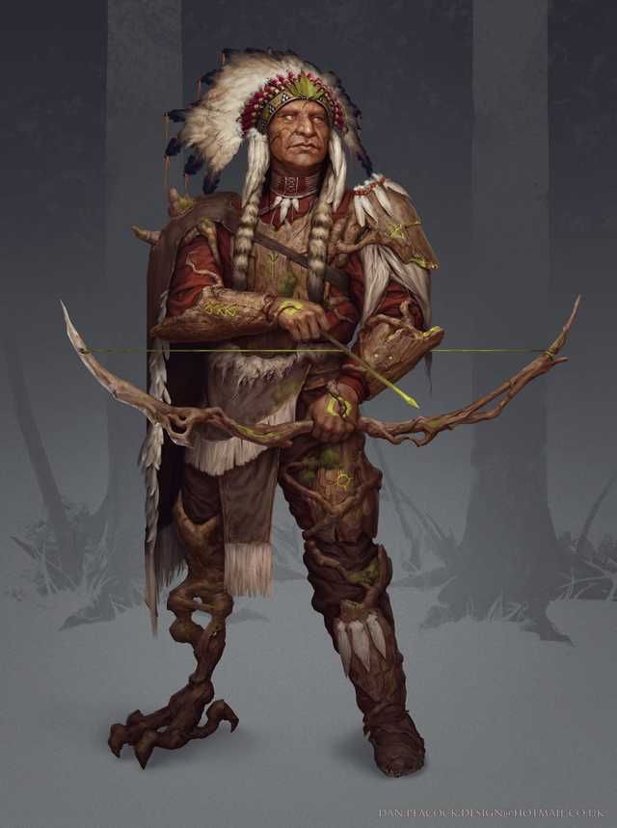

Liluye
Size: small town, population 2,000, guards / soldiers 20, militia 100
Trade Goods: tobacco, fishing, salt, grain
Local Goods:
Standard: eagle
Colors: yellow, black, and red
Patron Deity: Wajosen the Wind Eagle - animal spirit of leadership and wisdom
Ruler: Chief Yohacan and his wife Onxe (f)

Home: Stormcry Lodge
Steward: Missanek
Marshal: Musqua
Head Shaman: Spirit Walker Ohawas the Cold Flame
Wild Mage: Aquointan
Head Warrior: Oussawack (f)
Chief Warriors in Service:
Keshowse
Nimatew
Utchunquoyes

Local Powers: Sunset Men (thieves guild), Circle of Tainuwa (order of druids)
Local Sites: The Indoor River Inn & Tavern, Atabey’s Inn & Tavern

Description:
The tribes travelling between the Yahana and Keeyak rivers make their lives hunting the plains south of the Hawenniyo Hills. They consider the coastal town of Liluye their home and venture there every spring to offer tribute from their hunts in exchange for goods that come in by way of the sea.

Industry:
They also transport salt found in the Hills of the Hawenniyo, where the Sun Walker villages dwell. Traders from afar find great value in these gifts and in exchange Liluye has become a prosperous and well defended settlement. Liluye also makes good use of the catches in Bright Cloud Bay and has developed tobacco fields that generate much demand from traders from the west.

Key Figures:

Local Lore:
Masawu Pit – The shaman’s lodge contains a sacred Masawu fire pit. When lit, it iis connected to the Masawu fire pit in the lodge of the Seven Fires Council in Ioskeha. These were created by Masawu, the spirit known as the Skeleton Man and holder of the secrets of fire. On each new moon the flames are lit in every pit and elders from all peoples enter a trance. Masawu transports them temporarily into the ethereal plane, which they call the Fifth World, and they appear before the fire in Ioskeha as ghostly apparitions. Here, elders can commune with one another on matters of council business.

History:

Customs:
Each year there is a festival of lights on the water to celebrate the Beaver Spirit, which is the town’s patron spirit animal. It is believed the Beaver gives the people good fortune by protecting the waterways of the Keeyaak River. He represents productivity and teamwork, as well as protection from harm.

The people of Liluye call themselves the Eagle People.
[Developer’s Note: the Eagle People are loosely based on the Croatan, Catawba, Powhatan, Tuscarora]

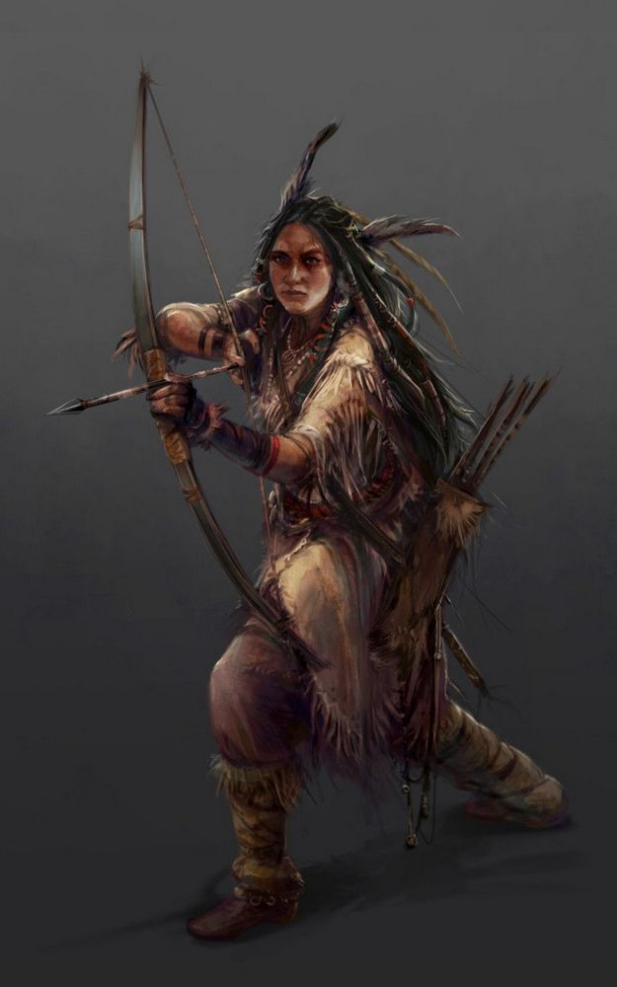

Unetuuwa
Size: small town, population 2,000, guards / soldiers 20, militia 100
Trade Goods: gems, stone
Local Goods:
Standard: moose
Colors: white and black
Patron Deity: Amishkuapeu the Beaver - animal spirit of industry and preparation
Ruler: Chief Hawáte and his wife Sinopa (f)

Home: Shadow Watch Lodge
Steward: Ainima
Marshal: Ponoká
Head Shaman: Spirit Walker Dáawiia the Tree Caller (f)
Wild Mage: Asaksiwa
Head Warrior: Nioókska
Chief Warriors in Service:
Natáyo
Otahko
Apoyi

Local Powers: Blackened Eyes (thieves guild), Lodge of Tabananica, Band of the Mountain Lion (order of rangers)
Local Sites: Takoda Inn & Tavern, The Raccoon Warren Inn & Tavern

Description:
The settlement of Unetuuwa bears a grave burden, guarding the lands from the evils of to the east. Miners work the High Fist Mountains, taking from them iron, silver, all manner of precious stones, and magical elements they transport down the Wakina River. There, the small town readies their weapons within a fortress always vigilant to what passes through the Valley of the Dawn. The warriors of Unetuuwa are the fiercest of the Haka’Na and the shaman call on the gods of light and darkness to divine the plans of those in the Cursed Lands.

Industry:

Key Figures:

Local Lore:
Masawu Pit – The shaman’s lodge contains a sacred Masawu fire pit. When lit, it iis connected to the Masawu fire pit in the lodge of the Seven Fires Council in Ioskeha. These were created by Masawu, the spirit known as the Skeleton Man and holder of the secrets of fire. On each new moon the flames are lit in every pit and elders from all peoples enter a trance. Masawu transports them temporarily into the ethereal plane, which they call the Fifth World, and they appear before the fire in Ioskeha as ghostly apparitions. Here, elders can commune with one another on matters of council business.

Here dwell the Canotila, a race of forest-dwelling creatures, similar to fairies. They are considered messengers from the spirit world and dwell in the forest, but sometimes they appear in dreams.
Legends tell of the great evil past the High Fist Mountains.

History:
Over seven thousand years ago (800 PA4) the Sadaran Kingdom rose up and spread westward, covering the Haka’Na lands in great darkness. It wasn’t until almost five hundred years later that the Haka’Na tribes united and marched on Sadara and defeated it in the War of the Falling Stars (270 AA1). Since that time, the Haka’Na have been ever vigilant against the darkness that dwells there still.

Customs:
The people of Unetuuwa call themselves the Moose People.
[Developer’s Note: the Moose People are loosely based on the Blackfoot, Crow, Arikara, Mandan, Hidatsa]

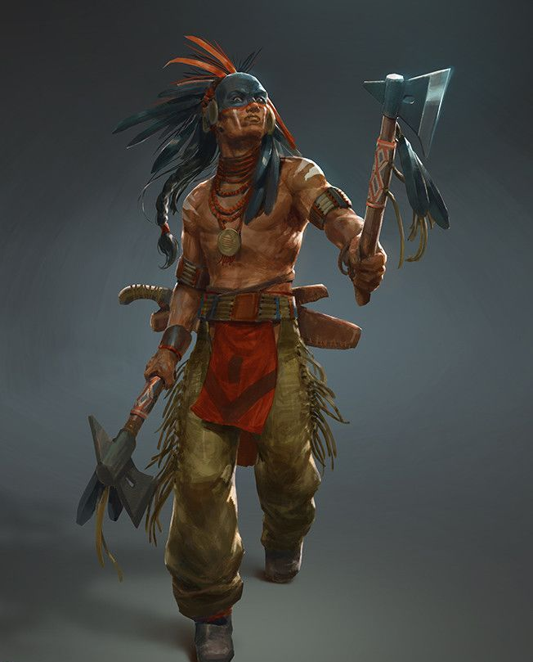

The Island Settlements of the Haka’Na
Tohono, Katamut, and Untunktahe are island towns settled by fishermen coming from the Black Wing, Badger, and Bright Cloud regions. Primarily fishing towns, they share a culture unique among the Haka’Na including similar gods, customs, and dialects.
Torngarsuk, a sky god, is their chief deity. He is the master of whales and seals and is the most powerful supernatural being in the islands. He appears in the form of a bear but he is invisible to everyone but the angakoq (the medicine men or shamans among island peoples). Torngarsuk is invoked by fishermen when one falls ill. They see Torngarsuk as their benefactor; when the angakoq call upon him, they ask that if he does not come that he leave them "in the land of plenty". The angakoqs each keep a familiar spirit in a leather bottle which they evoke and consult like an oracle. This familiar spirit seeks Torngarsuk in his cave and brings good fortune as well as healing power.
The other gods of the islands are Aningan, the sun, Malina, the moon, and Tulok, the stars. Each island has adopted one of these as their patron protector. Once each year the island peoples meet on one of the islands (the host island alternates between the three) and celebrate the great Igaluk Festival. There are many games where people from each tribe compete to see which god will be the favored of Torngarsuk for the year. It is a source of great pride for the winning tribe.

Katamut
Size: small town, population 2,000, guards / soldiers 20, militia 100
Trade Goods: fishing, flax, dyes
Local Goods:
Standard: geese
Colors: blue, black, and red
Patron Deity: Malina, goddess of the moon
Ruler: Chief Ogima and his wife Inungoa (f)

Home: Wind Friend Lodge
Steward: Aqillutaq
Marshal: Kanut
Head Shaman: Spirit Walker Tashunka the Moon Traveller
Wild Mage: Sakari (f)
Head Warrior: Amaruq
Chief Warriors in Service:
Alornerk
Kunikpaa
Tikaani

Local Powers: Moon Breed (thieves guild), Band of the Thrush (order of rangers)
Local Sites: Kanga Fala Inn & Tavern, The Twisted Horn Inn & Tavern

Description:
The Isle of Ominotago was once a popular fishing destination for the people living in Ayaabe. In the spring boats would shelter in the deep cove and wait for the whales migrating north up from the Aurora Sea. A thousand years ago a restless young fisherman named Kayuk decided to winter on the island. When his people found him the next spring, he claimed he had been visited by the sea spirits, who told him this place would make a good home if he could rid it of evil forest spirits. Kayuk did so and the sea spirits blessed it. To this day the people of Katamut and Ayaabe are strong allies and the fishing town regularly hosts fishermen visiting in the spring who help with the whale hunt.

The fishing town sits along the Noreast Jaunt trade route and receives ships coming this way regularly. Here ships arriving from Norgarde or leaving from Xiandai take on provisions and trade. It is uncommon for the pirates called the Red Devils to come this far north, but the fishermen are wary of their red sails and avoid them.

Industry:
Katamut’s primary source of food is fishing and whaling. Oil and ivory from whales is a valuable trade good here. Flax grows in the fields north of the forest, as well as plants useful for dyes. Those who do not fish in Katamut work the fields to harvest flax as well as dye plants and prepare them for trade.

Key Figures:

Local Lore:
Masawu Pit – The shaman’s lodge contains a sacred Masawu fire pit. When lit, it iis connected to the Masawu fire pit in the lodge of the Seven Fires Council in Ioskeha. These were created by Masawu, the spirit known as the Skeleton Man and holder of the secrets of fire. On each new moon the flames are lit in every pit and elders from all peoples enter a trance. Masawu transports them temporarily into the ethereal plane, which they call the Fifth World, and they appear before the fire in Ioskeha as ghostly apparitions. Here, elders can commune with one another on matters of council business.

Malina is the patron goddess of Katamut. Goddess of the moon, she is sister to Aningan, god of the sun, and lover of Tulok, god of the stars.

History:

Customs:
The people of Katamut call themselves the Geese People.
[Developer’s Note: the Geese People are loosely based on the Taino]

Untunktahe
Size: small town, population 2,000, guards / soldiers 20, militia 100
Trade Goods: trade hub, tobacco, platinum, fishing
Local Goods:
Standard: hawk
Colors: green, black, and red
Patron Deity: Aningan, god of the sun
Ruler: Chief Cetanwakuwa and his wife Anana (f)

Home: Sky Claw Lodge
Steward: Higalik
Marshal: Ataninnuaq
Head Shaman: Spirit Walker Sheshebenha the Eye of the Sun (f)
Wild Mage: Aquutaq of the Endless Ice Field
Head Warrior: Tarralikitak
Chief Warriors in Service:
Pattangayok
Piktaungitok
Asuilaak

Local Powers: Father Sky Traders, Coiled Snake (thieves guild), Circle of Kiviok (order of druids)
Local Sites: Samoset House Inn & Tavern, Two Moons Inn & Tavern

Description:
Untunktahe is a westerly facing fishing town sitting in the shadow of the Tabaldak Mountains. To the north lies the Sunset Forest. Just east of the town lies X pass, which traverses the Tabaldak and opens into Sunrise Forest.

Industry:
Untunktahe is one of the few trade port towns in Haka’Na lands. Located east of the Immolas Strait, traffic here is mostly limited to ships out of Sakura. Very few ships from the west dare to venture this way for fear of the dragons of the Elderwyrm Mountains. Thankfully, this includes most pirates out of Korsair Bay. Occasionally, a Norgardian ship may make the perilous Noreast Jaunt to come this way. Untunktahe mostly sees ships out of the Sakuran city of Ayozu, with whom they have an informal partnership. The only other Haka’Na town to operate a trading seaport is Ayaabe far to the west, which has a partnership with the Xiandai town of Baozang. While neither town feels a competition for trade, it has created a rivalry between merchants in Boazang and Ayozu for Haka’Na goods.

The fields south of the town are home to tobacco fields, where the Untunktahe people have also learned to farm the plant. Pipe leaf from these fields is very valuable in Xiandai.

Today the people of Untunktahe know the stone from their legends to be platinum and have developed the craft to mine it from the mountains. They are very protective of the mines, for they know it is valuable to traders who pass this way by ship. An envoy was sent to the Dwarven Kingdom of Onyklesh, where expert miners were hired to come and show the people their craft.

Key Figures:

Local Lore:
Masawu Pit – The shaman’s lodge contains a sacred Masawu fire pit. When lit, it iis connected to the Masawu fire pit in the lodge of the Seven Fires Council in Ioskeha. These were created by Masawu, the spirit known as the Skeleton Man and holder of the secrets of fire. On each new moon the flames are lit in every pit and elders from all peoples enter a trance. Masawu transports them temporarily into the ethereal plane, which they call the Fifth World, and they appear before the fire in Ioskeha as ghostly apparitions. Here, elders can commune with one another on matters of council business.

Aningan is the patron god of Untunktahe. God of the sun, he is brother to Malina, goddess of the moon, and rival to Tulok, god of the stars.

History:
It is said that the fishermen who set out from Unetuuwa long ago would make offerings to the sea goddess Sedna. When a young man forgot his offering, Sedna in her anger sent a storm that scattered the boats to the open sea. During the storm the young man prayed for forgiveness and threw himself into the sea. The next morning the boats washed up on the shores of the Isle of Wahanila. There the fishermen found a new home and have stayed ever since.

According to the history of the Untunktahe people, two thousand years ago they were visited by strange men from under the world who were taller than children but shorter than their own men and were covered in fur. These people, who they called Under Men, greeted the people and spoke of walking here from the north, traveling under the waters. It is believed these were Dwarves from the High Fist Mountains, now the location of Dwarven ruins when the kingdom there fell to Sadara millennia ago. This suggests the Dwarves had discovered a subterranean route beneath the sea from the High Fist Mountains to the Tabaldak range. The people say the Under Men showed them pale stone that glittered in the sun. One day the Under Men stopped visiting the villages. The people discovered openings in the Tabaldak and where the glittering stone came from.

Customs:
The people of Untunktahe call themselves the Hawk People.
[Developer’s Note: the Hawk People are loosely based on the Taino]

Tohono
Size: small town, population 2,000, guards / soldiers 20, militia 100
Trade Goods: timber, fishing
Local Goods:
Standard: whale
Colors: blue and black
Patron Deity: Tulok, god of the stars
Ruler: Chief Wahanassatta and his wife Silatuyok (f)

Home: North Star Lodge
Steward: Adlartok
Marshal: Tatkret
Head Shaman: Spirit Walker Hok’Ee the Shaper of Storms
Wild Mage: Tulugaq of the Black Raven
Head Warrior: Uyarak
Chief Warriors in Service:
Nutarniq
Nuniq (f)
Chulyin

Local Powers: Heyoka (thieves guild), Lodge of Chetanzi, Band of the Red Throated Loon (order of rangers)
Local Sites: Kilenya Inn & Tavern, Snow Goose Inn & Tavern

Description:
Tohono is the largest of the whaling towns in the Haka’Na lands. Settled by people from the Black Wing Bay region, Tohono folk are hardy stock and conditioned for life on the northern waters. The fishermen have rigged larger boats suited for expeditions into the waters north of Black Wing Reach: they are larger, stronger, and better insulated. Whaling expeditions can be gone for months at a time, bringing back whale oil, blubber, ivory, and ambergris. For long voyages, camps are set up along the northern coast of Eastern Amadar. These structures are primitive but endure from season to season. They are a welcome refuge from storms and are sometimes used by experienced seamen from Norgarde who know where to find them.

Industry:
In time the people of Tohono looked to the great Amarok Forest for resources. Today they have developed timber operations, felling the spruces and pines and working them into timber that is sturdy and in high demand on the mainland and south in Xiandai and Katura. The carpenters of Tohono also create artistic lodge poles, which are revered by the Haka’Na tribes for their good luck.

Key Figures:

Local Lore:
Masawu Pit – The shaman’s lodge contains a sacred Masawu fire pit. When lit, it iis connected to the Masawu fire pit in the lodge of the Seven Fires Council in Ioskeha. These were created by Masawu, the spirit known as the Skeleton Man and holder of the secrets of fire. On each new moon the flames are lit in every pit and elders from all peoples enter a trance. Masawu transports them temporarily into the ethereal plane, which they call the Fifth World, and they appear before the fire in Ioskeha as ghostly apparitions. Here, elders can commune with one another on matters of council business.

It is said that the great Mimlos Whale dwells in the northern waters. Stories are told of this evil creature, which attacks boats and brings hunger to the people. In many stories the great Thunderbird battles with the Mimlos Whale and tries to carry it off to its nest in the mountains. But each time the Mimlos Whale escapes. So terrible are the battles that the mountains crack and trees are uprooted.

The forest of Amarok is rumored to be the home to the Kushtaka. Kushtaka are shape-shifters capable of assuming human form. They normally take the form of an otter primarily but potentially they assume the form of other animals. Some Kushtaka are friendly and helpful, frequently saving lost men from death by freezing. Sometimes the Kushtaka save the lost individual by distracting them with curiously otter-like illusions of their family and friends as they transform the human into a fellow Kushtaka, thus allowing him to survive in the cold. Naturally, this is counted a mixed blessing. However, sometimes Kushtaka are cruel creatures who take delight in tricking fishermen to their deaths. It is said the Kushtaka will imitate the cries of a baby or the screams of a woman to lure victims to the river. Once there, the Kushtaka either kills the person and tears them to shreds or will turn them into another Kushtaka. Legends have it Kushtaka can be warded off through copper, urine, dogs and in some stories fire.

Tulok is the patron god of Untunktahe. God of the stars, he is lover to Malina, goddess of the moon, and rival to Aningan, god of the sun.

Also here are the Canotila, a race of forest-dwelling creatures, similar to fairies. They are considered messengers from the spirit world and dwell in the forest, but sometimes they appear in dreams.

History:

Customs:

The people of Tohono call themselves the Whale People.
[Developer’s Note: the Whale People are loosely based on the Taino]

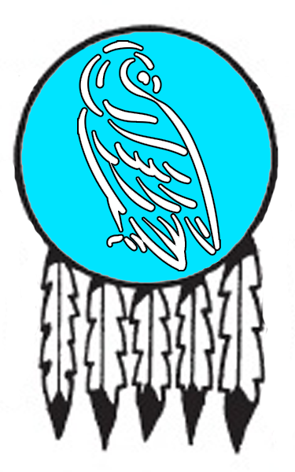
Snowbird People
Size: 25,000, 250 warriors, 1250 militia
Trade Goods:
Local Goods: whale blubber, whale oil, seal skin, caribou hides and bone tools
Standard: Snow Bird
Colors: blue and white
Patron Deity: Pukimna, the Caribou Mother
Ruler: Chief Sarkak and his wife Kunuatok (f)

Home:
Steward: Osoochiak
Marshal: Bammiuk
Head Shaman: Evalun the Cloud Changer
Wild Mage: Meeka (f) the Shining Star
Head Warrior: Tungilik
Chief Warriors in Service:
Ovilu (f)
Pitseolak
Qatsiya
Saila (f)
Okakluk

Local Powers:
Local Sites:

Description:
The Snowbird People occupy the frozen northwestern reaches of the Haka’Na lands, more specifically all lands north of the Wenopa Hills in the Dream Walk Lake region.

Industry:
Survival in the frozen wastes is preoccupied with hunting. Hunters are armed with bows, harpoons, clubs and the knives made of stone, bone, ivory, horn, antler or teeth. The harpoon is a type of javelin with a wooden shaft, a long and slender thrusting tip and a rope so the hunter can retrieve the weapon after a cast. To prepare game they use a skinning and butchering knife called an "ulu" which has a large, crescent-shaped blade. Fishing can be done on the water or by cutting holes in the ice. The fishing spear has three heads like a trident, and is used in conjunction with nets and fishing lines. Another tool they use is the snow probe made of antler to test the depth of snow when traveling over glaciers or to look for breathing holes used by seals.

People of this region travel over land by dog sleds called qamutiik. On water they use single-person kayaks or larger seal-skin boats called umiait. Rangers among the tribes have been known to tame giant stags, moose, or even polar bears as mounts.

Clothing consists of hooded parka, pants, mittens, inner footwear, and outer boots, all made of animal hide and fur from caribou, seals, and seabirds. These are decorated with ornamental trim and inlay, dye, decorative attachments like pendants and beads, and design motifs.

Key Figures:
The Stone Coats are giants that roam the Wenopa Hills. They are slow, dumb creatures that are savage and cruel and hunt for human flesh.

Local Lore:
Masawu Pit – The shaman’s lodge contains a sacred Masawu fire pit. When lit, it iis connected to the Masawu fire pit in the lodge of the Seven Fires Council in Ioskeha. These were created by Masawu, the spirit known as the Skeleton Man and holder of the secrets of fire. On each new moon the flames are lit in every pit and elders from all peoples enter a trance. Masawu transports them temporarily into the ethereal plane, which they call the Fifth World, and they appear before the fire in Ioskeha as ghostly apparitions. Here, elders can commune with one another on matters of council business.

It is said that the Caribou Mother dwells in the lands to the north of here. Called by the name Pukimna by some, she takes the form of a gigantic caribou that roams the Horn Mountains. There she tends to the health and wellbeing of the herds and is a caretaker of those lands.

History:
280-288 WA3 - Norgardians rage their way through the lands of the Snowbird people, decimating every village in their path; Stalf Sealskin steals the Amulet of Sedna

288 WA3 - Battle of the Broken Ice: Warriors of the Snowbird people call on Pukimna, the Caribou Mother; the Norgardians are surrounded and defeated, mauled by polar bears and taken under the ice by whales

Customs:

The people of the far northwestern region of Haka’Na lands call themselves the Snowbird People.
[Developer’s Note: the Snowbird People are loosely based on the Inuit (including the Alaskan Iñupiat, the Greenlandic Inuit, and the Canadian Inuit)]

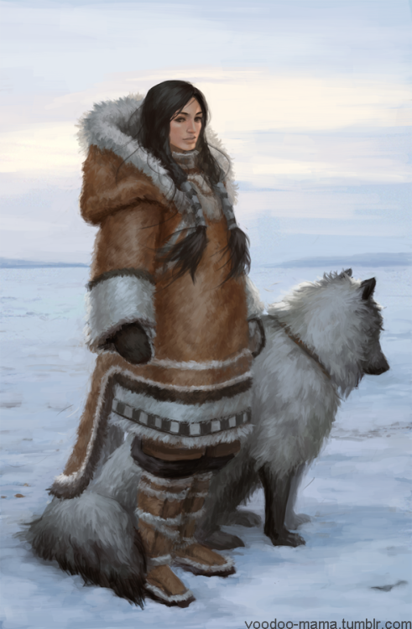

Sea Lion People
Size: 25,000, 250 warriors, 1250 militia
Trade Goods:
Local Goods: whale blubber, whale oil, seal skin, caribou hides and bone tools
Standard: Sea Lion
Colors: green and white
Patron Deity: Komokwa, god of the undersea world
Ruler: Chief Nakashuk (f) and her husband Igruk

Home:
Steward: Akitirq
Marshal: Epirvik
Head Shaman: Twamie the Speaker
Wild Mage: Aviliaju (f) the Weaver of Patterns
Head Warrior: Isaacie
Chief Warriors in Service:
Ulgavik
Mususi
Kaitanak (f)
Jamasie
Kiakshuk

Local Powers:
Local Sites:

Description:
The Sea Lion people dwell in the far northeast of the Haka’Na lands, specifically between the Staghorn Mountains and High Fist Mountains north of the Ursula Lakes. There is little organization to the tribes. There are scattered settlements of clans who dwell in snow-block houses or in semisubterranean houses built of stone or sod over a wooden or whalebone framework. In summer many live in animal-skin tents.

Industry:
Survival in the frozen wastes is preoccupied with hunting. Hunters are armed with bows, harpoons, clubs and the knives made of stone, bone, ivory, horn, antler or teeth. The harpoon is a type of javelin with a wooden shaft, a long and slender thrusting tip and a rope so the hunter can retrieve the weapon after a cast. To prepare game they use a skinning and butchering knife called an "ulu" which has a large, crescent-shaped blade. Fishing can be done on the water or by cutting holes in the ice. The fishing spear has three heads like a trident, and is used in conjunction with nets and fishing lines. Another tool they use is the snow probe made of antler to test the depth of snow when traveling over glaciers or to look for breathing holes used by seals.

People of this region travel over land by dog sleds called qamutiik. On water they use single-person kayaks or larger seal-skin boats called umiait. Rangers among the tribes have been known to tame giant stags, moose, or even polar bears as mounts.

Clothing consists of hooded parka, pants, mittens, inner footwear, and outer boots, all made of animal hide and fur from caribou, seals, and seabirds. These are decorated with ornamental trim and inlay, dye, decorative attachments like pendants and beads, and design motifs.

Key Figures:
Komokwa is the god of the undersea world, master of sea lions, responsible for the rising and ebbing of the tides as well as the riches these tides deposit on beaches and those claimed by the vagaries of sea weather, both material and human lives. He has the power to see into the future, heal the sick and injured, and bestow powers on those whom he favors.; patron deity of the Sea Lion People

Local Lore:
Masawu Pit – The shaman’s lodge contains a sacred Masawu fire pit. When lit, it iis connected to the Masawu fire pit in the lodge of the Seven Fires Council in Ioskeha. These were created by Masawu, the spirit known as the Skeleton Man and holder of the secrets of fire. On each new moon the flames are lit in every pit and elders from all peoples enter a trance. Masawu transports them temporarily into the ethereal plane, which they call the Fifth World, and they appear before the fire in Ioskeha as ghostly apparitions. Here, elders can commune with one another on matters of council business.

The Stonka tribe of goblins lurk in the eastern Staghorn Mountains. They are known by their sign of lightning striking a mountain peak.

History:
44 WA4 - the evil shaman Micanopy crafts the Flint Helm, commanding the Spirit of Winter

47-49 WA4 - The Yeti War: Micanopy launches a savage assault of Yeti on Tall Bear; a combined army of the Bear People, the Otter People, and the Sea Lion People defeat the yeti and Micanopy; the Flint Helm is lost

Customs:

The people of the far northeastern region of Haka’Na lands call themselves the Sea Lion People.
[Developer’s Note: the Sea Lion People are loosely based on the Yupik (or Yuit) of eastern Siberia and Alaska.]

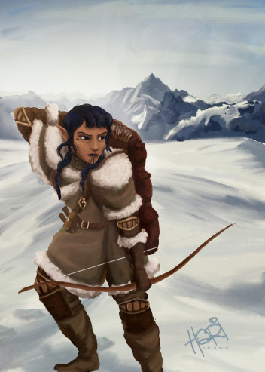

History of the Haka’Na Lands

First Primordial Age (PA1)
Dawn of the Haka peoples

10 PA1 - Manitou, the Great Spirit, enters the material realm and smiles upon the lands of the Haka'Na

60 PA2 - Clash between Waukheon and the Serpent over present-day Thunderbird Mountain

Second Primordial Age (PA2)
722 PA2 - the powerful shaman Howahkan is beguiled by dark spirits to cross the High Fist Mountains, his cult finds the crown of power

730 PA2 - Howahkan's power grows, he sends his warriors and unholy acolytes to lay waste to the land, making friends with unnatural beasts

740 PA2 - Howahkan's dark reign comes to an end when the Eight Elders trek over the High Fist Mountains armed with eight war clubs given by Wakheon; they defeat Howahkan and are lost in a great fire

Third Primordial Age (PA3)

Fourth primordial Age (PA4)
340 PA4 - War of the Plain Spirits - the peoples of Machakw and Hurit wage war over the lands around the Tonagosk River

360 PA4 - The peoples of Machakw and Hurit make peace; the evil witch Wambleeska was never found

800 PA4 - the evil wizard Iretrix rises to power past the High Fist Mountains; dark kingdom of Sadara forms in Eastern Amadar

872-888 PA4 - The Wizard War: Telemechus triggers a world-wide war of mages, some of whom march on Ongolk to stop him and some who join him in attacking the ley lines in their lands; epic battles wage all over the world, destroying cities and upsetting the balance of magic

888 PA4 - The Battle of Forlorn: Telemechus is slain but not before rupturing the magical ley lines permeating Nemmyrl; the victorious general Dragan of Celedon seizes the opportunity to rid the world of magic and ruptures the Singularion as it is embedded in the ley lines; the resulting explosion sends a shock wave that ruptures the magical ley lines around the world and triggers the Dead Century

First Ancient Age (AA1)
270 AA1 - War of Falling Stars: Haka'Na tribes unite and march east past the High Fist Mountains to wage war on Iretrix and his dark host

292 AA1 – End of the War of Falling Stars: after years of bloody battles, the Haka’Na tribes succeed in slaying the wizard Iretrix and destroying the evil Kingdom of Sadara

Second Ancient Age (AA2)

Third Ancient Age (AA3)
330 AA3 - paladins of Waukheon from the Haka'Na lands invade Abereft and liberate the slave camps

670 AA3 - War of Tesoro - rumors of platinum in the Ongolk valley region spark an invasion of prospector ships; invaders battle Haka'Na warriors alongside the Dwarves of Agatren; thousands die before the invaders are repelled

Fourth Ancient Age (AA4)

First Written Age (WA1)
400 WA1 - Hill giants from the Owachee Hills harass the town of Machakw under their chief Karawaq

408 WA1 - Rangers of the Band of the Water Beetle are led by Ciqala Singing Spear and slay the giants over an eight-year period.

Second Written Age (WA2)
150 WA2 - Pirate Canstibar moves into the abandoned city of Madrina on the Isle of Ariago, creating a pirate stronghold in the Korsair Sea

230 WA2 - Aranck Proud Paw, defender of Ayaabe, rescues the elven town of Sylvir from a Haraka gnoll invasion; the domain of Elyon names him and his people Elf Friend and bestows the town a magic spear called Darkless

480 WA2 - Scourge of the Blood Star: the evil shaman Chogan wields the Blood Star Ring and raises an army of Wendigo to terrorize the land; all of the western Haka'Na lands are locked in terror

492 WA2 - the fall of Chogan: Haka'Na braves, joined by shaman from all over the land and the Elenar star elves of Cetaris, defeat the Wendigo and slay Chogan; the Blood Star ring is lost

720 WA2 - Mortavay unites orc tribes and marches east into Haka'Na lands; wipes out Machakw, attacks Turuwe and Hurit

724 WA2 - Mortavay's forces are stopped near Moon Lake in the Battle of Moon Lake

Third Written Age (WA3)
280-288 WA3 - Norgardians rage their way through the lands of the Snowbird people, decimating every village in their path; Stalf Sealskin steals the Amulet of Sedna

288 WA3 - Battle of the Broken Ice: Warriors of the Snowbird people call on Pukimna, the Caribou Mother; the Norgardians are surrounded and defeated, mauled by polar bears and taken under the ice by whales

293 WA3 - Holfan the Blooded sails his ships into Fool's Inlet during a great storm and discovers a Haka'Na town. After savage battles the Haka'Na drive the Norgardsmen back into the sea. And Holfan’s horn, pulled from his bloody corpse, is taken as a trophy and inspires the town to be called Red Horn

640 WA3 - Second Dark Crusade reaches Haka'Na

812 WA3 - evil shaman Hehosho uses the Broken Hoop to summon demons in Namakek, builds an army of bugbears and gnolls under the banner Black Sky

814 WA3 - Black Sky invades Haka'Na lands, destroys Unetuuwa

815-821 WA3 - War of Black Sky: Liluye, Ayaabe, Ioskeha, and Tall Bear fight Hehosho's forces, who plunder eastern Haka'Na lands and conquer Sunwalk Valley; Hehosho desecrates the valley and makes it his stronghold

821 WA3 - Battle of Sunwalk - Red Horn joins the Haka'Na alliance, which marches on Sunwalk Valley from the north; Kiwidinok (f) the huntress is gifted the Bow of Hawenniyo and slays Hehosho; the Black Sky armies are destroyed

Fourth Written Age (WA4)
44 WA4 - the evil shaman Micanopy crafts the Flint Helm, commanding the Spirit of Winter

47-49 WA4 - The Yeti War: Micanopy launches a savage assault of Yeti on Tall Bear; a combined army of the Bear People, the Otter People, and the Sea Lion People defeat the yeti and Micanopy; the Flint Helm is lost

207 WA4 - Saurian tribes of the Slizz and Sekkasit mount a full assault on Hurit and almost destroyed it completely; Chief Chochmo set the main bridge ablaze, slaying the Saurian chieftains and saving the town

220 WA4 - the Great Hunt - warriors from all over the Haka'Na lands quest to find the Great Stag and win reknown for capturing him

331 WA4 - Baozang attacks the town of Ayaabe, set on conquering it to colonize Haka'Na lands; Ayaabe warriors decimate the Xiandai mercenaries and burn their ships

390 WA4 - Ko’Ohchen is attacked by lizardfolk forces; three heroes secure the Kaliska stone and wash the armies away

Local Goods

Cereals: maize (corn), maygrass, little barley, wild rice; (pseudo-cereals) amaranth, quinoa, erect knotweed, sumpweed, and sunflowers
Fiber: cotton, yucca, agave, dogbane (native american hemp), hemp, hoopvine, jute
Fruits: Tomatoes, chili peppers, avocados, cranberries, blueberries, huckleberries, cherimoyas, papayas, passionfruit, pineapples, soursops, strawberries, elderberry, grapes, mayapple, persimmon, plum, black cherry, black raspberry, blueberry, buffaloberry, chokecherry, cocoplum, cranberry, dewberry, desert apricot, may hawthorn, ground plum, huckleberry, maypop, pawpaw, pigeon plum, prickly pear, pumpkin, red mulberry, salal berry, salmonberry, saskatoonberry, saw palmetto, crabapple, thimbleberry, toyon, wintergreen, squashes, watermelon, canary melon, cantaloupe melon
Meat and poultry: turkey, bison, muscovy ducks, deer, and guinea pigs
Nuts: Peanut, black walnuts, white walnet, shagbark hickory, pecans, hickory nuts, acorns, pinion pine nuts, cashew nuts, acorns
Vegetables: squash, chives, dandelions, knotweed (sumpgrass), artichoke, common beans, tepary beans, scarlet runner beans, lima beans, pole beans, peanuts, Jicama, manioc (cassava), potatoes, sweet potatoes, sunchokes, oca, mashua, ulloco, arrowroot, yacon, leren, groundnuts
Herbs: ginseng, echinacea, sage
Oils:
Fermented Drink:
Salt-water fish:
Fresh-water fish: salmon, steelhead
Wood: cedar, fir, larch, hemlock, pine, spruce, redwood, sequoia, walnut, ash, basswood, beech, chestnut, hickory, oak, poplar, elm, maple, sycamore
Textiles:
Dishes:
Other: Chocolate, canna, tobacco, chicle, rubber, maple syrup, birch syrup, vanilla, maple sap, sunflower

Notes on Culture
Angakkuq - an intellectual and spiritual figure in Inuit culture who corresponds to a medicine man

Local Deities
Most Native American religions were generally characterized by animism and shamanism. Animists perceive the world as filled with living entities: spirit-beings that animate the sun, moon, rain, thunder, animals, plants, topographic features, and many other natural phenomena. Shamans are men and women who have achieved a level of knowledge or power regarding physiological and spiritual health, especially its maintenance, recovery, or destruction. Always in a somewhat liminal state, shamans had to be acutely aware of the community’s goings-on or risk the consequences.
- Tawa – sun spirit and creator of men, flanked by his Kachina nature spirits; patron deity of Machakw
- Iktomi – trickster god; patron deity of Tiruwe
- Saqsakaew the Heron – animal spirit of luck and patience; patron spirit of Hurit
- Tatanka Ska - the great white buffalo and god of the hunt; patron deity of Tatanka
- Corn Mother - goddess of fertility and the harvest; patron deity of Ko’Ohchen
- Ataensic - Sky Woman and the Great Mother, tied to the moon and death, patron deity of Ioskeha
- Moqwaio the Wolf - animal spirit of the hunt and escort of the dead; patron deity of Red Horn
- Deer Woman - spirit of fertility and love; the Great Stag; patron deity of Ayaabe
- Kaiti the Bear - animal spirit of strength and resilience; patron deity of Tall Bear
- Wajosen the Wind Eagle - animal spirit of leadership and wisdom; patron deity of Liluye
- Amishkuapeu the Beaver - animal spirit of industry and preparation; patron deity of Unetuuwa
- patron deity of Katamut
- patron deity of Untunktahe
- Tulok - god of the stars, patron deity of Tohono

Other deities and spirits in the land
- Áłtsé hashké – ceremonial name for the Coyote god, a mischievous trickster god (also see: Skelep)
- Hah-nu-nah - the Turtle, the earth bearer. When he moves the sea gets rough and the earth shakes.
- Pukimna - the Caribou Mother, patron deity of the Snow Bird People
- Komokwa – god of the undersea world, master of sea lions, responsible for the rising and ebbing of the tides as well as the riches these tides deposit on beaches and those claimed by the vagaries of sea weather, both material and human lives. He has the power to see into the future, heal the sick and injured, and bestow powers on those whom he favors.; patron deity of the Sea Lion People

Religious Orders

The Seven Fires Council is a body of holy men and women who reside in Ioskeha and pass on counsel from the gods to every corner of the Haka’Na people. Holy messengers are blessed to venture out each year and visit the Haka’Na settlements to deliver the new words from the gods. It is said the Haka’Na are united by this regular contact and that their entire civilization moves with these messages.

Daughters of the Raven
Among the Haka’Na are mystic women who commune with the Raven. They enter a trance to walk the spirit world in an effort to divine the future and counsel against evil portents. While the Seven Fires Council speaks to hope and virtues for the Haka’Na, the Daughters of the Raven commune with the darker aspects of fate and their words often lean towards vigilance and portents of doom. For this reason, they are often seen to clash with the Seven Fires. Those of great wisdom can probably see the words complement one another, but very few of the Haka’Na resist the urge to side with one or the other.

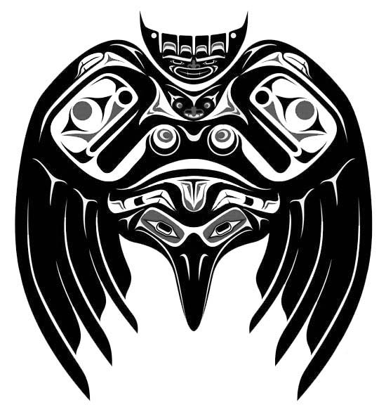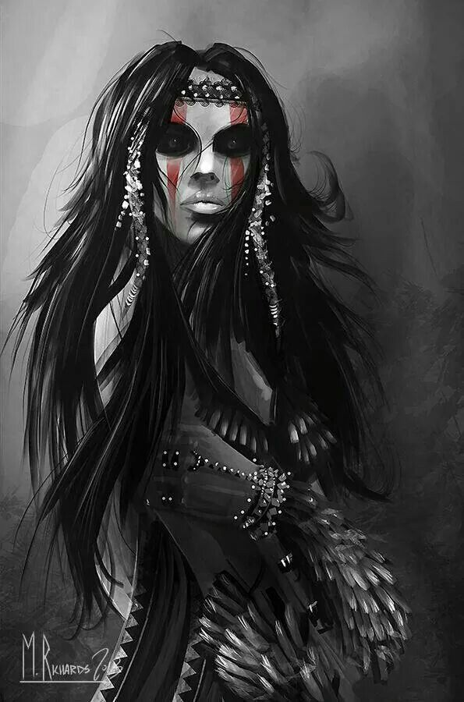

The Blood Star – cult of shaman that embrace the power of the Wendigo and seek to command them. They are abhorred by the tribes as evil and selfish. All who have worn the signet ring of the blood red star have been corrupted by the darkness of the Wendigo spirits and become one themselves.

(Research)
- Waukheon – the Thunder Bird; The flapping of WAUKHEON on his way to war makes the sky shake with thunder — and when he glances down to earth, lightning hits the ground. WAUKHEON constantly battles with Untunktahe the Water God.
- Untunktahe – water god, due to his pride he constantly challenges Waukheon
- Uncegila - She was fond of swimming up rivers and polluting them, then flooding the land with salt water so nothing could grow. Two twin lads, with the aid of a bow and some magic, managed to hit her seventh spot — the only vulnerable place on her body. She didn’t die quietly but writhed and thrashed over the land, causing more damage. To make matters worse, the Sun joined in after she’d completed her death throes, scorching the flesh from her bones and sucking up the moisture.
- Coyote -
- Raven –
- Beaver -
- Kwatee
- The Four Hares
  - Manabozho – aka Wisaaka aka the Great Hare, Protector of Humanity – rabbit trickster god, always ducking and diving and changing shape, god of mischief but is connected to creation, provisions, and transformation; oldest of the four brothers: Chakekenapok, Wabasso, and the wolfish Chibiabos
  - Chakekenapok – youngest of the four brothers, blamed for the death of their mother as she died during his birth, worked out how to make flints and fire but Manabozho knocked him to pieces: some of his body became flint, his bones became the roots of mountains, and his guts turned into grapevines. His fire duties went to Wabasso.
  - Wabasso – third of the brothers, traveled north to touch the sun, turned himself into a white rabbit, and met the Great Magician Spirits who taught him about medicine and healing; he gave this knowledge to Manabozho and became Guardian of the North instead. Now he’s the Maker of White for when the North Winds blow and bring snow.
  - Chibiabos – youngest of four brothers, Protector of the Dead; vandalized the Spirits and this melted the ice, he fell into the Underworld; Manabozho battled the spirits to get him back; now Chibiabos is Lord of the Land of the Dead and Guardian of Souls
- Ictinike – spider god of mischief, always battling Manobhozo
- Sedna – sea hag of the arctic, rules all arctic sea life; has one eye, no fingers, and a giant bloated body, was once a beautiful maiden but was sacrificed to appease her spurned ex-husband a bird spirit; sometimes appears as a walrus, rules the frozen underworld Adlivun from an an ice palace at the bottom of the sea, may be coaxed into favor by combing her dark tresses but only after travelling to Adlivun by entering a trance
- Wakan-Tanka
- Ahayuta-Achi
- Pamuya - moon goddess, name meaning "water moon."
- Aakuluujjusi
- Kokopelli - a fertility deity, usually depicted as a humpbacked flute player (often with feathers or antenna-like protrusions on his head), who has been venerated by some Native American cultures in the Southwestern United States. Like most fertility deities, Kokopelli presides over both childbirth and agriculture. He is also a trickster god and represents the spirit of music. Kokopelli carries unborn children on his back and distributes them to women; for this reason, young girls often fear him. He often takes part in rituals relating to marriage, and Kokopelli himself is sometimes depicted with a consort, a woman called Kokopelmimi. It is said that Kokopelli can be seen on the full and waning moon, much like the "rabbit on the moon".
  - Kokopelli also presides over the reproduction of game animals, and for this reason, he is often depicted with animal companions such as rams and deer.
- Beaver – aka Capa – the god of industry, preparation; was once a maiden who swam in a magic lake and would not leave when told to do so, thus turned into the mother of Beavers; gave humans the gift of strong drink
- Ioskeha –

The Rain Bird is rumored to visit this region and is highly regarded by the shaman of (TBD). A divine spirit that can summon rain, he is revered by the people and considered a good sign when he appears.
Skelep, the trickster god, also appears regularly in the wastelands to the west. Appearing in the form of an upright coyote, Skelep is fond of deception and mischief. According to legend, in the beginning the Great Spirit was fashioning various creatures out of clay. Skelep tried to do the same. But as he kept laughing, his efforts did not turn out well. The Great Spirit told him that if he stopped laughing he might do better. But Skelep denied laughing and thus, the first lie was told.

Visitors to Machakw will notice the constant presence of small black birds throughout town. Locals say they are related to the Rain Bird, their patron deity. Every person in the town is accompanied by one of these common birds. Even visitors will find that while they linger here, one of the birds will accompany them everywhere. While there seems to be no magical significance to the creatures, some say that they are protectors and advisors to those who have the ears to hear them.

An inuksuk or inukshuk is a manmade stone landmark or cairn built for use by the Inuit, Iñupiat, Kalaallit, Yupik, and other peoples of the Arctic region of North America. These structures are found in northern Canada, Greenland, and Alaska.

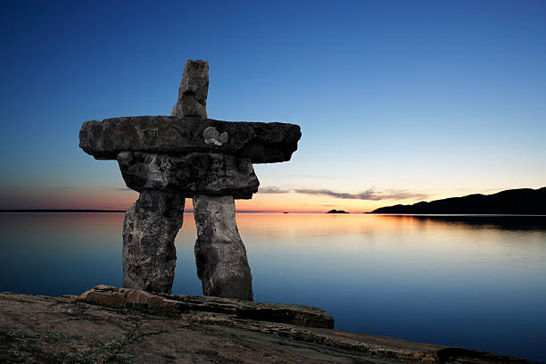

Creatures
The Haka’Na lands are home to a variety of strange creatures born of evil spirits. Some are unique to certain regions and are organized by the actual tribes on which the Haka’Na tribes were based.

Creatures in the lands of Machakw and the Horse People
Tawa, the sun spirit, is the patron deity of the Horse People. Accompanied by his Kachinas, nature spirits, he protects the people. The Kachinas are:
- Eototo (weather spirit and chief of the kachinas)
- Angwusnasomtaka (Crow Mother, mother figure of all the kachinas),
- Kokopelli (the fertility spirit)
- Mongwa (owl spirit and enforcer of the law,)
- Angak'china (long haired kachina, a spirit of rain and flowers)
- Mana (corn maidens, spirits of agriculture.)
- Cheveyo - ogre kachina, very scary
- Koshari - a sacred clown
Anaye: The Anaye are monstrous beings born in the primordial ages. They include
- Thelgeth/Theelgeth - hairy, headless Anaye
- Delgeth - carnivorous antelope
- Tsenahale/Tse'na'hale - feathered creature
- Binaye Ahani - limbless twins
- A few Anaye are said to have survived to the present day, and those are Old Age, Poverty, Cold, and Famine.
Johano: a magical breed of horses that are said to have come from the spirits of the sky. They may appear in one of the five colors of the day-time sky: turquoise, white shell, pearly shell, red shell, and coal.
Nimerigar: A violent race of magical little people who were said to kill and eat people.
Water Babies: Mysterious and dangerous water spirits. They inhabit springs and ponds, lead humans to a watery grave by mimicking the sounds of crying babies at night. Sometimes they are said to kill babies and take their place as changelings. Respectful treatment and offerings are often considered to ward off violence by the water babies.
Kolowisi - horned water serpent, generally a benevolent figure, not a monster.
Atasaya - terrible man-eating ogre.
Suuke - monsters who live in caves and carry off children in their baskets

Creatures in the lands of Tiruwe and the Washpaw People

Creatures in the lands of Hurit and the Heron People

Creatures in the lands of Tatanka and the Buffalo People
Red-Woman is an ogress and cannibal; she is a malevolent monster who kills just for the sake of killing, sometimes mutilating her victims in horrible ways. Some say she uses witchcraft to hypnotize people or affect their minds.

Creatures in the lands of Ko’Ohchen and the Badger People

Creatures in the lands of Red Horn and the Wolf People

Creatures in the lands of Ayaabe and the Elk People
Ghost-Witch aka Skadegamutc (pronounced skuh-deh-guh-mooch): A malevolent undead monster created by the death of an evil sorcerer, which returns to life by night to kill and devour humans.

Creatures in the lands of Ioskeha and the Otter People

Creatures in the lands of Tall Bear and the Black Bear People

Creatures in the lands of Liluye and the Eagle People

Creatures in the lands of Unetuuwa and the Moose People

Creatures in the lands of Katamut and the Geese People

Creatures in the lands of Untunktahe and the Hawk People

Creatures in the lands of Tohono and the Whale People

Creatures in the lands of Snowbird People

Creatures in the lands of Sea Lion People

- Ataensic – mother goddess, fell through the sky, associated with the moon and death
  - Ioskeha aka Sky-Holder - good twin son of Ataensic, hero and monster slayer
  - Tawescaron aka Flint – evil twin son of Ataensic, trickster god and associated with winter
- Hinon aka “Grandfather” – leader of the Thunders, powerful storm spirits who shapeshift between appearing as winged humans and giant birds; their gaze can bring death to normal men; enemy of the Oniare water serpents
- Oniare – dragon-like horned water serpent that lurks in the Sea of Orenda, capsizes boats and eats people, enemy of Hinon the thunder god, will spare travelers who make an offering to it; its breath is poisonous
- Stone Coats – race of rock giants about twice as tall as humans, with their bodies covered in rock-hard scales that repel all normal weapons. They are associated with winter and ice, and they hunt and eat humans. They are a tribe of primordial man-eating monsters created by Flint.
- Flying Heads – undead creatures that appear as huge, disembodied heads with fiery eyes and long, tangled hair; they fly through the air, pursuing humans to devour; they are also called Whirlwinds for the sometimes are appear from the midst of large whirlwinds which they can control and use them to attack
Azeban - These are trickster spirits that are mostly harmless and often appear in the form of a raccoon. They deceive animals and men to steal their food. They are known to engage in many foolish and/or mischievous things but are not dangerous or malevolent. (Abenaki legend)
Canotila, a race of forest-dwelling creatures similar to fairies. They are considered messengers from the spirit world and dwell in the forest, but sometimes they appear in dreams. (Lakota/Sioux legend)
Johano - a magical breed of horses that are said to have come from the sky god and that come in one of the five colors of the day-time sky: turquoise, white shell, pearly shell, red shell, and coal. (Navajo legend)

The Yehasuri are two feet tall creatures that are part of an ancient Catawba legend and are said to live on the Catawba Indian Reservation in South Carolina. Their name translates to "wild little people". They are tricksters and are generally depicted as small, but otherwise ordinary looking people. The Catawba believe that they live in tree stumps and eat a wide variety of food, such as frogs and bugs. They are said to be vicious on occasion, and the Catawba believe the only way to stop them is to rub tobacco on one's hand and recite the ancient Catawba prayer

Hah-nu-nah – the Great World Turtle, this massive creature plies the seas of the world and was once thought to hold up the world itself.

Kankakee
At the center of this immense Kachina swamp stands the mighty Kankakee, a massive bald cypress that dates back to the dawn of Nemmyrl itself. Kankakee is one of the largest and oldest treants. He is connected to the entire Kachina swamp and is aware of every creature in it. He patiently watches over these lands and is its custodian, caring little to interfere with the affairs of humans or any other race as long as the swamps maintain a balance of life.
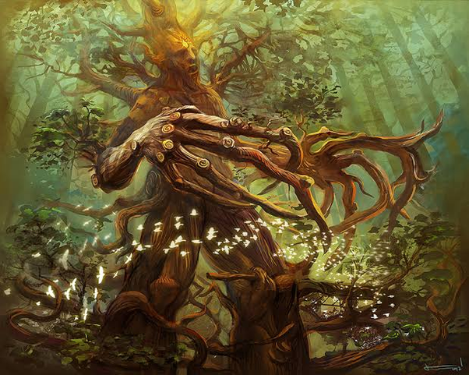

Other Races
Elves
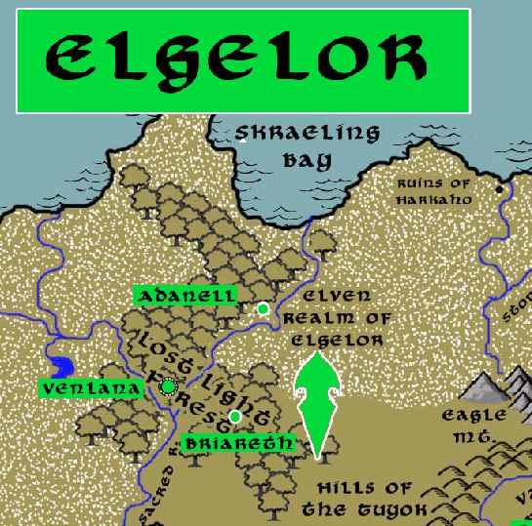
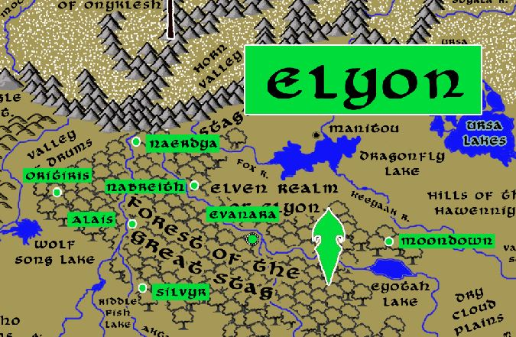

Dwarves
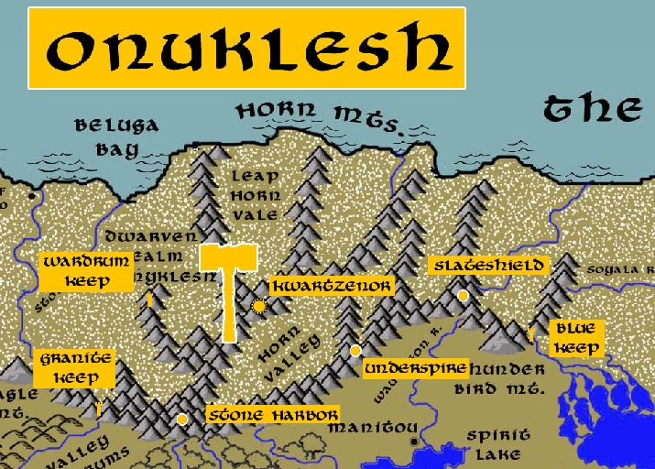

Magical Items

War clubs of Manitou (Thunder Bird)
Forged in the Great Horn Mountains in a volcano, imbued with the properties of fire and ice, used by Haka’Na paladins to combat great evil. +2 war clubs: grant +2 to ATK and DMG, protection from evil (+2 deflection bonus to AC and a +2 resistance bonus on saves. Both these bonuses apply against attacks made by evil creatures), additional +1 ATK/DMG vs evil creatures, resistance to energy (hot/cold) of 5

Singing Spear - The spear is said to cry with the yells of all it has slain. It was gifted by the Rain Bird to Ciqala, a brave of Machakw, three thousand years ago. With it Ciqala and her fellow warriors slew seven terrible giants, including their chief Karawaq. Ciqala was renamed Ciqala Singing Spear and is a legend among the people of Machakw.

The Keepers – mystic totem poles of the Twisted Hair Lodge in Machakw. Elders from tribes across the land travel here to share their oral histories. These are captured in the sacred smoke of the storytelling ceremony and preserved within the mystic totem poles. Master story-keepers of the Haka’Na are able to commune with these totem poles and recount the stories, sometimes even raising up the spirits of ancestors to tell them.

The Watcher – a giant stone totem pole erected commemorating the struggle of the First Dark Crusade and the rebuilding of Machakw. Facing westward, the grimacing face of the Great Thunder Bird is ever watchful of Vigil Pass. It is said the pole is enchanted with the spirit of Waukheon himself and will defend the town against any evil.

Sky Beads, given to the chief of Machakw many years ago by the Rain Bird himself. It is said that each of the five colored beads does something special: one will bring rain, one will bring thunder, one will make sickness go away, one will bring courage, and one will split the land as if struck by a giant hand. Currently worn by the chief of Machakw, Ohcumgache.

Rain Thief - a magic stick carried by the Omekh gnoll tribes operating out of the Nighthawk Valley region; it consumes all water that it touches and is used by the gnolls to lay waste to the land

The Drums of Malina are two simple wooden cylinders with rawhide stretched over them and inscribed in tribal designs denoting the goddess Malina and the Haka'Na people. When played you must make a Perform check. On a successful check, the drums project an aura with a radius of 10 feet. Everyone within the aura is transported to the astral plane, leaving their bodies behind. While there, each character comes face-to-face with an animal spirit from the Haka'Na lands. The exact spirit animal is up to the GM's discretion. Characters may ask the animal spirit three questions, upon which they receive the wisdom befitting that animal and its nature.

The Bloodstar Ring – the signet ring of the cult of the Wendigo, it was crafted long ago to command the evil creatures. It has powerful magic over the beasts, but is cursed. Any who wear it are eventually transformed into Wendigo themselves. In 492 WA2 Haka'Na braves, joined by shaman from all over the land and the Elenar star elves of Cetaris, defeated the Wendigo and slew the evil shaman Chogan; the Blood Star ring was lost.

Okataloa “the Water Song” - great warclub which is rumored to carry the power of life and death of the wetlands themselves. It is said to both harm and heal as needed, as well as producing a strange sound like the croaking of many frogs. Carried by chief Hakla of the Hurit people.

Medicine bundles - trademark of the Wakan, shaman from Tatanka. They possess spiritual power, are only entrusted to prominent religious figures of a tribe, and are passed down from keeper to keeper in each succeeding generation.

Amulet of Sedna – an ancient talisman that is cursed with the malice of the sea goddess but is able to stir the wrath of arctic and sea animals. Stolen by Stalf Sealskin the Norgardian chieftain who raided the lands of the Snowbird People during the great Erobring. It was lost when the Norgardians were destroyed in the Battle of the Broken Ice in 288 WA3.

Claws of Sungmanito – These are gauntlets that are fashioned with retractable metal claws. They are supernaturally sharp, able to sunder blades and shields. They are enchanted with the fierce spirit of Sungmanito, the Wolf Spirit of hunting and war. They are currently worn by Chief Dohate of the Wolf People in Red Horn.

Darkless – magic spear created by the Elves of Elyon; gifted to Aranck Proud Paw in 230 WA2 after Ayaabe rescued the town of Sylvir from a Haraka gnoll invasion; the domain of Elyon named him and his people Elf Friend and bestows the town the spear, where it remains to this day as a symbol of friendship between Elk People and Elyon. It is said to have the power of sight in total darkness for whoever wields it, and strikes true when none can see.

Stone Coat Belt - A magic vestment that grants its wearer the strength of the giants of the same name. Currently worn by Chief Kanuna of the Bear People in Tall Bear.

The Flint Helm – crafted by the evil shaman Micanopy in 44 WA4, it commands the Spirit of Winter, granting the wearer power over weather as well as over yeti. It was used to launch the Yeti War in the northern Haka’Na lands before a combined army of the Bear People, the Otter People, and the Sea Lion People defeated the yeti and Micanopy and the Flint Helm was lost.

The Broken Hoop – a cursed item of enormous power, the Broken Hoop was created out of pure chaos magic. It grants whoever wields it power over probability, making the near-impossible within ones grasp. It was wielded in 812 WA3 by the evil Sadaran shaman Hehosho to summon demons in Namakek and build an army of bugbears and gnolls under the banner Black Sky. With it, he conquered the eastern Haka’Na lands and desecrated Sunwalk Valley before the combined Haka’Na armies marched on him. Kiwidinok (f) the huntress was gifted the Bow of Hawenniyo and slew Hehosho. The Broken Hoop was lost and its current whereabouts unknown.

Bow of Hawenniyo – This magical weapon was created by the fertility spirit Hawenniyo and only appears in the hands of a brave hunter of noble heart. It was once held by the huntress Kiwidinok (f) who used in the War of Black Sky to slay the evil shaman Hehosho. Its current whereabouts are unknown, but is suspected to be missing from this world until such time a noble hunter earns it from Hawenniyo.

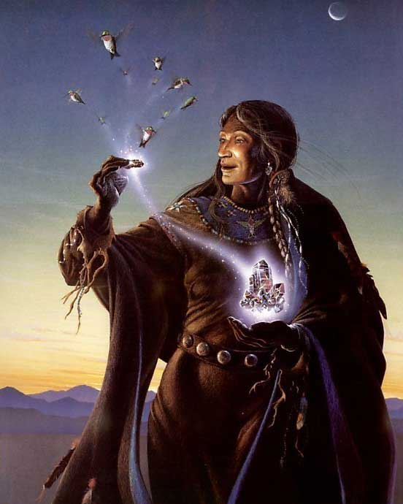

NPC Templates
Equipment typical to Haka’Na adventurers
- Greatclub 1d10
- Dagger 1d4
- Longspear 1d8
- Spear 1d8
- Quarterstaff 1d6/1d6
- Sling 1d4
- Axe, throwing 1d6
- Battleaxe 1d8
- Handaxe 1d6
- Longbow 1d6
- Shortbow 1d6
- Longbow, composite
- Shortbow, composite
- Padded Armor +1
- Leather Armor +2
- Studded Leather Armor +3
- Hide Armor +3
- Shield, light wooden +1
- Shield, heavy wooden +2

Skills: Balance, Climb, Craft (Bow), Craft (Spear), Craft (Leather Armor), Craft (Axe), Handle Animal, Heal, Hide, Jump, Knowledge (Nature), Knowledge (religion), Listen, Move Silently, Perform (dance), Perform (sing), Profession (any), Ride, Search, Spot, Survival, Swim, Tumble

Feats: varies

Special: Knowledge (Nature) +5, Survival +5

NPC’s start with 70 points to use on ability scores

Haka’Na Barbarian – Level 1
male human (5 ft., 9 in. tall)
HD 1d12+2; hp 14
Init +3 (+3 Dex)
Spd 30 ft.
AC 16 (+3 Dex)
Attack +5 melee or +4 ranged
SV Fort +5, Ref +2, Will +2
Str 13 (+1), Dex 14 (+2), Con 14 (+2), Int 10 (+0), Wis 10 (+0), Cha 9 (-1)

Skills (20 sp): Balance +3, Climb +5, Jump +4, Listen +3, Ride +3, Spot +4, Swim +2

Feats: Great Fortitude (+2 to Fort Saves), Iron Will (+2 to Will Saves)

Class Traits: Fast movement, illiteracy, rage 1/day

Special: Knowledge (Nature) +5, Survival +5

Possessions: Greatclub, Dagger, Longbow, Throwing Axe, Hide Armor, Water Skin, Bedroll, Blanket, Fishhook, Flint and steel, Belt pouch, Whetstone, Trail Rations (10 days)

Haka’Na Bard – Level 1
HD 1d6+0; hp 6
Init +1 (+1 Dex)
Spd 30 ft.
AC 14 (+1 Dex)
Attack +0 melee or +1 ranged
SV Fort +0, Ref +3, Will +2
Str 10 (+0) , Dex 12 (+1), Con 10 (+0), Int 14 (+2), Wis 10 (+0), Cha 14 (+2)

Skills (45 sp): Balance +1, Climb +0, Hide+1, Jump +2, Knowledge (Religion) +7, Knowledge (Geography) +7, Listen +0, Move Silently +1, Perform (dance) +7, Perform (sing) +7, Ride +1, Search +3, Spot +3, Swim +0, Tumble +1, Bluff +9, Decipher Script +2, Diplomacy +9, Gather Information +7, Sense Motive +3, Sleight of Hand +1, Use Magic Device +7, Intimidate +4

Feats: Negotiator (+2 on Diplomacy and Sense Motive checks), Persuasive (+2 on Bluff and Intimidate checks)

Class Traits: Bardic music, bardic knowledge, countersong, fascinate, inspire courage +1

Special: Knowledge (Nature) +5, Survival +5

Possessions: Dagger, Hand Axe, Short Bow, Hide Armor, Water Skin, Bedroll, Blanket, Fishhook, Flint and steel, Belt pouch, Whetstone, Trail Rations (10 days)

Spells: 0-level: 2 – Dancing Lights, Prestidigitation

Haka’Na Cleric – Level 1
HD 1d8+0; hp 8
Init +0 (+0 Dex)
Spd 30 ft.
AC 14 (+0 Dex)
Attack +2 melee or +0 ranged
SV Fort +2, Ref +0, Will +4
Str 14 (+2), Dex 10 (+0), Con 10 (+0), Int 10 (+0), Wis 16 (+3), Cha 10 (+0)

Skills (12 sp): Heal +7, Knowledge: Religion +5, Use Magic Device +3, Perform (Sing) +4

Feats: Self Sufficient (+2 on Heal and Survival checks), Iron Will (+2 to Will Saves)

Class Traits: Turn or rebuke undead

Special: Knowledge (Nature) +5, Survival +5

Possessions: Dagger 1d4, Quarterstaff 1d6/1d6, Handaxe 1d6, Hide Armor +3, Shield, light wooden +1, Healer’s Kit, Holy Water, Holy Symbol, Water Skin, Bedroll, Blanket, Fishhook, Flint and steel, Belt pouch, Whetstone, Trail Rations (10 days)

Spells: (0 level) 3, (1st level) 2 + 1 domain spell (Animal Domain: Calm Animal)

e.g. 0-level: cure minor wounds, guidance, inflict minor wounds, resistance, virtue
e.g. 1st-level: bane, bless, cause fear, command, cure light wounds, divine favor, entropic shield, magic weapon, obscuring mist, protection from chaos/evil/good/law, shield of faith, summon monster I

Haka’Na Druid – level 1
HD 1d8+1; hp 9
Init +2 (+2 Dex)
Spd 30 ft.
AC 16 (+2 Dex)
Attack +0 melee or +2 ranged
SV Fort +3, Ref +2, Will +4
Str 10 (+0), Dex 14 (+2), Con 12 (+1), Int 10 (+0), Wis 14 (+2), Cha 10 (+0)

Skills (20 sp): Balance +2, Climb +0, Craft (Bow) +0, Craft (Spear) +0, Craft (Leather Armor) +0, Craft (Axe) +0, Handle Animal +5, Heal +7, Hide +2, Jump +0, Listen +2, Move Silently +2, Ride +2, Search +3, Spot +2, Swim +3, Tumble +2

Feats: Track, Self-sufficient (+2 on Heal and Survival checks)

Class Traits: Animal companion, nature sense, wild empathy

Special: Knowledge (Nature) +5, Survival +9

Possessions: Bone Dagger, Quarterstaff, Bone Hand Axe, Wooden shield (light) +1, Longbow, Hide Armor, Water Skin, Bedroll, Blanket, Fishhook, Flint and steel, Belt pouch, Whetstone, Trail Rations (10 days)

Spells: (0 level) 3, (1st level) 2
e.g. 0-level flare, guidance, resistance, virtue
e.g. 1st-level : cure light wounds, entangle, obscuring mist, produce flame , summon nature’s ally, shillelagh

Haka’Na Fighter – level 1
HD 1d10+1; hp 11
Init +2 (+2 Dex)
Spd 30 ft.
AC 17 (+2 Dex)
Attack +3 melee or +3 ranged
SV Fort +3, Ref +2, Will +0
Str 14 (+2), Dex 14 (+2), Con 12 (+1), Int 10 (+0), Wis 10 (+0), Cha 10 (+0)

Skills (12 sp): Balance +2, Climb +4, Jump +2, Listen +2, Move Silently +4, Ride +2, Search +0, Spot +2, Swim +4, Tumble+4

Feats: Point Blank Shot (+1 within 30 feet), Rapid Shot (one extra ranged attack each round), Weapon Focus on Longbow (+1 ATK with Longbow)

Class Traits: Bonus feat

Special: Knowledge (Nature) +5, Survival +5

Possessions: Longspear 1d8, Spear 1d8, Throwing Axe 1d6, Battleaxe 1d8, Longbow composite +2, Studded Leather Armor +3, Heavy Wooden Shield +2, Water Skin, Bedroll, Blanket, Fishhook, Flint and steel, Belt pouch, Whetstone, Trail Rations (10 days)

Haka’Na Monk – Level 1
HD 1d8+0; hp 8
Init +2 (+2 Dex)
Spd 30 ft.
AC X (+2 Dex)
Attack +1 melee or +2 ranged
SV Fort +2, Ref +4, Will +4
Str 12 (+1), Dex 14 (+2), Con 10 (+0), Int 10 (+0), Wis 14 (+2), Cha 10 (+0)

Skills (20 sp): Balance +7, Climb +1, Escape Artist +2, Handle Animal +2, Heal +2, Hide +2, Jump +8, Knowledge (religion) +0, Listen +7, Move Silently +2, Ride +2, Search +0, Sense Motive +2, Spot +2, Swim +1, Tumble +7

Feats: Improved Unarmed Strike, Improved Grapple (+4 grapple, no attacks of opportunity), Deflect Arrows

Class Traits: Bonus feat, flurry of blows (-2/-2), unarmed strike 1d6

Special: Knowledge (Nature) +5, Survival +5

Possessions: Quarterstaff 1d6/1d6, Water Skin, Bedroll, Blanket, Fishhook, Flint and steel, Belt pouch, Whetstone, Trail Rations (10 days)

Haka’Na Paladin – Level 1
HD 1d10+0; hp 13
Init +0 (+0 Dex)
Spd 30 ft.
AC 15 (+0 Dex)
Attack +2 melee or +1 ranged
SV Fort +2, Ref +0, Will +2
Str 12 (+1), Dex 10 (+0), Con 10 (+0), Int 10 (+0), Wis 14 (+2), Cha 14 (+2)

Skills (12 sp): Balance +0, Climb +1, Handle Animal +2, Jump +1, Knowledge (religion) +5, Listen +2, Move Silently +0, Ride +7, Search +0, Spot +2, , Swim +1, Tumble +0

Feats: Toughness (+3 to HP), Weapon Focus: Battleaxe (+1 to ATK with Battleaxe)

Class Traits: Aura of good, detect evil, smith evil 1/day

Special: Knowledge (Nature) +5, Survival +5

Possessions: Battleaxe, Spear, Dagger, Throwing Axe, Hide Armor +3, Heavy Wooden Shield +2, Horse, Water Skin, Bedroll, Blanket, Fishhook, Flint and steel, Belt pouch, Whetstone, Trail Rations (10 days)

Spells: None

Haka’Na Ranger – Level 1
HD 1d8+; hp 8
Init +2 (+2 Dex)
Spd 30 ft.
AC 15 (+2 Dex)
Attack +2 melee or +3 ranged
SV Fort +2, Ref +4, Will +2
Str 12 (+1), Dex 14 (+2), Con 10 (+0), Int 10 (+0), Wis 14 (+2), Cha 10 (+0)

Skills (28 sp): Balance +3, Climb +5, Craft (Bow) +2, Craft (Spear) +1, Handle Animal +6, Heal +2, Hide +2, Jump +2, Listen +7, Move Silently +3, Ride +7, Search +0, Spot +2, Swim +3, Tumble +2

Feats: Track, Weapon Focus: Longbow (+1 to ATK with Longbow)

Class Traits: First Favored Enemy, Track, Wild Empathy

Special: Knowledge (Nature) +5, Survival +5

Possessions: Spear, Dagger, Hand Axe, Throwing Axe, Longbow, Hide Armor, Water Skin, Bedroll, Blanket, Fishhook, Flint and steel, Belt pouch, Whetstone, Trail Rations (10 days)

Haka’Na Rogue – Level 1
HD 1d6+0; hp 6
Init +3 (+3 Dex)
Spd 30 ft.
AC 13 (+3 Dex)
Attack +1 melee or +3 ranged
SV Fort +0, Ref +5, Will +0
Str 12 (+1), Dex 16 (+3), Con 10 (+0), Int 12 (+1), Wis 10 (+0), Cha 10 (+0)

Skills (40 sp): Appraise +3, Balance +4, Bluff +4, Climb +5, Disable Device +3, Escape Artist +4, Forgery +4, Gather Information +2, Hide +7, Jump +4, Listen +4, Move Silently +7, Open Lock +7, Ride +3, Search +5, Sleight of Hand +4, Spot +4, Swim +1, Tumble +6, Use Rope +3

Feats: Nimble Fingers (+2 to Disable Device and Open Locks), Stealthy (+2 on Hide and Move Silently)

Class Traits: Sneak Attack 1d6, Trapfinding

Special: Knowledge (Nature) +5, Survival +5

Possessions: Dagger, Quarterstaff, Shortbow, Sling, Throwing Axe, Caltrops, Thieves Kit, Water Skin, Bedroll, Blanket, Fishhook, Flint and steel, Belt pouch, Whetstone, Trail Rations (10 days)

Haka’Na Sorcerer – Level 1
HD 1d4+2; hp 6
Init +1 (+1 Dex)
Spd 30 ft.
AC 11 (+1 Dex)
Attack + melee or + ranged
SV Fort +2, Ref +0, Will +2
Str 10 (+0), Dex 12 (+1), Con 14 (+2), Int 10 (+0), Wis 10 (+0), Cha 14 (+2)

Skills (12 sp): Balance +1, Climb +0, Heal +0, Hide +1, Jump +0, Knowledge (Magic) +4, Listen +0, Move Silently +1, Perform (dance) +2, Ride +1, Search +0, Spellcraft +6, Spot +0, Swim +0, Tumble +1, Use Magic Device +6

Feats: Scribe Scroll, Magical Aptitude (+2 to Spellcraft and Use Magic Device)

Class Traits: Summon Familiar

Special: Knowledge (Nature) +5, Survival +5

Possessions: Quarterstaff, Dagger, Water Skin, Bedroll, Blanket, Fishhook, Flint and steel, Belt pouch, Whetstone, Trail Rations (10 days)

Spells Per Day: (0 level) 5, (1st level) 4
Spells Known: (0 level) 4, (1st level) 2

0 level spells known: Read Magic, Light, Ray of Frost, Mage Hand
1st level spells known: Magic Missile, Disguise Self

Haka’Na Wizard – Level 1
HD 1d4+1; hp 8
Init +2 (+2 Dex)
Spd 30 ft.
AC 12 (+2 Dex)
Attack +0 melee or +2 ranged
SV Fort +1, Ref +2, Will +2
Str 10 (+0), Dex 14 (+2), Con 12 (+1), Int 14 (+2), Wis 10 (+0), Cha 10 (+0)

Skills (20 sp): Balance +2, Decipher Script +6, Climb +0, Heal +4, Hide +2, Jump +0, Knowledge (Magic) +6, Listen +0, Move Silently +4, Ride +2, Search +2, Spellcraft +6, Spot +0, Swim +0, Tumble +2, Use Magic Device +6

Feats: Spell Penetration (+2 on caster level checks to defeat magical resistance), Toughness (+3 to HP)

Class Traits: Summon Familiar, Scribe Scroll

Special: Knowledge (Nature) +5, Survival +5

Possessions: Quarterstaff, Dagger, Spell Book, Ink, Quill, Parchment, Water Skin, Bedroll, Blanket, Fishhook, Flint and steel, Belt pouch, Whetstone, Trail Rations (10 days)

Spells: (0 level) 3, (1st level) 2

Spellbook:
0 level spells: (All) Read Magic, Light, Resistance, Acid Splash, Detect Poison, Detect Magic, Read Magic, Daze, Dancing Lights, Flare, Light, Ray of Frost, Ghost Sound, Disrupt Undead, Touch of Fatigue, Mage Hand, Mending, message, Open/Close, Arcane Mark, Prestidigitation
1st level spells: Sleep, Magic Missile, Silent Image

NPC TEMPLATE

NPC templates allow the creation of fully-developed NPCs from each of the thirty areas of Nemmyrl. These NPCs deviate from the standard randomly-generated NPCs in the following ways:
- Abilities have 70 points to be spread out for for ability scores.
- Special: Each region will have special skills or feats tied to the unique characteristics of that land.

[NAME] – [CLASS] [LEVEL]
SEX RACE HEIGHT
HD 1d+; hp
Init + (+ Dex)
Spd ft.
AC 10 (+ Dex)
Attack + melee or + ranged
SV Fort +, Ref +, Will +
Str 10, Dex 10, Con 10, Int 10, Wis 10, Cha 10 (70 points to start with)

Skills ( sp):

Feats:

Class Traits:

Special:

Possessions:

Spells:

Developer Notes
This is a list of notes on the development of this document, including notes on history, culture, and changes to the document.
Native American culture is so diverse it felt criminal to reduce a giant section of the world into a single amalgam of tropes for what we think of the indigenous peoples. So, I looked for ways to inform each of the regions of Haka’Na with a unique constellation of language, customs, and beliefs tied to real-world tribes. But where to start? There are hundreds of tribes all over North America. We could pick a handful of prominent tribes and just use them. Or, we could organize clusters of tribes that seem related in some way: environment, language, customs, lifestyles, etc.

First, I identified regions in Haka’Na lands where I could create unique peoples and left it vague as to how many different tribes dwell within them. I gave these peoples the names of to animals tied to these regions to keep it simple (avoid complicated names that may or may not have legitimate naming schemes, create some lyrical connection to their land, and to work well within the fantasy setting.

- The Horse People – western dry lands around Shining Face Lake, loosely based on the Apache, Navajo, Paiute, Laguna, Zuni, and Hopi
- The Washpaw People –Sea of Orenda region, loosely based on the Iroquois (Seneca, Oneida, Onondaga, Cayuga, Mohawk)
- The Heron People – Lost Spirit Swamp river lands, loosely based on the Natchez, Seminole, Chitimacha, Chawasha, Washa, Houma
- The Buffalo People – the Plains region, loosely based on the Sioux (Lakota, Dakota), Cheyenne, Pawnee, Omaha, Ponca, Arapaho
- The Badger People – the Dawn Reach region, loosely based on the Shoshone, Ute, Nez Perce, Miwok
- The Wolf People – the Sakoya Bay region, loosely based on the Comanche, Kiowa, and Osage
- The Elk People – Forest of the Great Stag, loosely based on the Algonquin (Cree, Ojibwe / Chippewa, Abenaki), Sauk-Fox, Assiniboine, Mohican
- The Otter People – lake region between Dragonfly Lake and the Ursa Lakes, loosely based on the Huron/Wyandot, Kickapoo, Potawatomi, Ottawa / Odawa, Winnebago
- The Black Bear People – Sun Walker Valley region, loosely based on the Choctaw, Chickasaw, Creek/ Muscogee, Cherokee, and Shawnee
- The Eagle People – eastern coastal region, loosely based on the Croatan, Catawba, Powhatan, Tuscarora
- The Moose People – the Badger Bay region, loosely based on Blackfoot, Crow, Arikara, Mandan, Hidatsa
- The Geese People – located on the Isle of Ominotago, loosely based on the Taino
- The Hawk People – located on the Isle of Wahanila, loosely based on the Taino
- The Whale People – located on the Isle of Arokei, loosely based on the Taino
- The Snowbird People – western arctic region, loosely based on the Inuit, Aleut, Tlingit
- The Sea Lion People – eastern arctic region, loosely based on the Inuit, Aleut, Tlingit
To the best of my ability, I have created name lists derived from either names or vocabulary words for each of these groupings and used them for the names of characters in these towns/settlements. I can’t vouch for their accuracy or proper spelling but I did my best. The website http://www.native-languages.org/ was a good resource.

Next, I had to find the general groupings of the Indigenous tribes used as inspiration for the Haka’Na.
- https://en.wikipedia.org/wiki/Circumpolar_peoples
- https://en.wikipedia.org/wiki/Alaska_natives
- https://en.wikipedia.org/wiki/Indigenous_peoples_of_the_Northeastern_Woodlands
- https://en.wikipedia.org/wiki/Indigenous_peoples_of_the_Southeastern_Woodlands
- https://en.wikipedia.org/wiki/Plains_Indians
- https://en.wikipedia.org/wiki/Indigenous_peoples_of_the_Great_Basin
- https://en.wikipedia.org/wiki/Indigenous_peoples_of_the_Northwest_Plateau
- https://en.wikipedia.org/wiki/Indigenous_peoples_of_the_Pacific_Northwest_Coast
- https://en.wikipedia.org/wiki/Indigenous_peoples_of_California
- https://en.wikipedia.org/wiki/Indigenous_peoples_of_the_North_American_Southwest
Some stood out to me:
- The Northeastern woodland tribes
- The Southeastern woodland tribes
- The Great Plains tribes and their nomadic culture
- The Southwestern tribes dwelling in an arid region in cliff sides
- The Great Basin and Western tribes
- The Mississipian culture as a basis for most of the tribes’ settlements and practices (with the exception of the Southwestern and Great Plains tribes

Noted customs:
When people from one nation plan to visit another, a runner is sent ahead to notify the town or village first. To fail to do so is not only considered rude, but can be seen as an act of hostility. This also gives the visited people time to prepare accommodations, whether it be a feast or to prepare goods in the event of trading.
When the visitors arrive, they stop a distance from the village or town to be seen and heard and offer up a song. Each nation has their own version of a hailing song. Anyone seen just outside a settlement without stopping or singing out can appear threatening to a Haka’Na settlement. It is also customary to leave a gift of tobacco at the border of another nation and offer up a prayer to the ancestors. If there is an elder in a home being visited, it is customary to bring them a small gift. And any Haka’Na home that is visited will offer up some form of food. It is considered a grave insult to refuse an offer of food in one’s home, as it is the custom to provide for one’s guests.

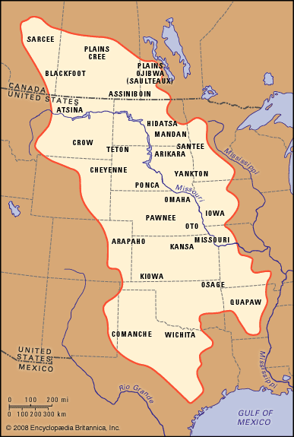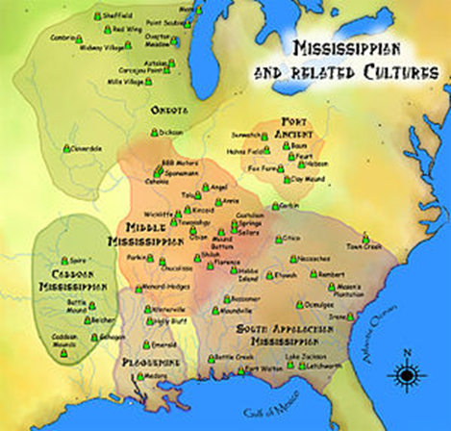

Mississippian Culture
https://en.wikipedia.org/wiki/Mississippian_culture
We can use the Mississippian culture to help build a basis for how most of the peoples built settlements and practiced some form of civilization. It was a Native American civilization that flourished in what is now the Midwestern, Eastern, and Southeastern United States from approximately 800 CE to 1600 CE, varying regionally. It was known for building large, earthen platform mounds, and often other shaped mounds as well. It was composed of a series of urban settlements and satellite villages (suburbs) linked together by loose trading networks.
A number of cultural traits are recognized as being characteristic of the Mississippians. Although not all Mississippian peoples practiced all of the following activities, they were distinct from their ancestors in the adoption of some or all of these traits.
- The construction of large, truncated earthwork pyramid mounds, or platform mounds. Such mounds were usually square, rectangular, or occasionally circular. Structures (domestic houses, temples, burial buildings, or other) were usually constructed atop such mounds.
- Maize-based agriculture. In most places, the development of Mississippian culture coincided with the adoption of comparatively large-scale, intensive maize agriculture, which supported larger populations and craft specialization.
- Shell-tempered pottery. The adoption and use of riverine (or more rarely marine) shells as tempering agents in ceramics.
- Widespread trade networks extending as far west as the Rocky Mountains, north to the Great Lakes, south to the Gulf of Mexico, and east to the Atlantic Ocean.
- The development of the chiefdom or complex chiefdom level of social complexity.
- The development of institutionalized social inequality.
- A centralization of control of combined political and religious power in the hands of few or one.
- The beginnings of a settlement hierarchy, in which one major center (with mounds) has clear influence or control over a number of lesser communities, which may or may not possess a smaller number of mounds.
- The adoption of the paraphernalia of the Southeastern Ceremonial Complex (SECC), also called the Southern Cult. This is the belief system of the Mississippians as we know it. SECC items are found in Mississippian-culture sites from Wisconsin (see Aztalan State Park) to the Gulf Coast, and from Florida to Arkansas and Oklahoma. The SECC was frequently tied into ritual game-playing, as with chunkey.
- The Mississippians had no writing system or stone architecture. They worked naturally occurring metal deposits, such as hammering and annealing copper for ritual objects such as Mississippian copper plates and other decorations,[6] but did not smelt iron or practice bronze metallurgy.

The Mississippian Culture flourished in what is now the Midwestern, Eastern, and Southeastern United States from 800 to 1500. Before European contact these tribes were generally matrilineal societies. Agriculture was the primary economic pursuit. The bulk of the tribes lived in towns (some covering hundreds of acres and populated with thousands of people). These communities regulated their space with planned streets, subdivided into residential and public areas. Their system of government was hereditary. Chiefdoms were of varying size and complexity, with high levels of military organization.

Southwestern Tribes
https://www.britannica.com/topic/Southwest-Indian/Socialization-and-education
The Southwest culture area is located between the Rocky Mountains and the Mexican Sierra Madre. The Continental Divide separates the landscape into the watersheds of two great river systems: the Colorado–Gila–San Juan, in the west, and the Rio Grande–Pecos, in the east. The environment is arid, with some areas averaging less than 4 inches (10 cm) of precipitation each year; droughts are common. Despite its low moisture content, coarse texture, and occasional salty patches, the soil of most of the Southwest is relatively fertile.
The distribution of resources in the region is determined more by elevation than by latitude. The predominant landscape feature in the north is the Colorado Plateau, a cool, arid plain into which the Colorado and Rio Grande systems have carved deep canyons. Precipitation tends to be greater at the plateau’s higher elevations, which support scrub and piñon-juniper woodland, rattlesnakes, rabbits, coyotes, bobcats, and mule deer. At lower elevations the plateau also supports grasses and antelope. To the south the river systems descend from the plateau, and canyons, mesas, and steep escarpments give way to a basin and range system. River valleys here support clusters of cottonwood, willow, mesquite, and sycamore trees, and mule deer, fish, and waterfowl. The areas away from the rivers are characterized by desert flora and fauna, including mesquite, creosote bush, cactus, yucca, small mammals, and reptiles.
Farming became important for subsequent residents including the Ancestral Pueblo (Anasazi; c. AD 100–1600), the Mogollon (c. AD 200–1450), and the Hohokam (c. AD 200–1400). These groups lived in permanent and semipermanent settlements that they sometimes built near (or even on) sheltering cliffs; developed various forms of irrigation; grew crops of corn (maize), beans, and squash; and had complex social and ritual habits.
Most peoples of the Southwest engaged in both farming and hunting and gathering; the degree to which a given culture relied upon domesticated or wild foods was primarily a matter of the group’s proximity to water. A number of domesticated resources were more or less ubiquitous throughout the culture area, including corn (maize), beans, squash, cotton, turkeys, and dogs. During the period of Spanish colonization, horses, burros, and sheep were added to the agricultural repertoire, as were new varieties of beans, plus wheat, melons, apricots, peaches, and other cultigens.
Most groups coped with the desert environment by occupying sites on waterways; these ranged in quality and reliability from large permanent rivers such as the Colorado, through secondary streams, to washes or gullies that channeled seasonal rainfall but were dry most of the year. Precipitation was unpredictable and fell in just a few major rains each year, compelling many groups to engage in irrigation. While settlements along major waterways could rely almost entirely on agriculture for food, groups whose access was limited to ephemeral waterways typically used farming to supplement hunting and gathering, relying on wild foods during much of the year.

Clothing
In most tribes, Native American men wore breechclouts or breechcloths (a long rectangular piece of hide or cloth tucked over a belt, so that the flaps fell down in front and behind), sometimes with leather leggings attached in colder climates. Here's a page of breechcloth and legging pictures. In some tribes Indian clothing for men was a short kilt or fur trousers instead of a breechcloth. Most American Indian men did not use shirts, but Plains Indian warriors did wear special buckskin war shirts decorated with ermine tails, hair, and intricate quillwork and beadwork. Here are pictures of two traditional Sioux war shirts. Native American clothing for women usually consisted of skirts and leggings, though the length, design, and material of the skirts varied from tribe to tribe. In some cultures, Indian women's shirts were optional and were treated more like coats. In others, Native American women always wore tunics or mantles in public. And in some tribes women usually wore one-piece American Indian dresses instead, like this Cheyenne buckskin dress. Nearly all Native Americans had some form of moccasin (a sturdy leather shoe) or mukluk (heavier boot), with the styles of footwear differing from tribe to tribe (as you can see from these mocasin pictures). Most tribes used cloaks in colder weather, but some of the northern tribes wore Inuit-style fur parkas instead. Most variable of all were headgear and formal clothing, which were different in nearly every tribe. Here's a page illustrating traditional hairstyles from several different tribes.

shirt, leggings, and moccasins. In cold weather they wore bison-skin robes, called buffalo robes, painted with scenes of battles they had fought. ... Women's clothing typically consisted of a long dress, leggings, and moccasins.

Deities and where they are from
- Rain Bird - patron deity of Machakw
- Iktome - spider god of mischief, patron deity of Tiruwe
- Saqsakaew - the Great Heron and spirit of good luck and patience; patron deity of Hurit
- Tatanka Ska - the great white buffalo and god of the hunt; patron deity of Tatanka
- Corn Mother - goddess of fertility and the harvest, patron deity of Ko’Ohchen
- Manitou - the Creator of all things and the Giver of Life
- Ataensic – Sky Mother, patron deity of Ioskeha
- ; Patron deity of Red Horn
- Deer Woman - spirit of fertility and love; patron deity of Ayaabe
- The Great Bear? Patron deity of Tall Bear
- Beaver Spirit - god of industry, preparation. Patron deity of Liluye
- Eagle Spirit – patron deity of Unetuuwa
- Malina - goddess of the moon, patron deity of Katamut (see also Athenesic)
- Aningan, god of the sun, patron deity of Untunktahe
- Tulok - god of the stars, patron deity of Tohono
- Áłtsé hashké – ceremonial name for the Coyote god, a mischievous trickster god (also see: Skelep)
- Hah-nu-nah - the Turtle, the earth bearer. When he moves the sea gets rough and the earth shakes.
- Pukimna - the Caribou Mother, patron deity of the Snow Bird People

Manitou - (aka Aasha Monetoo, aka Gitche Manitou "Great Spirit", Orenda to the Iroquois) - Algonquin, Cree, Ojibwe, Anishinaabe, Shawnee
Algonquian religion acknowledges medicine men, who used Manitou to see the future, change the weather, and heal illness. Ojibwe medicine men were primarily healers who used their spiritual connection to cure patients, since illness was then believed to be caused by magic and spirits. To communicate with spirits and manipulate Manitou, a healer would enter a trance, induced by singing, dancing, drum beats, or the use of hallucinogens. Non-healers could also interact with spirits by embarking upon a "vision quest," by means of prayer, fasting, hallucinogens, and/or removing themselves from the society of others. A person who underwent vision quests would be visited by an "animal, voice, or object," which would become his (or her) guardian spirit.

Ayaabe – Huron, Wyandot people
Ioskeha - Creator god, made the first people and specialized in demon-bashing and magic.
He had a lot of trouble with his twin brother Tawiscara as they fought for world control. Whenever a confrontation took place, they always grabbed the nearest object to battle with. In the final epic duel, Tawiscara snatched up some thorny rose twigs, but these were no match for the stag antlers Ioskeha found lying about. Tawiscara was driven, somewhat battered, into exile, weeping tears of flint.

Rain Bird (same and Thunder Bird?)

