Notes on the lands of Norgarde

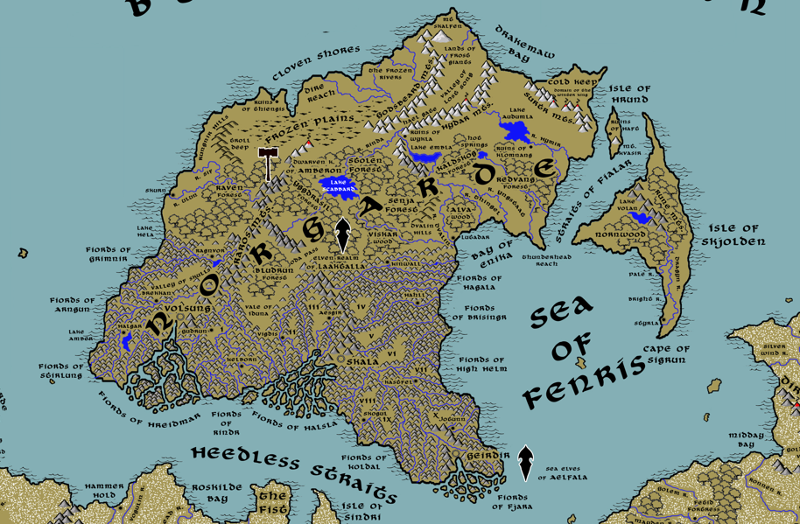

Table of Contents
- Overview
- Towns and Cities
- Best in the Land
- Stewards of Power in this Land
- Points of Interest
- History
- Local Goods
- Notes on Culture
- Local Deities
- Creatures
- Other Races
- Magical Items
- NPC Templates
- Developer Notes

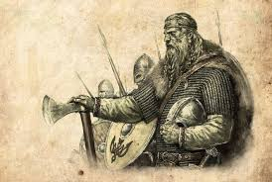

Overview
Far above the rest of Nemmerle is perched the frozen lands of Norgarde. Separated from the continent of Amadar by the Heedless Straits, it is a world unto itself. While life here is hard, there is a stark beauty to the land.

The upper half of Norgarde is marked by frozen forests divided by four mountain ranges: Raros in the west, the Godsbeard and Hydar to the far north, and the Surtr to the northeast. Dwarves have made a home in the Raros Mountains and have allied themselves with the humans in defense of the land. Frost Giants have made their homes in the Godsbeard and Hydar ranges and rule the land with servants they’ve captured in the lands below. Far to the northeast lie the Surtr Mountains and the domain of the otherworldly Winter King. On the northwestern shores the Rungnir Hills are the dwelling place of the Tubgutt trolls.

South of the mountains are dense and foreboding forests populated by bugbears and other loathesome creatures. Small bands of snow elves have built homes deep in the Ygdrasil forest, but they are reclusive and hostile to outsiders.

The southern half of the continent is scarred and pitted from glaciers that carved countless rivers and fiords. Most settlements are reachable only by the shallow inlets that snake around towering and majestic rock formations covered in brilliant green foliage. Only three such settlements are large enough to be considered cities: Volsung, seat of power over the Kingdom of Hreidmar; Skala, seat of power over the Kingdom of Halsla; and Geirdur, seat of power over the Kingdom of Fjara. To the east is the region of the Brisingr fiords, with no king ruling over them. Most settlements are collections of villages organized under jarls and their great halls. They are referred to as towns but no one outside of Norgarde would consider them as such.

It is cold here with ground barely capable of holding crops. Norgardians are scrappy farmers, making most of their terrain. But they are mostly known as masterful fishermen and shipwrights. Some earn a living launching raiding parties into the Amadar continent. Kord is the principal god here, for strength and courage are valued above all else. The people hold to a code of honor and hospitality. Social gatherings revolve around great halls where stories are told and mead toasted to valorous heroes.

In the Primordial Ages human tribes called the Skanes endured the brutal conditions out of sheer savagery. They were a primitive people, but quickly developed a penchant for survival. In the Ancient Ages it was Thidrik and his Filungar movement that transformed the Hegren tribes into master ship builders and craftsmen. The Hegren prospered and the people of Norgarde developed an artisan culture to go along with their warrior creed. In the second millenium of the Written Age, the Great Erobring marked another transformation as plunder of new goods and materials from around the world and contact with new peoples inspired new trade lanes and new innovations. The people collectively referred to themselves and Norgardians, but regional groups formed corresponding to the large fiord systems.

Peoples
- Hreidmar – people living along the waterways of the Hreidmar fiord system
- Halslans – people living along the waterways of the Halsla fiord system
- Fjarans – people living along the waterways of the Fjara fiord system
- Brisingrs – people living along the waterways of the Brisingr fiord system
- Styrlans – people living on the Isle of Skjolden, named after their capital of Styrla
- Kastavs – people who settled the Northwest region of Amadar

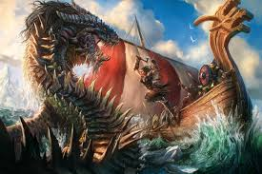

Regions of Norgarde
- Kingdom of Hreidmar: Brekkan, Halgar, Volsung, and Gudrun
- Kingdom of Halsla: Kelborn, Vigdis, Aesgir, and Skala
- Kingdom of Fjara: Kastfel, Jotunn, Skogul, and Geirdir
- The Brisingrs: Lutadar, Kinwall, and Hahll
- Independent towns: Ragnvor, Skurn, and Styrla

Towns and Cities

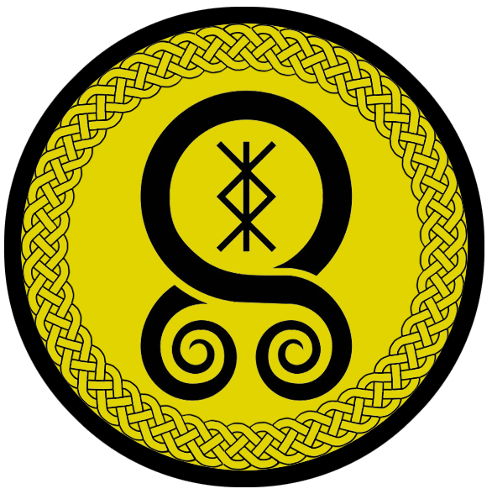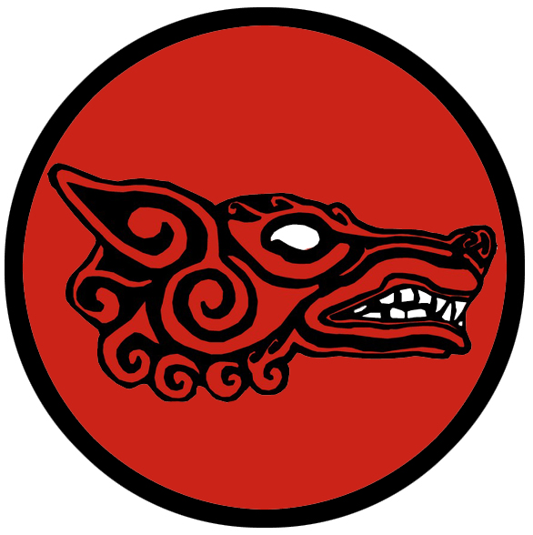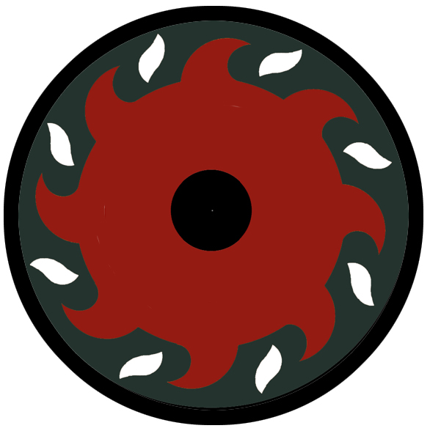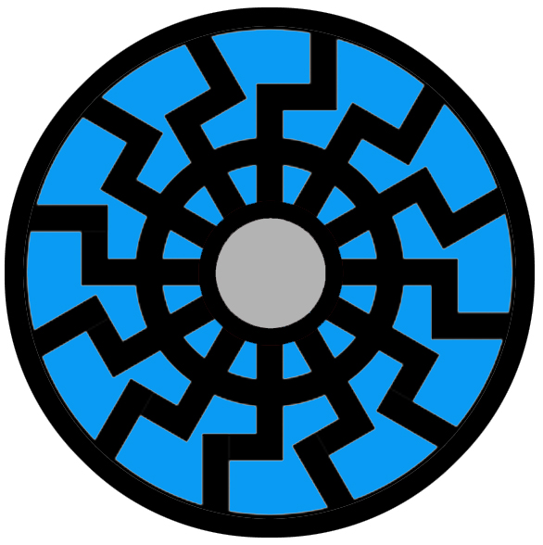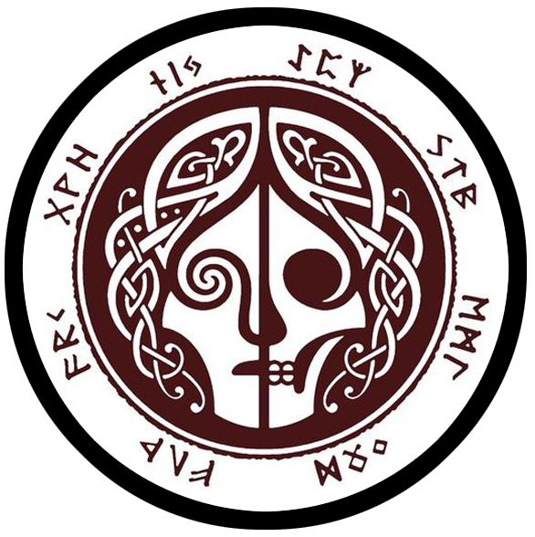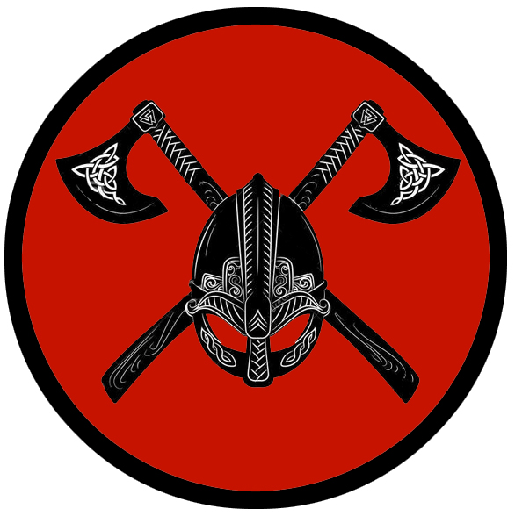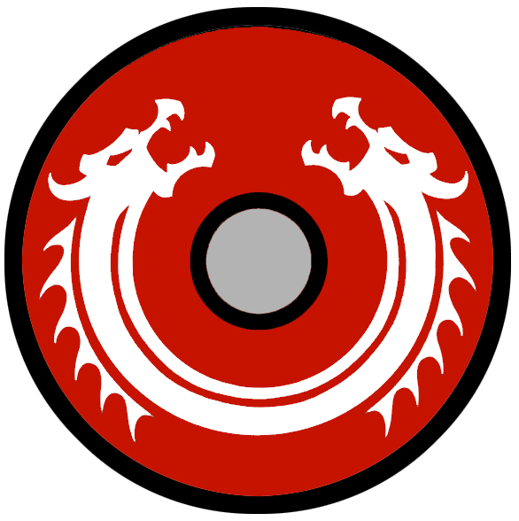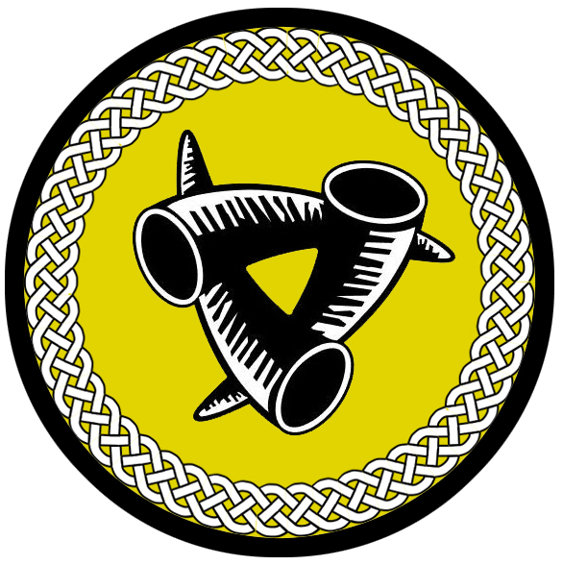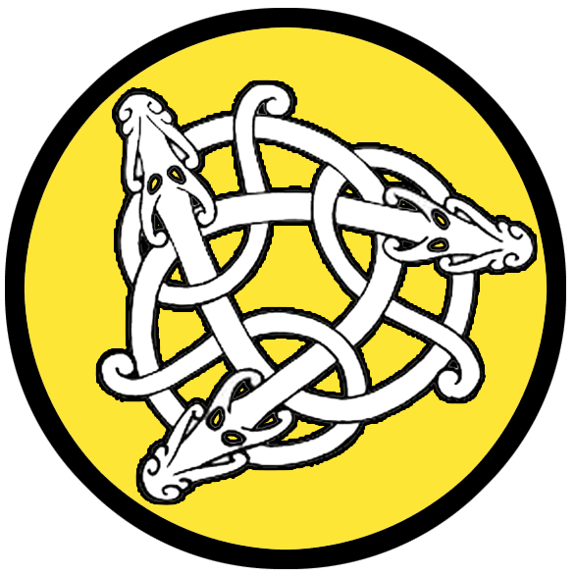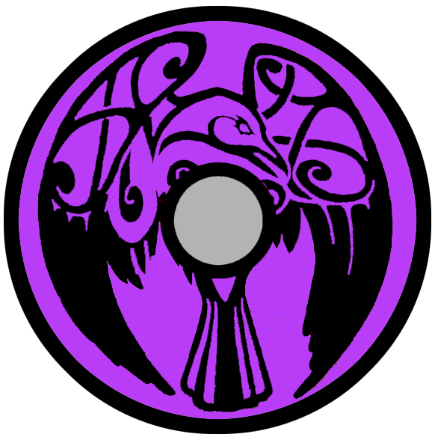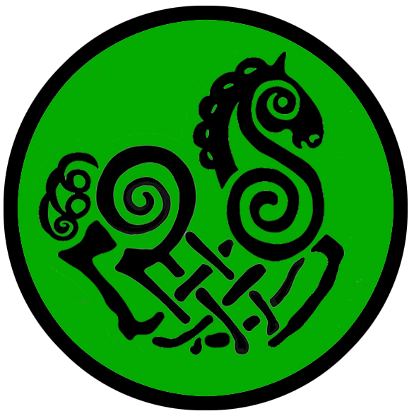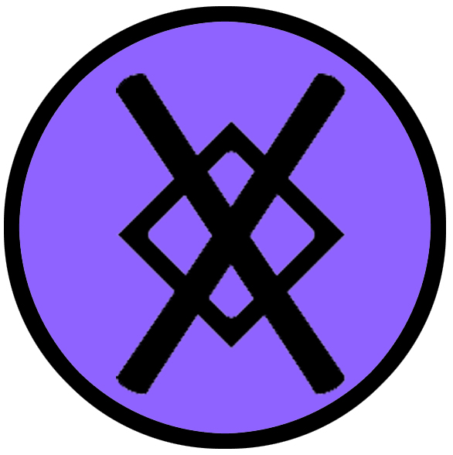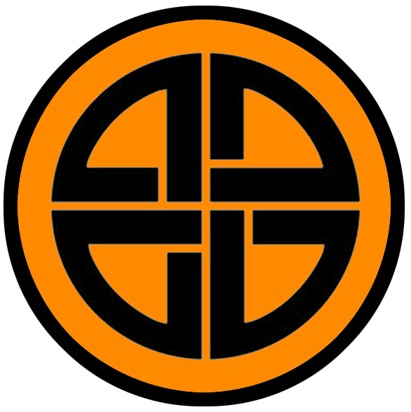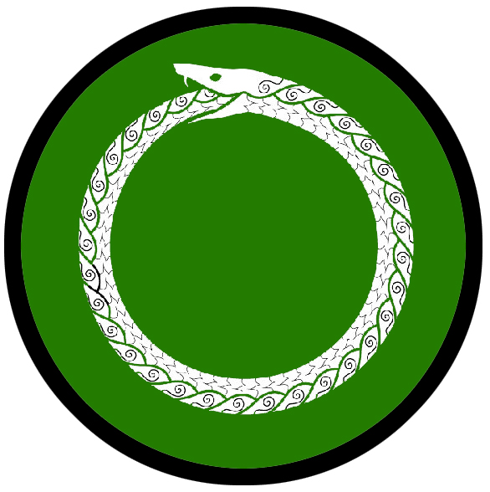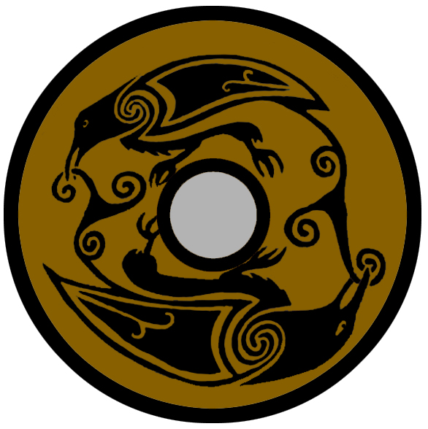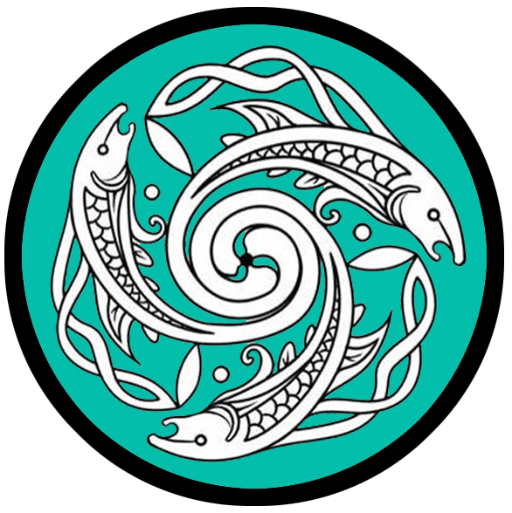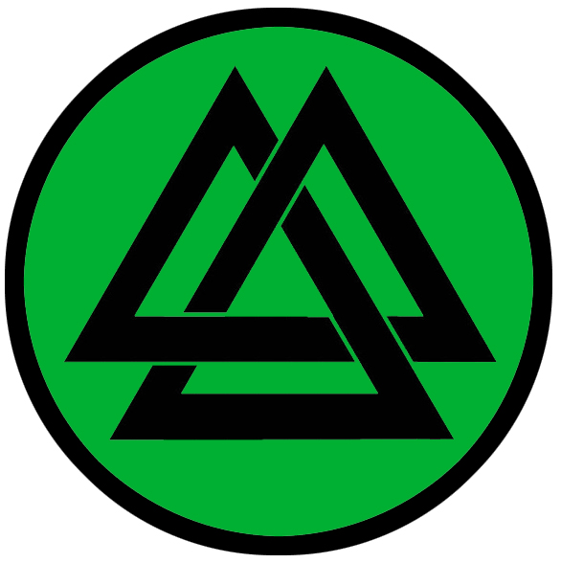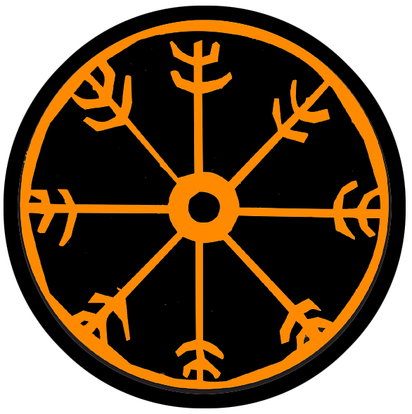
- Skurn – small town, sign of the troll cross, ruled by Jarl Fagerlan
- Ragnvor – small town, sign of the wolf’s head, ruled by Jarl Sornes
- Kingdom of Hreidmar
  - Volsung – large city, sign of the sun burst, ruled by King Furness
  - Brekkan – small town, sign of the black sun, ruled by Jarl Hanstad
  - Halgar – small town, sign of the goddess hel, ruled by Jarl Landur
  - Gudrun – small town, sign of the crossed axes and helm, ruled by Jarl Drager
- Kingdom of Halsla
  - Skala - metropolis, sign of the twin dragons, ruled by King Athilsson Steel Eye
  - Kelborn – small town, sign of the triple horn, ruled by Jarl Arngrim
  - Vigdis – small town, sign of the three dragons, ruled by Jarl Beinar
  - Aesgir – small town, sign of the black raven, ruled by Jarl Mannidor Mother Bear
- Kingdom of Fjara
  - Geirdir – large city, sign of the eight legged horse, ruled by King Tornquest
  - Skogul – small town, sign of the gungnir spear symbol, ruled by Jarl Ekstruun
  - Kastfel – small town, sign of the shield knot, ruled by Jarl Degermark
  - Jotunn – small town, sign of the circular world serpent, ruled by Jarl Sjoholm
- Brisingr Lands
  - Kinwall – small town, sign of the twin ravens ruled by Jarl Ragnfre
  - Lutadar – small town, sign of the three fish, ruled by Jarl Skjoldor
  - Hahll – small town, sign of the slain warrior’s knot, ruled by Jarl Nordlund
- Styrla – small town, sign of the helm of awe symbol, ruled by Jarl Stenbock
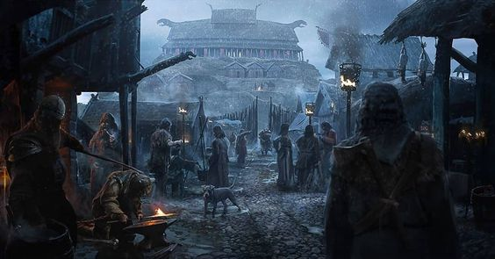

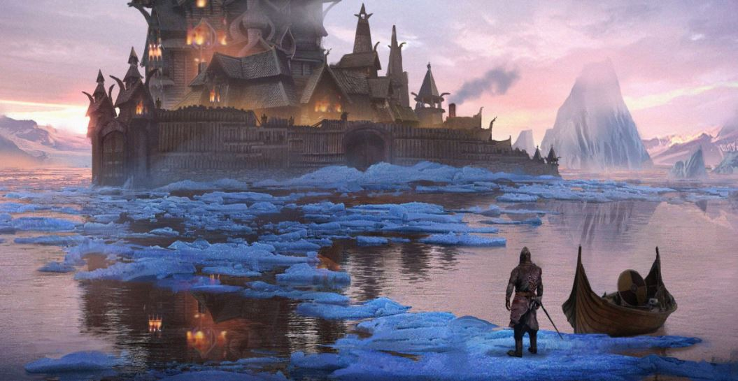

Best in the Land
Trade Hub: Volsung, Styrla
Religion: Skala
Arts: Geirdir, Styrla
Magic: Kinwall
Spirits: Kelborn, Geirdir
Steel: Gudrun
Grain:
Crafted Goods (e.g. Pottery, Textiles, Metal Wares):
Harvested Goods (e.g. Aromatics, Medicine, Dyes):
Mined Goods:
Precious Metals:
Ship Building: Volsung (strong ships), Skala (nimble ships), Geirdir (fast ships)
Other:

Stewards of Power in this Land
Kings and their armies are not the only wielders of power. There are many unseen friends and foes that shape the destiny of the land. Each of the groups listed below are well known to the people of this region. Some are feared, others venerated. All of them play their part in the grand drama of this land’s story.

Merchant Companies
Hundred Oards – Volsung
Daughters of Aegir – Styrla

Mercenary Companies
Skoldveg – Geirdir

Smuggling Rings
Long Chain – Halgar
Helhest – Jotunn

Centers of Worship (Churches, Cathedrals, Shrines, Lodges, Temples)
Hov of Mimir - Skurn
Hov of Fenrir - Ragnvor
Hov of Vadir - Volsung
Hov of Tyr - Brekkan
Hov of Ran - Halgar
Hov of Vor - Gudrun
High Hov of Njord - Skala
Hov of Nerthus - Kelborn
Hov of Gefjun - Vigdis
Hov of Yngvi - Aesgir
Hov of Forseti - Geirdir
Hov of Sjofn - Skogul
Hov of Ull - Kastfel
Hov of Dellingr - Jotunn
Hov of Skadi - Kinwall
Hov of Saga - Lutadar
Hov of Syn - Hahll
Hov of Kvasir - Styrla

Orders of Paladins
Order of Sigrun – Volsung
Order of the Longship – Skala
Order of the Einherjar – Geirdir

Druidic Circles
Circle of the Black Wing – Skurn
Circle of the Wycn Elm – Kinwall
Circle of the Silver Fish – Styrla

Bands of Rangers
Band of the Eldritch Oak – Ragnvor
Band of the Ice Bear – Vigdis
Band of Thunder – Lutadar

Schools of Magic
Algaron Sanctum – Vigdis

Bardic Colleges
Bragi Hall – Geirdir

Warrior Academies
Sigrun Hall – Volsung

Assassins Guilds
Helheim – Skala

Cults
(none)

Other Guilds
Filungar Shipwrights Guild – Skala

Monasteries
Hov of the Life Tree - Ygdrasil Forest
Hov of the Fates - Rune Mountains, Isle of Skjolden
Hov of the Wolf - Raven Forest
Hov of the Broken Shield - Hegland Valley
Hov of the Bear - Bludrun Forest
Hov of the Salt - Alva Wood
Hov of the Boar - Nurla Valley

Pirates
Captain Strake Gilderson – Isle of Skjolden

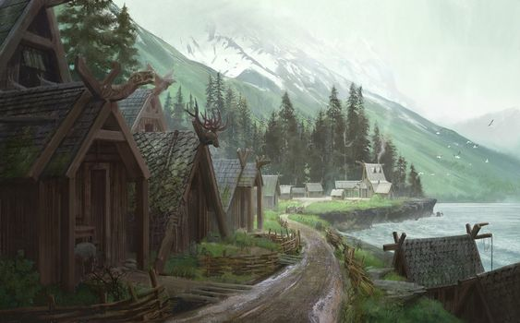

Points of Interest
- Isle of Skjolden – east of the Norgardian mainland, this island was settled by the early Skanes in the Primordial Ages.
  - Two massive tribes of Sahuagin plague the inhabitants of Skjolden. The Pelagra dominate the coastline east of Dragyn River and who are known by their sign of the two parallel, crashing waves. The Benthra dominate the western shores facing the Straits of Fialar and are known by their sign of the bubble symbol with ripples radiating outward. These tribes are extremely aggressive, attacking each other and any humans that dwell here or make landfall in their areas.
- Cape of Sigrun – the southern tip of the Isle of Skjolden is a prominent landmark for ships travelling the Noreast Jaunt. The ancient lighthouse Gangnrad stands here, illuminating the sea lanes passing between here and the Amadar lands to the east. Gangnrad is actually a cinder cone formation created by volcanic activity over thousands of years. In the Ancient Ages a volcanic eruption ended abruptly, with the lava head cooling just as gases continued pushing upward out of the vent. This inflated the magma into a giant sphere, which cooled and hardened. Today the sphere is incredibly strong, having been blasted many times by white dragons out of their hatred of fire. So now the lava tube below projects a bright orange light upward, filling the sphere with an unearthly glow that can be seen for hundreds of miles. Gangnrad means “Advisor to Travellers” in the old Norgardian language.
- Straits of Fialar – The waterway between Norgarde and the Isle of Skjolden is a perilous region for ships: northern winds howl and lash the ocean, sending up breakers and white caps. Only seasoned sailors can manage the straits and they are wise enough to stay away from them. The Sahuagin tribe called the Benthra (“sea floor”) dominate the waterways and are identifiable by their dull yellow stripes.
- Nornwood Forest – location of the Hov of the Fates
- River Dragyn
- Pale River
- Bright River
- Lake Volan – inhabited by the black dragon Andedräkt
- Rune Mts. – rumored to be the location of the fabled underground city of the Svirfneblin gnomes, deep gnomes who are almost impossible to find, with skin the color of stone, gray eyes, and wiry frame
  - Dwelling place of the Kaldving tribe of Frost Giants
- Isle of Hrund – the island stands a lonely vigil in the midst of the tumultuous Fialar Straits. Tall waves pound it from all sides, sending up sea spray that hangs as a gaussy veil all around.
- Mt. Kvasir – a lone peak on the Isle of Hrund, it is almost invisible from the sea and full of mystery. Travelers who claim to have made landfall on Hrund say that Kvasir is covered in ice and glows a soft green light.
  - At the top of the mountain stands Odhrǫrir, magic cauldron of the dwarves Fjalar and Galar, in which they collected the blood of the giant and god Kvasir and mixed honey to create the Mead of Poetry. The mead is no longer here, but the cauldron still pulses with a powerful sentience.
- Ruins of Haft – located on the Isle of Hrund, this town was a fledgling port for early Hergren sailors looking to dare the northern waters. It was founded in 860 AA1 by Trud Eyvalds and became a welcome sanctuary for travelers in these remote parts. But in 430 AA4 the Winter King came out of Cold Keep and destroyed the town to retrieve the Casket of Ullr, which was stolen and brought here nine years hence. The Winter King froze the entire town, leaving a thin layer of ice over everything. To this day the town stands preserved as it was in pristine condition, the thin layer of magical ice barely visible to the naked eye. Travelers may find it a queer place to explore, for it looks to all appearances like a normal town locked in time.

- Fjords of Grimnir
- Fjords of Arngun
- Fjords of Stirlung
- Fjords of Hreidmar – the people of this region are so named for these Fjords, calling themselves Hreidmar
- Fjords of Rindr
- Fjords of Halsla – the people of this region are so named for these Fjords, calling themselves Halslans
- Fjords of Koldal
- Fjords of Fjara – the people of this region are so named for these Fjords, calling themselves Fjarans
- Fjords of High Helm
- Fjords of Brisingr – the people of this region are so named for these Fjords, calling themselves Brisingers
- Fjords of Hagala
- Bay of Enika
- Thunderhead Reach
- Cloven Shores
- Drakemaw Bay
- Heedless Straits
- Raven Forest – home of the Laaktala Elves in their settlement of Jorildyn, location of the Hov of the Wolf
- Ygdrasil Forest - home of the Laaktala Elves in their settlements of Reysalor, Ralyndur, Brindarry, and Yndraer; home of the Hov of the Life Tree
  - 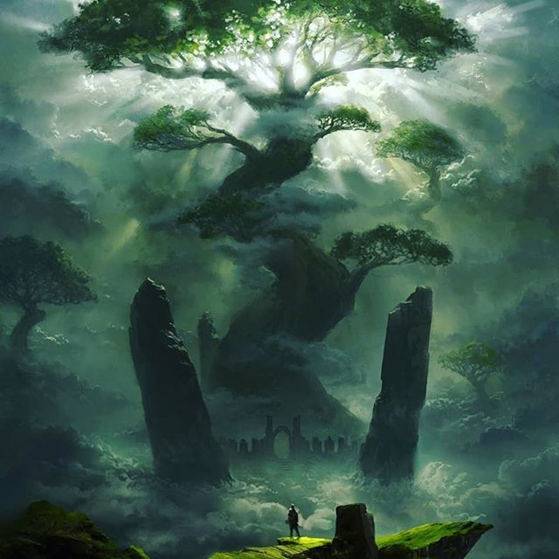
- Bludrun Forest – home of the Laaktala Elves in their settlement of Ylyndar, location of the Hov of the Bear
- Viskar Wood – Pine, birch, and spruce trees are predominant here, harvested by the nearby town of Kinwall for lodge poles and spruce beer. There are also droves of reindeer and rare plants used for medicine by Kinwall healers. It is a friendly forest, filled with good creatures and well protected by elves and druids.
  - These woods are under the protection of the druids of the Circle of the Wych Elm. The druids often gather in a circle in the Viskar Wood and commune with the lights. Outsiders will likely not notice that trees throughout the Viskar Wood are marked with intricate runes, creating a dense and sophisticated field of magic in the region that only the Kinwall mystics can understand.
  - home of the Laaktala Elves in their settlement of Stilmyst
- Stolen Forest – location of the Arch Mage of Norgarde, Kadlin Rognvauld (f); Kadlin, also known as the Bone Collector, dwells in crumbling stone tower in the center of the forest. An unnatural, lush covering of moss and flowers conceals the tower from the casual eye. At the center of the keep stands a three-foot-long purplish shard of crystal mounted on a stand. This is one of the rare Archemite Shards, which the most vaunted wizards use to communicate with one another. Legend tells the shards were from the eye of an elder god who was slain in the Battle of Vail. They fell from the sky and were gathered by the greatest of wizards. Now they are passed down from one master wizard to their heir (or taken by force).
- Senja Forest
- Alva Wood – Several diminutive creatures of the fey make their home here. Huntsmen from the town of Lutadar trap for furs found here, but the rangers of the Band of Thunder keep a watchful eye on the woods and its perils.
  - Home of the Hov of the Salt, a monastery dedicated to the wild nature and feritility spirits
  - The forest of is rumored to be the home to the Huldra. a dangerous seductress who lives in the forest.
- Kaldskog Forest
- Redvang Forest
- Frozen Plains
- River Sif
- River Ulun
- Rivers of the Fiords of Grimnir (4)
- Rivers of the Fiords of Arngun (4)
- Rivers of the Fiords of Stirlung (4)
- Rivers of the Fiords of Hreidmar (5)
- Rivers of the Fiords of Rindr (3)
- Rivers of the Fiords of Halsla (8)
- Rivers of the Fiords of Koldal (7)
- Rivers of the Fiords of Fjara (7)
- Rivers of the Fiords of High Helm (3)
- Rivers of the Fiords of Brisingr (3)
- Rivers of the Fiords of Hagala (8)
- River Rinda
- River Viskar (unlabeled)
- River Dvalin
- River Thingel
- River Yngstaat
- River (unnamed)
- River (unnamed)
- River (unnamed)
- River Hymir
- River (unnamed)
- River (unnamed)
- Frozen River 1
- Frozen River 2
- Frozen River 3
- Frozen River 4
- Frozen River 5
- Lake Amber
- Lake Hela
- Lake Scabbard
- Lake Embla
- Hot Springs
- Lake Audumla
- Godsbeard Mts.
  - The white dragon Isklåda “Ice Talon” dwells here
  - Dwelling place of the Nagrind tribe of Frost Giants
- Hydar Mts.
  - Dwelling place of the Hrimr tribe of Frost Giants
- Raros Mts.
  - The white dragon Vitlaga dwells here
  - Dwelling place of the Krekz goblin tribe, marked by three red stripes
  - Dwelling place of the Unar tribe of Frost Giants
- Surtr Mts. – these tall mountains are permanently covered in snow and ice. Some are active volcanoes sending up plumes of smoke and ash giving the region a hazy look. Giant creatures can be seen trapped in ice in the sides of the mountains, relics from the Primordial Ages and beyond. The Surtr Mountains close off the north-east corner of the continent, creating a defensive wall around the region known as Cold Keep.
  - Dwelling place of the Vindra tribe of Frost Giants
- Mt. Skalfen – The largest of all mountains in Norgarde, Mt. Skalfen towers above the other peaks in the Lost Song Valley. It spews giant clouds of ash into the sky, casting a permanent shadow over the land. Poisonous fumes are said to slay all but the darkest creatures. It is also a place of legend. Tales tell of tunnels in the heart of the mountain dating back to the Ancient Ages and where lies the Forge of Skafta. Swords and shields of legend hail from here: Hetjuhamar “Hero Hammer,” Næturöx “Night Axe,” and Örlögsverð “Sword of Fate.” It is a place sought by heros and wizards alike for its dark secrets.
- Hanvil Mts.
- Rungnir Hills – bleak and desolate hills swept by icy winds blowing off the sea
  - Dwelling place of the Tubgutt tribe of Trolls
- Dvalin Hills – dominated by the Azok tribe of Orcs, who bear the mark of the severed ear
- Oda Pass
- Valley of Skulls “Skalledal”
  - Dominated by the Uloth tribe of Orcs who bear the sign of the jaw bone as well as packs of Wargs collectively known as the Madfangs
  - 33 WA4 - the white dragon Vitlaga ("white flame") destroys the villages of Kallethem Vale "Cold Home"; Uloth Orcs infest the ruins and the vale is renamed Skalledal "Skull Valley"
- Vale of Iduna – it is said there are apple trees in this region that bear magical fruit; they are impossible to find unless a wood spirit leads one to them; the apples are said to hold the gift of immortality. Though wizards agree this is likely an exaggeration, they are intrigued by what powers the apples may indeed hold if they do exist.
- Hael Gate – Hael Gate is the sole entryway into the Valley of Lost Song.
- Valley of Lost Song – a wide, broken land between the Godsbeard and Hydar mountain ranges, this wasteland is home to frost giants, remorhaz, and other fell creatures of the north. The sky here is concealed by a perpetual layer of ash and smoke jetting out of volcanoes in this region. The smell of sulphur is thick from the scattered thermal vents dotting the land that send up scalding hot geysers. It is not a place for
  - Many years ago, during the Ancient Ages, there was a skald name Torsten who fell in love with an Elven maiden from Laaktalla named Cerwyen. He composed a song of such exquisite rapture in her honor that it caused the very woodland creatures to weep. When the Elves mounted a war on the Frost Giants, Torsten joined their cause to prove his love and gain their acceptance. The battle went against the Elves and so Torsten called on his gods and sang the song with such passion it caused the snow to melt in the mountains above the battle, triggering an avalanche that saved the day. Afterwards Torsten found he had lost his voice from the effort. The song is said to be lost to memory now, but can still be heard ringing off the mountainsides in this valley.
- (I) Hegland Valley – home of the Hov of the Broken Shield
- (II) Holva Valley
- (III) Baerdiga Valley
- (IV) Habrok Valley
- (V) Lawgiver Valley
- (VI) Severed Sun Valley
- (VII) Gullifax Valley
- (VIII) Nurla Valley – home of the Hov of the Boar
- (IX) Hymir Valley
- (X) Aserna Valley
- Lands of the Frost Giants
- Troll Deep - 123 AA4- The March on Troll Deep - hundreds of warriors infected with the plague march on Troll Deep to die in battle rather than in a bed; a score of trolls are brought down before the last of the warriors falls
- Cold Keep – Cold Keep is a frozen bastion in the far north, surrounded by volcanic mountains on one side and the northern sea on the other. It is the protected domain of the Winter King, an ageless necromancer who dwells in a glittering palace of ice. It is said that there is a small dell where the trees are green and flowers bloom. It is a tiny haven of warm spring, kept that way in honor of the Winter King’s late wife for whom he created it. Outside of the oasis of warmth the land is covered in black ice and ravaged by frost giants and the like. None enter the region without the king’s spies discovering them. A slow death in the king’s dungeons is promised to all who seek his legendary treasure horde.
- Amberon (dwarves) – Dwarves are referred to as the sons and daughters of Dvalin in Norgarde. The Kingdom of Amberon occupies the Raros Mountain Range. The capital city is Thunderhame, upriver from the town of Skurn. Smaller towns are Horndeep, Hreidmar, and Yaramir. There are also three outposts situated at the ends of the mountain ranges where Dwarves keep a watchful eye on the lands below: Plunder Keep near Volsung, Lindwyrm Keep overlooking the Oda Pass, and Frostfang Keep at the northernmost point of the Raros Mountains.
- Laaktalla (elves) – The Helceren or Ice Elves of Norgarde are a hard-edged version of their southern cousins. Weathering the cold climes of the north, they dress in beautiful gray and white furs and don hoods that resemble animal faces. They have seven settlements spread throughout the wild midland region: Jorildyn in Raven Forest, Stilmyst in Viskar Wood, Ylyndar in Bludrun Forest, and the towns of Reysalor, Ralyndur, Brindarry, and Yndraer in the Ygdrasil Forest.
- Aelfala (sea elves) -
- Dire Reach
- Ruins of Thiasi –
  - 500 AA1 - Hegren break off rom the town of Skurn and travel north to found the towns of Thiengis and Thiasi
  - 90 AA3 - Fall of the town Thiasi, destroyed by trolls
- Ruins of Thiengis –
  - 500 AA1 - Hegren break off rom the town of Skurn and travel north to found the towns of Thiengis and Thiasi
  - 910 AA1 - Snydri jarl of Thiengis forges alliance with the Troll King of the Rungnir Hills
  - 410 AA2 - Thiengis sides with the troll kingdom and conquers the town of Skurn
  - 610 AA2 - Jarl Valgerd Hallfri of Thiengis breaks the 700-year alliance with the troll kingdom; the gods send the magic longboat Skidbladnir, Hallfri and an army of priests and druids cleanse the town and region and liberate Skurn
  - 333 WA4 - Town of Thiengis is destroyed by the trolls of Troll Deep
- Ruins of Wykla - located far to the north, the town of Wykla was founded in the Second Primordial age and was warded by a weather wizard who made the land around it habitable. All was well until 340 PA3 when the ancient ice wyrm Aldagin destroyed the town of Wykla and made a home in the Hydar Mountains with another adult dragon named Cagamal. They ruled over the region for two centuries and spawned a dozen white dragons that terrorized the north.
- Ruins of Klomnang

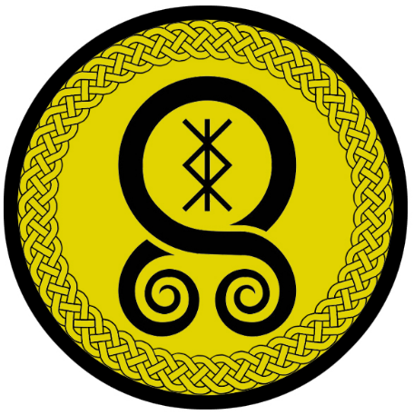
Skurn
Size: small town, population 2,000, guards / soldiers 20, militia 100
Trade Goods: timber, gold, fishing
Local Goods: spruce beer, lodge poles, whaling
Standard: troll cross
Colors: yellow and black
Patron Deity: Mímir – god of knowledge and wisdom
Ruler: Jarl Tord Fagerlan and his wife Styrlaug (f)

Home: Hall of Dörrudur (Hall of the Spearmen)
Steward: Oyvind Norred
Marshal: Jarle Greger
House Priest: Thea the Taker of Tears (f)
House Adviser (Scholar/Mage/etc): Egil Erstad Longnose
Captain of the Guard: Ottar Holien
Chief Warriors in Service:
Sigurkarl Steinarr
Bella Thorhaddurs
Kjartan Falkor

Local Powers: The Unmissed Sons (thieves guild), Hov of Mimir , Circle of the Black Wing (order of druids)
Local Sites: The Bellytimber Inn & Tavern, The Fisherman’s Net Inn & Tavern, Maidenhair Brewery

Description:
Large white whale bones stand gleaming along the coastline, just above where the waves break against the low cliffs. Short wooden piers extend out at odd angles, enclosed within a man-made cove. An archway made of an enormous whale’s ribcage spans the entrance to the cove. Tall wooden lodge poles, fierce faces carved on them, stand watch over a settlement of low wooden buildings weathered by the salt of the sea.
Unlike most Norgarde towns, which are nestled within the shadows of the fiords, Skurn sits atop an elevated plateau with plains all around. The River Uun flows at the foot of the town, descending from the Raros Mountains. The people here have dug out a cove from the river, housing a fortified port for their ships. This is to protect them from attacks from the open sea to the west.
Skurn is a mix between a logger town, a mining town, and a fishing town. Elements of all three can be found in the nets spread out being repaired, the generous use of quality timber in the houses, and the relative prosperity enjoyed by the influx of gold. People here are practical and hard working. Thoughts of sailing abroad and making war are distant thoughts. More likely it is good food and conversation that the people of Skurn enjoy.

Industry:
While its people are still handy on the water and make regular journeys into the sea, they are most adept at fishing and harvesting timber. Skurn is known for its whaling boats. Each year blubber, whale bone, and whale oil are harvested in a large cover separate from the main one. Pine, birch, and spruce are the most common wood harvested. The spruce is carved into handsome lodge poles honoring Kord and are in high demand throughout Norgarde. These are similar to the ones fashioned in Kinwall on the east coast. Spruce Beer is a unique brew made in Skurn. It has a bitter, full-bodied taste and is often used by sailors to stave off scurvy. It can be consumed as a tea from the shoot tips or even eaten straight from the tree when light green and new in spring. It is esteemed as a source of tone wood by stringed-instrument makers.

Mining operations were founded up river years ago that have yielded bounties of gold. This has given the town resources to survive in spite of being out in the open. Timber and furs are harvested from the Raven Forest up river.

The Maidenhead House crafts a very popular mead in Norgarde.

Key Figures:
Jarl Tord Fagerlan – stubborn, conservative, pious
Jarl Tord is an old man, having retired from raiding the northern coast of Amadar. He is famous for his exploits, burning ships and returning with their treasures. He is tall and lean with a strong build even for his age. His long gray hair hangs loose around a meticulously braided beard. He dresses in dark brown leather jerkins cut in the Norgardian style and is fond of silver chains. The hammer he carries at his side he calls Båtbryter “Boat Breaker” and it is said to glow when near the sea.
Tord is a pious man, praying often to the gods and supporting any cause to support their priests. He is content on keeping Skurn to itself and expanding the farms around it as well as developing a better port for his boats. Long ago he fell in love with Marga Hanstad of Brekkan when she was a shield maiden and a great fighter on their towns’ joint raids. But she spurned his advances. Still to this day he has a soft spot for her and is likely to heed any requests she makes. This makes his wife angry and the people talk. But he argues the partnership is to defend against Ragnvor more than anything else. Wise as he is, he is stubborn and unwilling to listen to most of his people and even more so from outsiders.
Political: Tord continues to carry a torch for Jarl Marga, lending aid to whatever plans she proposes and and dropping his customary reserve when her name is mentioned. Ragnvor and Jarl Vidar he sees as vermin that should be taught a lesson. Normally dismissive of his military career, he makes an exception where Ragnvor is concerned: if he were twenty years younger he would certainly attack and conquer the town. Of Jarl Jostein and Halgar, he is openly contemptuous of the young pup. He sees Halgar as a gloomy place that has brought the ill of the gods upon themselves. Jarl Johan he respects, seeing a man who invests heavily in his town, but one he secretly fears is unpredictable. He is courteous but distant with him. As for the king, Tord is sickened by his cowardice and scheming. He makes little show of his fealty to Arnfinn. Rather, he employs spies in the church to watch the king and entertains schemes of his own to see the gods strike the man down.

Egil Erstad Longnose, court mage – disfigured, secretive, lecherous
Egil Longnose is shunned by many of the people of Skurn. His prodigious nose is a sign of his troll bloodline and sets him apart. He is a short, stooped man with short, dark eyes set close about his long pointed nose. He often wears the hood of his robes over his head to hide his features and is mostly reclusive. But his powers are much sought after in the land and he has been known to craft strong weapons and crafty instruments. Egil is not one to seek attention, keeping to his wooden tower located a short distance within the woods. He is occasionally seen lurking on hilltops overlooking ponds where women folk bathe.

Local Lore:
The waters off Skurn are menaced by Raudkembingur, a demonic whale with red hair. For hundreds of years the great beast has attacked and swallowed ships and sailors whole. Survivors describe a whale-like creature who is unmatched in ferocity and desire to destroy ships. It has a red crest on its neck, large jaws with rows of sharp teeth, and a brownish body. It is a very fast swimmer. It will play dead for months, waiting for a foolish ship to come near it. If it fails to catch a ship that it chased, it will die of frustration. It is said that a young callous man was cursed into becoming this red headed whale by elves. (730 WA3)

While trolls are not uncommon throughout Norgarde, the Hungnir Hills to the north is a breeding ground for trolls in this region. The people here are always on edge for their kind and the creatures are prominent in Skurn history. It is rumored the Mother of Trolls once visited Skurn two thousand years ago (620 WA2) and wed the jarl. Today there are still humans with the name Trolkin that are believed to have troll blood in them: the men tending to appear beastly but the women looking exceptionally fair with an unsettlingly exotic look to them. Trolkin are shunned by the people of Skurn but have occasionally been called on for their help, as they possess strange abilities.

Raven Forest is the source of many legends. The druids of the Circle of the Black Wing work to bring balance to the forest, which is often fouled by trolls and other creatures. There is rumor of a dark witch who appears in the guise of a Valkyrie, luring warriors to their doom. The locals call her Halvenga, but it is unknown if that is her true name.

History:
820 AA4 - Baldvina Bracegirdle, shieldmaiden of Skurn, hunts down the marauding Tubgutt trolls in the Rungnir Hills; finds the magic sword Quern-biter

620 WA2 - Mother of Trolls comes down from the Hrungnir Hills and weds the Jarl of Skurn

Customs:
The people of Skurn are fond of their lodge poles. There are competitions for standing atop the poles, leaping from one to the other, fighting while standing atop them, and even feats of strength in throwing them. Men and women looking to be recognized as warriors will observe an overnight vigil atop a lodge pole, thinking on their duties as protectors and the ideals of the warrior.

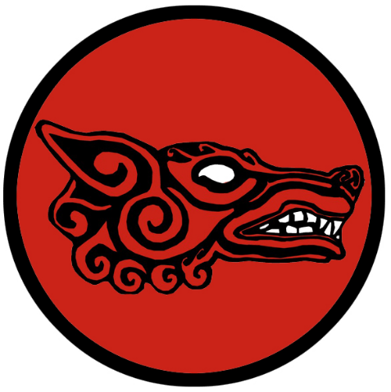
Ragnvor
Size: small town, population 2,000, guards / soldiers 20, militia 100
Trade Goods: copper, stone, furs
Local Goods:
Standard: wolf’s head
Colors: red and black
Patron Deity: Fenrir - great ravenous wolf
Ruler: Jarl Vidar Sornes and his wife Torunn (f)

Home: Hall of Hildólf ("battle-wolf")
Steward: Erik Solem
Marshal: Sjur Stordalen
House Priest: Ali of the Holy Circle
House Adviser (Scholar/Mage/etc): Arnhild Keeper of the Hidden Flame (f)
Captain of the Guard: Dag Overbey
Chief Warriors in Service:
Vermund Svans
Valgard Arnvids
Hungerd Steinolf (f)

Local Powers: Dark Delves (thieves guild), Hov of the Fenrir , Band of the Eldritch Oak (order of rangers)
Local Sites: The Reelpot Inn & Tavern, The Gray Wolf Inn & Tavern

Description:
Ragnvor is a savage town, even by Norgarde standards. Nestled in the fiords of Grimnir, the tribes here feel little connection with their cousins to the south. Centuries of struggle have plagued the town: orcs, goblins, and trolls descend from the mountains and have battled the people here almost to extinction. The result has been a culture of blood. The people have adopted the savage ways of their foes to survive. Every full moon the residents strip naked and bathe in blood as a ritual to show the gods their willingness to embrace death and mete it out in kind. When wading into battle Ragnvor warriors mark themselves in white paint to fashion skull masks and carry the bones of their enemies strapped to their armor.

Four hundred years ago the white dragon Vitlaga ("white flame") destroyed the villages of Kallethem Vale "Cold Home" (33 WA4). Orcs of the Uloth tribes infested the ruins and the vale was renamed Skalledal or "Skull Valley.” The Valley of Skulls has a long history as a bloody battlefield, changing hands between men and Orc. Currently the land is split, with the west belonging to Orc tribes and the east held by warriors from Ragnvor. This stalemate has been in place for the last forty years, with some suspecting neither side eager to press the fight or end it. Instead almost weekly shows of force ensue as if part of some ritual. Both sides seem to thrill at the prospect of battle and take great pride in whatever feats they perform. But these seem to be for the pure thrill of it rather than a tactical advantage.

Industry:
The people of Ragnvor are creatures of the depths and of the wild. Half the town works in the quarry or in the copper mines. The rest are full time hunters, trapping and skinning creatures of the frozen north: sable, ermine, fox, marten, and beaver. Peope here are not picky: it is not uncommon for leatherworkers to fashion garments from trolls, goblins, and warg.

Key Figures:
Jarl Vidar Sornes – warmonger, ambitious, masochist
Jarl Vidar was the third son of his father Jarl Koll, but took the seat of power after slaying his father and both brothers. He is a feared and vicious ruler and has a short temper. He is ever envious of Brekkan’s history of prosperity and brave warriors and can think of nothing but the conquest of the Valley of Skulls. A large bear of a man, he has long dark red hair he ties up in a top knot and a blood red beard that hangs down to his stomach. He wears a linen shirt that tailored to like a butcher’s apron. His fingers are adorned with the rings of warriors slain by his house over the last century. Vidar is fond of his pack of tamed dire wolves and is known for feeding them with those he finds disagreeable. His sole aim for Ragnvor is to crush Brekkan and silence their smirks of superiority. Even more so, Vidar dreams for greater power for Ragnvor and to recapture the olden days of his town’s superiority in the Hreidmar lands.
Political Mindset: Vidar has no friends, only enemies. He despises Jarl Tord and Skurn almost as much as he hates Jarl Marga and Brekkan. The king in Volsung is to him a weak tyrant to be deposed when Ragnvor returns to its former greatness. Vidar thinks of Jarl Jostein as a mere boy whose smirk will be wiped clean when he is eventually blood-eagled by Ragnvor priests. Only Johan of Gudrun commands the slightest respect, for he builds weapons of war. Vidar can see a use for the man, so he keeps the door open if envoys of Gudrun call on him.
Arnhild Keeper of the Hidden Flame, court mage – emotionless, mysterious, dangerous
Arnhild is a thin, pale man with a bald head and narrow face. He stares emotionless with tiny, dark eyes. He is mostly silent but when he speaks he has a high pitched and unsettling voice. People once rumored he was the runt of the litter, but those people mysteriously disappeared. On his left cheek he bears a tattoo of a flame. It is said that Arnhild spent many years studying dragons, speaks their language, and craves their power. He is known to disappear for weeks at a time, some thinking he ventures up to seek the counsel of the great white dragon in the Raros Mountains. Jarl Vidar tasks Arnhild with researching how to tame the Madfang wargs of Skull Valley and devise curses for his enemies. But Arnhild says little of these matters. Keeping to himself, he keeps his true ambitions secret.

Local Lore:
There are eleven Vatnavættir, or water spirits, who are guardians of the eleven fiords of Norgarde. Sigyn watches over the Grimnir Fiords and is largely ignored by the folk of Ragnvor to their own peril. She is a quick-tempered and sullen spirit. She requires a gift of blood be thrown to her waters. Any blood will do, so sailors often cut open a rat or rabbit and throw it overboard.
Ragnvor is the home of the Úlfhéðnar, shape-shifting berserkers who take on wolf form in battle. It is a secretive cult, meeting in the wilderness and praying to the gods for strength and fury. Initiates are men and women of great prowess who must prove themselves worthy before receiving their gifts (or to some, a curse). Úlfhéðnar, like all berserkers, are unstable individuals tortured by inner conflict. It is said they are the hardest of men and women, with a touch of the uncanny about them. The Úlfhéðnar are bitter enemies of the rival berserker cults: the Svinfylking, boar warriors of Skogul, and the Hamrammr, bear warriors of Kelborn.
Legend speaks of an ancient white dragon that lives in the Raros Mountains to the east. Its first recorded appearance was dated to 760 WA1. It is said to descend on unsuspecting travelers and herds in the region. Older folk tell of a time when adventurers brought back treasure from the dragon’s horde nigh unto a century ago. But the dragon wrought terrible revenge on the town to retrieve it and seek revenge. (20 WA3)

Warg packs roam the hills around Ragnvor, collectively called the Madfangs. In dark times the packs will join together and assault the outlying farms around Ragnvor. The mother of wargs is called Garda and directs her children to feed on men. Often they join forces with the Uloth Orcs to wage war on the humans. It is said a hundred years ago the warrior Kanut managed to capture a warg and rode it as a mount in battle.

History:
Ragnvor has had a violent history with the villages to the south. Eight hundred years ago (850 WA3) the chieftain Klauten led a fleet of boats against the Hreidmar settlements and left them all in flame. It was a hundred years before the Hreidmar drove the Ragnvor invaders out. Fear and loathing against the Ragnvor remain in Brekkan and all parts south to this day.

Customs:
Visitors here are captured or killed without hesitation. Only acts of strength are respected. Those who fail to impress them are impressed into service or killed. The people of Ragnvor are proud and have little interest in life beyond their fiord. Once every three moons prisoners are released into the woods and hunted. The Great Hunt is a profoundly religious event and warriors distinguish themselves by chasing down and slaying the prisoners.

A quarter mile from the town, issuing forth from a snowy mountain, is a blood-red waterfall named Hratha. Some say the stone and soil within the mountain give the water its red hue. Others claim it is a blood sign from the gods. For whatever reason, the people of Ragnvor revere the falls and bathe in it ritually before battle.

Kingdom of Hreidmar

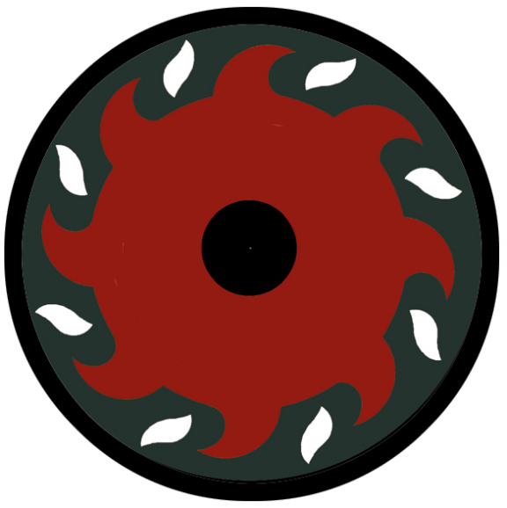
Volsung
Size: large city, population 25,000, guards / soldiers 250, militia 2250
Trade Goods: trade hub, amber, wool, fishing, ship-building
Local Goods:
Standard: sun burst
Colors: brown and red
Patron Deity: Vadir - god of vengeance, wears mighty boots capable of stomping on giants and giant serpents
Ruler: King Arnfinn Furness and his wife Ingegärd (f)

Home: Hall of Hertýr ("host-god")
Steward: Anders Heiberd
Marshal: Kjartan Oster
House Priest: Eirin of the Holy Hearth (f)
House Adviser (Scholar/Mage/etc): Solfrid the Rune Keeper (f)
Captain of the Guard: Brage Wahlrun
Chief Warriors in Service:
Gunnulf Svartbrands
Atsurr Grimwalds
Gellir Hjorleifs

Local Powers: Hundred Oars trading company, The Unseen Hand (thieves guild), Hov of Skögul, Order of the Arm Ring (order of paladins), Order of Sigrun (warrior school for shield maidens), Hall of Bragi (bardic college)
Local Sites: Aegir’s Cauldron Inn & Tavern, The Giant’s Tankard Inn & Tavern

Description:
Known as the Red City of the North, Volsung stands proudly at the head of the Hreidmar Fiords. The red timbers that give the city its name can be seen for miles, the buildings striking a sharp contrast with the blues and whites of the water and mountains. Seven mountains loom over the cove in a semicircle. The Hall of the Carved Horns looks down from a cliff jutting out from the side of one mountain. Below, the town spreads out to the water’s edge where a massive harbor hosts a hundred ships. Boats from other lands can be seen here, for it is a bristling trade hub that has made welcome to merchants from afar. Giant poles stand along the edge of the wide harbor, colorful squares of canvas hanging from them like the sails of ships. Volsung is a busy place, with the many voices of the harbor echoing off the mountains beyond.

Industry:
Volsung is an impressive city, having built a major ship-building complex and a trade hub that commands a large share of the traffic along the Norwest Jaunt and Halsla trade routes. Most trade that comes to Norgarde from western and central Amadar happens in Volsung, with the far-off island town of Styrla focusing on eastern traffic. The city also has rich amber mines in the mountains as well as thriving sheep herds that are tended in the Korla Valley to the north.

Ships built in Volsung are the trademark Norgarde craft, with long prows, shallow draft, many oars, and square sails. What distinguishes Volsung ships are their hulls, which are built for strength over speed or agility. While ships built in Skala are the most nimble and those from Geirdir are built for speed, Volsung boats are the most rugged at sea.

Volsung is noteworthy for its dark red timber that is featured on the outer walls and towers. The city has earned the name The Red City of the North because of this.

Key Figures:
King Arnfinn Furness – physically weak, mother issues, schemer
King Arnfinn is an average sized man with no distinguishing strength or athleticism. A childhood illness left him with a weak constitution and a withered left hand. An only son, he was sheltered by his mother and took to reading scrolls from far off lands. His curly blonde hair is receding and his beard is patchy. His soft blue eyes seem haunted. He speaks softly but is known to launch into fits of rage. He dresses only in dull red robes, for they remind him of his mother. In his left hand he carries a leather bound tome that some say holds his secrets.
Arnfinn is not a warrior nor has he ever engaged in warfare or raids. Many in court would seek to overthrow him and rule the city with strength. But Arnfinn is crafty, keeping his foes pitted against one another and partnering with allies who further his enterprises. His Jarls learned long ago to never trust him, for his enemies came to quick endings. From his dragon-headed tower Arnfinn overlooks Volsung and carefully strategizes ways to strengthen the city and hold onto his power. He is enterprising and intellectual and will hear any who offer to give him counsel. But he is just as eager to eliminate middle men and take charge of ventures best left to his personal attention.
Political Mindset: Arnfinn tolerates Skurn and Jarl Tord, in spite of their not being a subject of the Hreidmar lands. He secretly identifies with Tord as a father figure and makes an effort to keep open relations with him. Marga he finds agreeable, a bit off-putting for being so hard edged. She has proven useful as a war leader and answers his summons when war is needed. Jarl Vidar, too, is a valuable war ally even if he is predictable. He prefers to let Brekkan and Ragnvor settle their own disputes and even considers it to his advantage that two of his jarls waste their energies watching one another. Jarl Jostein is a wild card. Arnfinn is convinced the young charmer could be useful. He secretly supports Jostein’s efforts to spy on Gudrun, thinking a check against Johan is necessary. For Johan and Gudrun, Arnfinn fears, are too capable and growing in power. The king keeps Johan close. For if Volsung is to rule with strength, Arnfinn believes he must keep Gudrun on a short leash.

Solfrid the Rune Keeper, court mage – elderly, intelligent, ill-humored
Solfrid is old beyond reckoning. He is a thin wisp of a man, with long white hair and a beard he ties into a knot. Short and stooped, he is hard of hearing and speaks loudly. His eyes are almost white with cataracts. Solfrid shuffles about in robes of black that are as old as he. Around his waist he wears a belt, from which hang a variety of glittering metal charms.
Solfrid was the reader of runes for the last three jarls of Volsung. His knowledge is vast, as is his grasp of rune magic. Legends say he traveled to the Godsbeard Mountains and read the first runes left by the gods. Others say he communed with the elves in the Ygdrasil Woods and their enchantments have granted him long life and special visions. Solfrid keeps to himself and is of ill humor most times. He secretly yearns to return to the Godsbeard Mountains, for he believes a prophecy that tells of the fall of men hailing from those dark and forgotten lands.
The Order of Sigrun is here. This is a special school for shield maidens and is highly regarded for the mastery of sword and shield taught to the women who are trained here. Sigrun warriors are highly sought after by jarls all over Norgarde, but they only answer a summons if the will of the gods is answered by the duty.

Local Lore:
Legend tells of the Fosse grim visiting Volsung from time to time. Fosse grim is a water spirit that plays enchanted songs on the violin, luring women and children to drown in lakes and streams. However, in some stories he is depicted as a harmless creature, appearing as a skald and entertaining regular folk with his songs. According to one story Fosse grim even agreed to live with a human that fell in love with him, but he supposedly left after some time because he could not live away from a water source too long.

There are eleven Vatnavættir, or water spirits, who are guardians of the eleven fiords of Norgarde. Beyla watches over the Hreidmar Fiords and is venerated by the people of Volsung and Gudrun. She is full of laughter and exuberance, sometimes to the fright of sailors as powerful currents and winds rise up with her mood.
The islands leading up the Hreidmar Fiords are said to be infested with fish-men who dwell in underwater caves. Most suspect these to be Kuo-Toa dwellings. Ships passing through the Fiords at night are regularly attacked and many Volsung ships bear the claw marks of these creatures on their hulls. On rare occasions the creatures send raiding parties into the outer villages. Volsung regularly sends raiding parties of its own in the continued struggle to rid the islands of these fish men.

History:
Brekkan, Halgar, Volsung, and Gudrun are all located in the Hreidmar region of Norgarde, which is located in the south-west corner of the continent around the Hreidmar Fiords. The Hreidmar are a culturally distinct people and speak the same dialect of Norgardian.

Three hundred years ago (170 WA4) King Brenlig of Skala scored a conclusive victory in the War of Salt and Soil when his navy conquered those of King Stol’s of Volsung and King Renni’s of Geirdir while his ground forces encircled their capitals. Since then the throne has ruled from Skala. And since then Volsung has plotted to wrest that control away.

Customs:

Brekkan
Size: small town, population 2,000, guards / soldiers 20, militia 100
Trade Goods: fishing, amber, lead
Local Goods:
Standard: black sun
Colors: blue and black
Patron Deity: Tyr – god of war
Ruler: Jarl Marga Hanstad (f)

Home: Hall of Hveðrungr ("roarer")
Steward: Sindre Roed
Marshal: Mikkel Teig
House Priest: Sindre the Deep Diviner
House Adviser (Scholar/Mage/etc): Rannveig the Branded (f)
Captain of the Guard: Hallgrim Sondrol
Chief Warriors in Service:
Alof Thran
Arnbjorg Vestar
Ragnfrid Ærnmun (f)

Local Powers: The Unbidden (thieves guild), The Hov of the Tyr
Local Sites: The Yarken Table Inn & Tavern, The Yellow-Haired Valkyrie Inn & Tavern

Description:
Far up the Arngun Fiords the northern bank of the river slopes upward gently, rising up to a plateau. Atop the plateau stands the Hall of Broadsail, a large longhouse built in the likeness of a mighty sea vessel. Dragon heads project from each end of the hall in the likeness of a prow and stern. Behind the hall, tall snow-capped mountains stand. A part in the mountains reveals a pass northward into a valley. The town of Brekkan spreads out beneath the plateau, dark timber houses on either side of streets paved with oaken planks. A thousand or more rusted shields and spears are mounted on the cliff walls overlooking the river, trophies taken from enemies past. A tall lodge pole stands at the head of the main pier, topped by a thick wooden hoop bearing the sign of the black sun. Cheers are not heard on the air, nor the sounds of laughter or music. For these are the stern people of a town always ready for battle.
Brekkan, Halgar, Volsung, and Gudrun are all located in the Hreidmar region of Norgarde, which is located in the south-west corner of the continent around the Hreidmar Fiords. The Hreidmar are a culturally distinct people and speak the same dialect of Norgardian.

Industry:

Key Figures:
Jarl Marga Hanstad (f) – fierce, protective, apolitical
Jarl Marga was once a silver merchant’s daughter, promised to marry the youngest son of a wealthy land owner. She refused the betrothal and instead became a shield maiden. After many years of raiding, she gained renown. The town’s corrupt and slovenly Jarl lured her to his bed chamber where he forced himself on her. The next morning she emerged with his head in her hands. Soon after, she took over the town as Jarl. She is a different sort of Jarl, unconcerned with politics in Hreidmar. She is more comfortable on a raid than in holding court.

Marga is tall with white-blonde hair and narrow, critical eyes. She is a fair ruler and fiercely protective of her people. Some say she is the daughter of Tyr himself. She is ever vigilant against her enemies in Ragnvor who seek to destroy Brekkan. Every spring she leads a raid into Skull Valley, hoping to reclaim more of the land from the creatures living there. At her side she carries the sword Drømmeker “Dream Maker,” given to her to fight for her dream of peace in Skull Valley.

Political Mindset: Marga is respectful of Skurn and Jarl Tord’s affections for her, so she keeps him as an ally against Ragnvor. Jarl Jostein she finds puzzling and secretly admires his carefree spirit, but she knows better than to rely on Halgar. Jarl Johan she admires the most, for he is hard working and a student of war. But she keeps an eye on his plans, for if anyone were to upset the balance in Hreidmar it would be the town of Gudrun. King Arnfinn she serves dutifully as her king and is first to volunteer when he calls for warriors. But secretly the man sickens her: his weakness and scheming voiding any respect she has for him as a true leader.

Rannveig the Branded, court mage – disfigured, surly, vengeful
Rannveig was once a thrall in the service of the Jarl of Volsung. He won his freedom by knowing how to cast rune stones even at a young age. His prophecies were never heeded by the Jarl and so he was branded each time tragedy struck the city. Rannveig is a short, thick man with large limbs. His face and arms are covered in brands he received over the years. He has long curly black hair and bulging eyes. He is a surly and detached man, short of words and wearing a scowl most of the time. Upon his left arm he wears five arm rings, one for each of his four sons he lost in the Valley of Skulls. For him, there is only the promise of helping Brekkan defeat darkness that keeps him going.

Local Lore:
It is rumored that they mystical Fylgja reside in these lands. These are spirits who from time to time appear when a baby is born. They are connected in some way to the person’sr fate or fortune. It is believed the type of animal reflects the character of the person they represent. If the person has a "tame nature", their fylgja might be an ox, goat, or boar. If they have an "untame nature" they would have fylgjur such as a wolf, deer, bear, eagle, falcon, leopard, lion, or a serpent. Those with arcane destinies, such as wizards and sorcerers, tend to have a fox as their fylgja to reflect that they are sly and hiding something. Some even say that the person born with a fylgia may one day be a shape-shifter with the ability to transform into the creature itself. Town folk are highly suspicious when animals appear at the birth of a child and mark the child as having a special future.

There are eleven Vatnavættir, or water spirits, who are guardians of the eleven fiords of Norgarde. Idunn watches over the Arngun Fiords and is venerated by the people of Brekkan. She is lighthearted and whimsical. She requires the gift of flower garlands.

History:
Brekkan has had a long-standing feud with the town of Ragnvor to the north. Eight hundred years ago the Ragnvor chieftain Klauten led a fleet of boats against the Hreidmar settlements and left them all in flame, including Brekkan (850 WA3). It was a hundred years before the Hreidmar drove the Ragnvor invaders out. Fear and loathing against the Ragnvor remain in Brekkan and all parts south to this day.
The Valley of Skulls lies to the north of Brekkan and is a treacherous place. Orc tribes move down from the hills and wage war on humans who venture here. A thousand years ago (620 WA3) the priests of the town prayed to Kord for a savior against their enemies. Kord is said to have walked among the people at night and spoke with them as a traveler. At last he met one farmer’s son named Kadulf who impressed him with his wit and his courage. He gifted Kadulf the Blood Brand, a magical sword of many powers.

Kadulf grew to lead Brekkan to many victories over the Uloth Orcs. On his death the town held a series of trials to find who would be worthy to wield the sword and assume the role of guardian over Brekkan. To this day the town always names a guardian, which usually follows ritual trials to find who is worthy. Today it is Hallgrim, captain of the guard. Hallgrim holds tight to his duties and is always vigilant of the orcs in the valley and often leads men out to find and slay orcs who wander too far south. The orcs fear and respect the Kadulf and call any guardian who wields Blood Brand by the name Kadulf.

Customs:

Halgar
Size: small town, population 2,000, guards / soldiers 20, militia 100
Trade Goods: amber, lead, tin
Local Goods:
Standard: goddess hel
Colors: yellow and black
Patron Deity: Rán - goddess of death who collects the drowned in a net
Ruler: Jarl Jostein Landur and his wife Siv (f)

Home: Hall of Draugadróttin ("lord of the dead")
Steward: Hallgrim Vennerod
Marshal: Solfrid Omdahl (f)
House Priest: Hanna the Painter of Dreams (f)
House Adviser (Scholar/Mage/etc): Mads the Shadowless
Captain of the Guard: Hugem Winding
Chief Warriors in Service:
Ærinmund Asmunds
Otrygg Sturlas
Holmgeir Thords

Local Powers: The Heavy Sacks (thieves guild), The Long Chain (smuggling ring), Hov of Ran
Local Sites: Cave of the Gru Inn & Tavern, The Edritch Inn & Tavern

Description:
Just beyond the banks of Amber Lake, deep within a hidden cove in the Fiords of Arngun, lies the town of Halgar. Strange greenish mist hangs above the rocks along the river’s edge. The mist carries a strange odor. Occassionally a brief burst of flame erupts from between the rocks. There is an otherworldly sense to the place. Sound itself seems muted in the air here. At last three long piers can be seen jutting out into the waters. Distant lamp lights appear through the mist, illuminating narrow streets between many low buildings. A small course of the river leads inland, encircling a small island joined by a wooden causeway. Atop this stands the Hall of Hela, a dark and forbidding structure. Large ornamental drinking horns are mounted at each end of the roof. Reflective disks of tin are hung from high places, which catch the light and are said to ward off evil spirits. Few dare venture to Halgar, for many tales are told of the lost spirits who dwell here amongst the cliffs.

Industry:
The town is notable for the dark timbers that make up its outer walls and towers.

Halgar employs several mines in the upper hills around the fords. Amber, tin, and lead are mined and sent to Volsung where they are used for their purposes or traded.

Key Figures:
Jarl Jostein Landur – young, charismatic, impulsive
Jarl Jostein is a young ruler, having gained the seat of power from what some would call sheer luck. During a raid ten summers ago, the former jarl pointed in Jostein’s direction and said ‘You are in charge” before diving over the rail of the boat. He took six arrows and died instantly. After that, Jostein was hailed the new jarl for lack of any heirs. Jostein is handsome, with curly brown hair, a thin beard, and a smile always on his face. He wears tall boots and a loose-fitting linen shirt he wears open to show his chest. Jostein has a devil-may-care attitude towards his rule, inviting his subjects to steal and plunder from afar and share in the wealth at home. He laughs away portents of doom, sharing the sentiment of the people of Hagar that the fates have already written everyone’s destiny and to live life to the fullest while one can. Jostein enjoys flirting with women and drinking heavily. He also flirts with other towns and the alliances they offer. Some consider Jostein too young and unreliable, but he seems unconcerned with his reputation. He is a headstrong man and often makes rash promises and plans.
Political Mindset: Jarl Jostein is amused by all of the leaders in Hreidmar, thinking them all too old and too clumsy to properly rule. Of Tord in Skurn, Jostein laughs at the doddering old man and lays odds on who will kill him and take his place. Of Marga and Vidar, he jests the two should share a bed and get it over with. Their feud seems like a waste of time. Of Johan in Gudrun, he is most annoyed: he envies the Jarl’s prosperity and seems to get no help from him when he asks. But the king, he fears. Jostein, more than any other Jarl, panders to Arnfinn’s station and works hard to win his favor. He hopes that Volsung will grant Halgar more prominence and fund their raids across the seas.
Mads the Shadowless, court mage – serious, mysterious, elusive
Mads is an old and serious wizard, keen to further his studies instead over serving his young jarl. He is short and slender, with a balding head, pointed beard, and a permanent frown even in the best of moods. He wears dark robes fitted with small stones that glow to fit his mood. His staff is always with him and it topped with a mysterious orb containing some sort of creature no one can identify but with whom Mads is always carrying on conversations. Mads is a grumpy old man, made grumpier still whenever Jostein jests at his expense. He has not time for folly and makes that clear. He disappears for days at a time, travelling into the strange caves surrounding the town and researching the mists and vapors there looking for passages into other realms.

Local Lore:
Stories tell of dark nights where passages along the waterways temporarily become portals to the underworld. There is also tell of the Reaper’s Boat, which trolls the waters on moonless nights looking to carry people off to their doom.

It is rumored that Vordr, or wardens, dwell in this region. Vordr are spirits that wander the land, guarding certain places and sometimes even people. At times, the Vordr reveals itself as a small light or as the shape (hamr) of the person it is guarding. The perception of another person's warden is said to elicit a physical sensation such as an itching hand or nose, as a foreboding or an apparition. The warden sometimes arrives before the actual person, which someone endowed with fine senses might perceive. Certain trees outside the town are called Warden Trees. These are believed to be inhabited by a Vordr and bring good fortune to the land. It is considered a high offense to harm a Warden Tree.

There are eleven Vatnavættir, or water spirits, who are guardians of the eleven fiords of Norgarde. Hariasa watches over the Stirlung Fiords and is venerated by the people of Halgar. She is a melancholy spirit and her soft crying can be heard on the haunting gales that blow through Stirlung. She requires the gift of salt to honor her many tears.

History:
Brekkan, Halgar, Volsung, and Gudrun are all located in the Hreidmar region of Norgarde, which is located in the south-west corner of the continent around the Hreidmar Fiords. The Hreidmar are a culturally distinct people and speak the same dialect of Norgardian.

610 AA4 – Thieves from Halgar dress as women and steal into the high hall in Volsung, making off with treasure and Brisingamen, magic torc of the gods

943 WA3 - Volsung dispatches thieves from Halgar as spies into the Ragnvor camps; generals are slain, food stores burned, and treasure is carried off; Ragnvor forces become destabilized

Customs:
The people of Halgar are storied thieves and pranksters. Ships from Halgar are almost always engaged in raiding parties on the open sea, preferring treasure hunting over fishing. This has made them valuable allies for Volsung in times of war, when they are employed as spies and for small strike forces to harass the enemy. Even in the town itself thievery is common, with travelers being warned “When in Halgar, have both hands on your coin purse. And never make a deal there, for you will always lose.”

Of particular note is the dark humor that is characteristic of Halgar. Most songs and stories from here deal with death and misfortune, often in a comical light. The people here are fond of gallows humor, which is met with unease by outsiders. Adventurers are often from Halgar, for its people laugh at death and are eager to challenge it.

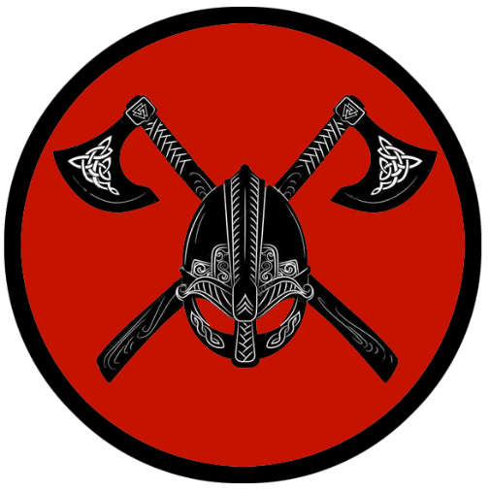
Gudrun
Size: small town, population 2,000, guards / soldiers 20, militia 100
Trade Goods: iron, steel, stone
Local Goods:
Standard: crossed axes and helm
Colors: violet and black
Patron Deity: Vor - goddess of scholars, she who knows all
Ruler: Jarl Johan Drager and his wife Katla (f)

Home: Hall of Járngrímr ("iron-grim")
Steward: Sigve Monsuun
Marshal: Bjarte Steen
House Priest: Sindre the Frostbane
House Adviser (Scholar/Mage/etc): Orjan the Painted
Captain of the Guard: Hjordis Stigen (f)
Chief Warriors in Service:
Hring Skjaldulfs
Arfast Sigenoths
Steinkel Hildiglums

Local Powers: The Norgeld (thieves guild), The Hov of the Vor , Dugrun Forge (steel smiths)
Local Sites: The Drinking Skull Inn & Tavern, The Laughing Lindworm Inn & Tavern

Description:
Nestled into the cliffs of the mountain range, the black buildings of Gudrun are almost invisible to travelers who aren’t looking for them. The timbers of the houses are coated in pitch. Very little light can be seen from the water’s edge and the single landing where boats sit and are rarely used. During the day there are only the trails of smoke from furnaces that give any sign of life. There are no sounds coming from this town, only the faint puffing of bellows within the forges and the banging of hammers on metal and stone.
Gudrun overlooks the Hegland Valley to the east. The valley is fertile and farms have been settled there, but farming is a secondary industry here. The outer walls of the town are reinforced by stone, more so than most Norgarde towns. And of those towns that do pay coin for Gudrun stone, none have walls as expertly worked and fashioned as those by the masons here. Gudrun people are dour, humorless people who spend their days in the mines and forges and rarely venture into the sunlight. Norgardians joke they are more Dwarven than human, and there is something to that. The Dwarves of Amberon are close allies and have bonded over their love of metallurgy and stone.

Industry:
Gudrun is a mining town, its people clever at mining stone and iron from the hills. The people of Gudrun have long won the respect of the Dwarves living to the north in Plunder Keep and Yaramir and are now considered allies. From them the men have learned many secrets of their craft.

Gudrun is also known as the source of the finest steel in Norgarde. The Dugrun Forge has been in business for four hundred years and creates blades sought after by jarls and kings. It also serves as a school for smiths from all over the continent. It is rumored the masters keep a cauldron of boiling lindworm’s blood and quench each newly-forged blade in it.

Key Figures:
Jarl Johan Drager – industrious, domineering, lust for power
Jarl Johan is a short, broad-shouldered man with dark curly hair and a giant puff of a beard. His blue eyes contrast with his large red cheeks. He wears a tunic of green and is adorned in bracelets, chains, and rings of various metals. His large hands are calloused and strong, for he comes from a family of blacksmiths and keeps to his trade even as jarl. Some say that Johan looks like an oversized dwarf, which delights him. He has made fast friends with the Dwarves of the Kingdom of Amberon and employs its engineers to help improve his mining and steel works.
Johan is a man of a strict work discipline but is capable of great mirth. He entertains several women outside of his marriage, much to the aggravation of his wife. Land owners around Gudrun are annoyed with Johan’s obsession with mining and forging great weapons. They would prefer he put his efforts into the rich valley to the east. But Johan is determined to build Gudrun’s prominence as a military power. He has his eyes set on the seat of power in Volsung and is not very careful in his criticism towards King Arnfinn.
Politics: Johan is a man of ambition. He pays grudging deference to the king and when forced will supply him with arms and ships. He knows in time the resources of Gudrun could help him make a bid for the throne in Volsung. He is busy building alliances with his neighbors to the east: Kelborn and Vigdis. Though they are part of the Halsla Kingdom, they are eager to see Volsung lose face. Johan tolerates envoys from Halgar, but he sees Jarl Jostein as reckless and gullible enough to use against the throne. Johan respects Jarl Marga and her work in Brekkan, but does not trust her enough to recruit her help. He gives little thought to Skurn and Ragnvor, except for sizing them up in the event they oppose him. Of note is Johan’s rivalry with Jarl Agnar of Kelborn. Both are fierce enemies and often sneak off to Hegland Valley and test one another’s strength in battle. This goes on without permission from their kings. Johan is mindful of Agnar as a potential obstacle to his plans.

Orjan the Painted, court mage – unsettling, soft spoken, dark minded
Orjan is thin, with white wisps of hair and pale skin. His sunken eyes are ringed with dark circles, giving him a ghostly appearance. His skin is covered in faint tattoos featuring intricate Dwarven and human runes. A tattered robe trails behind him, smelling musty and unclean. Bands of leather encircle his waist and thighs, securing several small flasks that contain various exotic soil samples he collects. Orjan speeks in whispers and sometimes appears to be asleep even standing up.
Orjan was a child when he ventured into the mines. He spent more time there than above ground and became fascinated by all things subterranean. He is reclusive and avoids human contact whenever possible. He secretly prays to Surtr for the secrets of the depths and is fluent in dark tongues. Orjan is useful as a wizard to a master of mines, but he is often hard to find and employs much of his time to his research on the hells and the abyss.

Local Lore:
There are eleven Vatnavættir, or water spirits, who are guardians of the eleven fiords of Norgarde. Beyla watches over the Hreidmar Fiords and is venerated by the people of Volsung and Gudrun. She is full of laughter and exuberance, sometimes to the fright of sailors as powerful currents and winds rise up with her mood.
It is also the site of visits from terrible lindworms that live in the mountains. They are said to be enormous wingless serpents that have two great claws and burst into flame as they slither over the land. The shed skin of a lindworm is believed to greatly increase a person's knowledge about nature and medicine.
But goblins from the surround hills are a constant source of worry.
History:
Brekkan, Halgar, Volsung, and Gudrun are all located in the Hreidmar region of Norgarde, which is located in the south-west corner of the continent around the Hreidmar Fiords. The Hreidmar are a culturally distinct people and speak the same dialect of Norgardian.

50 AA2 - the wizard Linjarn the Puny creates the Staff of Behemoth which controls all giants; sets himself up as king of Norgarde

50 AA2 - Volsung falls to Linjarn's army of giants

60 AA2 - the hero Bjarnwyr and his band battle their way to Linjarn's keep and slay him; the Staff of Behemoth is lost

70 AA2 - Battle of the Godsbeard - Dwarves of Amberon, joined by Norgarde warriors, fight Krong's forces and barely survive

Customs:

Kingdom of Halsla

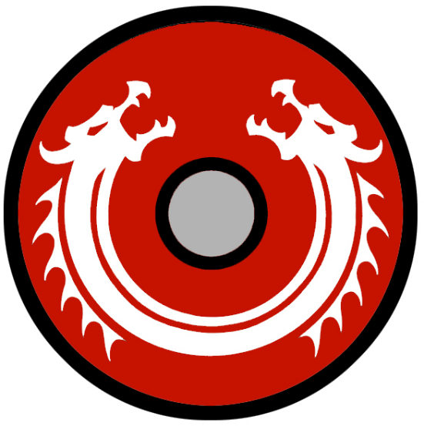
Skala
Size: metropolis, population 50,000, guards / soldiers 500, militia 2500
Trade Goods: ship-building, fishing, religious center, wool, tin, amber
Local Goods:
Standard: twin dragons
Colors: red and white
Patron Deity: Njord - god of wind and sea, of wealth and bad marriage
Ruler: King Thiodolf Athilsson and his wife Ingrid (f)

Home: Hall of Ítreker ("splendid ruler")
Steward: Guthhere Audgis
Marshal: Hallkatla Dunfjall (f)
House Priest: Grelod of the Elder Altar (f)
House Adviser (Scholar/Mage/etc): Hring the Stormbringer
Captain of the Guard: Kalf Oddleif
Chief Warriors in Service:
Orm Thorgrims
Asfrith Nafnis
Snorri Hrodgæirs

Local Powers: The Bludmark (thieves guild), High Hov of Njord (cathedral), Order of the Longship (order of paladins), Helheim (assassins guild), Filungar Shipwrights Guild
Local Sites: The Journeyman Inn & Tavern, The Shield Maiden Inn & Tavern

Description:
The Halsla Fiords are many and winding. Rivers snake through a score of large islands and low peaks, offering little view of the sea behind or the land ahead. Three large coves wait at the northern reach. Two of the coves lay quiet, only stones from buildings long since destroyed by giants and goblins. The third and central cove opens up to a majestic sight. Rounding a bend in the river, the mountains open up and offer a wide view of a yawning shore and a formidable city standing at its edge.

Skala is a marvel of northern civilization. Its buildings are made of the finest timbers and the streets paved with lacquered wood. Ornately carved wooden poles decorate each corner, topped by covered braziers illuminating the night with magical lindwurm fires. Over seeing it all from its hilltop, the great Hall of Hosts shines in splendor and is said to hold three hundred or more guests. Life is more fast-paced here than in most Norgardian towns, and some say the old ways are in danger of being lost by unscrupulous merchants.

Industry:
Skala is the greatest city in Norgarde, the result of years of industry as well as Norgardians considering it the center of their faith and culture. Shielded by many islands, Skala’s cove is well defended from attacks by outsiders. It was the first city to capitalize on raids into Erigoth.

Wool, tin, and amber are all sources of revenue for Skala. Fields for the sheep herds sit in the shadow of the fiord peaks. The mines are worked from the nearby mountain range as well as the rocky hills all around. But the primary source of growth for Skala is the enormous port where the fishing trade is booming and ships of the highest craftsmanship are built.

Ships built in Skala are the trademark Norgarde craft, with long prows, shallow draft, many oars, and square sails. What distinguishes Skala ships are their nimble design, which are built for agility over speed or strength. While ships Geirdir are built for speed and Volsung boats are the most rugged, boats from Skala are the most maneuverable.

Key Figures:
King Thiodolf “Steel Eye” Athilsson – restless, generous, charismatic
King “Steel Eye” is a celebrated hero in all of Norgarde: raider of Amadar, slayer of giants, and victor over fifteen jarls. Twenty years ago, he breached the walls of Hammer Hold in Erigoth and brought back the magical axe Bakvordur. With it he slew the troll king Kurzol and rescued the maiden Ingrid, and made her his wife. It is said he has sailed to the farthest northern waters and stole the Himnarik, the heavenly lights that shine in the sky in this part of the world.
Today Steel Eye is a restless king, presiding over the rich city of Skala but always thinking of conquest. Visitors to his palace-sized great hall are struck by the man’s enormous height and build, his perfect beard that still bears no signs of gray, and most of all his piercing eyes. He is a generous host and loves to hear and tell tales of heroes and gods and monsters. Priests of the hovs of Skala keep him busy with rites and blessings, but he has long since lost much interest in matters of state. In his heart he can only see another conquest, and it is no secret he desires to rule the kingdoms of Hreidmar and Fjara as well.
Political Mindset: King Steel Eye tolerates the war-loving Agnar from Kelborn. The two have faced overwhelming odds in battle alongside each other, and it has forged a bond of loyalty. But Steel Eye grows weary of Agnar’s unstable personality and insistence on pointless attacks on other towns. As for Unnulf of Vigdis, Steel Eye finds his somber mood less than fun but is keen to hear his counsel. Unnulf may be a bit peculiar, but he seems loyal and is very capable. Steel Eye is also keen to visit Vigdis to see Unnulf’s wife, Asa. Steel Eye and Asa were lovers years ago and occasionally rekindle their passion in secret. As to Jarl Mother Bear, Steel Eye finds her refreshingly honest and capable. The two have won mutual respect over the years. He initially worried that there would be tension, for Skala and Aesgir have a long history of feuding. But he trusts her to speak the truth and he counts on her loyalty.

Hring the Stormbringer, court mage

Knights of the Longship, an order of holy warriors charged with missions against evil wherever the priests send them.

Filungar – In 867 PA4 Thidrik traveled to Skala and founded the Filungar, a guild of shipwrights; their skills launched the growth of Hegren artisans.

Local Lore:
There are eleven Vatnavættir, or water spirits, who are guardians of the eleven fiords of Norgarde. Meili watches over the Halsla Fiords and is venerated by the people of Vigdis, Aesgir, and Skala. She is a strong-minded spirit and favors the warriors. She requires the gift of mead.
At the top of the king’s great hall stands a vessel that emanates an otherworldly light. In it is a portion of the Himnarik, the heavenly nighttime lights that illuminate the sky in northern waters. Years ago King Steel Eye Athilson somehow captured a portion of this ethereal essence and brought it back to Skala.
History:
Kelborn, Vigdis, Aesgir, and Skala are all part of the Halslan region of Norgarde, which occupies the south-central portion of the continent around the Halsla Fiords.

Skala has ruled over all Norgarde for the last three hundred years. Before that, the continent’s history has been a whirlwind of feuds and shifts in power. For thousands of years power revolved around the individual fishing villages, who either fought with their neighbors or made alliances with them to fight other neighbors. Eventually trade improved with merchants from afar that allowed three villages to grow: Volsung in the west, Skala in the central region, and Geirdir in the east. With their growth came power to press the villages of their regions into service. Each crowned their own king and wars continued at a larger scale.

At last King Brenlig of Skala scored a conclusive victory in the Sea of Fenris in the War of Salt and Soil (170 WA4) when his navy conquered those of King Stol’s of Volsung and King Renni’s of Geirdir while his ground forces encircled their capitals. The current dynasty of the Magnus clan only began fifty years ago when Skeld Magnus slew Jorgen Sverker and took over the throne (438 WA4)

570 PA3 - The Mead of Saga is found in the mountains north of Skala

Customs:

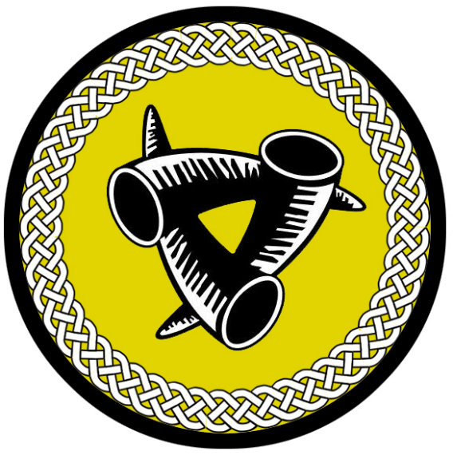
Kelborn
Size: small town, population 2,000, guards / soldiers 20, militia 100
Trade Goods: amber, mead, salt
Local Goods:
Standard: triple horn
Colors: white and brown
Patron Deity: Nerthus - goddess of lakes, springs, and holy waters
Ruler: Jarl Agnar Arngrim and his wife Thurid (f)

Home: Hall of Jörmunr ("mighty-one")
Steward: Gisli Vogsson
Marshal: Sigbrand Torsten
House Priest: Hallfrid of the Whispering Wind (f)
House Adviser (Scholar/Mage/etc): Skura of the Many Stars (f)
Captain of the Guard: Brund Hringsson
Chief Warriors in Service:
Hallad Dagfinns
Liut Geirmunds
Vekel Wealglists

Local Powers: Haunted Men (thieves guild), Hov of Nerthus
Local Sites: The Blue Boar Inn & Tavern, The Swan Maiden Inn & Tavern, Bolverka Mead House

Description:
Kelborn is an uninviting town. The waters around the small port are ringed by a wall of ropes connecting spike buoys. A horn from the town guard opens the perimeter. The buildings of Kelborn are just as forbidding, each built thick like bunkers with a motif of ornate spikes. The great Hall of Bruin stands as a mighty fortress, large wooden headpieces depicting bears standing at each end. People here are larger than average and built thick as trees. It is a somber place with little music or reverie. Town folk work hard in the salt and amber mines during the day. At night they carouse with abandon, drinking and fighting with no regard for the next day.

Industry:
Kelborn is the site of the Bolverka Mead House, maker of the finest mead in Norgarde. It is said the gods gifted the people of Kelborn with bees from Kord’s personal hives and blessed them. Virgins of the town harvest the sacred honey and toil before arcane ovens to brew the spirit. Travelers are warned that it is a heady draught and prone to reveal the truth of a person who drinks it.

Key Figures:
Jarl Agnar Arngrim – warmonger, unstable, paranoid
Jarl Agnar is a short man, but broad and impossibly strong. He often presents himself shirtless and covered in small chains around his neck with many adornments. His red face is covered it tribal tattoos and his eyes are ringed in dark henna markings. At his side he carries his bladed war club Tansmidur “Tooth Taker.” It is a club larger than most men can carry and covered in teeth from its victims over the last century. His exploits in battle are storied, for he is merciless in battle and launches random attacks without provocation.
Agnar is an unstable man. He is of a line of berserkers, men and women who give themselves over completely to the ferocity of battle. This makes him an unreliable ruler of state. Like many towns, Kelborn is mostly run by the wife of the jarl, in this case Thurid. Agnar’s real ambition is to lead Kelborn in raids against other Norgardian towns and grow in power. This is kept in check by King Steel Eye, who is the only figure who Agnar respects enough to listen. Agnar is feverishly paranoid, often found in his battle room talking to his special ravens, who he sends off to spy on neighboring towns.
Political Mindset: Agnar respects King Steel Eye and will abide by his wishes. But this doesn’t keep him from persistently asking permission from the king to raid other Norgardian towns. He believes strength is the only trait that matters and that all towns must prove themselves. As to Jarl Unnulf, Agnar finds him mysterious and unsettling. He despises what he sees as weakness in the man, and secretly desires to cut him down and burn his pathetic town. As to Jarl Mother Bear, Agnar is conflicted. He has fought alongside her and has marked her courage and ability. But she stands in his way of conquest, holding the best iron and stone resources in the kingdom. Many years ago in a drunken stupor after battle he made advances on her. She flatly refused. He found the rejection unacceptable and resents her to this day. He would very much like to conquer her and her town, adding her humiliation and her town’s strength to his conquests.
Agnar knows of the forges in nearby Gudrun and of Jarl Johan’s ambitions. This only fuels his lust for battle. Occasionally Agnar launches secret raids into Hegland Valley, where he and Johan battle without the knowledge of their kings. The each have taken the measure of one another and are eager to see the other vanquished.

Skura of the Many Stars (f), court mage

Local Lore:
There are eleven Vatnavættir, or water spirits, who are guardians of the eleven fiords of Norgarde. Snoetra watches over the Rindr Fiords and is venerated by the people of Kelborn. She is a clever spirit and wont to play tricks on those at sea. She favors those who hatch schemes and use guile. She requires the gift of silver.
Kelborn is the home of the Hamrammr, shape-shifting berserkers who take on bear form in battle. It is a secretive cult, meeting in the wilderness and praying to the gods for strength and fury. Initiates are men and women of great prowess who must prove themselves worthy before receiving their gifts (or to some, a curse). Hamrammr, like all berserkers, are unstable individuals tortured by inner conflict. It is said they are the hardest of men and women, with a touch of the uncanny about them. The Hamrammr are bitter enemies of the rival berserker cults: the Úlfhéðnar, or wolf men of Ragnvor, and the Svinfylking, boar warriors of Skogul.

History:
Kelborn, Vigdis, Aesgir, and Skala are all part of the Halslan region of Norgarde, which occupies the south-central portion of the continent around the Halsla Fiords.

Of particular renown in Kelborn are two legendary heroes: Svigrun the Sure-Handed and Halidan the Huge. Three hundred years ago the town was locked in the War of Salt and Soil (170 WA4). Geirdeir had launched assaults from both sea and over land, overwhelming the countryside. All hope seemed to be lost. One critical engagement turned the tide. In it the field of battle spread from one side of the town to the other. Svigrun, a nimble and clever fighter managed to route the enemy in a flourish of style that left onlookers amazed. Meanwhile on the other side of town, at probably the exact moment, Halidan, a towering and powerful fighter, waded into a hail of arrows and swung his mighty battle axe, cutting down armored men and their horses. So great were his blows his fellow town folk were stunned at the display of might.

Afterwards both heroes were hailed, but the town quickly divided on the point of whose feats were more worthy of praise. Neither hero seemed willing to regard the other, and so they fueled the divide even further. To this day two statues stand, one on either side of the town, each of a hero marking the spot of their victory. One half of the town is decorated in the blue and gold of Svigrun, the other half in the black and red of Halidan. Town folk argue passionately to this day over who was greater. The debate can at times lead to violent clashes, which suit the war-loving residents just fine. Visitors to the town are regaled with the tales of one or the other hero, depending on which side of the town they are in. It isn't long before visitors are pressed into choosing which hero they prefer, and the answer invariably alienates half the residents.

Customs:
Kelborn has a long history of conflict with other towns in Norgarde. Every adult considers themselves a warrior, from the hands in the fields to the members of the jarl's personal guard. Little time passes before folk become restless and are spoiling for a fight of some kind. Typically in the spring months the boats are readied and axes sharpened.

Knattleikr is a popular sport throughout Norgarde, but Kelborn is obsessed with it. In it players are divided into teams, each with a captain. A ball made of ox hide is batted with large cudgels as players push, shove, gouge, and punch across the field to get the ball to the other side. The game demands so much time that it is played from morning to night. It is a spectator game, with tournaments drawing huge crowds from all over Iceland. Kelborn inhabitants are constantly playing the game, practicing their combat skills for the day they are called to fight.

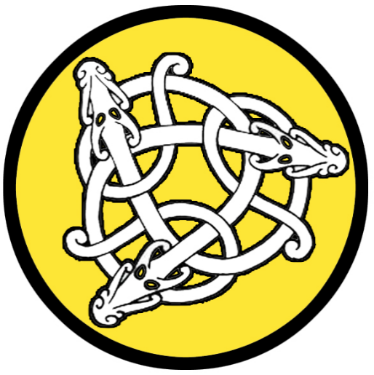
Vigdis
Size: small town, population 2,000, guards / soldiers 20, militia 100
Trade Goods: livestock, wool, magic center
Local Goods:
Standard: three dragons
Colors: yellow and white
Patron Deity: Gefjun - goddess of plowing and generosity, accompanied by her four oxen
Ruler: Jarl Unnulf Beinar and his wife Asa (f)

Home: Hall of Göndlir ("wand-wielder")
Steward: Ofieg Anlaff
Marshal: Jorund Ragnelf
House Priest: Waltheof Watcher of the Loom
House Adviser (Scholar/Mage/etc): Asdis of the Secret Stair (f)
Captain of the Guard: Hallbern Slodesson
Chief Warriors in Service:
Hrifla Sveins
Authgrim Jokuls
Torrad Illugis

Local Powers: The Black Wargs (thieves guild), Hov of Gefjun , Band of the Ice Bear (order of rangers), Algaron Sanctum (school of magic)
Local Sites: Elderbeard’s Inn & Tavern, Helm and Hammer Inn & Tavern

Description:
Vigdis is a pastoral town, connected to the sea by river but at home in the valley pastures that spread out in the shadows of the mountains. The town sits astride a broad river, a large series of stone bridges built to traverse it. Upon the bridges stand many buildings creating the center of the town. The great Hall of the Sward stands here too. Its large turf roof a shock of green upon which goats can be seen grazing at all times. The people here are whimsical and their spirits light. The sounds of the lur, a long horn used for callng cattle, can be heard sounding through the air. When the call for boats is heard, the warriors of Vigdis are ready. But for the most part townfolk here are content living in the hills and valleys.

Industry:
A passageway between the hills to the east opens up to the long, narrow Holva Valley to the east. To the west, Iduna Valley is accessible. Holva Valley is where the town folk tend sheep and harvest wool, which fetches a handsome price south in the weaving shops of Amadar. Cattle are herded in Iduna Valley.

The Algaron Sanctum is housed in a squat, dark-timbered longhouse situated halfway up one of the many mountains here. It overlooks the town and is accessible by a narrow path winding up the mountainside. It is the home of all magical studies in Norgarde. It is here the secrets of the ancient runes are studied and the rare books on the arcane are stored in its library. Occassionally there are sounds of explosions that erupt nearby, the sounds echoing off the mountains. Runes are dangerous things and experiments sometimes go awry.

Key Figures:
Jarl Unnulf Beinar – stoic, intelligent, socially awkward
Jarl Unnulf is a stolid man, showing little emotion. His beard is trimmed and neat, his curly brown hair carefully arranged loose and in braids. His right eye is blue, his left one green. Occasionally the two eyes switch colors, leading town folk to rumor he is of the gods. Unnulf’s voice is calm, almost serene. It is difficult for others to gauge his mind set or predict him. In secret, Unnulf is actually twin brothers who share the same name as well as the seat of power in Vigdis. Their mindset is so alike they are capable of communicating with one another without speaking. Only their common wife, Asa, knows their secret. Like many Norgardian women, it is Asa who runs most of the town’s business. She enjoys having two husbands and knows how to keep them both on a short leash. Regardless, the Unnulf brothers are highly intelligent and calculating. They are no strangers to joining raids and are capable in battle. But their real strength is in team work. While one of them stays at home running the town, the other is often traveling to form alliances with other towns.
Political Mindset: The Unnulf brothers see King Steel Eye as a worthy ruler and are always ready to offer him assistance when asked. They suspect that Asa and the king are fooling around, but this doesn’t bother them. In fact, this may play in their favor. As to Jarl Agnar, they find his unstable moods disquieting and are mildly concerned about the man’s ambitions. They have discovered Agnar’s raven spies and have ordered Asdis, the court mage, to place charms on the birds when they appear so as to give false information. As to Mother Bear, the brothers find her fascinating but difficult to measure. She does not seem to pose a threat. In fact, she seems a predictable and reliable ally to the kingdom with little agenda outside of her own town. But they wonder what strength lies in her town’s mines that could benefit Vigdis. To them she is a puzzle and worthy of figuring out.

Asdis of the Secret Stair (f), court mage

Rangers from the Band of the Ice Bear are known to roam the hills all around the town and valleys. They make regular trips north into the Vale of Iduna and Bludrun Forest. The town walls are decorated with the skulls of strange beasts from these places.

Local Lore:
There are eleven Vatnavættir, or water spirits, who are guardians of the eleven fiords of Norgarde. Meili watches over the Halsla Fiords and is venerated by the people of Vigdis, Aesgir, and Skala. She is a strong-minded spirit and favors the warriors. She requires the gift of mead.

History:
Kelborn, Vigdis, Aesgir, and Skala are all part of the Halslan region of Norgarde, which occupies the south-central portion of the continent around the Halsla Fiords.

Vigdis fosters a longtime rivalry with the town of Aesgir off to the east. Raiding parties from both towns trek overland or upriver to burn the fields in one another’s valleys and make off with spoils.

Centuries ago a necromancer named Orvar the Desolate lived high in the hills overlooking Vigdis (130 AA4). He was known to plunder the graves of the town folk and perform experiments on the deceased. Tales are told of the undead returning in the form of draugr and menacing the farms around Vigdis. Warriors could never find Orvar’s lair. A feud broke out between Vigdis and Aesgir, one of many between the historic rivals. The battles waged were fierce with many warriors falling. After one such battle a hundred warriors were prepared for funeral pyres, but Orvar’s draugr stole them off in the night. A month later, still recovering from their war with Aesgir, the town fell under a massive siege by the very soldiers they had lost. Some say that Orvar had come to steal the Armlet of Life, a band held by the priests of the Hov of the Gefjun Woman. The relic was known to restore health to those close to death. Perhaps Orvar sought to twist the item’s power over life to cruel ends. Whatever the reason, the town was overrun and looked to be lost. The priestess Tindra Hellqvist secured the armlet and staged a heroic battle to turn the undead and destroy them utterly. Full of resolve, she led a party of heroes up into the hills and vanquished Orvar. To this day, it is rumored that Orvar’s spirit lingers and that every so often a draugr will appear in the night. The people of Vigdis are wary of draugr now, and perform elaborate rituals on their dead to prevent such a thing. Some of the rituals involve tying the big toes of the corpses together, which is believed to prevent a draugr from rising or at least to prevent it from walking.

Customs:
Farmers of Vigdis are musicians in their own rustic fashion. Herdsmen and shepherds play the lur, a long horn used for calling cattle. The deep tones of the lur can be heard echoing off the mountains here, a sound that people here long for when away at sea. The tradition of Kulning finds its home here, a form of singing used to call livestock down from inaccessible mountain pastures. Women of Vigdis have mastered this singing style, which has inspired skalds to incorporate it into their music.

Aesgir
Size: small town, population 2,000, guards / soldiers 20, militia 100
Trade Goods: iron, stone, flax
Local Goods:
Standard: black raven
Colors: violet and black
Patron Deity: Yngvi - god of sacral kingship, virility, peace, and prosperity
Ruler: Jarl Bergthra “Mother Bear” Mannidor (f)

Home: Hall of Hrafnáss ("raven-god")
Steward: Gorm Audgis (f)
Marshal: Thiodolf Sigmund
House Priest: Lodmund of the Soul Steed
House Adviser (Scholar/Mage/etc): Torhalla the Troll Tamer (f)
Captain of the Guard: Jorund Slodesson
Chief Warriors in Service:
Sigvid Thometills
Hrafn Hreitharrs
Sighadd Asulfs

Local Powers: The Sterlingen (thieves guild), Hov of Yngvi
Local Sites: The Ale Forge Inn & Tavern, The Golden Hoard Inn & Tavern

Description:
Perched atop a mountain terrace, Aesgir looks out over the Baerdiga Valley. Below on the valley floor three walled villages sit atop man-made hills surrounded by trenches and wooden palisades. A narrow road leads up to the town proper, where the great Sky Hall stands behind a wall of stone. A dozen wooden lookout towers stand at regular intervals at the center of the valley. Fields of bright blue flax color the landscape of the valley floor. Aesgir is a quiet, rustic town that is connected to the sea but very much at home in the mountains.

Industry:
The people of Aesgir are miners and farmers by trade. The mines in the surrounding mountains provide most of the iron and stone for Halsla towns. Farming here is more successful than in most places in Norgarde. The ground is fallow and the people here cultivate it carefully against frost. Flax and linseed oil are exported downriver and bring in more coin than even iron, which is mostly claimed by Skala.

Key Figures:
Jarl Bergthra Mannifor “Mother Bear” (f) – stern, fair-minded, strong-willed
Jarl Bergthra is known as Mother Bear in these lands. She is a tall woman with broad shoulders and a strong bearing. Her pale grey eyes look out over a prominent jaw and thin lips that are drawn back in a mild scowl. Twin vertical scars frame her face. They are the marks of her late husband, who foolishly sought to dominate her before she cut him down. Her long brown hair is always worn up. She wears about her neck the heavy metal torq, Gydja. It was worn by Drifa, high queen of Aesgir, long ago when the town ruled on its own. It is said to convey enormous power to its wearer but only to women. Some even think Bergthra capable of shapeshifting to that of a large bear, from whence her name comes. She has never entertained the rumor but hasn’t dispelled it either. This is mostly because it is true. Bergthra is in fact a lycanthrope, but the torq helps her maintain control.
Mother Bear is a firm but fair ruler of her people. She has little time for political intrigue, more interested in building up her town’s industry. It is said that when Mother Bear sets her mind to something she is relentless. This has served her well in reinforcing her town’s defenses and improving the output from her mines. When other jarls come to court Mother Bear is polite but she lets one of her many female consorts do the talking. She is no stranger to war and is surprisingly adroit at shifting from matters of state to those of war. Of her many female lovers, Luta is her true soul mate. A ravishing beauty, Luta is fluent in song, dance, and storytelling.
Political Mindset: Mother Bear is fond of King Steel Eye. They have sailed on many expeditions and fought side by side. The two have a good understanding and consider one another a loyal friend. Steel Eye once defended her honor, which has won her undying loyalty. She is keen to see him succeed and makes all the iron and stone from her mines available to him as needed. She is aware of the bad history between Skala and Aesgir, but the king’s respect has tabled that matter for now. If a new king were to sit in Skala, then Mother Bear would be quick to reassess her town’s position and consider independence from the throne or even taking over the Halsla Kingdom.
As for the other jarls in Halsla, Mother Bear has a cool attitude. Agnar is a fool and a danger in her eyes. They have fought alongside one another as allies, but she can only see him as an inevitable foe. She is unaware of his raven spies, but her intuition tells her he is up to something. Jarl Unnulf she finds harmless, but peculiar. She is perhaps the only one who suspects that Unnulf is in fact twin brothers but she keeps it to herself. On his visits to Aesgir she sends women to his bed chamber. Their reports tell her what can often be discovered in the bed: the two men have slightly different behavior there. Mother Bear finds deception unsettling and for this keeps a sharp eye on Vigdis. As for the jarls of the Brisingr lands, she has heard the tales of their raids in the Fjara towns centuries ago. She knows they are capable of great things if compelled. She has a tolerant view towards Styrmir of Kinwall, feeling a kinship with his appetites. Henrik of Hahll intrigues her, for he reminds her of her brother she lost to the trolls of the north. He too was luckless in most things, but his courage overcame darkness when Aesgir needed it most. In Henrik she sees the gods at work.

Torhalla the Troll Tamer (f), court mage

Local Lore:
There are eleven Vatnavættir, or water spirits, who are guardians of the eleven fiords of Norgarde. Meili watches over the Halsla Fiords and is venerated by the people of Vigdis, Aesgir, and Skala. She is a strong-minded spirit and favors the warriors. She requires the gift of mead.

The Dwarves of Amberon make infrequent visits to Aesgir from their outpost, Lindwyrm Keep. Relations are fair, with the town making overtures of friendship in exchange for the Dwarves’ tutelage in working iron and stone.
Goblins are a frequent problem in Baerdiga Valley. The Clan of the Husk dwells in the mountains north of here and attack regularly.

History:
Kelborn, Vigdis, Aesgir, and Skala are all part of the Halslan region of Norgarde, which occupies the south-central portion of the continent around the Halsla Fiords.

The southern end of the valley was the site eight hundred years ago (780 WA3) of the feud between the Aesgir and tribes from Skala. After years of abuse from the king, the Aesgir town folk refused to send tribute. Troops from Skala made their way north from the coast, intent on burning the town to the ground. The priests of Aesgir called on Kord and, it is rumored, in his fury he brought down fire and lightning and wiped out the Skala soldiers in what is now called the Day of Kord’s Fury. The king shortly sued for peace. The people of Aesgir responded the next year with tribute as if nothing had happened, and the king made sure to treat them fairly for fear of the gods.

Aesgir fosters a longtime rivalry with the town of Vigdis off to the west. Raiding parties from both towns trek overland or upriver to burn the fields in one another’s valleys and make off with spoils.

Customs:
The Aesgir are a more pious people than most, erecting wooden totems to the gods and praying in open spaces outlined with stones marked in runes. The priesthood holds a special position of power here and none dare desecrate the names of the gods openly.

Kingdom of Fjara

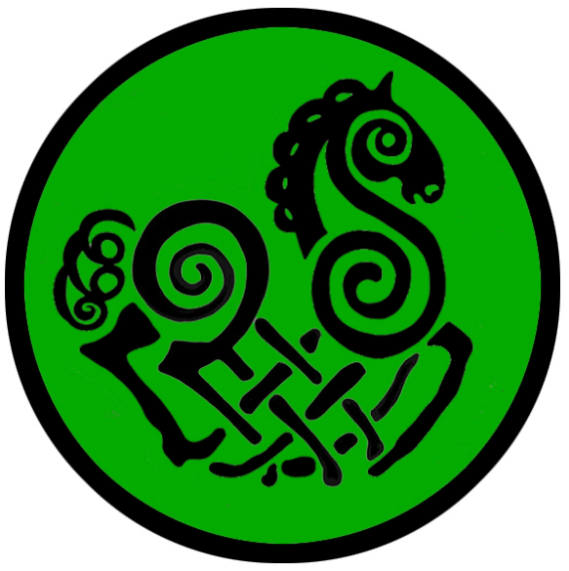
Geirdir
Size: large city, population 25,000, guards / soldiers 250, militia 2250
Trade Goods: amber, tin, mead, fishing, ship-building
Local Goods:
Standard: eight-legged horse Sleipnir
Colors: green and black
Patron Deity: Forseti - god of justice, reconciler and overseer of conflict
Ruler: King Stefan Tornquest and his wife Henny (f)

Home: Hall of Hagvirkr ("skilful worker")
Steward: Theom Gunnar
Marshal: Folke Dahlen
House Priest: Sjalle of the Flaming Hammer
House Adviser (Scholar/Mage/etc): Jescala the Sea Maven (f)
Captain of the Guard: Vensel Sodergren
Chief Warriors in Service:
Varin Slodis
Kaupmann Rognvalds
Yrsa Gilli (f)

Local Powers: The Silver Sword (thieves guild), Hov of Forseti, Skoldveg "Shield Wall" (mercenary company), Order of the Einherjar (order of paladins)
Local Sites: The Wench House Inn & Tavern, The Drunken Dwarf Inn & Tavern, Saga Mead House

Description:
Geirdir is a city that is one with the sea. More than any other Norgardian town, the capital of the Fjaran Kingdom embraces the open waters. A third of the large cove leading up to the city is filled with elaborate wooden piers. A staggering variety of sailing vessels are here, some from distant lands. Colorful wind socks flutter from a hundred poles, each ornately carved in figures depicting mermaids, swordfish, sea giants, and the like. Sailing shanties can be heard on the air as fishermen tend to their nets and boatbuilders work their lathes.

Looming over the harbor stands an enormous wooden tower topped by a massive piece of polished spar, a native crystalline stone. This is called the Solskifa, and is magically attuned to follow the sun as it moves. The crystal captures the sun’s rays and gives sailors a sense of the weather. The glow of the Solskifa is a marvel to behold.

Gierdir, along with Kastfel, Skogul, and Jotunn, is part of the Fjaran region of Norgarde, located in the south-eastern portion of the continent.

Industry:
Ships built in Geirdir are the trademark Norgarde craft, with long prows, shallow draft, many oars, and square sails. What distinguishes Geirdir ships is their sleek hull design, which is built for speed over agility or strength. While Volsung boats are the most rugged and boats from Skala are the most maneuverable, Geirdir boats slice through the water faster than any other.

The Saga Mead House is a prosperous distiller of the favored Norgarde spirit. Where the mead of Kelborn is rumored to come from Kord himself, saga mead from here is rumored to come from Gunla, daughter of the giant king Vafthrudnir. It is a heady drink and said to inspire courage befitting the warriors of old. Some say it drives a warrior to a berserk rage in battle. For this reason warriors going into battle literally bathe in the mead to anoint them, hoping to achieve such feats as would earn them immortality in song.

Key Figures:
King Stefan Tornquest – intolerant, obsessed, greedy
King Stefan is a short, stout man with long hair in the back but balding at the top. On his scalp he has tattooed the Norgardian symbol for wealth. He dresses in rich silk from Xiandai but cut in the local fashion. His hands are large and rough from years as a sea hand. He is the most capable seaman in the land and rose to his station from the great wealth he acquired from expeditions to the far eastern lands. Around his neck he wears a magical sun stone named Sovisir, which is said to help navigate even the most dangerous waters.
Stefan is an intemperate man, prone to mood swings. His passions are the perfection of boat-building in Geirdir’s proud shipyard as well as the accumulation of exotic treasures from far-off lands. He is often away from home on adventures. Often his people assume he is dead, but he appears soon after with heavy-laden boats. Instead of gold he often brings back strange items of no particular value, which leaves his crews grumbling. But he insists his seer, Jescala, knows their true worth. Stefan is particularly bitter towards the sea elves of Aelfala, who dwell on the islands at the mouth of the Fjaran fiords. He hates them with a vile passion and regularly launches attacks to wipe all the sea elves from around the coast.
Political Mindset:
Stefan has little love for his subject jarls. He sees them only as a means to an end and is not above pitting them one against the other. Of Jarl Hook-hand he has utter contempt. He sees through the flattery of the man and knows them to be empty words. Skogul depends on him for protection rather than fix their problems on their own. He is short with Hook-hand and demands him to take more responsibility. Of Katja of Kastfel he admires for her seamanship and strength in battle. But he is puzzled by her religious zealotry. His pride is pricked when she speaks to him of the gods, getting the sense she is judging him. Secretly he wishes for a chance to put her in her place. But at least her warriors are of some use. Towards Ravel of Jotunn, he holds a peculiar fascination. He feels Ravel is unstable, which sickens him, but he also sees him as a play thing. Stefan takes joy in prodding the man with conspiratorial talk and ordering his boats on long missions for no purpose. It is Stefan’s plan to eventually have the jarl murdered and place one of his own brothers in power in Jotunn. But that day can wait.
Jescala the Sea Maven (f), court mage
Order of the Einherjar – The paladins serving the Einherjar are so named for the valiant dead who await the end of days and are prepared to fight the darkness threatening the world. Their name means “to fight alone,” and this informs the order’s culture. Knights of the Einherjar seek no leave to engage in quests handed down from the gods: slaying the unworthy, defending the shores of Norgarde, pillaging foreign lands to bring tribute back to Kord. Warriors of the Einherjar do not consider themselves knights but holy warriors. Each one is blessed with enormous strength and constitution. Many a king of Norgarde has sought their service but few rest easy knowing they are a breed apart.

Local Lore:
The many islands south of Geirdir are home to the Kingdom of Aelfala of the sea elves, whom the Norgardians call Sjóálfar. Hundreds of years ago the sailors of Geirdir fought the Sea Elves for passage out to the open sea. King Beirkuld won a decisive victory over the elves and stole the Crown of Iargwyn (250 WA4). Beirkuld took it to the great Vatnavættir sea spirit, Melkora, who watches over the Fjiords of Fjara. Gifting it to her he earned her favor and the Sjóálfar have since left the boats of men in peace. It is not unheard of for conflict to reemerge from time to time, but for the most part` the men of Gierdir leave the Elven islands alone and keep to the waterways.

Sea giants are known to dwell beneath the waves near Geirdir. They are seldom seen and rarely bother with humans. Tales are told of unwise sailors who hunted the giants for gold, but were met with calamity when the peaceful brutes were riled. Occassionally a sea giant will appear and warn of particularly bad weather coming. Wise sailors leave the giants be and pay heed to their counsel when they do see them.

There are eleven Vatnavættir, or water spirits, who are guardians of the eleven fiords of Norgarde. Melkora watches over the Fjara Fiords and is venerated by the people of Geirdir. She is a chaotic spirit, always looking to cast away order. Those who embrace her ways know how to navigate the shifting tides of the fiords as well as life. She requires the gift of dust.

History:
Three hundred years ago King Brenlig of Skala scored a conclusive victory in the Sea of Fenris in the War of Salt and Soil (170 WA4). Brenlig’s navy conquered those of King Stol’s of Volsung and King Renni’s of Geirdir while his ground forces encircled their capitals. Since then the throne has ruled from Skala. And, since then, Geirdir has plotted to wrest that control away.

900 PA3 - Kulring the Wolfhead leads a crusade of 100 ships to find the Shield of Kord; the quest will claim the lives of every sailor but one: Hobrim Svaldur, who returns the shield to Geirdir; this spawns a tradition of songs over the saga

Customs:

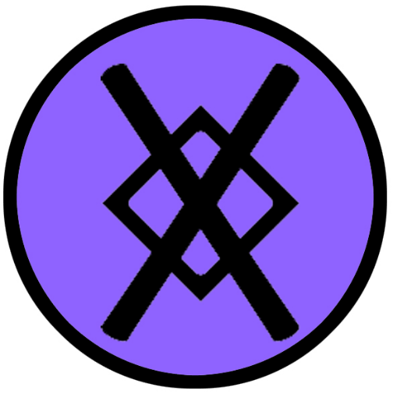
Skogul
Size: small town, population 2,000, guards / soldiers 20, militia 100
Trade Goods: amber, lead, fishing
Local Goods:
Standard: gungnir, magical spear emblem
Colors: purple and black
Patron Deity: Sjofn, goddess of human passion
Ruler: Jarl Öngull “Hook Hand” Ekstruun and his wife Svala (f)

Home: Hall of Hnikuðr ("striker")
Steward: Rune Eklum
Marshal: Folke Sparre
House Priest: Adelheid of the Oath Ledger (f)
House Adviser (Scholar/Mage/etc): Ovid the Green Seer
Captain of the Guard: Nea Stenbock (f)
Chief Warriors in Service:
Spiut Hrossketils
Mar Grimkels
Ufi Geitirgests

Local Powers: Moon Lot (thieves guild), Hov of Sjofn
Local Sites: The Mystic Maven Inn & Tavern, The Ale Horn Inn & Tavern

Description:
Skogul is a fishing town that has become host to travelers from afar. It is closer to the Heedless Straits than any other town or city, so sailing vessels often venture here first. The town itself begins at the water’s edge as a myriad of landings and stalls where goods and trinkets are sold. Colorful banners flap in the breeze as town folk sell produce, fish, and metal wares. Music and revelry spill out of taverns catering to outlanders.

Skogul folk have become shrewd traders and fast talkers, capable of sizing up ships and their cargo and striking deals that are very profitable. Some say a person from Skogul can talk a visitor right out of their clothes. Their talent for appraisal is well renowned in Norgarde. Some go on to work the markets in Volsung and Styrla or accompany expeditions to help improve the value of their return trip.

Industry:
The people of Skogul have thriving tin and amber mines northeast of the town. Scattered among the towering hills and mountains on either side of the waterways, the workers disappear into the mines at sunrise and load their ore in a secret port further upriver for fear of poachers. Skogul amber is popular in southern lands.

Skogul enjoys the best fishing in all of Norgarde, overlooking the Halsla Fiords and the warm waters of the Heedless Straits. Many merchants traveling to Skala tend to visit Skogul, either on accident or out of convenience as it is easier to reach. For this reason Skogul is considered one of the friendlier ports of call when traveling to the northern continent. People here are more tolerant of outsiders and foreign tongues.

Key Figures:
Jarl Öngull “Hook-hand” Ekstruun – manipulative, theatrical, charismatic
Jarl Hook-hand is an average sized man with a neat, short beard and twinkling blue eyes. He wears bright purples and yellows and a chain featuring pendants of many different symbols he switches out regularly depending on his audience. He is a fast talker and very charming. He is keen to tell outlandish stories and flatter his guests. His right hand is missing, replaced by a hook. This has earned him his name and is a prop he uses for telling varying tales of how he lost his hand. Jarl Hook-Hand knows his town is a frequent stop for travelers, so he sets an impressive table for visitors from other lands. Skogul has little to offer on the political stage, necessitating him to make the most of every contact he meets. Hook-hand has earned a reputation for being a “fisher of friends.” As close as his town is to Skala and the neighboring kingdom of Halsla, the jarl is keen to use his wiles to protect his city with pacts and agreements with other towns. He employs many spies to visit the halls of other jarls. While he is known to have four daughters, somehow the jarl presents an ever-growing number of fetching young ladies he claims are his daughters. These he sends as beguiling envoys to other jarls and visitors from abroad.
Political Mindset: Hook-hand spends much of his time charming the other rules of Fjarna, waging intricate schemes to exploit them to his own ends. He pays lavish deference to his king in Geirdir, plying him with compliments and overtures of loyalty. He is a silver-tongued defender of his town, appealing to Stefan’s sense of honor to safeguard the Nurla Valley against any encroachments from Skala. Jarl Katja he once envisioned as a paramour, but quickly learned her pious nature made her difficult to beguile. He has instead made quite a show of piety himself by gifting her with holy relics. To her he has confided his suspicions that the king is not quite the man the gods intended to rule. It is his hope to win her support if and when the day comes he may usurp the throne. Lastly, as for Ravel of Jotunn, he is quick to take advantage of the jarl’s fears. Hook-hand sends regular pledges of support to Ravel and has even staged the capture of assassins whose heads he sends to Jotunn. It is his hope to bring Ravel to his side if the time comes he needs the support. After that, only the gods know.

Ovid the Green Seer, court mage -
Local Lore:
South and east of the town is the site of the mighty Koldal Falls. Waters flowing from the mountains descend in a mighty cataract that is breathtaking to behold. On nights where there is a full moon, the falls appear to reverse direction, running up instead of down.

It is rumored there are waterways that snake behind the falls where sea elves and merfolk live. The sea elves are known as the Sjóálfar and are distant cousins to those in the Kingdom of Aelfala near Geirdir. They are rarely seen and do not bother the people of Skogul, but are known to cut the nets of fishermen from time to time. Some suspect this is if one of their pets is caught in the nets.

The town also has tenant farmers working the fields of the Nurla Valley to the north. The valley is far from secure, however. Goblins and other creatures often descend from the hills in raiding parties. They rarely venture as far as the town’s defenses, but in recent history there have been notable battles. For this reason the farmers are often weapon-wielding warriors or accompanied by the jarl’s men.

The sea spirit Astridina is revered by the people here. She is one of the Vatnavættir (guardians of the specific waters) and protects the Fiords of Koldal. A statue of her stands at the mouth of one of the many rivers leading into the sea. She is depicted as a slender maiden with long, flowing and unkempt hair, holding a giant fish hook.

There are eleven Vatnavættir, or water spirits, who are guardians of the eleven fiords of Norgarde. Astradina watches over the Koldal Fiords and is venerated by the people of Skogul. She is a champion of justice and watches over the lawful. She requires a gift of fresh water.
Skogul is the home of the Svinfylking , shape-shifting berserkers who take on the form of large boars in battle. It is a secretive cult, meeting in the wilderness and praying to the gods for strength and fury. Initiates are men and women of great prowess who must prove themselves worthy before receiving their gifts (or to some, a curse). Svinfylking, like all berserkers, are unstable individuals tortured by inner conflict. It is said they are the hardest of men and women, with a touch of the uncanny about them. The Svinfylking are bitter enemies of the rival berserker cults: the Úlfhéðnar, wolf warriors of Ragnvor, and the Hamrammr, bear warriors of Kelborn.

History:
Skogul, along with Kastfel, Gierdir, and Jotunn, is part of the Fjara region of Norgarde, located in the south-eastern portion of the continent. During the many skirmishes between the Fjaran and the clans of the Halslans to the west, Skogul is the first of the Fjaran towns to be attacked as it is the nearest to Skala. There is a long-standing enmity here towards the city. Town folk mumble amongst themselves of their hatred for Skala. They long for a day when the Fjaran kingdom finally puts the city to the torch.

Customs:
Town folk often wear a silver fish hook on their clothing in deference to Astradina, the sea spirit watching over these waters.

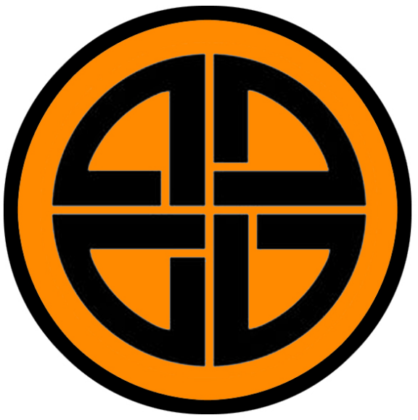
Kastfel
Size: small town, population 2,000, guards / soldiers 20, militia 100
Trade Goods: ivory (walrus), tin
Local Goods:
Standard: shield knot
Colors: orange and black
Patron Deity: Ull, god of archers and explorers
Ruler: Jarl Katja Degermark (f)

Home: Rostungur Hall “Hall of the Walrus”
Steward: Kalle Widforss
Marshal: Maltem Sparre
House Priest: Ored of the Sacred Wheel
House Adviser (Scholar/Mage/etc): Vilda the Vain (f)
Captain of the Guard: Tagen Sohlmen
Chief Warriors in Service:
Hakon Hjarrandis
Bothvar Snorris
Thord Sigbrands

Local Powers: The Secret Skalds (thieves guild), Hov of Ull
Local Sites: Eagle Head Inn & Tavern, The Troll’s Daughter Inn & Tavern

Description:
At a place where the High Helm Rivers break eastward and southward, a spit of land sits on the northern side of low mountains. Here on mossy banks stands the town of Kastfel, shrouded by strange trees whose branches twist into mysterious shapes. These are the very Sigil Trees the druids speak of, whose branches are said to take the shape of runes and other signs. The careless eye may not even see the town but for these trees. Behind vine-covered gates a cluster of buildings leads to a series of ever rising stone terraces, each with buildings larger than the ones below.

At the top stands the Hall of Rostungur, or Hall of the Walrus. The hall looks out over the forest and offers a full view of the rivers. Below, the light beneath the trees has a hue of green and feels otherworldly. North of the town, beyond the river, is a mountain pass that leads to Gullifax Vale. Upriver there are hidden wooden barricades that are deployed across the river as needed. For no one is more cautious of being hunted than hunters themselves.

Kastfel is a town of sea hunters. Boats here are equipped for war and expeditions. The town’s port is small, for at any given time most of the boats are away hunting or exploring. The people here speak in hushed tones, cautious to draw attention to their town as well as a habit of hunters.

Industry:
The people of Kastfel are the most skilled seaman among the Norgardians. Long have they plied the waters of the Fenris Sea and they know it and the Fiords of High Helm better than anyone. Ivory from the tusks of the walrus is a trademark of the town. Merchants pay handsomely for exotic quality of the walrus ivory ornaments made in Kastfel.

Key Figures:
Jarl Katja Degermark (f) – inquisitive, penitent, commanding
Years ago, when Katja was but a child, she came to Kastfel as a prisoner after a raid on a neighboring town. The high priest at that time ordered all prisoners examined for their fitness to live among them. In a panic, Katja picked up the priest’s knife and killed him with it. The jarl was so impressed he took it as a sign and raised her as his own. Each night she was made to kneel before the town’s lodge poles depicting the gods, instructed to learn their purpose for her.
Jarl Katja is a slender woman with high cheekbones and soft blue eyes that give her a regal bearing. Her auburn hair falls about her shoulders in round curls. She has a throaty, arresting voice. And when she speaks it commands attention. Katja is an intelligent leader and curious open to all ideas brought to her by her counselors. She is also a fierce shield maiden when the war drums sound. This has won her the respect of her boatmen. But her most compelling attribute is her dedication to the gods. She is fascinated by signs and portents and consults the seers daily. It is her deepest desire to please the gods with her cunning and ambition.
Political Mindset: Katja approves of King Stefan and shares his wander lust. Many times she accompanies him on his journeys abroad. She secretly wonders if his ambitions are in line with the gods and indeed if he is worthy of their favor. Her Alva warns her that there are signs the gods will depose Stefan and replace him with a more righteous champion. Perhaps it is she. As for Ongull, Katja has her reservations. She thinks he is a duplicitous man and full of guile. She is immune to his flattery and has no use for his several daughters he tries to pawn off on the others. But his words and deeds to honor the gods, however feigned they may be, have given her pause. She wonders if the prophecies of a more righteous king may point to him. As for Ravel of Jotunn, he is an unsightly beast and craven. She wonders if the man may be doomed by the gods and if she may be the one to bring it. Lastly, Katja regularly treats with Vensel of Styrla. The two towns have traditionally been firm trade partners. She finds the man dull and unstable. Occasionally she finds the esoteric tomes in his library worthy of her religious studies, but books mean little to the woman warrior. She is more interested in securing better terms with Vensel’s harbor, which her boats frequently use on their long voyages eastward. She wonders privately if the old man without an heir will be of use for much longer.

Vilda the Vain (f), court mage

Local Lore:
The Mare monster gives people bad dreams at night by sitting on them in their sleep. It is believed that the Mare are the troubled souls of living people which left their bodies at night but never returned. Often these are witches, whose souls took the forms of animals, but normal people, in particular adolescents, are also thought to become Mare when their spirits wander. The idea that the soul wanders at night is a common belief among Norgardians. It is also believed that when the Mare touch a living thing, people, cattle or trees, it can cause their hair to become entangled. It is also said to be why the branches and roots of some trees became entangled.

The Flaming Ship of Bergfinn is a popular story in these parts. It is said on some nights that Bergfinn’s ship can be seen on the open sea, a bright blaze of burning flame surrounding it and the ghosts of his men.

There are eleven Vatnavættir, or water spirits, who are guardians of the eleven fiords of Norgarde. Njörun watches over the High Helm Fiords and is venerated by the people of Kastfel. She is a spirit who celebrates life and looks to see it grown and flourish. She requires a gift of fruit.

History:
Kastfel, along with Jotunn, Skogul, and Geirdir, is part of the Fjara region of Norgarde, located in the south-eastern portion of the continent. Like other towns of the Fjara, Kastfel has long endured war with the Halslan clans. Being so far east, the town is rarely attacked from the sea. Instead ships from Skala make the portage to the mountains north of the town and attack from the rivers. For this reason, the town has defenses bristling along the river banks.

Kastfel ships often tangle with the fishing lanes of the Brisingrer towns to the north. Feuds with the northern towns are far more frequent and often limited to engagements at sea.

Two hundred and seventy years ago Bergfinn the Flame Beard led a fleet of war ships against the combined forces of Hahll, Kinwall, and Lutadar. The Brisingrer ships ruled the open waters in a feud called the War of the Eastwater (220 WA4) and they threatened to destroy all villages along the southeastern coast. Bergfinn defied the counsel of his fellow Fjaran chieftains, sailing north in an offensive posture rather than defend the mainland. His fleet managed to divide and defeat several Brisingrer parties at sea. At last, he was surrounded by overwhelming numbers. His men fought valiantly, though all of his ships were now fastened by enemy tow lines and boarding parties threatened to wipe them out. Bergfinn ordered flaming pitch be hurled and emptied all around. The ensuing fire engulfed the entire fleet and most of the enemy ships as well. Bergfinn secured his place as a hero among his people.

Customs:
Kastfel boats travel far, always eager to explore. They are familiar with the people who travel the Noreast Jaunt trade route. Often seamen with wander lust will sign on to voyages along this route.
It was the people of this town that joined Thyri Eyleifurs eight thousand years ago and colonized the Isle of Skjolden and founded the town of Styrla. The town enjoys a strong alliance with Styrla to this day and the two exchange gifts and favors.

Kastfel seamen are adroit at sea combat. They are highly sought after by the city of Geirdir during sea campaigns when warriors are needed for boarding parties.

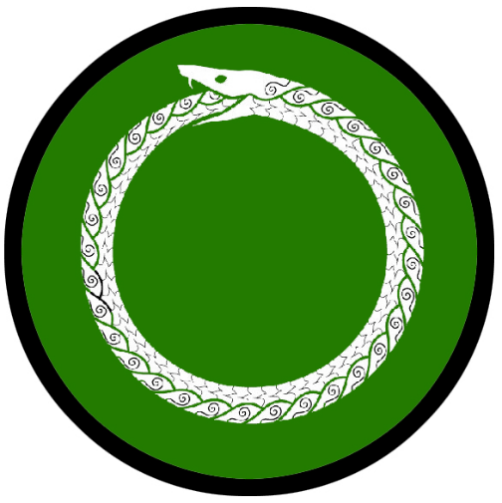
Jotunn
Size: small town, population 2,000, guards / soldiers 20, militia 100
Trade Goods: tin, fishing
Local Goods: frost crab
Standard: circular world serpent (Jormungandr)
Colors: green and white
Patron Deity: Dellingr, god of the dawn
Ruler: Jarl Ravel Sjoholm and his wife Tindra (f)

Home: Hall of Viðrir ("stormer")
Steward: Aelf Westermarck
Marshal: Onde Rehn
House Priest: Sigge of the Unseen Sigil
House Adviser (Scholar/Mage/etc): Stellana of the Night Sky (f)
Captain of the Guard: Thea Gungreth (f)
Chief Warriors in Service:
Gæira Sigvids
Leif Ulfriks
Gjaflaug Ottar (f)

Local Powers: The Hidden Host (thieves guild), Helhest (smuggling ring), Hov of Dellingr
Local Sites: The Black Bull Inn & Tavern, The Sea Serpent Inn & Tavern

Description:
Jotunn is a fortress of a town, built on the side of a mountain with crude rock walls and buildings large and heavily reinforced. It is a town built in defense of giants, who terrorize these lands. Everywhere there are signs of damage from hurled boulders, cast away trees, and overturned pillars. Trenches have been dug, wide as well as deep, with walls of spikes erected along the interior. Flanking the town are twin waterfalls that feed the rivers flowing east to the sea.

At the center of town stands an enormous stone hand reaching skyward up from the ground. No one knows where it came from. Legends speak of the mother of giants, who was turned to stone and buried on this site. Another mystery lies far up the mountain. At its peak there stands an old and weathered dome in the shape of a giant Norgardian warrior’s helmet. Cracks can be seen in the gleaming white stone where tiny flowers grow. Stone steps lead up into one of the eyelets. None venture here, for none who have return to tell of its secrets.

Visitors may not that some of Jotunn’s residents are larger than most humans. It is said they descend from giant stock. Most people here share the mirth of giants: crude, banal, dull-minded folk. Jotunn is a poor town compared to most. The people are restless and eager to improve their fortunes. Raids at sea are not uncommon, but Jotunn folk prefer the mountains and to attack neighboring villages. The banner of the world-consuming serpent is feared more in Norgarde than even in other lands.

Industry:
The town of Jotunn was once a small fishing village. Its fishermen developed skills in netting some of the most rare and prize fish in the Fenris Sea, as well as frost crab which is a highly prized commodity. The tin mines in the hills bring little more than misery to the town folk, who would rather see gold. The Helhest smuggling ring operates a small fleet of ships that work the Noreast Jaunt, Fenris, and Halsla shipping lanes.

Key Figures:
Jarl Ravel Sjoholm – insecure, paranoid, wrathful
As a child Jarl Ravel was pulled from the wreckage of a sinking ship when his father the jarl was murdered. Young Ravel was not expected to survive. It is said a troll born woman cared for the young man, nurturing him with strange tonics. Today he is a tall man but lean with spindly arms. His long hooked nose and haunted eyes peer out from a mane of dark black hair. Some rumor that Ravel is himself of troll blood, which drives him mad with rage to hear. He dresses in dark colors and wears only a wooden totem of unknown origin. At his side he carries Svartanott, an infamous sword named “Black Night,” that is rumored to carry a curse. Ravel is plagued by inner demons, fearful of his own downfall. He sees conspirators all around him and is sick with worry. He finds relief only in hunting giants in the Vafthrudnir Valley and going on long expeditions into the wild. He knows his town is a poor one, made up mostly of fishermen. He covets the power of other jarls so he may stand proud and shake the shame he feels towards himself.
Political Mindset: Ravel is fearful of all the jarls of the Fjarna lands, but King Stefan frightens him the most. He sees an overbearing task master in Stefan and is quick to do whatever it takes to avoid his fury. This of course infuriates Ravel, who is exceedingly jealous of the man’s success. He would not miss the king if a new one were to take his place. Towards Katja Ravel is also fearful, withering under her religious scrutiny. He will work with her only when ordered. Otherwise he wants nothing to do with her or Kastfel. Only Hook-hand of Skogul resembles anything close to an ally. Ravel reluctantly listens to his counsel and is relieved whenever the jarl sends him heads of would-be conspirators. He wonders if Ongull is a man who would make a much better leader to follow, but frets over what it would take to make that happen.

Stellana of the Night Sky (f), court mage -

Local Lore:
Jotunn is named for the ancient giant who once roamed these lands. Jotunn’s father, Vafthrudnir, was king of the giants two thousand years ago. Vafthrudnir’s was a wise giant and would grant wisdom even to men-folk if offered a handsome prize. His great hall is rumored to be deep within the northernmost of the tall mountains to the west. Much of the Jotunn law and lore comes from wisdom gleaned from the giants. Today the hill giants around Jotunn are cruel and dim-witted descendants who have no respect for men. The people of Jotunn periodically engage in war with the giants and are skilled in fending them off of their lands. Vafthrudnir Valley to the north still bears the giant king’s name and is the site of many battles against the large folk, who are loathe to see any humans there.

History:
Jotunn, along with Kastfel, Skogul, and Geirdir, is part of the Fjaran region of Norgarde, located in the south-eastern portion of the continent.

Customs:

Lands of the Brisingr

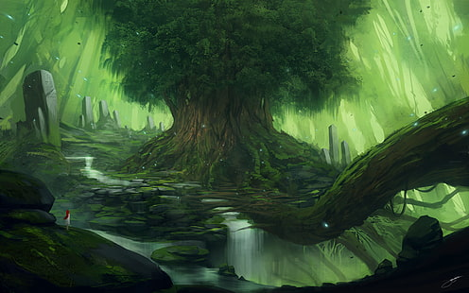

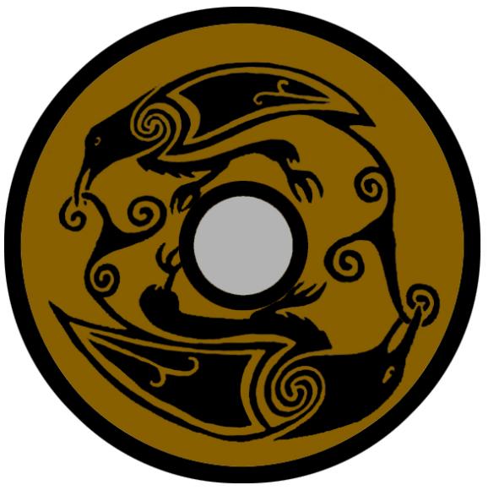
Kinwall
Size: small town, population 2,000, guards / soldiers 20, militia 100
Trade Goods: timber, furs, medicine
Local Goods: spruce beer, lodge poles, reindeer herding
Standard: twin ravens
Colors: brown and black
Patron Deity: Skadi - goddess of winter and the hunt
Ruler: Jarl Styrmir Ragnfre and his wife Fastvi (f)

Home: Hall of Sigmundr ("victory-protection")
Steward: Alvi Hrutsson
Marshal: Skuri Karsid (f)
House Priest: Vigot of the Silent Bell
House Adviser (Scholar/Mage/etc): Jarngerd of the Norlight (Northern Lights)
Captain of the Guard: Staekar Mjornan
Chief Warriors in Service:
Gærrar Gautis
Sumarlid Thorhalls
Ondott Nafnis

Local Powers: The Lookout (thieves guild), Hov of Skadi, Circle of the Wych Elm (order of druids)
Local Sites: The Royal Oak Inn & Tavern, The Triple Horn Inn & Tavern

Description:
Kinwall is a rustic town, its dark brown timber walls decorated with flora. Vines, flowers, and purple hyssop are arranged in a fashion both pleasing to the eye and holding special meaning to druids in this land. Tall wooden pillars stand watch at the edges of town, grim faces carved into them. Much of the woodwork here is a marvel to behold. Elaborate carvings can be seen in large lintels over every doorway. Curved and elegant beams make up the bridges crossing the riverway, shrouded in mists coming up from the rapids.

Kinwall is located far inland from the coast and lies abreast of the Viskar Wood to the north. The town is so named for the stone walls erected north of the town, built over the centuries by the local folk to represent their bond with one another against the perils of the wild. The wall is said to be enchanted to protect against creatures from the woodlands. Strange markings on the walls glow in a soft light when living creatures, man or otherwise, approach it. Some say late at night a low, pleasing song emates from it as if it were alive.

The people here are softspoken and earnest. Their dress is slightly different, donning browns and greens of the forest. In battle they

Industry:
While its people are still handy on the water and make regular journeys into the Sea of Fenris, the people of Kinwall are most adept at hunting and harvesting timber. Pine, birch, and spruce are the most common wood harvested. The spruce is carved into handsome lodge poles honoring Kord and treasured as works of art throughout Norgarde. These are similar to the ones fashioned in Skurn on the west coast. Spruce Beer is a unique brew made in Kinwall. It has a bitter, full-bodied taste and is often used by sailors to stave off scurvy. It can be consumed as a tea from the shoot tips or even eaten straight from the tree when light green and new in spring. It is esteemed as a source of tone wood by stringed-instrument makers.

Rare plants are found in the wilderness and brought here for study. Kinwall has a long tradition of studying herbs and developing medicines. The more common herbs used by healers here are willow bark, mugwort, chicory, camomile, angelica, yarrow and plantain weed called “White Foot.” Towns throughout Norgarde seek special tonics and poultices from here, as well as the storied healers. Healers record their recipes in svartebøker, “black books.”

Reindeer have been herded by the people of Kinwall for generations. While not a substantial trade good, the leather, sinews, hides, and antlers are sought after by the other Brisingr towns.

Key Figures:
Jarl Styrmir Ragnfre – practical, tactless, liar
Jarl Styrmir is a heavy man, fond of food and drink. But his great girth belies his prowess in hunting and in battle. He is a thick man with long dark hair and a wide beard he adorns with tiny river stones. His red cheeks billow with song and laughter. His forearms are marked by the brands of ancient runes, which he had inscribed at great pains. At his table he rests his magical heavy axe Skerandi the “Man Splitter.” Styrmir is a proud and vigilant chieftain to his rustic town in the north. He has little patience for flowery words when speaking with southern jarls, prone to say things plainly and often rudely. He is also a habitual liar, weaving tall tales and making promises he never keeps. Styrmir cares only to see his trappers and loggers prosperous and the woodland creatures kept north of the town’s walls.
Political Mindset: Styrmir tires quickly of any political talk, preferring to negotiate for trade goods with other towns rather than think of power. He is a simple man and sees little beyond his town. Regarding Brynhild of Lutadar, Styrmir enjoys her company and their annual hunting trips into the northern wildlands. He covets the silver coming from her mines, but has found his tall tales do little to pry much from her hands. He regards her as an ally and mostly trustworthy and leaves it at that. As to Henrik of Hahll, Styrmir pities the fool for his bad luck but keeps him at a distance. He has little consideration of Hahll’s traditional role as leader of the Brisingr lands. Vensel of Styrla he considers an even greater fool, but at least he is a wealthy harbor master. Styrmir finds the old man an easy audience for his tall tales and an easy mark to trade useless books his boats find for good coin. His only other regular dealings are with Mother Bear of Aesgir. In her, Styrmir finds an intriguing equal. He admires her strength and her rustic qualities, much in line with the Brisingrs. He once made the mistake of trying to charm Luta, Mother Bear’s mistress, and quickly learned to keep to business with them both.

Jarngerd of the Norlight (Northern Lights), court mage -
The Algaron Sanctum of magic is the one school in the world specializing in the study of ancient runes. Rune magic is rumored to have started in Norgarde. Its practice here overlaps with that of divine magic, the rune being considered a calling card of the gods.

The druids here call themselves the Circle of the Wych Elm. Along with tending to the Viskar Wood, they are also said to be at one with the strange sky lights that appear in the northern nighttime skies. These northern lights appear at irregular times, shimmering bands that twist and turn across the nighttime skies. It is a beautiful sight to behold. The druids often gather in a circle in the Viskar Wood and commune with the lights.

Wizards of Algaron work closely with the druids of the Circle of the Wych Elm. Outsiders will likely not notice that trees throughout the Viskar Wood are marked with intricate runes, creating a dense and sophisticated field of magic in the region that only the Kinwall mystics can understand.

Local Lore:
There are eleven Vatnavættir, or water spirits, who are guardians of the eleven fiords of Norgarde. Ēostre watches over the Hagala Fiords and is venerated by the people of Kinwall. She is a champion of craftsmen and seeks to see things built in harmony with nature. She requires a gift of wood.

History:

Customs:
The north-east reaches of Norgarde are called the land of the Brisingr people, so named for the Brisingr Fiords but including the fiords of Hagala as well. The towns of Lutadar, Kinwall, and Hahll share a bond that distinguishes them from towns in the south. They hail from nomadic peoples who still wander the far northern wildlands to this day. Brisingr clans have fought, intermarried, and bonded over common traditions for countless generations. Their manners are a little rougher than their southern cousins.

The winters are harsher further north and there are fewer visitors from other lands. Kinwall and Lutadar frequent the forests north of the fiords, but relations with the Elves of Laaktalla are as cold as the weather here. Brisingr dress is different from other Norgardian towns. Men and women wear a gakti: a long brightly-colored jacket-skirt in the cases of men, a longer dress version for women. These are made of reindeer leather and sinews. The colours, patterns and the jewellery of the gákti indicate where a person is from and whether they are married: red from Lutadar, green from Kinwall, and blue from Hahll. Women also wear fringed shawls fastened by one or more silver brooches. Boots and shoes, called nutukas, are made of reindeer fur or leather with pointed or curled toes and band-woven ankle wraps. Brisingrs also wear distinctive hats made of wool, fur, or leather. Holy men and women adorn these with feathers or antlers. When there are kingdom-wide Thengs it is easy to distinguish Brisingrs among other Norgardians.

Hunters returning from the forest are often covered in blood. The people of Kinwall see blood as a sign of strength and life. It is used to mark the outside of the town during special holidays and celebrations.

Brisingrs have their own style of waging war. Instead of open fights on land, they tend to wear muted colors and paint their faces to match the terrain and attack from concealment. From the vantage point of brush, trees, and rocks they use bows, spears, slings, and special blowguns with poisoned darts. Some say their style of fighting lacks honor, but the Brisingr are practical folk and their style of combat is feared for its effectiveness. The hunters of Kinwall have become adept at hiding in Viskar Wood, often standing so still that they take on the form of trees. Many travelers have been surprised to find themselves surrounded by Kinwall hunters they mistook to be trees. It is rumored the druids of the Circle of the Wych Elm have aided them in this art.

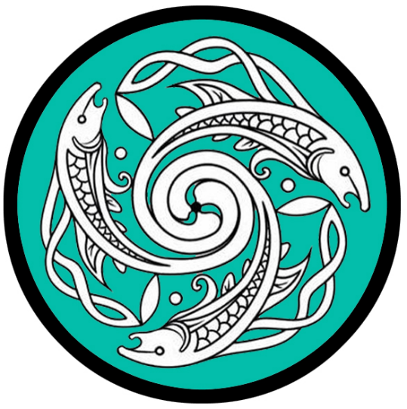
Lutadar
Size: small town, population 2,000, guards / soldiers 20, militia 100
Trade Goods: clay, furs, silver, fishing
Local Goods:
Standard: three fish
Colors: teal and white
Patron Deity: Sága - goddess of prophecy and song
Ruler: Jarl Brynhild Skjoldor (f)

Home: Hall of Langbarðr ("long-beard")
Steward: Gudny Sigenoth (f)
Marshal: Fasthulf Herlaug
House Priest: Sorli of the Waterlight
House Adviser (Scholar/Mage/etc): Hrafn the Black
Captain of the Guard: Torlef Arnor
Chief Warriors in Service:
Hjorvarth Koigrims
Alrik Jarnskeggis
Sigewine Gudmunds

Local Powers: The Oarmen (thieves guild), Hov of Saga, Band of Thunder (order of rangers)
Local Sites: Rook and Raven Inn & Tavern, Dragon Head Inn & Tavern

Description:
Lutadar is a frontier town, the farthest north of the Brisingr tribes. One of the few coastal towns, it lies not in the shadow of mountains but at the southern edge of Alva Wood. There it sits on the sandy banks, half of the houses floating on the water of the Fenris Sea on elaborate wooden piers. A fleet of fishing boats bob lazily on the water, tied to moorings where stacks of handmade traps are piled. The Dvalin River flows nearby, wood posts and wattle fences in the water forming a weir. The people here are quiet, earnest folk who walk along the shore in high-cut breeches carrying three-tipped fishing spears. A merry tune carries on the wind from where women mend the fishing nets.

Rising a quarter-mile from shore are thirteen giant stones, narrow and curved. Jet-black, of a strange ore not found here, they tower thirty feet above the water. Long ago they were chiseled to resemble the prows of Norgardian longboats. Fierce animal heads stare outward from the coastline as if guarding it. At night their eyes glow a soft green light. Tales tell of invaders coming on moonless nights, with only their screams making it to shore.

Industry:
Lutadar is one of the few coastal Norgardian towns not located within the fiords. It sits alongside the Dvalin River and looks out over the Bay of Enika and the Sea of Fenris beyond. The Dvalin is the life blood of the town. Silt marshes along the delta are farmed for clays. Salmon leap up the river where it descends in one waterfall after another. Hunters, a large portion of the town’s population, make month-long trips into the dangerous forests north of the town in search of pelts. Most lucrative of all, Lutadar operates a small silver-mine far to the north in the Dvalin Hills. The mine’s location is kept secret, with only a few trusted to know it.

Key Figures:
Jarl Brynhild Skjoldor (f) – solemn, stubborn, impatient
Jarl Brynhild is a short woman and light of frame. Her blonde hair is worn up in intricate braids. The right side of her face is adorned with tribal tattoos in the form of animal paws. Her bright blue eyes are framed by dark blue paint she wears like a raccoon’s mask. She is a hunter at heart and spends much of her time ranging north and west of the town in the wilderness. She says very little, having little patience for talking. Many suitors have approached her for her hand in marriage. Brynhild beds the ones she deems worthy and sends them home empty handed. Those who disrespect her she challenges to combat and sends them to their gods.
The only child of the former jarl of Lutadar, Brynhild has proven herself more than capable of running the town and quieting those who doubted her. At her sides she carries her twin throwing axes: Hratt and Skarpur (“Swift” and “Sharp”). Within her rustic hall she has mounted the skulls of every beast she has slain, including several trolls, giants, goblins, and even a young dragon. She holds her duties as forest warden as sacred. Her dream is to one day travel to the Godsbeard Mountains and see what glory she can win for herself there.
Political Mindset: Brynhild has few political ambitions but quietly sees the value in keeping the Brisingr clans united. Regarding Styrmir of Kinwall, she enjoys his company on their annual hunting trips into the north. He is a worthy ally and she admires his rune brands. But she keeps an eye on him, for she knows he covets the silver from Lutadar’s mines. As for Henrik of Hahll, she grudgingly acknowledges his role as the traditional leader of the Brisingrs and often reminds him of it. Secretly, she finds the luckless man a source of fascination. She believes the gods have a role for him that is not yet clear. She has once or twice casually bedded him. Now his haunted eyes stay with her when she is on one of her hunts. She feels ready to follow him if Brisingr calls for it, but she hopes that the gods will show him his purpose before it is too late. Brynhild finds Vensel of Styrla an amusing man and enjoys his company. Not one to read much herself, she enjoys his many stories and almost sees him as a father figure. In him she finds a reliable trade partner where her silver can find real value. The only other figure within Brynhild’s sphere is Mother Bear of Aesgir. This is a woman after her own heart and Brynhild meets her as a tentative ally. The two get along well and have no quarrel with one another. Privately Brynhild has worked out the woman’s animal spirit. Her hunter’s instinct is to be cautious around her.
Hrafn the Black, court mage -

Local Lore:
Just to the north is the Forest of the Alva, where several diminutive creatures of the fey make their home. Huntsmen from the town make good coin from the furs found there. Rangers of the Band of Thunder keep a watchful eye on the woods and its perils.

The forest of is rumored to be the home to the Huldra. a dangerous seductress who lives in the forest. The Huldra is said to lure men down into endless cave systems that they would not be able to find their way out from, or lure them into the forest in order to secure her freedom or sometimes to suck the life out of a man. One of her methods is to appear suddenly out of the rain and mist, friendly and enticing to the point that no man can resist her charm. She has a long cow's tail that she ties under her skirt in order to hide it from men. If she can manage to get married in a church, her tail falls off and she becomes human. However, she also becomes very ugly. It is often said that the young and beautiful Huldra is moody and dangerous, but when she becomes old and ugly she becomes gentle and caring to the man who made her human.

History:

Customs:
The north-east reaches of Norgarde are called the land of the Brisingr people, so named for the Brisingr Fiords but including the fiords of Hagala as well. The towns of Lutadar, Kinwall, and Hahll share a bond that distinguishes them from towns in the south. They hail from nomadic peoples who still wander the far northern wildlands to this day. Brisingr clans have fought, intermarried, and bonded over common traditions for countless generations. Their manners are a little rougher than their southern cousins.

The winters are harsher further north and there are fewer visitors from other lands. Kinwall and Lutadar frequent the forests north of the fiords, but relations with the Elves of Laaktalla are as cold as the weather here. Brisingr dress is different from other Norgardian towns. Men and women wear a gakti: a long brightly-colored jacket-skirt in the cases of men, a longer dress version for women. These are made of reindeer leather and sinews. The colours, patterns and the jewellery of the gákti indicate where a person is from and whether they are married: red from Lutadar, green from Kinwall, and blue from Hahll. Women also wear fringed shawls fastened by one or more silver brooches. Boots and shoes, called nutukas, are made of reindeer fur or leather with pointed or curled toes and band-woven ankle wraps. Brisingrs also wear distinctive hats made of wool, fur, or leather. Holy men and women adorn these with feathers or antlers. When there are kingdom-wide Thengs it is easy to distinguish Brisingrs among other Norgardians.

Brisingrs have their own style of waging war. Instead of open fights on land, they tend to wear muted colors and paint their faces to match the terrain and attack from concealment. From the vantage point of brush, trees, and rocks they use bows, spears, slings, and special blowguns with poisoned darts. Some say their style of fighting lacks honor, but the Brisingr are practical folk and their style of combat is feared for its effectiveness.

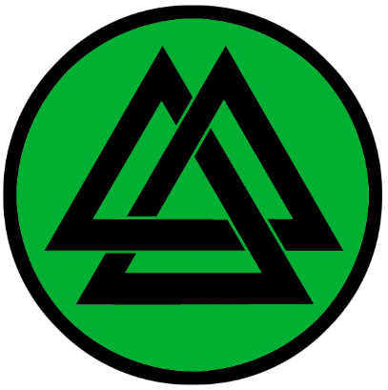
Hahll
Size: small town, population 2,000, guards / soldiers 20, militia 100
Trade Goods: tin, salt
Local Goods:
Standard: three triangles in a knot, the knot of the slain warrior and the Heart of Vala
Colors: green and black
Patron Deity: Syn - goddess of justice and protector of entryways
Ruler: Jarl Henrik Nordlund (Henrik the Luckless) and his wife Gerrid (f)

Home: Hall of Gangleri ("wanderer")
Steward: Niklen Orstrom
Marshal: Jakob Holmlund
House Priest: Onde of the Deep Night
House Adviser (Scholar/Mage/etc): Leona the Many Marked (f)
Captain of the Guard: Viggo Barkstrun
Chief Warriors in Service:
Fridgeir Arnljots
Svartbrand Stækars
Thjodhild Dan (f)

Local Powers: Filcher Kings (thieves guild), Hov of Syn
Local Sites: Murder of Crows Inn & Tavern, The Ice King’s Table Inn & Tavern

Description:
Those who row up the Brisingr Rivers are met with a curious site: strange stone formations that have formed archways over the water in several places. Some tower twice as high as a mast and are large enough grass has grown on their tops. Here outlier buildings from the town of Hall stand, tended by fishermen as well as sentries guarding the way to the town of Hahll. Some say the town got its name from an outlander who remarked the archways formed a great hall like those of the Norgardians. And so the Syn Archways, named for the guardian goddess, are decorated each spring and a great feast held. Boats that launch to raid are celebrated with showers of offerings as they pass beneath the arches: flowers, bones, blood.

The town of Hahll itself stands atop a flat plain just above the river’s edge, with stone stairs leading up from the embankments. Large semicircular stones stand along the plain’s edge, carved to resemble giant shields of elaborate design.

Industry:
The people of Hahll split their time working the boats and working the mines they’ve delved into the surrounding peaks. Tin and salt are poor resources for a growing town, but the people make do. The Eldrigg family has carried on a tradition of tin metallurgy for three generations. Their specialty is dipping copper drinking vessels into molten tin to plate it, making them more pleasant to use. Eldrigg vessels can be found along trade routes throughout Western Amadar.

Key Figures:
Jarl Henrik Nordlund often called Henrik the Luckless – Unlucky, proud, tongue-tied
Jarl Henrik is an average sized man with short, curly blonde hair and a short cropped beard. He wears a stern expression and has narrow, dark eyes. At his side he carries the famed sword Trolvig (“Troll Slayer”). He speaks little, for he has a stutter that brings him great shame. Often he has one of his men speak for him. Some whisper he is Henrik the Luckless: his last wife was slain by poison intended for him, his only child drowned at sea, and his first expedition into the Habrok Vale was ambushed with only a few men surviving. Still, Henrik feels great responsibility for uniting the people of the Brisingr lands against the Norgardian jarls who seek to make them a part of their kingdoms. Years ago the town of Aesgir invaded these lands. Henrik’s father was earl and fell in battle, leaving his young son to take up the mantle. Henrik is a man who feels the charge of leading the Brisingrs has fallen to an ill-equipped man, but he soldiers on resolutely to do his service.
Political Mindset: Henrik is ill-at-ease meeting with other jarls. His stammering speech makes for ill conversation. Styrmir he finds obstinate and rude. The man is a lout and dismissive of their peoples’ alliance. In him he finds no help with the cause of protecting the north. He wonders how to appeal to a man so determined to remain isolated. Brynhild of Lutadar Henrik finds fascinating, if hard to reach. The woman is almost as stingy with words as he. But at times this is a relief. The two find small ways to communicate without speaking. Her few words of encouragement inspire him to rethink his doomed life and consider his destiny. Regarding Vensel of Styrla, Henrik finds a man more than willing to fill a conversation when he cannot find his own tongue. Vensel is a tenuous ally and safe port for Hahll’s boats when they do venture to sea. But Henrik wonders what aide the man can offer if pressed for it. Lastly, Henrik is familiar with Mother Bear in Aesgir and keeps a close eye on her. The two towns occasionally cross paths in the Habrok Valley. Henrik has done his best to set an even tone with the jarl of the Halsla Kingdom, hoping to prevent any need for conflict in the north. She is a capable leader and has a level head, Henrik reasons, and tries to keep an open dialogue with her.

Leona the Many Marked (f), court mage -

Local Lore:
The hills in the region around Hahll are a popular stomping ground for hill giants. Only Jotunn to the south has more trouble with the large folk. The people of Hahll are ever watchful, as farmsteads are constantly under attack. Travelers here will notice strong braided cords tied between trees at random intervals along the countryside. In forest clearings there may be giant upturned caltrops made from wrought iron or even wood. These are foot snares for passing giants. The town hall is decorated with the skulls of giants slain in the past.

The most famous giant in these lands is Uggra, who is said to stand taller than most and is clever for a giant. He has terrorized the farmers for two generations and moves quietly to evade traps and attackers. It is said he kidnaps young maidens to be his bride.

The statue of Kels Horen stands atop a low mountain just outside the town. It is hewn from oak and Horen is depicted with an upraised shield pointed southward. Druids inscribed runes upon the statue that the town seer is attuned to. Anything larger than a small hunting party approaching the town, including a large host of men or a giant, alerts the seer.

There are eleven Vatnavættir, or water spirits, who are guardians of the eleven fiords of Norgarde. Skadi watches over the Brisingr Fiords and is venerated by the people of Hahll. She is a champion of knowledge and favors explorers. She requires a gift of smooth stones taken from a freshwater stream.

History:
The jarls of Hahll have traditionally been the ones to unite the Brisingrer clans. Kels Horen was the most successful. Two hundred years ago (320 WA4) he united a fighting force from the three towns and managed to sack and conquer all the towns of the Fjara Kingdom. He was slain by forces from Geirdir and his body burned in honor by his foes. A statue to him stands just outside Hahll today.

780 PA4 - Second Amberon War: Chieftain Skardi of Hahll hears of the fortunes of Amberon and recruits an army to march on the Dwarves

810 PA4 - Second Amberon War ends when Orc tribes attack; Skardi and the Dwarven king join forces; Dwarves reward the Norgardesmen for their help and toast their bravery

Customs:
The north-east reaches of Norgarde are called the land of the Brisingr people, so named for the Brisingr Fiords but including the fiords of Hagala as well. The towns of Lutadar, Kinwall, and Hahll share a bond that distinguishes them from towns in the south. They hail from nomadic peoples who still wander the far northern wildlands to this day. Brisingr clans have fought, intermarried, and bonded over common traditions for countless generations. Their manners are a little rougher than their southern cousins.

The winters are harsher further north and there are fewer visitors from other lands. Kinwall and Lutadar frequent the forests north of the fiords, but relations with the Elves of Laaktalla are as cold as the weather here. Brisingr dress is different from other Norgardian towns. Men and women wear a gakti: a long brightly-colored jacket-skirt in the cases of men, a longer dress version for women. These are made of reindeer leather and sinews. The colours, patterns and the jewellery of the gákti indicate where a person is from and whether they are married: red from Lutadar, green from Kinwall, and blue from Hahll. Women also wear fringed shawls fastened by one or more silver brooches. Boots and shoes, called nutukas, are made of reindeer fur or leather with pointed or curled toes and band-woven ankle wraps. Brisingrs also wear distinctive hats made of wool, fur, or leather. Holy men and women adorn these with feathers or antlers. When there are kingdom-wide Thengs it is easy to distinguish Brisingrs among other Norgardians.

Brisingrs have their own style of waging war. Instead of open fights on land, they tend to wear muted colors and paint their faces to match the terrain and attack from concealment. From the vantage point of brush, trees, and rocks they use bows, spears, slings, and special blowguns with poisoned darts. Some say their style of fighting lacks honor, but the Brisingr are practical folk and their style of combat is feared for its effectiveness.

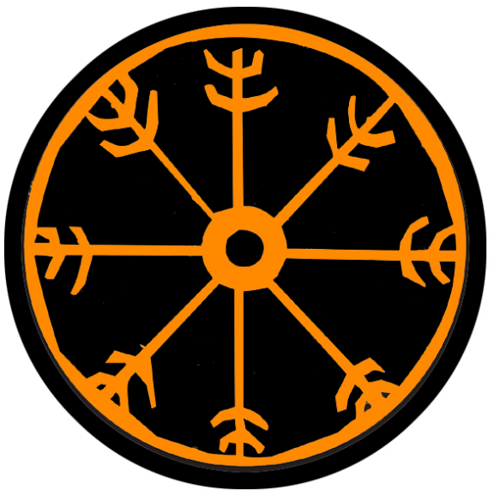
Styrla (Independent Town)
Size: small town, population 2,000, guards / soldiers 20, militia 100
Trade Goods: trade hub, furs, fishing
Local Goods:
Standard: helm of awe symbol
Colors: black and orange
Patron Deity: Kvasir - god of drink and poetry
Ruler: Jarl Vensel Stenbock and his wife Renata (f)

Home: Hall of Sanngetall ("truth-getter")
Steward: Gosta Ekdal
Marshal: Karlem Hernman
House Priest: Vilmala of the Mount (f)
House Adviser (Scholar/Mage/etc): Gudhlek the Crafty
Captain of the Guard: Arvid Kroon
Chief Warriors in Service:
Sigelac Herjolfs
Ketilbjorn Brusis
Leidolf Thorgrims

Local Powers: Daughters of Aegir trading company, The Deep Cups (thieves guild), Circle of the Silver Fish (order of druids), Thunder Sails (pirates), Suttungr Hall (bardic college), Hov of Kvasir
Local Sites: The Bloodied Shield Inn & Tavern, The Eight-Legged Horse Inn & Tavern

Description:
Styrla is a humble town that appears mystical and otherworldly for first time visitors. Nestled into the mossy cliffs of the Isle of Skjolden, Styrla appears as an assortment of thatched huts, clay tiled rooftops, and larger buildings covered in plaster painted a variety of muted colors. The buildings trickle down a series of terraces and encircle a man-made harbor filled with ships from many places. A tall statue of the warrior Varsud, jarl of Styrla from years ago, stands at the entrance of the harmor with sword held aloft, a Norgardian arm ring hanging from the tip. Soft whisps of mist hang in the air, moisture carried out to sea from hot geysers found further inland. Songs can be heard drifting through the air in more than one tongue. The people here are earnest but convey a lightheard air to their work.

Styrla is a progressive Norgardian town. Wooden sculptures and lodge poles adorn its streets. Its people are still fishermen and warriors by necessity. But interwoven with the old world is the concept of stories and poems and literature. Early settlers built a library, where books were stored that were captured in raids. Skidi Armod, the town’s first jarl of the Written Ages, actually traded gold and valuable gems found on his raids for books and scrolls other Norgardians had brought back. Word spread among the other towns that Skidi was a fool and gullible. Some Norgardian boats would specifically collect artifacts and documents they considered useless, knowing they could trade it in Styrla for real treasure.

Styrla sits alone across the Fenris Sea on the Isle of Skjolden. In spite of its solitude, its location has made it a thriving trade hub along the Fenris Crossing and Noreast Jaunt sea routes. It was eight thousand years ago that Thyri Eyleifurs of Kastfel stormed out of a marriage to a jarl of Geirdir and sailed off to eventually found Styrla. The town enjoys a strong alliance with Kastfel to this day and the two exchange gifts and favors.

The people of Styrla are fiercely independent and have an identity that sets them slightly apart from the clans on the mainland. Unique to Styrla are the number and quality of songs and written poems celebrating the exploits of the gods and heroes from Norgardian history.

Industry:
The town has made a strong trade partnership with the Hyderin town of Targuth to the south. What it lacks in prime trade goods itself it has made up in bartering and trading for goods that come this way on merchant ships. The Daughters of Aegir Trading Company has managed to secure all manner of goods from around the world and offered them here on the secondary market.

Most of the town’s trade goods are rare furs found in the Nornwood forest far to the north. Explorers are eager to seek out mines in the Raven Mountains on the northern end of the island, but the forest is wild and dangerous and has kept expansion at bay. Druids of the Circle of the Silver Fish have worked for decades to learn the secrets of the woods. Nyads and Dryads live throughout the area and are very protective of the forest and its Dragyn River and its waterways.

Suttungr Hall is the famous bardic college that trains skalds that travel throughout the world. Styrlan skalds are without peer for their mastery of oral histories and of music and are highly sought after in the halls of jarls elsewhere. Some say they have a better history of Norgarde than anywhere else. Ringfrecht’s Great Edda captures many of these stories in one massive volume and is required reading for any scholar of the region.

Key Figures:
Jarl Vensel Stenbock – addled, jovial, thoughtful
Jarl Vensel is a retired warrior, his large frame stooped with age. His beard has grown out beyond his waist, but he wraps it over his shoulder when eating or as a scarf. His small grey eyes twinkle out from under bushy white eyebrows. The top of his bald head he covers with a soft cap of brilliant green. Vensel hung up his sword long ago, becoming fascinated with reading and song. He taught himself how to read and now spends most of his time perusing the library of books in Styrla’s library. Books here were captured from lands far away and feed his imagination. Vensel is a quirky character, speaking in long disjointed streams of topics and laughing at the strangest things. He is a good listener and welcomes all visitors to a private audience to hear their tales. He is a shrewd businessman, when the job requires it. He regularly consults his steward and his seers about the money coming into the port and makes sure the Daughters of Aegir trading company is running a tight ship. His wife Renata, a ravishing beauty, is his fourth wife and far younger than he. Tongues wag in the town about the old man and his child wife. Vensel is a man who has found a good retirement and is not too worried about power or conquest. Some press him on who his successor will be. He dismisses this, saying that the gods will make that clear when the time comes.
Political Mindset: Vensel is welcoming to all the jarls of the Brisingr towns. While he is sympathetic to their desire to remain independent of the southern kingdoms, he is reluctant to get involved. Styrmir of Kinwall he finds amusing for brief spells, but clearly a liar and untrustworthy. Brynhild of Lutadar is a reliable partner with a steady supply of silver for his ventures. Vensel regards her like a daughter after a fashion, advising her when he sees the need and willing to help. Henrik of Hahll is a most delightful man, Vensel thinks, for he listens patiently through all of his long and erratic talks. He pities the man for his misfortune and wonders sometimes if the gods have something up their sleeve for him. For good or ill, Vensel believes Henrik has a destiny to fulfill that no one yet suspects. Lastly, Vensel regularly treats with Katja of Kastfel. The woman is perplexing but oddly fascinating. The two towns have traditionally been trade partners and Vensel hopes to continue that. Her piety to the gods is often a way he invites her to review his many books and he seeks her insight into them.
Gudhlek the Crafty, court mage

Vot Varsson – world reknowned skald
Vot Varsson is the greatest storyteller and musician of Norgarde. His name is spoken in awe in the great halls and his talents sought after by every jarl and king. He has written a hundred songs and almost as many epic poems, each of them beloved by Norgardians high and low. His collection of stories, Sigur og Ósigur (Victory and Defeat), recounts battles between heroes and the dark creatures and wizards they encountered. He travels the world, singing and telling tales to lords as far away as Treviland and Tirudor. He is also a part-time adventurer, wandering with an ear for more stories. When he isn’t performing or doing field research, he visits every library and bardic college, investigating the more obscure narratives that he can preserve and celebrate. He is a short man with wavy blonde hair and beard, twinkling eyes, and a rascal’s grin. He wears a doublet of velvet cut in Norgardian style and is festooned with pendants of no real value to the untrained eye. Each pendant is a lost relic from another age and has mysterious powers. At his side he has Grátabros (“crying smile”), his talharpa or Norgardian lyre played with a bow of horsehair.

Local Lore:
In Norgarde stories Fjalar and his brother Galar were wicked dwarves who killed the giant Kvasir and turned his blood into the mead of poetry, which inspired poets. Suttungr son of Kvasir, had his revenge and hid the Mead of Poetry in the mountains. It is rumored the skald masters of Suttungr have found the mead and kept it hidden, using it to infuse their skalds with divine powers.

The pirates of the Thunder Sails are a peril of this region. They have a hidden port far up the coast in the Strait of Fialar, but their ships pass this way often enough that the town’s fishermen are always on the lookout. A hundred years ago the pirates sought to take Styrla and expand their operations, but Jarl Stenbock’s ancestor, Varsud, mounted a valiant resistance (360 WA4). Varsud died in the battle and his likeness is preserved in a menacing statue of him guarding the entrance to the harbor.

Lake Volan far to the north is inhabited by the black dragon Andedräkt “Breath of Death”

Two massive tribes of Sahuagin plague the inhabitants of Skjolden. The Pelagra (“open sea”), dominate the coastline east of Dragyn River and are identifiable by their dull orange stripes. The Benthra (“sea floor”) dominate the western shores facing the Straits of Fialar and are identifiable by their dull yellow stripes. These tribes are extremely aggressive, attacking each other and any humans that dwell here or make landfall in their areas.

Many regard Varsud, whose statue stands in the harbor, as the epitome of heroes for Styrla. While his deeds were great, few remember Thyri Eyleifurs. It was she who, eight thousand years ago, founded the colony that became Styrla. Miles north of the town stands the crumbling statue to Thyri. It stands thirty feet tall and guards the entrance to her tomb, which is guarded by powerful runes. It is said the tomb houses her arsenal of powerful weapons and relics, gifted by the gods for her valor. It is also said that only a Norgardian hero worthy of Thyri’s regard may pass untouched and borrow a weapon to help defeat evil in battle, but that the weapon must be returned within a year’s time on pain of curse.

History:
391 PA4 - Thyri Eyleifurs storms out of her wedding to jarl Bjarkar in present-day Skala; she steals a boat and sails to the Isle of Skjolden with a retinue of followers from her home town of Kastfel

391-403 PA4 - Thyri Eyleifurs and her companions spend the next twelve years fighting for survival on Skjalden, tested by the gods in battle against the Benthra and Pelagra tribes of Sahuagin

402 PA4 - Thyri defeats the champions of the Benthra and Pelagra tribes in single combat; the colony is named Styrla and Thyri is crowned jarl

404 PA4 - Jarl Bjarker, furious at the news of his runaway bride becoming a ruler across the sea, attacks her colony with thirty long boats

405 PA4 - Invasion of Styrla: after a year-long series of battles, Bjarker breaches the walls of Thyri's colony; Thyri returns her bridal gift, a silver hammer, by embedding it in Bjarker's skull; Bjarker's forces disband and return home

Customs:

History of Norgarde

First Primordial Age (PA1)
Dawn of the Skanes - out of the ashes of the land emerge a primitive people who call themselves the Skanes

10 PA1 - Wodan the Wise lingers after the cosmic Battle of Vail to reflect on the carnage; he wanders north to drink and fish and make sport; his god companions eventually join him and make Norgarde their home

360-450 PA1 - War of the Cannibals: first Norgarde farmers are beset by wild canniablistic humans out of the mountains

450 PA1 - The Last Hunt: Chieftain Jhurlen leads a small band of warriors into the caverns of the Raros Mountains and kills the queen of the wild men

730 PA1 - the wizard Algaron first learns of rune magic from the gods

840 PA1 - Ulvkil, barbarian chieftain, slays the serpent Heidrun; the dying serpent tricks Ulvkil into taking up the Helmet of Power from his lair

841 PA1 - Jarl Ulvkil goes mad with the power of the Helmet, raises a dark army of undead warriors and ravages Norgarde

860 PA1 - warrior priests of Wodan quest and battle to find the Eight Scepters of War

870 PA1 - Eight warrior priests of Wodan destory Ulvkil and the Helmet and are themselves consumed by the mighty cataclysm

Second Primordial Age (PA2)
390-500 PA2 - Hundred Year Winter blankets Norgarde, thousands die

420 PA2 - Skane tribes migrate out from present-day Skala to the east and west

810 PA2 - Jarl Dvalin leads a campaign against the Dwarves of Amberon

Third Primordial Age (PA3)
340 PA3 - the ancient ice wyrm Aldagin destroys the town of Wykla and makes a home in the Hydar mountains with his mate Cagamal; they rule over the region for two centuries and spawn a dozen white dragons that terrorize the north

570 PA3 - The Mead of Saga is found in the mountains north of Skala

887 PA3 - Kulring the Wolfhead leads a crusade of 100 ships to find the Shield of Kord; the quest will claim the lives of every sailor but one: Hobrim Svaldur, who returns the shield to Geirdir; this spawns a tradition of songs over the saga

Fourth primordial Age (PA4)

391 PA4 - Thyri Eyleifurs storms out of her wedding to jarl Bjarkar in present-day Skala; she steals a boat and sails to the Isle of Skjolden with a retinue of followers from her home town of Kastfel

391-403 PA4 - Thyri Eyleifurs and her companions spend the next twelve years fighting for survival on Skjalden, tested by the gods in battle against the Benthra and Pelagra tribes of Sahuagin

402 PA4 - Thyri defeats the champions of the Benthra and Pelagra tribes in single combat; the colony is named Styrla and Thyri is crowned jarl

404 PA4 - Jarl Bjarker, furious at the news of his runaway bride becoming a ruler across the sea, attacks her colony with thirty long boats

405 PA4 - Invasion of Styrla: after a year-long series of battles, Bjarker breaches the walls of Styrla; Thyri returns her bridal gift, a silver hammer, by embedding it in Bjarker's skull; Bjarker's forces disband and return home; Bjarker’s body is interred in stone, the skull and hammer still visible atop the tomb

780 PA4 – Second Seige of Amberon: Chieftain Skardi of Hahll hears of the fortunes of Amberon and recruits an army to march on the Dwarves

810 PA4 - Second Seige of Amberon ends when Orc tribes attack; Skardi and the Dwarven king join forces; Dwarves reward the Norgardesmen for their help and toast their bravery

810 PA4 - Battle of Darkwood PA4 - Elves from the Final Forest mount a furious retaliation and destroy Waiofar's forces; the Many-Thorned Mantle is lost
811 PA4 - Elves reclaim the Darkwood and establish the Kingdom of Kalanon
872-888 PA4 - The Wizard War: Telemechus triggers a world-wide war of mages, some of whom march on Ongolk to stop him and some who join him in attacking the ley lines in their lands; epic battles wage all over the world, destroying cities and upsetting the balance of magic

888 PA4 - The Battle of Forlorn: Telemechus is slain but not before rupturing the magical ley lines permeating Nemmyrl; the victorious general Dragan of Celedon seizes the opportunity to rid the world of magic and ruptures the Singularion as it is embedded in the ley lines; the resulting explosion sends a shock wave that ruptures the magical ley lines around the world and triggers the Dead Century

First Ancient Age (AA1)
170 AA1 - tribal clans of Norgade organize under regional kings and master the art of ship-building

260 AA1 - founding of Skala by the Skanes

320 AA1 - founding of Volsung by the tribes now identifying as the Volgans

370 AA1 - founding of Geirdir by the tribes now identifying as the Hegren

410 AA1 - Brisingrs war with Fjarans

470 AA1 - Hreidmar war with Halslans

500 AA1 - Volgans break off rom the town of Skurn and travel north to found the town of Thiengis

510 AA1 - Fjarans and Brisingrs war with Halslans and Hreidmar

540 AA1 - Suttungr Hall is founded in Styrla, beginning the formal tradition of Skaldic poetry and song

570 AA1 - Halslans war with Fjarans

590 AA1 - Halslans war with Hreidmar

620 AA1 - Halslans and Hreidmar war with Fjarans

650 AA1 - Brisingrs war with Halslans

670 AA1 - Hreidmar and Halslans war with Fjarans and Brisingrs

700 AA1 - Hreidmar war with Halslans

720 AA1 - Halslans and Hreidmar war with Fjarans

760 AA1 - Brisingrs war with Fjarans

881 AA1 - Snydri jarl of Thiengis forges alliance with the Troll King of the Rungnir Hills

Second Ancient Age (AA2)
20 AA2 - giants come down from the Godsbeard, Hydar, and Raros mountains of Norgarde and lay waste to the land

30 AA2 - Krong the Mighty appoints himself king of the giants, organizes his kind to take over Norgarde
40 AA2 - Fall of the Elven settlement in the Stolen Forest as Krong's giants destroy the land
50 AA2 - the wizard Linjarn the Puny creates the Staff of Behemoth which controls all giants; sets himself up as king of Norgarde

50 AA2 - Volsung falls to Linjarn's army of giants

60 AA2 - the hero Bjarnwyr and his band battle their way to Linjarn's keep and slay him; the Staff of Behemoth is lost

70 AA2 - Battle of the Godsbeard - Dwarves of Amberon, joined by Norgardian and elven Laaktala warriors, fight Krong's forces and barely survive

120 AA2 - the hero Astrid slays Krong the king of giants; Hrolfr the Slayer steps up as the new king of giants

170 AA2 - Warrior Queen Alfhild leads an army and slays the king of giants Hrolfr the Slayer, driving the giants back to their mountains

410 AA2 - Thiengis sides with the troll kingdom and conquers the town of Skurn

610 AA2 - Jarl Valgerd Hallfri of Thiengis breaks the 700 year alliance with the troll kingdom; the gods send the magic longboat Skidbladnir, Hallfri and an army of priests and druids cleanse the town and region and liberate Skurn

Third Ancient Age (AA3)
70 AA3 - trolls sweep down from the mountains in Norgarde to destroy villages and begin the War of the Trolls

90 AA3 - Fall of the town Thiasi, destroyed by trolls

140 AA3 - end of the War of Trolls in Norgarde - Gudruf Haselfled leads an army to drive the trolls into the mountains of Norgarde

500 AA3 - Battle of Lost Song - Elves of Laaktalla mount a war against the Frost Giants in the north. Torsten, a human skald, falls in love with the Elven maid Cerwyen and joins the Elves. He saves the battle by singing his song causing an avalanche. The song is so powerful it robs him of his voice, but can still be heard in the winds around the valley now named for it.

Fourth Ancient Age (AA4)
120 AA4 - Pox of Hela: a plague sweeps the lands of Norgarde; thousands die

123 AA4 - The March on Troll Deep - hundreds of warriors infected with the plague march on Troll Deep to die in battle rather than in a bed; a score of Raca trolls is brought down before the last of the warriors falls

150 AA4 - Hanuhal, priest of Wodan, travels to Hel to vanquish the demon Stathuun and lift the plague

540 AA4 - Heinar Hoarbeard, defeated by the king in Geirdir, retreats to the Isle of Algron; there he falls under the spell of a witch who promises him great power; Heinar builds the town of Geldheim and Algron becomes the seat of a small but powerful line of rogue rulers called the Hoarkings and Hoarqueens. (referenced from Oberon Sea atlas)

820 AA4 - Baldvina Bracegirdle, shieldmaiden of Skurn, hunts down a tribe of marauding trolls in the Rungnir Hills; finds the magic sword Quern-biter

First Written Age (WA1)
290 WA1 - Celedonian Tertius navy rounds the northern tip of Western Amadar and battles Norgarde ships awaiting them

390 WA1 - Celedon Tertius navy attempts to invade Norgardian fiords but is repelled

590 WA1 - sea serpents appear around Norgarde, becoming the major foe of Norgarde sailors for 70 years

610 WA1 - Norgarde war ships destroy most of the Celedonian Tertius navy in the Battle of Roskilde Bay
620 WA1 - remnants of the Tertius navy beseige Styrla

660 WA1 - Kargus the Deaf dies slaying the last of the sea serpents in the Sea of Fenris

760 WA1 - the White Dragon Vitlaga moves into the Raros Mountains

900 WA1 - Norgarde ships destroy the last of the Tertius fleet based out of Hammer Hold; the city falls shortly thereafter and the Thoon and Echidna Legions are sacrificed to the sea

Second Written Age (WA2)
90 WA2 - Vafthrudnir, king of giants, hands down a set of laws to the men of Jotunn

150 WA2 - War of Fiords - battles waged throughout the fiords as Skala, Volsung, and Geirdir vie for control of Norgarde

180 WA2 - Yggri, priest of Wodan, has a vision that Norgarde warriors are too plentiful at home and wage pointless wars among themselves; charges all warriors to take to the seas to win reknown in the eyes of the gods

180 WA2 - Norgarde warriors hear the call of Wodan and take to the sea in staggering numbers; ship-building booms; warriors are called to seek fortune abroad or die at sea in honor
190 WA2 - Norgardians invade middle Amadar and conquers modern-day Erigoth and Hyderis
210 WA2 - Norgarde ships raid northern Haka'Na; settle in Kapinga Bay

220 WA2 - Norgarde navy rules the seas of Nemmyrl including the Ferrago, Inner, and Myriad Seas

230 WA2 - Norgarde ships land in far eastern land of Sadara; set up traveler's havens along the Frostbite Shores for passing ships to anchor and take on water and shelter from storms

280 WA2 - Beasts of the Haka'Na lands avenge the deaths of the local tribes at the hands of Norgarde raiders, wipe out every Norgarde camp; Norgardians flee Haka'Na altogether

370 WA2 - a dark power comes down from the High Fist Mountains in Sadara and wipes out all Norgarde settlements, driving the Norgardians out of Sadara completely

420 WA2 - a war for rule over Norgarde calls the ships home to once again war in the homeland, bringing an end to the High Age of Norgarde conquest at sea

620 WA2 - Mother of Trolls comes down from the Hrungnir Hills and weds the Jarl of Skurn

Third Written Age (WA3)
20 WA3 - the White Dragon Vitlaga of Raros attacks the town of Ragnvor and rampages the countryside for hundreds of miles

80 WA3 - The Great Horn of Örlög (fate) is found and blown, waking the spirits of the Northern tribes and beginning the Great Erobring "Great War"; Norgarde ships raid northern coastline of Western and Central Amadar, beginning an era of massive raids and colonization by Norgarde ships

90 WA3 - Norgarde conquers Hammer Hold, Hansla, and Windenfre in Erigoth

100 WA3 - Norgarde conquers Wolfenfels and Dammerung in Erigoth

130 WA3 - Norgarde est. settlements in northwestern coastline of Amadar

140 WA3 - Norgarde ships cross the Augemere Sea and explore river systems southward

150 WA3 - Norgarde raiders invade eastern Treviland and western Tirudor, sack Lyre, Novulum, and Ibilis

170 WA3 - Norgarde raiders explore the Wandering Isle, Isle of Ronan, and sack Cold Anchor in Vesper Bay
180 WA3 - Norgarde ships crossing the Augemere explore the river systems into Plenia, sack Fleur, Highvow, and Valcouer
190 WA3 - Norgarde invaders sack Illustrim
200 WA3 - Norgarde ships crossing the Howling Sea explore the river systems southward into Tirudor
210 WA3 - Norgarde raiders sack Esideron and Osorio in Tirudor
220 WA3 - Norgarde raiders sack Arrione and Ataia in Plenia
230 WA3 - Norgarde raiders sack Fortuna in Tirudor
240 WA3 - Aerek Longblade creates High Hall in Geirdir, paneling it with gold from Illustrim, Arrione, and Fortuna

250 WA3 - Norgarde ships explore Haunted Bay and rivers systems southward into Fordoon and Hyderis
260 WA3 - Norgarde raiders sack Targuth and Haselden

270 WA3 - Norgarde raiders sack Bronde, are stopped by Orc tribes after crossing the Hynde River
280 WA3 - Norgarde ships explore coastline of northeastern Amadar, cross into the snowy reaches of Haka'Na lands

290 WA3 - Norgarde ships cross the Sea of Oberon and explore the river systems through Gildran to the Bay of Banners

300 WA3 - Norgarde settlers colonize the Verdant Valley and Mooradells in Plenia

310 WA3 - Norgarde ships invade Fredegn Isle but are repelled by the city of Tulith

320 WA3 - Norgarde settlers colonize lands from Upper Treias to the Wetflosh as well as the Nary Lands and parts of Ordonia

350 WA3 - Nobles of Treviland band together and defeat Norgarde raiders in the Battle of Keslinga

410 WA3 - Plenish King, driven out of Arrione, musters his nobles and defeats the Norgardians at the Battle of Tuvay

420 WA3 - Tirudoran knights mount an all-out offensive to retake the captured cities and drive out the Norgardians

470 WA3 - Norgarde driven out of Amadar

480 WA3 - the shield maiden Sagala defeats the great wolf Sköll and frees Svolvaer from the oppression of the great wolf packs

510 WA3 - The curse of Freja - a blight sweeps the land, wiping out crops in Norgarde and creating a famine that lasts for decades

540 WA3 - Sonlea, priestess of Freja, completes the trials to lift the blight on Norgarde

620 WA3 - Kord appears to Kadulf in Brekkan, gifts him the Blood Brand to fight the savages of Ragnvor; Kadulf becomes the first Guardian of Brekkan

661 WA3 - Norgarde ships land in Northern Amadar to liberate their colonies, swear revenge on Mortavay and open a second front on her northern forces; Erigot forces join the Norgardians in the northern fight

730 WA3 - Raudkembingur is created by the Elves, a demonic whale that was once a foolish young mage who stole a cursed relic from Raven Forest

780 WA3 - Day of Kord's Fury - priests of Aesgir pray down fire and lightning over soldiers from Skala

830 WA3 - First appearance of the great sea serpent Quickdeath, who terrorizes the northern seas for centuries

850 WA3 - Ragnvor chieftain Klauten invades Hreidmar region, wiping out the armies with savage hit-and-run tactics

851 WA3 - 33 WA4 - Ragnvor occupies all of Hreidmar lands

Fourth Written Age (WA4)

33 WA4 - the white dragon Vitlaga ("white flame") destroys the villages of Kallethem Vale "Cold Home" ; Uloth Orcs infest the ruins and the vale is renamed Skalledal "Skull Valley"

34 WA4 - Volsung dispatches thieves from Halgar as spies into the Ragnvor camps; generals are slain, food stores burned, and treasure is carried off; Ragnvor forces become destabilized

36 WA4 - Battle of Hreidmar - Hreidmar forces rise up to drive out the Ragnvor settlers

60 WA4 - War breaks out between the three Norgarde lands; throne moves to Geirdir

120 WA4 - War breaks out between the three Norgarde lands; throne moves to Volsung

130 WA4 - Orvar the Desolate spreads terror over Vigdis wth his army of the undead

170 WA4 - War of Salt and Soil; King Brenlig of Skala defeats the navies of Gierdir and Volsung, throne moves to Skala

220 WA4 - War of the Eastwater: Brisingrer ships rule the open water around the southeastern coastline

224 WA4 - Bergfinn the Flame Beard of Fjara breaks his fleet from defense and manages to engage all Brisingrer ships and destroying them before he and his fleet are also destroyed

250 WA4 - War of the Sea Elves: King Beirkuld of Geirdir wins a decisive victory over the Aelfala sea elves and steals the Crown of Iargwyn

290 WA4 - Brenlig bloodline is ended when Thiodolf Sverker wins the throne

320 WA4 - Kels Horen of Hahll unites the Brisingrer clans and manages to sack and conquer all towns of the Fjara before he is slain by forces from Geirdir

333 WA4 - Town of Thiengis is destroyed by the trolls of Troll Deep

360 WA4 - Thunder Sail pirates try to take the town of Styrla but are defeated by Varsud Stenbok

405 WA4 - Gunnar Sverker, king in Skala, aids the dwarves of Amberon in defeating an army of trolls ; Dwarves gift Gunnar with the Ulfstone

425 WA4 - Gunnar Sverker goes made, leads expedition into the wild northern sea and disappears along with the Ulftstone

432 WA4 – Jorgen Sverker goes mad, slaughters hundreds in the Raving Reaving

438 WA4 - Skeld Magnus defeats Sverker and assumes throne over Norgarde

455 WA4 - Skeld Magnus falls to the sea serpent Quickdeath; son Stellan assumes throne

456 WA4 - Stellan launches expedition and slays Quickdeath

470 WA4 - Stelland falls in battle; Aric Magnus fends off rivals from Volsung and its allies

Recent Events in Norgarde (Fourth Written Age) – written in more detail

405 WA4 – Gunnar Sverker, king in Skala, aids the dwarves of Hamar in defeating an army of trolls coming down from Troll Deep. The dwarven king gifts Gunnar with the Ulfstone, a magical orb that answers one question per year to aid a good king. Gunnar marries Brigi, a daughter of the Halldorr clan in Hahll, and solidifies the bond with the clans to the east.

418 WA4 – Gunnar Sverker begins to consult the Ulfstone more and more frequently, against the advice of his sages. A dwarven cleric appears at court warning the stone is not to be consulted more than once per year, but is sent away by the king. Gunnar begins to have visions of far off treasures.

425 WA4 – Gunnar Sverker goes mad. He leads an expedition of seven ships into the wild northern seas, convinced of a great fortune there told him by the Ulfstone. He, his ships, and the Ulfstone are never seen again.

432 WA4 – Jorgen Sverker, son of Gunnar and king in Ragnvald, hears of a powerful treasure to the north. A recently uncovered ancient tome is brought back from a raid in the east, telling of the mystic Bands of Svala. Sverker leads an expedition combing the north and finds the bands. They bestow upon him great power over his enemies, but also madness. He begins a reign of blood over the peoples of Norgarde. The skalds dub the next six years the Raving Reaving.

436 WA4 – Sverker forces wipe out the people of the village Ragnvor. One of their warriors, Skeld Magnus, swears revenge. He rallies the clans of all four fiords including the cities of Hahl and Geirborg, and marches on Sverker’s army.

438 WA4 – Skeld Magnus defeats Jorgen Sverker, king in Ragnvald, and assumes the throne beginning the Magnus line in Skala. Skeld wins the name “Unbreaking” in the final battle when he is assaulted viciously by Sverker and his bands of power but manages to fight on and slay Sverker himself. Sverker’s son, Wulfgar, flees with his remaining forces and the Bands of Svala to the lands upstream from the village of Skurn and disappear.

455 WA4 – Stellan Magnus, son of Skeld the Unbreaking, assumes the throne when his father is lost at sea to the sea serpent they called Quickdeath

456 WA4 - Stellan raises a fleet of war galleys and sails to the Sea of Fenris; after many ships and men are lost his forces avenge his father and slay Quickdeath

470 WA4 – Hrothgar Ohildr of Volsung unites the clans of Brekkan, Halgar, Gudrun, and Kelborn to overthrow the high seat in Skala. Stellan Magnus, king in Skala, falls in the battle near Halgar. His son, Aric Magnus, avenges his father by sweeping through the Fiords of Hreidmar and crushes Ohildr’s forces. Aric Magnus assumes the king’s seat over Norgarde.
Local Goods
Cereals: einkorn (wheat), barley, oats, rye, club wheat, millet
Fiber: nettle, hemp and flax
Fruits: sloes, plums, apples, blackberries, lingenberries, blueberries, bilberries, raspberries, elderberries, cloudberried (hjortron), hawthorn berries, cherries, sour cherries, bullaces, cloudberries, strawberries, crabapple, rose hips, rowan berries, cranberries (tranbär), juniper berries (enbär)
Meat and poultry: beef, mutton, lamb, goat, pork, horse, chicken, geese, ducks
Nuts: hazelnuts
Vegetables: carrots, parsnips, turnips, celery, spinach, wild celery, cabbage, radishes, fava beans, beets, angelica, mushrooms, leeks, onions, edible seaweeds, potatoes, rutabaga, beans, peas, horsebeans
Herbs: sage, dill, coriander, hops, poppyseed, black mustard, fennel, watercress, cumin, mustard, horseradish, lovage, parsley, mint, thyme, marjoram, wild caraway, juniper berries
Oils: linsee oil (flax), cod liver oil, shark liver oil, sheeps wool oil, other fish liver oil
Fermented Drink: barley for beer, honey for mead, hops and bog myrtle were used to flavor ale, bjórr - a drink which was both very alcoholic and which is described as being sweet, akvavit fermented from grain and potatoes
Salt-water fish: cod, coalfish, herring, haddock, flat-fish, ling, horse mackerel, smelt, saithe, roach, rudd, bream, whale meat
Fresh-water fish: perch, pike
Esturiane fish: oysters, cockles, mussels, winkles, smelt, eels, salmon, and scallops
Wood: alder, aspen, ash, birch, boxwood, elder, elm, fruitwood (cherry, blackthorn, apple, pear, hawthorne), hazel, maple, oak, poplar, pine, spruce, spindlewood, willow, yew, beechwood, sweet chestnut
Textiles: wool, linen (flax)
Dishes: Osyrat Kornbröd (Barley Flatbread), Green Soup, Nässelsoppa (Nettle Soup), Rökt Fisk (Smoked Fish), Chicken Stew With Beer, Honey Glazed Root Vegetables, Kokt Svinmålla (Boiled Lambsquarters), Pancake with Berries, Färskost (Skyr), Kornmjölsgröt (Barley Porridge)

https://en.wikipedia.org/wiki/Trade_during_the_Viking_Age
Honey, tin, wheat, wool, various types of fur and hides, feathers, falcons, whalebone, walrus ivory, and amber.

Notes on Culture
Norgardian men wear trousers and tunics, while women dress in strap dresses worn over undergarments. Ordinary clothes are made of local materials, like wool and flax, woven by the women. But the wealthy import more expensive material for their clothing, such as silk. Norgardian attire does not contain buttons or pockets. Hoods or some kind of head garment made wool or linen are common during winter. During the winter Norgardians don heavy wool socks, scarves, and mittens. Shoes are ankle height or full calf boots made of leather.

Norgardian fabrics run the range of white, black, blue, red, yellow, and various other colors. But some colors are harder to come by than others. Red is a valuable color for prestige, being more expensive as it derives from the madder plant root, a plant that isn’t native to Norgarde.
Men
Norgardian men wear undergarments of linen covered by a tunic that extends to the knees. Base garments are lighter and shorter sleeved in the warmer months and thicker and longer during the dark of winter. Trousers are simple wool or linen, and can be either loose-fitting or tight. Men also wear leggings or wool wrappings from their knees down to their ankles and feet.
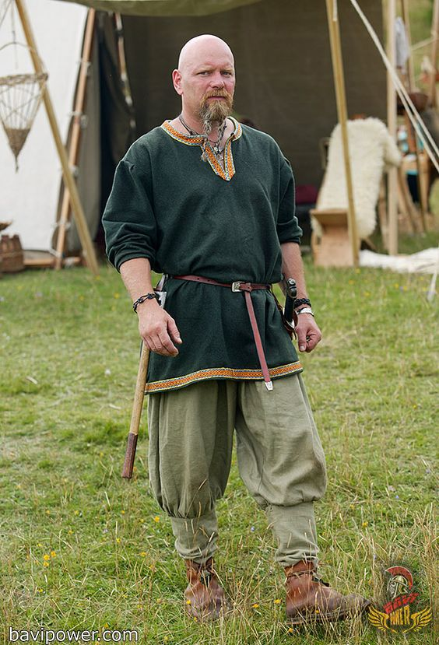
Women
Norgardian women wear a linen under-dress, which stretches from the shoulder down to ankle length. This layer is either plain or patterned depending on what community one belongs to. Over this they wear a wool strap dress which is slightly shorter in length. The two layers are fastened together at the straps by two iron or bronze brooches. If a woman is of very high standing, she might have had gold brooches. Over this she wears a cloak or furs in the colder seasons.
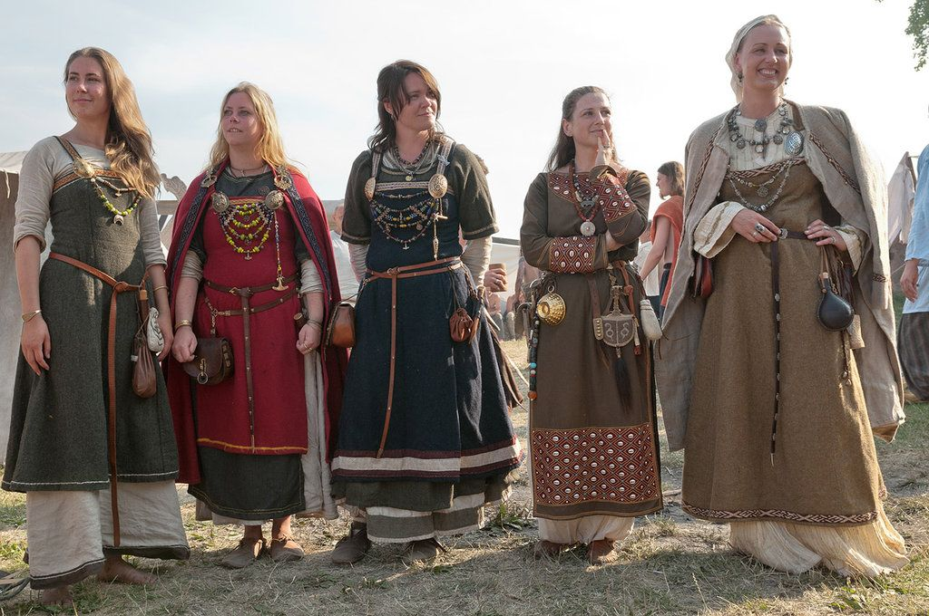

Military Attire, Weapons, and Armor
Clothing: Norgardian warriors wear undergarments of linen covered by a tunic that extends to the knees. Base garments are lighter and shorter sleeved in the warmer months and thicker and longer during the dark of winter. Trousers are simple wool or linen, and can be either loose-fitting or tight. Men also wear leggings or wool wrappings from their knees down to their ankles and feet.
Armor: Norgardian warriors wear heavy cloaks and much thicker tunics of sheep's skin or some other hides. A strong leather belt around the waist holds weapons in place. Warriors wear thick, leather body armor, round shields, and metal helmets. Norgardians do not prefer overly heavy clothing or armor, largely because it is a hindrance in battle. In some cases, they may wear chain shirts. They tend to carry light wooden shields and wear steel caps with nasal guards or face plates.
Weapons: Norgardian warriors tend to carry short or long swords, battle axes, throwing axes, and short bows.
Base Stats: Chain Shirt +5 AC, Light Wooden Shield +1, Throwing Axe 1d6 / x2, Short bow 1d6 / x3, Steel Cap with Face Plate
Markings and Standards: Norgardian armies are recognized by the designs on their shields. All other parts of their clothing and armor are of mundane and varied colors and patterns. They do not typically carry standards or flags.

Social Structure
Nogardian social structure is highly stratified, with three ranks or classes:
- Jarls - aristocracy
- Karls - farmers or peasants
- Thralls - enslaved people
Hersir - military commander of a hundred (a county subdivision) of about 100 men and owed allegiance to a jarl or king.

Norgardians build their larger dwellings to resemble their longboats: long, oval, with a roof like a keel. These longhouses have timber frames (preferably of oak), wattle walls, and thatched roofs. In some cases the front door is elaborately decorated. A few houses even have turf roofs, where goats can be seen standing and grazing. Inside a longhouse a low bench follows each of the long sides on which the inhabitants sleep at night. A fire pit sits in the middle of the house, with a hole in the roof above to allow smoke to get out. Floors consist of pounded earth. Depending on how large a longhouse actually is, rooms are partly unused. One end of the house may store provisions for the winter and various tools, while some at the other end are made into barns in which animals shelter. Norgardian families live and gather in the centre of the longhouse, working, cooking, and telling folk tales by the light and warmth of the open fire.
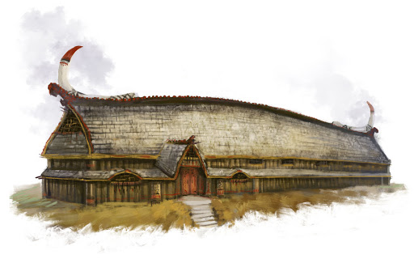
More humble shelters are pit houses. These are dug about a few feet into the ground, using the surrounding dirt as lower part of the wall. By digging the house into the ground the inhabitants make use of the soil’s insulating properties and to some degree the heat coming from the ground.
Norgardian explorers regularly settle in other parts of the world to winter. There they construct imposing ring-shaped strongholds known as trelleborgs. Some they may abandon and return to reclaim, others may linger and become trade towns. The Norgardian colonies in northwestern Amadar wilderness are built in this fashion.
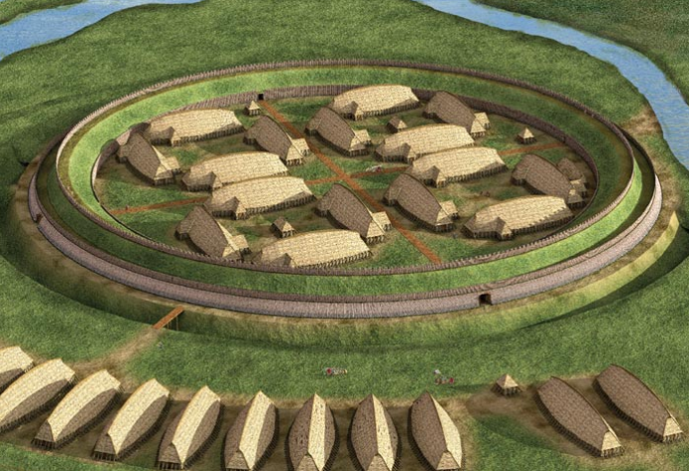

Norgeld – tribute paid to Norgarde raiders to buy them off and send them away from a raided kingdom or region
Alva / Vala – female seers, mystics, oracles
Portage – carrying of Norgarde longboats over land from one river system to another
Danvikka – fortifications made by Norgarde raiding parties when beaching their boats on a river bank and reinforcing an area to protect from local armed forces, composed of wooden palisades and earthen works both moats and embankments

Large standing stones are erected in memory of the dead – mostly powerful people – and their honourable deeds. They are intended to be visible and are painted in bright colours. The stones often stand near roads or bridges, where many people pass by.

Stone rings are arranged near most towns and cities. This is where meetings of great importance, called Thengs, are held among prominent leaders. Norgarde law is enforced in towns on the sites of large stones called Law Rocks, but Thengs are where important political matters are decided. Truces, wars, tributes to the gods in time of woe, all are discussed in the stone circles. Thengs are convened once a year or when circumstances dictate the need for one.

The land is divided up by familial clans who have staked out their territory and who fight constantly over their borders. Each clan is led by a jarl who rules with near autonomy over his region. Over the jarls sits a king or queen who has united the clans. In Norgarde there are three kingdoms. Once a year the jarls meet to pay homage to their kings: in the Hreidar kingdom they meet in Volsung, in the Halsla kingdom they meet in Skala, and in the Fjarna kingdom they meet in Geirdir. Hold of the throne depends heavily on a show of strength, so it is not considered treason for a jarl to challenge the king to combat for the right of rule.

The history of men on Norgarde is rumored to have originated millennia ago when the gods looked upon the world and wagered over which peoples were the strongest. Coming to no firm answer, they agreed to see how rugged they could make man and woman, and so bred the Norgardians from the very ice and rock. It is said Kord himself challenged the North people to fashion what they will of the ‘boat’ given to them to live upon. And the Norgardians have taken that challenge as an honor ever since, tilling food from scarce earth, honing their hunting and fighting skills to survive, and taking to the seas to plunder what they may.

Runes
Runes are ancient primitive symbols handed down by the gods at the dawn of time. They are raw, powerful conduits to the primordial forces that birthed the world. They are elusive mysteries that some spend a lifetime studying while others have them revealed in visions. But they are dangerous magic, unforgiving to those who make even the slightest mistake. Woe to those who have gone made or been destroyed utterly by their untameable power.

The known runes and their meanings

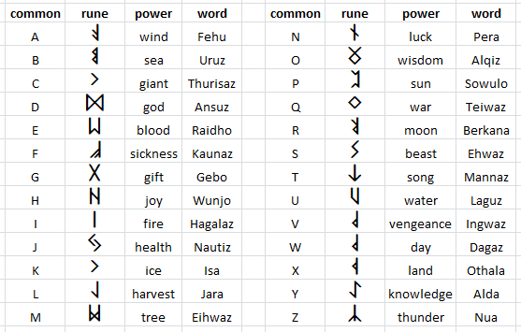

Rune markers dot the land, erected by ancient wizards who discovered the power of rune magic. Little is known about these markers. They predate any written history. But wizards travel to these markers to divine their secrets. There are rumors that ill events seem to follow when the rune markers are activated. In times of war and calamity it is common for wizards to be dispatched to consult the markers. Whether the wizards truly learn anything is unconfirmed, but most come back with some portent or another to satisfy their masters.

Contact with other planes
In the lands of Norgarde are otherworldly beings, called the Huldrefolk, which translates to the 'concealed people' – these are invisible creatures operating on another plane. They are sought out during ceremonial trances where one is able to walk among the spirits.

Other customs
- Arm Rings –
- King’s Table - The board game enjoyed most often by Norgardians is Hnefatafl “The King’s Table”. Two players of unequal strength engage in the game. One player is by far the strongest, with the most pieces. His job is to corner the king, who is defending his castle with a much smaller force.
- Knattleikr –players are divided into teams, each with a captain. A ball made of ox hide is batted with large cudgels as players push, shove, gouge, and punch across the field to get the ball to the other side. The game demands so much time that it is played from morning to night. It is a spectator game, with tournaments drawing huge crowds from all over Iceland.
  - Game-play involved a hard ball was hit by a stick, although players could also use their hands. Body contact was allowed in the fight for the ball where the strongest had the best chance to win. Thus, intimidation was a vital ingredient; several wars of words have been recorded in the old sagas. There were penalties and a penalty box.
  - It is conjectured by some that the playing field was lined, usually played on a flat ice‐covered surface, e.g. a frozen pond (though bumpy, land‐based ice, svell, is also mentioned). The Vikings may have used tar and sand under the soles of their boots for traction.
- Naked Run
- Polar Bear Plunge
- Thorrablot "feast of Thorri" - eating of disgusting foods before winter consisting of sour ram testicles, boiled sheep heads, blood pudding, liver sausage and fermented shark. Thorri is the personification of winter. Eating is seen as a sign of strength and girding one for winter’s wrath.
- The kransen is a gilt circlet worn by maidens of Norgarde. A symbol of virginity, among other things, it is stored before a wedding for a bride’s future daughter. During the wedding ceremony, the kransen is replaced with a bridal crown.
- Weddings : In the lead up to a wedding, Norse brides and grooms are separated so they can strip away their former selves before entering their new lives together. For the bride, this means being stripped of old clothing and any symbols of her unwed status, such as her kransen, a gilt circlet worn by Scandinavian girls. The kransen, symbolic of virginity, among other things, is stored for the bride’s future daughter. During the wedding ceremony, the kransen is replaced with a bridal crown.
During her sequestration, the bride cleanses herself in a bathhouse. Hot stones are placed in the tub to produce steam, and women often switch themselves with birch twigs to induce perspiration, which symbolically washes a bride’s maiden status away. Once the bath is finished, the bride plunges into cold water to close the pores and end the cleansing process. Throughout these preparations, women are attended by their mother, married sisters, and other married female relatives and friends.
  - Like Norgarde brides, grooms undergo symbolic rituals before entering their new lives as married men. His attendants are his father, married brothers and other married male friends. In order to rid themselves of bachelor hood and destroy all vestiges of the unmarried self, Norgarde men participated in a symbolic sword ceremony.
The ceremony entails a groom-to-be breaking into a grave in order to retrieve the sword of an ancestor, which is placed there by his attendants. In order to obtain the sword, the groom has to enter the grave and emerge with the sword. Through this action, he enters death as a boy and emerges into a life a man, reborn, but the same.
Once the groom has his sword, he, like his bride, goes to a bath house to symbolically wash away his bachelor status and purify himself for the wedding ceremony. During his cleansing, he gains insight and instruction on husbandly and fatherly duties from his attendants.
  - Norgarde brides don’t wear elaborate costumes or gowns. Rather, the ornamental focus is on her hair and crown. A woman's hair is very important in Norgarde culture, and indicative of her sexual allure. The longer, the better. As a replacement for the kransen, brides wear a bridal-crown, which is typically a family heirloom. These crowns are usually made of silver adorned with rock-crystals and elaborate designs such as crosses and clover leaves, and draped with red and green garland silk cords. Some bridal-crowns are beautifully woven from straw and wheat, then garlanded with flowers.
  - During a Norgarde wedding, the groom presents his ancestral sword to his bride, which she keeps for any future sons they might have. The bride then gifts the groom a sword of her ancestors, symbolizing a transfer of a father’s protection of a bride to the husband. This gift exchange symbolizes a sacred union, sanctified by mystic rites. The bride and groom then exchange rings to further consecrate their wedding vows, offering rings to one another on the hilt of their new swords.
  - At the feast, a simulacrum of Kord is placed in the bride’s lap as she asked for Kord’s blessing. The goddess Vár is said to witness a couple's vows and perhaps watch over the feast.
  - The bride and groom drink bridal-ale together at their post-wedding feast. Their union is only binding once they did so. The ale is usually honey-based mead, and the wedding can only go forward if the couple have had enough of it to last a month; it has to be drunk throughout their honeymoon. The first serving is presented to the groom by his wife in a vessel called the kåsa, known as a "loving-cup." The bride might recite a formal verse while presenting the ale. Before drinking it, the groom consecrates the ale to Kord by making the sign of a hammer over it, and toast to Kord. He then sips and passes the cup to his bride, who makes a toast to Freyja before drinking.
- Raid and warfare tactics : https://en.wikipedia.org/wiki/Viking_raid_warfare_and_tactics
Berserkers – Berserkers are fierce warriors who embody the wild rage and untamed spirit of savage creatures. These are unstable individuals tortured by inner conflict. It is said they are the hardest of men and women, with a touch of the uncanny about them. Initiates are men and women of great prowess who must prove themselves worthy before receiving their gifts (or to some, a curse). Born of the primordial age, there exist three ancient wilderness cults devoted to the powers of beasts and that harness their fury: the Úlfhéðnar, or wolf warriors, the Svinfylking , or boar warriors, and the Hamrammr, who are the bear warriors.
There are three Hovs, or monasteries, dedicated to these three branchs of the Berserker:
- Hov of the Wolf – located in the Raven Forest
- Hov of the Bear – located in the Bludrun Forest
- Hov of the Boar – located in the woods of Nurla Valley

https://en.wikipedia.org/wiki/Viking_ships

Faering - an open rowboat with two pairs of oars
Byrding - light freighter
Knarr - heavy freighter; sturdier by design and they depended mostly on sail-power, only putting oars to use as auxiliaries, if there was no wind on the open water. Because of this, the knarr was used for longer voyages, ocean going transports and more hazardous trips than the Gokstad type
Warships - longships / dragonships; graceful, long, narrow, light, wooden boat with a shallow draft hull designed for speed. The ship's shallow draft allowed navigation in waters only one meter deep and permitted beach landings, while its light weight enabled it to be carried over portages
Karvi / Karve - a small type of Viking longship, with a broad hull somewhat similar to the knarr.
Busse
Snekke
Drekkar
Skeid

Musical Instruments
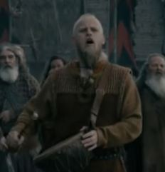
- Talharpa – lyre with four strings played with a bow strung with horsehair
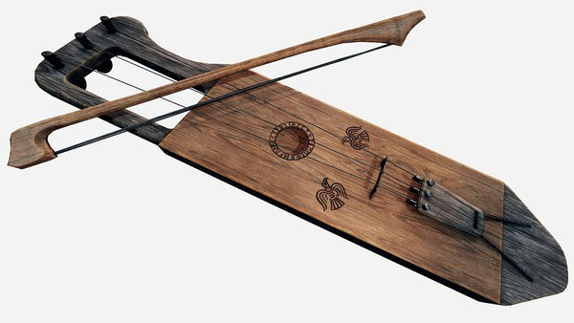
- Lur - a trumpet-like instrument made from either wood or bronze that comes in a variety of different lengths. They are more practical than musical, used to marshal troops and frighten the enemy. They are also used by farmers to call their livestock. Some are used as part of religious rituals. Wooden lurs are generally made from one piece of wood split lengthwise, with the interior hollowed out and the two halves tightly bound together with willow bands.
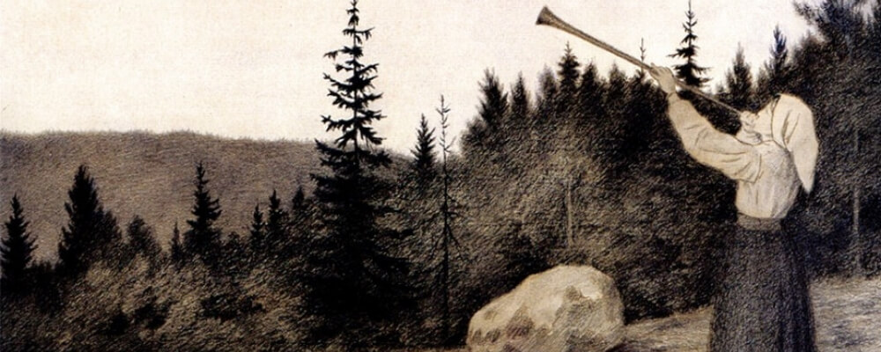
- Drums - These are made with a shallow round or oval wooden frame supported by one or two crossbars inside that looks a bit like wheel spokes. A rawhide head is then stretched taught over the frame. Drums are play both as musical rhythm instruments and for religious and practical purposes.
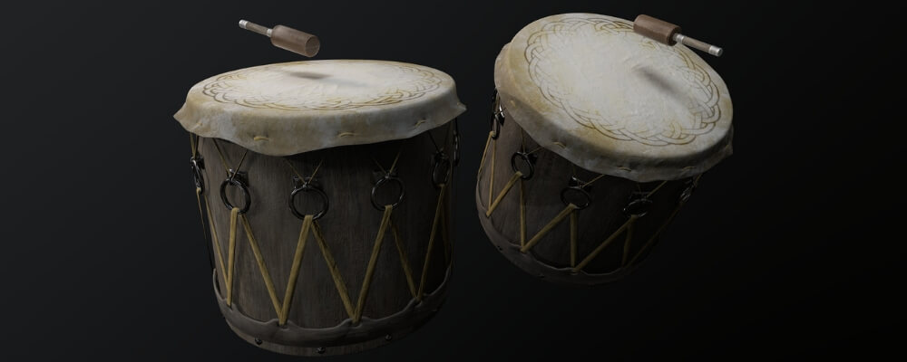
- An elaborate musical rattle survives from Stövernhaugen in Norway that consists of three iron rings threaded on a large oval ring, and attached to the top of a stave 170 centimeters long. The stave would have been tapped against the floor to produce a drumming noise and causing the iron rings to crash together to produce a rattling sound.
- Pan Flute
- Cow or Goat Horn
- Flute

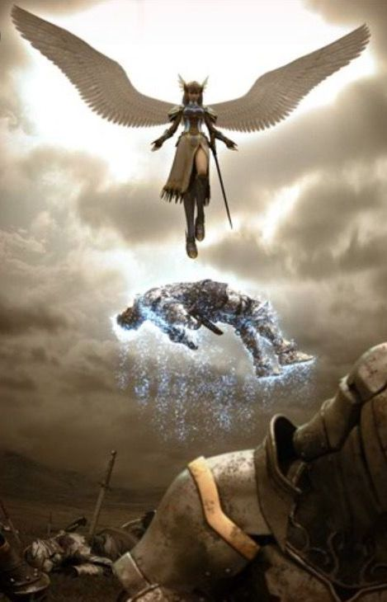
Local Deities
Norgardian religion is more of a folk religion than an organized one. The central activities at the center of the religion are sacred acts, rituals, and worship of the gods. Rites are referred to as the forn sidr (ancient custom). Sacrifice (blót) plays a huge role in most of the rituals, which are usually made to ensure fertility and growth but are occasionally made for protection on voyages or for fortune in battle. Every-day rituals involve foodstuffs like grain, but larger sacrifices involve animals (the more sacred the occasion, the larger the animal sacrificed). Calendar events regularly feature sacrifices as well as communal feasting on sacrificial meat and fermented drinks like bear and mead. Women play a powerful role in Norgardian faith, as all women are seen to have sacred powers stemming from fertility. Certain women, named the Alva, emerge from each village or tribe as a seer. Alva are able to read bones to divine the future as well as scribe runes to channel powerful magic.

All Norgardians worship Odin, father of man and king of gods.

Patron Gods of towns, cities, and monasteries (Hovs)
Mimir - god of knowledge and wisdom, patron god of Skurn
Fenrir - great ravenous wolf, patron god of Ragnvor
Vadir - god of vengeance, wears mighty boots capable of stomping on giants and giant serpents, patron god of Volsung
Tyr - god of war, patron god of Brekkan
Ran - goddess of death who collects the drowned in a net, patron goddess of Halgar
Vor - goddess of scholars, she who knows all, patron goddess of Gudrun
Njord - god of wind and sea, wealth and bad marriage, patron god of Skala
Nerthus - goddess of lakes, springs, and holy waters, patron goddes of Kelborn
Gefjun - goddess of plowing and generosity, accompanied by her four oxen, patron goddess of Vigdis
Yngvi - god of sacral kingship, virility, peace and prosperity, patron god of Aesgir
Forseti - god of justice, reconciler and overseer of conflict, patron god of Geirdir
Sjofn - goddess of human passion, patron goddess of Skogul
Ull - god of archers and explorers, patron god of Kastfel
Dellingr - god of the dawn, patron god of Jotunn
Skadi - goddess of winter and the hunt, patron goddess of Kinwall
Sága - goddess of prophecy and song, patron goddess of Lutadar
Syn - goddess of justice, protector of entry ways, patron goddess of Hahll
Kvasir - god of drink and poetry, patron god of Styrla

Hov of the Life Tree - Ygdrasil, the Life Tree
Hov of the Fates - Norns – three goddesses of destiny
Hov of the Wolf - Úlfhéðnar - shape-shifting wolf berserkers
Hov of the Broken Shield - Aesir – warriors of Asgard
Hov of the Bear - Hamrammr - shape-shifting bear berserkers
Hov of the Salt - Vanir - wild nature and fertility gods
Hov of the Boar - Svinfylking - shape-shifting boar berserkers

[NEEDS TO BE REVISED]
Vatnavættir are guardian spirits of the waters and guardians of the eleven fiords of Norgarde. Each Vatnavættir has a female aspect and each has her own unique temperament. And to each a different form of tribute is required if sailors wish to win favor.

- Sigyn watches over the Grimnir Fiords and is largely ignored by the folk of Ragnvor to their own peril. She is a quick-tempered and sullen spirit. She requires a gift of blood be thrown to her waters. Any blood will do, so sailors often cut open a rat or rabbit and throw it overboard.
- Idunn watches over the Arngun Fiords and is venerated by the people of Brekkan. She is lighthearted and whimsical. She requires the gift of flower garlands.
- Hariasa watches over the Stirlung Fiords and is venerated by the people of Halgar. She is a melancholy spirit and her soft crying can be heard on the haunting gales that blow through Stirlung. She requires the gift of salt to honor her many tears.
- Beyla watches over the Hreidmar Fiords and is venerated by the people of Volsung and Gudrun. She is full of laughter and exuberance, sometimes to the fright of sailors as powerful currents and winds rise up with her mood.
- Snoetra watches over the Rindr Fiords and is venerated by the people of Kelborn. She is a clever spirit and wont to play tricks on those at sea. She favors those who hatch schemes and use guile. She requires the gift of silver.
- Meili watches over the Halsla Fiords and is venerated by the people of Vigdis, Aesgir, and Skala. She is a strong-minded spirit and favors the warriors. She requires the gift of mead.
- Astradina watches over the Koldal Fiords and is venerated by the people of Skogul. She is a champion of justice and watches over the lawful. She requires a gift of fresh water.
- Melkora watches over the Fjara Fiords and is venerated by the people of Geirdir. She is a chaotic spirit, always looking to cast away order. Those who embrace her ways know how to navigate the shifting tides of the fiords as well as life. She requires the gift of dust.
- Njörun watches over the High Helm Fiords and is venerated by the people of Kastfel. She is a spirit who celebrates life and looks to see it grown and flourish. She requires a gift of fruit.
- Skadi watches over the Brisingr Fiords and is venerated by the people of Hahll. She is a champion of knowledge and favors explorers. She requires a gift of smooth stones taken from a freshwater stream.
- Ēostre watches over the Hagala Fiords and is venerated by the people of Kinwall. She is a champion of craftsmen and seeks to see things built in harmony with nature. She requires a gift of wood.

Hovs – Hovs are open-air places of worship. Some are the sites adopted by warrior monks who have sought isolation from the rest of the world to focus on their faith. Below are the Hovs of Norgarde

Hov | Alignment | Faith | Location
Hov of the Life Tree | CN | Ygdrasil, the Life Tree | Ygdrasil Forest
Hov of the Fates | N | Norns – three goddesses of destiny | Rune Mountains, Isle of Skjolden
Hov of the Wolf | NE | Úlfhéðnar - wolf berserkers | Raven Forest
Hov of the Broken Shield | LG | Aesir – warriors of Asgard | Hegland Valley
Hov of the Bear | NE | Hamrammr - bear berserkers | Bludrun Forest
Hov of the Salt | CG | Vanir - wild nature and fertility gods | Alva Wood
Hov of the Boar | NE | Svinfylking - boar berserkers | Nurla Valley

Nithing Pole – these are carved wooden poles ranging from a few inches in diameter to large timbers, topped with a decorative figurehead. The poles are carved by villagers and then enchanted by druids to contain powerful spells to affect where they are posted. Most often, Nithing poles are designed to ward off wights and other fell creatures. Some poles are enchanted to bless a patch of land and foster growth in the plants and animals. Others still are misused to contain curses against those whose lands they are posted on.

The figurehead can be carved in a variety of styles, normally with designs to denote power (like a fist or hammer), fertility (tree, produce), or some kind of curse (animal or monster faces contorted into gruesome expressions).

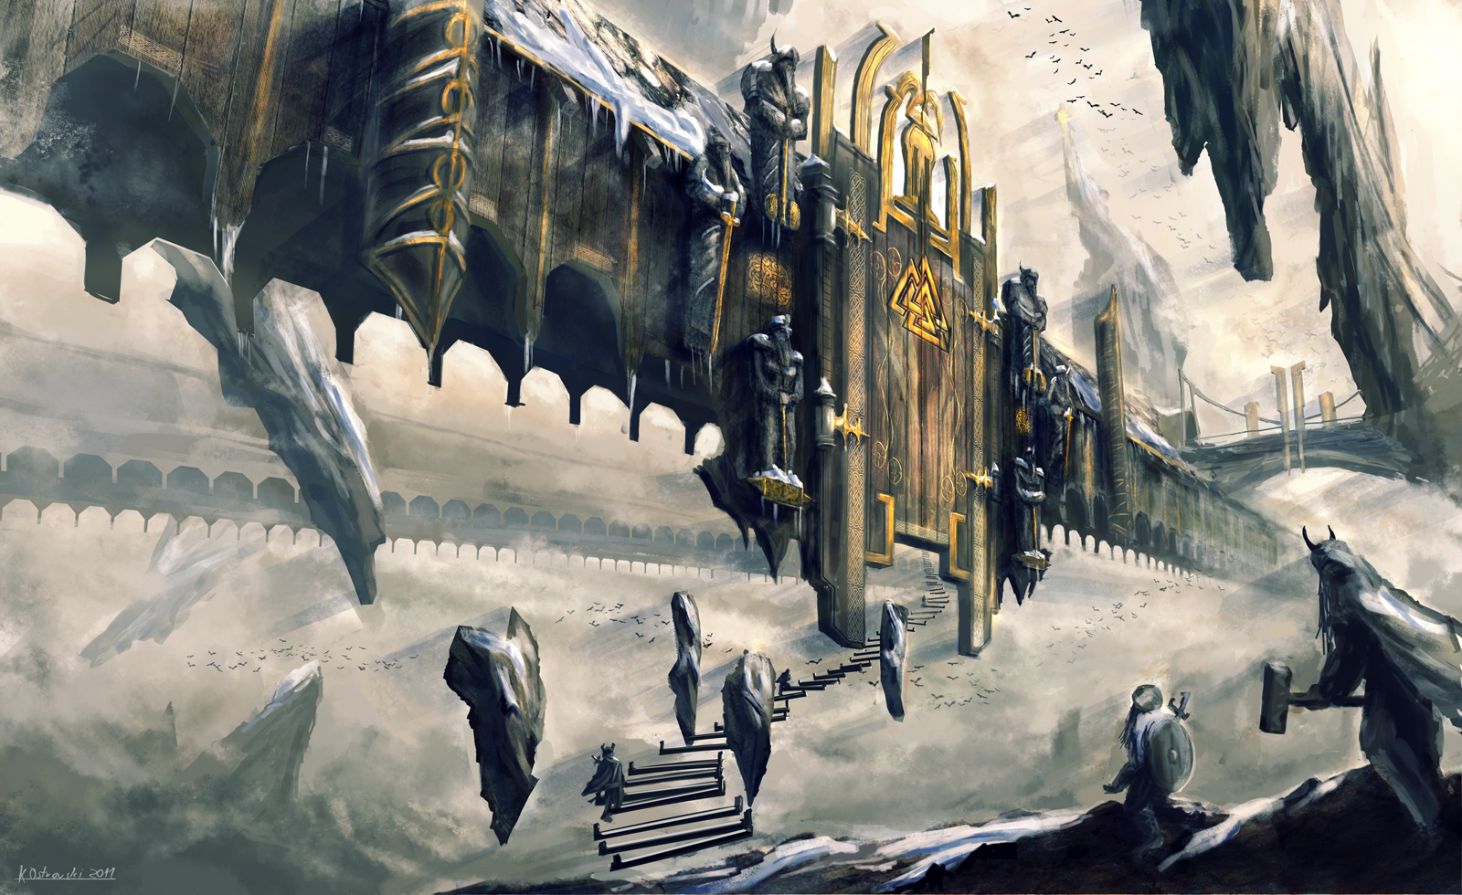

The Nine Realms of the Ginnungagap
- Asgard – home of the Aesir
  - Valhalla – home of half of the valiant dead, ruled over by Kord
  - Folkvangr – home of half of the valiant dead, ruled over by Kord’s queen
- Vanaheim – home of the Vanir
  - The Vanir gods is an old branch of gods. The Vanir are masters of sorcery and magic. They are also widely acknowledged for their talent to predict the future. Nobody knows where exactly the land, Vanaheim is located, or even how it looks like.
- Alfheim – home of the light elves
  - The light elves are beautiful creatures. They are considered the “guardian angels” The god Freyr is the ruler of Alfheim. The Light elves are minor gods of nature and fertility; they can help or hinder humans with their knowledge of magical powers. The elves are known for inspiring poets in art and music.
- Nidavellir aka Svartalfheim – land of the dwarves and dark elves
  - they live under the rocks, in caves, and underground. Hreidmar was the king of Svartalfheim until he was killed, Svartalfheim means Dark fields. The dwarves are masters of craftsmanship, and the gods of Asgard have received many powerful gifts
- Niflheim – land of the dead
  - “Mist home” or “Mist World,” it is the darkest and coldest region of all the realms
  - The eldest spring in the world called Hvergelmir “bubbling boiling spring” is located in Niflheim and it is protected by the huge dragon called Nidhug. Yggdrasil extends one of its three large roots into this spring to draw forth water.
- Jotunheim – land of the giants,
  - consists mostly of rocks, wilderness, and dense forests, and it lies in the snowy regions on the outermost shores of the ocean that spans between the nine realms. Because of this, the giants live mostly from the fish from the rivers, and the animals from the forest, there is no fertile land in Jotunheim.
    - One of the roots of Yggdrasil passes through here to reach the Spring of Mimir aka Mímisbrunnr - water of the well contains much wisdom and demands a mighty sacrifice before one may drink of it
  - The giants and the Aesir are constantly fighting, but it also happens from time to time, that love affairs will occur.
  - Jotunheim is separated from Asgard by the river Iving, which never freezes over. The stronghold of Utgard could be called the giants’ version of Asgard, and it is so tall that it is hard to see the top of it. The fortress is carved from blocks of snow and glistening icicles, and inside lives the feared jotun king.
- Muspelheim – is a burning hot place, filled with lava, flames, sparks, and soot. Muspelheim is the home of fire giants, fire demons, and ruled by the giant Surtr, sworn enemy of the Aesir.
- Midgard – the earthly realm of Nemmyrl, accessible from Asgard only by Bifrost, the Rainbow Bridge
- Helheim - Hel is where all the dishonorable dead, thieves, murderers, and those the gods and goddesses feel is not brave enough to go to Valhalla or Folkvangr. Helheim is ruled over by Hel. It is a very grim and cold place, and any person who arrives here will never feel joy or happiness again.

Creatures of Norgarde
- Draugr – The Draugar are undead who consume flesh and drink blood. They possess superhuman strength and can increase their size at will, but they cannot shake the unmistakable stench of decay and have the hideous visage of a dead body. The Draugar creature often live in their graves in order to defend the treasure that they were buried with, but they are also known to enter communities in order to wreak havoc on the living, often tormenting those who wronged them in life.
  - They can kill by crushing someone with their superior strength, eating their flesh, eating them whole in their enlarged state, or kill indirectly by driving a person mad. These creatures were said to be able to enter the dreams of the living to torment them and would always leave behind a gift to show the victim that the encounter was real.
  - The Draugar can be killed and suffer a second death if their bodies decay too much, or if they are burned, dismembered or otherwise destroyed. It was believed that evil, greedy or unpopular people were most likely to become Draugr after death.
- 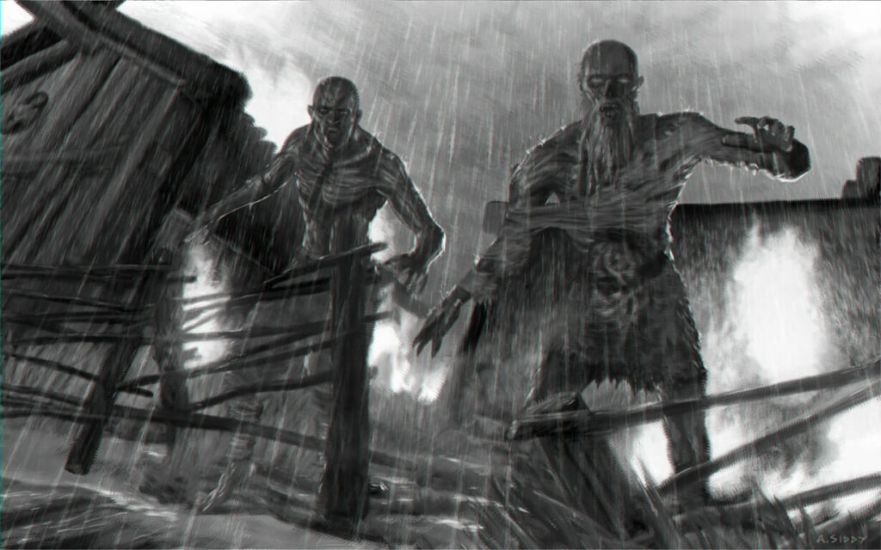
- Huldrefolk –
- Huldra - is said to lure men down into endless cave systems that they would not be able to find their way out from, or lure them into the forest in order to secure her freedom or sometimes to suck the life out of a man. One of her methods is to appear suddenly out of the rain and mist, friendly and enticing to the point that no man can resist her charm. She has a long cow's tail that she ties under her skirt in order to hide it from men. If she can manage to get married in a church, her tail falls off and she becomes human. However, she also becomes very ugly. It is often said that the young and beautiful Huldra is moody and dangerous, but when she becomes old and ugly she becomes gentle and caring to the man who made her human.

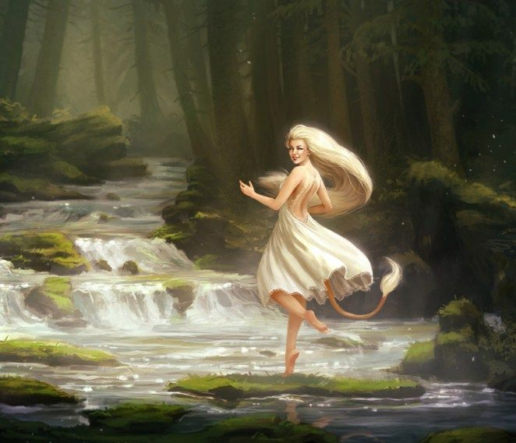

- Hill Giants –
- Frost Giants -
- Lindworms - enormous wingless serpents that have two great claws and burst into flame as they slither over the land. The shed skin of a lindworm is believed to greatly increase a person's knowledge about nature and medicine.

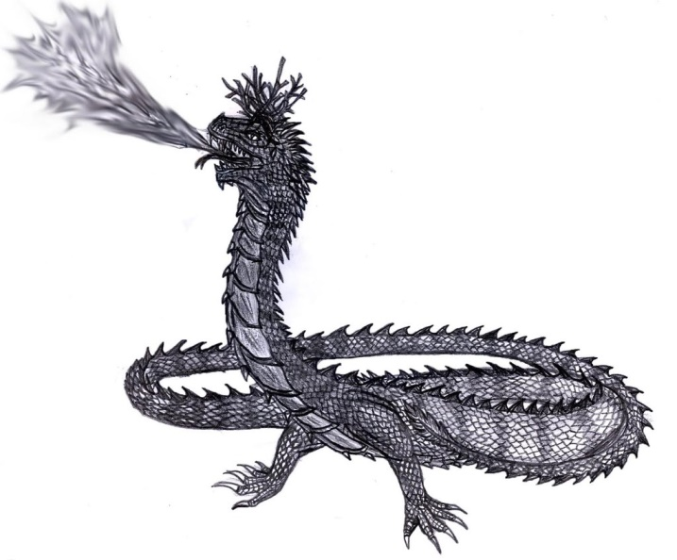

- Fosse grim is a water spirit that plays enchanted songs on the violin, luring women and children to drown in lakes and streams. However, in some stories he is depicted as a harmless creature, appearing as a skald and entertaining regular folk with his songs. According to one story Fosse grim even agreed to live with a human that fell in love with him, but he supposedly left after some time because he could not live away from a water source too long.

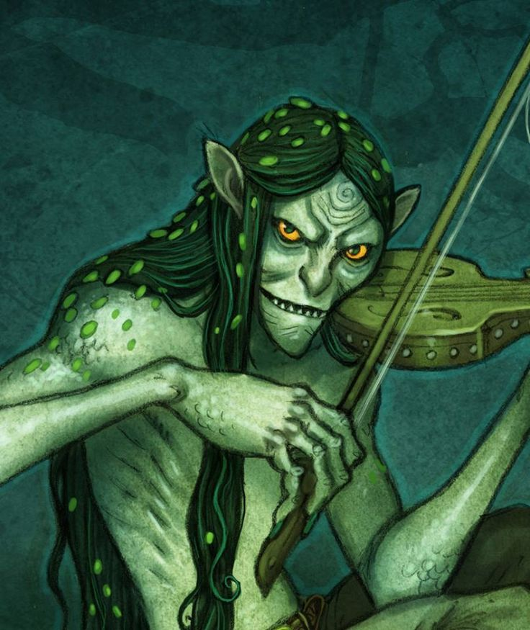

- Kuo Toa
- Sahuagin - Two massive tribes of Sahuagin plague the inhabitants of Skjolden. The Pelagra (“open sea”), dominate the coastline east of Dragyn River and are identifiable by their dull orange stripes. The Benthra (“sea floor”) dominate the western shores facing the Straits of Fialar and are identifiable by their full yellow stripes. These tribes are extremely aggressive, attacking each other and any humans that dwell here or make landfall in their areas.
- Fylgja - spirits who from time to time appear when a baby is born. They are connected in some way to the person’sr fate or fortune. It is believed the type of animal reflects the character of the person they represent. If the person has a "tame nature", their fylgja might be an ox, goat, or boar. If they have an "untame nature" they would have fylgjur such as a wolf, deer, bear, eagle, falcon, leopard, lion, or a serpent. Those with arcane destinies, such as wizards and sorcerers, tend to have a fox as their fylgja to reflect that they are sly and hiding something. Some even say that the person born with a fylgia may one day be a shape-shifter with the ability to transform into the creature itself. Town folk are highly suspicious when animals appear at the birth of a child and mark the child as having a special future.
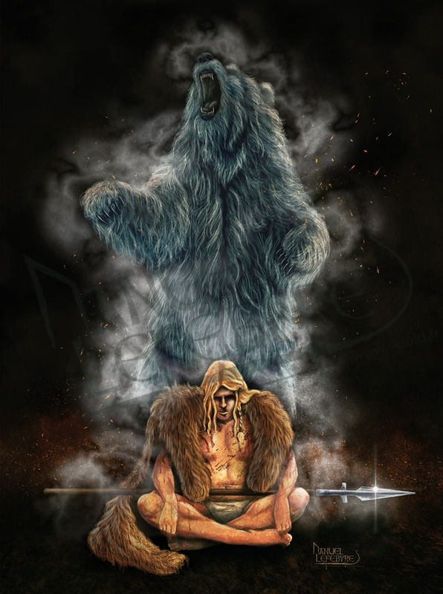
- Mare - The Mare monster gives people bad dreams at night by sitting on them in their sleep. It is believed that the Mare are the troubled souls of living people which left their bodies at night but never returned. Often these are witches, whose souls took the forms of animals, but normal people, in particular adolescents, are also thought to become Mare when their spirits wander. The idea that the soul wanders at night is a common belief among Norgardians. It is also believed that when the Mare touch a living thing, people, cattle or trees, it can cause their hair to become entangled. It is also said to be why the branches and roots of some trees became entangled.
- 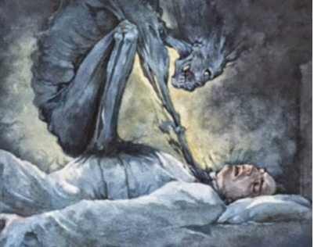
- Trolls - Two different types of trolls are found in Norgarde. There are large ugly trolls that dwell in forests and mountains, and small gnome-like trolls that live underground in deep caves and caverns. They are generally depicted as not very intelligent and quite malevolent, but they can show kindness in exchange for a favour. A distant cousin, the Trow, are sea trolls that live beneath the sea around the coastline.
- Wargs - Warg packs roam the hills around Ragnvor collectively called the Madfangs. In dark times the packs will join together and assault the outlying farms around Ragnvor. The mother of wargs is called Garda and directs her children to feed on men.
- Raudkembingur, a demonic whale with red hair. For hundreds of years the great beast has attacked ships and swallowed sailors whole. Survivors describe a whale like creature who is unmatched in ferocity and desire to destroy ships. It has a red crest on its neck, large jaws with rows of sharp teeth, and a brownish body. It is a very fast swimmer. It will play dead for months, waiting for a foolish ship to come near it. If it fails to catch a ship that it chased, it will die of frustration
- 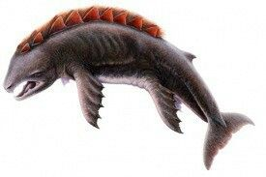
- Valkyries - Valkyrie elegant, noble maidens that bear dead heroes to Valhalla, the heavenly home of Kord’s fallen army. They are celestial creatures who ride winged horses and are armed for battle. Valkyrie means ‘choosers of the slain’. They not only work for Kord, but sometimes choose who live and die in battles, using malicious magic to ensure their preferences.
- The Norns – The Norns are mystical women who came into the world at the dawn of time. They dwell in the land of Urtr far to the north. There they commune with the spirit world and Yggdrasil itself, some tending to the tree and others working looms where they weave the fate of the living. They are a mysterious race, hailing from the lineage of the Joten giants, some from the Alfar (Elves), and others from the Dvalin (Dwarves). Some of the Norns are of good alignment and seek to aid the living, others are evil and seek to bring calamity. It is a common believe among Norgardians that one’s fate is set at birth, woven on the Norn looms, and there is little to do to change it.
- Yggdrasil – Yggdrasil is called the Tree of Life. It is an enormous ever-green ash-tree, covered with white mud or loam. It is hidden in the far northern forests and which towers high enough to touch the clouds. Yggdrasil is an ancient and sentient creature said to have spawned the race of Treants and is a guardian of nature. The exact location of Yggdrasil is unknown, for it is invisible unless revealed by the gods and seems to move from place to place. It is connected to all trees throughout Norgarde, and communes with special woodland squirrels named Ratatoskr who serve as its eyes and ears.
  - Yggdrasil’s three mighty roots draw water from three sources:
    - Spring of Mimir aka Mímisbrunnr - water of the well contains much wisdom and demands a mighty sacrifice before one may drink of it, passage to the well crosses Jotunheim land of the giants
    - Well of Urd – an ever-moving spring of water where the three Norns visit and draw up water; those seeking the Norns must follow the root to the well and address the Norns there with their questions.
    - Spring of Hvergelmir – located in the land of the dead, Niflheim, the “bubbling boiling spring” is located in Niflheim and it is protected by the huge dragon called Nidhug
- The Great Eagles
- Nidhug - The guardian dragon beneath the tree Yggdrasil, dwells in Niflheim and guards the Spring of Hvergelmir
- Ratatoskr - Ratatoskr is a squirrel that runs up and down the tree of life, delivering the messages of the gods. However, he is mischievous, and enjoys stirring trouble between the wise eagle that sits at the top of the tree and the hungry dragon that dwells in its roots.
- Vordr - spirits that wander the land, guarding certain places and sometimes even people. At times, the Vordr reveals itself as a small light or as the shape (hamr) of the person it is guarding. The perception of another person's warden is said to elicit a physical sensation such as an itching hand or nose, as a foreboding or an apparition. The warden sometimes arrives before the actual person, which someone endowed with fine senses might perceive. Certain trees outside the town are called Warden Trees. These are believed to be inhabited by a Vordr and bring good fortune to the land. It is considered a high offense to harm a Warden Tree.
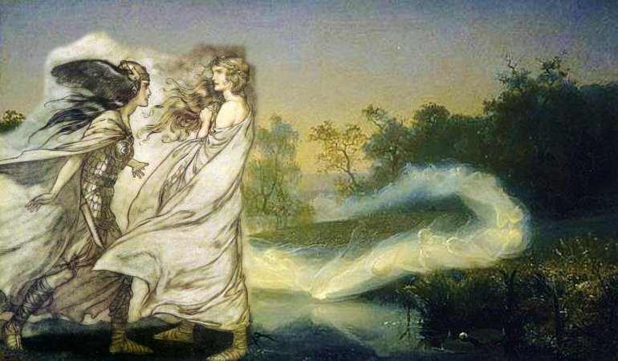

- The Vættir (Old Norse; singular Vættr) of Norse myth are spirits. The term can be used to refer to the full Norse cosmos of supernatural beings, including the Álfar (elves), Dvergar(dwarves), Jötnar (giants), and gods (the Æsir and Vanir). Vættir can also refer more specifically to Landvættir (nature spirits), Sjóvættir (sea spirits), vatnavættir (guardians of the specific waters), or Húsvættir (house spirits.)
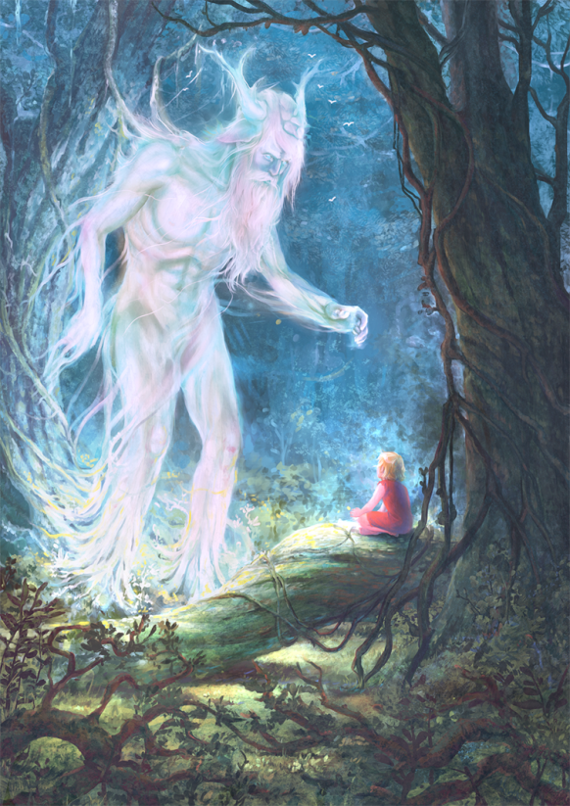
- Jörmungandr – Sailors of Norgarde speak in hushed whispers of the dreaded world-serpent, a creature of such epic scale that it is said it can encircle the world itself and will bring the doom of all mankind. Luckily Jörmungandr has only been recorded a handful of times in history, said to appear in only the darkest of times. Some think it hails from another plane of existence, possibly the plane of water. It is an epic force of nature and short of divine intervention there is little that can one can hope to use to stop it or survive its wrath.
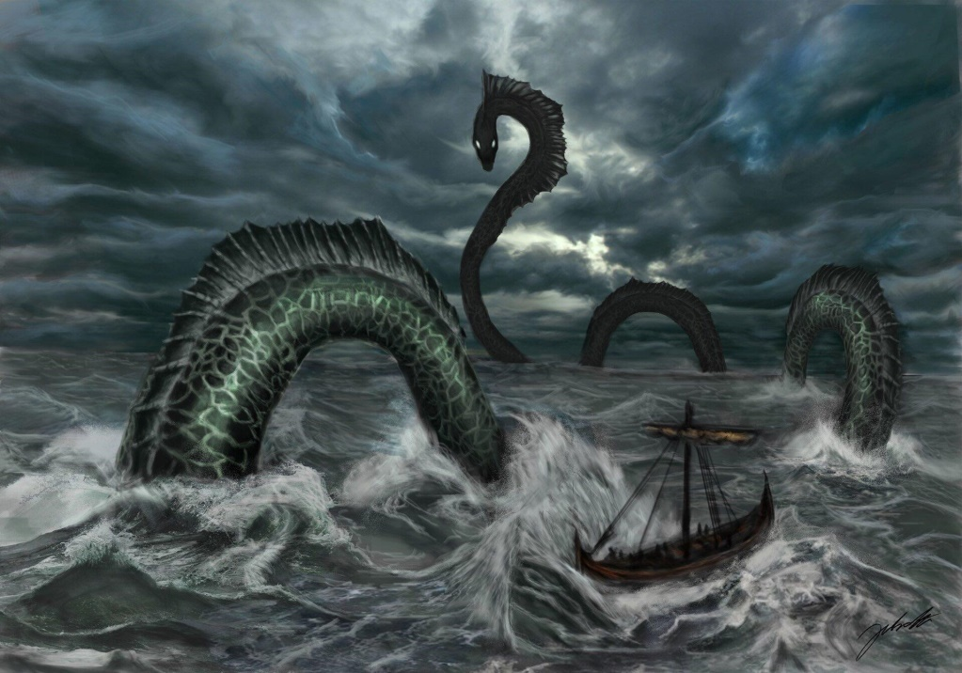

- Landvættir (land spirits) are chthonic guardians of specific grounds, such as wild places or farms. When Norgarde ships approached land, they sometimes remove their carved dragonheads from the bows of their longships, so as not to frighten and thus provoke the landvættir to attack, thereby incur bad luck from them
- Sjóvættir (sea spirits)
- Vatnavættir (guardians of the specific waters)
- Húsvættir (house spirits) - keepers of the household, like brownies in Treviland and the tomte.
  - Nisse aka Tomte - The nisse is a solitary vätte, living on the farmstead. He is usually benevolent and helpful, which cannot be said about an innately mischievous illvätte. If treated well, they protect the family and animals from evil and misfortune,[28] and may also aid the chores and farm work. However, a nisse can cause a lot of damage if he is displeased or angry, including killing of livestock or causing serious accidents; generally described as being short, having a long white beard, and wearing a conical or knit cap in gray, red or some other bright colour.
  - Vittra
- Huldrefolk (or Huldufólk), 'concealed people' and referring to their otherworldliness or their power of invisibility.
- Rå - spirits that protect natural features throughout Norgarde
- Hafgufa and Lyngbakr – The Hafgufa and Lyngbakr are the largest of all sea monsters in the northern seas. They are giant creatures, the only two of their kind, that appear like a small island or large rock on the sea surface. They feed on whales, ships, men, and anything they can catch in their enormous maws.
  - When the tide is low at night, the Hafgufa’s nose and head rise out of the water and resemble two massive rocks rising from the sea. The creature is known to belch, expelling so much food that it attracts all the nearby fish, then closes its mouth and devours them all at once.
  - The Lyngbakr prefers to wait for prey to climb atop its back, then sink and devour what is left floating on the surface.
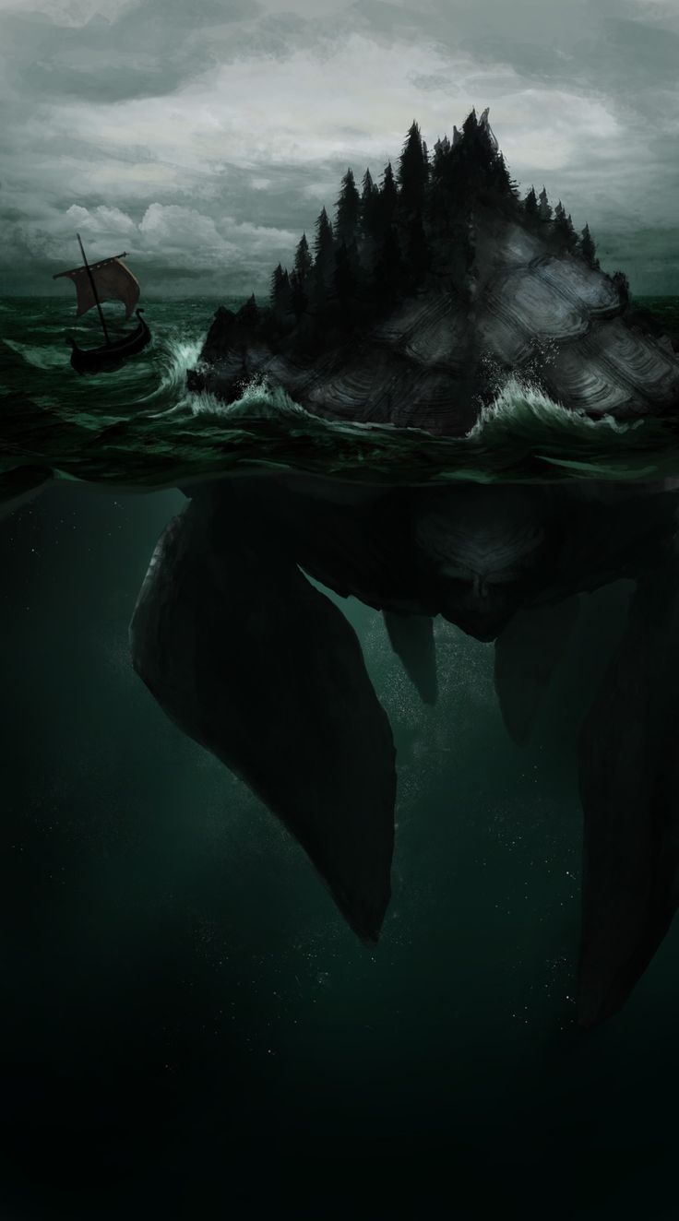
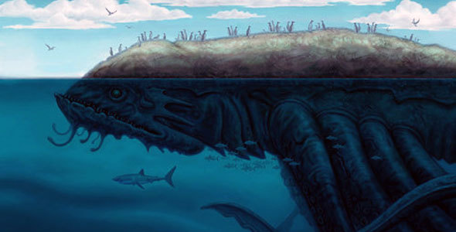
- Hrökkáll - A malicious wizard from Styrlung once revived a dead, half-rotted eel, giving rise to an evil and toxic creature. It was the first Hrökkáll, or “coil-eel”. The eel’s descendants went on to infest polluted waters.
  - A hrökkáll is two feet long, and resembles an eel in appearance. It lives in still ponds and stagnant water, and occasionally in running rivers. It has flexible, iron-hard scales, and sharp saw-toothed fins. It secretes corrosive venom and its meat is poisonous. Captured hrökkálls have been known to melt their way through earth and rock to squirm back into the water.
  - Hrökkálls lie in wait until someone steps in the water. Then they coil around the person’s leg and constrict it, slicing into flesh and bone alike and amputating the limb. It is unknown whether hrökkálls use their acidic venom or their bladed fins (or both) to do this. They will dismember humans and horses in this way, but sheep are safe as their legs are too narrow for the hrökkáll to gain a hold.
- 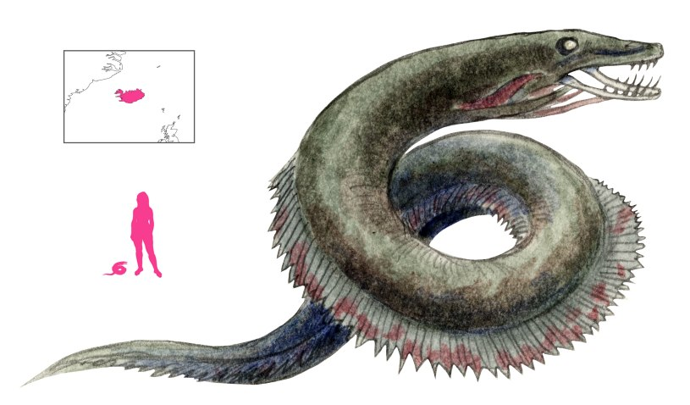

- Amberon (dwarves) – Dwarves are referred to as the sons and daughters of Dvalin in Norgarde. The Kingdom of Amberon occupies the Raros Mountain Range. The capital city is Thunderhame, upriver from the town of Skurn. Smaller towns are Horndeep, Hreidmar, and Yaramir. There are also three outposts situated at the ends of the mountain ranges where Dwarves keep a watchful eye on the lands below: Plunder Keep near Volsung, Lindwyrm Keep overlooking the Oda Pass, and Frostfang Keep at the northernmost point of the Raros Mountains.
  - Dwarven sub-race: Niebelung (from Norse mythology)
- Laaktalla (elves) – Wild Elves populate the forests of Norgarde. They are barbaric, tribal creatures that other Elves have named the Grugach. Norgardians make no distinction, calling all Elves “Alfar” and all Sea Elves “Sjóálfar.” The hair of the Wild Elves ranges from black to light brown, they dress in simple clothing of animal skins and plant weaves. They contend they are the true Elves, for others have lost their primal essence. They have seven settlements spread throughout the wild midland region: Jorildyn in Raven Forest, Stilmyst in Viskar Wood, Ylyndar in Bludrun Forest, and the towns of Reysalor, Ralyndur, Brindarry, and Yndraer in the Ygdrasil Forest.
  - In the Prose Edda: there are two different races of Elves or Alfar, the Dark Elves, Dokkalfar, and the Light Elves, Ljosalfar. The two are described as polar opposites. The Dark Elves prefer to dwell underground, while the Light Elves live in a heavenly realm “at the southernmost end of heaven”.
- Sæhrímnir – a mighty boar from the dawn of time, it is immortal; like a phoenix, it rises up the next day after it is killed; the gods make sport of hunting it and slaying it, then feasting on it only to release it and hunt it again; it is cooked in a special cauldron called Eldhrímnir

From the 2nd Edition Vikings Campaign Sourcebook

Gast (spectre)
Genganger (zombie)
Hamhelypa (werewolf)
Havmand (merman)
Linnorm (dragon)
Nokk (nixie)
Nisse (brownie)
Pukje (goblin)
Sending (revenant)
Skogsra (nymph)
Sjora (mermaid)
Spoke (poltergeist)
Svipa (ghost)

Types of giants
- Cliff giants – Similar to hill giants but 25’ to 30’ tall. Neutral evil. Normally do not venture into human territories to make mischief but may ambush trespassers in their territory.
- Frost giants – Similar to normal frost giants, but stand 25’ to 30’ tall. 20% of them are 10th level magic users.
- Joten – Most powerful and wise of their kind. Most are nearly as old as the beginning of the world. They have near godlike powers and abilities. They have the general presence of storm giants but stand 75’ to 100’ tall.
- Kalevanpojat – Similar to hill giants. Can transmute rock to mud and earth to stone each three times per day. Live in cabins in the wilderness and only attack if settlers expand into their territory. Dry land becomes inexplicably swampy, no matter how many times it is drained. Good fields fill and refill with stones, making plowing impossible.
- Thursir – Ill-tempered brutes, enlarged versions of hill giants. Can cause disease or madness up to three times per day. Stand about 20’ to 25’ tall. Hari and beards are wild and unkempt and their ears are noticeably larger. They dress in crude, rustic clothing and fight with cudgels fashioned from trees. They have lived as long as the Joten, but are not nearly as intelligent. They tend to be slow-witted and easily tricked or enraged.
- Sea Giants – Similar in size, appearance, and abilities as cloud giants. Dwell beneath the waves but can breathe air and water equally well. Can predict weather at will. Rarely disturb humans but may appear to warn of bad weather. Hair is normally pale blonde-green and dress in ordinary clothing draped in seaweed.
Trolls
Trow – sea trolls

Other Races
Elves
Doman of Laaktalla – The Helceren or Ice Elves of Norgarde are a hard-edged version of their southern cousins. Weathering the cold climes of the north, they dress in beautiful gray furs and don hoods that resemble animal faces. Homes are made in the boughs of the trees, stark and ominous as they tower over the landscape. Laaktalla Elves are both feared and respected by the Norgarde humans, who think them trickster spirits and dub them “Alfar.”

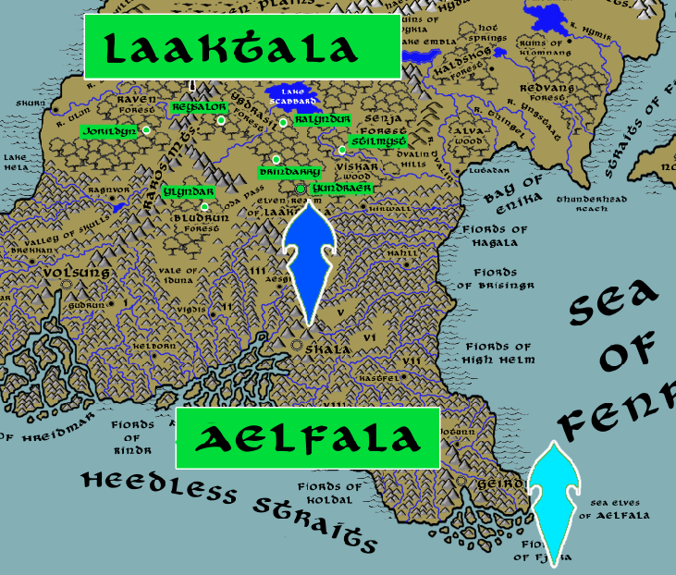
Aelfar – the sea elves dwell in the sea just outside most fjords, made up of small settlements. The largest concentrations of sea elves are at the Fjords of Fjara and the Bay of Enika. The elves of Enika wage terrible wars with the Sahuagin occupying the Straits of Fialar. The jarls and kings in the Geirodur region have a long history of conflict with the sea elves.
The many islands south of Geirdir are home to the Kingdom of Aelfala of the sea elves, whom the Norgardians call Sjóálfar. Hundreds of years ago the sailors of Geirdir fought the Sea Elves for passage out to the open sea. King Beirkuld won a decisive victory over the elves and stole the Crown of Iargwyn (250 WA4). Beirkuld took it to the great Vatnavættir sea spirit, Melkora, who watches over the Fjiords of Fjara. Gifting it to her he earned her favor and the Sjóálfar have since left the boats of men in peace. It is not unheard of for conflict to reemerge from time to time, but for the most part` the men of Gierdir leave the Elven islands alone and keep to the waterways.

Dwarves
Kingdom of Amberon – Dwarves are referred to as the sons and daughters of Dvalin in Norgarde. The Kingdom of Amberon occupies the Raros Mountain Range. The capital city is Thunderhame, upriver from the town of Skurn. Smaller towns are Horndeep, Hreidmar, and Yaramir. There are also three outposts situated at the ends of the mountain ranges where Dwarves keep a watchful eye on the lands below: Plunder Keep near Volsung, Lindwyrm Keep overlooking the Oda Pass, and Frostfang Keep at the northernmost point of the Raros Mountains.
Dwarves and Norgardians hold a grudging respect for one another. Much of their history is intertwined, both in this world and the world of the divine. Both races are rugged and value strength, battle, drink, and treasure. But it is not uncommon for tribes to look at one another with mistrust and conflict is not unheard of. Dwarves are sought out for their skill in smithing and metalwork. Humans are seen as allies in battle when other humans would shirk from danger.

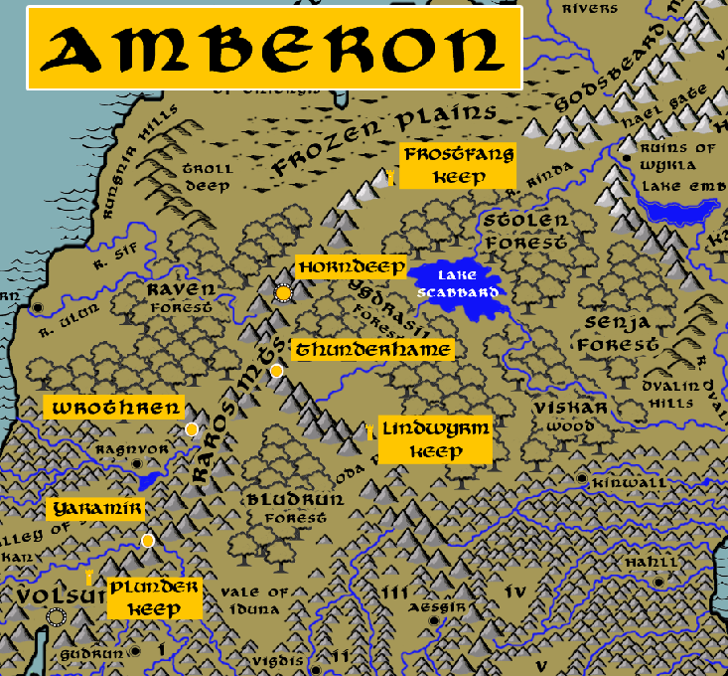

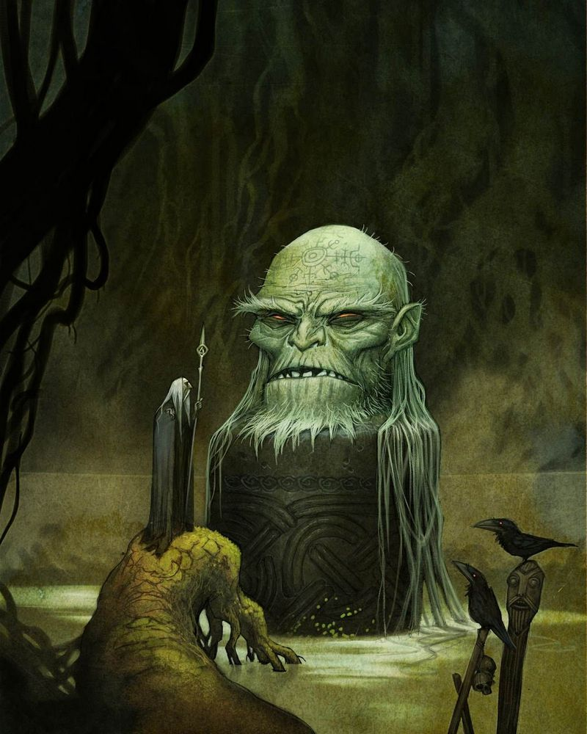
Magical Items
Archemite Shards - a three-foot-long purplish shard of crystal mounted on a stand. This is one of the rare gem stones which the most vaunted wizards use to communicate with one another. Legend tells the shards were from the eye of an elder god who was slain in the Battle of Vail. They fell from the sky and were gathered by the greatest of wizards. Now they are passed down from one master wizard to their heir (or taken by force). Kadlyn the Bone Collector, greatest wizard of Norgarde, keeps her Archemite in her tower in the Stolen Forest.

Huliðshjálmr aka Tarnhelm. A helm of Teleportation, Transformation and/or Invisibility. Once owned by Fafnir, taken by Sigurd. helm of invisibility and teleportation, each once per day; invisibility is like the spell invisibility (not Greater Invisibility) and teleportation is like the spell teleportation

Megingjörð – taken by Kord when he slew the king of the frost giants
belt grants +6 strength

Dart of the Mistletoe – used to kill a god through deception
once per day can be hurled with an automatic hit and returns to its owner
defeats magic resistance
causes 4d4+4 damage plus poison (Con save DC 20 else -8 Con)

Odrorir, Mead of Poetry - one draught, grants a Skald +4 Cha, +20 on Bardic Knowledge checks,
and inspiration to craft one song capable of +10 diplomacy

The Mead of Saga - 570 PA3 - The Mead of Saga is found in the mountains north of Skala

Vial of Fafnir - one draught, grants the one who bathes in it permanent protection
like the spell Mage Armor (+4 AC)
Mistilteinn - the magical sword of Prainn, the draugr, later owned by Hromundr Gripsson and it could never go blunt.
+2 longsword, enchanted with the Keen spell so its critical
range is 17-20 and it is a vorpal weapon

Angurvadal (Stream of Anguish), The sword was inscribed with Runic letters, which blazed in time of war, but gleamed with a dim light in time of peace.
+2 longsword that has the sun runes permanently inscribed: weapon glows and causes additional 4d6 scorching ray damage

Svalinn: A shield that protects the earth from being burned by the sun.
this version is a +2 round wooden shield inscribed with a sun emblem, the shield grants 10 damage reduction against all energy attacks

Quern-biter - sword of Haakon of Norgarde and his follower, Thoralf Skolinson the Strong, said to be sharp enough to cut through quernstones.
+2 longsword which on a roll of 20 will break whatever it strikes
Found by the shield maiden Baldvina Bracegirdle of Skurn after slaying trolls, it is said to be buried with her outside the town.

Skofnung was the sword of legendary king Hrólf Kraki. "The best of all swords that have been carried in northern lands", it was renowned for supernatural sharpness and hardness, as well as for being imbued with the spirits of the king's 12 faithful berserker bodyguards.
+2 bastard sword, critical range of 17-20, can summon 1d6 5th level barbarian warriors once per day

Bracers of Skadi – giantess who is patron of the bow
Grants +4 to Dex when firing a bow of any kind

Gungnir – spear of Kor, it hits every target automatically

Andvaranaut (Andvari's Gift), first owned by Andvari, is a magic ring that could help with finding sources of gold. The mischievous god Loki stole Andvari's treasure and the ring. In revenge, Andvari cursed the ring to bring misfortune and destruction to whoever possessed it.

Brisingamen – torc, or necklace, of Freya
Draupnir – forged by the dwarves of Norgarde, this magical ring will multiply itself into eight duplicates. Whoever is wearing the ring at the time is also duplicated. This can be done once every nine nights.
Eitr – a powerful magical poison produced by the serpents of Norgarde and especially the world serpent Jormungandr
Eldhrímnir – a powerful magic cauldron which is the only device that can slay some magical beasts from the birth of time in Norgarde, such as the Sæhrímnir, or immortal boar
Gambanteinn – a cursed relic crafted by the wizard Skirnir at the dawn of time; appears in the shape of a magic staff that carries an aura of fear; it is said to be capable of casting curses, also the ability to teleport its victims into limbo
Gjallarhorn – horn of the gods, notably Mimir god of wisdom. It is said to be able to produce waters from the roots of Ygdrasil and manifest great wisdom to those who drink from it. It is also said that the blact can be heard in all worlds. Some say if blown by one of the faithful, it can summon the attention of the gods.
Gleipnir – the unbreakable chain forged by Norgardian dwarves, it is a relic used by the gods to bind such creatures as Fenrir the wolf. It is said to be made of the sound of a cat’s football, the beard of a woman, the roots of a mountain, the sinews of a bear, the breath of a fish, and the spittle of a bird. even though Gleipnir is as thin as a silken ribbon, it is stronger than any iron chain
Helskór ("hel-shoes") are magical boots that allow the wearer to walk on water as well as flame. These are said to be made available, hanging from a tree at the entrance on the other side of life, to any just man or woman to wear to cross the stream to the other side. It is from this relic that some Norgardians place special shoes they call Helskor on the dead so that they can walk to Valhalla.
Járnglófar – iron gauntlets of divine power that grant the wearer incredible strength and protection. (These are the iron gloves of the Thunder God Thor in Norse mythology, when Thor uses these gloves together with his power belt Megingjörð it makes him twice as strong.)
Singasteinn ("singing stone" or "chanting stone")
Dainsleif is a sword made by the dwarves Dain. The sword is cursed, once drawn it must kill a man before it can be returned to the sheath. A strike from this cursed sword never failed to kill or cause a serious wound that will never heal.
Hofund is the sword of the God Heimdall
Hringhorni is the longship of the God Baldur.
Laevateinn is Loki’s magic sword
Skidbladnir is a magic ship that belonged to the Gods, made by the dwarves. Skidbladnir can hold all the Gods and their equipment, but yet it can also be folded small enough to be put in the pocket. The ship is able to sail on the water, in the air, and also overland.
- 610 AA2 - Jarl Valgerd Hallfri of Thiengis breaks the 700 year alliance with the troll kingdom; the gods send the magic longboat Skidbladnir, Hallfri and an army of priests and druids cleanse the town and region and liberate Skurn
Himmelen Talharpa "Heavens Talharpa"
This magical lyre is built in the fashion of the Norgardian talharpa. When played with a bow and accompanied by the gutteral styles of Norgardian song, it allows the musician to take control of the weather within 1 mile of you for the duration. You must be outdoors to cast this spell. Moving to a place where you don’t have a clear path to the sky ends the spell early. When you cast the spell, you change the current weather conditions. You may only create one weather effect, choosing from: rain, fog, snow, heavy winds, hail, or fair weather (which comes in handy at sea). The spell lasts for as long as you play and ends when you stop. When the spell ends, the weather gradually returns to normal. This song may be played once per day. During the song, you can cast each of the following spells one time: fog, wind wall, lightning bolt, thunder wave, and ice storm. You can only cast one spell at a time, but you can maintain the conditions caused by any one spell that has a duration.

Odhrǫrir – magic cauldron of the dwarves Fjalar and Galar, in which they collected the blood of the giant and god Kvasir and mixed honey to create the Mead of Poetry. The mead is no longer here, but the cauldron still pulses with a powerful sentience. It is located atop Mt. Kvasir on the Isle of Hrund.

Casket of Ullr – A powerful artifact, it is a small chest made of pure crystal that contains the essence of the ancient winter god Ullr. When opened, it has the power to control weather within a hundred miles, bringing frost and ruin. It sits in the treasury of the Winter King in Cold Keep to the north. It was once stolen by the thief Snækol Hämings and taken to the town of Haft, but the Winter King retrieved it nine years later and destroyed the town.

Forge of Skafta – Tales tell of tunnels in the heart of Skalfen mountain dating back to the Ancient Ages and where lies the Forge of Skafta. Swords and shields of legend hail from here:
- Hetjuhamar “Hero Hammer”
- Næturöx “Night Axe”
- Örlögsverð “Sword of Fate”

Crown of Iargwyn – a powerful relic, it is clearly the work of Elves but its origin is unknown. Rumors tell of its power over the very waves of the sea. Hundreds of years ago the sailors of Geirdir fought the Sea Elves for passage out to the open sea. King Beirkuld won a decisive victory over the elves and stole the (250 WA4). Beirkuld took it to the great Vatnavættir sea spirit, Melkora, who watches over the Fjiords of Fjara. Gifting it to her he earned her favor and the Sjóálfar have since left the boats of men in peace.

Mästermyr, a masterwork set of shipbuilding tools – In 846 PA4 - Thidrik the Shipwright traveled to the Yggdrasil Forest and received a vision of the gods to craft the Mästermyr, a masterwork set of shipbuilding tools; his work next to Scabbard Lake attracts people that come to be known as the Hegren tribes. It was once in the city of Skala but was lost to the ages. It is an incredibly powerful artifact able to craft a magical longboat capable of flight and many other abilities depending on the builder.
The Mästermyr contains a complete set of ship-building tools:
- 4 different kinds of axe
- 2 planes
- a drill
- a profile scraper
- a knife
- a chisel
- a hammer
- a rivet iron, for forging ship’s rivets.
Sun Stone of Njord – this magical chunk of ruby quartz is imbued with the ability to guide sailors flawlessly through any weather and grant any ships in the area good fortune against calamity at sea; it was once used by Hjarrandi Hagisson in 182 WA2 to inspire a fleet of Norgardian ships to dominate the middle seas of Ferrago, Inner, and Myriad Seas before being lost in battle

Amity Hammer – magic hammer gifted by the Dwarves of Amberon to Hrut, warlord chieftain of the Skanes, following the end of the War of the Caves in 30 PA3
Shield of Forseti - 887 PA3 - Kulring the Wolfhead leads a crusade of 100 ships to find the Shield of Forseti; the quest will claim the lives of every sailor but one: Hobrim Svaldur, who returns the shield to the settlement in present-day Geirdir

NPC Templates
This is a list of notes and stats to help develop NPC’s relevant to this region.

Developer Notes
Name Sources:
Fantasynamegenerators.com
Colonies: Icelandic names
Norgardian settlements:
Western – Norwegian names
Central – Viking names
Eastern – Swedish names

Notes on development:
8/9/2020 changed the following names:
Fiords that need to be renamed
Replace Fjords with Fiords
Replace Singasi with Hreidmar (Singasin with Hreidmar)
Replace Auropia with Hagala
Replace Svarda with Halsla (Svardan with Halslans)
Replace Gudrun with Koldal
Replace Geirodur with Fjara (Geirodurs with Fjaran)

Pronunciation of Nordic characters
https://guidetoiceland.is/history-culture/the-difficult-icelandic-language
There are 32 letters in the Icelandic alphabet. Notice that there’s no C, no Q, no W, and no Z. All of the regular vowels (A, E, I, O, U and Y) have identical Icelandic vowels with a comma over them. This comma is not an accent but signifies a different vowel with a different sound.

In addition, the Icelandic alphabet has the vowels Æ and Ö. So, in total, there are 14 vowels in the Icelandic alphabet and 18 consonants.

Most letters sound the same in Icelandic as they do in English, but I will list the pronunciation of the odd ones out.

Ð – ð: This letter that looks like a D with a line through it when it’s a capital letter is sometimes confused for an Ó when it’s in lowercase. In fact, this letter sounds identical to TH in the word “the,” “they,” or “then.”

G – g: The letter G is identical to the English G in some words, such as “golf” (golf), “gata” (street), or “gefa” (give). Sometimes, there’s a soft pronunciation of the letter G, such as in “vegur” (way/road) or “skógur” (forest). This soft G is similar to G in the English words “thing,” “design,” or “campaign.”

H – h: The H is pronounced like a regular H in English – EXCEPT when it’s combined with a V, then it sounds like a K. This happens for example in all of our question words: “hvað:” kvath (what), “hver:” kver (who – or hot spring), “hvenær:” kven-I-r (when), “hvernig:” kvernig (how), “af hverju:” af kveryu (why).

J – j: The letter J presents people with some difficulties. It’s not hard to pronounce – but the pronunciation is not the same as English. The Icelandic J is pronounced like the English Y. A great example is “jójó” (yo-yo), that’s pronounced the same way. “Jól” (yule/Christmas) and “eyja” (island) are pronounced as “yol” and “A-ya.” The English word “jazz” is pronounced “djass” in Icelandic.
L – l: A regular L is pronounced the same as an L in English. The trouble starts when there’s a double L, such as in the word “jökull” (glacier). The double L has a slight click sound and can best be described as pronouncing it as TL (so, yökutl – more on Ö later).

R – r: The R in Icelandic is rolled. You can get away with rolling it just a little bit, but if you can roll it properly, you’ll be able to pronounce “Reykjavík:” RAkyaveek (smoky bay) like a local.

V – v: The letter V is pronounced like V in English or like a W. There’s no W in Icelandic, and most of the time, Icelanders won’t hear the difference between V and W. You can have fun with that. Ask them to talk about videos, VCRs, and other words beginning with a V in English.

Þ – þ: The famous Icelandic Þ. Þ appears in many words, most notably in “Þingvellir” (parliament fields) on the Golden Circle. This is NOT a P, so please don’t ever pronounce Þingvellir as Pingvellir. Or write it down like that. Þ is pronounced like TH in the word “thing” or “think,” and an acceptable way to write Þingvellir if you have no Þ in your keyboard is Thingvellir.

Æ – æ: Simply, Æ is pronounced like an uppercase I. Always. You can also remember it as sounding like YE in the word “bye” (bæ).

Ö – ö: Ö is different from O (pronounced like O in the English word “ought” or “fought”) and Ó (pronounced like the English O in “oh” or “over”). Ö is pronounced like U in the word “urn,” “murmur,” or “under.”

Additionally, the combination of a couple of letters makes them sound different.

These combinations are:

Au: When A is combined with U (AU), it’s pronounced differently. I can’t think of an example of it occurring in English, but it kind of sounds like a combination of Ö+I (öi).

Ei / Ey: The combination of E and I (EI) or of E and Y (EY) sound the same. And it’s pronounced like a capital A. Or AY in the word “way.” An Icelandic example is “eyja:” A-ya (island).

