Introduction to Nemmyrl
A campaign world and playground for the imagination
The world of Nemmyrl is ancient beyond reckoning. Seven continents and a hundred islands remain as mute testament to the gods who forged this land eons ago. Now is the Fourth Written Age, a time when endless bloodshed and catastrophes have given way to the height of civilization. But darkness, ever hungering, threatens to reclaim its place and snuff out the feeble works of men.
Find here, a reckoning of the continents as told by Agringetorix the wandering wizard…
Norgarde: frozen lands at the top of the world. There dwell the north men, barbarians borne of old gods, ever eager for battle, masters of the sea. Three tribes battle from fiord to fiord, pausing only to raid the lands to the south. Here frost giants and trolls lay low a people wrought hard by the elements, yet only serve to stoke the fury of the north-men.
Amadar: largest of all continents and spanning the breadth of the world. Its western arm hosts the four sovereign kingdoms who bicker while a darkness grows on their doorstep. To the center, the sprawling lands of the Oberon Sea, home to storied kingdoms millennia ago but now a chaotic miasma of savage creatures with only the Hyderian riders to contain them. And at Amadar’s eastward arm, the wild forests of the noble Haka’Na nomadic people who sup with the spirits of nature and wish only to safeguard their lands.
Arnland: home of empires from the dawn of man. To the west, the ruined lands of Celedon, whose armies once ruled half the world and brought the light of civilization. At the center, the vast sands of the Tarbian desert and its seven Jeweled Cities. And to the east, the city states of Mythenia, home to the first philosophers, warrior poets, and musicians who even now hear from the gods.
Gaeadon: at the center of the world, by far the wildest and most chaotic of all lands. Here a mighty broken mountain range divides the continent and disgorges molten rivers of flame. Surrounding the mountains lie the gentrified kingdom of Kyre to the north, the enchanted land of Adhanar home of the fay to the west, and the scattered sea towns of Barter Bay to the north-east. South of the mountains lies the blasted wastelands of the Kazeldun war chieftains.
Xiandai: the gateway to the east, birthplace of dragons, home to heavenly magic borne of monasteries. Here empires rule with equal parts might and tranquility. North of the serpentine Ryuluun Mountains, two emperors scheme to make the land their own. But south of the mountains lie the deserts and plains of the nomadic Moghun warlords bent on destruction.
Katura: the farthest east of all lands and first to greet the rising sun. To the north lie the austere Sakurans, bound to honor and their rigid traditions, where warfare is an art form and death is as important as life. South of this, the Pajra jungle and the Mahabar people. Tested by the gods and their monsoons, the people endure and conjure spices and aromatics that are sought the world over.
Kaduru: the hot and untamed southerly lands, covered in jungles and plains filled with the most exotic of beasts. Here four regal kingdoms stand at the four points of the compass, unafraid in the face of the savage wilderness, embracing the spirits of beasts as man was meant to do, and raising their voices in celebration of life. Their war drums shake the ground and their masks strike fear in the hearts of the jungles that seek to vanquish them.
The Maelstrom: Hearken to the tale of Matu Matu, resplendent kingdom aloft on the seas, lost in the Primordial Ages as man first tempted the gods and fell to calamity. The magical land sank and is no more. Now the site of a ravenous vortex, drinking the ocean and all who dare venture too near its watery maw. A half a hundred small islands remain, laid out in a spiral that marks the course of the waters. It is the only headstone to commemorate the most powerful people brought to ruin. Each island a relic of magic preserved as if trapped in amber, though few dare to venture close enough to claim their treasures.

Nemmyrl began as a custom campaign world for my 3.5e Dungeons and Dragons gaming group. What started as a small duchy called Kendor soon expanded to a multi-continent world as my mind yearned to explore various cultures from real-world history and a develop to a scale that allowed characters to travel to far-off lands. Just as traditional D&D tends to mine medieval European folklore for adventure tropes, this world does the same for the rest of the world. I won’t pretend it is a perfect structure, but it makes a real attempt to give players and DM’s a giant playground to explore with just enough structure for them to construct epic level adventures.
This document is meant to describe the architecture of supporting files that make up the Nemmyrl story world.
Basic Anatomy of Support Documents
- Geography – the basics of the world and its regions (maps)
- Documents on the Lands – atlases and how they describe the regions (Atlases)
- Maps – world maps used as a visual directory of where resources, sites, and races are located (maps)
- History – how twelve thousand years of history are chronicled and cross-referenced (History Timeline)
- Persons, Places, and Things – a directory of colorful powers that influence each region (Powers document)
- Conclusion – a summary of what this document is used for and where to go from here

Geography
World Maps
- World Map 1 - Plain
- World Map 2 - Scale, Equator, Arctic Line
- World Map 3 - Continents
- World Map 4 - Regions

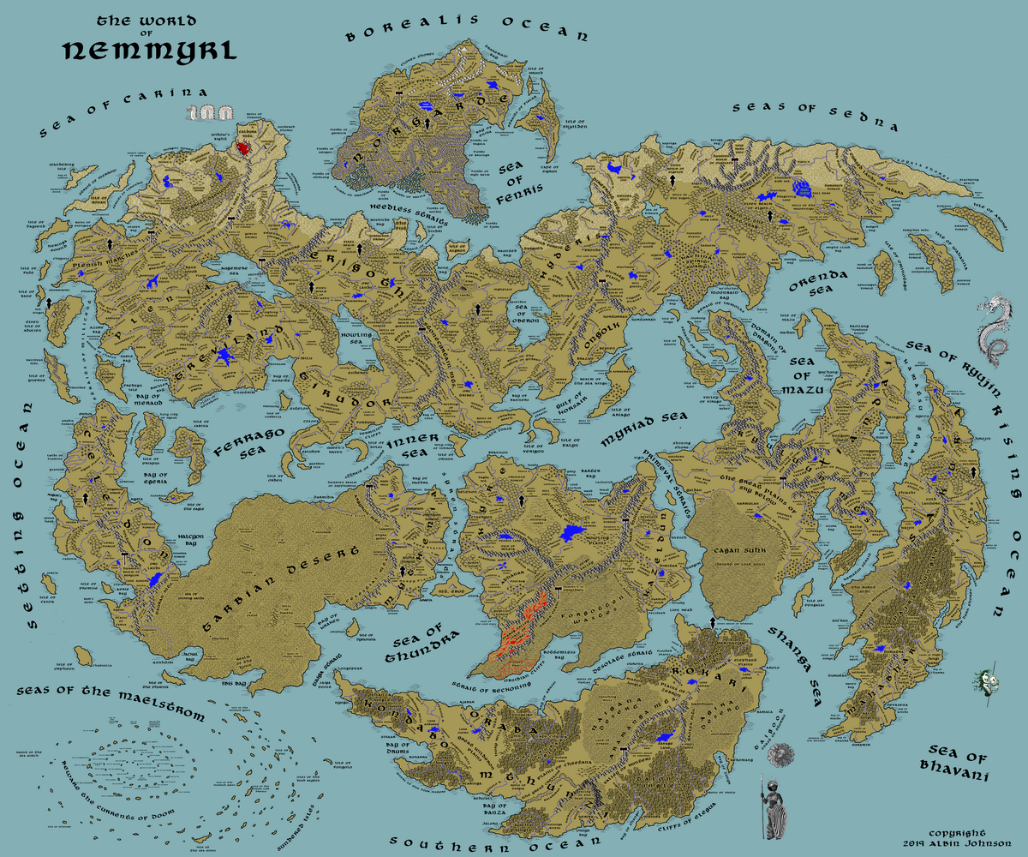
Map 1. World Map

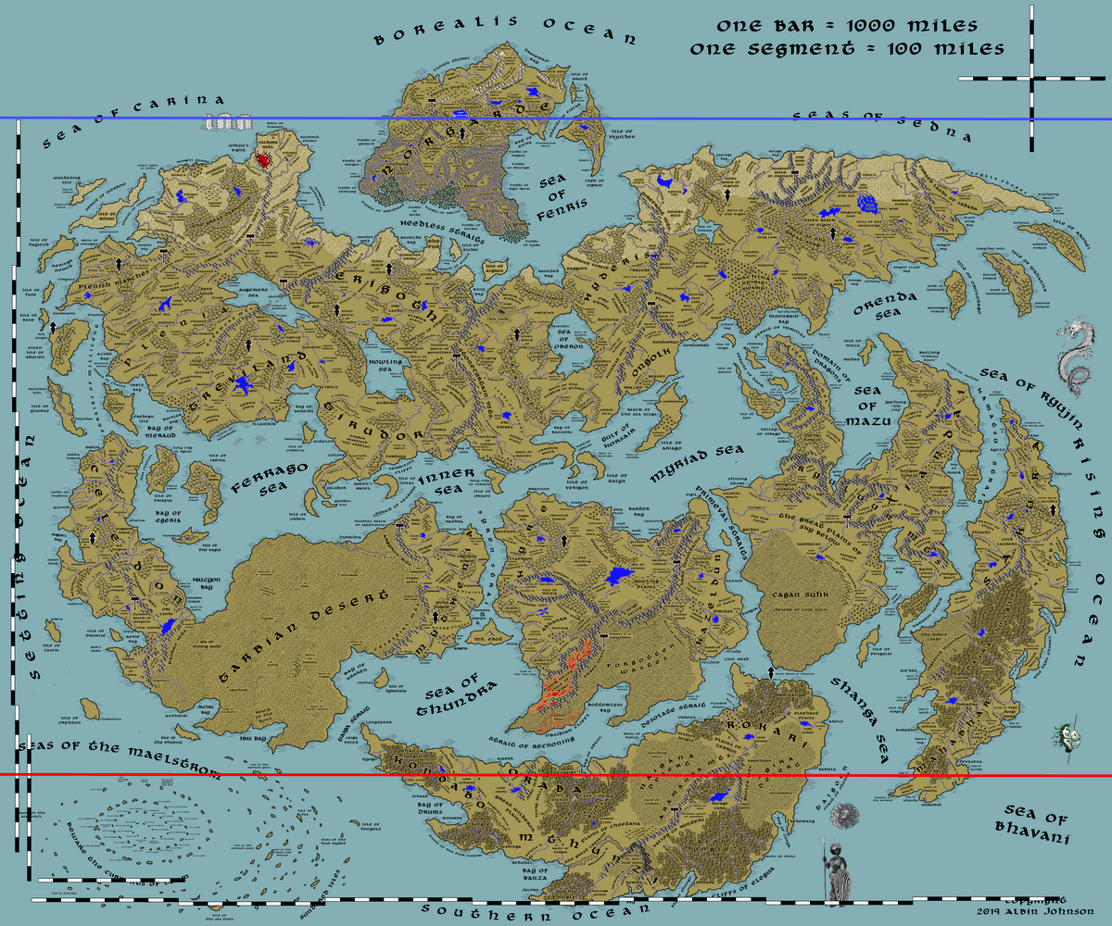
Map 2. World map showing scale, equator (in red)and arctic line (in blue)
Nemmyrl covers an area of roughly six thousand miles north-south by seven thousand miles east-west. A blue horizontal band marks the arctic line, though regions just below this line can be seen to be populated with year-round ground frost. A red horizontal band marks the world’s equator, giving an indication of what areas are the tropical. These are generalized regions to indicate the relative temperatures and environments of the regions.

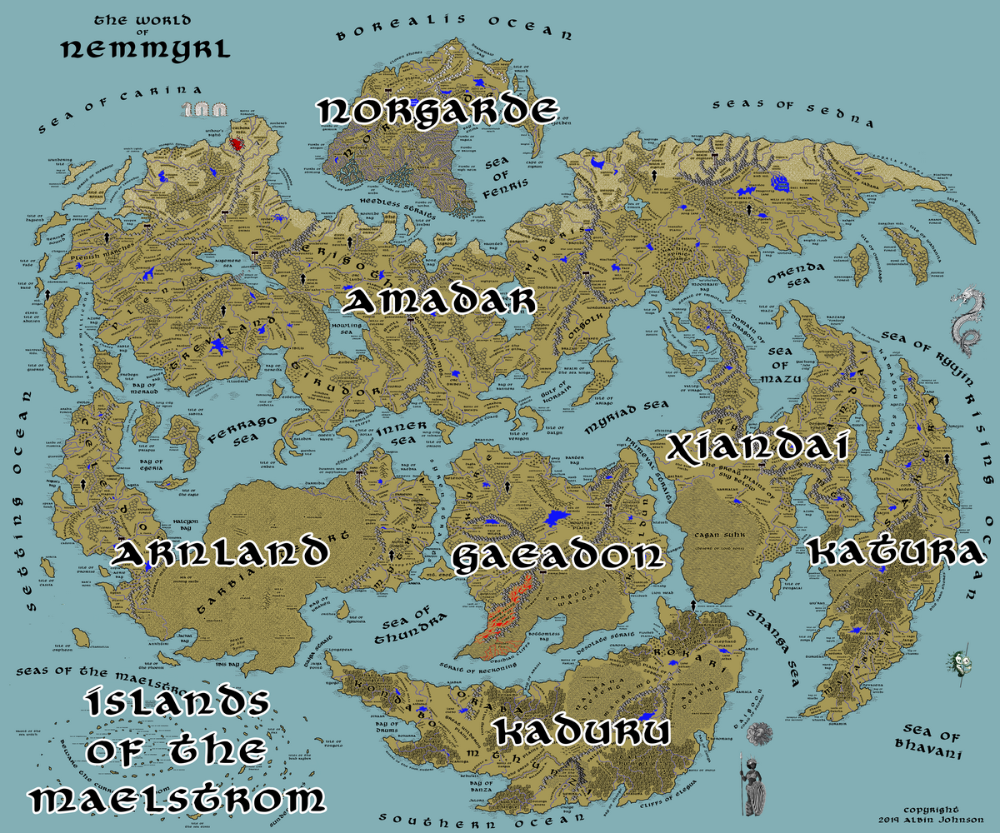
Map 3. The Seven Continents
Nemmyrl is composed of seven continents, one of which sank millennia ago and resulted in an archipelago of islands.

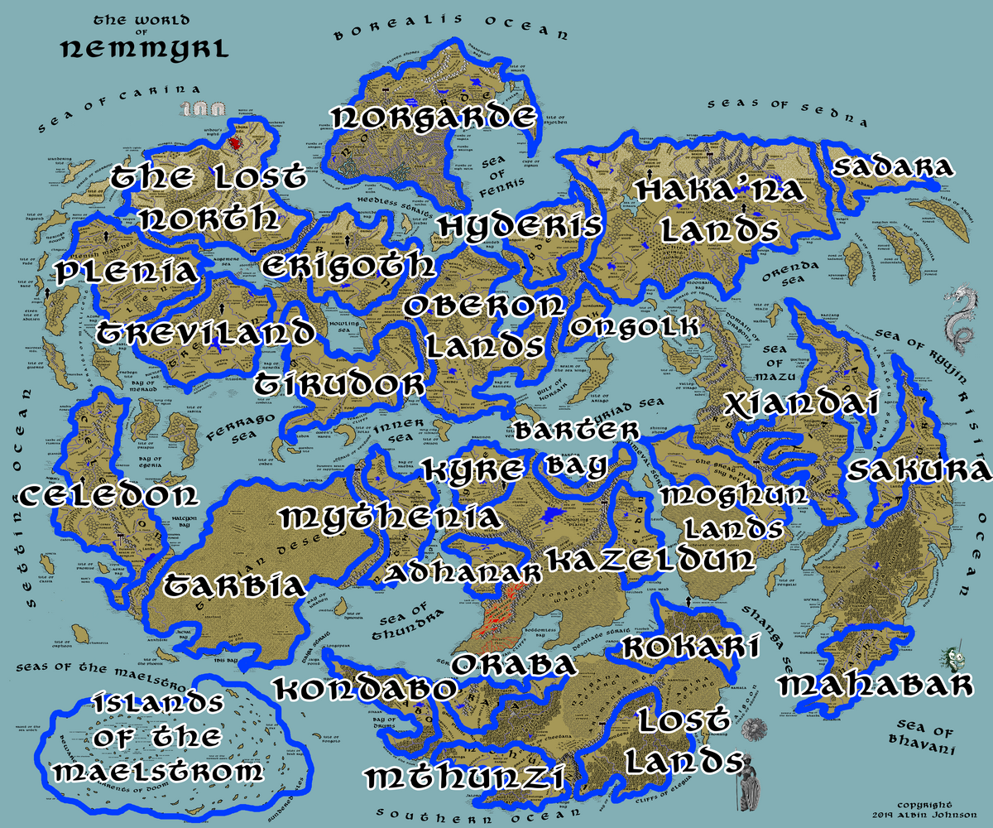
Map 4. World Map of Regions
The seven continents can be broken down into twenty-eight different regions that each have their own distinct identity. Some of these regions are declared kingdoms of men, although truthfully humans only control a fraction of these lands. Some of these regions were once kingdoms of men but have since collapsed and fallen to chaotic forces.

Documents on the Lands
Each of these twenty-eight lands is described in its own document called an Atlas. There are also Atlases for each of the Elven Domains and Dwarven Kingdoms.
All towns and cities are tracked in a central spreadsheet named “_Nemmyrl.Towns.and.Cities.” This spreadsheet tracks the trade goods generated by each town/city, a master list of land features to keep track of all the proper names for locations, and a tab detailing the Elven domains and Dwarven kingdoms.
Each Atlas contains the following sections:
- Overview – a brief description of the region
- Towns and Cities – a list of human settlements and information on each
  - Size: (from small towns to metropolises as detailed in 3.5e DMG)
  - Trade Goods: goods that command value enough to be traded with other lands
  - Local Goods: goods that are unique to here and noteworthy
  - Standard: heraldic symbol used by this town/city to represent it
  - Colors: heraldic colors used by this town/city to represent it
  - Patron Deity: a deity tied to the local history and culture that many locals hold to
  - Ruler: the ruling person or body that commands power in this town/city/kingdom/region
  - Home: the traditional castle/keep/palace of the ruler
  - Steward:
  - Marshal:
  - House Priest:
  - House Adviser (Scholar/Mage/etc):
  - Captain of the Guard:
  - Chief Warriors in Service:
  - Local Powers: (these are tied to various people, places, or things in the Directory of Powers)
  - Local Sites: (these are tied to various people, places, or things in the Directory of Powers)
  - Description: A description of the town/city, its appearance, prominent features, local attitude.
  - Industry: This details what Trade Goods or Local Goods are produced or harvested here. It also includes any
  - Key Figures: This lists major characters who play a prominent role in this town/city/region
  - Local Lore: This lists any creatures or magical features in this town/city/region
  - History: This lists items from the World History Timeline and may go into more detail to describe major events that have happened here.
  - Customs: This lists any unique traditions or customs practiced by the locals.
- Best in the Land – a brief synopsis of goods and services that are the hallmark of this region
- Points of Interest – a list of geographical locations and notes about them
- History – a condensed timeline of major events that occurred here during the entire history of the world
- Local Goods – a list of foods, flora, fauna, and other features unique to this region
  - Cereals
  - Fiber
  - Fruits
  - Meat and Poultry
  - Nuts
  - Vegetables
  - Herbs
  - Oils
  - Fermented Drink
  - Salt-water Fish
  - Fresh-water Fish
  - Wood
  - Textiles
  - Local Dishes
- Notes on Culture – a description of life here among humans including their customs, clothing, architecture, etc
- Local Deities – a list of deities worshipped in this region
- Creatures – a list of creatures unique to this region
- Magical Items – a list of magic items that are reputed to exist in this region
- NPC Templates – a list of templates for how NPC’s should be equipped in this region based on favored armor, weapons, and skills
- Developer Notes – a list of notes I’ve made from research or changes made to this region over its development

Maps
The world map has multiple layers available to illustrate the location of resources, populations, and points of interest:
- World Map 5 - Agricultural Trade Goods
- World Map 6 - Mined Trade Goods
- World Map 7 - Precious Resources
- World Map 8 - Important Sites
- World Map 9 - Trade Hubs, Merchant Companies, and Trade Routes
- World Map 10 - Pirates
- World Map 11 - Elven Domains
- World Map 12 - Dwarven Kingdoms
- World Map 13 – Dragons

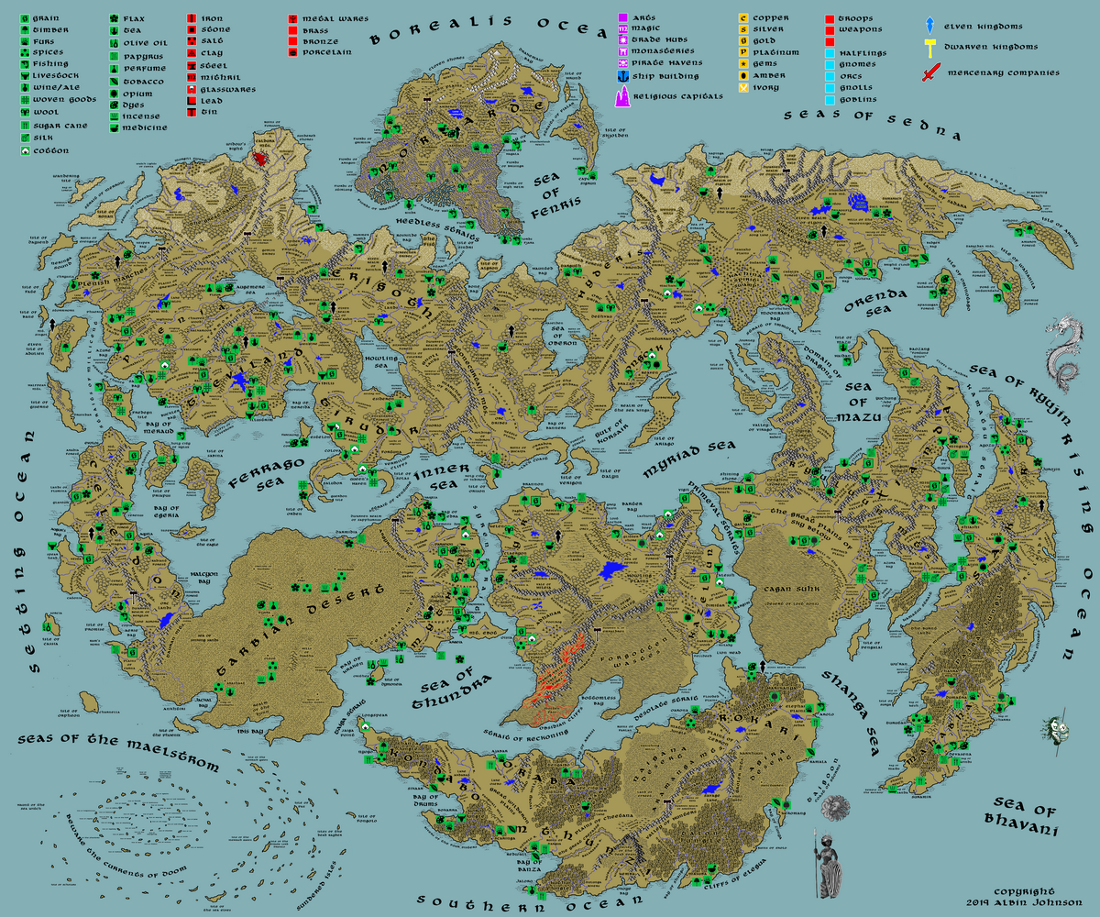
Map 5. Agricultural Trade Goods
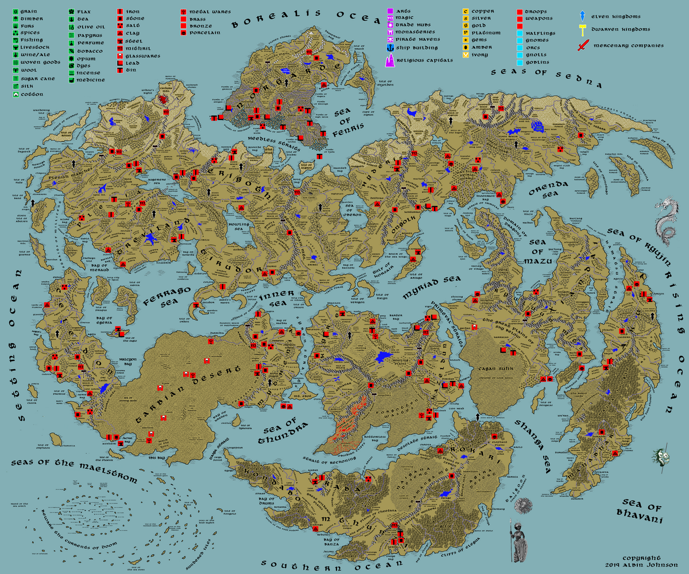
Map 6. Mined Trade Goods
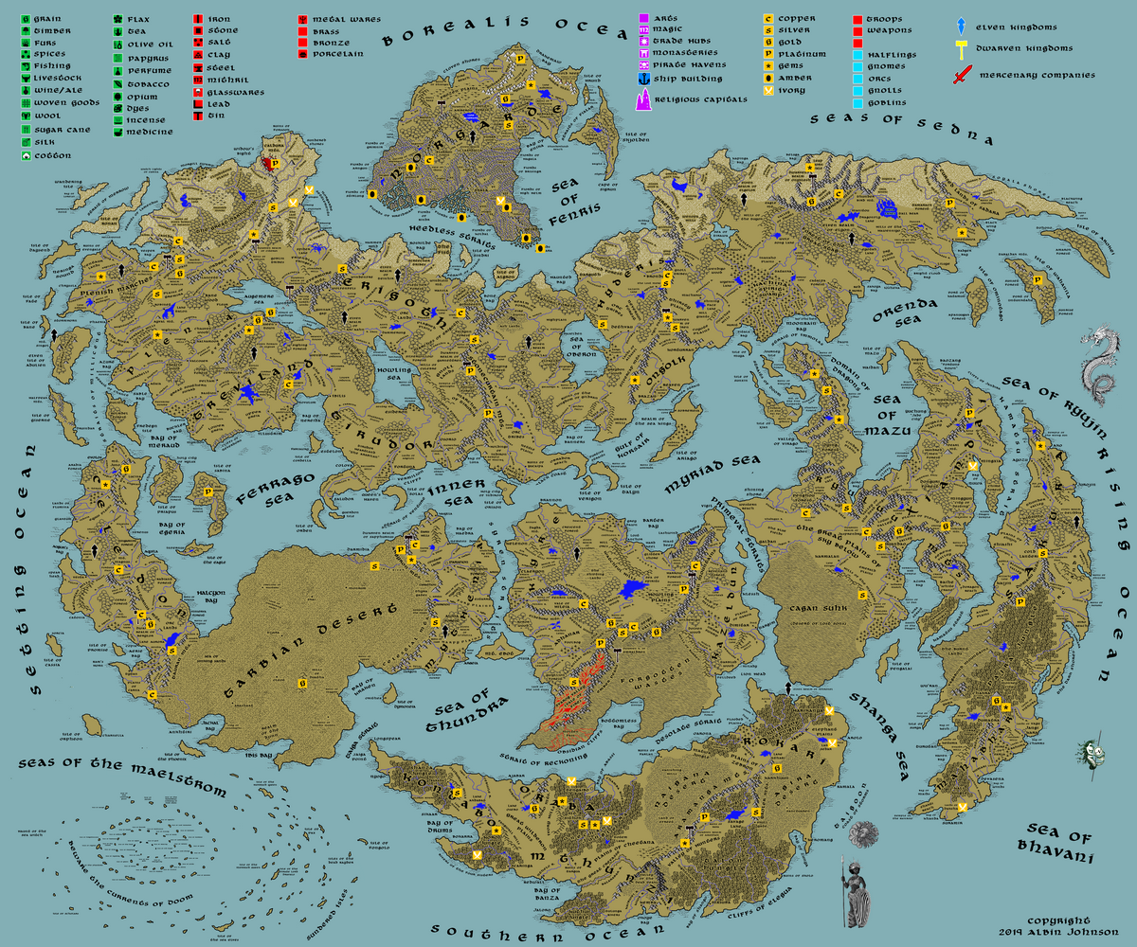
Map 7. Mined Precious Stones and Minerals

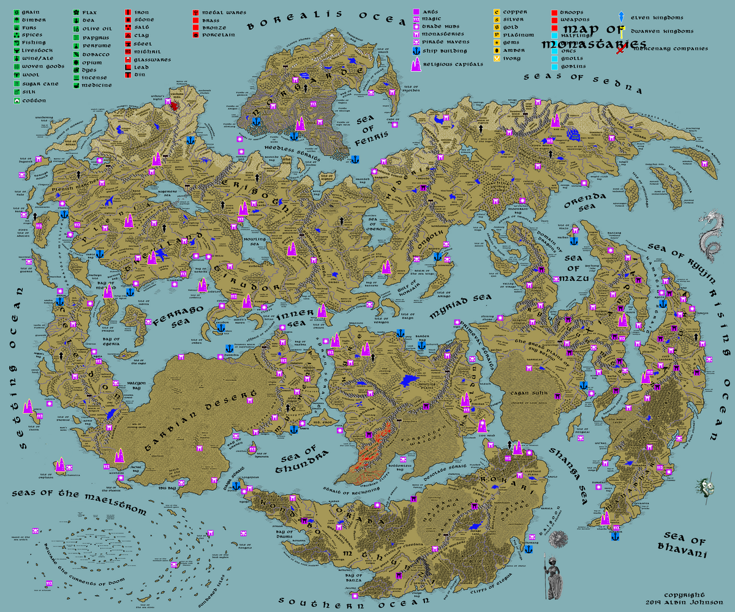
Map 8. Important Sites

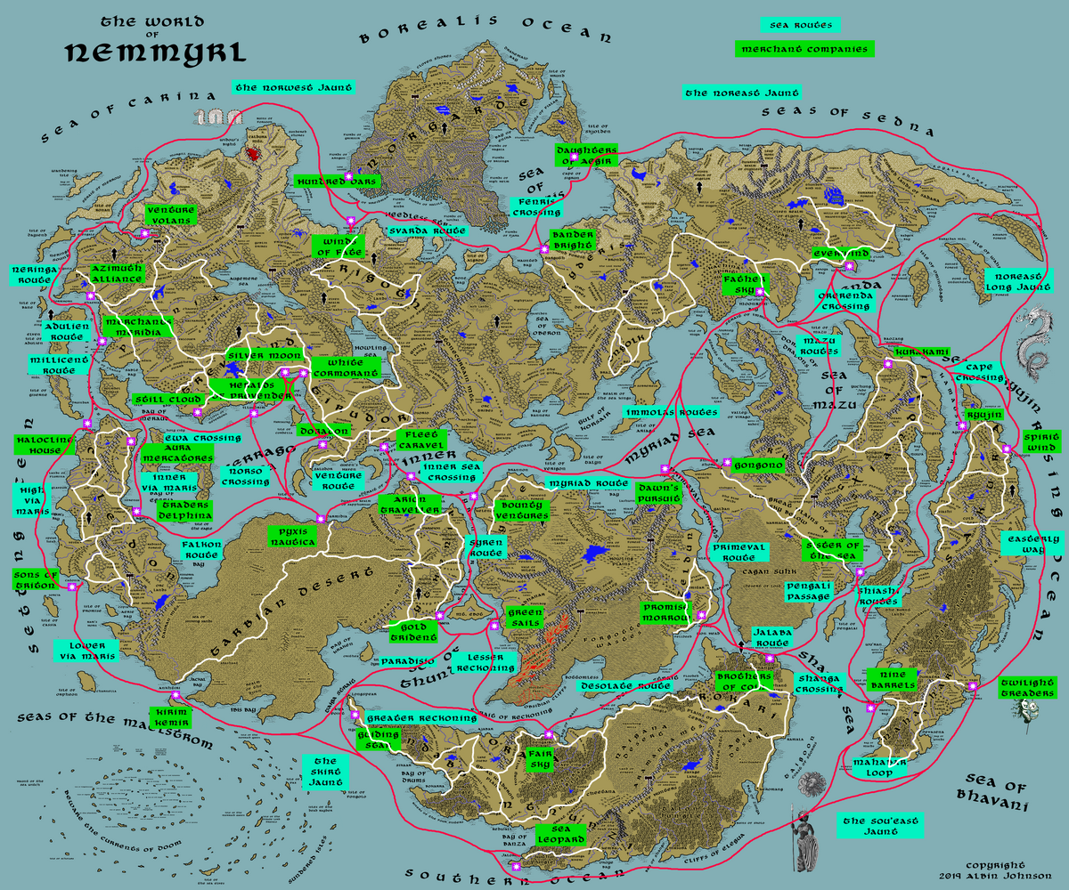
Map 9. Trade Hubs, Merchant Companies, and Trade Routes (land and sea)

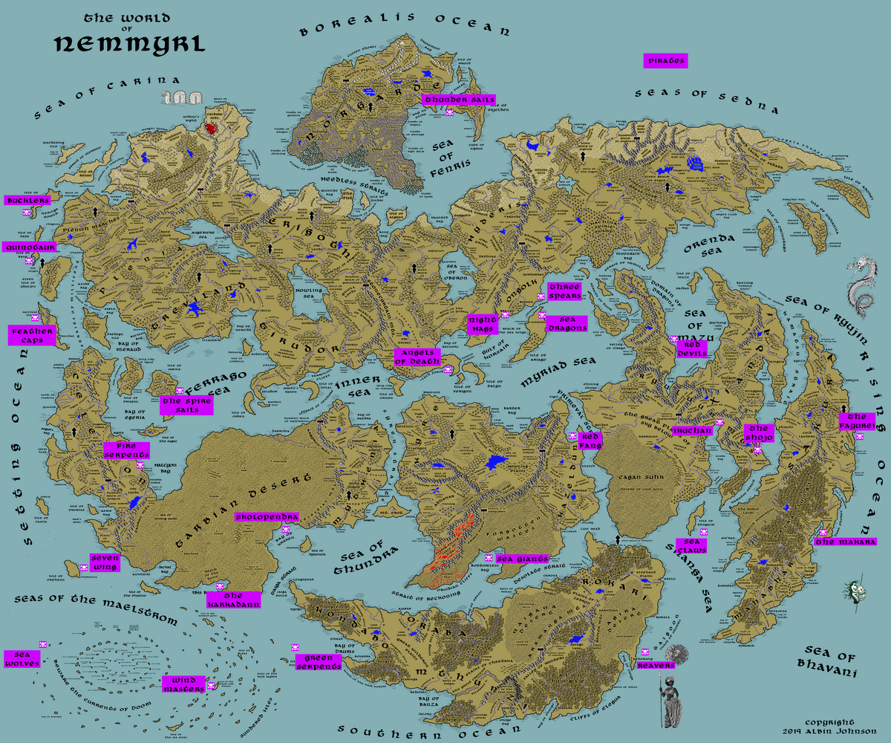
Map 10. Known Pirates

Dwarves and Elves have their place in Nemmyrl. The Dwarves reside beneath mountains, content to mine and explore a vast subterranean world many times the size of the surface. The Elves dwell mostly in the forest lands, content to stay apart from mankind and closer to nature.

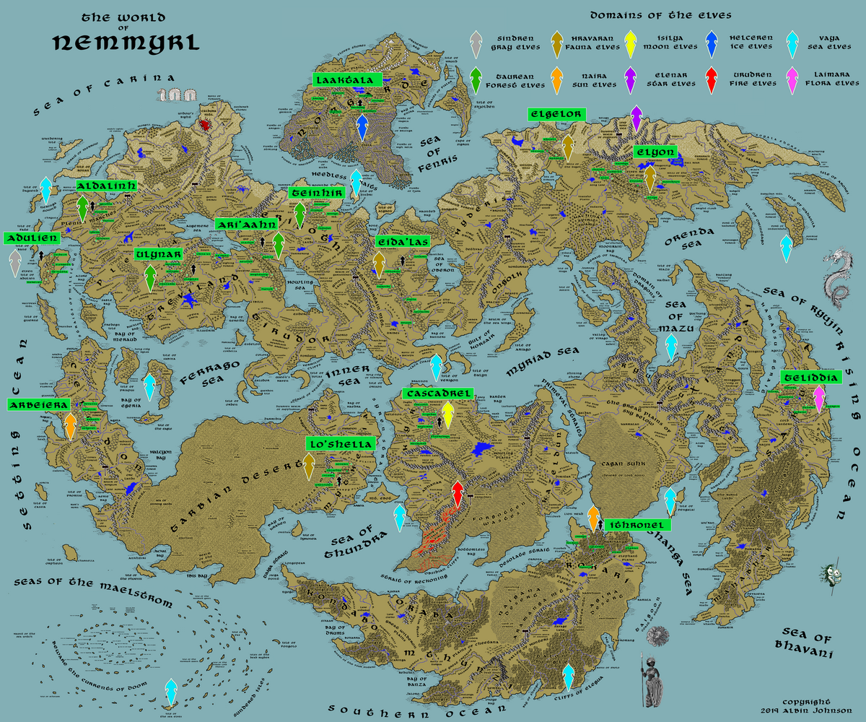
Map 11. The Many Races of Elves and their Domains

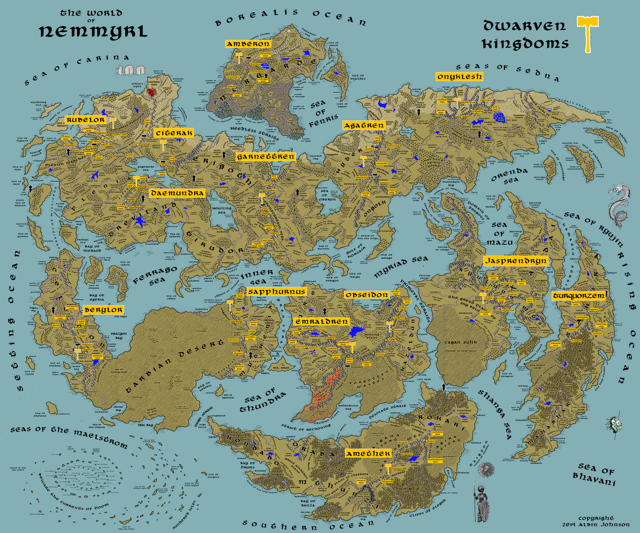
Map 12. The Fourteen Kingdoms of the Dwarves

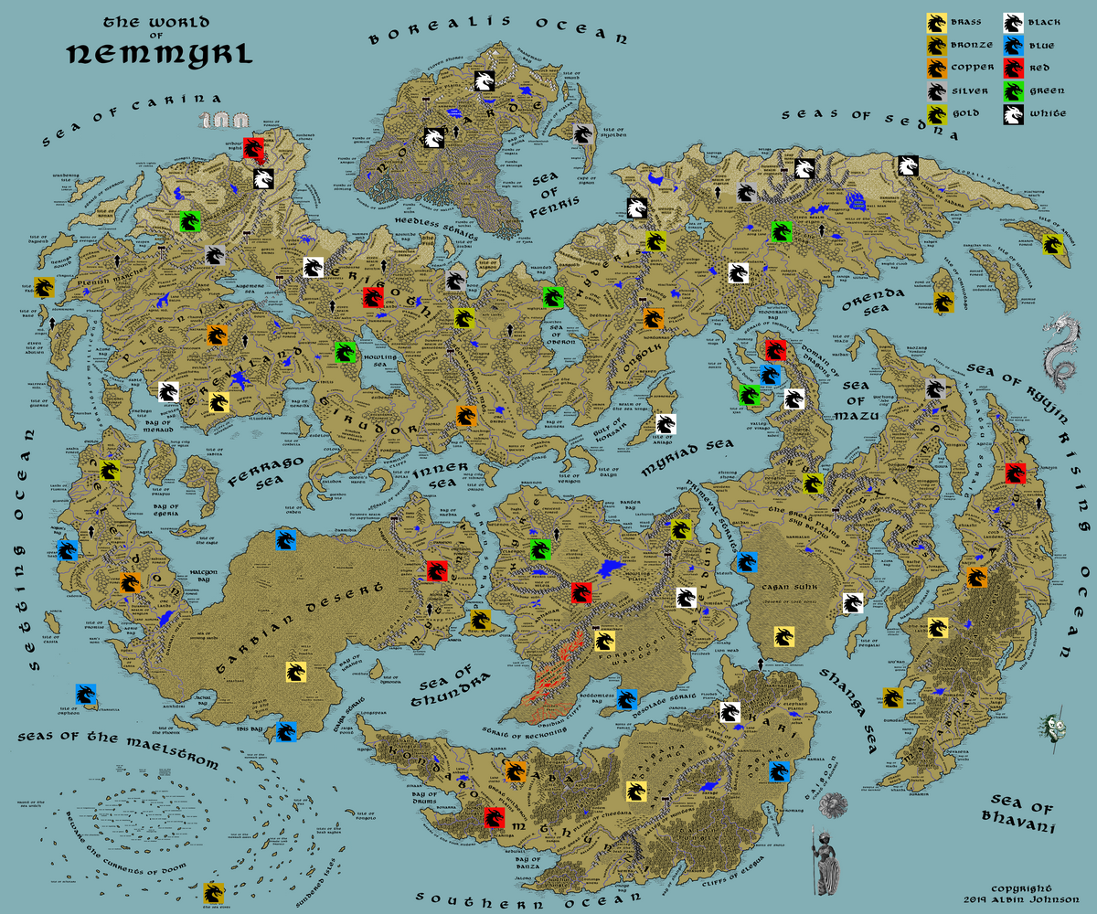
Map 13. Known Dragons of Nemmyrl

History
The history of Nemmyrl is for the most part a murky mystery to most who live in the world. The average person can only recall the events of the last hundred years or so, usually organized around a ruler’s span of reign. They might even know a few old legends. But the true history of the world is known to only a handful of scholars, the caretakers of the ancient Library of Sargon, and the elves of Adulien. This history is known as the Adulien Calendar, the world’s oldest and most complete set of accounts, and named for the elves who began it millennia ago.
The Adulien Calendar marks the beginning of known history at almost twelve thousand years ago. It begins with the cosmic battle of the gods described in the Song of Vail. The Battle of Vail destroyed the old world and ushered in the current world. Anything predating this time is considered the "Lost Ages" and almost nothing is known about it.
Three major epochs have transpired since the Battle of Vail: the Primordial Ages, marked by primitive tribes of men, wildly unstable magic, and acts by the gods on the world; the Ancient Ages, marked by fledgling empires grappling with the forces of chaos and artifacts being wielded; and the Written Ages, marked by coalescing civilizations battling with one another over innovations and new concepts that bring order and relative safety.
Within each of the major epochs the Adulien Calendar details four one-thousand-year ages. Each Age begins with a numerical zero-year and counts to year 1000, at which time the calendar resets to year zero for the next age. Years are annotated as follows: 300 PA1 would be the year 300 in the First Primordial Age (the first one thousand years), 810 AA3 would be the 810th year in the Third Ancient Age, 484 WA3 would be the year 484 in the Third Written Age, and so on. Sometimes the Ages are referred to by names that describes some significant trend of that period of history.
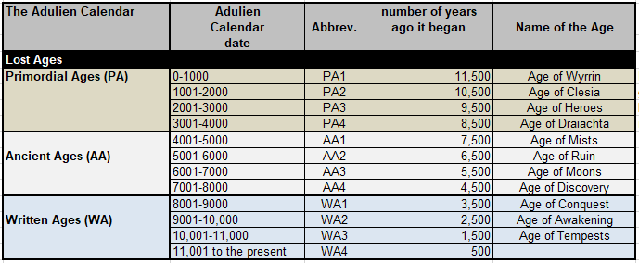
The entire course of historical events from the Adulien Calendar is detailed in the Excel file “0.4.Nemmyrl.World.History.Timeline.xlsx”
Persons, Places, and Things
In addition to creating maps and descriptions of the places, I have created a directory of important adventure-related people, places, and things that would help populate the world with intrigue. This directory is a spreadsheet called “0.3.Nemmyrl.Powers.xlsx” and is cross-referenced with the individual Atlases and each of the Town and City Descriptions. Below are the categories covered for each town or city in the Nemmyrl Powers directory:
- Taverns & Inns
- Merchant Companies
- Mercenary Companies
- Thieves' Guilds
- Smuggling Rings
- Shrines, Lodges, Cathedrals, Temples
- Orders of Paladins
- Circles of Druids
- Bands of Rangers
- Sanctums of Magic
- Assassins Guilds
- Cults
- Bardic Colleges
- Warrior Academies
- Other Guilds (Artisans)
- Brothels
- Spirits, Concoctions, and Aromatics
- Epic Creatures
- Mundane Creatures
- Patron Deities

Separate sections within this directory detail the following and are also cross-linked with the individual Atlases and the Town and City Descriptions.
- Monastaries
- Dragons
- Pirates
- Trade Routes
- Constructs: Each land or kingdom is defined by a matrix of magic created by the gods at the dawn of time. This system of interwoven magic is called a Construct and was created to grant the land magical harmony and prosperity. Each Construct is tied to a network of special locations, items, sites, or even figures that keep the land in balance. These Constructs are almost completely unknown, lost in the wash of time, but they are referred to cryptically by lore masters and wizards as describing the balance of the land. There are Terra Constructs, which are tied to a single land or kingdom, and there are World Constructs, which encompass globe-spanning powers beyond the imagination. The former are quest hooks for mid-level characters while the latter are ideal for high-level characters.
  - A very few determined and powerful wizards or clerics have been known to undergo extreme measures to decipher these Constructs and learn how to manipulate them. Manipulation of these ancient systems is fraught with peril but promise enormous power in the most unlikely of circumstances. There are often cycles of time tied to these Constructs that offer windows, however brief, to alter the system, extract a magical effect, alter destiny, or even allow the Construct to be undone. Tales tell of tragic figures seeking power beyond their right and inviting doom on their lands. Often times there are unlikely figures who are thrust into the narrative, forced to help rectify these misdeeds. Some call them heroes.

Conclusion
This document does not cover in detail the countless features that inform a mythological world. It serves as a directory for what documents make up Nemmyrl and how they are organized. It is recommended that the reader begin with the world map, pick one of the regions to read more about, and start with that region’s Atlas. Each region’s Atlas should have all the information necessary to know about its people, creatures, geography, history, and magical sites. The meta-documents (Towns & Cities, Powers, History Timeline, World Map, etc) are there to track development as well as reference for the DM who wants to see how everything is connected. The default starting location for most adventures is the kingdom of Treviland in Western Amadar. This kingdom is based on Anglo-Saxon England and an ideal place for a conventional Western European fantasy campaign. Of course, any region of Nemmyrl is ready for a fantasy campaign but the DM should do some research on the culture, background, and flavor of the region to modify how the player characters will be equipped and what adventures they will engage.

