**D&D Classes – Sakura Templates**

The regular player classes are also present in the Sakura region. However, they take on different cultural tones based on the land. Below are the terms used locally to describe these classes. This document lists in detail what each of these classes represent in the Sakuran culture as well as their unique abilities and motivations.

* Barbarian – Yaban “savages”
* Bard – Kabuki – classically trained performers of the aristocracy
* Cleric – Gukashu “scholarly monks”
* Druid – Matsuri – those who walk the way of the Kami
* Fighter – Ronin “masterless warriors”
* Monk – Akuso “rowdy monks”
* Ranger – Shinkai “walkers of the invisible realm”
* Rogue – Bandits
* Paladin – Samurai – honor-bound warriors driven by divine purpose
* Sorcerer – Shingon – those who embody the raw power of the Shingon form of magic
* Wizard – Onmyōdō – those who study the power of Shingon form of magic

**Barbarian** 

Barbarians are wild people from the hills and plains and are despised and feared by farmers and town folk. They look to stones as sacred objects of worship, containing the spirits of Kami. These are called **Ishigami** and are believed to grow over time and even produce child stones (**koishgami**). Barbarians are able to speak to these stones and tap into their power. Some have even been known to summon the very stones to aid them.

Barbarians retain all traits of the normal barbarian class. In addition, they obtain:

* Cast Summon Earth Elemental once per day (levels 1-5: small; levels 7-13: medium; levels 14-20: large).
* Cast Speak with Stone once per day
* Cast Stoneskin once per day
* Cast Stone Shape once per day

**Honor Objective**: winning any one-on-one combat against an equal or greater opponent earns you Honor points (DM’s discretion based on the battle); losing or turning down a fight or suffering an insult loses Honor points (DM’s discretion)

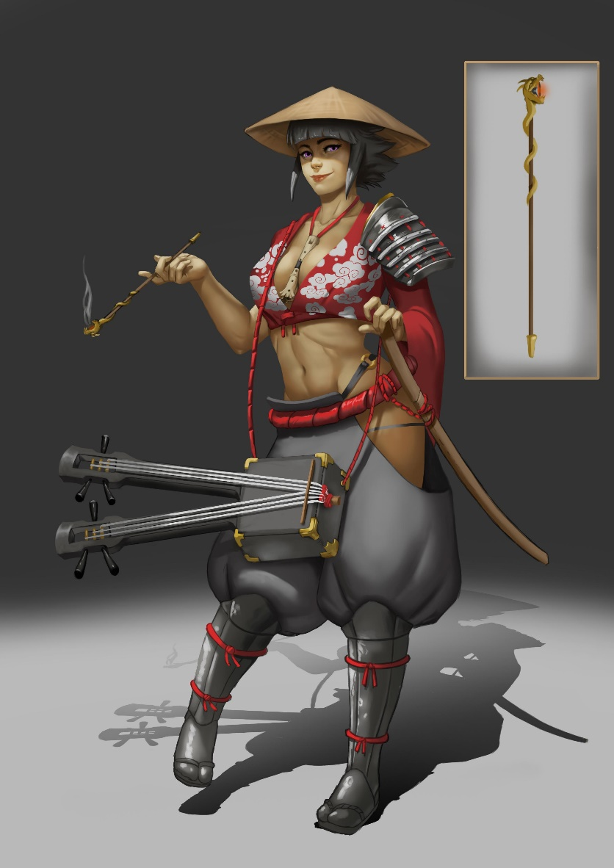**Bard**

Performers in Sakura hold the title of Kabuki. They hold incredible power and influence. They wear the finest clothes, know every ritual and ceremony, and are masters of disguise. A properly trained kabuki will know all five schools of performance: theater, dance, song, poetry, and instruments. Kabuki are highly regarded everywhere they go and allowed passage even into noble courts. They are masters of the tea ceremony, which is considered a religious ritual unto itself.

Kabuki retain all traits of the normal bard class. In addition, they obtain:

* Diplomacy 2 ranks per level
* Bluff 2 ranks per level
* Perform (dance) 2 ranks per level
* Perform (song) 2 ranks per level
* Perform (instrument) 2 ranks per level
* Perform (acting) 2 ranks per level
* Perform (poetry) 2 ranks per level
* Disguise 3 ranks per level
* **Shrine of Glory** - Cast Leomund’s Secure Shelter once/day: this is a gorgeously appointed dwelling furnished with luxurious mats and pillows, artwork, find food and drink, costumes, musical instruments, and a formal tea ceremony setting
* **Flow of Benzai** – Once per day the Kabuki Bard can channel the power of the Benzai, goddess of everything that flows (words, knowledge, eloquence, and music). The Kabuki Bard takes on an overpowering radiance, causing anyone within a 120’ radius to become enthralled and amazed. Any performance made during the 5 minutes this lasts gains +20 to success rolls. Any Diplomacy rolls following the performance to anyone who was in attendance is also modified by +20.
* **Tea Ceremony** – Once per day the Kabuki Bard can perform the Tea Ceremony, a ritual performed by all members of Sakuran society. However, this ceremony radiates magical power and is revered by all who observe the ritual. It is particularly useful when courting nobility or brokering sensitive negotiations.

**Honor Objectives**: Winning over an audience, persuading a noble to gain favor, talking their way out of a fight, successfully fooling others with a disguise, all can earn Honor points. A successful Tea Ceremony wins double Honor points (DM’s discretion). Failing a performance, gaining the ire of a noble, being forced to fight, and being caught in disguise, all lose Honor points. A failed Tea Ceremony is catastrophic and loses all Honor points.

**Cleric** 

**Gukashu** are scholarly monks and tend to temple worship within the large towns and cities. Their serve the greatest of the god figures: **Inari** (goddess of rice and fertility), **Fujin** (god of wind), **Amaterasu** (sun goddess), **Tenjin** (god of scholarship), **Takemikazuchi** (god of thunder and swords), and **Hachiman** (god of war and protection). They channel the divine power of**Satori**“enlightenment”.

Gukashu retain all traits of the normal cleric class. In addition, they obtain:

Bonus spells on command once/day:

* Healing Domain Spells (if a cleric of Inari)
* Air Domain Spells (if a cleric of Fujin)
* Sun Domain Spells (if a cleric of Amaterasu)
* Knowledge Domain Spells (if a cleric of Tenjin)
* Destruction Domain Spells (if a cleric of Takemikazuchi)
* War Domain Spells (if a cleric of Hachiman)
* **Satori Focus**: after meditating for a minimum of one hour, a Gukashu Cleric is able to tap into the powers of Satori, unleashing divine energies.
* **Soul Refresh** – once per day the Gukashu Cleric can gain 2d6 temporary hit points that last for one hour and then are lost
* **Fury of Fujin** – Once per day an Gukashu Cleric can execute triple their number of attacks for a single round
* **Brand of Amaterasu** – Once per day the Gukashu Cleric can call forth intense and searing light from her weapon, which radiates out to 120 feet and causes 1d6 burning damage per level of the Samurai to any creatures of evil alignment (twice damage to undead); this is an energy attack with a FORT Save DC 15; those who save take half damage
* **Blessings of Inari** – Once per day the Gukashu Cleric can cast an aura of healing magic, which restores up to 1d8 hit points per level of the Gukashu, to be distributed as she sees fit between those she intends to heal; this radiates out to 60’
* **Might of Aizen** – Once per day the Gukashu Cleric can cast an aura channeling the power of Aizen, god of spiritual awakening, known to transform earthly desires (love/lust) into enlightenment. This effect is in a radius of 10 feet per level of the Gukashu. All allies are granted +4 to their Wisdom scores. The Gukashu becomes translucent and ephemeral, all attacks to her person have only a 20% chance of effecting her form. This effect lasts one minute.

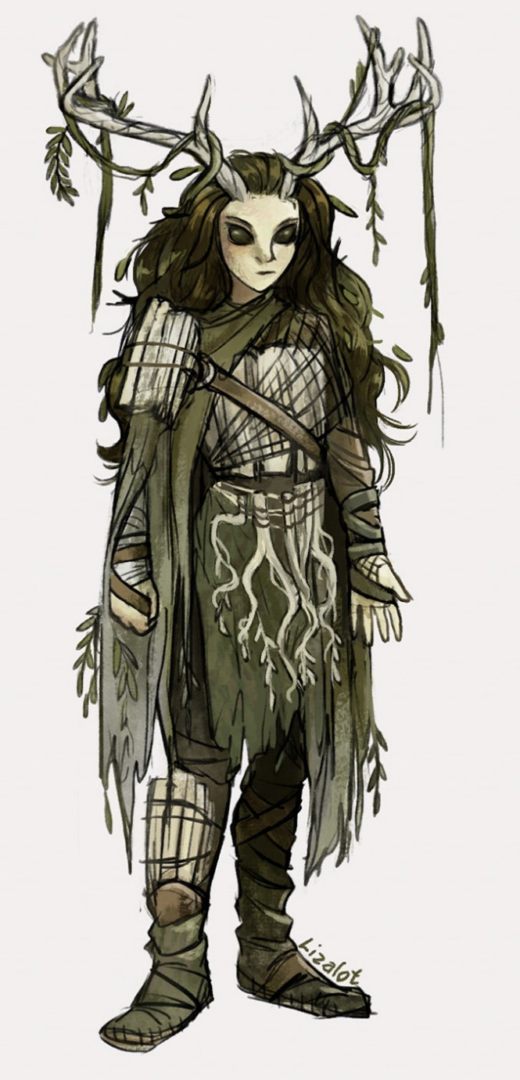**Druid**

Those who dwell in the forest become one with the powers of nature called **Kami**. Druids Those who walk the path of **Matsuri** become druids. Matsuri is the worship and honor given to the kami and ancestral spirits. Certain women who are considered the purest are called **Miko**. They are deemed worthy to take on the nature of the kami and gradually become kami themselves. These are called **Hime-gami**, or female kami. A Matsuri druid is given a charm called a **Mamori** when they begin their life journey. The charm helps the Matsuri Druid remain pure. It also protects them from evil kami striking them with sickness or causing disaster to befall them.

Druids retain all traits of the normal druid class. In addition, they obtain:

* **Summon Hokora** - Once per day the Matsuri Druid can create a Hokora, a special shrine to the Kami that is suffused with pure life force. It appears much like the structure from Leomund’s Secure Shelter, but is rustic and covered in living fines, flowers, and small insects. While here the Matsuri Druid is protected from all harm, as are anyone who join her within the structure. The Hokora disappears after 24 hours.
* **Chorus of the Kami** – Once per day the Matsuri Druid can enter a trance and listen to the collective voice of the spirits of nature. This must take place in relative calm and quiet and near a forest, windy plain, babbling brook, or other natural setting. On a successful Wisdom check the Matsuri Druid can hear the voices of Kami which often contain portents of upcoming events.
* **Wrath of the Land –** Once per day the Matsuri Druid can summon plant life in the surrounding area to rise up and ensnare the object of her wrath. This effect takes place in a radius of 10 feet per level of the Matsuri Druid and must take place where there is vegetation. All opponents within the area must make a grapple check DC 18 or be ensnared. This check can take place every round until they are free, but if they remain within the area they must continue making the check or lose a turn for each turn ensnared.

* **Fighter** – These are all warriors who practice the art of soldiery. Some may even be fallen Samurai, called Ronin, who have no master but who still possess the power of **Mushin**: “no-mind-ness,” the mental state of forgetting oneself that often accompanies great warriors.

Ronin retain all traits of the normal fighter class. In addition, they obtain:

* **Mushin focus** – after meditating for a minimum of one hour, a Ronin is able to tap into the power of Mushin, unleashing improved fighting ability. Once per day they may do the following:
* **Deft Stroke** – Once per day a Ronin can re-roll a single combat roll, whether to-hit or damage
* **Fury of Fujin** – Once per day a Ronin can execute triple their number of attacks for a single round
* **Great Vault** – Once per day a Ronin can perform a Jump check; for every point over 5 that the Ronin rolls (modified by their STR modifier) they can leap 5 feet in any direction (including straight up!)
* **Mantis Bite** – Once per day a Ronin can attempt to finish off any single opponent with a death stroke removing their head; the opponent can be of any size category, but the attempt must be made within reach of the opponent’s head and can be done at the same time as a Great Vault to reach the head
* **Slippery Eel** – Once per day a Ronin can attempt a blinding flurry of moves that evades even the most impossible barrage of attacks. Such a move will lend the Ronin a +4 to AC for the next five rounds. This action can be executed at the time of the threat but does not change the initiative order. However, this action does count as the player’s next action.

* **Monk** – **Akuso** are the “rowdy monks,” peasant priests, who serve the lesser gods in secluded monasteries and maintain roadside shrines. Akuso practice ancient forms of unarmed combat fueled by mystical energies of the **Satori**“enlightenment” and **Mushin** “no-mind-ness,” the mental state of forgetting oneself that often accompanies great warriors.

Akuso retain all traits of the normal monk class. In addition, they obtain:

* **Satori/Mushin Focus**: after meditating for a minimum of one hour, an Akuso Monk is able to tap into the powers of Satori and Mushin, unleashing improved fighting abilities.
* **Touch of Falter** – once per day on a successful melee touch attack, the Akuso Monk inflicts paralysis on an opponent; DC 15 CON save stuns the opponent for one round, otherwise the opponent is paralyzed for 10 minutes
* **Great Thrust** – once per day the Akuso Monk can channel her energy into an open palm strike that forces everything in front of her back 5d12 feet; REF save DC 15 to avoid falling prone; provision for whether they anchor themselves
* **Soul Refresh** – once per day the Akuso Monk can gain 2d6 temporary hit points that last for one hour and then are lost
* **Fury of Fujin** – Once per day an Akuso Monk can execute triple their number of attacks for a single round
* **Great Vault** – Once per day an Akuso Monk can perform a Jump check; for every point over 5 that the Monk rolls (modified by their STR modifier) they can leap 5 feet in any direction (including straight up!)
* **Slippery Eel** – Once per day a Monk can attempt a blinding flurry of moves that evades even the most impossible barrage of attacks. Such a move will lend the Monk a +4 to AC for the next five rounds. This action can be executed at the time of the threat but does not change the initiative order. However, this action does count as the player’s next action.



* **Ranger** – Those who dwell in the forest become one with the powers of nature called **Kami**. Those who walk the path of **Shinkai** become rangers. Kami are believed to be hidden from this world and inhabit a complementary existence that mirrors our own called **Shinkai.**Rangers tread these paths and have developed the special sight to see through many paths others would consider hidden.

Rangers retain all traits of the normal ranger class. In addition, they obtain:



* **Rogue** – Bandits are wanton criminals that are despised and feared by farmers and town folk. They tend to dwell in the wild, but as masters of disguise they sometimes abide in larger cities as part of established guilds. Those who survive to master their craft eventually learn to walk the **Way of the Shadow**, mastering the arts of invisibility, deception, and lethal techniques of assassination.

Bandits retain all traits of the normal rogue class. In addition, they obtain:

* **Shadow Walk** - Once per day the Shadow Bandit can become invisible. This functions like the Invisibility spell with the same duration as the Bandit’s level and same limitations.
* **Furtive Leap** - Once per day a Shadow Bandit can perform a Jump check; for every point over 5 that the Ronin rolls (modified by their STR modifier) they can leap 10 feet in any direction (including straight up!)
* **Slippery Eel** – Once per day a Shadow Bandit can attempt a blinding flurry of moves that evades even the most impossible barrage of attacks. Such a move will lend the Ronin a +4 to AC for the next five rounds. This action can be executed at the time of the threat but does not change the initiative order. However, this action does count as the player’s next action.
* **Dark Energy** – Once per day the Shadow Bandit can transfer life energy from themselves to another or vice-versa. The opponent must be willing or unconscious. If unconscious, the other character rolls a FORT Save DC 15 to resist. A save means no energy is transferred. Energy is in the form of hit points. A Shadow Bandit can transfer up to 1d4 hit points worth of energy per their level of Shadow Bandit.
* **Walk of the Ant** – Once per day the Shadow Bandit can perform a perfect balancing act, even walking a razor-thin wire with ease. This effect lasts 1 minute per level of Shadow Bandit.
* **Walk of the Spider** – Once per day the Shadow Bandit can scale any surface, even sheer surfaces, at the same rate of movement as their walking speed. This effect lasts for 1 minute per level of the Shadow Bandit.

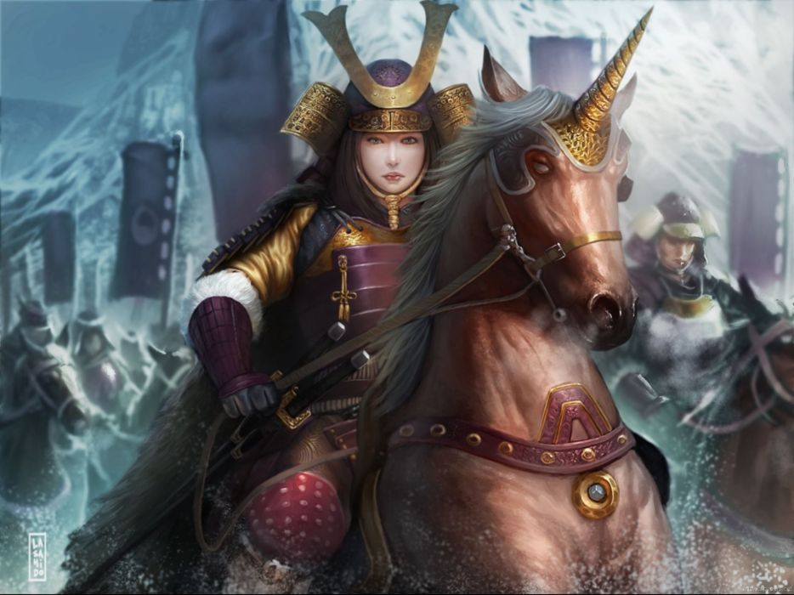

* **Paladin** – **Samurai**are noble warriors bound by oath to serve their noble lord or lady. They channel the power of **Mushin:** “no-mind-ness,” the mental state of forgetting oneself that often accompanies great warriors. Those Samurai who serve a deity may also channel the power of **Satori** “enlightenment” just as the priests do.

Samurai retain all traits of the normal paladin class. In addition, they obtain:

* **Satori/Mushin Focus**: after meditating for a minimum of one hour, a Samurai is able to tap into the powers of Satori and Mushin, unleashing improved fighting abilities.
* **Deft Stroke** – Once per day a Samurai can re-roll a single combat roll, whether to-hit or damage
* **Fury of Fujin** – Once per day a Samurai can execute triple their number of attacks for a single round
* **Mantis Bite** – Once per day a Samurai can attempt to finish off any single opponent with a death stroke removing their head; the opponent can be of any size category, but the attempt must be made within reach of the opponent’s head and can be done at the same time as a Great Vault to reach the head
* **Soul Refresh** – once per day the Samurai can gain 2d6 temporary hit points that last for one hour and then are lost
* **Aura of Hachiman** – once per day the Samurai can project an aura of awe and terror that will shake the nerves of any and all foes facing her; this is a fear effect with a FORT Save DC 17; those who fail are forced to flee in terror, otherwise if they save they still suffer -4 to attack rolls for 5 rounds
* **Brand of Amaterasu** – Once per day the Samurai can call forth intense and searing light from her sword, which radiates out to 120 feet and causes 1d6 burning damage per level of the Samurai to any creatures of evil alignment (twice damage to undead); this is an energy attack with a FORT Save DC 15; those who save take half damage

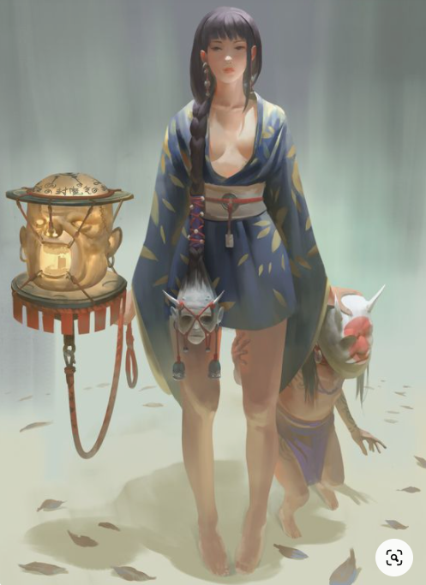* **Sorcerer** – Known as **Sons and Daughters of the Dragon**, these practitioners of the arcane possess the power of **Shingon (“**True Word”) within their blood. Shingon stresses mysticism and ritual, and seeks to tap into the primal interconnecting powers of the universe.

Sons and Daughters of the Dragon retain all traits of the normal sorcerer class. In addition, they obtain:

* **Wizard** – Known as **Onmyōdō**, these practitioners of the arcane study **Shingon (“**True Word”). Shingon stresses mysticism and ritual, and seeks to tap into the primal interconnecting powers of the universe.

Onmyōdō retain all traits of the normal wizard class. In addition, they obtain: