**Sakura Campaign**

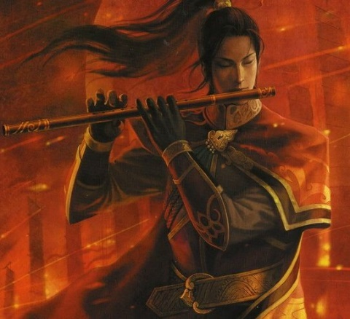

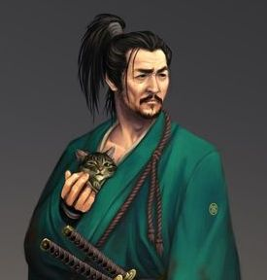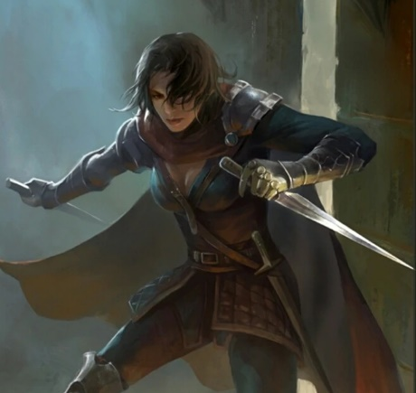 Mae, Shadow Bandit Kaito, Kabuki Bard Yuri, Matsuri Druid

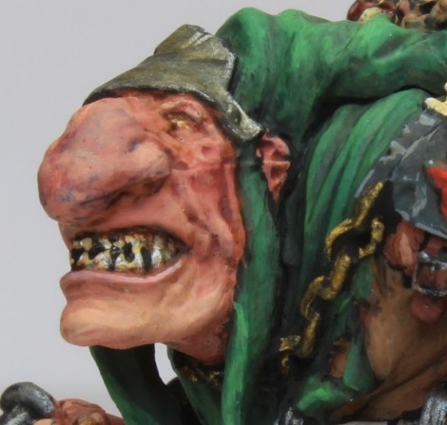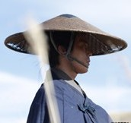 **Shun**, Monk of Benzai **Klom**, Half-Oni Barbarian Haru, Ronin

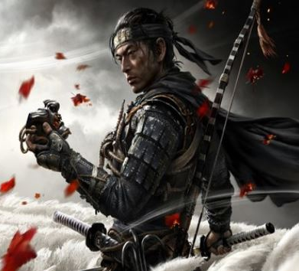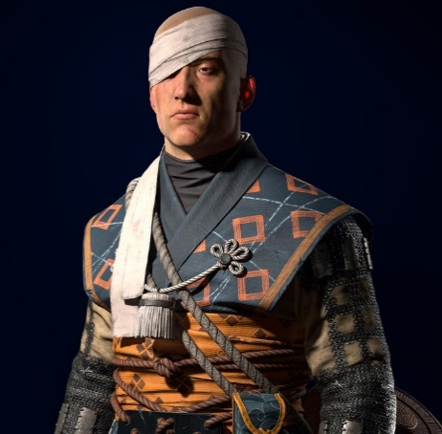

Jin Endo, Ronin Katsuari, Gukashu priest of Amaterasu

* ShaySavage - Shay - Mae the thief
* Dymux - Dave - Kaito the kabuki bard
* Adept Mage - Sarah – Yuri the matsuri druid
* Dagfrith - Alan – **Shun** the monk from the monastery of All That Flows
* Hjorleif - Jarred – **Klom** the barbarian half-Oni
* pennst92 - Mike - Haru the ronin
* Twisting Nether - Beau - Jin the ronin
* DM - Al - dumb DM, running Katsuari the priest

**Chapters**

* Chapter 1 – The Wounded Warrior
* Chapter 2 – Journey into the Lost Lands
* Chapter 3 – Entering the Shadow of Suzume
* Chapter 4 – The Tomb of Itakura
* Chapter 5 – The Fall and Rise of House Shigoro
* Chapter 6 – The North Wall
* Chapter 7 – The Village

**Major Characters so far**

**Daimyo Amano** of Ako – lord of the city of Ako, commissioned the party to seek out the Gem of Many Faces to ward off a prophecy of doom for his lands

**Lord Korudo Kazusane** – vassal of Ako, he seems suspicious and may be plotting to overthrow Amano; he employs the sorceress Itami Bo

**Itami Bo** – sorceress, in service to Korudo; implicated in letters the party found in the prefecture’s office that order someone to slay the party

**Aritsune Itakura** – patriarch of the fallen Itakura clan, the party rectified the sins of his house while in his family tomb and his armor is now worn by Jin the ronin

**Furendorī – a Momonjii**, a kindly Kami of the forest, aided the party during their trip into the Azuma lands and gifted them with advice and boons

**Suzume** - the Osakabe Hime, a powerful yokai. She is capable of manipulating people like puppets. She is extremely knowledgeable about many things and controls a multitude of kenzokushin—animal-like spirits who act as messengers. She can read a person’s heart and see their true desires. Slain by the party at Castle Shigoro

**House Shigoro –** a noble house in the lands of Azuma that fell when Suzume infiltrated it; the family and their court retreated into a pocket dimension within the castle to avoid Suzume. The family sacrificed itself by rupturing the protective spell to send Klom and Shun back to this world to destroy Suzume.

**The gem of Ōku-no-kao (Many Faces**) – an ancient artifact, this rainbow-colored gem can create duplicates of whomever bathes in its light. It is prophesied to be the doom of Ako, so Amano commissioned a party of adventurers chosen by fate to retrieve it.

**Destiny Rings** – Rings given to the party by Amano, they bear the sigil of Ako and grant safe passage in the lands of his allies. They are purple amethyst stones and bear a faint magical aura.

**No Hiroshi** – Ranger of House Amano, sent a letter to the Daimyo offering clues about the whereabouts of the Gem of Many Faces; he has not been seen since leaving for Azuma lands where he was scouting for the Daimyo

**Twelve Stones of Destiny** – referenced in the letter from No Hiroshi to Amano; it is unclear what this refers to

**Kagezami** – warlord who serves shogun reputed for conquering and reaving; he has conspired with Kazusane to track down the heroes and retrieve the Gem of Many Faces.

**Chapter 1****: The Wounded Warrior**

**Daimyo Amano** of Ako

**Lord Korudo Kazusane** – vassal of Ako

**Itami Bo** – sorceress, in service to Korudo

The city comes alive with the sounds of gongs and bells drawing everyone to the center of the city. Hanging in a cage is the broken and bleeding body of a warrior bearing the livery of the city of Shiashi: a blue bonsai tree. The party is drawn into the square along with the crowds. The prefect is there, addressing the citizens while holding out twelve rings with purple amethyst stones. The prefect instructs the people to come forward if they have information on why this warrior from Shiashi was found in this region. He has his men place the twelve rings in the decorative trees in the city square, bidding anyone who feels the fates compelling them to pick up the rings.

The group eventually lingers around the city square long enough that the cleric Katsuari appears and bids them to pick up the rings, for they have been spotted by the city guard and will be questioned regardless. They do so and are ushered in to meet with Daimyo Amano. He bids them accept the mission to find the gem and bring it to his court to prevent it falling into the wrong hands.

Shiashi is currently at war with the Shogun in Kaijin, hoping to wrest control of the land. The northern city of Ayozu has taken advantage of this conflict, launching at attack on the town of Jurojin to secure the north. Ako has stayed out of the war but supports the Shogun. It is the daimyo’s concern that Ayozu will use the gem to win the war in the north against Jurojin and then attack Ako.

Letter found on the desk of the prefect:

Great Daimyo,

The signs of our seer align with those of yours.

The marks of the Azuma are clear.

The old tongue points to Shizoku.

A darkness grows - many of our spies have not returned.

We know she is on the move but we cannot stand against her.

We pray that the 12 stones of destiny find our salvation.

May the gem be in the hands of the righteous.

May our lands return to peace.

* No Hiroshi

Message from the pigeon about the flight to the Monastery of All that Flows

many bad hoomans down there

many shoot shoot

bad wind - ded things

big big two leg things

burn burn

bad things growing

**The gem of Ōku-no-kao (Many Faces**) – an ancient artifact, this rainbow-colored gem can create duplicates of whomever bathes in its light. The duplicates retain the memories and personality of the original creature, who can then see and hear everything the duplicates see and hear. Also, once per day the original creature can will itself to switch places with any one of the duplicates. The unfortunate side effect of this gem is that within one year of the spell the duplicates all assert that they have sole right to the identity and will begin warring with one another until only one remains.



20 thugs attack the party at the dock; 13 are slain, two are captured, five flee

They are dressed in black tunics embroidered in dark purple thread, same as the three strangers observing the proceedings in the city square the day before.

XP awards:

qty 8 CR2 opponents vs 5th level party (x2) = EL8 = 2250 xp

qty 8 CR3 opponents vs 5th level party (x2) = EL8 = 2250 xp

qty 4 CR4 opponents vs 5th level party (x2) = EL9 = 3000 xp

total 7500 xp div by 8 players = 937 xp apiece

(xp calculated for 2 4-person 5th level parties, so divided in half - the alternative would be considering the entire group a 10th-level 4-person group but that would result in much less XP)

Honor points: victory in battle: all characters receive 5 honor points

Fortune points: all players got involved, so 5 fortune points for everyone!

total haul from thieves

83 gold pieces

111 silver pieces

5 gems - light ruby est 25 gp each

10 pearls - 100 gp each

15 bands featuring a symbol of four serpent heads in a wheel (symbol of an old, defunct coven of witches called the Gekaigo)

message case with message (ornamental case worth 125 gp):

message

Kill the agents of Ako and retrieve the destiny rings

Find out what they know before executing

Take any maps you find and report back

- Itari Bo

**Appendix**

Equipment typical to Sakura adventurers

* Tanto (Dagger) 1d4 / 19-20
* Wakizashi (Short Sword) 1d6 / 19-20
* Katana (Longsword) 1d8 / 19-20
* Nodachi (Greatsword) 2d6 / 19-20
* Yari (Spear) 1d8 / x3
* Bo (Quarterstaff) 1d6/1d6 x2
* Ono (Handaxe) 1d6 / x3
* Yawara (Sap) 1d6 / x3
* Masakari (Battleaxe) 1d8 / x3
* Kanabo (War Club) 1d10 / x2
* Kama 1d6 / x2
* Nunchaku 1d6 / x2
* Sai 1d4 / x2
* Siangham 1d6 / x2
* Naginata (Glaive) 1d10 / x3
* Daikyu (Longbow) 1d8 / x3
* Daikyu (Shortbow) 1d6 / x3
* Daikyu (Longbow, composite) 1d8 / x3
* Daikyu (Shortbow, composite) 1d6 / x3
* Padded Armor +1 AC
* Haramaki (Leather Armor) +2 AC
* Studded (Leather Armor) +3
* Kusari Katabira (Chain Shirt) +4 AC
* Kusari Gusoku (Chainmail) +5
* Karuta-style (Scale Mail) +4 AC
* Domaru (Half Plate) +7 AC
* O-Yoroi (Full Plate) +8 AC

**Chapter 2****:**

Party takes a boat down the coast of Sakura to the coastline of the Azuma lands.

Attacked by froggy creatures, Yuri is bitten and becomes very ill. She uses her abilities to detect a **Momonjii**, a Kami of goodness**.** He advises the group and grants them gifts.

One weapon of each player’s choice now augmented to +1 attack/damage.

Yuri’s weapon can emanate light on command.

Other assorted presents that promise meaning in the future.

575 XP

5 honor points

**Chapter 3****: Entering the Shadow of Suzume**

Following the Momonjii’s advice, the party sets off north to find the entrance to the ancient catacombs beneath the ruins of Shizoku. The land is barren, filled with gnarled roots and stalks, sickened creatures, and blanketed under a steel gray sky full of gloom. It is a cheerless place, the very air feeling oppressive.

Marching Order

**Shun**

Jin + Haru

Kaito + Katsuari

Mae

**Klom**m / Yuri

The birds and bugs seem to be buzzing and tweeting the name “Suzume.” Yuri consults one of the misshapen insects that are found in this land. The insect warns that all creatures here fear Suzume and are compelled to cry out her name. It goes on to describe, "Suzume is the Osakabe Hime, a powerful yokai. She wields great power here. Osakabe hime is a powerful yōkai, capable of manipulating people like puppets. She is extremely knowledgeable about many things and controls a multitude of kenzokushin—animal-like spirits who act as messengers. She can read a person’s heart and see their true desires. She can then manipulate them any way she pleases. It is rumored that anybody who sees her face will die instantly."

The party comes across one party of Tengu and avoids them. But many miles later Yuri’s owl, Nia, is snatched out of the air by a swooping figure. Yuri breaks ranks and pursues where she hears the scuffle between the owl and the creature, the party follows frantically. This attracts another group of Tengu, who use their power of mimicry to lead the party to think a band of the daimyo’s retainers are nearby and ready to lend assistance. But the group is caught in an ambush and hail of arrows. The party quickly dispatches them and rescues Nia.

The party sees a lantern floating into the sky. The Tengu are signaling for reinforcements.

* 9 Tengu, 1 Flying Tengu
* 42 gp
* 73 sp
* 204 cp
* silver mirror, tarnished – cracked - cursed
* musty leather pouch – small bag of holding
* 9x katana (not MWK)
* a set of boots that seem different from the others and in fairly good shape – boots of landing
* one small battleaxe of pretty good quality - cursed
* 9 crude jade pendants marked with the symbol of the Shihai tribe (broken Naginata)

XP awards

qty 8 CR3 opponents vs 5th level party (x2) = EL8 = 2250 xp

qty 2 CR3 opponents vs 5th level party (x2) = EL8 = 562 xp

three traps @ 125 XP each = 375 xp

XP total for party = 3187

Divided between eight characters = 400 xp apiece

Watch

1st watch – Mae, Kaito

2nd watch – Yuri, Haru, **Klom**m

3rd watch – **Shun**, Jin, Katsuari

Party finds the entrance to the catacombs beneath Shizoku. The entryway reveals a trap, which claims Haru and drops him deep into darkness. The party enters the catacombs and retrieves him. They find the burial chamber of Itakura Aritsune, a legendary hero of the Azuma lands.

The entry way is decorated with many scenes of Sakuran nobility. A haiku appears when the large knockers are moved on the fifteen-foot-tall double doors:

*Listen to my rhythm!*

*I’m the sound of your heartbeat*

*Played since ancient times*

After many attempts to use the knockers to find a rhythm that will allow the doors to open, Yuri casually mentions the need for a drum, at which time the riddle haiku is answered and the doors open. Within the entryway, an inscription reads:

*Here lies the ancestral tomb Itakura*

The party finds the private tomb of Itakura Aritsune, whose armor was divine and stolen and scattered here by demons. Down one hallway they hear moaning. They find Haru, who lies within a chamber where any who fall to the pit trap above is deposited. They administer healing and Haru feels partially restored.

Mae discovers three scrolls in the hallway honoring the Itakura family: invisible x2, spider climb

**Chapter 4:** **The Tomb of Itakura**

The group explores the ruins of the tomb of the Itakura family. Along the way they learn of the three curses on the place and the three wells: one of greed, one of charity, and one of the oppressed crying out for justice. Aritsune, patriarch of the clan and eldest of those buried here, appears as a ghost and bids the group to resist the temptations offered by ghosts of his three descendants, whose evil in life created the curses. After many battles, one of which causes a cave-in, the heroes retrieve the three cursed items that plague the Itakura clan and dump them into the well of the oppressed. Haru is lost in battle, and Jin defeats a large demon warrior. The group collects the pieces of Aritsune’s armor and finds it unlocks the power to defeat the demons occupying the large keep in the catacombs.

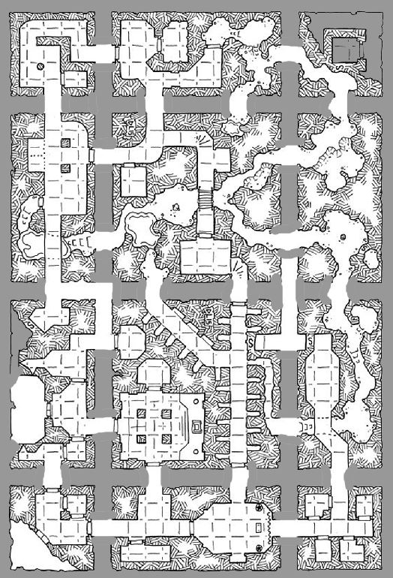

**Chapter 5****: The Fall and Rise of House Shigoro**

After surviving the Tomb of Itakura and retrieving the lost Gem of Many Faces, the party returns to the coast only to find their boat has been destroyed and the crew slain. Desperate, they party seeks a safe path home over land. Tengu scouts can be seen flying overhead in the distance. It is clear their tribes are on the march to find the party. Consulting a map, the group rules out heading west into Cold Lantern Pass. Instead, the River Gozen to the north marks the edge of civilization and a faster path out of the Azuma lands. Shun speaks up, pointing out that a monastery Tamonten, god of war and justice, lies at the mouth of the Gozen River. The journey is long and arduous, with the sounds of “Suzume” still being uttered by the birds and insects. After some days, Yuri become aware of a strong presence just west of their intended path. Curious, the group hikes a half day to investigate. They find a large, deep depression in the land that forms a hidden valley. There stands a venerable castle, abandoned and showing years of neglect. They enter, finding only small mounds of dried grass scattered here and there throughout the place. Passing a shrine statue at the entrance, Klom notices the house crest bears the sign of a gopher. It seems to wink at him. He touches the statue and disappears. Shun notices Klom is missing and leaves the group to investigate. He, too, touches the statue and disappears.

What follows are two stories: one of Klom and Shun transported to a place and time where the castle is restored and like new, with people happily dwelling there and tending to their daily tasks. The other story finds the rest of the party awakening some dark force in the castle tower, which brings to life a horde of strange grass-golems that mindlessly attack in waves. A battle ensues that drives the group to the rooftops where they barely hold off the swarming abominations.

Meanwhile, Klom and Shun are shown to Lord and Lady Shigoro, masters of the castle. They are told the people here feared Suzume and the wizards created a dimensional place where they could all hide and be safe from her. But they did not know so many years had passed and that she had grown as a danger to the world. So they decide to collapse the dimension and sacrifice themselves to return Shun and Klom with the knowledge of retrieving the Casket of the Ki-Rin heart to destroy the witch.

Shun and Klom return to the present, joining their fellows in the midst of a raging battle. Flames erupt from the distant tower as Suzume emerges in dragon form. She unleashes a gout of flame, which all but Kaito manage to avoid. Kaito disappears in a flash of smoke! But Klom and Shun leap atop the long neck of the dragon while their companions hack at her lower body near the ground. Working together, the group destroys the witch and the castle is returned to a haunted silence. They watch as a black smoke rises from the dragon’s body and drifts into the air, trailing off in rapid motions as if drawn by a string.

Recap of the adventure of Klom and Shun in the ghostly other dimension…

(at the point in the adventure when the group has entered the keep and is exploring the barracks and stables…)

**DM** — While waiting in the gatehouse, Klom’s eyes drift to the sword standing embedded in the floor. On the pommel is a kanji featuring a gopher and bamboo shoots. Suddenly the gopher winks at you when you look at it closely.

**Klom** — !! Klom just pokes the sword with his foot

**DM** — the gopher says the words "join us, it is safe"

**Klom** — How I join you?

**DM** — "take the sword and enter the sanctuary"

**Klom** — what are you safe from?

**DM** — from the evil lady

**Klom** — Do like Goffers... Klom no like evil lady either. Klom take sword

**DM** — there is a flash of light and you are standing in the gatehouse, only the walls and timbers appear like new! the sun is shining, two men in armor turn to you and smile "Hello! You made it!"

**Klom** — looks all around amazed, he'll holster his slingshot

**DM** — "the lord and lady will want to meet you! you are safe now!"

**Klom** — he'll look towards the door the party went through

**DM** — "Suzume is the dark one. You are safe from her now. Come with us! You look hungry"

**Klom** — Klom like food, no meat though. I must get my friends first

**DM** —the guards look around but see no one else with Klom. “Perhaps your friends will follow. Come! The lord and lady will be eager to meet you!” you are ushered to the great tower and feasted by the daimyo and his lady, masters of Shigoro House known by their sign of the gopher kanji; you spend the afternoon being offered food and drink, the residents are eager to hear your stories

**Klom** — tells the most fascinating stories an Oni can. He then tells of his most recent travels with his friends

**DM** — the crowd seems to grow, servants, guards, even children gather to listen

**Klom** — Proudly shows the goat. Klom attempts to speak through his mind towards the lord and lady. I do not mean to intrude or over stay my welcome. Is there anything you fine hosts would ask of me?

**DM** — "We would know more about Suzume. You came from outside. Is she still out there?" the people assembled remain silent, but their eyes tell of their horror at the sound of the witch

**Klom** — Suzume? The lady of the forests? I know not well of a Suzume

**DM** — The daimyo’s top general spits. “She is the evil one, she controlled all the land! Her cursed flute and her cursed children destroy the very life in the grass, in the trees, the animals that walk and fly and swim!”

**Klom** — Klom relays any information the group knew of Suzume, whether be the insects or potential Yuris bad tripp

**DM** — your hosts seem intrigued by the story "Yes, the insects. That sounds like her."

**Klom** — Then it must be her. She, she still dwells in these lands. My party makes an attempt now to end her reign. Is that why you fine folk have protected yourselves here?

**DM** — Yes! This is our sanctuary! We enjoy utopia here. It is the finest place in the entire Third Written Age!

**Klom** — Your keep is gorgeous and your people are healthy... wait, the third age? No, I exist within the 4th age (to himself, or at least the current iteration of my soul does)

(Elsewhere, Shun the monk breaks away from the party to try to open the door to the second gatehouse inside the castle. Standing atop the roof, he inspects his surroundings)

**DM** — you don't find much, but your eyes scan the floor and make out an unsettling thing

there are scattered clusters of moss/grass that are embedded in the floor - each one looks to be in the form of a small child or baby. as you scale the top of the roof, the sound of the flute becomes louder - it's coming from the keep. you look in that direction and seem to think there was a figure in a window

but it's gone now. you approach the door of the gatehouse, which is open. there, standing in front of you.... is you!

**Shun** — I greet myself.

**DM** — your alter ego bows and hands you a sword in a ceremonial fashion

**Shun** — I accept it with a bow. “You look like me, but I am me. Who are you?”

**DM** — he bows in return and fades away

**Shun** — I examine the sword. Carefully. And closely.

**DM** — the sword fades away

**Shun** — Was it a match to the one in my haversack?

**DM** — just before it fades you see the kanji of the gopher of house Shigoro, identical to the sword you have

**Shun** — I will pull out the one from my haversack and wait to see if he returns.

**DM** — he does not, but several people appear from around the corner and greet you

**Shun** — I greet them with a bow and a polite greeting.

**DM** — they appear to be in good health and happy to see you

**Shun** — I return the sword to my haversack.

**DM** — they bid you welcome "You are safe now! the lord and lady will like to meet you!"

**Shun** — "Thank you. From what danger am I now safe? Please, take me to your lord and lady.

Have you seen my large friend, Klom?"

**DM** — they bring you to the great hall and there your friend is sitting, a fully belly and everyone listening to his stories and playing with his goats

**Shun** — Klom! I am happy to see you again.

**Klom** — Klom speaks in an ethereal voice to all around. He appears different, almost human like. It is a shocking thing for the monk to see. Could this be Klom? What made him look this way? This place? Was there more to the half-Oni than anyone suspected? “SHUN!! My good-man, please join us!

Where are the others?”

**Shun** — Thank you. They are outside on the ramps, probably looking for us.

**Klom** — I was just catching our gracious host up upon our travels, I was regaling them of recent endeavors

**DM** — the lord and lady greet **Shun** warmly. Young maidens come forth and present the guests with red higanbana blossoms. There is music as well as dancers. The entire court rejoices with you for what seems like hours. Days? Time has no meaning here, it feels.

**Klom** — My Lord, My lady. This is my faithful friend, Shun. He was been by my side for many a danger

**Shun** — Thank you for the gracious welcome. Will our friends be joining us?

**DM** — the court look confused. Your friends?

**Klom** — Aye, my Lord. There are others in our party

**Shun** — Klom and I were traveling with a group of friends. First Klom and then I were separated from them. They are outside somewhere, but nearby.

**Klom** — Klom turns to Shun and whispers - They claim we… they, us, now reside within the Third Written Age. But Klom remembers our priest friend tell me we are from the Fourth Age.

**Shun** — "Uhm. Uh, oh," Shun whispers back.

**Klom** — yes..

**Shun** — "How did we get here, uhm...now?" "When?" Confused expression.

**Klom** — I spoke with my Goffer friends upon the sword. Then I was led here. That was how many days ago…?

**Shun** – for my part, I met myself in a doorway and he handed me a sword with the gopher symbol on it.

I carry the one from the entry in my haversack. After handing me the sword, he faded away, then a moment later so did the sword. And so, apparently, have we both… at least from our world.

**DM** — The lord and lady look concerned. The Onmyodo wizard approaches. He is an elderly man, but with eyes that seem to light with a purple flame. "You are from another age!?!” he asks. “Is Suzume dead and gone? Surely after all this time the might of the Azuma Kingdom has rid itself of her!?”

**Shun** — Yes, my Lord, my Lady. We are from the 4th age.

**Klom** — i spoke with the goffers and they told me to take the sword to the courtyard, there i'd be safe

My Oni form does love small critters

**Shun** — We believe Suzume is still alive in some way, or at least her ghost seems to still hold some sway.

Klom, you moved the sword? It was in its original position when we got there.

**Klom** — she still haunts the lands amongst this keep. at least within our time, the 4th Age

correct

**DM** — Small children begin to sing a sad song about the dark days of the witch’s coming. There are passages of tiny bunnies turning into terrible monsters and flowers that began to issue poisonous vapors. The house priest comes up and inspects you, bringing a special mirror

**Shun** — Who is this terror? Why is she causing trouble?

**DM** — The wizard weaves magical illusions in the air. A woman with black eyes appears, a pall of darkness extends from her causing trees to wither and men to fall down dead. “She is Suzume - the Osakabe Hime, a powerful yokai. She wields great power here. She capable of manipulating people like puppets. She is extremely knowledgeable about many things and controls a multitude of kenzokushin—animal-like spirits who act as messengers. She can read a person’s heart and see their true desires. She can then manipulate them any way she pleases. It is rumored that anybody who sees her face will die instantly!”

**Shun** — That must make her a terribly lonely and bitter person. No friends to share life. Very sad.

But no excuse for evil.

**DM** — the priest looks worriedly at the lord and lady "she has marked them, my lord - she will find us here!"

**Shun** — How are we marked? Can it be removed? If not, we must leave to keep you safe.

**DM** —The priest explains, “you are marked by her energy, which clung to you as soon as you entered this place. It is harmless, but she can use it to find you here. So our time is running out. She must be destroyed - but we have an advantage! you are in the sanctuary - and she does not know it yet.”

**Shun** — My Lord, it sounds like you have a plan. Please, tell us more. Especially about any weaknesses this terror has.

**DM** — The priest and wizard nod to one another. “Our sanctuary is trapped in time,” the onyo-modo wizard explains, waving his hands. A series of magical images appears in mid-air. You watch as an image of the castle is duplicated. On one side, the castle remains new and covered in beautiful vegetation. In the other, you see people and animals battling wild monstrosities, vegetation comes to life and spreads dark liquid everywhere. As the sun rises and falls a thousand times in quick succession, you see the castle slowly crumble and become covered in vines and decay until it appears like it does now. “But since we are bound by a bubble of this magical protection, anything that happens here will affect what is your world in the now.”

“But only if and at the very moment when the bubble collapses,” explains the priest.

**Klom** — So you’ve protected your people all this time? Ever since the Third Age?

**DM** — The diamyo answers, “It was my wish to see my people avoid such an evil fate. And so, I spent a fortune to build this sanctuary. It seems the years have passed without us knowing for how long. But I assumed the Shogun of Azuma would defeat this evil.

**Klom** — within our time, your keep is a mess, I did not see much, it still stands, but its attractiveness has long faded. And your Azuma Kingdom is no more. Tengu have taken over.

**DM** — The daimyo sighs. “Kingdoms rise and kingdoms fall. Who knew we fell when I sought to save us? But is there time for us to rise once more?”

**Shun** — If the enchantment is damaged, what will happen to you and your people?

**DM** — The people bow their heads. The Onmyodo nods, “When the bubble is ruptured, at that moment time will collapse in and the years will catch up to us. We will age hundreds of years in an instant. So, whatever we do, we must do it within seconds of ending the enchantment.”

**Klom** — “But our party now roams your keep, in search of answers against Suzume.”

**Shun** — “How do we defeat her and keep the enchantment safe?”

**DM** — The Onmyodo wizard serving as advisor speaks up, “There is no time. Your friends even now are in dire danger. But we will sacrifice ourselves if it ends Suzume.”

The daimyo nods "Make it so!"

**Klom** — It is our mission also; she has hurt our friends and pollutes the land with her magic. Enlist us, grant us aid and we will fight for you.

**DM** — The wizard shakes his head. “A noble gesture, thank you. But you can achieve more in your time. If we weaken the keep, then it will weaken her. It is here my magic is strongest. It is here she will be strongest.”

They bring forth a great gong. Guards rush in, all armed and ready.

The wizard continues, “She has the great casket of the KiRin heart and she traps its power to give health to the land. When we return you, you must destroy her and save the casket.”

**Shun** — Does the daimyo have his sword? If not, I will see if it is still in my haversack -- if so, I will present it to him and the helm (carefully and respectfully). Although the wizard may want to make sure the evil one has not tampered with it.

**DM** — The daimyo sees the sword and is moved visibly by the gift. The retainers rush to armor him. “I fled the evil, thinking of my family. But I see now our house failed to guard this land and we are filled with shame. We are ready now to end this evil.” He accepts the helmet and sword, looking impressive with his now-complete armor: “I can die now with honor, thank you.”

**Klom** — It will be a great end, my lord

**DM** — the guards rush to arms and produce torches. the priests come forth and offer a prayer, the people kneel and whisper in answer to the prayer. the daimyo motions to one of his retainers, takes two scrolls, and hands them to you both.

**Klom** — **Klom** gives a most elegant bow

**DM** — "You are now the last protectors and defenders of House Shigoro.” he puts a ring on each of you, bearing the kanji of House Shigoro

**Shun** — **Shun** bows low accepting both the scroll and the ring. “Thank you, Lord Shigoro, for this honor.

May the Lady of All that Flows and the Lord of Lightning bless our endeavor.”

**DM** — the gong is rung, the guards light the curtains and set barrels of oil on fire; as the flames rise higher, you see as everyone begins to crumble to dust

**Shun** — **Shun** bows to them, but must watch as they sacrifice themselves. It would be dishonorable to do otherwise.

**Klom** — **Klom** bows to their honor

**DM** — the entire place is consumed in flames, the people bowing and singing a song of thanks to Inuri; one by one the people fade away; the beautiful estate fades from your view, to be replaced by the same estate but in ruin. you find at your feet a higanbana blossom, laid there by one of the court maidens

**Shun** — Pick up the blossom at my feet, smell it carefully, and then place it in my haversack.

**Klom** —"Pretty flower…”

**DM** — the daimyo, the last to remain visible as the time spell collapses, bows and draws his sword. He yells “Death to Suzume! Long live the memory of Shigoro!” then disappears into the void of ages.

**Chapter 6: The North Wall**

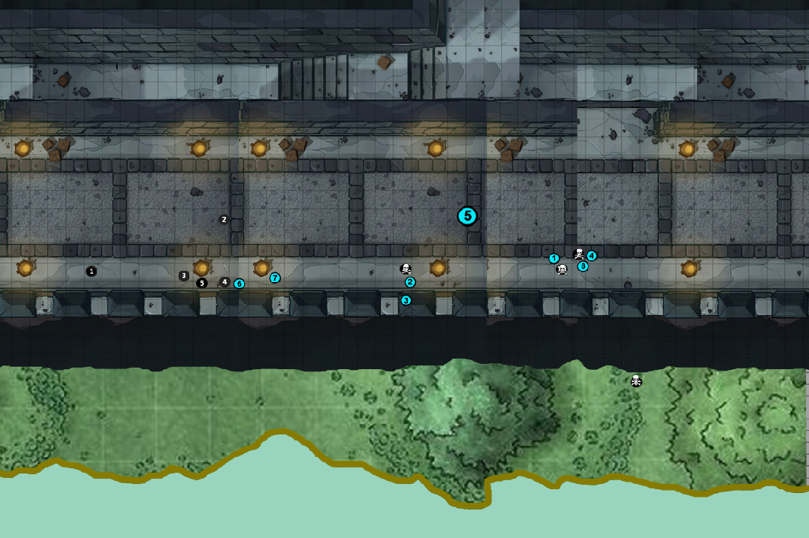

The party travels far enough north to come face-to-face with the Oban, the ancient Watching Wall. This wall was erected along the Gozen River to seal off the Azuma lands after they were overrun by Tengu centuries ago. Today it is guarded by nervous sentries wary for any suspicious creatures that appear out of the lost Azuma lands.

The party approaches the river and finds four totems tucked away in their travelling sacks: tiny wooden figurines of a canoe, a fox, a rabbit, and a cabbage. After many tries working out the puzzle, they realize the canoe will grow to accommodate the entire party if brought near the water. But it will only move forward if the proper token is placed within it. At last the party figures out the sequence of which totem must be placed in the canoe at which points in crossing and re-crossing the river.

At the foot of the wall, the party is spotted. Kaito tries to negotiate his way to the top. He is ordered to enter a cage which is suspended from a crane atop the wall that lowers a chain connected to the cage. Haru and Mae offer to escort the Kabuki minstrel. But halfway up, the cage is stopped and archers train their bows on them and demand answers. In a flash, Jin channels his inner Mushin force and leaps to the top of the wall. Meanwhile, Mae manages to pick the lock to the cage and free her comrades, allowing them to take the wall as well. A terrible figure appears, a giant of a samurai in black armor, a strange house symbol glowing on his helmet. It is the fearsome Kagazami, famous warlord who works for the Shogun and is known as a reaver and despoiler of lands. Jin and Kagezami clash violently, with others joining the attack before long. At last they stagger the samurai, who utters a desperate command and disappears. The rest of the guard are dispatched and the wall is taken.

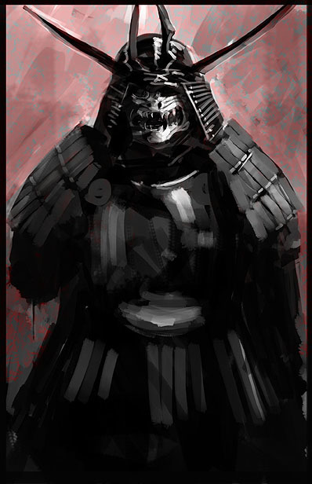

**Chapter 7: The Village**

After securing the outpost atop the defensive wall at the River Gozen, the party collects provisions takes rest. But it is anything but restful for some in the party who have visions:

**Yuri:**

*During her nights sleeping in the wall fortifications, Yuri shivers. She feels the land grow colder, the many kami going to sleep. Her sense of all the life forms in nature, a wide flora of creatures, all begin to fade. Even her heart begins to shiver. Something is moving over the land, drawing it into an early and unnatural winter. She has a vision of a lotus flower, but with one of the petals missing. It seems to indicate some direction in the distance where there is a great disturbance in the natural order.*

**Klom:**

*Klom is feeling a great weight on his soul. It began when he was in the crypt of Itakura. Every night he has a dream of a great demon towering above the land. He laughs as ice grows over the mountains. Klom sees many figures that resemble daimyo generals kneel before the demon. A blue symbol is inscribed upon each of the daimyo. It bears the name "Kaikagon"*

*A familiar voice creeps into Klom's mind: "the scales will be even, my dear Klomm. You will usher in the age of Kaikagon…"*

**Jin:**

*As Jin stands watch atop the newly won wall, he feels a tug at his heart. The sword of Itakura grows warm in his hands. There is a presence to the north that feels familiar, almost of a kinship with Jin. There is a sense of longing, of familial bonds, of sadness and loss.*

*But the encounter with Kagezami has left Jin rattled. Some great power dwells in the dark general, something unbridled and supernatural. Jin senses a darkness in the warrior that he felt once before, but dismissed. He sensed it in the crypt of Itakura when he peered down into the hellscape that claimed Haru. And, if he really thinks about it, the feeling began as early as their departure from Ako weeks ago.*

*The direction of the feeling of loss and sadness is the same as the lotus flower. He feels a sense of longing in that same direction. Itakura's voice appears in your head, sounding bitter: "Sumi's grave is at unrest, Murakami dishonored her and stole her birthright"*

**Monastery of War and Justice**

At last, the group sets out on their return journey to Ako. Along the way they visit the **Monastery of War and Justice**. Magical stairs appear when Shun rings the sacred gong at the base of a small peak overlooking the eastern seas. The monks welcome the party and hear their tale of the quest. There is discussion of an assassin named **Songbird**, and the possibility that she may be at work in the north. But the party stops short of sharing too much concerning the Gem of Many Faces. In the end, the monks refuse to get involved in the politics of the great Daimyo who are escalating war in the region. But they do agree to send envoys north and west to seek help in identifying Songbird and her whereabouts.

**Naked in the Snow**

Frustrated by the lack of support, the party resumes their journey. Along the way Kaito summons a beautiful heated lodge in which they can take rest overnight. The snows outside build, but inside the heroes are treated to fine cushions, lovely music, and aromatic teas.

But in the night, there are figures seen in the distance. They approach, naked humans lurching absent-mindedly. They appear to have ash discoloring their faces and bodies. The party is roused in time to see the group of naked people running towards the lodge. The party subdues two of them and Katsuari heals them, returning them to good health from their frozen state. They report they are farmers from the village of Arima. There, they had prepared for their winter festivals when a snow storm appeared. A terrible figure appeared, along with frightening creatures, and swept over the place. The villagers’ hearts were filled with despair and life-stealing cold, and then all went dark.

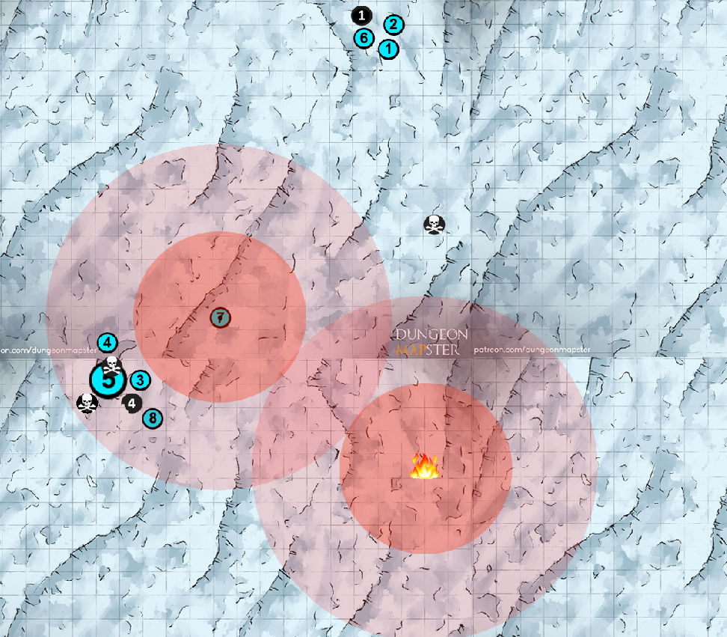

Kaito recalls his knowledge of folk traditions and shares this with the group. He says that this time of year is **Somin-Bukuro**, a season during the winter where villagers celebrate a time of giving and fellowship; they honor Somin: a poor but kind-hearted man who treats with the gods to grant gifts to humans who have good hearts. Somin gifts good people with **komagi** (small wooden charms with hexagon shapes).

It is also the time of year for **Matsue**, an event when people burn pine decorations and coal powder from kitchen stove or ashes mixed with alcohol or just water but now to mark the face of participant they use a kind of ink. The fun of this festival is the fuss of painting face by ink. It is said that ink grants blessings like preventing illnesses or tragedy at sea.

Lastly, there is a competition called **Shingi:** naked men clash and compete for two sacred sticks of wood which is a symbol of hope and luck. A festival when monks complete their training "Shushoue", which prays for the peace of society and the happiness of the people. The highlight is a fierce battle for Shingi by naked men "Fuku Otoko.”

The party returns to their rest, but Yuri enters a trance to gain insight and is met with a powerful vision.

*Yuri enters the spirit world and is overwhelmed by the beauty of the Kami landscape. But she is also sad, because it is clear that every leaf, every vine, every shimmering firefly is suffering from the tinge of blight. A thousand Kodama creatures surround you, their eyes drinking in your presence. At last, a towering figure of an illustrious Ki-Rin approaches, its majesty shining like the sun.*

*"Child," he answers, "the source of the darkness you seek is the Crypt of Itoru. It is there that evil doers have found the altar and the scales to summon the beast."*

*The crypt is in the midst of the Nightfall Marshes. But first, you must cleanse this village of its evil. A secret lies there that will aid you, aid your friends, and aid the world."*

*In the village of Arima you must find the source of peace and harmony and use them to destroy the evil there. Nothing else will prevail.*

*In the marshes you must sacrifice something dear to you to save the world. I have spoken.”*

*He turns to leave.*

**The Village of Arima**

The party sets out to investigate for the village of Arima. They find the village abandoned. There are signs that the villagers were celebrating Somin-Bukuro, Matsue, and Shingi: burnt pine cones, bowls of soot, tiny hexagon-shaped pendants, and random lengths of wood litter the ground.

Suddenly they are beset by a Yuki-Onna, a yokai snow witch of great malevolence. Simultaneously, the buildings come alive with creeping figures, disgusting yokai they had seen before: Akaname. While the party battles a horde of Akaname, the Yuki-Onna manages to bewitch Klom and turn him against the party. Katsuari falls beneath the half-Oni’s mighty war club.

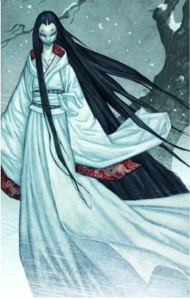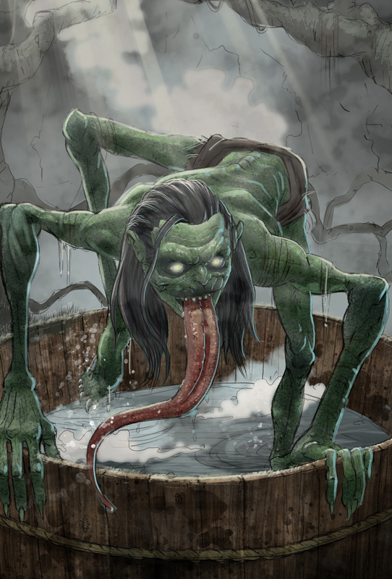

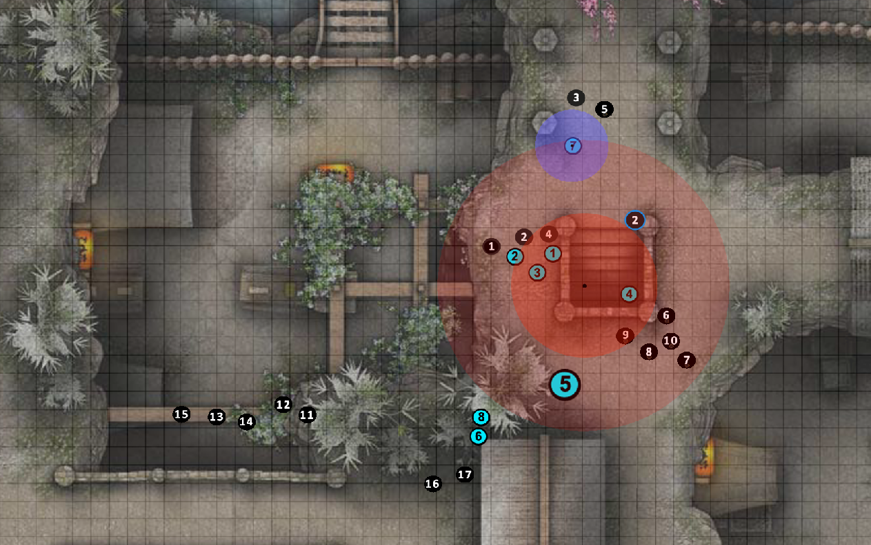

Jin, enraged by the witch’s treachery, summons up a great rage and executes a perfect Mantis Bit move, beheading her with his katana. But no sooner has the creature fallen than another appears and calls down a great storm. The battle rages on…

