Notes on the lands of Sakura
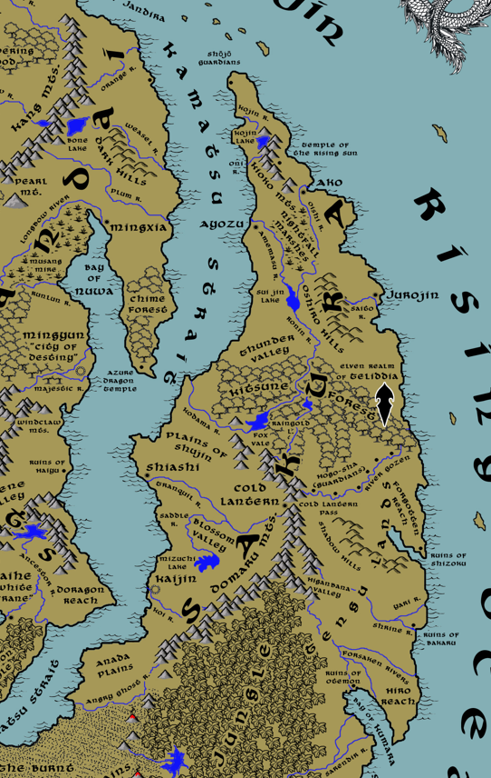

Table of Contents
- Overview
- Towns and Cities
- Best in the Land
- Stewards of Power in this Land
- Points of Interest
- History
- Local Goods
- Notes on Culture
- Local Deities
- Creatures
- Other Races
- Magical Items
- NPC Templates
- Developer Notes
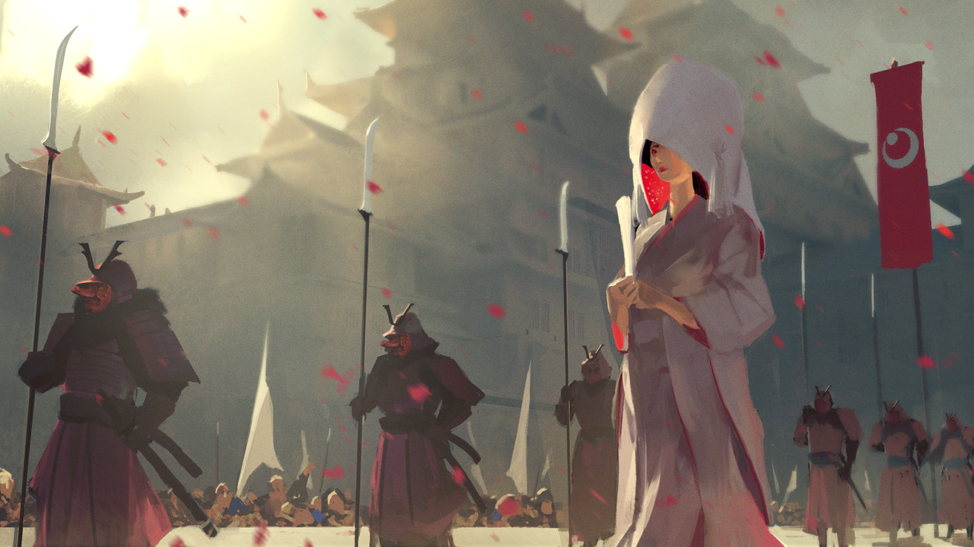

Overview
In the days before time, when the world was new, the sun rose up from the sea and Amaterasu smiled at the first land to greet her. She blessed the place and named it Sakura, after the cherry blossom, and brought forth other majestic plants and flowers as were not seen elsewhere in the world. Her heavenly kin joined her, as well as the seven lucky gods, the divine Kami, the magical creatures called Yokai, and they filled the land with enchantment.
But such was the beauty of Sakura that the hells below grew jealous and sought to corrupt it. Foul demons came forth, the races of ogres called Oni and bird-like creatures called Tengu, to plague this new realm. Amaterasu despaired, knowing the inevitability of conflict between good and evil. So, she gifted the race of men the secrets of Musubi, the magical power that permeates all creation. The magic manifested in different ways for different servants: to the warrior there was the power through stillness of mind (Mushin), to the scholar there were the complexities of the universe (Shingon), and to the devout there was a direct channel to the gods through enlightenment (Satori).
The peoples of Sakura occupy the upper half of the continent of Katura. The center of this land is marked by impassable obstacles: the Domaru Mountain range, the Pajra Jungle, the Burnt Lands of the western shores, and the lost Azuma lands teeming with Tengu tribes. West, across the Kamatsu straits, lies the sprawling Xiandai Empire. They are oft times enemies but share many cultural traits. To the north lies the Sea of Ryujin and beyond it the impenetrable wilderness of the Haka’Na. Far to the south lies the kingdom of Mahabar.
The first tribes that dwelled in these lands called themselves the Oshi. As the tribes scattered and diversified, tribes west of the Domaru Mts began to call themselves "Nishi", eastern tribes identified as "Azuma", and those in the north called themselves "Kita.” These three peoples persisted for millennia, and their traditions live on in the three regions of current day Sakura. But in 494 AA4 the land was united when Akabashi of Shizoku ended years of war and became the first emperor. Imperial rule lasted for three thousand years until the War of the Red Lilly. Houjou, the last of the emperors, failed to heed the advice of his generals and allowed Tengu hordes to wipe out the Azuma lands. Kotodai, general over the Sakuran armies, slew Houjou and contained the Tengu. He established a shogunate over the land, which has persisted to this day.
Sakura is a land struck in sharp contrast between beauty and brutality, all in the pursuit of order. From high-born to low, the people dedicate themselves to the pursuit of perfection in all forms. Whether in the arts or craftsmanship or the keeping of a household, all are considered worthy parts of tradition and expressions of harmony. Even warfare is studied as a form of art. In this vein the culture is bound by strict rules of honor and societal position. Such strict adherence to order has led to centuries of feuds between the lords.
Power in Sakura is marshalled by a powerful military system, while monasteries serve as the conscience of the land. Long ago, Sakuran lands recognized an emperor who was supported by the monks. Eleven hundred years ago the Shogunate took over as the ruling system. This was in response to the loss of the Azuma Kingdom of the east, fears of Xiandai aggression, and a need for military strength. Now a Shogun rules over the entire land with regional generals, or Daimyos, ruling from the larger towns and cities. Today the hearts of the people are divided between absolute devotion to their masters while showing reverence at shrines that decorate the land.
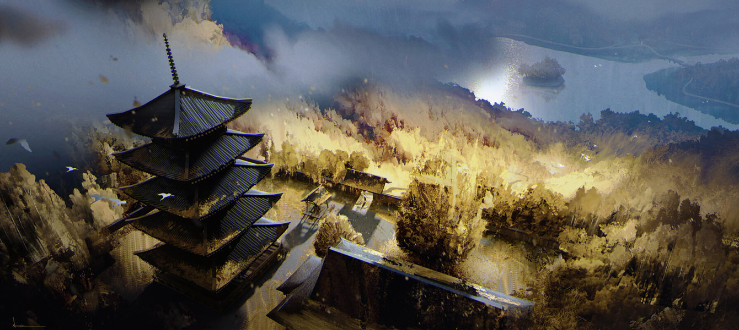
Current Situation in Sakura:
Sakura is embroiled in civil war. Five years ago, Daimyo Yashiro of Shiashi declared war on the Shimazu shogunate in Kaijin. Since then, a dozen battlefields have been staked out south of the Tranquil River. Blossom Valley is the focus of the heaviest fighting, with blue and red banners clashing constantly.
Meanwhile, in the north, House Yoneda in Ayozu wasted no time in forming an alliance with Yashiro. With the promise of a northern shogunate as his prize, Yoneda has launched a full assault on Jurojin, thinking the town a smaller and easier opponent. Yoneda’s witch, Miyake Ono, has raised a horde of undead out of the Nightfall Marshes to terrorize the land. Yoneda has even secured aide from Mingxia, across the waters. The Xiandai city is more than happy to sow unrest in its longtime foes in Sakura. But Jurojin has proven no easy target: Daimyo Katakura has leveraged the superior weapons and armor of the town and utilized knowledge of the Oshiro Hills to his advantage in repelling Yoneda.
The city of Ako alone remains true to the shogun, but it has been forced to defend its lands. No ships or troops can make it south. So, Daimyo Amano sends his forces west to harry his old nemesis in Ayozu.
Only Cold Lantern has remained out of the fighting. Daimyo Hoshina has no ambitions outside of protecting the lands against the Tengu hordes.

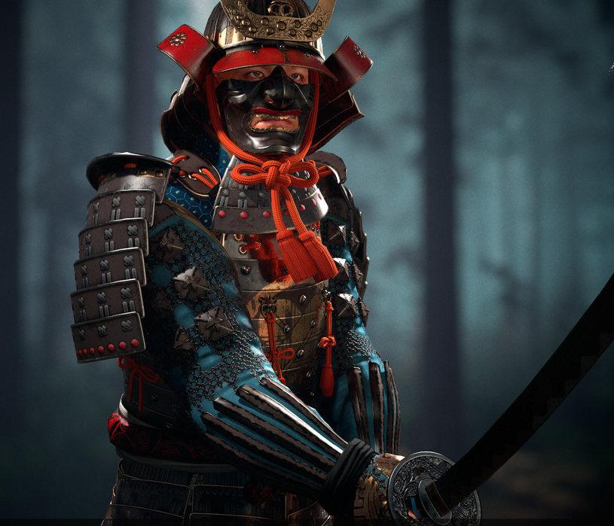

Towns and Cities
Regions of Sakura
- Ako is the seat of power over all lands north of the Nightfall Marshes
- Ayozu is the seat of power over all lands from the Amemasu River estuary down to Thunder Valley
- Jurojin is the seat of power from the lands just north of the Oshiro Hills down to the edge of Kitsune Forest
- Shiashi is the seat of power from the Plains of Shujin down to Blossom Valley
- Kaijin is the seat of power from Mizuchi Lake down to the Angry Ghost River as well as the ruling seat of the Shogun
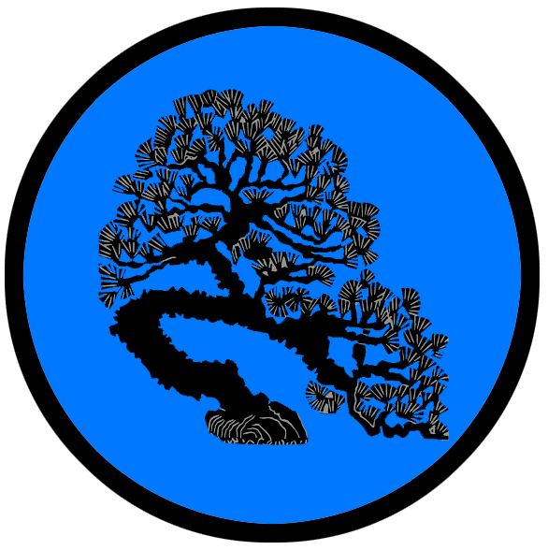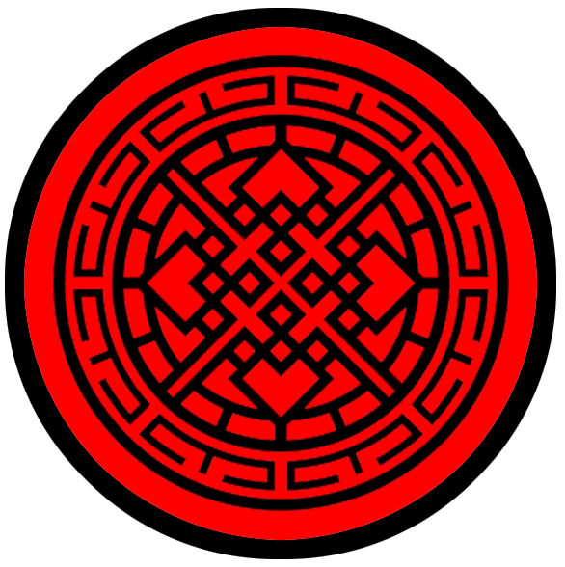
- Ako – small city, kamon of the kitsune fox, green banners, Daimyo Amano
- Ayozu – small city, kamon of the chrysanthemum, orange banners, Daimyo Yoneda
- Jurojin – large town, kamon of the tortoise shell, yellow banners, Daimyo Katakura
- Shiashi – large city, kamon of the bonsai tree, blue banners, Daimyo Yashiro
- Tsumetai (“Cold Lantern”) – small town, kamon of the lantern, black banners, Daimyo Hoshina
- Kaijin – metropolis, kamon of the four diamonds, red banners, Shogun Shimazu

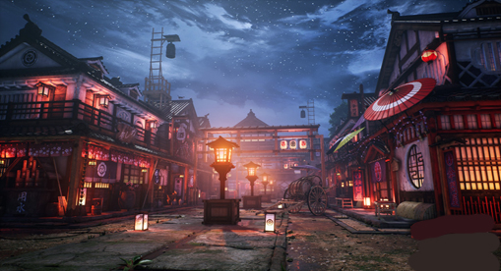

Best in the Land
Trade Hub: Ayozu, Jurojin
Religion: Kaijin
Arts: Bardic college Gunkimono (Shiashi), Bardic college Michiyuki (Kaijin)
Magic: Kaijin
Spirits: Ako
Steel: Jurojin, Kaijin
Grain: Ako, Shiashi, Kaijin
Crafted Goods (e.g. Pottery, Textiles, Metal Wares): Jorogumo (weavers guild) in Shiashi
Harvested Goods (e.g. Aromatics, Medicine, Dyes):
Mined Goods: iron (Jurojin, Kaijin)
Precious Metals: Ginza silver guild (Tsumetai), gems (Ako), platinum (Kaijin)
Ship Building: Ayozu
Samurai schools (Daigaku): Kodokan (Ako), Kyuba No Michi (Ayozu), Bunbu Ichi (Jurojin), Kenjutsu (Shiashi), Gorinso (Kaijin)
Sword Makers: Shiranui (Jurojin), Namahage (Kaijin)

Stewards of Power in this Land
Kings and their armies are not the only wielders of power. There are many unseen friends and foes that shape the destiny of the land. Each of the groups listed below are well known to the people of this region. Some are feared, others venerated. All of them play their part in the grand drama of this land’s story.

Merchant Companies
Ryujin Traders - Ayozu
Spirit Wind Traders - Jurojin

Mercenary Companies
(none)

Smuggling Rings
Black Orchid – Kaijin

Centers of Worship (Churches, Cathedrals, Shrines, Lodges, Temples)
Temple of Inari - Ako
Temple of Fujin - Ayozu
Temple of Rising Sun (Amaterasu) - Jurojin
Temple of Tenjin - Shiashi
Temple of Takemikazuchi - Tsumetai "Cold Lantern"
Temple of Hachiman - Kaijin

Orders of Paladins
Order of Taiyo (sun) – Jurojin
Order of the Tiger – Kaijin

Druidic Circles
Circle of the Cherry Blossom – Jurojin

Bands of Rangers
Band of the Snow Leopard – Tsumetai “Cold Lantern”

Schools of Magic
Okami Sanctum – Kaijin

Bardic Colleges
Daigaku Gunkimono – Shiashi
Daigaku Michiyuki – Kaijin

Warrior Academies
Daigaku Kodokan - Ako
Daigaku Kyûba No Michi - Ayozu
Daigaku Bunbu Ichi - Jurojin
Daigaku Kenjutsu - Shiashi
Daigaku Gorinso - Kaijin

Assassins Guilds
Shinobi - Jurojin
Kunoichi - Shiashi
Korugo - Kaijin

Cults
(none)

Other Guilds
Shiranui (sword makers) - Jurojin
Jorōgumo (weavers guild) - Shiashi
Ginza (silver guild) – Tsumetai “Cold Lantern”
Namahage (sword makers) - Kaijin

Monasteries
Monastery of Inner Dawn (Aizen) - Kioko Mountains in the north of Sakura
Monastery of Seven Sages (Rokuju) - along the banks of the Oishi River
Monastery of All that Flows (Benzai) - Oshiro Hills, overlooking Sui Jin Lake
Monastery of Full Cup (Hotei) - overlooking the Kamatsu Strait, north of Shiashi
Monastery of the Laughing God (Hiruko) - Domaru Mountains, at the head of the Ronin River
Monastery of War and Justice (Tamonten) - at the mouth of the Gozen River
Monastery of the High Harvest (Daikoku) - along the banks of the Tranquil River
Monastery of the Sacred Water (Suijin) - Domaru Mountains, at the head of the Angry Ghost River
Monastery of Fruitful Tree (Kichijo) - overlooking the Kamatsu Strait, along the Angry Ghost River
Monastery of the Faceless Ghost (Noppera-bō) - northern edge of the Nightfall Marshes
Monastery of the Shroud (Shinigami) - Oshiro Hills
Monastery of the Dark Moon (Tsukiyomi) - Kitsune Forest, alongside the Ronin River
Monastery of the Spider Clan (Tsuchigumo) - Northern Domaru Mts. Overlooking the Kodama River
Monastery of the Vengeful Ghost (Onryō) - Domaru Mts overlooking the Higanbana Valley
Monastery of Wind Demon (Idzuna) - Shadow Hills in eastern (Azuma) region of Sakura
Monastery of the Mother Ghost (Mu-Onna) - Domaru Mts overlooking the Koi River

Pirates
Captain Eight Bells Assano – Forgotten Reach

Points of Interest
- Kitsune Forest – dwelling place of the elusive Kitsune, magical creatures that resemble foxes but are intelligent. The elves of Teliddia also make their home here, living in peace with the Kitsune. Legends tell of the Hoshi-no-Tama, a mystical sphere guarded by a Kitsune. It is said to hold the power of the Kitsune and if stolen can give the one who obtains it power to force the Kitsune to help them. Visitors are mostly unwelcome here, but are granted favor if they can tolerate the Kitsune’s pranks and illusions with good humor.
  - Here, alongside the Ronin River, is the Monastery of the Dark Moon, where monks study and train in the ways of Tsukiyomi, god of the moon.

- Plains of Shujin – these are vast coastal plains that stretch north of Shiashi and the Tranquil River and end at the Kodama River. Countless farming villages populate the plains, but wartime conflicts regularly cause the landscape of farmers to change. Three hundred years ago the northern forces rebelling against the Shogunate were repelled here. Since then, common folk fear to wander off established roads, for fear of ghosts.
  - Location of the Monastery of the Full Cup, where monks study and train in the ways of Hotei, god of contentment.
- Forgotten Reach – Once a part of the proud Azuma kingdom, these lands fell to Tengu armies one thousand years ago. The capital city, Shizoku, had once been a formidable power in the east, but now lies in ruin. It was also the site of the Forge of Nagaari, where ancient sword making traditions were kept. Tengu tribes occupy these lands, making them inhospitable to outsiders.
  - Here dwells the Shihai (“domination”) tribe of Tengu, known by their sign of the green broken naginata spear. The tribe also occupies the ruins of Shizoku.
- Anada Plains – the southern-most reaches of current Sakuran lands, the plains border the Burnt Lands beyond the Koi River. Courageous farmers stake out homesteads here, but are always wary of invaders from Xiandai across the strait.
- Hiro Reach - Once a part of the proud Azuma kingdom, these lands fell to Tengu armies one thousand years ago. The peninsula wraps around the Bay of Kumara. Otemon, the city that reigned over this region, lies in ruins at the western end of the reach. Tengu tribes living here make travel impossible, but pirates sailing down the coast often times make port in the bay.
  - Here dwells the Akuno (“evil”) tribe of Tengu, known by their sign of the blue horned skull

- Kojin River
- Oni River
- Oishi River
  - Home of the Monastery of the Seven Sages, where monks study and train in the ways of Rokuju, god of wisdom
- Amemasu River
- Saito River
- Ronin River
  - The mouth of the river is home of the Monastery of the Laughing God, where monks study and train in the ways of Hiruko, the laughing god.
- Kodama River
  - Kodama River is wide, slow-moving river that drifts along the edge of the Kitsune Forest before emptying into the Kamatsu Strait. It is regarded with reverence by the people for it is the gathering place of the Kodama, or tree spirits, that live in the forest.
  - Overlooking the Kodama River from its lofty perch in the Domaru Mountains, is the Monastery of the Spider Clan, where ninja study and train in the nefarious ways of Tsuchigumo. Initiates become assassins who have mastered invisibility, stealth, and infiltration.
- River (unnamed)
- Gozen River
  - The mouth of the river is home of the Monastery of War and Justice, where monks study and train in the ways of Tamonten, god of war and justice.
- Tranquil River
  - The banks of the river are home to the Monastery of the High Harvest, where monks study and train in the ways of Daikoku, god of the harvest.
- Saddle River – This river breaks off from the Tranquil River and turns south sharply, looping back and ending in Mizuchi Lake. Its western banks tower over the waterway and the lands of Blossom Valley below.
- Yari River – The Yari River breaks off from the Shrine River and empties into the Rising Sea in the east.
- Shrine River – This river rolls eastward out of the Domaru Mountains to cross the once-proud Azuma Lands. The city of Bakaru stood proudly at its banks, ruling this region, but now lies in ruins after falling to the Tengu one thousand years ago.
- Koi River –
  - Located at the head of the river, looking down from its perch in the Domaru Mountains, is the Monastery of the Mother Ghost, where ninja study and train in the nefarious ways of Mu-Onna. The only ninja school to train women exclusively, initiates become assassins who have mastered invisibility, stealth, and infiltration.
  - 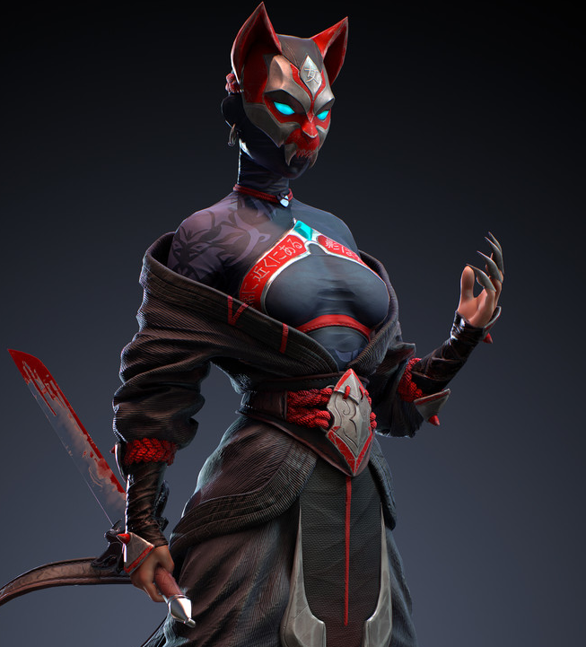
- Forsaken Rivers – the three rivers that snake out into Hiro Reach were once controlled by the city of Otemon, which now lies in ruins after falling to the Tengu one thousand years ago.
- Angry Ghost River - southernmost river in current Sakuran lands, it overlooks the Burnt Lands to the south.
  - At the head of the river lies the home of the Monastery of the Sacred Water, where monks study and train in the ways of Suijin, god of water.
  - At the mouth of the river, overlooking the Kamatsu Strait, lies the home of the Monastery of the Fruitful Tree, where monks study and train in the ways of Kichijo, goddess of fertility.

- Kojin Lake
- Sui Jin Lake
  - Location of the Monastery of All That Flows, where monks study and train in the ways of Benzai, goddess of all that flows.
- Raingold Lake
- Lake (unnamed)
- Mizuchi Lake

- Nightfall Marshes – These dreaded marsh lands lie between the Amemasu and Oishi Rivers, fed by them and draining into their estuaries. The land has yielded good farming but has also offered a natural barrier against invaders. This has allowed the simple farming villages in the region to merge and grow into the city of Ako. The marshes sit between the cities of Ako and Ayuza. Over the centuries the daimyo of the two cities have waged war, hiring rangers to find safe foot paths and sending troops through the Nightfall Marshes, which are so named for the evil demons who are said to dwell there. The crossing is treacherous and some battles have erupted within the swamps themselves. Entire companies have disappeared while crossing these lands. It is said the Nightfall Marshes are haunted by the spirits of slain warriors who linger there and are hungry for revenge. The marshes are also home to the Abura-sumashi, spirits who appear to lone travelers. They are a rare yokai native to the Nightfall Marshes. They appear as squat humanoids with a large ugly head like a potato or a stone, wearing a straw-woven raincoat.
  - Currently Yoneda, daimyo of Ayozu, has ordered his witch, Miyake Ono, to raise a horde of undead out of the Nightfall Marshes to terrorize the land in his bid to conquer the north.
  - The northern edge of the marshes is the home of the Monastery of the Faceless Ghost, where ninja study and train in the ways of Noppera-bō. Initiates become assassins who have mastered invisibility, stealth, and infiltration.
  - Here dwells the Ekibyo (“pestilence”) tribe of Tengu, known by their sign of the orange cypress cones

- Kioko Mts
  - home of the great red dragon Honoshita (“flame tongue”)
  - home of the Monastery of Inner Dawn, where monks train and study in the ways of Aizen, god of spiritual awakening.

- Domaru Mts – A mighty range of mountains that run north-south along the center of Sakura and divide it into eastern and western lands.
  - home to the copper dragon Kireina (“beautiful one”)

- Oshiro Hills
  - Location of the Monastery of the Shroud, where ninja study and train in the nefarious ways of Shinigami, god of death. Initiates become assassins who have mastered invisibility, stealth, and infiltration. Rumor has it that they drink of the elixir called the Dark Dream, which offers up visions of the future. Their cult leaders have spent centuries looking for power over the dead, often raising up armies of corpses which have threatened Jurojin and the surrounding villages. These hordes they call the Shiryō, the souls of the dead, the opposite of ikiryo.
- Shadow Hills
  - Here lies the Monastery of the Wind Demon, where ninja study and train in the nefarious ways of Idzuna. Initiates become assassins who have mastered invisibility, stealth, and infiltration.
  - Site of Daimyo Akida’s last stand against the Tengu during the War of the Red Lily

- Thunder Valley
- Blossom Valley – A vast stretch of fertile land bounded on the west by the Saddle River, Blossom Valley is a pastoral and beautiful place. Its name comes from the many colorful flowering plants that inhabit the hills and dells of the region: reds of the tsubaki (camellia), violets of the sumire and asago (morning glory), pinks and yellows and whites of the kiku chrysanthemum, and the light pink of the ume apricot flowers. Druids stand as guardians of these flowering groves and the valley is often visited by the flora elves out of Teliddia.
  - But war has now marred the pristine beauty of this place, with armies of Jurojin and Kaijin claiming both sides of the valley as staging areas. Bloody battles wage almost daily, with villagers caught in the middle.
- Cold Lantern Pass – A narrow pass that runs east-west through the Domaru Mountain range. The pass has been the focal point of invasions from the eastern lands occupied by the Tengu tribes ever since they conquered the Azuma kingdom here one thousand years ago. Now it is the location of Tsumetai (Cold Lantern), a small fortified town that houses troops to defend the pass. It is a dark and cheerless place fill with the sounds of howling winds and dark creatures lurking in the shadows.
- Fox Vale – location of the Tanjoki, the birth tree, the original cherry blossom tree brought forth by Ameterasu when she looked upon Sakura; the tree is over fifty feet tall and sacred. Thousands of Kodama tree spirits make the many branches their home. Monks travel from all over Sakura to meditate beneath the tree and connect with the divine spirits.
- Higanbana Valley – a dark place where Tengu tribes originated; it is so named for the Higanbana flower, or red spider lily, which adorns the land here and is called the flower of death.
  - Looking down from its lofty perch in the Domaru Mountains is the Monastery of the Vengeful Ghost, where ninja study and train in the nefarious ways of Onryō. Initiates become assassins who have mastered invisibility, stealth, and infiltration.
  - Here dwells the Satsujin (“murder”) tribe of Tengu, known by their mark of the red higanbana blossom

- Temple of the Rising Sun

- Teliddia - Elven Kingdom
  - Mavra - Elven town of Teliddia
  - Mevera - Elven town of Teliddia
  - Elawarin - Elven city of Teliddia
  - Aldaval - Elven town of Teliddia
  - Panarel - Elven town of Teliddia
  - Taerylin - Elven town of Teliddia

- Turquorzem - Dwarven Kingdom
  - Duridor - Dwarven town of Turquorzem
  - Hammerfell - Dwarven city of Turquorzem
  - Keterak - Dwarven town of Turquorzem
  - Harkilum - Dwarven town of Turquorzem
  - Endegarn - Dwarven town of Turquorzem
  - Basilisk Keep - Dwarven town of Turquorzem
  - Darkforge Keep - Dwarven town of Turquorzem
  - Firestoke Keep - Dwarven outpost of Turquorzem

- Hogo-Sha (the River Guardians) – After the fall of the Azuma lands one thousand years ago, the Sakuran lords had a massive fifty-foot-tall wood and stone palisade erected along the northern banks of the Gozen River. Watch towers stand every fifty miles, monitoring the lands south of them for Tengu activity. Once every generation some Tengu warlord arises and unites several tribes to assault the wall. The conflict is always cataclysmic, but so far, the Sakuran forces have never allowed the Tengu to invade northward even when the wall has been sundered. Onmyōdō wizards have cast a myriad of spells on the walls over the centuries, accumulating into a permanent enchantment that some say has given the wall an intelligence of its own.

- Ruins of Shizoku – Once a great city of the Azuma lands, Shizoku fell during the Tengu Invasion in 456 WA3. The Shihai (“domination”) tribe of Tengu, known by their sign of the green broken naginata spear, constantly wander from the Forgotten Reaches into the ruins and control most of the city.
- Ruins of Bakaru – Once a great city of the Azuma lands, Bakaru fell during the Tengu Invasion in 453 WA3.
  - Here dwells the Kurayami (“darkness”) tribe of Tengu, known by their sign of the twin upside down black triangles
- Ruins of Otemon – Once a great city of the Azuma lands, Otemon was the first great city to fall during the Tengu Invasion in 452 WA3.
  - Here dwells the Itazura (“mischief”) tribe of Tengu, known by their sign of the yellow sake gourd
- Shojo Guardians – Standing at the northern mouth of the Kamatsu Straits, one on the Xiandai coast and one on the Sakura coast, these 100-foot-tall statues depict a Xiandai warrior and a Sakuran warrior brandishing spears that point heavenward. They were erected in the First Ancient Age by two princes who waged the cruel and pointless Fisher King War as a reminder of the friendship once shown between Xiandai and Sakura and the pledge to strength during peace time.


Ako
Size: small city
Trade Goods: grain, tea, wine, gems
Local Goods:
Standard: sign of the kitsune fox
Colors: green and white
Patron Deity: Inari, goddess of rice and fertility
Ruler: Daimyo Amano Katagiri and his wife Yono (f)

Home: Castle Tategami aka Castle Horse Mane
Steward (Jito): Ashikaga Mochiyori
Marshal (Shugo): Izumi Tsunesada
House Priest (Gukashu): Nomura Chikakage
House Adviser (Scholar/Mage/etc) (Onmyōdō): Karasumaru Yasuhira
Captain of the Guard (Bansho): Sakakibara Nagakore
Chief Warriors in Service (Kashindan):
Kashin (retainer) Samurai Nanbu Akihiko
Kashin (retainer) Samurai Soga Nakaari
Kashin (retainer) Samurai Nagaso Katsunori
Kashin (retainer) Samurai Amago Tsuna (f)
Kashin (retainer) Samurai Adachi Aritoki
Kashin (retainer) Samurai Nomiya Yukinari

Local Powers: Wind Demons (thieves guild), Kodokan (warrior academy), Temple of Inari
Local Sites: The Broken Wheel Inn & Tavern, The Emperor’s Sword Inn & Tavern, Aonyōbō Shrine (brothel), Raiju House (rice wine)

Description:
Ako is known as the City of Reeds. Situated in the midst of marshlands, the city is comprised of countless islands connected by elevated wooden causeways. It is a quiet city with farmers dominating among the castes. Life is slow here and tranquility a premium.

Ako sits along the Oishi River in the shadow of the Kioko Mountains. The land here is damp and waterlogged, alternating with rice fields and dangerous marshes. To the west are the vast Nightfall Marshes, which is fed by the Amemasu and Oishi Rivers and drains into their estuaries. The land has yields good farming as well as serving as a natural barrier against invaders. This has allowed the simple farming villages in the region to merge and grow into the city of Ako.

The castle of Daimyo Amano is a proud, old Ishigaki, or stone castle standing at the highest point of land where it gently descends into the wetlands all around. The castle was built from stone brought down from the Kioko Mountains over three thousand years ago. The pale green sheen of the stones gives it the name Midori Castle (Green Castle), and this color is featured prominently throughout the city’s outer walls and buildings. It is also the color of House Amano. Radiating out from the castle are the several farming villages, which are all collectively named Nôson.

Industry:
Grain, tea, and spirits are the mainstays of the economy here. Centuries ago, rangers from the farming town discovered gems in the Kioko Mountains. The Daimyo commissioned mining works to be started. It wasn’t long before they were contending with creatures of the mountains that threatened the mines.

Raiju House is a large rice farm located outside the city on the lower hills overlooking the sea. Here the Raiju rice wine is bottled and exported throughout eastern Nemmyrl.

Key Figures:
Daimyo Amano is a middle-aged man with a cool temperament and is keen to listen. He has abandoned his ancestors’ grudges against the Shogunate in Kaijin. Instead, he is invested in securing the stability of the lands around the Oishi River and Kioko Mountains. He knows he cannot compete with Ayozu and Jurojin and their merchant companies. So, he has invested heavily in the gem mines in the Kioko Mountains and jealously guards their existence.
While he is a man of little words, Amano is capable of swift action. He has hired ninja assassins in the past, either to protect the secrets of his mines or to eliminate warlords who trouble the north with talk of rebellion. In the wake of Ayozu’s attacks on Jurojin he has sent small detachments west to harry his old adversaries while their main forces are deployed to Jurojin.

Local Lore:
Many strange creatures plague the mines in the Kioko Mountains. There is the Ōmukade: a giant, human-eating centipede that lives in the mountains as well as Yobuko, a mountain-dwelling spirit. They persist to this day, in spite of heroes over the ages slaying the Ōmukade and priests beseeching Yobuko for favor.

Here stands the proud Temple of Inari, goddess of rice and fertility. She is the patron goddess of Ako. She is said to appear in the forests outside the city, accompanied by her helpful fox companions, bringing health and prosperity to her people. Rainfall is plentiful here, which is good for crops but often comes with heavy storms.

The area around Ako is rumored to be haunted by the Abura-sumashi, spirits who appear to lone travelers. They are a rare yokai native to the Nightfall Marshes. They appear as squat humanoids with a large ugly head like a potato or a stone, wearing a straw-woven raincoat. The name abura sumashi means “oil presser,” and comes from the act of pressing oil out of the seeds of tea plants which grow around Ako. Though its origins are a mystery, it is commonly believed that abura sumashi are the ghosts of oil thieves who escaped into the woods. Oil was a very difficult and expensive commodity to make, requiring a lot of time and hard work to extract it from tea seeds, and so its theft is a very serious crime. Those thieves who went unpunished in life are reincarnated as yokai – a sort of divine punishment for their sins.

History:
Ako has a long history of conflict with its western neighbor, Ayozu. Over the centuries the daimyo of the two cities have waged war, hiring rangers to find safe foot paths and sending troops through the Nightfall Marshes, which are so named for the evil demons who are said to dwell there. The crossing is treacherous and some battles waged in the swamps themselves. Sometimes entire companies have disappeared while crossing it. It is said the Nightfall Marshes are haunted by the spirits of slain warriors who linger there and are hungry for revenge.

Customs:
The people of Ako live a quiet farming life. They are not much engaged with the rest of Sakura except in times of war, which happen more often than they care for. Farmers here are suspicious of outsiders. They will honor a traveler with hospitality but quietly send word to the Daimyo’s guard. They are also a superstitious lot, for there are many yokai that inhabit the Nightfall Marshes and Kioko Mountains.

The symbol for Ako is that of the kitsune fox mask. Though Kitsune Forest lies hundreds of miles up the Oichi and Ronin Rivers, the magical creatures are often spotted in this region. They are the servants to Inari, patron goddess here, and often appear to do her bidding. The people of Ako see the kitsune as favorable creatures, for though they are tricky they are mostly kind. And the people have had to be tricky to survive wars waged by the larger cities.

It is said that long ago that these lands suffered drought. Inari summoned Ameonna, the rain-making female spirit, to smile upon Ako. Hiyoribō, the spirit who stops the rainfall, grew jealous. For centuries the clouds over Ako regularly flash with lightning and thunder as if Ameonna and Hiyoribō are clashing. It is also said that both spirits are fighting over the affections of Ikazuchi-no-Kami, a thunder god of Sakura. It is now a custom that once each year a champion of Ameonna is selected from the city. He or she must travel into the Kioko Mountains and face a beast chosen by Hiyoribō. Whoever prevails determines if that year will have rain or drought. A ceremony is held to see the champion off. If the champion returns victorious the city holds a great festival.

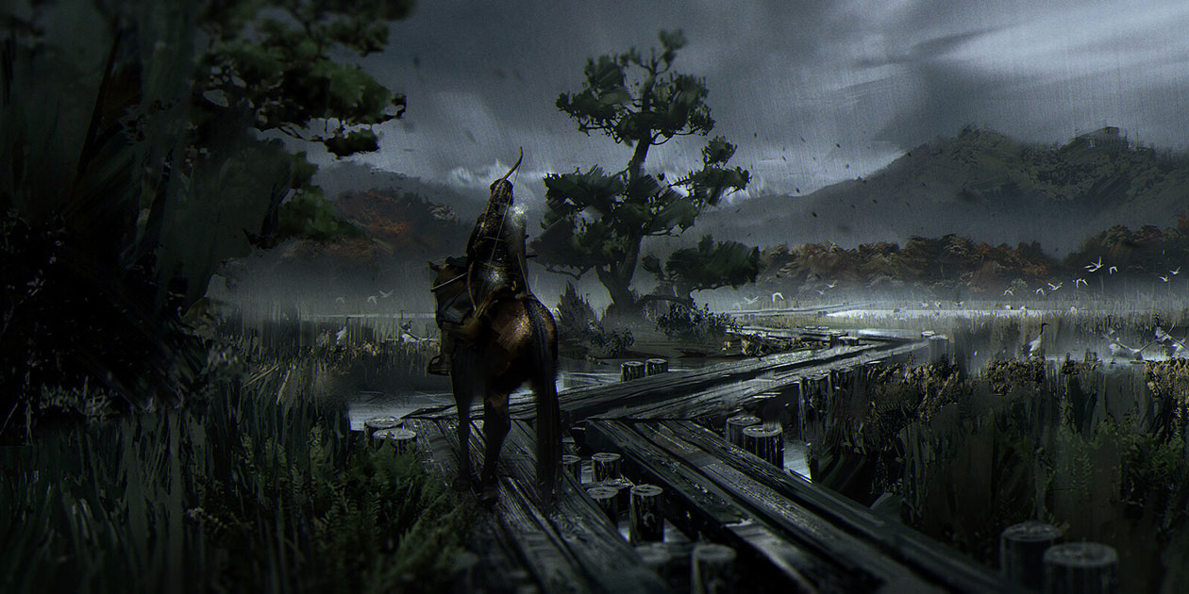

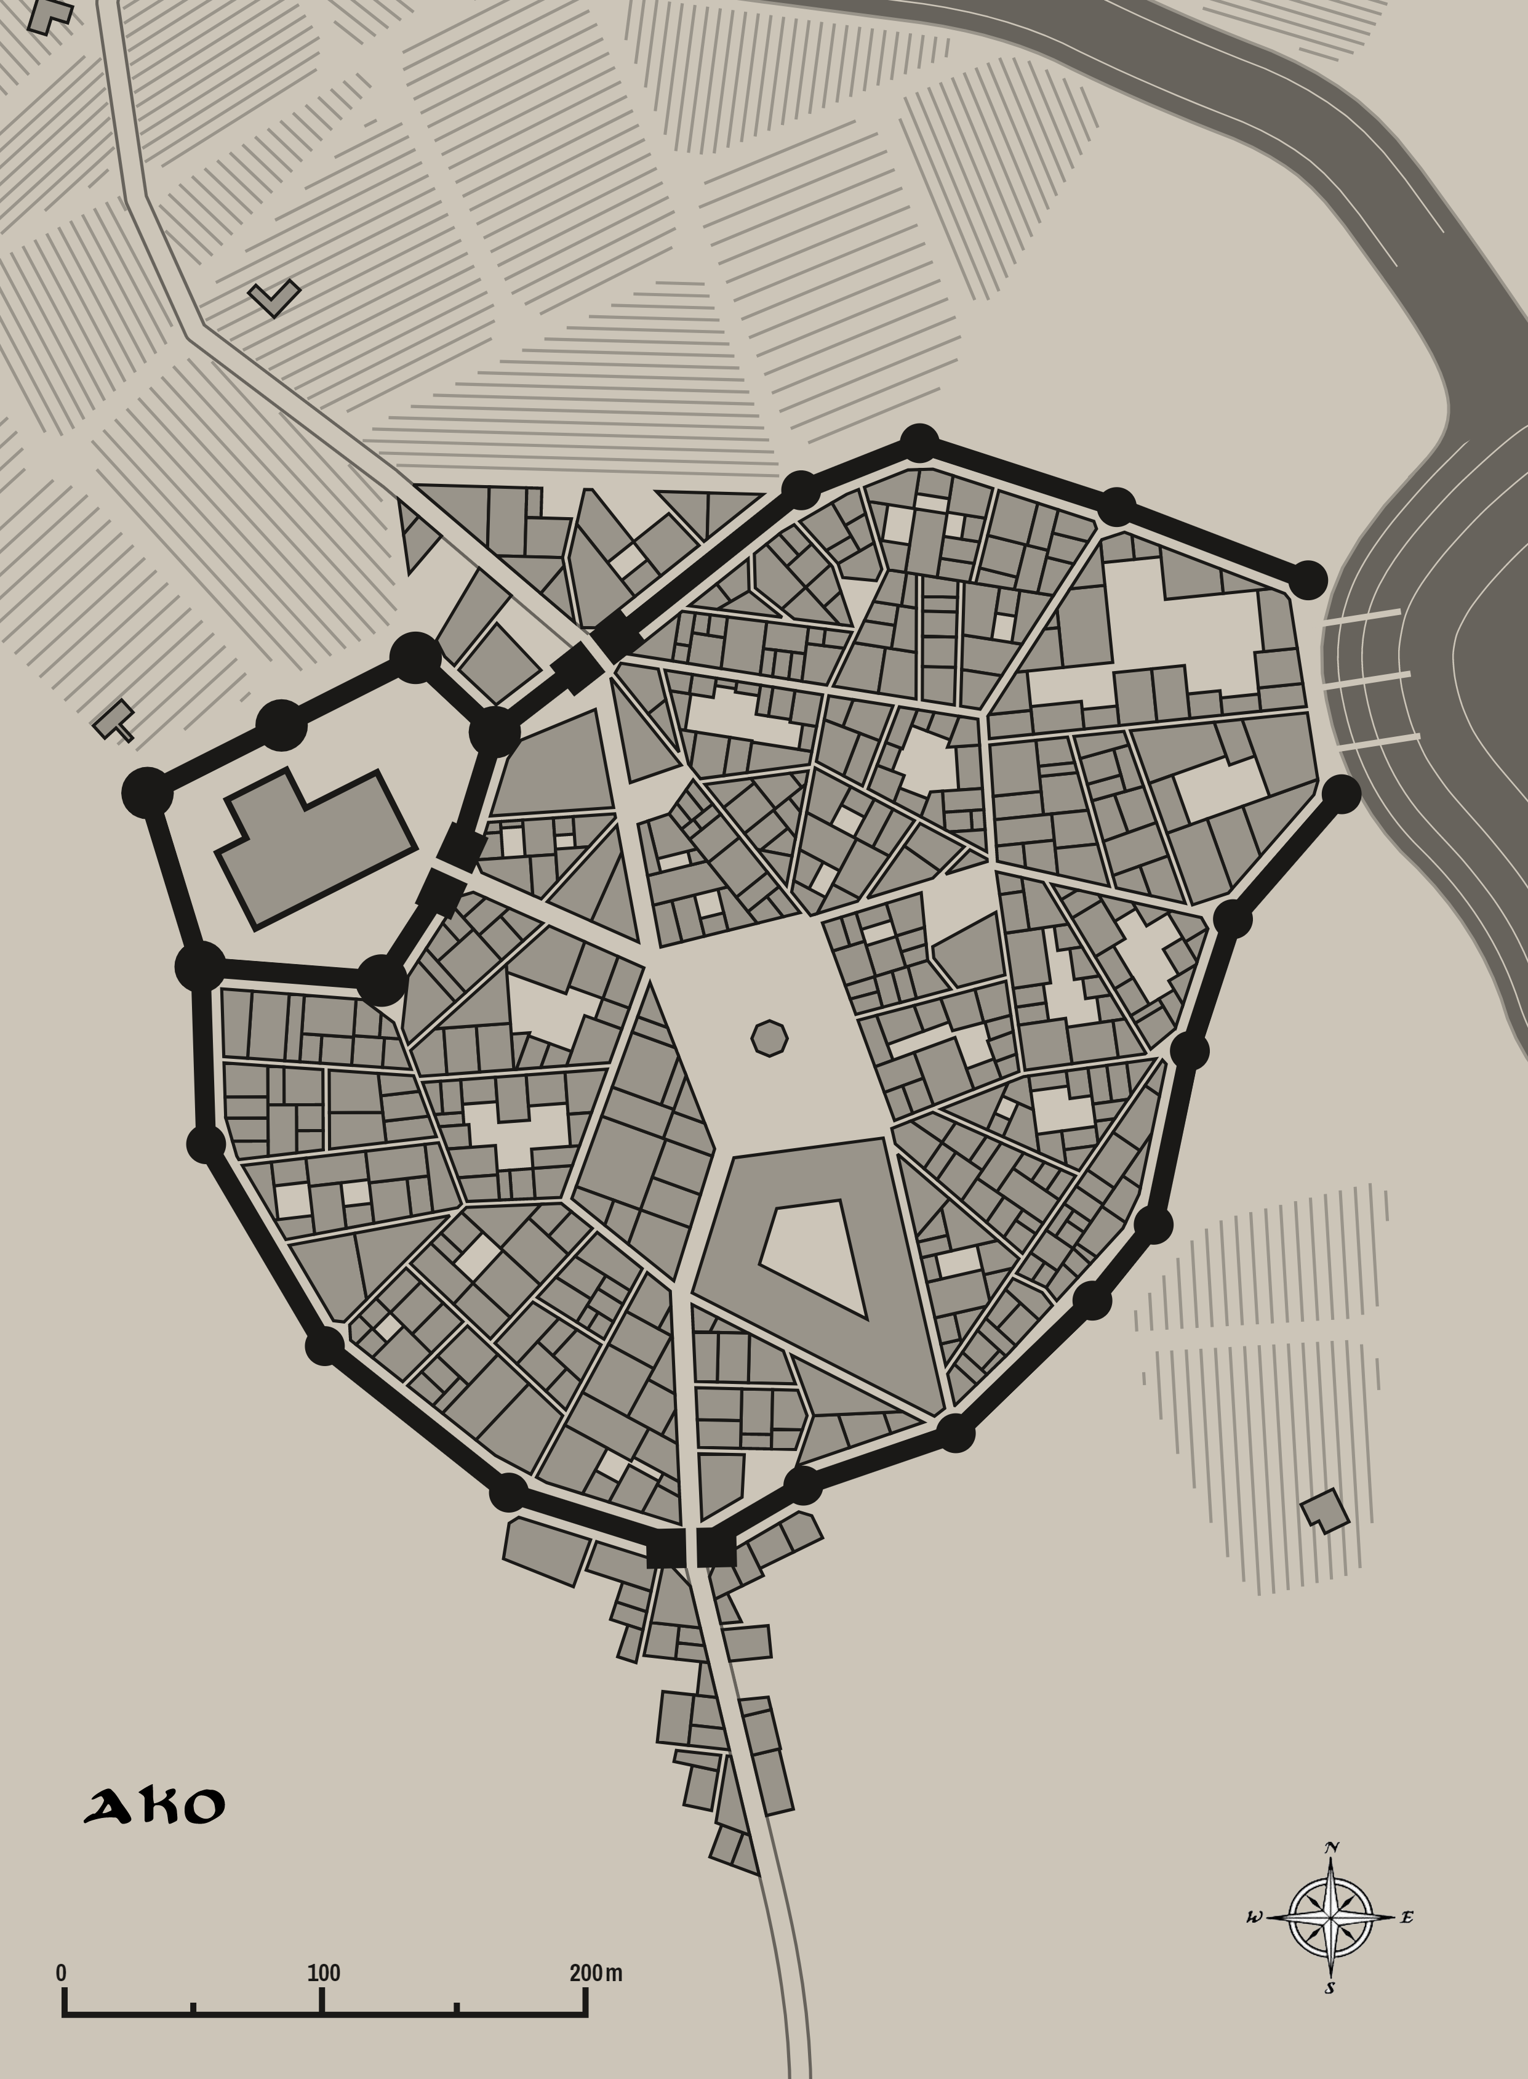


Ayozu
Size: small city
Trade Goods: trade hub, pottery, clay, fishing, spices, ship building
Local Goods:
Standard: sign of the chrysanthemum
Colors: orange and black
Patron Deity: Fujin, god of wind
Ruler: Daimyo Yoneda Tanehisa and his wife Kisa (f)

Home: Castle Ikari aka Castle Fury
Steward (Jito): Kinoshita Motokore
Marshal (Shugo): Ii Haruie
House Priest (Gukashu): Nomura Sadakata
House Adviser (Scholar/Mage/etc) (Onmyōdō): Miyake Yono (f) the Fetid Blossom
Captain of the Guard (Bansho): Suda Terumune
Chief Warriors in Service (Kashindan):
Kashin (retainer) Samurai Endou Yukitoshi
Kashin (retainer) Samurai Ina Korechika
Kashin (retainer) Samurai Shouni Sadatane
Kashin (retainer) Samurai Daidouji Takeaki
Kashin (retainer) Samurai Soejima Atsukata
Kashin (retainer) Samurai Tokudaiji Sanenaga

Local Powers: Ryujin Traders, Betobeto (thieves guild), Kyûba no michi (warrior academy), Temple of Fujin
Local Sites: Laughing Man Inn & Tavern, The Ghost Maiden Inn & Tavern, Shōjō House (brothel)

Description:
Ayozu sits at the end of the Amemasu River where it empties into the Kamatsu Strait. Rich orange clays and silt decorate the estuary, giving the castle of Ayozu the nickname the Orange Castle and lending itself to the color scheme of the city’s outer walls and flags. The castle of Daimyo Tanehisa is considered a Hirajiro: ‘Castle on the plain’, a castle built on flat ground (as opposed to a Yamashiro). But it sits atop a packed clay island surrounded by streams branching off the main river. This has offered it a good defense from attacks overland.

Industry:
Trade with ships passing through the Kamatsu has caused the farming and fishing villages on these banks to merge and grow into a major trading center. The center of the city along the riverbanks has been transformed into a large market area. The coastal area is a large, deep seaport and shipyard. Further upriver is the Nôson, or farming village district. Ships from Ayozu are highly coveted in Sakura and are often commissioned as war ships in the naval fleets of other Daimyo.

Ayozu is a strong trade partner with the Xiandai city of Mingxia. Farmers from Mingxia have grown tired of seeing their goods handed over to the emperor in the City of Destiny. They have begun sending caravans overland to Plum River, where boats cross the Kamatsu and trade with Ayozu. It is an amicable partnership and one that has helped both sides. It does, however, cause tensions with the City of Destiny. In the past the Shogun of Sakura has had strong words for Ayozu’s practices, warning of war with Xiandai. But Ayozu quietly continues the practice.

Key Figures:
Daimyo Yoneda is a headstrong man with wild ambitions. He has secured ties with Mingxia to work together for trade and war, choosing to forget the role Mingxia played three hundred years ago putting down the revolt in the north. Yoneda has allied with the city of Shiashi in conquering all of Sakura: Daimyo Yoshiro conquering the capital in Kaijin and ruling the south, while Yoneda conquers Ako and Jurojin and rules the north.

Yoneda has launched a full attack on the town of Jurojin, thinking it weak and an easy first target in his bid to seize control of the north. His court wizard, Miyake Ono, has raised an army of undead soldiers from the Nighfall Marshes. Gashadokuro, giant undead skeletons towering thirty feet high, march ahead of them destroying everything in their path.

Miyake Ono, the court wizard, is also known as the Fetid Blossom. She dresses in deep purples and blacks and bears a purplish streak across her eyes. She is astonishingly beautiful, but carries an aroma of sweet decay. Miyake is not afraid to delve into the dark arts. She has the full trust of the Daimyo and manipulates him to her own ends. She employs unthinkable forces to terrorize Yoneda’s enemies and keep the region in fear.

Here stands the Temple of Fujin, the god of wind and one of Sakura’s oldest gods. Fujin is the patron god of Ayozu.

Local Lore:
Creatures of the sea frequent the Kamatsu Strait. Sailors warn of the Isonade, a fish-like sea monster with a barb-covered tail. A handful of ships disappear each year that are rumored to fall victim to the beast. Others warn of Samebito, a shark-man from the undersea Dragon Palace which is rumored to lie somewhere to the north. Samebito is said to attack ships and plunder them for sport and occasionally wanders into the city to find a bride. Finally, there are the Shōjō, red-haired sea sprites who love rice wine and jewels. They are said to seduce sailors as well as take human form and visit the taverns at night.

History:
Ayozu has a long history of conflict with its eastern neighbor, Ako. Over the centuries the daimyo of the two cities have waged war, hiring rangers to find safe foot paths and sending troops through the Nightfall Marshes, which are so named for the evil demons said to dwell there. The crossing is treacherous and some battles have been waged in the swamps themselves. Sometimes entire companies have disappeared while crossing the marshes. It is said the Nightfall is haunted by the spirits of slain warriors who linger here and are hungry for revenge.

Customs:

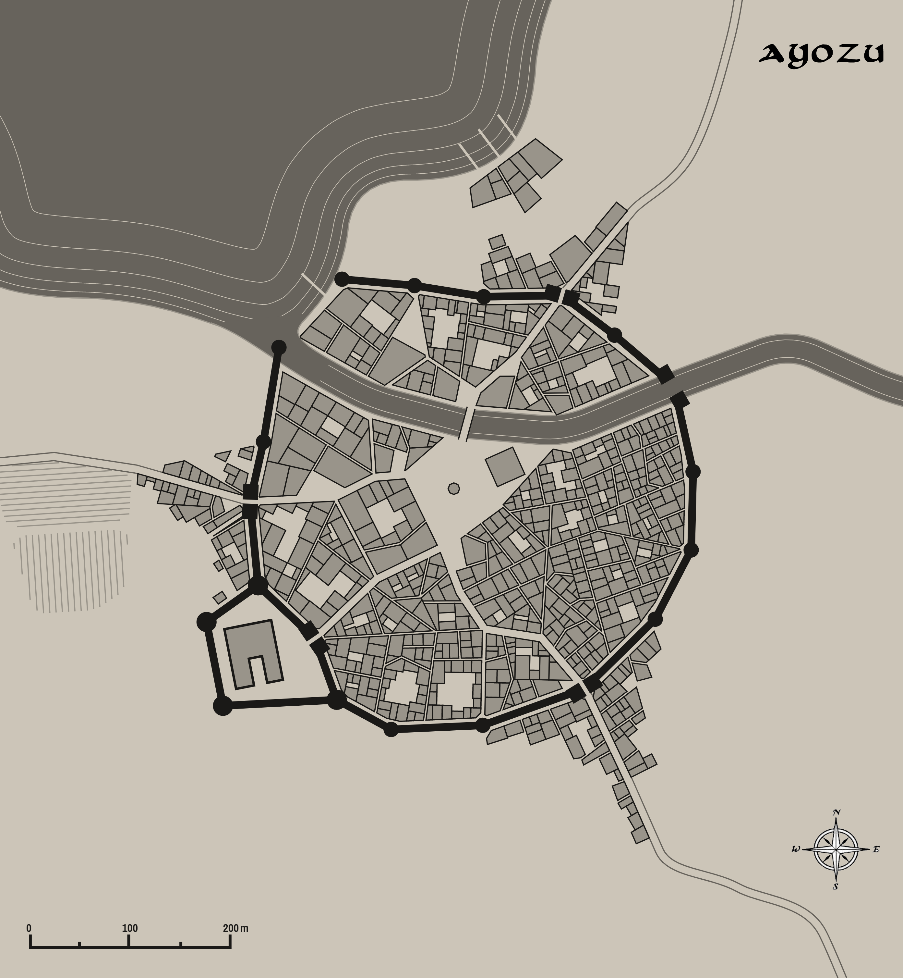


Jurojin
Size: large town
Trade Goods: trade hub, steel, iron, flax
Local Goods:
Standard: sign of the turtle shell
Colors: yellow and black
Patron Deity: Amaterasu, goddess of the sun
Ruler: Daimyo Katakura Takanori and his wife Ima (f)

Home: Castle Hinode aka Castle Sunrise
Steward (Jito): Nitta Atsuharu
Marshal (Shugo): Takeya Tokiari
House Priest (Gukashu): Ishii Kisa (f)
House Adviser (Scholar/Mage/etc) (Onmyōdō): Rokkaku Hirahiko
Captain of the Guard (Bansho): Takamatsu Hidetane
Chief Warriors in Service (Kashindan):
Kashin (retainer) Samurai Tanaka Muneuji
Kashin (retainer) Samurai Takenaka Mochikane
Kashin (retainer) Samurai Hashimoto Michimasa
Kashin (retainer) Samurai Itagaki Katsutoshi

Local Powers: Spirit Wind Traders, Fortune Ghosts (thieves guild), Circle of the Cherry Blossom (order of druids), Bunbu Ichi (warrior academy), Shiranui (sword makers), Temple of the Rising Sun, Order of Taiyo (Sun) (paladins), Shinobi (assassin’s guild)
Local Sites: The Forged Coin Inn & Tavern, Inn of the Setting Sun, Taka-onna Palace (brothel), Kimuro Wine House (sake)

Description:
Settled alongside the Saito River where it empties into the Ryujin Sea, Jurojin is the eastern most of all towns in Nemmyrl. It is called the Town of Dawn, for it is the first large settlement to see the sunrise. The castle of the Daimyo (Honjo) sits atop a central hill, with five smaller hills surrounding it. These are the foothills of the Oshiro Hills to the west. Each of the five hills has a smaller castle (Shijo) that support the main castle. Bright yellow No-bori, or long vertical flags that act as standards, fly from every castle. Yellow is the customary color of Jurojin and is reflected on the highlights painted on many of the buildings in the town.

The farming villages and markets are located within and between the hills with a lower outer wall encircling the hills and town on the land side. Fields of flax and other crops are cultivated outside of town.

A known threat in this region is a cult dwells in the Hills of Oshiro who worship Shinigami, the god of death. Their cult members are dangerous zealots who oppose Amaterasu and her guiding principles. It is feared that their worshippers steal into villages and poison sleeping victims who they offer up as sacrifices to their god. Rumor has it that they drink of the elixir called the Dark Dream, which offers up visions of the future. Their cult leaders have spent centuries looking for power over the dead, often raising up armies of corpses which have threatened Jurojin and the surrounding villages. These hordes they call the Shiryō, the souls of the dead, the opposite of ikiryo.

Industry:
Jurojin is a major trade hub that deals frequently with ships coming or going along the trade routes of the Noreast Long Jaunt, the Cape Crossing, and the Easterly Way down to Mahabar. Goods from the east are highly sought after by Norgardesmen and by ships from Western Amadar. Most of the traffic is with Jangi Kara to the south or ships from Xiandai.

The sword makers, called Katanakaji, of Jurojin have united to form the Shiranui Guild and create expert swords worthy of heroes. Each sword is embossed with a maker’s mark of the Shiranui flame. Warriors enjoy lengthy debates over the relative qualities of the two great sword makers of Sakura: Shiranui and Namahage, in Kaijin.

Key Figures:
Daimyo Katakura
Katakura is a short, broad-shouldered man with a wide, squat face. He wears a permanent scowl with a square jaw that projects outward as if in defiance. The Oshiro Hills to the west are his stomping grounds from childhood. Katakura has many small fortresses there from which he hunts. By his side he carries the divine blade, Kusanagi no Tsurugi "Grass-Cutting Sword", the hereditary sword of the lord protector of the town of Jurojin.

Katakura’s family has worked hard to build up the trade center in the large town, using the fine steel produced here for generations as an incentive to merchants. He has had no political leanings up to now, but attacks by Ayozu have stoked a great flame in his belly. Katakura has doubled production on weapons and armor and is determined to have revenge on Ayozu. He has already begun to use the Oshiro Hills to his advantage, launching hit-and-run attacks on Yoneda’s forces.

Local Lore:
The famous Temple of the Rising Sun is here, where the worship of the sun goddess Amaterasu hails her arrival each morning. It is also the temple of Ryujin, the king of the sea. Great statues of these gods stand over thirty feet high, their hands clasping to form a great arch that looks east. It is said that great blessings come when praying under this archway. It has been a sacred place for millennia and the chosen location for coronations and royal weddings. Perched atop the shoulders of Amaterasu is also a statue of Yatagarasu, her three-legged crow. Monks of the Temple attest that the crow disappears from time to time. It is believed it travels the lands of Sakura as a messenger of important events and as a spy for Amaterasu as she watches the deeds of men.

The castle of the daimyo is the resting place of the legendary sword Kusanagi no Tsurugi - "Grass-Cutting Sword.” It is a mythical blade found within the Orochi serpent after the storm god Susanoo no Mikoto slew the monster, it chipped the god's sword as he did so. Susanoo gifted the blade to his sister, Amaterasu. It is now the hereditary sword of the lord protector of the town of Jurojin.

Ningyo are a special breed of merfolk who inhabit the eastern sea. They are shy and playful, but they are rumored to bring misfortune to those who drop their guard around them. They are fond of trinkets from humans and are notorious for stealing anything near shore or on a boat that isn’t carefully watched.

Stories tell of the Shiranui, a mysterious flame seen over the seas near Jurojin. It has been at times thought a portent of great evil, an ill omen, a harbinger of famine and war. At other times, sailors say it is the guiding light that has brought them back to shore in dimmest light or through storms.

History:
Seven hundred years ago the Shogun in Kaijin took note of the growing traffic moving across the Ryujin Sea and commissioned a great seaport created here. This favor was much appreciated by the local Daimyo until war time came and he realized the debt he had pledged to the Shogun. Decades of futile battles were fought with the northern city of Ako on orders from Kaijin, which cost the life of the Daimyo and all his sons.

Customs:
The people of Jurojin are accustomed to dealing with the barbarians from the west, whom they refer to as Namban.

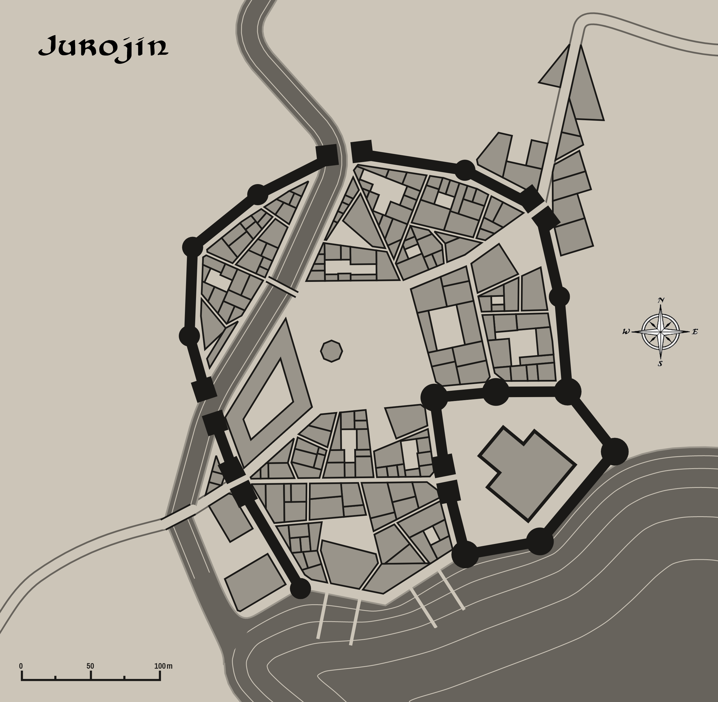

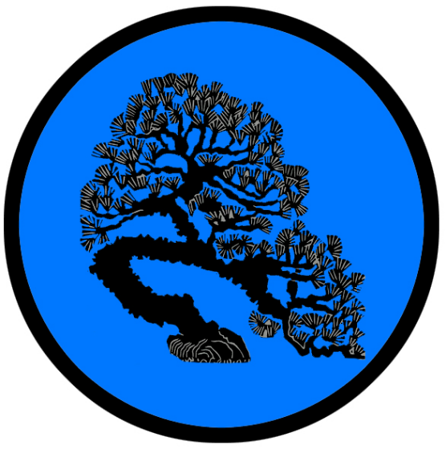
Shiashi
Size: large city
Trade Goods: incense, grain, tea, silk, stone
Local Goods:
Standard: sign of the bonsai tree
Colors: blue and black
Patron Deity: Tenjin, god of scholarship
Ruler: Daimyo Yashiro Shigehiro and his wife Amame (f)

Home: Castle Keikai aka Castle Vigilant
Steward (Jito): Hotta Ujinari
Marshal (Shugo): Uesugi Yasuuji
House Priest (Gukashu): Ito Narihira
House Adviser (Scholar/Mage/etc) (Onmyōdō): Jou Kan (f)
Captain of the Guard (Bansho): Hatakeyama Michihiro
Chief Warriors in Service (Kashindan):
Kashin (retainer) Samurai Tsuchimikado Tanehide
Kashin (retainer) Samurai Konoe Nakateru
Kashin (retainer) Samurai Kujou Kunitomo

Local Powers: Dodomeki (thieves guild), Kunoichi (smuggling ring), Temple of Tenjin, Kenjutsu (warrior academy), Gunkimono (bardic college), Jorōgumo (weavers guild)
Local Sites: The Queen’s Orchid Inn & Tavern, Aizen’s Altar Inn & Tavern, House of Rokurokubi (brothel)

Description:
Shiashi is the oldest city in Sakura and considered the home of refined Sakuran etiquette. Shiashi straddles the River Stillness where it opens into the Kamatsu Strait. The land all around is flat and even, with the river creating fertile wetlands. The land here is tranquil, with the glittering waters of the sea lending to the blue color theme of the town and castle. Tea houses, called chashitsu, stand throughout the countryside with cultivated meditation gardens.

Industry:
The wetlands are where rice, tea, and plants for incense are grown in well cultivated fields. Stone is brought down by river from the northern Domaru Mountains.

Another powerful industry in Shiashi is the loomers guild, called Jorōgumo. It is named for the mythical spider woman that is said to haunt the countryside of these lands. The Jorōgumo are experts in weaving the elaborate tatami mats that have been made popular in Shiyashi. They also produce the finest silk garments in Sakura, which are high status symbols among the nobles.

Key Figures:
Daimyo Yashiro
Yashiro is a middle-aged man, with greying hair and a terrible scar that dominates the left side of his face. He is a very tradition-minded soldier and veteran of many battles. He received a vision from his ancestors crying out for a return of power to the city. Since then Yashiro has sworn his life to do so and launched a full-scale war on Kaijin. He is convinced it is his destiny to be the next shogun. He has secured an alliance with the city of Ayozu, promising them the north if they pledge to attack Ako and Jurojin and leave the south to him.

While Shaishi is not a major trading port it does a brisk business with ship traffic in the strait. The Kunoichi smugglers are keen navigators of the shipping lanes and avoid patrol boats of the regional merchant houses, the shogun, and Xiandais’ imperial fleet.

The Gunkimono is a famous bardic college in Shiashi that teaches the fine arts of song, storytelling, fan dances, and the tea ceremony.

Rangers from Shiashi long ago explored the valley that opens up at the northern end of the Domaru Mountains. It is a mysterious and dangerous place to casual travelers. But it is reputed to be quite beautiful and full of magical creatures, including faeiries which the Sakurans call Yōsei. The rangers called it Fox Vale, for it is surrounded by the Kitsune Forest and the fox-like creatures are known to appear there. Legends tell of the Hoshi-no-Tama, a mystical sphere guarded by a Kitsune. It is said to hold the power of the Kitsune and if stolen can give the one who obtains it power to force the Kitsune to help them.

Here stands the Temple of Tenjin, god of scholars. He is the patron god of Shiashi.

Local Lore:
Some say the waters off of Ayozu are the place to see Heikegani, mystical crabs with human-faced shells, the spirits of the warriors killed in the Battle of the Flaming Sails.

There are also tales of Nure-onna, large serpent-like creatures with an upper body resembling that of an attractive woman and a lower torso of a giant snake. Nure-onna often appear on the banks of rivers and lakes, their upper body hovering above water to give the illusion of a young woman bathing.

History:
Two thousand years ago, in an attempt to rein in the excess of the upper classes, the Musubi masters introduced the tea ceremony. In architecture this promoted the design of chashitsu (tea houses) to a modest size with simple detailing and materials. The style informed residential architecture with lighter, more intimate buildings relying on slender rafters and pillars with sliding inner partitions (fusuma) and outer sliding walls shōji. Although woven grass and straw tatami mats were in common use in Sakura, they were often thrown all over the floor. Shiashi began the rituals of ceremony where tatami mats were made to be works of art, have a standard size, and be closely fitted together.

For many centuries Shiashi was the seat of the Shogunate. But two thousand years ago protracted wars with Mingyun, the City of Destiny, left Shiashi depleted and weak. In particular was the Battle of the Flaming Sails, a great sea battle in which the Mingyun fleet wiped out the Shiashi fleet (190 WA2). Tanuma Arikage, Daimyo of Kaijin and celebrated as the Master of Swords, rose to power and began a ten-year campaign that would move the Shogunate to Kaijin (210 WA2).

Customs:

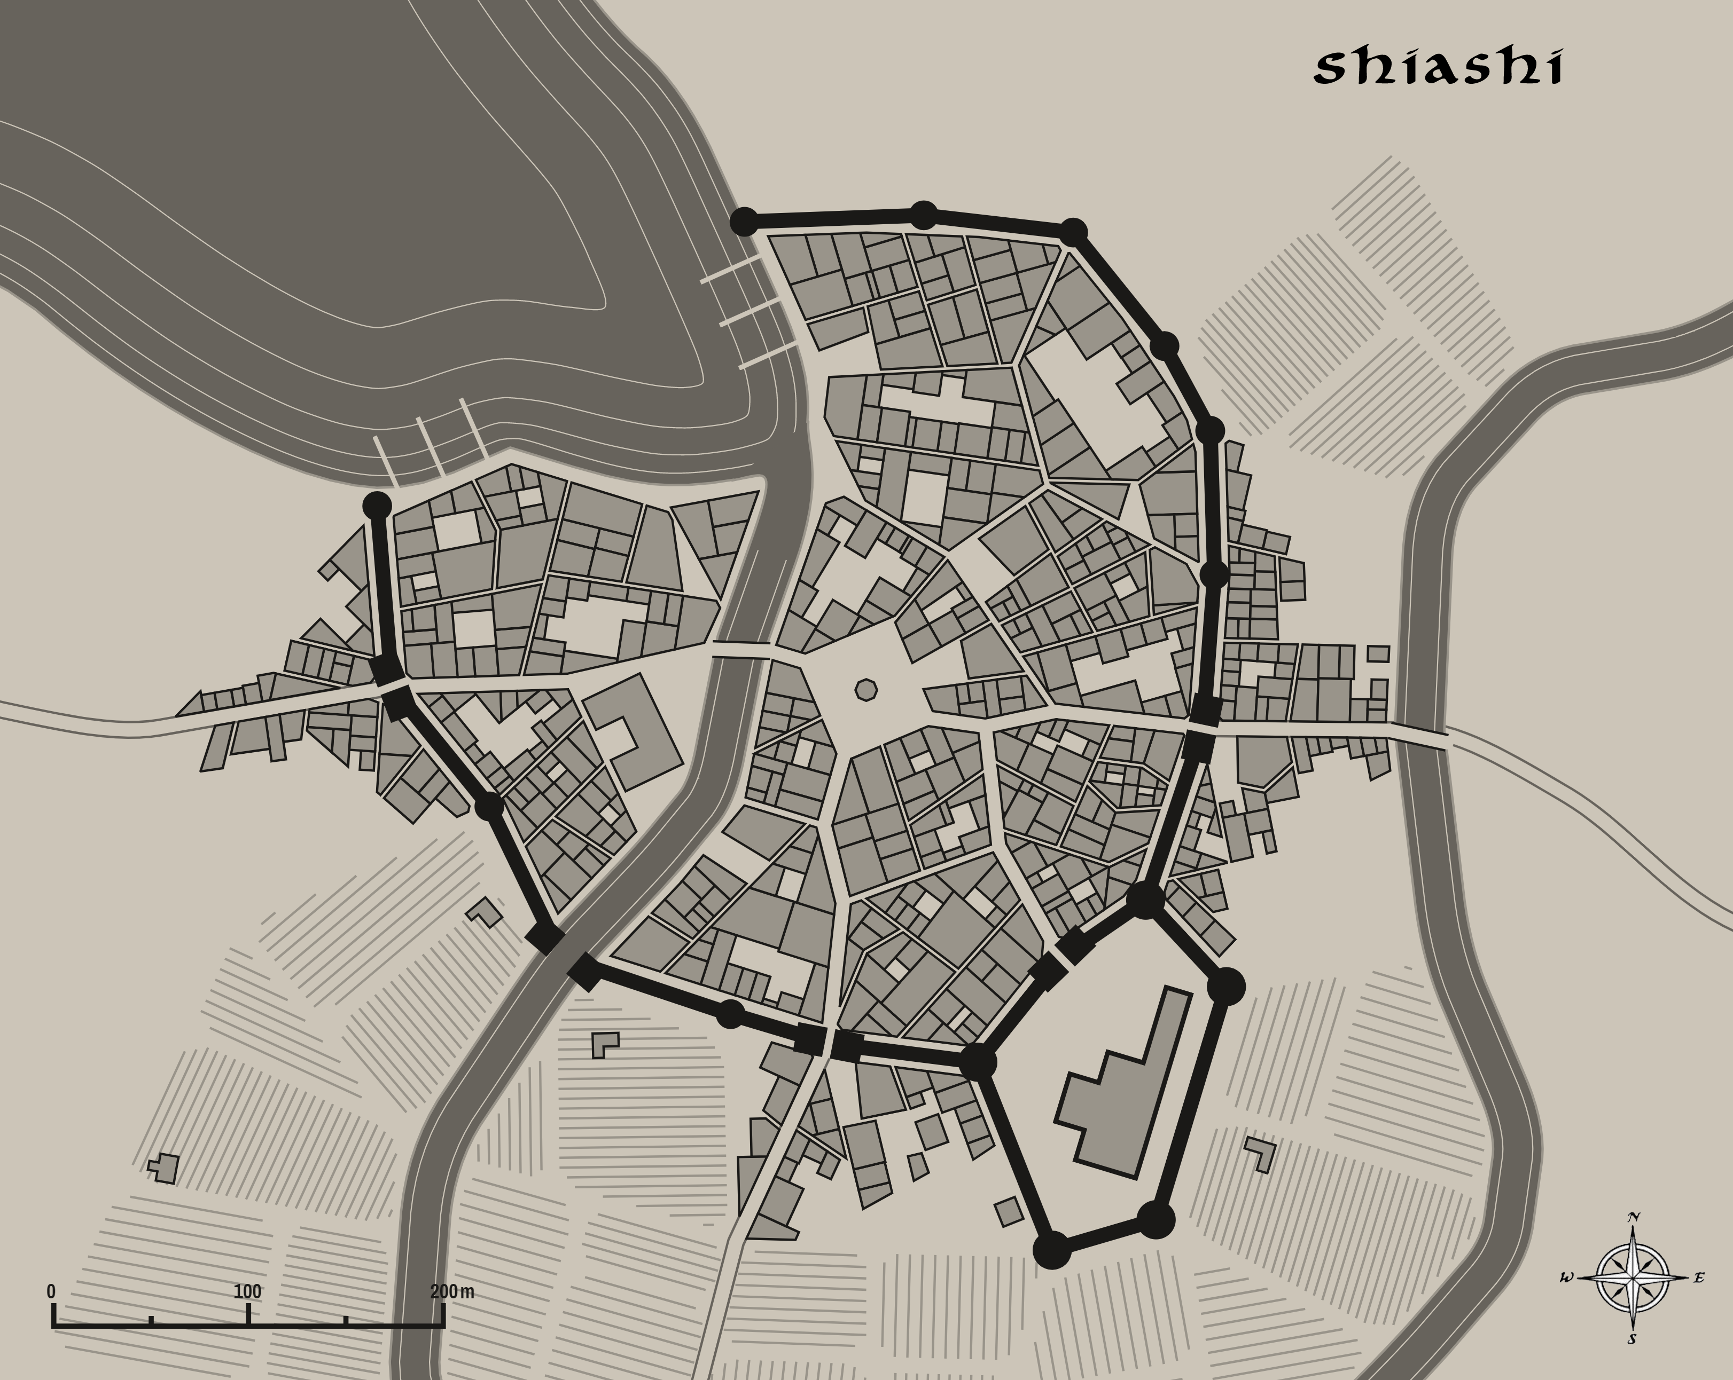

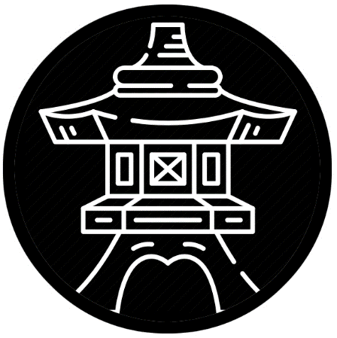
Tsumetai “Cold Lantern”
Size: small town
Trade Goods: medicine, opium, silver
Local Goods:
Standard: sign of the lantern
Colors: black and white
Patron Deity: Takemikazuchi, god of thunder and god of swords
Ruler: Daimyo Hoshina Atsuhira and his wife Naka (f)

Home: Castle Sanda aka Castle Thunder
Steward (Jito): Takeda Korenari
Marshal (Shugo): Suzuki Yukiharu
House Priest (Gukashu): Asai Manmi (f)
House Adviser (Scholar/Mage/etc) (Onmyōdō): Fujinami Kuniatsu
Captain of the Guard (Bansho): Mibu Ietoshi
Chief Warriors in Service (Kashindan):
Kashin (retainer) Samurai Chiba Tokikatsu
Kashin (retainer) Samurai Suganuma Munetoshi
Kashin (retainer) Samurai Sanjo Arinobu

Local Powers: The Nimble Nezumi (thieves guild), Band of the Snow Leopard (order of rangers), Akahana (opium), Ginza (silver guild), Temple of Takemikazuchi
Local Sites: Mistress Manse Inn & Tavern, The Black Kabuto Inn & Tavern, Chambers of Uwan (brothel)

Description:
Winding between the Domaru Mountains is a narrow pass submerged in half light, barely visible in the shadow of the tall peaks through which it cuts. Some say the gods struck the ancient dragon that terrorized these lands, cutting it in two. The mountains are said to be the petrified remains of the dragon, the pass marking where the gods’ blade cut it in twain. Cold Lantern sits atop a towering butte one thousand feet above the ground overlooking the pass.

Steep sides carved into columns by the forces that created it. This offers a dazzling view of the Domaru Mountain range as well as the surrounding countryside and the Cold Lantern Pass through the mountains. The road to the pass climbs gradually to just below the snow line where it passes through a narrow gap between the Domaru Mountains. The No-bori flags colored black fly from the walls of the town to signify House Hoshina.

On the western side of the pass the River Stillness wanders out of the mountains and to the sea. To the east, far out of view from here, the River Gozen wanders eastward. A handful of villages are located at the base of the mountains on the western side, scattered around the main road.

Access to the top of the butte and the town is nearly impossible by climb as its walls are virtually vertical. A large mechanical winch operates an elevator allowing access up onto the roof of the butte and the town proper. A hidden doorway in the side of the rock allows passage to a great winding stair, which is thoroughly defended in the event of a breach.

Life can be grim here. It is cold and remote with few travelers passing this way. One would expect the town to be cheerless, but the cold brings neighbors close together. Their lodges are insulated, warm, full of food and in the evenings, there is music and storytelling.

Here stands the Temple of Takemikazuchi, known as a god of thunder and the god of swords. He is the patron god of Cold Lantern.

The town of Cold Lantern is primarily a military one. The Kuruwa, or castle complex, dominates most of the town. Tall Yagura, or guard towers, stand tall from each of the four corners of the castle with artillery weapons trained on the pass.

A series of Shijo (support castles) were built along the Gozen River to support a main castle (Honjo) to guard the river from any future Tengu crossings. The town of Cold Lantern was fortified and a larger garrison assigned to protect from any westward incursions. Since that time there have been scores of attempts by Tengu to penetrate these defenses, but with limited success.

Industry:
Fields on the western side of the mountains are aflame with the bright red poppies that grow there indigenously. Villagers work the poppy fields and cultivate them for use in cooking oils which are used in cakes and bread. Some farmers are chosen by the daimyo harvest the poppies immediately after bloom to use in the production of opium, which is known among merchants as Akahana opium. Seeds are preserved and used in analgesic medicines. Other medicinal plants are indigenous to this region, some of them rare and located far up the slopes.

Silver was discovered in the mountains a hundred years ago. A portion of the villagers and town folk work the mines, which are located within the pass itself. A local guild of silver smiths, called the Ginza, control the supply of silver in Sakura and operate the mint where coins for the realm are struck. The Ginza hold great power, if even in secret, and all Daimyo of Sakura know to pay respect to them.

Key Figures:
Daimyo Hoshina takes his duties seriously, drilling his soldiers daily in different maneuvers designed for defending the pass. He is a tall man with a strong build. His face has been hardened by many winters. He wears a black cloak trimmed in ornamental crystals that make him appear covered in frost. Hoshina has no political leanings, feeling his duty is first and foremost to his town and safeguarding the pass from the Tengu. He has no interest in participating in the war raging in the west between Shiashi and Kaijin. He has seen a vision that tells of his end coming in a glorious death in the pass, against overwhelming odds. He sees no reason to leave his post and tempt fate into a lesser end.

The rangers of the Band of the Snow Leopard are specifically tasked with scouting the mountain sides for any signs of Tengu activity. They are expert Tengu hunters and highly regarded in the kingdom.

Local Lore:
It is rumored that the Yuki-Onna haunts the mountains around Cold Lantern. Taking the appearance of a shivering maiden, the creature they call the Snow Woman lures unsuspecting people within her reach then sucks the souls out of them.

History:
Cold Lantern has served as a critical guard post over the mountain pass for five thousand years. At one time the Sakura kingdom extended as far south as the present-day Forsaken Rivers east of the Pajra Jungle. These were the lands of the Azuma people. Four thousand years ago marked the War of the Red Lilly, when southeastern Sakura was invaded by Tengu armies (451 AA4). The town of Otemon, the southernmost settlement, was overrun and the castle of Daimyo Akida breached. Shortly thereafter the Tengu crossed the Shrine River and destroyed Bakaru.

The Tengu general Harnhak led twenty thousand infantry and one thousand warg riders all the way up to the Shadow Hills, the Sakuran forces in full retreat. Harnhak drove westward, hugging the jungle, forcing the Sakuran soldiers to take to the hills. There they were encircled, cut off from retreat north. In the songs that tell of that battle, it was called Akida’s Last Stand. Akida’s men fought bravely but without reinforcements they eventually fell to the Tengu army (454 AA4).

Over the course of the next two years Sakuran forces marching in from the pass and from north of the Gozen River fought a fierce series of battles to contain the Tengu. Harnhak managed to overwhelm the armies in Cold Lantern Pass and breach the western side of the Domaru Mountains. To the north his expansion was checked at Kitsune Forest when the Elves of Teliddia countered them. Regrouping his forces, the Sakuran Shogun Katodai cut off the Tengu west of the Domaru, encircling and eliminating them. Forces from the northern provinces swept through the Kitsune and pushed the Tengu south of the Gozen River. Harnhak was slain in the counter-assault by the samurai hero Sukesada. The Tengu retreated back to the Shadow Hills and fortified and have held the lands south of the Gozen ever since.

Customs:

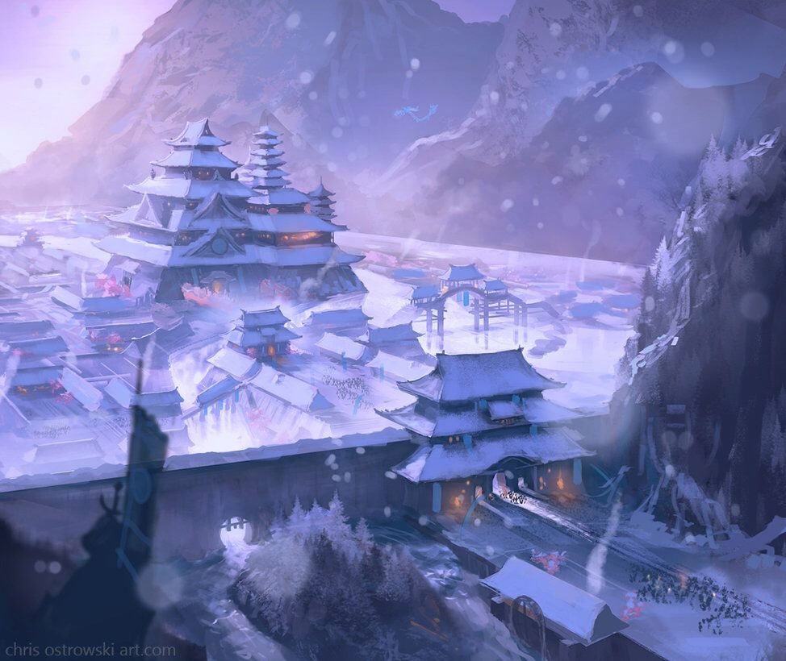

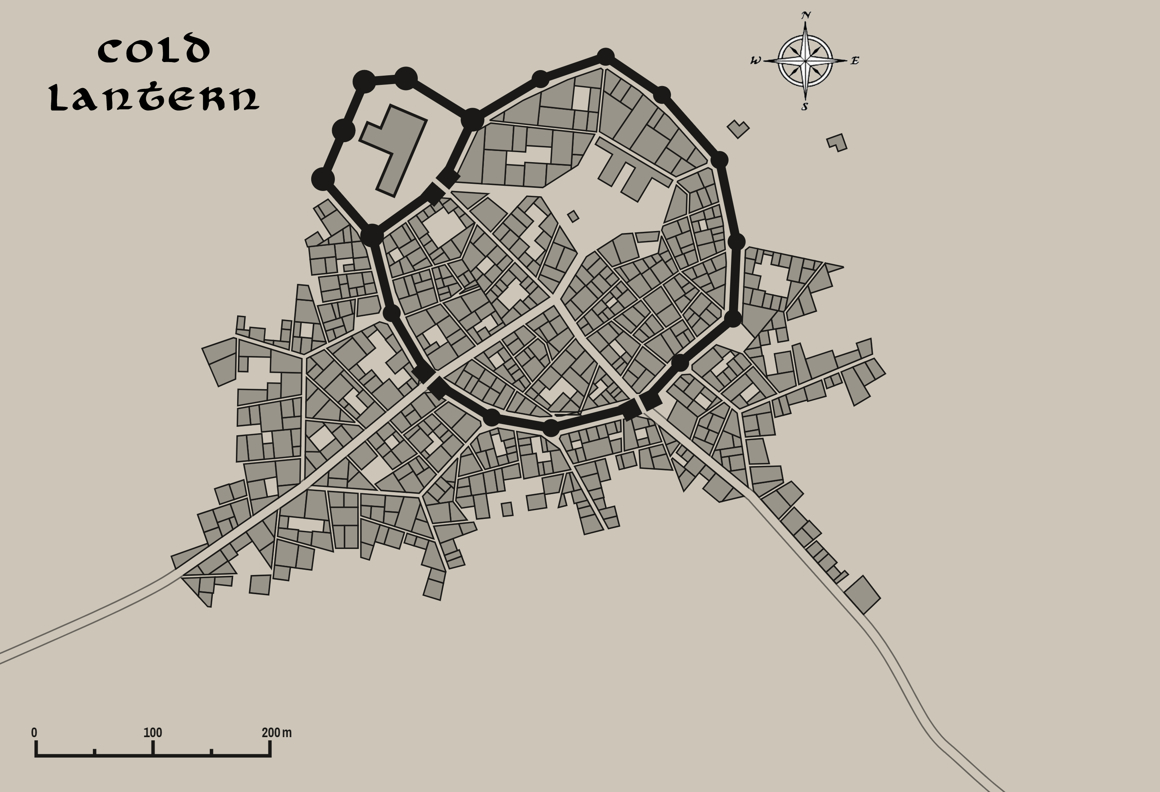

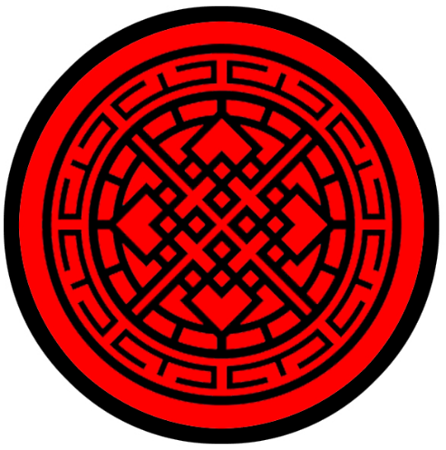
Kaijin
Size: metropolis
Trade Goods: grain, steel, iron, magic center, Seishin opium, silk, platinum, religious center
Local Goods:
Standard: four diamonds
Colors: red and black
Patron Deity: Hachiman, god of war and protection
Ruler: Shogun Shimazu Hikoto and his wife Kiyoyo (f)

Home: Castle Hogosha aka Castle Defender
Steward (Jito): Koide Kazukatsu
Marshal (Shugo): Akiyama Moritame
House Priest (Gukashu): Yuuki Masanori
House Adviser (Scholar/Mage/etc) (Onmyōdō): Morioka Iesada
Captain of the Guard (Bansho): Murakami Kitsu (f)
Chief Warriors in Service (Kashindan):
Kashin (retainer) Samurai Nishio Tsunemori
Kashin (retainer) Samurai Andou Akimoto
Kashin (retainer) Samurai Itami Tanemune

Local Powers: Nurarihyon (thieves guild), Black Orchid (smuggling ring), Temple of Hachiman, Order of the Tiger (order of paladins), Okami Sanctum (school of magic), Korugo (smuggling ring), Michiyuki (bardic college), Gorinso (warrior academy), Namahage (sword maker guild)
Local Sites: The Two Travelers Inn & Tavern, Midori House Inn & Tavern, Hannya House (brothel)

Description:
Kaijin sits atop a low, sloping hill alongside the Koi River where it empties into the Kamatsu Strait. The low outer walls of the city are red lacquered wood with pitch black timber posts and lintels. The inner walls are higher, with colors reversed. Both have wide walkways running their lengths. Castle Hogosha looms prominently over the landscape, situated at the highest point of the hill. Its Yagura, or guard towers, stand like sentries overlooking the town. Their tops glitter in gold appointments that make them seem like tall spears. Long vertical flags colored red, called No-bori, flap proudly in the breeze from atop the higher inner walls of the city walls.

The city of Kaijin has grown to enormous size since rising to power. Castle Hogosha is flanked by high stone walls that gradually run down to the sea, enclosing a massive sprawl of markets and scattered farming villages, or Nôson. Peasants come and go by three different roads out into the lower fields of rice and poppy flowers. Seishin opium is manufactured here.

Kaijin is the most well defended city in Sakura, with stone inner walls and a massive army that commands the lands after centuries of feuds. The city operates with like a military camp, with constant drills commencing in all areas of the city and secret police always watching.

Industry:
Two thousand years ago explorers first discovered iron in the Domaru Mountains. Since then Kaijin has produced most of the iron for building materials and weapons in Sakura. Sword masters perfected techniques for refining the iron into the strongest steel known to man. Today the sword makers (Katanakaji) of Namahage foundry produce legendary Sakuran swords. Each one is embossed with the maker’s mark of a sun. It is said that the gods themselves often visit Kaijin to commission swords of greatness. Warriors of the Gorinso academy each carry a Namahage sword upon graduating the grueling trials of the academy. Many debate the relative qualities of the two great sword makers of Sakura: Namahage and Shiranui, in Jurojin.

Key Figures:
Ruling from his castle, Shogun Shimazu is attended by the many Bunji (nobles of the court) who hold large estates in Sakura. Shimazu is young, the eldest of his father’s many sons. He stands shorter than most men, but is fiery-eyed and hot-tempered. He is quick to see any criticism of his rule as a challenge and is cold-blooded in cutting down any opposition. He wears about him the medallion of his house: a bright red ruby that is said to give him strength and far sight. Shimazu has little time for the gods but is keen to consult the wizards for the means to crush his enemies and spread fear. He was shocked at declaration of war from Shiashi, but secretly pleased at the chance to mobilize his armies.

Standing near to Castle Tategami is the Temple of the Setting Sun, a brilliant gold and orange temple with a massive roof with curved eaves. Perched atop it is a magical glowing sphere that burns night and day. It is called the Eye of Hachiman and is said to hold the power of Hachiman, god of war and protector over all Sakura lands. Stories tell of light from the temple shining even during the darkest of times in Sakura and it is seen as a beacon of hope. The temple is supported by a jinai: a temple complex that includes religious, militant, and economic dimensions. Here the priests consult the gods and goddesses, chief among them Hachiman the patron god of Kaijin. Here too reside the Order of the Tiger, paladins of Hachiman who are samurai dedicated to him. The priests of the temple dispatch the paladins to all corners of the world as the light beckons.

Local Lore:
Strange creatures are said to reside in the countryside surrounding Kaijin. There is Momonjii, an old-man who appears to travelers on the road and is waiting for you at every fork in the road. Most take no notice of him, even if they see him. But he only makes himself seen to those he chooses and appears to dispense advice and visions of one’s destiny.

Far to the south in the Anada Lands, it is said there dwells the Gashadokuro, a giant skeleton that is the spirit of the unburied dead. The creature is seldom seen, but is said to appear in times of great darkness and turmoil. It is infamous for raiding small villages and devouring livestock and people.

History:
For many centuries Shiashi was the seat of the Shogunate. But two thousand years ago, protracted wars with Mingyun, the City of Destiny, left Shiashi depleted and weak. Tanuma Arikage, Daimyo of Kaijin and celebrated Master of Swords, rose to power and began a ten-year campaign that would move the Shogunate to Kaijin (210 WA2). The Winds of Arikage, as it was known, saw terrible destruction wrought on the regions controlled by Ako, Ayuzo, and Jurojin.

In the Domaru Mountains there have always been fierce tribes of Tengu. Every generation has stories of Tengu armies mounting assaults on the city. One hundred years ago a massive army came down under the command of a warlord Tengu named Torguru, who wielded a cursed sword name Kaminari (“lightning”). It was a blade of such evil that it wiped out the entire Order of the Tiger (370 WA4). The Akuso, or war monks, of the Suijin Monastery heard of the devastation and came out of their seclusion to face Torguru’s warriors. It is said they came as one hundred monks and fought fiercely, channeling the forces of their gods. Nevertheless, Torguru breached the walls of Tategami Castle and his priests commenced the rites to desecrate the Eye of Amaterasu. In the final moments of the great battle the ronin samurai Sanjou (f) returned to the home of her former master. She stole into Gorinso armory and retrieved the blessed blade Hino Kokoro (fire heart). With it she slew Toguru and summoned the light of Amaterasu, destroying the Tengu priests and their army.

Customs:

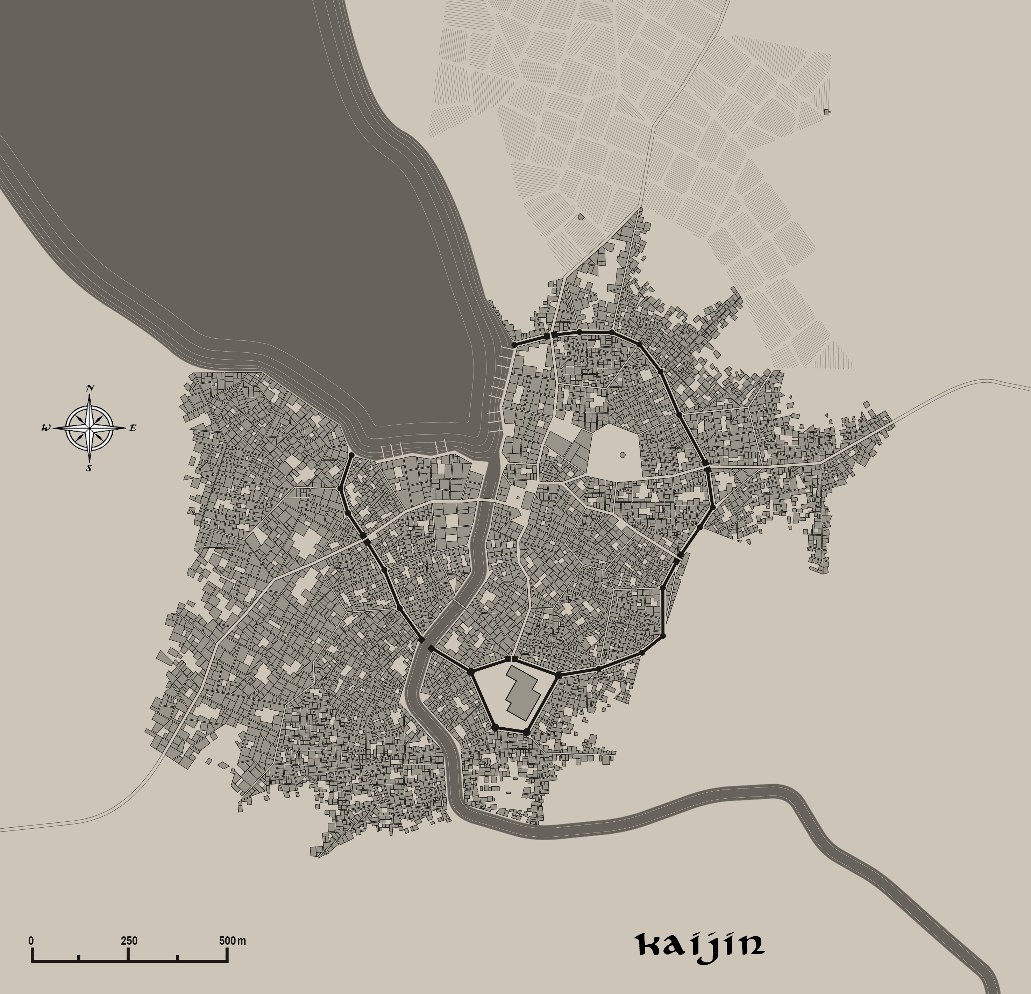
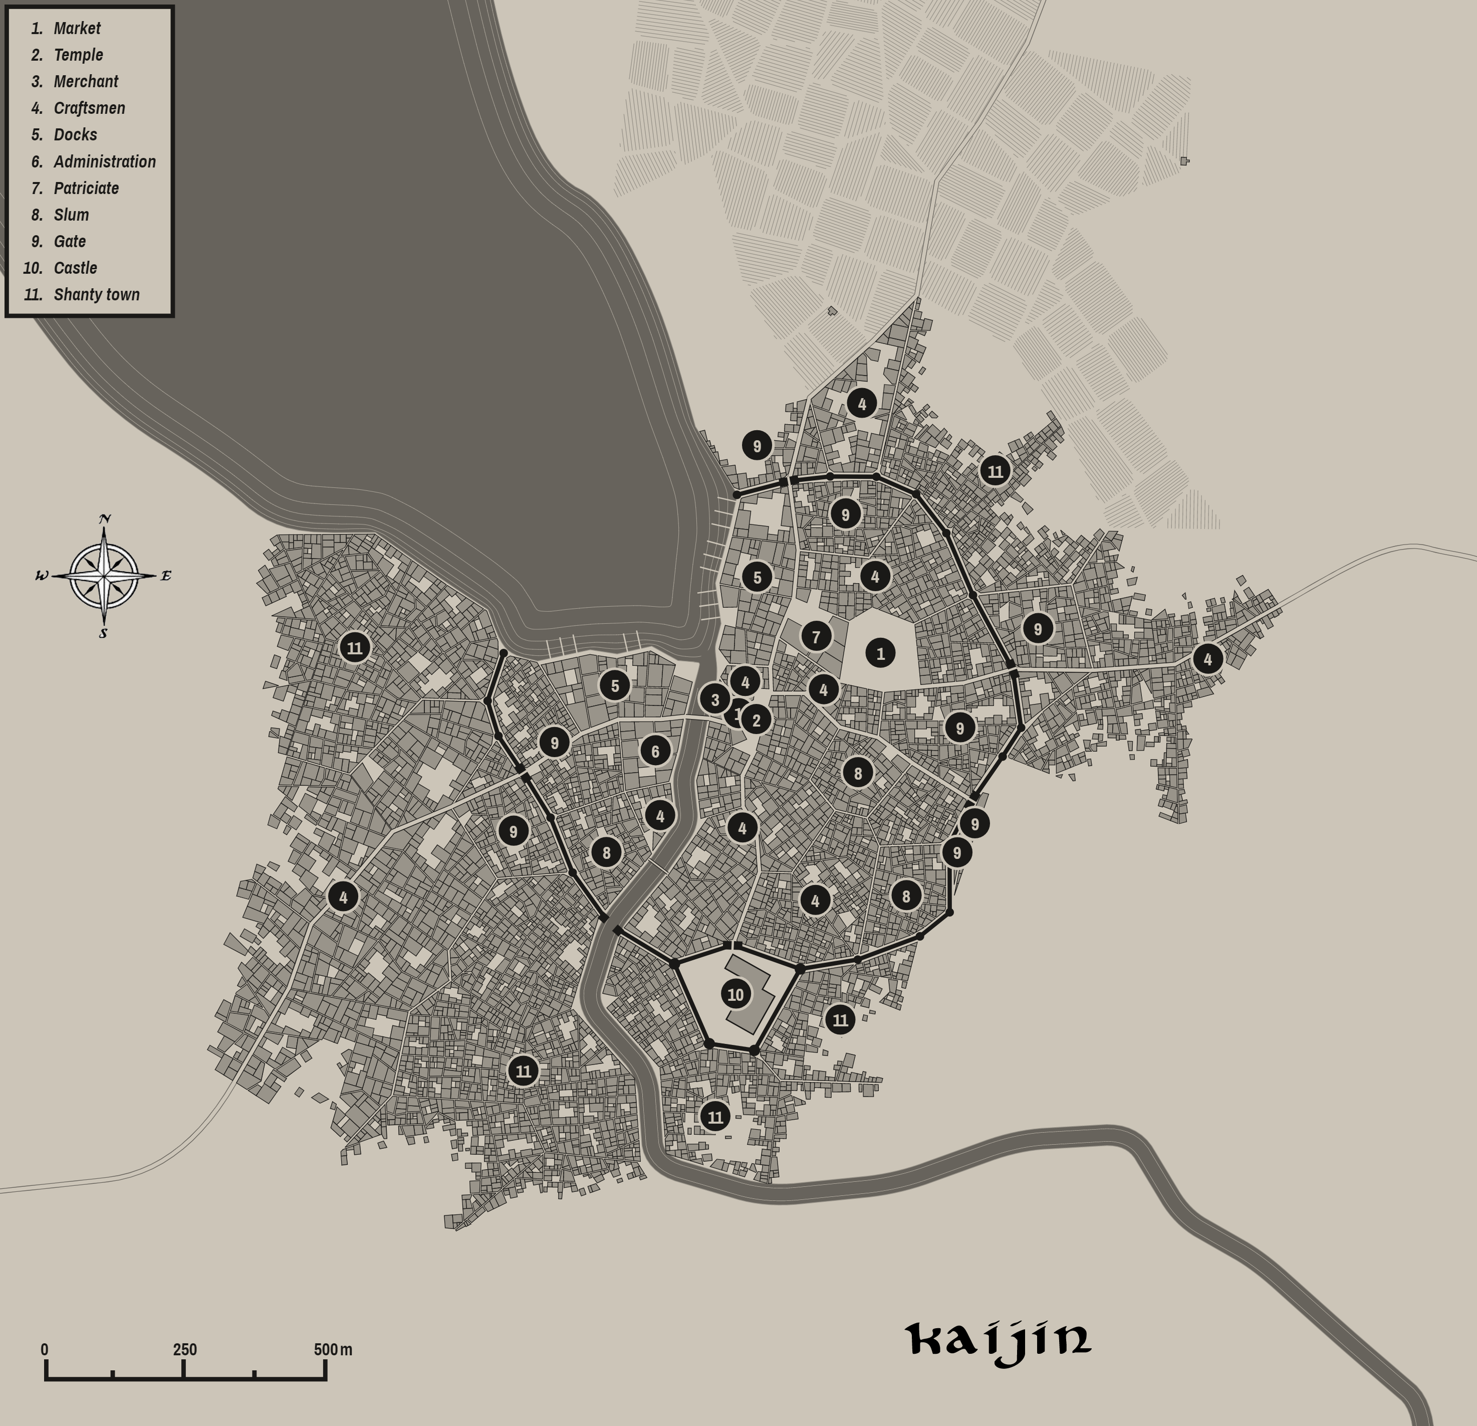

History of Sakura

First Primordial Age (PA1)
Dawn of the Oshi people

100 PA1 - the sun goddess Amaterasu smiles on Sakura and brings forth the Tanjoki (birth tree): a magical cherry blossom to mark the land as her own - she places it in present-day Fox Vale

101 PA1 - Fujin and Ryujin bring mighty winds and waves to shape the terrain and coastline of Sakura

102 PA1 - Inari walks the length and breadth of Sakura, pouring out her pitcher to make the land fertile

103 PA1 - Takemikazuchi brings down lightning and thunder and pierces the land with swords to form the rivers; the rivers mark the sacred form of all sword strokes

104 PA1 - Hachiman arrives in Sakura; seeing what the other gods have done, he chooses one hundred of the humans and girds them for battle, instilling in them the art of war and protection

160 PA1 - Yiza queen of the Ki-rin arrives in Sakura and makes it her home

180 PA1 - the Kitsune arrive in Sakura and take up residence in the forest

680 PA1 - Oshi tribes migrate east, west, and north of the Domaru Mts.

Second Primordial Age (PA2)
140 PA2 - The Blight of Tengu - hordes of Tengu emerge from the Nightfall Marshes in northern Sakura, they sweep across the land wreaking destruction

151 PA2 - Yiza queen of the Ki-rin hears the pleas of the Sakuran people; she descends upon the Tengu hordes with her children, driving them back into the marshes which now bear their name

770 PA2 - Oshi tribes west of the Domaru Mts begin to call themselves "Nishi", eastern tribes identify as "Azuma", those in the north call themselves "Kita"

Third Primordial Age (PA3)
320 PA3 - war breaks out between the Nishi tribes west of the Domaru Mts and the Azuma east of the mountains

410 PA3 - Battle of Sword and Wind - Nishi general Okaza calls on the god Hachiman who helps the Nishi roll through the Azuma ranks; the Azuma general Sanjo summons Fujin the god of wind who blows the Nishi ranks off the mountain tops; Azuma dominates Sakura for centuries following this victory

610 PA3 - the evil sorcerer Tasuzen wields the crown of power and seizes control of the Azuma throne in Shizoku

620 PA3 - the Eight Ronin depart Azuma lands, banished for defying Tasuzen

622 PA3 - the Eight Ronin are summoned by Amaterasu who tells them to find the Eight Blades of the Sun

625 PA3 - Tasuzen trades his eyes to the demons in exchange for three dragons, one each to terrorize the west, north, and east

631 PA3 - the Eight Ronin dive beneath Kojin Lake to find the Eight Blades - their struggles form the Kojin River as well as ignite a volcano in the Kioko Mts.

635 PA3 - the Eight Ronin find the last of the Eight Blades and have them anointed at the Temple of the Rising Sun

637 PA3 - the Eight Ronin spend the next three years battling Tasuzen's armies

640 PA3 - The Eight Ronin battle their way to the top of the Domaru Mountains and defeat Tasuzen's armies, slaying Tasuzen and his dragons

Fourth primordial Age (PA4)
150 PA4 - Battle of Nightfall Marshes - warlords within the Kita tribes wage war for control of the North; Lord Suteru lays waste to Lord Moro's forces

430 PA4 - the great demon Yanagiza lays waste to Blossom Valley

872-888 PA4 - The Wizard War: Telemechus triggers a world-wide war of mages, some of whom march on Ongolk to stop him and some who join him in attacking the ley lines in their lands; epic battles wage all over the world, destroying cities and upsetting the balance of magic
888 PA4 - The Battle of Forlorn: Telemechus is slain but not before rupturing the magical ley lines permeating Nemmyrl; the victorious general Dragan of Celedon seizes the opportunity to rid the world of magic and ruptures the Singularion as it is embedded in the ley lines; the resulting explosion sends a shock wave that ruptures the magical ley lines around the world and triggers the Dead Century

First Ancient Age (AA1)
400 AA1 - Masuharu takes power in Kaijin after his six rivals mysteriously disappear

402 AA1 - Masuharu, fearing retaliation from mages, orders a purge of all Onmyōdō (wizards) in Sakura

403 AA1 - the kings of the Kita and Azuma kingdoms join Masaharu in purging wizards in Sakura

405 AA1 - the Great Katuran War: Sakuran armies unite from all three kingdoms and march south to Mahabar, half to the lands of Yama and half to Vithoba

407 AA1 - Sakuran forces deal devastating strikes to Mahabar, taking Turutan and Dumatra

410 AA1 - Sakuran warships blockade Devasena while ground forces occupy the Tiger Rivers; Mahabar is divided with Jangi Kara isolated from Suramir

411 AA1 - Sakuran conquerors brand the Mahabar people and claim them as slaves

420 AA1 - After ten years of seige, Suramir falls to Sakuran forces; Jangi Kara pulls back its ships to protect the city

422 AA1 - Masuharu's head priest Gonuhan climbs Chakra Mountain and finds the tomb of Indrani's first prophet; he steals the headpiece of Indrani, a relic of great power

425 AA1 - Jangi Kara falls; Sakura takes control of all of Mahabar

625 AA1 - Jayadeva Lion Eye, a paladin of Indrani, launches a brutal counter assault on the Sakuran occupiers

627 AA1 - Jayadeva is drawn to Chakra Mountain where the goddess Indrani gifts him with the Badala Talwar (sword of revenge)

629 AA1 - The Lion Eye army crushes the Sakuran forces, striking from the jungles

630 AA1 - Jayadeva hunts down the heirs to the priest Gonuhan, slaying them and liberating several Mahabar relics including the headpiece of Indrani

631 AA1 - a mysterious monsoon rolls in just as Jayadeva's forces liberate Devasena; the Sakuran forces are dragged out to sea

635 AA1 - Battle of Jangi Kara : Jayadeva is slain in the retaking of Jangi Kara but the Sakuran back is broken and Mahabar forces retake their land with savage ferocity

Second Ancient Age (AA2)

110 AA2 - the demon Shuten terrorizes Kaijin; he 50 feet tall with a red body, five horns, and 15 eyes; he steals women from the town and takes them for his feasts in the Domoru Mountains

140 AA2 - warriors Raikō and Hōshō infiltrate Shuten’s lair disguised as yamabushi (mountain priests) to free women kidnapped from Kaijin; they slay Shuten,

141 AA2 - Shuten's five horns are made into the magical Five Shuten Spears, his fifteen eyes into the magical Shuten Talismans

770 AA2 - Junjii pirates raid Azura Bay, raiding farms and towns and controlling the region for forty years
810 AA2 - sea druid Tomotan aides the farmers in the Azura Bay region by trapping the Junjii ships within the bay and calling down devastating storms to destroy the pirates' ships

Third Ancient Age (AA3)
30 AA3 - The Dark Reign of the White Millstone: the demon Satsujin appears in Ayozu; he slays the ruler of the town and assumes control disguises as him

31 AA3 - Satsujin attracts followers to Ayozu, instilling fear and awe; he invokes a blud lust in his retainers and launches a campaign of bloodshed in the lands around Ayozu

32 AA3 - Satsujin's army raises the banner of the white millstone, which strikes fear throughout the north; Satsujin forces march east to Ako, joined by undead warriors from the Nightfall Marshes

33 AA3 - Ako falls to the White Millstone armies; later that year Jurojin falls; monks from the temples Aizen, Rokuju, and Benzai are slaughtered, as are all samurai adepts from the Kodokan, Kyuba No Michi, and Bunbu Ichi schools

35 AA3 - the city of Shiashi rushes north to face Satsujin's armies, not heeding its ally Kaijin to wait and attack in force; Shiashi troops are ambushed in Thunder Valley and decimated as are all students from the Kenjutsu school

36 AA3 - the White Millstone armies pour into Nishi lands of the west but divert a second force east of the Domoru Mountains

38 AA3 - Satsujin presses into Blossom Valley; Kaijin forces stall the advance and send dispatches to Cold Lantern to attack the enemy from the rear

39 AA3 - Battle of Blossom Valley - Cold Lantern forces engage the White Millstone armies during the battle and seem to turn the tide; unknown to Cold Lantern, Sanjutsin's forces are stopped by the Azuma armies and cut west across the Domaru Mountains and catch Cold Lantern from the rear

41 AA3 - fall of Kaijin - Satsujin reinforces control of all of northern and western Sakura; he oversees a reign of darkness calling up every curse on the land while the Azuma forces barely keep the White Millstone at bay

42 AA3 - Satsujin reveals himself in his demon form: wearing blood red samurai armor and flaming eyes, he beheads a thousand people as food to his demon allies

44 AA3 - Satsujin forces ninety-four maidens from the captured towns and villages to marry him with the intent to get upon them demonic children; monks of the Tamonten shrine attempt to rescue the maidens but fail, but it does give the maidens enough time to commit suicide

52 AA3 - Satsujin creates arcane eyes throughout the land that spy on travelers as well as invoke fear in even the strongest of warriors

71 AA3 - a monk from the Kichijo shrine makes it through the Pajra Jungle to resistance forces in the western Azuma lands; he tells of the Eyes of Satsujin, which cause all heroes to hide

72 AA3 - The Ninety Four Answer: the greatest samurai from Otemon, Bakaru, and Shizoku as well as monks from the remaining shrines launch a daring raid on Ayozu, blindfolding themselves on their journey to resist the Eyes of Satsujin

73 AA3 - the Azuma samurai attack the demons around Ayozu, sacrificing themselves to allow priests of Amaterasu to banish Satsujin from this world using the Ten Chimes of Heaven

80 AA3 - the Ten Chimes of Heaven are divided among the ten shrines throughout Sakura; the eyes of Satsujin, which have closed since his defeat, are destroyed in consecration ceremonies

290 AA3 - Xiandai invades Sakura

650 AA3 - Battle of Kaihei - General Doruhan crushes the Xiandai armies in Sakura, freeing the kingdom

Fourth Ancient Age (AA4)
50 AA4 - weaponsmith Nagaari visits the realm of fire and retrieves the secret of sword making from Takemikazuchi the god of swords

51 - Nagaari builds his forge in Shizoku

80 AA4 - Nagaari, sensing his impending death, commissions his best students to carry on his secrets to swordmaking
82 AA4 - Nagaari faces the Inu demon of Agi Bridge and slays him with his first sword before succumbing to his wounds; the sword is lost to the ages
100 AA4 - Narikore founds the Shiranui school of sword making in Jurojin
105 AA4 - Hirasane founds the Namahage school of sword making in Kaijin
210 AA4 - the Kadokan school of Bushido is formed in Ako

222 AA4 - the Kyûba No Michi school of Bushido is formed in Ayozu

225 AA4 - the Bunbu Ichi school of Bushido is formed in Jurojin

228 AA4 - the Kenjutsu school of Bushido is formed in Shiashi

231 AA4 - the Gorinso school of Bushido is formed in Kaijin

450 AA4 - War of the Bride - Princess Makino of Shizoku is betrothed to King Hamuro of Shiashi; Shiashi spurns Makino, calling her unfit; Shizoku declares war on the western kingdom of Nishi

490 AA4 - after decades of war between the three kingdoms, Akabashi of Shizoku becomes the first Emperor of Sakura

First Written Age (WA1)

490 WA1 - the Weavers Guild Jorogumo in Shiashi is wiped out by the local Daimyo for its leader failing to pay proper honor to the clan

490-494 WA1 – Jorogumo War - members of the Weavers Guild leverage their network of spies to bring war between Shiashi and its neighbors; the Daimyo of Shiashi is brought to ruin and commits suicide to save face, the Jorogumo rises from its ashes and appoints a new Daimyo

Second Written Age (WA2)
190 WA2 - Battle of the Flaming Sails - great sea battle in which the Mingyun fleet wipes out the Sakuran ships from Shiashi

210 WA2 - seat of power in Sakura shifts from Shiashi to Kaijin

780 WA2 - Kamatsu War - Xiandai ships land at Anada Plains and wipe out farms and villages, setting off decades of naval sea battles between Xiandai and Sakura

870 WA2 - Battle of Nuwa - Sakuran ships pursue the remnants of the Xiandai fleet to Nuwa Bay and decimate them, resulting in Sakuran naval superiority for the next two hundred years

Third Written Age (WA3)
50 WA3 - Sakuran navy attacks the Mingyun naval forces but fall afoul of the gods; Haishen god of the sea destroys the Sakuran fleet, ending their reign of the seas in the east

448 WA3 - War of the Red Lilly: an Onmyodo wizard appears before Emperor Harano prophesying of doom in the eastern Azuma lands

449 WA3 - Harano scoffs at the prophecy of fear and orders the Azuma armies to conquer the Tengu of Higanbana Valley to show their courage

450 WA3 - Azuma towns of Shizoku, Bakaru, and Otemon send soldiers into Higanbana Valley and take the heads of Tengu chieftains, unknowingly igniting the Tengu tribes to unite for revenge

451 WA3 - Tengu forces led by the chieftain Harnhak rise up from Higanbana Valley and invade the Azuma lands of eastern Sakura

452 WA3 - Fall of Otemon: Tengu battle their way across the Forsaken Rivers and destroy the town
453 WA3 - Fall of Bakaru: Tengu cross the Shrine River and destroy the town

455-458 WA3 - Dwarves of Turquorzem battle the Tengu at Cold Lantern Pass

457 WA3 - Elves of Teliddia attack the Tengu of Harnhak and help contain his advance

454 WA3 - Akida's Last Stand: Daimyo Akida of Shizoku and his forces are encircled at the Shadow Hills and wiped out by Tengu forces

455-456 WA3 - fall of Shizoku: Tengu armies take the Forgotten Reach, cutting off Shizoku; the town is overrun when ships from Jurojin fail to arrive in support; the original Forge of Nagaari is lost, along with all its secrets to sword making

456 WA3 - Emperor Harano commits seppuku in shame for losing the lands of Azuma

457 WA3 - monks arrive in Kaijin to plead with the Daimyo Katodai to rescue the eastern lands; Daimyo of Jurojin is assassinated, likely for his failure to assist the Emperor

458 WA3 - Sakuran forces marching in from Cold Lantern Pass and from north of the Gozen River fight a fierce series of battles to contain the Tengu; they are joined by the Dwaves of Turqorzem

459 WA3 - Fall of Cold Lantern: Harnhak and his Tengu armies break through to Western Sakura

460 WA3 - Elves of Teliddia attack the Tengu of Harnhak and help contain his advance

461 WA3 - Daimyo Katodai cuts off the Tengu west of the Domaru, encircling and eliminating them; Harnhak is slain by the samurai Sukesada

462 – The Hogo-Sha, or River Guardians, are built along the Gozen River: a series of fortresses to guard against future Tengu invasions out of the fallen Azuma lands

463 WA3 - Houjou, son of Harano, arrives in Kaijin and assumes power as the new Emperor; Houjou immediately launches a war against the Kita northern lands to punish them for failing to rescue the Azuma in their time of need

471 WA3 - after years of bloodshed, Daimyo Katodai turns on Houjou and slays him for being a weak and spiteful Emperor

472 WA3 - Katodai names himself Shogun over all remaining Sakura, claiming the land should never be weak before an enemy again

670 WA3 - shogun Shimazu is tricked by the witch Itazura to let her create five duplicates of him with the gem of Ōku-no-kao (Many Faces)

670-692 WA3 - War of the Six Shoguns: all five duplicates wage war on Shimazu, throwing Sakura into chaos

692 WA3 - Battle of the Six Banners: the Orange Shogun prevails over all others and assumes control in Kaijin

841 WA3 - Isle of Mazu seized by Sakuran general Kiroko on orders from Ayozu

843 WA3 - Xiandai ships attack Sakuran forces around Mazu; conflict escalates until both kingdoms' fleets converge on the waters

844 WA3 - Mazu War: hundreds of ships of various sizes engage in multiple battles until dragons out of the Elderwyrm Mountains appear and destroy both fleets

866 WA3 - Xiandai warriors secretly enter the Isle of Mazu disguised as fishermen; they wipe out the Sakuran guard holding the island, returning it to Xiandai control

Fourth Written Age (WA4)
10 WA4 - War of Shrines between Xiandai and Sakura and parts of Mahabar

175 WA4 - Ako, Ayozu, and Jurojin grumble over heavy taxes levied by Shogun Tokikore in Kaijin

178 WA4 - emissaries from the north appeal to the Daimyo in Shiashi to intercede on their behalf with Kaijin; the Daimyo betrays them by informing the Shogun Tokikore in Kaijin

179 WA4 - Kaijin hires Xiandai mercenaries to raze the crops of the northern towns

180 WA4 - Shiro Wars - Ako, Ayozu, and Jurojin rebel against the Shogun

182 WA4 - Battle of Shujin: an enormous battle is fought north of Shiashi; the northern forces are barely repelled

184 WA4 - Battle of Thunder: southern forces march through the winter and surprise northern forces on the Plains of Thunder, defeating them again

185 WA4 - One hundred samurai from the north sneak through Cold Lantern Pass and lead an army to invade the south lands

186 WA4 - desperate to push back the northern forces, Shogun Tokikore pays the city of Mingxia a fortune to send ships to harass the northern towns

189 WA4 - the Shogun gathers his strength and marches eastward through Cold Lantern Pass, moving up through the Kitsune Forsest to surprise Jurojin from the south

192 WA4 - having depleted his fortune, the Shogun can no longer pay for Xiandai naval support; he desperately launches a war of attrition in the north, conquering the Daimyos of all three northern towns and cities

194 WA4 - Three Rivers Campaign: Tokikore launches a series of brilliant maneuvers to isolate and defeat Ayozu, Ako, and Jurojin; Kaijin regains control of all of Sakura

370 WA4 - Tengu chieftain Torguru attacks Kaijin and destroys the paladins of the Order of the Tiger and the monks of the Suijin monastery with the lightning sword Kaminari; ronin Sanjou, a ronin, wields the blessed blade Hino Kokoro and slays Torgru and his army

Local Goods
Cereals: rice, millet, sorghum; (pseudo-cereals) kuttu ka atta (buckwheat)
Fiber: bamboo, flax, kenaf, ramie, jute
Fruits: coconut, apple, barberry, arhat, che, jujube (red date), ash pumpkin, pear, durian, goumi (cherry silverberry), kiwi, jackfruit, chamoe melon, black currant, gooseberry, lanzones, lapsi, longan, loquat, lychee, mango, mangosteen, mock strawberry, nungu, peach, persimmon, rambutan, sageretia (mock buckthorn), gac (melon), sprite melon, chamoe (melon), bailan melon, hami melon
Meat and poultry: ox, duck, pork, chicken
Nuts: ginkgo (from the maidenhair tree), eastern chestnut, pine nuts
Vegetables: cabbage, azuki bean, soybean, pigeonpea, yams, cucumber, red beans, green beans
Herbs: chameleon plant, cassia, ginger, lesser galanga, perilla, sichuan pepper, star anise, wasabi, water pepper, horse radish, fiddleheads, butterbur buds
Oils: coconut
Fermented Drink: rice wine, millet wine, dark tea
Salt-water fish: tuna, crab, cod
Fresh-water fish: carp (grown in ponds, often on silk farms, very popular)
Wood: spruce, walnut, birch, camphorwood, laurel, magnolia, larch, maple, oak, pine, poplar, fir
Textiles:
Other: sthiitake mushrooms, tea
Dishes: raw fish and rice: (nare-zushi, namanare, haya-zushi), misu karu (drink made of 7-10 different grains), jeok (meat dish with skewers served with vegetables and mushrooms), doubanjiang ( spicy, salty paste made from fermented broad beans, soybeans, salt, rice, and various spices), congee (rice pudding), mantou (cloud-like steamed bread), soybeans and cucumber, bean curd, noodles, anfu ham (dry-cured ham), babaofan (glutinous rice), doubanjiang, wonton, zongzi (rice dumplings, glutinous rice stuffed with different fillings and wrapped in bamboo leaves), nian gao (glutinous rice cake), Provisions stored in castles: (Beans – red, green, soy – kept dry when stored, Rice (koku), Salt Storehouse, Dried giant horse-radish, Dried Fiddleheads, Miso Paste, Dried codfish, Butterbur buds – herbs)

Agricultural products
Provisions for when a castle and its villages are under siege, measured in ‘kan’
Keeps for five to ten years
Beans – red, green, soy – kept dry when stored
Rice (koku)
Salt Storehouse
Dried giant horse-radish
Dried Fiddleheads
Miso Paste
Dried codfish
Butterbur buds – herbs

Notes on Culture
Fire Festivals – Every autumn villages all over Sakura hold Fire Festivals, where peasants gather firewood from the forest and transport it in large processions to a regional meeting place. A large bonfire is built where people take turns tossing in branches and uttering a curse for something in their lives that has gone wrong. Everyone sings a solemn song about the futility of life and then dances with abandon. The most popular song goes like:
The life of a man,
Burn it in the fire,
The life of an insect,
Throw it in the fire.
When you realize
The world is dark
Life is just a dream
Lose yourself.

Military
Sakura is ruled by a single Shogun which is a hereditary title and is the military ruler. He is served by his territorial lords, or Daimyo, who rule their domains (called “Han”) which include castles and towns surrounding them. Each household has the following positions who serve them: Steward (Jito), Marshal (Shugo), House Priest (Gukashu, or scholarly monk), Sage (Onmyodo, or wizard), Captain of the Guard (Bansho), and group of retainers (Kashindan). The Kashindan is a group of Kashin (retainers) who are Samurai, each of whom holds land in the region and their own smaller estates, called Shoen. Other titles include the Joshu (castellan in charge of castle upkeep), Taisho (commander of military forces), Gennin (attendants to Samurai, much like squires), Jito (stewards in charge of maintaining order in a Shoen), Shugo (contstables who maintain order in provinces), and Ronin (master-less Samurai).
The Buke-sho hatto is the set of rules for governing a Daimyo.
Bushido is the code of the Samurai.
Armies are made up of Ashigaru (light infantry), Bajo (cavalry), Heishi (conscripted infantry), and Rappa (irregular troops, including Ninja).
Heraldry of Sakura is signified with symbols called kamon or mondokoro, which refer specifically to emblems used to identify a family.

Notes on Historical Context:
The Kamakura period of Japanese history began with the transfer of power in Japan from the imperial court to the Kamakura shogunate. Sakura is modeled after this period in terms of political structure. A shogun rules the lands with loyal Daimyos in charge of the different regions. Instead of heavy influence from China (Xiandai) and the spread of Buddhism, the Sakura lands maintain their ties to their native religion which is modeled after Shinto.

Religion
Religion plays a large role in the lives of Sakurans of every station. They worship Kami (gods) and Yokai (spirits), all of whom possess the mystical energy called musubi. Temple worship within the large towns and cities is maintained by Gukashu (scholarly monks) and focuses on the greatest of the god figures: Inari (goddess of rice and fertility), Fujin (god of wind), Amaterasu (sun goddess), Tenjin (god of scholarship), Takemikazuchi (god of thunder and swords), and Hachiman (god of war and protection). In rural areas there are smaller temples and shrines to lesser gods and spirits that are attended by Akuso (“rowdy monks”). These are peasant priests, often dwelling in seclusion and are known as warrior monks. While the Samurai schools teach military order with the sword, the Akuso practice ancient forms of unarmed combat fueled by mystical energies. Both the Gukashu and the Akuso channel the powers of Satori (“enlightenment”).

Customs
Yamayaki is a traditional festival held just before spring. Farmers set fire to the vegetation on the mountain sides, burning it away in a brilliant nighttime display. It is said the tradition began out of territorial disputes. Others say it was to ward off aggressive boar in the region. For whatever reason, the town gathers once each year and holds a bizarre festival while watching the flames.

Setsubun is a holiday held each year just before spring. It is believed that this is the time the spirit world comes closest to the material world. Adults wear demon masks to ward off the evil spirits. Children join in by throwing roasted soy beans at the costumed adults, banishing the demons.

Sakurans often carry charms blessed with holy symbols to give them good fortune. Dondo Yaki is the traditional burning of lucky items at a shrine. It is believed to be bad luck to discard luck items or to hold onto them into the next year.

Toro Nagashi is a ceremony involving floating lanterns that are placed in rivers once each year to commemorate the spirits of the dead.
Harae is the ritual used by priests to purify shrines. It involves the casting of salt over the shrine, often in dramatic flourishes. It is considered an exorcism to drive out bad spirits.
Sento are communal baths where villagers gather each evening. It is considered a community activity and is a place where people gather to socialize and gossip. A special bath house called the Onsen is considered a place of purification and the waters are to be kept clean. For this reason, visitors carry a towel with them to clean before entering. To keep the soiled cloth from entering the waters, bathers place the towels on their heads while in the bath.

Local Deities
Worship in Sakura is divided between worship of the gods, worship of nature, and the study of Musubi. Musubi is the interconnecting energy of the universe. There are four spheres of magic tied to Musubi:
- Satori
- Shingon
- Mushin
- Matsuri
Satori – Enlightenment, known as the 'flash of truth', describes a state when all is understood. It is a walk pursued by monks and priests as well as divine warriors. It is the pursuit of the will of the divine and the wisdom of the gods. Priests are the main followers of Satori, always praying and seeking the favor of the higher powers. It is also pursued by monks and paladins, both of whom also train in Mushin, combining their faith with the attuning of their bodies.
All followers of Satori are considered monks in Sakura. But some follow rites and practices that resemble priests of the west. Scholarly monks (Gakushu) are the equivalent of clerics. They manage the large temples found in towns and cities. They worship the gods and study Satori, but also hold offices in courts and provide counsel. They also study the Kami spirits and seek to tap into the hidden mysteries of the universe. “Rowdy” monks (Akuso) dwell in shrines located in the countryside. Like the Gakushu, they worship the gods and study Satori, but also hone these energies to perfect their bodies and become living weapons.
Shingon – Known as the ‘True Word,’ this stresses mysticism and ritual. It is pursued by wizards, known as Onmyōdō, and sorcerers, who are born with an innate connection to Shingon. Straddling the gap between religion and scholarly study, this is the study of the nature of powers that elude our physical world. It is practiced by wizards (Onmyōdō) and is naturally gifted to sorcerers, those who have been ‘born of the dragon.’

Mushin - Describes a state of 'no-mind-ness', the mental discipline of forgetting oneself and giving oneself over to action guided from on high. It is a walk pursued by all warriors who respect their craft. Less than a religion, this is the practice of meditation that allows one to achieve the full potential of their minds and bodies. This is normally practiced by any warrior class: monks, ronin, samurai.
Matsuri – Is the worship and honor given to the kami and ancestral spirits. Kami are the spirits or phenomena that can be elements of the landscape, forces of nature, as well as beings and the qualities that these beings express; they can also be the spirits of venerated dead persons. Many kami are considered the ancient ancestors of entire clans. They are manifestations of musubi the interconnecting energy of the universe, and are considered exemplary of what humanity should strive towards. Kami are believed to be "hidden" from this world, and inhabit a complementary existence that mirrors our own: Shinkai

Within Sakuran religion it is believed that the nature of life is sacred, because the kami began human life. Yet people cannot perceive this divine nature, which the kami created, on their own; therefore, magokoro, or purification, is necessary in order to see the divine nature. This purification can only be granted by the kami. Followers of Matsuri wear omamori to aid them in remaining pure and protected. Mamori are charms that keep the evil kami from striking a human with sickness or causing disaster to befall them.

Miko - Certain women who are considered the purest are called miko. They are deemed worthy to serve the kami in the rites of worship and partake of the sacred offerings to the kami. To partake of the sacred food offering is to take on the nature of the kami and is considered as the most sacred act in all rites. Some miko are rumored to be actual kami. They are called Hime-gami, or female kami.

Stones are also considered a sacred object of worship, containing the spirits of Kami. They are called Ishigami and often bear the names of the kami. They are believed to grow over time and can even produce child stones (koishgami). They are often found along the sides of roads. Barbarians, called Yaban, are the only class of people who seem to be able to commune with them.

Temples feature Torii archways, which is a barrier separating the sacred precincts of the kami from the outer secular world. Surrounding a temple is a Kamigaki or sacred fence. The taller the archway and fence indicates the more powerful the kami that is worshiped.

Major Deities
These gods have massive temples built to them, residing in the larger towns and cities of Sakura. There, priests called Gakushu offer up prayers, commission works, and research the gods.

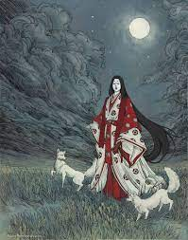
Inari - goddess of rice, tea, sake, world success, and fertility; uses foxes as her messengers on this plane. Patron deity of Ako.

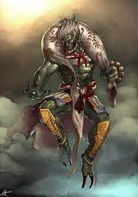
Fujin - god of wind. Patron deity of Ayozu – depicted holding a bag of winds, has a messy appearance and wild hair from all the wind; usually has four fingers on each hand, one for each direction of the winds; feared for the typhoons that he creates, but also credited with defending the land from invaders whenever a naval fleet meets one of the typhoons

Raijin – god of thunder, lightning, and storms; usually depicted holding hammers surrounded by drums; has three fingers on each hand to represent the past, present, and future; one of the most feared deities; people pray to him for lightning and rain: some believe that his lightning is responsible for fertilizing rice plants and that a rice field struck by Raijin’s lightning would enjoy a bountiful harvest

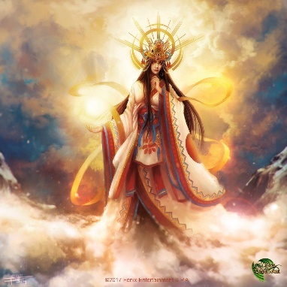
Amaterasu - goddess of the sun. Patron deity of Jurojin.

Tenjin- god of scholarship. Patron deity of Shiashi.

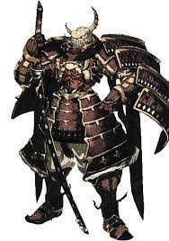
Takemikazuchi - god of thunder and god of swords. Patron deity of Tsumetai “Cold Lantern”.

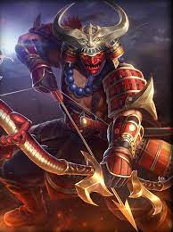
Hachiman - god of war and protection. Patron deity of Kaijin.

Ryujin – god of sea

Other Local Deities
These gods have smaller temples built in their name and are located in remote parts of the land. Monks called Akuso offer prayers, perform good works in their name, and train themselves rigorously to achieve perfection.
- Kami - The basic life force in nature, manifested in spirits
- Suijin - The god of water
- Aizen - a wisdom king known to transform earthly desires (love/lust) into spiritual awakening.
- Tsukuyomi – god of the moon
- Kagu-tsuchi - the god of destructive fire, worshiped by blacksmiths
  - Kagu-tsuchi's birth burned his mother Izanami, causing her death. His father Izanagi, in his grief, beheaded Kagu-tsuchi with his sword, Ame-no-Ohabari, and cut his body into eight pieces, which became eight volcanoes. The blood that dripped off Izanagi's sword created a number of deities, including the sea god Watatsumi and rain god Kuraokami.
- Watatsumi – sea god, worshiped by sailors
- Kuraokami – rain god, worshiped by farmers
- Seven Lucky Gods
  - Benzai - goddess of everything that flows: words, knowledge, eloquence, and music
  - Tamonten - god of war and justice; he is the god of fortunate warriors and guards, as well as the punisher of criminals. Said to live halfway down the side of Mount Sumeru, the small pagoda he carries symbolizes the divine treasure house that he both guards and gives away its contents.
  - Daikoku - the god of wealth, the harvest and the kitchen. He is recognised by his wide face, smile, and flat black hat. He is often portrayed holding a golden mallet, seated on bales of rice, with mice nearby (which signify plentiful food).
  - Hiruko - god of overcoming hardship. Said to be born without bones, he eventually overcame his handicaps to become the mirthful and auspicious "Laughing God". He is often depicted holding a rod and a large red sea bream or sea bass. Jellyfish are also associated with this god
  - Rokuju - god of wisdom and longevity; said to be an incarnation of the Southern Polestar. He is a star god accompanied by a crane and a turtle, which are considered to be symbols of longevity, and also sometimes accompanied by a black deer. The sacred book tied to his staff is said to contain the lifespan of every person on Earth.
  - Hotei - god of contentment and abundance
  - Kichijo - goddess of fertility and beauty
- Kuraokami, or Okami, is a legendary Japanese dragon and Shinto deity of rain and snow.

Monasteries in Sakura
Temples are large and elaborate palaces filled with breathtaking sculptures. They are the mainstay of worship for Sakurans who live near a town or city. But many priests and monks devoted to the divine tend to dwell in the wilderness, far from civilization. Their places of worship tend to be very plain structures, older than recorded history but elegant in their simplicity. There monks and priests train and meditate and focus their devotion in seclusion. Some are devoted to the gods and study Satori, the magical realm of enlightenment. But there are those where evil monks seek power from dark forces. These are typically the place where Ninja are trained, drawing off powers granted by demons.

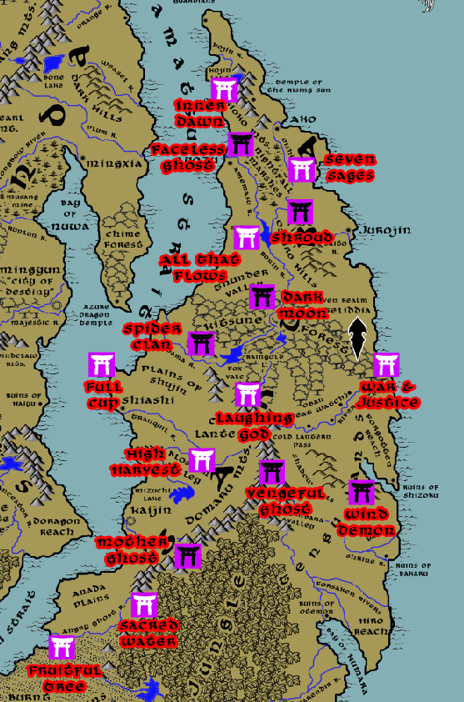

Monasteries Alignment Location
Monastery of Inner Dawn (Aizen) | Neutral Good | Kioko Mountains in the north of Sakura
Monastery of Seven Sages (Rokuju) | Neutral Good | along the banks of the Oishi River
Monastery of All that Flows (Benzai) | Chaotic Good | Oshiro Hills, overlooking Sui Jin Lake
Monastery of Full Cup (Hotei) | Neutral Good | overlooking the Kamatsu Strait, north of Shiashi
Monastery of the Laughing God (Hiruko) | Chaotic Good | Domaru Mountains, at the head of the Ronin River
Monastery of War and Justice (Tamonten) | Lawful Good | at the mouth of the Gozen River
Monastery of the High Harvest (Daikoku) | Lawful Good | along the banks of the Tranquil River
Monastery of the Sacred Water (Suijin) | True Neutral | Domaru Mountains, at the head of the Angry Ghost River
Monastery of Fruitful Tree (Kichijo) | Chaotic Good | overlooking the Kamatsu Strait, along the Angry Ghost River
Monastery of the Faceless Ghost (Noppera-bō) | Neutral Evil | northern edge of the Nightfall Marshes
Monastery of the Shroud (Shinigami) | Chaotic Evil | Oshiro Hills
Monastery of the Dark Moon (Tsukiyomi) | Neutral Evil | Kitsune Forest, alongside the Ronin River
Monastery of the Spider Clan (Tsuchigumo) | Lawful Evil | Northern Domaru Mts. Overlooking the Kodama River
Monastery of the Vengeful Ghost (Onryō) | Lawful Evil | Domaru Mts overlooking the Higanbana Valley
Monastery of Wind Demon (Idzuna) | Chaotic Evil | Shadow Hills in eastern (Azuma) region of Sakura
Monastery of the Mother Ghost (Mu-Onna) | Neutral Evil | Domaru Mts overlooking the Koi River

Creatures

Yokai – is a term to describe all strange and supernatural creatures. The word is a combination of the characters yō (attractive, bewitching, calamity) and kai (mystery, wonder). Yokai refers to all monsters, demons, spirits, or goblins, but it can encompass all of that and more. The world of yokai also includes ghosts, gods (kami), transformed humans and animals (bakemono), spirit possession (tsukimono), urban legends, and other strange phenomena. It is a broad and vague term.

[note: for purposes of this fictional world, Yokai will cover all supernatural creatures with the exception of Kami – those will be left to divine beings and forces of nature that are sources of worship]

- Abura-sumashi
- Akuma
- Amabie
- Bakeneko
- Daitengu
- Futakuchi-onna
- Gashadokuro
- Heikegani
- Isonade
- Kamaitachi
- Ki-rin
- Kitsune
- Momonjii
- Mu-onna
- Ningyo
- Nure-onna
- Ōmukade
- Samebito
- Shōjō
- Tengu
- Tsukumogami
- Yuki-Onna

Tengu and Oni
The only creatures to organize in force are the bird-like Tengu and the large ogres known as Oni. Like the Orcs and Gnolls in other parts of the world, these are evil creatures that seek to overthrow the land and wipe out all humankind.

Tengu
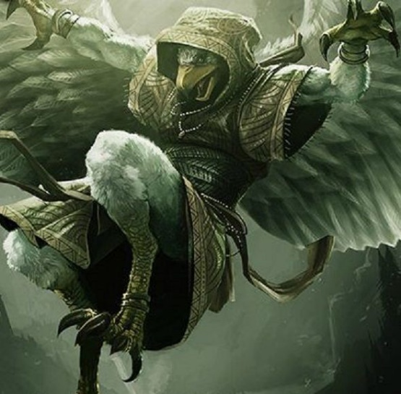
Type: medium humanoid, chaotic neutral
Hit Dice: 13 (3d8)
Initiative: +1
Speed: 30’ (one in ten can fly at a speed of 40’)
AC: 13
Attacks / Damage:
Short sword +5 to hit, reach 5’, 1d6+3 piercing damage
Short bow +5 to hit, range 80’/320’, 1d6+3 piercing damage
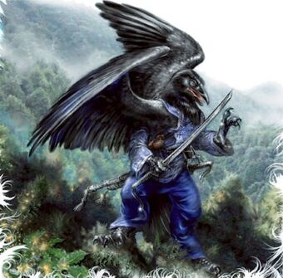
Face/Reach: 5’/5’
Special Attacks: Ambusher: the tengu have +4 on attacks against any surprised creature

Special Qualities:
Mimicry: Tengu can mimic the voice of any creature that they have heard before. This involves rolling a bluff check, opposed by a creature's sense motive check in order to realize the voice is fake.
Low-Light Vision: Tengu can see up to four times as far as humans in dim lighting.

Saves: +1/+4/+2
Abilities: 10/16/10/11/10/10
Skills: +4 racial bonus on Hide and Move Silently checks, +4 racial bonus on Spot checks, +8 racial bonus on Bluff checks.

Automatic Languages: Common, Tengu, which sounds much like birds chirping and cawing. Bonus Languages: Any (except Secret languages).
Favored Class: a tengu's favored class is Ranger.

Feats:
Climate/Terrain:
Organization:
Challenge Rating: 1/4
Treasure:
Alignment:
Advancement:

Notes: Tengu are crow-like humanoids with bodies covered in feathers, arms and hands ending in taloned claws, and avian faces with dark black eyes and prominent beaks for mouths. Tengu have short, stunted wings they can tuck inward behind their backs. These are colored to match the feathers on their bodies and can range from pale white to gray to dark black.
Tengu are a dangerous race. The first of the intelligent creatures to populate Sakura, they were quickly fighting with humans for control of the land. Tengu believe themselves to be the highest creatures of this world and see it as their divine right to conquer humans and expand. Some philosophers have noted this is not unlike the mindset of humans themselves.
Tengu have long clashed with Sakurans. They have conquered and hold the eastern lands beyond the Domaru Mountains. Tengu are lithe, fast, regimented, and diligent. To enter Tengu territory is to be under constant watch from unknown forces. Here the tengu take every precaution to keep their village from being discovered by outsiders.

One in ten tengu are actually Daitengu. These are built differently, with large wings that are capable of flight. Daitengu fly at a speed of 40 feet (average maneuverability). A Daitengu can't fly while carrying a medium or heavy load or while fatigued or exhausted. Daitengu can safely fly for a number of rounds equal to their Constitution modifier (minimum 1 round). They can exert themselves to fly for up to twice as long, but then they're fatigued at the end of the flight. Daitengu are likewise fatigued after spending a total of more than 10 minutes per day flying. Because Daitengu can glide before, after, and between rounds of actual flight, they can remain aloft for extended periods (even if they can only use flight for 1 round at a time without becoming fatigued). When they reach 10 Hit Dice, Daitengu have enough stamina and prowess to fly for longer periods. They can fly at a speed of 40 feet (average maneuverability), and flying requires no more exertion than walking or running.

https://www.dandwiki.com/wiki/Tengu_(3.5e_Race)

Personality
The Tengu are by nature alert, always keeping watch over their surroundings. They tend to stay hidden and watch from afar. Their lives mainly involve labor to supply and feed the treetop villages in which they nest and judicious reconnaissance of their territory, always ensuring that their village is never discovered. On the rare occasions when individual Tengu interact with non-Tengu, it is usually to exchange information. Tengu make great investigators due to their aptitude for spotting details and keeping watch, as well as their natural affinity for reading others.

Physical Description
Tengu are mostly humanoid in shape, but as Crow folk, Tengu appear different in several ways. First, their nails tend to be sharper, like a crow's talons. Secondly, Tengu are lithe and slender, with males being noticeably larger than females, and tend to have thinner, slightly longer noses than humans do. Finally, every Tengu sports a pair of black feathery wings. For most, these are too small to achieve flight. But for one in ten Tengu there are the Daitengu, whose larger winds allow them to fly at great speed. Some Daitengu are capable of flying so fast they appear as a blurr to those not expecting them to fly by. All Tengu are slightly smaller than Humans and often weigh less. They are relatively long-lived compared to humans, often living several centuries.

Relations
Tengu are reclusive, and tend to keep others at a distance even on the occasions when contact is made. The Tengu are less suspicious of the Kappa, however, and tend to trust them more than other races, since they sometimes share mountains together, the Kappa in the dank caves and the Tengu high in the trees and clouds. Most communication with non-tengu is between Tengu and Kappa. Tengu are automatically unfriendly towards all races except other Tengu and Kappas.

Lands
The Tengu are tree-dwelling people that live in the Mountains. Their villages tend to be wooden structures built into massive trees that grow high in the mountain forests, far away from human civilization. their treetop structures are only accessible by flight, and are unnoticeable from the ground. Most people who walk through the mountains and stumble upon a Tengu village dont even know it before they are assailed by swarms of talons and arrows.

Racial Traits
Strength -2, Dexterity +2, Constitution -2, Wisdom +2, Charisma +2: Tengu are frighteningly fast, but not physically impressive. They are also great at studying others, and their exotic looks are alluring to others.

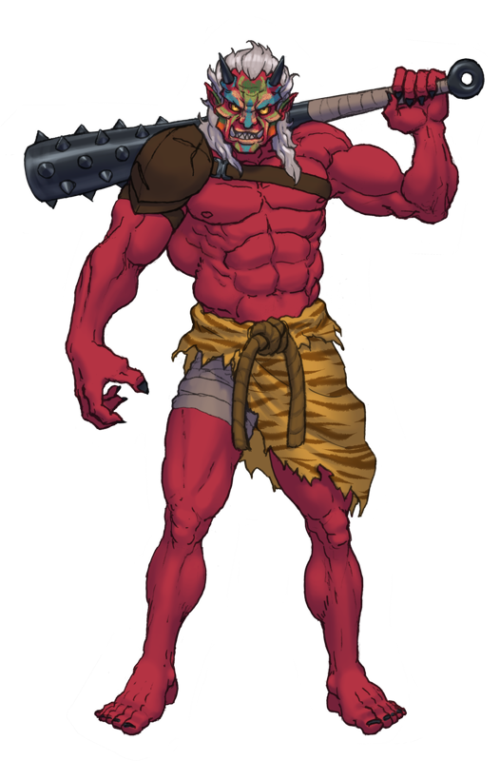
Oni
Type: Large-sized Giant
Hit Dice: 110 (13d10+39)
Initiative: (-1 Dex, -1 size, +6 natural)
Speed: 30 ft.
AC: 14
Attacks / Damage: Claw (Oni Form Only). Melee Weapon Attack: +7 to hit, reach 5 ft., one target. Hit: 8 (1d8 + 4) slashing damage.

Kanabo club. Melee Weapon Attack: +7 to hit, reach 10 ft., one target. Hit: 15 (2d10 + 4) bludgeoning damage, or 9 (1d10 + 4) bludgeoning damage in small or medium form.

Face/Reach: 5’ / 10’
Special Attacks:
Magic Weapons. The oni's weapon attacks are magical.

Multiattack. The oni makes two attacks, either with its claws or its club.

Special Qualities: Innate Spellcasting. The oni's innate spellcasting ability is Charisma-based (spell save DC 13). The oni can innately cast the following spells, requiring no material components:
At will: darkness, invisibility
1/day each: charm person, cone of cold, gaseous form, sleep

Regeneration. The oni regains 10 hit points at the start of its turn if it has at least 1 hit point.

Darkvision 60’

Change Shape. The oni magically polymorphs into a small or medium humanoid, into a large giant, or back into its true form. Other than its size, its statistics are the same in each form. The only equipment that is transformed is its glaive, which shrinks so that it can be wielded in humanoid form. If the oni dies, it reverts to its true form and its glaive reverts to its normal size.

Saves: Fort +6, Ref +3, Will +4
Abilities: 19/11/16/14/12/15
Skills: Climb +4, Listen +2, Spot +2
Feats: Weapon Focus (Kanabo club)
Climate/Terrain:
Organization:
Challenge Rating: 7
Treasure:
Alignment:
Advancement:
Notes:
Oni are large ogres native to Sakura. They are hideous, gigantic ogre-like creatures with a single horn or multiple horns emerging from their heads and manes of unruly hair. Their skin color varies, varies from dark red, blue, or green. Rare, ancient Oni have even been described with white, black, or yellow skin. Their demonic faces cause some to misidentify them as demonic, with glowering yellow eyes, large horned teeth, and long claws. They wear loincloths of tiger pelt and carry iron kanabō clubs. Oni are more intelligent than western ogres, delighting in mischief. All but a few are evil and love to plunder farms and eat everything that moves. Mostly solitary, occasionally they form into clans in the hills and mountains. Oni are still not as intelligent as the Tengu, who often trick or enslave the large creatures as heavy infantry in their armies. Oni speak Giant, common, and Sakuran.

Abumi-guchi

Type: Tiny Aberration
Hit Dice:
Initiative:
Speed:
AC:
Attacks / Damage:
Face/Reach:
Special Attacks:
Special Qualities:
Saves:
Abilities:
Skills:
Feats:
Climate/Terrain:
Organization:
Challenge Rating:
Treasure:
Alignment:
Advancement:
Notes: a strange, furry yokai formed from a stirrup, usually one that once belonged to a dead soldier. It is said that the abumi-guchi will wait where it lies for the dead soldier to return. Fields where great battles were once fought are said to be filled with these creatures.

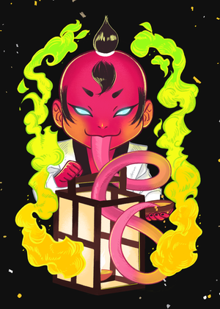
Abura-akago
Type:
Hit Dice:
Initiative:
Speed:
AC:
Attacks / Damage:
Face/Reach:
Special Attacks:
Special Qualities:
Saves:
Abilities:
Skills:
Feats:
Climate/Terrain:
Organization:
Challenge Rating:
Treasure:
Alignment:
Advancement:
Notes: Abura-akago are tiny demons that appear as tiny humanoids with baby-like features. They have red skin, yellow eyes, and a long tongue. They are fond of tormenting humans by licking the oil out of their lamps, a substance that delights them. When discovered, they burst into flame and fly about erratically to escape out the nearest window. Anyone coming in contact with a Abura-akago will take burn damage. They are also capable of spitting fire equivalent in strength and heat to five flasks of alchemist’s fire.

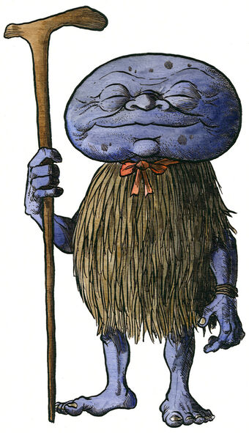
Abura-sumashi,
Type:
Hit Dice:
Initiative:
Speed:
AC:
Attacks / Damage:
Face/Reach:
Special Attacks:
Special Qualities:
Saves:
Abilities:
Skills:
Feats:
Climate/Terrain:
Organization:
Challenge Rating:
Treasure:
Alignment:
Advancement:
Notes: Abura-sumashi are spirits who appear to lone travelers. They are a rare yokai native to the Nightfall Marshes. They appear as squat humanoids with a large ugly head like a potato or a stone, wearing a straw-woven raincoat. The name abura sumashi means “oil presser,” and comes from the act of pressing oil out of the seeds of tea plants which grow around Ako. Though its origins are a mystery, it is commonly believed that abura sumashi are the ghosts of oil thieves who escaped into the woods. Oil was a very difficult and expensive commodity to make, requiring a lot of time and hard work to extract it from tea seeds, and so its theft is a very serious crime. Those thieves who went unpunished in life are reincarnated as yokai – a sort of divine punishment for their sins.

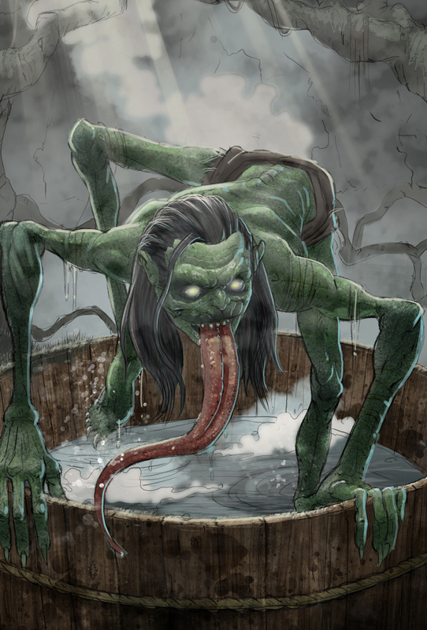
Akaname

Type: Medium-Size Outsider (Demon)
Hit Dice: 6d8+6 (33 hp)
Initiative: +3 (Dex)
Speed: 30’
AC: 16 (+3 Dex, +3 Natural Armor)
Attacks / Damage: 2x claws +6 to hit (1d8 dmg), bite +3 to hit (1d6 dmg), raspy tongue +10 to hit (1d4 + disease)
Face/Reach: 5’ / 5’
Special Attacks: Prehensile Tongue – On a successful hit with its tongue, the Akaname can perform a grapple check as a free action. This deals an additional 1d4 points of crushing damage and pins the limb of the opponent until freed.
Disease: On a successful bite or tongue attack an opponent must roll a DC 18 Fortitude Save or be stricken with Fetid Fever. This inflicts 1d4 points of Constitution damage per day until the victim dies. It is identified by a bright red rash that appears on the belly.
Special Qualities:
Saves: +10/+10/+1
Abilities: 11/16/12/9/6/6
Skills: Jump +12, Climb +12, Hide +8
Feats: Dodge, Combat Reflexes
Climate/Terrain:
Organization:
Challenge Rating: 3
Treasure:
Alignment:
Advancement:
Notes: Akaname are foul demons who revel in filth and grime. They appear anywhere there is decay or filth, most often that caused by humans. Akaname often appear on battlefields bereft of honor, in graveyards of the cursed, and in the store houses of the wealthy. It is said that if food stores are left to rot when others in the land are left starving, the injustice of the world summons the Akaname.
Akaname are wild, mischievous creatures who love to cause suffering and spread disease. They are also incredibly fast and able to climb up walls with ease, making them hard to catch. They are lurking creatures, able to hide in shadows as well as underwater for several minutes. They wreak destruction then flee when attacked, preferring to engage in hit-and-run attacks from cover and shadow.
Akaname are small, goblin-like yōkai which inhabit only the dirtiest homes and public baths. They are about the size of a child or a small adult, though they generally appear much smaller due to their hunching posture. Akaname have a mop of greasy, slimy hair on the tops of their heads. Their bodies are naked, and their skin is greasy like their hair. Akaname come in many colors and varieties, ranging from a dark, mottled green reminiscent of mold, to the ruddy pink of bedsores. They come in both one-eyed and two-eyed varieties, and can have anywhere from one to five fingers and toes. All akaname have an extremely long, sticky tongue. They use this to lap up the slime, grease, hair, and other filth found in bath houses and behind toilets.


Akuma
Type: Demon; Large Outsider (Chaotic, Evil)
Hit Dice: 9d8+27 (67 hp)
Initiative: +0
Speed: 30’, Fly 40’ (poor)
AC: 26 (-1 size, +17 natural)
Attacks / Damage: Bite +13 melee (1d4+3 damage), 2 claws +8 melee (1d6+7 damage), +2 Flaming Nodachi (Greatsword) +15 melee (3d6+10 + 1d6 fire damage)
Face/Reach: 5’ x 5’ / 10’
Special Attacks: Spell-like abilities, Gaze of Madness, summon demons
Special Qualities: Damage reduction 20/ +2, Spell Resistanced 23, demon qualities, half damage
Saves: Fort +9, Ref +6, Will +8
Abilities: Str 21 (+5), Dex 10 (+0), Con 17 (+3), Int 14 (+2), Wis 14 (+2), Cha 14 (+2)
Skills: Concentration +15, Hide +14, Listen +22, Move Silently +12, Search +14, Spellcraft +14, Spot +22
Feats: Blind Fighting, Cleave, Power Attack
Climate/Terrain: Any land and underground
Organization: Solitary or gang (2-4)
Challenge Rating: 14
Treasure: Standard
Alignment: Always chaotic evil
Advancement: 10-13 HD (Large); 14-27 HD (Huge)
Notes: Akuma are flying demons with fiery head and eyes, typically carrying a large Nodachi greatsword. Akuma are harbingers of doom and appear just before terrible calamities. Mortals gazing upon an Akuma must make a Will save or succumb to madness, which can only be lifted by Remove Curse.

Akuma lust only for destruction and chaos.
Akuma enjoy tempting humans into warfare and ruin, but prefer to lure them with the promise of power through human agents. They also make formidable opponents in battle. Akuma are towering (15 feet tall), broad, well-muscled and wreathed in flame. They have demonic heads with sharp fangs, blazing white eyes, and curved horns.

Combat: Akuma prefer subterfuge over open combat, but are ecstatic to march into battle when the time is ripe and their plans lead to chaos.

Spell-Like Abilities: the following effects are either cast automatically or at will:
1st-level: burning hands, charm person, detect good, enlarge
2nd-level: death knell, desecrate, shatter, mirror image
3rd-level: deeper darkness, dispel magic
4th-level: chaos hammer, confusion, unholy blight
7th-level: reverse gravity
These abilities are as the spells cast by a 10th-level sorcerer (save DC 13 + spell level).

Gaze of Madness: Anyone who looks upon an Akuma must pass a Will Save DC 14 or be driven mad. Anyone making the save cannot be affected by any Akuma for the next 24 hours. The person feels a great disturbance to the fabric of reality but is otherwise unaffected. Those who fail the save are rendered insane and will remain so until a Remove Curse is cast upon them. Afflicted characters have no concept of reality and are filled with panic, running out of control and flailing about until they succumb to exhaustion.

Demon Traits: Immune to poison and electricity, resistance to cold, fire, and acid (Resistance 20), telepathy, +8 racial bonus to Listen and Spot checks.

Telepathy: Akuma can communicate telepathically with any creature within 100 feet who has a language.

Summon Yokai: Once per day an Akuma can attempt to summon 1d4 Akaname with a 10% chance of success.

Amabie
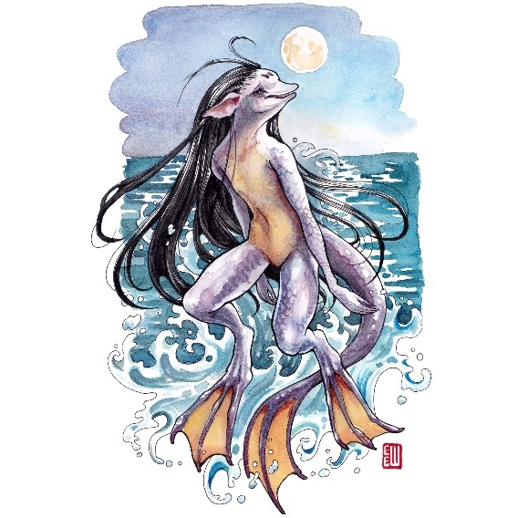
Type:
Hit Dice:
Initiative:
Speed:
AC:
Attacks / Damage:
Face/Reach:
Special Attacks:
Special Qualities:
Saves:
Abilities:
Skills:
Feats:
Climate/Terrain:
Organization:
Challenge Rating:
Treasure:
Alignment:
Advancement:
Notes: Amabie are aquatic humanoid creatures with a beak-like snout and large fins for feet and tail. These creatures are solitary and harmless. They occasionally emerge from the sea to utter prophecies, usually for either an abundant harvest or an epidemic. They are known to have healing powers and will offer aide if treated respectfully. Many villages have amabie totems placed in their windows to defend against illness.

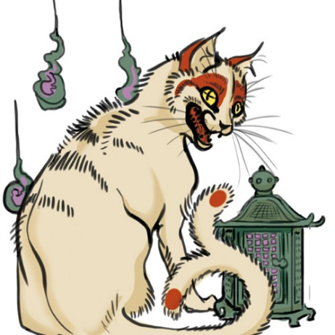
Bakeneko
Type: Tiny Magical Beast
Hit Dice: 4d6 (14 hp); Nekomata: 8d6 (32 hp)
Initiative: +7 (+3 Dex, +4 Improved Initiative)
Speed: 40’
AC: 15 (+3 Dex, +2 Size)
Attacks / Damage:
Face/Reach: 2 ½’ x 2 ½’ / 5’
Special Attacks: Spell-like abilities

Special Qualities: Alternate Form, Immune to Poison, Low-light Vision, Spell like Abilities, Telepathy

Saves: Fort +0, Ref +5, Will +4
Abilities: Str 7 (-2), Dex 16 (+3), Con 11 (+0), Int 16 (+3), Wis 15 (+2), Cha 16 (+3)
Skills: Spot +8, Listen +4, Move Silently +12, Hide +12
Feats: Dodge, Improved Initiative, Moblity
Climate/Terrain: Temperate regions
Organization: Solitary
Challenge Rating: 4 (CR 6 for Nekomata)
Treasure: Double coins; 50% goods; 50% items
Alignment: Chaotic Evil
Advancement: 2-3 HD (Tiny)
Notes: Bakeneko are magical creatures resembling cats that can speak and possess shape-shifting abilities allowing them to disguise as humans. Bakeneko are fond of manipulating people for their own gain, entrancing them with their eyes and using mind control that only the very strong can resist. While they exercise their mind control their tails split in two. It has been said that some of the shops that keep cats are actually being run by the Bakeneko to further some devious scheme known only to them. The same is said of wizards who go mad, that a Bakeneko replaced their familiars and are now controlling them.

Bakeneko speak multiple languages, including yokai, common, and Sakuran. In their human form they tend to wear hats with noticeably fancy decorations. They are mischievous and love to cause misfortune, moving objects to trip unsuspecting persons, relieving themselves on items of great value, and inscribing invisible marks that cause harm.

The oldest Bakeneko evolve into a more powerful form of yokai called the Nekomata. While not all bakeneko are malicious or violent towards their masters, all nekomata are; they look upon humans with contempt. Nekomata summon fireballs and start great conflagrations, killing many people. They reanimate and control corpses like puppet-masters with their necromantic powers, and they use their powerful influence to blackmail or enslave humans. Nekomata can enlarge at will to a large-sized version, capable of eating things that are much bigger than their normal size. They are immune to poison and can bring down great misfortune.

Alternate Form (Su): A Bakeneko can assume other forms at will as a standard action. This ability functions as the spell polymorph self as cast by a 12th-level sorcerer, except that the Bakeneko can assume forms no larger than Medium-size. Nekomata cast spells as a 12th-level sorcer, can grow to large-sized form, and often consume their human masters and assume their shape.

Telepathy (Su): A Bakeneko can communicate telepathically with any creature within 100 feet that has a language.

Spell-like Abilities (Bakeneko): At will, as a 6th-level sorcerer, can cast the following spells as a free action. The spells are Charisma based with a DC of 15 plus spell level.
0-level: Arcane Mark (invisible): bestows curses in a given area until removed
1st-level: Burning Hands (emanating from the tail)
3rd-level: Suggestion (requires eye contact)
4th-level: Polymorph (self), Bestow Curse
5th-level: Dominate Person (requires eye contact), Telekinesis

Spell-like Abilities (Nekomata): At will, as a 12th-level sorcerer, can cast the following spells as a free action. The spells are Charisma based with a DC of 18 plus spell level.
0-level: Arcane Mark (invisible): bestows curses in a given area until removed
1st-level: Burning Hands (emanating from the tail)
2nd-level: Command Undead, Flaming Sphere (emanating from the tail)
3rd-level: Suggestion (requires eye contact)
4th-level: Animate Dead, Polymorph (self), Bestow Curse, Contagion
5th-level: Dominate Person (requires eye contact), Telekinesis


Daidarabatchi

Type:
Hit Dice:
Initiative:
Speed:
AC:
Attacks / Damage:
Face/Reach:
Special Attacks:
Special Qualities:
Saves:
Abilities:
Skills:
Feats:
Climate/Terrain:
Organization:
Challenge Rating:
Treasure:
Alignment:
Advancement:
Notes: Daidarabatchi are giants that are so enormous they reshape the land; they often hide as mountains when sleeping

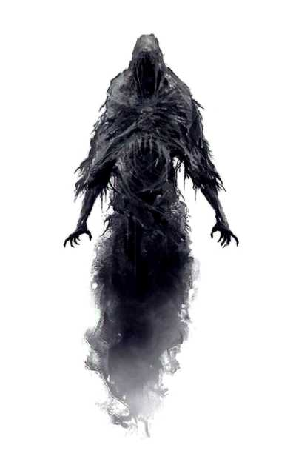
Enenra

Type: large elemental (air)
Hit Dice: 7d8+7 (38 hp)
Initiative: +5 (dex)
Speed: 30’ / 50’ fly (perfect)
AC: 22 (-1 size, +5 Dex, +8 natural)
Attacks / Damage: 2 wings +9 melee, bite +4 melee, 2 claws +4 melee
Face/Reach: 5’ / 10’
Special Attacks: smoke claws: An enenra in smoke form can engulf opponents by moving on top of them. It fills the air around one medium-sized or smaller opponent without provoking an attack of opportunity. The target must succeed at a Fort Save (DC 14) or inhale part of the creature. Smoke inside the victim solidifies into a claw or talon and begins to rip at the surrounding organs, dealing 3d4 points of damage per round. The affected creature can attempt another Fort save each subsequent round to cough out the semivaporous menace.
Special Qualities: smoke form: Most of the time an enenra is more or less solid, but at will it can assume a smoke form. It can switch forms once per round as a free action and can spend up to 20 rounds per day in smoke form. An enenra in smoke form can fly at a speed of 50’. The ability is otherwise similar to a gaseous form spell cast by a 7th-level sorcerer.
Saves: Fort +3, Ref +10, Will +2
Abilities: 14/21/13/6/11/11
Skills: Listen +9, Move Silently +9, Spot +9
Feats: Multiattack, Weapon Finesse (wing)
Climate/Terrain:
Organization:
Challenge Rating: 6
Treasure:
Alignment:
Advancement:
Notes: The enenra is a yokai that takes the form of smoke and darkness. It often emanates from bonfires at night and can only be seen by the pure of heart.

Futakuchi-onna
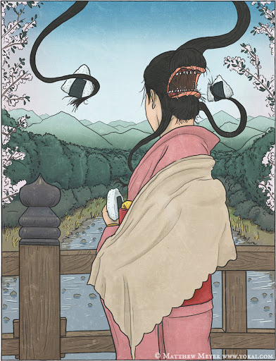
Type:
Hit Dice:
Initiative:
Speed:
AC:
Attacks / Damage:
Face/Reach:
Special Attacks:
Special Qualities:
Saves:
Abilities:
Skills:
Feats:
Climate/Terrain:
Organization:
Challenge Rating:
Treasure:
Alignment:
Advancement:
Notes: Also called the Two-Mouthed Woman, this creature is the result of a curse placed on a normal mortal female, usually human. The curse causes a second mouth to form at the back of her head. The second mouth is powerful and contains several sharp teeth. It often mumbles spiteful and threatening things to the woman and demands food. If it is not fed, it can screech obscenely and cause the woman tremendous pain. Eventually, the woman's hair begins to move like a pair of serpents, allowing the mouth to help itself to the woman's meals. While no food passes through her normal lips, the mouth in the back of her head consumes twice what the other one would.

Families who notice that their food stocks are shrinking at an alarming rate, while the women in their houses hardly eat a bite, may be the victims of a futakuchi onna. Futakuchi onna appear as regular women until their terrible secret is revealed: in the back of their skulls—buried beneath long, thick hair—is a second mouth, full of teeth and with large, fat lips. This second mouth is ravenous, and uses long strands of its hair-like tentacles to gorge itself on any food it can find.

futakuchi onna are most often thought to be shape-changed yama uba posing as young women. In the western regions they are frequently shape-changed kumo, or magical spiders. In the other tales they are the result of curses brought about by wicked deeds, similar to rokuro kubi. In each story, regardless of its true nature, this yōkai is used as a punishment upon a greedy man or woman for wickedness and extreme parsimony.

Legends: One story tells of how in a small rural village in Fukushima there lived a stingy miser. Because he could not bear the thought of paying for food to support a family, the miser lived entirely by himself. One day he met a woman who did not eat anything at all, and he immediately took her for his wife. The miser was thrilled with her because she never ate a thing and was still a hard worker. However, his stores of rice steadily decreased, and he could not figure why, for he never saw his wife eat.

One day, the miser pretended to leave for work. In truth he stayed behind to spy on his new wife. As the miser watched from a hidden location, his wife untied her hair, and revealed a second mouth on the back of her head, complete with ghastly lips and teeth. Her hair reached out with tentacle-like stalks and began to scoop rice balls into the second mouth, which cooed out with pleasure in a vulgar, raspy voice.

The miser was horrified and resolved to divorce his wife as soon as possible. However, she learned of his plan before he could act on it, and trapped him in a bathtub and carried him off into the mountains. The miser managed to escape. He hid in a heavily scented lily marsh where the futakuchi onna could not find him.

Another story tells of a wicked stepmother who always gave plenty of food to her own daughter, but never enough to her stepdaughter. Gradually the stepdaughter grew sicker and sicker, until she starved to death. Forty-nine days later, the wicked stepmother was afflicted with a terrible headache. The back of her head split open, and lips, teeth, and a tongue formed. This new mouth ached with debilitating pain until it was fed, and it shrieked in the voice of the dead stepdaughter. From then on the stepmother always had to feed both of her mouths, and always felt the hunger pangs of the stepdaughter she murdered.
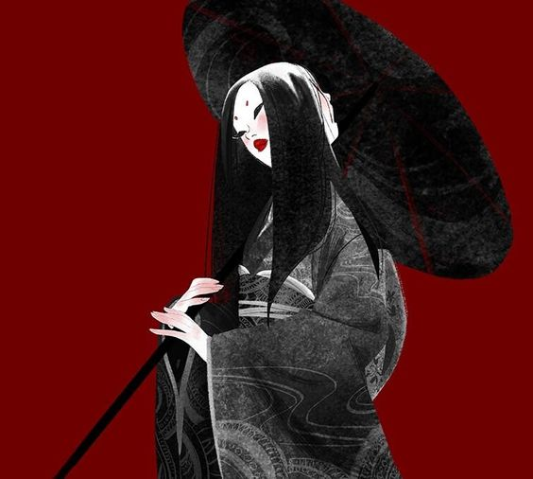

Gashadokuro
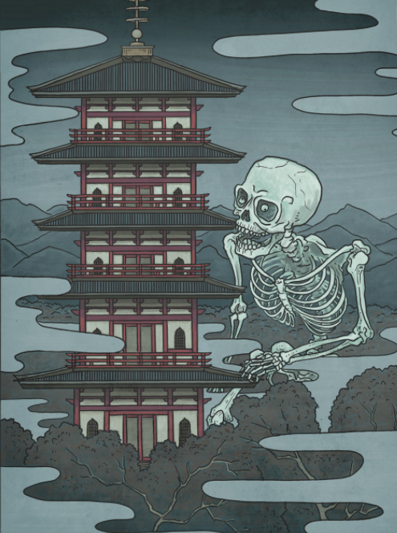
Type: Gargantuan Undead
Hit Dice: 24d12+3 (159 hp)
Initiative: -1 (Dex)
Speed: 40’
AC: 11 (-4 size, -1 Dex, +6 natural)
Attacks / Damage: Slam +15 melee / 2d8+10
Face/Reach: 20’x20’ / 20’
Special Attacks:
Special Qualities: Undead, partial actions only
Saves: Fort +8, Ref +7, Will +14
Abilities: Str 25 (+7), Dex 8 (-1), Con 0, Int 0, Wis 10, Cha 1
Skills:
Feats: Toughness, Improved Critical (slam)
Climate/Terrain: any land and underground
Organization: solitary
Challenge Rating: 6
Treasure: none
Alignment: Always neutral
Advancement:
Notes:
Gashadokuro are skeletal giants made up of the bones of the unburied dead and animated by their anger. The creature is seldom seen, but is said to appear in times of great darkness and turmoil. It is infamous for raiding small villages and devouring livestock and people. They wander around the countryside in the darkest hours of the night. Their teeth chatter and bones rattle with the “gachi gachi” sound of this yōkai’s namesake. But they are not always noisy. If they should happen upon a human out late on the roads, the gashadokuro will silently creep up and catch their victims, crushing them in their hands or biting off their head.

Soldiers whose bodies rot in the fields and victims of famine who die unknown in the wilderness rarely receive proper funerary rites. Unable to pass on, their souls are reborn as ghosts, longing eternally for that which they once had. These people die with anger and pain in their hearts. That energy remains long after their flesh has rotted from their bones. As their bodies decay, their anger ferments into a grudge against the living, which twists them into a supernatural force. When the bones of hundreds of victims gather together into one mass, they form the humongous, skeletal monster known as the gashadokuro.

Too large and powerful to be killed, gashadokuro maintain their existence until the energy and malice stored up in their bodies has completely burnt out.

Undead traits: immune to poison, sleep, paralysis, stunning, disease, death effects, and necromantic effects and they ignore mind-influending effects (charms, compulsions, phantasms, patterns, and morale effects). Undead are not subject to critical hits, subdual damage, ability damage, ability drain, or energy drain.

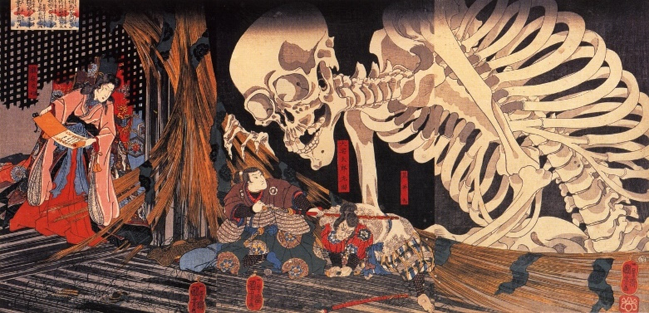

Heikegani
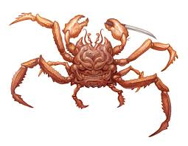
Type: small aberration
Hit Dice:
Initiative:
Speed:
AC:
Attacks / Damage:
Face/Reach:
Special Attacks:
Special Qualities:
Saves:
Abilities:
Skills:
Feats:
Climate/Terrain:
Organization:
Challenge Rating:
Treasure:
Alignment:
Advancement:
Notes: mystical crabs with human-faced shells, the spirits of the warriors killed in the Battle of the Flaming Sails.

Isonade

Type: Gargantuan beast, unaligned
Hit Dice: 15d20+60 (217 hit points)
Initiative:
Speed: 20’, swim 60’
AC: 16 (natural armor)
Attacks / Damage:
Face/Reach:
Special Attacks:
Special Qualities: Damage Resistance (fire) Damage Immunities (cold), Darkvision 120’
Saves:
Abilities: Str 24 (+7), Dex 14 (+2), Con 19 (+4), Int 3 (-4), Wis 11 (+0), Cha 11 (+0)
Skills:
Feats:
Climate/Terrain:
Organization:
Challenge Rating: 12
Treasure:
Alignment:
Advancement:
Notes: Isonade are mysterious, shark-like sea monsters which scour the rocky coastlines searching for boats to scuttle and fishermen to snatch. Their bodies are enormous, and their fins are covered with countless, tiny metallic barbs like a grater. They use these barbs to hook their prey, dragging them deep into the water to be eaten. Isonade are said to appear when the north winds blow and the sea currents change.

Despite their size, isonade are incredibly elusive. They move through the water with unparalleled grace and can swim without creating so much as a splash. This makes them difficult to spot. By the time most sailors have noticed that the winds have changed and a strange color is upon the sea, it is too late—a huge tail is already rising out of the water, above their heads. When isonade strike, they do not thrash about violently like a hungry shark. Instead they hook their prey on their fins or tail with a gentle stroking motion, dragging them into the depths almost peacefully. They do this without a sound and without ever showing their bodies, making them all the more dangerous for their stealth.

Combat:

Improved Grapple

Multiattack. The sea serpent makes two attacks: once with its bite and once with its constrict.
Bite. Melee Weapon Attack: +11 to hit, reach 20 ft., one target. Hit: 25 (4d8 + 7) piercing damage.
Constrict. Melee Weapon Attack: +11 to hit, reach 20 ft., one target. Hit: 21 (4d6 + 7) bludgeoning damage, and the target is grappled (escape DC 21). Until this grapple ends, the creature is restrained, and the sea serpent can’t constrict another target.
Elusive Dive. The sea serpent takes the Dash action, and until the beginning of its next turn, it gains a +10 bonus on Dexterity (Stealth) checks and cannot be tracked by nonmagical means.

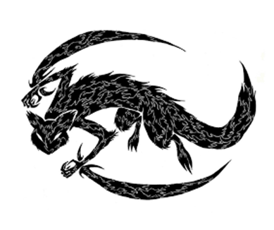
Kamaitachi
Type: Tiny Magical Beast
Hit Dice: 2d10+6 (18 hp)
Initiative: +7 (+3 Dex, +4 Improved Init)
Speed: 60’
AC: 23 (+3 Dex, +10 glamer and speed)
Attacks / Damage: 2 claws +6 to hit, 1d4 points damage each
Face/Reach: 2 ½’ x 2 ½’ / 5’
Special Attacks: Blood drain, Heal
Special Qualities: Displacement, Resistance to Ranged Attacks
Saves: Fort +2, Ref +4, Will +1
Abilities: Str 3, Dex 17, Con 10, Int 2, Wis 12, Cha 5
Skills: Balance +10, Climb +11, Hide +13, Move Silently +9, Spot +4
Feats: Weapon Finesse (claws), Improved Initiative
Climate/Terrain: mountains, neighboring areas above ground
Organization: Travel in threes
Challenge Rating: 3
Treasure: None
Alignment: Chaotic neutral
Advancement:
Notes: The slashing “sickle weasel” haunts the mountain regions of Sakura. While it appears like a weasel and is the same size, it has fur like that of a hedgehog, a cry like that of a dog, and rides through the air on whirlwinds that it creates magically. They usually appear in threes, attacking people with razor-sharp limbs and drawing out blood before the victim knows what is going on. The trio take turns, one of them cutting their prey, one of them quickly drawing out blood, and the one of them applying a resin that closes the wounds. Kama itachi are incredibly fast and difficult to see, so most victims fall over and feel no pain, blaming the wind for knocking them over.

Combat:
Kama itachi rake opponents with their claws as they whirl around them at incredible speeds. The cuts themselves cause no damage, because they are quickly sealed up by one of the three attackers. However, blood is drawn out leaving the victim feel weak.

Displacement (Su): A light-bending glamer continually surrounds a kama itachi, making it difficult to see. Any melee or ranged attack directed at it has a 50% miss chance unless the attacker can locate the beast by some means other than sight. A true seeing effect allows the user to see the beast’s position, but see invisibility has no effect.

Blood Drain: Each round on a successful attack the Kama itachi sucks blood from a living victim, inflicting 1d4 hit points damage and 1 point of Constitution.

Heal: Each round a victim is attacked, one of the three Kama itachi covers any wounds in a sticky solution that is secreted in the creature’s skin. This closes any wounds and allows the character to ignore any damage, except that caused by the blood drain. If one of the three Kama itachi are slain, however, the remaining two will only continue cutting and draining their prey without bothering to heal them.

Kitsune
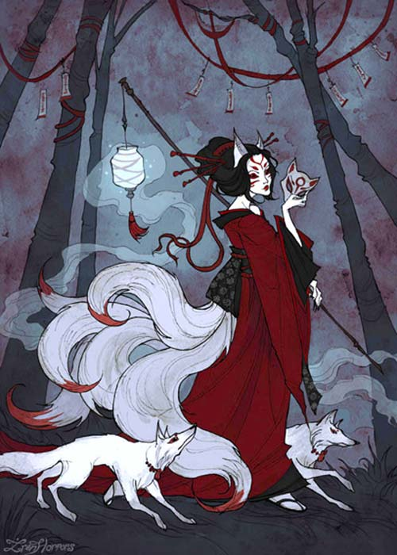
Type: medium lycanthrope, either chaotic good or chaotic evil
Hit Dice: 1 hit die per tail, up to nine tails; common Kitsune: 5d8-10 (22 hp)
Initiative: +8
Speed: 50’
AC: 17
Attacks / Damage: 2x claw (2d4 + poison)
Face/Reach: 5’ / 5’
Special Attacks: Fox fire: Once per day a Kitsune can release one small orb of fire for every tail they possess; the orb can be fired at targets as a ranged touch attack with a range increment of 20’; each orb does 3d6 fire damage.
Special Qualities: Alter Self at will
Saves: +1/+5/+10
Abilities: 10/18/10/12/12/20
Skills: Spot +10, Listen +10
Feats: Acrobatic, Agile, Improved Initiative, Dodge, Lightning Reflexes,
Climate/Terrain:
Organization:
Challenge Rating: CR 3 (CR 6 for 9-tailed elder Kitsune)
Treasure:
Alignment:
Advancement:

Notes: Kitsune are divine creatures (Yokai) that resemble foxes. They are intelligent beings with paranormal abilities that increase with their age and wisdom. The more tails a kitsune has – they may have as many as nine – the older, wiser, and more powerful it is.
At the age of fifty Kitsune develop the ability to shapeshift, most often into the appearance of a human female. In this form, they may retain fox-like traits, such as a coating of fine hair, a fox-shaped shadow, or a reflection that shows its true form. Enlightened elders are said to be able to divine the true form of a disguised Kitsune. Oft times Kitsune drop their disguise if they get drunk or careless, at which point their tails appear, or at the appearance of a dog, which can sense a Kitsune and frighten them with their barking.
Other abilities possessed by Kitsune as they grow older and gain more tails include possession, generating fire or lightning, willful manifestation in the dreams of others, flight, invisibility, and the creation of illusions so elaborate as to be almost indistinguishable from reality.
Good Kitsune are known to serve Inari, goddess of rice and fertility, and act as her messengers. Kitsune can be either good, like those serving Inari, or evil, prone to trickery and mischief.
Kitsune can cast the following spells at will; all are Charisma based:
0-level: Daze, Dancing Lights, Ghost Sound (Save DC 15)
1st-level: Change Self, Charm Person, Hypnotism, Message, Ventriloquism (Save DC 16)
2nd-level: Alter Self, Cat’s Grace, Eagle’s Splendor, Invisibility (Save DC 17)
Kuzunoha is the most famous Kitsune in folklore, having taken the form of a beautiful maiden and marrying a cruel Daimyo. It is said she used her position to undermine the Daimyo’s oppression on the land, strengthen the faith of the locals in the gods, and eventually topple the Daimyo’s supremacy. For this, she paid her life and is considered a hero.

https://www.dandwiki.com/wiki/Kitsune_(5e_Race)

Ki-rin
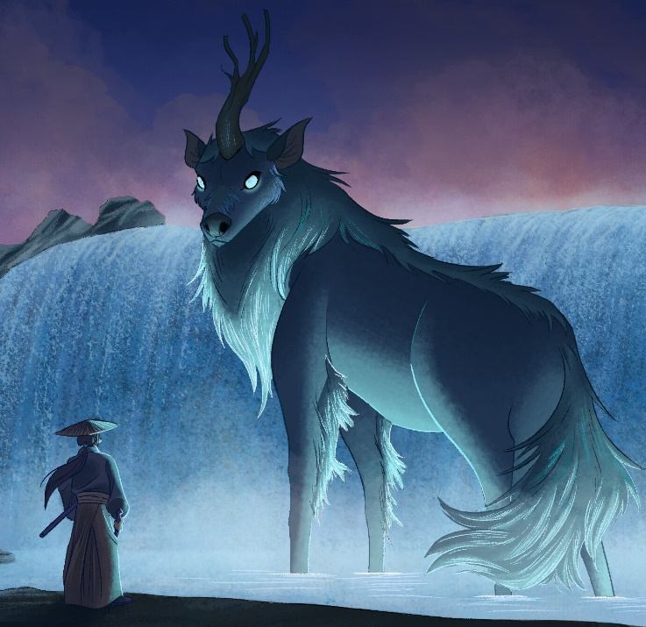
Type: Large Outsider (Air, Good)
Hit Dice: 12d8+60 hp (108 hp)
Initiative: +2 (Dex)
Speed: 60, 120 flying (good)
AC: 25 (-1 size, +2 Dex, +14 natural)
Attacks: 2 hooves +18 melee, 1 horn +18 melee
Damage: Hoof 2d4, horn 3d6
Face/Reach: 5 ft. by 10 ft./5 ft.
Special Attacks: Spells
Special Qualities: Spells, spell-like abilities, SR 29
Saves: Fortitude +13, Reflex +10, Will +15
Abilities: Str 25, Dex 15, Con 20, Int 20, Wis 25, Cha 19
Skills: Appraise +20, Concentration +25, Decipher Script +10, Diplomacy +14, Gather Information +19, Knowledge: Arcana +20, Knowledge: Planes +20, Scry +30, Sense Motive +27, Spellcraft +20. Spot +23
Feats: Empower Spell, Cleave (horn), Improved Critical (horn)

Climate/Terrain: Sky
Organization: Solitary
Climate/Terrain:
Organization:
Challenge Rating: 16
Treasure:
Alignment:
Advancement:
Treasure: Standard coins, standard goods, double art
Alignment: Always Lawful Good
Advancement: 9-15 HD (Huge)

Kir-rin are beautiful creatures native to the Celestial plane. They sometimes work for good-aligned deities in direct opposition to the forces of evil, other times they serve as protectors of large areas of the mortal world. They are regarded as harbingers of good fortune, and days when a ki-rin are sighted are considered blessed. When on the material plane, they roam the sky in search of good deeds to reward and malefactors to punish.

Ki-rin resemble horse-like deer covered in golden scales, thick gold manes and tails, pink-tinged gold cloven hooves, and large violet eyes. A single graceful, branched horn grows from the middle of their foreheads, similar to unicorns. They are large creatures, usually about 13 feet in length.

These creatures almost never set foot on ground; the females, if they exist (for none have been seen, nor have any young) never do. They occasionally build lairs on almost inaccessable mountain tops. These lairs are filled with creature comforts, often things that the ki-rin created itself through its magic. When they do land, it is usually in order to help good beings in times of dire trouble against evil. Although they will monitor the actions of very evil beings, ki-rin usually do not interfere unless they grow too powerful. They are omnivorous, and create all their own food using magic. Ki-rin speak their own language, and use telepathy to speak with other beings.

COMBAT
Ki-rin can strike with two hooves or with its powerful horn, which is considered a +3 magical weapon; the magic fades if removed from the body. Ki-rin are peaceful and will rarely attack except in the cause of good.

Spells: Ki-rin cast spells as if they were 18th-level sorcerers (save DC 11 + 4 Cha bonus + spell level).

Spell-Like Abilities: In addition to their spells, ki-rin can cast, at will, major creation, persistant image, create food and water, wind walk, gaseous form, control weather, plane shift (to the Astral, Ethereal, and Prime Material planes only), and call lightning, as 18th-level sorcerers.

Telepathy (Su): Ki-rin can speak to any intelligent, language-using being within 100 feet via telepathy. The also automatically pick up the conscious thoughts of intelligent beings within that range, making them very difficult to surprise.

Sample Spells (18th level sorcerer): (6/7/7/7/7/6/6/6/5):
0th -- Arcane Mark, Dancing Lights, Detect Magic, Disrupt Undead, Ghost Sound, Light, Mage Hand, Message, Read Magic.
1st -- Enlarge Person, Feather Fall, Magic Missile, Protection from Law, Ray of Enfeeblement.
2nd -- Obscure Object, Phantom Trap, Pyrotechnics, Resist Energy, Web.
3rd -- Explosive Runes, Magic Circle against Chaos, Ray of Exhaustion, Stinking Cloud.
4th -- Arcane Eye, Dimensional Anchor, Greater Invisibility, Shout.
5th -- Cloudkill, Dream, Magic Jar, Permanency.
6th -- Chain Lightning, Eyebite, Mass Suggestion.
7th -- Mage's Sword, Plane Shift, Statue.
8th -- Demand, Polymorph Any Object.

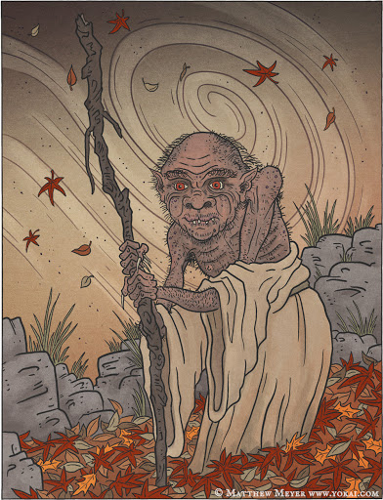
Momonjii
Type:
Hit Dice:
Initiative:
Speed:
AC:
Attacks / Damage:
Face/Reach:
Special Attacks:
Special Qualities:
Saves:
Abilities:
Skills:
Feats:
Climate/Terrain:
Organization:
Challenge Rating:
Treasure:
Alignment:
Advancement:
Notes: A Momonjii is an old-man who appears to travelers on the road and is waiting for you at every fork in the road. Most take no notice of him, even if they see him. But he only makes himself seen to those he chooses and appears to dispense advice and visions of one’s destiny.

Mu-onna
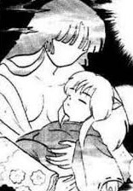
Hit Dice:
Initiative:
Speed:
AC:
Attacks / Damage:
Face/Reach:
Special Attacks:
Special Qualities:
Saves:
Abilities:
Skills:
Feats:
Climate/Terrain:
Organization:
Challenge Rating:
Treasure:
Alignment:
Advancement:
Notes: A Mu-onna is a vengeful spirit of a mother who lost her child to famine or war. She appears as a faceless woman. She protects children in danger, but may also try to merge or absorb them. They can look into the child's soul to find information while merging with them. To gather the information, or to merge with them, the Mu-onna must cast a spell to put the child's soul to sleep. Since the Mu-onna is made from a mother's tender feelings, she may be willing to allow herself to be destroyed for the sake of the child.

Ningyo
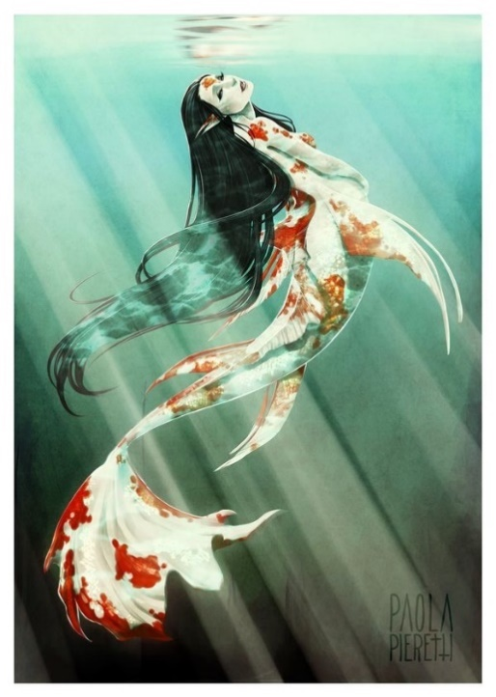
Type:
Hit Dice:
Initiative:
Speed:
AC:
Attacks / Damage:
Face/Reach:
Special Attacks:
Special Qualities:
Saves:
Abilities:
Skills:
Feats:
Climate/Terrain:
Organization:
Challenge Rating:
Treasure:
Alignment:
Advancement:
Notes: Ningyo are a special breed of merfolk who inhabit the eastern sea. They are shy and playful, but they are rumored to bring misfortune to those who drop their guard around them. They are fond of trinkets from humans and are notorious for stealing anything near shore or on a boat that isn’t carefully watched.

Nure-onna
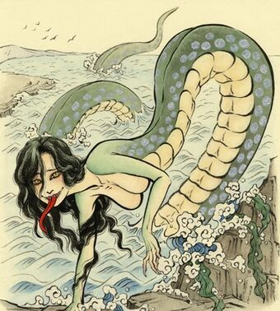
Type:
Hit Dice:
Initiative:
Speed:
AC:
Attacks / Damage:
Face/Reach:
Special Attacks:
Special Qualities:
Saves:
Abilities:
Skills:
Feats:
Climate/Terrain:
Organization:
Challenge Rating:
Treasure:
Alignment:
Advancement:
Notes: A Nure-onna is large serpent-like creatures with an upper body resembling that of an attractive woman and a lower torso of a giant snake. Nure-onna often appear on the banks of rivers and lakes, their upper body hovering above water to give the illusion of a young woman bathing.

Ōmukade
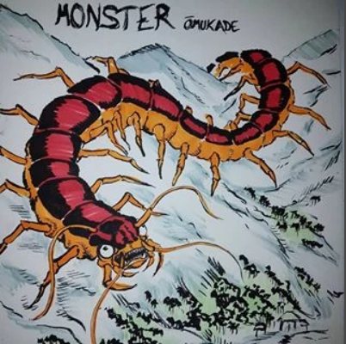
Type:
Hit Dice:
Initiative:
Speed:
AC:
Attacks / Damage:
Face/Reach:
Special Attacks:
Special Qualities:
Saves:
Abilities:
Skills:
Feats:
Climate/Terrain:
Organization:
Challenge Rating:
Treasure:
Alignment:
Advancement:
Notes: a giant, human-eating centipede that lives in the mountains as well as Yobuko, a mountain-dwelling spirit

Samebito
Type:
Hit Dice:
Initiative:
Speed:
AC:
Attacks / Damage:
Face/Reach:
Special Attacks:
Special Qualities:
Saves:
Abilities:
Skills:
Feats:
Climate/Terrain:
Organization:
Challenge Rating:
Treasure:
Alignment:
Advancement:
Notes: a shark-man from the undersea Dragon Palace which is rumored to lie somewhere to the north. Samebito is said to attack ships and plunder them for sport and occasionally wanders into the city to find a bride.

Shōjō
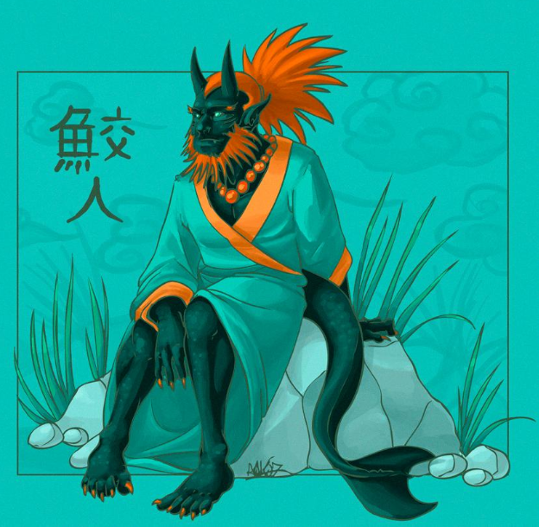
Type:
Hit Dice:
Initiative:
Speed:
AC:
Attacks / Damage:
Face/Reach:
Special Attacks:
Special Qualities:
Saves:
Abilities:
Skills:
Feats:
Climate/Terrain:
Organization:
Challenge Rating:
Treasure:
Alignment:
Advancement:
Notes: red-haired sea sprites who love rice wine and jewels. They are said to seduce sailors as well as take human form and visit the taverns at night.

Along the mountainous coasts of Japan lives a race of intelligent sea spirits known as shōjō. They look like man-sized apes, with long, shaggy red hair. Their faces are also reddish and blushed as if drunk. Shōjō are bipedal like humans, and occasionally wear clothes or skirts made of seaweed.

Behavior: Shōjō spend their lives drinking large quantities of alcohol and playing in the sea and sand of secluded beaches. They revel in drunken silliness, singing, dancing, and enjoying life. Despite their silly appearance and demeanor, they are said to be wise. Extremely fond of sake and other types of alcohol, they are excellent brewers themselves and can distil a powerful brine wine from seawater. The taste of the wine varies depending on the imbiber. If he is a good person, the wine will be delicious. However, if he is a wicked person it will taste like a foul poison. The wine may even kill him if he does not change his evil ways. ways.

Interactions: Shōjō can understand human languages and even parrot a number of words. They are curious and gentle towards friendly humans. Generally peaceful, shōjō keep to themselves, preferring to remain apart from the world of mankind. Occasionally there have been stories of groups of shōjō harassing sailors and ships which stray too close to their homes. These stories are rarely violent; usually the shōjō flee into the water after stealing a few barrels of sake.

Origin: The name shōjō is the Japanese version of the Chinese name for these ape-like spirit, xīng xīng. The name connotes liveliness, a fitting match for the personality of this creature. Due to the orangutan’s physical resemblance to this yōkai, the name shōjō is applied to that species of great ape in both Japan and China. Additionally, shōjō can be used to refer to a person who is a heavy drinker. The famous artist and yōkai painter Kawanabe Kyōsai jokingly referred to himself as a shōjō in this way.

Tsukumogami
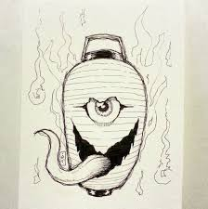
Type: Aberration (size varies)
Hit Dice: 7d8+12 (52 hp)
Initiative: +1 (Dex)
Speed: 10’
AC: 13 (-1 size, +1 Dex, +3 natural)
Attacks / Damage: Slam +8 melee; 1d8+6
Face/Reach: 5’ x 5’ / 10’
Special Attacks: Adhesive
Special Qualities: Mimic shape, acid immunity
Saves: Fort +5, Ref +3, Will +6
Abilities: Str 19, Dex 12, Con 17, Int 10, Wis 13, Cha 10
Skills: Climb +9, Disguise +12, Listen +11, Spot +6
Feats: Skill Focus (Disguise)
Climate/Terrain: Any land and underground
Organization: Solitary
Challenge Rating: 4
Treasure: 1/10th coins; 50% goods; 50% items
Alignment: Usually neutral
Advancement: 8-10 HD (Large); 11-21 HD (Huge)
Notes: refers to inanimate objects of ancient origin that become alive and self-aware

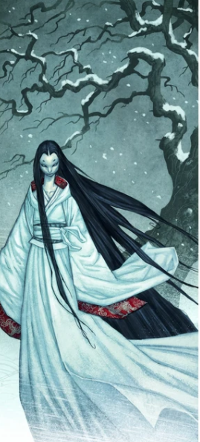
Yuki-Onna
Type: medium sized fey
Hit Dice: 143 (22d8 + 44)
Initiative:
Speed: 30’
AC: 16 (natural armor)
Attacks / Damage: Paralyzing Touch: Melee Weapon Attack: +7 to hit, reach 5 ft., one target, inflicts 2d6 + 4 cold damage.
Face/Reach: 5’ / 5’
Special Attacks: Freezing Body, Draining Kiss, Charm
Special Qualities: Magic resistance, innate spellcasting, Dark vision 60’, Immune to Cold attacks, Vulnerable to Fire damage, Resistance 5 from non-magical weapons
Saves: Fort +5/
Abilities: 12/18/15/12/16/18
Skills: Hide +10, Move Silently +10, Bluff +15
Feats:
Climate/Terrain: mountain regions, cold regions
Organization: solitary, sometimes seen in groups of three
Challenge Rating: 8
Treasure:
Alignment: chaotic neutral
Advancement:
Notes: Yuki onna resemble beautiful human females. They have an otherworldly beauty, with long black hair and dark, piercing eyes. Their skin is ageless and as white as snow, but their bodies are as cold as ice. They always wear robes as white as snow that are in constant motion, moving around them even when there is no breeze.

Personality
Yuki onna despise and loathe all humans and anything that involves them. While they are killers, Yuki onna are not entirely cold blooded. Legends tell of rare cases where one falls in love with their intended prey and lets them go free. Some go so far as to marry humans and live happily together. As supernatural spirits never age, however, their husbands inevitably discover their true identities. This revelation usually ends these happy marriages.

Biology
All Yuki onna are female and live very long lives. When one nears the end of her life, she enters into a state similar to temporal stasis. Gradually turning into solid ice, her body breaks into two or three large pieces, each piece becoming a new yuki-on-na. If a Yuki onna is encountered while in stasis, and struck with a weapon, her body disintegrates into ice crystals; this prevents new Yuki onna from being created. Yuki onna are obligate carnivores, eating only flesh and bones. Their favorite meal is the meat from a freshly killed human.

Combat
Yuki onna attack any humans that venture into their territory. They wait until the weather conditions are ideal for an ambush. Under the cover of a blizzard, they are virtually invisible thanks to the camouflaging effect of their white robes against the swirling snow. If their victim makes eye contact with a yuki-on-na, they became temporarily paralyzed. They do not use weapons, instead inflicting damage by simply touching their victim. A mere touch is enough to give a human a deep, unshakable chill. They feed on life force, sucking it from human’s mouths with an icy breath that freezes their victims solid. Yuki-onna make their lairs near roads and trade routes, waiting for travelers to pass by. They will stalk travelers and caravans for days, singling out targets to lure away from the group. Only then, when a suitable opportunity presents itself, will she whip up a blizzard and move in for the kill.

Abilities
Yuki onna have the innate ability to duplicate the effects of disguise, comprehend languages, ESP, and know history spells at will. Once a day, the touch of a Yuki onna causes her victim to become completely disorientated for up to eighteen hours, unable to remember the direction they were heading or how to return along their path. Yuki onna are immune to the cold and cold-based spells but vulnerable to fire and fire-based spells.

Society
Yuki onna were normally solitary creatures but groups of up to three individuals have been sighted temporarily living and hunting together, usually after they are freshly created. Yuki onna do not collect or hoard treasure.

Homelands
Yuki onna lived in the cold, arctic regions of Sakura, although most of them have been spotted in the Domaru Mountains. They make their lairs within mountain caves or valleys filled with evergreens. Their territory extends only a few miles around their lair, they rarely if ever travel beyond their territory.
Outside of Sakura, they are known to occasionally be found in the Ryuluun Mountains of Xiandai.

Innate Spellcasting. The yuki-onna’s innate spellcasting ability is Charisma (spell save DC 15, +7 to hit with spell attacks). The yuki-onna can innately cast the following spells, requiring no material components:

At will: dancing lights, fog cloud, gust of wind, ray of frost
3/day each: misty step, sleet storm, wind wall
1/day each: cone of cold, control weather, ice storm

Magic Resistance: The yuki-onna has advantage on saving throws against spells and other magical effects.

Freezing Body: A creature that touches the yuki-onna or hits it with a melee attack while within 5 feet of it takes 11 (2d10) cold damage.

ACTIONS
Paralyzing Touch: Melee Weapon Attack: +7 to hit, reach 5 ft., one target, inflicts 2d6 + 4 cold damage. The target must succeed on a DC 15 Constitution saving throw or be paralyzed for 1 minute. An affected creature can repeat the saving throw at the end of

Charm: The yuki onna targets one humanoid it can see within 30 feet of it. If the target can see the yuki-onna, it must succeed on a DC 15 Wisdom saving throw or be magically charmed for 24 hours. The charmed target sees the yuki-onna as a close friend or lover and will obey the yuki-onna’s verbal commands. If the target suffers any harm or receives a suicidal command, it can repeat the saving throw, ending the effect on a success. If the target successfully saves against the effect, or the effect on it ends, the target is immune to this yuki-onna’s Charm for the next 24 hours. The yuki-onna can have only one target charmed at a time. If it charms another, the effect on the previous target ends.

Draining Kiss: The yuki onna kisses a creature charmed by it or a willing creature. The target must make a DC 15 Constitution saving throw against this magic, taking 5d10 damage on a failed save, or half as much damage on a successful one. For every five points drained, the Yuki Onna gains one hit point.

Jubokko (vampiric trees)
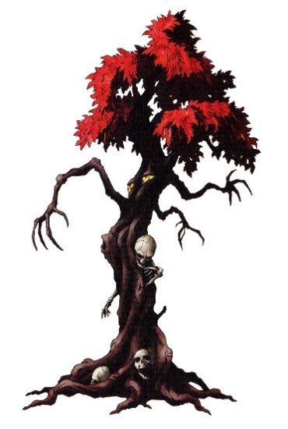
Type: large plant
Hit Dice:
Initiative:
Speed:
AC:
Attacks / Damage:
Face/Reach:
Special Attacks:
Special Qualities:
Saves:
Abilities:
Skills:
Feats:
Climate/Terrain:
Organization:
Challenge Rating:
Treasure:
Alignment:
Advancement:
Notes:

See also: Akateko - red hand dangling from a tree
Bashonosei - banana tree spirit
Jinmenju (tree with human-faced fruits)

Kijimuna
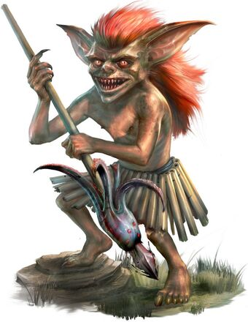
Type: small fey
Hit Dice:
Initiative:
Speed:
AC:
Attacks / Damage:
Face/Reach:
Special Attacks:
Special Qualities:
Saves:
Abilities:
Skills:
Feats:
Climate/Terrain:
Organization:
Challenge Rating:
Treasure:
Alignment:
Advancement:
Notes: tree sprites that resemble red-headed small children

Kijimunā are fey creature that makes their homes in the banyan trees. Physically, kijimunā are about the same height as a child, with wild and thick bright red hair, and red tinted skin. They wear skirts made of grass, and move about by hopping rather than walking. Although kijimunā retain the appearance of child-like youthfulness into their adulthood.

Behavior: The kijimunā lifestyle mimics humans in many ways. They fish along the shores, live in family units, get married, and raise children in much the same way as the native islanders. On rare occasions, they marry into human families. The kijimunā diet consists entirely of seafood and they are excellent fishermen. They particularly love fish heads and fish eyes. Sailors attribute eyeless corpses of fish found on beaches to picky kijimunā.

Kijimunā have a number of peculiar fears and prejudices. They loathe chickens and cooking pots. They are extremely put off by people passing gas. However, the thing they hate above all else is the octopus. They avoid octopuses at all costs, despising them and fearing them at the same time.

Interactions: Kijimunā often help fishermen catch fish, or aid humans in other ways in return for a cooked meal. When they form friendships with humans, it can last for a lifetime. Kijimunā will often return to their human friends many times, even spending holidays with their adopted family.

Unprovoked kijimunā attacks on humans are rare. Cutting down the banyan tree in which they live is a sure way to earn their wrath. Kijimunā thus wronged have been known to murder livestock, sabotage boats so they sink while their owners are far out at sea, or magically trap people in hollow trees from which they cannot escape. Sometimes they press down on peoples’ chests while they sleep, or snuff out lights during the night. Once earned, the enmity of a kijimunā can never be assuaged.

Kodama

Type: Tiny Fey
Hit Dice: 1/2 d6 +1 (2 hp)
Initiative: +4 (Dex)
Speed: 20’
AC: 18 (+2 size, +4 Dex, +2 natural)
Attacks / Damage:
Face/Reach: 2 ½ ft. x 2 ½ ft. / 0 ft.
Special Attacks: spell-like abilities
Special Qualities: symbiosis
Saves: +1/+6/+6
Abilities: 5/18/13/10/18/14
Skills: Hide +16, Listen +7, Move Silently +8, Wilderness Lore +10
Feats: Alertness, Dodge, Improved Initiative
Climate/Terrain: Temperate and warm forest
Organization: Gang (2-4), band (6-11), or tribe (20-80)
Challenge Rating: 1
Treasure: no coins, 50% goods, 50% items
Alignment: always neutral good
Advancement: 1-3 HD (tiny)
Notes: Deep in the mountainous forests of Sakura, the souls of the trees are animated as spirits called kodama. These souls wander outside of their hosts, tending to their groves and maintaining the balance of nature. Kodama are rarely ever seen, but are often heard—particularly as echoes that take just a little longer to return than they should. When they do appear, they resemble faint orbs of light in the distance; or occasionally a tiny, funny shaped vaguely humanoid figure. A kodama’s life force is directly tied to the tree it inhabits; if either the tree or the kodama dies, the other cannot live.

Interactions: Kodama are revered as gods of the trees and protectors of the forests. They bless the lands around their forest with vitality, and villagers who find a kodama-inhabited tree honor it by marking it with a sacred rope known as a shimenawa. Occasionally, very old trees will bleed when cut, and this is regarded as a sign that a kodama is living inside. Cutting down such an ancient tree is a grave sin, and can bring down a powerful curse, causing a prosperous community to fall into ruin.

Spell-like Abilities: Kodama can communicate with plants at will (as speak with plants). They can also, at will, step inside any tree and use dimension door as cast by a 7th level sorcerer to reach their home tree. A Kodama can use charm person three times per day, as cast by a 4th-level sorcerer; targets must succeed at a Will save DC15 or be charmed for four hours.

Symbiosis: Each Kodama is mystically bound to a single tree and must never stray more than 300 yards from it. Any who do become ill and die within 4d6 hours. A kodama’s tree does not radiate magic.

Tsurube-otoshi

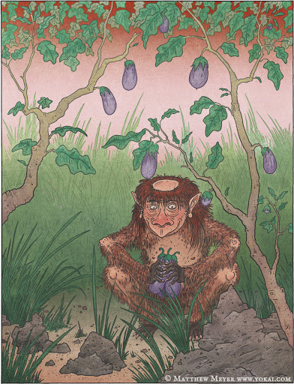
monster that drops from trees to attack and eat them
Type:
Hit Dice:
Initiative:
Speed:
AC:
Attacks / Damage:
Face/Reach:
Special Attacks:
Special Qualities:
Saves:
Abilities:
Skills:
Feats:
Climate/Terrain:
Organization:
Challenge Rating:
Treasure:
Alignment:
Advancement:
Notes:

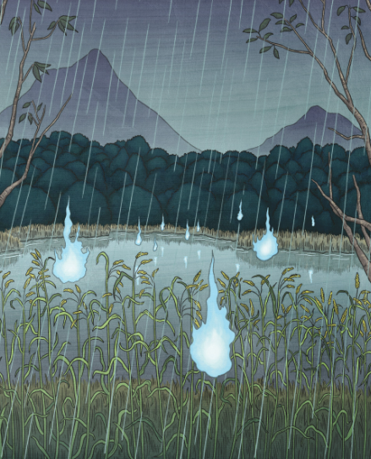
Onibi
Type: Small Aberration (Fire)
Hit Dice: 9d8 (40)
Initiative: +13 (+9 Dex, +4 Improved Initiative)
Speed: Fly 50’ (perfect)
AC: 29 (+1 size, +9 Dex, +9 deflection)
Attacks / Damage: Fire +16 melee (2d8 damage)
Face/Reach: 5’ / 5’
Special Attacks: Energy drain +16 melee
Special Qualities: Spell immunity, Natural invisibility
Saves: +3/+12/+9
Abilities: -/29/10/15/16/12
Skills: Bluff +11, Listen +17, Search +14, Spot +17
Feats: Alertness, Blind Fighting, Dodge, Improved Initiative
Climate/Terrain: grasslands, forests, watersides, graveyards
Organization:
Challenge Rating: 6
Treasure:
Alignment: Always chaotic evil
Advancement: 10-18 HD (small)
Notes: One of the more dangerous types of fire ball yōkai, onibi are a beautiful, but deadly phenomenon. Their name means “demon fire,” and they certainly earn that moniker. They look like small balls of flame, usually blue or blue-white (red and yellow onibi are less common), and appear in groups of twenty to thirty orbs. The orbs can range in size from three to thirty centimeters, and usually float around at eye-level. They appear in places surrounded by nature—most often during the spring and summer months, and particularly on rainy days.

See also: Shiranui aka Kaika (mysterious fire) aka Oyabi (fireball) - a mysterious flame seen over the seas near Jurojin. It has been at times thought a portent of great evil, an ill omen, a harbinger of famine and war. At other times, sailors say it is the guiding light that has brought them back to shore in dimmest light or through storms. Shiranui were thought to be manifestations of the lanterns created by Ryūjin, the dragon god of the sea.

Onibi are found all over Sakura. In some areas, they manifest the faces and even voices of the victims whose life force they have drained. Sometimes onibi are said to take the shape of a small bird.

Onibi do not create much heat, but the orbs possess a different danger. Living creatures that draw too close are swarmed by dozens of orbs, which drain away the life force from their victims. Soon nothing is left but a dead husk on the ground. During the night, onibi are often mistaken for distant lanterns, and people have vanished into the forests chasing after these phantom lights. Travelers should take care not to be led off their paths to their deaths by demon fire.

Onibi are born out of the dead bodies of humans and animals. It is not known what causes onibi to develop; sometimes they appear and sometimes they do not. Intense grudges and malice are also able to create onibi.

Combat:
Energy Drain (Su): Living creatures hit by an inobi’s touch attack receive one negative level. The Fortitude Save to remove the negative level has a DC of 14.
Spell Immunity (Ex): The only spells that can affect inobi are magic circle against chaos, magic circle against evil, magic missile, maze, protection from chaos, and protection from evil.
Natural Invisibility (Ex): A startled or frightened inobi can extinguish its glow, effectively becoming invisible as the spell.

Orochi
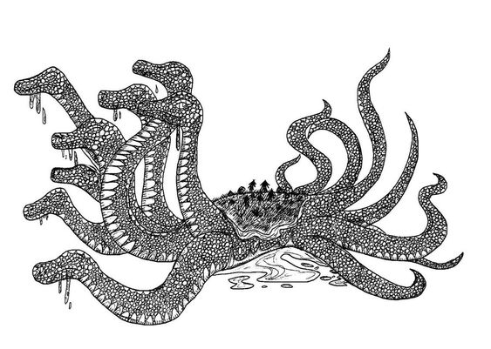
Type:
Hit Dice:
Initiative:
Speed:
AC:
Attacks / Damage:
Face/Reach:
Special Attacks:
Special Qualities:
Saves:
Abilities:
Skills:
Feats:
Climate/Terrain:
Organization:
Challenge Rating:
Treasure:
Alignment:
Advancement:
Notes: eight-headed and eight-tailed sea serpent
Nukekubi

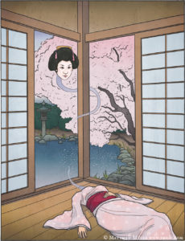
Type: Medium cursed humanoid, lawful evil
Hit Dice: (body) 20 (head) 40 (11d8+11 HP)
Initiative: +3
Speed: (body) 30’ (head: fly 40’)
AC: (body) 13 (head) 17
Attacks / Damage:
Face/Reach: 5’ / 5’
Special Attacks: gaze attack (charm), blood drain
Special Qualities: detachable flying head
Saves: Fort +, Ref +, Will +
Abilities: STR 10 (+0), DEX 16 (+3), CON 12 (+1), INT 11 (+0), WIS 10 (+0), CHA 16 (+3)
Skills: Perception +3, Stealth +6
Feats:
Climate/Terrain: civilized areas
Organization: solitary
Challenge Rating: 5
Treasure: standard
Alignment: lawful evil
Advancement:
Notes:
Rokurokubi and Nukekubi
Rokurokubi are yokai that appear as a normal human woman, but whose necks can stretch to as long as ten to twenty feet. Nukekubi are yokai similar to rokurokubi but whose heads can detach from their bodies. Both have a gaze attack that can enthrall a victim and both drink blood, an attack that drains life levels from the victim.

A Nukekubi can detach their heads as a free action, with the body and head moving independently each turn on the creature’s initiative roll. Each part of the creature has its own hit points and abilities. If the hit points of the head are reduced to zero, the head and body die. Slaying the body will have no effect on the head, which will live on and later become an evil spirit on its own.

Gaze Attack: As a free action a Nukekubi can perform a gaze attack. Anyone facing the creature within 30 feet must make a Will save DC 20 or be under the command of the Nukekubi. A successful saving throw negates the effect. Afflicted characters may perform a saving throw each turn to free themselves of the effects. Opponents can avoid the need to make the saving throw by not looking at the creature. Creatures under the thrall of the Nukekubi will be controlled by her as a free action, performing whatever actions she deems fit to ensure her survival.

Blood Drain: The head of the Nukekubi can produce fangs, which inflict a terrible bite. On a successful bite attack from the head, the creature performs a grapple check as a free action. On a successful grapple, the head inflicts an additional 1d8 hit points damage and causes the victim to perform a CON save vs DC 15 or lose a life level. Life levels may be restored over time with rest or the lesser restoration spell.

Monster Name

Type:
Hit Dice: ( HP)
Initiative:
Speed:
AC:
Attacks / Damage:
Face/Reach:
Special Attacks:
Special Qualities:
Saves: Fort +, Ref +, Will +
Abilities:
Skills:
Feats:
Climate/Terrain:
Organization:
Challenge Rating:
Treasure:
Alignment:
Advancement:
Notes:

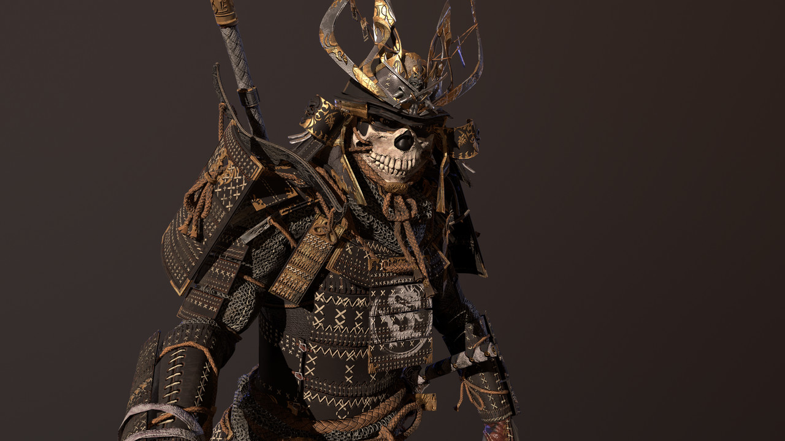

Other Races
Elves
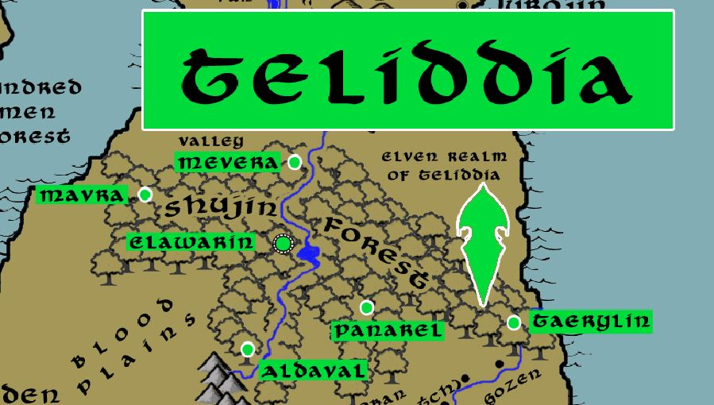

Dwarves
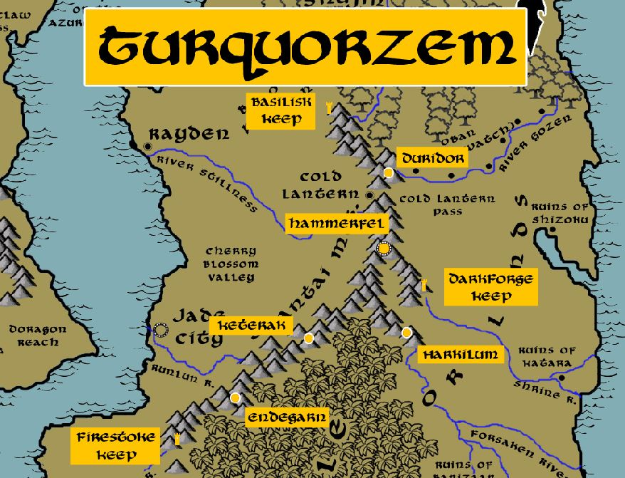

Magical Items

The gem of Ōku-no-kao (Many Faces) – an ancient artifact, this rainbow-colored gem can create duplicates of whomever bathes in its light. The duplicates retain the memories and personality of the original creature, who can then see and hear everything the duplicates see and hear. Also, once per day the original creature can will itself to switch places with any one of the duplicates. The unfortunate side effect of this gem is that within one year of the spell the duplicates all assert that they have sole right to the identity and will begin warring with one another until only one remains.

The Ten Chimes of Heaven – These are ten divinely powered chimes made of pure silver. Each chime, when struck, invokes the heavenly power of Amaterasu. Used together, they create an overwhelming aura of good that is powerful enough it banished the evil demon Satsujin in the Ancient Ages. The ten chimes were divided up among the nine monasteries of good alignment, with the tenth enshrined in the Temple of Amaterasu in Jurojin.

The Eyes of Satsujin – These bright red glowing spheres float and travel at high speed as commanded by whoever masters them. They were created by the demon Satsujin during the Dark Reign of the White Millstone in the Third Ancient Age. Satsujin sent them to every corner of Sakura to monitor his enemies and to project a powerful aura of fear to any who gazed upon them. After Satsujin was banished, most of the eyes were captured and destroyed. However, a few were left unaccounted for. It is rumored that they exist to this day and serve either a demon in the underworld or an evil sorcerer.

Legendary Weapons

Ame no Nuhoko - bejeweled spear (naginata) used by the creation gods Izanagi and Izanami to carve out the lands of Sakura from the sea

Totsuka no Tsurugi - Sword of Ten Hand-breadths - not a specific weapon, it is a class of immense ancient swords wielded by the gods

Ame no Ohabari – divine sword wielded by the god Izanami, who used it to kill his son Kagu-tsuchi for causing the death of Izanami during childbirth. Kagu-tsuchi was cut into eight pieces, which became eight volcanoes. He became the god of destructive fire and is worshipped by blacksmiths. The blood from the blade created a number of deities, including the sea god Watatsumi and rain god Kuraokami.
Futsunomitama - the divine sword of the storm god Takemikazuchi

Kusanagi no Tsurugi - "Grass-Cutting Sword" - mythical blade found within the Orochi serpent after the storm god Susanoo no Mikoto slew the monster, it chipped the god's sword as he did so. Susanoo gifted the blade to his sister, Amaterasu. It is now the hereditary sword of the lord protector of the town of Jurojin. Originally known as the Ame-no-Murakumo-no-Tsurugi, "Heavenly Sword of Gathering Clouds"

Ame no Makakoyumi - heavenly bow of Wakahiko, who was dispatched by the gods to slay a rebellious earth god but instead fired the bow at his masters after falling in love with a princess of that realm; the arrow was redirected back and Wakahiko and killed him

Kogarasumaru - the oldest and most powerful samurai blade, it was a tachi blade gifted to the first samurai by Yatagarasu, the divine three-legged crow of the sun

Kogitsunemaru - "Small Fox" blade; forged with the help of the Kitsune

Onimaru Kunitsuna - one of the five legendary blades of Japan; it appears in the dreams of heroes tormented by nightmares of Oni demons; it will appear as an old man in the dream, claiming it has gone rusty from the filth of human hands and must be cleaned; the warrior must then engage in a series of battles with the rusted blade, slowly purging it and himself of impurities, until the blade reaches its full power; it is a slayer of Oni demons and can, on command, attack an Oni on its own

Onikiri - "Demon Slayer" - it is a vorpal sword against demons and infernal creatures

Dōjikiri Yasutsuna - "Ogre Slasher"

Kaminari – the Lightning Sword, once wielded by the Tengu Toguru when he the paladins of the Order of the Tiger and the monks of the Suijin monastery (370 WA4). It is a terrible weapon, projecting lightning bolts as it strikes and affecting metal items as if it were a magnet.

Muramasa - cursed katana, forged by the sword master Muramasa Sengo in the Primordial Ages, it was imbued with a hidden enchantment that it would prove tragic to its wielder if misused; after many warlords abused the power of the blade to inflict cruelty on the land the sword permanently became cursed

Samurai Armor of Itakura Aritsune
The armor is made up of twelve pieces. Not every little piece affects the armor’s AC, but having all pieces together does affect the magical properties imbued upon the armor as a whole.
Aritsune's armor is O-Yoroi style armor, which is the heaviest form of samurai armor and meant for mounted combat. It is the equivalent of full plate armor, granting +8 to AC but with the corresponding limited movement and ability check penalties on it.
In addition, the armor has magical properties when worn complete:

Aura of Good (always on)

Magical Properties
Once per day you can activate the following spells as a 5th level caster
- Protection from Chaos
- Light (emanates from the armor)
- Bless
- Resistance
- Magic Circle against Chaos
- Heal Mount
- Mark of Justice
Imprinting - Once and only once, upon receiving the armor, the wearer may enter a trance and modify the cosmetic look of the armor to suit their vision of lordship over a house. The color of the lamellar plates, the laces that bind them together, any material that trims the armor, even the emblems marking the outside of the armor all transform to the liking of the new owner. In addition, a Sashimono, or small regimental flag, will appear mounted to the back of the armor on command. The color and design of the banner must be chosen at the time of the armor's transformation. Any character with Knowledge (Nobility) can perform a check to recognize the original armor. But for most people the armor appears unique and new.

Sword of Itakura (Magical weapon)
+3 to ATK/DMG
DMG: 1d10 +3 while two-handing
Crit: 19-20 x2
Special: Luck Blade or Fire (Flame) Blade: Pick between extra 1d6 fire damage or rerolling a roll. You must pick the most recent roll if you choose luck. The blade also grants a luck bonus +1 to all saving throws.

The sword contains a powerful spirit of law within it. If the owner were to spend time anointing the blade during a nightly cleaning, he/she would form a bond with the blade and learn more about its nature. The sword contains powerful magic akin to wishes within the blade, but the owner must spend time divining what the sword requires to activate them.

Two rituals must be performed daily on the sword
Chiburi: for any noble sword after bloodying it: a circular movement is performed with the sword with intention to gather blood on the edge of the sword. Then it is hit with the fist to shake off the blood drops. If this move is not performed (the blood is not removed) the blood could glue the sword in the sheath.
Nightly cleaning: this is done with holy water, dried, then a small Uchiko ball is tapped against the blade to release a fine powder to keep the sword from rusting

NPC Templates
Equipment typical to Sakura adventurers
- Tanto (Dagger) 1d4 / 19-20
- Wakizashi (Short Sword) 1d6 / 19-20
- Katana (Longsword) 1d10 / 19-20
- Nodachi (Greatsword) 2d6 / 19-20
- Yari (Spear) 1d8 / x3
- Bo (Quarterstaff) 1d6/1d6 x2
- Ono (Handaxe) 1d6 / x3
- Yawara (Sap) 1d6 / x3
- Masakari (Battleaxe) 1d8 / x3
- Kanabo (War Club) 1d10 / x2
- Tetsubo (Heavy Mace) 1d8 / x2
- Kama 1d6 / x2
- Nunchaku 1d6 / x2
- Sai 1d4 / x2
- Siangham 1d6 / x2
- Naginata (Glaive) 1d10 / x3
- Daikyu (Longbow) 1d8 / x3
- Hankyu (Shortbow) 1d6 / x3
- Daikyu (Longbow, composite) 1d8 / x3
- Hankyu (Shortbow, composite) 1d6 / x3
- Padded Armor +1 AC
- Haramaki (Leather Armor) +2 AC
- Studded Haramaki (Leather Armor) +3
- Kusari Katabira (Chain Shirt) +4 AC
- Kusari Gusoku (Chainmail) +5
- Karuta-style (Scale Mail) +4 AC
- Domaru (Half Plate) +7 AC
- O-Yoroi (Full Plate) +8 AC

Skills: Appraise, Balance, Concentration, Craft (household goods), Craft (Bow), Craft (Leather Armor), Craft (Sword), Knowledge (nature), Knowledge (religion), Listen, Move Silently, Perform (ceremony), Perform (sing), Profession (any), Ride, Search, Spot

Feats: varies

Special: Craft (fine household goods) +5, Concentration +5

NPC’s start with 70 points to use on ability scores

Sakuran Barbarian – Level 1
male human (5 ft., 9 in. tall)
HD 1d12+2; hp 14
Init +3 (+3 Dex)
Spd 30 ft.
AC 16 (+3 Dex)
Attack +5 melee or +4 ranged
SV Fort +5, Ref +2, Will +2
Str 13 (+1), Dex 14 (+2), Con 14 (+2), Int 10 (+0), Wis 10 (+0), Cha 9 (-1)

Skills (20 sp): Balance +3, Climb +5, Jump +4, Listen +3, Ride +3, Spot +4, Swim +2

Feats: Great Fortitude (+2 to Fort Saves), Iron Will (+2 to Will Saves)

Class Traits: Fast movement, illiteracy, rage 1/day

Special: Craft (fine household goods) +5, Concentration +5

Possessions: Greatclub, Dagger, Daikyu Longbow, Throwing Axe, Hide Armor, Water Skin, Bedroll, Blanket, Fishhook, Flint and steel, Belt pouch, Whetstone, Trail Rations (10 days)

Sakuran Bard – Level 1
HD 1d6+0; hp 6
Init +1 (+1 Dex)
Spd 30 ft.
AC 14 (+1 Dex)
Attack +0 melee or +1 ranged
SV Fort +0, Ref +3, Will +2
Str 10 (+0) , Dex 12 (+1), Con 10 (+0), Int 14 (+2), Wis 10 (+0), Cha 14 (+2)

Skills (45 sp): Balance +1, Climb +0, Hide+1, Jump +2, Knowledge (Religion) +7, Knowledge (Geography) +7, Listen +0, Move Silently +1, Perform (dance) +7, Perform (sing) +7, Ride +1, Search +3, Spot +3, Swim +0, Tumble +1, Bluff +9, Decipher Script +2, Diplomacy +9, Gather Information +7, Sense Motive +3, Sleight of Hand +1, Use Magic Device +7, Intimidate +4

Feats: Negotiator (+2 on Diplomacy and Sense Motive checks), Persuasive (+2 on Bluff and Intimidate checks)

Class Traits: Bardic music, bardic knowledge, countersong, fascinate, inspire courage +1

Special: Craft (fine household goods) +5, Concentration +5

Possessions: Dagger, Wakizashi Short Sword 1d6, Hand Axe, Daikyu Short Bow, Hide Armor, Water Skin, Bedroll, Blanket, Fishhook, Flint and steel, Belt pouch, Whetstone, Trail Rations (10 days)

Spells: 0-level: 2 – Dancing Lights, Prestidigitation

Sakuran Cleric – Level 1
HD 1d8+0; hp 8
Init +0 (+0 Dex)
Spd 30 ft.
AC 13 (+0 Dex)
Attack +2 melee or +0 ranged
SV Fort +2, Ref +0, Will +4
Str 14 (+2), Dex 10 (+0), Con 10 (+0), Int 10 (+0), Wis 16 (+3), Cha 10 (+0)

Skills (12 sp): Heal +7, Knowledge: Religion +5, Use Magic Device +3, Perform (Sing) +4

Feats: Self Sufficient (+2 on Heal and Survival checks), Iron Will (+2 to Will Saves)

Class Traits: Turn or rebuke undead

Special: Craft (fine household goods) +5, Concentration +5

Possessions: Dagger 1d4, Quarterstaff 1d6/1d6, Hide Armor +3, Healer’s Kit, Holy Water, Holy Symbol, Water Skin, Bedroll, Blanket, Fishhook, Flint and steel, Belt pouch, Whetstone, Trail Rations (10 days)

Spells: (0 level) 3, (1st level) 2 + 1 domain spell (Animal Domain: Calm Animal)

e.g. 0-level: cure minor wounds, guidance, inflict minor wounds, resistance, virtue
e.g. 1st-level: bane, bless, cause fear, command, cure light wounds, divine favor, entropic shield, magic weapon, obscuring mist, protection from chaos/evil/good/law, shield of faith, summon monster I

Sakuran Druid – level 1
HD 1d8+1; hp 9
Init +2 (+2 Dex)
Spd 30 ft.
AC 16 (+2 Dex)
Attack +0 melee or +2 ranged
SV Fort +3, Ref +2, Will +4
Str 10 (+0), Dex 14 (+2), Con 12 (+1), Int 10 (+0), Wis 14 (+2), Cha 10 (+0)

Skills (20 sp): Balance +2, Climb +0, Craft (Bow) +0, Craft (Spear) +0, Craft (Leather Armor) +0, Craft (Axe) +0, Handle Animal +5, Heal +7, Hide +2, Jump +0, Listen +2, Move Silently +2, Ride +2, Search +3, Spot +2, Swim +3, Tumble +2

Feats: Track, Self-sufficient (+2 on Heal and Survival checks)

Class Traits: Animal companion, nature sense, wild empathy

Special: Knowledge (Nature) +5, Survival +9

Possessions: Bone Dagger, Quarterstaff, Bone Hand Axe, Wooden shield (light) +1, Daikyu Longbow, Hide Armor, Water Skin, Bedroll, Blanket, Fishhook, Flint and steel, Belt pouch, Whetstone, Trail Rations (10 days)

Spells: (0 level) 3, (1st level) 2
e.g. 0-level flare, guidance, resistance, virtue
e.g. 1st-level : cure light wounds, entangle, obscuring mist, produce flame , summon nature’s ally, shillelagh

Sakuran Fighter – level 1
HD 1d10+1; hp 11
Init +2 (+2 Dex)
Spd 30 ft.
AC 17 (+2 Dex)
Attack +3 melee or +3 ranged
SV Fort +3, Ref +2, Will +0
Str 14 (+2), Dex 14 (+2), Con 12 (+1), Int 10 (+0), Wis 10 (+0), Cha 10 (+0)

Skills (12 sp): Balance +2, Climb +4, Jump +2, Listen +2, Move Silently +4, Ride +2, Search +0, Spot +2, Swim +4, Tumble+4

Feats: Point Blank Shot (+1 within 30 feet), Rapid Shot (one extra ranged attack each round), Weapon Focus on Longbow (+1 ATK with Longbow)

Class Traits: Bonus feat

Special: Craft (fine household goods) +5, Concentration +5

Possessions: Longspear 1d8, Spear 1d8, Tanto Dagger 1d4, Wakizashi Short Sword 1d6, Katana Longsword 1d8, Daikyu Longbow composite +2, Studded Leather Armor +3, Heavy Wooden Shield +2, Water Skin, Bedroll, Blanket, Fishhook, Flint and steel, Belt pouch, Whetstone, Trail Rations (10 days)

Sakuran Monk – Level 1
HD 1d8+0; hp 8
Init +2 (+2 Dex)
Spd 30 ft.
AC X (+2 Dex)
Attack +1 melee or +2 ranged
SV Fort +2, Ref +4, Will +4
Str 12 (+1), Dex 14 (+2), Con 10 (+0), Int 10 (+0), Wis 14 (+2), Cha 10 (+0)

Skills (20 sp): Balance +7, Climb +1, Escape Artist +2, Handle Animal +2, Heal +2, Hide +2, Jump +8, Knowledge (religion) +0, Listen +7, Move Silently +2, Ride +2, Search +0, Sense Motive +2, Spot +2, Swim +1, Tumble +7

Feats: Improved Unarmed Strike, Improved Grapple (+4 grapple, no attacks of opportunity), Deflect Arrows

Class Traits: Bonus feat, flurry of blows (-2/-2), unarmed strike 1d6

Special: Craft (fine household goods) +5, Concentration +5

Possessions: Quarterstaff 1d6/1d6, Water Skin, Bedroll, Blanket, Fishhook, Flint and steel, Belt pouch, Whetstone, Trail Rations (10 days)

Sakuran Paladin – Level 1
HD 1d10+0; hp 13
Init +0 (+0 Dex)
Spd 30 ft.
AC 14 (+0 Dex)
Attack +2 melee or +1 ranged
SV Fort +2, Ref +0, Will +2
Str 12 (+1), Dex 10 (+0), Con 10 (+0), Int 10 (+0), Wis 14 (+2), Cha 14 (+2)

Skills (12 sp): Balance +0, Climb +1, Handle Animal +2, Jump +1, Knowledge (religion) +5, Listen +2, Move Silently +0, Ride +7, Search +0, Spot +2, , Swim +1, Tumble +0

Feats: Toughness (+3 to HP), Weapon Focus: Battleaxe (+1 to ATK with Battleaxe)

Class Traits: Aura of good, detect evil, smith evil 1/day

Special: Craft (fine household goods) +5, Concentration +5

Possessions: Longspear , Tanto Dagger 1d4, Wakizashi Short Sword 1d6, Katana Longsword 1d8, Daikyu Longbow composite +1, Karuta-style Scale Mail Armor +4, Horse, Water Skin, Bedroll, Blanket, Fishhook, Flint and steel, Belt pouch, Whetstone, Trail Rations (10 days)

Spells: None

Sakuran Ranger – Level 1
HD 1d8+; hp 8
Init +2 (+2 Dex)
Spd 30 ft.
AC 15 (+2 Dex)
Attack +2 melee or +3 ranged
SV Fort +2, Ref +4, Will +2
Str 12 (+1), Dex 14 (+2), Con 10 (+0), Int 10 (+0), Wis 14 (+2), Cha 10 (+0)

Skills (28 sp): Balance +3, Climb +5, Craft (Bow) +2, Craft (Spear) +1, Handle Animal +6, Heal +2, Hide +2, Jump +2, Listen +7, Move Silently +3, Ride +7, Search +0, Spot +2, Swim +3, Tumble +2

Feats: Track, Weapon Focus: Longbow (+1 to ATK with Longbow)

Class Traits: First Favored Enemy, Track, Wild Empathy

Special: Craft (fine household goods) +5, Concentration +5

Possessions: Spear, Tanto Dagger 1d4, Katana Longsword 1d8, Daikyu Longbow composite +1, Hand Axe, Studded Leather Armor +3, Water Skin, Bedroll, Blanket, Fishhook, Flint and steel, Belt pouch, Whetstone, Trail Rations (10 days)

Sakuran Rogue – Level 1
HD 1d6+0; hp 6
Init +3 (+3 Dex)
Spd 30 ft.
AC 15 (+3 Dex)
Attack +1 melee or +3 ranged
SV Fort +0, Ref +5, Will +0
Str 12 (+1), Dex 16 (+3), Con 10 (+0), Int 12 (+1), Wis 10 (+0), Cha 10 (+0)

Skills (40 sp): Appraise +3, Balance +4, Bluff +4, Climb +5, Disable Device +3, Escape Artist +4, Forgery +4, Gather Information +2, Hide +7, Jump +4, Listen +4, Move Silently +7, Open Lock +7, Ride +3, Search +5, Sleight of Hand +4, Spot +4, Swim +1, Tumble +6, Use Rope +3

Feats: Nimble Fingers (+2 to Disable Device and Open Locks), Stealthy (+2 on Hide and Move Silently)

Class Traits: Sneak Attack 1d6, Trapfinding

Special: Craft (fine household goods) +5, Concentration +5

Possessions: Leather Armor +2 AC, Tanto Dagger, Wakizashi Short Sword, Quarterstaff, Daikyu Shortbow, Sling, Caltrops, Thieves Kit, Water Skin, Bedroll, Blanket, Fishhook, Flint and steel, Belt pouch, Whetstone, Trail Rations (10 days)

Sakuran Sorcerer – Level 1
HD 1d4+2; hp 6
Init +1 (+1 Dex)
Spd 30 ft.
AC 11 (+1 Dex)
Attack + melee or + ranged
SV Fort +2, Ref +0, Will +2
Str 10 (+0), Dex 12 (+1), Con 14 (+2), Int 10 (+0), Wis 10 (+0), Cha 14 (+2)

Skills (12 sp): Balance +1, Climb +0, Heal +0, Hide +1, Jump +0, Knowledge (Magic) +4, Listen +0, Move Silently +1, Perform (dance) +2, Ride +1, Search +0, Spellcraft +6, Spot +0, Swim +0, Tumble +1, Use Magic Device +6

Feats: Scribe Scroll, Magical Aptitude (+2 to Spellcraft and Use Magic Device)

Class Traits: Summon Familiar

Special: Craft (fine household goods) +5, Concentration +5

Possessions: Quarterstaff, Tanto Dagger, Water Skin, Bedroll, Blanket, Fishhook, Flint and steel, Belt pouch, Whetstone, Trail Rations (10 days)

Spells Per Day: (0 level) 5, (1st level) 4
Spells Known: (0 level) 4, (1st level) 2

0 level spells known: Read Magic, Light, Ray of Frost, Mage Hand
1st level spells known: Magic Missile, Disguise Self

Sakuran Wizard – Level 1
HD 1d4+1; hp 8
Init +2 (+2 Dex)
Spd 30 ft.
AC 12 (+2 Dex)
Attack +0 melee or +2 ranged
SV Fort +1, Ref +2, Will +2
Str 10 (+0), Dex 14 (+2), Con 12 (+1), Int 14 (+2), Wis 10 (+0), Cha 10 (+0)

Skills (20 sp): Balance +2, Decipher Script +6, Climb +0, Heal +4, Hide +2, Jump +0, Knowledge (Magic) +6, Listen +0, Move Silently +4, Ride +2, Search +2, Spellcraft +6, Spot +0, Swim +0, Tumble +2, Use Magic Device +6

Feats: Spell Penetration (+2 on caster level checks to defeat magical resistance), Toughness (+3 to HP)

Class Traits: Summon Familiar, Scribe Scroll

Special: Craft (fine household goods) +5, Concentration +5

Possessions: Quarterstaff, Tanto Dagger, Spell Book, Ink, Quill, Parchment, Water Skin, Bedroll, Blanket, Fishhook, Flint and steel, Belt pouch, Whetstone, Trail Rations (10 days)

Spells: (0 level) 3, (1st level) 2

Spellbook:
0 level spells: (All) Read Magic, Light, Resistance, Acid Splash, Detect Poison, Detect Magic, Read Magic, Daze, Dancing Lights, Flare, Light, Ray of Frost, Ghost Sound, Disrupt Undead, Touch of Fatigue, Mage Hand, Mending, message, Open/Close, Arcane Mark, Prestidigitation
1st level spells: Sleep, Magic Missile, Silent Image

NPC TEMPLATE

NPC templates allow the creation of fully-developed NPCs from each of the thirty areas of Nemmyrl. These NPCs deviate from the standard randomly-generated NPCs in the following ways:
- Abilities have 70 points to be spread out for for ability scores.
- Special: Each region will have special skills or feats tied to the unique characteristics of that land.

[NAME] – [CLASS] [LEVEL]
SEX RACE HEIGHT
HD 1d+; hp
Init + (+ Dex)
Spd ft.
AC 10 (+ Dex)
Attack + melee or + ranged
SV Fort +, Ref +, Will +
Str 10, Dex 10, Con 10, Int 10, Wis 10, Cha 10 (70 points to start with)

Skills ( sp):

Feats:

Class Traits:

Special:

Possessions:

Spells:

Developer Notes
http://japanesetransliteration.com/ translates words into hiragana for use in the kamon generator
https://www.ayataka.jp/fun/kamon/index.php kamon generator
Lamellar armour is a type of body armour, made from small rectangular plates (scales or lamellae) of iron or steel, leather (rawhide), or bronze laced into horizontal rows. Lamellar armor was used over a wide range of time periods in Central Asia, Eastern Asia (especially in China, Japan, Mongolia, and Tibet), Western Asia, and Eastern Europe. Lamellar armour consists of small platelets known as "lamellae" or "lames", which are punched and laced together, typically in horizontal rows. Lamellae can be made of metal, leather cuir bouilli, horn, stone, bone or more exotic substances. Metal lamellae may be lacquered to resist corrosion or for decoration. Unlike scale armour, which it resembles, lamellar armour is not attached to a cloth or leather backing (although it is typically worn over a padded undergarment). In Asia, lamellar armor eventually overtook scale armour in popularity as lamellar restricted the user's movements much less than scale armour.

Lamellar armor reached Japan around the 5th century, predating the rise of the samurai caste.[5] Early Japanese lamellar armour, called keiko, took the form of a sleeveless jacket and a helmet.[6] The middle of the Heian period was when lamellar armour started to take the shape that would be associated with samurai armour. By the late Heian period Japanese lamellar armour developed into full-fledged samurai armour called Ō-yoroi.[7] Japanese lamellar armour was made from hundreds or even thousands of individual leather (rawhide) or iron scales or lamellae known as kozane, that were lacquered and laced together into armour strips. This was a very time-consuming process.[8] The two most common types of scales which made up the Japanese lamellar armour were hon kozane, which were constructed from narrow or small scales/lamellae, and hon iyozane, which were constructed from wider scales/lamellae.

Shinto Cosmology
Shinto describes a universe divided into three parts: the Plain of High Heaven (Takama-no-hara), where the kami live; the Phenomenal or Manifested World (Utsushi-yo), where humans dwell; and the Nether World (Yomotsu-kuni), where unclean spirits reside.

Terms from Feudal Japan
- Military Ranks
- Castles
- Classes
- Arts & Culture
- Weapons & Armor
- Ships
- Architecture
Military Ranks
Shogun = Hereditary military ruler of Japan
Bakufu = “tent/camp government” term used to refer to the shogunate
Daimyo = Feudal territorial lords, daimyo establish and maintain their domains (called "han"), build castles, and establish towns around their castles where their samurai retainers reside and serve in their armies
Hatamoto - ‘Bannerman"; retainers close to the Daimyo/Shogun and accorded certain privileges and special status
Joshu - A castellan; a castle keeper-a prestigious posting for the retainer of a Daimyo in the 16th Century.
Bansho = “captain”
Taisho - General, captain, commander.
Kashin – Retainer; Kashindan - A daimyo’s retainer band, led by a senior retainer
Samurai - warriors sworn to serve and fight for their daimyo, they followed a bushido. (many defeated samurai were spared execution if they took up a monk's habit.)
Gennin - Attendants to samurai, whose responsibilities included horse care, equipment maintenance, and so on.
Ashigaru - “light feet” – infantry
Bajo - term for cavalry
Heishi - Term applied to conscripted infantry of the Yamato Period.
Ninja - Popular term often loosely applied to irregular forces, spies, and assassins
Rappa - Term used, especially among the Go-Hojo, for irregular troops otherwise described as NINJA.

Kagemusha - "Shadow warrior’; an individual who acted as the double for a daimyo when his appearance on the battlefield or elsewhere needed to be feigned.
Buke-sho hatto = A set of rules for governing the daimyo
Ronin -master-less samurai
Shugo - constables responsible for maintaining order in provinces
Shoen - large rural estates
Jito - stewards responsible for maintaining order in a shoen
Bushido - code of the samurai

Castles
Tenshukaku The heavily defended living quarters of the daimyo
Kuruwa - Term for a castle compound.
Yagura Also known as the guard towers and turrets they were storerooms and watch towers found at the corners of the castle walls. There were usually more than one per castle.
Goten Or palace was the lord's home and workplace.
Donjon - Castle keeps, popular in the later 16th Century. The first castle keep was built by Matsunaga Hisahide in 1567 at Tamon. Donjons were ultimately designed as much for appearance as defensive capability.
Hirajiro - ‘Castle on the plain’, ‘Plain castle’, a castle built on flat ground (as opposed to a YAMASHIRO)
Oshiro – a castle
Honjô - A primary castle mutually supported by satellite castles (Shijo).
Shijo – satellite castle or fort that acts as part of a defensive system anchored by a primary castle (Honjo)
Otemon - A castle’s main gate
Han = domain of a daimyo
Hori - Water-filled moat
Ishigaki - Stone castle walls.
Jinai - Temple complexes that included religious, militant, and economic dimensions
Shiden - 'Hall for sleeping'; the central structure in Heian Period residencial complexes

Classes
Uji - Clan, family
Machi - Communities within a city; a large town; a division (block) of a city.
Akuso = “rowdy monks” – term for warrior monks later known as Sohei
Akuto = outlaw bandits
Bunji - Noble; a member of the imperial court.
Bushi - Warrior
Daikan - Deputy, intendant, manager. Daikan could refer to the official tax collector for a daimyo.
Gakushu - Scholarly monks
Onmyōshi - Astrologer
Onmyōdō (wizard) –“way of the yin and yang” is a traditional Japanese esoteric cosmology, a mixture of natural science and occultism. It is based on the Chinese philosophies of Wu Xing (five elements) and yin and yang, introduced into Japan at the beginning of the 6th century. It was accepted as a practical system of divination.
Dogo - Village leader, headman, especially one whose assets allow him a certain amount of political and/or military clout locally.
Nanushi - A term sometimes applied to village elders
Shokunin - Craftsman, a term that at first had a general connotation (to include, for example, doctors) but eventually came to mean one who worked with their hands.
Hyakushô - Farmer, villager, cultivator
Minka - 'House/houses of the people', a broad term for a variety of residential housing
Mura – Village
Nôson - Farming village.
Eta - Term used to describe those people who handled tasks considered exceptionally distasteful: executioners, butchers, undertakers, midwives, and tomb attendants - in general, any job which required the handling of the dead or the remains of the dead. Even the makers of leather armor could be considered Eta. Currently known as Buraku-min.
Ginza - Silver guild
Gumin - "Stupid commoners"; samurai phrase for peasants and townspeople
Katanakaji - Swordsmith
Za - Trade or craft guild
Chonin - A class term for merchants and artisans, who figured in below the peasants and above outcasts on the social scale.
Joro - Prostitute, especially those catering to the lower classes.
Keiseimachi - 'Courtesan district'
Namban - ‘Southern Barbarians’, term applied to Westerners
Ninja - The ninja emerged as mercenaries in the 15th century, where they were recruited as spies, raiders, arsonists and even terrorists. Amongst the samurai, a sense of ritual and decorum was observed, where one was expected to fight or duel openly. Combined with the unrest of the Sengoku period, these factors created a demand for men willing to commit deeds considered disreputable for conventional warriors.[19][2] By the Sengoku period, the shinobi had several roles, including spy (kanchō), scout (teisatsu), surprise attacker (kishu), and agitator (konran).[22] The ninja families were organized into larger guilds, each with their own territories.[24] A system of rank existed. A jōnin ("upper person") was the highest rank, representing the group and hiring out mercenaries. This is followed by the chūnin ("middle person"), assistants to the jōnin. At the bottom was the genin ("lower person"), field agents drawn from the lower class and assigned to carry out actual missions.
Kunoichi - female ninja

Arts & Culture
Cha-no-Yu - Tea ceremony; a custom refined in the later 15th Century and popular among the samurai and court nobles. Considered in many ways an art form.
Chado - The Way of Tea; a term used to describe the art and practice of the tea ceremony.
Chadō is counted as one of the three classical Japanese arts of refinement, along with kōdō for incense appreciation, and kadō for flower arrangement.
Biwa - Gourd-shaped lute-a musical instrument that predated the SAMISEN
Koto - 13-stringed board zither popular from the early Heian Period onward, especially in the Court.
Samisen - Three-stringed lute introduced from China and popular from the late-16th Century on. Best-known as a woman’s instrument.
Shakuhachi - End-blown bamboo flute often associated with Buddhist monks and traveling musicians. Also known as Hitoyogiri Shakuhachi.
Dengaku - ‘Country music’, ‘rustic music’; music popular with the common people, often including dance routines as part of a performance.
Gagaku - Style of music traditionally favored by the Imperial Court.
Wind, string and percussion instruments are essential elements of gagaku music.

Wind[edit]
- Hichiriki (篳篥), oboe
- O-hichiriki (大篳篥)
- Ryūteki (龍笛), transverse flute used in tōgaku
- Shō (笙), mouth organ
- U (竽), large mouth organ
- Komabue (高麗笛), transverse flute smaller than ryūteki, used in komagaku
- Azuma-asobi-bue (東遊笛), also called chukan
- Kagurabue (神楽笛), transverse flute larger than ryūteki, used in kuniburi no utamai
- Shakuhachi (尺八)
- Haishō (排簫), panpipes

String[edit]
- Gaku Biwa (楽琵琶), 4-stringed lute
- Gogen biwa (五絃琵琶), 5-stringed lute
- Gakuso (箏), 13-string zither of Chinese origin
- Kugo (箜篌), angled harp used in ancient times and recently revived
- Genkan (阮咸)
- Yamatogoto (大和琴, also called wa-gon), zither of Japanese origin, with 6 or 7 strings

Percussion[edit]
- Shōko (鉦鼓), small gong, struck with two horn beaters
- Kakko (鞨鼓/羯鼓), small hourglass-shaped drum struck with two wooden sticks
- Tsuri-daiko (釣太鼓), drum on a stand with ornately painted head, played with two padded sticks
- Da-daiko (鼉太鼓), large drums used at festivals
- Ikko (一鼓), small, ornately decorated hourglass-shaped drum
- San-no-tsuzumi (三の鼓), hourglass-shaped drum
- Shakubyoshi (笏拍子, also called shaku), clapper made from a pair of flat wooden sticks
- Hōkyō (方響)
- Suzu (鈴), a bell tree clapper, specific to Mikomai dance performed as Mi-kagura
- Tsuzumi (鼓), hourglass drum, specific to Shirabyōshi dance performed as Mi-kagura

The ryūteki (龍笛, literally "dragon flute") is a Japanese transverse fue made of bamboo.[1] It is used in gagaku, the Shinto classical music associated with Japan's imperial court. The sound of the ryūteki is said to represent the dragons which ascend the skies between the heavenly lights (represented by the shō) and the people of the earth (represented by the hichiriki). The ryūteki is one of the three flutes used in gagaku, in particular to play songs of Chinese style. The pitch is lower than that of the komabue and higher than that of the kagurabue.

Furyū - A group dance making use of outlandish costumes to tell an often energetic and occasionally bawdy tale;
Imayo - Type of singing style popular in the late Heian Period.
Sarugaku - ‘Monkey music’, a term that theater was commonly known by in the early 15th Century. The phrase Sarugaku no nō meant, roughly, ‘theater of the best kind’ and provided the better known title of NŌ.
Tanka - Style of Japanese poetry
Kabuki - Popular form of theater developed in the early Edo Period
Kagura - Ancient form of dance-drama that predates NO
Horagai - Conch-shell used as a signaling device on the battlefield and for ceremonial purposes.
Keppan - 'Blood seal', the act of cutting the fourth finger on one's left hand with a knife and smearing the resultant blood on an oath, below the signer's signature or monogram
Seppuku - ritual suicide
Taiho - system of taxing the peasants
Kiseru - Long handled wooden pipe popular among samurai in the late 16th Century after the introduction of tobacco to Japan.
Koku - A unit of rice (44.8 gallons/180 liters) that was used to measure an individual’s wealth and a place’s theoretical productivity. In the 16th Century, a simple samurai might be awarded a stipend of 100 koku a year, while in the Edo Period an income of 10,000 koku was considered Daimyo status. One koku was held to be enough rice to feed one man for a year.
Ryo - Unit of gold currency
Shoji - Japanese chess
Sugoroku - Backgammon, popular in medieval Japan

Weapons & Armor
Bo - Wooden staff primarily used by non-samurai in the Edo period.
Tachi - Term for sword, specifically the long sword carried by the samurai; KATANA.
Gun sen - Folding war fan often made out of metal.
Do-maru = Samurai armor made of metal and leather scales that were laced together
Gyorin - Battle formation; 'fish scale'. Supposedly tilized by some daimyô in the 16th Century, the gyorin was intended to make an army appear as if it were preparing to retreat-thereby tricking an enemy into attacking.
Hoshi - 1) Arrowhead. 2) Battle formation; 'arrowhead'. A 16th Century formation, the 'hoshi' was intended for a charge-probably a standard formation.
Kakuyoku - Battle formation; 'crane's wing'. Used by certain daimyô in the 16th Century (notably Takeda Shingen at Kawanakajima in 1561), the kakuyoku was supposedly intended to envelop a retreating or surprised enemy.
Hachimaki - Traditional white head cloth worn with armor and acting as a helmet pad or cushion
Haidate - Thigh guard additions to suits of armor that became popular in the 16th Century.
Hara-ate - Traditional armor type normally reserved for the lower classes that protected only the front of the torso
Jingasa - Simple iron helmet used by foot soldiers in the 16th Century that doubled as a shallow pot for cooking rations in the field
Jitte - Iron bar with a prong on one side used to disarm an attacker, developed for use by the YORIKI in the Edo Period
Kaburaya - "Turnip head’-bulbous arrow head that produced a distinctive noise in flight.
Kabuto - The traditional helmet of the samurai, often decorated with a sometimes-elaborate crest.
Shikoro - Neck guard that hangs from the bowl of a samurai’s KABUTO.
Kamishimo - Formal samurai attire consisting of a KIMONO, HAKAMA, and KATAGINU. During the Edo Period, kamishimo become more ‘everyday wear’.
Konidatai - The baggage/supply train for an army in the field.
Kubi bukuro - 'Head bag'; a netted bad used to carry the heads of defeated enemies.
Mempo - Face mask or plate worn with armor, popular from the mid-16th Century and progressively more elaborate as time went on.
Naginata - A mid-sized pole-arm topped with a curving blade popular in the Heian Period. Originally the weapon of a foot soldier, the naginata came to be known as the favored weapon of the warrior monks (SOHEI) and women
No-bori - Long, vertical flag popular in Japan after the 15th Century; carried by the retainers of a daimyo in battle (and the daimyo himself) and displaying individual family crests, patterns, or written characters.
No-dachi - ‘Field Sword’; an extremely large two-handed sword fairly popular in the 15th and 16th Centuries, essentially an over-sized TACHI
O-Yoroi - Elaborate suit of armor often constructed with many thousands of strips of laminated bamboo, the O-Yoroi was expensive and box-like, intended for use by samurai on horseback. It was impractical for fighting on foot
Sashimono - Small banner affixed to the back of a suit of armor, for battlefield recognition purposes. Common in and after the 16th Century.
Tanto - Short bladed knife
Utsubo - Arrow quiver
Wakizashi - Short sword carried with the katana by the samurai
Yabusame - A form of archery practice conducted from horseback
Yari - Lance, spear
Yumi - Bow. The bow acted as the ‘official’ weapon of the samurai during the Heian Period but by the 15th Century had been more or less relegated to the common soldiery. Made from laminated strips of bamboo composited over a core of wood, the Japanese bow was generally effective out to 80 meters. In the later 16th Century, bowmen acted as skirmishers in most daimyo battle formations.

Yari - spear

Tachi - great sword
Tanto - dagger

Katana
Wakizashi
Daisho - big and small - Katana and Wakizashi - Edo period

O-Yoroi - armor

Tanegashima

Ships
Kobaya - Small, open roof ship found in medieval navies, manned by 20 oarsmen.
Seki-bune - Medium-sized ship common in 14th-16th Century navies, operated by a 40-man crew.

Architecture
https://en.wikipedia.org/wiki/Japanese_architecture

Architecture is informed by simplicity due to its association with the military order. New residences used a buke-zukuri style that was associated with buildings surrounded by narrow moats or stockades. Defense became a priority, with buildings grouped under a single roof rather than around a garden. The gardens of the Heian period houses often became training grounds.
After the fall of the Kamakura shogunate in 1333, the Ashikaga shogunate was formed, having later its seat in the Kyoto district of Muromachi. The proximity of the shogunate to the imperial court led to a rivalry in the upper levels of society which caused tendencies toward luxurious goods and lifestyles. Aristocratic houses were adapted from the simple buke-zukuri style to resemble the earlier shinden-zukuri style. A good example of this ostentatious architecture is the Kinkaku-ji in Kyōto, which is decorated with lacquer and gold leaf, in contrast to its otherwise simple structure and plain bark roofs.
In an attempt to rein in the excess of the upper classes, the Zen masters introduced the tea ceremony. In architecture this promoted the design of chashitsu (tea houses) to a modest size with simple detailing and materials. The style informed residential architecture with lighter, more intimate buildings relying on slender rafters and pillars with sliding inner partitions fusuma and outer sliding walls shōji .^{[20]} Although woven grass and straw tatami mats first began to appear in the Kamakura period, they were often thrown all over the floor. In the Muromachi period they began to have a regular size and be closely fitted together. A typically sized Chashitsu is 4 1/2 mats in size. In the garden, Zen principles replaced water with sand or gravel to produce the dry garden (karesansui) like the one at Ryōan-ji.

Major styles

In response to native requirements such as earthquake resistance and shelter against heavy rainfall and the summer heat and sun, the master carpenters of this time responded with a unique type of architecture, creating the Daibutsuyō and Zenshūyō styles.

Aristocratic-style of building known as shinden-zukuri. The style was characterised by symmetrical buildings placed as arms that defined an inner garden. This garden then used borrowed scenery to seemingly blend with the wider landscape.

Vernacular houses in the minka style/form. These were characterized by the use local materials and labor, being primarily constructed of wood, having packed earth floors and thatched roofs.

buke-zukuri style that was associated with buildings surrounded by narrow moats or stockades. Defense became a priority, with buildings grouped under a single roof rather than around a garden. The gardens of the Heian period houses often became training grounds. architecture in the Kamakura period was informed by a simplicity due to its association with the military order

Shoin style
Verandas linked the interiors of residential buildings with highly cultivated exterior gardens. Fusuma and byōbu became highly decorated with paintings and often an interior room with shelving and alcove (tokonoma) were used to display art work (typically a hanging scroll).

In larger cities:
They built an imposing fortress around which buildings of the state administration and residences for the provincial daimyōs were constructed. The city grew around these buildings connected by a network of roads and canals. By 1700 the population had swollen to one million inhabitants. The scarcity of space for residential architecture resulted in houses being built over two stories, often constructed on raised stone plinths.

Although machiya (townhouses) had been around since the Heian period they began to be refined during the Edo period. Machiya typically occupied deep, narrow plots abutting the street (the width of the plot was usually indicative of the wealth of the owner), often with a workshop or shop on the ground floor. Tiles rather than thatch were used on the roof and exposed timbers were often plastered in an effort to protect the building against fire

Castles
Typically it consisted of a central tower or tenshu (天守, lit. heaven defense) surrounded by gardens and fortified buildings. All of this was set within massive stone walls and surrounded by deep moats. The dark interiors of castles were often decorated by artists. The spaces were separated up using sliding fusuma panels and byōbu folding screens.

Chashitsu (tea houses) were a modest size with simple detailing and materials. The style informed residential architecture with lighter, more intimate buildings relying on slender rafters and pillars with sliding inner partitions fusuma and outer sliding walls shōji . Although woven grass and straw tatami mats first began to appear in the Kamakura period, they were often thrown all over the floor. In the Muromachi period they began to have a regular size and be closely fitted together. In the garden, Zen principles replaced water with sand or gravel to produce the dry garden (karesansui)

Sakura Architecture
- Sakuran structures are almost always built using wood in various forms (planks, straw, tree bark, paper, etc.). Unlike both Western and some Xiandai architecture, the use of stone is avoided except for certain specific uses, for example temple podia and pagoda foundations and in castle fortifications. Native species like cedar(sugi) are popular as an interior finish because of its prominent grain, while pine (matsu) and larch (aka matsu) are common for structural uses. Brick roofing tiles and a type of cypress called hinoki are used for roofs.
- The hidden roof is a type of roof widely used in Sakura both at temples and shrines. It is composed of a true roof above and a second roof beneath, permitting an outer roof of steep pitch to have eaves of shallow pitch, jutting widely from the walls but without overhanging them. The second roof is visible only from under the eaves and is therefore called a "hidden roof" (giving its name to the whole structure) while the first roof is externally visible and is called an "exposed roof"
- The general structure is almost always the same: posts and lintels support a large and gently curved roof, while the walls are paper-thin, often movable and never load-bearing. Arches and barrel roofs are completely absent. Gable and eave curves are gentler than in Xiandai and columnar entasis (convexity at the center) limited.
- The roof is the most visually impressive component, often constituting half the size of the whole edifice. The slightly curved eaves extend far beyond the walls, covering verandas, and their weight must therefore be supported by complex bracket systems in temples and shrines. Simpler solutions are adopted in domestic structures. The oversize eaves give the interior a characteristic dimness, which contributes to the building's atmosphere. The interior of the building normally consists of a single room at the center called moya, from which depart any other less important spaces.
- Inner space divisions are fluid, and room size can be modified through the use of screens or movable paper walls. The large, single space offered by the main hall can therefore be divided according to the need. For example, some walls can be removed and different rooms joined temporarily to make space for some more guests. The separation between inside and outside is itself in some measure not absolute as entire walls can be removed, opening a residence or temple to visitors. Verandas appear to be part of the building to an outsider, but part of the external world to those in the building. Structures are therefore made to a certain extent part of their environment. Care is taken to blend the edifice into the surrounding natural environment.
- The use of construction modules keeps proportions between different parts of the edifice constant, preserving its overall harmony.

Early Sakurans
The population was primarily hunter-gatherer with some primitive agriculture skills and their behavior was predominantly determined by changes in climatic conditions and other natural forces. Early dwellings were pit houses consisting of shallow pits with tamped earth floors and grass roofs designed to collect rainwater with the aid of storage jars. Later in the period, a colder climate with greater rainfall led to a decline in population, which contributed to an interest in ritual. Concentric stone circles first appeared during this time.
Granaries
Raised floor store houses as were used as granaries. A wooden box made of thick boards joined in the corners in a log cabin style and supported on eight pillars. The roof is thatched but, unlike the typically hipped roof of the pit dwellings, it is a simple V-shaped gable. These are still used in smaller villages and the rural outlying areas of Sakura.
Ancient Burial Mounds in Sakura
Long ago the Sakurans employed many-chambered burial mounds or tumuli (kofun literally means "old mounds"). Early in the period the tombs, known as "keyhole kofun", often made use of the existing topography, shaping it and adding man-made moats to form a distinctive keyhole shape, i.e. that of a circle interconnected with a triangle. Access was via a vertical shaft that was sealed off once the burial was completed. There was room inside the chamber for a coffin and grave goods. The mounds were often decorated with terracotta figures called haniwa. Later in the period mounds began to be located on flat ground and their scale greatly increased. Later burials were phased out in favor of cremation rituals.
Daibutsu – term for giant statues of Buddha; possible deity for Sakura? Maybe giant creatures of divine nature.

Japanese Names for possible use:

Misa Uehara - Princess Yuki

Class Equivalents in Sakura

* Barbarian – Barbarians are wild people from the hills and plains and are despised and feared by farmers and town folk. They look to stones as sacred objects of worship, containing the spirits of Kami. These are called Ishigami and are believed to grow over time and even produce child stones (koishgami). Barbarians are able to speak to these stones and tap into their power. Some have even been known to summon the very stones to aide them.

* Bard – Performers in Sakura hold the title of Kabuki. They hold incredible power and influence. They wear the finest clothes, know every ritual and ceremony, and are masters of disguise. A properly trained kabuki will know all five schools of performance: theater, dance, song, poetry, and instruments. Kabuki are highly regarded everywhere they go and allowed passage even into noble courts. They are masters of the tea ceremony, which is considered a religious ritual unto itself.

* Cleric – Gukashu are scholarly monks and tend to temple worship within the large towns and cities. Their serve the greatest of the god figures: Inari (goddess of rice and fertility), Fujin (god of wind), Amaterasu (sun goddess), Tenjin (god of scholarship), Takemikazuchi (god of thunder and swords), and Hachiman (god of war and protection). They channel the divine power of Satori “enlightenment”.

* Druid - Those who dwell in the forest become one with the powers of nature called Kami. Druids Those who walk the path of Matsuri become druids. Matsuri is the worship and honor given to the kami and ancestral spirits. Certain women who are considered the purest are called Miko. They are deemed worthy to take on the nature of the kami and gradually become kami themselves. These are called Hime-gami, or female kami.

* Fighter – These are all warriors who practice the art of soldiery. Some may even be fallen Samurai, called Ronin, who have no master but who still possess the power of Mushin: “no-mind-ness,” the mental state of forgetting oneself that often accompanies great warriors.

* Monk – Akuso are the “rowdy monks,” peasant priests, who serve the lesser gods in secluded monasteries and maintain roadside shrines. Akuso practice ancient forms of unarmed combat fueled by mystical energies of the Satori “enlightenment” and Mushin “no-mind-ness,” the mental state of forgetting oneself that often accompanies great warriors.

* Ranger – Those who dwell in the forest become one with the powers of nature called Kami. Those who walk the path of Shinkai become rangers. Kami are believed to be hidden from this world and inhabit a complementary existence that mirrors our own called Shinkai. Rangers tread these paths and have developed the special sight to see through many paths that others would consider hidden.

* Rogue – Thieves are wanton criminals that are despised and feared by farmers and town folk. They tend to dwell in the wild, but as masters of disguise they sometimes abide in larger cities as part of established guilds. Those who survive to master their craft eventually learn to walk the Way of the Shadow, mastering the arts of invisibility, deception, and lethal techniques of assassination.

* Paladin – Samurai are noble warriors bound by oath to serve their noble lord or lady. They channel the power of Mushin: “no-mind-ness,” the mental state of forgetting oneself that often accompanies great warriors. Those Samurai who serve a deity may also channel the power of Satori “enlightenment” just as the priests do.

* Sorcerer – Known as Sons and Daughters of the Dragon, these practitioners of the arcane possess the power of Shingon (“True Word”) within their blood. Shingon stresses mysticism and ritual, and seeks to tap into the primal interconnecting powers of the universe.

* Wizard – Known as Onmyōdō, these practitioners of the arcane study Shingon (“True Word”). Shingon stresses mysticism and ritual, and seeks to tap into the primal interconnecting powers of the universe.

